Microwave-assisted extraction in closed vessel in food analysis

Donatella Ferrara^{1,2}, Marco Beccaria^{3,4}, Chiara E. Cordero², Giorgia Purcaro¹

- Gembloux Agro-Bio Tech, University of Liège, Gembloux, Belgium
- Dipartimento di Scienza e Tecnologia del Farmaco, Università degli Studi di Torino, Torino, Italy
- Department of Chemical, Pharmaceutical, and Agricultural Sciences (DOCPAS), University of Ferrara, Ferrara, Italy
- Organic and Biological Analytical Chemistry Group, MolSys Research Unit, University of Liège, Liège, Belgium

Keywords: chromatography, contaminants, functional food components, lipids, microwave- assisted extraction

Abstract
Microwave-assisted extraction (MAE) is an important technique in analytical chemistry. It offers several advantages over traditional extraction methods, such as improved extraction efficiency, shorter extraction times, reduced solvent consumption, and enhanced analyte recovery. Using microwaves, heat is directly applied to the sample, leading to rapid and efficient extraction of target compounds by enhancing the solubility and diffusion of the target compounds, thus requiring lower solvent volume. Therefore, MAE can be considered a more environmentally friendly and cost-effective option facilitating the transition toward greener and more sustainable analytical chemistry workflows. This contribution systematically reviews the application of MAE to a selection of target compounds/compounds classes of relevance for food quality and safety assessment. As inclusion criteria, MAE active temperature control and molecularly-resolved characterization of the extracts were considered. Contents include a brief introduction of the principles of operation, available systems characteristics, and key parameters influencing extraction efficiency and selectivity. The application section covers functional food components (e.g., phenols, diterpenes, and carotenoids), lipids, contaminants (e.g., polycyclic aromatic hydrocarbons and mineral oil hydrocarbons),

Article Related Abbreviations: COP, cholesterol oxidation product; DAD, diode array detector; DAK, dialkyl ketone; DOE, designs of experiments; DES, deep eutectic solvents; FA, fatty acid; FAME, fatty acid methyl esters; FID, flame ionization detector; FLD, fluorescence detector; LC, liquid chromatography; LOD, limit of detection; LOQ, limit of quantification; MAE, microwave-assisted extraction; MAED, microwave-assisted extraction and derivatization; MAS, microwave-assisted saponification; MOAH, mineral oil aromatic hydrocarbon; MOH, mineral oil hydrocarbon; MOSH, mineral oil saturated hydrocarbon; MS, mass spectrometry; MW, microwave; PAH, polycyclic aromatic hydrocarbon; PLE, pressurized liquid extraction; PMAE, pressurized microwave-assisted extraction; SPE, solid-phase extraction; TAG, triglycerides.
Giorgia Purcaro, Gembloux Agro-Bio Tech, University of Liège, Passage des Déportés 2, Gembloux, 5030, Belgium. Email: gpurcaro@uliege.be

pesticides, veterinary drug residues, and a selection of process contaminants and xenobiotics of relevance for food safety.

Introduction

The discovery of microwave (MW) radiation occurred in 1945, during World War II. A Raytheon engineer, Percy Spencer, was working with a magnetron to be used in combat radar equipment when he noticed the melting of the chocolate bar in his pocket. The potentialities were promptly understood and covered by a patent for its use in the cooking process. In 1947 the first commercial MW oven was sold, but the high costs and the power requirement limited its diffusion.
Following the expiration of the patent Japanese scientists re-engineered the MW generator in the 1970s, leading to a cheaper domestic MW oven, allowing for easier food heating and mass processing [1]. The era of the use of MWs in chemical laboratories started in 1975 when Samra et al. [2] exploited the heat generated by an MW oven for the analysis of metals in biological samples, thus performing the first MW-assisted digestion, which has become the main application field of MW. In 1986, the first MW-assisted organic synthesis was presented, proving enhanced reaction rates, reaction kinetics, and leading to cleaner reaction products and higher yields [4, 5]. In the same year, Ganzler et al. [3] presented the first extraction of organic compounds from soils, seeds, foods, and feed using a domestic MW oven, technique then named MW-assisted extraction (MAE).
Since then, several laboratories have investigated the analytical capabilities of MW in the sample preparation step, mainly using domestic MW ovens. Initially, MAE was mainly proposed for the extraction of organic contaminants, such as polycyclic aromatic hydrocarbons (PAHs), polychlorobiphenyls, pesticides, herbicides, phenols, neutral and basic priority pollutants from various matrices such as sediments, soils, or atmospheric particles [6]. In 1993, Streinheimer [7] described a method for the quantitative estimation of atrazine and its principal degradation products in agricultural soils and groundwater using a laboratory MAE system, and in 1994 Lopez et al. [8] used a laboratory MW oven dedicated to digestion for extracting organic contaminants using a closed-vessel MAE approach for PAHs extraction from soils and sediments, indicating MAE as a valuable alternative to the traditional Soxhlet and sonication methods.
Although these early works showed the potentiality of the technology in chemical laboratories, many limitations were evident. Using a domestic MW oven there was no control of temperature and pressure, and the use of flammable solvent was not possible unless to risk for the operators. It appeared clear, though, that a specific system for laboratory applications was necessary to fully exploit the technique’s potential avoiding any risk. Initially, systems designed for digestion started to be applied for extraction but without a fine control of the temperature (a time-power program was settable, and no temperature control was possible). In the ’90s, thermocouples and optic fibers started to appear to record process temperature, but active control of the temperature was still no implemented. Starting from the mid-90s the back regulation of the power based on the actual temperature was introduced, thus allowing for a fine regulation.
Despite being longly investigated, the use of MW for analytes extraction has never spread as much as for mineralization/digestion and synthesis. However, more recently, MAE has gained more attention among greener and more sustainable analytical sample preparation techniques as will be explained in more detailed later [9–11].
Several reviews have been published focusing on the use of MAE for the large-scale extraction of active compounds [12, 13], while much less is available on the use of this technology at the lab scale along with analytical workflows. Most of the reviews are very specific [14, 15] and deal with pharmaceutical and personal care products applications [16], and environmental and biological samples [17, 18]. Only a few reviews have been found on the use of MAE in food-related analytical determinations. Of those available, the focus is only on contaminants [19, 20].
This review aims to fill this gap by providing an almost comprehensive overview of the use of MAE in food analysis, starting from the theoretical basis and then covering different fields of application. The discussion will be limited to those applications describing commercially available closed vessel systems for MAE as a crucial yet preliminary step before the analytical determination of target molecules by suitable chromatographic techniques.

THEORETICAL CONSIDERATIONS ON THE MICROWAVE TECHNOLOGY

MW radiation refers to the electromagnetic radiation spanning the 300 MHz–300 GHz frequency range. The energy provided by this radiation causes dielectric polarization, which is composed of four components: i) electronic polarization; ii) atomic polarization; iii) dipolar polarization; and iv) interfacial polarization. However, electronic and atomic polarization are neglectable at the frequency applied for MW, while interfacial polarization is strongly dependent on the frequency, thus, the dipolar polarization is the most relevant component generating heat in the microwave. Typically, molecules in a sample with permanent or induced dipole moments are randomly oriented. When microwave energy is applied, the electric field causes oscillation of the electric dipoles to orient themselves in phase with the electric field that oscillates at a very high frequency. This phenomenon causes heat production through frictional force. Similarly, the ions in the samples move following the electric field oscillation (i.e., ionic conduction) [21, 22]. For both mechanisms producing heat, that is, ionic conduction and dipole rotation, the extent strongly depends on the nature of the extraction solvent and the sample. The ability of a material to transform microwave energy into heat is given by the dissipation factor (or loss tangent, tan δ = ε″/ε′); where, ε″ is the dielectric loss factor, which represents the ability of the material to dissipate the absorbed electromagnetic energy, converting it into heat; and ε′ is the dielectric constant, which represents a measure of the ability of a material to be polarized by an external electric field. Table 1 [23] reports the tan δ values of a series of common solvents. A solvent with a high tan δ value is highly adsorptive to MW, while those with lower tan δ value tend to be transparent to MW (meaning that they are less/not affected by the energy transmitted) [5]. The tan δ of most solvents decreases at higher temperatures making it more challenging to heat hot solvents than cold solvents. When exploiting MWs for chemical applications, the behaviour of the extraction solvent can be tuned using a mixture of solvents.
Table 1
Physical constants and dissipation factors for some solvents commonly used in Microwave-assisted extraction (MAE). Table adapted [23].
Solvents | Boiling Point (◦C) | Dielectric Constantª, ε′ | Dissipation factor^{b}, tan δ | Closed-vessel  temperature ^{c}(◦C)
Acetone | 56 | 20.7 | 0.054 | 164
Acetonitrile | 82 | 37.5 | 0.062 | 194
Ethanol | 78 | 24.3 | 0.941 | 164
Hexane | 69 | 1.89 | 0.020 | –
Methanol | 65 | 32.6 | 0.659 | 151
Water | 100 | 78.3 | 0.123 | –
Hexane-acetone (1:1) | 52 | – | – | 156
2-Propanol | 82 | 19.9 | 0.799 | 145
a Determined at 20◦C.
b Determined at 20◦C and 2.45 GHz.
c Determined at 1207 kPa.

From a simplistic viewpoint, the main difference between MW and conduction heating is related to efficiency. In conductive heating, the heat is generated by an isomantle or hotplate, transmitted to the vessel before being transferred to the solution, where a temperature gradient is established through convection current (Figure 1A).
Therefore, the internal temperature is lower than the external one, and the thermic equilibrium may require a long time to be reached. Stirring may improve the process, but the overall control is weak, with risks of overheating the external surfaces before reaching the required temperature. Contrarily, in microwave heating (Figure 1B), the reaction vessels are transparent to MWs (they are usually made of Teflon, tan δ = 1.5 × 10−4), so the heating occurs directly within the sample while the vessels remain cold. Therefore, the targeted temperature is reached more efficiently and in a significantly shorter time [24]. However, we will discuss later that heating with MW also has other advantages in the extraction efficiency besides the rapidity.

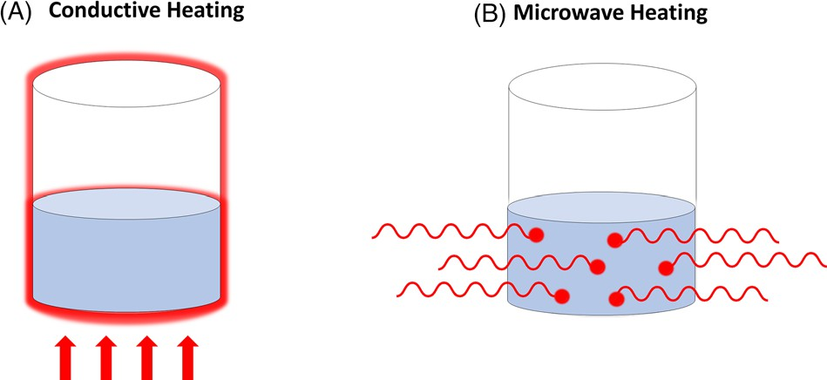
Figure 1: Scheme of the heating principle by conduction (A) and by microwave irradiation (B).

MICROWAVE INSTRUMENT FOR LABORATORY APPLICATIONS

An MW instrument is composed of an MW generator (a “magnetron”), the waveguide, the applicator or the resonance cavity, and the circulator.

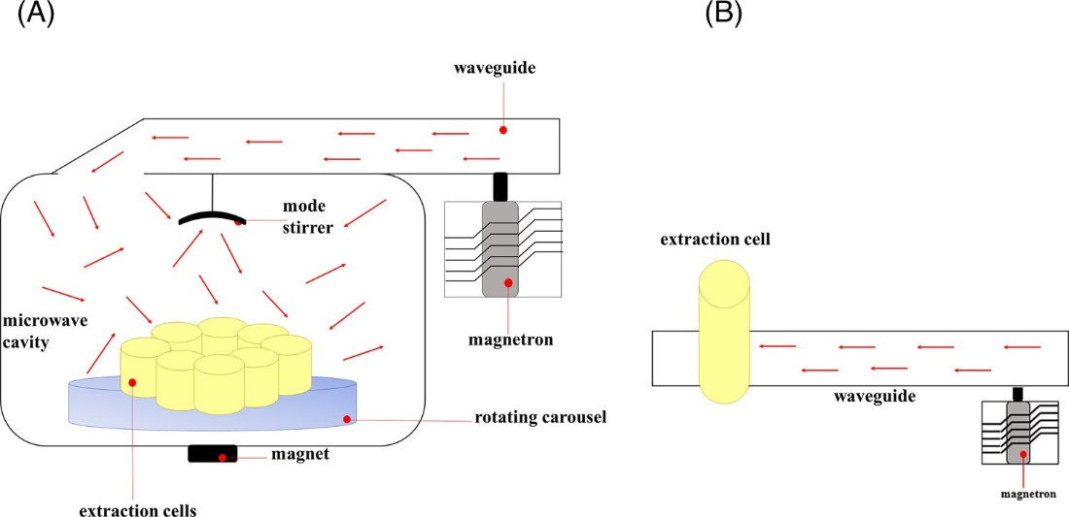
Figure 2: Scheme of the different microwave (MW) designs, namely (A) multi-mode cavity or (B) focused or single-mode. Reproduce with permission from [19].

Among different MW sources, the magnetron is the one that has found the most significant applicability in industrial, defense, and space applications due to its efficient and compact size. The magnetron uses the interaction of electron flow, driven by a magnetic field, with cavities to produce MW radiation. It consists of an anode with a series of cavities that open into a central vacuum chamber containing a metal cathode. A permanent magnet provides a magnetic field that runs parallel to the cylinder axis. The cathode is heated by a high voltage direct current, producing electrons that flow toward the cylinder wall at 90◦ angles to the magnetic field. The electrons are deflected by the field in curved paths, causing the creation of circular currents within the cavities. These currents produce MW radiation at frequencies related to the size of the cavities. Therefore, the MWs must be directed to where they are needed. This is achieved by a metal structure known as a waveguide, along which the MWs travel. The propagation unit is a rectangular or, less often, circular channel of reflective material. To focus MW radiation on the sample, the applicator, which is the device used to insert the sample, can either be a multimode cavity (Figure 2A) where MWs are spread randomly, or it can be the waveguide itself (Figure 2B). If the cavity is a multimode type, to achieve uniform distribution of MW radiation is necessary to use a stirrer mode, which is a fan-shaped blade used to reflect and mix the energy entering the microwave cavity from the waveguide. In this way, the sample heating will be more position-independent, and multiple samples can be treated at the same time. This system is used for performing pressurized MAE (PMAE). The single-mode instrument guarantees stronger and homogenous irradiation, but generally, it processes a sample at the time, and it is mainly used for atmospheric pressure systems, called focused MAE or atmospheric pressure MAE (Figure 2B).
An important distinction of the commercially available instruments is between open or closed vessels, with the latter being the most suitable from an analytical viewpoint. In the closed vessel system, temperature and pressure are the two essential parameters to keep under control. The most used temperature sensor is the thermocouple; however, its use has been debated as the metallic nature of the thermocouple can disturb the MW or even cause the concentration of heat at its tip. Metallic components are indeed generally not recommended in the MW. An alternative is using optical fibers, which can also be coated with polytetrafluoroethylene to operate in the most severe environments. Optical fibers provide a more accurate measurement than metal thermocouples, which can self-heat in MW and thus give inaccurate readings. The downside of the optical fiber is that they are expensive. These two con- tact temperature sensors have been generally replaced by non-contact methods, such as optical pyrometers and the infrared sensor [22, 25].
When operating in a closed vessel, the control of the operative pressure is crucial. The generation of overpressure within the vessel is beneficial as it increases the solvent’s boiling point, but, if out of control, it can be dangerous for the equipment and the operator. The pressure measurements are performed with classical pressure sensors (such as piezoelectric, membranes, and load cells), but some devices have been devised specifically for use in the presence of high-strength electromagnetic fields. An example of this is the use of a glass ring that changes the color of the transmitted polarized lights according to the pressure at which it is exposed in the reaction chamber [22]. Fiber optics can also be used to measure pressure [22]. In modern systems, the closure of the vessel is studied with a calibrated spring that opens to release the overpressure and then quickly reseal the vessel.

MAE: OPTIMIZATION OF THE ANALYTICAL CONDITIONS

As for all the extraction techniques, the optimal conditions depend highly on the matrix characteristics and the targeted analytes to extract. The samples should be as homogenous as possible to guarantee the repeatability of the procedure. This means that when dealing with solid samples, it is important to finely ground the samples in order also to maximize the surface/volume exposure, which in turn maximizes the extraction yield.
The water content of the sample represents a key parameter to be optimized. Indeed, water has a very high dielectric constant, which means that it heats up very efficiently. This, on the one side, guarantees rapid heating of the overall sample-extraction solvent system; on the other side, the evaporation of the matrix-related water causes dilatation and expansion of internal pores, thus facilitating the contact with the extraction solvent and favoring the analyte-matrix interactions, and thus the release of the analyte(s) into the extraction solvent. On the contrary, excessive water content can negatively impact the extraction, forming a protecting layer and/or creating solubility issues, especially when apolar solvents are used for extracting apolar substances. For instance, it was shown an increment in the extraction yield of PAHs in dichloromethane when the water content was increased from 0% to 30%, while over this percentage, the recovery decreased [26]. Therefore, drying or lyophilizing the sample may be beneficial. The water content is, therefore, a crucial parameter to test during method development.
As a general rule, the sample should be completely immersed in the extraction solvent, but thanks to the increased solubility of the analytes, the total amount of solvent is generally significantly lower than the amount needed in traditional extraction [19]. Concerning the nature of the extraction solvent, besides the general consideration regarding the solubility of the targeted analytes, the interaction with the matrix, and the compatibility with the following procedures, the ability of the solvent to absorb the MW should be considered. Different strategies can be exploited. For instance, a polar solvent that intensively absorbs the MW may be preferred to extract polar compounds thanks to the solubility match, but if dealing with thermal-sensible compounds, as for instance essential oils from the water-rich matrix (e.g., leaves or peel), an opposite strategy can be used [17]. The water-rich matrix is easily heated, and the vegetable tissue is disrupted, releasing the analytes of interest. In this case, a solvent with a very low dielectric constant can be used, thus limiting the thermal damage of the extract [17]. A mixture of solvents characterized by different dielectric constants can also be used, but most often, this causes a poor selectivity of the extraction step, requiring a following purification, for instance, in the case of PAHs extracted from smoked meat with a mixture of hexane and acetone [27]. Finally, transparent solvent (e.g., hexane) can also be used, but with the trick of adding a highly absorbent insert (usually made of carbon black material) in the extraction vessel, consequentially the heating transfer to the extraction solvent occurs mainly through conduction and not MW irradiation [27].
Lastly, the extraction time and temperature need to be optimized. These two parameters usually move together as a shorter extraction time is generally required at higher temperatures. Obviously, attention must be paid to the thermal stability of the analytes and the matrix to set the optimal conditions. As aforementioned, when using closed-vessel MW systems, the solvent may increase its boiling point due to the overpressure created by the vapors in the closed-vessel (as in a pressure cooker). Although to a limited extent, this reflects one of the benefits of the pressurized liquid extraction (PLE) system. Under these conditions, the solubility of the analytes is increased, as well as their diffusion rate, while the viscosity of the sol- vent and the superficial tension are decreased, facilitating the penetration of the solvent into the sample matrix and the disruption of the analyte-matrix interactions, overall increasing the mass transfer and thus leading to higher extraction yield [23, 28].

Applications

The main applications herein described are divided into three principal topics: extraction of antioxidant and active compounds, lipids, and contaminants. A table summarizing the main applications is reported in Table S1.
As mentioned in the introduction, this review will focus on the use of PMAE coupled with chromatographic separation for food analysis. In this context, MAE has often been compared to more traditional extraction techniques, such as liquid-liquid, and liquid-solid extraction methods, compared to which it can be considered greener and more sustainable. Indeed, it allows for significantly shortened extraction time, using less solvent and often safer ones, increasing productivity and, at the same time, guaranteeing similar or superior performances [29]. As for pressurized-liquid extraction (PLE), PMAE allows to extract at a higher temperature than the boiling point of the extraction solvent, thus significantly increasing the mass transfer and facilitating the breakage of the matrix-analyte interaction. Generally speaking, PLE and MAE provide similar or higher extraction yields and better repeatability compared to more traditional techniques. Although PLE provides advantages over MAE as it can be considered a semi-dynamic extraction and filtration can be automated within the extraction process step, MAE can process a higher number of samples simultaneously, thus significantly increasing the overall productivity of the laboratory [22].

Antioxidant and active compounds

With the term active compounds, we refer to natural components that play a role in the prevention of various chronic diseases, including cancer, cardiovascular disease, inflammation, and other oxidative stress-related pathologies [30]. Most of these components are antioxidants, and among them, phenolic compounds (which include phenolic acid, flavonoids, and tannins) have received the greatest attention. Indeed, most of the papers referred to the extraction of phenolic compounds, primarily from plants. Many reviews and book chapters have been published on this topic [30–32]. Therefore, herein we discuss mainly the application of MAE to food matrices other than plants. This section will be divided into two main sub-sections, one dealing with phenolic compounds and the other on diterpenes and carotenoids.

Phenolic compounds

Phenolic compounds are specialized metabolites of plants and important constituents of fruits and vegetables. Their relevance in the human diet is related to the proven beneficial effects on health [30]. Recent trends in food functionalization use phenolic compounds, often extracted from waste and by-products of the food industry, to fortify processed foods while improving their stability and healthy profile. Therefore, the detailed characterization of phenolic fractions is necessary, and by utilizing the MAE several benefits are achieved [14, 33].
The total phenolic content is routinely determined with Folin-Ciocâlteu’s method. However, chromatographic techniques are also used for detailed characterization of the phenolic profile, mainly liquid chromatography (LC) coupled to different detectors. The diode array detector (DAD) or a combination of DAD and mass spectrometry (MS) are the configurations most often used to profile phenolic compounds, including anthocyanins and other bio-active phenols [34–36]. Alternatively, LC-MS alone is also used [37, 38]. For example, the determination of phenolic composition from pita fruit by-products and anthocyanins from Ficus carica L. peel was performed by HPLC-DAD-ESI/MS [39, 40]. After MAE, no additional purification was performed, obtaining satisfactory limits of quantification (LOQ) in the 2.17 × 10−7–1.02 × 10−4 mg/mL range.
The main difficulty in the extraction process of phenolic compounds is that they are sensitive to thermal and oxidative degradation, thus, shorter and milder extraction conditions are preferable. In this regard, MAE can play an important role. Moreover, as aforementioned, MAE has been increasingly proposed as a more sustainable alternative to traditional methods, such as liquid-solid or liquid-liquid extraction, Soxhlet extraction, and ultrasound extraction.
Almost all the works herein considered for phenolic compounds compared the efficiency of MAE with one or more traditional extraction techniques. In the work of Liazid et al. [37], recovery comparable to the conventional maceration extraction was obtained for eight phenolic compounds from the grape skin (i.e., 87 %). The extraction was performed with 25 mL of an aqueous methanol solution at 40% (v/v) and the time was significantly shortened from 5 h with the maceration to 5 min with MAE. Moreover, with the latter procedure, three additional compounds were successfully extracted and detected (i.e., malvidin 3-coumaroylglucoside (cis), malvidin 3- caffeoylglucoside and petunidin 3-p-coumaroylglucoside).
The use of MAE could reduce solvent consumption by up to ten times compared to traditional extraction, as reported by Halil et al. for the extraction with ethanol from Morus nigra L. fruit [36]. Moreover, the same work reported a significantly lower extraction time, that is, 10 min instead of 300 min, thus minimizing the degradation of the most sensitive compounds [36]. Maccelli et al. [34] reported degradation of the (poly)phenols, anthocyanins, flavonoids, phytosterols, carotenoids, and saponins, even with the use of MAE if the extraction times exceeded 15 min and the temperatures were above 60◦C (i.e., 80, 100, and 120◦C).
Although not using a commercial PMAE, worth mentioning is the approach proposed by Xiaohua et al. for the extraction of labile compounds from different foods [41]. They proposed the use of a lab-made low-temperature vacuum MW system. The MW oven was modified, adding a low-temperature extraction tank, a cooling tube, and a vacuum pump. The system was used to extract Vitamin C, aloin A, and β-carotene from different food samples, obtaining a higher extraction efficiency than conventional MAE and solvent extraction. In fact, the absence of air in the extraction vessel preserved the most oxygen-sensitive compounds. We can assume that the different extraction was carried out with the same conditions, even if not clearly specified. The comparison is shown in Figure 3.
To identify the best extraction conditions, many researchers have employed designs of experiments (DOE), such as factorial, central composite, and orthogonal array designs [37, 38]. The parameters evaluated were usually the extraction time, temperature (or MW irradiation power for the earliest works), and sample weight. The latter was never reported as a significant parameter affecting the recovery, except for Ballard et al. [42]. In contrast, the correlation between time and temperature was always significant and further investigated by a full experimental design. In the case of degradation-prone compounds, such as phenolic compounds, the use of DOE is highly beneficial as the delicate equilibrium between extraction efficiency and degradation can be more easily identified by a DOE. Indeed, generally higher temperature and longer time increase the extraction yield, but at the same time, increasing the temperature may permit the reduction of the extraction time, also limiting degradation. In the case of MAE, it has been shown that the extraction time can be reduced from hours to min. For example, Liazid et al. studied the recovery of eleven anthocyanins from grape skin. Extraction times between 2.5 and 30 min were tested. After 5 min, no benefit on the yields was observed, while further extending the extraction above 15 min negatively impacted the recoveries [37].

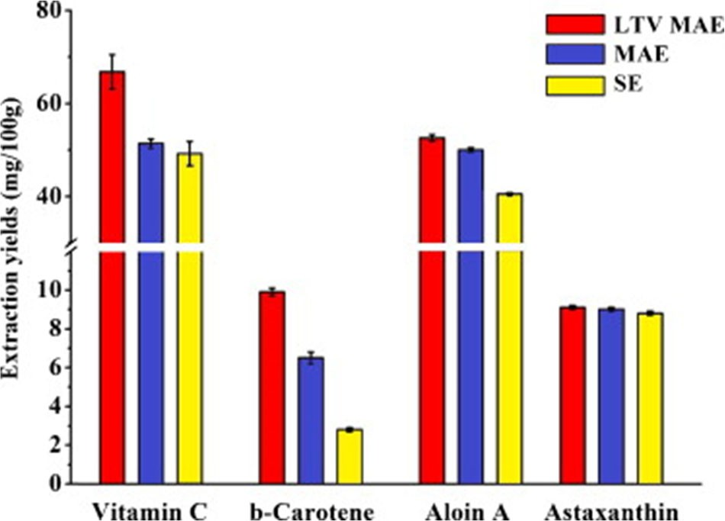
Figure 3: Comparison of the extraction yield obtained applying low-temperature-vacuum MAE (red), classical MAE (blue), and solvent extraction (SE, yellow). Reproduced with permission from [41].

Another important factor is the amount and the type of solvent to improve both the extraction efficiency and the greenness of the method. The most used solvent for the extraction of phenolic compounds is a mixture of water and ethanol, with different percentages of ethanol ranging from 30 to 80%. The amount depends mainly on the original water content of the matrix. For instance, 80% of ethanol was used for the extraction of astragalosides (triterpenoid saponins that possess antioxidant activities) in Radix Astragali [Astragalus membranaceus var. mongholicus (Bunge)] [43]. In contrast, for the extraction from fruit samples, a lower percentage of ethanol is used, such as 56% for papaya leaves [44] and 36% for mango seeds [45]. To improve further the greenness of the extraction, Bubalo et al. [46] considered deep eutectic solvents (DES) as a green alternative to conventional solvents to isolate phenolic compounds from the grape skin. A comparison of the extraction performance was conducted among five different DES Choline chloride-based, and with a series of conventional solvents, such as water, aqueous methanol (MeOH; 70:30 v/v), and acidified aqueous solution of methanol (methanol/water/ 12 M HCl, 70:29:1, v/v/v; with pH = 1.25). The comparison of the extraction yields of two flavonoids chosen as representatives is shown in Figure 4. For the extraction of quercitin-3-O-glucoside, DES Choline chloride-based containing glycerol showed very good extraction efficiency, while for the (+)-catechin, the best performing mixture was that with DES Chlorine chloride-based containing oxalic acid. In general, also for the eight anthocyanins analyzed, the most promising one was chloride-based DES containing oxalic acid as a hydrogen bond donor with 25% water. This can be attributed to the fact that anthocyanins are polar compounds, and therefore the polar organic acid-based DES (more polar than those based on sugars and polyalcohols), showed better performances.
Bonacci et al. [47] and Bener et al. [48] used natural- based DES for the MAE of bioactive compounds from olive oil production wastes and by-products, and from Turkish hazelnut. According to them, the extraction with natural- based DES resulted in a higher polyphenolic content from food by-products (i.e., 60.88 mg/kg-dry sample) than the traditional extraction method utilizing ethanol as a solvent (i.e., 52.97 mg/kg-dry sample).

Diterpenes and Carotenoids

Diterpenes have been successfully determined from green coffee oil using MW-assisted methanolysis. The comparison with the traditional heating technique showed clear improvements. An observed yield of 99% was obtained with MW, compared to 25.9% obtained with conventional heating [49].
Tsukui et al. developed a fast method using MW irradiation for the oil extraction from coffee beans, obtaining advantages over the Soxhlet extraction. In terms of results, the MAE led to a space-time yield of 0.07572 g/h compared to the space-time yield of 0.01270 g/h obtained with Soxhlet extraction [50]. In addition to this, they also used MW irradiation for methanolysis to quantify two diterpenes (cafestol and kahweol) in coffee oil according to Oigman et al. protocol [49].
MAE technology was also successfully applied to extract carotenoids from foods and marine organisms [51]. Nevertheless, if not properly optimized, the extraction yield can be lower compared to classical methods (e.g., Soxhlet). Extending the extraction time in MAE is not recommended since studies have shown that carotenoids are easily degraded during the extraction process due to oxidation and isomerization [52]. Pre-treatments of the sample before MAE, such as water and citric acid blanching, were found to be beneficial in improving the yield [51, 53]. In general, when MAE technology is applied in carotenoid extraction, it is important to define the highest temperature for rapid extraction without damaging the thermo-labile carotenoids. For the extraction of carotenoids from paprika powder, Kiss et al. [54] determined the best conditions as 120 s at 60◦C. Furthermore, they proved that the efficiency and the selectivity of MAE depend on the dielectric constant of the solvent. They considered different solvent mixtures (water with different percent of organic modifier), showing that the selectivity is influenced by the percent of organic modifier more than the type, as shown in the two-dimensional non-linear selectivity map reported in Figure 5.
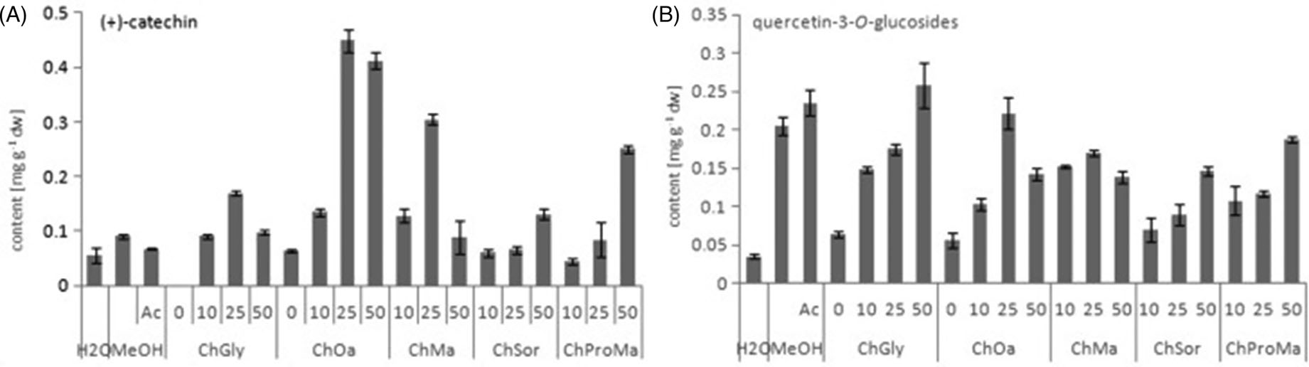
Figure 4: (+)-Catechin and quercetin-3-O-glucoside content in grape skin extracted with different DES Chlorine Cloride-based containing ChGyl (Glycerol), ChOa (Oxalic acid), ChSor (Sorbose), ChMa (Malic acid), ChProMa (Proline and Malic acid), water (H2O), aqueous methanol (MeOH) and acidified aqueous solution of methanol. The number in the graph (0–50) indicates water content in DES (%). Reproduce with permission [46].

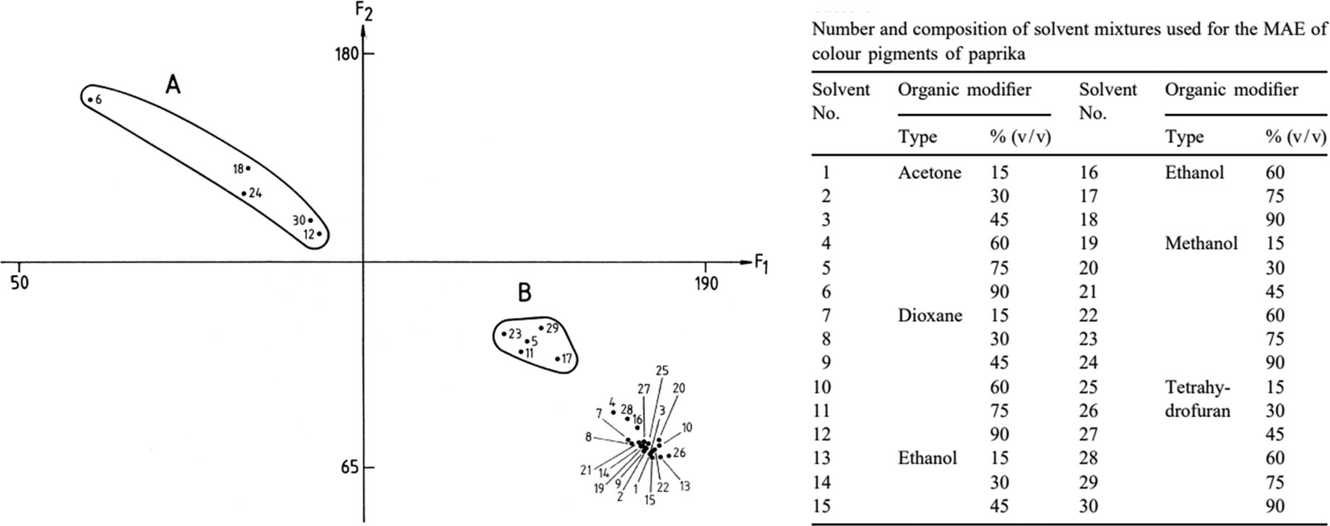
Figure 5: Two-dimensional non-linear selectivity map of solvent mixture. Numbers refer to the solvent mixture in the table. Reproduce with permission [54].

Lipids

Several methods have been developed for total lipid extraction over the years [55]. However, the Soxhlet one, introduced in 1879 by Franz von Soxhlet for milk fat determination [56], remains the reference method [57]. The Soxhlet generally provides a high extraction yield; however, it has limitations for samples containing a high amount of water [55], it requires a very long extraction time (several hours), and continuous heating at the boiling temperature may lead to lipid oxidation and degradation of heat-labile compounds [58]. Besides Soxhlet, Folch, and Bligh and Dyer methods, which use different ratios of chloroform/methanol/water, are considered gold standards for lipid extraction [59, 60]. The former is generally preferred to extract lipids from solid tissue, whereas the latter is more suitable for biological fluids [61]. Although these not energy-based methodologies have been improved and modified over the years, these conventional sample preparation methods may still require large solvent volumes involving intensive sample manipulation [19]. To overcome these disadvantages, developing energy-based methodologies such as MAE can lead to rapid and environmentally friendly extraction methods, minimizing solvent consumption and time. The procedure for extraction and derivatization of lipid samples using microwaves is generally composed of a three-step process: cell-wall disruption, lipid extraction, and derivatization (e.g., transesterification for fatty acid analysis). Compared to other extraction methods, such as Soxhlet and Bligh and Dyer [60], under optimal conditions, MW can effectively break the cell wall thanks to the expansion of the intra-cellular water [62, 63].
Lipid extraction efficiency depends on factors such as the MW power applied, solvent types, and mixing sol- vent ratios [64]. Extraction time may remain critical as thermo-oxidative degradation can occur, but generally, using MW, the time is significantly reduced [65]. Considering the clear advantages in terms of time and throughput, MAE is already considered an established methodology in total lipid extraction and with this aim, it has already been described elsewhere [66, 67]. Therefore, the focus of this section is mainly on the use of MW in one-step extraction/derivatization (MAED), the extraction of tar- get lipid classes, and/or the improvement of derivatization procedures.
MAED methodology has been widely applied in oleaginous biomasses from marine resources [70–73] but, to date, only a few contributions have been published in food domains. Khoomrung et al. used the MW energy to break the rigid cell wall structure of yeasts (Saccharomyces cerevisiae) and simultaneously derivatize the bonded/no- bonded fatty acids (FAs) in a single step, modifying a derivatization method (using BF3 in MeOH) previously proposed by Abdulkadir and Tsuchiya [68]. The preparation of the fatty acid methyl esters (FAMEs) was reduced from 120 to 11 min. The MW temperature was ramped to 120◦C within 6 min and maintained for 5 min. After cooling at room temperature, 2 mL of water was added to the sample. After centrifugation, the upper organic phase containing FAMEs was directly analyzed by GC-MS [69].
In 2015, González-Arrojo et al., developed a one-step extraction/transmethylation based on MW-assisted methodology using hexane with methanolic chlorhydric acid followed by GC-MS analysis for the FA investigation in milk and dairy products [70]. The authors compared the results to the reference ISO method, involving a first extraction with hexane followed by esterification with methyl acetate and sodium methylate [71]. In the same year, Brunton et al. used the MAED approach to investigate FA composition in different foods (milk, butter, infant formula, cooked chicken breast slices, cooked ham slices, uncooked sausages, spaghetti bolognese, lasagne, and chicken). A 10 mm stir bar inside the MW vessel was added to facilitate homogenization. A solution containing potassium hydroxide and methanol was used and the reaction vessel was heated to 90◦C in 4 min and held at this temperature for 10 min. The vessel was ice-cooled at room temperature, and methylation was performed by adding 15 mL of 5% acetyl chloride in MeOH solution, heating to 120◦C in 4 min, and holding for 2 min. FAMEs were analyzed by GC-FID and identified by comparing their linear retention indices with those of authentic standards [72]. The authors compared their MAED methodology with the respective standard methods for FAMEs preparation [73–76] obtaining comparable results [79–82].
Liu et al. investigated FA in raw nuts and seeds using a MW–ultrasonic synergistic in situ extraction– derivatization followed by GC-MS analysis. The response surface methodology was used to optimize parameters such as reaction temperature, microwave power, amounts of catalyst, and derivatization reagent [77]. Gravador et al., applied MAED followed by GC-FID analysis to investigate three branched chain FAs: 4-methyloctanoic acid, 4-ethyloctanoic acid, and 4-methylnonanoic acid from subcutaneous adipose tissue of lamb using a methodology based on the method previously developed by Brunton et al. [72]. The method was validated in terms of linearity, limit of detection (LOD), LOQ, and accuracy.
Fina et al. [78] recently developed a one-step microwave- assisted lipid extraction/methyl ester derivatization process in food samples. The authors used an acidic methanolic solution for transesterification and cyclohexane as extraction solvent, applying a temperature of 120◦C per 15 min. Several foods and ready-to-eat products were investigated to verify broad applicability. The method was optimized and validated by comparing it to different reference methods from the literature [59, 60, 79, 80], particularly with the official American Oil Chemistry Society method for FAMEs analysis in food [81]. The proposed MAED procedure provided a greener and faster alternative to the reference ones when evaluated based on the AGREEprep metrics [82]. Moreover, a fast comprehensive two-dimensional GC (GC×GC) methodology using a reversed-fill/flush flow modulator and flame ionization detector (FID) was developed for FAMEs analysis allowing their complete profiling in a short time (∼30 min). The authors claimed that due to the separation power of GC×GC, there was no need for MS hyphenation during FAMEs identification, making the analytical technique even greener and less costly, simplifying the method even further and contributing to the acceptance of this technology for routine applications. Figure 6 reports the FAMEs % comparison in cow milk using the proposed MAED methodology and a reference one for milk samples [79], with no significant differences observed [78].

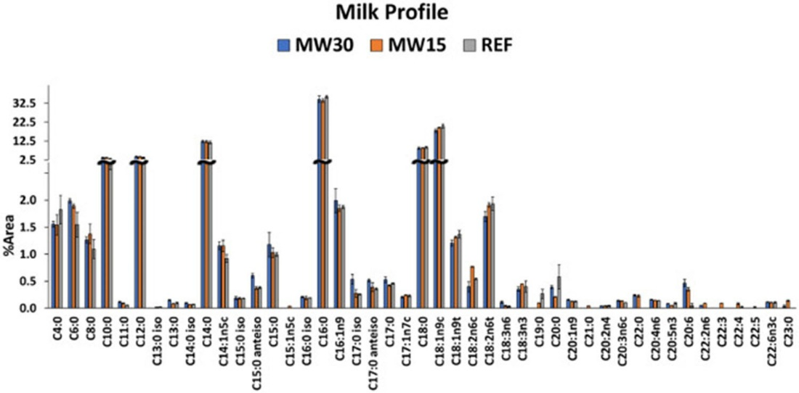
Figure 6: Comparison of the fatty acid methyl esters (FAMEs) percentage profile of milk analyzed using the reference method (grey bars) [79] and the microwave-assisted extraction and derivatization (MAED) at 120◦C for 30 min [blue bars] and 15 min [orange bars]). Error bars indicate the standard deviation of three replicates. Reproduce with permission [78].

The same research group developed a microwave-assisted saponification (MAS) method followed by solid-phase extraction (SPE) to characterize sterols and dialkyl ketones (DAK) in fats. After the MAS, the unsaponifiable fraction was extracted using diethyl ether, and DAK and sterol fractions were both isolated using a single lab-made SPE. GC-FID was used for quantification and GC-MS for confirming the identification of the different targeted compounds. The proposed method showed good recoveries (> 80%) and LOQ (0.04−0.07 μg/g for the 4 DAK and 0.07 μg/g calculated on the internal standard α- cholestanol), with repeatability below 15% for DAKs and generally lower than 6% for sterols. Different lipid samples were investigated, namely palm oil, rapeseed oil (raw and hydrogenated), shea butter, and a mixture of the formers after chemical interesterification (responsible for DAK formation) [83].
Souza et al. [84] developed a MAS methodology for the investigation of cholesterol and cholesterol oxide products (COPs) in shrimps (raw, salted, and dried-salted). The optimization of the MAS conditions was carried out using dried salted shrimps and a central composite rotational design (three variables and two levels). After saponification, samples were extracted with hexane. The extract, containing cholesterols and COPs, was dried and derivatized to form the trimethylsilyl ether-derivatives, then analyzed by GC-MS. To monitor artifact formation due to cholesterol oxidation during saponification, 1 mg of cholesterol-D6 was added to 500 mg of dried salted shrimps. The method was validated in terms of LOD, LOQ, recovery, repeatability, and intermediate precision.

Contaminants in food

The use of MAE for the analysis of contaminants is probably the most explored use of MW technology in the extraction field. A few recent reviews deal with the topic [19, 20]. This review will give a general overview, dividing the broad topic into the main groups of contaminants, namely hydrocarbons, pesticides, and antibiotics, and grouping the remaining into a section defined as various.

Hydrocarbon contamination: polycyclic aromatic and mineral oil hydrocarbons

Although chemically very similar, when referring to PAHs or to mineral oil hydrocarbons (MOHs, which are divided into saturated mineral oil saturated hydrocarbon [MOSH] and aromatic mineral oil aromatic hydrocarbons [MOAH]), the sources of contamination in food are very different. Indeed, PAHs originate mainly from pyrogenic origin, while MOHs are of petrogenic origin and contain a minimal amount of PAHs. Therefore, even if the analytical procedure, especially from the sample preparation view-point, is very similar, no papers deal with them together. On the other hand, some reviews have been published, merging their discussion [19, 85].
When dealing with hydrocarbon determination, the basic extraction procedure generally follows the lipid extraction protocol as this class of contaminants is highly lipophilic [27, 86]. This means that a purification step is necessary to isolate the hydrocarbons from the bulk of the triglycerides (TAGs), which is often performed using a silica-based SPE cartridge, which easily allows for retaining the TAGs and elutes the hydrocarbons. Nevertheless, an important development that has significantly simplified the extraction procedure is the use of a simultaneous hydrolysis/saponification and extraction step to get rid of the bulk of the TAGs and easily retain in the supernatant organic phase only the less polar compounds, among which the hydrocarbons. This procedure was optimized by Pena et al. in 2009 for the analysis of PAHs from fish tissue [87] and extended to grilled meat shortly after [88]. The main advantage is that this procedure minimizes the need for the following purification step. For instance, in meat samples, the SPE purification was performed using a 500 mg SPE cartridge rather than a 5 g, significantly reducing the amount of solvent needed [27, 88, 89]. Obtaining cleaner extract also allowed the miniaturization of the purification step by performing a selective dispersive liquid-liquid microextraction [90–93] using 100 μL of tetra- chloroethylene and 500 μL of acetone into 10 mL of sample solution and obtaining recoveries above 80% and LOQ generally lower than 0.9 μg/kg, except for fluoranthene, dibenzo[a,h]anthracene, and naphthalene for grilled meat [91]. In contrast, higher recovery and lower LOQ were obtained using the same approach for smoked rice [92] and toasted bread [93]. No additional purification was used for the determination of PAHs from propolis and propolis- based supplements after alkali hydrolysis and using LC separation coupled with a fluorescence detector (FLD), obtaining recoveries in the 77–102% range and LOQ lower than 0.3 μg/kg [89].
When dealing with MOHs of petrogenic origin, i.e., MOSH and MOAH, MAE is mainly used as a combined extraction and enrichment step. In fact, the content of fats in the extract is the main limiting factor for attaining the required LOQ. The routine method for MOSH and MOAH determination uses a hyphenated LC-GC-FID system, where the LC separation is exploited for retaining the triglycerides coextracted with the MOHs and to further separate the MOSH from the MOAH. Nevertheless, the LC silica column’s maximum load ability is 20 mg. Therefore, an enrichment step is necessary to improve the LOQ when dealing with high-fat-content food. This step can be done by employing a higher capacity separation column before using the analytical one, but a saponification step is usually preferred to eliminate most of the triglyceride fraction [94, 95]. Performing simultaneously saponification and extraction in the same closed vessel has been largely reported [96–104]. In fact, compared to traditional extraction, it not only allowed for an efficient pre-concentration before the LC-GC-FID analysis, as shown in Figure 7A, but also allowed for quantitative extraction of the external contamination originating from the food packaging along with the pre-existing contamination tightly tangled with the matrix (Figure 7B).
Nevertheless, the optimization of the saponification conditions is highly sample-dependent. In the case of high- fat products, such as biscuits or fish feed, a saturated KOH solution in methanol was always used, but when applied directly to edible oil, particularly olive oil [100], it was necessary to reduce the concentration of KOH to 1.5 N and to add an additional washing step to avoid the formation of solid soap and emulsion. The modified procedure resulted in recovery higher than 90% and a 5-fold enrichment compared to the direct injection of the oil into the LC-GC-FID system.

Pesticides

Pesticides refer to a vast class of compounds widely used to prevent the loss of crops due to weeds and pests. Their determination is mainly performed with chromatographic techniques, either GC and LC, coupled with highly selective and sensitive detectors, such as the triple-quadrupole MS. Nevertheless, even if powerful and advanced detectors are used, the sample preparation step, beyond extraction of the targeted analytes, remains vital to ensure the required sensitivity and avoid overloading the analytical instruments with a high level of interferents that can cause extensive matrix effects and shorten the life of the system itself [105, 106]. Among the alternatives to the traditional solid-liquid or liquid-liquid extraction procedures, MAE has an important place in guaranteeing an efficient extraction, reducing time and solvent consumption [20].
For the extraction of different classes of pesticides in vegetable products, the high presence of water in the matrix (over 80%) assures an efficient heating of the system; meanwhile, the local expansion of water disrupts the inter- action of pesticides with the matrix increasing the overall extraction yield [107]. Nevertheless, attention must be paid to the applied temperature when thermolabile pesticides are extracted. Also, the selection of the proper solvent or solvent mixture is important for the selectivity of extraction and thus to target multi-classes residues.
Several solvents and mixtures have been tested, such as hexane and acetone [108, 109], acetonitrile [110–112], and acetonitrile/acetone [107]. In particular, the latter (1/1 v/v) succeeded in the efficient extraction of 72 pesticides from 35 different matrices [107], while acetonitrile alone was proven suitable for the combined extraction of pesticides and mycotoxins (total of 46 analytes) in a single procedure from apple [111] providing comparable performances with the quick, easy, cheap, effective, rugged, and safe procedure but is a simpler workflow.
The presence of water in the matrix was also beneficial in extracting pesticides from animal tissues. Zhang et al.[113] compared the extraction efficiency of organochloride pesticides from fish muscle tissue fresh or freeze-dried, showing a significant recovery loss when the sample was freeze-dried (Figure 8).
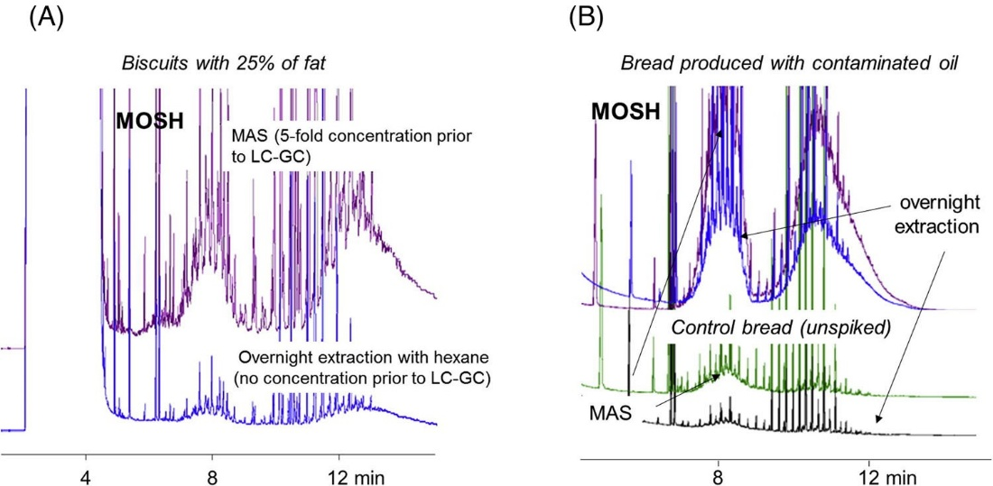
Figure 7: (A) Comparison between mineral oil saturated hydrocarbon (MOSH) traces of a biscuit sample, containing 25% fat, analyzed after overnight extraction (injecting into the LC column an amount of extract corresponding to 50 mg of the sample) or after MAS and a 5-fold concentration (injecting an amount of extract corresponding to 250 mg of the sample containing more than 70 mg of fat). (B) Comparison between MAS and overnight extraction. The figure displays MOSH traces of a sample prepared with unspiked extra virgin olive oil (control bread) and a sample prepared with the same extra virgin olive oil spiked with printing ink solvent. Reproduce with permission [96].

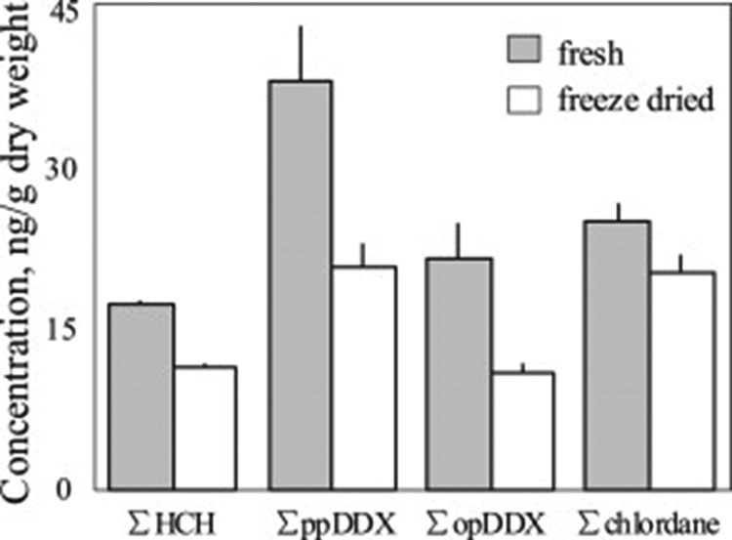
Figure 8: Comparison of the extracted concentrations of organochlorine pesticides in fresh and freeze-dried fish muscle tissue. The results were converted to ng per gram of freeze-dried weight. Both means (bars) and standard deviations (sticks) are shown. Reproduce with permission [113].

MAE using a mixture of methanol/water was used for the extraction of eight selected pesticides from infant milk formula and compared with Soxhlet extraction followed by the same purification method (i.e., SPE) and analytical determination (i.e., LC-MS/MS). Significantly higher recoveries were obtained using MAE, ranging between 87% and 98%, compared to Soxhlet, for which recoveries in the 35%–75% range were obtained at the same spiked con- centration [114]. Gfrerer et al.[115] compared MAE with Soxhlet extraction, dive-in Soxhlet extraction, fluidized-bed extraction, and PLE, for the analysis of chlorinated pesticides in animal feed using a certified reference material (i.e., BCR-115). Pressurized liquid extraction gave the highest recoveries, as for its nature, it is a dynamic extraction, but MAE gave comparable results with superior repeatability, that is, relative standard deviations in the 0.4%–2.8% range.

Antibiotics and steroids

Guedes-Alonso et al. optimized a MAE protocol to analyze fifteen hormones and glucocorticoids in fish tissue [116]. They studied the impact of different conditions, namely sample weight, extraction solvent volume, extraction time, and microwave power, using a 24 factorial design and thus narrowing down to two main variables significantly impacting the extraction yield: extraction time and MW power. These two parameters were further optimized, exploiting a 32 factorial experimental design, defining an optimal at 7 min and 450 W using methanol as extraction solvent. Unfortunately, no mention of the corresponding extraction temperature was reported. A similar study was performed by Aufartova et al. [117] to analyze fluoroquinolones from fish. The authors compared methanol and acetonitrile, selecting the former for easier compatibility with the eluent of the following LC-FLD determination. Three variables were preliminarily studied with a 23 facto- rial design, namely extraction solvent volume, extraction time, and MW power. And then narrowed down to the latter two to perform a 32 factorial design, setting the final conditions to 8 min and 150 W, which allowed to reach a temperature closer to the solvent boiling point.
The efficiency of MAE for the analysis of steroids from infant formula was investigated by studying the temperature-time profile of extraction using acetonitrile as solvent. The highest recoveries (95%–97%) were obtained using 10 mL of acetonitrile at 60◦C for 6 min. Then the extract was cleaned in gel permeation chromatography and derivatized prior to the measurements in GC-MS/MS, reaching LOQ in the range of 0.094–0.265 μg/kg [118].

Various

MAE was successfully used to extract heterocyclic aromatic amines from beefburgers and fried chicken nuggets [119, 120]. Agudelo Mesa et al. [119] presented an interesting approach by using MAE for a “pre-cleaning” of the samples from lipids before the actual extraction of the heterocyclic aromatic amines. The samples were defat- ted by adding three times 3 mL of heptane at 90, 100, and 110◦C. The heating was possible thanks to the natural water present in the sample. The lipids were extracted in heptane in only 3 min, while it was evaluated (although unclear how) that otherwise, 42 mL and 42 min would have been necessary to reach the same results without using the MAE.
A sensitive and alternative method to the official Association of Official Agricultural Chemists was developed by Huang et al. [121] to analyze N-nitrosamines in pork samples. The extraction was followed by a dispersive µ-SPE and GC-chemical ionization-MS analysis, reaching LOQs in the 0.03–0.36 ng/g range.
MAE was also successfully applied for the analysis of contaminants migrating from food contact materials, such as bisphenol A, but also novolac glycidyl ethers, bisphenol A diglycidyl ether and its derivatives from metal can coatings [122, 123], or phthalate esters [124]. As well as for the analysis of 21 dyes in different food products by extracting 10 g of samples with 15 mL of methanol/water (95/5 v/v) at 80◦C for 5 min, followed by an SPE cleaning and LC-UV detector [125].
Pallaroni et al. thoughtfully studied the effect of different MAE conditions (i.e., time, temperature, and solvent) for the extraction of zearalone from wheat and corn [126] and then compared the optimized method with other traditional and alternative techniques, that is, blending, shaking, ultrasound-assisted extraction, and accelerated solvent extraction showing superior yield using MAE, closely followed by the accelerated solvent extraction technique.

Conclusion

The use of MAE for analytical methods is a powerful alternative to more traditional extraction methods, such as Soxhlet and ultrasound. The efficient heating and the disruption effect on the matrix, which weakens the matrix- analytes interaction and increases the contact surface with the extraction solvent, have been proven beneficial in many fields of application in food analysis. Overall, MAE allows for less time- and solvent-consuming extraction with superior or equal extraction yield compared to the traditional methods. Moreover, commercial closed-vessel systems allow for the simultaneous processing of more samples, significantly increasing the laboratory throughput.
Of particular interest is the possibility of merging multiple steps of the sample preparation procedure with the extraction one, such as simultaneous saponification and extraction (i.e., MAS) or extraction and derivatization (e.g., MAED), thus simplifying the overall procedure.
Together, these benefits lead to a greener and more sustainable sample preparation method. In the authors’ opinion, the MW technology is still under-exploited, both at routine and research levels. More fundamental studies on the advantages of MW in different sample preparation steps should be done to convince that extraction time is not the only benefit of using MAE. The possibility of miniaturizing the sample preparation while still exploiting the MW is the next step that so far has not been explored and will provide an extra impulse toward greener techniques and the diffusion of the MW technology.

Acknowledgments

This article is based upon work from the Sample Preparation Study Group and Network, supported by the Division of Analytical Chemistry of the European Chemical Society.

Conflict of Interest statement

The authors declare no conflict of interest.

Data availability statement

Data sharing is not applicable to this article as no new data were created or analyzed in this study

Or CID

Chiara E. Cordero https://orcid.org/0000-0003-3201- 0775
Giorgia Purcaro https://orcid.org/0000-0002-8235-940

References

- Veronesi P. An introduction to dielectric heating in microwave chemistry. Berlin: De Gruyter; 2017.
- Abu-Samra A, Steven Morris J, Koirtyohann SR. Wet ashing of some biological samples in a microwave oven. Anal Chem. 1971;47:1475–7.
- Ganzler K, Salgò A, Valkò K. Microwave extraction: a novel sample preparation method for chromatography. J Chromatogr. 1986;371:299–306.
- Gedye R, Smith F, Westaway K, Ali H, Baldisera L, Laberge L, et al. The use of microwave ovens for rapid organic synthesis. Tetrahedron Lett. 1986;27:279–82.
- Gawande MB, Shelke SN, Zboril R, Varma RS. Microwave- assisted chemistry: Synthetic applications for rapid assembly of nanomaterials and organics. Acc Chem Res. 2014;47:1338– 48.
- Andelman JB, Suess MJD. Polynuclear aromatic hydrocarbons in the water environment. Bull Org mond Santd. 1970;43:479– 508.
- Steinheimer’ TR. HPLC determination of atrazine and principal degradates in agricultural soils and associated surface and ground water. J Agric Food Chem. 1993;41:588–95.
- Lopez-Avila’ V, Young R, Beckerl WF. Microwave-assisted extraction of organic compounds from standard reference soils and sediments. Anal Chem. 1994;66:1097–106.
- Câmara JS, Perestrelo R, Berenguer CV, Andrade CFP, Gomes TM, Olayanju B, et al. Green extraction techniques as advanced sample preparation approaches in biological, food, and environmental matrices: a review. Molecules 2022;27:1–29.
- Chemat F, Abert Vian M, Fabiano-Tixier AS, Nutrizio M, Režek Jambrak A, Munekata PES, et al. A review of sustainable and intensified techniques for extraction of food and natural products. Green Chem. 2020;22:2325–53.
- Thakur S, Chaudhary J, Sharma B, Verma A, Tamulevicius S, Takur VK. Sustainability of bioplastics: opportunities and challenges. Curr Opin Green Sustain Chem. 2018;13:68– 75.
- Ekezie FGC, Sun DW, Cheng JH. Acceleration of microwave- assisted extraction processes of food components by integrating technologies and applying emerging solvents: A review of latest developments. Trends Food Sci Technol. 2017;67:160– 72.
- Kala HK, Mehta R, Sen KK, Tandey R, Mandal V. Critical analysis of research trends and issues in microwave assisted extraction of phenolics: Have we really done enough. TrAC Trends Anal Chem. 2016;85:140–52.
- Routray W, Orsat V. Microwave-assisted extraction of flavonoids: a review. Food Bioproc Tech. 2012;5:409–24.
- Zhang HF, Yang XH, Wang Y. Microwave assisted extraction of secondary metabolites from plants: current status and future directions. Trends Food Sci Technol. 2011;22:672–88.
- Llompart M, Celeiro M, Dagnac T. Microwave-assisted extraction of pharmaceuticals, personal care products and industrial contaminants in the environment. TrAC Trends Anal Chem. 2019;116:136–50.
- Sanchez-Prado L, Garcia-Jares C, Dagnac T, Llompart M. Microwave-assisted extraction of emerging pollutants in environmental and biological samples before chromato- graphic determination. TrAC Trends Anal Chem. 2015;71:119– 43.
- Teo CC, Chong WPK, Ho YS. Development and application of microwave-assisted extraction technique in biological sample preparation for small molecule analysis. Metabolomics 2013;9:1109–28.
- Moret S, Conchione C, Srbinovska A, Lucci P. Microwave- based technique for fast and reliable extraction of organic contaminants from food, with a special focus on hydrocarbon contaminants. Foods 2019;8:1–20.
- Wang H, Ding J, Ren N. Recent advances in microwave-assisted extraction of trace organic pollutants from food and environ- mental samples. TrAC—Trends Anal Chem. 2016;75:197–208.
- Horikoshi S, Serpone N. General introduction to microwave chemistry in microwaves in catalysis: methodology and appli- cations. Weinheim: Wiley-VCH Verlag GmbH & Co; 2015.
- Chemat F, Cravotto G. Microwave-assisted extraction for bioac- tive compounds. Theory and practice. New York, NY: Springer; 2012.
- Eskilsson CS, Bjorklund E. Analytical-scale microwave-assisted extraction. J Chromatogr A. 2000;902:227–50.
- Mello PA, Barin JS, Guarnieri RA. Microwave heating in microwave-assisted sample preparation for trace element determination. Amsterdam, NL: Elsevier B.V.; 2014.
- de Castro MD, Castillo-Peinado LS. Microwave-assisted extraction of food components in innovative food processing technologies: extraction, separation, component modification and process intensification. Amsterdam, NL: Elsevier Inc.; 2016.
- Budzinski H, Letellier M, Garrigues P, Le Menachťlptc K. Optimisation of the microwave-assisted extraction in open cell of polycyclic aromatic hydrocarbons from soils and sediments Study of moisture effect. J Chromatogr A. 1999;837:187–200.
- Purcaro G, Moret S, Conte LS. Optimisation of microwave assisted extraction (MAE) for polycyclic aromatic hydrocarbon (PAH) determination in smoked meat. Meat Sci. 2009;81:275– 80.
- Letellier M, Budzinski H. Microwave assisted extraction of organic compounds. Analysis 1999;27:259–71.
- Chemat F, Abert Vian M, Fabiano-Tixier AS, Nutrizio M, Režek Jambrak A, Munekata PES, et al. A review of sustainable and intensified techniques for extraction of food and natural products. Green Chem. 2020;22:2325–53.
- Bravo L, Mateos R, Analysis of flavonoids in functional foods and nutraceuticals in methods of analysis for functional foods and nutraceuticals. Oxfordshire: Taylor & Francis Group; 2008.
- Bagade SB, Patil M. Recent advances in microwave assisted extraction of bioactive compounds from complex herbal samples: a review. Crit Rev Anal Chem. 2021;51:138–49.
- Belščak-Cvitanovic A, Komes D. Extraction and formulation of bioactive compounds in handbook of coffee processing by- products: sustainable applications. Amsterdam, NL: Elsevier Inc.; 2017.
- Panzella L, Moccia F, Nasti R, Marzorati S, Verotta L, Napolitano A. Bioactive Phenolic Compounds From Agri- Food Wastes: An Update on Green and Sustainable Extraction Methodologies. Front Nutr. 2020;7:1–27.
- Maccelli A, Cesa S, Cairone F, Secci D, Menghini L, Chiavarino B, et al. Metabolic profiling of different wild and cultivated Allium species based on high-resolution mass spectrometry, high-performance liquid chromatography-photodiode array detector, and color analysis. J Mass Spectrom. 2020;55:425–55.
- Mollica A, Locatelli M, Macedonio G, Carradori S, Sobolev AP, De Salvador RF, et al. Microwave-assisted extraction, HPLC analysis, and inhibitory effects on carbonic anhydrase I, II, VA, and VII isoforms of 14 blueberry Italian cultivars. J Enzyme Inhib Med Chem. 2016;31:1–6.
- Koyu H, Kazan A, Demir S, Haznedaroglu MZ, Yesil-Celiktasnigra L. fruits maximizing tyrosinase inhibitory activity with isolation of bioactive constituents. Food Chem. 2018;248:183– 91.
- Liazid A, Guerrero RF, Cantos E, Palma M, Barroso CG. Microwave assisted extraction of anthocyanins from grape skins. Food Chem. 2011;124:1238–43.
- Yang Z, Zhai W. Optimization of microwave-assisted extraction of anthocyanins from purple corn (Zea mays L.) cob and identification with HPLC-MS. Innov Food Sci and Emerg Technol. 2010;11:470–6.
- Ferreres F, Grosso C, Gil-Izquierdo A, Valentão P, Mota AT, Andrade PB. Optimization of the recovery of high-value com- pounds from pitaya fruit by-products using microwave-assisted extraction. Food Chem. 2017;230:463–74.
- Backes E, Pereira C, Barros L, Prieto MA, Genena AK, Barreiro MF, et al. Recovery of bioactive anthocyanin pigments from Ficus carica L. peel by heat, microwave, and ultrasound based extraction techniques. Food Res Int. 2018;113:197–209.
- Xiao X, Song W, Wang J, Li G. Microwave-assisted extraction performed in low temperature and in vacuo for the extraction of labile compounds in food samples. Anal Chim Acta. 2012;712:85–93.
- Ballard TS, Mallikarjunan P, Zhou K, O’Keefe S. Microwave- assisted extraction of phenolic antioxidant compounds from peanut skins. Food Chem. 2010;120:1185–92.
- Yan MM, Liu W, Fu YJ, Zu YG, Chen CY, Luo M. Optimisation of the microwave-assisted extraction process for four main astragalosides in Radix Astragali. Food Chem. 2010;119:1663– 70.
- Alara OR, Abdurahman NH, Ali HA, Zain NM. Microwave- assisted extraction of phenolic compounds from Carica papaya leaves: an optimization study and LC-QTOF-MS analysis. Future Foods. 2021;3:1–8.
- Torres-León C, de Azevedo Ramos B, dos Santos Correia MT, Carneiro-da-Cunha MG, Ramirez-Guzman N, Alves LC, et al. Antioxidant and anti-staphylococcal activity of polyphenolic- rich extracts from Ataulfo mango seed. LWT. 2021;148:1– 10.
- Cvjetko Bubalo M, Ćurko N, Tomašević M, Kovačević Ganić K, Radojcic Redovnikovic I. Green extraction of grape skin phenolics by using deep eutectic solvents. Food Chem. 2016;200:159– 66.
- Bonacci S, Di Gioia ML, Costanzo P, Maiuolo L, Tallarico S, Nardi M. Natural deep eutectic solvent as extraction media for the main phenolic compounds from olive oil processing wastes. Antioxidants 2020;9:1–14.
- Bener M, Şen FB, Önem AN, Bekdeşer B, Çelik SE, Lalikoglu M, et al. Microwave-assisted extraction of antioxidant compounds from by-products of Turkish hazelnut (Corylus avellana L.) using natural deep eutectic solvents: Modeling, optimization and phenolic characterization. Food Chem. 2022;385:1– 13.
- Oigman SS, De Souza ROMA, Dos Santos Júnior HM, Hovell AMC, Hamerski L, Rezende CM. Microwave-assisted methanolysis of green coffee oil. Food Chem. 2012;134:999– 1004.
- Tsukui A, Santos Júnior HM, Oigman SS, De Souza ROMA, Bizzo HR, Rezende CM. Microwave-assisted extraction of green coffee oil and quantification of diterpenes by HPLC. Food Chem. 2014;164:266–71.
- Saini RK, Keum YS. Carotenoid extraction methods: a review of recent developments. Food Chem. 2018;240:90–103.
- Ngamwonglumlert L, Devahastin S, Chiewchan N. Natural colorants: pigment stability and extraction yield enhance- ment via utilization of appropriate pretreatment and extraction methods. Crit Rev Food Sci Nutr. 2017;57:3243–59.
- Hiranvarachat B, Devahastin S, Chiewchan N, Vijaya Raghavan GS. Structural modification by different pretreatment methods to enhance microwave-assisted extraction of β-carotene from carrots. J Food Eng. 2013;115:190–7.
- Kiss GAC, Forgacs E, Cserhati T, Mota T, Morais H, Ramos A. Optimisation of the microwave-assisted extraction of pigments from paprika (Capsicum annuum L.) powders. J Chromatogr A. 2000;889:41–9.
- Manirakiza P, Covaci A, Schepens P. Comparative study on total lipid determination using Soxhlet, Roese-Gottlieb, Bligh & Dyer, and modified Bligh & Dyer extraction methods. J Food Compos Anal. 2001;14:93–100.
- Soxhlet F. Die gewichtsanalytische Bestimmung des Milch- fettes. Dinglers Polytech J. 1879;232:461–5.
- ISO 659. Oilseeds — Determination of oil content.International Organisation for Standardisation (ISO), Geneva, Switzerland. 1998.
- Chen W, Liu Y, Song L, Sommerfeld M, Hu Q. Automated accelerated solvent extraction method for total lipid analysis of microalgae. Algal Res. 2020;51:1–9.
- Folch J, Lees M, Sloane Stanley GH. A simple method for the isolation and purification of total lipids from animal tissues. J Biol Chem. 1957;226:497–509.
- Bligh EG, Dyer WJ. A rapid method of total lipid extraction and purification. Can J Biochem Physiol. 1959;37:911–7.
- Pati S, Nie B, Arnold RD, Cummings BS. Extraction, chromato- graphic and mass spectrometric methods for lipid analysis. Biomed Chromatogr. 2016;30:695–709.
- Zghaibi N, Omar R, Kamal SMM, Biak DRA, Harun R. Microwave-assisted brine extraction for enhancement of the quantity and quality of lipid production from microalgae nannochloropsis sp. Molecules. 2019;24:1– 21.
- Wahidin S, Idris A, Shaleh SRM. Rapid biodiesel production using wet microalgae via microwave irradiation. Energy Convers Manag. 2014;84:227–33.
- Teo CL, Idris A. Enhancing the various solvent extraction method via microwave irradiation for extraction of lipids from marine microalgae in biodiesel production. Bioresour Technol. 2014;171:477–81.
- Borugadda VB, Goud VV. Thermal, oxidative and low temperature properties of methyl esters prepared from oils of different fatty acids composition: a comparative study. Thermochim Acta. 2014;577:33–40.
- Jiang H, Liu Z, Wang S. Microwave processing: effects and impacts on food components. Crit Rev Food Sci Nutr. 2018;58:2476–89.
- Dai YM, Chen KT, Chen CC. Study of the microwave lipid extraction from microalgae for biodiesel production. Chem Eng J. 2014;250:267–73.
- Abdulkadir S, Tsuchiya M. One-step method for quantitative and qualitative analysis of fatty acids in marine animal samples. J Exp Mar Biol Ecol. 2008;354:1–8.
- Khoomrung S, Chumnanpuen P, Jansa-Ard S, Nookaew I, Nielsen J. Fast and accurate preparation fatty acid methyl esters by microwave-assisted derivatization in the yeast Saccharomyces cerevisiae. Appl Microbiol Biotechnol. 2012;94:1637– 46.
- González-Arrojo A, Soldado A, Vicente F, de la Roza-Delgado B. Microwave-assisted methodology feasibility for one-step extraction and transmethylation of fatty acids in milk for GC-mass spectrometry. Food Anal Methods. 2015;8:2250– 60.
- ISO 15884. Milk fat- preparation of fatty acid methyl esters. International Standard ISO 15884-IDF 182. International Organization for Standardisation (ISO), Geneva, Switzerland. 2002.
- Brunton NP, Mason C, Collins MJ. Rapid microwave assisted preparation of fatty acid methyl esters for the analysis of fatty acid profiles in foods. J Anal Chem. 2015;70:1218– 24.
- Wagner KH, Plasser E, Proell C, Kanzler S. Comprehensive studies on the trans fatty acid content of Austrian foods: convenience products, fast food and fats. Food Chem. 2008;108:1054– 60.
- Juárez M, Marco A, Brunton N, Lynch B, Troy DJ, Mullen AM. Cooking effect on fatty acid profile of pork breakfast sausages enriched in conjugated linoleic acid by dietary supplementation or direct addition. Food Chem. 2009;117:393– 7.
- Park PW, Goins RE. In situ preparation of fatty acid methyl esters for analysis of fatty acid composition in foods. J Food Sci. 1994;59:1262–6.
- Kramer JKG, Fellner V, Dugan MER, Sauer FD, Mossoba MM, Yurawecz MP. Evaluating acid and base catalysts in the methylation of milk and rumen fatty acid with special emphasis on conjugated dienes and total trans fatty acids. Lipids. 1997;32:1219–28.
- Liu RL, Song SH, Wub M, He T, Zhang ZQ. Rapid analysis of fatty acid profiles in raw nuts and seeds by microwave- ultrasonic synergistic in situ extraction-derivatisation and gas chromatography-mass spectrometry. Food Chem. 2013;141:4269–77.
- Fina A, Mascrez S, Beccaria M, De Luca C, Aspromonte J, Cordero C, et al. A high throughput method for fatty acid pro- filing using simultaneous microwave-assisted extraction and derivatization followed by reversed fill/flush flow modulation comprehensive multidimensional gas chromatography. Adv Sample Prep. 2022;4:100039.
- Cruz-Hernandez C, Hill AR, Yurawecz MP, Delmonte P, Mossoba MM, Dugan MER, et al. Methods for analysis of conjugated linoleic acids and trans-18:1 isomers in dairy fats by using a combination of gas chromatography, silver-ion thin-layer chromatography/gas chromatography, and silver-ion liquid chromatography. J AOAC Int. 2004;87:545.
- Jariyasopit N, Khamsaeng S, Panya A, Vinaisuratern P, Metem P, Asawalertpanich W, et al. Quantitative analysis of nutrient metabolite compositions of retail cow’s milk and milk alternatives in Thailand using GC-MS. J Food Compos Anal. 2021;97:1–10.
- AOCS. Direct methylation of lipids in foods by alkali hydrol- ysis. In: Firestone D, ed. Official methods and recommended practices of the AOCS. 7th ed. Urbana, IL: AOCS Press; 2017.
- Pena-Pereira F, Tobiszewski M, Wojnowski W, Psillakis E. A tutorial on AGREEprep an analytical greenness metric for sample preparation. Adv Sample Prep. 2022;3:100025.
- Mascrez S, Danthine S, Purcaro G. Microwave-assisted saponification method followed by solid-phase extraction for the characterization of sterols and dialkyl ketones in fats. Foods. 2021;10:1–12.
- Souza HAL, Mariutti LRB, Bragagnolo N. Microwave assisted direct saponification for the simultaneous determination of cholesterol and cholesterol oxides in shrimp. J Steroid Biochem Mol Biol. 2017;169:88–95.
- Purcaro G, Barp L, Moret S. Determination of hydrocarbon contamination in foods. A review. Anal Methods. 2016;8:5755– 72.
- Ramalhosa MJ, Paíga P, Morais S, Sousa AMM, Gonçalves MP, Delerue-Matos C, et al. Analysis of polycyclic aromatic hydro- carbons in fish: Optimisation and validation of microwave- assisted extraction. Food Chem. 2012;135:234–42.
- Pena T, Pensado L, Casais C, Mejuto C, Phan-Tan-Luu R, Cela R. Optimization of a microwave-assisted extraction method for the analysis of polycyclic aromatic hydrocarbons from fish samples. J Chromatogr A. 2006;1121:163–9.
- Akpambang VOE, Purcaro G, Lajide L, Amoo IA, Conte LS, Moret S. Determination of polycyclic aromatic hydrocarbons (PAHs) in commonly consumed Nigerian smoked/grilled fish and meat. Food Addit Contam Part A. 2009;26:1096–103.
- Moret S, Purcaro G, Conte LS. Polycyclic aromatic hydrocar- bons (PAHs) levels in propolis and propolis-based dietary supplements from the Italian market. Food Chem. 2010;122:333–8.
- Ghasemzadeh-Mohammadi V, Mohammadi A, Hashemi M, Khaksar R, Haratian P. Microwave-assisted extraction and dispersive liquid-liquid microextraction followed by gas chromatography-mass spectrometry for isolation and determination of polycyclic aromatic hydrocarbons in smoked fish. J Chromatogr A. 2012;1237:30–6.
- Kamankesh M, Mohammadi A, Hosseini H, Modarres Tehrani Z. Rapid determination of polycyclic aromatic hydrocar- bons in grilled meat using microwave-assisted extraction and dispersive liquid-liquid microextraction coupled to gas chromatography-mass spectrometry. Meat Sci. 2015;103:61–7.
- Mahmoudpour M, Mohtadinia J, Mousavi MM, Ansarin M, Nemati M. Application of the microwave-assisted extraction and dispersive liquid–liquid microextraction for the analysis of PAHs in smoked rice. Food Anal Methods. 2017;10:277–86.
- Mahmoudpour M, Pilevar Z, Javanmardi F, Taram F, Mousavi MM. PAHs in toasted bread: Determination using microwave- assisted extraction and dispersive liquid-liquid microextraction followed by high-performance liquid chromatography. Anal Methods. 2018;10:2398–404.
- Sdrigotti N, Collard M, Purcaro G. Evolution of hyphen- ated techniques for mineral oil analysis in food. J Sep Sci. 2021;44:464–82.
- Hochegger A, Moret S, Geurts L, Gude T, Leitner E, Mertens B, et al. Mineral oil risk assessment: knowledge gaps and roadmap. Outcome of a multi-stakeholders workshop. Trends Food Sci Technol. 2021;113:151–66.
- Moret S, Scolaro M, Barp L, Purcaro G, Conte LS. Microwave assisted saponification (MAS) followed by on-line liquid chromatography (LC)-gas chromatography (GC) for high- throughput and high-sensitivity determination of mineral oil in different cereal-based foodstuffs. Food Chem. 2016;196:50– 7.
- Bauwens G, Conchione C, Sdrigotti N, Moret S, Purcaro G. Quantification and characterization of mineral oil in fish feed by liquid chromatography-gas chromatography-flame ionization detector and liquid chromatography-comprehensive multidimensional gas chromatography-time-of-flight mass spectrometer/flame ionization detector. J Chromatogr A. 2022;1677:1–13.
- Ana S, Chiara C, Fabiola C, Luca MU, Sabrina M. High sensitivity determination of mineral oils and olefin oligomers in cocoa powder and related packaging: Method validation and market survey. Food Chem. 2022;396:1–8.
- Srbinovska A, Conchione C, Lucci P, Moret S. On-line HP(LC)- GC-FID determination of hydrocarbon contaminants in fresh and packaged fish and fish products. J AOAC Int. 2021;104:267– 73.
- Menegoz Ursol L, Conchione C, Srbinovska A, Moret S. Optimization and validation of microwave assisted saponification (MAS) followed by epoxidation for high-sensitivity determination of mineral oil aromatic hydrocarbons (MOAH) in extra virgin olive oil. Food Chem. 2022;370:1–9.
- Gharbi I, Moret S, Chaari O, Issaoui M, Conte LS, Lucci P, et al. Evaluation of hydrocarbon contaminants in olives and virgin olive oils from Tunisia. Food Control. 2017;75:160–6.
- Menegoz Ursol L, Conchione C, Peroni D, Carretta A, Moret S. A study on the impact of harvesting operations on the mineral oil contamination of olive oils. Food Chem. 2023;406:1–11.
- Srbinovska A, Gasparotto L, Conchione C, Menegoz Ursol L, Lambertini F, Suman M, et al. Mineral oil contamination in basil pesto from the Italian market: Ingredient contribution and market survey. J Food Comp Anal. 2023;115:1–7.
- Conchione C, Lucci P, Moret S. Migration of polypropylene oligomers into ready-to-eat vegetable soups. Foods 2020;9:1–12.
- Fenik J, Tankiewicz M, Biziuk M. Properties and determination of pesticides in fruits and vegetables. TrAC Trends Anal Chem. 2011;30:814–26.
- Gilbert-López B, García-Reyes JF, Molina-Díaz A. Sample treatment and determination of pesticide residues in fatty vegetable matrices: A review. Talanta. 2009;79:109–28.
- Satpathy G, Tyagi YK, Gupta RK. A novel optimised and validated method for analysis of multi-residues of pesticides in fruits and vegetables by microwave-assisted extraction (MAE)- dispersive solid-phase extraction (d-SPE)-retention time locked (RTL)-gas chromatography-mass spectrometry with Deconvolution reporting software (DRS). Food Chem. 2011;127:1300–8.
- Bouaid A, Martin-Esteban A, Fernàndez P, Càmara C. Microwave-assisted extraction method for the determination of atrazine and four organophosphorus pesticides in oranges by gas chromatography (GC). J Anal Chem. 2000;367:291–4.
- Barriada-Pereira M, González-Castro MJ, Muniategui-Lorenzo S, López-Mahía P, Prada-Rodríguez D, Fernández-Fernández E. Determination of organochlorine pesticides in horticultural samples by microwave assisted extraction followed by GC-ECD. Int J Environ Anal Chem. 2005;85:325–33.
- Paíga P, Morais S, Correia M, Alves A, Delerue-Matos C. Screening of carbamates and ureas in fresh and processed tomato samples using microwave-assisted extraction and liquid chromatography. Anal Lett. 2009;42:265–83.
- Kalogiouri NP, Papadakis EN, Maggalou MG, Karaoglanidis GS, Samanidou VF, Menkissoglu-Spiroudi U. Development of a microwave-assisted extraction protocol for the simultaneous determination of mycotoxins and pesticide residues in apples by LC-MS/MS. Appl Sci (Switzerland). 2021;11:1–16.
- Raina-Fulton R, Xie Z, Sample preparation methods for pesticide analysis in food commodities, biological and environ- mental matrices in ideas and applications toward sample preparation for food and beverage analysis. London: InTech; 2017.
- Zhang Y, Lin N, Su S, Shen G, Chen Y, Yang C, et al. Freeze drying reduces the extractability of organochlorine pesticides in fish muscle tissue by microwave-assisted method. Env Poll. 2014;191:250–2.
- Fang G, Lau HF, Law WS, Li SFY. Systematic optimisation of coupled microwave-assisted extraction-solid phase extraction for the determination of pesticides in infant milk formula via LC-MS/MS. Food Chem. 2012;134:2473–80.
- Gfrerer M, Chen S, Lankmayr EP, Quan X, Yang F. Comparison of different extraction techniques for the determination of chlorinated pesticides in animal feed. Anal Bioanal Chem. 2004;378:1861–7.
- Guedes-Alonso R, Sosa-Ferrera Z, Santana-Rodríguez JJ. Determination of steroid hormones in fish tissues by microwave- assisted extraction coupled to ultra-high performance liquid chromatography tandem mass spectrometry. Food Chem. 2017;237:1012–20.
- Aufartová J, Brabcová I, Torres-Padrón ME, Solich P, Sosa- Ferrera Z, Santana-Rodríguez JJ. Determination of fluoroquinolones in fishes using microwave-assisted extraction combined with ultra-high performance liquid chromatography and fluorescence detection. J Food Comp Anal. 2017;56:140–6.
- Yang Y, Li H, Zhang J, Sun N, Sun H. Analysis of infant formula for steroid hormones by gas chromatography-tandem mass spectrometry using microwave-assisted extraction and gel permeation chromatography clean up. Food Anal Methods. 2014;7:798–805.
- Mesa LBA, Padro JM, Reta M. Analysis of non-polar hetero- cyclic aromatic amines in beefburguers by using microwave- assisted extraction and dispersive liquid-ionic liquid microextraction. Food Chem. 2013;141:1694–701.
- Barzegar F, Omidi N, Kamankesh M, Mohammadi A, Ferdowsi R, Jazaeri S. An advanced microwave-assisted extraction-low density solvent based on a sensitive microextraction method coupled with reverse phase high-performance liquid chromatography for the simultaneous determination of heterocyclic aromatic amines in fried chicken nuggets. Anal Methods. 2019;11:942–9.
- Huang MC, Chen HC, Fu SC, Ding WH. Determination of volatile N-nitrosamines in meat products by microwave- assisted extraction coupled with dispersive micro solid-phase extraction and gas chromatography-Chemical ionisation mass spectrometry. Food Chem. 2013;138:227–33.
- Hong Z, Ming X, Yanbin L, Zhiyuan D, Honghai W. Microwave- assisted extraction for the simultaneous determination of Novolac glycidyl ethers, bisphenol a diglycidyl ether, and its derivatives in canned food using HPLC with fluorescence detection. J Sep Sci. 2010;33:235–43.
- Zamani B, Ghanati K, Kamankesh M, Farhoodi M, Mohammadi A. Migration of Bisphenol-A into packaged food simulants: Development of a novel MAE-LDS-ME strategy for the investigation of storage time and temperature. J Vinyl and Addit Technol. 2023;29:176–87.
- Sun H, Yang Y, Li H, Zhang J, Sun N. Development of multiresidue analysis for twenty phthalate esters in edible vegetable oils by microwave-assisted extraction-gel permeation chromatography-solid phase extraction-gas chromatography- tandem mass spectrometry. J Agric Food Chem. 2012;60:5532– 9.
- Sun H, Sun N, Li H, Zhang J, Yang Y. Development of multiresidue analysis for 21 synthetic colorants in meat by microwave-assisted extraction-solid-phase extraction-reversed- phase ultrahigh performance liquid chromatography. Food Anal Methods. 2013;6:1291–9.

