Supplementary figures
A
3T3-L1mG0S2
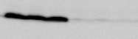
G0S2
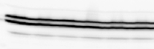
Erk1/2

+Dox
-Dox

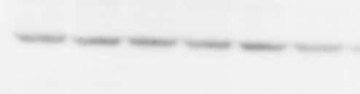
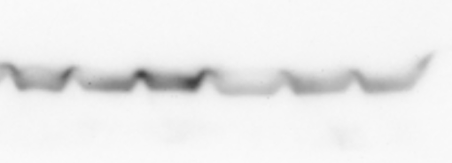
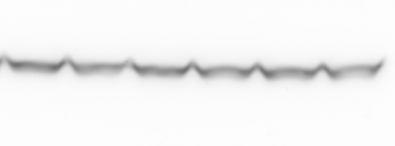
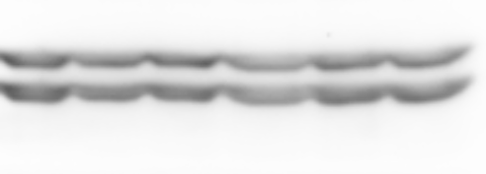
B
FSP27
CGI58
ATGL
Erk12
+Dox
3T3-L1mG0S2
-Dox
Supplementary Figure S1: Differentiated 3T3-L1mG0S2 were co-cultured with E0771 cells for 72h with (+Dox) or without (-Dox) 2µg/ml of doxycycline. Western blot analysis of whole cell extracts with specific antibodies to G0S2, FSP27, CGI58, ATGL and Erk1/2. (A) Induction of G0S2 overexpression upon doxycycline treatment. (B) The expression of FSP27, CGI58 and ATGL are not significantly altered by the overexpression of G0S2.
A
B
Supplementary Figure S2: Incorporation of ¹⁴C in the organic phase and in the aqueous phase of 3T3-L1mG0S2 preadipocyte. Differentiated 3T3-L1mG0S2 cultured in 6 wells plates were labeled with 0.1 µCi/mL of ¹⁴C-acetate (PerkinElmer, # NEC553050UC) during 24h. The cells were rinsed 3 times and cultured for 24h with or without 2µg/mL doxycycline to induce (+G0S2) or not (CTR) G0S2 overexpression. The cells were rinsed 3 times and were processed for lipid extraction and the total radioactivity in the organic (A) and in the aqueous (B) phases was counted. (n= 6 biological replicates).
More than 99% (mean of 99,6%) of the 14C is associated with the organic phase and the 14C incorporation was not affected by the overexpression of G0S2.

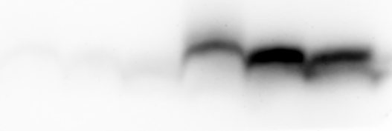
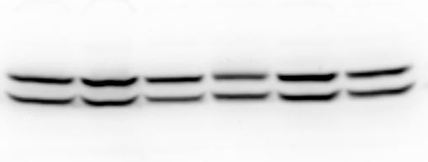
WT-PyMT
aP2G0S2-PyMT
G0S2
Erk1/2

Supplementary Figure S3: G0S2 is overexpressed in white adipose tissue of aP2G0S2 mice. Western blot analysis of G0S2 expression in white adipose tissue of 13 weeks old WT-PyMT or aP2G0S2-PyMT mice.

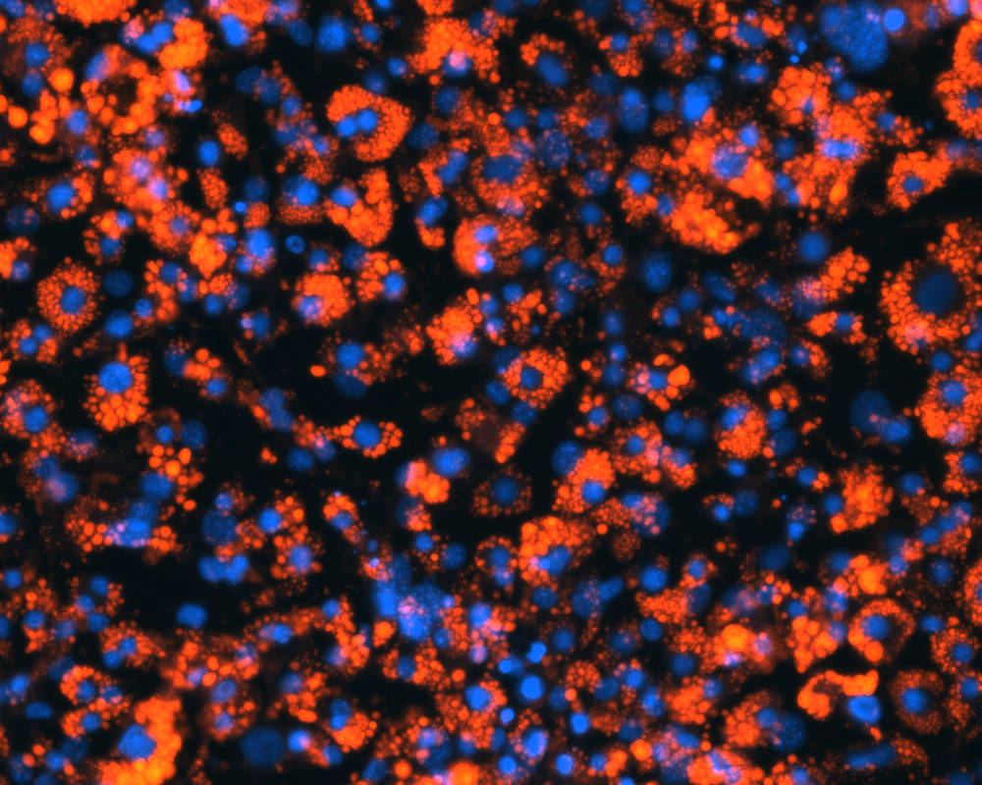
A

pH 7,4

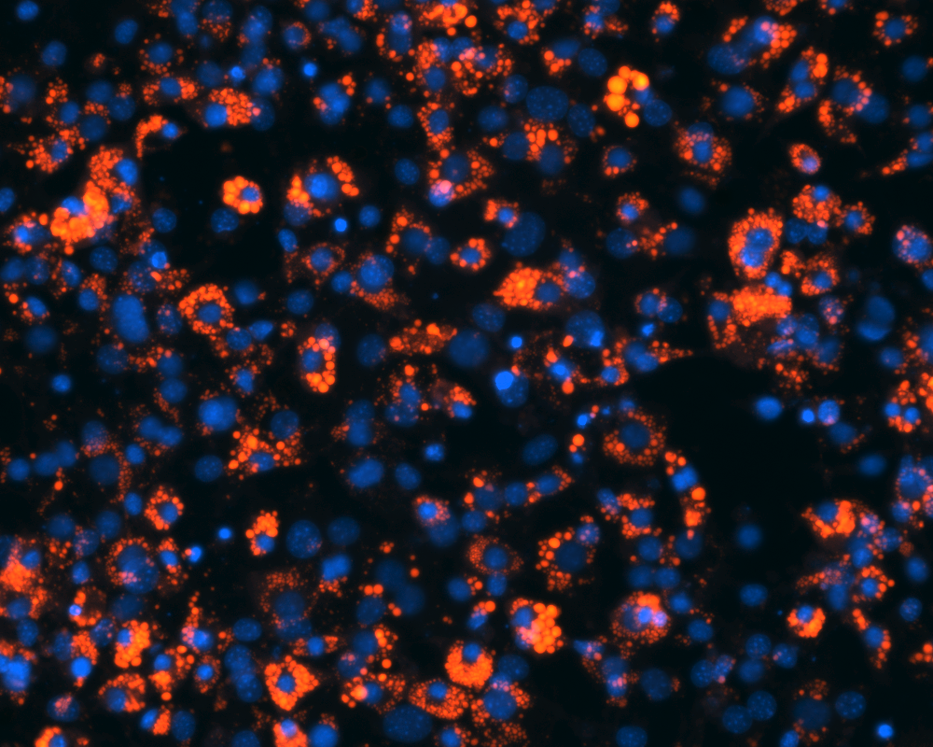

pH 6,5


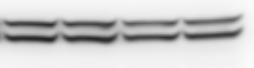
B
HSL
pH 6,5
pH 7,4
pH 7,0
pH 6,7
Erk1/2

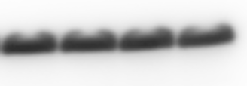
FABP4

Supplementary Figure S4: (A) BODIPY® and DAPI staining of 3T3_L1 preadipocytes cultured for 24h at the indicated pH. Bar=50µm. (B) Western blotting analysis of whole cell lysates of 3T3-L1 preadipocytes cultured for 24h at the indicated pH with specific antibodies to HSL, FABP4 and Erk1/2. The expression of HSL and FABP4 are not modified by acidosis.

Supplementary table S1. List of reagents.
Reagent | Supplier
insulin | Sigma | I6634
dibutyryl cAMP (dbcAMP) | Sigma | D0627
dexamethasone | Sigma | D4902
sodium phospho-ascorbate | Sigma | 49752
heparin | Sigma | H3149
Isobutylmethylxanthine (IBMX) | Sigma | I5879
T3 | Sigma | T6397
Transferrin | Sigma | T8158
rosiglitazone | Sigma | R2408
doxycycline | Sigma | D9891
doxorubicin | Sigma | D1515
bovine serum albumin (BSA) | Sigma | A7030
glycerol standard solution | Sigma | G7793
Atglistatin | Sigma | SML1075
Chloroquine | Sigma | C6628
Human basic FGF | Peprotech | 100-18B
BodipyTM | Thermofisher | D3922
Blasticidin® | Invivogen | Ant-bl-1
G418 | Invivogen | Ant-gn-1
Bafilomycin A1 | Selleckchem | S1413

Supplementary Table S2. List of antibodies.
Primary antibody
Rabbit anti-G0S2 | Reference [21] |  | Western blotting
Rabbit anti-G0S2 | Santa Cruz Biotechnology | # sc-133424 | Western blotting
Goat anti-CGI-58 | Abcam | #ab59488 | Western blotting
Rabbit anti-FSP27 | Abcam | #ab198204 | Western blotting
Rabbit anti-ATGL | Cell signaling Technology | #2439 | Western blotting
Rabbit anti-AKT | Cell signaling Technology | #9272 | Western blotting
Rabbit anti-Phospho-AKT (ser473) | Cell signaling Technology | #9271 | Western blotting
Rabbit anti-HSL | Cell signaling Technology | #4107 | Western blotting
Rabbit anti-FABP4 | Cell signaling technoilogy | #50699 | Western blotting
Rabbit anti-C/EBPalpha | Cell signaling Technology | #8178 | Western blotting
Rabbit anti-Erk1/2 | Sigma | #M5670 | Western blotting
Rabbit anti-NCOR1 | Diagenode | C15410341 | ChIP
Rabbit anti-C/EBPalpha | Diagenode | C15410225 | ChIP
Rabbit ctr IgG | Diagenode | C15410206 | ChIP
Secondary antibody
HRP-conjugated anti-rabbit IgG | Cell signaling Technology | #7074 | Western blotting
HRP-conjugated anti-goat IgG | DAKO | #P0449 | Western blotting

Supplementary Table S3: Oligonucleotides used for QPCR, ChIP measurements and genotyping.
Application | Target | Sequence
qPCR | mATGL | GCC ATG ATG GTG CCC TAT ACT C
qPCR | mATGL | AAC AAG CGG ATG GTG AAG GA
qPCR | mCGI-58 | CGA TCC TGC ATA GAT GGC AAC
qPCR | mCGI-58 | AGG ACT TCG GTC GCA GTG AC
qPCR | mG0S2 | TTC AAG GTG CCA CCG AAT CC
qPCR | mG0S2 | GTC CCA GAC CCC TTA GGT GA
qPCR | mFSP27 | GGA AGC CCC CAT CAG AAC A
qPCR | mFSP27 | GCT TCT GGG AAA GGG CTA GCT
qPCR | m36B4 | AAT CAG ATG AGG ATA TGG GAT TCG
qPCR | m36B4 | GGC TGA CTT GGT TGC TTT GG
ChIP | promoter mG0S2 | GGG AAC CAA CTG GCC AGA A
ChIP | promoter mG0S2 | TGA GCA GGC TGT TGC AAG AT
genotyping | aP2 vector | CAG ACA TGA TAA GAT ACA TTG ATG AGT TTG G
genotyping | aP2 vector | GGT CTG GTC ATG AAG GAA ATG ATC TGG CC

