Impact of column temperature on triacylglycerol regioisomers separation in silver ion liquid chromatography using heptane-based mobile phases

Aleksandra Gorskaª, Nicolò Salgarella^{b}, Raffaele Calaminici^{c}, Emanuele Forte^{c}, Marco Beccaria^{d}, Giorgia Purcaro^{a,∗}

ª Analytical Chemistry Lab, Gembloux Agro-Bio Tech, University of Liège, Gembloux 5030, Belgium
^{b} Department of Agricultural, Forest and Food Sciences, University of Turin, 10124, Italy
^{c} Soremartec Italia srl (Ferrero Group), Alba CN 12051, Italy
^{d} Department of Chemical, Pharmaceutical, and Agricutural Sciences (DOCPAS), Via Luigi Borsari 46, University of Ferrara, 44121 Ferrara, Italy

Keywords: Silver-ion high-performance liquid chromatography (Ag+-HPLC) Triacylglycerols (TAGs) Temperature Regioisomer Acetonitrile (ACN)

Abstract
This work presents the investigation of the use of heptane as an alternative and less toxic mobile phase to the most used hexane for triacylglycerols (TAGs) analysis in silver ion high-performance liquid chromatography (Ag+-HPLC). The impact of column temperature (in the 5 °C-35 °C range) on the retention and resolution of five pairs of regioisomers relevant for the confectionery industry was investigated using a heptane-based mobile phase modified with acetonitrile (ACN). The retention behaviour was compared for a standard TAG mixture and an interesterified cocoa butter. The temperature effect previously observed with hexane-based mobile phases was confirmed for this new system, and it was also observed that the ACN concentration had an important impact on the strength of the temperature effect, with a higher ACN concentration leading to a lesser impact of temperature on the TAGs’ elution behaviour. In general, the study allowed to conclude on the equivalence of hexane and heptane for TAGs regioisomers separation in Ag+-HPLC, independently of the used temperature or the ACN concentration. In addition, the applicability of heptane-based mobile phases for the separation of TAGs regioisomers was demonstrated on three other confectionary fat samples, namely palm olein, interesterified palm olein, and interesterified shea olein.

∗Corresponding author: Gembloux Agro-Bio Tech, University of Liège, Bât. G1 Chimie des agro-biosystèmes, Passage des Déportés 2, 5030 Gembloux, Belgium.
E-mail address: gpurcaro@uliege.be (G. Purcaro).

Introduction

Triacylglycerols (TAGs) are the most abundant molecules in fats and oils, generally composing more than 95% of the total matrix [1]. Their structure consists of a glycerol backbone esterified with three fatty acids (FAs), and the number of possible FAs combinations on the glycerol skeleton confers to TAGs a very large variability. On a theoretical base, the number of total possible TAG isomers is given by n3, where n is the number of different FAs, while the total number is reduced to (n2 + n3)/2 without considering enantiomers, and to (n3 + 3n2 + 2n)/6 without considering isomers [2]. These numbers are in practice reduced according to the biosynthesis preferences [3]. The regioisomeric configuration of TAGs (i.e., how acyl chains are disposed amongst the sn-1(3) and sn-2 positions of TAGs [4]), is of utmost importance in the food industry, particularly in the confectionery industry, since it affects the crystallization and polymorphic properties of fats, impacting the texture and mechanical properties of the final food product. There have been numerous approaches to TAG regioisomers characterization [5,6], with high-performance liquid chromatography (HPLC) techniques being the most effective [3]. Among the different HPLC separation mechanisms, particularly widespread for TAG analysis is silver ion (Ag+) HPLC (Ag+-HPLC), which uses columns coated with immobilized silver cation to form weak and reversible complexes with the π-electrons of the double bonds of eluting analytes. Nevertheless, the elution properties and separation capability of this column are highly affected by not only the mobile phase composition but also the elution temperature [7]. Comparing the two most frequently used mobile phases, namely chlorinated- based and hexane-based, both added with acetonitrile (ACN) as a polar modifier, it has been shown that only the latter provides resolution of the regioisomers [7]. Moreover, although column temperature programming as a control tool for retention times and resolution is rarely used for HPLC, different research groups have studied its potential in the case of Ag+-HPLC, and have shown that temperature changes could have a strong impact in particular on the retention of polyunsaturated TAGs when hexane-based mobile phase is used [7–9]. At present, most of the studies investigating TAGs in Ag⁺-HPLC used a hexane-based mobile phase and investigated different polar modifiers (e.g., proprionitrile and/or butyronitrile) [10–13]. Nevertheless, the attention towards greener analytical chemistry during the last years requires the revision of analytical protocols to minimize or promote the use of more sustainable and less toxic solvents. In this regard, it is desirable to replace hexane with less toxic solvents, such as heptane [14]. It should be stated that both hexane and heptane are toxic. However, hexane is more volatile, can cause peripheral neuropathy, and is more neurotoxic than heptane [15]. Although the stability of the heptane-ACN mixture as a mobile phase for TAG analysis was comparable to hexane-ACN [10], the effect of analysis temperature has never been investigated in this alternative mobile phase.
The aim of this work was, therefore, to investigate the use of heptane in place of hexane and its effect on the temperature- related behaviour in the TAGs elution. The attention is mainly focused on TAGs regioisomers common in the confectionery industry, which have not received much attention previously, and, in particular, on the main TAGs present in cocoa butter, a natural fat of particular relevance because of its unusual and highly valued physical properties and its specific TAG composition [16]. Column temperatures ranging from 5 to 35 °C were tested analysing both a TAG standard mixture and a chemically interesterified (CIE) cocoa butter. Furthermore, the suitability of the heptane-based mobile phase was demonstrated on three other vegetable fats: palm olein, CIE palm olein, and CIE shea olein.

Materials and methods

REAGENTS

n-Heptane, n-hexane, and 2-propanol HiPerSolv CHRO- MANORM® and anhydrous sodium sulphate AnalaR NORMAPUR® were purchased from VWR (United Kingdom). ACN LiChrosolv® was supplied by Merck (Darmstadt, Germany). All TAG standards (steaoryl-oleoyl-steaoryl glycerol [TAG-C54:1 , SOS], steaoryl- steaoryl-oleoyl glycerol [TAG-C54:1 , SSO], palmitoyl-oleoyl-steaoryl glycerol [TAG-C52:1 , POS], palmitoyl-steaoryl-oleoyl glycerol [TAG- C52:1 , PSO], palmitoyl-oleoyl-palmitoyl glycerol [TAG-C50:1 , POP], palmitoyl-palmitoyl-oleoyl glycerol [TAG-C50:1 , PPO], steaoryl- oleoyl-oleoyl glycerol [TAG-C54:2 , SOO], steaoryl-oleoyl-oleoyl glycerol [TAG-C54:2 , OSO], palmitoyl-oleoyl-oleoyl glycerol [TAG- C52:2 , POO], and palmioyl-oleoyl-oleoyl glycerol [TAG-C52:2 , OPO])) were provided by Larodan (Sweden) (P: palmitic acid, C16:0 ; S: stearic acid, C18:0 ; O; oleic acid, C18:1n9c). The palm olein, the CIE cocoa butter, the CIE palm olein, and the CIE shea olein samples were provided by the Soremartec Italia srl company.

SAMPLE PREPARATION

The TAG standards, the CIE cocoa butter, the palm olein, the CIE palm olein, the CIE shea olein samples were first heated until melted and then mechanically homogenized. The TAG standard mix was prepared by adding each TAG standard to n-heptane up to a concentration of 10 mg/kg (total TAG concentration being 100 mg/kg). The CIE cocoa butter, the palm olein, the CIE palm olein, and the CIE shea olein samples were dehydrated with Na2SO4 and filtered through a Buchner funnel. It was then diluted in n-heptane up to a concentration of 5000 mg/kg.

SILVER-ION HPLC-APCI(+)-MS

Silver-ion HPLC–MS experiments were performed on a liquid chromatograph HPLC Ultimate 3000 Agilent (Thermo Fisher Scientific, Milan, Italy) coupled to a linear ion-trap mass analyser LTQ XL (Thermo Fisher Scientific, Milan, Italy) located in the laboratory of Soremartec Italia srl company. Positive-ion APCI was used in the mass range 500–1000 Th with the ionization source heated at 450 °C. The capillary temperature was set at 250 °C, the flow rate of sheath gas and auxiliary gas were set at 35.0 and 15.0 arbitrary units, the capillary voltage was 25.0 V, the source voltage 6.0 kV, and the tube lens 110.0 V. Extracted ion current (EIC) chromatograms of protonated molecules and fragment ions were used to support the identification and data extraction of coeluting peaks. The separation was achieved on a ChromSpher Lipids column (250 mm × 4.6 mm, 5 μm particle size; Agilent Technologies, Italy) in isocratic mode with a mobile phase composed of I) 99.8% (v/v) n-heptane or n-hexane, 0.1% (v/v) 2-propanol, 0.1% (v/v) ACN or II) 99.4% (v/v) n-heptane or n-hexane, 0.3% 2-propanol (v/v) and 0.3% ACN (v/v) and a flow rate of 1 mL/min. The injection volume was 10.0 μL. HPLC experiments were performed in four replicates at column temperatures of 5, 10, 15, 25, 30, and 35 °C for both the standard TAG and cocoa butter sample using the elution I with heptane, while they were performed in triplicate for the comparison of hexane- and heptane-based mobile phases using the standard TAG mixture for the other elution tests, employing either elution I or elution II. The column was conditioned 40 min before each analysis with the same mobile phase and flow, at a column temperature corresponding to one of the following analyses. Blanks (containing n-heptane or n-hexane) were performed following conditioning for each of the given column temperature.

DATA ELABORATION

Data acquisition and analysis were performed using the Thermo Scientific Xcalibur software 4.0. The m/z windows set for the EIC chromatograms were 889.20–890.20 for SOS/SSO, 861.20–
862.20 for POS/PSO, 833.20–834.20 for POP/PPO, 887.20–888.20 for SOO/OSO and 859.20–860.20 for POO/OPO. The studied chromato- graphic parameters for each peak were the retention times (in minutes), the area, the height, the width at 50% height, and the tailing factor (TF) at 10%. The TF was only measured at 5 and 35 °C, and a Student’s t-test was performed on the results. The resolution was calculated between each couple of regioisomers based on their retention times and peak widths at 50%. Additionally, the number of theoretical plates of the column was calculated for each studied temperature [17].

Results and discussion

HEXANE- VS HEPTANE-BASED MOBILE PHASES

A comparison of hexane- and heptane-based mobile phases was performed for the analysis of a standard mixture of TAG regioisomers and using 0.1 or 0.3% ACN. The amount of ACN was 0.1% as for the optimized internal method, while the value of 0.3% was derived from the calculation of the ACN percentage at the elution time of AOA according to the work of Lísa et al. [7] (the value is an estimation due to the unknown dwell volume of the system used). As can be observed in Tables 1, S1 of the supplementary material, Tables 2 and S2, the retention times (RTs) and resolution among the regioisomers at 10 and 30 °C and using 0.1 or 0.3% ACN are relatively alike using hexane or heptane, with resembling chromatograms (Fig. 1). In statistical terms, the difference in RTs appears to be significant (p < 0.05). However, this difference is primarily attributable to the unusually high inter-batch variability (as evidenced by the coeﬃcients of variation of RTs, which range from 15 to 25%, as shown in Table S3 of the supplementary material), despite the relatively low overall intra-batch variability. Since the trials with heptane- and hexane-based mobile phases were conducted on different days, it cannot be excluded that any observed statistical difference is a result of the inter-batch variability rather than a consequence of the change in the mobile phase, which, in any case, guarantee a satisfactory resolution of all the TAGs.
In both types of mobile phases, all TAGs were more retained at 30 °C than at 10 °C, with a temperature effect three times stronger with 0.1% ACN than with 0.3% ACN. Indeed, for 0.1% ACN, on average, the RTs of monounsaturated and diunsaturated TAGs were 58 and 113% higher at 30 °C (than at 10 °C), respectively, while these percentages were of 16 and 36% when 0.3% ACN was used (Tables 1 and S1). No measurements of resolution are reported for the systems using 0.3% of ACN as all regioisomers coeluted.

Table 1
Evolution of retention times between 10 and 30 °C in different solvent systems (ACN: acetonitrile). ∆RT_{10–30} _{°C} = (RT₃₀ _{°C} - RT₁₀ _{°C})/∆RT₁₀ _{°C}. mo.: monounsaturated triacylglycerols; di.: diunsaturated triacylglycerols; SD: standard deviation.

∆RT10–30 °C
 | 0.1% ACN |  |  | 0.3% ACN
 | ∆RT_{10–30} _{°C} Hexane | ∆RT_{10–30} _{°C} Heptane |  | ∆RT_{10–30} _{°C} Hexane | ∆RT_{10–30} _{°C} Heptane
SOS | 61% | 56% |  | 12% | 20%
SSO | 61% | 56% |  | 12% | 19%
POS | 60% | 55% |  | 13% | 22%
PSO | 60% | 56% |  | 13% | 13%
POP | 59% | 54% |  | 14% | 23%
PPO | 59% | 54% |  | 14% | 23%
SOO | 118% | 108% |  | 26% | 39%
OSO | 120% | 107% |  | 30% | 47%
POO | 117% | 107% |  | 26% | 40%
OPO | 118% | 107% |  | 30% | 48%
Mean mo. | 60% | 55% |  | 13% | 20%
SD mo. | 1% | 1% |  | 1% | 4%
Mean di. | 118% | 107% |  | 28% | 44%
SD di. | 1% | 1% |  | 2% | 4%

Table 2
Comparison of the resolution (Res, mean of 3 replicates ± standard deviation) of triacylglycerol regioisomers in hexane- (C6) and heptane- (C7) based mobile phases at different temperatures. ∆Res is calculated as (Res_{C7}-Res_{C6})/Res_{C6}.

 | 0.1% ACN 10 °C |  |  |  | 0.1% ACN 30 °C
 | C6 | C7 | ∆Res |  | C6 | C7 | ∆Res
SOS/SSO | 2.0 ± 0.0 | 1.7 ± 0.1 | −15% |  | 2.7 ± 0.1 | 2.4 ± 0.2 | −10%
POS/PSO | 2.0 ± 0.2 | 1.7 ± 0.1 | −20% |  | 2.8 ± 0.3 | 2.7 ± 0.2 | −4%
POP/PPO | 2.0 ± 0.0 | 1.8 ± 0.2 | −11% |  | 2.6 ± 0.1 | 2.6 ± 0.2 | −2%
SOO/OSO | 2.1 ± 0.2 | 1.8 ± 0.1 | −18% |  | 2.6 ± 0.3 | 2.2 ± 0.2 | −14%
POO/OPO | 2.1 ± 0.0 | 2.0 ± 0.0 | −8% |  | 2.7 ± 0.1 | 2.3 ± 0.3 | −14%

The increase of TAGs’ RT at higher temperatures confirms that changing hexane by heptane in the mobile phase does not sup- press the increased retention behaviour at higher temperatures previously described [7–9]. The mechanisms behind this unusual LC retention behaviour have not yet been fully understood. It has been suggested that the increased TAG retention behaviour could be due to the temperature-dependent stabilities of the silver-ion complexes with unsaturated TAGs and ACN; these two types of complexes being competitively formed during the separation process [8]. More specifically, the hypothesis made by Adlof and List [8] in 2004 was that Ag+-ACN complex could be exothermic and therefore less stable at higher temperatures [8]. This hypothesis is supported by the fact that in pure hexane mobile phases TAGs tend to elute faster at higher temperatures [18].
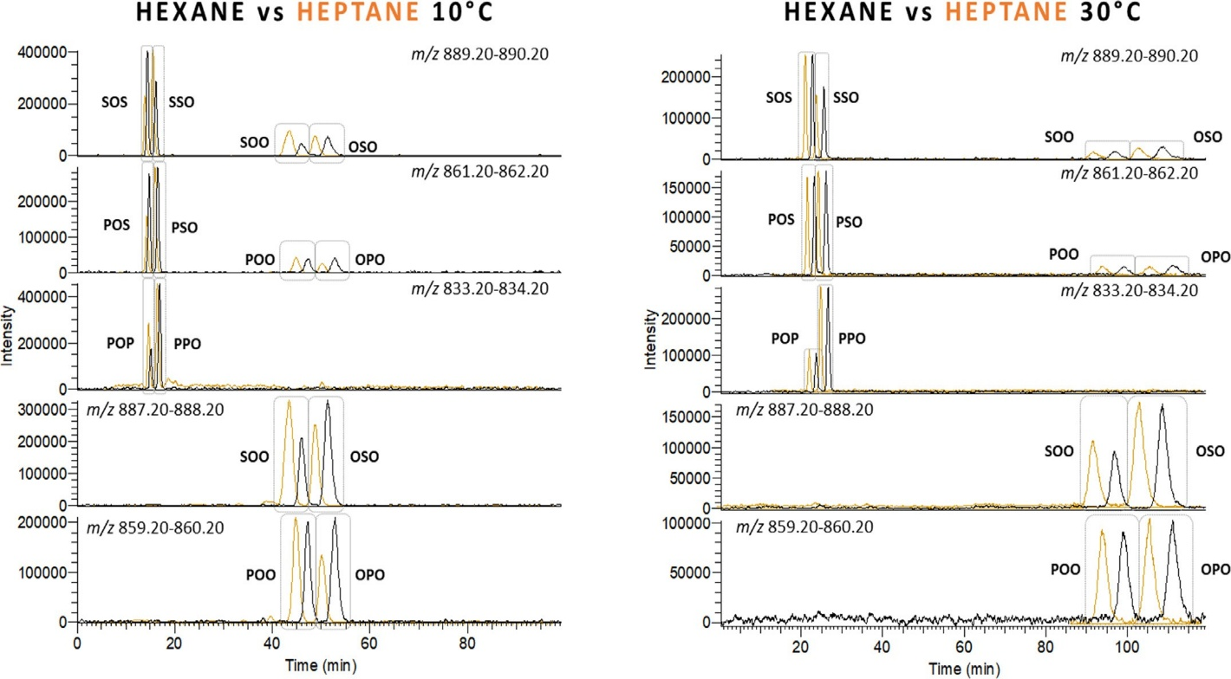
Figure 1: Extracted ions chromatograms of triacylglycerol regioisomers in hexane- (black) and heptane-based (orange) mobile phases (0.1% ACN, 0.1% 2-propanol) at 10 and 30 °C of column temperature.

Furthermore, considering the observations made in this study, particularly the results in Tables 1 and S1, it also appears that the strength of the temperature effect is linked to the concentration of ACN in the mobile phase. The change of RTs is indeed higher between two temperatures when a lower (but not zero) ACN con- centration is used. This could be explained by the chemical equilibria existing between the ACN found in the solvent and the one complexed to the silver ions (ACN ­ ACN-Ag+). When the ACN is present in the solvent at low concentrations and the temperature of the system is increased, the dissociation of the exothermic ACN-Ag+ complex could be more favourable compared to higher ACN concentrations because of the potential antagonistic effect caused by the higher ACN concentration, favouring ACN-Ag+ complex formation (thus disfavouring its dissociation). This would also explain why in the study of Adlof and List [8], when they varied the column temperature from 10 to 30 °C with 1% of ACN in hexane, POP RTs increased by 11%, whereas in our case, the increase was of 60% with a ten times lower ACN concentration (0.1%) and ap- proximately 13% when 0.3% ACN was used.
Because of the similar elution behaviour of TAGs in both hexane- and heptane-based solvents, it is possible to conclude on the equivalence of heptane and hexane for TAG analysis in Ag+- HPLC, which means they can be used interchangeably without significantly impacting the separation behaviour and performances.

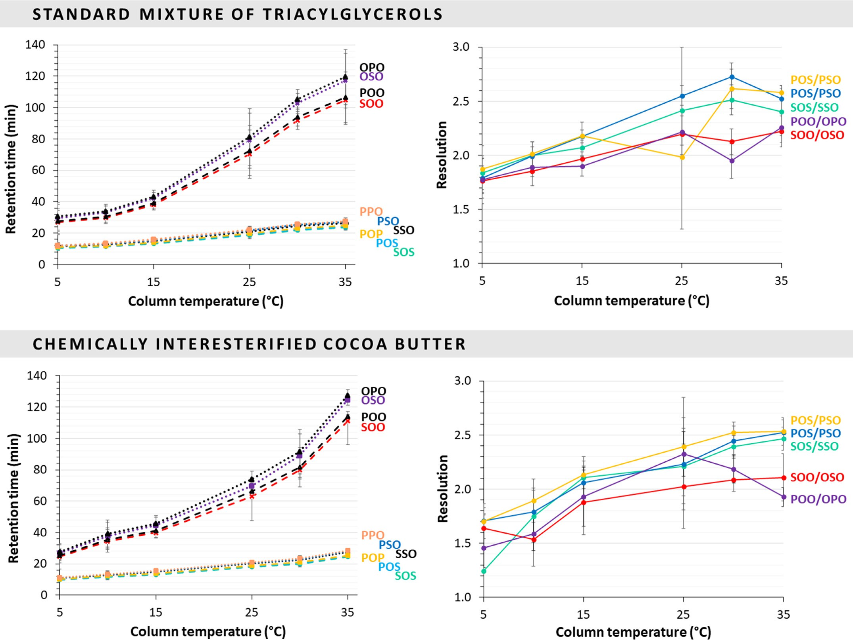
Figure 2: Evolution of retention times and resolution with column temperature for different triacylglycerol regioisomers from a standard mixture and a chemically interesterified cocoa butter sample using a heptane-based mobile phase (0.1% ACN, 0.1% 2-propanol).

EFFECT OF COLUMN TEMPERATURE IN HEPTANE-BASED SOLVENTS

The effect of column temperature on the separation of TAG regioisomers was assessed on a standard mixture of regioisomers and on a CIE cocoa butter sample using heptane-based mobile phase and 0.1% of ACN to assure a satisfactory resolution of all the TAGs of interest. As shown in Fig. 2, the increase in column temperature led to higher TAG RTs in the two studied cases. Diunsaturated TAGs exhibited both higher RTs compared to monounsaturated TAGs and a higher response to temperature change. How- ever, in both types of TAGs, the relationship linking the RT with the temperature resulted exponential, at least in the 5–25 °C temperature range. Indeed, when fitting an exponential model to the mean of the mono- and diunsaturated curves, the obtained R² was 0.998 for both, while it was lower in the case of a linear model (0.985 and 0.949 for mono- and diunsaturated TAGs, respectively).
When it comes to the resolution, the five pairs of regioisomers studied (SOS/SSO, POS/PSO, POP/PPO, SOO/OSO, POO/OPO) were better resolved at 35 °C than at 5 °C for both the standard and cocoa butter samples (Fig. 2 and supplementary Table S4), with an average increase of 41% for monounsaturated TAGs and 29% for diunsaturated TAGs. This increase of resolution at higher temperatures was also confirmed by the work of Lísa et al. for a hexane-based mobile phase [7]. Nevertheless, the stronger analyte- stationary phase interaction at increasing temperature caused an
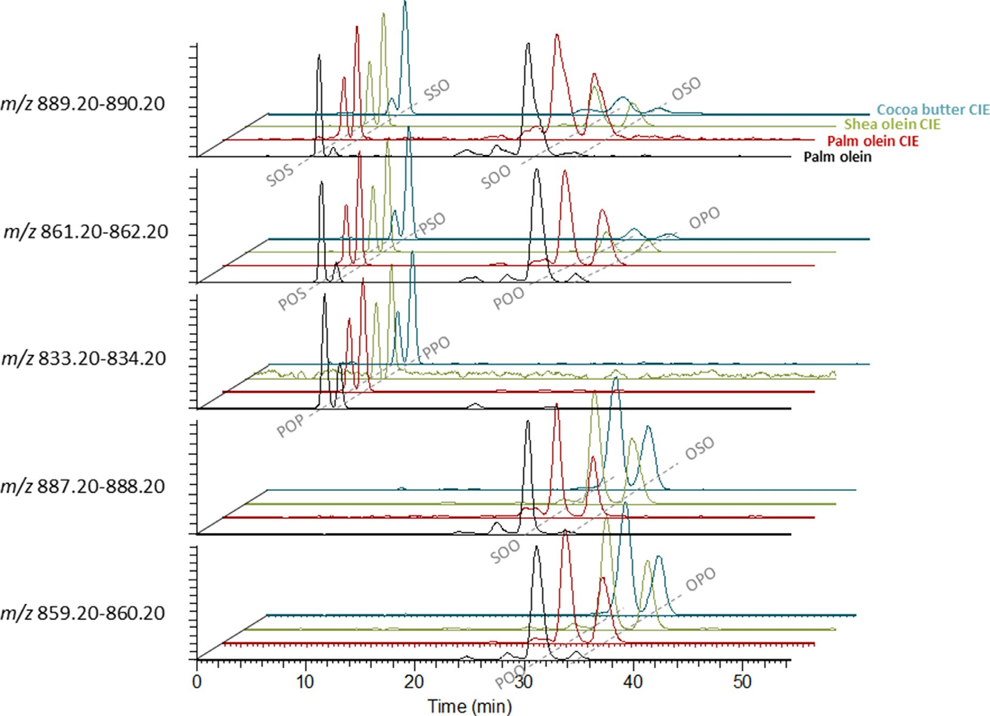
Figure 3: Extracted ion chromatograms of chemically interesterified (CIE) shea olein, CIE palm olein, CIE cocoa butter and palm olein in a heptane-based mobile phase (0.1% ACN, 0.1% 2-propanol) at 10 °C of column temperature. The dashed lines indicate the peaks that are associated to a given TAG.

expected peak broadening that resulted in a reduction of peak height between 5 and 35 °C of 55% (with a standard deviation of 3%) and 79% (with a standard deviation of 2%) for mono- and di- unsaturated TAGs, respectively. Obviously, such decrease of height impacts the sensitivity of the method in a negative way. Then, regarding the number of theoretical plates, the value was of ∼7100 at 35 °C and ∼4600 at 5 °C (Table S5 in the supplementary material). Finally, the TF was calculated at 5 and 35 °C for both samples, and was not significantly different between the two temperatures nor between the two samples (Table S6 of the supplementary material).

ANALYSIS OF OTHER CONFECTIONERY FATS AND OILS

As an illustration of the applicability of the method using heptane-based solvents to other matrices, i.e., three additional confectionary fats containing SOS/SSO, POS/PSO, POP/PPO, SOO/OSO and POO/OPO were analysed, namely CIE shea olein, CIE palm olein and non-interesterified palm olein. All these TAGs eluted in a similar way for the three fat samples, as shown in Fig. 3, and there was no substantial difference between the results obtained using standard mixtures of TAGs and fat samples. Furthermore, the mobile phase composed of heptane with 0.1% ACN and 0.1% 2-propanol proved to be well-suited for the separation of the considered regioisomers in confectionery fat matrices.

Conclusion

The present study investigated the replacement of a hexane- by a heptane-based mobile phase in the context of TAGs analysis by Ag+-HPLC (ChromSpher Lipids column) at different column temperatures. The main focus was on TAGs relevant to the confectionery industry, to which not much attention was previously devoted.
A direct comparison of the results obtained with heptane- and hexane-based mobile phases at different temperatures (10 and 30 °C) and ACN concentrations (0.1 and 0.3%) allowed to conclude on the equivalence of both solvents when it comes to chromato- graphic separation of TAGs, thus supporting the use of heptane as a less toxic mobile phase without affecting the chromatographic performance.
The particular temperature-related behaviour previously observed in hexane-based mobile phases could also be confirmed for heptane-based mobile phases in the present study. In addition, it appeared that the ACN concentration had an influence on the strength of the temperature effect, which was stronger for lower (but not zero) ACN concentrations. What is also interesting is that despite slight differences, probably due to the presence of a low quantity of more polar compounds or to the general poor inter-batch repeatability of the Ag⁺-HPLC system, the interesterified cocoa butter sample showed the same general behaviour as the standard mixture. Other studied confectionery fat samples were also tested at 10 °C of column temperature, and their regioisomers showed to elute similarly than in the two previous samples.
Finally, although an increase in resolution was observed increasing the analysis temperature, it must be underlined that this caused a decrease of the signal intensity due to the peak broadening. Therefore, for the specific TAGs investigated in this study, working at a lower temperature (∼10 °C) allows for a suﬃcient resolution between critical pairs and increased sensitivity of the method.

Declaration of Competing Interest

The authors declare that they have no known competing financial interests or personal relationships that could have appeared to influence the work reported in this paper.

Credit authorship contribution statement

Aleksandra Gorska: Investigation, Validation, Visualization, Formal analysis, Data curation, Writing – original draft, Writing – review & editing. Nicolò Salgarella: Investigation, Validation. Raffaele Calaminici: Conceptualization, Supervision, Project administration. Emanuele Forte: Conceptualization, Supervision, Resources, Funding acquisition, Project administration. Marco Beccaria: Methodology, Writing – review & editing. Giorgia Purcaro: Methodology, Validation, Supervision, Writing – review & editing, Project administration.

Data availability

Data will be made available on request.

Acknowledgments

This article is based upon work from the Sample Preparation Study Group and Network, supported by the Division of Analytical Chemistry of the European Chemical Society.

References

- F. Gunstone, The Chemistry of Oils and Fats: Sources, Composition, Properties and Uses, John Wiley & Sons, 2009.
- Rezanka, T. Triacylglycerol Regioisomers Analysis. AOCS Lipid Library. https:// lipidlibrary.aocs.org/lipid-analysis/lipidomics/triacylglycerol-regioisomers- analysis.
- S. Indelicato, D. Bongiorno, R. Pitonzo, V. Di Stefano, V. Calabrese, S. Indelicato, G. Avellone, Triacylglycerols in edible oils: determination, characterization, quantitation, chemometric approach and evaluation of adulterations, J. Chromatogr. A 1515 (2017) 1–16, doi:10.1016/j.chroma.2017.08.002.
- P.J. Kalo, A. Kemppinen, Regiospecific analysis of TAGs using chromatography, MS, and Chromatography-MS, Eur. J. Lipid Sci. Technol. 114 (4) (2012) 399–411, doi:10.1002/ejlt.201100367.
- G. Dobson, W.W. Christie, B. Nikolova-Damyanova, Silver ion chromatography of lipids and fatty acids, J. Chromatogr. B. Biomed. Sci. App. 671 (1) (1995) 197–222, doi:10.1016/0378-4347(95)00157-E.
- S. Momchilova, B. Nikolova-Damyanova, Regio- and stereospecific analysis of triacylglycerols—a brief overview of the challenges and the achievements, Symmetry (Basel) 14 (2) (2022) 247, doi:10.3390/sym14020247.
- M. Lísa, R. Denev, M. Holčapek, Retention behavior of isomeric triacylglycerols in silver-ion HPLC: effects of mobile phase composition and temperature, J. Sep. Sci. 36 (17) (2013) 2888–2900, doi:10.1002/jssc.201300550.
- R. Adlof, G. List, Analysis of triglyceride isomers by silver-ion high-performance liquid chromatography. Effect of column temperature on retention times, J. Chromatogr. A 1046 (1–2) (2004) 109–113, doi:10.1016/j.chroma.2004.06.012.
- R. Adlof, Analysis of triacylglycerol and fatty acid isomers by low-temperature silver-ion high performance liquid chromatography with acetonitrile in Hexane as Solvent: limitations of the methodology, J. Chromatogr. A 1148 (2) (2007) 256–259, doi:10.1016/j.chroma.2007.03.070.
- R.G. Harfmann, S. Julka, H.J. Cortes, Instability of hexane–acetonitrile mobile phases used for the chromatographic analysis of triacylglycerides, J. Sep. Sci. 31 (6–7) (2008) 915–920, doi:10.1002/jssc.200700578.
- A. Müller, K. Düsterloh, R. Ringseis, K. Eder, H. Steinhart, Development of an alternative eluent system for Ag+-HPLC analysis of conjugated linoleic acid isomers, J. Sep. Sci. 29 (3) (2006) 358–365, doi:10.1002/jssc.200500382.
- L. Mondello, M. Beccaria, P. Donato, F. Cacciola, G. Dugo, P. Dugo, Comprehensive two-dimensional liquid chromatography with evaporative light-scattering detection for the analysis of triacylglycerols in borago oﬃcinalis, J. Sep. Sci. 34 (6) (2011) 688–692, doi:10.1002/jssc.201000843.

- S.M. Momchilova, B.M. Nikolova-Damyanova, Advances in silver ion chromatography for the analysis of fatty acids and triacylglycerols—2001 to 2011, Anal. Sci. 28 (9) (2012) 837–844, doi:10.2116/analsci.28.837.
- K. Alfonsi, J. Colberg, P.J. Dunn, T. Fevig, S. Jennings, T.A. Johnson, H.P. Kleine, C. Knight, M.A. Nagy, D.A. Perry, M. Stefaniak, Green chemistry tools to influence a medicinal chemistry and research chemistry based organisation, Green Chem. 10 (1) (2008) 31–36, doi:10.1039/B711717E.
- O. Buddrick, O.A.H. Jones, P.D. Morrison, D.M. Small, Heptane as a less toxic option than hexane for the separation of vitamin e from food products using normal phase HPLC, RSC Adv. 3 (46) (2013) 24063–24068, doi:10.1039/ C3RA44442B.
- V. Santoro, F. Dal Bello, R. Aigotti, D. Gastaldi, F. Romaniello, E. Forte, M. Magni, C. Baiocchi, C. Medana, Characterization and determination of interesterification markers (triacylglycerol regioisomers) in confectionery oils by liquid chromatography-mass spectrometry, Foods 7 (2) (2018) 23, doi:10.3390/ foods7020023.
- J. Cazes, R.P.W. Scott, Chromatography Theory, CRC Press, Boca Raton, 2002, doi:10.1201/9780367800543.
- W.W. Christie, X. Han, Lipid Analysis: Isolation, Separation, Identification and Lipidomic Analysis, Elsevier, 2010.

