Continuous flow hydrothermal synthesis of zeolite LTA in intensified
reactor. Experimental and multiphysics CFD modelling approach.
Sher Ahmad^{a,c*}, Lilia Ben Mustapha^{b}, Sébastien Calvo^{a*}, François Collignon^{b}, Antony E. Fernandes^{b*}, and Dominique Toyeª
ª Department of Chemical Engineering / PEPs, University of Liège, Allée de la Chimie 3, 4000 Liège, Belgium. E-mail: scalvo@uliege.be
^{b} Certech, rue Jules Bordet 45, 7180 Seneffe, Belgium. E-mail: antony.fernandes@certech.be
^{c} School of Chemical and Materials Engineering (SCME), National University of Science and Technology, Sector H-12, Islamabad, Pakistan. E-mail: sher.ahmad@scme.nust.edu.pk

Abstract
Zeolites are conventionally synthesized in batch-wise hydrothermal processes that usually take several hours or days to complete. In current research work, continuous flow process is developed on pilot scale for the hydrothermal synthesis of zeolite LTA. The pilot reactor was able to produce highly crystalline zeolite nanoparticles without any clogging, which often encounters for particle flow in tubular reactors. Steady-state zeolite production rates of 55-80 g⋅h⁻¹ (dry basis) were achieved with a residence time below 10 minutes, with corresponding space time yields (STY) between ca. 700 and 1100 g⋅L⁻¹⋅h⁻¹. A couple CFD model with a population balance model was developed to investigate the continuous flow hydrothermal process. The average particle size obtained from the model was in good agreement with the experimental data. The model was further applied to study the effects of critical parameters, such as temperature and flow rate, to highlight potential process optimization directions.
Keywords: hydrothermal synthesis, zeolites, process intensification, crystallization, population balance modelling, computational fluid dynamics.

Introduction
Process intensification (PI) is among the most progressing area in chemical engineering research due to its high demand for the sustainable future of chemical process industry [1]. PI is termed as any development in chemical engineering that results in compact, environmental friendly, safer and energy efficient technology [1-2]. One major aspect of PI is the development of continuous flow technologies (CF) both at micro/milli-scale [3], and larger scale [4] to replace conventional batch processes. One such application is hydrothermal synthesis of inorganic materials which usually carried out in batch type reactors. During this process, the materials (precursors) precipitate from aqueous alkaline solutions at high temperature and pressure [5]. Following heating, nucleation, crystal growth, breakage and agglomeration occur simultaneously, resulting in fine microstructure crystals [5]. However, batch reactors depict several drawbacks for application in hydrothermal synthesis such as long operation, maintenance times and non-uniform heat and mass transfer that can lead to uncontrolled crystallinity and particle size distribution [6]. In contrast, continuous flow reactors have shown several advantages such as enhanced heat and mass transfers, precise control of process parameters and consistent product quality [7]. Aside from these advantages, continuous flow processes can straightforwardly be scaled up and thus fulfil many of the ideals of green chemistry [8].
Although many zeolites occur naturally as minerals, a great variety of synthetic zeolites have been reported and have found applications in catalysts [9], detections [10], membrane separations [12] etc.
Significant efforts have recently been made to develop continuous flow processes for zeolite synthesis. For example, Cundy et al. [13] reported a semi-continuous system for the synthesis of zeolites ZSM-5 crystals. However they observed slow crystallization kinetics and hence long residence time. Similarly in another study [14], Liu and co. developed a fast heating tubular reactor and achieved the synthesis of microporous silicates crystals in 1 minute. Similarly, Liu et al. [15] successfully synthesized high-silica zeolites in 10 minutes in a continuous flow tubular reactor using an hot oil bath as the heating media. Later, Liu et al. [16] also synthesized ZSM-5 zeolites in a continuous flow reactor with a residence time on the order of seconds.
Despite recent interest and progress, efforts to develop efficient, safe, sustainable, reliable, and scalable continuous processes for hydrothermal synthesis are still necessary. More often, the development of such processes that imply the manipulation of solids in micro/meso-fluidic reactors is hampered by the fouling and clogging of the reactor channels [13].
In crystallization, product quality and hence properties are closed linked to average particle size and particle size distribution (PSD). While most research has focused on improving experimental methods or reactor types, there are few research studies on mathematical modelling of zeolite synthesis mainly in batch processes. For example, Thompson and Dyer [17] applied population balance model (PBM) for the hydrothermal synthesis of zeolite particles in batch process. In other studies, mathematical models were developed based on the experimental data to predict the nucleation and growth rates of zeolite synthesis in batch processes [14-15]. However, in order to model the synthesis of zeolite in continuous flow reactors, it is important to simultaneously study reaction kinetics and heat and mass transfer. To this end, coupled CFD models with population balance have successfully been implemented for the investigation of multiphase flow both at lab scale and industrial scale [19-23].
We report here the development of a pilot scale continuous flow reactor for the efficient hydrothermal synthesis of zeolite A (also known as zeolite LTA). A CFD model coupled with a population balance model, fed with experimental data, was also developed in order to better understand the interconnected transport phenomena occurring simultaneously within the reactor, for process optimization and design based scale up of the process.

Materials and methods

Continuous flow synthesis of zeolite LTA
The flow reactor (Fig. 1) consists of a flexible stainless-steel double tube heat exchanger (L= 6 m; OD = 3/8”) wherein a PFA tubing (OD = 6 mm, ID = 4 mm) was inserted (inner tube) to limit fouling and clogging. A progressing cavity pump was used to feed the zeolite precursor solution into the PFA tube. A dosing pump allowed the injection of water for cooling and diluting the reaction mixture at the outlet of the reactor. The outer tube of the exchanger (thermoregulation tube) was connected to a circulation thermostat. The pressure in the reactor tube was controlled by an electropneumatic back-pressure regulator. Different temperature and pressure sensors were installed to continuously monitor temperature and pressure of the process, as indicated in Fig. 1.
The zeolite LTA precursor solution is the mixture of aluminate and silicate solutions prepared in caustic solution. For this purpose, caustic solution was prepared by adding 26.4 g of sodium hydroxide (Acros Organics, 98%) in 650 mL deionized water. Then the caustic solution was transferred to two polypropylene bottles (equal volume). Then aluminate and the silicate solutions were prepared by adding 54.04 g of sodium aluminate (Sigma-Aldrich, technical grade, anhydrous)) and 65.86 g of sodium metasilicate (Sigma-Aldrich, 49.5-52.5% Na₂O)) to each half of the caustic solution at room temperature, respectively. Afterwards, the silicate and the aluminate solution were mixed together and stirred at 900 rpm for 1 hour. The prepared mixture (continuously stirred at 400 rpm), referred as the zeolite precursor solution, was pumped (8-12 mL⋅min⁻¹) at ambient temperature into the inner tube of the reactor and heated by flowing thermal fluid (130°C, 20 L⋅min⁻¹) into the outer tube in counter current. Water was injected at the reactor exit to rapidly cool the reaction mixture.
Samples were periodically taken for each 10 minutes for analysis. The samples were washed with deionized water and centrifuged (4000 rpm, 5 min) (5 times) and finally dried (70°C, overnight) before analysis.
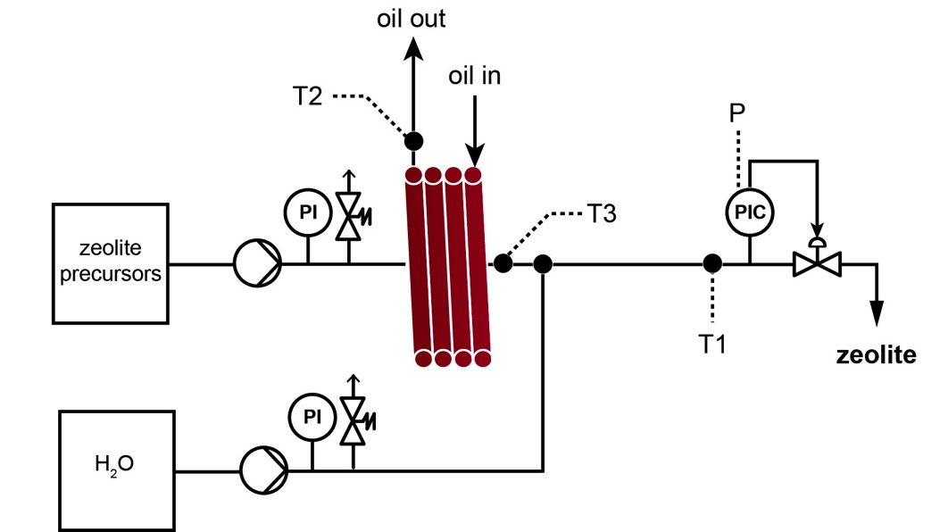
Fig. 1. Illustration of the intensified reactor designed for the continuous flow synthesis of zeolite LTA.

Characterization
Viscosity measurements of the zeolite precursor solution were performed on ARES equipment from Rheometrics Scientific in a parallel-plate geometry, with an upper disc diameter of 40 mm. To avoid the flowing of the suspension, the lower plate was a cup with a diameter of 42 mm. The dynamic test was done at a frequency of 10 rad⋅s⁻¹ at 30°C.
The crystallinity of the zeolite particles were measured by X-ray diffraction (XRD) with a D2 phaser diffractometer from Bruker. The lattice constant “a” (= b = c) of the cubic structure of LTA zeolites was calculated from the interplanar spacing (d_{hkl} calculated from the Bragg’s equation) and from the value of Miller indices of the crystal planes of LTA zeolite (h, k and l) [20] using Eq (1):
$$\begin{aligned}\frac{1}{d_{hkl}^{2}}=\left(\frac{h^{2}}{a^{2}}+\frac{k^{2}}{b^{2}}+\frac{l^{2}}{c^{2}}\right)=\frac{1}{a^{2}}\left(h^{2}+k^{2}+l^{2}\right) \#\left(1\right)\end{aligned}$$
The Size-Strain Plot (SSP) method was used for the determination of the average crystallite diameters (d_{SSP}) of LTA zeolite [21].
Similarly, Beckman Coulter LS 13 320 laser diffraction analyzer was used to experimental measured the Particle size distribution (PSD) of the zeolite particles.
SEM images were obtained on MAIA3 instrument from TESCAN. The sample were observed by low-vacuum scanning electron microscopy (LV-SEM). Imaging was performed in secondary electron mode, with topographic contrast. A specific electron detector, adapted to LV mode, was used. In this mode, sample charging is compensated by a nitrogen partial pressure in the SEM chamber, and sample coating prior to observation is not required.

Modelling and Simulation
Hydrothermal zeolite synthesis is a multiphase crystallization process which involves two phases, i-e; liquid phase (gel solution) as well as solid phase (amorphous and crystalline). Modelling of such a complex system implies the coupling of different processes simultaneously such as heat transfer, mass transfer from one phase to another, reaction kinetics (nucleation and crystal growth) and fluid dynamics. Here in, two distinct phases (continuous liquid phase (gel) and the dispersed solid phase (zeolite) were separately studied using modelling equations for each phase. The mass transfer within the phases is interlinked by the crystals nucleation, growth and dissolution, etc. The modelling strategy, further summarized in Fig. 2, was performed assuming the following assumptions:
- Crystallization rate of zeolite particles was only liquid phase concentration and temperature dependent.
- Only nucleation and growth rates were considered without any agglomeration and breakage of the particles.
- particles are assumed to be flowing with the gel solution (homogenous slurry is considered)
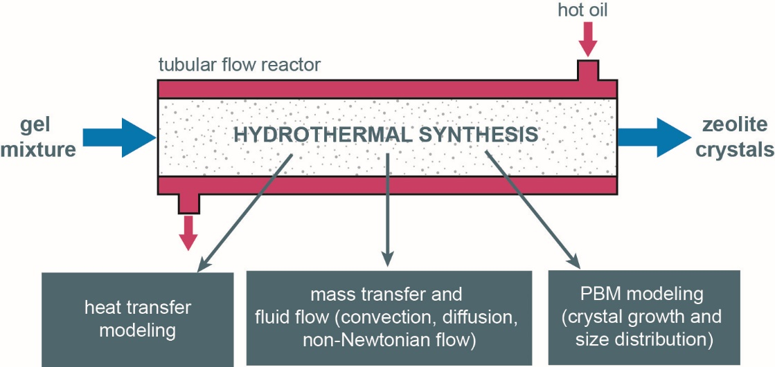
Fig. 2. Main strategies used for modeling the continuous flow hydrothermal synthesis of zeolites.

Fluid flow and heat transfer modelling
The simulation of the flow field in a continuous flow reactor is governed by continuity and Navier-Stokes equations (Eq (2) and (3)).
$$\begin{aligned}{ ρ}_{i} \left(u_{i}.∇\right)u_{i}=∇.\left[-P_{i}+μ_{i}\left(∇u_{i}\right)\right] \#\left(2\right)\end{aligned}$$
$$\begin{aligned}{ ρ}_{i} ∇.u_{i}=0 \#\left(3\right)\end{aligned}$$
Where i represents the zeolite precursor solution or the heat transfer fluid, u denotes linear velocity (m⋅s⁻¹), $μ$ is the dynamic viscosity of the solution (kg⋅m⁻¹⋅s⁻¹), $ρ$ is the density (kg⋅m⁻³), P is the operating pressure (Pa).
Stokes number (St), which expresses the ratio between particle and flow characteristic time, is useful to determine the particle behavior within the flowing fluid.
$$\frac{τ_{p}u_{i}}{D}=\frac{ρ_{zeolite}d_{zeolite}u_{i}}{18µD} (4)$$
Stokes number calculated for the particle range 0.1-5 µm was on the order of 10⁻⁶-10⁻⁵, which confirmed that the particles followed the flow and that no sedimentation occurred within the reactor, unless agglomeration of particles is to be considered. From the experimental data plot of shear stress and strain rate, it was observed that zeolite precursor (gel) solution showed pseudo plastic behavior, obeying power law for viscosity with an n value of -1. In order to compute velocity profiles within both tubes, Eq (2) and (3) were numerically solved in COMSOL Multiphysics. Heat balance equation was applied for the tube-in-tube heat exchanger: hot oil (T: 403 K) flew in the outer tube (ID: 10 mm) while the zeolite precursor solution (feed) (T=300 K) flew in the inner tube (ID: 4 mm)
Transient heat balance shown in Eq (5) was solved for the temperature gradients in axial and radial directions. For this purpose, 2D axisymmetric geometry was considered.
$$\begin{aligned}\frac{dT_{oil}}{dt}+ρ_{oil}{Cp}_{oil}Q_{oil}{∇T}_{oil}=k_{PFA}{∇T}_{PFA}+k_{steel}{∇T}_{steel}+\frac{dT_{f}}{dt}+ρ_{f}{Cp}_{f}Q_{f}{∇T}_{f} \\ +{(m}_{z}{/M_{z})∆H}_{cryst.}\#\left(5\right)\end{aligned}$$

Zeolite synthesis and reaction kinetics
To understand the mechanism dissolution of zeolite precursors to produce zeolite particles. It is important to understand the reaction kinetics which includes nucleation, crystal growth agglomeration and breakage. Due to complex transport phenomena occurring simultaneously in different domains and therefore it becomes challenging to study all the parameters together. Perhaps this is one of the reason that although the understanding of the nucleation mechanisms in microporous systems are of primary importance for the engineering and production of valuable industrial materials, several fundamental issues are still a matter of debate.
One dimensional PBM applied to this system is shown in equation (6) that accounts only for particle nucleation and growth and does not consider aggregation and breakage of the particles.
$$\begin{aligned}\frac{∂n\left(x,L,t\right)}{∂t}+ \frac{∂(u_{x} n(x,L,t)}{∂x}+\frac{∂[Q\left(L,t,x\right)*n\left(L, t,x\right)]}{∂x}=B\left(t,x\right) \#\left(6\right)\end{aligned}$$
This equation describes the change in the population density of particles, n, based on particle size (L), a given reactor length x, at time t. The first term is related to the change of population density over time, the second term is the advective term, the third term accounts for the growth rate and the term on the right describes the nucleation of new particles. Q and B are respectively the particle growth and nucleation rates, these are explained in detail below. To simplify the resolution of this partial differential equation, a discretization technique was applied. Equation (6) is transformed into a set of ordinary differential equations moments (Equation 8-11); moments of distribution is defined according to equation (7).
$$\begin{aligned}m_{i}=\int_{0}^{∞}{L^{i}\left[{dN\left(L,t\right)}/{dL}\right]dL} \#\left(7\right)\end{aligned}$$
$$\begin{aligned}\frac{dm_{0}}{dt_{c}}+\frac{dm_{0}}{dx}u_{x} =B \#\left(8\right)\end{aligned}$$
$$\begin{aligned} \frac{dm_{1}}{dt_{c}}+\frac{dm_{1}}{dx}u_{x}=Qm_{o} \#\left(9\right)\end{aligned}$$
$$\begin{aligned} \frac{dm_{2}}{dt_{c}}+\frac{dm_{2}}{dx}u_{x}=2Qm_{1} \#\left(10\right)\end{aligned}$$
$$\begin{aligned} \frac{dm_{3}}{dt_{c}}+\frac{dm_{3}}{dx}u_{x}=3Qm_{2} \#\left(11\right)\end{aligned}$$
Where $m_{i}$(i = 0, 1, 2 and 3) are the moments of particle size distribution at the crystallization time t, defined according to Eq. (7). $u_{x}$ is the linear velocity (m⋅s⁻¹) computed from Navier-Stokes equations (Eq. 2 and 3).
The practical meaning of moments is that zeroth, first, second and third moments correspond to number, length, surface area and volume of the particle, respectively. These first four moments are important to construct particle size distribution curves and to study the behavior of different factors affecting the zeolite synthesis.
Nucleation and crystal growth rates were estimated from the correlations obtained from experimental particle size distribution and linear crystal growth using the methods described by Zhdanov and Samulevich [22]–[25].
$$\begin{aligned}B=\frac{dN}{{dt}_{c}}=\overline{N}m_{tot}\sum_{i=1}^{p}{f_{i}}k_{i}n_{i}{\left(t_{c}\right)}^{\left(n_{i}-1\right)}exp\left[-k_{i}{\left(t_{c}\right)}^{n_{i}}\right] \#\left(12\right)\end{aligned}$$
Where $\overline{N}$ is the specific number of nuclei released from the mass of gel needed for the crystallization of a unit mass of zeolite, $m_{tot}$ is the total mass of the crystals formed, fi, ki, ni are the parameters obtained by non-linear regression of experimental plots of nucleation rates, and $t_{c}$ is the crystallization time.
$\overline{N}$ (kg⁻¹) was calculated from the experimental particle size distributions as:
$$\begin{aligned}\overline{N}={\sum{N_{i}}}/{Gρ_{zeolite}\sum{N_{i}{{(L}_{i})}^{3}}} \#\left(13\right)\end{aligned}$$
Crystal growth rate was calculated from the following relation [22]–[25]:
$$\begin{aligned}Q=\frac{dL}{{dt}_{c}}=K_{g}=k_{g}{[C}_{Al}-C_{{Al}_{sat}}]{[C}_{Si}-C_{{Si}_{sat}}] \#\left(14\right)\end{aligned}$$
$$\begin{aligned}\ln{K_{g}=\ln\left(A\right)}+\frac{E_{a}}{RT} \#\left(15\right)\end{aligned}$$
Where Q is the crystal growth rate (m⋅s⁻¹); $K_{g}$ is the temperature-dependent linear crystal growth rate (m⋅s⁻¹) obtained from experimental data; $k_{g}$ is the crystal growth rate constant (mL²⋅s⁻¹⋅mol²); $C_{Al}$(mol⋅L⁻¹) is the aluminum concentration inside the reactor at any time t; $C_{Si}$ (mol⋅L⁻¹) is the silicon concentration inside the reactor at any time t; ${C_{{Si}_{sat}} and C}_{{Al}_{sat}}$ (mol⋅L⁻¹) are the silicon and aluminum saturation concentration obtained from the experimental data[26].
The mass of formed crystals was computed from Eq. (16):
$$\begin{aligned}m_{z}=Gρ_{zeolite}\int_{0}^{∞}{L^{3}\left[\frac{dN\left(L,t\right)}{dL}\right]}=Gρm_{3} \#\left(16\right)\end{aligned}$$
Where, $m_{z}$ is the mass of the crystals (kg) and G is the shape factor; for this study, spherical particles were considered ( G= 1). $ρ_{SiO2}$ is the density of silica (kg⋅m⁻³), L is the particle size (m), N is the number of particles, $m_{3}$ is 3rd moment (related to the volume of particles).
Changes in aluminum and silicon concentrations during crystallization process are simulated by Eq. (17) by applying the mass balance for aluminum and silicon in the zeolite precursor solution.
$$\begin{aligned}\frac{{dC}_{i}}{{dt}_{c}}+\frac{dC_{i}}{dx}u_{x}+D_{i}\frac{d^{2}C_{i}}{{dx}^{2}}={ρ_{zeolite}*R}_{i} \#\left(17\right)\end{aligned}$$
$${R_{i}=a}_{x}\left(\frac{{dm}_{G}}{{dt}_{c}}\right)-b_{x}\left(\frac{{dm}_{z}}{{dt}_{c}}\right) (18)$$
Where C_{i} corresponds to Si or Al concentration (mol⋅m⁻³), $x$ represents the length of the reactor, R_{i} is the rate of zeolite formation (mol⋅m⁻³⋅s⁻¹), $u_{x}$ (m⋅s⁻¹) is the linear velocity in axial direction of the gel, m_{z} and $m_{G}$ are the mass of the of crystalline zeolite and amorphous aluminosilicate (kg) respectively, $a_{x}$ and $b_{x}$ are constants for amorphous and crystalline aluminosilicates, respectively; their values are given in Table 1. Ri is the reaction rate (mol⋅m⁻³⋅s⁻¹).
Due to the rapid dissolution of amorphous aluminosilicates at initial time, the first term on the left side of Eq. (18) can be ignored. $D_{Al/Si}$ is the effective diffusion of aluminium/silicon in water:
$$\begin{aligned}D_{Al/Si}=\frac{K_{B}T}{8πr^{3}μ_{H_{2}O}} \#\left(19\right)\end{aligned}$$
Where K_{B} is the Boltzmann’s constant (J⋅K⁻¹), T is the absolute temperature (K) and r is the radius of the silica aluminate particle (m). The radius is obtained from the spherical volume equivalent of the molecular cell. Inserting B and Q, the set of moments were coupled with transport equations and solved numerically using COMSOL Multiphysics® 5.6 with MATLAB® 19.

Table 1. Modelling and Simulation parameters
Symbols | Value | Unit | Description
d_{i} | 4 x 10⁻³ | [m] | Pipe inner diameter
d_{ext} | 6 x 10⁻³ | [m] | Pipe outer diameter
L_{tube} | 6 | [m] | Reactor length
Q_{oil} | 3.75 x 10⁻⁴ | [m³⋅s⁻¹] | Oil flow rate
cp_{oil} | 2.567 x 10³ | [J⋅kg⁻¹⋅K⁻¹] | Oil heat capacity (Mobiltherm® 605)
$ρ_{oil}$ | 8.74 x 10² | [kg⋅m⁻³] | Oil density (Mobiltherm® 605)
µ_{oil} | 4.3 x 10⁻³ | [Pa⋅s] | Oil viscosity (Mobiltherm® 605)
K_{g} | 4.47 x 10⁻⁹ | [m⋅s⁻¹] | Linear crystal growth (experimentally determined)
$\overline{N}$ | 7.85 x 10¹⁵ | [kg⁻¹] | Crystal Specific number (experimentally determined)
k_{i} | 8.6 x 10⁻⁶ | [-] | Kinetic parameters of nucleation rate [23]
f_{i} | 3 x 10⁻¹ | [-] | Kinetic parameters of nucleation rate [23]
n_{i} | 1 x 10⁻¹ | [-] | Kinetic parameters of nucleation rate [23]
K_{PFA} | 2.09 x 10⁻¹ | [W⋅m⁻¹⋅K⁻¹] | PFA thermal conductivity
K_{steel} | 17 | [W⋅m⁻¹⋅K⁻¹] | Steel thermal conductivity
M_{z} | 3.65 x 10⁻¹ | [kg⋅mol⁻¹] | Zeolite molecular weight [23]
P_{i} | 3 x 10⁵ | [Pa] | Operating pressure
a_{x}, b_{x} | 5.48 | [mol⋅kg⁻¹] | Constant (2/Mz)
K_{oil} | 1.19 x 10⁻¹ | [W⋅m⁻¹⋅K⁻¹] | Oil thermal conductivity (Mobiltherm® 605)
ρ_{zeolite} | 2.2 x 10³ | [kg⋅m⁻³] | Density of the zeolite
E_{A} | 68 | [kJ⋅mol⁻¹] | Activation energy of zeolite LTA

Results and discussion

Continuous flow synthesis of zeolite LTA
The description of the pilot flow reactor used for the hydrothermal synthesis of zeolite LTA is given in section 2.1 (Fig. 1). Different experimental conditions were tested (Table 2); for each test, samples were periodically taken, washed, dried and analyzed.

Table 2. Experimental conditions used for the continuous flow synthesis of zeolite LTA.
Entry/zeolite sample | Precursor solution  mL⋅min⁻¹ | Water  mL⋅min⁻¹ | Residence time  min | SSPR^{(a)}  g⋅h⁻¹ | STY^{(b)}  g⋅L⁻¹⋅h⁻¹ | Yield of zeolite (%)^{(c)}
1 / LTA1 | 8 | 0 | 9.4 | 0 | 0 | 0
2 / LTA2 | 8 | 16 | 9.4 | 54 | 722 | 61
3 / LTA3 | 8 | 8 | 9.4 | 56 | 750 | 63
4 / LTA4 | 8 | 4 | 9.4 | 58 | 777 | 62
5 / LTA5 | 12 | 0 | 6.3 | 0 | 0 | 0
6 / LTA6 | 12 | 12 | 6.3 | 86 | 1146 | 61
(a) Steady-state production rate; (b) space-time yield; (c) at steady state.

It was observed that the water injected at the outlet of the tube-in-tube reactor to cool and dilute the reaction mixture (Fig. 1) was essential to avoid the hydrodynamic failure of the process due to zeolite precipitation. Without this additional input (Table 2, Entries 1,5), the process was rapidly stopped due to clogging and overpressure in the reactor. While this downstream dilution and cooling was indispensable, the water flow rate (4-16 mL⋅min⁻¹) had little influence on the efficiency of the process, and steady-state production rates (SSPR) of ca. 50-60 g⋅h⁻¹ of dry zeolite could be recorded (Table 2, Entries 2-4). Yields of zeolite – calculated as the ratio of the weight flow of isolated dry zeolite to the weight flow of Na₂Al₂O₄ and Na₂SiO₃ in the initial gel at steady state – were about 60%, regardless of the residence time in the reactor and the precursor gel/dilution water ratio.

Fig. 3 shows a typical monitoring (temperatures T1-3 and pressure P, see Fig. 1) of the flow process, depicting the stability of the system under operation.
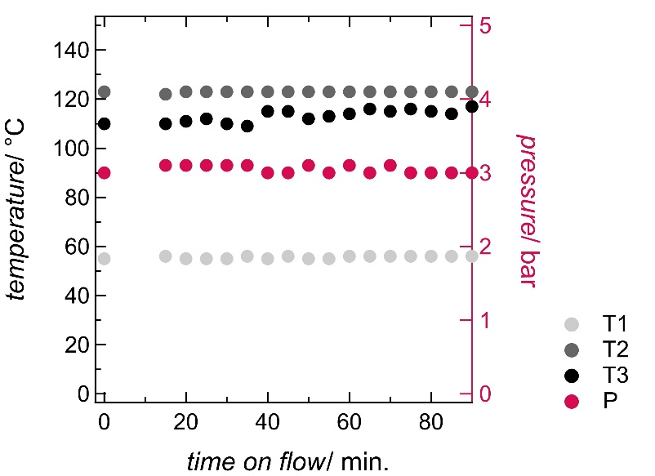

Fig. 3. Typical monitoring of the flow hydrothermal synthesis of zeolite LTA. Gel flow rate: 8 mL/min, Gel/water= 0.5.
Increasing the flow rate of the precursor solution up to 12 mL⋅min⁻¹ allowed to reach an SSPR of 86 g⋅h⁻¹ of dry zeolite LTA (Table 2, Entry 6). Given a reactor volume of ca. 75 mL, space-time yields (STY) of up to 1146 g⋅L⁻¹⋅h⁻¹ (dry zeolite) could be attained (Table 2). This production rate is significantly higher than values typically obtained in a batch reactor (100-200 g_{z}⋅L_{r}⁻¹⋅h⁻¹) since in batch reactor, operating times for heating and cooling severely impact the production rate and yield. In comparison, Liu et al. [16] previously synthesized ZSM-5 zeolite crystals in continuous flow reactor with a STY of 690 g⋅L⁻¹⋅h⁻¹ with a productivity of only ca. 11 g⋅h⁻¹, with a reactor operated at much higher temperature (260°C) and pressure (240 bar) [16].

Continuous production of zeolite LTA as a function of time is presented in Fig. 4. Although the water flow rate at the output of the reactor had little influence on the SSPR (vide supra), it was observed that decreasing the dilution (i..e., decreasing the water/gel flow rate ratio) allowed to reach the steady state more rapidly. When the gel flow rate was kept at 8 mL⋅min⁻¹, the steady-state production rate of 55 g⋅h⁻¹ was achieved in ca. 30 minutes for gel/H₂O ratio of 1-2; as the gel/H₂O ratio decreased to 0.5, the SSPR is achieved in ca. 60 minutes.

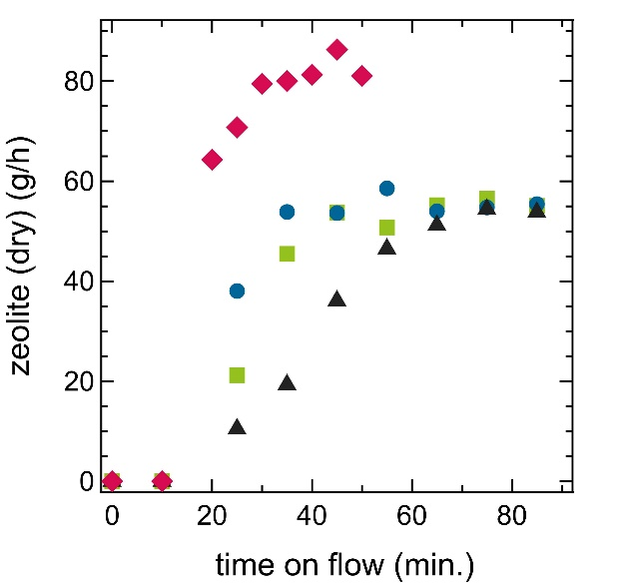
Fig. 4. Continuous production of zeolite LTA for different residence times and gel/H₂O ratios. Black triangle: res. time 9.4 min, Gel/H₂O = 0.5; Green square: res. time 9.4 min, Gel/H₂O = 1; Blue dot: res. time 9.4 min, Gel/H₂O = 2; Red diamond: res. time 6.3 min, Gel/H₂O = 1.

Characterization of synthesized zeolites
Fig. 5 displays images obtained by electronic microscopy (SEM) of zeolite samples synthesized in the flow reactor, transitioning from amorphous to regular crystals as the reactor reaches equilibrium. At steady-state, population of cubic-shaped crystallites (typical for zeolite LTA) and a quasi-absence of irregular particles are observed. Particles size vary from ca. 0.5 to 2 µm, with a majority of particle having a quasi-homogeneous size below 1 µm. This apparent homogenous particle range is typical of a continuous process where crystallization occurs more homogeneously compared to a batch process.

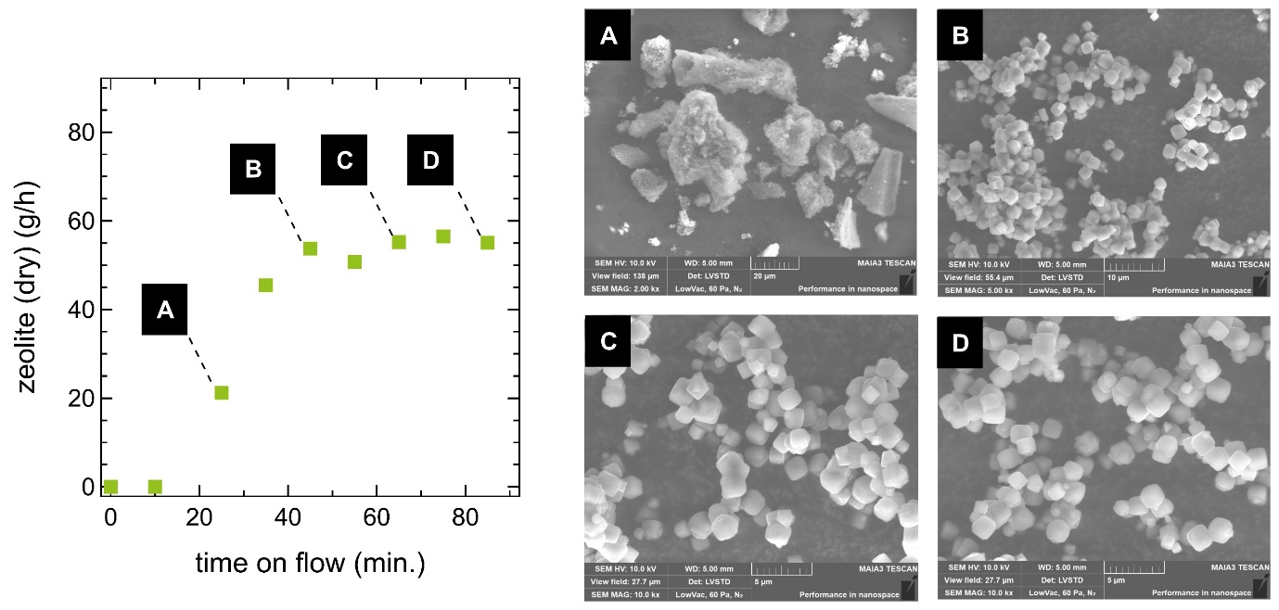
Fig. 5. SEM images of zeolite LTA synthesized in flow (residence time 9.4 min, gel/H₂O= 1).
Fig. 6 (a) and (b) display the XRD and the PSD (obtained by DLS) of a sample produced in the continuous flow reactor at the steady-state conditions, respectively. The diffractogram shows the high purity and crystallinity of the synthesized zeolite LTA. Surface intensity of each peak was used to calculate the relative crystallinity. Bragg angles, were used to calculate i) the inter-planar distance (d_{hkl}) by using the Bragg’s equation, and ii) the average size of the crystallites by using the Size-Strain Plot (SSP) method [27]. The lattice constant “a” was determined as previously described.
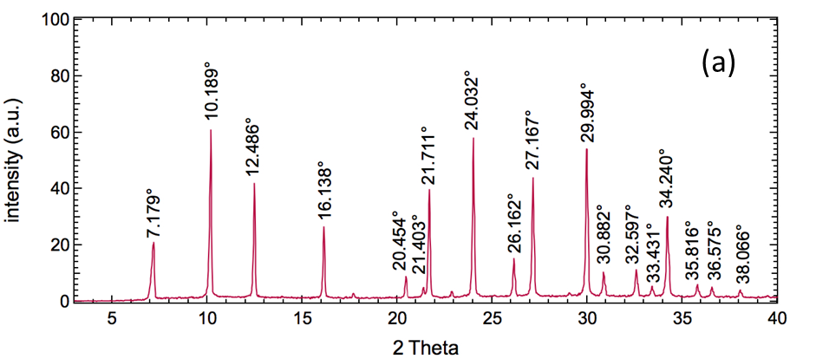
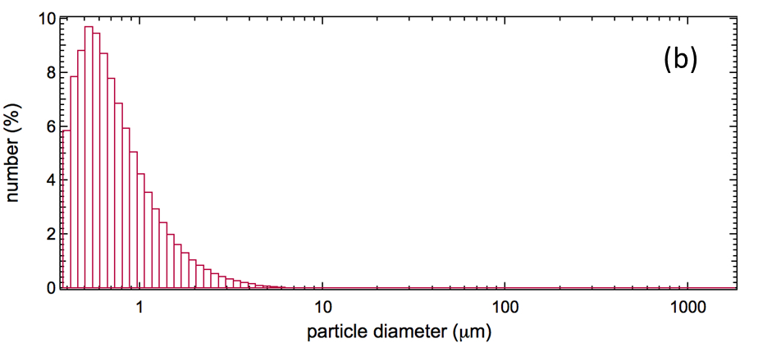
Fig. 6. (a) XRD and (b) DLS of zeolite LTA synthesized in the continuous flow reactor.
Table 4 presents, for each sample, the relative crystallinity and calculated unit cell parameters, and compares crystal diameters obtained by the SSP method (d_{SSP}) with the average diameters measured by laser diffraction (d_{LASER}).

Table 4. Relative crystallinity, unit cell parameters and crystal sizes obtained by the Size-Strain Plot (SSP) approach and laser diffraction measurements.
Zeolite sample |  | Relative  crystallinity % | Lattice  constant « a »  nm | Mean cristal size,  d_{SSP}  ±0.05 µm | Mean particle size, d_{LASER}  ±0.05 µm
LTA2 | 97 |  | 2.462 ± 0.013 | 0.77 | 0.84
LTA3 | 100 |  | 2.449 ± 0.005 | 0.40 | 0.85
LTA4 | 91 |  | 2.451 ± 0.004 | 0.84 | 0.84
LTA6 | 98 |  | 2.451 ± 0.004 | 0.70 | 0.80

Calculated lattice parameter « a » are close to reference LTA zeolites (2.455 nm for dehydrated LTA and 2.461 nm for hydrated LTA). These values, combined with the low XRD background (Fig. 6a), confirms the quasi absence of amorphous materials as observed by SEM at steady-state (Fig. 5).
Average crystal sizes determined via SEM observations (< 1 µm, Fig. 5) agree with the values obtained by laser diffraction and with the ones determined indirectly by using the SSP method (Table 4). Indeed, these results confirmed that zeolite LTA particles of high purity and crystallinity were obtained.

Modelling and simulation results
The PSD obtained from modelling matches relatively well with the experimental results (Fig. 7); the wider experimental PSD towards higher diameters could be explained by agglomeration of smaller particles – a phenomenon not taken into consideration in the models. Nevertheless, the model replicated the PSD with relatively well match of the average particle diameter, enabling thus its preliminary application for the study and optimization of the continuous hydrothermal process..
Fig. 7. Experimental and modelled particle size distribution.

Velocity and temperature distribution along the reactor length
Fig. 8 shows the steady-state axisymmetric 2D velocity profiles for the gel solution and heating oil. As can be seen from the color difference, the feed velocity is very low (1.6 × 10⁻³ m⋅s⁻¹) in comparison to the oil velocity (2.3 m⋅s⁻¹). It can also be observed that velocity is zero near the boundaries due to non-slip conditions.
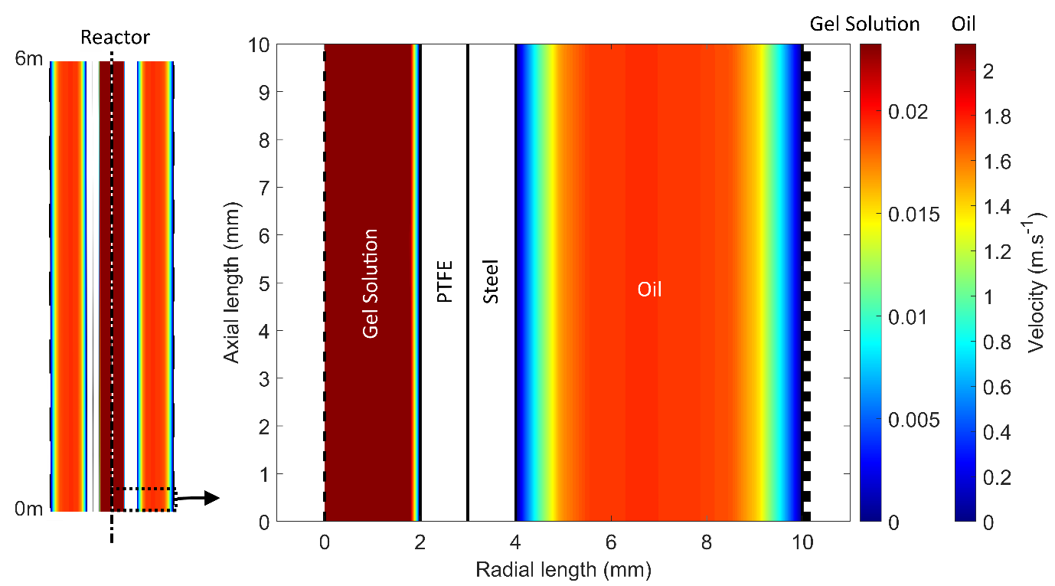
Fig. 8. Axisymmetric 2D velocity profiles of feed and heating oil. Profiles are extracted at the reactor length of 1-10 mm. (Feed: 8 mL⋅min⁻¹, Oil: 2000 mL⋅min⁻¹).
Radial and axial temperature profiles at different reactor lengths were obtained by solving Eq. (3) (Fig. 9). It can be observed that the temperature of the gel solution is increased from 298 K (Fig. 9a) to 403 K (Fig. 9d) and reached steady state at a reactor length of ca. 3 m (Fig. 9).
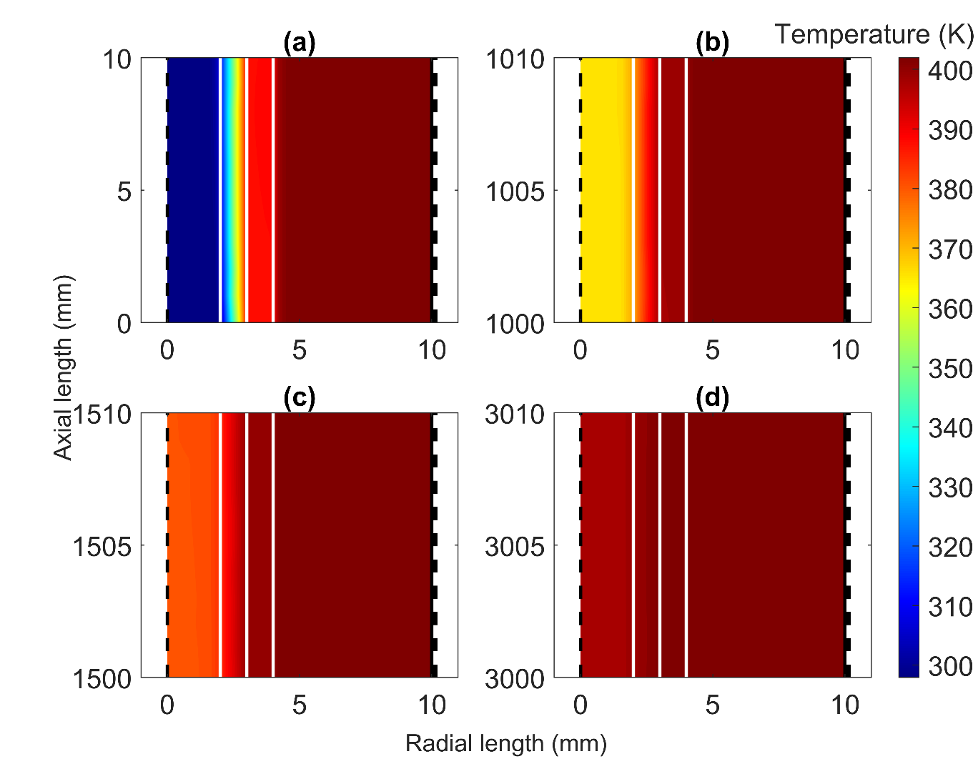
Fig. 9. Axial and radial temperature profiles at different reactor lengths; (a) at start of the reactor; (b) at 1 m length; (c) at 1.5 m length and (d) at 3 m length. Flow rate: 8 mL⋅min⁻¹, gel solution inlet temperature: 298 K, oil inlet temperature: 403 K.
Detailed heat transfer analysis was performed to investigate the radial heat transfer from oil to feed solution (Fig. 10). Temperature profiles are very steep in the PFA region, which is due to its lower thermal conductivity compared to steel.
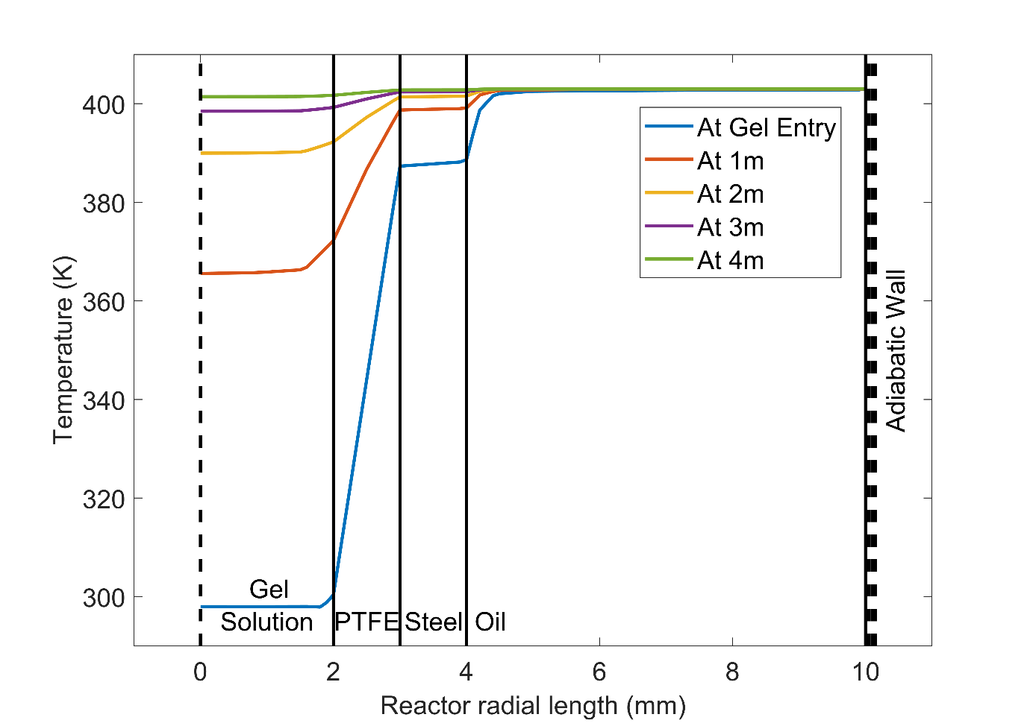
Fig. 10. Radial temperature profiles obtained at different reactor lengths. Gel: 8 mL⋅min⁻¹; Oil: 2000 mL⋅min⁻¹; Feed inlet temperature: 298 K; Oil inlet temperature: 403 K.
Furthermore, the effect of the gel flow rate was also studied (Fig. 11). When the gel flow rate was kept at 8 mL⋅min⁻¹, the steady-state temperature was reached at a reactor length of ca. 2 m; doubling this flow rate also resulted in a two-fold increase in the reactor length needed to reach the steady-state temperature.

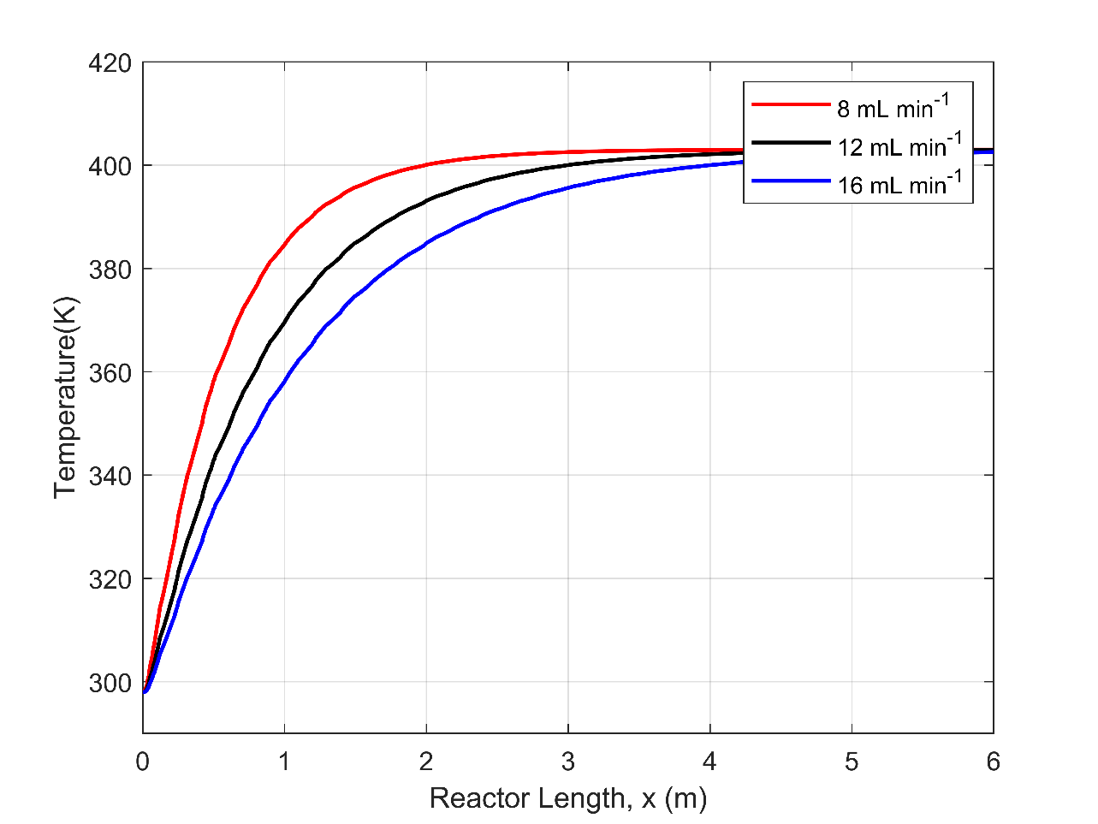
Fig 11: Effect of flow rate on the gel temperature profiles along the length of the reactor. Flow rate of oil: 2000 mL min⁻¹; Feed inlet temperature: 298 K; Oil inlet temperature: 403 K.

Evaluation of Al and Si concentration along the length of the reactor
Concentration profile for aluminum and silicon species along the length of the reactor was studied by numerically solving transport equations (Eq. 16, Fig. 12). The concentration of the species remained unchanged at initial reactor length however, as the reaction temperature is reached (Fig. 9), the concentration in the continuous phase changes rapidly due to formation of crystals. At a flow rate of 8 mL⋅min⁻¹, complete conversion was observed for aluminum at a reactor length of 1.5 m. For higher flow rates, i.e., 12 and 16 mL⋅min⁻¹, complete conversion of aluminum species occurred at reactor length of 2 and 3 m, respectively. These results are essentially linked with the gel temperature profiles reached in the reactor for the different flow rates. From this, optimization of reactor length and/or feed flow rate can be foreseen to achieve even higher STY and productivity.
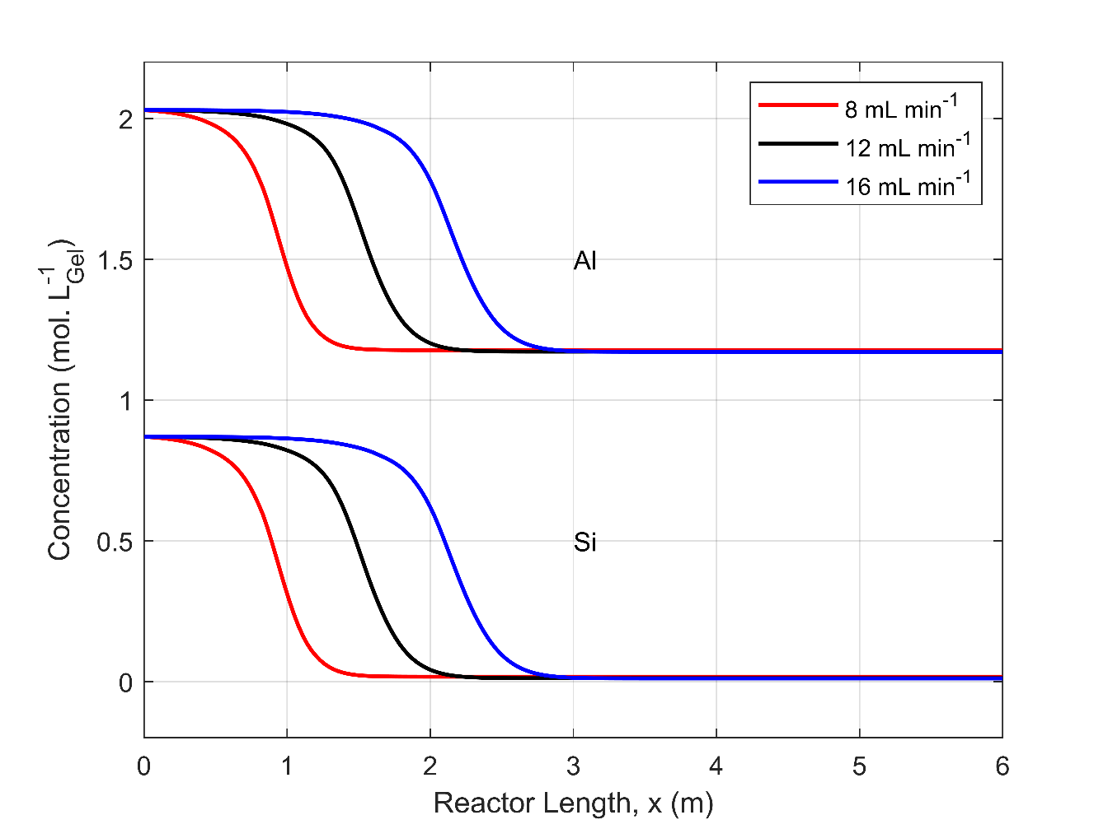
Fig. 12. Silicon and aluminum concentrations (gel) evaluation along the length of the reactor for different gel flow rates. Initial concentration: aluminum: 2 mol⋅L⁻¹, silicon: 0.9 mol L⁻¹. Initial gel temperature: 298 K. Oil flow rate: 2000 mL⋅min⁻¹.

Effects of temperature on particle size distribution and crystal growth
The PSD was simulated for temperatures ranging from 373 to 403 K (Fig. 13). For the same residence time (9.4 min), wider PSD are obtained with increasing temperature since both nucleation and growth rates increase competitively. Furthermore, nucleation reaches saturation value more rapidly at higher operating temperature. This shows that, with the increase in temperature, and thus nucleation/growth rate constants, the residence time could further be reduced to achieve narrower PSD.
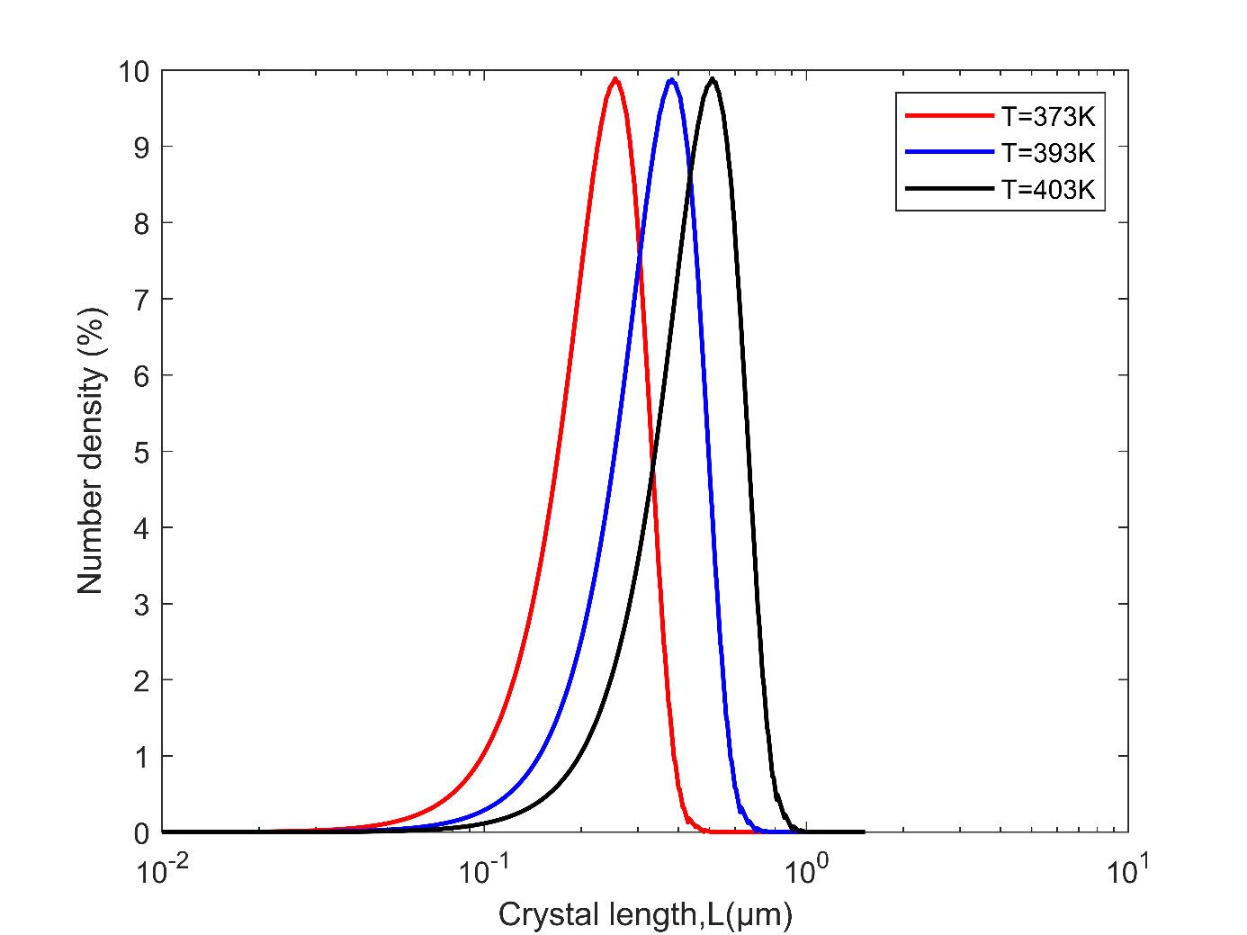
Fig. 13. PSD obtained from simulation at different operating temperatures. Feed flow rate = 8 mL⋅min⁻¹ Oil: 2000 mL⋅min⁻¹; Initial concentration; aluminum: 2 mol⋅L⁻¹, silicon: 0.9 mol⋅L⁻¹.
Fig. 14 shows indeed the effect of operating temperature on particle growth rate. At 403 K, the average particle size reached is ca. 1.25 µm while at 373 K, the maximum crystal size is 0.6 µm. From this, it can be foreseen that under optimal temperature and flow rate conditions, the length of the reactor could further be optimized to match with the optimal residence time needed for reaching steady state – this again allowing to further improve the overall efficiency of the process.
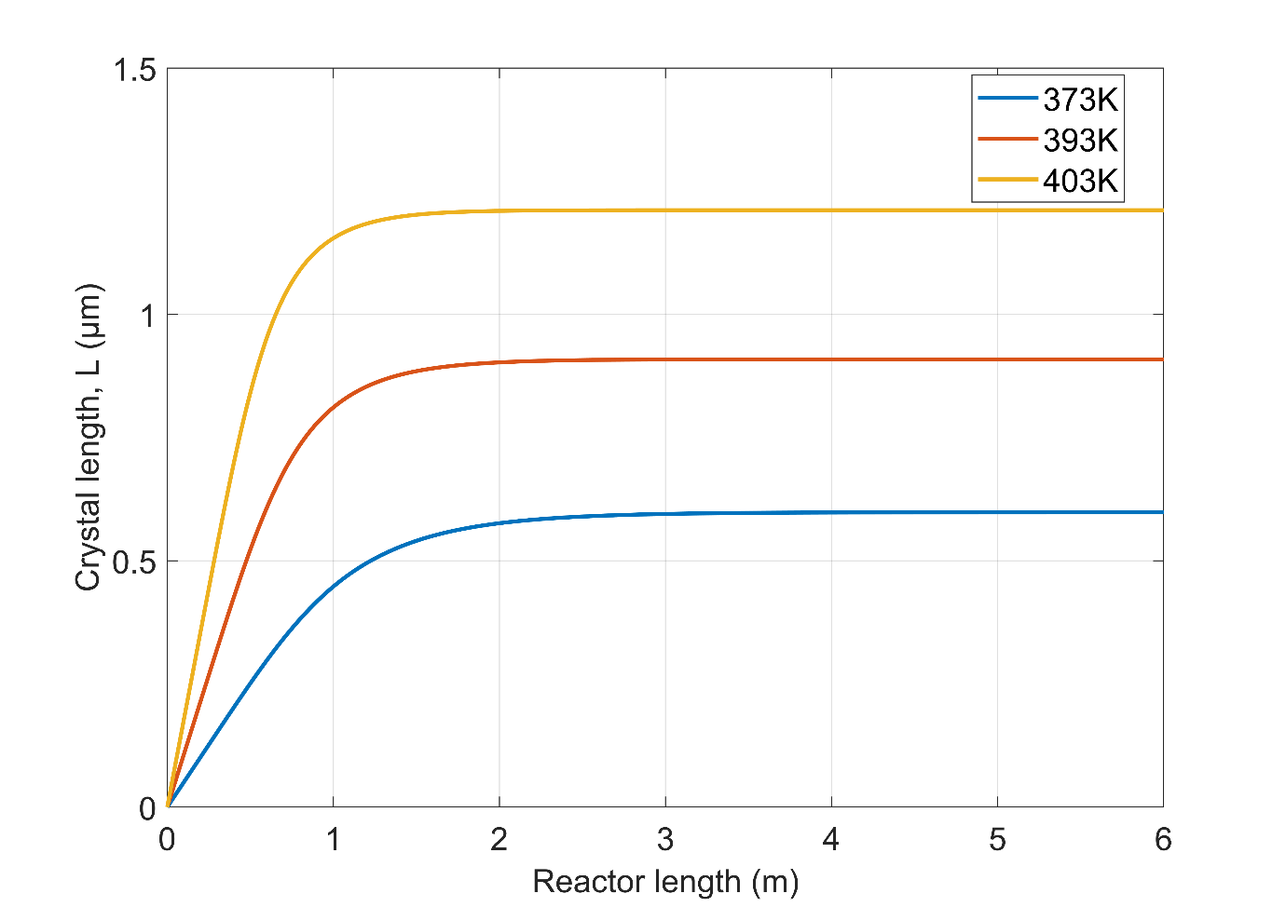
Fig. 14. Evaluation of zeolite crystal diameter at different temperatures. Gel flow rate: 8 mL⋅min⁻¹. Initial concentration; aluminum: 2 mol⋅L⁻¹, silicon: 0.9 mol⋅L⁻¹
The effect of temperature on the zeolite concentration profile is shown in Fig. 15. At 403 K, the steady-state production rate of 55 g⋅L⁻¹ is reached at a reactor length of 2 m while at 373 K a length of 3.5 m is necessary. This confirms again that, by increasing the operating temperature, the steady-state production rate can be achieved at the initial length of the reactor.
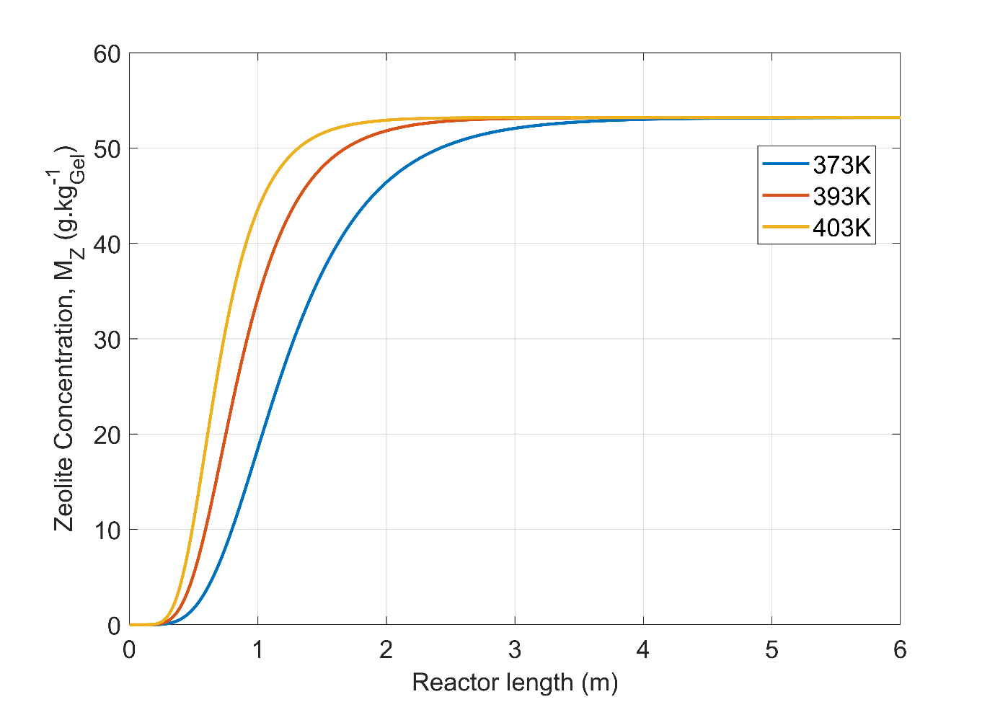
Fig. 15. Zeolite concentration along the length of the reactor for different operating temperatures. Gel flow rate of 8 mL⋅min⁻¹. Oil flow rate: 2000 mL⋅min⁻¹. Initial concentration; aluminum: 2 mol⋅L⁻¹, silicon: 0.9 mol⋅L⁻1.

Conclusion
A pilot-scale process was developed for the continuous flow hydrothermal synthesis of zeolite LTA. Different experimental conditions were studied and allowed to achieve production rates of up to ca. 90 g⋅h⁻¹ of dry zeolite at steady state, corresponding to a STY of ca. 1100 g⋅L⁻¹⋅h⁻¹. High quality zeolite LTA was obtained within residence time of less than 10 min, this without any clogging. A CFD model coupled with population balance equations was developed and solved to closely simulate the hydrothermal flow process. The data obtained from this hybrid model matched well with the particle size distributions obtained experimentally. The simulations provided useful insights to further optimize the design, operation and scale-up of the continuous flow reactor while reducing experimental load. Developments are ongoing to refine the models by integrating for instance particle aggregation and breakage phenomena.
Acknowledgments
This work was supported by the European Regional Development Fund (ERDF) and Wallonia within the framework of the program “Wallonie-2020.EU” (INTENSE4CHEM, project no. (699993-152208).
References

[1] T. Van Gerven and A. Stankiewicz, “Structure, Energy, Synergy, Time—The Fundamentals of Process Intensification,” Ind. Eng. Chem. Res., vol. 48, no. 5, pp. 2465–2474, Mar. 2009, doi: 10.1021/ie801501y.
[2] “Ramshaw: Process Intensification: Engineering for... - Google Scholar.” https://scholar.google.com/scholar_lookup?hl=en&publication_year=2013&pages=%00empty%00&author=D.+Raey&author=C.+Ramshaw&author=A.+Harvey&isbn=%00null%00&title=Process+Intensification%3A+Engineering+for+efficiency%2C+sustainability+and+flexibility (accessed Jan. 27, 2023).
[3] K. S. Elvira, X. C. i Solvas, R. C. R. Wootton, and A. J. deMello, “The past, present and potential for microfluidic reactor technology in chemical synthesis,” Nat. Chem., vol. 5, no. 11, Art. no. 11, Nov. 2013, doi: 10.1038/nchem.1753.
[4] T. McGlone, N. E. B. Briggs, C. A. Clark, C. J. Brown, J. Sefcik, and A. J. Florence, “Oscillatory Flow Reactors (OFRs) for Continuous Manufacturing and Crystallization,” Org. Process Res. Dev., vol. 19, no. 9, pp. 1186–1202, Sep. 2015, doi: 10.1021/acs.oprd.5b00225.
[5] Y.-I. Cho et al., “Synthesis of TiO2 Nano-Powders from Aqueous Solutions with Various Cation and Anion Species,” in Characterization & Control of Interfaces for High Quality Advanced Materials, John Wiley & Sons, Ltd, 2006, pp. 59–66. doi: 10.1002/9781118406038.ch8.
[6] C. Xu, “Continuous and batch hydrothermal synthesis of metal oxide nanoparticles and metal oxide-activated carbon nanocomposites,” Aug. 2006, Accessed: Dec. 28, 2021. [Online]. Available: https://smartech.gatech.edu/handle/1853/13982
[7] J. A. Darr, J. Zhang, N. M. Makwana, and X. Weng, “Continuous Hydrothermal Synthesis of Inorganic Nanoparticles: Applications and Future Directions,” Chem. Rev., vol. 117, no. 17, pp. 11125–11238, Sep. 2017, doi: 10.1021/acs.chemrev.6b00417.
[8] E. Lester, P. Blood, J. Denyer, D. Giddings, B. Azzopardi, and M. Poliakoff, “Reaction engineering: The supercritical water hydrothermal synthesis of nano-particles,” J. Supercrit. Fluids, vol. 37, no. 2, pp. 209–214, Apr. 2006, doi: 10.1016/j.supflu.2005.08.011.
[9] J. Mei, A. Duan, and X. Wang, “A Brief Review on Solvent-Free Synthesis of Zeolites,” Materials, vol. 14, no. 4, Art. no. 4, Jan. 2021, doi: 10.3390/ma14040788.
[10] S. Mintova, S. Mo, and T. Bein, “Humidity Sensing with Ultrathin LTA-Type Molecular Sieve Films Grown on Piezoelectric Devices,” Chem. Mater., vol. 13, no. 3, pp. 901–905, Mar. 2001, doi: 10.1021/cm000671w.
[11] S. Mintova and T. Bein, “Microporous Films Prepared by Spin-Coating Stable Colloidal Suspensions of Zeolites,” Adv. Mater., vol. 13, no. 24, pp. 1880–1883, 2001, doi: 10.1002/1521-4095(200112)13:24<1880::AID-ADMA1880>3.0.CO;2-7.
[12] A. Petushkov, J. Freeman, and S. C. Larsen, “Framework Stability of Nanocrystalline NaY in Aqueous Solution at Varying pH,” Langmuir, vol. 26, no. 9, pp. 6695–6701, May 2010, doi: 10.1021/la9040198.
[13] C. S. Cundy, M. S. Henty, and R. J. Plaisted, “Zeolite synthesis using a semicontinuous reactor, Part 1: Controlled nucleation and growth of ZSM-5 crystals having well-defined morphologies,” Zeolites, vol. 15, no. 4, pp. 353–372, May 1995, doi: 10.1016/0144-2449(94)00052-T.
[14] Z. Liu, T. Wakihara, D. Nishioka, K. Oshima, T. Takewaki, and T. Okubo, “One-minute synthesis of crystalline microporous aluminophosphate (AlPO4-5) by combining fast heating with a seed-assisted method,” Chem. Commun., vol. 50, no. 19, pp. 2526–2528, Feb. 2014, doi: 10.1039/C3CC49548E.
[15] Z. Liu et al., “Widening Synthesis Bottlenecks: Realization of Ultrafast and Continuous-Flow Synthesis of High-Silica Zeolite SSZ-13 for NOx Removal,” Angew. Chem., vol. 127, no. 19, pp. 5775–5779, 2015, doi: 10.1002/ange.201501160.
[16] Z. Liu et al., “Continuous flow synthesis of ZSM-5 zeolite on the order of seconds,” Proc. Natl. Acad. Sci., vol. 113, no. 50, pp. 14267–14271, Dec. 2016, doi: 10.1073/pnas.1615872113.
[17] R. W. Thompson and A. Dyer, “A modified population balance model for hydrothermal molecular sieve zeolite synthesis,” Zeolites, vol. 5, no. 5, pp. 292–301, Sep. 1985, doi: 10.1016/0144-2449(85)90161-7.
[18] J. Bronic, P. Frontera, F. Testa, B. Subotic, R. Aiello, and J. B. Nagy, “02-P-29 - Study of zeolite a crystallization from clear solution by hydrothermal synthesis and population balance simulation,” in Studies in Surface Science and Catalysis, vol. 135, A. Galarneau, F. Fajula, F. Di Renzo, and J. Vedrine, Eds. Elsevier, 2001, p. 192. doi: 10.1016/S0167-2991(01)81368-9.
[19] A. Y. Sheikh, A. G. Jones, and P. Graham, “Population balance modeling of particle formation during the chemical synthesis of zeolite crystals: Assessment of hydrothermal precipitation kinetics,” Zeolites, vol. 16, no. 2, pp. 164–172, Feb. 1996, doi: 10.1016/0144-2449(95)00116-6.
[20] L. B. McCusker and C. Baerlocher, “Chapter 3 Zeolite structures,” in Studies in Surface Science and Catalysis, vol. 137, H. van Bekkum, E. M. Flanigen, P. A. Jacobs, and J. C. Jansen, Eds. Elsevier, 2001, pp. 37–67. doi: 10.1016/S0167-2991(01)80244-5.
[21] P. Shunmuga Sundaram, T. Sangeetha, S. Rajakarthihan, R. Vijayalaksmi, A. Elangovan, and G. Arivazhagan, “XRD structural studies on cobalt doped zinc oxide nanoparticles synthesized by coprecipitation method: Williamson-Hall and size-strain plot approaches,” Phys. B Condens. Matter, vol. 595, p. 412342, Oct. 2020, doi: 10.1016/j.physb.2020.412342.
[22] S. Bosnar, T. Antonić, J. Bronić, and B. Subotić, “Mechanism and kinetics of the growth of zeolite microcrystals. Part 2: Influence of sodium ions concentration in the liquid phase on the growth kinetics of zeolite A microcrystals,” Microporous Mesoporous Mater., vol. 76, no. 1–3, pp. 157–165, Dec. 2004, doi: 10.1016/j.micromeso.2004.07.021.
[23] J. Bronić, A. Mužic, T. Antonić Jelić, J. Kontrec, and B. Subotić, “Mechanism of crystallization of zeolite A microcrystals from initially clear aluminosilicate solution: A population balance analysis,” J. Cryst. Growth, vol. 310, no. 22, pp. 4656–4665, Nov. 2008, doi: 10.1016/j.jcrysgro.2008.08.044.
[24] C. S. Cundy, B. M. Lowe, and D. M. Sinclair, “Direct measurements of the crystal growth rate and nucleation behaviour of silicalite, a zeolitic silica polymorph,” J. Cryst. Growth, vol. 100, no. 1–2, pp. 189–202, Feb. 1990, doi: 10.1016/0022-0248(90)90622-R.
[25] J. N. Watson, L. E. Iton, R. I. Keir, J. C. Thomas, T. L. Dowling, and J. W. White, “TPA−Silicalite Crystallization from Homogeneous Solution: Kinetics and Mechanism of Nucleation and Growth,” J. Phys. Chem. B, vol. 101, no. 48, pp. 10094–10104, Nov. 1997, doi: 10.1021/jp971531l.
[26] T. Ejaz, A. G. Jones, and P. Graham, “Solubility of Zeolite A and Its Amorphous Precursor under Synthesis Conditions,” J. Chem. Eng. Data, vol. 44, no. 3, pp. 574–576, May 1999, doi: 10.1021/je980164j.
[27] P. Shunmuga Sundaram, T. Sangeetha, S. Rajakarthihan, R. Vijayalaksmi, A. Elangovan, and G. Arivazhagan, “XRD structural studies on cobalt doped zinc oxide nanoparticles synthesized by coprecipitation method: Williamson-Hall and size-strain plot approaches,” Phys. B Condens. Matter, vol. 595, p. 412342, Oct. 2020, doi: 10.1016/j.physb.2020.412342.

