Predicting physiological responses of dairy cows using comprehensive variables
Hang Shu^{a,b}, Yongfeng Li^{a,b}, Jérôme Bindelle^{b}, Zhongming Jinª, Tingting Fang^{c}, Mingjie Xing^{c}, Leifeng Guoª, Wensheng Wangª*
ª Agricultural Information Institute, Chinese Academy of Agricultural Sciences, Beijing 100086, China
^{b} AgroBioChem/TERRA, Precision Livestock and Nutrition Unit, Gembloux Agro-Bio Tech, University of Liège, 5030 Gembloux, Belgium
^{c} Institute of Animal Sciences, Chinese Academy of Agricultural Sciences, Beijing 100193, China
* Corresponding author.
E-mail address: wangwensheng@caas.cn (W. Wang).

Abstract
Heat stress is increasingly affecting the production, health, and reproduction of dairy cows. Previous studies used limited variables as predictors of physiological responses, and the developed models poorly predict animal responses in evaporatively cooled environments. The aim of this study was to build machine learning models using comprehensive variables to predict physiological responses of dairy cows raised on an actual dairy farm equipped with sprinklers. Four algorithms including random forest, gradient boosting machine, artificial neural network (ANN), and regularized linear regression were used to predict respiration rate (RR), vaginal temperature (VT), and eye temperature (ET) with 13 predictor variables from three dimensions: production, cow-related, and environmental factors. The classification performance of the predicted values in recognizing individual heat stress states was compared with commonly used thermal indices. The performance on the testing sets shows that the ANN models yielded the lowest root mean squared error for predicting RR (13.24 breaths/min), VT (0.30 ℃), and ET (0.29 ℃). The results interpreted with partial dependence plots and Local Interpretable Model-agnostic Explanations show that P.M. measurements and winter calving contributed most to high RR and VT predictions, whereas lying posture, high ambient temperature, and low wind speed contributed most to high ET predictions. When determining the ground-truth heat stress state by the actual RR, the best classification performance was yielded by the predicted RR with an accuracy of 77.7%; when determining the ground-truth heat stress state by the actual VT, the best classification performance was yielded by the predicted VT with an accuracy of 75.3%. This study demonstrates the ability of ANN in predicting physiological responses of dairy cows raised on actual farms with access to sprinklers. Adding more predictors other than meteorological parameters into training could increase predictive performance. Recognizing the heat stress state of individual animals, especially those at the highest risk, based on the predicted physiological responses and their interpretations can inform better heat abatement decisions.
Keywords. Precision livestock farming; Animal welfare; Predictive modeling; Thermal comfort; Interpretability

1. Introduction
In the dairy industry, heat stress is increasingly affecting the production, health, and reproduction of dairy cows (Ranjitkar et al., 2020). Thermal indices have long been developed and applied to describe the amplitude and duration of heat stress (Herbut et al., 2018). However, environmental indicators can neither reflect the true response of animals nor address individual variation within a herd (Bar et al., 2019; Koltes et al., 2018).
Heat stress induces acute responses which are driven by the autonomic nervous system to maintain homeostasis, as well as chronic responses which are driven by the endocrine system to achieve a new physiological state (Collier et al., 2019). Physiological responses, such as respiration rate (RR), core body temperatures (CBT), and body surface temperatures (BST), can be obtained by direct measurement or predictive modeling, and further used for determining the heat stress state of animals. Although the direct measurement of such responses can provide the most accurate results, it is difficult to achieve continuous alarms since traditional manual measurements are invasive, tedious, and time-consuming (Shu et al., 2021). Predictive modeling offers a non-invasive alternative to predict physiological responses from more easily accessible data such as meteorological parameters (Dado-Senn et al., 2020b; Dikmen and Hansen, 2009).
Machine learning (ML) models have gained much interest in animal science research due to their advantage in predicting nonlinear relationships and being less subject to assumptions about data distribution (Gorczyca and Gebremedhin, 2020). Tree-based algorithms and neural networks are two typical methods that have been extensively used in regression (e.g., prediction of productivity, energy consumption, physiological state) and classification (e.g., behavior recognition, disease detection, body condition scoring) tasks (Cockburn, 2020; Piwczyński et al., 2020). For such a regression task predicting physiological responses, random forest (RF), gradient boosting machine (GBM), and artificial neural network (ANN) have shown much better predictive ability than traditional linear models in broilers (Abreu et al., 2020), dairy cows (Hernández-Julio et al., 2014; Pacheco et al., 2020), beef cattle (Sousa et al., 2016; Sousa et al., 2018), sheep (Fuentes et al., 2020a), and pigs (Gorczyca et al., 2018).
The choice of predictors is of particular importance for the predictive ability of the model. Many studies relied solely on meteorological parameters to predict physiological responses (Brown-Brandl et al., 2005; Gorczyca and Gebremedhin, 2020; Hernández-Julio et al., 2014). Some studies used subcutaneous temperatures (Chung et al., 2020; Iwasaki et al., 2019) or BST (Pacheco et al., 2020; Sousa et al., 2016) as predictors since vasodilation during heat stress drives more blood from the core to the periphery. Li et al. (2020) incorporated previous milk yield and time block into their predictive model, reflecting production level and diurnal changes in cow physiology, respectively. Moreover, lots of cow-related factors are well documented to have an impact on cows’ susceptibility to heat stress, including age, breed, lactation stage, parity, and body posture (Ammer et al., 2016; Becker et al., 2020; Spiers et al., 2004). Accordingly, inputting cow-related factors is supposed to better deal with individual variation in heat stress predictions (Pinto et al., 2019). Days in milk (DIM) and parity have been incorporated into ML models for predicting milk productivity and quality (Bovo et al., 2021; Fuentes et al., 2020b). However, few attempts have been made to incorporate cow-related factors into ML models for predicting physiological responses of dairy cows exposed to heat stress.
The other concern about using ML methods is that the models can only be applied and interpreted in the environment similar to where they were originally developed due to their data-driven nature. Dairy farms employ a variety of cooling strategies to alleviate heat stress, the most efficient and widely used of which is electric fans coupled with evaporative cooling (e.g., misters and sprinklers) (Chen et al., 2015). Fans plus misters systems produce small droplets and cool the air through evaporation as they disperse, whereas fans plus sprinklers systems produce much larger droplets to wet the skin surface of cows and cool the surface directly through evaporation of the water (Ji et al., 2020; Schauberger et al., 2020). All these microenvironmental changes can be captured by ambient sensors and their effect on cow thermal comfort can still be explained. However, the fact that the large droplets delivered by sprinklers wet the surface of cows making them more efficiently cooled by fans would be neglected by previous models which were developed in the absence of sprinklers. The lack of these data makes it unknown whether ML methods would remain useful in such a complex environment in order to guide decision making with regards to cow management.
To explore the abovementioned questions, this study aimed to build and compare ML models for predicting physiological responses (RR, CBT, and BST) of dairy cows from previous milk yield, cow-related factors, microenvironmental parameters, and time block on an actual farm which was equipped with sprinklers. We hypothesized that ML models developed using comprehensive variables would perform well in this real-world environment.

2. Materials and Methods
The experimental protocols were approved by the Experimental Animal Care and Use Committee of Institute of Animal Sciences, Chinese Academy of Agricultural Sciences (approval number IAS2021-220).

2.1. Location, facilities, and animals
The experiment was conducted from May to August 2021 at an intensive dairy farm, located in Shandong, China (coordinates: 34◦50’37’’N, 115◦26’11’’E; altitude: 52 m), characterized by a temperate continental monsoon climate with hot and humid summers. The experiment was conducted over three different phases, firstly during 20 days in late spring and early summer (May-June), secondly during 10 days in mid-summer (July), and thirdly during 10 days in late summer (August). These phases were expected to cover a wide range of thermal environments, thus facilitating the training of ML models.
For each experimental phase, a new group of 19 to 20 primi- and multiparous Holstein dairy cows reared in a free-stall pen (15 m × 90 m) were selected based on similar parity, lactation stage, and body condition score (Wildman et al., 1982), so that cows were comparable at the beginning of each phase (Table 1). The barn was covered by a double-pitched roof, and therefore, most of the solar radiation was prevented from reaching the cows inside the barn. The pen was equipped with a total of 22 fans (diameter: 1.1 m; capacity: 25,000 m³/h each; installation height: 2.8 m) and 46 sprinklers (flow rate: 1.5 L/min each; installation height: 2 m; 1 min on and 4 min off). Fans and sprinklers were automatically turned on when the indoor temperature reached 20 °C and 25 °C, respectively. Cows were milked three times per day at 08:30, 16:30, and 00:00 h, and were fed a total mixed ration three times per day after milked. Cows had free access to drinking water but no access to outdoor pasture. One cow in phase 1 and another in phase 3 were withdrawn from the experiment due to health issues, namely high somatic cell count and gastroenteritis, respectively.

2.2. Variables
Respiration rate (RR), vaginal temperature (VT), and eye temperature (ET) were the three response variables for predictive modeling, while candidate predictor variables were determined along three dimensions: production factors, cow-related factors, and environmental factors (Fig. 1).
Production factors included the single daily milk yield (DMY) of three days before the test day. The use of DMY was initially motivated by the fact that high-producing cows typically suffer more from heat stress (Collier et al., 2012). The milk yield in the last few days could represent the mean production level of individual cows. Besides, the changing dynamics or accumulated response (Li et al., 2021) of DMY over previous days was intended to show how the animals were coordinated by acclimatization. This information is important since exposure to heat stress would induce stress responses in either acute (minutes to days) or chronic (days to weeks) ways, manifesting into different physiological states (Collier et al., 2019). For example, cows showed a much steeper increase in RR and VT during acute stress than during chronic stress (de Andrade Ferrazza et al., 2017). Given that acute stress takes at least three days to achieve thermal balance (Hahn, 1999), the previous three days’ DMY was finally nominated.
Cow-related factors including birth season, calving season, DIM, parity, age in months (AIM), and posture were nominated since they have long been identified as influencing factors of individual sensitivity to heat stress (Ammer et al., 2016; Becker et al., 2020; Spiers et al., 2004). Environmental factors included ambient temperature (Ta), relative humidity (RH), and wind speed (WS) which represented indoor microenvironments, as well as time block which represented time effect.

2.3. Data collection
Vaginal temperature (VT) was recorded automatically at an interval of 5 min by using data loggers (DS1922L, accuracy: ± 0.5 °C, resolution: ± 0.0625 °C; Maxim Integrated, San Jose, CA, USA) attached to modified vaginal controlled internal drug releases (Pfizer Animal Health, New York, NY, USA). The devices were removed after a week in vivo for each cow per phase to avoid interfering with artificial insemination and risking harming the fetuses. Meteorological parameters were measured automatically at an interval of 10 min by using six Kestrel environmental data loggers (model: 5000 and 5400; accuracy: ± 0.4 °C Ta, ± 1% RH, ± 1.66% WS; Nielsen-Kellerman, Boothwyn, PA, USA) which were evenly placed in the pen at a height of 2.2 m. These readings were used for describing the overall thermal condition throughout the entire experiment.
The manual field measurement of physiological (RR and ET) and microenvironmental variables (Ta, RH, and WS) was conducted twice on each test day, once during A.M. (08:00-11:30 h) and once during P.M. (13:30-16:30 h). For each measurement, each cow was expected to be measured twice, once while lying and once while standing, with at least a 30-min gap between the two observations. However, due to their unconstrained nature, the number of times the cows were measured varied for each measurement, with mean ± standard deviation observations of 2.0 ± 0.9, 2.4 ± 0.9, and 2.3 ± 0.8 per cow per measurement for three periods, respectively. For each observation, RR was recorded by two trained observers (intra-class correlation coefficient: 0.91) by timing 15 flank movements (and converting to breaths/min); ET was measured from the cows’ side with an angle of approximately 90° and a distance of approximately 1.5 m by a photographer using a portable infrared camera (VarioCAM HR, accuracy: ± 0.5 °C, resolution: 640 × 480 pixels; InfraTec, Dresden, Germany) which was fully warmed up as per Howell et al. (2020); and microenvironmental parameters (i.e., Ta, RH, and WS) were manually collected from the closest Kestrel data logger.
Previous DMY (kg/day) and cow-related factors including birth season, calving season, DIM, parity, and AIM were acquired from the automatic milking system (Afimilk, Kibbutz Afikim, Israel). Birth season and calving season were coded to spring (March to May), summer (June to August), autumn (September to November), and winter (December to February). Body posture (lying or standing) was recorded manually for every observation. Time block (A.M. or P.M.) was recorded for two separate field measurements on each test day.

2.4. Data processing
The infrared images were interpreted using IRBIS 3 Standard software (YSHY, Beijing, China). Low-quality images were manually removed. ET was determined using the maximum temperature of the medial canthus area, as per Shu et al. (2022b). The data of the two sick cows on the day they were withdrawn from the experiment were removed from the dataset for data quality control.
Further data processing was done using R software (version 4.1.0; https://www.R-project.org/). To ensure a high-quality prediction, it is important that the observations used for training and testing are included in the same distribution and are not subject to outliers. This can be done by calculating Mahalanobis distance which is an effective distance metric that measures the distance between an observation and the barycenter defined in the multi-dimensional space (Shah and Gemperline, 1989). Thus, a principal component analysis was first performed using the PCA function from the FactoMineR package to reduce the dimensionality of the predictor matrix. The Mahalanobis distances between observations were then calculated, referring to the method described in Soyeurt et al. (2020). The presence of outliers among observations was detected using a Mahalanobis distance threshold of 5 as convention. Moreover, although multicollinearity does not typically affect accuracy, it can be a problem when interpreting the results, and thus should be carefully dealt with. Multicollinearity was detected using variance inflation factors with a threshold of 5 (Gareth et al., 2013). This was done by first building a regression model that included all predictor variables using the lm function, and then applying the vif function of the car package to the regression model. Besides, correlation matrices were built to visualize the correlations among 13 candidate predictor variables using the cor function.

2.5. Predictive modeling
Predictive modeling was performed using the h2o package. For each response variable, the h2o.splitFrame function was used to randomly divide 85% of the data as the training set and 15% as the testing set (Fig. 1). The training set was used to fit the model and the testing set was used to collect the final performance. Moreover, 5-fold cross-validation was performed to enhance the model reliability and avoid issues with “lucky” data split. Four ML algorithms, including RF, GBM, ANN, and linear regression with elastic net regularization, were used for modeling (Fig. 1). The reason for choosing these algorithms was that they are typical methods in such a regression task and are easily accessible from popular software. The grid search was performed to identify the best combination of hyperparameters using the h2o.grid function. For RF, GBM, and ANN, a random grid search was performed with the parameter max_models setting to 2,000. For regularized linear regression, a cartesian grid search was performed due to much fewer options of hyperparameters. For each algorithm, the model with the lowest cross-validation root mean squared error (RMSE) was selected as the best performing model. These selected models were further evaluated for their performance on the testing set, and the one with the lowest RMSE and the highest coefficient of determination (R²) was selected as the overall best model.
To interpret and visualize the results, partial dependence plots which are available in the h2o package were built to understand how the response variables changed with the predictor variables. Understanding which variables are most influential and how different levels of variables affect animals’ response to heat stress is important to make an accurate prediction at the individual level. The state-of-the-art post-hoc local interpretability technique, Local Interpretable Model-agnostic Explanations (LIME), was performed using the lime package to gain further insight into individual predictions. The top five influential predictor variables that best explained the linear model were used for plotting LIME heatmaps.

2.5.1. Random forests
Random forests (RF) is a powerful tree-based algorithm that is commonly used in both classification and regression tasks (Breiman, 2001). RF is a kind of ensemble algorithm, adopting the method of bagging in which decision trees are trained with replacement sampling and the mean prediction of all trees is the output. The hyperparameters randomly searched included the number of trees (10 to 250, increased by 10), the maximum tree depth (10 to 100, increased by 10), the number of variables to consider at each split (3 to 13, increased by 1), and the minimum number of observations for a leaf (1, 2, 10, 20, and 30).

2.5.2. Gradient boosting machines
Gradient Boosting Machines (GBM) is another tree-based ensemble method (Friedman, 2001). Unlike RF, GBM uses the method of boosting in which the weights of all training samples are adjusted according to the residual gradient so that the next base learner pays more attention to the wrongly classified samples. The hyperparameters randomly searched included the number of trees (10 to 250, increased by 50), the maximum tree depth (10 to 100, increased by 10), the minimum number of observations for a leaf (1, 2, 10, 20, and 30), and the learning rate (0.0001, 0.001, 0.01, 0.1, 0.2, 0.3, 0.4, and 0.5).

2.5.3. Artificial neural networks
Artificial neural networks (ANN) can fit arbitrary nonlinear functions through reasonable network architecture configuration (McCulloch and Pitts, 1943). In the present study, the feedforward ANN model with a multi-layer architecture was trained with stochastic gradient descent using back-propagation. The hyperparameters randomly searched included the activation function (ReLU or Tanh), the number of hidden layers (1, 2, and 3) with the number of neurons (20, 50, 100, and 200) in each hidden layer, the dropout rate (0 to 0.5, increased by 0.05), and the epochs (5 to 500, increased by 5).

2.5.4. Regularized linear regression
Multiple linear regression can suffer from multicollinearity and overfitting, especially on small datasets. Hence, several regularization methods have been introduced to deal with these problems by shrinking the regression coefficients toward zero. The regularization method used in this study was elastic net which combines L1 (LASSO) and L2 (RIDGE) regularization (Zou and Hastie, 2005). The hyperparameters were α (0 to 1, increased by 0.01) and λ (searched automatically by setting the parameter lambda_search to “TRUE”) in which α controls the weights of L1 and L2 regularization, and λ controls the strength of regularization.

2.6. Recognition of heat stress state
The predicted values of RR and VT making use of the revised thresholds for high-producing (> 35kg/day) dairy cows (RR of 60 breaths/min and VT of 38.5 ℃) (Collier et al., 2012) were further tested for their ability to serve as classifiers for recognizing the cows’ heat stress state (Fig. 1). The predicted ET was not considered here due to the lack of commonly recognized threshold. These proposed classifiers were compared with the most commonly used temperature-humidity index (THI) classifiers: 68 (Collier et al., 2012), 70 (Dunn et al., 2014), 72 (Armstrong, 1994); adjusted THI (THIadj) classifier: 74 (Mader et al., 2006); and more recent equivalent temperature index for cattle (ETIC) classifier: 23 (Wang et al., 2018). The THI was calculated according to Eq. (1) as recommended by National Research Council (NRC, 1971):
$THI=(1.8×Ta+32)-(0.55-0.005×RH)×(1.8×Ta-26)$ (1)
THIadj and ETIC were calculated according to Eq. (2) and Eq. (3), respectively:
$THIadj=\left[0.8×Ta+\frac{RH}{100}×\left(Ta-14.4\right)+46.4\right]+4.51-1.992×WS+0.0068×SR$ (2)
$ETIC=Ta-0.0038×Ta×\left(100-RH\right)-0.1173×{WS}^{0.707}×\left(39.2-Ta \right)+1.86×{10}^{-4}×Ta×SR)$ (3)
where SR represents solar radiation and was set to zero as per the original authors’ instructions for use in indoor situations.
The ground truth of individual heat stress states (heat-stressed or non-heat-stressed) was determined by using measured values (RR and VT) and the corresponding thresholds (60 breaths/min and 38.5 ℃), respectively. The classification performance was evaluated using four metrics: recall, precision, F1-score, and accuracy. Recall measures how many cows that are truly heat-stressed can be correctly classified as being heat-stressed whereas precision measures how many cows that are classified as being heat-stressed are truly heat-stressed. F1-score is a comprehensive measure that strikes a balance between recall and precision, while accuracy indicates the overall rate of correctly classified cows. The equations are as follows:
$recall = \frac{TP}{TP+FN}×100\%$ (4)
$precision = \frac{TP}{TP+FP}×100\%$ (5)
$F1-score = \frac{2TP}{2TP+FP+FN}×100\%$ (6)
$accuracy = \frac{TP+TN}{TP+FP+TN+FN}×100\%$ (7)
where TP denotes true positive (heat-stressed cows correctly classified as heat-stressed cows), FP denotes false positive (non-heat-stressed cows incorrectly classified as heat-stressed cows), TN denotes true negative (non-heat-stressed cows correctly classified as non-heat-stressed cows), and FN denotes false negative (heat-stressed cows incorrectly classified as non-heat-stressed cows).

3. Results and Discussion
The daily patterns of meteorological variables during the entire experimental period are shown in Fig. 2. Ta and RH had opposite trajectories, while THI began to increase in May and remained stably high from June to August. Additionally, all three variables showed a shrinking diurnal change from May to early August. These facts indicate an increased intensity and duration of daily exposure to heat stress during the experimental phases. In addition to acute responses, heat stress is well documented to induce chronic responses in dairy cows, even during temperature drops in Autumn (Amamou et al., 2019). Our results indicate that this experiment well covered the onset and development of heat stress. Thus, the induced physiological responses in dairy cows including both acute and chronic responses were expected to be well collected. This heterogeneous data would definitively contribute to better training of ML algorithms in terms of the non-linear response of dairy cows to heat stress.

3.1. Data cleaning and descriptive statistics
After removing outliers, a total of 2,910, 1,561, and 1,866 observations were obtained for the datasets modeling RR, VT, and ET, respectively. The variance inflation factors among the 13 candidate predictor variables in RR, VT, and ET sets were all below 5. The correlation matrices (see Appendix A. Supplementary Material Fig. S1-S3) show that none of the correlations between candidate predictor variables was higher than 0.75. These findings support that multicollinearity was not present in the datasets, and therefore, all candidate variables were used for modeling. The descriptive statistics of the three datasets are summarized in Table 2.

3.2. Model performance
The predictive performance of the four candidate algorithms on the testing sets is shown in Table 3. ANN always performed the best on the testing set with the lowest RMSE of 13.24 breaths/min, 0.30 ℃, and 0.29 ℃, and the highest R² of 0.56, 0.45, and 0.45 when predicting RR, VT, and ET, respectively. Besides, ANN had similar results between the training and testing sets, indicating no overfitting occurred. Although GBM had roughly good results on the testing sets, an obvious decrease was always observed between the training set and cross-validation, as well as between the training and testing sets, suggesting the occurrence of overfitting. GBM reportedly has a higher potential for overfitting compared with RF, especially on small datasets (Cha et al., 2021). Collectively, our results suggest that ANN is more appropriate to predict physiological responses of dairy cows managed with sprinklers. The linear regressions between measured and predicted values are shown in Fig. 3. In all cases, the regression line between measured and predicted values was close to the regressed diagonal line, indicating a good correlation between predictions and actuals. The data points from different experimental phases show no obvious differential distribution around the diagonal. This is confirmed by the partial results for the three different experimental phases, which show similar performance relative to the overall results (Table 4).
The advantage of ANN in predicting physiological responses of dairy cows has been reported in previous studies. Under a free-stall barn without evaporative cooling, Pacheco et al. (2020) developed ANN models for predicting RR and rectal temperature of 35 Holstein dairy cows. The best model that they selected had an RMSE of 10.01 breaths/min and an R² of 0.74 for predicting RR, and an RMSE of 0.40 ℃ and an R² of 0.71 for predicting rectal temperature. Another recent study compared different ML algorithms in predicting physiological responses using historical data collected from 20 Holstein dairy cows restrained in outdoor headlocks and deprived of sprinklers (Gorczyca and Gebremedhin, 2020). RF models produced the lowest RMSE for predicting RR (9.70 breaths/min) and BST (0.33 °C), while an ANN model produced the lowest RMSE for predicting VT (0.43 °C). However, efforts have not been done yet to predict physiological responses of dairy cows managed with sprinklers. The RMSE of the overall best models proposed in this study was close to those of the abovementioned studies, particularly VT, which had the lowest RMSE among relevant studies. Our results extend the advantage of non-linear models over linear regression models to situations equipped with sprinklers. More importantly, the gains in performance from non-linear models over linear models are greater than the previous studies. This fact highlights the non-linear effect induced by sprinkler systems and the ability of advanced ML algorithms to fit it.

3.3. Model interpretation
In this study, 13 predictors from both animal and environmental perspectives were used for modeling. This provided a basis for further mining the effects of comprehensive predictors on physiological responses by applying state-of-the-art post-hoc interpretability methods. The global interpretation of the overall best models shown in Fig. 4 helps to understand the relationships between response and predictor variables by visualizing the change in predicted values as the specified predictor changes assuming the remaining predictors fixed at their mean value.
The mean response in predicted RR, VT, and ET along with changing DMY of the three days before the test day is shown in Fig. 4(a-c). The positive association between production level and RR prediction reported by Janni (2019) and Li et al. (2020) is not clear in our results, probably because the test cows had similar high production levels when entering the study and thus the difference in heat sensitivity between production levels was not discernible. In fact, it is rather difficult to interpret these variables separately because they contained dynamic information as a pattern of response. Acclimatization manifests in different physiology and production dynamics depending on the intensity and duration of heat stress exposure. Cows typically lose milk production when they enter the acute phase of heat stress, but their productivity can be restored to some extent during chronic stress (Collier et al., 2019). Thus, the input of these production variables should contribute to a better prediction because they function like sensors, recording the results of cows’ acclimatization to heat stress and its mitigation.
Cows born in summer had much lower RR and VT compared with those born in other seasons (Fig. 4(d)). This result is consistent with previous knowledge that in-utero heat stress would affect thermoregulation during the entire life of newborn cattle (Dado-Senn et al., 2020a). Lower RR and VT, in this case, could represent a better ability to maintain thermal homeostasis, which benefits from fetal heat acclimatization (Ahmed et al., 2017). Autumn calving cows had the lowest mean predicted RR and VT compared with cows calving in winter and spring (Fig. 4(e)). The lower RR and VT of autumn calving cows are probably because they were more advance in their lactation thus having less heat load due to lower milk production during heat waves (Ferreira and De Vries, 2015). This is confirmed by a decreased VT since approximately 170 DIM (Fig. 4(f)). Similarly, a decreased VT was reported during late lactation (> 150 DIM) in a recent study using 826 Holstein cows (Yan et al., 2021). It is hard to say why RR stayed at a high level during late lactation (Fig. 4(f)), possibly due to its more primary function in thermoregulation or simply because the effect of DIM was masked by that of calving season. Indeed, an increase in RR is used by cows to reduce heat load and hence prevent an increase in CBT (Gaughan et al., 2000).
Parity was found to have a positive relationship with predicted RR and VT (Fig. 4(g)), and possibly masked the effects of AIM (Fig. 4(h)). Older cows are known to be more susceptible to heat stress (Benni et al., 2020). A trend of RR increasing with parity was also found in the study of Yan et al. (2021). In addition, Choukeir et al. (2020) reported that multiparous cows had a higher VT than primiparous cows. Lying cows had higher RR, VT, and ET than standing cows (Fig. 4(i)). Similarly, lying was related to increased RR and CBT in the study of Atkins et al. (2018). Increasing standing time is well known as a behavioral change strategy taken by heat-stressed cows to dissipate excessive heat (Nordlund et al., 2019). The THI threshold for RR was found to be 65 in lying cows and 70 in standing cows, suggesting that lying cows are more susceptible to heat stress (Pinto et al., 2020). The inapparent association of ET with the abovementioned cow-related factors is most likely due to its direct exposure to external environments and thus being less connected with internal animal factors.
The predicted physiological responses had a clear positive relationship with Ta (Fig. 4(j)). The predicted RR and VT increased with a gradually decreasing slope until around 30 °C, after which they increased at a much steeper slope. These results demonstrate the effectiveness of sprinklers in alleviating heat stress in dairy cows by delaying the upper critical temperature of 25 °C (Kadzere et al., 2002) to about 30 °C. On the other hand, ET increased almost linearly with Ta, suggesting that BST is a better representation of microenvironments and a dominant front-line heat dissipator. In the case of RH, ET and VT increased sequentially at around 45% and 70% RH, respectively, whereas RR increased almost linearly with RH within the measured range (Fig. 4(k)). These findings are not surprising since high RH would significantly inhibit latent heat dissipation and result in a high physiological level (Maia et al., 2008). In the case of WS, RR and ET had an overall decreasing trend with WS, whereas VT stayed relatively stable (Fig. 4(l)). These results are consistent with previous knowledge that RR and ET respond much more promptly to microenvironmental changes than VT (Shu et al., 2022a). As expected, observations measured in P.M. had higher RR, VT, and ET than those measured in A.M. (Fig. 4(m)), which is consistent with previous studies on the circadian rhythm of physiological indicators related to heat stress (Kaufman et al., 2018). Again, the above results re-emphasize the non-linear relationship between environmental parameters and physiological responses of dairy cows managed with sprinklers and the ability of ML algorithms to fit it.
The R² (mean ± standard deviation) obtained for the local interpretation of the overall best models were 0.81 ± 0.14, 0.78 ± 0.15, and 0.82 ± 0.09 for RR, VT, and ET, respectively, indicating good quality of the interpretations of LIME. As shown in Figs. 5-7, time block and calving season were common features that strongly influenced RR and VT predictions, whereas posture, Ta, and WS had consistently strong influences on ET predictions. The cases with the highest predicted RR and VT were marked by P.M. measurements plus certain levels of cow-related factors (e.g., births in autumn and spring calving for RR, winter calving for VT, and multiparity for both) (Fig. 8), whereas the cases with the lowest predicted RR and VT were marked by A.M. measurements plus other levels of cow-related factors (e.g., autumn calving, births in summer, and standing posture for RR) (Fig. 9). In the case of ET, Ta was the factor that consistently had a strong positive influence on the predictions, whereas WS and standing posture always had the greatest negative influence (Fig. 8 and Fig. 9). These results are consistent with those from the partial dependence plots, suggesting that cow-related factors had a greater impact on RR and VT than on ET, which was more determined by microenvironmental factors. Identifying common contributing features among the most extreme cases can provide useful information for targeted cooling. Collectively, our results suggest herd homogeneity in response to heat stress as well as a potential for customized heat abatement in different subgroups of cows.

3.4. Recognition of heat stress state
The classification performance of the proposed classifiers (i.e., predicted RR and VT), THI classifiers, THIadj classifier, and ETIC classifier in recognizing the state of heat stress is listed in Table 5. As expected, the F1-score and accuracy of the predicted values were the highest, indicating a good ability in recognizing the actual heat stress state. In general, the predicted RR and VT had lower recall than the environmental classifiers, implying a worse ability for detecting heat-stressed animals. However, the better recall of THI and ETIC thresholds was compromised by the lower precision and accuracy, with a huge number of non-heat-stressed cows being misclassified as heat-stressed cows. In fact, THI (68) and ETIC (23) almost classified all the cows as being heat-stressed. Accordingly, environmental classifiers performed poorly on the RR set where 49.1% of the cases were truly heat stressed, but performed very well on the VT set where most cases were truly heat stressed (69.4%). It can be reasonably speculated that the proposed classifiers would perform much better than environmental classifiers when processing on a more balanced dataset. Similarly, the high recall of THI thresholds was balanced by the low precision in the study of Li et al. (2020). These facts demonstrate the deficiency of environmental thresholds in dealing with individual variation since different animals behave differently under identical thermal environment. Our findings highlight that heat abatement strategies controlled by environmental thresholds can be abused by wasting unnecessary efforts on non-heat-stressed animals. A more appropriate way is to make heat abatement decisions according to the predicted heat stress state of animals.

3.5. Limitations and perspectives
One of the biggest limitations of the present study is that data were collected over one single summer. Besides, only mid-lactating cows were included. These limitations resulted in inadequate heterogeneity of DMY and some cow-related factors (i.e., DIM, calving season). Although most interpretations are rational and consistent with previous knowledge, it should be noted that the interpretations could be arbitrary at certain ranges when there was insufficient training data to make a meaningful prediction. Increasing sample size and balancing data distribution, in this respect, is of great importance to improve the interpretations. The dilemma between prediction and interpretation should also be noticed. Although multicollinearity was not detected mathematically, some predictors correlated logistically, e.g., DIM and calving season, AIM and parity. Certain predictors would have to be removed to get more reliable interpretations. However, accuracy would be sacrificed to some extent as a result of information loss.
The moderate R² might indicate that there is still room for improvement in the fit of the current dataset. This could be done by introducing more variables that contribute to explaining the variance of cow physiological responses (Brown-Brandl et al., 2005). In this respect, sprinkler-related parameters (e.g., flow rate) and other variables that could reflect the interaction between cows and sprinklers (e.g., how much and how long cows receive watering) should be considered in further studies. These variables may be collected by future sprinklers equipped with cow sensing systems. Another possible way to increase the fit is to increase the data size since ANN would perform better when training with sufficiently large data (Becker et al., 2021). Collectively, further studies with data collected over different seasons and years, as well as more useful variables with more reasonable combinations, are required to confirm the results of this study and further improve the model fit and interpretation.

4. Conclusions
The models proposed in this study provide acceptable prediction errors and are reliable in the real-world farm equipped with sprinklers. Our work highlights the benefits of inputting more contributing variables in predicting physiological responses of dairy cows under heat stress. The attempt at global and local interpretation using the state-of-the-art method was basically in line with previous knowledge in this field, and therefore, will help future studies to deeply explain non-linear relationships between physiological responses and their influencing factors as well as to identify the most vulnerable animals taking into account individual variations in response to heat stress. Furthermore, recognizing the heat stress state of animals based on the predicted physiological responses can inform better heat abatement decisions by saving efforts from non-heat-stressed animals to heat-stressed animals. Further studies on larger datasets with more influencing factors are warranted to improve model fitness abilities.

Acknowledgements
This work was supported by the Major Science and Technology Program of Inner Mongolia Autonomous Region [2020ZD0004]; the Key Research and Development Plan of Hebei Province [20327202D]; and the Key Research and Development Plan of Hebei Province [20326602D]. The authors are grateful to Fuyu Sun, Xiaoyang Chen, Qianzi Ren, and Wenju Zhang, as well as Yinxiang dairy farm, for their help in data collection.

References
Abreu, L.H.P., Yanagi Junior, T., Bahuti, M., Hernández-Julio, Y.F., Ferraz, P.F.P., 2020. Artificial neural networks for prediction of physiological and productive variables of broilers. Engenharia agrícola 40, 1-9.
Ahmed, B., Younas, U., Asar, T., Dikmen, S., Hansen, P., Dahl, G., 2017. Cows exposed to heat stress during fetal life exhibit improved thermal tolerance. J. Anim. Sci. 95.
Amamou, H., Beckers, Y., Mahouachi, M., Hammami, H., 2019. Thermotolerance indicators related to production and physiological responses to heat stress of holstein cows. J. Therm. Biol. 82, 90-98.
Ammer, S., Lambertz, C., Gauly, M., 2016. Is reticular temperature a useful indicator of heat stress in dairy cattle? J. Dairy Sci. 99, 10067-10076.
Armstrong, D.V., 1994. Heat Stress Interaction with Shade and Cooling. J. Dairy Sci. 77, 2044-2050.
Atkins, I.K., Cook, N.B., Mondaca, M.R., Choi, C.Y., 2018. Continuous Respiration Rate Measurement of Heat-Stressed Dairy Cows and Relation to Environment, Body Temperature, and Lying Time. Transactions of the ASABE 61, 1475-1485.
Bar, D., Kaim, M., Flamenbaum, I., Hanochi, B., Toaff-Rosenstein, R.L., 2019. Technical note: Accelerometer-based recording of heavy breathing in lactating and dry cows as an automated measure of heat load. J. Dairy Sci. 102, 3480-3486.
Becker, C.A., Aghalari, A., Marufuzzaman, M., Stone, A.E., 2021. Predicting dairy cattle heat stress using machine learning techniques. J. Dairy Sci. 104, 501-524.
Becker, C.A., Collier, R.J., Stone, A.E., 2020. Invited review: Physiological and behavioral effects of heat stress in dairy cows. J. Dairy Sci. 103, 6751-6770.
Benni, S., Pastell, M., Bonora, F., Tassinari, P., Torreggiani, D., 2020. A generalised additive model to characterise dairy cows' responses to heat stress. Animal 14, 418-424.
Bovo, M., Agrusti, M., Benni, S., Torreggiani, D., Tassinari, P., 2021. Random Forest Modelling of Milk Yield of Dairy Cows under Heat Stress Conditions. Animals 11, 1305.
Breiman, L., 2001. Random Forests. Machine Learning 45, 5-32.
Brown-Brandl, T.M., Jones, D.D., Woldt, W.E., 2005. Evaluating Modelling Techniques for Cattle Heat Stress Prediction. Biosys. Eng. 91, 513-524.
Cha, G.-W., Moon, H.-J., Kim, Y.-C., 2021. Comparison of Random Forest and Gradient Boosting Machine Models for Predicting Demolition Waste Based on Small Datasets and Categorical Variables. Int. J. Environ. Res. Public Health 18, 8530.
Chen, J.M., Schütz, K.E., Tucker, C.B., 2015. Cooling cows efficiently with sprinklers: Physiological responses to water spray. J. Dairy Sci. 98, 6925-6938.
Choukeir, A.I., Kovács, L., Kézér, L.F., Buják, D., Szelényi, Z., Abdelmegeid, M.K., Gáspárdy, A., Szenci, O., 2020. Evaluation of a commercial intravaginal thermometer to predict calving in a Hungarian Holstein-Friesian dairy farm. Reproduction in Domestic Animals 55, 1535-1540.
Chung, H., Li, J., Kim, Y., Van Os, J.M.C., Brounts, S.H., Choi, C.Y., 2020. Using implantable biosensors and wearable scanners to monitor dairy cattle's core body temperature in real-time. Comput. Electron. Agric. 174, 105453.
Cockburn, M., 2020. Review: Application and Prospective Discussion of Machine Learning for the Management of Dairy Farms. Animals 10, 1690.
Collier, R.J., Baumgard, L.H., Zimbelman, R.B., Xiao, Y., 2019. Heat stress: physiology of acclimation and adaptation. Animal Frontiers 9, 12-19.
Collier, R.J., Laun, W.H., Rungruang, S., Zimbleman, R.B., 2012. Quantifying Heat Stress and Its Impact on Metabolism and Performance, Florida Ruminant Nutrition Symposium. University of Florida, Gainesville, FL, USA, pp. 74–83.
Dado-Senn, B., Laporta, J., Dahl, G.E., 2020a. Carry over effects of late-gestational heat stress on dairy cattle progeny. Theriogenology 154, 17-23.
Dado-Senn, B., Ouellet, V., Dahl, G.E., Laporta, J., 2020b. Methods for assessing heat stress in preweaned dairy calves exposed to chronic heat stress or continuous cooling. J. Dairy Sci. 103, 8587-8600.
de Andrade Ferrazza, R., Mogollón Garcia, H.D., Vallejo Aristizábal, V.H., de Souza Nogueira, C., Veríssimo, C.J., Sartori, J.R., Sartori, R., Pinheiro Ferreira, J.C., 2017. Thermoregulatory responses of Holstein cows exposed to experimentally induced heat stress. J. Therm. Biol. 66, 68-80.
Dikmen, S., Hansen, P.J., 2009. Is the temperature-humidity index the best indicator of heat stress in lactating dairy cows in a subtropical environment? J. Dairy Sci. 92, 109-116.
Dunn, R.J.H., Mead, N.E., Willett, K.M., Parker, D.E., 2014. Analysis of heat stress in UK dairy cattle and impact on milk yields. Environmental Research Letters 9, 064006.
Ferreira, F.C., De Vries, A., 2015. Effects of season and herd milk volume on somatic cell counts of Florida dairy farms. J. Dairy Sci. 98, 4182-4197.
Friedman, J.H., 2001. Greedy function approximation: A gradient boosting machine. The Annals of Statistics 29, 1189-1232, 1144.
Fuentes, S., Gonzalez Viejo, C., Chauhan, S.S., Joy, A., Tongson, E., Dunshea, F.R., 2020a. Non-Invasive Sheep Biometrics Obtained by Computer Vision Algorithms and Machine Learning Modeling Using Integrated Visible/Infrared Thermal Cameras. Sensors 20, 6334.
Fuentes, S., Gonzalez Viejo, C., Cullen, B., Tongson, E., Chauhan, S.S., Dunshea, F.R., 2020b. Artificial Intelligence Applied to a Robotic Dairy Farm to Model Milk Productivity and Quality based on Cow Data and Daily Environmental Parameters. Sensors 20, 2975.
Gareth, J., Daniela, W., Trevor, H., Robert, T., 2013. An introduction to statistical learning: with applications in R. Spinger.
Gaughan, J., Sm, H., Hahn, G., Mader, T., Ra, E., 2000. Respiration rate—is it a good measure of heat stress in cattle? Asian-Australas J Anim Sci 13.
Gorczyca, M.T., Gebremedhin, K.G., 2020. Ranking of environmental heat stressors for dairy cows using machine learning algorithms. Comput. Electron. Agric. 168, 105124.
Gorczyca, M.T., Milan, H.F.M., Maia, A.S.C., Gebremedhin, K.G., 2018. Machine learning algorithms to predict core, skin, and hair-coat temperatures of piglets. Comput. Electron. Agric. 151, 286-294.
Hahn, G.L., 1999. Dynamic responses of cattle to thermal heat loads. J. Anim. Sci. 77, 10-20.
Herbut, P., Angrecka, S., Walczak, J., 2018. Environmental parameters to assessing of heat stress in dairy cattle—a review. Int. J. Biometeorol. 62, 2089-2097.
Hernández-Julio, Y.F., Yanagi, T., de Fátima Ávila Pires, M., Aurélio Lopes, M., Ribeiro de Lima, R., 2014. Models for Prediction of Physiological Responses of Holstein Dairy Cows. Applied artificial intelligence 28, 766-792.
Howell, K., Dudek, K., Soroko, M., 2020. Thermal camera performance and image analysis repeatability in equine thermography. Infrared Physics & Technology 110, 103447.
Iwasaki, W., Ishida, S., Kondo, D., Ito, Y., Tateno, J., Tomioka, M., 2019. Monitoring of the core body temperature of cows using implantable wireless thermometers. Comput. Electron. Agric. 163, 104849.
Janni, K.A., 2019. Modeling lactating cow respiration rates during heat stress based on dry-bulb and dew-point temperatures, daily milk production and air velocity, 2019 ASABE Annual International Meeting. ASABE, St. Joseph, MI, p. 1.
Ji, B., Banhazi, T., Perano, K., Ghahramani, A., Bowtell, L., Wang, C., Li, B., 2020. A review of measuring, assessing and mitigating heat stress in dairy cattle. Biosys. Eng. 199, 4-26.
Kadzere, C.T., Murphy, M.R., Silanikove, N., Maltz, E., 2002. Heat stress in lactating dairy cows: a review. Livestock production science 77, 59-91.
Kaufman, J.D., Saxton, A.M., Ríus, A.G., 2018. Short communication: Relationships among temperature-humidity index with rectal, udder surface, and vaginal temperatures in lactating dairy cows experiencing heat stress. J. Dairy Sci. 101, 6424-6429.
Koltes, J.E., Koltes, D.A., Mote, B.E., Tucker, J., Hubbell, D.S., 2018. Automated collection of heat stress data in livestock: new technologies and opportunities. Translational Animal Science 2, 319-323.
Li, G., Chen, J., Peng, D., Gu, X., 2021. Short communication: The lag response of daily milk yield to heat stress in dairy cows. J. Dairy Sci. 104, 981-988.
Li, G., Chen, S., Chen, J., Peng, D., Gu, X., 2020. Predicting rectal temperature and respiration rate responses in lactating dairy cows exposed to heat stress. J. Dairy Sci. 103, 5466-5484.
Mader, T., Davis, M., Brown-Brandl, T., 2006. Environmental factors influencing heat stress in feedlot cattle. J. Anim. Sci. 84, 712-719.
Maia, A.S.C., Silva, R.G.d., Loureiro, C.M.B., 2008. Latent heat loss of Holstein cows in a tropical environment: a prediction model. Revista brasileira de zootecnia 37, 1837-1843.
McCulloch, W.S., Pitts, W., 1943. A logical calculus of the ideas immanent in nervous activity. The bulletin of mathematical biophysics 5, 115-133.
Nordlund, K., Strassburg, P., Bennett, T., Oetzel, G., Cook, N.B., 2019. Thermodynamics of standing and lying behavior in lactating dairy cows in freestall and parlor holding pens during conditions of heat stress. J. Dairy Sci. 102.
NRC, 1971. A Guide to Environmental Research on Animals. National Academy Press, Washington, DC, USA, p. 374.
Pacheco, V.M., Sousa, R.V.d., Rodrigues, A.V.D.S., Sardinha, E.J.d.S., Martello, L.S., 2020. Thermal imaging combined with predictive machine learning based model for the development of thermal stress level classifiers. Livestock science 241.
Pinto, S., Hoffmann, G., Ammon, C., Amon, B., Heuwieser, W., Halachmi, I., Banhazi, T., Amon, T., 2019. Influence of Barn Climate, Body Postures and Milk Yield on the Respiration Rate of Dairy Cows. Annals of animal science 19, 469-481.
Pinto, S., Hoffmann, G., Ammon, C., Amon, T., 2020. Critical THI thresholds based on the physiological parameters of lactating dairy cows. J. Therm. Biol. 88.
Piwczyński, D., Sitkowska, B., Kolenda, M., Brzozowski, M., Aerts, J., Schork, P.M., 2020. Forecasting the milk yield of cows on farms equipped with automatic milking system with the use of decision trees. Animal Science Journal 91, e13414.
Ranjitkar, S., Bu, D., Van Wijk, M., Ma, Y., Ma, L., Zhao, L., Shi, J., Liu, C., Xu, J., 2020. Will heat stress take its toll on milk production in China? Clim. Change 161, 637-652.
Schauberger, G., Hennig-Pauka, I., Zollitsch, W., Hörtenhuber, S.J., Baumgartner, J., Niebuhr, K., Piringer, M., Knauder, W., Anders, I., Andre, K., Schönhart, M., 2020. Efficacy of adaptation measures to alleviate heat stress in confined livestock buildings in temperate climate zones. Biosys. Eng. 200, 157-175.
Shah, N.K., Gemperline, P.J., 1989. A program for calculating Mahalanobis distances using principal component analysis. TrAC Trends in Analytical Chemistry 8, 357-361.
Shu, H., Guo, L., Bindelle, J., Fang, T., Xing, M., Sun, F., Chen, X., Zhang, W., Wang, W., 2022a. Evaluation of environmental and physiological indicators in lactating dairy cows exposed to heat stress. Int. J. Biometeorol. 66, 1219-1232.
Shu, H., Li, Y., Fang, T., Xing, M., Sun, F., Chen, X., Bindelle, J., Wang, W., Guo, L., 2022b. Evaluation of the Best Region for Measuring Eye Temperature in Dairy Cows Exposed to Heat Stress. Frontiers in Veterinary Science 9.
Shu, H., Wang, W., Guo, L., Bindelle, J., 2021. Recent Advances on Early Detection of Heat Strain in Dairy Cows Using Animal-Based Indicators: A Review. Animals 11, 980.
Sousa, R.V.d., Canata, T.F., Leme, P.R., Martello, L.S., 2016. Development and evaluation of a fuzzy logic classifier for assessing beef cattle thermal stress using weather and physiological variables. Comput. Electron. Agric. 127, 176-183.
Sousa, R.V.d., Rodrigues, A.V.d.S., Abreu, M.G.d., Tabile, R.A., Martello, L.S., 2018. Predictive model based on artificial neural network for assessing beef cattle thermal stress using weather and physiological variables. Comput. Electron. Agric. 144, 37-43.
Soyeurt, H., Grelet, C., McParland, S., Calmels, M., Coffey, M., Tedde, A., Delhez, P., Dehareng, F., Gengler, N., 2020. A comparison of 4 different machine learning algorithms to predict lactoferrin content in bovine milk from mid-infrared spectra. J. Dairy Sci. 103, 11585-11596.
Spiers, D.E., Spain, J.N., Sampson, J.D., Rhoads, R.P., 2004. Use of physiological parameters to predict milk yield and feed intake in heat-stressed dairy cows. J. Therm. Biol. 29, 759-764.
Wang, X., Gao, H., Gebremedhin, K.G., Bjerg, B.S., Van Os, J., Tucker, C.B., Zhang, G., 2018. A predictive model of equivalent temperature index for dairy cattle (ETIC). J. Therm. Biol. 76, 165-170.
Wildman, E.E., Jones, G.M., Wagner, P.E., Boman, R.L., Troutt, H.F., Lesch, T.N., 1982. A Dairy Cow Body Condition Scoring System and Its Relationship to Selected Production Characteristics. J. Dairy Sci. 65, 495-501.
Yan, G., Liu, K., Hao, Z., Shi, Z., Li, H., 2021. The effects of cow-related factors on rectal temperature, respiration rate, and temperature-humidity index thresholds for lactating cows exposed to heat stress. J. Therm. Biol. 100, 103041.
Zou, H., Hastie, T., 2005. Regularization and variable selection via the elastic net. J. Roy. Stat. Soc. Ser. B. (Stat. Method.) 67, 301-320.

Table 1
Summary of the cows at the beginning of each phase.
Variable | First phase (n = 20) |  | Second phase (n = 20) |  | Third phase (n = 19)
 | Mean ± SD | Min, Max | Mean ± SD | Min, Max | Mean ± SD | Min, Max
Parity | 2.7 ± 0.9 | 1, 5 | 2.5 ± 1.1 | 1, 5 | 2.5 ± 1.2 | 1, 5
Days in milk | 150.2 ± 21.1 | 109, 179 | 150.9 ± 16.9 | 113, 178 | 150.0 ± 15.9 | 119, 178
Body condition score¹ | 3.0 ± 0.2 | 2.8, 3.5 | 3.1 ± 0.3 | 2.8, 3.5 | 3.1 ± 0.2 | 2.8, 3.5
Daily milk yield (kg/day) | 43.0 ± 5.3 | 30.9, 52.9 | 39.3 ± 5.0 | 30.4, 50.4 | 37.4 ± 5.5 | 28.8, 50.4
¹ Body condition score was measured using a 1 (severe undercondition) to 5 (severe overcondition) scale as per Wildman et al. (1982).
SD = standard deviation; Min = minimum; Max= maximum.
Table 2
Summary of the datasets for predicting respiration rate (RR), vaginal temperature (VT), and eye temperature (ET). Continuous variables are summarized as mean ± standard deviation, categorical variables are summarized as n (%).
Predictor | RR set (n = 2910) | VT set (n = 1561) | ET set (n = 1866)
DMY1D (kg/day) | 39.3 ± 7.0 | 38.4 ± 6.8 | 39.1 ± 7.1
DMY2D (kg/day) | 39.5 ± 7.1 | 38.3 ± 6.8 | 39.2 ± 7.2
DMY3D (kg/day) | 39.5 ± 7.1 | 38.5 ± 7.0 | 39.2 ± 7.1
Birth season
Spring | 1411 (48.5) | 883 (56.6) | 926 (49.6)
Summer | 377 (13.0) | 150 (9.6) | 213 (11.4)
Autumn | 287 (9.9) | 130 (8.3) | 183 (9.8)
Winter | 835 (28.7) | 398 (25.5) | 544 (29.2)
Calving season
Spring | 273 (9.4) | 219 (14.0) | 186 (10.0)
Autumn | 514 (17.7) | 122 (7.8) | 293 (15.7)
Winter | 2123 (73.0) | 1220 (78.2) | 1387 (74.3)
Days in milk | 168.0 ± 20.1 | 167.4 ± 18.9 | 168.4 ± 19.7
Parity
1 | 629 (21.6) | 349 (22.4) | 389 (20.8)
2 | 960 (33.0) | 527 (33.8) | 619 (33.2)
3 | 814 (28.0) | 468 (30.0) | 525 (28.1)
4 | 402 (13.8) | 193 (12.4) | 271 (14.5)
5 | 105 (3.6) | 24 (1.5) | 62 (3.3)
Age in months | 48.4 ± 12.7 | 46.7 ± 13.1 | 48.4 ± 13.1
Posture
Standing | 1503 (51.6) | 786 (50.4) | 1103 (59.1)
Lying | 1407 (48.4) | 775 (49.6) | 763 (40.9)
Ambient temperature (℃) | 28.9 ± 4.0 | 28.5 ± 3.9 | 29.6 ± 3.4
Relative humidity (%) | 61.4 ± 17.8 | 68.1 ± 10.1 | 61.0 ± 17.6
Wind speed (m/s) | 1.3 ± 0.9 | 1.3 ± 0.9 | 1.3 ± 0.9
Time block
A.M. | 1417 (48.7) | 781 (50.0) | 840 (45.0)
P.M. | 1493 (51.3) | 780 (50.0) | 1026 (55.0)
DMY1D = daily milk yield of the day before the test day (kg/day); DMY2D = daily milk yield of the 2nd day before the test day (kg/day); DMY3D = daily milk yield of the 3rd day before the test day (kg/day).
Table 3
Performance of four candidate algorithms in predicting respiration rate (RR, breaths/min), vaginal temperature (VT, °C), and eye temperature (ET, °C) on the training sets, 5-fold cross-validation, and testing sets.
Response | Algorithm | Training |  | Cross-validation (SD) |  | Testing
 |  | RMSE | R² | RMSE | R² | RMSE | R²
RR | Random forest | 14.59 | 0.43 | 14.54 (0.58) | 0.44 (0.03) | 14.36 | 0.45
 | Gradient boosting machine | 11.99 | 0.62 | 14.40 (0.49) | 0.45 (0.02) | 13.34 | 0.55
 | Artificial neural network | 12.86 | 0.57 | 13.26 (0.49) | 0.55 (0.02) | 13.24 | 0.56
 | Regularized linear regression | 15.79 | 0.35 | 15.89 (0.57) | 0.34 (0.04) | 15.42 | 0.40
VT | Random forest | 0.35 | 0.26 | 0.35 (0.03) | 0.26 (0.03) | 0.31 | 0.43
 | Gradient boosting machine | 0.26 | 0.59 | 0.35 (0.02) | 0.25 (0.06) | 0.31 | 0.44
 | Artificial neural network | 0.31 | 0.43 | 0.35 (0.01) | 0.42 (0.05) | 0.30 | 0.45
 | Regularized linear regression | 0.36 | 0.21 | 0.36 (0.01) | 0.19 (0.05) | 0.36 | 0.22
ET | Random forest | 0.28 | 0.46 | 0.33 (0.02) | 0.44 (0.02) | 0.34 | 0.42
 | Gradient boosting machine | 0.25 | 0.68 | 0.33 (0.02) | 0.43 (0.03) | 0.31 | 0.44
 | Artificial neural network | 0.29 | 0.58 | 0.33 (0.01) | 0.44 (0.03) | 0.29 | 0.45
 | Regularized linear regression | 0.35 | 0.38 | 0.35 (0.02) | 0.36 (0.01) | 0.31 | 0.33
SD = standard deviation; RMSE = root mean squared error; R² = coefficient of determination.
Table 4
Performance of the overall best models (artificial neural networks) in predicting respiration rate (RR, breaths/min), vaginal temperature (VT, °C), and eye temperature (ET, °C) on the testing sets summarized by three experimental phases.
Response | Phase 1 |  |  | Phase 2 |  |  | Phase 3 |  |  | All
 | n | RMSE | R² | n | RMSE | R² | n | RMSE | R² | n | RMSE | R²
RR | 214 | 12.09 | 0.58 | 113 | 12.82 | 0.53 | 99 | 13.75 | 0.52 | 426 | 13.24 | 0.56
VT | 54 | 0.32 | 0.53 | 85 | 0.33 | 0.47 | 96 | 0.32 | 0.49 | 235 | 0.30 | 0.45
ET | 125 | 0.27 | 0.51 | 82 | 0.30 | 0.42 | 81 | 0.28 | 0.44 | 288 | 0.29 | 0.45
RMSE = root mean squared error; R² = coefficient of determination.
Table 5
Performance of the proposed classifiers, temperature-humidity index (THI) classifiers, adjusted temperature-humidity index (THIadj) classifier, and equivalent temperature index for cattle (ETIC) classifier in recognizing heat stress state on the testing sets based on measured respiration rate (RR) and vaginal temperature (VT), respectively.
Response | Classifier (threshold) | Recall (%) | Precision (%) | F1-score (%) | Accuracy (%)
RR (n = 426) | Predicted RR (60 breaths/min) | 85.6 | 73.4 | 79 | 77.7
 | THI (68) | 99.5 | 50.7 | 67.2 | 52.3
 | THI (70) | 98.6 | 53 | 68.9 | 56.3
 | THI (72) | 97.1 | 55.9 | 71 | 61
 | THIadj (74) | 93.8 | 58.9 | 72.3 | 64.8
 | ETIC (23) | 100 | 49.1 | 65.8 | 49.1
VT (n = 235) | Predicted VT (38.5 ℃) | 89.6 | 78.1 | 83.4 | 75.3
 | THI (68) | 97.5 | 69.4 | 81.1 | 68.5
 | THI (70) | 91.4 | 69.3 | 78.8 | 66
 | THI (72) | 85.9 | 69.7 | 76.9 | 64.3
 | THIadj (74) | 82.2 | 70.5 | 75.9 | 63.8
 | ETIC (23) | 100 | 69.4 | 81.9 | 69.4

Fig. 1. Flow chart showing the strategic plan of the present study. RF = random forest; GBM = gradient boosting machine; ANN = artificial neural network; RLR = regularized linear regression; RR = respiration rate; VT = vaginal temperature; ET = eye temperature.
Fig. 2. Daily patterns of (a) ambient temperature (Ta), (b) relative humidity (RH), and (c) temperature-humidity index (THI). Zones in green, purple, and yellow represent three experimental phases, respectively. Ta_mean, Ta_max, and Ta_min are the mean, maximum, and minimum of daily Ta, respectively; RH_mean, RH_max, and RH_min are the mean, maximum, and minimum of daily RH, respectively; THI_mean, THI_max, and THI_min are the mean, maximum, and minimum for daily THI, respectively.
Fig. 3. Measured and predicted (a) respiration rate (RR), (b) vaginal temperature (VT), and (c) eye temperature (ET) from the overall best models (artificial neural networks) on the testing sets. The data points in green, purple, and yellow belong to three experimental phases, respectively. The red lines represent the linear regression. The dotted lines represent the diagonal line with a slope of 1. RMSE = root mean squared error; R² = coefficient of determination.
Fig. 4. Partial dependence plots of the overall best models (artificial neural networks) on the testing sets showing the effect of production (a-c), cow-related (d-i), and environmental factors (j-m) on respiration rate (RR), vaginal temperature (VT), and eye temperature (ET). The 95% confidence intervals for continuous and categorical variables are shown with dotted lines and error bars, respectively. DMY1D = daily milk yield of the day before the test day (kg/day); DMY2D = daily milk yield of the 2nd day before the test day (kg/day); DMY3D = daily milk yield of the 3rd day before the test day (kg/day).
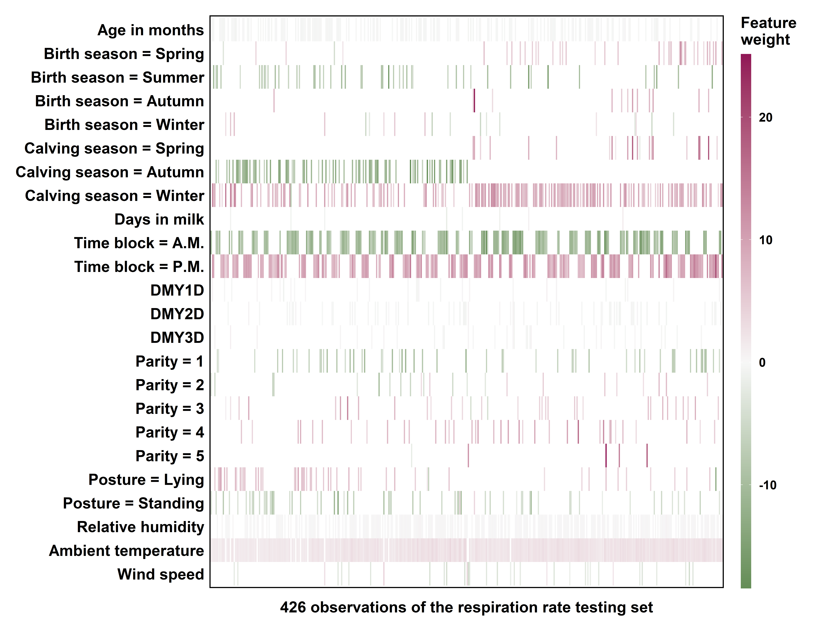Fig. 5. Local interpretation heatmap of the overall best respiration rate model (an artificial neural network) showing the influence of different predictor variables on the prediction of 426 observations of the testing set. The top five influential predictor variables that best explained each observation were used for plotting. DMY1D = daily milk yield of the day before the test day (kg/day); DMY2D = daily milk yield of the 2nd day before the test day (kg/day); DMY3D = daily milk yield of the 3rd day before the test day (kg/day).
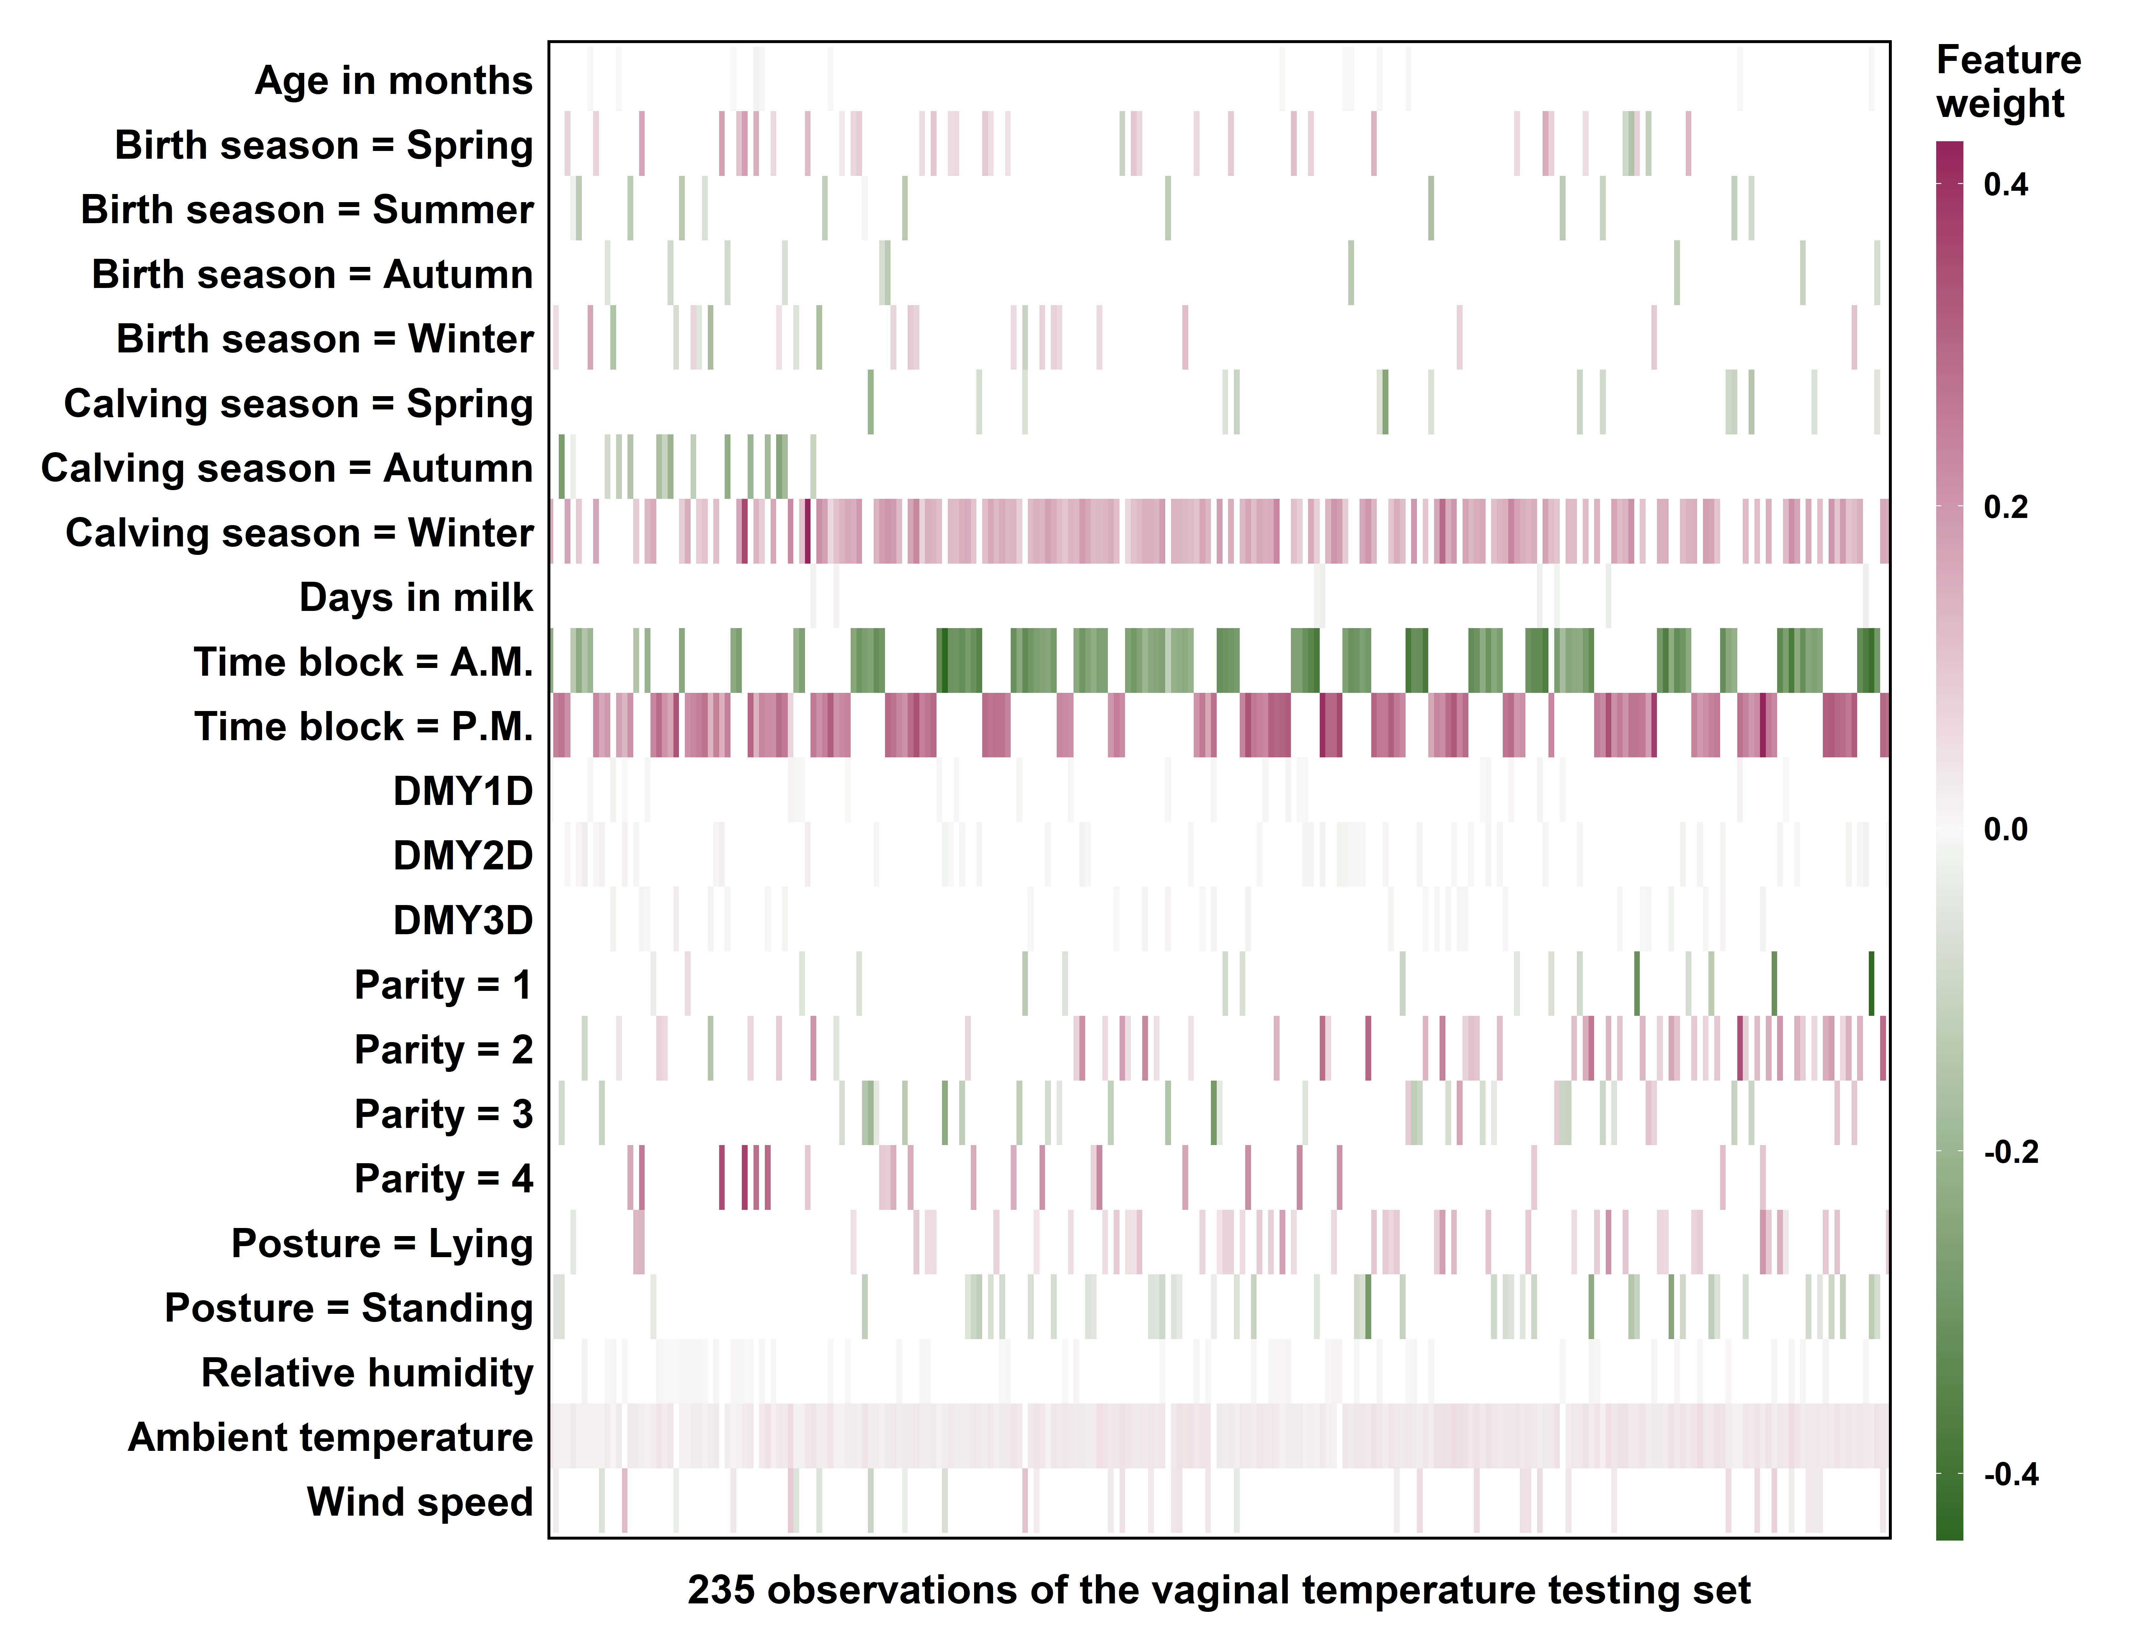Fig. 6. Local interpretation heatmap of the overall best vaginal temperature model (an artificial neural network) showing the influence of different predictor variables on the prediction of 235 observations of the testing set. The top five influential predictor variables that best explained each observation were used for plotting. DMY1D = daily milk yield of the day before the test day (kg/day); DMY2D = daily milk yield of the 2nd day before the test day (kg/day); DMY3D = daily milk yield of the 3rd day before the test day (kg/day).
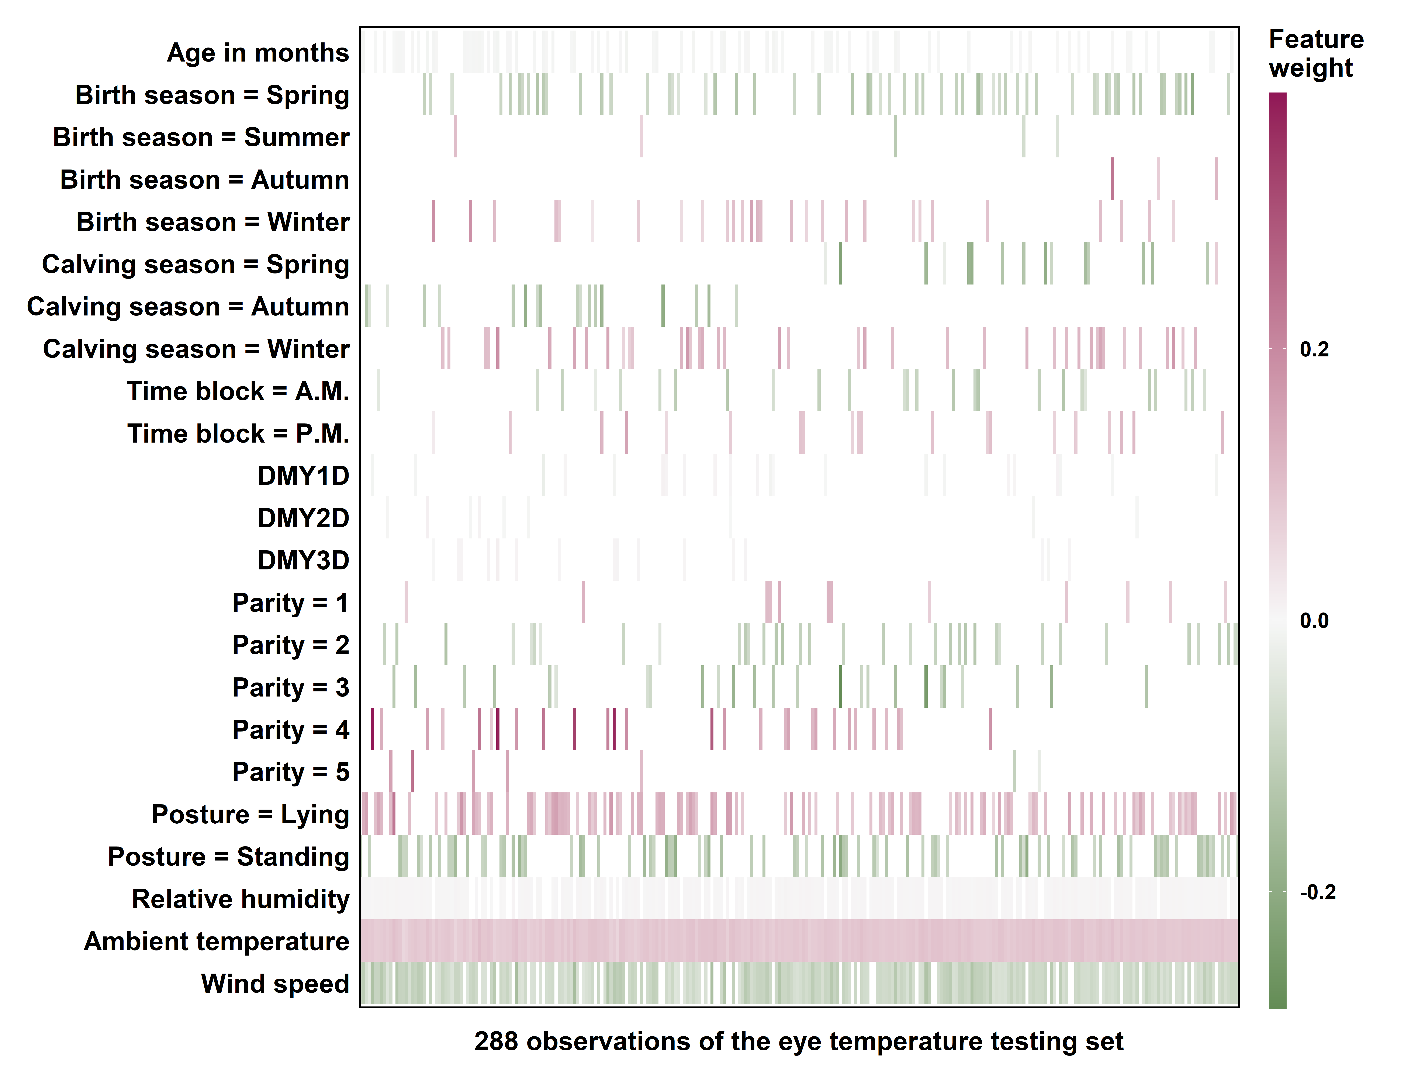Fig. 7. Local interpretation heatmap of the overall best eye temperature model (an artificial neural network) showing the influence of different predictor variables on the prediction of 288 observations of the testing set. The top five influential predictor variables that best explained each observation were used for plotting. DMY1D = daily milk yield of the day before the test day (kg/day); DMY2D = daily milk yield of the 2nd day before the test day (kg/day); DMY3D = daily milk yield of the 3rd day before the test day (kg/day).
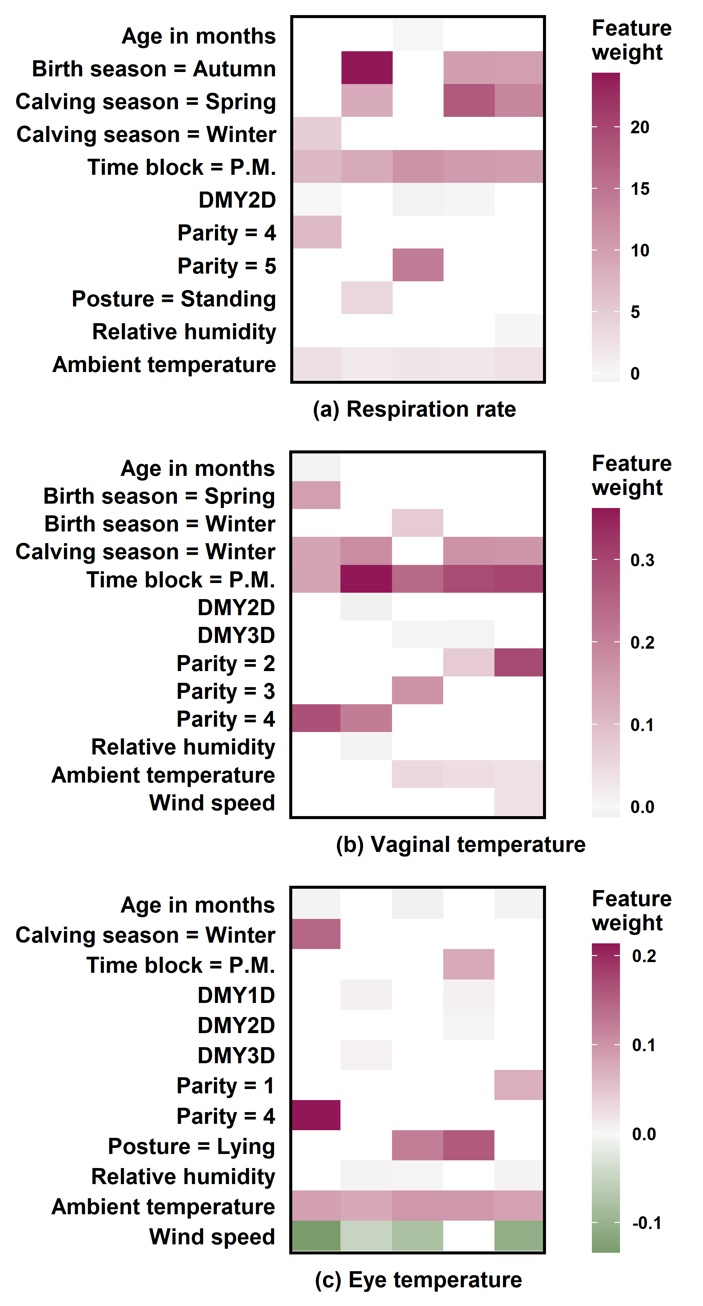
Fig. 8. Local interpretation heatmaps of the overall best models (artificial neural networks) plotting the top five influential predictor variables of five observations with the highest prediction selected from the testing set of (a) respiration rate, (b) vaginal temperature, and (c) eye temperature. DMY1D = daily milk yield of the day before the test day (kg/day); DMY2D = daily milk yield of the 2nd day before the test day (kg/day); DMY3D = daily milk yield of the 3rd day before the test day (kg/day).
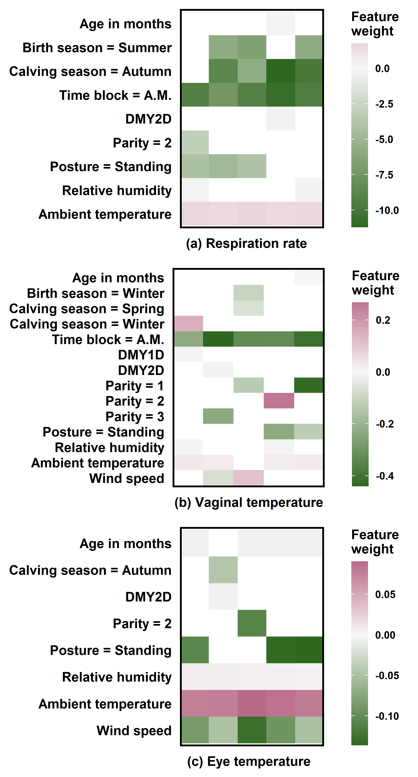
Fig. 9. Local interpretation heatmaps of the overall best models (artificial neural networks) plotting the top five influential predictor variables of five observations with the lowest prediction selected from the testing set of (a) respiration rate, (b) vaginal temperature, and (c) eye temperature. DMY1D = daily milk yield of the day before the test day (kg/day); DMY2D = daily milk yield of the 2nd day before the test day (kg/day).
Appendix A. Supplementary Material
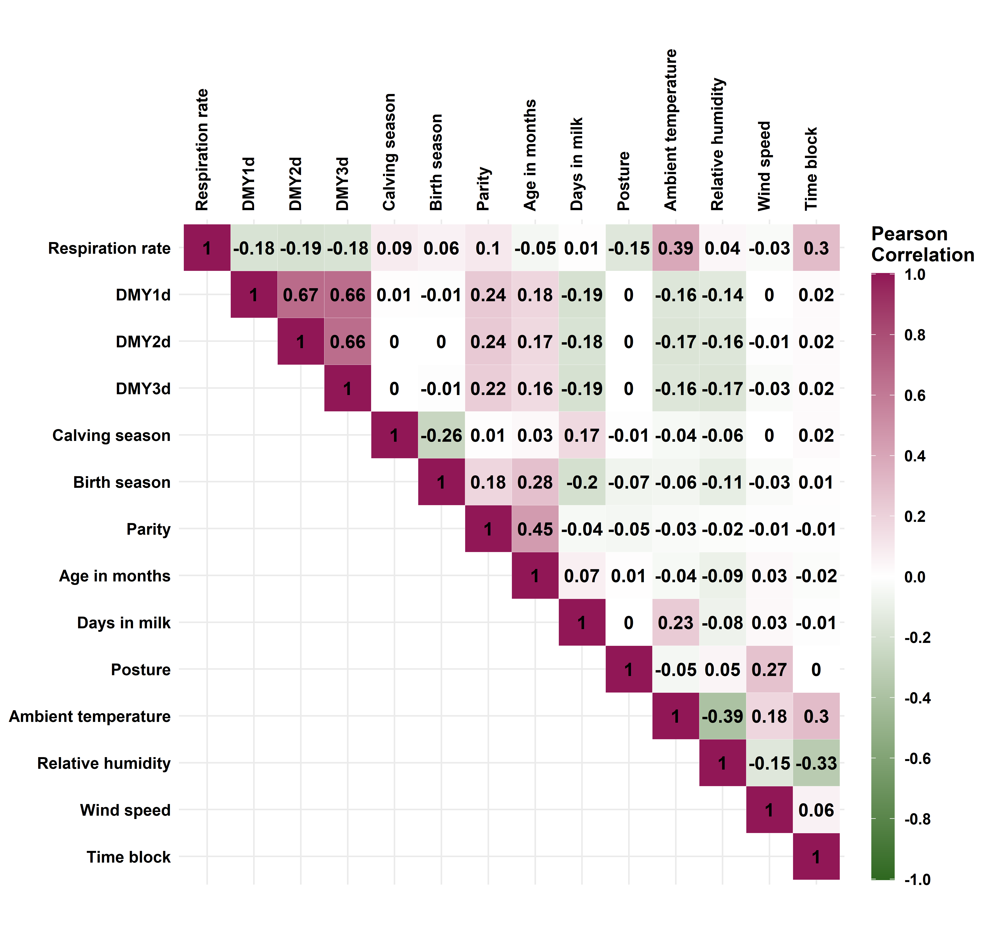
Fig. S1. Correlation heatmap of the respiration rate set (n = 2,910). DMY1D = daily milk yield of the day before the test day; DMY2D = daily milk yield of the 2nd day before the test day; DMY3D = daily milk yield of the 3rd day before the test day.
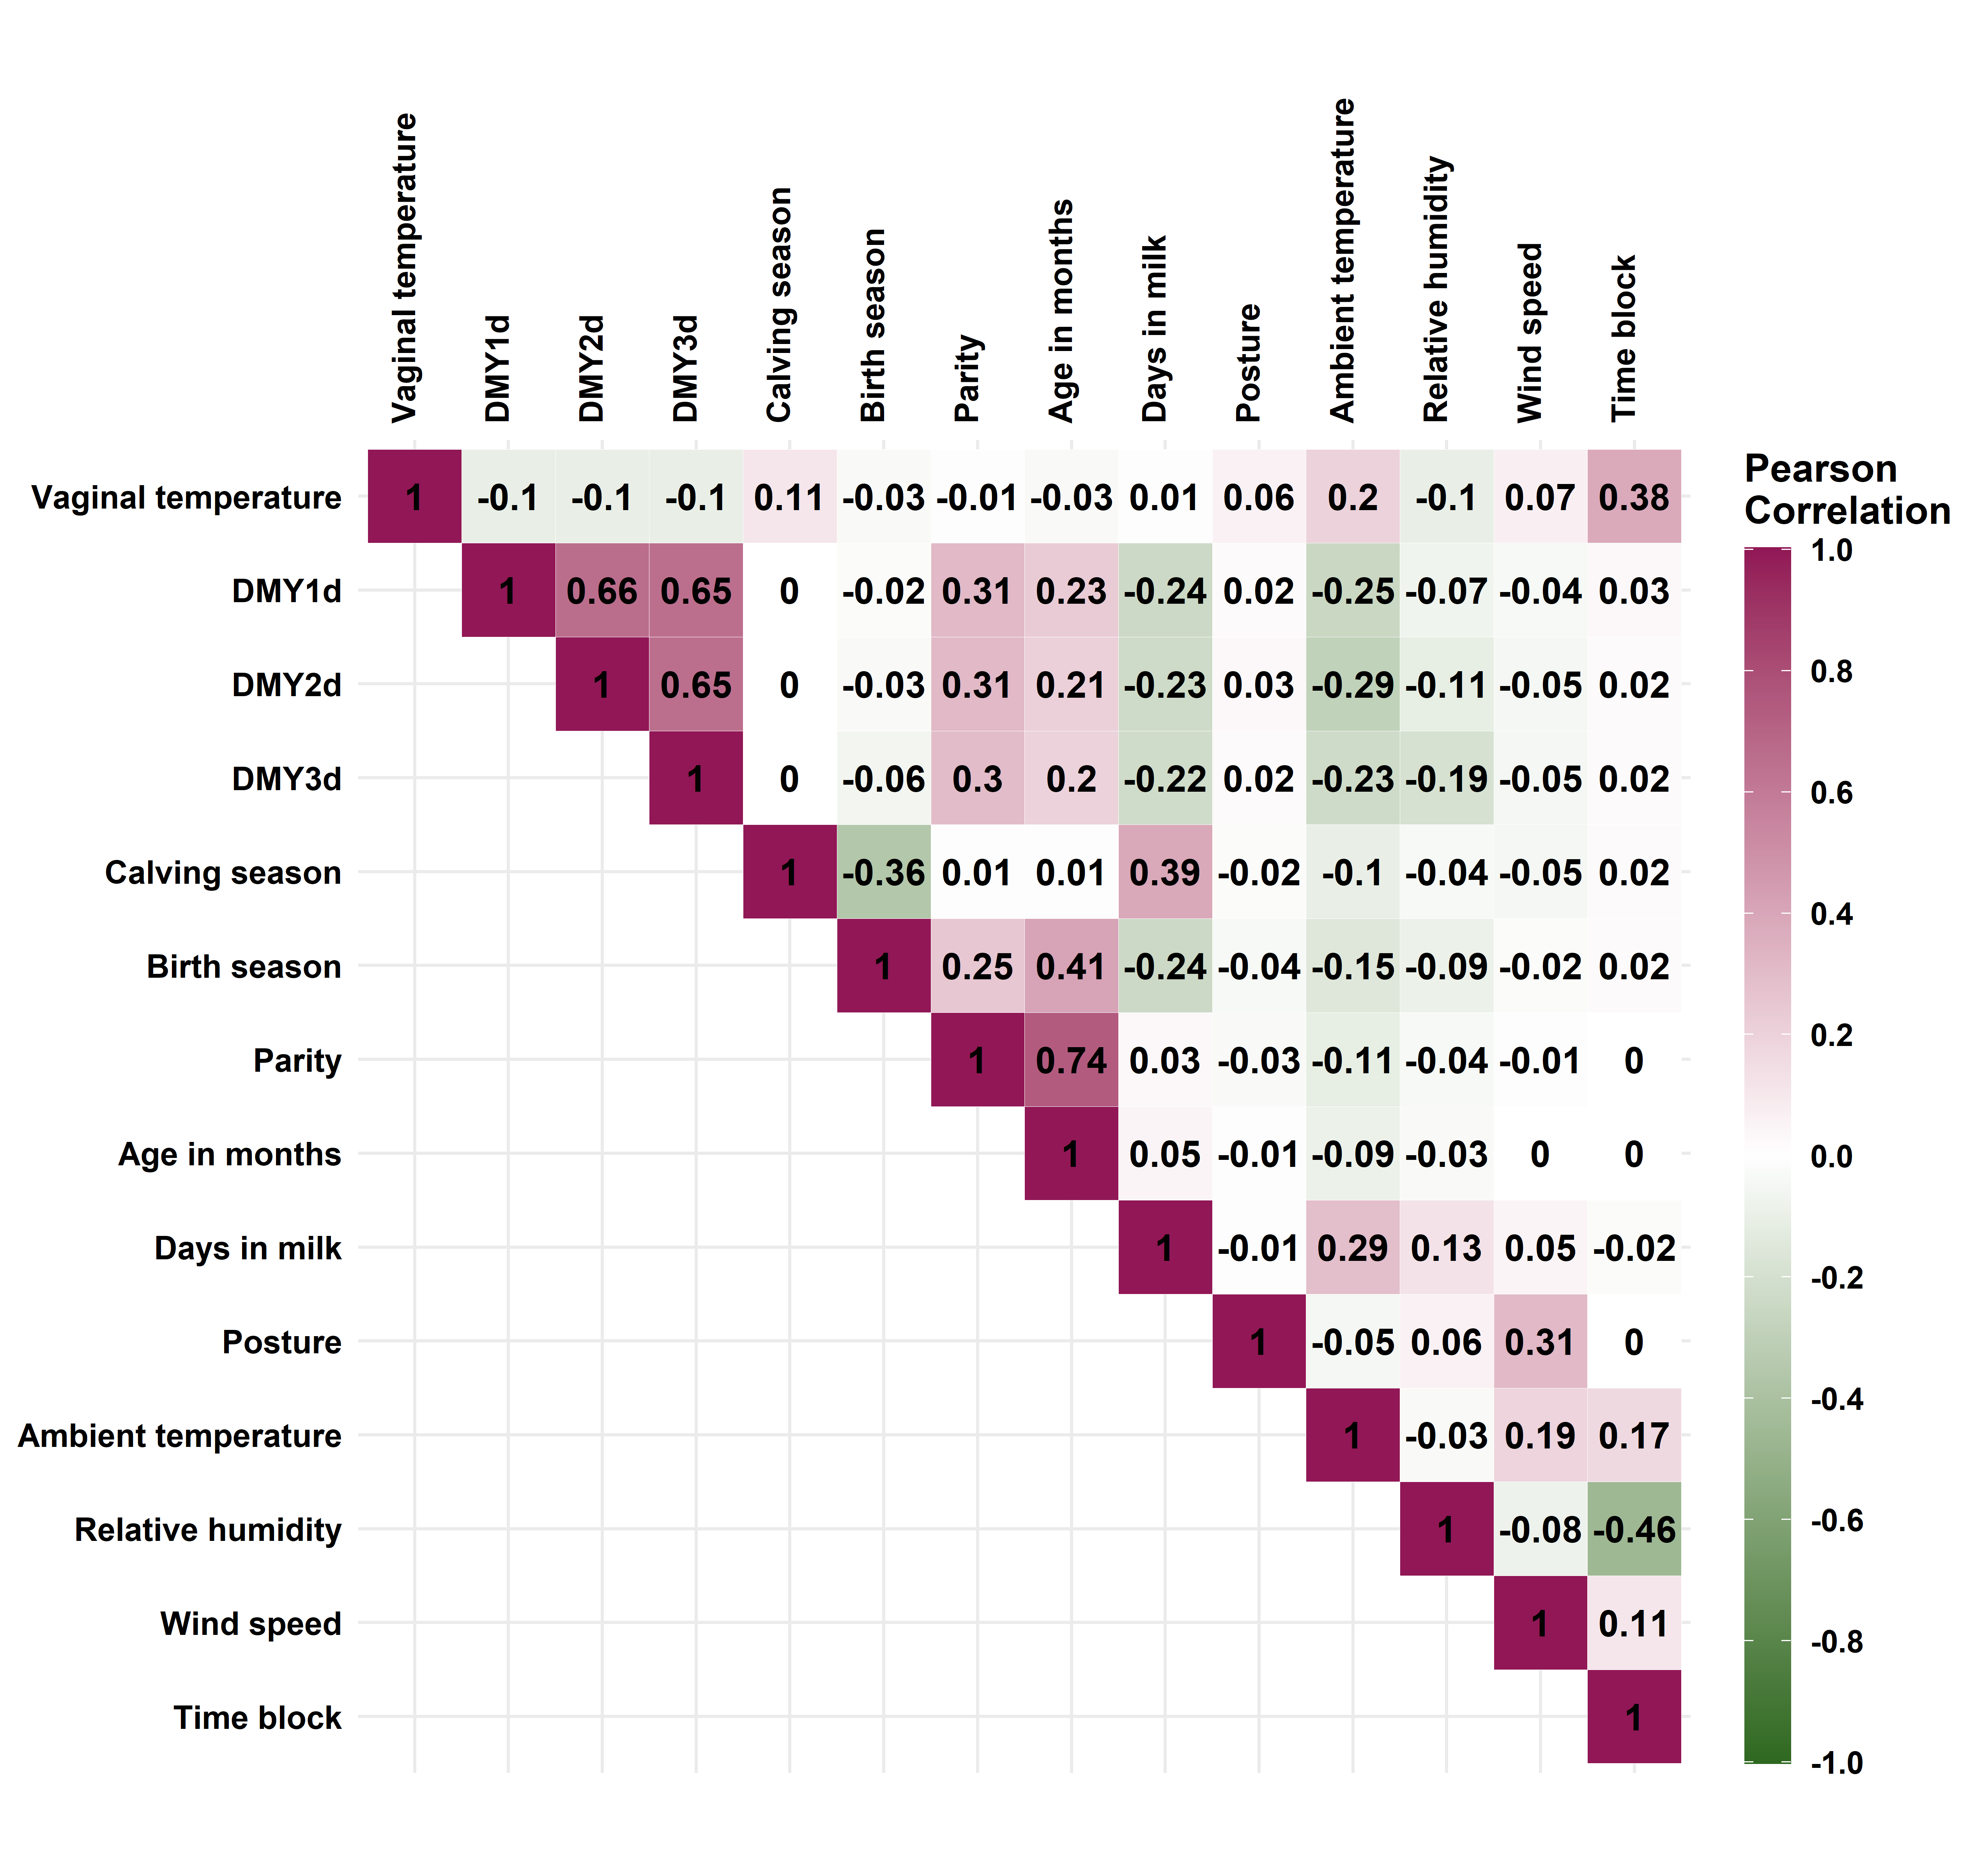
Fig. S2. Correlation heatmap of the vaginal temperature set (n = 1,561). DMY1D = daily milk yield of the day before the test day; DMY2D = daily milk yield of the 2nd day before the test day; DMY3D = daily milk yield of the 3rd day before the test day.
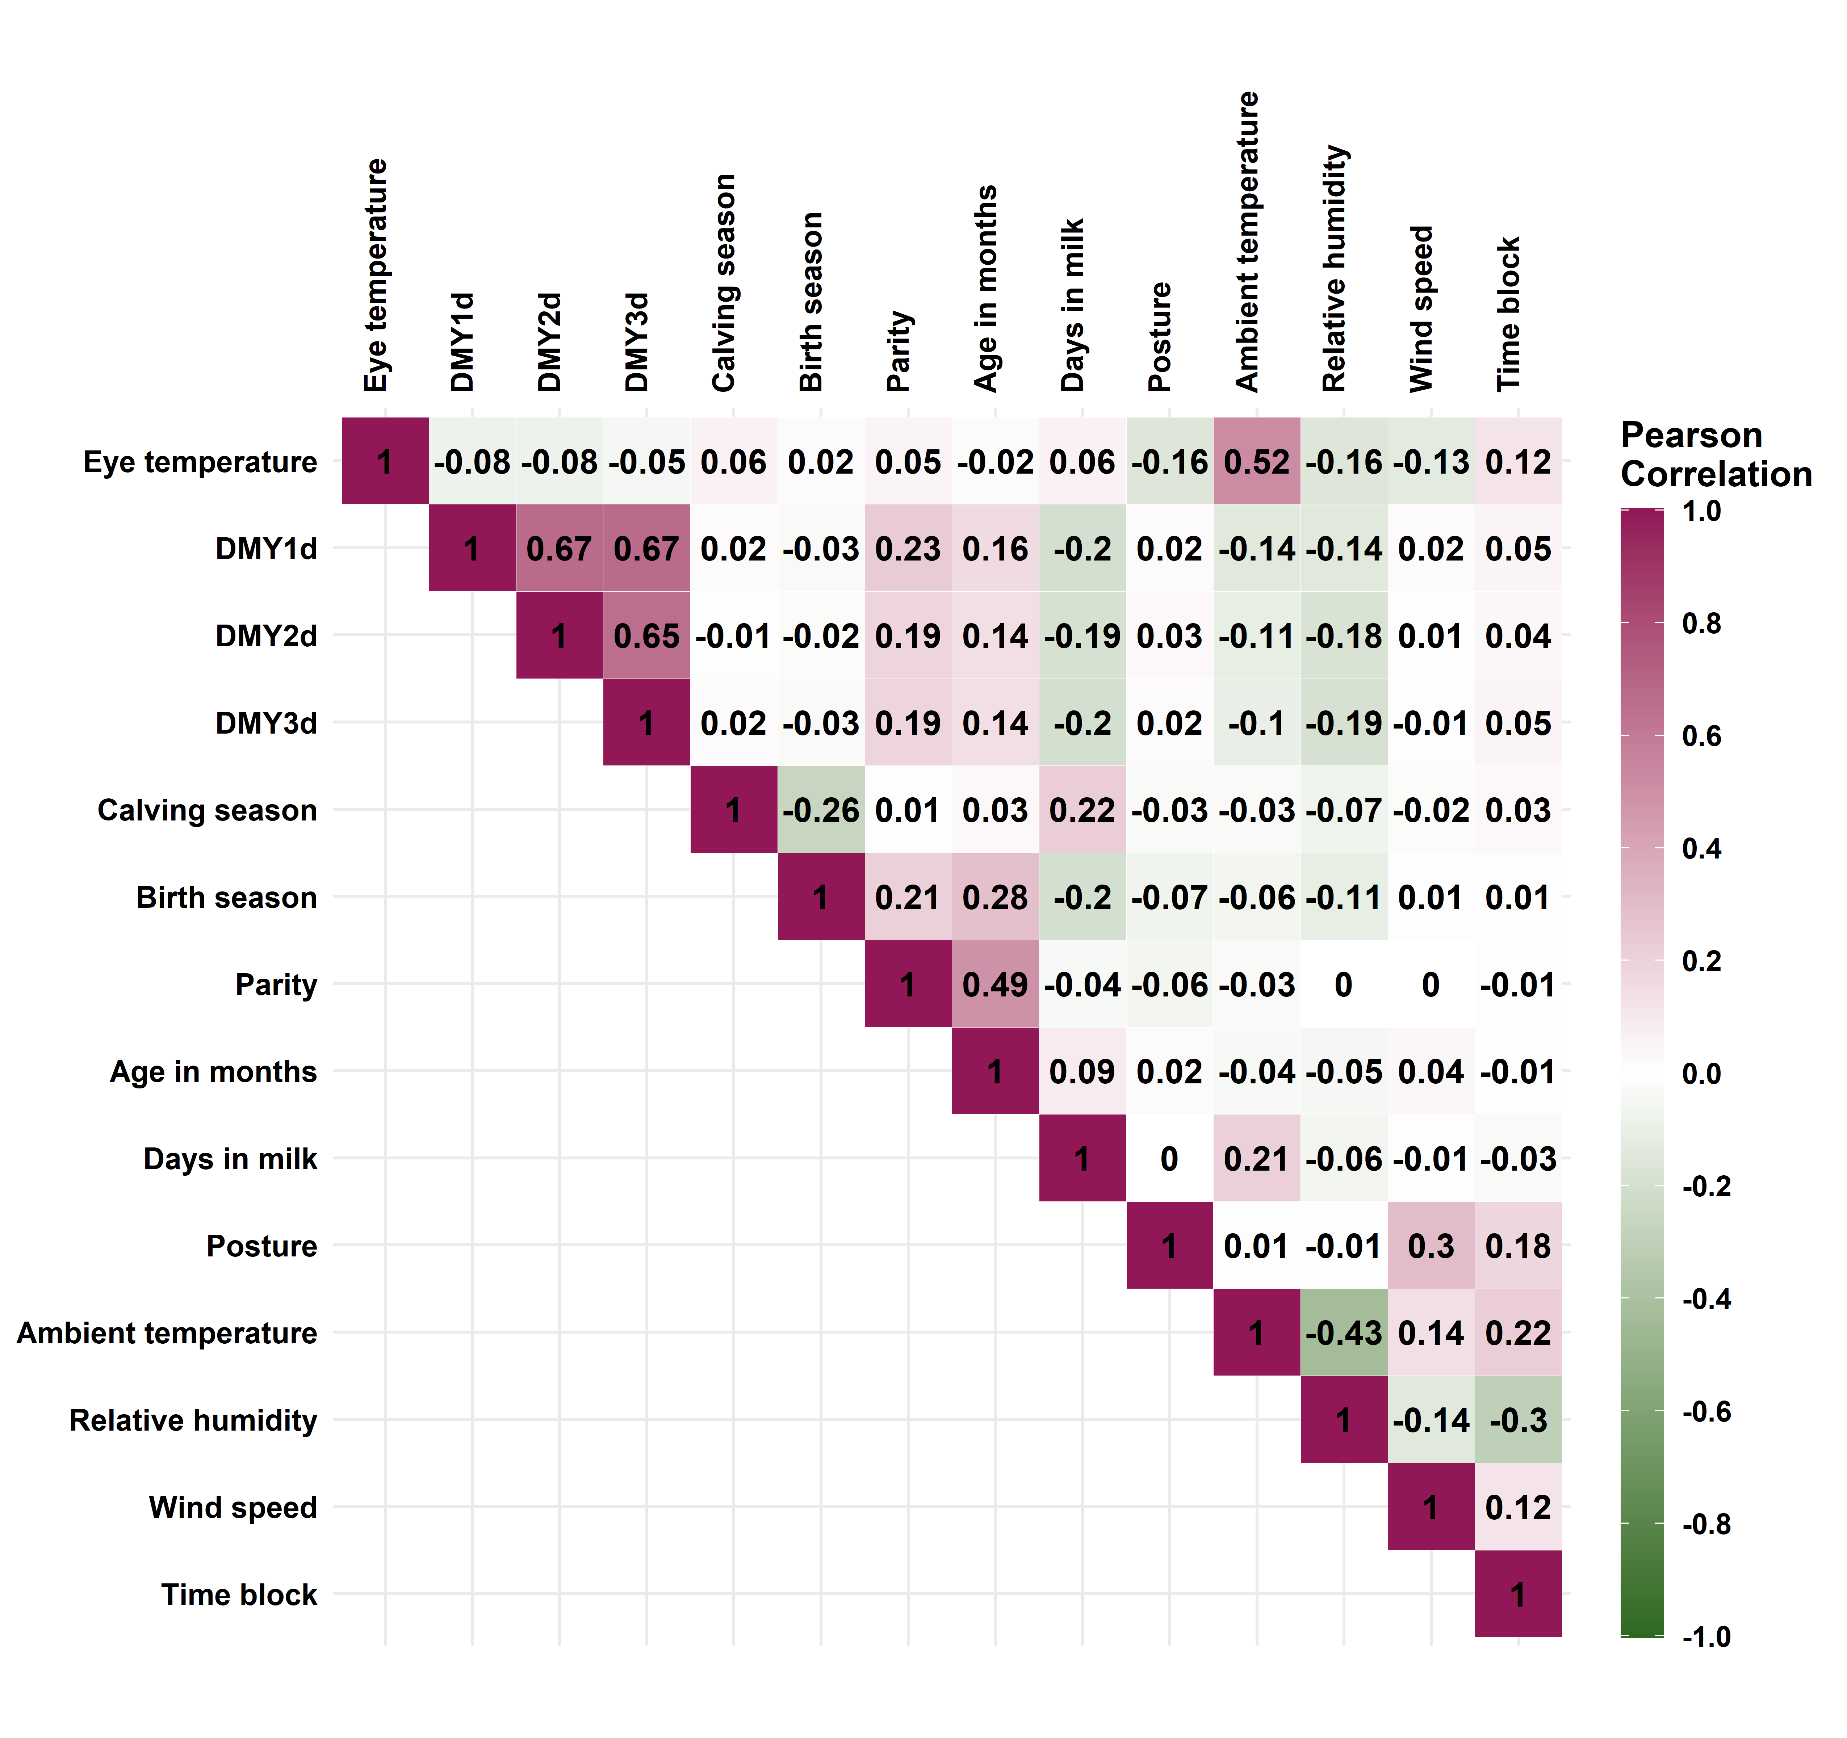Fig. S3. Correlation heatmap of the eye temperature set (n = 1,866). DMY1D = daily milk yield of the day before the test day; DMY2D = daily milk yield of the 2nd day before the test day; DMY3D = daily milk yield of the 3rd day before the test day.

Abbreviations: AIM, age in months; ANN, artificial neural networks; BST, body surface temperatures; CBT, core body temperatures; DIM, days in milk; DMY, daily milk yield; ET, eye temperature; ETIC, equivalent temperature index for cattle; GBM, gradient boosting machines; LIME, Local Interpretable Model-agnostic Explanations; ML, machine learning; RF, random forests; RH, relative humidity; RR, respiration rate; Ta, ambient temperature; THI, temperature-humidity index; THIadj, adjusted temperature-humidity index; VT, vaginal temperature; WS, wind speed

