Supplementary Material

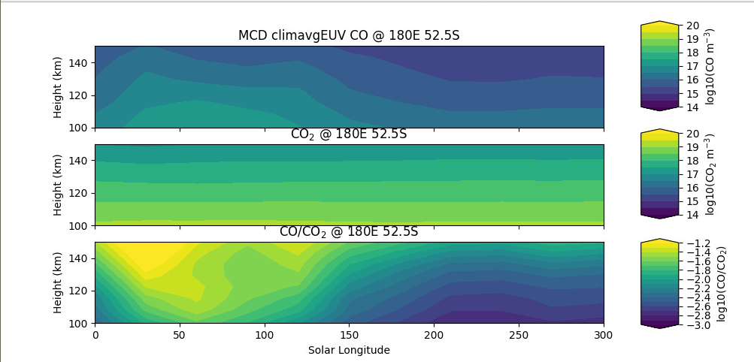

Seasonal variation of the lower thermospheric CO and CO₂ densities and CO/CO₂ ratio from the Mars Climate Database (MCD, González‐Galindo et al., 2009; Millour et al., 2010). The latitude is 52.5° S and the planetary longitude is fixed to 180°. The altitude ranges from 100 to 150 km.

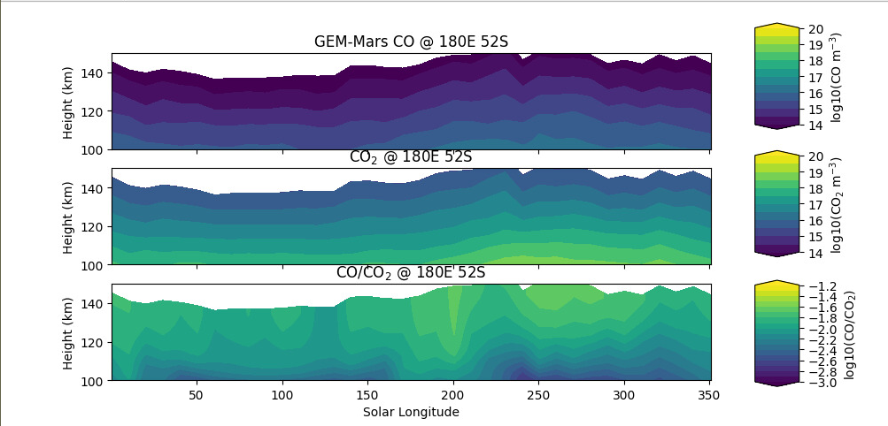
Same for the GEM-Mars model (Neary and Daerden, 2018; Daerden et al., 2019). Note the difference in the CO density and seasonal variation between the two models and the higher CO/CO₂ variability in the Mars Climate Database.

References

Daerden, F., L. Neary, S. Viscardy, A. García Muñoz, R. T. Clancy, M. D. Smith, et al. (2019), Mars atmospheric chemistry simulations with the GEM-Mars general circulation model, Icarus, 326, 197-224.

González‐Galindo, F., Forget, F., López‐Valverde, M. A., Angelats i Coll, M., & Millour, E. (2009). A ground‐to‐exosphere Martian general circulation model: 1. Seasonal, diurnal, and solar cycle variation of thermospheric temperatures. Journal of Geophysical Research: Planets, 114(E4).

Millour, E., Francois, F., Aymeric, S., Margaux, V., Vladimir, Z., Luca, M., et al. (2019). The Mars climate database (MCD version 5.3). Geophysical Research Abstracts, 21, EGU General Assembly 2019.

Neary, L., & Daerden, F. (2018). The GEM-Mars general circulation model for Mars: Description and evaluation. Icarus, 300, 458-476.

