The role of comprehensive two‑dimensional gas chromatography in mineral oil determination

Grégory Bauwens^{1*}, Aleksandra Gorska^{1*}, Giorgia Purcaro¹

- Analytical Chemistry Lab, Gembloux Agro-Bio Tech, University of Liège, Gembloux, Bât. G1 Chimie Des Agro-Biosystèmes, Passage Des Déportés 2, 5030 Gembloux, Belgium
* These authors contributed equally to the publication.

Keywords: Comprehensive two-dimensional gas chromatography (GC × GC) Food Hyphenated chromatographic techniques Mineral oil aromatic hydrocarbons (MOAH) Mineral oil saturated hydrocarbons (MOSH)

Abstract
Mineral oil hydrocarbons (MOH) contain a wide structural diversity of molecules, for which the reference method of analysis is the online coupled liquid chromatography-gas chromatography with flame ionization detection (LC-GC-FID). These com- pounds are very heterogeneous from a toxicological viewpoint, and an accurate risk assessment when dealing with a MOH contamination can only be performed if sufficient information is available on the types of structures present (i.e., number of carbons, degree of alkylation, number of aromatic rings). Unfortunately, the separation performances of the current LC-GC- FID method are insufficient for such characterization, not even mentioning the possible coelution of interfering compounds which additionally hinder MOH determination. Comprehensive two-dimensional gas chromatography (GC × GC), while mostly used for confirmation purposes in the past, starts to prove its relevance for overcoming the weaknesses of the LC-GC method and reaching even better the analytical requirements defined in the latest EFSA opinion. The present paper therefore aims at highlighting how GC × GC has contributed to the understanding of the MOH topic, how it has developed to meet the requirements of MOH determination, and how it could play a role in the field for overcoming many of the current analytical and toxicological challenges related to the topic.

Introduction

Mineral oil hydrocarbons (MOH) are a complex mixture of petrogenic origin formed by a large number of structural isomers and divided into two main fractions: mineral oil saturated hydrocarbons (MOSH), composed of linear, branched paraffins and alkyl-substituted cycloalkanes, and mineral oil aromatic hydrocarbons (MOAH), which include mainly alkyl-substituted (poly)aromatic hydrocarbons with a different number of fused rings [1]. Notwithstanding the already complex composition of the two fractions, the presence of the so-called MOH analog mixtures (such as poly- olefin oligomers or poly-alpha-olefin migrated from food contact material) may be detected, significantly complicating the interpretation of the results [2].
The analytical characterization and quantification of MOH are highly challenging issues that chemical analysts face. Interestingly, the determination of MOH has always been tightly related to multidimensional techniques. In particular, the hyphenated liquid chromatography-gas chromatography (LC-GC) technique and the understanding of the MOH problem have developed in mutual support, as detailed in a review by Sdrigotti et al. [3] published in early 2021. In that review, the role of comprehensive two-dimensional GC (GC × GC), among other hyphenated techniques, was briefly discussed as well. GC × GC had always been mentioned as a powerful tool but perceived as immature for routine analysis. More recently, evolutions in the way of applying GC × GC in the field of MOH are setting a change in the overall analytical flowchart for MOH. Indeed, since the publication of Sdrigotti et al., the role of GC × GC has significantly changed, and it has opened new perspectives.
Therefore, the goal of this review is to critically highlight the role that GC × GC has played and will play in the determination and understanding of the MOH issue. The review will first set the frame of the MOH in the European Union, giving a brief overview of the toxicological aspects, where GC × GC already has played a critical role. A brief summary of the routine analytical method for MOH determination is described to provide the background for discussing the role of GC × GC in more detail.

MOH within the European Union frame

The presence of MOH in food has been known since the 1990s [4], when the presence of batching oil was found by chance in a hazelnut sample analyzed for determining the presence of by-products due to the irradiation process [5]. Nevertheless, the concern and the attention of the authorities and consumers started rising in 2008/2009 following the scandal of highly contaminated sunflower oil from Ukraine and the migration of a high amount of MOH from recycled paper packaging [6, 7]. In 2012, the European Food Safety Authority (EFSA) published an opinion on MOH in food, highlighting the topic’s urgency [8]. The lack of detailed toxicological information and the complexity of the analytical determination, along with the necessity of improving the analytical methods, were reported. The hyphenated LC-GC- FID method was pinpointed as the most effective method for routine analysis although it did not give the possibility of a more detailed characterization of the sub-classes, for which GC × GC was timidly suggested.
In an attempt to acquire additional and systematic information, in 2017, the European Union (EU) required the col- lection of more data on a list of food commodities (Commission Recommendation 2017/84 [9]). The collection of data was required according to the guidance that was published only 2 years after, in 2019, by the Joint Research Center (JRC) [10]. This guidance indicates the analytical procedure to use based on a decision tree, which specifies whether or not to apply one or more additional purification techniques for the MOSH or MOAH fraction and clearly indicates the use of GC × GC-FID/MS in case of doubts on the origin of the contamination. Despite the indications provided by the decision tree, the results’ uncertainty remained significant [11, 12], pinpointing the necessity of developing standardized methods for different matrices. This guidance is expected to be updated soon to improve the standardization of the overall analytical process and provide additional support in data interpretation.
In 2019, a new scandal followed after the publication by Foodwatch on the presence of MOAH in infant and follow- on formula [13], followed by a Rapid Alert System for Food and Feed (RASFF) procedure to recall contaminated prod- ucts. Shortly after, the EFSA published an opinion highlighting the high uncertainty in the data provided and the need to quantify the most concerning 3–7-ring MOAH sub-fraction [14]. Since then, no methods have been validated for quantifying the 3–7 rings, but the JRC, following the request of the Directorate General for Health and Food Safety (DG SANTE) of the European Commission, has organized a series of interlaboratory trials to harmonize and validate a method for the determination of MOAH in infant formula [15, 16]. The final report is expected soon.
From the viewpoint of the standardized methods available for MOSH and MOAH determination in food, the method proposed by Biedermann et al. in 2009 [1] has been slightly modified into the official EN 16995:2017 for the determination of MOSH and MOAH in oils and vegetable fats [17]. The main limitation of such a method is the quantification (LOQ) limit of 10 mg/kg. In order to lower this limit, the German Society for Fat Science (DGF) and the French Tech- nical Institute for the Study and Research of Fats (ITERG) have organized an interlaboratory trial, and the validated method, with LOQs of 3 mg/kg for the MOSH fraction and 2 mg/kg for the MOAH fraction, has just been accepted (ISO/CD 20122, March 2023) by the International Organization for Standardization (ISO) to update the original method (https://www.iso.org/standard/86091.html?browse=tc).
Nevertheless, the limited information related to the risk assessment and the still poor robustness of the analytical methods had prevented the setting of a limit until April 2022 when the Standing Committee on Plants, Animals, Food and Feed (SCoPAFF) section issued a statement reporting the maximum acceptable limits of MOAH as equal to the LOQs reported in the JRC Guidance [10], i.e., 0.5 mg/kg for dry food (≤ 4% fat/oil), 1 mg/kg for foods with high fat/oil con- tent (i.e., > 4%), and 2 mg/kg for fats/oils [10].

Toxicity of mineral oil hydrocarbons

A main question that needs to be addressed when dealing with chemical contaminants is their impact on human health. For mineral oils, this question is particularly tricky. As a reminder, the terms MOSH and MOAH are related to the two “humps” that are obtained during chromatographic analysis by LC-GC-FID [1, 18], and their composition is defined with a relatively poor specificity. From a toxicological view- point, MOSH and MOAH are anything but homogeneous and two different types of MOSH or MOAH compositions may have different toxicological effects [19]. A thoughtful discussion of the toxicological aspects is out of the scope of this paper; the reader is directed toward the new EFSA Opinion that has been just published for public consultation (https://connect.efsa.europa.eu/RM/s/publicconsultation2/a0l09000006qqHf/pc0400). Here, briefly, the most important aspects are reported, while emphasis is given to the role of GC × GC in supporting the reported findings.
In the case of MOAH, the number of aromatic rings and the type and degree of alkylation significantly impact the toxic potential. Polycyclic aromatic compounds (PACs) containing 3 to 7 aromatic rings and with no or low degree of alkylation are those of major concern as they have been associated with carcinogenicity [8], mutagenicity [8, 20], and detrimental effects on prenatal development [21–23]. On the contrary, mono- and diaromatics and highly alkylated compounds are presumed to be of lesser concern since they are not metabolized into DNA-reactive species [8, 14]. It appears evident that the ability to determine the occurrence of the different sub-class of MOAH in the exposure sources, particularly food, is highly important. The critical role of GC × GC to achieve such a level of characterization is discussed in The role of GC×GC in the analytical characterization of MOH. Hochegger et al. [24] combined toxicological tests using a miniaturized Ames test (i.e., a biological assay that uses histidine auxotrophic Salmonella strains to assess the mutagenicity of a chemical species) on different MOAH sub-fractions separated based on the number of rings using an LC donor–acceptor chromatographic method [25]. Each sub-fraction was carefully characterized by GC × GC to pro- file the distribution of rings and the degree of alkylation. While a mid-polar × apolar column set was used, the authors of the present paper suggest that an apolar × polar column set may better characterize the studied MOAH sub-fractions and provide a better understanding of the structural characteristics of potentially toxic fractions. The outcomes in terms of separation power using different column configurations are discussed in more detail in “The role of GC×GC in the analytical characterization of MOH.”
The combination of both the enhanced separation power of GC × GC and toxicity tests is needed and could be the key to the performance of more accurate risk assessments [20, 26]. The outcomes could steer toward a more specific MOAH sub-fraction to be monitored routinely in food, possibly simplifying the analytical flowchart. This approach could also provide a better understanding of the physiological processes occurring when exposed to such complex contaminants.
Contrarily, MOSH can differentially accumulate in human tissues [19, 27]. In experiments on Fischer 344 rats, MOSH are mainly accumulated in the liver and to a lesser extent in adipose tissue, although in the former case accumulated MOSH quantities decreased when the exposure was ceased, while in the latter it remained constant [2]. In human studies, the highest MOSH concentration was found in lymph nodes, followed by the liver [28, 29]. Initially, the accumulation of MOSH was associated with the formation of lipogranulomas in Fischer 344 rats, but it was then found not relevant for humans.
In this context, GC × GC has significantly contributed to the understanding of the differential accumulation in humans [29], in Fischer 344 rats [30, 31], and in Sprague Dawley rats [26]. Indeed, while the distribution of the accumulated MOSH in terms of C-number can be easily derived by the LC-GC-FID analysis, GC × GC has provided a better insight on the structural MOSH characteristics that affect the accumulation of MOSH. In fact, not all MOSH accumulate; those that have a carbon number below C20 are quickly absorbed and metabolized, while MOSH above C35 are less able to pass through cellular membranes and are thus less bioavailable. So, in reality, only C20–C35, and more specifically the naphthenic compounds of that carbon number range, are the MOSH that are mostly retained in the human body [26, 27, 30, 31]. The first work studying the differential accumulation was published in 2015 by Biedermann et al. using GC × GC to achieve the required sub-class characterization [29]. This study also defined the routinely applied column set, i.e., mid-polar × apolar, which has been used from then on. The selection of the column set was based on the better separation of the MOSH fraction in the 2D space, thus allowing for the easy differentiation between normal and branched paraffins, multibranched paraffins, and polycyclic naphthenes, as shown in Fig.1.

Routine analytical determination of MOH

The reliable determination of MOSH and MOAH is a particularly challenging task, which not only requires advanced chromatographic techniques, but also needs dedicated extraction and purification steps, a very careful manipulation, solvent and reagent selection (to avoid cross-contamination and high blank levels), and a careful interpretation of the chromatogram to integrate and quantify correctly. For a complete overview of all the methods proposed over the years to optimize the different steps of the method flow- chart, the readers are directed toward specific reviews [3, 18, 32–35]. Only the fundamental steps of the methods mainly applied at present will be discussed herein.
As a general rule, sample manipulation should be maintained at a minimum to minimize the contamination of the blank and increase the reproducibility of the results [10].
The overall procedure is highly sample dependent, ranging from a simple dilution to a long and rather tedious sample preparation method comprising extraction, enrichment, and interferent removal before the final LC-GC-FID determination. The use of the completely hyphenated LC-GC- FID platform is preferred over offline techniques since it is less prone to cross-contamination, fully automated, and more sensitive since all of the fraction of interest is transferred into the GC-FID.

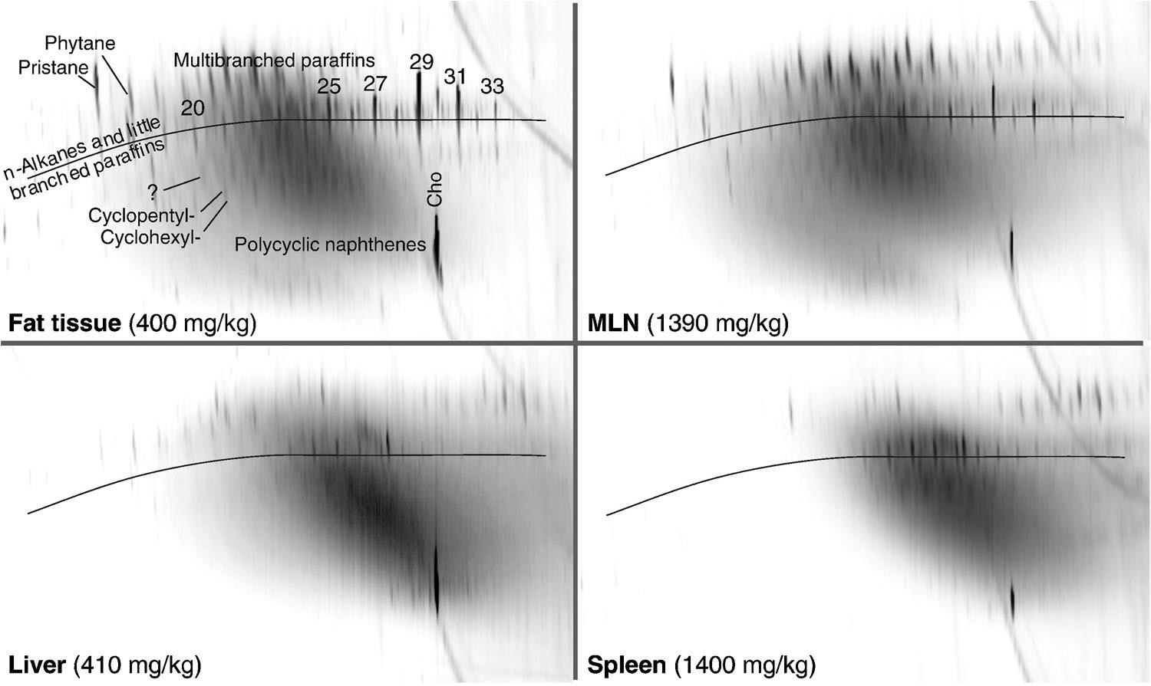
Fig. 1 GC × GC-FID plots of MOSH obtained from four tis- sues of the same male subject. Reproduced with permission from [29]

As aforementioned, each additional step adds to the blank contribution and uncertainty of the results. To harmonize the diverse procedures and thus ensure higher reproducibility of the results, the JRC included in the Guidance published in 2019 [10] a decision tree explaining when and whether to apply an additional step (named auxiliary methods). These auxiliary methods refer to (i) enrichment when the required LOQ is not reached, (ii) clean-up in aluminum oxide to remove the naturally present n-alkanes eluted in the MOSH fraction, and (iii) epoxidation to remove biogenic olefin mainly from the MOAH fraction. These three additional steps are herein briefly described.

Enrichment
Enrichment can be performed with a simple extract concentration before injection in the LC-GC-FID, but more often involves an offline LC pre-separation or a saponification step to remove the triglycerides. Generally, the limit in the LOQ is determined by the capacity of the LC silica column coupled to the GC-FID system. The role of the LC column is to retain triglycerides (or other polar substances) while allowing the elution and separation of the MOSH and MOAH fractions. In the online setup, a 250-mm × 2-mm- i.d., 5-μm d_{p} Lichrosphere silica column is used, which has a capacity limited to 20 mg of fats to leave sufficient chromatographic separation space and also to separate the MOSH and the MOAH efficiently [1]. Therefore, when analyzing highly fatty food, such as edible fats and oils, removing the bulk of the triglycerides before the injection in the LC-GC-FID system is required to reach the desired LOQ. This enrichment can be done by exploiting a more retentive sorbent, such as using a solid-phase extraction (SPE) cartridge packed with activated silica [36, 37] or with an additional LC purification [38]. The latter is performed offline on a silica column of wider diameter (i.e., 250-mm × 4.6- mm i.d., 5 μm d_{p}) that can retain up to ~ 10 times more fat (~ 150–200 mg), but the hydrocarbon fraction is eluted in 6 mL of solvent, thus making the online coupling challenging to optimize. A more common alternative is the use of a saponification step simultaneously or after the extraction [33, 34, 39]. In this context, microwave-assisted extraction allows maximizing the throughput and the extraction yield [40–44]. Nevertheless, when saponification is applied, the partition of the internal standards used for quantification changes, therefore impacting the accuracy of the results [44].

Activated aluminum oxide

Activated aluminum oxide, commonly called Alox clean-up, is used to remove naturally occurring n-alkanes. They can be recognized from their distribution in the C21 to C33 range with the prevalence of the odd C numbers over the even ones. This auxiliary step must be performed only when the natural alkanes overload the GC column (which leads their peaks to mask part/all of the MOSH hump) hindering a correct definition of the MOSH hump; contrarily, they can be subtracted from the integration of the hump [45]. The purification can be done automatically by sending the MOSH fraction into a secondary aluminum oxide column (10 cm × 2 mm i.d., 63–200 μm) activated at ~ 400 °C, which retains the long-chain n-alkanes. The column can then be repristinated by washing it in backflush with iso-octane.

Epoxidation

Epoxidation is the auxiliary step applied to remove naturally occurring olefins, such as squalene, carotenoids, and sterenes. While it is sometimes possible to cope with their presence by not integrating the associated peaks, it becomes impossible when these olefins overload the GC column (as for alkanes in the MOSH fraction), or when they form humps that need to be distinguished from the one of MOAH (Fig. 2) [46]. The presence of these compounds is particularly critical when edible oil (as such or used as an ingredient) under- goes a refining process; indeed, they form a generally narrow hump superimposed on the MOAH hump impacting its reliable quantification [1, 46]. In these cases, an interference-removal procedure must be implemented, and derivatization was suggested. Several approaches have been tested, such as hydroboration [47], bromination [48], bromohydrin reaction [47], and epoxidation. Epoxidation was the only method retained because of its higher selectivity and better capacity to remove the olefins, becoming the accepted routine method for removing the interferences [10]. Epoxidation is a chemical reaction in which an alkene (i.e., the nucleophile) reacts with an oxidizing agent (i.e., the electrophile) such as a per- acid or hydrogen peroxide or an organic hydroperoxide to form an epoxide. Compared to the native alkene, the formed derivative has a higher polarity, resulting in stronger retention during the LC chromatographic separation, thus eluting beyond the MOAH fraction [1, 46, 47, 49]. This process is critical as, on one hand, it can cause the loss of 20–35% of the MOAH [46] and, on the other hand, the removal of the interference may not be exhaustive, thus unpredictably affecting the quantification of the MOAH. This auxiliary step is discussed further in “The role of GC×GC in the analytical characterization of MOH” as GC × GC has been playing an important role in increasing the understanding of what is occurring during this reaction.

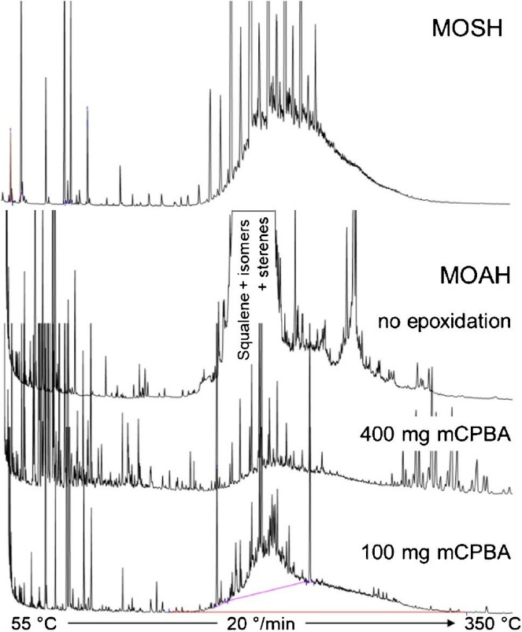

Fig. 2 MOSH and MOAH LC-GC-FID trace obtained from olive pomace oil. Biogenic olefins are clearly present in the MOAH fraction when not submitted to epoxidation. The two bottom chromato- grams show the removal obtained when epoxidation is performed with different amounts of mCPBA. Reproduced with permission from [46]

LC‑GC‑FID

The analytical method of choice for the characterization and quantification of MOSH and MOAH is the online method developed by Biedermann and Grob in 2009 [1]. The method exploited the use of a retentive silica LC column of 25 cm × 2.1 mm and 5 μm d_{p} where MOSH are eluted with barely any retention, followed by the MOAH, while the triglycerides are retained and removed by backflushing with dichloromethane. A bunch of internal standards in precise concentrations was added for quality control of the LC separation to verify the performance of the trans- fer into the GC and to quantify the MOSH and the MOAH humps. The original standard mixture was later adapted to limit coelution problems in the GC and simplify the identification of the standards in the GC chromatogram [32]. Therefore, the standard mixture routinely used today (and commercialized for this purpose) includes n-undecane (C₁₁), n-tridecane (C₁₃), bicyclohexyl (CyCy), and cholestane (Cho) eluted in the MOSH fraction and 1-methylnaphtha- lene (1MN), 2-methylnaphthalene (2MN), n-pentylbenzene (5B), 1,3,5-tri-tert-butylbenzene (TBB), and perylene (Per) eluted in the MOAH fraction. C₁₁ is used to verify (by having a ratio of 1 with CyCy) that no losses of the most volatile fraction occur during the partially concurrent solvent evaporation step that allows the transfer of a large volume of LC eluent (450 µL) into the GC. CyCy is used as the internal standard for the quantification of the MOSH hump, and the absence of coelution is verified by the CyCy:C₁₃ ratio (2:1). Finally, Cho had been considered the marker of the end of elution of the MOSH fraction from the LC column, but in a later publication, it was proven that CyCy is actually more retained than Cho due to the size exclusion effect [50]. Although still in use since part of the commercially available standard mixture, the use of Cho is obsolete.
On the MOAH fraction, 5B is used as C₁₁ to exclude a loss of volatile during the transfer, and 1MN and 2MN are used to verify the presence of coeluted compounds on the quantification the standard (TBB or 2MN). Finally, it was proposed that TBB and Per be used to mark the window of elution of the MOAH fraction from the LC column. But, in the same publication discussing the most appropriate use of CyCy as a marker for the MOSH, it was highlighted that TBB is not the most suitable choice to mark the start of the MOAH fraction. It was indeed shown that 1,4-di(2- ethylhexil)benzene (DEHB) is a more suitable marker than TBB, reflecting more accurately the aging of the column in terms of retention of the MOAH fraction. However, DEHB elutes in a crowded area of the GC chromatogram, and it should be verified on a separate run. Therefore, so far, TBB is preferred.
Finally, the fraction from the LC is transferred into a retention gap connected to a solvent vapor exit and the analytical GC column. The fraction is evaporated through the partially concurrent eluent evaporation mechanism (explained in detail elsewhere [32, 51, 52]) before closing the solvent vapor exit and starting the GC-FID analysis. Care must be taken on the optimization of the transfer conditions to avoid the loss of the most volatile compounds through the solvent vapor exit. It should also be noted that with certain types of samples, complete transfer of the LC fraction into the retention gap can cause the buildup of high-boiling- point material in the retention gap which affects the chromatographic performances by causing discrimination and splitting of the peaks. When such effects are observed, it is necessary to replace the retention gap.
MOSH and MOAH generate a UCM, generally called a “hump.” Modern instruments transfer both the MOSH and the MOAH fractions into two parallel retention gaps before starting the chromatographic run, thus simultaneously generating the two chromatographic traces.

Data interpretation and integration

Although the analytical method is wisely designed and highly performant, limitations still remain. In fact, the integration of the MOSH and MOAH hump is not straightforward, especially when riding peaks and superimposed humps appear. Moreover, the information that can be derived is limited to the total MOSH or MOAH fraction. More detailed information, such as sub-class profiles (e.g., the distribution of MOAH according to the number of rings), cannot be obtained. The JRC published a report to explain and support a correct integration and interpretation of the results [16]. Indeed, expert and highly trained analysts are needed. Background subtraction, baseline correction, and riding peak removal are required, and these procedures are anything but straightforward. The baseline correction should take into account the offset and the column bleeding, and the trimming of the riding peaks should be done after evaluation of their source based on the knowledge of the sample and the specific chromatographic pattern (e.g., the distribution of even and odd alkanes, width of a superimposed hump, etc.). A thoughtful discussion is reported in the mentioned report by the JRC where several examples are discussed [16], but previous literature also discussed the riding peak removal (e.g., [18]).
GC × GC plays a critical role in overcoming these limitations. Indeed, it allows the chromatographic removal of the bleeding from the area of interest as the former has no retention in the secondary column. Some of the interferences that normally coelute on top of the MOSH/MOAH hump are chromatographically separated, thus not requiring trimming and analyst interpretation. Finally, the 2D or even 3D visualization supports the interpretation of the chromatographic pattern, simplifying the integration of the riding peaks for their removal. All these points are described in more detail in the following section.

The role of GC × GC in the analytical characterization of MOH

GC × GC is a powerful technique, introduced in 1991 by Liu and Phillips [53], which has promptly gained attention and diffused toward many fields of applications. A thoughtful description of the technique is out of the scope of this review; for a deeper insight into this technique, the readers are directed toward specific literature, such as [54–56]. The use of GC × GC allows for an increase in sensitivity, an enhancement of the separation power, and the obtention of well-ordered two-dimensional (2D) plots with a defined group-type separation. Despite the widely proven advantages of GC × GC, its use at the routine level is still limited due to the initial cost of investment and its perception as a complicated technique. However, when considered in relation to the challenges associated with MOH analysis, these limitations are neglectable compared to the advantages provided in terms of confidence in the data generated. Moreover, when comparing the technical complexity of running LC-GC or GC × GC, it is the authors’ opinion that GC × GC is far easier regarding troubleshooting and instrument downtime.
In the field of MOH analysis, the exploitation of the capability of GC × GC appeared for the first time in 2009 [1, 57] and its potentialities were promptly captured in the EFSA opinion published in 2012, suggesting its use for confirmatory purposes [8]. Supplementary Table 1 reports a complete list of the papers published since 2009 dealing with MOH analysis and involving GC × GC.
Since the first application, GC × GC has played a significant role in the field of MOH analysis, providing a better understanding and significant support in the improvement of the analytical methods, as well as contributing to advancing the knowledge on the toxicological aspects, as briefly discussed in “Toxicity of mineral oil hydrocarbons.”
Before entering the discussion on the benefits of GC × GC in MOH analysis, it is important to mention that some general considerations should be made regarding the optimization of the GC × GC method. The first consideration is on the optimal modulator to use. The broad range of volatilities that must be covered requires effective focusing of the more volatile compounds, while also remobilizing the high boiling compounds. Therefore, cold and hot jet temperatures should ideally be regulated accordingly. Flow modulators have not been used for MOH determination, and while theoretically suitable, a different mindset is needed for its optimization. This is because columns with lower internal diameters are used in the first dimension, limiting the sample capacity. Additionally, a very low carrier gas flow is used in the first dimension, requiring a very low temperature ramp to assure the elution of C₅₀ in the isotherm, leading to very long analysis time and broader spread of the MOH hump.
To fully leverage the benefits of GC × GC for MOH analysis thus performing also quantification, as discussed in the following paragraphs, a large-volume injection should be used. Specifically, the most suitable technique is the on-column injection to ensure no discrimination in the entire C10–C50 range. However, optimizing this injection technique is not straightforward and requires a rather long isotherm at the beginning of the chromatographic analysis, which disrupts the well-known group-type separation. Proper adaptations of the secondary oven temperature program must therefore be made to recover this separation [58].

Characterization of the MOSH and MOAH hump

As aforementioned, GC × GC has been suggested as a confirmatory method. Mass spectrometry (MS) commonly plays a crucial role in the confirmation of identity, especially when dealing with contaminants. However, in the case of MOSH and MOAH, the outcomes of MS are questionable. Indeed, the lack of proper calibration standards prevents the use of MS for the quantification of the MOSH/MOAH hump; on the contrary, the FID has a virtual response factor of 1 for MOSH and MOAH, thus allowing for easy quantification of the entire hump referring to a single standard [18]. Nevertheless, the lack of selectivity and the reduced sensitivity of the FID requires extensive purification, to ideally allow only the MOSH/MOAH to enter the detector, and a higher concentration factor. From the point of view of sensitivity, it has been estimated that ~ 50 ng is needed to form a detectable hump in the FID (with the variability related to the hump width) [32]. This can be translated into the necessity of injecting the equivalent of 100 mg of food to reach the lower LOQ required by the JRC Guidance (i.e., 0.5 mg/kg).
From a qualitative viewpoint, the necessity of confirming the chemical nature of the hump has been raised to handle the too-high uncertainty related to MOH analysis [11, 59, 60], and in this context, the use of GC–MS has been proposed [59]. Nevertheless, only very aspecific fragments were selected, i.e., m/z 43, 57, 71, and 85 for MOSH and m/z 91, 105, 119, and 133 for MOAH. These fragments are also abundant in the main interferences of the two fractions, such as synthetic hydrocarbons (i.e., POSH), possibly coeluted with the MOSH, and biogenic olefins (i.e., squalene isomers, carotenoids, sterenes), often coeluted with the MOAH fraction [60]. Due to this main limitation, the only acceptable solution for confirmatory purposes is to exploit the chromatographic separation power given by GC × GC [10, 12, 60]. Indeed, the use of GC × GC allows for a better characterization of the MOSH and MOAH fractions and possibly a more detailed characterization of interfering com- pounds. The extent of separation depends on the column set used, notwithstanding that a pre-separation of MOSH from MOAH is necessary to prevent the coelution of the four- and five-ring saturated hydrocarbons (i.e., steranes, hopanes, and bicyclic sesquiterpenes) with the highly alkylated two- and three-ring aromatics.
The most common column set used for a detailed characterization of the MOH is a mid-polar (50% diphenyl-polysiloxane) × non-polar (1% diphenyl-polysiloxane) [29, 58, 61–63]. This combination enables a relatively easy identification within the MOSH class (n- and iso-alkanes versus cycloalkanes), with a clear separation of the MOH markers (i.e., phytane and pristane, steranes and hopanes), as shown in Fig. 3A, and of the polyolefin and resin-related oligomeric hydrocarbons (POH and ROH, respectively) [61, 64–66]. In particular, the characteristic 2D pattern supports identifying the source of the synthetic hydrocarbons (Fig. 4).
Using an apolar and mid-polar configuration, the MOSH fraction results squeeze together (Fig. 3C) and a detailed characterization is no longer possible, except for a partial separation of steranes and hopanes.
On the contrary, the mono- and diaromatics are well separated using the mid-polar × apolar column configuration for the MOAH fraction (Fig. 3C), while the tri- and polyaromatics are closely eluted together. Contrarily, using an apolar column in the first dimension and a mid-polar column in the second, the MOAH fraction is more spread in the 2D space, allowing for a detailed characterization of the different sub-classes (Fig. 3D). In both cases, the degree of alkylation can be relatively easily defined. It should be noted that the increase in sensitivity when using GC × GC depends on the distribution of compounds within the class and thus cannot be, in general, evaluated. In fact, when referring to a single peak, GC × GC provides a general tenfold increment in sensitivity. In the case of MOH analysis, hundreds of compounds merge to form a mound (equivalent to a hump in two dimensions [62]). Therefore, the more compact the mound (as in the case of using a mid-polar × apolar column set), the higher the sensitivity gain. Conversely, if the mound is more spread in the 2D space, the sensitivity gain is lower, although a two-dimensional approach is generally more sensitive than a one-dimensional approach.

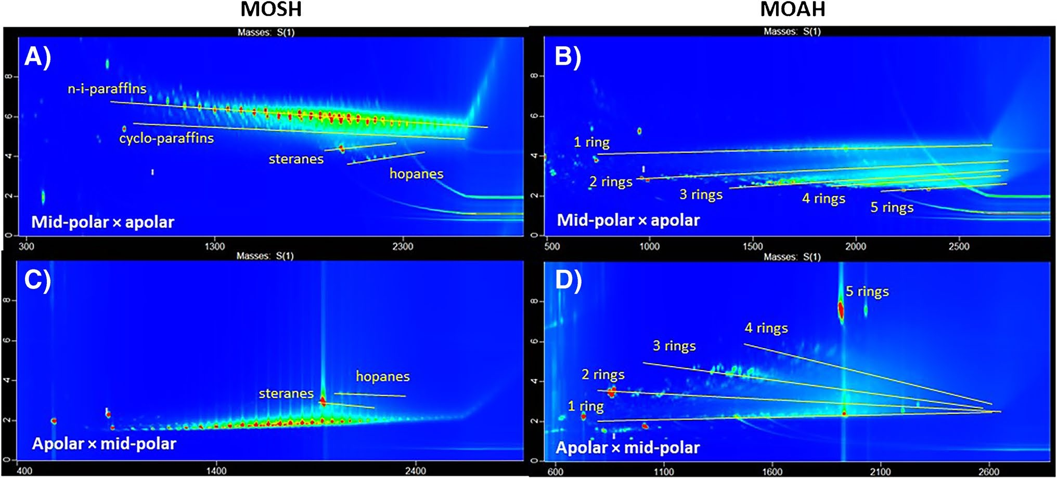
Fig. 3 2D plots of a heavy gas oil sample obtained using a mid-polar × apolar column set (A and B) and an apolar × mid-polar column set (C and D) of MOSH (A and C) and MOAH (B and D)

The role of GC × GC as a quantitative tool

Although GC × GC has been exploited since 2009 for a more in-depth characterization of the MOH humps, quantification performed in GC × GC has rarely been reported [29, 65, 67, 68]. Most of these works elaborated on data where there was no need to remove the riding peaks (e.g., [65]); for the other paper, an underestimation cannot be ruled out (e.g., [67]). Indeed, it was clearly demonstrated that the common commercially available GC × GC soft- ware was not able to handle the peculiarity of the MOSH and MOAH quantification where the well-shaped peaks riding on top of the hump need to be removed [58]. A test mixture was created using a paraffin mixture spiked with n-alkanes and analyzed and integrated by GC × GC-FID. Despite the integration parameters applied, it was impossible to avoid the integration of the riding peaks in the 2D plot down to the baseline (thus including part of the underlying mound) leading to a significant overestimation of the area to be removed and, therefore, underestimation of the remaining hump (Fig. 5).
A dedicated algorithm was developed to upgrade the software to perform the integration according to the specific requirements of the MOH quantification. This new approach consisted of reconstructing each 1D chromato- gram at every given 2D retention time, trimming the riding peaks and placing back the trimmed trace into the original file (Fig. 6). The outcome of this process is a perfectly trimmed mound where the operator can set the smoothing factor for any specific retention time windows to adapt to the presence of a specific group of interferences.

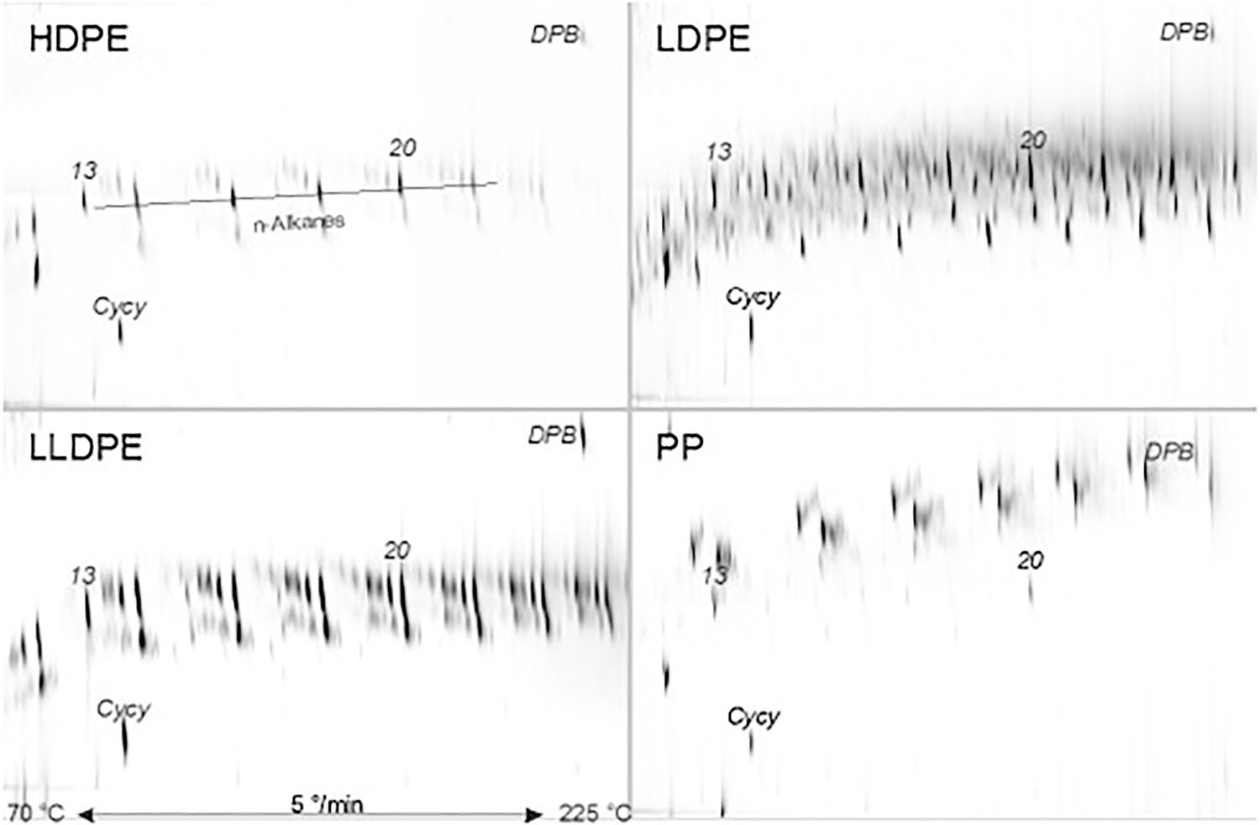
Fig. 4 Relevant sections of GC × GC–MS plots of the oligomers from polyolefins (saturated and monounsaturated hydrocarbons). Reproduced with permission from [61]

Moreover, the new algorithm incorporated the possibility of performing an automatic blank subtraction (either on the 1D or 2D data), which is highly important to avoid overestimation due to the bleeding of the column and other contaminants and to support the proper drawing of the baseline for integration. This procedure was acknowledged in the JRC report on data integration [16].
An alternative approach for quantification was proposed by Biedermann et al. at the end of 2022 [69]. The chromato- gram to be integrated was imported twice into the software, one without any correction and the other with a baseline correction set just under the riding peaks by applying the “rolling ball” algorithm. The latter was subtracted from the previous one, and the default baseline correction was applied. Both papers reporting reliable integration on the 2D chromatogram highlighted how this step forward has an important impact for answering urgent toxicological questions related to the occurrence of the 3–7 rings versus the 1–2 rings.
An important consideration for quantifying in GC × GC using the classical column set, i.e., mid-polar × apolar, is with regard to the elution of the MOAH. The JRC Guidance requires the determination of the total amount of MOSH/MOAH in the C10–C50 range and the amount distribution in specific sub-fractions, called C-fractions (different for MOSH and MOAH). These ranges are determined in an apolar column where the elution mechanism is based solely on volatility, thus simulating the distillation performed during the production of the different MOH products and the correspondence of the respective MOSH and MOAH fractions. When using a mid-polar column, the MOAH, more polar than the MOSH, are more retained, thus losing the correspondence between the two fractions. This shift can be controlled by the iso-volatility curves in the 2D plots [70]. However, to simplify the determination, Bauwens et al. proposed an approximation based on the shift of the linear retention index (LRI) calculated from a mixture of polycyclic aromatic hydrocarbons in the mid-polar column used as the first dimension [62]. A correlation curve was built using the LRI calculated in the apolar column versus the one calculated in the mid-polar column. The curve obtained was used to convert the elution window of each C-fraction in the apolar column into the elution window in the mid-polar column. Finally, the C-fractions were calculated by drawing a polygon with the vertices in the upper part of the 2D plot corresponding to the LRI of the specific C-fraction (e.g., 1000–1600 for the C10–C16 fraction) and the vertices of the bottom part

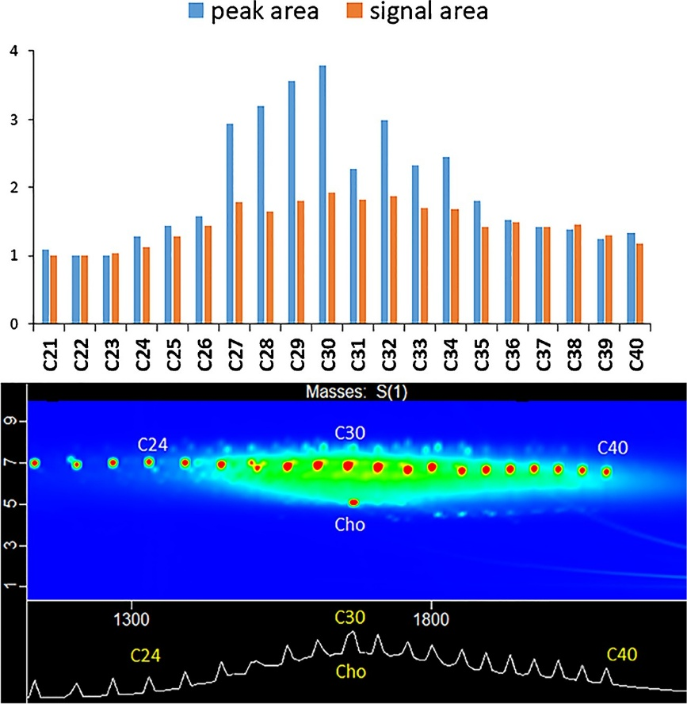
Fig. 5 The bar plot on top reports the relative response factor (calculated versus C20) for alkane solution added (1 mg/ kg each) to a paraffin solution (77 mg/kg) when integrated with no dedicated MOSH/ MOAH software. On the bottom is reported the corresponding 2D plot showing the correspondence of the hump with the overestimated alkanes Reproduced with permission from [58]

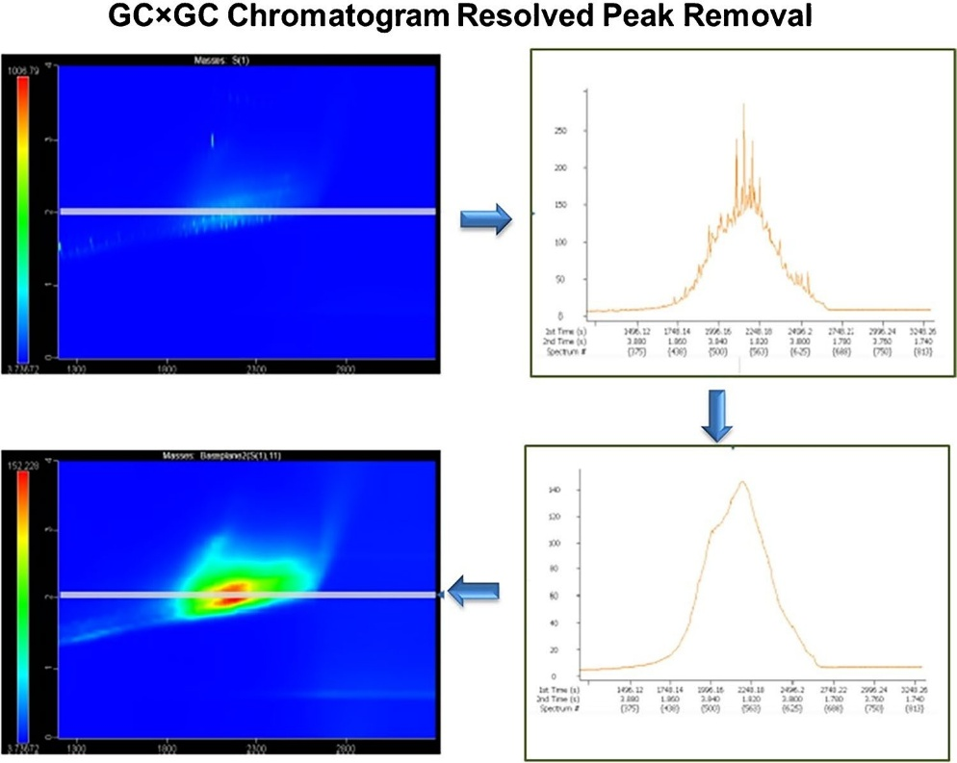
Fig. 6 Scheme of the process of smoothing operated by the algorithm to trim the riding peak on top of the UCM in 2D plots. Reproduced with permission from [58]

corresponding to the calculated shift based on the correlation curve (e.g., 1130–1880 for the C10–C16 fraction). This approach considered a shift based only on the parent polycyclic aromatic hydrocarbons and not evaluating the behavior according to the degree of alkylation. The effective elution behavior of the alkylated MOAH was verified shortly after by Biedermann et al. by trapping the different C-fractions at the end of an apolar column by pulling the extremity of the column out of the oven at the specific time windows corresponding to the C-fraction [69]. The different capillary segments generated were then installed between the injector and the first dimension column of a GC × GC system, showing that the elution of the alkylated MOAH well approximates the iso-volatility curves (Fig. 7) [69]. By the way, the need for a C-fraction determination will soon be outdated as it is foreseen that only the total amount of MOSH/MOAH will have to be reported in the updated JRC Guidance that was supposed to be published in early 2023.

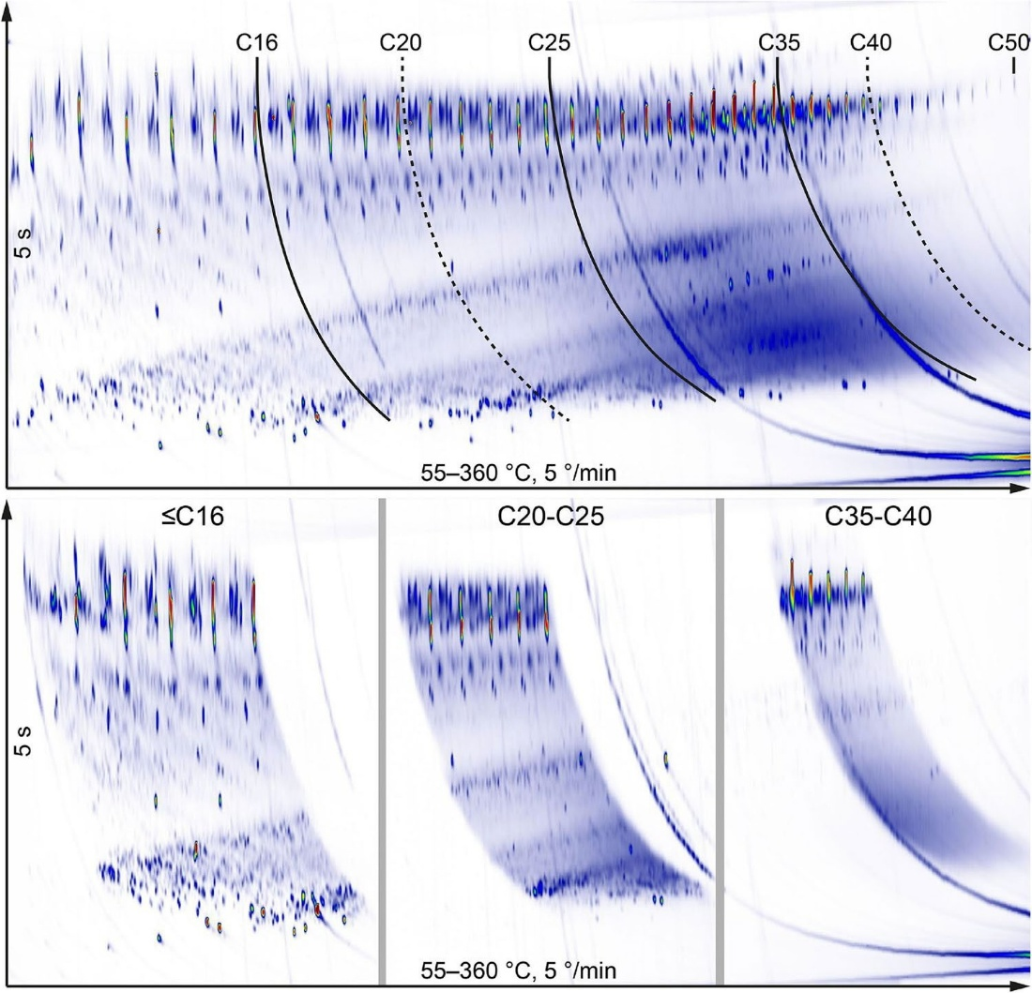
Fig. 7 On top, a GC × GC chromatogram with drawing of the lines delimiting sections corresponding to substances eluting in a specific C-fraction window of the apolar GC

At the beginning of 2023, a validation of the use of LC-GC × GC was presented based on the comparison of results obtained during the participation in two interlaboratory comparisons (ILC), one on vegetable oil and the other one on infant formula, both by LC-GC-FID [71]. The same instrument was used to perform both the LC-GC-FID analyses and the LC-GC × GC-FID ones. The column set used was an apolar × mid-polar in order to easily switch on or off the modulator to move from 1 to 2D analysis. A preliminary ILC was organized by the JRC to validate the performance of the LC-GC-FID platform by simply injecting a pure mineral oil sample (Shell SN500) into the system [15]. Based on the results, the JRC set a required performance corresponding to a relative standard deviation lower than 5% and recovery between 92 and 100%. Only 6 out of 30 laboratories reported satisfactory results. Repeatability column conventionally used for LC-GC. The dotted lines indicate the cuts which are applied only for MOSH. At the bottom, three different GC × GC chromatograms corresponding to the pre-fractionated C-fractions trapped on a cooled 7–20-cm section of the GC column exit coated with 100% dimethyl polysiloxane. From left to right: up to n-alkane C16 (left); elution times from C20–C25 (middle) and C35–C40 (right). Components below the volatility of C11 were not retained. Reproduced with permission from [69] and recovery data for the LC-GC × GC analysis were 2.5% of RSD and 99.1% of recovery at the highest point (Fig. 8).
The samples (i.e., oils and infant formulas) were prepared following the standard operative procedures (SOPs) provided for the specific ILC and then injected in LC-GC- FID and LC-GC × GC-FID. The latter results were compared with the overall outcomes of the ILC. The results clearly showed that the LC-GC × GC-FID could successfully perform quantitative analysis, providing at the same time

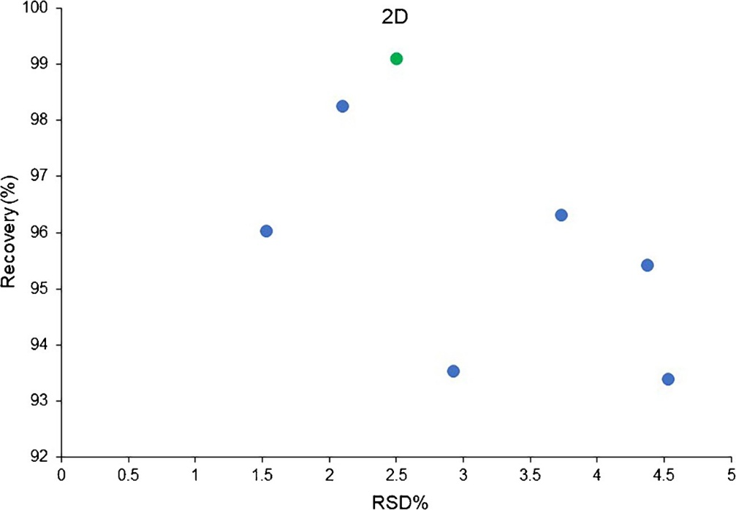
Fig. 8 Representation of the results that satisfy JRC require- ments in terms of recovery % (y-axis) and RSD% (x-axis). 2D label on a green dot identifies the results obtained using the LC-GC × GC-FID platform. Adapted from [71]

the confirmatory information that may be required in particular cases. Moreover, the routine analysis by LC-GC × GC-FID, implying the reliable quantification of the 2D data, can pro- vide additional information related to the distribution of the 1–2 MOAH rings and the more than 2-ring MOAH [58, 62, 69, 72], thus filling a critical gap for the risk assessment.
It is worth noting that the unified LC-GC × GC system, while a bit more complicated to troubleshoot as the GC × GC part cannot be straightforwardly tested with a conventional injection, does not require additional skills compared to running an LC-GC-FID or GC × GC separately. Furthermore, in the authors’ experience, troubleshooting is mostly related to the LC-GC transfer.

The role of GC × GC in supporting the sample preparation

As aforementioned, GC × GC plays an important role in characterizing the MOSH fraction when MOSH analogs, such as POH and ROH, are present. Expert eyes can detect such co-presence when sufficiently concentrated, but up to today, no alternative sample preparation has been proposed to differentiate them; thus, either they are removed during the trimming of the hump, or the results are reported as the sum of MOSH and POH/ROH. The use of GC × GC can provide separated information regarding the amount of MOSH and POSH, since they can be chromatographically separated using a mid-polar × apolar column set (Fig. 4). However, in the case of naturally occurring n-alkanes, aluminum oxide purification remains the method to be used.
In the case of the MOAH, the determination by LC-GC- FID in food, and in particular in fatty matrices, may be often hindered by the coelution of interfering olefins, which are either naturally present in the matrix (e.g., carotenes, squalene, sterenes, and their derivatives) or formed during the refining of fats and oils [1, 46].
As aforementioned, epoxidation is the method of choice, in particular using meta-chloroperoxybenzoic acid (mCPBA) as the epoxidation agent. Originally, dichloromethane was used as solvent [1], but it was later changed to a mixture of hexane/ethanol (7/5 v/v) to reduce the kinetics of the reaction. This modification allowed performing the procedure at ambient temperature without the need for the addition of a polyunsaturated oil as the stopper and facilitating the solvent exchange, thus promoting the complete automation of this step substantially. Despite the undebatable advantage of the latter method toward automation, the performances of the two methods were proven comparable regarding MOAH losses (estimated between 20 and 35%) [46]. At the same time, also the removal of the targeted interferences resulted in no significant improvement [46]. To better understand how epoxidation and edible oil refining act on the interferences, Biedermann et al. [46] extensively used GC × GC coupled to FID or MS to characterize the compounds in different matrices before and after these two processes. Such characterization is more delicate using a monodimensional approach such as LC-GC-FID, particularly if the interferences coelute in the same retention window as the MOAH and/or if they form a hump that must not be confused with MOAH. The methodology to follow up with GC × GC-FID to verify the presence of interferences and MOAH when the interpretation of the LC-GC-FID chromatogram is unsure was detailed; it was mainly based on the visual aspect of the chromatogram and the way compounds elute (Fig. 9). With the help of MS coupling, the authors tried to identify the molecules that resisted epoxidation by using characteristic m/z fragments. Carotene, squalene, and their isomers were found to be completely removed by this reaction unless the oil had undergone refining. In the latter case, mainly if harsh refining conditions were applied, persistent interferences of aromatic structure could be created from isomerized squalene or dehydration of sterols (forming sterenes), and, therefore, cannot be completely removed by epoxidation. A similar systematic characterization was per- formed by Albert et al. using LC-GC × GC-MS [73].
More recently, in 2022, Nestola proposed a revised version of the method that he developed with Schmidt in 2017, which tried to address some of the problems encountered with the previous method, such as the loss of part of MOAH, the recurrent presence of impurities in mCPBA limiting MOAH determination, and the persisting interferences post-epoxidation [49]. For this purpose, he investigated other epoxidation reagents, i.e., performic and peracetic acids, and studied the epoxidation reaction kinetics using model substances. Regarding the new reagents, the best results were obtained with performic acid combined with chloroform as a solvent since this system was able to remove some recalcitrant olefins (i.e., π-electron-deficient olefins), while not being associated with impurities. When it comes to the reaction kinetics, it was concluded that mono- and diaromatics are less affected by epoxidation than tri- and polyaromatics. The loss of the latter was considered as “often irrelevant” because of their low abundance in refined mineral oil; however, this could be problematic in case of contamination with a weakly refined mineral oil, still containing the toxic MOAH fraction, and if a survey on the occurrence of the more concerning 3-and-more-ring MOAH fraction is performed.
Nevertheless, the use of GC × GC was shown effective in minimizing the interferences of biogenic olefins in the elution area of interest of the 3-and-more-ring MOAH (they mainly elute in the 1–2 ring area), thus suggesting the possibility of skipping this additional purification step [69, 72]. Anyway, the 2D plots also support an easier interpretation of the remaining biogenic olefin, thus allowing a more accurate trimming of the superimposed hump [72].

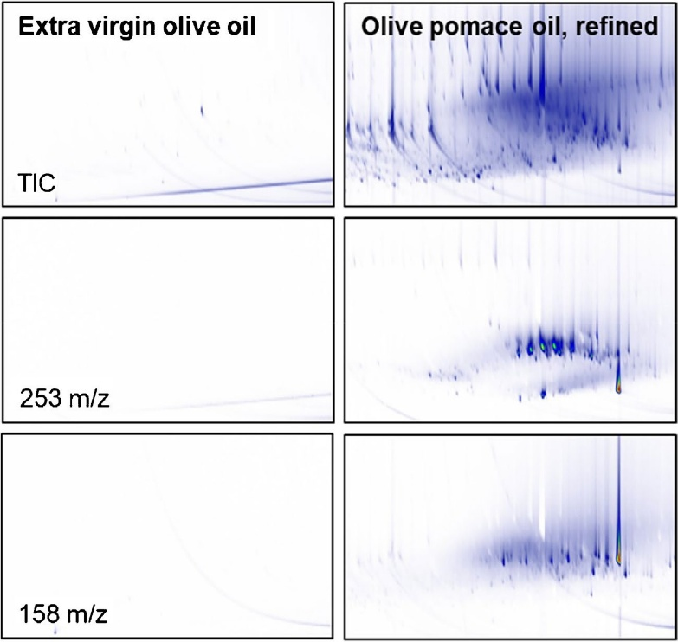
Fig. 9 GC × GC–MS plots of the region of the interfering material from an epoxidized (non-refined) extra virgin olive oil and an epoxidized (strongly) refined olive pomace oil (right), indicating that the residual interfering material and possibly precursors of it are formed during refining. Reproduced with permission from [46]

Moreover, Biedermann et al. [69] showed promising preliminary results using donor-acceptor complex chromatography LC (as reported in [25]) coupled to GC × GC for quantification of 3-and-more-ring MOAH, avoiding the use of epoxidation. Indeed, the more selective LC separation reduced the amount of interferences reducing the risk of overloading of the GC × GC which causes a shift of the interferences in the 2D plot into the 3-and-more-ring MOAH elution zone.

Concluding remarks

In conclusion, since its first application to the mineral oil topic in 2009 and until 2021, GC × GC had been used as a confirmatory technique of the MOH contamination. The 2D separation with FID as detector often offers enough information on the origin and the composition of the mineral oil contamination, but detection with MS (alternative or simultaneously to FID) has been often used as a confirmatory tool for complex samples. It must be stressed that when FID and MS are acquired simultaneously, care must be paid as the use of a passive splitter between the two detectors can cause a change in the percentage of the diverted flow during the chromatographic run, thus affecting the reliability of the quantification. More recently, approaches able to reliably quantify 2D chromatograms of MOSH/MOAH were developed using a single detector at a time. This new breakthrough allows quantifying specific sub-classes, which could be useful for further toxicological evaluation of the latter, while providing confirmatory information at the same time. Moreover, the use of GC × GC has proven potential capability to reduce the long and tedious sample separation steps needed when analyzing complex samples since some interfering compounds are chromatographically separated from the hydrocarbons of interest. Particularly, for the MOAH fraction, the epoxidation step needed to remove the natural olefins, but leading to a loss in the quantification, can potentially be avoided when using GC × GC. In fact, the interferences are partially eluted in a different chromatographic part of the 2D plot than the MOAH and partially coeluted with the 1–2-ring fraction. This means that the quantification of the more concerning 3-and-more-ring fraction can be done more robustly. Moreover, there is space to improve the chromatographic selectivity by selecting different separation mechanisms either in LC or GC. The sensitivity is also improved in GC × GC although by a smaller factor than what has been found for single compounds.
Finally, the combination of GC × GC and toxicological studies is the key to offer a deeper understanding of the physiological process linked to the ingestion of these com- pounds as well as allowing the acquisition of more complete occurrence data leading to solve the long issue of assessing the risk of mineral oil contamination.
The efforts to improve the analytical methods for MOSH and MOAH determination are still not over, particularly regarding the removal of interferents, but it is the authors’ opinion that GC × GC (hyphenated directly to LC or offline) is the fundamental technique to solve the remaining issues and acquire a full understanding of the different matrices. GC × GC should be used routinely for the determination of MOSH and MOAH, or at least all the positive samples in LC-GC-FID should be run in GC × GC to significantly increase the information obtained and the confidence in the results. The resistance in accepting GC × GC as a routine method due to the perceived difficulty in operating it should be overpassed, as the technique is mature and robust to enter the routine environment and all the tools are there to support operators in entering the marvelous world of comprehensive chromatography.

Supplementary information

The online version contains supplementary material available at https://doi.org/10.1007/s00216-023-04718-3.

Acknowledgements

This work is supported by Fonds de la Recherche Scientifique Belgique (FNRS) (PDR projects-ToxAnaMOH, T.0187.23).

Declarations

Conflict of interest

The authors declare no competing interests.

References
- Biedermann M, Fiselier K, Grob K. Aromatic hydrocarbons of mineral oil origin in foods: method for determining the total con- centration and first result. J Agric Food Chem. 2009;57:8711–21. https://doi.org/10.1021/jf901375e.
- Hochegger A, Moret S, Geurts L, Gude T, Leitner E, Mertens B, O’Hagan S, Poças F, Simat TJ, Purcaro G. Mineral oil risk assessment: knowledge gaps and roadmap. Outcome of a multi-stake- holders workshop. Trends Food Sci Technol. 2021;113:151–66. https://doi.org/10.1016/j.tifs.2021.03.021.
- Sdrigotti N, Collard M, Purcaro G. Evolution of hyphenated techniques for mineral oil analysis. J Sep Sci. 2021;44:464–82. https:// doi.org/10.1002/jssc.202000901.
- Grob K, Artho A, Biedermann M, Egli J. Food contamination by hydrocarbons from lubricating oils and release agents: determination by coupled LC-GC. Food Addit Contam. 1991;8:437–46.
- Biedermann M, Grob K, Meier W. Partially concurrent eluent evaporation with an early vapor exit; detection of food irradiation through coupled LC-GC analysis of fat. J high Resolut Chroma- togr. 1989;12:591–8.
- Grob K. Could the Ukrainian sunflower oil contaminated with mineral oil wake up sleeping dogs? Eur J Lipid Sci Technol. 2008;110:979–81. https://doi.org/10.1002/ejlt.200800234.
- Biedermann M, Grob K. Is recycled newspaper suitable for food contact materials? Technical grade mineral oils from printing inks. Eur Food Res Technol. 2010;230:785–96. https://doi.org/ 10.1007/s00217-010-1223-9.
- European Food Safety Authorithy (EFSA). Scientific opinion on mineral oil hydrocarbons in food. 2012.
- Commission of the European Union. Commission Recommendation (EU) 2017/84 of 16 January 2017 on the monitoring of mineral oil hydrocarbons in food and in materials and articles intended to come into contact with food. Off J Eur Union. 2017;L12:95–6. https://doi.org/10.2903/j.efsa.2012.2704.L.
- Bratinova S, Hoekstra E. Joint Research Center (JRC). Guidance on sampling, analysis and data reporting for the monitoring of mineral oil hydrocarbons in food and food contact materials. In the frame of Commission Recommendation (EU) 2017/84. 2019.
- Koster S, Varela J, Stadler RH, Moulin J, Cruz-Hernandez C, Hielscher J, Lesueur C, Roïz J, Simian H. Mineral oil hydrocar- bons in foods: is the data reliable? Food Addit Contam - Part A Chem Anal Control Expo Risk Assess. 2020;37:69–83. https:// doi.org/10.1080/19440049.2019.1678770.
- Bratinova S, Hoekstra E, Emons H, Hutzler C, Kappenstein O, Biedermann M, McCombie G. The reliability of MOSH/MOAH data: a comment on a recently published article. Journal Fur Ver- braucherschutz Und Lebensmittelsicherheit. 2020;15(3):285–7. https://doi.org/10.1007/S00003-020-01287-W/METRICS.
- Foodwatch (2019) International test of various canned baby milk products for their content of mineral oil hydrocarbons (MOSH/ MOAH). https://www.foodwatch.org/fileadmin/-INT/mineral_oil/ documents/2019-10-24_Projectreport_babymilk_FINAL.pdf.
- Arcella D, Baert K, Binaglia M (2019) Rapid risk assessment on the possible risk for public health due to the contamination of infant formula and follow‐on formula by mineral oil aromatic hydrocarbons (MOAH). EFSA Supporting Publications. 16(11). https://doi.org/10.2903/SP.EFSA.2019.EN-1741
- European Commission, Joint Research Centre, Goncalves C, Karasek L, Bratinova S et al. Determination of MOSH/MOAH in Shell SN500 mineral oil : JRC IF 2021-03 : the third interlabo- ratory comparison. Publications Office of the European Union. 2022. https://data.europa.eu/doi/10.2760/23771
- Bratinova S, Robouch P, Beldi G, Senaldi C, Goncalves C, Kar- asek L, Valzacchi S, Conneely P, Hoekstra E, Emons H. Determination of MOAH in Infant Formula, JRC IF 2020-02 - The 2nd interlaboratory comparison, European Commission, Geel, JRC 125669 EN. (2021).
- European standards. CSN EN 16995 - Foodstuffs - Vegetable oils and foodstuff on basis of vegetable oils - Determination of mineral oil saturated hydrocarbons (MOSH) and mineral oil aromatic hydrocarbons (MOAH) with on-line HPLC-GC-FID analysis. 2017.
- Biedermann M, Grob K. On-line coupled high performance liquid chromatography-gas chromatography for the analysis of contamination by mineral oil. Part 1: Method of analysis. J Chromatogr A. 2012;1255:56–75. https://doi.org/10.1016/j.chroma.2012.05.095.
- Pirow R, Blume A, Hellwig N, Herzler M, Huhse B, Hutzler C, Pfaff K, Thierse HJ, Tralau T, Vieth B, Luch A. Mineral oil in food, cosmetic products, and in products regulated by other legislations. Crit Rev Toxicol. 2019;49:742–89. https://doi.org/10. 1080/10408444.2019.1694862.
- Tarnow P, Hutzler C, Grabiger S, Schön K, Tralau T, Luch A. Estrogenic activity of mineral oil aromatic hydrocarbons used in printing inks. PLoS ONE. 2016;11:1–15. https://doi.org/10.1371/ journal.pone.0147239.
- Carrillo J-C, Kamelia L, Romanuka J, Kral O, Isola A, Niemelä H, Steneholm A. Comparison of PAC and MOAH for understanding the carcinogenic and developmental toxicity potential of mineral oils. Regul Toxicol Pharmacol. 2022;132:105193. https://doi.org/ 10.1016/j.yrtph.2022.105193.
- Kamelia L, de Haan L, Ketelslegers HB, Rietjens IMCM, Boogaard PJ. In vitro prenatal developmental toxicity induced by some petroleum substances is mediated by their 3- to 7-ring PAH constituent with a potential role for the aryl hydrocarbon receptor (AhR). Toxicol Lett. 2019;315:64–76. https://doi.org/ 10.1016/j.toxlet.2019.08.001.
- Kamelia L, Louisse J, de Haan L, Rietjens IMCM, Boogaard PJ. Prenatal developmental toxicity testing of petroleum substances: application of the mouse embryonic stem cell test (EST) to com- pare in vitro potencies with potencies observed in vivo. Toxicol Vitr. 2017;44:303–12. https://doi.org/10.1016/j.tiv.2017.07.018.
- Hochegger A, Wagenhofer R, Savić S, Mayrhofer E, Washüttl M, Leitner E. Combination of multidimensional instrumental analysis and the Ames Test for the toxicological evaluation of mineral oil aromatic hydrocarbons. J Agric Food Chem. 2022;2022:16401–9. https://doi.org/10.1021/ACS.JAFC.2C05970/ASSET/IMAGES/LARGE/JF2C05970_0007.JPEG.

- Koch M, Becker E, Päch M, Kühn S, Kirchhoff E. Separation of the mineral oil aromatic hydrocarbons of three and more aromatic rings from those of one or two aromatic rings. J Sep Sci. 2020;43:1089–99. https://doi.org/10.1002/jssc.201900833.
- Carrillo JC, Shen H, Momin F, Kral O, Schnieder H, Kühn S. GTL synthetic paraffin oil shows low liver and tissue retention compared to mineral oil. Food Chem Toxicol. 2022;159:112701. https://doi.org/10.1016/j.fct.2021.112701.
- Isola AL, Carrillo JC, Lemaire P, Niemelä H, Steneholm A. Lack of human-relevant adversity of MOSH retained in tissues: Analysis of adversity and implications for regulatory assessment. Regulatory Toxicology and Pharmacology. 137:105284. https://doi.org/10.1016/j.yrtph.2022.105284.
- Barp L, Kornauth C, Wuerger T, Rudas M, Biedermann M, Reiner A, Concin N, Grob K. Mineral oil in human tissues, Part I: Concentrations and molecular mass distributions. Food Chem Toxicol. 2014;72:312–21. https://doi.org/10.1016/j.fct.2014.04.029.
- Biedermann M, Barp L, Kornauth C, Würger T, Rudas M, Reiner A, Concin N, Grob K. Mineral oil in human tissues, Part II: Characterization of the accumulated hydrocarbons by comprehensive two-dimensional gas chromatography. Sci Total Environ. 2015;506–507:644–55. https://doi.org/10.1016/j.scito tenv.2014.07.038.
- Barp L, Biedermann M, Grob K, Blas-Y-Estrada F, Nygaard UC, Alexander J, Cravedi JP. Mineral oil saturated hydrocarbons (MOSH) in female Fischer 344 rats; accumulation of wax com- ponents; implications for risk assessment. Sci Total Environ. 2017;583:319–33. https://doi.org/10.1016/j.scitotenv.2017.01.071.
- Barp L, Biedermann M, Grob K, Blas-Y-Estrada F, Nygaard UC, Alexander J, Cravedi JP. Accumulation of mineral oil saturated hydrocarbons (MOSH) in female Fischer 344 rats: comparison with human data and consequences for risk assessment. Sci Total Environ. 2017;575:1263–78. https://doi.org/10.1016/j. scitotenv.2016.09.203.
- Biedermann M, Grob K. On-line coupled high performance liquid chromatography-gas chromatography for the analysis of contamination by mineral oil. Part 2: Migration from paper- board into dry foods: interpretation of chromatograms. J Chromatogr A. 2012;1255:76–99. https://doi.org/10.1016/j.chroma. 2012.05.096.
- Weber S, Schrag K, Mildau G, Kuballa T, Walch SG, Lachenmeier DW (2018) Analytical methods for the determination of mineral oil saturated hydrocarbons (MOSH) and Mineral Oil Aromatic Hydrocarbons (MOAH)—A Short Review. Analytical Chemistry Insights. 2018;13. https://doi.org/10.1177/11773 90118777757.
- Purcaro G, Barp L, Moret S. Determination of hydrocarbon contamination in foods. RevAnal Methods. 2016;8:5755–72. https:// doi.org/10.1039/c6ay00655h.
- Polyakova A, van Leeuwen S, Peters R. Review on chromatographic and specific detection methodologies for unravelling the complexity of MOAH in foods. Anal Chim Acta. 2022;1234:340098. https://doi.org/10.1016/j.aca.2022.340098.
- Moret S, Barp L, Grob K, Conte LS. Optimised off-line SPE-GC- FID method for the determination of mineral oil saturated hydro- carbons (MOSH) in vegetable oils. Food Chem. 2011;129:1898– 903. https://doi.org/10.1016/j.foodchem.2011.05.140.
- Fiselier K, Grundböck F, Schön K, Kappenstein O, Pfaff K, Hutzler C, Luch A, Grob K. Development of a manual method for the determination of mineral oil in foods and paperboard. J Chro- matogr A. 2013;1271:192–200. https://doi.org/10.1016/j.chroma. 2012.11.034.
- Moret S, Grob K, Conte LS. On-line high-performance liquid chromatography-solvent evaporation-high-performance liquid chromatography-capillary gas chromatography-flame ionisation detection for the analysis of mineral oil polyaromatic hydrocar- bons in fatty foods. J Chromatogr A. 1996;750:361–8. https://doi. org/10.1016/0021-9673(96)00453-0.
- Moret S, Scolaro M, Barp L, Purcaro G, Conte LS. Microwave assisted saponification (MAS) followed by on-line liquid chromatography (LC)-gas chromatography (GC) for high-throughput and high-sensitivity determination of mineral oil in different cereal- based foodstuffs. Food Chem. 2016;196:50–7. https://doi.org/10. 1016/j.foodchem.2015.09.032.
- Moret S, Conchione C, Srbinovska A, Lucci P. Microwave-based technique for fast and reliable extraction of organic contaminants from food, with a special focus on hydrocarbon contaminants. Foods. 2019;8(10):503. https://doi.org/10.3390/foods8100503.
- Srbinovska A, Gasparotto L, Conchione C, MenegozUrsol L, Lambertini F, Suman M, Moret S. Mineral oil contamination in basil pesto from the Italian market: Ingredient contribution and market survey. J Food Compos Anal. 2023;115:10491. https://doi. org/10.1016/j.jfca.2022.104914.
- MenegozUrsol L, Conchione C, Peroni D, Carretta A, Moret S. A study on the impact of harvesting operations on the mineral oil contamination of olive oils. Food Chem. 2023;406:135032. https://doi.org/10.1016/j.foodchem.2022.135032.
- Srbinovska A, Conchione C, Celaj F, MenegozUrsol L, Moret S. High sensitivity determination of mineral oils and olefin oligomers in cocoa powder and related packaging: Method validation and market survey. Food Chem. 2022;396:133686. https://doi.org/10. 1016/j.foodchem.2022.133686.
- MenegozUrsol L, Conchione C, Srbinovska A, Moret S. Optimization and validation of microwave assisted saponification (MAS) followed by epoxidation for high-sensitivity determination of mineral oil aromatic hydrocarbons (MOAH) in extra virgin olive oil. Food Chem. 2022;370:130966. https://doi.org/10.1016/j.foodc hem.2021.130966.
- Fiselier K, Fiorini D, Grob K. Activated aluminum oxide selectively retaining long chain n-alkanes. Part I, description of the retention properties. Anal Chim Acta. 2009;634:96–101. https:// doi.org/10.1016/j.aca.2008.12.007.
- Biedermann M, Munoz C, Grob K. Epoxidation for the analysis of the mineral oil aromatic hydrocarbons in food. An update J Chromatogr A. 2020;1624:461236. https://doi.org/10.1016/j.chroma. 2020.461236.
- Nestola M, Schmidt TC. Determination of mineral oil aromatic hydrocarbons in edible oils and fats by online liquid chromatography–gas chromatography–flame ionization detection – evaluation of automated removal strategies for biogenic olefins. J Chromatogr A. 2017;1505:69–76. https://doi.org/10.1016/j.chroma.2017.05.035.
- Wagner C, Neukom HP, Galetti V, Grob K. Determination of mineral paraffins in feeds and foodstuffs by bromination and preseparation on aluminium oxide: method and results of a ring test. Mitt Leb Hyg. 2001;92:231–49.
- Nestola M. Automated workflow utilizing saponification and improved epoxidation for the sensitive determination of mineral oil saturated and aromatic hydrocarbons in edible oils and fats. J Chromatogr A. 2022;1682:463523. https://doi.org/10.1016/j.chroma. 2022.463523.
- Biedermann M, Munoz C, Grob K. Update of on-line coupled liquid chromatography – gas chromatography for the analysis of mineral oil hydrocarbons in foods and cosmetics. J Chromatogr A. 2017;1521:140–9. https://doi.org/10.1016/j.chroma.2017.09.028.
- Purcaro G, Moret S, Conte L. Sample pre-fractionation of environmental and food samples using LC-GC multidimensional techniques. TrAC - Trends Anal Chem. 2013;43:146–60. https://doi. org/10.1016/j.trac.2012.10.007.
- Purcaro G, Moret S, Conte L. Hyphenated liquid chromatography- gas chromatography technique: recent evolution and applications. J Chromatogr A. 2012;1255:100–11. https://doi.org/10.1016/j. chroma.2012.02.018.
- Lui Z, Phillips JB. Comprehensive two-dimensional gas chromatography using an on-column thermal modulator interface. J Chromatogr Sci. 1991;29:227–31.
- Tranchida PQ, Purcaro G, Maimone M, Mondello L. Impact of comprehensive two-dimensional gas chromatography with mass spectrometry on food analysis. J Sep Sci. 2016;39:149–61. https:// doi.org/10.1002/jssc.201500379.
- Tranchida PQ, Purcaro G, Dugo P, Mondello L, Purcaro G. Modula- tors for comprehensive two-dimensional gas chromatography. TrAC - Trends Anal Chem. 2011;30:1437–61. https://doi.org/10.1016/j. trac.2011.06.010.
- Vendeuvre C, Ruiz-Guerrero R, Bertoncini F, Duval L, Thiébaut D. Comprehensive two-dimensional gas chromatography for detailed characterisation of petroleum products. Oil Gas Sci Technol. 2007;62:43–55. https://doi.org/10.2516/ogst:2007004.
- Biedermann M, Grob K. Comprehensive two-dimensional GC after HPLC preseparation for the characterization of aromatic hydrocar- bons of mineral oil origin in contaminated sunflower oil. J Sep Sci. 2009;32:3726–37. https://doi.org/10.1002/jssc.200900366.
- Bauwens G, Pantó S, Purcaro G. Mineral oil saturated and aromatic hydrocarbons quantification: mono- and two-dimensional approaches. J Chromatogr A. 2021;1643:462044. https://doi.org/ 10.1016/j.chroma.2021.462044.
- Spack LW, Leszczyk G, Varela J, Simian H, Gude T, Stadler RH. Understanding the contamination of food with mineral oil: the need for a confirmatory analytical and procedural approach. Food Addit Contam - Part A Chem Anal Control Expo Risk Assess. 2017;34:1052–71. https://doi.org/10.1080/19440049.2017.1306655.
- Biedermann M, McCombie G, Grob K, Kappenstein O, Hutzler C, Pfaff K, Luch A. FID or MS for mineral oil analysis? J fur Ver- braucherschutz und Leb. 2017;12:363–5. https://doi.org/10.1007/ s00003-017-1127-8.
- Biedermann M, Grob K. Comprehensive two-dimensional gas chromatography for characterizing mineral oils in foods and distinguishing them from synthetic hydrocarbons. J Chromatogr A. 2015;1375:146–53. https://doi.org/10.1016/j.chroma.2014.11.064.
- Bauwens G, Conchione C, Sdrigotti N, Moret S, Purcaro G. Quantification and characterization of mineral oil in fish feed by liquid chromatography-gas chromatography-flame ionization detector and liquid chromatography-comprehensive multidimensional gas chromatography-time-of-flight mass spectrometer/flame ionization detector. J Chromatogr. 2022;A 1677:463208. https://doi.org/10. 1016/j.chroma.2022.463208.
- Pantó S, Collard M, Purcaro G. Comprehensive gas chromatography coupled to simultaneous dual detection (ToFMS/FID) as a confirmatory method for MOSH&MOAH determination in food. Current Trend in Mass Spectrometry. 2020;18(3):15–20.
- Lommatzsch M, Biedermann M, Simat TJ, Grob K. Argentation high performance liquid chromatography on-line coupled to gas chromatography for the analysis of monounsaturated polyolefin oligomers in packaging materials and foods. J Chromatogr A. 2015;1402:94–101. https://doi.org/10.1016/j.chroma.2015.05.019.
- McCombie G, Hötzer K, Daniel J, Biedermann M, Eicher A, Grob K. Compliance work for polyolefins in food contact: results of an official control campaign. Food Control. 2016;59:793–800. https:// doi.org/10.1016/j.foodcont.2015.06.058.
- Lommatzsch M, Biedermann M, Grob K, Simat TJ. Analysis of saturated and aromatic hydrocarbons migrating from a polyolefin- based hot-melt adhesive into food. Food Addit Contam - Part A Chem Anal Control Expo Risk Assess. 2016;33:473–88. https:// doi.org/10.1080/19440049.2015.1130863.

- Purcaro G, Tranchida PQ, Barp L, Moret S, Conte LS, Mondello L. Detailed elucidation of hydrocarbon contamination in food products by using solid-phase extraction and comprehensive gas chromatography with dual detection. Anal Chim Acta. 2013;773:97–104. https://doi.org/10.1016/j.aca.2013.03.002.
- Zoccali M, Tranchida PQ, Mondello L. On-line liquid chromatography-comprehensive two dimensional gas chromatography with dual detection for the analysis of mineral oil and synthetic hydrocarbons in cosmetic lip care products. Anal Chim Acta. 2019;1048:221–6. https://doi.org/10.1016/j.aca.2018.10.069.
- Biedermann M, Eicher A, Altherr T, McCombie G. Quantification of mineral oil aromatic hydrocarbons by number of aromatic rings via comprehensive two-dimensional gas chromatography: first results in food. J Chromatogr Open. 2022;2:100072. https://doi.org/ 10.1016/J.JCOA.2022.100072.
- Bieri S, Marriott PJ. Dual-injection system with multiple injections for determining bidimensional retention indexes in comprehensive two-dimensional gas chromatography. Anal Chem. 2008;80:760–8. https://doi.org/10.1021/ac071367q.
- Bauwens G, Barp L, Purcaro G. Validation of the liquid chromatography-comprehensive multidimensional gas chromatography-time- of-flight mass spectrometer / flame ionization detector platform for mineral oil analysis exploiting interlaboratory comparison data. Green Anal Chem. 2023;4:100047. https://doi.org/10.1016/j.greeac. 2022.100047.
- Bauwens G, Cavaco Soares A, Lacoste F, Ribera D, Blomsma C, Berg I, Campos F, Coenradie A, Creanga A, Zwagerman R, Purcaro G. Investigation of the effect of refining on the presence of targeted mineral oil aromatic hydrocarbons in coconut oil. Food Addit Con- tam - Part A. 2023;0:1–12. https://doi.org/10.1080/19440049.2022. 2164621.
- Albert C, Humpf HU, Brühl L. Determining MOSH and MOAH with high sensitivity in vegetable oil a new, reliable, and comparable approach using online LC-GC-FID evaluation of method precision data. J Agric Food Chem. 2022. https://doi.org/10.1021/acs. jafc.2c01189.

