A gift to the world

Jean-Marie Choffray*
Liège, May 14, 2023.

MicroStrategy just released the knowledge and the intelligence – the hope too! – that was shared at the First World Conference (May 1-4, 2023) on Bitcoin & Lightning for Corporations. This material is a treasure trove for anyone interested in Bitcoin and Lightning. As our world awakens to the opportunities offered by the most powerful – decentralized, permissionless, censorship-resistant – network of encrypted digital energy, the diversity and breadth of these conferences offer a unique educational and operational guide to the technological, psychological and political challenges that need to be overcome in this field. Hi-tech revolutions don’t happen every day. In all likelihood, the Bitcoin and Lightening Protocols won’t disappear in the fog of History, even if their diffusion will undoubtedly give rise to unforeseen setbacks and deceptions. “Reality is that which, when you stop believing in it, doesn't go away” – Philip K. Dick.

* Emeritus Professor of Computer Science, University of Liege School of Management.
PhD-77, Management Science, Massachusetts Institute of Technology.

Être plus, c’est s’unir davantage.
P. Teilhard de Chardin

Bitcoin is a bank in cyberspace, run by incorruptible software, offering a global, affordable, simple, & secure savings account to billions of people that don't have the option or desire to run their own hedge fund.
Bitcoin is hope

A gift to the world

“Block reward refers to the cryptocurrency rewarded to a miner when they successfully validate a new block. The block reward is made of two components: the block subsidy and the transaction fees. The block subsidy consists of newly generated coins and represents the biggest part of a block reward. The other part is made up of all fees paid by the transactions that are included in the block” (cf. Binance).

On May 7, 2023, for the second time in its short history, the fee that Bitcoin miners got for discovering a new block approached the subsidy – currently 6.25 BTC [… Bitcoin]. In other words, some bitcoin miners were getting paid more to process transactions on the blockchain than they were rewarded for creating new BTC, an encouraging development after what the crypto industry went through over the last twelve months. This increase in fees was linked to a backlog of several hundred thousand transactions awaiting confirmation. Transaction fees surpassing mining subsidy is proof that market participants start valuing at its right price the preservation of their most important information on the blockchain.

Today, MicroStrategy released the bulk of the expertise and of the experience shared at the First World Conference on Bitcoin & Lightning for Corporations. The diversity and depth of these conferences offer a unique educational and operational guide to the technological, psychological and political challenges that will have to be overcome for this technology to succeed. For sure, the Bitcoin and Lightening Networks won’t disappear tomorrow, even if their diffusion will inevitably experience setbacks and other deceptions.

The magnitude of the challenge (opportunity?)…

“The real economy balance sheet has $520 trillion in real assets, such as machinery and equipment, infrastructure, buildings, natural resources, and intellectual property, or IP. These are mirrored on the liability side as net worth.”

“The financial balance sheet of households, corporations, and governments has $510 trillion in financial assets like stocks, bonds, pension funds, and cash and deposits that facilitate ownership and risk transfer of real assets as well as enabling savings and consumption over time. These financial assets are mirrored on the liability side of the balance sheet since they represent eventual claims against those same sectors.”

“Finally, financial institutions create and intermediate those financial assets and liabilities – in the process transforming their risks, maturity, and size – and hold $510 trillion in financial assets and a similar level of liabilities. While each of these three balance sheets equalizes within itself at a closed economy level, in our analysis of ten countries, there is a small negative net financial position, meaning that these countries borrow collectively from the rest of the world, and so assets and liabilities do not match precisely” (Source: McKinsey & Company, The rise of the global balance sheet: How productively are we using our wealth?)

The thirteenth edition of the Credit Suisse Global Wealth Report provides “the most comprehensive information available on global household wealth. Wealth creation in recent years has been exposed to a sequence of continuing economic challenges. While it is too early to assess the impact of widespread inflation and the Russia-Ukraine war, wealth growth proved resilient in 2020 when COVID-19 caused major economic disruption, and the recovery during 2021 produced even more favorable conditions. By year-end, global wealth at prevailing exchange rates totaled USD 463.6 trillion, a gain of 9.8%. Wealth per adult rose 8.4% to USD 87,489. US dollar appreciation depressed these rates by 2.9%. Setting aside exchange rate movements, aggregate global wealth grew by 12.7% in 2021, which is the fastest annual rate ever recorded […] While some reversal of the exceptional wealth gains of 2021 is likely in 2022/2023 as several countries face slower growth or even recession, our five-year outlook is for wealth to continue growing. We would expect global wealth to increase by USD 169 trillion by 2026, a cumulative rise of 36%, with middle-income countries primarily driving global wealth increases. Our forecast is that, by 2024, global wealth per adult should pass the USD 100,000 threshold and that the number of millionaires will exceed 87 million individuals over the next five years.”

Hence, some reasonable hypotheses for the next three to five years, assuming no “Black Swan” disrupting significantly the evolution of the world economy, would be:

- Global value of wealth instruments: $500 - $1,500 trillion
- Number of millionaires: 60 - 90 million
- Number of Bitcoins (encrypted blockchains): ~ 20 million
- One hundred million Satoshi per Bitcoin

All other things being equal, the addressable market for Bitcoin falls in between 2.5% and 5% of the economic value of all underlying assets (real, direct financial, and derived financial), leading to an “absolute minimum” of $12.5 to $37.5 trillion. This corresponds to (25 to 75) times today’s market capitalization of Bitcoin ($0.5 trillion)... From another standpoint, there are more than 56 million millionaires in the world, and only 1 million addresses (people?) with more than 1 bitcoin. “Do the math” (CZ-Binance).

The Bitcoin Network hash rate is on the move, now at an all-time high of 350 EH/s [exahash: one quintillion hashes] and up 36.7% year to date. “The more hashing (computing) power in the network, the greater its security and its overall resistance to attack. Although Bitcoin’s exact hashing power is unknown, it is possible to estimate it from the number of blocks being mined and the current block difficulty.” So, it’s reasonable to assume that it would be almost impossible for a malevolent actor, public or private, whatever his technological prowess and financial resources, to take hold of the Bitcoin Network.

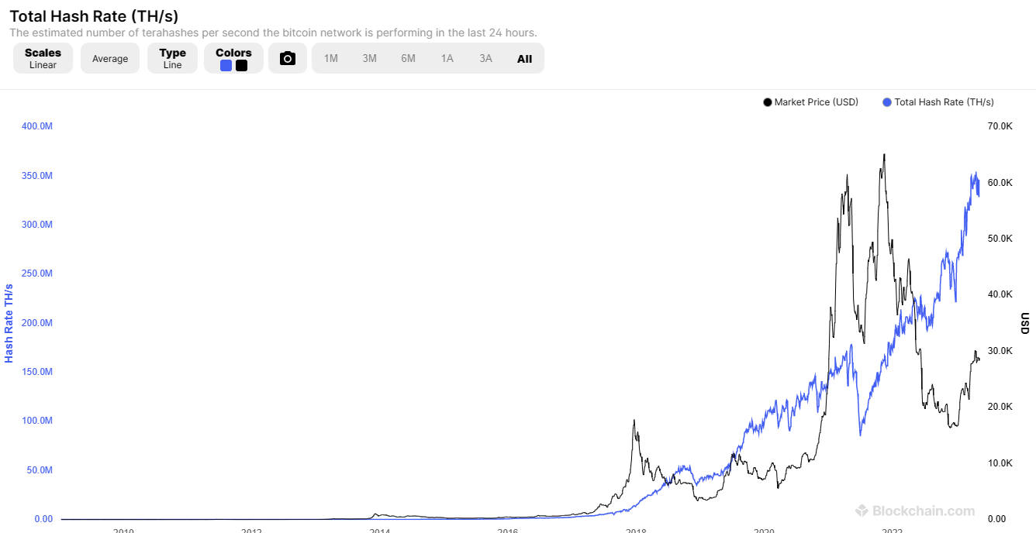

(Source: Blockchain.com)

A gift to the world…

Fifteen years ago, Satoshi Nakamoto made a gift to the world. Building on the work of many others, he proposed “A system for electronic transactions without relying on trust […] A peer-to-peer network using proof-of-work to record a public history of transactions that quickly becomes computationally impractical for an attacker to change if honest nodes control a majority of CPU power [… Central Processing Unit] A peer-to-peer version of electronic cash that would allow online payments to be sent directly from one party to another without going through a financial institution […] The network timestamps transactions by hashing [… encrypting] them into an ongoing chain of hash-based proof-of-work, forming a record that cannot be changed without redoing the proof-of-work.” Today, the Bitcoin Protocol has become the most powerful public network of encrypted digital energy, allowing for the preservation through time and space, and for the seamless transmission (censorship resistant) of the most valuable information – text, image, method and code (i.e. intellectual property) – that an individual, or an organization, possesses. In addition, the network’s integrity and robustness rest upon a stack of more than one million Bitcoin, valued at (+/-) thirty billion dollars, that haven’t been hacked, or tempered with, to date… To put it simply, Bitcoin is becoming gradually, computationally and cryptographically: “tout en tous et tous en tout »…

Today, MicroStrategy – and, thus, Michel Saylor – made another gift to the world. They released most of the expertise and of the experience shared at the First World Conference on Bitcoin & Lightning for Corporations. “This event brings together corporate leaders, financial executives, and technology innovators to discuss the future of Bitcoin and Lightning in the corporate world. It features expert advice needed for corporations – to plug into Bitcoin and Lightning and reimagine their business – directly from the market’s most credible voices and experienced practitioners.”

The diversity and depth of these conferences provide an exceptional guide to the technological, psychological, and political challenges facing this potentially disruptive technology. One certainty: the Bitcoin and Lightening Networks won’t disappear tomorrow, even if their diffusion is likely to experience temporary setbacks and other deceptive actions. For real-time information on the status of the Bitcoin Network, refer to the Bitcoin (BTC) price stats and information.

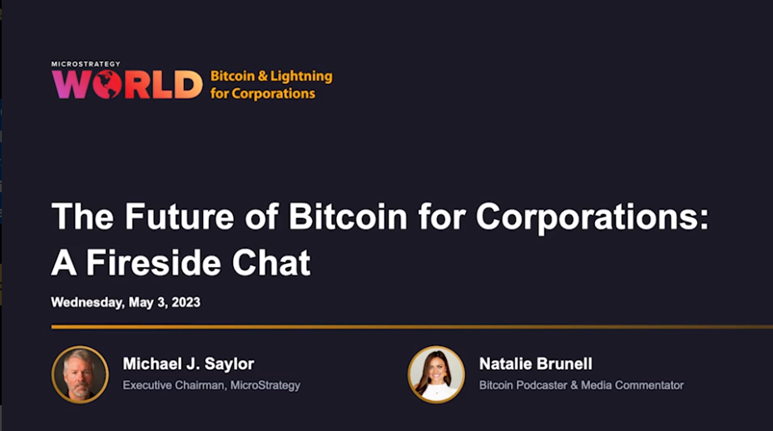

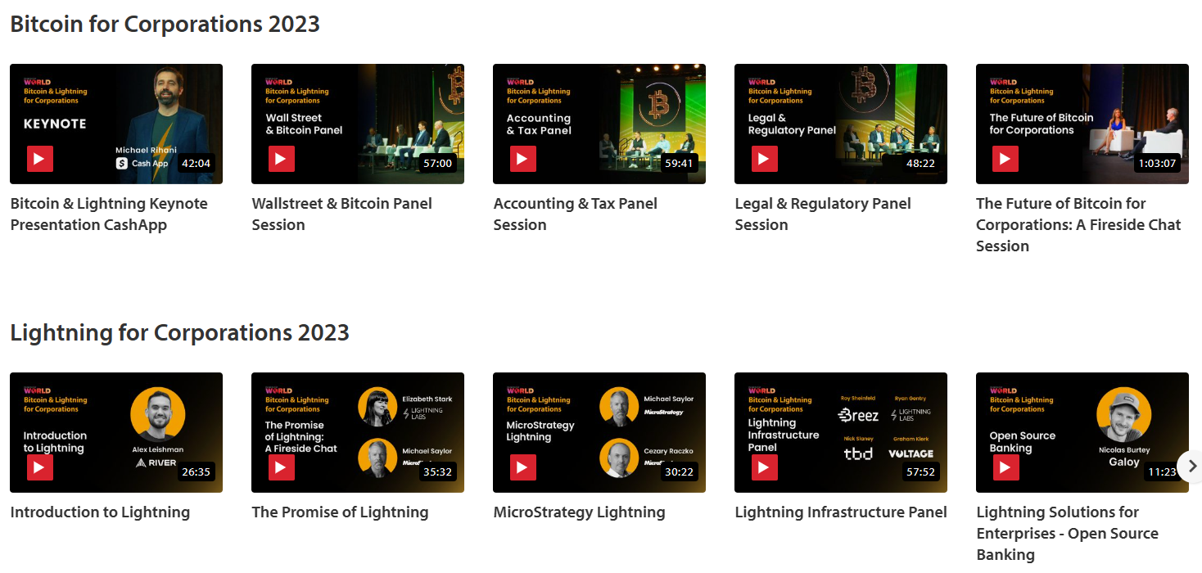

(Source: MicroStrategy, May 14, 2023)

* * *

Milton Friedman can rest in peace. His 1999 vision of the future of money is taking shape: “The one thing that’s missing, but that will soon be developed, it’s a reliable e-cash. A method where buying on the Internet you can transfer funds from A to B, without A knowing B or B knowing A. The way in which I can take a 20 dollar bill and hand it over to you and there’s no record of where it came from. And you may get that without knowing who I am. That kind of thing will develop on the Internet.”

We can ignore reality, but we cannot ignore the consequences
of ignoring reality. (Ayn Rand)

Beware such unequivocal impossibility.

* * *

