Survival of The Fittest

Jean-Marie Choffray*
Liège, May 1, 2023.

Life is unfair... Even the “best” disappear when they fail to adapt to changes in their environment. The rise of the cost of money (see Federal Funds Effective Rate below), over the last twelve months, has put medium-sized banks in a perilous situation. “Only when the tide goes out do you learn who has been swimming naked” (Warren Buffett). The burden of debt has rarely been as heavy as today. And, what is true for banks is probably true for most businesses with significant leverage (debt to equity ratio). European firms, particularly, should be carefully monitored. Financing being mostly marketing, financial reporting is more an art than a science. We all learn to: “ Believe nothing you hear, and only one half that you see” (Edgar Allan Poe). Today’s collapse of First Republic Bank provides an excellent example of the distance separating the rosy picture of financial statements from the harsh reality (liquidity and solvability) that a company may face. Reader beware!

Five Year Evolution of Federal Funds Effective Rate
(Source: FRED, St Louis Fed)

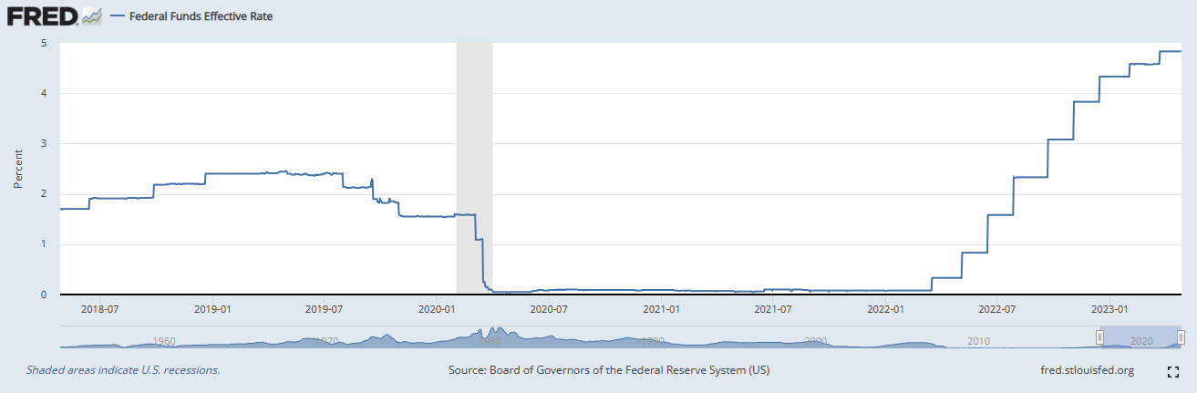

* Emeritus Professor of Computer Science, University of Liege School of Management.
PhD-77, Management Science, Massachusetts Institute of Technology.

Le secret des grandes fortunes sans cause apparente est un crime
oublié, parce qu’il a été proprement fait.
Honoré de Balzac

Survival of The Fittest

“Ever wonder why fund managers can’t beat the S&P 500? ’Cause they’re sheep – and the sheep get slaughtered. I been in the business since ’69. Most of these high paid MBA types, they don’t add up to dog shit. Gimme guys who are poor, smart and hungry. And no feelings. You win some, you lose some, but you keep on fighting… and if you need a friend, get a dog.”
Michael Douglas as Gordon Gekko in Wall Street

Today’s implosion of First Republic Bank (NYSE: FRC), the fourteen’s largest US commercial bank, a 2022 Fortune 500 company, is not a trivial event. After the collapse in March of Silicon Valley Bank, Signature Bank, and the liquidation of Silvergate Capital, it’s more than $500 billion in assets (close to the Belgian GDP) that have changed hands. Shareholders and debtholders have lost most, if not all, of their investment. The financial information published by these banks reflected the past, and did not take into consideration the severe depreciation of their assets in a restrictive monetary environment (high interest rates, reduced liquidity).

For your information, I have reproduced in the following pages:
- First Republic Bank First Quarter 2023 Results, April 24, 2023
- JPM assumes the deposits of First Republic Bank, May 1, 2023
- JPM acquires majority of assets of First Republic Bank, May 1, 2023
- JPM Investor Presentation, May 1, 2023
- Federal Reserve Board report on Silicon Valley Bank, April 28, 2023

As to the final result, a surrogate for the cost of incompetence and the lack of supervision… A graph (six months) is worth a thousand words!

(Source: BigCharts, from MarketWatch, Monday, May 1, 2023)

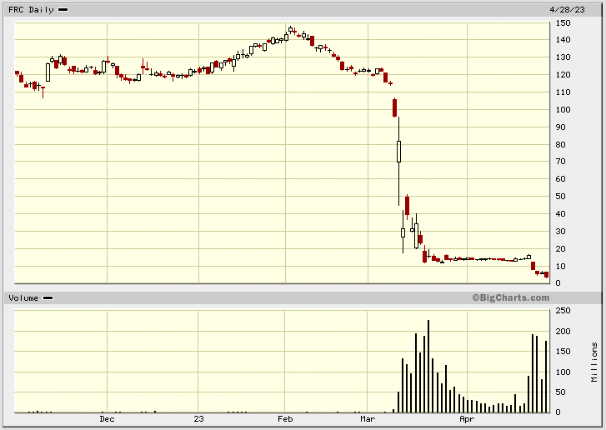

The lesson…

Our world hasn’t fundamentally changed (John Kenneth Galbraith, A Short History of Financial Euphoria). In turbulent times, Management and financial statements cannot, and should not, be trusted. They are akin to storytellers and fairy tales for those afraid of a brutal – and nonparametric – reality. As to the shareholders and the debtholders: fools and their money are soon parted. “Our government invited us and others to step up, and we did […] The transaction is expected to generate more than $500 million of incremental net income per year […] FDIC will provide $50 billion of five-year, fixed-rate term financing […] FDIC will provide loss share agreements with respect to most acquired loans […] IRR > 20%” (Jamie Dimon). As always, only the strongest – and/or the politically connected – survive… Cui bono?

First Republic Bank First Quarter 2023 Results
(Source: First Republic Bank, Monday; April 24, 2023)

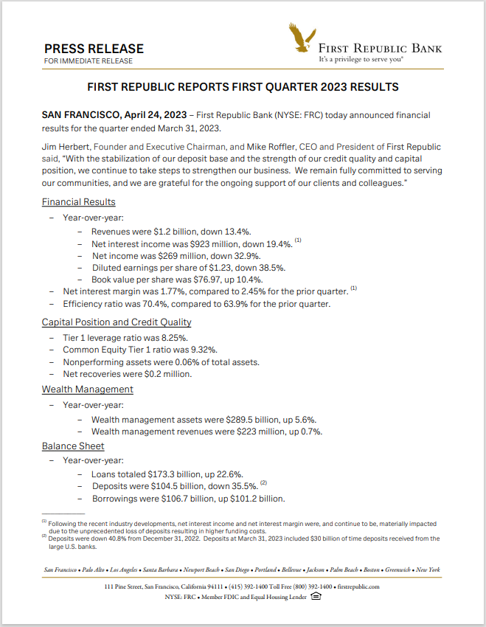

JPMorgan Chase Bank, National Association, Columbus, Ohio Assumes All the Deposits of First Republic Bank, San Francisco, California
(Source: Federal Deposit Insurance Corporation, Monday, May 1, 2023)

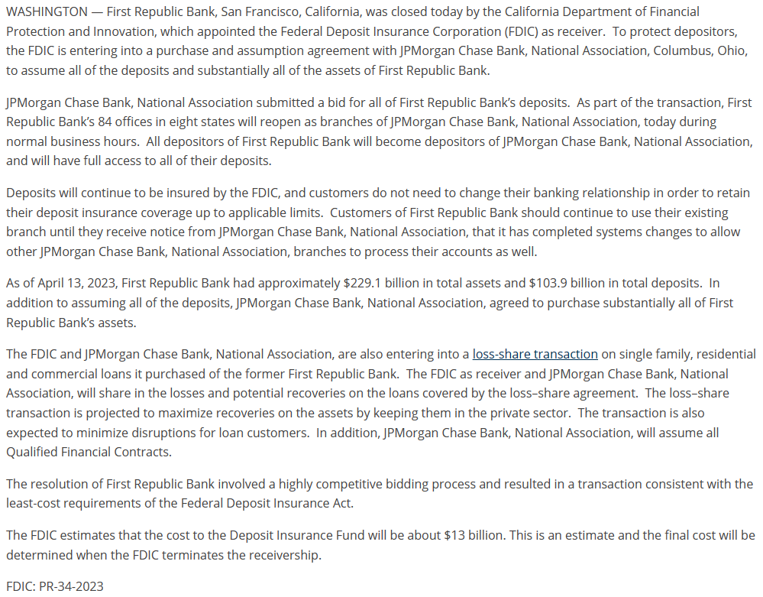

JPMorgan Chase acquires substantial majority of assets and assumes certain liabilities of First Republic Bank
(Source: JPMorgan Chase, Monday, May 1, 2023)

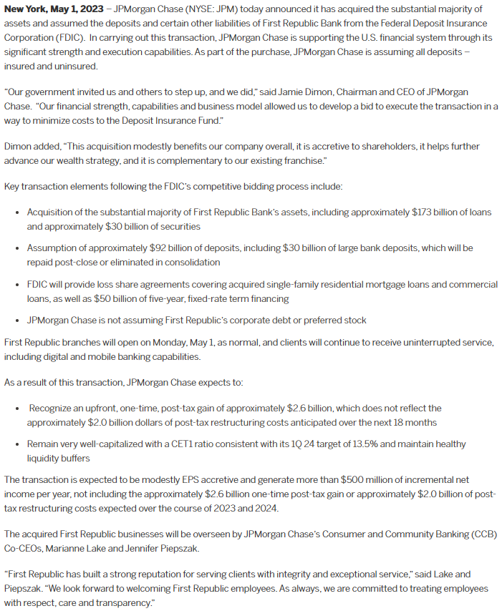

JPMorgan Chase Investor Presentation
(Source: JPMorgan Chase, Monday, May 1, 2023)

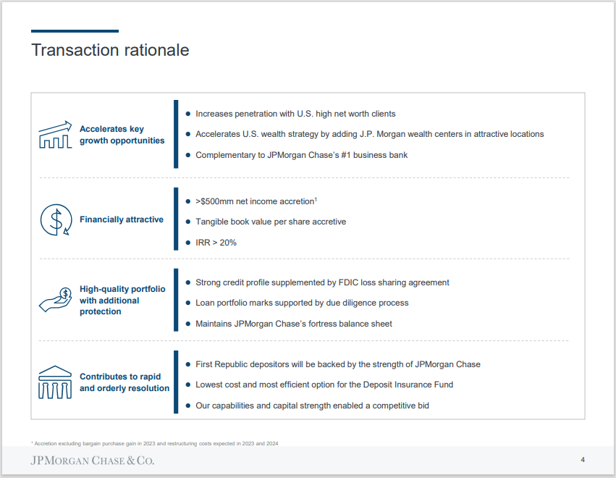

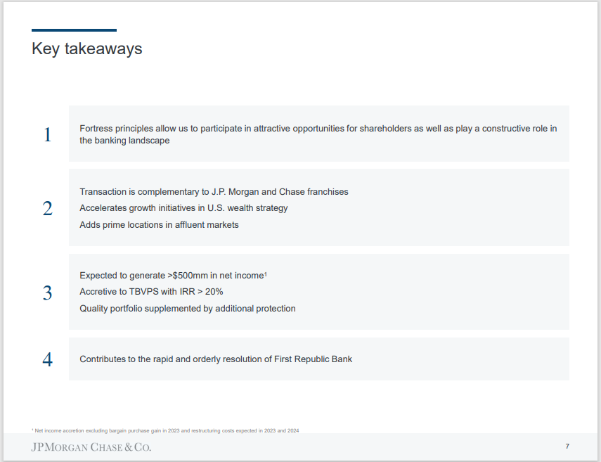

Federal Reserve Board announces the results from the review of the supervision and regulation of Silicon Valley Bank, led by Vice Chair for Supervision Barr
(Source: The Federal Reserve, Friday, April 28, 2023)

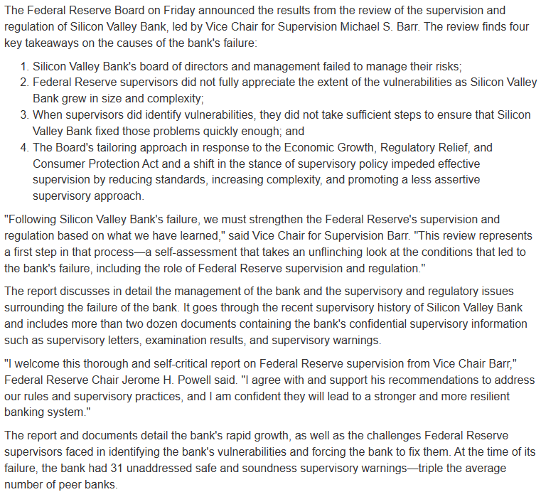

See complete report

* * *

