Exploring different high‑capacity tools and extraction modes
to characterize the aroma of brewed coffee

Damien Eggermont1 · Natasha Damiana Spadafora2 · Juan Aspromonte3 · Rocío Pellegrino3 · Giorgia Purcaro1
- Gembloux Agro-Bio Tech, University of Liege, Bat. G1 Chimie Des Agro‑Biosystemes, Passage Des Deportes 2, 5030 Gembloux, Belgium
- Department of Chemical, Pharmaceutical and Agricultural Sciences, University of Ferrara, 44121 Ferrara, Italy
- Laboratorio de Investigacion Y Desarrollo de Metodos Analiticos, LIDMA, Facultad de Ciencias Exactas (Universidad Nacional de La Plata, CIC-PBA, CONICET), 1900 La Plata, Argentina

Keywords: High capacity (HC) HiSorb Solid-phase microextraction (SPME) Multi-cumulative trapping (MCT) Multidimensional comprehensive gas chromatography (GC × GC) Coffee
Abstract
In the present work, the potential benefit of using multi-cumulative trapping headspace extraction was explored by comparing the results using solid-phase microextraction (SPME) coated with divinylbenzene/carboxen/polydimethylsiloxane and a probe-like tool coated with polydimethylsiloxane. The efficiency of a single 30-min extraction, already explored in previous work, was compared with that of multiple shorter extractions. We evaluated three different conditions, i.e., three repeated extractions for 10 min each from different sample vials (for both the probe-like tool and SPME) or from the same vial (for SPME) containing brewed coffee. The entire study was performed using comprehensive two-dimensional gas chromatography coupled with mass spectrometry. The two-dimensional plots were aligned and integrated using a tile-sum approach before any statistical analysis. A detailed comparison of all the tested conditions was performed on a set of 25 targeted compounds. Although a single 30-min extraction using the probe-like tool provided a significantly higher compound intensity than SPME single extraction, the use of multiple shorter extractions with SPME showed similar results. However, multiple extractions with the probe-like tool showed a greater increase in the number of extracted compounds. Furthermore, an untargeted cross sample comparison was performed to evaluate the ability of the two tested tools and the different extraction procedures in differentiating between espresso-brewed coffee samples obtained from capsules made of different packaging materials (i.e., compostable capsules, aluminum capsules, aluminum multilayer pack). The highest explained variance was obtained using the probe-like tool and multiple extractions (91.6% compared to 83.9% of the single extraction); nevertheless, SPME multiple extractions showed similar results with 88.3% of variance explained.

Introduction
Headspace (HS) analysis mediated by the use of high-capacity (HC) tools for the analysis of volatile and semi-volatile compounds is a highly explored technique in various fields of application such as clinical [1, 2], environmental [3, 4], and food [5–7]. In fact, HC tools are easy to use, solvent free, and, in some cases, easy to automate [8]. Among the different HC techniques, solid-phase microextraction (SPME) is the most widely applied and the most versatile. Nevertheless, over the years, different HC tools have been developed, including stir-bar sorptive extraction (SBSE) [9], SPME Arrow [10–13], a probe-like tool (commercially available with the name of HiSorb) [14, 15], and thin-film solid-phase microextraction (TF-SPME) [16]. The main difference among these HC tools is the sorbent volume, which is positively related to the extraction yield according to the equation R = Eβ, where R is the recovery, E is the enrichment factor, and β is the phase ratio (β = V_{e}/V_{s}, where V_{e} is the volume of the extractant or sorbent and V_{s} the volume of the sample) [17]. The sorbent volume of the different tools is around 0.6 µL for SPME (PDMS 100 µm), 24–126 µL for SBSE, 3.8–11.8 µL for SPME Arrow, 63 µL for HiSorb, and 40 µL for TF-SPME. The latter tool, along with a higher sorbent volume, has the advantage of a significantly higher surface-to-volume ratio leading to much faster extraction kinetics [18]. Nevertheless, the two tools exhibiting the highest sorbent volume, i.e., SBSE and TF-SPME, are penalized by a lack of full automation.
On the other hand, alternative approaches have been used to improve the extraction kinetics and the extraction yield of HS-HC. Besides the most classical approach of adjusting the stirring rate and extraction temperature, some attractive alternatives have been suggested. For instance, Psillakis et al. systematically investigated the use of reduced-pressure conditions, named Vac-HS, and formulated its underlying principle [19–23]. Another interesting approach is the use of multi-cumulative trapping (MCT). This approach was presented for the first time in 2000 by Lipinski and collaborators in direct-immersion SPME to enhance the sensitivity for the analysis of pesticides in water [24]. Later, Chin et al. trapped multiple extractions using a cold trap at the head of the chromatographic column to increase the detection limit in GC-O for screening of wine aroma [25]. More recently, the MCT-SPME technique has been successfully applied to discriminate between extra-virgin olive oil, virgin and lampante oil, and among different geographical origins [26–28]. When applying the MCT-SPME approach, multiple sequential extractions from the same vial (or different ones) are cumulated in a cryo-trap and then released together into the GC system. Similarly to vacuum SPME, MCT-SPME applied to a single vial significantly increased the extraction of the semi-volatile and more polar compounds [27]. When working under non-saturated HS conditions, the first extraction reduces the amount of the most volatile analytes, positively changing the equilibrium toward the less volatile ones and reducing the displacement effect when adsorption sorbents are used (e.g., the DVB/CAR/PDMS coating used in the cited studies). This beneficial depletion of the most volatile compounds was reported as an interesting strategy also for the use of TF-SPME, coupling with different coatings [29]. The increased extraction of less volatile compounds improved the discrimination capability for olive oil quality and authenticity by using a fingerprinting approach [28].
The goal of this study is to explore the use of MCT using a HiSorb probe and compare its extraction performance with that of MCT-SPME for brewed coffee volatile characterization. The present work follows a previous one where HiSorb extraction conditions were optimized and the untargeted extraction yield was compared with that of the SPME coated with the same phase (PDMS) and another commonly used sorbent phase, namely, DVB/CAR/PDMS [30]. The MCT or single-extraction approaches are applied to explore their potential in discriminating between brewed coffees obtained from different capsule materials. The results obtained using MCT in combination with HiSorb probes are compared with those obtained using SPME in MCT mode performed from both multiple vials (MV) and a single vial (SV).

Materials and methods

Chemicals and reagents
n-Hexane and alkane mixture (C₇–C₃₀) were from MilliporeSigma® (USA). The alkane mixture was used for quality control of the instrument performance and to calculate the linear retention index (LRI) to support peak identification. The probe-like tool, commercially named HiSorb, was kindly provided by Markes International Ltd. (UK). It consisted of a probe coated with polydimethylsiloxane (PDMS) (H1-XXABC). SPME fibers coated with divinylbenzene/carboxen/polydimethylsiloxane (DVB/CAR/PDMS) df 50/30 µm/1 cm length were kindly provided by MilliporeSigma® (USA).

Coffee samples and brewing procedure
A local coffee roasting company, Charles Liégeois (Belgium), kindly provided us with 23 coffee samples, consisting of 11 aluminum-pack, 6 aluminum-capsule, and 6 compostable-capsule-packed coffee samples. For method optimization and preliminary comparison, a commercially available ground coffee sample (Arabica 100%) was prepared according to the Turkish method proposed by Bicchi et al. [31] and treated as reported in [30].
The samples provided by the roasting company were prepared using a Nespresso Inissia coffee machine (De’Longhi Appliances S.r.l., Italy). For the coffee samples not already in capsules (named “pack” afterwards), a re-usable aluminum capsule was used to prepare the espresso using the amount of coffee determined in [30].

Headspace high‑capacity multi‑cumulative trapping extraction
A Centri sample extraction and enrichment platform (Markes International Ltd., UK) was used for sample preparation. Extraction, either using HiSorb or SPME, was performed from a 20-mL vial where 1 mL of brewed coffee was added, following the procedure reported below. Triplicates were used for the MCT and tool comparison.

HiSorb probe extraction
HiSorb probes consisted of a PDMS extraction phase, and the extractions followed the previously optimized method [30]. Briefly, samples were left to equilibrate for 20 min at 60 °C under agitation (350 rpm) before 30 min of extraction. The probes were dried under air flow before desorption at 270 °C for 10 min. The volatiles were focused on an electronically cooled trap (U-T12ME-2S, Markes International Ltd.) set at 0 °C before injection into the GC × GC system at 300 °C for 3 min.

SPME extraction
SPME fibers consisted of a DVB/CAR/PDMS phase and were pre-conditioned as recommended by the manufacturer for 30 min at 270 °C. The sample preparation and extraction procedures were the same as for HiSorb, except for the drying step, which was not applied for SPME. The SPME desorption was limited to 4 min, verifying the absence of carryover.

Multi‑cumulative trapping
Multi-cumulative trapping extractions were achieved following two different approaches, namely SV-MCT (repeated extraction from the same vial) and MV-MCT (repeated extraction from different vials containing the same sample). In the first case, several extractions (as previously described) were performed on the same aliquot and trapped all together. In the latter, the extractions were performed on different aliquots of the same sample. The compounds extracted from each exposure step were desorbed at 270 °C in the injector and re-trapped on an electrically cooled focusing trap (U-T12ME-2S, Markes International Ltd.) set at 0 °C. The focusing trap was then heated up at 300 °C to inject the sum of all extractions at once.
SPME fibers can use both MV and SV-MCT approaches since the pierced septum does not exhibit loss of sealing capacity for several subsequent septum piercings (tested up to 6). In the present work, 5 min of enrichment delay was used before performing a new extraction from the same vial, as reported by Mascrez and Purcaro [26]. Regarding HiSorb, the size of the probe does not allow for a re-sealing of the septum and the instrument was not equipped with a re-cap tool. Therefore, only the MV-MCT approach was used for extraction with HiSorb.
The results obtained using three extractions of 10 min (3 × 10 min) in MV (HiSorb and SPME) and SV (SPME only) for the MCT approach were compared with the previously obtained optimal single extraction of 30 min using a HiSorb probe.

GC × GC‑qMS analysis
All the samples were analyzed in a Shimadzu GCMSTQ8050 NX (Shimadzu, Germany), consisting of a GC-2030 and triple-quadrupole mass spectrometer detector (TQ-MS). The system was upgraded to a comprehensive multidimensional system using an INSIGHT differential flow modulator (SepSolve Analytical Ltd., UK). The first-dimension column (¹D) was a 20 m × 0.18 mm i.d. × 0.18 µm SLB-5MS silphenylene polymer capillary column (practically equivalent in polarity to poly(5% diphenyl/95% methylsiloxane)), kindly donated by MilliporeSigma (USA). The second-dimension column (²D) was an SLB-50 (MilliporeSigma, 5 m × 0.25 mm i.d. × 0.25 µm) equivalent to 50% phenylpolysilphenylene-50% siloxane. The eluent of the second column was diverted into the MS and a VUV detector (VGA-101, VUV Analytics, USA) with a ratio corresponding to 41% and 59%, respectively. The splitting was obtained by connecting the outlet of the second column to two uncoated capillaries, i.e., 1.1 m × 0.18 mm i.d. connected to the MS and a 20 cm × 0.25 mm i.d. to the VUV detector (data not used in this study). The splitting of the flow before entering the MS detector is anyway needed to have a flow rate compatible with the MS detector. The GC temperature program was 40 °C (held 5 min) increased to 280 °C at 6 °C/min. The carrier gas was helium. The flow was regulated through the programmed pressure mode both at the inlet and the auxiliary pressure-controlled module (to regulate the ²D column flow), to generate 0.6 mL/ min in the ¹D column and 16 mL/min in the ²D column. A 1 m × 0.1 mm i.d. bleeding line from the reversed fill/flush modulator was connected to an auxiliary pressure controlled to generate a 0.6 mL/min flow. Modulation time of 3.5 s was used, including 100 ms of reinjection.
The TQ-MS was used in single-quadrupole mode, setting the electron ionization (EI) at 70 eV. The ion source and transfer line temperatures were 200 °C and 280 °C, respectively. The scan range was set from 45 to 350 m/z, with an acquisition frequency of 50 Hz.
Data were acquired using Shimadzu GCMSolution version 4.45 from Shimadzu.

Data treatment and statistical analysis
The ChromCompare + software version 2.1.4 (SepSolve Analytical Ltd., UK) was used for data elaboration after a careful alignment based on the ¹D and ²D retention time and the spectral information. A dynamic background compensation (DBC) based on a peak width of 0.6 s was applied before the untargeted tile-based approach. A tile size of 5 modulations (18 s) in ¹D and of 1.2 s in ²D with 25% overlap was applied. Artifacts and siloxane were removed by a careful comparison with blank samples.

Chromatographic integration and VOC identification
Chromatograms of the samples were integrated after a DBC pretreatment via ChromSpace GC × GC data processing software (SepSolve Analytical, Peterborough, UK), and incorporated within the ChromCompare + analytical software. Significant compounds were putatively identified based on the NIST17 library similarity ≥ 75% and supported with the experimental linear retention index (LRI) within a ± 30 range compared to the LRI reported on the NIST17 library.

Exploratory classification of the samples
The probabilistic quotient normalization (PQN) [32] and a logarithmic transformation were applied in order to make the distribution of the variables closer to normal [33, 34]. A data reduction based on random forest (RF) was performed using 100 repetitions of 10 decision trees with 15 randomly presented samples and half of the whole features randomly picked presented at each tree with an error threshold of 0.2. The top 30 most significant features were selected. In summary, a data matrix of size 30 × 23 (features × samples) was obtained for each of the methods applied and saved in ASCII format for visualization and further analysis.
Principal component analysis (PCA) was applied to all three feature reduced datasets (single-extraction HiSorb, MCT-HiSorb, and MCT-SPME-SV), in order to explore the classification of the coffee samples based on the type of packaging, that is, aluminum-capsule packed, compostable capsule packed, and multilayer aluminum pack. Score plots were constructed using the first three principal components (PC).

Further statistical analysis
Further statistical and visualization treatments were performed using Excel (Microsoft Office, version 2016), Minitab (Minitab LCC, version 19.2020.1), Morpheus (https://s oftware.b roa dinstit ute .org/m orp heus /), and RStudio (RStudio PBC, version 1.4.1717, R version 4.1.0).

Figure 1
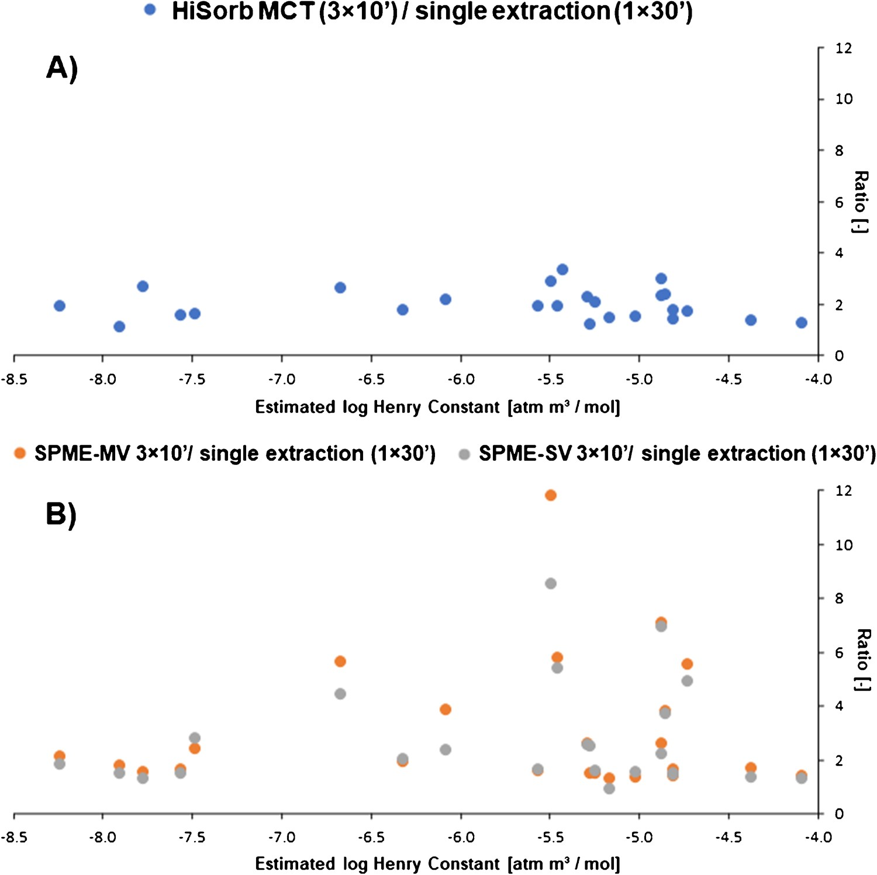

Fig. 1 Ratio of intensity obtained for 25 selected target compounds obtained with (A) MCT-HiSorb MV and (B) MCT-SPME-SV using 3 extractions of 10 min, and the reference method of a single extraction of 30 min using either HiSorb or SPME, accordingly; plotted against their log-transformed Henry’s constant

Results and discussion

Study of the multi‑trapping conditions for HiSorb and SPME
In our recent publication [27], HiSorb was compared, in terms of coverage and analyte response intensity, with the more commonly used SPME approach in characterizing the HS profile of brewed coffee. In this regard, HiSorb showed a higher performance.
Recently, we also investigated the use of the MCT approach, as explained in the introduction, that can be applied to both HiSorb and SPME methodologies. The use of MCT was investigated to study the volatile profile of the espresso coffee samples previously explored using single extraction. Three extraction conditions were evaluated: MCT-SPME-MV, MCT-SPME-SV, and MCT-HiSorb (also
MV). One milliliter was used for all experiments, as reported previously [30]. However, as shown by the results discussed below, where negligible differences were observed between MCT-SPME-SV and MCT-SPME-MV, 1 mL of sample led to the saturation of the HS for most of the compounds. However, by using volumes lower than 1 mL, a total volatilization of the sample is likely to occur during the conditioning and sampling times, creating a crust on the vial wall.
In fact, when comparing the extraction capacity between the two SPME approaches, MCT-SPME-MV and MCT-SPME-SV, the results are very comparable. Only few analytes with higher volatility (e.g., methyl pyrazine, 1-(acetyloxy)-2-propanone, 2-furanmethanol) are better recovered when working in MCT-SPME-MV than MCT-
SPME-SV (Fig. 1). It is expected that the reuse of the same vial for multiple extractions will cause a depletion of the more volatile analytes, eventually improving the recovery of the less volatile ones [27, 35]. However, in this case, MCT-SPME-SV did not show a clear benefit in the recovery of the less volatile compounds. This is an indication that the HS remained saturated for most of the compounds, and the depletion of the more volatile analytes was not fully achieved under the studied conditions. Therefore, no significative advantage of MCT-SPME-SV over MCT-SPME-MV would be expected.
The MCT extraction conditions were compared with those of the single-step 30-min extraction using either HiSorb or SPME. The 25 compounds already identified in the previous work, which covered a wide range of polarities and volatilities [30], were used to evaluate the potential benefit of MCT. The ratio of the obtained area of these compounds when using MCT and the one obtained when using the single extraction with the same type of probe (HiSorb or SPME) was plotted against Henry’s constant of each analyte (Fig. 1(A and B)). The overall recoveries increased in all MCT approaches by roughly twofold (median value). HiSorb probes used with the MCT approach showed a 1–3 times.
higher recovery than when HiSorb probes were used in single extraction for all analytes without any particular trend (Fig. 1(A)). While SPME showed a twice median increment for both MV and SV-MCT approaches, compared to the single-step SPME (Fig. 1(B)). However, there is a broad variability, namely in the ~ 1–12 and 1–9 ratio ranges, for MV and SV, respectively, with a clear trend of increased signal for the more volatile compounds for both extraction modes. This improved extraction of the most volatile compounds with multiple shorter SPME extractions is due to the lower sorbent volume, which is quickly saturated in the first minutes of extraction. The renewal of the vial and concentration of the extracted compounds in the cold trap has a higher impact on sensitivity than a longer exposure time. Therefore, proper analyte extraction can be achieved within a shorter time per vial, with a net gain in the aggregate, thanks to the high capacity of the cold trap. The adsorption process is more favorable in the first few minutes; therefore, having a fresh solid phase has a higher impact on recoveries than extending the extraction time per vial. In this case, this allows for the same total extraction time for single or MCT approaches.
The signal of the compounds obtained with MCT-SPME (either MV or SV) compared with a single HiSorb extraction of 30 min showed a median ratio of 0.6 (ranging between 0.2 and 1.5). Furthermore, almost the same number of total peaks was extracted using MCT-SPME either in SV or MV mode compared to HiSorb 1 × 30 min. MCT-HiSorb 3 × 10 min provided an increase of about 36% of the total number of compounds extracted compared to a single 30-min extraction with HiSorb. Figure 2 shows the comparison between the 2D plot obtained using MCT-HiSorb 3 × 10 min and that using MCT-SPME-SV 3 × 10 min. In the insert box, the normalized (against the highest) total number of peaks for the different extraction conditions is reported. Nevertheless, when investigating the coverage of the key odorants, as reported in our previous work [30], no differences were noted using HiSorb or SPME in both tested modes.
Figure 2
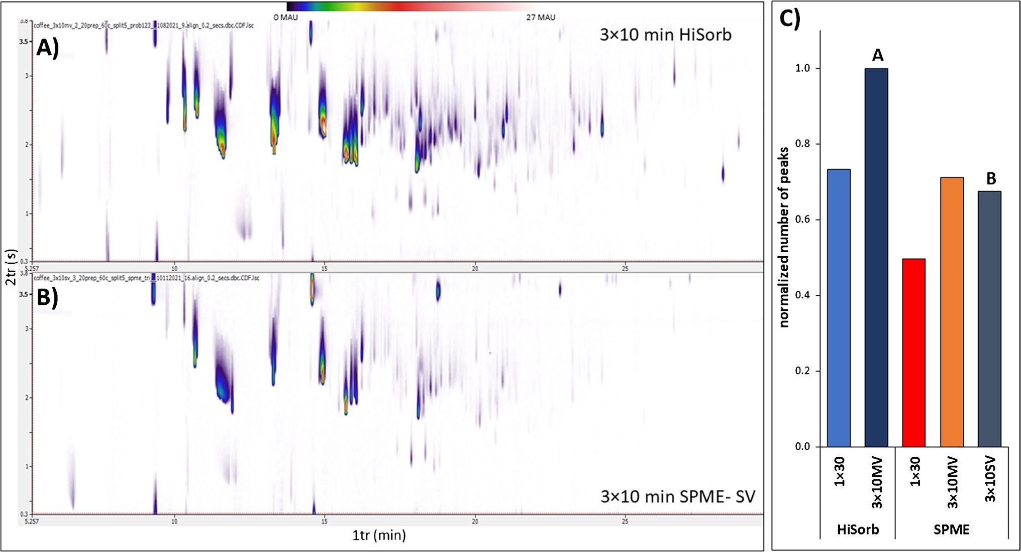
Fig. 2 Comparison of the 2D plot obtained by extracting the same ber of compounds extracted using HiSorb 1 × 30 min, MCT-HiSorb brewed coffee using (A) MCT-HiSorb 3 × 10 min and (B) MCT- 3 × 10 min (A) and SPME 1 × 30 min, MCT-SPME-MV 3 × 10 min, SPME-SV 3 × 10 min. (C) Normalized comparison of the total num- MCT-SPME-SV 3 × 10 min (B)

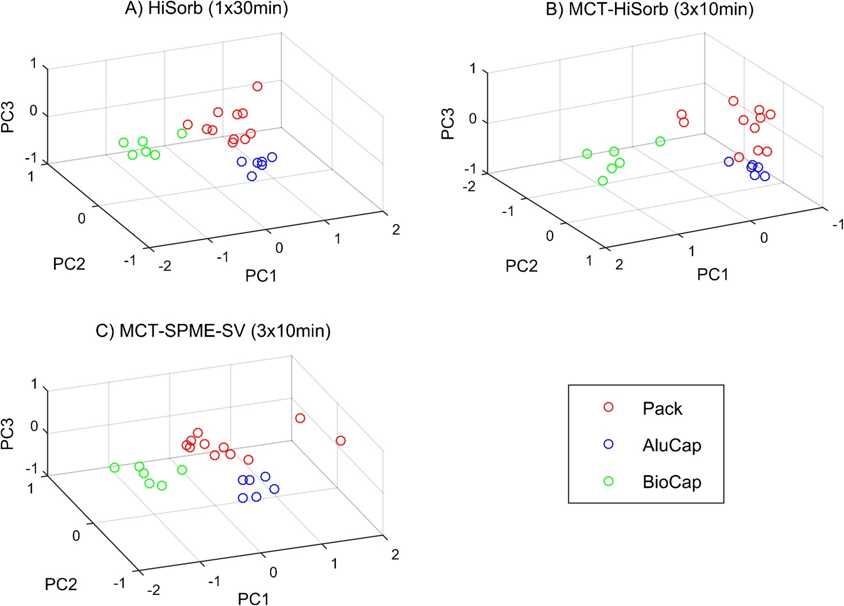
Figure 3

Fig. 3 3D score plot for PC1, PC2, and PC3 for (A) HiSorb single extraction, (B) MCT-HiSorb, and (C) MCT-SPME-SV models using the selected features (red: aluminum multilayer pack, blue: aluminum capsule, green: biodegradable capsule
Table 1
Table 1 Corresponding explained variance for the first three principal components for the HiSorb single extraction, MCT-HiSorb, and MCT-SPME-SV models using the selected features
Mode | Explained variance (%)
Mode | PC1 | PC2 | PC3 | Total
HiSorb | 60.8 | 14.3 | 8.8 | 83.9
MCT-HiSorb | 57.0 | 24.3 | 10.3 | 91.6
MCT-SPME-SV | 69.6 | 10.6 | 7.8 | 88.3

Table 2 Tentative identification of the selected features, along with untargeted approach for HiSorb single extraction, HiSorb MCT, and the MS similarity and the linear retention indices calculated experi- SPME SV-MCT after removal of redundancy mentally (RI) and reported in the NIST library (NIST RI), for the
 | 1tr (min) | 2tr (s) | Features | MS | RI | NIST RI
HiSorb single extraction | 3.75 | 1.5 | Unknown
 | 6.23 | 2.4 | 2,3-Pentanedione | 705 | 483 | 669
 | 8.93 | 0.6 | Unknown
 | 9.38 | 1.5 | Unknown
 | 11.40 | 1.5 | 2 furanmethanol | 846 | 826 | 830
 | 13.20 | 3.3 | Ethanone, 1-(2-furanyl)- | 862 | 883 | 889
 | 13.43 | 0.6 | Pyrazine 2,5 dimethyl | 857 | 885 | 889
 | 14.33 | 0.6 | Unknown
 | 15.23 | 0.6 | Unknown
 | 15.90 | 3.3 | Pyrazine, 2-ethyl-5-methyl- | 833 | 962 | 975
 | 15.90 | 3.3 | Pyrazine, 2-ethyl-6-methyl- | 823 | 967 | 976
 | 16.13 | 0.6 | Pyrazine, 2-ethyl-3-methyl- | 850 | 978 | 970
 | 16.13 | 2.4 | Unknown
 | 16.35 | 3.3 | Unknown
 | 16.58 | 2.4 | 4(H)-Pyridine, N-acetyl- | 653 | 991 | 1038*
 | 16.80 | 0.6 | Unknown
 | 17.25 | 2.4 | Unknown
 | 18.38 | 2.4 | Phenol 2 methoxy | 817 | 1055 | 1063
 | 18.83 | 1.5 | 2-Cyclopenten-1-one, 3-ethyl-2-hydroxy- | 830 | 1065 | 1100
 | 19.73 | 2.4 | 4C-Pyrazine |  | 1095
 | 24.23 | 2.4 | 2 methoxy 4 vinylphenol | 834 | 1275 | 1285
 | 25.80 | 0.6 | Unknown
HiSorb MCT | 3.75 | 2.4 | Unknown
 | 4.88 | 2.4 | Unknown
 | 7.80 | 3.3 | Unknown
 | 10.28 | 2.4 | Pyrazine, methyl- | 846 | 791 | 801
 | 13.43 | 3.3 | Butanoic acid, 4-hydroxy- | 852 | 892 | 933*
 | 15.00 | 1.5 | Benzaldehyde | 833 | 936 | 933
 | 15.00 | 1.5 | 2-Furancarboxaldehyde, 5-methyl- | 833 | 936 | 940
 | 15.23 | 3.3 | Alkane |  | 944
 | 17.93 | 2.4 | Unknown
 | 19.50 | 1.5 | Unknown
 | 20.85 | 1.5 | 1H-Pyrrole, 1-(2-furanylmethyl)- | 831 | 1145 | 1153
 | 20.85 | 0.6 | 1H-Pyrrole, 1-(2-furanylmethyl)- + unknown | 831 | 1145 | 1153
 | 20.85 | 0.6 | Unknown
 | 21.75 | 0.6 | Unknown
 | 21.98 | 0.6 | Unknown

Table 2 (continued)
 | 1tr (min) | 2tr (s) | Features | MS | RI | NIST RI
SPME SV-MCT | 7.80 | 3.3 | Unknown
 | 8.93 | 2.4 | Unknown
 | 10.28 | 3.3 | Furan, 2-(methoxymethyl)- | 815 | 622 | 845*
 | 10.95 | 2.4 | 2/3 furaldehyde | 823 | 689 | 804
 | 14.78 | 3.3 | 2-Furancarboxaldehyde, 5 methyl | 869 | 928 | 933
 | 15.00 | 3.3 | Benzaldehyde | 865 | 932 | 933
 | 15.23 | 0.6 | Unknown
 | 15.68 | 1.5 | 2-Furanmethanol, acetate | 838 | 955 | 966
 | 16.13 | 2.4 | Furan, 2-[(methylthio)methyl]- | 792 | 963 | 980
 | 16.58 | 2.4 | 4(H)-Pyridine, N-acetyl- | 720 | 986 | 1038*
 | 17.25 | 3.3 | Unknown
 | 17.48 | 3.3 | Unknown
 | 18.38 | 1.5 | Unknown
 | 19.28 | 2.4 | Unknown
 | 19.50 | 2.4 | Unknown
 | 21.08 | 2.4 | Unknown
 | 24.23 | 2.4 | 2-Methoxy-4-vinylphenol | 854 | 1276 | 1285
* NIST RI calculation based on a semi-standard non-polar column

Classification of brewed coffee based on the capsule material
The ability to obtain an appropriate classification of the samples depending on their packaging, i.e., biodegradable capsules, aluminum capsules, and multilayer aluminum packaging, was also investigated.
MCT-SPME-MV was not tested further as it provided almost superimposable results to HS-SPME-SV (Fig. 1(B)). However, MCT-SPME-SV would be expected to bring more useful information than MCT-SPME-MV [26, 28]. Therefore, only MCT-HiSorb, MCT-SPME-SV, and the previously studied single-extraction HiSorb were considered for comparison purposes through PCA.
Comprehensive GC × GC–MS analysis is a very powerful tool when dealing with complex samples because of the wide range of information that can be obtained for each sample. However, the volume and complexity of the acquired data require the use of specific software for its interpretation. To reduce complexity, the top 30 most important features were selected for each of the data sets.
The selected features were used to explore the discrimination capacity of each of the proposed MCT techniques regarding coffee packaging by means of PCA. In all cases, the first three components accounted for more than 80% of the explained variance, while the following ones fell below 5%. Figure 3 shows the corresponding 3D score plots for PC1, PC2, and PC3 for each case, and Table 1 summarizes the explained variance of each component.
PCA analysis showed differences among the coffee packaging types, with samples from the biodegradable capsule being more easily differentiated than those from the other two types in all tested conditions. Samples from the biodegradable capsule packaging are more easily differentiated than the other two classes in all the conditions tested.
Although none of the extraction techniques achieved complete discrimination of the three classes of samples by packaging, the PCA plot for MCT-HiSorb shows an overall better discrimination among classes.
Such a trend can be explained by considering the higher capacity of the solid phase in the HiSorb probe. This allows for the extraction of a wider range of analytes (in particular the more polar and less volatile ones) and suggests that a higher recovery paired with a wider variety of extracted analytes is needed to increase the discrimination capacity of the extraction technique.
The different selected features were tentatively identified (see Table 2). Six components were reported to decrease due to oxidation; i.e., 2,3-pentandione, 2-methoxy-phenol, 2-methoxy-4-vinylphenol (that are 3 potent odorants [36]), 1-(2-furanylmethyl)-1H-pyrrole-, N-acetyl4(H)-pyridine, and 1-(2-furanyl)-ethanone (previously found also in [37–41]) were found in smaller amounts in the biodegradable cap samples than in the other samples. However, 2-methoxy-4-vinylphenol was also reported to increase with storage time [40, 41]. Furfural was present at a higher concentration in the biodegradable cap sample than in the others. Furfural is an oxidation product of furfuryl alcohol reported to increase with the storage time [37, 42]. The biodegradable capsules are made of cellulosic material, permeable to air and oxygen, differently from the other two categories of samples. The characteristics of the capsules explain the differences in the volatile profile, characterized mainly by oxidation and a loss of odorants in the biodegradable capsules. Similar results were previously reported analyzing the grounded coffee within different types of capsules [37] [38]. Here, we show that the same trends can be translated into the final product, i.e., the brewed coffee.

Conclusion
In the present paper, the comparison between HiSorb and SPME was performed using both single extraction and shorter MCT extractions. The use of the MCT approach resulted in a higher number of compounds extracted (targeted analysis) and allowed capturing useful information when the fingerprinting approach (untargeted analysis) was applied. Furthermore, the MCT-SPME extraction approach showed similar results to those obtained with HiSorb used in the single-extraction mode. Nevertheless, the use of HiSorb showed a clear advantage in the extraction of less volatile compounds compared to SPME. The employment of the extraction techniques described throughout this manuscript applied to a cross-sample comparison allowed easily discriminating coffee brewed in a compostable capsule from the other two brewing capsule materials, regardless of the tool used, mainly due to the presence of oxidation markers transferred to the brewed drink. However, MCT-HiSorb showed overall better discrimination across the classes of brewed coffee materials.
It is important to highlight that the coatings of the two extraction tools used here, SPME and HiSorb, were not comparable, with DVB/CAR/PDMS for the first one and PDMS for the latter. New coatings for HiSorb have only recently been made commercially available. In a future scenario, it will be very interesting to evaluate their behavior with relevant food applications.
Acknowledgements The authors thank Shimadzu, Markes, SepSolve, and MilliporeSigma for their support. This article is based upon work from the Sample Preparation Study Group and Network, supported by the Division of Analytical Chemistry of the European Chemical Society.
Funding Natasha Damiana Spadafora benefits from funding of the program PON “Research and Innovation” 2014–2020 (PON R&I), Action IV.6 “Contratti di ricerca su tematiche Green.”
Declarations
Conflict of interest The authors declare no competing interests.

References
- Souza-Silva ÉA, Reyes-Garcés N, Gómez-Ríos GA, Boyaci E, Bojko B, Pawliszyn J. A critical review of the state of the art of solid-phase microextraction of complex matrices III. Bioanalytical and clinical applications. TrAC - Trends Anal Chem. 2015;71:249–64. https:// doi. org/ 10. 1016/j. trac. 2015. 04. 017.
- Roszkowska A, Miękus N, Bączek T. Application of solidphase microextraction in current biomedical research. J Sep Sci. 2019;42:285–302. https:// doi. org/ 10. 1002/ jssc. 20180 0785.
- Souza-Silva ÉA, Gionfriddo E, Pawliszyn J. A critical review of the state of the art of solid-phase microextraction of complex matrices II. Food analysis. TrAC - Trends Anal Chem.
2015;71:236–48. https:// doi. org/ 10. 1016/j. trac. 2015. 04. 018.
- Llompart M, Celeiro M, García-Jares C, Dagnac T. Environmental applications of solid-phase microextraction. TrAC - Trends Anal Chem. 2019;112:1–12. https://d oi.org/1 0 .1016 /j.t rac.2018.1 2 .02 0.
- Xu CH, Chen GS, Xiong ZH, Fan YX, Wang XC, Liu Y. Applications of solid-phase microextraction in food analysis. TrAC - Trends Anal Chem. 2016;80:12–29. https://d oi.org/1 0 .1016 /j.t rac. 2016. 02. 022.
- Tranchida PQ, Maimone M, Purcaro G, Dugo P, Mondello L. The penetration of green sample-preparation techniques in comprehensive two-dimensional gas chromatography. TrAC - Trends Anal Chem. 2015;71:74–84. https://d oi.org/1 0 .1016 /j.t rac.2015.0 3 .01 1.
- Tranchida PQ, Purcaro G, Maimone M, Mondello L. Impact of comprehensive two-dimensional gas chromatography with mass spectrometry on food analysis. J Sep Sci. 2016;39:149–61. https:// doi. org/ 10. 1002/ jssc. 20150 0379.
- Pawliszyn J. Handbook of solid phase microextraction, first. London: Elsevier Inc.; 2012.
- Baltussen E, Sandra P, David F, Cramers C. Stir bar sorptive extraction (SBSE), a novel extraction technique for aqueous samples: theory and principles. J Microcolumn Sep. 1999;11:737–47. https:// doi. org/ 10. 1002/ (SICI) 1520- 667X(1999) 11: 10% 3c737:: AID- MCS7% 3e3.0. CO;2-4.
- Kremser A, Jochmann MA, Schmidt TC. PAL SPME Arrow - evaluation of a novel solid-phase microextraction device for freely dissolved PAHs in water. Anal Bioanal Chem. 2016;408:943–52. https://d oi.org/1 0 .1007 /s 00216-015-9 187- z.
- Helin A, Rönkkö T, Parshintsev J, Hartonen K, Schilling B, Läubli T, Riekkola ML. Solid phase microextraction Arrow for the sampling of volatile amines in wastewater and atmosphere. J Chromatogr A. 2015;1426:56–63. https:// doi. org/ 10. 1016/j. chroma. 2015. 11. 061.
- . Herrington JS, Gómez-Ríos GA, Myers C, Stidsen G, Bell DS (2020) Hunting molecules in complex matrices with spme arrows: a review. Separations 7: https:// doi. org/ 10. 3390/ separ ation s7010 012.
- . Scheuler KH, Schilling C. Extraction device. US patent US20140220701A1. 2014.
- Faulkner H, O’Callaghan TF, McAuliffe S, Hennessy D, Stanton C, O’Sullivan MG, Kerry JP, Kilcawley KN. Effect of different forage types on the volatile and sensory properties of bovine milk. J Dairy Sci. 2018;101:1034–47. https:// doi. org/ 10. 3168/ jds. 2017- 13141.
- Hearn L, Cole R, Spadafora ND, Szafnauer R. Volatile and semi-volatile compounds in flavoured hard seltzer beverages: comparison of high-capacity sorptive extraction (HiSorb) methods. Adv Sample Prep. 2022;3:100032. https://d oi.org/1 0 . 1016/j. sampre. 2022. 100032.
16 . Wilcockson JB, Gobas FAPC. Thin-film solid-phase extraction to measure fugacities of organic chemicals with low volatility in biological samples. Environ Sci Technol. 2001;35:1425–31. https:// doi. org/ 10. 1021/ es001 561t.
- Reyes-Garcés N, Gionfriddo E, Gómez-Ríos GA, Alam MN, Boyacı E, Bojko B, Singh V, Grandy J, Pawliszyn J. Advances in solid phase microextraction and perspective on future directions. Anal Chem. 2018;90:302–60. https:// doi. org/ 10. 1021/ acs. analc hem. 7b045 02.
- Olcer YA, Tascon M, Eroglu AE, Boyacı E. Thin film microextraction: towards faster and more sensitive microextraction. TrAC - Trends Anal Chem. 2019;113:93–101. https:// doi. org/ 10. 1016/j. trac. 2019. 01. 022.
- Psillakis E, Yiantzi E, Sanchez-Prado L, Kalogerakis N. Vacuum-assisted headspace solid phase microextraction: Improved extraction of semivolatiles by non-equilibrium headspace sampling under reduced pressure conditions. Anal Chim Acta.
2012;742:30–6. https:// doi. org/ 10. 1016/j. aca. 2012. 01. 019.
- Psillakis E, Mousouraki A, Yiantzi E, Kalogerakis N. Effect of Henry’s law constant and operating parameters on vacuumassisted headspace solid phase microextraction. J Chromatogr A. 2012;1244:55–60. https://d oi.org/1 0 .1016 /j.c hroma.2012.0 5 .00 6.
- Yiantzi E, Kalogerakis N, Psillakis E. Design and testing of a new sampler for simplified vacuum-assisted headspace solid-phase microextraction. Anal Chim Acta. 2016;927:46–54. https:// doi. org/ 10. 1016/j. aca. 2016. 05. 001.
- Psillakis E. Vacuum-assisted headspace solid-phase microextraction: a tutorial review. Anal Chim Acta. 2017;986:12–24. https:// doi. org/ 10. 1016/j. aca. 2017. 06. 033.
- Mascrez S, Psillakis E, Purcaro G. A multifaceted investigation on the effect of vacuum on the headspace solid-phase microextraction of extra-virgin olive oil. Anal Chim Acta. 2020;1103:106–14. https:// doi. org/ 10. 1016/j. aca. 2019. 12. 053.
- Lipinski J. Automated multiple solid phase micro extraction. An approach to enhance the limit of detection for the determination of pesticides in water. Fresenius J Anal Chem. 2000;367:445–9. https:// doi. org/ 10. 1007/ s0021 60000 358.
- Chin ST, Eyres GT, Marriott PJ. Cumulative solid phase microextraction sampling for gas chromatography-olfactometry of Shiraz wine. J Chromatogr A. 2012;1255:221–7. https:// doi. org/ 10. 1016/j. chroma. 2012. 03. 084.
- Mascrez S, Purcaro G. Exploring multiple-cumulative trapping solid-phase microextraction for olive oil aroma profiling. J Sep Sci. 2020;43:1934–41. https:// doi. org/ 10. 1002/ jssc. 20200 0098.
- Mascrez S, Purcaro G. Enhancement of volatile profiling using multiple-cumulative trapping solid-phase microextraction. Consideration on sample volume. Anal Chim Acta. 2020;1122:89–96. https:// doi. org/ 10. 1016/j. aca. 2020. 05. 007.
- Spadafora ND, Mascrez S, McGregor L, Purcaro G. Exploring multiple-cumulative trapping solid-phase microextraction coupled to gas chromatography–mass spectrometry for quality and authenticity assessment of olive oil. Food Chem. 2022;383:132438. https:// doi. org/ 10. 1016/j. foodc hem. 2022. 132438.
- Wieczorek MN, Zhou W, Pawliszyn J. Sequential thin film-solid phase microextraction as a new strategy for addressing displacement and saturation effects in food analysis. Food Chem. 2022;389:133038. https:// doi. org/ 10. 1016/j. foodc hem. 2022. 133038.
- Eggermont D, Spadafora ND, Aspromonte J, Purcaro G. Unraveling the impact of the capsule material on the aroma of brewed coffee by headspace analysis using a HiSorb probe followed by reverse fill/flush flow modulation GC×GC-MS. Anal Bioanal Chem. 2022. https:// doi. org/ 10. 1007/ s00216- 022- 04457-x.
- Bicchi C, Iori C, Rubiolo P, Sandra P. Headspace sorptive extraction (HSSE), stir bar sorptive extraction (SBSE), and solid phase microextraction (SPME) applied to the analysis of roasted Arabica coffee and coffee brew. J Agric Food Chem. 2002;50:449–59. https:// doi. org/ 10. 1021/ jf010 877x.
- Dieterle F, Ross A, Schlotterbeck G, Senn H. Probabilistic quotient normalization as robust method to account for dilution of complex biological mixtures. Application in ¹ H NMR metabonomics. Anal Chem. 2006;78:4281–90. https://d oi.org/1 0 .1021 / ac051 632c.
- Massart D. Chemometrics : a textbook. New York: Elsevier Science Ltd.; 1988.
- Smolinska A, Hauschild A-C, Fijten RRR, Dallinga JW, Baumbach J, van Schooten FJ. Current breathomics—a review on data pre-processing techniques and machine learning in metabolomics breath analysis. J Breath Res. 2014;8:027105. https:// doi. org/ 10. 1088/ 1752- 7155/8/ 2/ 027105.
- Kolb B, Ettre LS. Static headspace–gas chromatography: theory and practice. 2nd ed. Hoboken, NJ; John Wiley & Son; 2006.
- Blank I, Sen A, Grosch W. Potent odorants of the roasted powder and brew of Arabica coffee. Z Leb Unters Forsch. 1992;195:239– 45. https:// doi. org/ 10. 1007/ BF012 02802.
- Strocchi G, Bagnulo E, Ruosi MR, Ravaioli G, Trapani F, Bicchi C, Pellegrino G, Liberto E. Potential aroma chemical fingerprint of oxidised coffee note by HS-SPME-GC-MS and machine learning. Foods. 2022;11:4083. https:// doi. org/ 10. 3390/ foods 11244 083.
38 . Toledo PRAB, Pezza L, Pezza HR, Toci AT. Relationship between the different aspects related to coffee quality and their volatile compounds. Compr Rev Food Sci Food Saf. 2016;15:705–19. https:// doi. org/ 10. 1111/ 1541- 4337. 12205.
39. Cincotta F, Tripodi G, Merlino M, Verzera A, Condurso C. Variety and shelf-life of coffee packaged in capsules LWT - Food. Sci Technol. 2020;118:108718. https:// doi. org/ 10. 1016/j. lwt. 2019.
108718.
40 . Tressl R, Gruenewald KG, Kamperschroeer H, Silwar R. Verhalten einiger schwerfluchtiger Aromastoffe während der Alterung von Röstkaffee. Chem Mikrobiol Technol Leb. 1979;6:52–7.
- Kallio H, Leino M, Koullias K, Kallio S, Kaitaranta J. Headspace of roasted ground coffee as an indicator of storage time. Food Chem. 1990;36:135–48. https:// doi. org/ 10. 1016/ 0308- 8146(90) 90097-N.
- Makri E, Tsimogiannis D, Dermesonluoglu EK, Taoukisa PS. Modeling of Greek coffee aroma loss during storage at different temperatures and water activities. Procedia Food Sci. 2011;1:1111–7. https:// doi. org/ 10. 1016/j. profoo. 2011. 09. 166.
Publisher's Note Springer Nature remains neutral with regard to jurisdictional claims in published maps and institutional affiliations.
Springer Nature or its licensor (e.g. a society or other partner) holds exclusive rights to this article under a publishing agreement with the author(s) or other rightsholder(s); author self-archiving of the accepted manuscript version of this article is solely governed by the terms of such publishing agreement and applicable law.

