Comprehensive analysis of floral scent and fatty acids in nectar of Silene nutans through modern analytical gas chromatography techniques
Natasha Damiana Spadafora ª, Damien Eggermont ^{b}, Veronika Křešťáková ^{b} ^{c}, Tatiana Chenet ^{d}, Fabienne Van Rossum ^{e} ^{f}, Giorgia Purcaro ^{b}
- Department of Chemical, Pharmaceutical and Agricultural Sciences, University of Ferrara, 44121, Ferrara, Italy
- Gembloux Agro-Bio Tech, University of Liège, Passage des Déportés 2, Gembloux, 5030, Belgium
- Department of Biochemistry, Faculty of Science, Masaryk University, 32500, Brno, Czech Republic
- Department of Environment and Prevention Sciences, University of Ferrara, 44121, Ferrara, Italy
- Meise Botanic Garden, Nieuwelaan 38, 1860, Meise, Belgium
- Service général de l’Enseignement supérieur et de la Recherche scientifique, Fédération Wallonie-Bruxelles, rue A. Lavallée 1, 1080, Brussels, Belgium

Keywords: Head-space extraction Chemometrics GC × GC Fatty acids Volatile organic compounds
Abstract
The aim of this work was to show the potential of multidimensional gas chromatography combined with mass spectrometry and suitable chemometrics means based on untargeted and profiling data analysis to strengthen the information provided by floral scent and nectar fatty acids of four genetically differentiated lineages (E1, W1, W2, and W3) of the nocturnal moth-pollinated herb Silene nutans. Volatile organic compounds emitted by flowers were trapped for a total of 42 samples by in-vivo sampling dynamic head space for analysing floral scent by untargeted approach, while 37 samples of nectar were collected for analysing fatty acids through profiling analysis. The resulting data from floral scent analysis were aligned and compared using a tile-based methodology followed by data mining to access high-level information. Based on floral scent and nectar fatty acid results, it was possible to distinguish E1 from the W lineages, and W3 from W1 and W2. This work puts the bases for a larger study aiming to clarify the existence of prezygotic barriers involved in speciation among lineages of S. nutans, and thus the possible implication of different flower scents and nectar compositions in this phenomenon

Introduction
The so-called plant volatilome, which refers to the emission of biogenic volatile organic compounds (BVOCs) from different plant organs (i.e., flowers, leaves, fruits, and roots), has been estimated to be composed of more than 1700 compounds [1–3]. These complex mixtures of BVOCs are not only involved in many biological and physiological processes, namely pollinating insect attraction, plant-plant interaction, and signaling between symbiotic organisms, but they may also be responsible for biological activities in mammals [3] . Besides VOCs in floral scent, nectar composition is also important for attracting pollinators, not only sugar content, but also amino acids and fatty acids, which can play the role of metabolic fuel, especially for moths (Lepidoptera) [4].
To properly investigate the biochemical activities of the investigated biosystem, the BVOCs or nectar fatty acid profile should be representative of the released metabolites and of the process investigated. In-vivo sampling represents the most suitable analytical approach to avoid BVOC profile changes due to biological response to plant collection, enzymatic reactions, and compound chemical degradation [ 5 , 6 ]. Moreover, the type and intensity of the BVOCs emitted or nectar production change depending on many variables; for instance, BVOCs intended to attract pollinators and nectar composition and amount may differ at the time of the day, with diurnal and/or nocturnal emission depending on pollination syndrome, and during the pollination stage, i.e. stamen dehiscence and stigma maturation (the maximum corresponding to the readiness for pollination, decreasing once stamens have faded or once fertilization has occurred) [7–9] . Also, the sampling technique can alter the BVOC profile, causing abiotic stresses, such as changing the natural plant micro-ambient environmental conditions due to the type of used confinement [ 10 , 11 ]. In fact, the most common in-vivo sampling techniques that guarantee a non-invasive sampling are either static (SHS) or dynamic headspace (DHS), which usually involve the use of an enclosure system (e.g., plastic bags, glass chambers, gas exchange cuvettes) to facilitate the isolation of the volatiles, but this system can generate abiotic stress [ 10 , 12 , 13 ]. When surveying the last 20 years of the scientific literature [14] , DHS is the most applied BVOC sampling technique, providing flexibility and sensitivity compared to SHS and high-capacity HS (HS-HC) techniques, such as the widely employed solid-phase microextraction (SPME). After sampling, the BVOCs are most often directly thermally desorbed into the inlet of a gas chromatograph (GC), most often coupled with a mass spectrometer (MS), for the following characterization. Surprisingly, despite the complexity of the plant volatilome (i.e., over 1700 compounds), comprehensive multidimensional GC (GC × GC) has been barely applied in-vivo applications [ 14 , 15 ]. Only Pankow et al . [16] investigated the emission of BVOCs from leaves of two tree species in-vivo using GC × GC–MS .
Compared to mono-dimensional GC, GC × GC exploits the enhanced separation efficiency obtained by coupling two columns (based on different separation mechanisms) in series using a modulator that cuts and reinjects the eluent from the first column into the second one [17] . Besides, GC × GC provides higher selectivity and sensitivity, along with the formation of group-type separation patterns which facilitate data interpretation [ 18 , 19 ]. The GC × GC two-dimensional (2D) chromatogram is also defined as a chromatographic fingerprint [20] , having the peculiar possibility to be treated using either fingerprinting or profiling approach [21] .
Silene nutans L. (Caryophyllaceae) is a moth-pollinated herbaceous species widespread in Europe. It shows a typical nocturnal pollination syndrome, with flower opening, anther dehiscence, nectar production and scent emission from dusk until dawn [ 22 , 7 , 23 ]. The species is composed of at least seven highly genetically differentiated lineages [ 24 , 25 ], with four lineages occurring in Western Europe, consisting of three western lineages (W1, W2 and W3) and one eastern lineage (E1), which show strong reproductive isolation among them [ 26 , 27 ]. In southern Belgium, W1 and E1 coexist in close parapatry as separate ecotypes [28] . Reproductive isolation can occur thanks to prezygotic barriers (such as temporal isolation through differences in phenology, and pollination isolation, involving differentiated pollinator attractive signals leading to distinct pollinator communities) or to postzygotic barriers (causing seed abortion and/or reduced hybrid fitness) [29– 31] . Clear evidence of postzygotic reproductive isolation related to plastid-nuclear incompatibilities has been shown between the four lineages of S. nutans [ 26 , 27 ], while insight on prezygotic barriers, in particular flower traits related to pollinator attractive signals (e.g., scent and nectar), is still lacking.
In this work, we show the efficacy of the GC × GC method to analyze scent composition and nectar fatty acids in order to discriminate groups within species. For this purpose, in-vivo sampling using DHS coupled with thermal desorption into a GC × GC system was used to identify differences and similarities in scent composition and nectar fatty acid profiles of four genetic lineages of S. nutans (i.e., W1, W2, W3 and E1). This work is a part of a larger work aiming to clarify the existence of prezygotic barriers involved in speciation among lineages of S. nutans , and thus the possible implication of different flower scents and nectar compositions in this phenomenon.

Material and methods

Chemicals and reagents
All chemicals employed, i.e. solvents (hexane, cyclohexane, methanol, chloroform and methyl acetate), reagents (trimethylsulfonium hydroxide) and reference standards (alkanes mixture and Supelco C37 FAME Mix) were from MilliporeSigma, the life science business of Merck KGaA (Darmstadt, Germany). Pure standard solution of n -alkanes (from n -C7 to n -C30) for system evaluation, flow/pressure optimization and linear retention index determination, was prepared in hexane at the concentration of 600 mg/L; pure standard of Supelco C37 FAME Mix for system evaluation was prepared in hexane at the concentration 2 g/L.

Plant material, scent and nectar sampling
Floral scent and nectar samples were collected on flowering plants from wild populations from UK, France, Belgium, Luxembourg and Germany (from the living collection kept at the Platform “Serres, cultures et terrains expérimentaux” of the University of Lille in France) belonging to the four lineages, namely, W1, W2, W3 and E1, in April-May 2021 (Table 1 ). All plants were kept in a phytotron (at SEFY, UCLouvain, Belgium) with a controlled temperature set at 21 °C, a moisture of 70% and 16 h daylight (night from 12 pm to 8 am).
Floral scent was collected during nocturnal blooming time by trapping volatile organic compounds (VOCs) from flowering plants for a total of 42 samples (8–14 per lineage) (Table 1 ). Dynamic extraction was performed onto sorbent-packed Thermal Desorption (TD) tubes (Tenax TA 35/60 mesh, Markes International Ltd, UK) placed within a group of flowers, using ACTI-VOC pumps (Markes), for one hour at a flow rate of 200 mL/min, between 7 and 8 am, under night period. Tubes were then closed and capped with brass caps and kept in the fridge until further analysis. Crude nectar was collected between 7 and 9 am, which corresponded to the end of the night and dawn in the phytotron, with 1–2 μl microcapillary tubes, from a mix of several flowers and individuals for each population. A total of 37 samples were collected and kept in the freezer until further analysis.
Table 1
Table 1 Sampling details of four lineages of Silene nutans for scent and nectar fatty acids (FAMEs) analyses.
Lineage | Location | FAME |  | Scent
Lineage | Location | Number of samples | Sample Code | Number of samples
E1 | UK | 1 | 8
E1 | Belgium | 4 | 1,2,5,7 | 8
E1 | Luxemburg | 1 | 6
E1 | Germany | 1 | 4 | 2
E1 | Mixed |  |  | 2
W1 | Belgium | 5 | 4,6,7,8,14 | 8
W1 | Brittany (France) | 3 | 1,2,3 | 4
W1 | UK | 1 | 13
W1 | Massif central (France) | 4 | 5,9,10,11 | 2
W1 | SW coast (France) | 1 | 12
W2 | SW coast (France) | 4 | 3,4,6,7 | 2
W2 | SW inland (France) | 4 | 1,2,5,8 | 4
W2 | Mixed |  |  | 2
W3 | Jura (France) | 4 | 2,4,6,7 | 2
W3 | Alps (France) | 4 | 1,3,5,8 | 2
W3 | Mixed |  |  | 4

Fatty acid methyl ester preparation
For 8 to 14 samples per lineage (37 samples in total), about 10 μL of nectar were mixed with 30 μL of methanolic trimethylsulfonium hydroxide solution (0.25 M). Following the procedure of derivatization reported in [32] . The reaction mixture was dried under nitrogen stream and then redissolved in 200 μL of tert–butyl– methyl ether/methanol (MeOH) mixture (10:1 v/v). The resulting solution containing fatty acid methyl esters (FAMEs) was directly injected into the GC × GC-FID system. Three samples were lost due to technical problems (i.e., W1.2, W1.10 and W1.11).

GC × GC–MS for scent analysis
Thermal desorption was carried out using a Centri autosampler (Markes International, Bridgend, UK) set on TD mode. The TD tubes were desorbed at 270 °C using a flow of 50 mL/min for 10 min, following a dry purge at 20 mL/min for 3 min, on a general-purpose cold trap (U-T12ME-2S, Markers International Ltd.) maintained at −10 °C. The cold trap was then desorbed onto the GC at 300 °C for 3 min using a 4.3:1 split. GC × GC was performed with a Shimadzu GCMS-TQ8050 NX (Shimadzu, Duisburg, Germany), consisting of a GC2030 coupled to a triple-quadrupole mass spectrometer detector (TQ-MS) (Shimadzu) and a VUV Analyzer (VUV Analyzer, Texas, USA), equipped with an INSIGHT® flow modulator (SepSolve, Peterborough, UK).
Dimensions for the columns were as follows: first dimension column, 20 m × 0.18 mm i.d. × 0.18 μm d _{f} SLB-5 ms capillary column [silphenylene polymer, practically equivalent in polarity to poly(5% diphenyl/95% methylsiloxane)]; second dimension column, 5 m × 0.25 mm i.d. × 0.25 μm d _{f} SLB-50MS [silphenylene polymer, practically equivalent in polarity to poly(50% diphenyl/50% methylsiloxane)], both from MilliporeSigma. The second dimension column was then connected through a Y-union (Restek) to a 1.1 m × 0.18 mm i.d. uncoated capillary connected to the MS and 20 cm × 0.25 mm i.d. uncoated capillary connected to the VUV (data not used). The calculated splitting flow ratio between the MS and the VUV was 41% and 59%, respectively, at the starting temperature, changing to 28% and 72%, respectively at 280 °C. This difference did not affect the data elaboration as it impacted all the samples equally.
Carrier gas was helium. The inlet pressure was programmed in order to generate a constant flow of 0.5 mL/min through the first column, and an auxiliary pressure controlled generated a 12 mL/min through the second column. The modulation time was 3.5 s with a flush pulse of 200 ms. Oven temperature program was 40 °C (hold 1 min) to 280 °C (hold 4 min) at 5 °C/min. The mass spectrometer was used in scan acquisition (in single quadrupole mode) for the entire study. The scan range was set to m/z 35–350 with a scanning rate of 20,0 0 0 amu /s, obtaining a spectra generation frequency of 50 Hz. The MS transfer line was set to 250 °C.
Data were acquired by GCMS Solution (ver. 2.6, Shimadzu) and processed using ChromSpace (SepSolve Analytical).

GC × GC-FID for fatty acid methyl ester analysis
The nectar samples were analyzed in a comprehensive multidimensional gas chromatographic system (GC × GC) consisting in a Nexis GC-2030 (Shimadzu Corporation, coupled to FID and equipped with an INSIGHT flow modulator (SepSolve Analytical Ltd, UK).
The chromatographic conditions were the same as reported in [33] . Briefly, the 1D column was a SepSolve 1D-FAMEs (stationary phase not disclosed) 20 m × 0.18 mm × 0.1 μm highly polar fused silica capillary column and the 2D column was a SepSolve 2DFAMEs (stationary phase not disclosed) 5 m × 0.25 mm × 0.1 μm non-polar fused silica capillary column (SepSolve Analytical Ltd, UK). The bleeding line was 4.20 m × 0.1 mm uncoated capillary segment. Carrier gas was helium. The inlet pressure was programmed in order to generate a constant flow of 0.5 mL/min through the first column, and an auxiliary pressure at 20 mL/min through the second column. Modulation time was 3.0 s, including 100 ms of reinjection time. Oven temperature program was 40 °C (3 min) raised at 9 °C/min up to 260 °C (2 min). The injection was performed in split mode (1:10 ratio), injecting 0.5 μL at 250 °C. Detection was performed using an FID set at 270 °C (air flow: 350 mL/min, H ₂ : 35 mL/min; make-up gas: 20 mL/min). Data acquisition frequency was set at 100 Hz.
Data were acquired by LabSolution ver 5.111 and processed by Chromspace Version 1.5.1 by Markes International Limited.

Data treatment and statistical analyses

Data treatment for scent analysis
GC × GC–MS deriving chromatograms were firstly aligned to one user-selected reference chromatogram in ChromCompare + software version 2.1.4 (SepSolve Analytical Ltd, UK) based on the ¹ D and ² D retention times and the available spectral information.
An untargeted tile-based approach was then applied, using a tile size of 14 s in ¹ D and of 0.9 s in ² D with 25% overlap. The signal for every individual m/z channel of each tile was integrated for comparison across every chromatogram in the dataset. This process generated a list of features labelled according to the tile retention times and m/z channel. The data matrix was cleaned from possible artifacts and siloxane derived from the sorbent and then normalized using the probabilistic quotient normalization (PQN) applied on the median [34] . The data underwent a logarithmic transformation to make the distribution of the variables closer to normal. The proprietary feature selection algorithm in ChromCompare + software was applied to reduce the number of features, retaining the top 100 most significant features for further elaboration. An additional non-parametric feature selection approach, namely random forest (RF) was performed in ChromCompare + to select the most discriminatory features as it has been proven to be robust to highly collinear data and resistant to different outliers [ 35 , 36 ]. The RF was applied under the following conditions: 100 repetitions of 10 decision trees with an error threshold of 0.2. The top 20 most significant features were selected. Principal component analysis (PCA) performed in ChromCompare + was used for additional statistical and visualization purposes. Sample chromatograms were integrated via ChromSpace GC × GC data processing software (SepSolve Analytical, Peterborough, UK), incorporated within the ChromCompare + interface analytical software using the proprietary deconvolution algorithm. Integrated peaks were putatively identified via comparison with the NIST20 library based on the combination of the mass spectra similarity match ≥80% and the experimental linear retention index (LRI) within a ± 20 range compared to the LRI reported on the NIST20 library.

Data treatment for fame analysis
GC × GC-FID data acquired in the analysis of FAMEs were integrated using ChromSpace (SepSolve Analytical, Peterborough, UK) and manually aligned. Only FAMEs present in at least all the samples of 1 group were retained in order to avoid spurious data to affect the further data analysis. The matrix obtained from FAMEs analysis was quantile normalized and log-transformed before further statistical analysis.

Further statistical analysis
One-way Analysis of Variance (ANOVA) followed by post-hoc analysis based on Fisher’s least significant difference method (Fisher’s LSD) was performed on each VOC feature and FAME, with lineage as grouping factor, using MetaboAnalyst 5.0 [37] .
A hierarchical clustering analysis was performed using the hclust function in package stat using MetaboAnalyst 5.0 and visualised by heatmap and dendrogram [37] . The hierarchical clustering was performed using similarity measures based on Euclidian distances, and the clustering algorithm Ward’s linkage was calculated to minimize the sum of squares of any two clusters.

Results

Volatile profiling of scent in silene lineages
As discussed in the introduction, GC × GC generates chromatographic fingerprints [20] that can be treated using either fingerprinting or profiling approach [21] . It provides an enhancement separation, providing higher level of information and confidence on the results compared to 1D GC. When a flow-modulator instead of cryogenic one is used, a high flow rate is required in the second dimension, thus limiting the compatibility with the MS unless the flow is partially diverted into waste or another detector. Nevertheless, the derived loss in signal is compensated by the high sensitivity of the modern MS and the impact of this loss depends on the kind of samples and sample-prep platforms used. In our case, although the flow to the MS was only 40% of the total flow eluting from the second column, it was compensated by the preconcentration provided by the sample trapping system. Here, the sample was focused on a trap and a 4.3:1 split ratio was applied to avoid severe overload of the major peaks that would have impaired the separation.
A two-dimensional GC × GC–MS plot of the scent of S. nutans from the E1 lineage is shown as an example of the obtained separation in Fig. 1 .
The sample sets were examined within the post-processing chemometrics platform described in Section 2.7 using the raw data, investigating the m/z as different channels, and visualizing the results through a PCA plot (Fig. 2 ).
The PCA of the overall fingerprint of the volatile profile (explained variance: PC1 = 55.80%, PC2 = 11.69%, PC3 = 7.27%) allowed separation of E1 from W1, W2 and W3 lineages, mainly along PC1 axis, while W lineages partially overlapped on all three selected PCs (Fig. 2 and Supplementary Fig. 1). Based on this preliminary data exploration, the samples could be separated into two classes, namely E and W. When only considering the 20 most discriminatory features selected using random forest (Table 2 reports the compounds deriving from the 20 selected features), which significantly (p < 0.05) differed among the four lineages (Supplementary Table 1), the PCA showed an increased explained variance in the PC1 (i.e., 80.86%), but the W lineages remained unseparated (Supplementary Fig. 2).
Boxplots of the relative abundance of each feature within the groups (i.e. , E, W1, W2, and W3) are reported in Supplementary Fig 3. All the features showed significantly different (p < 0.05) profiles between E1 and the W lineages (i.e. , W1, W2, and W3), except for F1, F2, and F3 (all unknowns) of E1, which were not significantly different from W1 in the case of F3, and from W3 for F1 and F2. Eight features were significantly different between W1 and W2, 5 between W1 and W3, and only 2 between W2 and W3.
The W sub-group (W1, W2, and W3) was then treated separately since the highly significant difference of this group of samples from the E1 masked the possible differences among W1, W2, and W3. A hierarchical clustering (HC) analysis was performed based on the top 20 features (VOCs) and visualised by means of a heatmap and a dendrogram (Fig. 3 ) to discriminate the different classes of W lineage samples. The HC analysis (Fig. 3 ) on the W lineage subgroup showed that the W1, W2, and W3 lineages could be discriminated based on their scent VOC profiles with an overall class prediction confidence based on the 20 top discriminators of 85.60%. Table 3 reports the compounds deriving from the 20 selected features.
Four main hierarchical clusters among features were visible. The first cluster showed lower abundance (bluish color on the cells) for most of the W3 samples and included F16 (1-Hexanol, 2-ethyl) and F11 (α-Pinene). The second cluster, which included F7 (Butanal, 3-methyl-, oxime), F12 (Benzaldehyde), and F14 (3-Carene), showed higher abundance (red color) for most W3 and W2 samples, while lower abundance corresponded to W1 cluster. The third cluster, only composed of methyl salicylate (F19) and acetic acid, phenylmethyl ester (F17), did not show any particular trend across samples. The fourth cluster distinguished W3 (higher abundance in most of the W3 samples) from W1 and W2 clusters. Unfortunately, within this cluster, only a compound class type characterization was possible, namely the amine compound class.
Figure 1
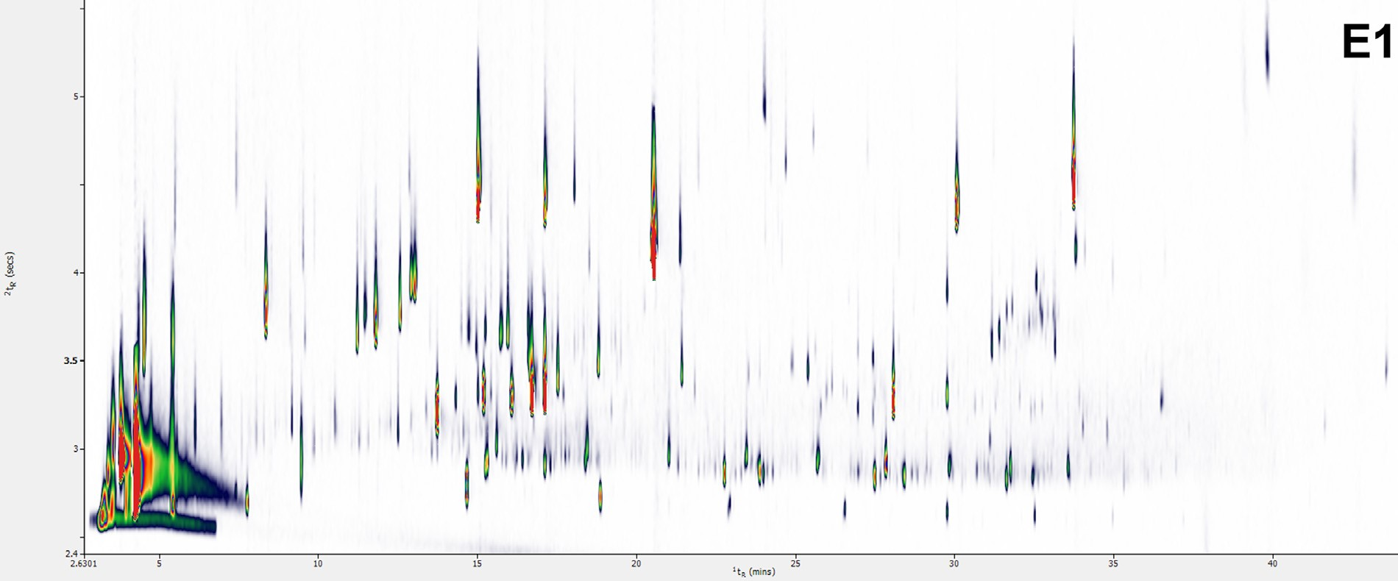
Fig. 1. A TDGC × GC–MS representative plot of volatiles collected from S. nutans E1 lineage.
Figure 2
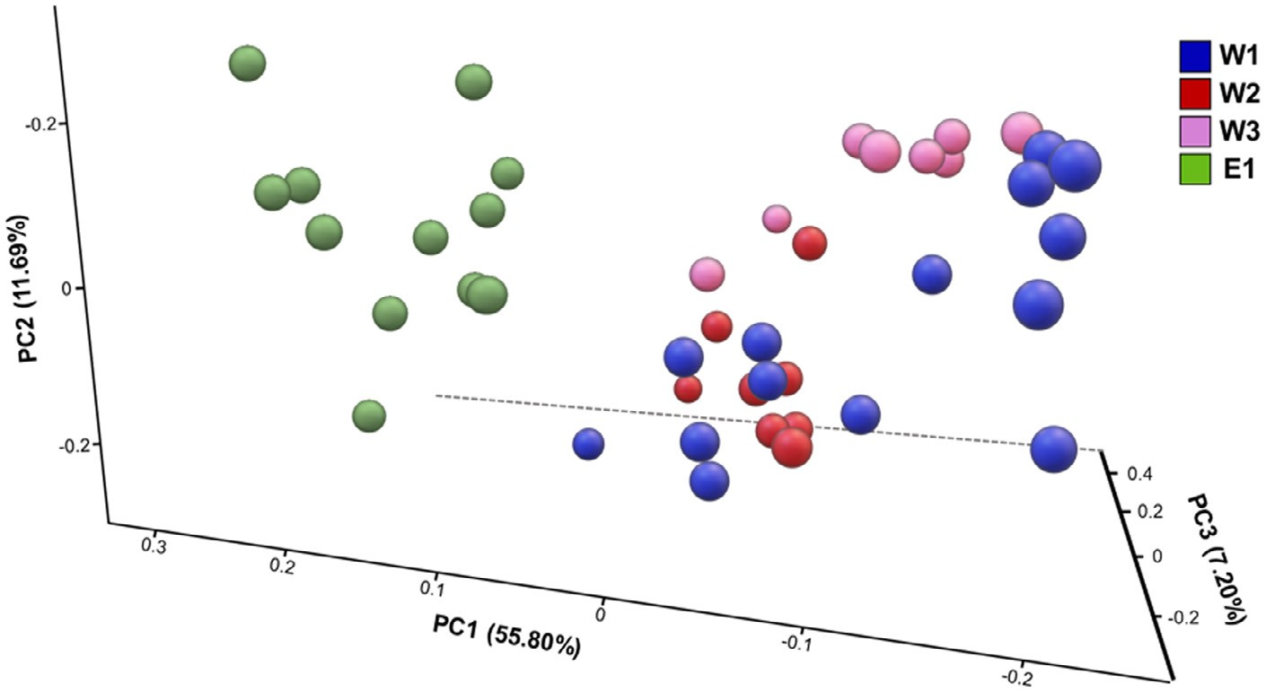

Fig. 2. Principal component analysis (PCA) of the overall fingerprint of the volatile profile analysed by TD–GC × GC–MS on 42 samples of S. nutans.

Table 2
Table 2 List of the top discriminatory compounds extrapolated after four classes (E, W1, W2, and W3) random forest analysis, reported in order of elution. The CAS number, mass similarity match (MS%), linear retention index (LRI) experimentally calculated and reported in the literature (LRIlib) are provided.
Compound |  | CAS | MS% | LRI | LRIlib
F1 | Unknown 1
F3 | Unknown 2
F4 | Unknown 3
F5  F7  F9  F10 F13  F16 | 1-Hexene, 4,5-dimethylPentane, 1-nitroBenzaldehyde  5-Hepten-2-one, 6-methylα-Terpineol Methyl salicylate | 16,106–59–5  628–05–7 100–52–7  110–93–0 98–55–5  119–36–8 | 812  881  881  888  855 850 | 745  882  958  986  1190 1196 | 741 ±1  896 ±29  962 ±3  986 ±2  1189 ±2  1192 ±2

Figure 3
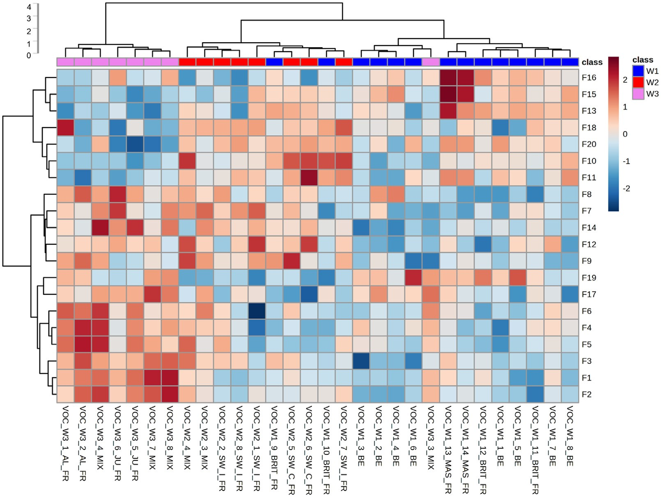
Fig. 3. Results of the hierarchical cluster analysis relative to the floral scent of three S. nutans W1 (blue), W2 (red), and W3 (pink) lineages. Each coloured cell on the heatmap corresponds to the relative abundance of each feature (column normalised) after PQN median normalization and Log10 transformation to make features intensity more comparable. Red color shows higher intensity and positive correlation, while blue is lower intensity and negative correlation.

Fatty acid methyl ester analysis
An example of a FAME bi-dimensional chromatographic profile for a nectar sample from E1 lineage is reported in Fig. 4 . A total of 29 FAMEs were identified among all the samples, based on the retention times of a standard mixture of FAMEs.
The hierarchical cluster analysis of samples according to the FAME patterns revealed a general clustering according to the four lineages. However, complete separation was not achieved (Fig. 5 ). A rather clear separation of E1 from the W lineages and between W1 and W3 lineages was shown, whereas W2 samples were found in three of the four main clusters.
The most abundant FAMEs, regardless of the lineage, were C16, C18, C18:1, and C18:3n3, ranging between about 5 and 40%. Differences were observed for C18:2n6 and C18:3n3, which were lower in W3 compared to the other lineages, C22:2 was almost absent in W2 and W3, as well as C15:1 and C18:2, which were almost absent in W3. C6, C18:1n9, and C20 were higher in W3 compared to all the other lineages. C11 and C17:1 were significantly abundant in E1 lineage samples, while C22 and C22:1n9 were almost absent in E1 lineage (Fig. 6 ). The ANOVAs showed a significant difference (p < 0.05) between at least two lineages for 18 out of the 29 FAMEs tested, i.e ., C6, C11, C14:1, C15, C15:1, C16:1, C17:1, C18, C18:1n9, C18:2, C18:2n6, C20, C20:2, C20:1n9, C20:5n3, C22, C22:1n9, and C22:2 (Supplementary Table 2). In particular, 16 FAMEs were significantly different between E1 and W3, 13 out of 18 were significantly different between W1 and W3, 9 between E1 and W2, 8 were significantly different between W1 and W2, while E1-W1 and W2-W3 showed only 5 significant features.

Table 3
Table 3 List of the top discriminatory compounds extrapolated after three W classes (W1, W2, and W3) random forest analysis, reported in order of elution, the CAS number, mass similarity match (MS%), linear retention index (LRI) experimentally calculated and reported in the literature (LRIlib)
Compound |  | CAS | MF | LRI | LRI _{lib}
F1 | Unknown 1
F4 | Amine compound 1
F7  F8 | Butanal, 3-methyl-, oxime  Unknown 2 | 626–90–4 | 800 | 869 | 864 ± 6
F9 | Unknown 3
F11  F12  F13 | α-Pinene  Benzaldehyde  Aldehyde | 80–56–8  100–52–7 | 876  805 | 942  970 | 937 ± 3  962 ± 3
F14  F15 | 3-Carene Unknown 4 | 13,466–78–9 | 890 | 1016 | 1011 ± 2
F16  F17  F18 | 1-Hexanol, 2-ethyl  Acetic acid, phenylmethyl ester  Unknown 5 | 104–76–7  140–11–4 | 817  905 | 1027  1161 | 1030 ± 3  1164 ± 2
F19  F20 | Methyl salicylate  Unknown 6 | 119–36–8 | 863 | 1198 | 1192 ± 2

Figure 4
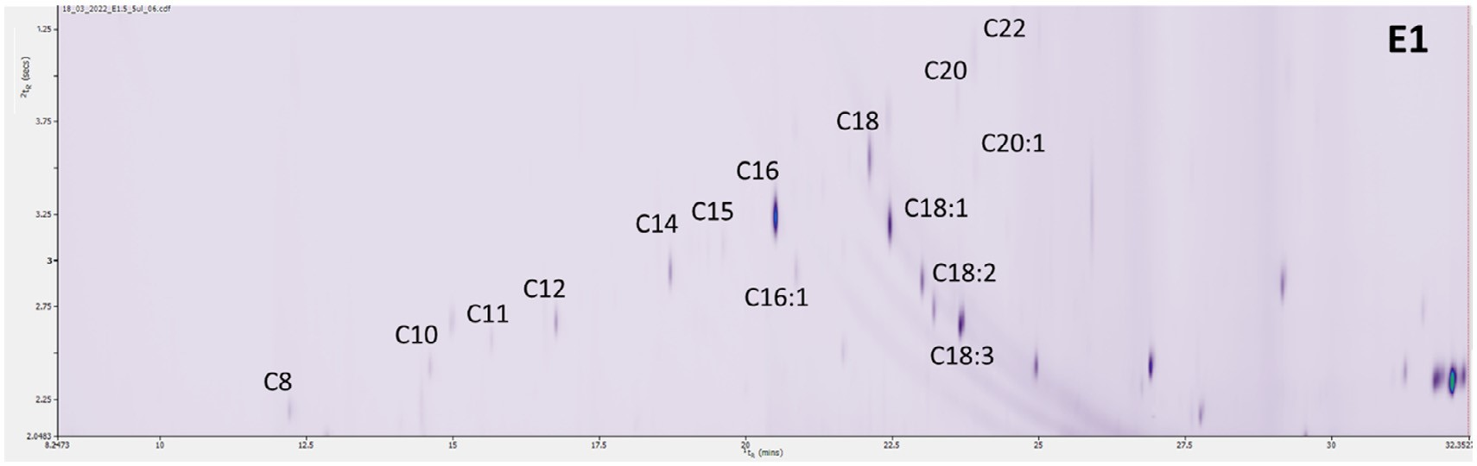
Fig. 4. A GC × GC-FID chromatogram of FAMEs from S. nutans E1 lineage.

Figure 5
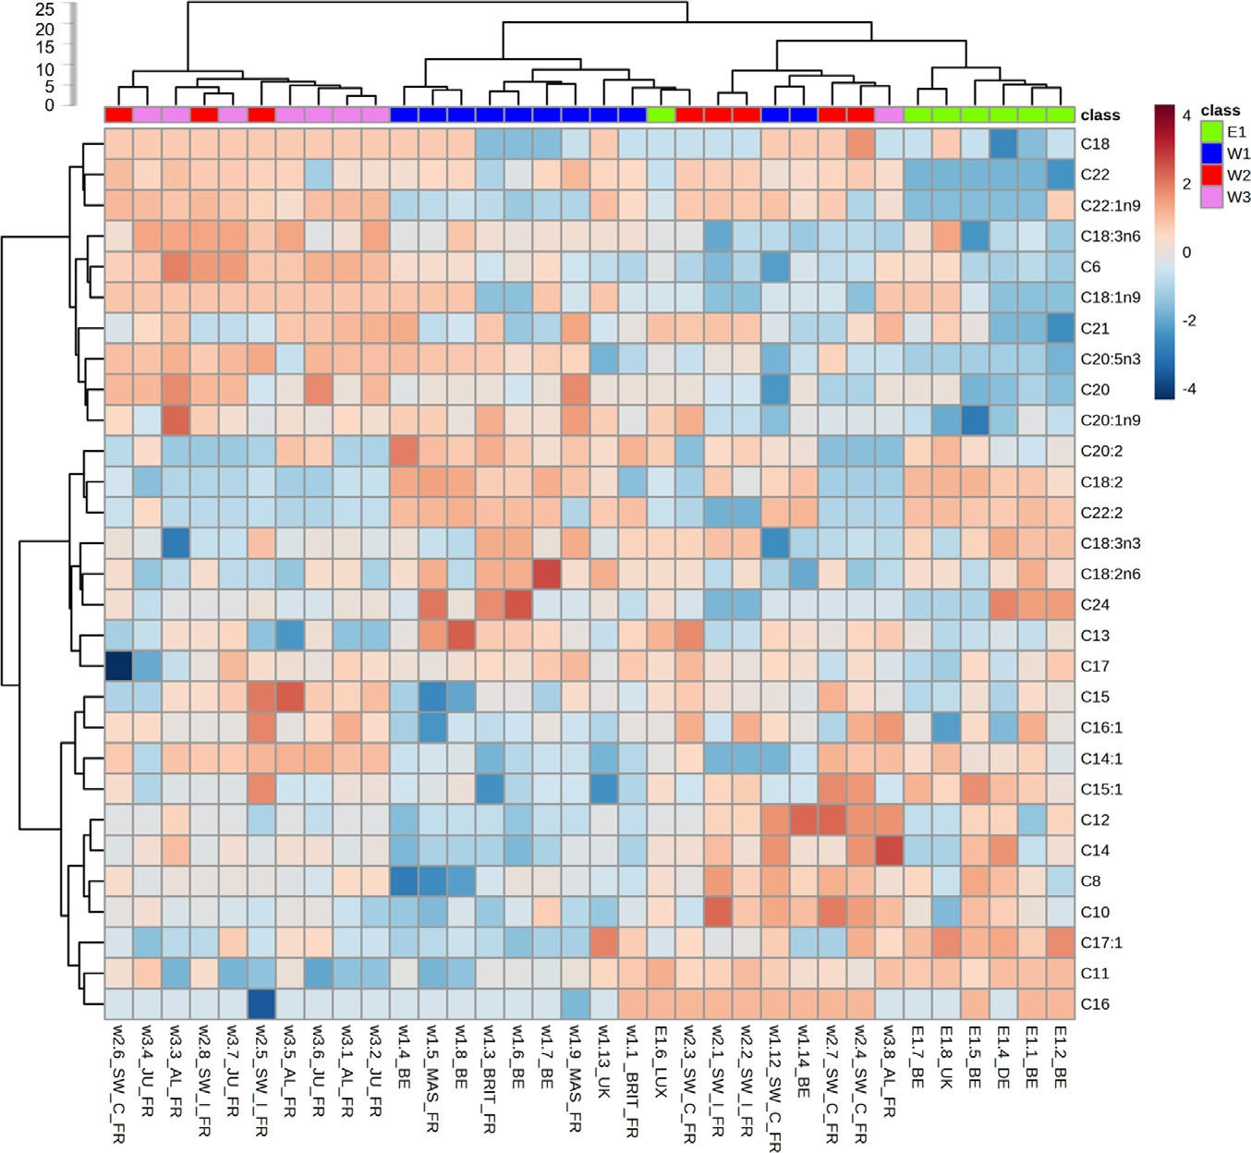
Fig. 5. Hierarchical cluster analysis obtained from the analysis of FAMEs extracted from nectars of the four lineages, i.e., E1 (green), W1 (blue), W2 (red), and W3 (pink). Each coloured cell on the heatmap corresponds to the relative abundance of each FAME (column normalised) after quantile normalization and Log10 transformation to make features intensity more comparable. Red color shows higher intensity and positive correlation, while blue is lower intensity and negative correlation.

Figure 6
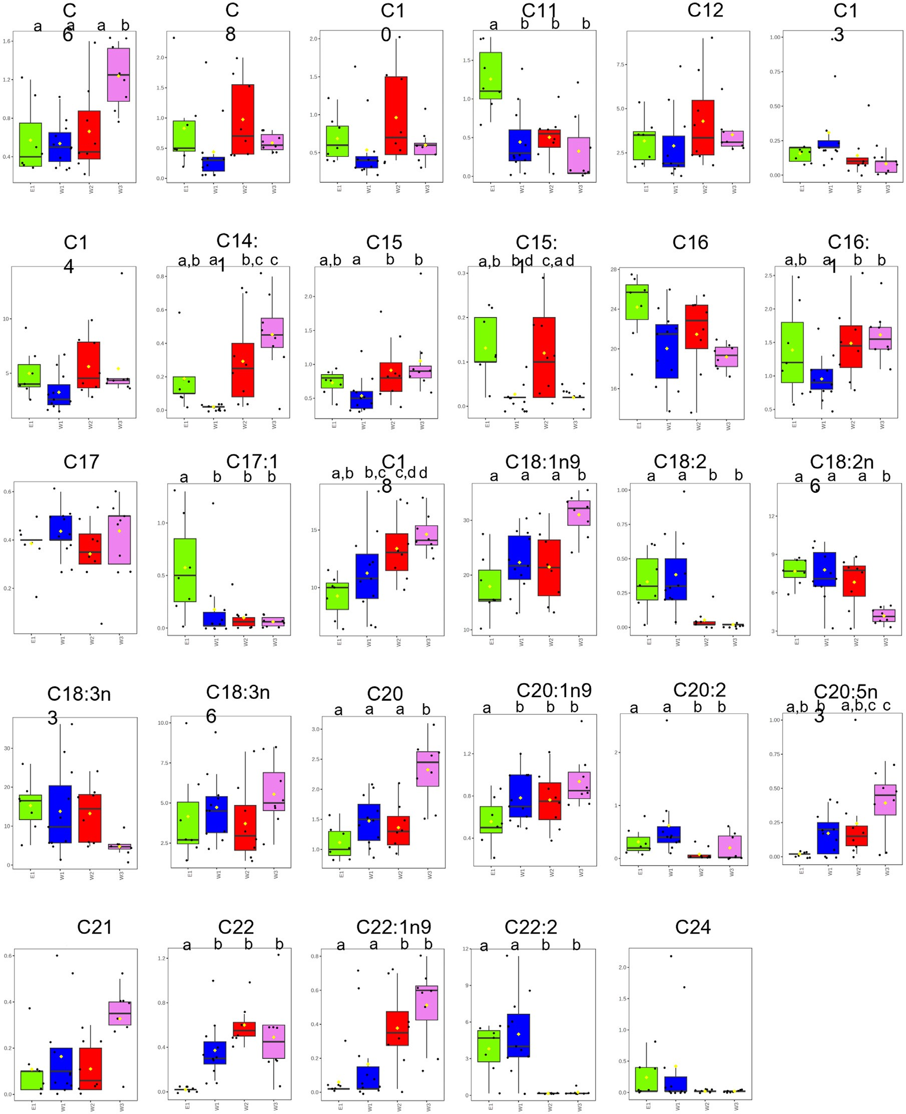
Fig. 6. Box plots representing the percentage distribution of the FAMEs in the 4 lineages, i.e., E1 (green), W1 (blue), W2 (red), and W3 (pink). Different letters indicate significant differences (p < 0.05, see Supplementary Table 2 for details). The black dots represent the relative intensity of the selected feature from all samples. The notch indicates the 95% confidence intervals around the median of each group. The mean relative intensity of each group is indicated with a yellow diamond.

Discussion
The GC × GC method allowed for a detailed analysis of floral scent and fatty acid composition in nectar. For the scent data, the 2D chromatograms were treated as chromatographic fingerprints and only the compounds related to the most discriminant features were identified. Some of the identified VOC compounds of floral scent, such as β–myrcene, d -Limonene, α-pinene, and methylsalicylate have been reported as semio-chemicals influencing the behavior of moth species of the Noctuidae family [ 1 , 22 ], which are the main pollinators of S. nutans [ 28 , 38 ]. In nectar, a total of 29 fatty acids were identified based on their elution in the 2D chromatogram, supporting the discrimination among the different lineages. Significant differences in VOC and FAME profiles were identified among the four lineages, particularly distinguishing E1 from the W lineages and W3 from W1 and W2. These results are coherent with phylogeographic patterns obtained from plastid and nuclear genetic data [ 25 , 24 ] and with Approximate Bayesian Computational analyses reconstructing evo-demographic scenarios using transcriptomic data [39] , which showed that the earliest genetic divergence having occurred was between eastern (E1) and western (W) lineages, followed by a second divergence between W3 and the group of W1 and W2.
In conclusion, the present findings revealed that the four genetic lineages do not only show divergence in neutral genetic diversity [25] and in the nuclear and plastid genes involved in the photosynthetic process, leading to postzygotic reproductive isolation through plastid-nuclear incompatibilities [ 26 , 27 ], but have also diverged in scent and nectar (fatty acids) compositions. Scent and nectar are floral traits that can play a role in pollinator (including nursery pollinators for Silene species) [28] attractiveness [ 1 , 4 , 22 ]. Whether these differences might lead to pollinator isolation [40] certainly merits further investigation.

Fundings
Nectar sampling was financed by the Silene International Research Network (CNRS). N.D.S benefited from the funding of the program PON “Research and Innovation” 2014–2020 (PON R&I), Action IV.6 “Contratti di ricerca su tematiche Green”.

Credit author statement
Conceptualization: FVR, GP; Data curation: DE, NDS, GP; Formal analysis: DE, VK; Funding acquisition: FVR, GP; Investigation: NDS, DE, VK, FVR, GP; Methodology: FVR, GP; Project administration: FVR, GP; Resources: FVR, GP; Software: NDS, DE, VK, GP; Supervision: FVR, GP; Visualization: NDS, DE, GP; Writing original draft: NDS, DE, GP; Writing review & editing: NDS, DE, FVR, VK, TC, GP.
Supplementary Fig. 1. Pairwise score plots between the selected principal components (PCs). The explained variance of each PC is shown in the corresponding diagonal cell based on 42 samples of S. nutans .
Supplementary Fig. 2 . Principal component analysis (PCA) obtained using the 20 top discriminatory features obtained with random forest (RF) of the entire set of samples analysed by TD– GCxGC–MS.
Supplementary Fig. 3 . Boxplots of the selected VOC features in the 4 lineages, i.e., E1 (green), W1 (blue), W2 (red), and W3 (pink). Different letters indicate significant differences (p < 0.05, see Supplementary Table S1 for details). The black dots represent the relative intensity of the selected feature from all samples. The mean relative intensity of each group is indicated with a yellow diamond.
Supplementary Table S1 . P-values on 20 selected VOC features resulting from the ANOVA followed by post-hoc tests based on Fisher’s least significant difference method.
Supplementary Table S2 . P-values resulting from the ANOVA followed by post-hoc tests based on Fisher’s least significant difference method.

Declaration of Competing Interest
The authors declare that they have no known competing financial interests or personal relationships that could have appeared to influence the work reported in this paper.
Data availability
Data will be made available on request.

Acknowledgements
The authors thank the “Plateforme Serres, cultures et terrains expérimentaux" and Pascal Touzet, Eric Schmitt, Nathalie Faure and Zoé Postel (Univ. Lille, France) for providing flowering plants of S. nutans , Marc Migon (SEFY, UCLouvain, Belgium), AnneLaure Jacquemart and Christel Buyens (ELIA, UCLouvain, Belgium) for help with the phytotron experiment. The authors also thank Markes International, SepSolve and Shimadzu for their support and the editors and the anonymous reviewers for constructive comments on the manuscript. This article is based upon work from the Sample Preparation Study Group and Network, supported by the Division of Analytical Chemistry of the European Chemical Society.

Supplementary materials
Supplementary material associated with this article can be found, in the online version, at doi: 10.1016/j.chroma.2023.463977 .

References
- J.T. Knudsen, R. Eriksson, J. Gershenzon, B. Ståhl, Diversity and distribution of floral scent, Bot. Rev. 72 (2006) 1–120, doi: 10.1663/0 0 06-8101(20 06)72-1: DADOFS-2.0.CO;2 .
- M.E. Maffei, J. Gertsch, G. Appendino, Plant volatiles: production, function and pharmacology, Nat. Prod. Rep. 28 (8) (2011) 1359–1380, doi: 10.1039/ c1np0 0 021g .
- C. Bicchi, M. Maffei, The plant volatilome: methods of analysis, Methods Mol. Biol. 918 (2012) 289–310, doi: 10.1007/978- 1- 61779- 995- 2 _ 15 .
- E. Levin, M.D. McCue, G. Davidowitz, More than just sugar: allocation of nectar amino acids and fatty acids in a Lepidopteran, Proc. R. Soc. B. 284 (2017) 2016– 2126, doi: 10.1098/rspb.2016.2126 .
- S. Risticevic, E.A. Souza-Silva, E. Gionfriddo, J.R. DeEll, J. Cochran, W.S. Hopkins, J. Pawliszyn, Application of in vivo solid phase microextraction (SPME) in capturing metabolome of apple (Malus domestica Borkh.) fruit, Sci. Rep. 10 (1) (2020) 6724, doi: 10.1038/s41598- 020- 63817- 8 .
- N. Kfoury, E. Scott, C. Orians, A. Robbat Jr., Direct contact sorptive extraction: a robust method for sampling plant volatiles in the field, J. Agric. Food Chem. 65 (38) (2017) 8501–8509, doi: 10.1021/acs.jafc.7b02847 .
- T. Witt, A. Jürgens, R. Geyer, G. Gottsberger, Nectar dynamics and sugar composition in flowers of Silene and Saponaria species (Caryophyllaceae), Plant Biol. 1 (1999) 334–345, doi: 10.1111/j.1438-8677.1999.tb00261.x .
- E. Pacini, M. Nepi, J. Vesprini, Nectar biodiversity: a short review, Plant Syst. Evol. 238 (2003) 7–21, doi: 10.1007/s00606- 002- 0277- y .
- G. Farré-Armengol, M. Fernández-Martínez, I. Filella, R.R. Junker, J. Peñuelas, Deciphering the biotic and climatic factors that influence floral scents: a systematic review of floral volatile emissions, Front. Plant Sci. 11 (2020) 1154, doi: 10.3389/fpls.2020.01154 .
- R. Holzinger, L. Sandoval-Soto, S. Rottenberger, P.J. Crutzen, J. Kesselmeier, Emissions of volatile organic compounds from Quercus ilex L. measured by proton transfer reaction mass spectrometry under different environmental conditions, J. Geophys. Res. Atmos. 105 (20 0 0) 20573–20579, doi: 10.1029/ 20 0 0JD90 0296 .
- M. Staudt, L. Lhoutellier, Monoterpene and sesquiterpene emissions from Quercus coccifera exhibit interacting responses to light and temperature, Biogeosciences 8 (2011) 2757–2771, doi: 10.5194/bg- 8- 2757- 2011 .
- J. Vercammen, H. Pham-Tuan, P. Sandra, Automated dynamic sampling system for the on-line monitoring of biogenic emissions from living organisms, J. Chromatogr. A 930 (2001) 39–51, doi: 10.1016/s0021-9673(01)01172-4 .
- U. Effmert, J. Große, U.S. Röse, F. Ehrig, R. Kägi, B. Piechulla, Volatile composition, emission pattern, and localization of floral scent emission in Mirabilis jalapa (Nyctaginaceae), Am. J. Bot. 92 (2005) 2–12, doi: 10.3732/ajb.92.1.2 .
- C. Cagliero, G. Mastellone, A. Marengo, C. Bicchi, B. Sgorbini, P. Rubiolo, Analytical strategies for in-vivo evaluation of plant volatile emissions A review, Anal. Chim. Acta. 1147 (2021) 240–258, doi: 10.1016/j.aca.2020.11.029 .
- F.A. Franchina, D. Zanella, L.M. Dubois, J.F. Focant, The role of sample preparation in multidimensional gas chromatographic separations for non-targeted analysis with the focus on recent biomedical, food, and plant applications, J. Sep. Sci. 44 (2021) 188–210, doi: 10.10 02/jssc.2020 0 0855 .
- J.F. Pankow, W. Luo, A.N. Melnychenko, K.C. Barsanti, L.M. Isabelle, C. Chen, A.B. Guenther, T.N. Rosenstiel, Atmos. Meas. Tech. 5 (2012) 345–361, doi: 10. 5194/amt- 5- 345- 2012 .
- Z. Lui, J.B. Phillips, Comprehensive two-dimensional gas chromatography using an on-column thermal modulator interface, J. Chromatogr. Sci. 29 (1991) 227– 231, doi: 10.1093/chromsci/29.6.227 .
- P.Q. Tranchida, G. Purcaro, P. Dugo, L. Mondello, Modulators for comprehensive two-dimensional gas chromatography, TrAC Trends Anal. Chem. 30 (2011) 1437–1461, doi: 10.1016/j.trac.2011.06.010 .
- H.D. Bahaghighat, C.E. Freye, R.E. Synovec, Recent advances in modulator technology for comprehensive two dimensional gas chromatography, TrAC Trends Anal. Chem. 113 (2019) 379–391, doi: 10.1016/j.trac.2018.04.016 .
- Z.L. Cardeal, P.P. de Souza, M.D.R.G. da Silva, P.J. Marriott, Comprehensive twodimensional gas chromatography for fingerprint pattern recognition in cachaça production, Talanta 74 (2008) 793–799, doi: 10.1016/j.talanta.2007.07.021 .
- F. Stilo, C. Bicchi, A.M. Jimenez-Carvelo, L. Cuadros-Rodriguez, S.E. Reichenbach, C. Cordero, Chromatographic fingerprinting by comprehensive twodimensional chromatography: fundamentals and tools, TrAC Trends in Anal. Chem. 134 (2021) 116133, doi: 10.1016/j.trac.2020.116133 .
- A. Jürgens, T. Witt, G. Gottsberger, Flower scent composition in night-flowering Silene species (Caryophyllaceae), Biochem. Syst. Ecol. 30 (2002) 383–397, doi: 10.1016/S0305-1978(01)00106-5 .
- M. Vanderplanck, P. Touzet, F. Van Rossum, E. Lahiani, I. De Cauwer, M. Dufaÿ, Does pollination syndrome reflect pollinator efficiency in Silene nutans? Acta Oecol. 105 (2020) 103557, doi: 10.1016/j.actao.2020.103557 .
- F. Van Rossum, H. Martin, S. Le Cadre, B. Brachi, M. Christenhusz, P. Touzet, Phylogeography of a widely distributed species reveals a cryptic assemblage of distinct genetic lineages needing separate conservation strategies, Perspect. Plant Ecol. Evol. Syst. 35 (2018) 44–51, doi: 10.1016/j.ppees.2018.10.003 .
- H. Martin, P. Touzet, F. Van Rossum, D. Delalande, J.-.F. Arnaud, Phylogeographic pattern of range expansion provides evidence for cryptic species lineages in Silene nutans in western Europe, Heredity (Edinb) 116 (2016) 286– 294, doi: 10.1038/hdy.2015.100 .
- H. Martin, P. Touzet, M. Dufay, C. Godé, E. Schmitt, E. Lahiani, L.F. Delph, F. Van Rossum, Lineages of Silene nutans developed rapid, strong, asymmetric postzygotic reproductive isolation in allopatry, Evolution (N Y) 71 (2017) 1519–1531, doi: 10.1111/evo.13245 .
- Z. Postel, C. Poux, S. Gallina, J.S. Varré, C. Godé, E. Schmitt, E. Meyer, F. Van Rossum, P. Touzet, Reproductive isolation among lineages of Silene nutans (Caryophyllaceae): a potential involvement of plastid-nuclear incompatibilities, Mol. Phylogenet. Evol. 169 (2022) 107436, doi: 10.1016/j.ympev.2022.107436 .
- C. Cornet, N. Noret, F. Van Rossum, Pollinator sharing between reproductively isolated genetic lineages of Silene nutans, Front. Plant Sci. 13 (2022) 927498, doi: 10.3389/fpls.2022.927498 .
- D. Kessler, M. Kallenbach, C. Diezel, E. Rothe, M. Murdock, I.T. Baldwin, How scent and nectar influence floral antagonists and mutualists, Elife 4 (2015) e07641, doi: 10.7554/eLife.07641 .
- E. Baack, M.C. Melo, L.H. Rieseberg, D. Ortiz-Barrientos, The origins of reproductive isolation in plants, New Phytol. 207 (2015) 968–984, doi: 10.1111/nph. 13424 .
- K. Christie, L.S. Fraser, D.B. Lowry, The strength of reproductive isolating barriers in seed plants: insights from studies quantifying premating and postmating reproductive barriers over the past 15 years, Evolution (N Y) 76 (2022) 2228– 2243, doi: 10.1111/evo.14565 .
- G. Purcaro, P.Q. Tranchida, P. Dugo, E.La Camera, G. Bisignano, L. Conte, L. Mondello, Characterization of bacterial lipid profiles by using rapid sample preparation and fast comprehensive two-dimensional gas chromatography in combination with mass spectrometry, J. Sep. Sci. 33 (2010) 2334–2340, doi: 10.1002/ jssc.2010 0 0160 .
- A. Fina, S. Mascrez, M. Beccaria, C. De Luca, J. Aspromonte, C. Cordero, G. Purcaro, A high throughput method for fatty acid profiling using simultaneous microwave-assisted extraction and derivatization followed by reversed fill/flush flow modulation comprehensive multidimensional gas chromatography, Adv. Sample Prep. 4 (2022) 10 0 039, doi: 10.1016/j.sampre.2022.10 0 039 .
- F. Dieterle, A. Ross, G. Schlotterbeck, H. Senn, Probabilistic quotient normalization as robust method to account for dilution of complex biological mixtures. application in 1 H NMR metabonomics, Anal. Chem. 78 (2006) 4281–4290, doi: 10.1021/ac051632c .
- L. Breiman, Random forests, Mach. Learn. 45 (2001) 5–32, doi: 10.1023/A: 1010933404324 .
- N.D. Spadafora, S. Mascrez, L. McGregor, G. Purcaro, Exploring multiplecumulative trapping solid-phase microextraction coupled to gas chromatography–mass spectrometry for quality and authenticity assessment of olive oil, Food Chem. 383 (2022) 132438, doi: 10.1016/j.foodchem.2022.132438 .
- Z. Pang, J. Chong, G. Zhou, D.A. De Lima Morais, L. Chang, M. Barrette, J. Xia, MetaboAnalyst 5.0: narrowing the gap between raw spectra and functional insights, Nucleic Acids Res. 49 (2021) W388–W396, doi: 10.1093/nar/gkab382 .
- A. Jürgens, T. Witt, G. Gottsberger, Reproduction and pollination in Central European populations of Silene and Saponaria species, Bot. Acta 109 (1996) 261– 340, doi: 10.1111/j.1438-8677.1996.tb00579.x .
- Z. Postel, Speciation and Organellar Genome Evolution in Lineages of Silene nutans (Caryophyllaceae), Université de Lille, France, 2022 PhD thesis .
- M. Bischoff, R.A. Raguso, A. Jürgens, D.R. Campbell, Context-dependent reproductive isolation mediated by floral scent and color, Evolution (N Y) 69 (2015) 1–13, doi: 10.1111/evo.12558 .

