Design Strategies of the Mantis Shrimp Spike: How The Crustacean Cuticle Became a Remarkable Biological Harpoon?

By Yann Delaunois, Alexandra Tits, Quentin Grossman, Sarah Smeets, Cédric Malherbe, Gauthier Eppe, G. Harry van Lenthe, Davide Ruffoni* and Philippe Compère*

*Equal supervision of the work and corresponding authors.

Supporting Information

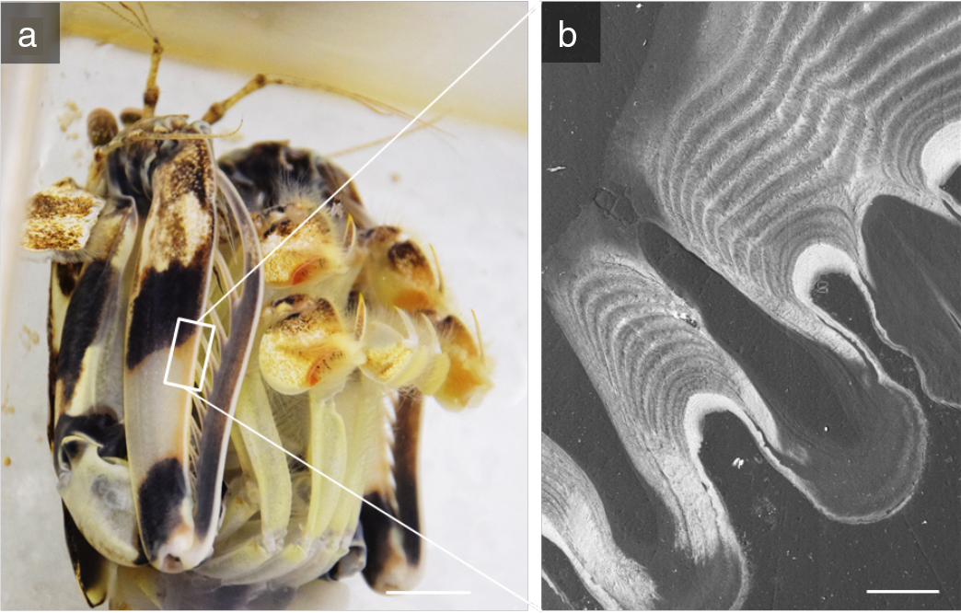
Figure S1: (a) The raptorial appendage at resting position with the spikes parked inside characteristic grooves of the propodus (scale bar: 1cm). (b) BSE-SEM image of a polished section showing the regular cavities and ridges with alternatively softer and harder mineralized cuticle hosting the distal part of the spikes (scale bar: 100 µm).

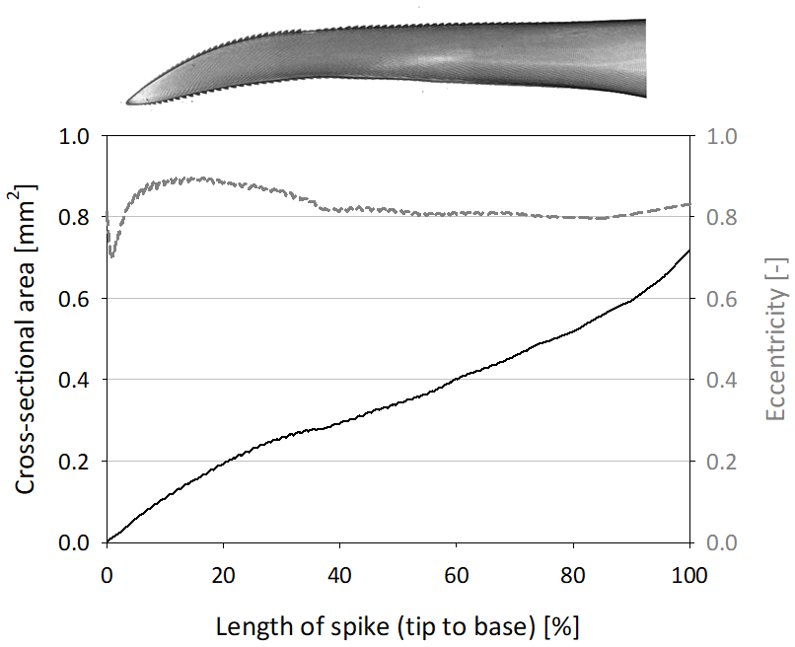
Figure S2: Variation of the cross-sectional area and eccentricity along the length of the spike as measured on micro-CT reconstructions. The cross-sectional area increases monotonically from the tip to the base (insertion on the dactyl) while the eccentricity remains practically constant and shows slightly higher values in the first third of the spike.

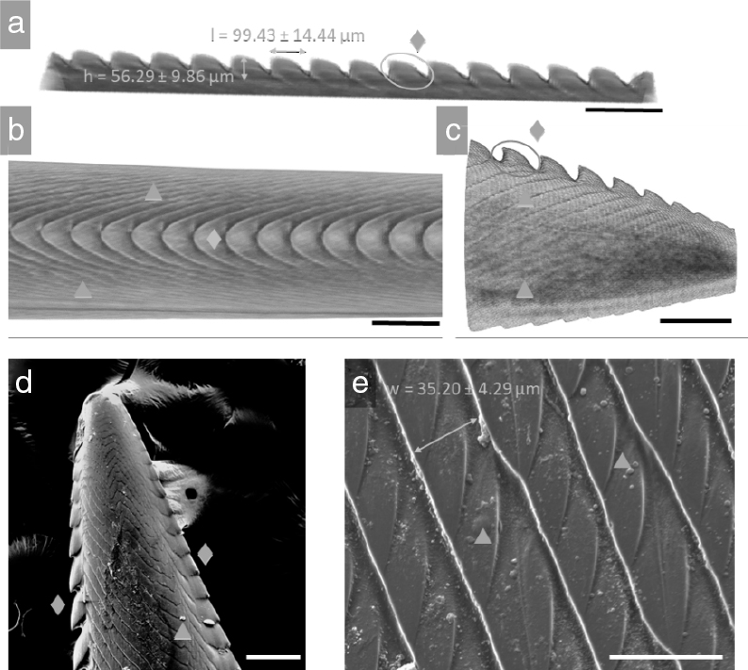

Figure S3: (a-c) Micro-CT reconstructions and (d-e) SE-SEM images of a distal spike showing (♦) serrations and (▲) grooves. These features are shown from multiple viewpoints including: (a, e) lateral side, (b) top view and (c, d) tip of the spike. The serrations grow out progressively from the tip and reach a stable dimension (within about 500 µm) before decreasing in size towards the base of the spike. The spacing between serrations is mirrored into oblique grooves wrapping around the spike and giving a characteristic “staircase” appearance. (e) Higher magnification SEM highlights a repetitive pattern of “sub-grooves” in between the main grooves. Scale bars: 200 µm (a-d) and 50 µm (e).
Figure S4. SE-SEM image of a longitudinal fractured surface showing the presence of mineral crystallites with a typical size of about 45 nm. HMR: Highly mineralized region, OHR: Outer Helicoidal Region, arrow heads: pore canals.

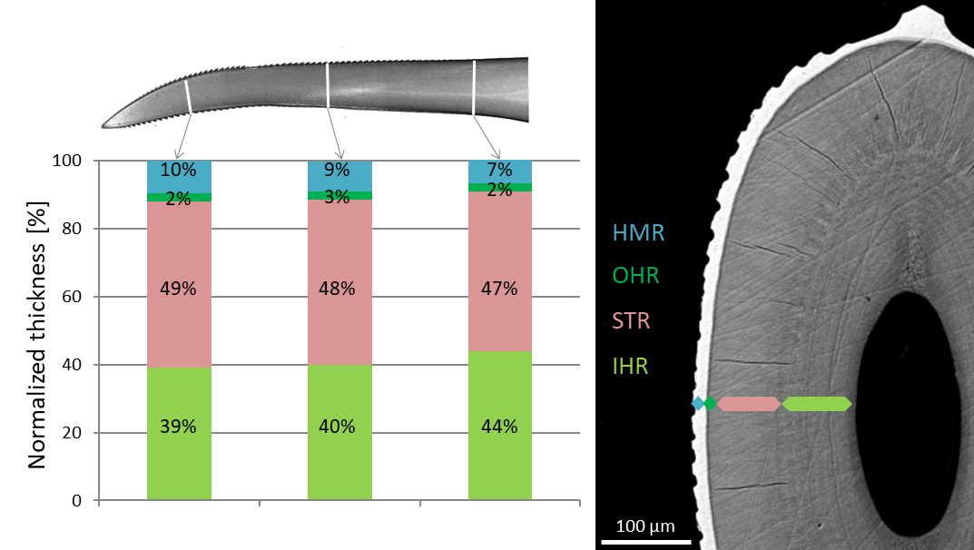
Figure S5: Relative contribution of the four microstructural regions (HMR: highly mineralized region, OHR: outer helicoidal region, STR: striated region, IHR: inner helicoidal region) to the total thickness of the spike cuticle measured on representative cross-sections at three different locations along the spike length. A small gradual increase of the relative thickness of the HMR at the expenses of the IHR is observed toward tip of the spike. Data based on BSE-SEM images of polished and resin embedded cross-sections (right).

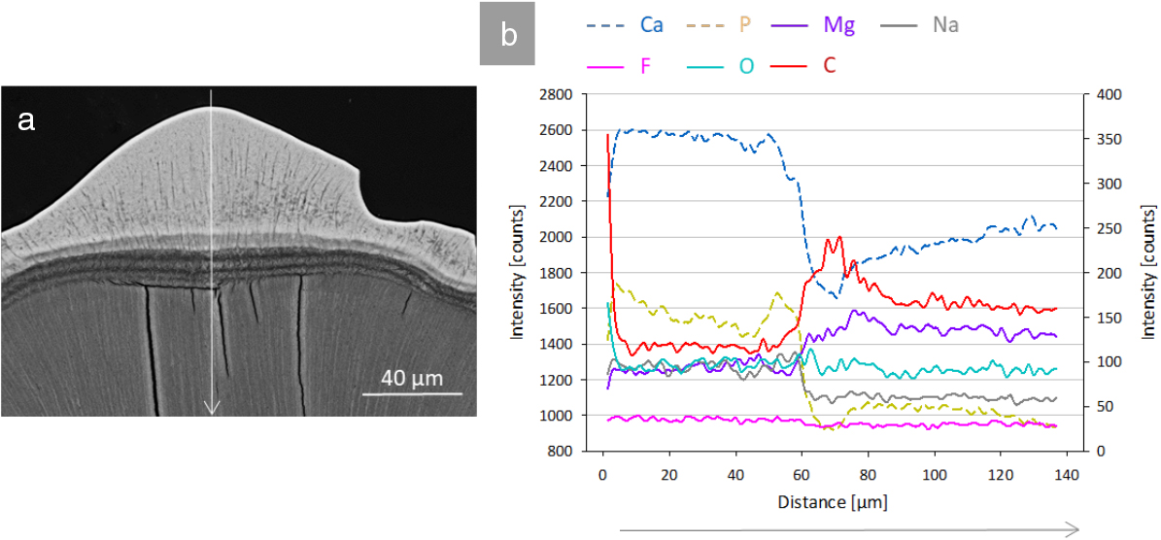
Figure S6: EDS line profiles at the level of a serration. (a) BSE-SEM view of the analyzed area on a polished transversal cross-section of the spike. (b) Element distribution along the dotted line in A as provided by profile plots of X-ray peak intensities of the major elements (in counts, left scale) as well as of the minor elements (in counts, right scale). Concentrations of Ca and P show a minimum within the OHR whereas C and O show an opposite trend, linked to the proportion of organic content. EDS profiles confirm that the OHR is the region with the lower mineral content as visible on the BSE-SEM images. As for minor elements, Na is co-localized with Ca and P but does not exhibit a drop in the OHR; F is practically constant along the analyzed line.

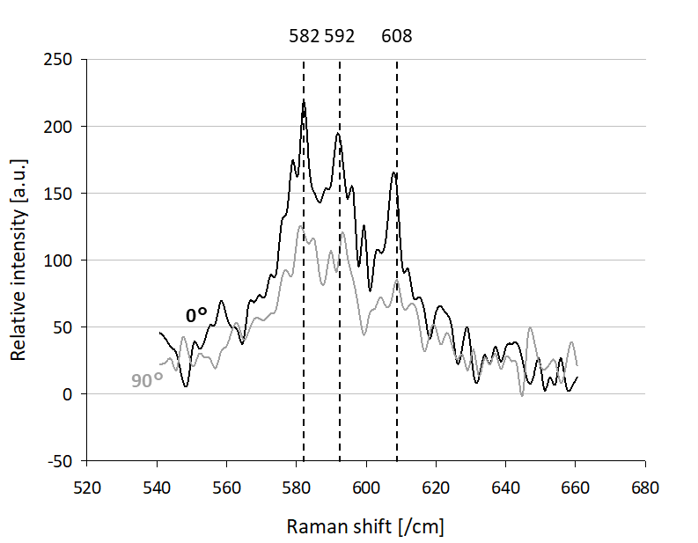
Figure S7: Polarized Raman Spectroscopy. Analysis of the Ѵ4 mode of the FAP signal in the highly crystalline area, where the signal at 0° and 90° polarization are compared. The difference between the relative intensity of the 582 cm⁻¹ and 592 cm⁻¹ peaks implies an orientation in the mineral as previously observed in the smashing club by Amini and colleagues [1].
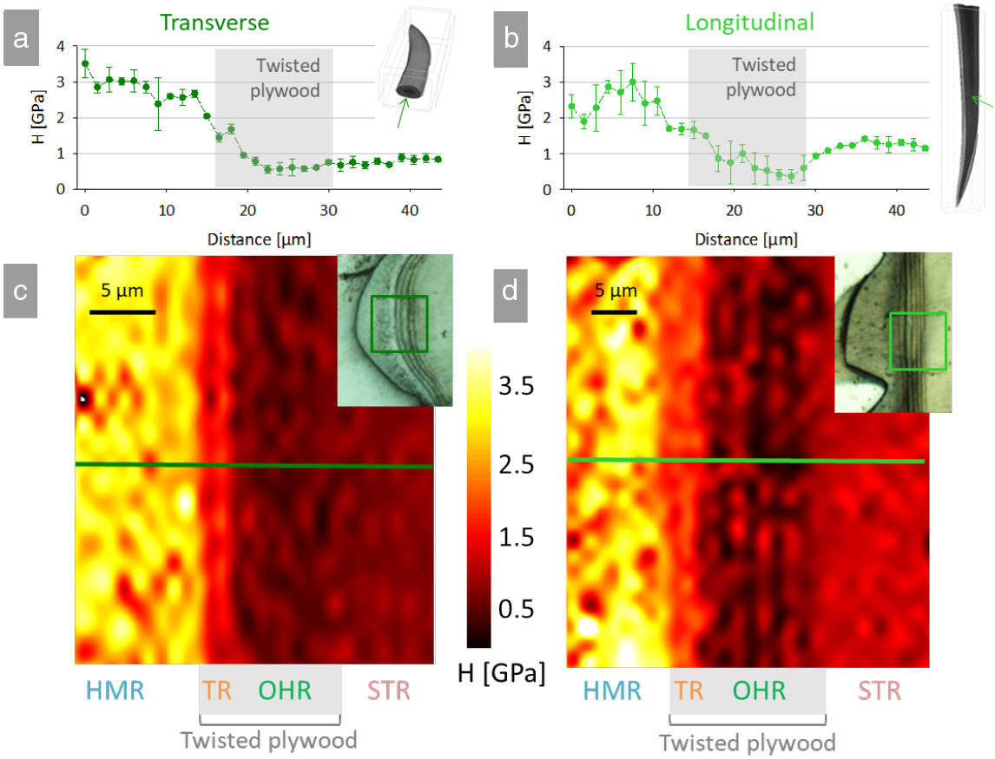
Figure S8: Nanomechanical properties of the spike cuticle measured by depth sensing nanoindentation. (a-b) Spatial variation of hardness, H, measured with high lateral resolution from the highly mineralized to the striated region, considering both (a) transverse and (b) longitudinal cross-sections. (c-d) High resolution maps of hardness focusing on the transition between HMR and STR on (c) transverse and (d) longitudinal cross-sections. Probed areas are highlighted in squares on the light micrographs and lines indicate the position of the mechanical profiles shown in (b) and (c). HMR: highly mineralized region; IHR: inner helicoidal region OHR: outer helicoidal region; STR: striated region and TR: transition region.

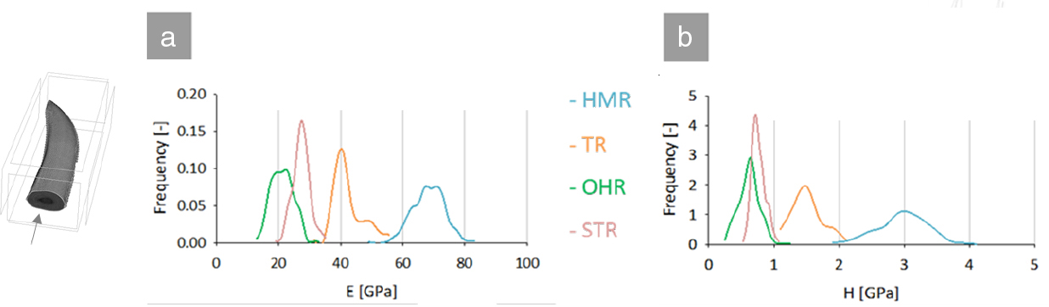
Figure S9: Frequency distributions of indentation modulus E and hardness H within different regions of the spike, based on high resolution nanoindentation experiments on a transverse cross-section (shown schematically with the micro-CT reconstruction on the left-side of the image). HMR: highly mineralized region; IHR: inner helicoidal region; OHR: outer helical region; STR: striated region; TR: transition region.
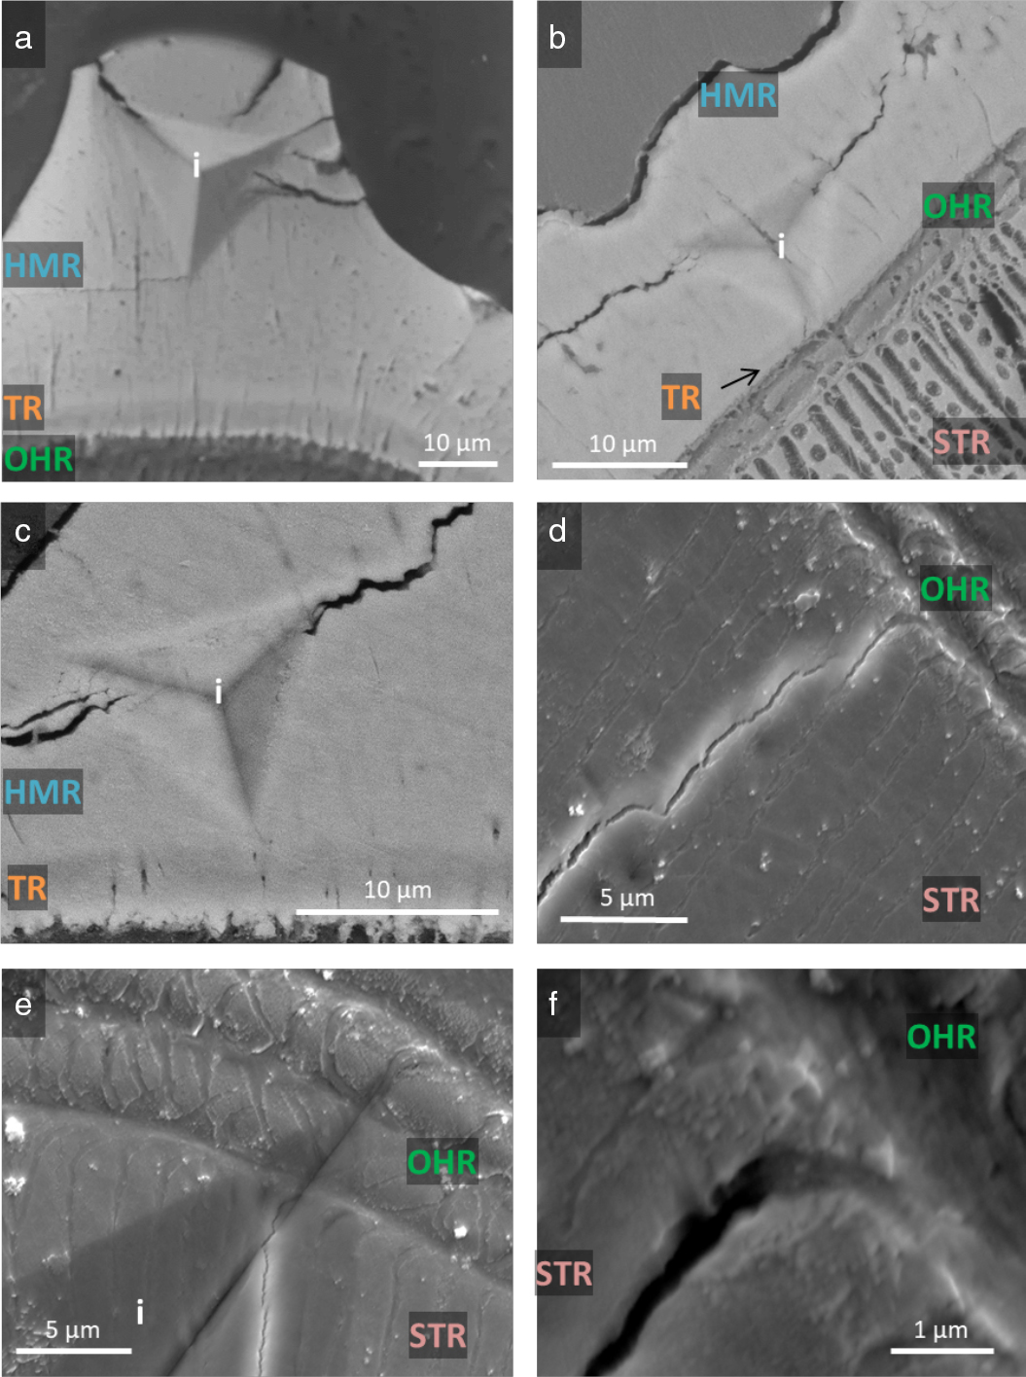
Figure S10: Micrographs of indentation induced damage behavior of the spike. (a-c) BSE-SEM images of cracks initiating within the HMR and propagating (a) within a serration, (b-c) parallel to the transition region (TR). No cracks were observed reaching the OHR. (d-f) SE-SEM images of cracks initiated within the STR, never being able to cross the OHR, even if the indent was partially located inside the OHR (e). HMR: highly mineralized region; OHR: outer helicoidal region; STR: striated region; TR: transition region; i: indentation imprint.

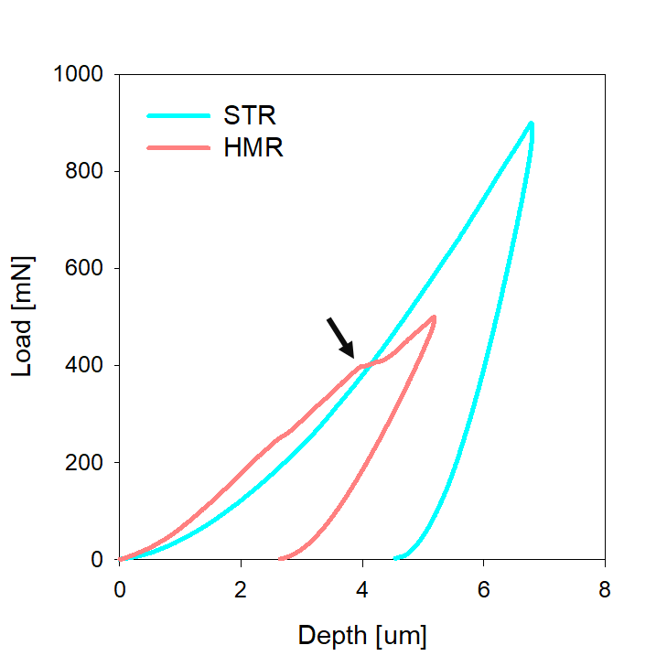
Figure S11. Typical high-load indentation curves for the highly mineralized region (HMR) and for the less mineralized but highly anisotropic region (STR). HMR shows a characteristic pop-in event (highlighted by the arrow) associated with sudden damage beneath the contact surface. Conversely, the indentation curve of STR is free from pop-in events, indicating a more progressive damaging behavior.

References:
[1] S. Amini, A. Masic, L. Bertinetti, J. S. Teguh, J. S. Herrin, X. Zhu, H. Su, A. Miserez, Nat. Commun. 2014, 5, 3187.

