Bitcoin’s Reality*

Jean-Marie Choffray**
Liège, April 10, 2023.

Over the past few weeks, people have regularly asked me what I thought of bitcoin? Where was its market headed? And…, should they invest? Of course, I never give any advice, aside from: “Do your own due diligence”. But, we live in a world of opportunity. Even if it’s a risky and treacherous world. The key to success is trying to understand the hidden intentions and agendas of the key stakeholders and market players. Almost an impossible task! That’s why I decided to summarize in two graphs (and their corresponding MACD analyses), and in two tables, what I know about what’s happening today, and what could happen tomorrow assuming no unforeseen events (Black Swans). The economic value of bitcoin necessarily falls in the interval $[0…∞/(21*10⁶)]. Rational investors are Free to Choose...

* Not an investment advice. Do your own due diligence.

** Emeritus Professor of Computer Science, University of Liege School of Management.
PhD-77, Management Science, Massachusetts Institute of Technology.

Prediction is very difficult, especially if it's about the future.
Niels Bohr

Bitcoin’s Reality

Historical context
- Modern Monetary Theory (MMT), at work.
- Assuming a 5% inflation rate, whatever its cause, fiat money loses approximately 95% of its value in 50 years.
- The New York Times’ politically driven attack on bitcoin mining is full of distortions & outright falsehoods. (Source : Riot Platforms).

Bitcoin Futures CME. Source: BigCharts, From MarketWatch
April 10, 2023; 3 years; Weekly data; SMA(10), SMA(20), SMA(40)
(Internet link)

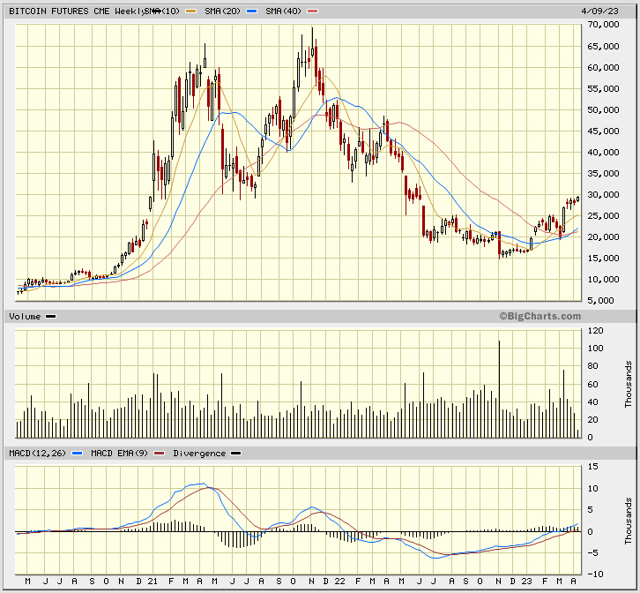

Bitcoin Futures CME. Source: BigCharts, From MarketWatch
April 10, 2023; 3 years; Daily data; SMA(50), SMA(100), SMA(200)
(Internet link)

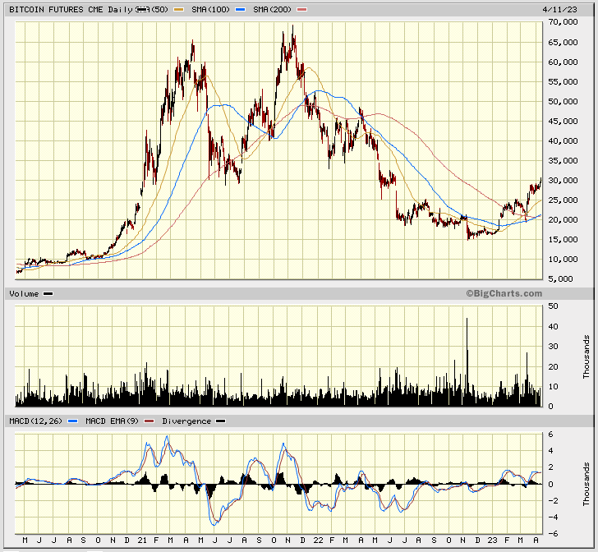

Bitcoin’s value proposition
(Source: Michael Rihani, Oct. 14, 2021)

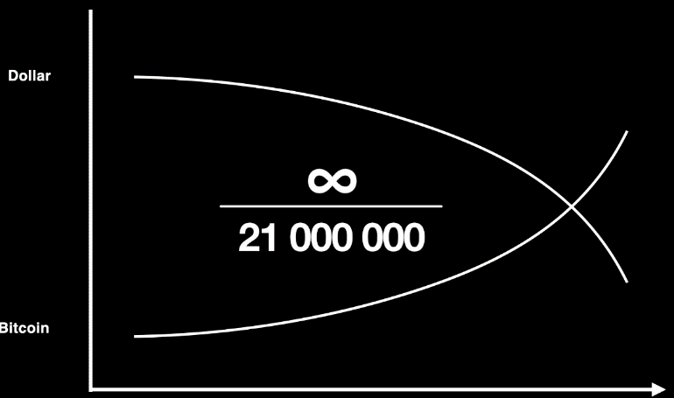

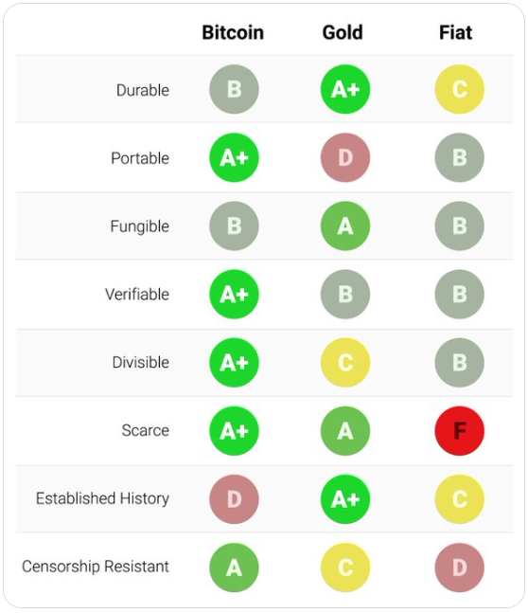

Bitcoin monthly performance over time
(Source: https://bitcoinmonthlyreturn.com )

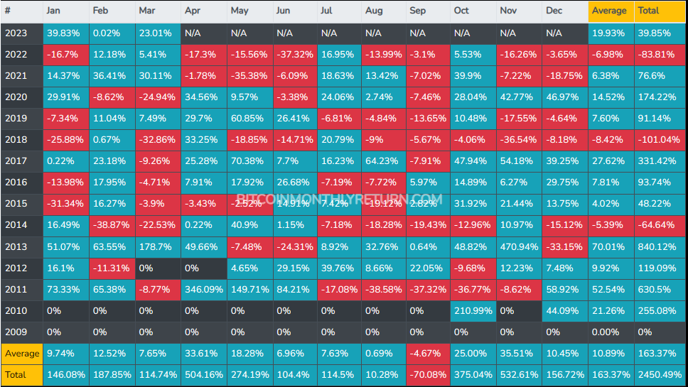

Useful sources of information
https://www.hope.com/en/websites

* * *

“There are more than 56 million millionaires in the world, and only 1 million people with more than 1 bitcoin. Do the math.” (Source: @cz_binance)

Lesson of History: If you can’t beat them, join them.

* * *

