Home as a second skin: a contribution to a theory of magic (of tidying).
Abstract
In this article, I describe a « magical » dimension in the work of Home Organisers (HOs) in Belgium. HOs, I argue, as Professional Organisers, not only help their clients to deal with the disorder and clutter of their homes but deliver a promise of magic: that “care” for the home interior produces “care” for the mind, the body and even the earth. To do this, they rely on the one hand on knowledge based on an epistemology of analogy; on the other hand, they use specific technical know-hows, allowing them to participate in the world transformation. In the course of their interventions, an order of things – both ideological and pragmatic – takes shape. From this double ordering stems a marvellous feeling. Indeed, the analogical principle (body-home-earth) that animates the process of Home Organising and the incorporation of collective representations allows the act of tidying to be magical.

Keywords: Home Organising – professional organisers - magic - hoarding - Belgium
Introduction
We are in a small village in Walloon Brabant (Belgium), one autumn morning in 2019. I am in Lucie's office, located in the very heart of her large – impeccably tidy – home. I have been questioning her about the principles and modalities of her profession for over an hour now. Lucie is a Home Organiser (HO); a domestic professional organiser. Her clients – almost exclusively women, as Lucie admits – contact her when "things don't work out"; when daily life becomes unbearable and unmanageable; when disorder and disorganisation have colonised their homes. "It's often after some kind of crisis, after a divorce or a move, this kind of thing, that they [the clients] call me: there is always a trigger.” Lucie, being very professional, proceeds according to a well-established protocol: firstly, a telephone call to find out a little more about the client and her expectations; secondly, a "diagnostic" meeting to assess the condition of the house and the objectives to be achieved; thirdly, an initial test intervention, which is supposed to determine whether or not the client is "ready" to continue the "operation"; and finally, the intervention itself, which takes place in one or more sessions (depending on the case) and consists of a general de-cluttering and a reorganisation of the interior and daily routine of its inhabitants. While I am carefully taking note of what she is saying, Lucie continues:
“It [the work of HOs] may seem a bit silly, like that, from the outside, but I swear it's magical! For me, tidying up my house, reclaiming my interior, it was... life-saving. [...] I was suffering from burnout. I liked my old job at the clinic [Lucie used to be a nutrition consultant]. But, with time going by, I switched off; it was getting too stressful... And above all, it lacked meaning... So I got burnt out. I found myself there, at home, not even being able to go shopping for my children. [...] After a few months, and with the encouragement of my therapist, I figured that I had to do something, I had to do something to get myself back in control. And then I thought: "Okay, okay, what can I do?", you know. In practical terms, at that time, I wasn’t leaving my house at all. [...] So I got interested in all sorts of things such as Home Organising and minimalism, and I thought, "Well, that I can do: tidying up my home, getting rid of useless stuff " [...] So that's what I did. And that was a turning point: I understood that tidying your interior is tidying your mind. [...]. Your home, you see, is a bit like your second skin: you have to take care of it because it's where you live. [...] And it's accessible, you know; It's right there, around you. You can do it, you can take care of it without having to leave [home]. [...] Taking care of your home does mean taking care of yourself.”
In 2011, Marie Kondo, who would later be considered as the "decluttering queen", published her flagship book: The Life-Changing Magic of Tidying Up: The Japanese Art of Decluttering and Organizing in Japan, translated in English in 2014 and in French in 2015. The book was a sensation, surpassing the million copies sold, and revealing to the general public a field still very little known in the French-speaking world: professional home organising and its miraculous benefits. This undeniable commercial success brought to light, in Belgium, a new form of "work on the self" (Marquis 2014) already publicised in the United States for several decades – consisting of "cleaning up your home, [to] clean up your inner self". This led to two phenomena. On the one hand, the already well-stocked self-help departments of the country's bookstores were filled with a flood of books on home cleaning techniques and their connection with well-being. On the other hand, through a handful of independent entrepreneurs who specialised in the field, a real technical and professional corpus of know-hows inspired by the American and Canadian practices was brought to the market via workshops and training courses. This corpus deals not only with the de-cluttering of homes, but also with the rationalisation and reorganisation of daily duties (such as shopping, storing, furnishing, etc.) and the optimisation of domestic space and its internal dynamics. There are significant ideological connections between these (new) – theoretical and practical – fields of knowledge and two other domaines: (a) the ecological and minimalist movements that have developed in the West in recent years (Gygi 2008) and (b) the self-development discourse at the socio-cultural level (Marquis 2016). Therefore, their visibility and their credibility have continued to grow together, creating a real craze for Home Organising in recent years.

This article aims at understanding the reasons given by actors in the field to explain this surge in interest for the sector. In other words, what I would like to do here is to take seriously Lucie's remarks, transcribed above, when she describes the tidying up and reorganisation of her interior – understood in their professional context – as "magical". This will allow us to provide a socio-anthropological analysis of a field of activity that is still too little explored by social sciences.

In order to do so, I will first describe the HOs’ profession. This description will be based on an ethnographic research carried out with a dozen professionals working in Wallonia and Brussels. I will then go back in more details to the statements made and the ethnomethods used by Lucie and her counterparts – in order to understand their implications – and question the socio-anthropological literature dealing with magical actions, housing, storage and their interconnections. In doing so, the aim of this paper will therefore be twofold: first, to develop an anthropological analysis of HOs’ work in French-speaking Belgium drawing upon my own ethnographic material. Secondly, by means of a confrontation between ethnographic examples and the anthropological literature, I attempt a socio-anthropological analysis of magical action, and more particularly of the magic of tidying.
Making a house into a home: the work of HOs
The phenomenon of Home Organising is deeply rooted at the crossroads of many contemporary social narratives related in one way or another to capitalism and its ideologies (Boltanski & Chiapello 1999), to the problem of excessive consumption for households that the latter produces (Bataille 1949; Migone 2007) and the gendered structuring of household control that it generates (Geist 2010). It is indeed meant to be a new form of reaction to the "excesses" of capitalism (see Brox & Williams-Oerberg 2022) and is fully in line with the minimalist and anti-accumulative Western movement that many social science observers have been able to highlight in recent years (Martin-Woodhead 2021; Gygi 2018). Hence, this phenomenon is undeniably linked to the rise of accumulation and disorder in collective representations (Denegri-Knott & Slater 2014; Lepselter 2011). Since 2013, in fact, these two phenomena are no longer considered only as domestic problems, potentially anxiety-provoking, but rather as an indication of an intimate and profound suffering, that of the expression of a new psychiatric syndrome: Hoarding Disorder (Frost & Steketee 2010). Thus, being included within the psychiatric discourse and its "seriousness", accumulation and disorder – now coagulated into a single syndrome – became more factual, thereby capturing society's attention (Herring 2014; Kilroy-Marac 2016, 2017; Newell 2014, 2019; Shaeffer 2017). But the establishment of this tendency to (excessive) accumulation and (chaotic) disorder in terms of “mental illness” did not happen overnight: Hoarding Disorder, at the intersection of several specific cultural narratives (see Herring 2014), is the crystallised product of many collective concerns (including psychological, psychiatric, sociological, anthropological and philosophical ones), several of which deal with housing, the inhabited, the arrangement of domestic space and their relationship to everyday objects (Baudrillard 2016; Gregson 2007).

Based on a text by Martin Heidegger (1993), Tim Ingold (2000) proposes an interesting and synthetic approach to this corpus of issues. For the latter, the question of dwelling is indistinguishable from that of building. To be involved in the one is necessarily to take part in the other, since the act of living, Ingold argues, is a permanent process, a nexus of interactions of all kinds, which must be constantly updated and which cannot be completed once and for all. He thus contrasts the "building perspective" – generally adopted by social sciences – with his "dwelling perspective". According to Ingold, "the forms people build, whether in the imagination or on the ground, arise within the current of their involved activity, in the specific relational contexts of their practical engagement with their surroundings" (Ingold 2000: 186). In other words, to inhabit (Lawrence 1987) is the result of a perpetual practical investment; it is the metastable result of a series of conscious actions consisting in the appropriation of a place – of a home (Easthope 2004; O’Mahony 2013). Stemming from this observation, we can extract from the anthropological literature a rudimentary typology of the various distinct tasks that need to be performed to make up a home: firstly, (a) the tasks that could be described, with de Certeau (2010), as everyday tasks, such as 'sleeping, collecting, laundering, tidying up, cooking, storing food, raising children [...]' (Gregson 2007: 26); then (b) occasional tasks such as daydreaming about the layout of the premises (Clarke 2001), decorating the home or rearranging furniture (Garvey 2001), sorting through possessions following a move (Marcoux 2001) or getting rid of some belongings (Gregson 2007). But whatever the category to which these activities belong, it is indeed through carrying them out that the process of appropriation of the living space becomes operational (Clarke 2001; Gregson 2007; Miller 2001, 2012): "the state of feeling at home is achieved principally through acts of appropriation, through which accommodation is transformed into accommodating" (Gregson 2007: 23).
This principle – that of investing in one's home and making it one's own – is at the core of the Home Organising movement; it is its ideological origin. However, the HO movement proposes a specific approach to its concrete materialisation: it adopts a systematic, rational, eco-responsible and pedagogical perspective on the matter. In fact, the work of HOs – that I met and followed during multiple “missions” for almost two years in several households in French-speaking Belgium – does not simply consist of "de-cluttering" the houses; "tidying up" their clients' belongings and re-ordering the daily management of their houses "like a small business". As Cindy, full-time HO for the past two years, shared with me, "I want to be a 'spark of joy' that awakens what my clients have in them [...] the goal is not to make their home like mine; the goal is for them to feel at home." Thus, by the promise of magic that they make, HOs certainly commit to achieving all these things (de-cluttering, tidying up, reorganising), but through the application of a precise protocol, which is supposed to guarantee the refinement and reorganisation of the premises, and at the same time, the (morally) right and (practically) good appropriation of their houses by their owners. After the HO intervention, not only must the premises be rationalised (in accordance with certain present-day values), but the client must also feel the benefit directly, on her person and on her interior.
Example of an ethnomethod: the "diagnosis"
By (re)taking in hand the home of their clients in a way which is specific to each HO and their personal influences (depending on their personality, professional background, amplitude of their involvement into the grey literature on the subject, the depth of their engagement within the flourishing and lucrative HO training sessions, etc.), each of their interventions is intended to be unique, each HO having their own particular style of doing their job. As mentioned above, the goal of any intervention is to generate a sense of “home” for the client, who is, most of the time, a woman. In order to do so, HOs may come back several times to their clients’ homes or never hear from them again once the work is finished; the work may be done in-depth (tidying up the closets, sorting out the clothes, complete rearrangement of the house furnishing, etc.) or, in a more superficial way (emptying a particularly cluttered room, setting up a storage strategy according to specifically-targeted problems, etc.). The extend of the work varies according to the case, the needs and desires of the client, as well as their involvement in the process and its ideology. However, the action protocol used by HOs is basically the same, whatever the case. It can be broken down, as mentioned in the introduction, into four major phases: (1) contact, (2) "diagnosis", (3) test intervention and, finally, (4) actual intervention (also called "mission"). While it is clear that the core of the HOs’ work is found in phases (3) and (4), I will nevertheless focus on phase (2) alone: the diagnosis. There are two reasons for this: firstly, because the existing literature on professional organisers (POs) – of which HOs are a part – already abounds with analyses focusing on phases (3) and (4) (see Roster 2015; Kilroy-Marac 2016, 2017; Berk, Seo & Li 2007) and, secondly, because the said literature completely neglects phase (2) and therefore is unable to empirically capture the production of normativity that is induced by the very fact of approaching tidying up by methods that are meant to be professional. However, as we shall see below, it is on the nature of such normativity that lays the truly magical aspect of tidying.

Diagnosis, as an ethnomethod (Garfinkel 1967), aims to map houses and the (mental and physical) work that needs to be done in them. Concretely, this phase consists of going to the location of the future “mission” and carrying out a tour of the house, room by room, in the company of the client – the latter punctuating the visit with explanatory comments on the state of the various rooms. In this journey, which goes right through the privacy of the houses’ inhabitants, many HOs bring their cameras, in order to photograph – after agreement – the cluttering of the place. It is also very common for them to take note of the causes invoked by clients to explain the disorder and clutter in their houses.
“While we walk, we talk a lot,” Lucie confides to me. “We have to! If we want to be able to help the client properly, we have to understand her. So we often go into the details of her life [...]. We try to understand what's wrong; the deep reasons why her interior is disordered. We ask a lot of questions [...] We talk about everything: family issues, personal troubles, everything. It's tiring, but it's really important!”
After this first face-to-face meeting and this (gruelling) collection of raw data, the HO goes home. She then proceeds to organise the data, much as an ethnographer would do. To this end, once in front of her computer, she draws up a personalised document -– about 12 pages long – containing, in detail, an "analysis of the objectives" pursued, a “site analysis" (compiling the history of the house and its “symptoms"), an “accumulation description” (highlighting the client's character traits and/or habits), a “room-by-room description” – supported by photos – including a description of problematic areas and possible solutions, a detail of the “general strategy” that will be implemented during the "mission" and the details of practical arrangements (cost, duration, etc.). The HO then sends the document to her client and, a few days later, phones her to hear her feedback and comments. Other documents may follow this first one; taking into account the client’s remarks. As shown on illustration I, these sorts of documents usually include a brief summary – in the shape of a visual representation – of the “state of play” and of the “objectives” to be achieved. The aim of the HO in producing such a document is to show the client the “route” or “path” to be followed.
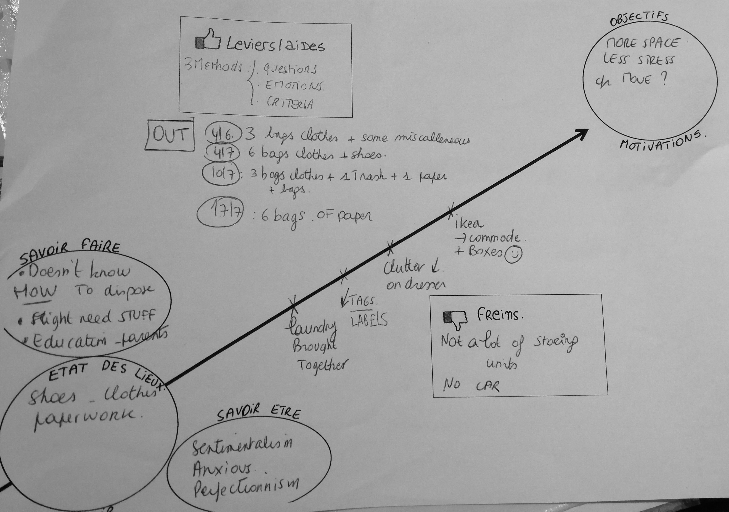
In addition to the remarkable amount of work involved in this kind of process, several points need to be raised in order to fully understand what these productions convey. Indeed, these various documents (which are very graphic) do not only draw up a synthesis – a "diagnosis" – of the existing situation and of the ethnomethods (the "remedies", in HO jargon) to be implemented in order to create a more organised and refined home. What they also do (and above all, I should add) is to transform one type of occurrence into another; they translate, like the academic ethnographer, observations, bits of conversations and interactions into data that can be classified, exploited, manipulated (Latour 1999). In that sense, HOs do 'circulate reference' (Ibid.) thus allowing the creation of knowledge. They literally create order out of disorder, classified data out of raw material. This operation is carried out according to a particular modality: that of writing. Indeed, it is by putting their reflections and observations on paper that HOs begin their work of “ordering” chaos; it is by passing through this medium, requiring the use of the cultural technology that is writing, that they make order and disorder apprehensible, cognitively but also practically. However, as Jack Goody has subtly shown, the use of such technology is not neutral since "modes of thought are affected by changes in the means of communication" (1979: 61). Writing, he specifies, "externalises, crystallises and accentuates this discontinuity [that of speech] by giving it a spatial and visual dimension that allows it to be subjected to possible rearrangements" (Ibid.: 186). In other words, what writing allows is not only the very possibility of “crystallising” – of making the raw reality apprehensible by direct observation – but also the intelligible organisation of this reality, the per se ordering of it. Indeed, this is what Goody shows again when he considers the use of lists (which HOs are fond of): "they make classification problems concrete, they enrich knowledge, order experience" (Ibid.: 170). And this “ordering” of experience is what HOs do when they present their clients with the various documents mentioned above. In fact, it is by making the disorder describable through writing that they draw its antithesis: order.
Illustration I. Sketch drawn by Lucie and her client to represent the “state of play” of the situation and the “objectives” to be achieved by the end of the mission.
But we need to go further and see how the order thus produced contains, in its very expression, a series of particular ideological colorations; how this order, as a generator of normativity, belongs to the sphere of “reason”. To this end, let’s consider illustration I for a moment. At the centre of this diagram is a line; this line connects the “state of play” of the problem encountered by the client with the objectives to be achieved in order to eradicate it definitively. The axis of this line is ascending in the direction of reading. If we take Goody's (1979) central thesis seriously, we are forced to note how, through this writing operation, a principle of 'rational', 'logical' (this is the meaning of the line) connection is expressed between the present state of things and the coveted future; the line becomes the symbol of a 'path' (see illustration I), of a process of progress – marked out by different steps – which is logical because it is thought out and organised by a professional organiser (who has collected data, who uses a recognised corpus of know-hows, etc.). Taking this principle of linkage as a fact, the HO performs a trick of the same order as what Goody describes concerning the tabulation carried out by some ethnologists of the last century: 'to include in the same table the classifications of the actor [here, the client and her problematic situation which is difficult to overcome] and those of the observer [here, the HO and her 'reasonable' action plan] is a bit of a trick' (1979: 127). By this trick, which is made possible through writing and schematisation, the client adopts the “logic” of the HO; the order (proposed by the HO) which will later be produced will be a particular order: a certain order which makes it possible to overcome disorder; an order which solves problems; an order which is therapeutic. But that's not all: this “rational” order, based on a certain “logic”, will also be a source of ascent, growth: self-development. This is in fact the meaning of the line oriented towards the upper right corner of the sheet, as if to signify a possibility: that of psychological rebound (see Marquis 2014). Thus, putting a certain reasoning on paper reveals the epistemological colouring of a rationale. And the latter to be precisely reasonable, that is to say: on the one hand, based on scientific thought circulating reference of reality in order to apprehend it cognitively and practically; and on the other hand, morally connoted, ideologically oriented towards the production of a specific order (therapeutic and enabling self-development). Through this reasonable and reasoned “rationale”, a logic producing a specific order (written first and then practical), the Home Organising movement clings to the field of self-development (see Marquis 2014; Réquilé 2008) and to therapeutic culture (see Imber 2004; Reiff 2006). In accordance with these fields, its message can be summed up in a lapidary proposition: by creating a certain order at home, one can get better.
Towards a theoretical sketch of the magic of tidying
- Similia similibus evocantur
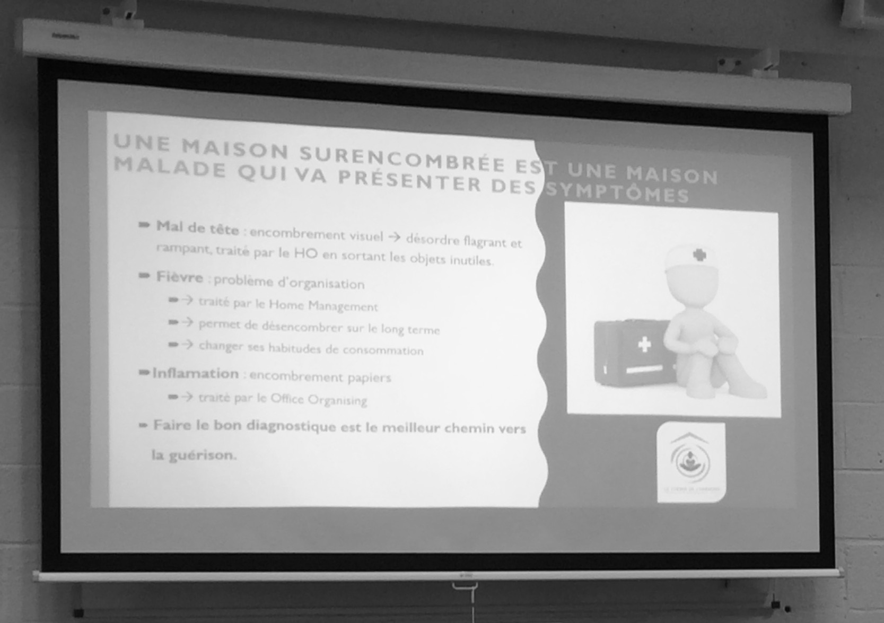
The entire process carried out by HOs – a process of which the second step (2) has just been described in detail – therefore consists of “caring”; and more precisely, caring for the person by caring for her home (see illustration II). This is because the promise of enchantment made by HOs necessarily passes through this stage; through the cleaning, caring for of the interior of the house, finally refined, tidy and orderly. It is indeed the very specificity of their activity; it is on this that the entire approach is based, as well as the mottos that epitomise it: “tidy your house to tidy your life”, “make [literally] room for the future” or, “clean your house to clean your mind”. This specific path – the one starting from the interior of the house and ending in the body – thus acts as the cornerstone of the activity; going through it in order to make it concrete is indeed the aim and objective of the work undertaken. This very particular link between the house and the body is what the following diagram represents (see illustration III) and this is what Inès, a HO instructor and pioneer in proselytising the profession in French-speaking Belgium, tells us about when she explains the following epistemological approach in detail:
Illustration II. “A cluttered home is a sick home that will show symptoms [such as] headache, fever or inflammation”. Slide from the PowerPoint presentation presented during a HO training session (see footnote n°4).
“At the beginning, it was a bit of a joke. I explained to the people I was training that you had to make it look as if the attic of a house was like the people's heads, with the memories and things that accumulate in it. [...] I explained that you had to see the living rooms of the house, like the kitchen, the sitting room, as the heart, you know. […]. The intimate rooms, such as the bathroom and the bedroom, correspond to the lower abdomen of the body [...]. For the basement, I used to tell them, "you have to pretend it's your legs", you know. Because that's what anchors us in our life, in our soil. [...] The functional rooms of the house, like the laundry room or the boiler room, well, they are the arms: very indispensable, because without them you can do almost nothing. […]. At the beginning, I said all that as a joke. Then, as time went by, I realised it was more than that: there's really a connection.”
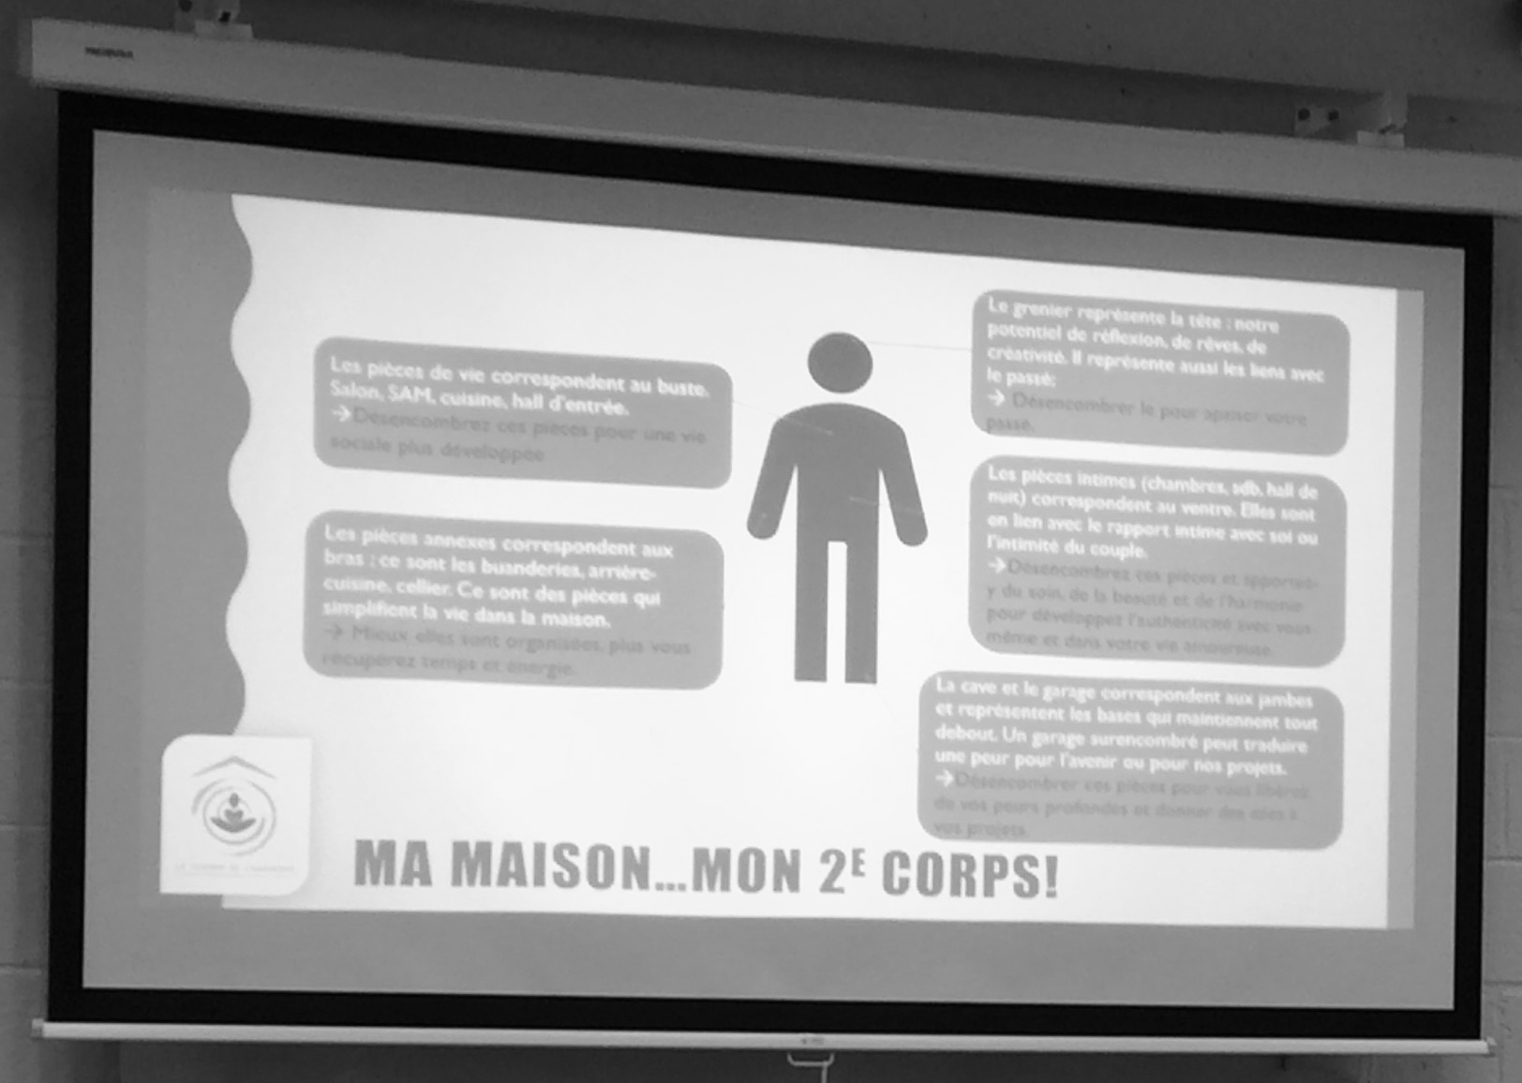
What Inès does here in her own words is undeniably an analogy between the human body and the architecture of a house's rooms. Out of prudence or modesty, it was at first just “a little bit of a joke” that such a connection was made: it was initially a matter of acting "as if". And, as Vinciane Despret explains, the “as if” generally means "making something possible, creating an attention for, [...] it is a bait for meanings" (2017: 202): it is a way of making the possible concrete. For Emmanuel Belin (2002), this type of displacement of the "maximum of likelihood", allowed by some socio-technical scaffoldings (“apparatus”) such as the one studied here and taking place at the heart of our daily actions, is precisely what generates a feeling of enchantment in individuals, a feeling that grants the real a properly magical surplus. Indeed, as Inès' words indicate – gradually abandoning the formulation “as if” (“as if the attic were people’s heads”) in favour of a simple affirmation (“the functional rooms [...] are the arms”) – her initially purely intuitive hypothesis, still suspended in the world of the presumed and the uncertain, quickly falls into the realm of reality; “with time”, experience and professional observation, the assumption crystallises, the idea coagulates and, through this very process, acquires a greater sense of reality (see Latour & Woolgar 1986) : what initially seemed fairly unbelievable because of its marvellous, enchanting dimension, has now become something quite possible. If doubt is of course allowed, the allegiance of the mind has changed sides: from now on, “there really is a link” between the home and the human body, it is no longer just a funny image.
Illustration III. “My home… My 2nd body!”. The different body parts are explicitly connected to the different rooms of a house. Slide from the PowerPoint presentation presented during a HO training session (see footnote n°4).
Such an analogical principle, anchored at the very heart of the epistemology of HO knowledge, is far from insignificant. It is, on the contrary, an indication of a particular way of thinking (see Jones 2017) which results in the construction of a specific “order of reality” (Tambiah 1990). Indeed, as several classical anthropological works have put forward, such a mode of thought, based on the “association of ideas” (Tylor [1871] 1920: 112-119) and operating according to the “laws of sympathy” (Frazer 1894: chapter III, § 1), is magical thinking. According to these studies, the truly magical dimension of an act – whether ritualised or not – is based on an "erroneous" understanding of natural phenomena, since it is based on a generic and non-scientific principle of analogical association. In other words, one thing would necessarily maintain a (magical) link with another by the simple fact that it resembles or is associated with it in some way (Frazer 1894); and by acting on one, one would necessarily act on the other: similia similibus evocantur (Hubert & Mauss 2019: 125).
In his study of the storage habits and the semiosis of possessions in North Atlantic societies, Alexander Newell (2014) attempts to grasp a similar “magical” connection between the body and a container: “in the space of storage, he said, we find insides and outsides folding into one another, as objects seemingly exterior to the person are embodiments of their most intimate interiorities, placed externally to a home’s social mapping and yet deeply internal to its architectural space” (2014: 193). But it is undoubtedly in the work of Lévy-Bruhl that such a way of thinking, in its psychological dimension, has been most finely analysed and approached. For the latter, there is in fact in every man, beyond logical-mathematical reasoning, an “other logic” that the author tries to apprehend by the term “participation” (2010). Participation thus designates this approach, operationalized by the feeling of “a consubstantiality, a communion, an identity itself (identity-duality) between beings and objects.” (Lévy-Bruhl 1998: 135). Without going into a detailed analysis of Levy-Bruhl’s theses on this principle of participation, one can note how such a reflexion is similar in many respects to the work of the paediatrician and psychoanalyst Donald Winnicott on the toddler psychological development (1965). For Winnicott, it is only in the course of ontogenesis that the child gradually discovers himself as an individual. Initially, Winnicott explains, the toddler perceives himself as omnipotent: when he seeks the breast, it is presented to him; he forms one with his environment and does not distinguish himself from it. It is only with time, and with the attentive help of the “good enough mother”, that the child learns to distinguish things from himself, to gradually – through an intermediate area qualified as "potential space" – make a distinction between the subjectively experienced and the objectively perceived (Winnicott 1971). However, for the psychoanalyst, although it is in early childhood that this structure of the mind is established, its consequences are not confined to this single period of existence; it extends its ramifications throughout human life. Thus, for Winnicott, the whole culture would be, in a way, only an extended, complexified form of this potential space (Ibid.). In other words, no one will ever completely emancipate oneself from this sense of belonging to the rest of things, from this modality of being “dividual” (Strathern 1988), from the “primitive mentality” (Lévy-Bruhl 2010) of participation.
In a completely different field – that of the history of thought – Michel Foucault has brilliantly pinpointed, in detail, this principle of participation from which thinking by association derives (2010). In his analysis of sixteenth-century Western thought, the philosopher looks at the “semiology of signatures”, which consists in reading from the signs of nature the functions and logics of affiliation of things (animals, plants, etc.) that make up the world. Based on an epistemology of resemblance, the knowledge of the time was based on (at least) four principles of fundamental similarities: convenience, emulation, analogy and sympathy. It was through these that knowledge was established. According to such principles, words and things were one, for the sign did not merely link things to their meaning, the sign itself was an object of deciphering, an iconicity that needed to be interpreted. In this way, knowledge “rolling up on itself” maintained intimate links with magical thought. At that time, Foucault explains, “divination is not a rival form of knowledge; it is part of the main body of knowledge itself” (2005: 36). In fact, in accordance with this principle of resemblance, “it is not possible to act upon those marks without at the same time operating upon that which is secretly indicated by them (Ibid.). Thus, the basic configuration of knowledge at that time was marks and similarities referring to one another. “The form of magic was [therefore] inherent in the way of knowing” (Ibid.: 37). In this 'analogical cosmography' (Ibid.: 25), man – as a flesh and blood being – played a central role. More precisely, it was his body that was perceived as a crossroads, a “privileged point” (Ibid.: 24): everything started from him and everything related to him. Thus, through the (il)logical leaps of participation allowed by the epistémè of resemblance (and in particular resemblance to the human body), magical thinking became operational: it linked together disparate elements of the world according to a configuration of its own and thus allowed the “miraculous” – the feeling of belonging to a greater world – to take place.
Such reasoning is close to Inès' words; it is indeed to such a magical thought that the analogy of the body and the house she proposed relates. As part of a kind of contemporary “analogical cosmology”, the agglutination of these two “natural symbols” (Douglas 2003), the body and the house, in the context of Home Organising, is a matter of magical thinking (see also Kilroy-Mirac 2016). Through this act of connection, tidying up one's interior – one's “second skin” – is ipso facto equivalent to performing a therapeutic act on one's own flesh, for one cannot be touched without touching the other: similia similibus curantur (Hubert & Mauss 2019: 125). But the prodigious power of propagation of this magical thought, carried by analogy, does not stop at the connection between home and body; it bounces back and, amplifying itself, comes to tie these last elements to the Earth itself – the entire “planet”. In fact, through many comments – whether these have been made to me by HOs themselves or written in the abundant literature of the field – Home Organising is linked to the ecological and minimalist movements of recent years.
But it was perhaps during the training course I attended that such a linking principle became most evident. In fact, during the course of this seminar, following the presentation of the “home-body” coupling that we have just discussed (see illustration III), we were shown a short video clip from "Conservation International", an American NGO fighting for the preservation of nature and its resources. The clip consisted of a sequence of aerial shots of various sumptuous natural landscapes and a hyperbolic soundtrack punctuated by the - inhabited - declamation of the following text (performed by the Oscar-winning French actress, Marion Cotillard):
“I am your home. I'm comfortable. I'm sheltering your family. Consider me for who I am. I'm your cosy nest. Your refuge. I'm the ground you're walking on. The base that keeps you upright. The walls that shelter you. The roof that protects you. I'm your home. If you don't take care of me, I can't take care of you”.
Obviously, the aim of the video is to draw the viewer's attention to the fragility of our planet's ecosystem, to raise awareness about this issue, by connecting it to the (domestic) interests of the person watching the clip. In the video, the Earth – speaking in the first person through the voice of Marion Cotillard – is shown as a house that needs to be taken care of (so that it can in turn properly fulfil its function of protecting its inhabitants). By introducing this new “Earth-home” coupling at this point in the presentation, the instructor subtly reverses the polarity of the message: if, in the original video clip, it is indeed a question of taking care of the Earth as one takes care of one's home, from now on, in the context of the above-mentioned enunciation, it will be a question of taking care of one's home in order to take care of the Earth. Through this circumstantial trick, the initial analogy is restored: once again, it can " extend, from a single given point, to an endless number of relationships" (Foucault 2005: 24). And this starting point is the home again; a point from which, it seems, things can magically align and heal each other. Thus, tidying up one's house will no longer just serve to “tidy one's mind”; from now on, it will also “save the planet”. This syllogistic trick demonstrates a deep, “mystical” connection – to use one of Lévy-Bruhl's terms – between the field of action of Home Organising and that of environmental movements fighting for the preservation of the planet. In this way, through the methodical use of analogy, HOs connect their activities to a certain type of dominant discourse concerning consumption (Bataille 1949; Turner 2010), to one of the major concerns currently shaping the collective representations of our society (see Pihkala 2018). Thus, if the home is indeed a “second skin”, the Earth, without doubt, is a third.
- Totum ex parte
This last point – concerning the analogical connection “body-home-earth” – allows us to approach the second facet of the HO activity considered as a magical process. It corresponds to the phenomenon of alignment of the client’s moral values with those that make up the collective representations of society with regard to consumption. In the first part of this article, I have shown how the activity of HOs was, in itself, a generator of normativity. Indeed, the simple fact of “putting things in order”, by first producing tables and lists, generates performative knowledge about order and disorder – about what is perceived as desirable, and what is perceived as undesirable. It is now time to analyse the nature of this normativity further.
Considering a certain arrangement of furniture and objects in the home as problematic – as a source of discomfort and tension – and as a springboard to self-development is not necessarily obvious (see above). In order to resort to an HO, one must therefore – at the very least – be aware of the existence of the profession and of the (miraculous) promises it carries. Moreover, one has to be sensitive to it, that is to say, one has to feel affected, touched by the Home Organising “message”, which establishes an analogical relationship between the interior of the house and the body. But there is also a broader connection that has to be acknowledged before getting oneself into to process of Home Organising: the one that establishes the connection between the inconvenience caused by the accumulation of objects and the cause of this accumulation – namely, 'consumption' (Cwerner & Metcalfe 2003). Indeed, one needs to be able to look critically at this other form of magical thinking, described by Jean Baudrillard as "the belief in the omnipotence of the sign [...] of happiness" (1996: 27), that is, in other words, the belief in the achievement of happiness through the acquisition of things. To be able to break away from this view, a certain “awareness” needs to be acquired, there needs to be a “trigger” (to use Lucie's term in our introduction). In this way, then, by rejecting this idea that one could find happiness in consumption, one is connected to a new collectivity; a collective thought that is thinking of itself as a collectivity, as a civilisation, even as humanity (see Angé & Berliner 2020). In this sense, tidying up your house, uncluttering it and reorganising its internal dynamics by requiring the help of a HO is necessarily seeking to synchronise your interior (your “second skin”) with certain shared moral ideas about what a “good” interior is – that is to say an interior which corresponds to a certain ideological stance on the harmful effects of the “consumer society” (Baudrillard 1996: 27).
Hence, to de-clutter, tidy and reorganise one's living space in this way is both to produce and reproduce a certain order of things (Douglas 2001); it is to align one's interior with the contemporary ideality of what an interior should be –- minimalist, ordered, refined – and, in doing so, it is “participating in the movement”; it is, in essence, to bring collective representations to life by endorsing their content for oneself. Such an approach, activated by the HOs and their clients, resonates with the demonstration made by Emile Durkheim in The Elementary Forms of the Religious Life ([1912] 2013) on the truly marvellous aspect of the religious phenomenon. For the latter, in fact, the secret of such an aspect lies in the social: it is through the process of sacralisation of the collective by its members and of the representations that animate it that the collective exists. Consequently, on the basis of this Durkheimian intuition, we can understand this other facet of the magic of tidying: it is that by ordering things – one's things – according to the order of things (carried by collective representations), one discovers oneself ordered – that is, in accordance with “the ideal social order of society” (Douglas 2001: 3); one switches from one clan to another: one leaves the indefinite space of impurity and enters into the sacred circle of purity (see Ibid.). In short, by putting oneself in line with the problematic of order and its values, one achieves a metamorphosis propelling one from the status of deviant (disordered, dumb, unaware), to the status of model (ordered, clever and aware). And from this alignment, wonder arises; from this moral order is discovered the magic, the one that silences the anguish of one’s deviant condition and transforms one into a “good” person. As Louise, one of many Inès’ clients, was verbalising it at the very end of Inès’ “mission” into her house, around a cup of tea in her newly re-arranged and tidied up living room,
“It's amazing... It's like I'm already feeling better, like everything is back in order (comme si tout était rentré dans l’ordre) [laughs]. It's a crazy feeling. […] I feel lightened, washed out from my problems […]. I’m like at peace with myself and, weirdly, with the world around me [laughs].
Thus, what is magical in the action undertaken by the clients of HOs is this (re)discovery of the sacredness of the values (because they are shared) that underpin collective representations – values that, from now on, they will necessarily incorporate and propagate by the example of their home fittings. Basically, seeing oneself confirmed as being “good” makes one feel “good”. And because it involves an action as prosaic as cleaning, it seems like a magical act, indubitably enchanting.
Conclusion: the order of things
During their “missions" helping clients who are overwhelmed by disorder and clutter in their homes, HOs do more than just offer a reorganisation assistance service. Rather, they deliver a promise of magic: that “care” for the home interior produces “care” for the mind, the body and even the earth. To do this, they rely, on the one hand, on knowledge based on an epistemology of analogy; on the other hand, they use technical know-hows allowing them to participate in the world transformation by "circulating reference" (Latour 1999). In the course of their interventions, an order of things – both ideological and pragmatic – takes shape. Ideological, first of all because, as I have shown, their way of putting the real in order (through writing, in particular) necessarily impact on the order generated: it is a rational and reasonable order (morally and scientifically speaking) which is thus produced, and this order is tied to self-development as well as to certain ecological and minimalist movements that shape the collective representations of our contemporary societies. Pragmatic, then, because from this “theoretical” order stems an effective practical application, generating a relatively standardised rearrangement (ordered, refined and functional) of the home interior. And from this double ordering stems a marvellous feeling – both for the HOs themselves, assiduous practitioners of this magical technique of tyding up, and for their clients, seduced by the outcome. Indeed, the analogical principle (body-home-earth) that animates the process of Home Organising and the incorporation of collective representations it allows make the act of tidying magical. By this very act, one acts on oneself and on the world; one participates in the latter – one becomes one with it by connecting with it.
This new “work on the self” (Marquis 2014) which Home Organising allows – typical of societies where autonomy has become a condition for action (Ehrenberg 2012) – reveals a certain attitude to contingency. Since tidying up one's interior allows, through the magical relationship that I have highlighted, to “save the planet”, it is, among other things, in such an attitude that the approach takes on its meaning. Indeed, in a world with an increasingly uncertain future (Callon, Lascoumes & Barthe 2001), the environment – personified as "the Earth" – is accredited with a certain agency but also with a certain morality: by its "reprisals", it becomes a source of anguish and danger (Douglas & Wildavsky 1982). And in front of such a danger, it is not surprising to see promises of solutions with magical colourings developing. This danger – thus personified – resembles the invisible forces which, intruding into human life, cause illness and death in the world of the "primitive" (Lévy-Bruhl 2010). Thus, the power granted by HOs and their clients to Home Organising is far from being “stupid” (to use Lucie’s words in the introduction); on the contrary, it is completely coherent and is part of this “other logic” that Lévy-Bruhl has tried to account for: faced with the profound uncertainty that the future represents – an uncertainty that is understood as morally and intentionally connoted – the solution proposed to try to remedy it must necessarily go through magical channels. Tidying, therefore, becomes a sensible way of restoring order to things present and future.
Bibliography
Abrahamson, Eric, and David Freedman. 2006. A perfect mess: The hidden benefits of disorder. New-York: Little Brown.

Angé, Olivia, and David Berliner. 2020. Ecological nostalgias. Memory, affect and creativity in times of ecological upheavals. Oxford: Berghahn Books.

Bachelard, Gaston. 1957. La poétique de l’espace. Paris: PUF.

Bataille, Georges. 1949. La part maudite. Paris: Editions de Minuit.

Baudrillard, Jean. 1970. La société de consommation. Paris: Editions Denoël.

------. 2016. Le système des objets. Paris: Gallimard.

Belin, Emmanuel. 2002. Une sociologie des espaces potentiels. Logique dispositive et expérience ordinaire. Bruxelles: De Boeck Université.

Belk, Russel, Seo, Joon, and Eric Li. 2007. “Dirty little secret: Home chaos and professional organizers”. Consumption Markets & Culture 10(2): 133-140.

Boltanski, Luc, and Eve Chiapello. 1999. Le nouvel esprit du capitalisme. Paris: Gallimard.

Bourdieu, Pierre. 1972. Esquisse d’une théorie de la pratique, précédé de trois essais d’ethnologie kabyle. Paris: Seuil.

------. 2001. Langage et pouvoir symbolique. Paris: Seuil.

Brox, Trine, and Elizabeth Williams-Oerberg. 2022. Buddhism and waste. The excess, discard, and afterlife of buddhist consumption. London: Bloomsbury Academic.

Buchli, Victor. 2013. An anthropology of architecture. New York: Bloomsbury.

Callon, Michel, Lascoumes, Pierre, and Yannick Barthe. 2001. Agir dans un monde incertain : essai sur la démocratie technique. Paris: Editions du Seuil.

Certeau de, Michel. 2010. L’invention du quotidien. 1. Arts de faire. Paris: Gallimard.

Cwerner, Saulo, and Alan Metcalfe. 2003. “Storage and clutter. Discourses and practices of order in the domestic world”. Journal of Design History 16(3): 229-239.

Denegri-knott, Janice, and Don Slater. 2014. “Disordering things”. Journal of Consumer Behaviour 13: 89–87.

Douglas, Mary. 2001. Purity and danger: An analysis of the concepts of pollution and taboo. London: Routledge.

------. 2003. Natural symbols: Explorations in cosmology. New-York: Routledge.

Douglas, Mary, and Aaron Wildavsky. 1982. Risk and culture. An essay on the selection of technological and environmental danger. London: University of California Press.

Dupuis, Ann, and David Thorns. 1996. Meaning of home for home owners. Housing Studies 11(4): 485-501.

Cieraad, Irene. 2006. At home: An anthropology of domestic space. Syracuse: University Press.

Clarck, Alison. 2001. “The aesthetics of social aspiration”. In Home possessions material culture behind closed doors, edited by Daniel Miller, 23-46. Oxford: Berg.

Despret, Vinciane. 2015. Au Bonheur des morts : récits de ceux qui restent. Paris: Editions La Découverte.

Durkheim, Émile. 2013. Les formes élémentaires de la vie religieuse : le système totémique en Australie. Paris: PUF.

Easthope, Hazel. 2004. A place called home. Housing, Theory and Society 21(3): 128–38.

Ehrenberg, Alain. 2012. La société du malaise. Paris: Odile Jacob.

Foucault, Michel. 2010. Les mots et les choses. Paris: Gallimard.

Frazer, James. 1894. The golden bough. New-York: MacMillan and Co.

Frost, Randy, and Gail Steketee .2010. Stuff. Compulsive hoarding and the meaning of things. New-York: Houghton Mifflin Harcourt.

Garfinkel, Harold. 1967. Studies in ethnomethodology. Cambridge: Polity Press.

Garvey, Pauline. 2001. “Organized disorder: Moving furniture in Norwegian homes”. In Home possessions material culture behind closed doors, edited by Daniel Miller, 47-68. Oxford: Berg.

Geist, Claudia. 2010. “Men’s and women’s reports about housework”. In Dividing the domestic: Men, women, and household work in cross-national perspective, edited by Treas Judith and Sonja Drobnič, 217-240. Standford: Standford University Press.

Goody, Jack. 1979. La Raison graphique : la domestication de la pensée sauvage. Paris: Editions de Minuit.

Gregson, Nicky. 2007. Living with things: Ridding, accommodation, dwelling. Wantage: Sean Kingston Pub.

Gygi, Fabio. 2018. “The metamorphosis of excess: ‘Rubbish houses’ and the imagined trajectory of things in post-bubble Japan”. In Consuming life in post-bubble Japan: A transdisciplinary perspective, edited by Cwiertka Katarzyna and Ewa Machotka, 129-150. Amsterdam: Amsterdam University Press.

Heidegger, Martin. 1993. “Building dwelling thinking”. In Basic writings: From being and time (1927) to the task of thinking (1964), edited by David Krell, 343-363. San Francisco: HarperSanFrancisco.

Herring, Scott. 2014. The hoarders: Material deviance in modern American culture. Chicago: University of Chicago Press.

Imber, Jonathan. 2004. Therapeutic culture: Triumph and defeat. New Brunswick, N.J: Transaction Publishers.

Ingold, Tim. 2000. The perception of the environment: Essays on livelihood, dwelling and skill. New-York: Routledge.

Jones, Graham. 2017. Magic’s reason. An anthropology of analogy. Chicago: The University of Chicago Press.

Kilroy-Marac, Katie. 2016. “A magical reorientation of the modern: Professional organizers and thingly care in contemporary North America”. Cultural Anthropology 31(3): 438-457.

------. (2017). “An order of distinction (or, how to tell a collection from a hoard)”. Journal of Material Culture 23(1): 20–38.

Kondo, Mary. 2014. The life-changing magic of tidying: A simple, effective way to banish clutter forever. London: Vermilion.

Latour, Bruno. 1999. Pandora’s hope. Essays on the reality of science studies. Cambridge: Harvard University Press.

Latour, Bruno & Steve Woolgar. 1986. Laboratory life: The social construction of scientific facts. Princeton: Princeton University Press.

Lepselter, Susan. 2011. “The disorder of things. Hoarding narratives in popular media”. Anthropological Quarterly, 84(4): 919-947.

Lévy-Bruhl, Lucien. 1998. Carnets. Paris: PUF.

------. 2010. La mentalité primitive. Paris: Flammarion.

Loreau, Dominique. 2011. Faire le ménage chez soi, faire le ménage en soi. Paris: Editions Marabout.

Macroux, Jean-Sébastien. 2001. “The refurbishment of memory”. In: Home possessions material culture behind closed doors, editied by Daniel Miller, 69-86. Oxford: Berg.

Marquis, Nicolas. 2014. Du bien-être au marché du malaise : la société du développement personnel. Paris: Presses universitaires de France.

------. 2016. "Performance et authenticité, changement individuel et changement collectif : une perspective sociologique sur quelques paradoxes apparents du “développement personnel”". Communication & Management 1(13): 47–62.

Martin-Woodhead, Amber. 2021. “Limited, considered and sustainable consumption: The (non)consumption practices of UK minimalists” Journal of Consumer Culture. 0(0) 1–20

Mauss, Marcel, and Henri Hubert. 2019. Esquisse d'une théorie générale de la magie. Suivi de l'origine des pouvoirs magiques dans les sociétés australiennes. Paris: PUF.

Migone, Andrea. 2007. “Hedonistic consumerism: Patterns of consumption in contemporary capitalism” Review of Radical Political Economics. 39(2):173-200.

Miller, Daniel. 2001. “Behind closed doors”. In Home possessions material culture behind closed doors, edited by Daniel Miller, 1-21. Oxford: Berg.

------. 2012. Stuff. Cambridge: Polity Press.

Newell, Alexander. 2014. “The matter of the unfetish. Hoarding and the spirit of possessions” Hau: Journal of Ethnographic Theory 4(3): 185–213.

------. 2019. “L’hospitalité des hoarders” L’Homme 231-232 : 111-134.

O’Mahony, Fox. 2013. The meaning of home: From theory to practice. International Journal of Law in the Built Environment 5(2): 156-71.

Pihkala, Panu. 2018. “The wicked problem of climate change. Eco-anxiety, tragedy, and hope: Psychological and spiritual dimensions of climate change” Zygon 53(2): 545–569.

Réquilé, Elise. 2008. "Entre soucis de soi et réenchantement subjectif. Sens et porté du développement personnel". Mouvements 2: 65–77.

Rieff, Peter. 2006. The Triumph of the therapeutic: Uses of faith after Freud. Wilmington: ISI Books.

Roster, Catherine. 2015. ““Help, I have too much stuff!”: Extreme possession attachment and professional organizers”. The Journal of Consumer Affairs 49(2): 303-327.

Shaeffer, Megan. 2017. “The social context of hoarding behavior: Building a foundation for sociological study”. Sociology Compass 11(4): 1-12.

Starhawks. 1997. Dreaming the dark: Magic, sex, and politics. Boston: Beacon Press.

Strathern, Marilyn. 1988. The gender of the gift: Problems with women and problems with society in Melanesia. Berkeley: University of California Press.

Tambiah, Stanley. 1990. Magic, science, religion, and the scope of rationality. Cambridge: Cambridge University Press.

Turner, Rita. 2010. “Discourses of consumption in US-American culture”. Sustainability 2010, 2(7): 2279-2301.

Turner, Terence. 2012. “The social skin” Hau: Journal of Ethnographic Theory 2(2): 486–504.

Tylor, Edward. 1920. Primitive culture. London: John Murray, Albemarle Street, W.

Winnicott, Donald. 1965. Maturational processes and the facilitating environment: Studies in the theory of emotional development. London: Hogarth Press.

------. 1971. Playing and reality. London: Tavistock.

Expression often used in the anglophone press. In French, the HO I have met often used “la papesse du rangement”, litteraly the “female pope of storage”.
For an analysis of the genesis of Professional Organisers, see Abrahamson & Freedman (2006) and Herrings (2014).
Title of Dominique Loreau’s French book (2011).
This research is based on two years of ethnographic fieldwork with twelve Home Organisers from Belgium (Brussels and Wallonia), and the participation to a 14 hour-training session titled « introduction au Home Organising » hosted by the IFAPME (Institut wallon de Formation en Alternance des indépendants et Petites et Moyennes Entreprises) in Liège, the 17th and 24th of October 2019. This research was made possible thanks to the funding of the FNRS (Fond National de la Recherche Scientifique).
Comment made by Samantha, a HO that I met during my fieldwork, regarding the purpose of her work.
Because, in western societies, women (still) tend to do more domestic work than men (Geist 2010), it is not surprising that most of the protagonists involved in the Home Organising movement – both among the HOs themselves and their clients – are female, generally white middle-class women between the age of forty and fifty-five. Even when they live with other people in the house (husband, children, lover, etc.), these women – “the clients” – are considered by the HOs as the locus of their attention, the centre around which the work into the house must be done.
As Bruno Latour precises, “we have taken science for realist painting, imagining that it made an exact copy of the world. The sciences do something else entirely-paintings too, for that matter. Through successive stages they link us to an aligned, transformed, constructed world” (1999: 78).
On the theme of symbolic plasticity of the human body and its relations, in particular, with the house, see Bachelard (1957), Bourdieu (1972), Buchli (2013), Cieraad (2006), Turner (2012), Scheperd-Hughes & Lock (1987) and Dupuis & Thorns (1996).
For Belin, an apparatus is “a generic signifier to designate and link all these ordinary ways of doing things […].” (2002: 172).
For a more in-depth analysis of the question, see Tambiah (1990).
See, for example, Crillen (2017).
https://www.youtube.com/watch?v=1CwEQ8QRnas, watched the 20th of November 2020.
During the training session that I attended (see note n°4), a continual and explicit reference to Pierre Rabhi’s ecological movement named “colibri” (see https://www.pierrerabhi.org) was made by the individuals who came to be initiated to Home Organising.
On that matter, see Bourdieu (2001).
Many connections could undoubtedly be pointed out between the "magical" action of the HOs, the ecological dimension of their ideology and the eco-feminist movement of the neo-witches shepherded, notably, by Starhawks (1997). Unfortunately, we lack the space to address these seriously here. They would deserve to be studied thoroughly elsewhere – I would like to cordially thank the reviewer who very accurately pointed it out.

