**Differential Kendrick’s plots as an innovative tool for lipidomics in complex samples: comparison of liquid chromatography and infusion-based methods to sample differential study**

Justine Hustin1, Christopher Kune1, Johann Far1, Gauthier Eppe1, Delphine Debois2,

Loïc Quinton1* & Edwin De Pauw1

1 Mass Spectrometry Laboratory, MolSys Research Unit, Department of Chemistry, University of Liège,

Allée du Six Août 11 – Quartier Agora, 4000 Liège, Belgium

2 ZenTech S.A., Avenue du Pré Aily 10, 4031 Liège, Belgique

*Corresponding Author Email: loic.quinton@uliege.be

**Abstract**

*Lipidomics has developed rapidly over the past decade. Non-targeted lipidomics from biological samples remains a challenge due to the high structural diversity, the concentration range of lipids and to the complexity of the biological sample. We introduce here the use of differential Kendrick’s plots as a rapid visualization tool for a qualitative non-targeted analysis of lipids categories and classes, from data generated by either liquid chromatography-mass spectrometry (LC-MS) or direct infusion (nESI-MS). Each lipid class is easily identified by comparison with the theoretical Kendrick plot pattern constructed from exact mass measurements and by using MSKendrickFilter, an in-house Python software. The lipids are identified with the LIPID MAPS database. In addition, in LC-MS, the software based on the Kendrick plots returns the retention time from all the lipids belonging to the same series. Lipid extracts from a yeast (Saccharomyces cerevisiae) are used as model. An on/off case comparing Kendrick plots from two cell lines (prostate cancer cell lines treated or not with a DGAT2 inhibition) clearly shows the effect of the inhibition.*

*Our study demonstrates the good performance of direct infusion as a fast qualitative screening method as well as for the analysis of chromatograms. A fast screening semi-quantitative approach is also possible while the targeted mode remains the golden standard for precise quantitative analysis.*

**Introduction**

Lipidomics is the part of metabolomics that aims at the qualitative and quantitative characterisation of lipids from complex mixtures. It is largely based on analytical methods in which mass spectrometry (MS) is of critical importance1,2,3. This newly emerged discipline finds important applications in the medical field, since the lipid composition is commonly impaired during pathological states4, including cardiovascular diseases, diabetes, cancers, glomerular lipidosis and neurodegenerations5,6,7,8,9. Cellular lipids are highly complex and contains thousands of species at concentration ranging from amol to nmol per milligram of protein1,10. Chemically, lipids present multiple isobaric structures present under the form of multiple isomeric structures2,11. According to the classification of The International Lipid Classification and Nomenclature Committee (ILCNC), lipids can be divided into 8 well-defined categories (Table 1)12. Each category of lipid has its own subclassification hierarchy (87 classes and 361 subclasses up to now based on structural characteristics)13. The LIPID MAPS structure database (LMSD, Nature Lipidomics Gateway, [*www.lipidmaps.org*](http://www.lipidmaps.org)), currently contains 43,798 unique lipid structures (as of 15/06/2022).

|  |  |
| --- | --- |
| Categories | Structures in Database |
| Fatty acyls (FA)  Glycerolipids (GL)  Glycerophospholipids (GP)  Sphingolipids (SP)  Sterol Lipids (ST)  Prenol Lipids (PR)  Saccharolipids (SL)  Polyketides (PK) | 10,078  7,680  9,993  4,906  3,184  1,596  1,335  7,026 |

Table 1 : Lipid categories of the comprehensive classification system and the number of structures in the LIPID MAPS database.

In lipidomics, lipids are classically investigated as classes or as single compounds, in targeted or untargeted methods14,15. Shotgun lipidomics, as introduced by Han and Gross, produced especially rich and complex mass spectra which could be used as sample fingerprints16,17,18,19,20,21,22,23. If high resolution mass spectrometry can help resolving compounds with very close masses, MS/MS is still mandatory to perform the elucidation of structural isomers24,25. Lipid isomers elucidation may moreover require the use of specific reactions like ozonolysis26,27,28.

In addition to front-end separation methods such as liquid chromatography (LC), multidimensional LC and gas chromatography (GC), ion mobility spectrometry (IMS) can be used both as an additional separation method and to provide an additional identifier by the mean of the drift time, thus improving the confidence level for the identification of lipids and their isomers29,30,31,32,33,34. Drift-tube ion mobility MS and LC-MS separation of isomers that differ only in the relative position of the two fatty acyl chains, the position of the double bonds or their geometric isomerism has been demonstrated recently35,36.

Kendrick plot analysis also gained attention in lipidomics in the past few years37,38. Indeed, compounds such as lipids differing only by the number of -CH2- units will be aligned in the classical Kendrick plots, facilitating their identification through grouping by homologous formulas39.

In this study, Kendrick’s analysis was first chosen to compare the performances of LC-MS and direct infusion (nESI-MS), using yeast lipid extracts. Second, differential Kendrick plot analysis was applied on direct infusion of lipids extracted from cancer cell lines (prostate cancer cells acting as a control sample and prostate cancer cells treated with a DGAT2 inhibitor lipid extract), to illustrate the discriminating power of the method. This analytical approach has proven to be powerful in rapidly profiling the qualitative differences in lipid compositions between samples (*i.e.* healthy and diseased patients), for example to monitor treatment progress. Other applications can be found in food safety, fraud detections and environmental monitoring.

**Materials and methods**

***Chemicals***

Acetonitrile (ACN), absolute methanol (MeOH) and water were ULC/MS-grade and 2-propanol (IPA) was LC/MS-grade purchased from Biosolve (Valkenswaard, Netherlands). HPLC-grade chloroform (CHCl3), HPLC-grade tert-butyl methyl ether (MTBE), formic acid (≥ 98%), ammonium formate (≥ 99%), phosphoric acid (85%), hydrochloric acid (HCl), phosphate-buffered saline (PBS) and 2,6-di-tert-butyl-4-methylphenol were purchased from Sigma-Aldrich (Overijse, Belgium).

LNCaP clone FGC; Prostate Carcinoma; Human (Homo sapiens) also called human prostate cancer cell lines (LNCaP cells) were purchased from LGC Standard (Teddington, United Kingdom).

SPLASH™ Lipidomix® solution containing the following isotopically labelled internal standards: PC 15:0–18:1(d7), PE 15:0–18:1(d7), PS 15:0–18:1(d7), PG 15:0–18:1(d7), PI 15:0–18:1(d7), PA 15:0–18:1(d7), LPC 18:1(d7), LPE 18:1(d7), Chol Ester 18:1(d7), MG 18:1(d7), DG 15:0–18:1(d7), TG 15:0–18:1(d7)-15:0 , SM 18:1(d9) and Cholesterol (d7) was obtained from Avanti Polar Lipids (Alabama, USA).

***Sample preparation***

Commercially available Bruggeman Instant dry yeast (*Saccharomyces cerevisiae*) used for baking was purchased in a local supermarket. Dry yeast was grinded in a porcelain mortar with a porcelain pestle.

***Lipid extraction procedure from yeast samples***

The extractions were performed according to the methanol/MTBE extraction method40. In the first step, the biological material is solubilized with a mixture of methyl-tert-butyl ether (MTBE) and methanol (MeOH) to bring lipids in solution, while proteins and other macromolecules are precipitated. Afterwards, water is added to the crude extract to induce phase separation. MTBE extraction results in a biphasic solvent system: (i) an organic phase (MTBE and MeOH) of lower density containing lipids and, (ii) the polar fraction (aqueous) of higher density. In this system, the insoluble protein plug and lie below the aqueous and organic fractions41.

Practically, 4.5 mg of dry yeast were placed into a 2 mL amber glass vial made of borosilicate equipped with an aluminium cap. 150 µL of methanol were added and the vial was vortexed. Then, 500 µL of MTBE was added and the mixture was shaken for 1 h at room temperature in an Eppendorf Thermomixer R (Eppendorf AG, Hamburg, Germany). Phase separation was induced by adding 125 µL of water. The vial was vortexed again and upon 10 min of incubation, the sample was centrifuged at a temperature of 5 °C (15 min, 2,500 g) using an Eppendorf Centrifuge 5,430 R (Eppendorf AG, Hamburg, Germany). After centrifugation, the upper phase (containing lipids) was collected, and evaporated in a Savant SpeedVac (Thermo Fisher Scientific). Extracted lipids were dissolved in 1 mL of IPA/ACN/water (45:30:25, v:v:v) and stored at -80 °C until use. The resulting lipid concentration is of the order of magnitude of µmol.L-1 as estimated according to the literature on *Saccharomyces cerevisiae*42**.**

***Lipid extraction procedure from human prostate cancer cell lines (LNCaP cells)***

Lipidomics human prostate cancer cell lines (LNCaP cells) extractions were performed by our collaborators, Lipometrix, the KU Leuven lipidomics core (KU Leuven, Belgium) according to the Folch extraction method40.

Fresh cultured LNCaP cells (human prostate cancer cell line used as control sample and human prostate cancer cell lines treated with a DGAT2 inhibitor) were washed 3 times with phosphate-buffered saline (PBS), and then scraped in 1 mL of PBS. The result was transferred to an Eppendorf tube and centrifuged for 5 min at 2,000 g. The supernatant was removed, the cell pellet was suspended in 800 µL of water, and then homogenized using a UP100H sonicator (UP100H Ultrasonic processor, Hielscher Ultrasound Technology, Germany). For lipid extraction, a volume of this cell homogenate containing approximately 300,000 cells was taken and is diluted with water to 700 µL. These 700 μL were mixed with 800 μL of 1 M HCl:CH3OH 1:8 (v/v), 900 μL CHCl3, 200 μg/mL of the antioxidant 2,6-di-*tert*-butyl-4-methylphenol and 3 μL of SPLASH® LIPIDOMIX® Mass Spec Standard (#330,707, Avanti Polar Lipids). After homogenization (vortex) and centrifugation, the lower organic fraction was collected and evaporated using a Savant Speedvac (Thermo Fisher Scientific) at room temperature and the remaining lipid pellet was stored at -20 °C under argon.

***Instrumentations and analytical conditions***

*Reverse-phase (C18) Ultra performance liquid chromatography (UPLC) coupled with a mass spectrometer (LTQ-FT Ultra 7T): RP-UPLC-ESI-FT-ICR.*

Lipid separation by reverse phase liquid chromatography was performed on a Waters Acquity UPLC I-Class system (Milford, MA, USA) running under MassLynx v4.1 software. In the auto sampler, samples were kept at 5 °C. The column ACQUITY UPLC CSH C18 Column, 130 Å (2.1 mm × 150 mm, 1.7 μm) was purchased from Waters (Zellik, Belgium). The mobile phases used was solvent A: 10 mM ammonium formate in ACN/water (60:40, v:v) with 0,1% formic acid and solvent B: 10 mM ammonium formate in IPA/ACN (90:10, v:v) with 0,1% formic acid. The linear gradient elution of 100 µL/min flow rate was done as follows: 0-1 min (B, 40-40%), 1-34 min (B, 40-99%), 34-39 min (B, 99-99%), 39-41 min (B, 99-40%), 41-45 min (B, 40-40%). Reverse phase separation was carried out at 55 °C (column oven temperature) and 5 µL of the lipid extract were injected in the column.

ESI-MS detection was performed by an LTQ-FT Ultra 7T mass spectrometer (Finnigan Thermo Fisher, San Jose, CA) using the ICR for accurate mass determination in positive mode. The sample was introduced to the LTQ-FT Ultra ESI source through a capillary by splitting the LC-column effluent using a Tee with a split ratio of 20:80 to inject a 20 µL/min flowrate into the ESI source of the mass spectrometer. The source temperature was set to 225 °C and the spray voltage to 3.5 kV. The LTQ-FT Ultra mass range was fixed to 100−1,100 *m/z* with a 100,000 mass resolving power at 400 *m/z* (full with at half maximum, FWHM) and was externally calibrated using the Thermo Scientific calibration mixture as recommended by the manufacturer. Typical mass accuracy was below 2 ppm or better. Data were carried out in triplicate and were processed using the XCalibur software v3.1.

*Direct infusion on a mass spectrometer (SolariX XR FT-ICR 9.4T): nESI-FT-ICR.*

Mass spectrometric analysis by direct infusion was performed in positive ion mode on an FT-ICR instrument SolariX XR 9.4T using the dynamically harmonized ICR cell (Bruker Daltonics, Bremen, Germany) equipped with a robotic nanoflow ion source NanoMate HD (Advion BioSciences, Ltd., Ithaca, NY). Ionization voltage was set to 2 kV, gas pressure to 0.4 psi, and the source was controlled by Chipsoft v6.3.3 software (Advion BioSciences). The mass range was fixed from 100 to 1,100 *m/z* using 400,000 mass resolving power (FWHM) at 500 *m/z* and was externally calibrated using phosphoric acid 0.1% in ACN/water (80:20, v:v). Typical accuracy is below 1 ppm or better. Data has been carried out in triplicate and were processed using the DataAnalysis software v5.0.

***Kendrick mass defect filtering***

Direct infusion and LC-MS raw data files have been first converted to mzML files (*i.e.,* standard open format for MS file) with the MSconvert software from Proteowizard43. For Kendrick mass defect analysis, the mzML file have been converted to ICK files and processed with our in-house Python software, MSKendrickFilter (MSKF) (<https://github.com/ChristopherKune/MSKendrickFilter>) written by C. Kune39,44,45. In this conversion process, profile MS data has been changed to centroid MS using an implemented peak picking algorithm. An intensity threshold, a peak prominence, and a peak distance of, respectively, 200,000 cps, 0 and 5 have been considered for this peak picking. Centroided LC-MS data have been realigned to reduce centroid m/z value variations.

Kendrick reference (KR) used in MSKF for lipids was –CH2– and the Kendrick mass (KM) and Kendrick mass defect (KMD) were computed according to Equation 1 and Equation 2, where *m/z* is the measured mass-to-charge ratio of the ions using IUPAC scale. The KMD filtering was applied to retain only the information linked with lipids of interest (*i.e.* theoretical KMD values between 0.10 and 0.50 and *m/z* between 300 and 1,100).

KM = m/z x $\frac{KR nominal mass}{KR exact mass}$

Equation 1

KMD = round (KM) – KM

Equation 2

The MSKF software allows the lipid signals to be grouped by classes, based on their KMD value (since all ions varying only by -CH2- units have the same KMD value), with a given KMD tolerance. In the case where two or more lipid classes have a similar KMD value, a second algorithm is applied to group the lipid signals based on mass difference. This algorithm groups all ions whose mass difference corresponds to a given formula, here -CH2- or -C2H4- with a given relative mass tolerance (2 ppm). It results to a set of potential lipid series that can be identified by database research.

Moreover, MSKF makes possible a simplification of the KMD plots by transforming signal series coming from different isotopes or cation adducts of the same species into the protonated monoisotopic lipid series.

***Data base search and lipid identification***

The filtered data were analysed by MSKF to isolate the lipid series constituting the lipid classes present in the yeast and in the cancer cells extracts. In a second time, LIPID MAPS structure database (LMSD, [http://www.lipidmaps.org](http://www.lipidmaps.org/)) was used for lipid class identification.

Notation such as A(X:Y); where A is the lipid class abbreviation, X and Y are respectively the number of carbon atoms and of double bonds on the acyl chains; is used when the regiochemistry and stereochemistry is unknown46. As an example PE(36:1) corresponds to a phosphatidylethanolamine with 36 carbon atoms and 1 double bond somewhere on one of the two acyl chains.

**Results and discussions**

***Kendrick plots and Kendrick differential plots analysis concept for lipidomics***

The Kendrick plot is a two-dimensional projection of atomic composition space where the X-axis corresponds to the Kendrick mass (KM) or the *m/z,* and the Y-axis corresponds to the Kendrick mass defect (KMD). KMD is based on the molecular formula only and does not discriminate structural isomers. Using CH2 as Kendrick reference (KR), all lipids that vary only in the number of CH2 units will show the same KMD and will be placed on the same horizontal line. They can be related to a lipid class. The unsaturation level, or modifications different than the extension of the CH2 units number, will shift the corresponding compounds to a parallel line. The Kendrick plot allows a rapid visualisation of the lipids by classes and by degree of unsaturation (double bond index). As all lipids belonging to the same series can be found on the same horizontal line, the identification of one of its members helps finding the others. Replacing a proton by a cation will shift the plot in the *m/z* and KMD axis and the cationized lipids will then appear as parallel lines, that can easily be reassembled by software. The accurate mass, isotopic signature, and mapping to databases such as LIPID MAPS can confirm the identification.

A theoretical Kendrick plots for the 8 classes of lipids referenced in the LIPID MAPS database was constructed (Figure 1). Some fatty acyls (FA) with a KMD range from 0.5 to 0.9 and *m/z* range from 100 to 400 acts differently and do not form any alignments. These fatty acyls are halogenated fatty acids and it is unlikely to find this type of lipid in our biological samples. Sources of halogenated fatty acids mainly include microorganisms, algae, marine invertebrates, and higher plants47.

Lipids presents in this plot are assumed to be singly protonated lipids [M+H]+. For clarity, adducts of K+, Na+, NH4+ are not considered in this representation but can be easily added if needed. Actually, it is essential to take them into consideration because come lipid categories are not present in the protonated form.

Figure 1 : Theoretical Kendrick plot of 8 classes of lipid structures referenced in the LIPID MAPS database, assuming charge state of z=+1 of proton adduct [M+H]+ (KMD range from 0 to 1 and m/z range from 0 to 1,100). Fatty acyls (FA), glycerolipids (GL), glycerophospholipids (GP), sphingolipids (SP), sterols (SL), prenols (PR), saccharolipids (SL) and polyketides (PK).

KMD plots can be exploited not only to identify lipid signals in a complex sample, but also to detect differences and similarities between various data sets. MSKendrickFilter software allows the similarity or difference between two MS data sets to be highlighted by performing a set of intersections or difference calculations with tolerance, respectively.

***KMD plot analysis for LC-MS lipidomics***

Currently, the most widely used technique for lipid analysis is high performance liquid chromatography coupled with mass spectrometry (HPLC-MS)33,48. HPLC, in addition to concentrating the analytes and reducing matrix interferences, allows, depending on the type of column used, to group lipids by classes or to separate individual lipids belonging to the same class. In the case of polar lipids, no prior derivatization is required.

Reverse phase liquid chromatography (RP-LC) using a C18 column is the most popularly LC separation method for lipid separation49. Lipid separation is based on hydrophobicity, thus on the acyl chains properties of the lipids (length, degree of unsaturation and number of double bonds48), explaining why RP-LC is more efficient for hydrophobic lipids than for polar lipids. To separate polar lipids, hydrophilic interaction liquid chromatography (HILIC), which separates lipids according to their polar heads, should be preferred 50.

The lipid extraction method is generally not exhaustive, the nature of analytical column and the composition of the mobile phase affect the number and the type of lipids (classes and subclasses) that can be resolved chromatographically. Exhaustive resolution of all lipids including isomers, in a single run for a rapid screening based on LC-MS methods remains a long-term goal. In order to propose a fast and efficient screening method, we have developed a data processing method based on Kendrick plots analysis, inspired from a method recently developed for MALDI mass spectrometry imaging purpose39.

In the same way as for MS imaging, an average MS spectrum can be generated from the LC data. This spectrum corresponds to the sum of each MS spectra of the LC-MS scans. From this spectrum, a KMD plot is constructed. An example of Kendrick plot of LC-MS data is shown in Figure 2 after signal denoising (*i.e*. by applying a signal threshold of 2,500,000, corresponding to the noise level in the average MS spectrum).

As shown in Figure 2, instead of analysing the LC peaks individually, one of the assumed lipid class can be selected on the Kendrick plot (Figure 2A) and the corresponding extracted ion chromatogram can be generated by the MSKendrickFilter software (Figure 2B and D). This KMD-based data analysis approach allows rapid visualization of lipid chromatograms.

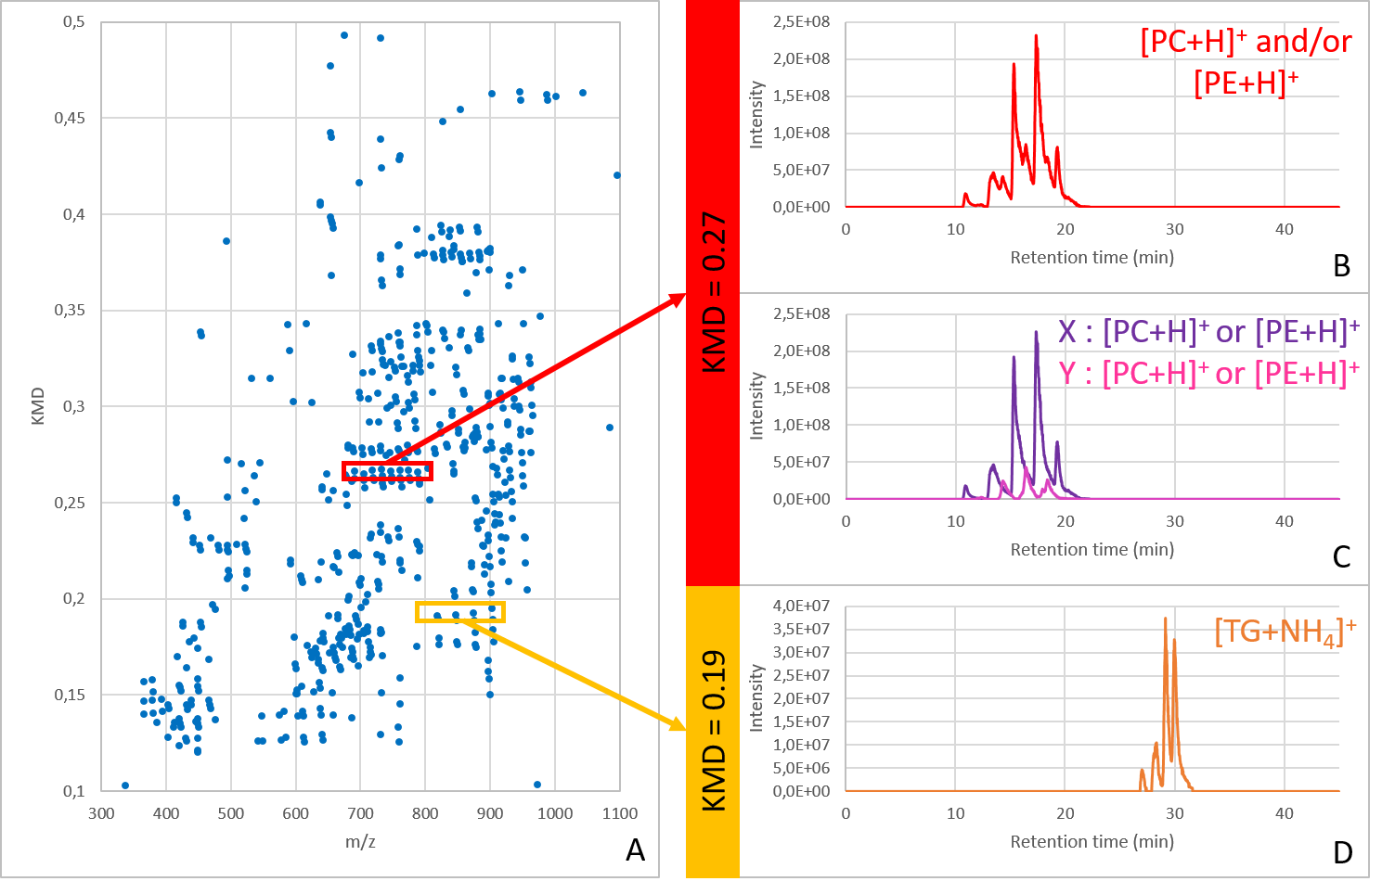

Figure 2 : Chromatogram extraction from the Kendrick plot. (A) Kendrick mass defect plot of the spectra obtained by LC-MS. By selecting a specific horizontal line in the Kendrick plot, it is possible to filter the Kendrick plot and provide the extracted ions chromatogram of this selection box. (B) Chromatogram from a specific line of protonated phosphatidylcholines (PC) and/or phosphatidylethanolamines (PE) which are isomers. (C) Extraction of chromatogram B allow us to separate two series of PC and/or PE. (D) Chromatogram from a specific line of triglycerides (TG detected as ammonium adducts). The retention time is different from the PC and PE one due to the size of the lipids.

Looking at the extracted chromatogram (Figure 2B) from the red selection box in Figure 2A, we observe that two different sets of lipids are present according to the chromatogram profile. Using the LIPID MAPS structure database, the *m/z* and KMD correspond to PC and/or PE which can be isomers. Grouping these lipids based on mass difference, using -C2H4- unit (equivalent to two -CH2-) leads to two sub-sets, depicted as X and Y. The chromatograms of X and Y are reported in purple and pink, respectively in Figure 2C. Four hypothesis, summarized in Table 2, can be made for the identification of these two lipid series.

|  |  |  |
| --- | --- | --- |
|  | X (Purple chromatogram) | Y (Pink chromatogram) |
| Hypothesis 1 | PC with even number of carbon atoms | PE with even number of carbon atoms |
| Hypothesis 2 | PC with even number of carbon atoms | PC with odd number of carbon atoms |
| Hypothesis 3 | PE with odd number of carbon atoms | PC with odd number of carbon atoms |
| Hypothesis 4 | PE with odd number of carbon atoms | PE with even number of carbon atoms |

Table 2 : 4 hypotheses for lipids identification of the pink and purple chromatogram from Figure 2C.

Lipids from sub-set X are more abundant than lipids from sub-set Y when looking at the relative intensities. Since it is known that lipids with an even number of carbon atoms in the acyl chains are more abundant than lipids with an odd number of carbon atoms11, assumptions 1 and 2 are the more likely. An MS/MS analysis alternating MS and MS/MS scans could be considered to unequivocally identify these lipids. The identification of a single lipid will be sufficient to identify all the lipids from the same sub-set. Figure 2D is the chromatogram from a specific line of triglycerides (TG detected as ammonium adducts). The retention time is different from the PC and PE due to the size of the lipids.

The Kendrick plot can also be built from the chromatogram or a section of the chromatogram, as pointed in Figure 3A. From the summed retention times from 26 to 32 minutes (Figure 3A), the corresponding Kendrick plot was generated (Figure 3B). The signals of the selected retention times are highlighted in different colors while the signals corresponding to the rest of the chromatogram appear in grey. This provides a cleaned KMD plot based on the retention time. It also allows to detect lipids without the need to explore the retention times. This can be useful in case of low intensity signals.

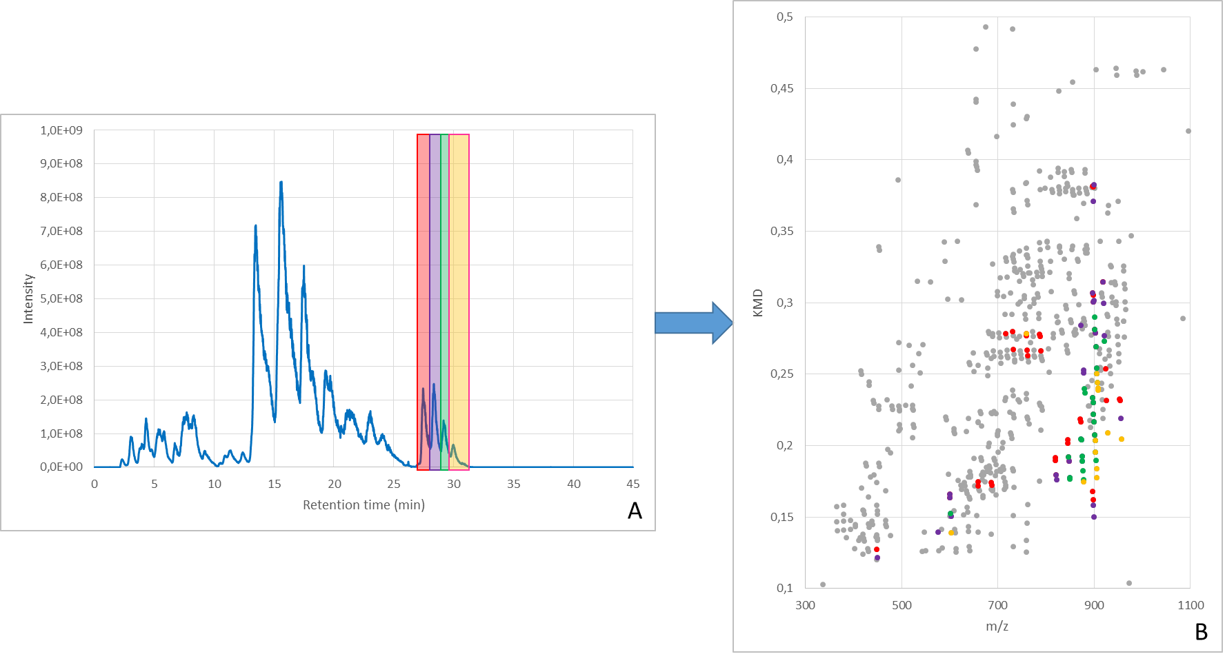

Figure 3 : Kendrick plot extraction from 26 to 32 minutes in the LC-MS chromatogram data of yeast lipid extract. (A) Full chromatogram of the spectra obtained by LC-MS. By selecting 4 different retention time ranges (in red, purple, green and yellow). (B) Kendrick plot reconstruction from the 4 different retention time ranges. (red : 27-28 min, purple : 28-29 min, green : 29-29.8 min and yellow : 29.8-31.1 min).

The software is built to allow the same approach to analyse data from other separation techniques such as ion mobility or capillary electrophoresis.

***Direct infusion MS and LC-MS KMD comparison***

To enable faster screening of lipids, direct infusion mass spectrometry appears to be a valuable option, especially using ultra high-resolution spectrometers. Indeed, Fourier transform mass spectrometry gives access to accurate mass and isotopic signature, allowing the determination of the elemental composition of low molecular weight molecules. The main advantages of direct infusion over LC-MS are a faster acquisition time and a minimal sample preparation apart from extraction.

Direct infusion also has drawbacks. On the one hand, there is no preconcentration step of the analytes. The detection limit is consequently higher and minor components may be lost. On the other hand, ion suppression effect is increased during direct infusion compared to LC, due to the increased coverage of the droplets surface by the matrix and the competition for the charge51. The simultaneous injections of many compounds increase the risk of interferences. In the absence of desalting, signals coming from different cation adducts generate more complex spectra. This drawback can be overcome by combining all the lipid series of the cation adducts to a unique series, aligned with the protonated lipid series. This results in a clean KMD plot. For the comparison between direct infusion MS and LC-MS Kendrick plots, a lipid extract from yeast was analysed using RP-UPLC-ESI-FT-ICR (LC-MS) and nESI-FT-ICR (direct infusion). Both analyses have been performed in triplicates. The KMD plots related to these experiments are provided in Figure SI1 and Figure SI2Figure. Most of the peaks are present in each plot even if few differences appear for the minor peaks which are sometimes suppressed by the threshold. Note that isotope contribution (mainly of 13C) and cation adducts are also part of these Kendrick plots (*i.e.* no cleaning of the KMD plot).

The differences and similarities of lipid detection between the two methods have been highlighted by extracting common and different signals between their generated KMD plots. In this case, the clustering by cation adducts was not performed to consider cation adducts in this comparative study. The result at the lipid category level is reported in Figure 4A.

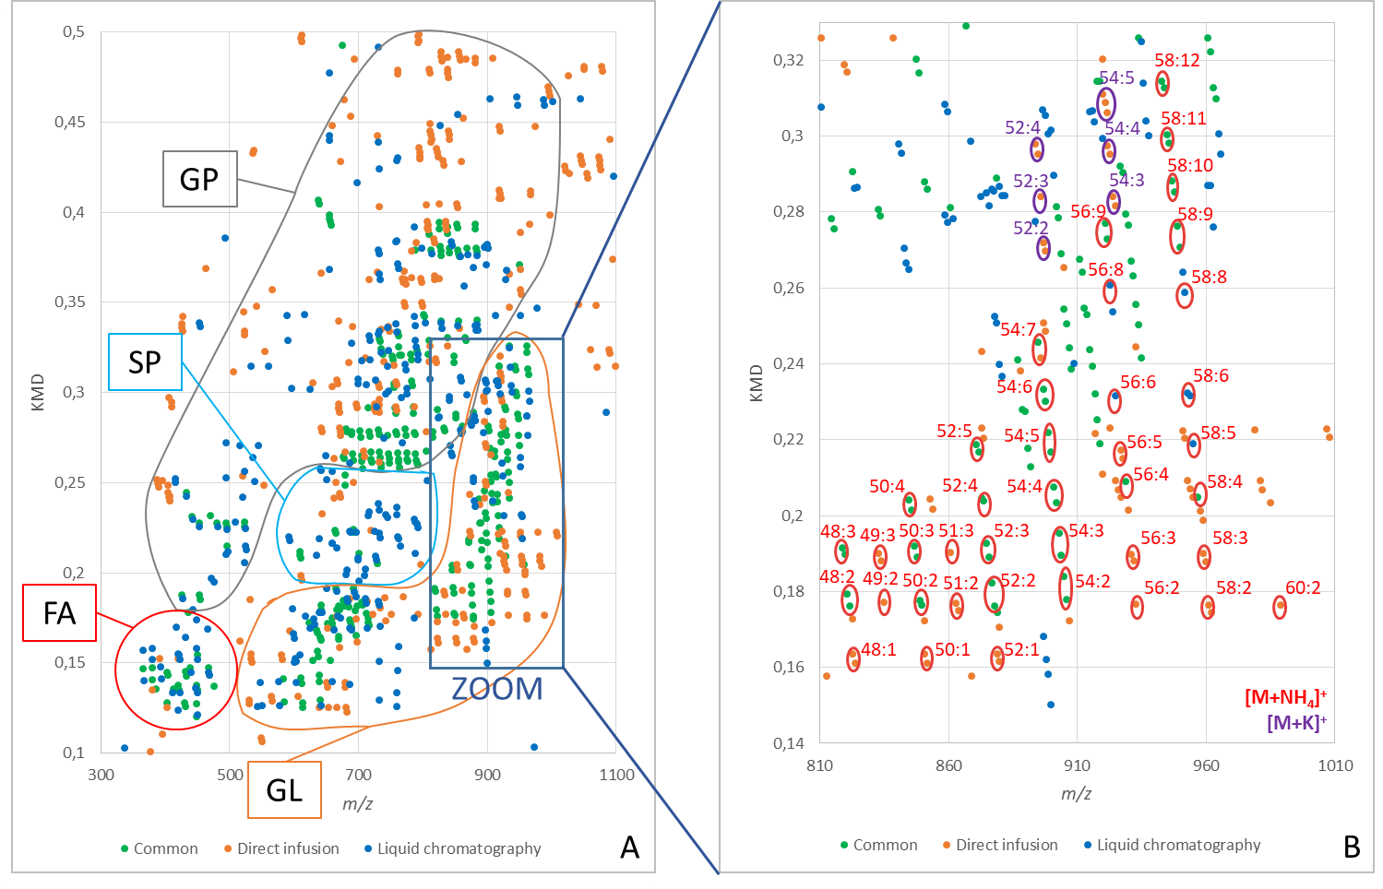

Figure 4 : (A) Comparison by the Kendrick plots of the yeast sample analysed by nESI-FT-ICR and RP-UPLC-ESI-FT-ICR. The area containing the fatty acyls (FA) is circled in red, the glycerolipids (GL) in orange, the sphingolipids (SP) in blue and the glycerophospholipids (GP) in grey. (B) Deep triglycerides comparison.

Lipid category identification was performed from the lipid KMD reference plot (Figure 1) considering H+, Na+, K+ and NH4+ as potential adducts. The Figure 4A shows that the same categories of lipids can be found in direct infusion and LC-MS. The four categories of lipids detected in positive mode for *Saccharomyces cerevisiae* lipid extract are: fatty acyls (FA), glycerolipids (GL) containing mainly diglycerides (DG) and triglycerides (TG) classes, sphingolipids (SP) containing mainly sphingomyelins (SM) and ceramides (Cer) classes, and glycerophospholipids (GP) containing predominantly phosphatidylcholines (PC), phosphatidylethanolamines (PE) and some phosphatidylglycerols (PG) and phosphatidylinositols (PI) classes. These categories (FA, GL, SP and GP from Table 1) are detected with the two methods, but not under the same adducts.

The KMD plots additionally allow the individual lipids from each structural class to be investigated. Figure 4B depicts the case of the triglycerides (TG) class which is part of the glycerolipids category. As we can see on Figure 4B, many triglycerides are detected by the two approaches. In direct infusion, different cation adducts are detected, mainly ammonium and potassium adducts (circled in red and purple respectively) while these species are only detected with ammonium adducts in LC-MS. This can be explained by the desalting provided by the reverse phase LC separation and the presence of ammonium in the mobile phase.

Moreover, some short acyl chain triglycerides are only detected by direct infusion. One hypothesis is that these lipids are below the signal threshold applied in LC-MS (corresponding to the noise level). On the contrary, the triglycerides detected specifically by LC-MS correspond to the ones of lower abundances, which could be explained by ion suppression effect, indeed more present and restrictive in direct infusion than in LC-MS. Even if all the lipids can be subjected to ion suppression, the least intense ones appear more impacted than the other ones in direct infusion. Specific TG from direct infusion and LC-MS are summarized in the Table 3.

|  |  |
| --- | --- |
| ***Triglycerides specific to direct infusion*** | ***Triglycerides specific to LC-MS*** |
| Potassium adducts TG | TG of lower abundance |
| Short acyl chain TG |  |

Table 3 : Specific triglycerides (TG) detected by direct infusion (left) and LC-MS (right).

Lipid identification was performed using LIPID MAPS database, considering H+, Na+, K+ and NH4+ as potential adducts. The unidentified points in Figure 4B correspond to masses that do not match the lipids present in the database.

According to the results, direct infusion combined with KMD analysis can detect all the different classes of lipids. As direct infusion is very fast compared to LC-MS, it appears to be a powerful tool for rapid profiling and high throughput screening. LC-MS which allows to highlight the presence of lipids of lower abundance will be more suitable for targeted analysis.

***Cancer cell lines lipid extracts comparison using differential Kendrick plot analysis***

Direct infusion has been demonstrated to be a credible challenger to classical LC-MS for qualitative lipid profiling. To illustrate this, the method has been applied to a real case: the comparison of the lipid content of prostate cancer cell lines and the same cells treated with a DGAT2 inhibitor. DGAT2 enzymes are involved in triglycerides synthesis which in turn are transformed into diglycerides under the action of the adipose-tissue triglyceride lipase (Figure 5)52. The introduction of an inhibitor of the DGAT2 enzyme is expected to strongly affect the relative abundance of triglycerides and diglycerides lipids. In this case, an on/off detection of the concerned lipids families is expected.

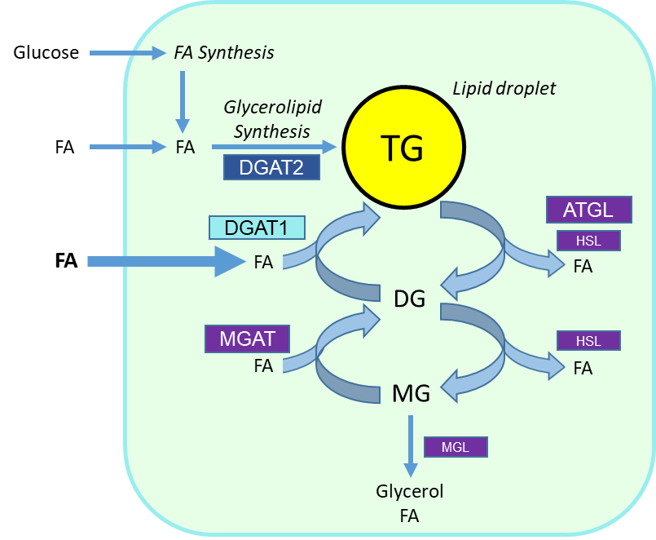

Figure 5 : Intracellular role of DGAT2. DGAT2 is an enzyme involved in the triglycerides synthesis and which are themselves transformed in diglycerides with the action of the adipose-tissue triglyceride lipase52.

The comparison of the Kendrick plots from the control sample and the treated sample is shown in Figure 6.

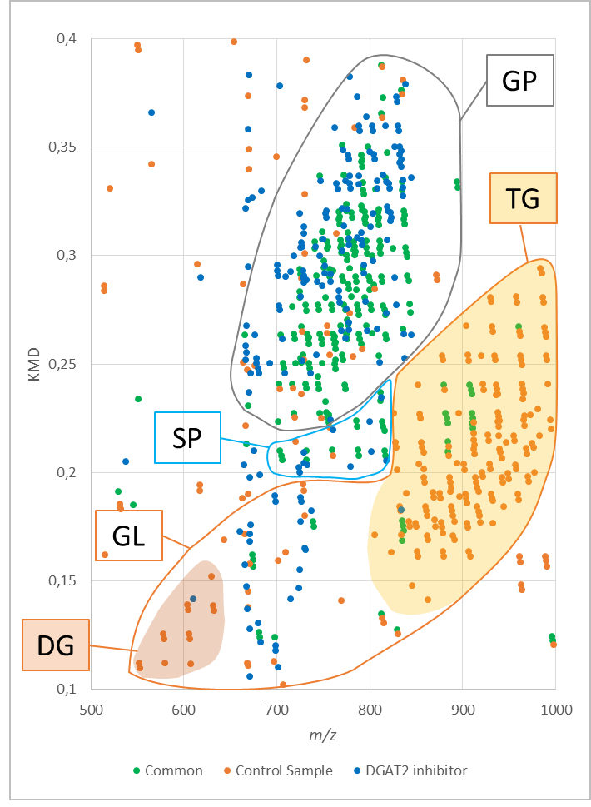

Figure 6 : Comparison of the Kendrick plot of the control lipids extracted from prostate cancer cell line and the prostate cancer cell line treated with DGAT2 inhibitor analysed by nESI-FT-ICR. The area containing lipids from the glycerolipid (GL) category in orange, from the sphingolipid (SP) category in blue and from the glycerophospholipids (GP) category in grey. In the glycerolipids category, triglycerides (TG) are coloured in yellow and diglycerides (DG) in brown.

As expected, the Kendrick plot easily showed that triglycerides (in yellow) and diglycerides (in brown) are only present in the control sample and are almost absent in the sample treated with DGAT2 inhibitor. Blue dots appearing only in the DGAT2 inhibitor sample, and especially in the GL area, have not been identified based on LIPID MAPS database. Moreover, as these signals do not show any alignment in the Kendrick 2D map, they are much probably not belonging to any lipid family and were not consequently taken into account for the study. This result confirms that KMD plot comparison (similitudes and/or differences) can be considered for rapid lipid profiling of biologically relevant samples emphasize (cell lines, biological fluids, laser micro dissected samples from biopsies…). Other applications are currently under development for first line screening in the field of food safety, food authentication, and environmental analysis. In these areas, a rapid qualitative screening method is also very important.

**Conclusions and perspectives**

Kendrick’s plots have proven to be very effective in detecting lipid categories and classes, including low intensity member in direct infusion mode, giving access to a fast screening and comparison method. It has also proven useful to produce, in UPLC, lipids class specific extracted ions chromatogram allowing the determination of the retention times of all the members of the same series, even hidden in the background noise. For every single point on the Kendrick plot, the linked Information is, for LC separation, the retention time and the absolute or relative ion intensities. If coupled to IMS, mobility or derived CCS can be added.

The concept of KMD plot comparison have been developed to rapidly highlight lipid signal similarities and differences between lipidomics MS datasets. This strategy has been applied to compare the performance of reverse phase LC-MS and direct infusion MS for lipidomics. From this study, at least one lipid of each class detected in LC-MS has also been detected in direct infusion. However, LC-MS is more suitable for the detection of low abundance lipids, not detected in direct infusion. Direct infusion MS combined with KMD analysis is a very fast method that is well suited for rapid qualitative profiling and high-throughput screening of lipid extracts in a non-targeted manner. Liquid chromatography is more suitable for targeted analysis of the low-abundance lipids from suspect samples.

As a proof of concept, the Kendrick plots of two cell cultures were constructed based on direct infusion results. It demonstrates the potential applications of differential KMD plots in the biomedical field. The applications can be extended to other fields of analytical chemistry such as food safety, which are currently under development.

The most efficient strategy to monitor quantitatively the changes of distribution of lipids (using the intensity that can be extracted from Kendrick plots) between families in non-targeted mode is being investigated.

**Acknowledgments**

We thank the Interreg EMR project EURLIPIDS (R-8598) for financial support.

We acknowledge Lipometrix, the KU Leuven lipidomics core who cultured the cells and performed the lipid extraction on those.

Thank you to the FEDER BIOMED HUB Technology Support (number 2.2.1/996) and the European Community’s Horizon 2020 Program (INFRAIA-02-2017, under Grant Agreement No.731077) for the funding the development of imaging on the SolariX XR 9.4T FT-ICR.

Finally, we acknowledge the company Johnson & Johnson (Janssen) for the donation of the LTQ FT Ultra 7T instrument.

**References**

(1) Breiding, M. *Trends Biochem. Sci*. **2014**, *63* (8), 1–18.

(2) Gross, R. W.; Han, X. *Chem. Biol.* **2011**, *18* (3), 284–291.

(3) Shevchenko, A.; Simons, K. *Nat. Rev. Mol. Cell Biol.* **2010**, *11* (8), 593–598.

(4) Zhao, Y. Y.; Vaziri, N. D.; Lin, R. C. *Adv. Clin. Chem.* **2015**; 153–175.

(5) Röhrig, F.; Schulze, A. *Nat. Rev. Cancer* **2016**, *16* (11), 732–749.

(6) Wang, J.; Han, X. *Trends Anal. Chem.* **2019**, *121*, 115697.

(7) Han, X. *Nat Rev Endocrinol* **2016**, *12*, 668–679.

(8) Van Meer, G.; Voelker, D.; Feigenson, G. *Nat. Rev. Mol. Cell Biol.* **2008**, *9*, 112–124.

(9) Sato, H.; Takahashi, N.; Sato, E.; Kisu, K.; Ito, S.; Saito, T. *Clin. Exp. Nephrol.* **2014**, *18* (2), 194–196.

(10) Muro, E.; Ekin Atilla-Gokcumen, G.; Eggert, U. S. *Mol. Biol. Cell* **2014**, *25* (12), 1819–1823.

(11) Bou Khalil, M.; Hou, W.; Zhou, H.; Elisma, F.; Swayne, L.; P. Blanchard, A.; Yao, Z.; A.L. Bennett, S.; Figeys, D. *Mass Spectrom. Rev.* **2010**, *29*, 877–929.

(12) Fahy, E.; Subramaniam, S.; Murphy, R. C.; Nishijima, M.; Raetz, C. R. H.; Shimizu, T.; Spener, F.; Van Meer, G.; Wakelam, M. J. O.; Dennis, E. A. *J. Lipid Res.* **2009**, *50* (SUPPL.), 9–14.

(13) Sud, M.; Fahy, E.; Cotter, D.; Brown, A.; Dennis, E. A.; Glass, C. K.; Merrill, A. H.; Murphy, R. C.; Raetz, C. R. H.; Russell, D. W.; Subramaniam, S. *Nucleic Acids Res.* **2007**, *35* (SUPPL. 1), 527–532.

(14) Haler, J. R. N.; Sisley, E. K.; Cintron-Diaz, Y. L.; Meitei, S. N.; Cooper, H. J.; Fernandez-Lima, F. *Anal. Methods* **2019**, *11* (18), 2385–2395.

(15) Köfeler, H. C.; Fauland, A.; Rechberger, G. N.; Trötzmüller, M. *Metabolites* **2012**, *2* (1), 19–38.

(16) Han, X.; Gross, R. W. *J. Lipid Res.* **2003**, *44* (6), 1071–1079.

(17) Han, X. *Anal. Biochem.* **2002**, *302* (2), 199–212.

(18) Han, X.; Gross, R. W. *Anal. Biochem.* **2001**, *295* (1), 88–100.

(19) Han, X.; Gross, R. W. *Mass Spectrom. Rev.* **2005**, *24* (3), 367–412.

(20) Han, X.; Yang, J.; Cheng, H.; Ye, H.; Gross, R. W. *Anal. Biochem.* **2004**, *330* (2), 317–331.

(21) Han, X.; Gross, R. W. *Proc. Natl. Acad. Sci. U. S. A.* **1994**, *91* (22), 10635–10639.

(22) Xianlin, H.; Richard W., G. *J. Am. Soc. Mass Spectrom.* **1995**, *6* (95), 1202–1210.

(23) Han, X.; Gross, R. W. *J. Am. Soc. Mass Spectrom.* **1996**, *118* (2), 451–457.

(24) Hsu, F. F.; Turk, J. *J. Chromatogr. B* **2009**, *877* (26), 2673–2695.

(25) Froning, M.; Helmer, P. O.; Hayen, H. *Rapid Commun. Mass Spectrom.* **2020**, *34* (21), 1–9.

(26) Sun, C.; Zhao, Y. Y.; Curtis, J. M. *Anal. Chem. Acta* **2013**, *762*, 68–75.

(27) Harris, R. A.; May, J. C.; Stinson, C. A.; Xia, Y.; McLean, J. A. *Anal. Chem.* **2018**, *90* (3), 1915–1924.

(28) Poad, B. L. J.; Zheng, X.; Mitchell, T. W.; Smith, R. D.; Baker, E. S.; Blanksby, S. J. *Anal. Chem.* **2018**, *90* (2), 1292–1300.

(29) Kyle, J. E.; Zhang, X.; Weitz, K. K.; Monroe, M. E.; Ibrahim, Y. M.; Moore, R. J.; Cha, J.; Sun, X.; Lovelace, E. S.; Wagoner, J.; Polyak, S. J.; Metz, T. O.; Dey, S. K.; Smith, R. D.; Burnum-Johnson, K. E.; Baker, E. S. *Analyst* **2016**, *141* (5), 1649–1659.

(30) Kilman, M.; May, J. C.; McLean, J. A. *Biochim. Biophys. Acta* **2011**, *1811* (11), 935–945.

(31) Hu, Ting ; Zhang, J.-L. *J. Sep. Sci.* **2018**, *41* (1), 351–372.

(32) Vasilopoulou, C. G.; Sulek, K.; Brunner, A. D.; Meitei, N. S.; Schweiger-Hufnagel, U.; Meyer, S. W.; Barsch, A.; Mann, M.; Meier, F. *Nat. Commun.* **2020**, *11* (1), 1–11.

(33) Cajka, T.; Fiehn, O. *Trends Anal. Chem.* **2014**, *61*, 192–206.

(34) Paglia, G.; Angel, P.; Williams, J. P.; Richardson, K.; Olivos, H. J.; Thompson, J. W.; Menikarachchi, L.; Lai, S.; Walsh, C.; Moseley, A.; Plumb, R. S.; Grant, D. F.; Palsson, B. O.; Langridge, J.; Geromanos, S.; Astarita, G. *Anal. Chem.* **2015**, *87* (2), 1137–1144.

(35) Groess, M. ; Graf, S. ; Knochenmuss, R. *Analyst* **2021**, *140* (20), 6904–6911.

(36) Kyle, J. E.; Zhang, X.; Weitz, K. K.; Monroe, M. E.; Ibrahim, Y. M.; Moore, R. J.; Cha, J.; Sun, X.; Lovelace, E. S.; Wagoner, J.; Polyak, S. J.; Metz, T. O.; Dey, S. K.; Smith, R. D.; Kristin, E. *Analyst* **2017**, *141* (5), 1649–1659.

(37) Lerno, L. A.; German, J. B.; Lebrilla, C. B. *Anal. Chem.* **2010**, *82* (10), 4236–4245.

(38) Korf, A.; Vosse, C.; Schmid, R.; Helmer, P. O.; Jeck, V.; Hayen, H. *Rapid Commun. Mass Spectrom.***2018**, pp 981–991.

(39) Kune, C.; McCann, A.; Raphaël, L. R.; Arias, A. A.; Tiquet, M.; Van Kruining, D.; Martinez, P. M.; Ongena, M.; Eppe, G.; Quinton, L.; Far, J.; De Pauw, E. *Anal. Chem.* **2019**, *91* (20), 13112–13118.

(40) Matyash, V.; Liebisch, G.; Kurzchalia, T. V.; Shevchenko, A.; Schwudke, D. *J. Lipid Res.* **2008**, *49* (5), 1137–1146.

(41) Eggers, L. F.; Schwudke, D. Wenk, M. R., Ed.; Springer Netherlands: Dordrecht, **2016**; 1–3.

(42) Mohammad, K.; Jiang, H.; Hossain, M. I.; Titorenko, V. I. *J. Visualized Exp.* **2020**, *2020* (157).

(43) Chambers, M. C.; MacLean, B.; Burke, R. *Nat Biotechnol.* **2017**, *30* (10), 1.

(44) Müller, W. H.; Verdin, A.; Kune, C.; Far, J.; De Pauw, E.; Malherbe, C.; Eppe, G. *Anal Bioanal Chem.* **2021**, *413* (10), 2821–2830.

(45) McCann, A.; Rappe, S.; La Rocca, R.; Tiquet, M.; Quinton, L.; Eppe, G.; Far, J.; De Pauw, E.; Kune, C. *Anal Bioanal Chem.* **2021**, pp 2831–2844.

(46) Liebisch, G.; Vizcaíno, J. A.; Köfeler, H.; Trötzmüller, M.; Griffiths, W. J.; Schmitz, G.; Spener, F.; Wakelam, M. J. O. *J. Lipid Res.* **2013**, *54* (6), 1523–1530.

(47) Dembitsky, V. M.; Srebnik, M. *Prog. Lipid Res.* **2002**, *41* (4), 315–367.

(48) Peterson, B. L.; Cummings, B. S. *Biomed. Chromatogr.* **2006**, *20* (3), 227–243.

(49) Cai, X.; Li, R. *Sci. Rep.* **2016**, *6* (October), 1–10.

(50) Spagou, K.; Tsoukali, H.; Raikos, N.; Gika H.; Wilson, I. D.; Theodoridis, G. *J. Sep. Sci.* **2010**, *33*, 716–727.

(51) Furey, A.; Moriarty, M.; Bane, V.; Kinsella, B.; Lehane, M. *Talanta* **2013**, *115*, 104–122.

(52) Yen, C. L. E.; Stone, S. J.; Koliwad, S.; Harris, C.; Farese, R. V. *J. Lipid Res.* **2008**, *49* (11), 2283–2301.

**SUPPORTING INFORMATION**

**Differential Kendrick’s plots as an innovative tool for lipidomics in complex samples: comparison of liquid chromatography and infusion-based methods to sample differential study**

Justine Hustin1, Christopher Kune1, Johann Far1, Gauthier Eppe1, Delphine Debois2,

Loïc Quinton1* & Edwin De Pauw1

1 Mass Spectrometry Laboratory, MolSys Research Unit, Department of Chemistry, University of Liège,

Allée du Six Août 11 – Quartier Agora, 4000 Liège, Belgium

2 ZenTech S.A., Avenue du Pré Aily 10, 4031 Liège, Belgique

*Corresponding Author Email: loic.quinton@uliege.be

**Supporting information Associated content**

|  |  |
| --- | --- |
| **Contents** | **Page No.** |
| **Figure SI1 :** Kendrick plots of the yeast lipid extract (Matyash method) done in triplicate on the summed mass spectra acquired by RP-UPLC-ESI-FT-ICR after background removal | **S-2** |
| **Figure SI2 :** Kendrick plots of the yeast lipid extract (Matyash method) done in triplicate by nESI-FT-ICR after background removal | **S-3** |

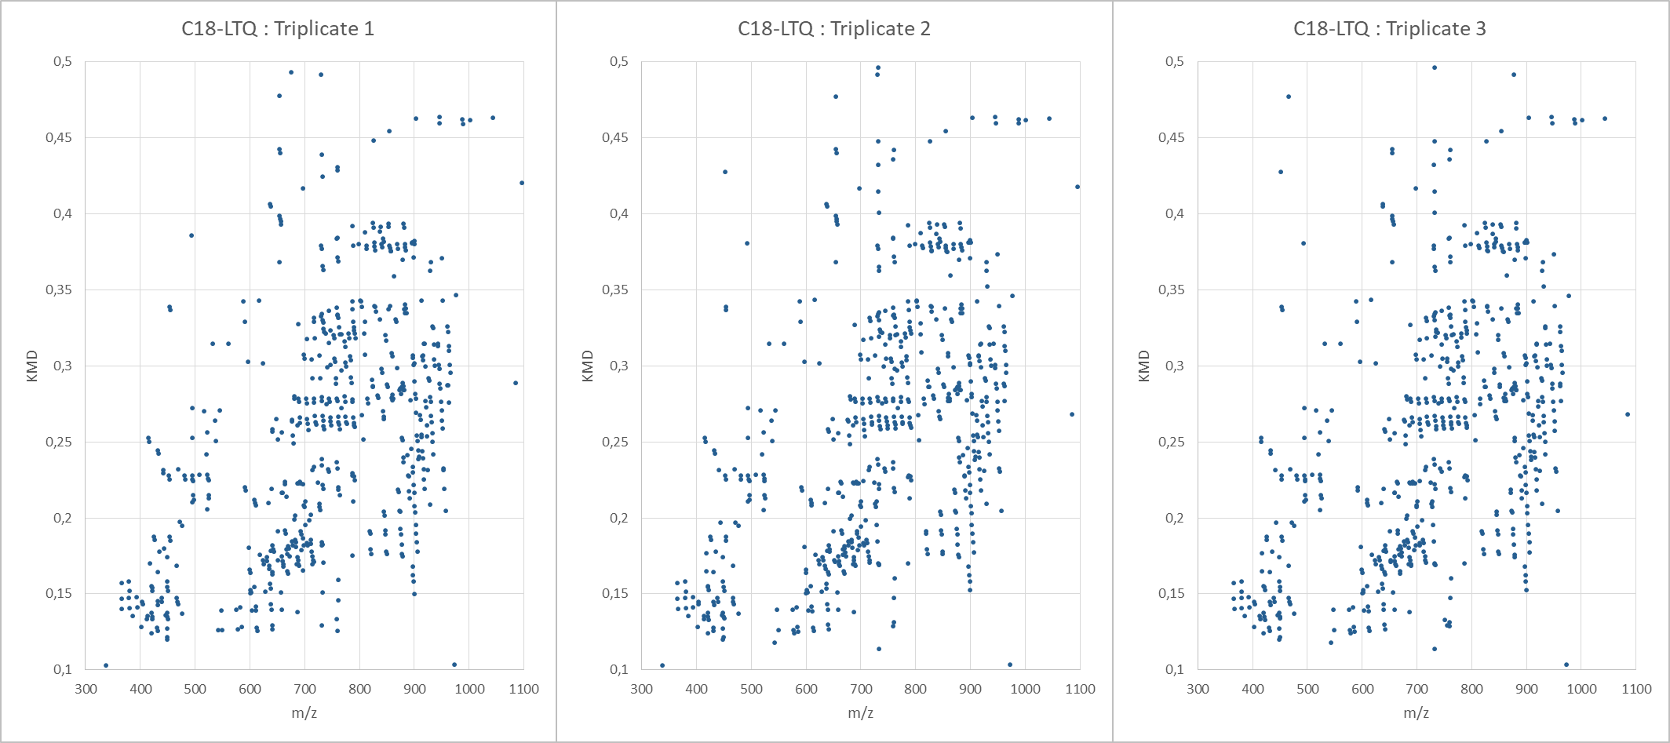

Figure SI1 : Kendrick plots of the yeast lipid extract (Matyash method) done in triplicate on the summed mass spectra acquired by RP-UPLC-ESI-FT-ICR after background removal.

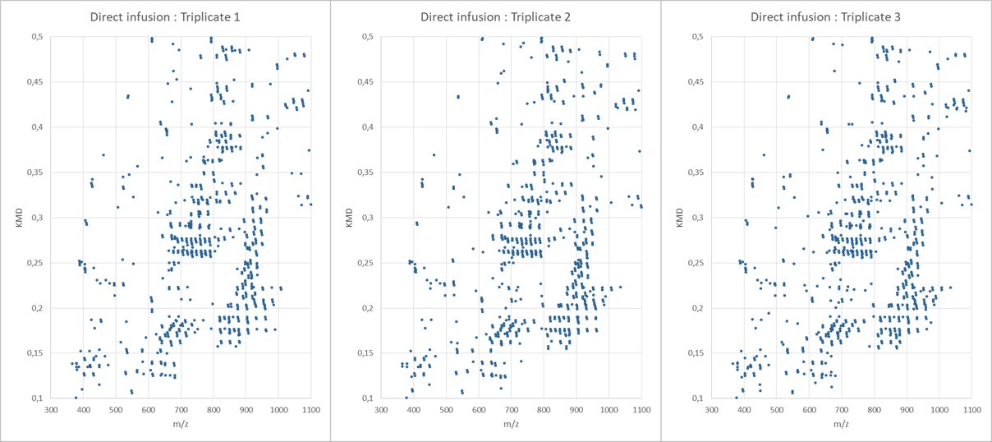

Figure SI2 : Kendrick plots of the yeast lipid extract (Matyash method) done in triplicate by nESI-FT-ICR after background removal.

**For Table of Content Use Only**

**Differential Kendrick’s plots as an innovative tool for lipidomics in complex samples: comparison of liquid chromatography and infusion-based methods to sample differential study**

Justine Hustin1, Christopher Kune1, Johann Far1, Gauthier Eppe1, Delphine Debois2,

Loïc Quinton1* & Edwin De Pauw1

1 Mass Spectrometry Laboratory, MolSys Research Unit, Department of Chemistry, University of Liège,

Allée du Six Août 11 – Quartier Agora, 4000 Liège, Belgium

2 ZenTech S.A., Avenue du Pré Aily 10, 4031 Liège, Belgique

*Corresponding Author Email: loic.quinton@uliege.be

