**The proof of the pudding is in the eating\***

[Jean-Marie Choffray](https://www.amazon.com/kindle-dbs/entity/author/B00DNUGN64?_encoding=UTF8&node=283155&offset=0&pageSize=12&searchAlias=stripbooks&sort=author-sidecar-rank&page=1&langFilter=default#formatSelectorHeader)**

Liège, February 3, 2023.

**Abstract**. MicroStrategy (Nasdaq: MSTR) is the only listed company I know of that has a Levered Long Bitcoin Hybrid Strategy. Its main goal is to grow its enterprise analytics business and acquire and hold bitcoin as a treasury reserve for the long term. The company is also in the initial stage of exploring innovative Lightning applications for cybersecurity to help customers monetize websites and deploy wallets in mass using Bitcoin. Since MicroStrategy adopted its bitcoin strategy, its stock has outperformed all of the major asset classes that it benchmarks against. It has outperformed most big tech stocks and enterprise software stocks too. Will its performance last? It’s anyone’s guess! But, some of the observations made by Management during the Q4 2022 earnings call, are worth sharing.

* The information contained in this paper is for informational purposes only. It is not to be construed as an offer to buy or sell any financial assets or securities.

** Emeritus Professor of Management Science at the University of Liège, Belgium.

PhD-77, Massachusetts Institute of Technology.

*Bitcoin is, right now, the only universally acknowledged digital commodity.*

*Fair value accounting is going to be a big plus for corporate adoption*

*since the volatility created by indefinite intangible accounting*

*is a negative for CFOs.*

Michael Saylor

**The proof of the pudding is in the eating**

Excerpts from **:** [MicroStrategy (MSTR) Q4 2022 Earnings Call Transcript](https://finance.yahoo.com/m/b1d55030-8268-3ed9-af2f-10dc7e46ff6e/microstrategy-mstr-q4-2022.html)

MicroStrategy (Nasdaq: MSTR) is a publicly-traded Business Intelligence company. Its vision is to enable Intelligence Everywhere. It provides modern analytics on an open, comprehensive enterprise platform. Optimized for cloud, its software features HyperIntelligence, a technology that overlays actionable enterprise data to help users make smarter, faster decisions. Its consultants support, innovate and modernize its platform across its customer base.

MicroStrategy's core strategy is to grow its enterprise analytics business and to acquire and hold bitcoin as a treasury reserve for the long-term. This Hybrid Strategy represents a paradigm shift where a company seeks to maximize the performance of both segments of its business, while identifying and capitalizing on the synergies that come from combining a mature and profitable enterprise software business with a large-scale digital asset holding.

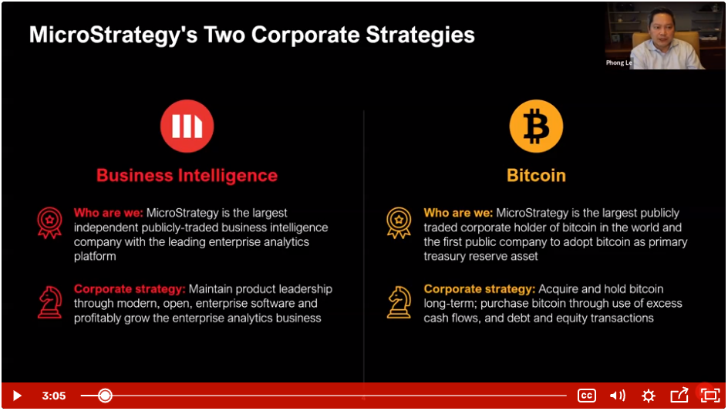

(Source: [MSTR Q4 2022 Financial Results](https://www.microstrategy.com/en/investor-relations/events-presentations/q4-2022-financial-results-webinar-recording), February 2, 2023)

***Phong Le -- President and Chief Executive Officer***

“Our bitcoin acquisition strategy is a balance sheet strategy. As of today, we're the largest publicly traded corporate holder of bitcoin in the world. We're the first public company to adopt bitcoin as a primary treasury reserve asset. Our strategy is to acquire and hold bitcoin for the long term.”

“As of December 31st, 2022, we held a total of 132,500 bitcoins acquired at an aggregate cost of $4 billion, or average cost of approximately $30,100 per bitcoin.”

“Since the adoption of our bitcoin acquisition strategy, we've taken a simple approach from day one, which is to buy and hold bitcoin.”

“We've taken steps along the way to minimize risk, particularly with counterparties. We buy only bitcoin in U.S. based markets. We custody bitcoin with institutional grade, U.S.-based regulated custodians and cold storage, and we have not lended our bitcoin to third parties for yield or any other purposes.”

“On the bitcoin innovation side, I'm delighted to share a preview of MicroStrategy Lighting, our new product that we are developing, which utilizes the Lightning Network, a second layer network that sits atop the bitcoin network. We envision MicroStrategy Lightning as an enterprise platform designed to leverage the power of the bitcoin Lightning Network to enable new e-commerce use cases and tackle modern cybersecurity challenges.”

“The first component of MicroStrategy Lightning platform is Lightning Rewards. Lightning Rewards is intended to allow any enterprise to reward their employees, customers, partners, and prospects for their engagement.”

“We expect that Lightning Platform will provide opportunities for new business models to monetize online content or minimize threats and the nuisance of bots and other malicious actors.”

***Andrew Kang --*** *Senior Executive Vice President and Chief Financial Officer*

“The price of bitcoin fell to a low of approximately $15,460 during the quarter, which drove the additional impairment toward bitcoin holdings under the current accounting rules. Non-GAAP cost of revenues were $26 million in the fourth quarter, an increase of $2.5 million or 11% year over year.”

“Since the adoption of our bitcoin strategy in Q3 of 2020, the digital asset impairment charges we have incurred each quarter have always been greater than our non-GAAP operating loss, showing the significant impact it has had on our reported income..”

“As of December 31st, 2022, we held a total 132,500 bitcoins, of which 14,890 bitcoins were held directly by MicroStrategy, the parent, with the remaining 117,610 bitcoins held at the MacroStrategy subsidiary.

“To touch on the regulatory perspective, we continue to be optimistic with the progress that the [Financial Accounting Standards Board](https://www.fasb.org/Page/ProjectPage?metadata=fasb-Accounting-for-and-Disclosure-of-Crypto-Assets) has made and its steps to [update how companies measure certain digital assets](https://www.wsj.com/articles/standards-setter-floats-new-rule-on-crypto-accounting-11675267296?tpl=cb?bingParse), including bitcoin on balance sheets. Since announcing this as an agenda item last year, the FASB has moved expeditiously and voted and agreed on how crypto assets should be presented in financial statements and what disclosures should be required under expected fair value accounting standards.”

***Michael Saylor*** *-- Executive Chairman*

“It was on August 11th of 2020 that we announced to the world that we had acquired $250 million worth of bitcoin, along with a tender offer. At that -- on the day before, our stock was about $121 to $122 a share. Today, the stock closed at $292 a share. So, of course, we measure our success based upon the creation of shareholder value.”

“Nobody that talks about bitcoin actually points out that despite its volatility, it is the No. 1 performing asset over the past two and a half years. So, we can see bitcoin is up 98% versus August 10th, 2020.”

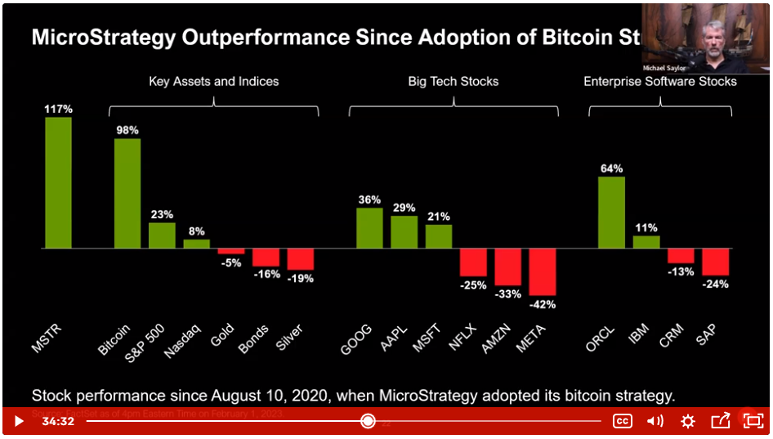

(Source: [MSTR Q4 2022 Financial Results](https://www.microstrategy.com/en/investor-relations/events-presentations/q4-2022-financial-results-webinar-recording), February 2, 2023)

“But long term, the rationalization of the crypto market will be beneficial for bitcoin. It has educated an entire generation of investors on the benefits of bitcoin as a decentralized digital commodity and the benefits of not having counterparty risk.”

“The reason that MicroStrategy was able to get through this entire crypto winter is because we weren't exposed directly to any cryptos, nor did we do business with any of the crypto exchanges. And we didn't do it for very clear reasons because we don't believe in the value proposition of unregistered securities.”

“And if there is any other result of the crypto winter, it's that we can see that everywhere in the world, regulators and the general public are enthusiastic about the promise of digital assets.”

“Bitcoin is the only universally acknowledged digital commodity. And so, if you are an investor, bitcoin is your safe haven in this regard. The others are all question marks. They're all generally unregistered securities, and they operate in a regulatory gray zone.”

“All the FASB initiatives to introduce fair value accounting for bitcoin is a very auspicious development.”

“The fact that bitcoin has managed to survive the meltdown of most of the crypto banks and crypto lenders and most of the crypto exchanges and most of the other crypto assets is a very auspicious development.”

“Lightning is really spreading rapidly, and it's being adopted by many, many, many businesses. We see dozens and dozens of Lightning start-ups being launched, lots of Lightning wallets. We see some exciting applications of Lightning.”

“We, as a company, have been very pleased with the early results of our Lightning R&D effort and MicroStrategy Lightning product development. It's quite impressive what you can do with Lightning.”

“We're going to see first dozens and then hundreds and then thousands of layer 3 applications that move bitcoin within a custodial network, like Cash App, or like a Coinbase or a Binance. And then, we're going to see all of those applications start to knit together with the layer 2 protocol, which we call Lightning. And as they adopt Lightning as their layer 2 protocol, we'll see -- there'll be massive transaction throughput on the layer 3.”

“And then, we also see people depositing and withdrawing satoshis [… 100 million satoshis (sats) = one bitcoin] on layer 2s. And then, we'll see the layer 1 will evolve to become the settlement network of the entire global digital monetary system. And that's why we decided to host a Lightning for Corporations track at MicroStrategy World coming up in May. This will be a first, to my knowledge.”

“Bitcoin is emerging as the grown-up institutional asset in the Digital Ecosystem, and Lightning is emerging as the Universal Language for moving money over IP.”