Molecular genetic characterization of Congolese patients with oculocutaneous albinism
Laetitia Mpola Mavinga^{a, c}*, Veronique Kakiese^{b}, Mamy Ngole^{c}, Cathy Songo^{c}, Aime Lumakaa^{c,d}, Valerie Race^{e}, Prosper Tshilobo Lukusaa^{c, e}, Koenraad Devriendt^{e}
ª Department of Pediatrics, Faculty of Medicine, University of Kinshasa, Democratic Republic of the Congo, The
^{b} Department of Dermatology, Faculty of Medicine, University of Kinshasa, Democratic Republic of the Congo, The
^{c} Centre for Human Genetics, Faculty of Medicine, University of Kinshasa, Democratic Republic of the Congo, The
^{d} Laboratory of Human Genetics, GIGA-R, University of Liège, Belgium
^{e} Center for Human Genetics, University Hospital, KU Leuven, Belgium

* Corresponding author. Department of Pediatrics, Faculty of Medicine, University of Kinshasa, Democratic Republic of the Congo, The. E-mail addresses: mavingalaetitia@gmail.com, laetitia.mavinga@unikin.ac.cd (L.M. Mavinga).

Keywords: OCA -- Melanin -- OCA2 gene -- DRCongo

Abstract
Background: Oculocutaneous albinism (OCA) is an autosomal recessive genetic disorder associated with reduced or absent pigmentation in the skin, hair and eyes. OCA type 2 (OCA2) is the most common type in Sub-Saharan Africa, related to a recurrent 2.7 kb intragenic deletion. Genomic data from Congolese patients are lacking. We aimed to describe genetic causes of OCA2 in a cohort of Congolese persons with OCA, and explore possible genotype-phenotype correlations.
Methods: A cross sectional study was conducted from January 2015 to December 2017 in Kinshasa, Democratic Republic of Congo (DRC). 165 Congolese unrelated families with non-syndromic OCA, identified through patients’ associations, consented to participate to this study. All index cases were tested for the known 2.7 kb deletion involving the exon 7 of the OCA2 gene. Patients heterozygous for the deletion underwent Sanger sequencing of all exons and flanking sequences in the OCA2 gene. Family segregation was performed for candidate pathogenic variants.
Results: The 2.7 kb deletion in the OCA2 gene was identified in 136/165 (82.4%) index cases, including 113 (68.5%) homozygotes and 23 (13.9%) heterozygotes. Sanger sequencing identified a pathogenic or likely pathogenic variant in the OCA2 gene in 12 out of 23 heterozygotes investigated (52.1%). Segregation analysis allowed us to locate the point mutation on the trans allele in the three patients from whom parental DNA was available.
Conclusion: The OCA2 2.7 kb deletion is the major cause of non-syndromic OCA in Congolese patients recruited in this study, confirming results from other Sub-Saharan African populations. Several additional mutations were detected in OCA patient’s heterozygote for the deletion, with to date no evidence for a second frequent founder mutation. The confirmation of a single mutation as the major cause will facilitate genetic counselling in this country.

1. Introduction
Oculocutaneous albinism (OCA) is a rare autosomal recessive disorder of melanin biosynthesis observed world-wide. It is more prevalent in Sub-Saharan African populations (1/2000 to 1/4000) compared to Caucasians (between 1/17,000-1/20,000) (Summers and Hand, 2019; Grønskov et al., 2007; Kamaraj and Purohit, 2014). The deficiency in melanin is responsible for reduction or absence of pigmentation in skin, hair and eyes (Ali et al., 2016). OCA is associated with significant morbidity and mortality, with serious and early vision problems and skin manifestations, including cancer (Simeonov et al., 2013a; Franklin et al., 2018).
In many Sub-Saharan African countries, people with albinism are considered as cursed or carriers of mystical power or both. Because of these misconceptions, they face discrimination, exclusion and violence. They risk being hunted and killed and their body parts being used in magic potions or witchcraft rituals. To address these inhumane attacks against persons with albinism in Africa, The United Nations Human Rights Council issued in 2017 a Regional Action Plan on Albinism.
OCA is etiologically heterogeneous, with seven non-syndromic types of albinism caused by mutations in different genes (named OCA1 to OCA7) (Wang et al., 2017). The clinical diagnosis of different types of OCA is limited because of phenotypic variation and clinical overlap between them (Hawkes et al., 2013). Of interest, the majority of cases in Sub-Saharan African (SSA) are caused by a founder mutation in the OCA2 gene (or P gene), an intragenic deletion of 2.7 kb (Krause and Seymour, 2018; Durham-Pierre et al., 1994). In the Democratic Republic of Congo (DRC), no genetic studies have been carried out. The aim of this study was to describe the contribution of OCA2 gene mutations in Congolese persons with OCA.

2. Methods

2.1. Study design and participants
A cross sectional study was conducted from January 2015 to December 2017 among 165 apparently unrelated Congolese families with OCA living in Kinshasa, the capital of DR Congo (DRC), identified through the Albinism patients’ associations. We collected clinical data including presence of freckles and visual impairment. Patients skin pigmentation was classified into one of three phototypes of skin pigmentation according to Von Luschan (Swiatoniowski et al., 2013). All individuals had the characteristic OCA2 phenotype, none presented clear evidence suggesting any of the other types of OCA.
A 5 ml blood sample was collected from each patient in an EDTA tube. Genomic DNA was extracted from lymphocytes using the « Salting Out » technique. The concentration and purity of the extracted DNA samples were evaluated by Spectrophotometry using a Nanodrop model ND 2000 (Nanodrop-Spectrophotometer Thermo Fisher Scientific). Targeted detection of the 2.7 kb deletion was done by PCR as described (Durham-Pierre et al., 1994). PCR products were separated by capillary electrophoresis on Qiaxcel (QIAGEN, Germany). In heterozygotes, all OCA2 exons were sequenced by Sanger sequencing on an 8-capillary sequencer Applied Biosystems 3500 DX (California, USA). Segregation analysis was performed for variants identified through Sanger sequencing when biological parents were available. Variants were classified following the ACMG guidelines (Richards et al., 2015). Variants positions are reported based on the OCA2 transcript NM_000275.3 according to the hg19 reference genome.

2.2. Statistical analysis
Statistical analysis was performed using Microsoft Excel 2013 and data were analyzed using SPSS for Windows version 23.0. A deviation was considered statistically significant when p < 0.05.

2.3. Compliance and ethical standards
The study was approved by the National Committee of the Public Health School of the University of Kinshasa/DRC in compliance with the principles of Helsinki Declaration (study number ESP/CE/049/2015). Written informed consent form was obtained from participants and parents of children at the recruitment.

3. Results
The 2.7 kb deletion involving exon 7 of the OCA2 gene was identified in 136 of the 165 index patients (82.4%). Fig. 1 summarizes the results from OCA2 gene analysis.
The proportions of the different genotypes were 68.5% (113/165) for the homozygous Del+/Del+, 17.6% (29/165) for the homozygous WT/ WT and 13.9% (23/165) for the heterozygous Del+/WT (Table 1).
OCA2 gene sequencing in the 23 patients heterozygous for the OCA2 2.7 kb deletion from whom DNA was available, revealed a second mutation of clinical interest in 12 of them (Table 1). In three patients in whom parental DNA was available (OCA11, OCA20 & OCA95), segregation analysis confirmed that the two mutations were in trans, thereby establishing the compound heterozygous state of the two variants. No variants of clinical relevance were found among the remaining 10 families. Due to limited resources, we had to restrict sequencing of the OCA2 gene to patients heterozygous for the deletion, since they had the highest chance of harboring an OCA2 variant. We identified 3 splicing and 1 truncating variant, classified as likely pathogenic in 9 families (Table 1): C.646+1G > T in exon 6 in three families, c.1364-1G>Ain exon 14 in three families, c.1842+2 T>C in exon 17 in one family, and c.2225dupT (p.Phe744ValfsTer17) in exon 21 in two families. Clinically significant missense variants were identified in 3 families (Table 1): c.1001C>T, (p.Ala334Val) in exon 9, c.1211C>T, (p.Thr404Met) in exon 12, and c.2360C>T, (p.Ala787Val) in exon 23.4/7 pathogenic variants were not present in ClinVar.
There was no significant association between the different genotypes (WT/WT, WT/Del and Del/Del) and different phototypes of skin color (Fig. 2) (p = 0.821), or the presence of freckles (p = 0.620). However, we observed a significant association between the presence of visual impairment and the OCA2 genotype (p = 0.043), which was due to homozygotes for the deletion presenting less frequently visual impairment compared to those heterozygous for the deletion (Table 2). The presentation of visual impairment may be age dependent, but we did not observe any difference in median age between the three genotype groups (p = 0.128), nor between the homozygous and heterozygous patients (p = 0.080).
Figure 1. Summary of results of OCA2 mutation analysis in 165 index cases with OCA
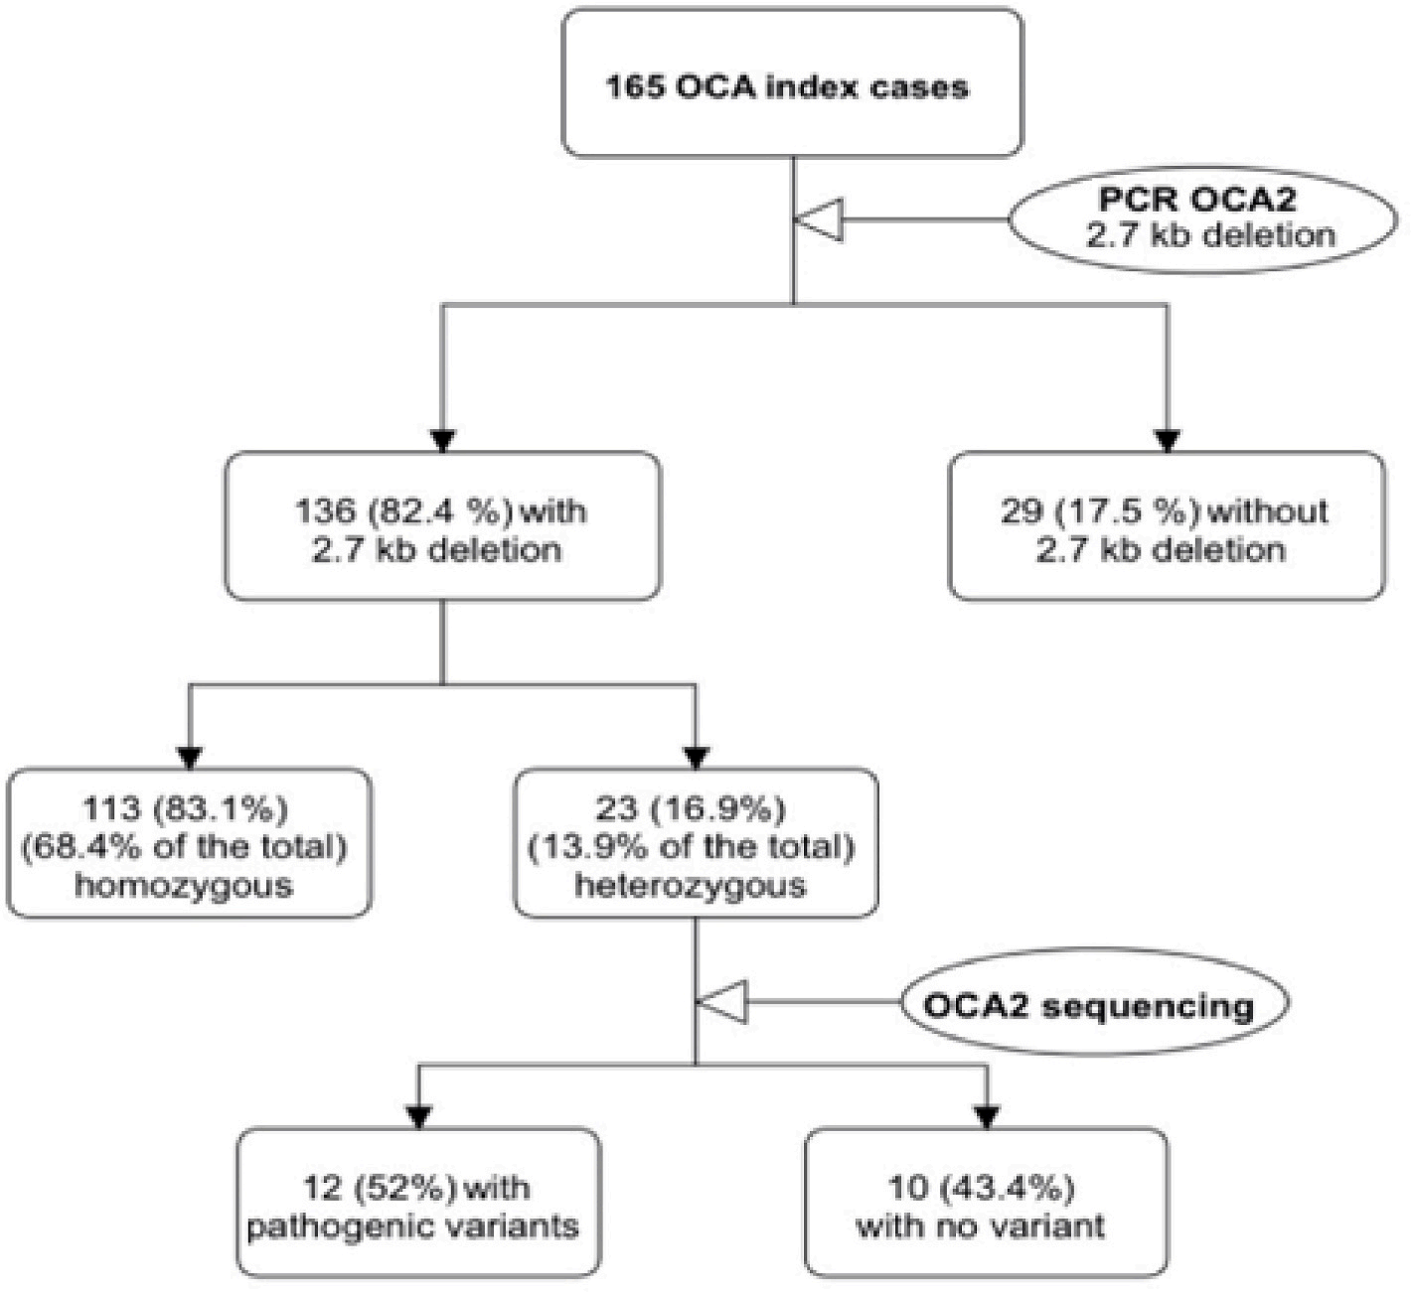

Table 1. Clinically relevant OCA2 variants detected in patients heterozygous for the OCA2 deletion.
Patient Chromosomal | Nucleotide change | Protein change | gnomAD (allele count) v2 | Clinvar | ACMG classification and literature reference
ID position
Truncating and splicing variants  95, 97, chr15:28267646C | c.646+1G > |  | Absent | Absent | Pathogenic based on PVS1, PM2,
132 > A  52, 115, chr15:28228630C | T c.1365-1G > |  | Absent | Absent | PM3 & PP3  Pathogenic based on PVS1, PM2,
127 > T  62 chr15:28200302 A | A c.1842+2 T |  | Total 1/251,490, | Absent (but c.1842+1G > T is | PM3 & PP3  Pathogenic based on PVS1, PM2,
>G | >C |  | African 0/16,256 No | recorded as pathogenic based on | PM3 & PP3
20, 88 chr15:28116319 | c.2225dupT | p. | homozygotes Absent | PMID: 8,302,318)  Absent | Pathogenic based on PVS1, PM2,
delA  Missense variants  133 chr15:28259965G | c.1001C > T | Phe744ValfsTer17  p.Ala334Val | Total 2/251,086 | VCV000000958.1 | PM3 & PP3  Pathogenic based on PS1, PM2,
>A  11 chr15:28231761G | c.1211C > T | p.Thr404Met | African 0/16,228 No homozygotes  Total 22/282,846 | VCV000211766.1 | PM3, PP2, PP3  Kerr R et al. (2000) (Kerr et al., 2000) PMID: 10649493  Pathogenic based on PS1, PM3, PP2,
>A  131 chr15:28090177G | c.2360C > T | p.Ala787Val | African 17/24,962 No homozygotes  Total 7/282,850 | VCV000617810.5 | PP3  Shahzad M et al. (2017) (Shahzad et al., 2017),  Simeonov D.R et al. (2013) (Simeonov et al., 2013b)  Pathogenic based on PM1, PM3,
>A |  |  | African 3/24,956 No homozygotes |  | PM5, PP2, PP3, PP5 Shahzad M et al. (2017) (Shahzad et al., 2017), Oetting W.S et al. (1998) (Oetting et al., 1998)

4. Discussion
A founder mutation, the 2.7 kb deletion in the OCA2 gene is the leading cause of OCA2 in African and African-American Blacks (Stevens et al., 1995; Aquaron et al., 2007). In line with this, we show that also in the DRC, the majority of OCA patients living in Kinshasa (82.4%) are homozygous or heterozygous for this deletion. In various studies in SSA, the proportion of OCA patients related to OCA2 ranged from 66% to 99%. In a study of Cameroonian albinos, Aquaron et al. showed that 66% of Cameroonians with albinism belonged to the OCA2 group (Sone et al., 2016). In Johannesburg, South Africa, molecular studies found a frequency of 78% of OCA2 (Aquaron et al., 2007). Other similar frequencies were reported in Zimbabwe (99%), Tanzania (77%) and Zambia (79%). This mutation has never been found in West African albinism patients (Senegal, Togo, Niger and Burkina Faso) (Brilliant, 2015).
Genetic counselling for OCA in the DR Congo is currently limited. The finding of a high proportion of OCA patients carrying a recurrent OCA2 mutation which is easily detectable and financially affordable will open the way to improved counselling for this condition.
The analysis of the haplotypes carried out previously suggested a unique origin for this mutation before the expansion of the Bantu 2000-3000 years ago (Aquaron et al., 2007).
Twenty three patients were heterozygous for this recurrent deletion, and in about half of them, a second OCA2 mutation was found by sequencing the exons and flanking intronic regions. This finding is consistent with the existence of other variants in Africans on the OCA2 gene alongside the predominant deletion frequently found in SSA as reported by Krause et al. (Krause and Seymour, 2018). Of interest, of the 7 pathogenic variants identified, 3 were detected in more than one family, and had not been reported in the literature before and were absent from Clinvar. This may indicate the presence of other founder mutations in this population. It is remarkable that in about 50% of heterozygotes, no variant of interest could be identified at the Sanger sequencing. Likewise, Simeonov et al. also failed to detect a second OCA2 mutation in 25% of families from their cohort (Simeonov et al., 2013a). This may suggest that there are mutations escaping detection by Sanger sequencing (e.g. intronic, regulatory or structural variants). A small proportion of heterozygotes may have another type of OCA, and be carrier of the OCA2 deletion by chance. Further studies are required to resolve this.
There was no significant association between the different genotypes regarding the OCA2 2.7 kb deletion and skin color or freckles. However, we found that homozygotes for the deletion had less frequently individual impairment compared to heterozygotes. We have no biological explanation for this, and certainly, this needs replication in a larger cohort.
Figure 2. Different phototypes of skin color
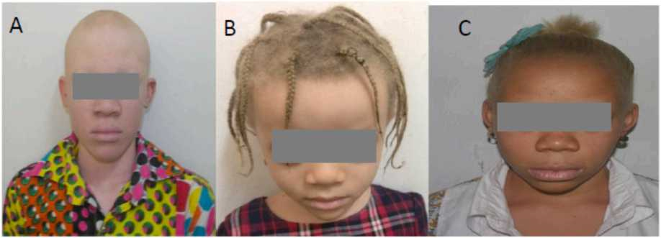
Légende : The panel A shows the Phototype I, corresponding to patients with very light skin. The panel B displays the Phototype II, representing patients with light skin. The Phototype III for patients with intermediate skin, is shown in panel C. . (For interpretation of the references to color in this figure legend, the reader is referred to the Web version of this article.)

Table 2. Associations between some phenotypes and genotypes
Phenotype | Genotype with regard to OCA2 2.7 kb deletion |  |  | P
 | WT/WT n (%) | Del/Del n (%) | WT/Del n (%)
Skin color |  |  |  | 0,821
Phototype I | 11 (37,9%) | 35 (31,0%) | 9 (39,1%)
Phototype II | 10 (34,5%) | 41 (36,3%) | 9 (39,1%)
Phototype III | 8 (27,6%) | 37 (32,7%) | 5 (21,8%)
Freckles |  |  |  | 0,620
Presence | 22 (75,8%) | 88 (77,8%) | 20 (87,0%)
Absence | 7 (24,2%) | 25 (22,2%) | 3 (13%)
Visual impairment |  |  |  | 0,043
Presence | 21 (72,4%) | 65 (57,5%) | 19 (82,6%)
Absence | 8 (27,6%) | 48 (42,5%) | 4 (17,4%)

5. Conclusion
This study demonstrated that the OCA2 2.7 kb deletion is the major cause of non-syndromic OCA in Congolese patients. This confirmation of a single mutation as the major cause will facilitate genetic counselling in Congolese families and allows targeted carrier screening to be offered to individuals with positive family history for OCA in DR Congo. Several additional mutations were detected in OCA patients heterozygous for the 2.7 OCA2 deletion. Additional investigations are needed to unravel the causal genetic defects in non-carriers of the 2.7 deletion.

CRediT authorship contribution statement
Laetitia Mpola Mavinga: Data curation, Investigation, Methodology, Visualization, Writing - original draft, Writing - review & editing. Veronique Kakiese: Resources. Mamy Ngole: Resources. Cathy Songo: Resources. Aime Lumaka: Formal analysis, Software. Valerie Race: Methodology, Investigation, Resources. Prosper Tshilobo Lukusa: Conceptualization, Validation, Supervision. Koenraad Dev- riendt: Conceptualization, Funding acquisition, Validation, Project administration.
Data availability
The data that has been used is confidential.
Acknowledgements
We thank all patients and their families for their collaboration. We also thank the associations of people living with albinism for their cooperation. We acknowledge the support from the Fair Nature and Society.

References
Ali, I., Abbassi, A.A., Niaz, U., Asghar, R., Ishaq, K., Aziz, T., et al., 2016. Molecular Analysis of Families Afflicted with Autosomal Recessive Occulocutanious Albinisim from Azad Jammu and Kashmir, vol. 5, pp. 107-113, 1.
Aquaron, R., Bergee-Lefranc, J.L., Badens, C., Austerlitz, F.G.B., 2007. Oculocutaneous albinism type 2 (OCA2) with homozygous 2.7-kb deletion of the P gene and sickle cell disease in a Cameroonian family . Identification of a common TAG haplotype in the mutated P gene. J. Hum. Genet. 52, 771-780.
Brilliant, M.H., 2015. Albinism in Africa: a medical and social emergency. Int Health 7 (4), 223-225.
Durham-Pierre, D., Gardner, J.M., Nakatsu, Y., King, R.A., Francke, U., Ching, A., et al., 1994. African origin of an intragenic deletion of the human P gene in tyrosinase positive oculocutaneous albinism. Nat. Genet. 7, 176-179.
Franklin, A., Lund, P., Bradbury-jones, C., Taylor, J., 2018. Children with Albinism in African Regions : Their Rights to ‘ Being ’ and ‘ Doing, pp. 1-8.
Grønskov, K., Ek, J., Brondum-nielsen, K., 2007. Oculocutaneous albinism. Orphanet J. Rare Dis. 8, 1-8.
Hawkes, J.E., Cassidy, P.B., Manga, P., Boissy, R.E., Goldgar, D., Cannon-Albright, L., et al., 2013. Report of a novel OCA2 gene mutation and an investigation of OCA2 variants on melanoma risk in a familial melanoma pedigree. J. Dermatol. Sci. 69 (1), 30-37.
Kamaraj, B., Purohit, R., 2014. Mutational analysis of oculocutaneous albinism : a compact review. BioMed Res. Int. 905472, 1-10.
Kerr, R., Stevens, G., Manga, P., Salm, S., John, P., Haw, T., et al., 2000. Identification of P gene mutations in individuals with oculocutaneous albinism in Sub-Saharan Africa. Hum. Mutat. 15, 166-172.
Krause, A., Seymour, H., 2018. Common and founder mutations for monogenic traits in sub-saharan african populations. Annu. Rev. Genom. Hum. Genet. 19, 149-175.
Oetting, W.S., Gardner, J.M., Fryer, J.P., Ching, A., Durham-Pierre, D., King, R.A., Brilliant, M.H., 1998. Mutations of the human P gene associated with Type II oculocutaneous albinism (OCA2). Hum. Mutat. 12 (6), 434.
Richards, S., Aziz, N., Bale, S., Bick, D., Das, S., Gastier-Foster, J., et al., 2015. Standards and guidelines for the interpretation of sequence variants: a joint consensus recommendation of the American college of medical genetics and genomics and the association for molecular pathology. Genet. Med. 17 (5), 405-424.
Shahzad, M., Yousaf, S., Waryah, Y.M., Gul, H., Kausar, T., Shaikh, R.S., et al., 2017. Molecular outcomes, clinical consequences, and genetic diagnosis of Oculocutaneous Albinism in Pakistani population. Nat Publ Gr 1-15. October 2016.
Simeonov DR, Wang X, Wang C, Sergeev Y, Dolinska M, Bower M, et al. DNA Variations in Oculocutaneous Albinism: an Updated Mutation List and Current Outstanding Issues in Molecular Diagnostics. Hum Mutat. 2013;vol. 34(6):827-835.
Simeonov, D.R., Wang, X., Wang, C., Sergeev, Y., Dolinska, M., Bower, M., et al., 2013b. DNA variations in oculocutaneous albinism: an updated mutation list and current outstanding issues in molecular diagnostics. Hum. Mutat. 34, 827-835.
Sone, M., Aquaron, R., Baker, C., 2016. Premier colloque international sur l’albinisme oculocutanee en Afrique subsaharienne, Douala, Cameroun, 24-25 juillet 2015. Douala (Cameroun). Med Sante Trop 26, 118-121.
Stevens, G., Jenkins, T., Ramsay, M., 1995. An intragenic deletion of the P gene is the common mutation causing tyrosinase-positive oculocutaneous albinism in southern african negroids. Am. J. Hum. Genet. 56, 586-591.
Summers, A.C.G., Hand, J.L., 2019. Oculocutaneous albinism. Oculocutaneous albinism - UpToDate 1-54.
Swiatoniowski, A.K., Quillen, E.E., Shriver, M.D., Jablonski, N.G., 2013. Technical Note : Comparing von Luschan Skin Color Tiles and Modern Spectrophotometry for Measuring Human Skin Pigmentation, vol. 330, pp. 325-330.
Wang, X., Zhu, Y., Shen, N., Peng, J., Wang, C., Liu, H., 2017. Mutational Analysis of a Chinese Family with Oculocutaneous Albinism Type 2, vol. 8, pp. 70345-70355, 41.
Further reading
Jennifer Kromberg, P.M., 2018. In: Linsley, P.B. (Ed.), Albinism in Africa : Historical, Geographic, Medical, Genetic, and Psychosocial Aspects. Elsevier, London, p. 339.

