Validity evidence for the Pictorial Scale of Perceived Water Competence short form (PSPWC-4)

Lisa M. Barnetta, Gavin Abbottb, Natalie Landerb, Boris Jidovtseffc and Nicola D. Ridgersb
aInstitute for Physical Activity and Nutrition, School of Health and Social Development, Deakin University, Geelong, Australia;
bInstitute for Physical Activity and Nutrition, School of Exercise and Nutrition Science, Deakin University, Geelong, Australia;
cResearch Unit for a life-Course Perspective on Health and Education, University of Liege, Liège, Belgium;
dAlliance for Research in Exercise, Nutrition and Activity (ARENA), Allied Health and Human Performance, University of South Australia, Adelaide, Australia

KEYWORDS: Perceived motor competence; reliability; child; motor skills
ABSTRACT
Promoting swimming and water safety is an important public health issue. The Pictorial Scale of Perceived Water Competence (PSPWC) requires children to indicate their perceived competence using three difficulty levels for 17 swimming scenarios. The aim was to purposefully select four critical scenarios of the PSPWC to create the PSPWC-short form and test for associations with actual swim competence. Four of 17 scenarios were selected and extended to a four-point response scale by adding an extra difficulty level. Parents whose children had participated in at least 1-week swim-intensive programme in 2021 were invited to participate in the study, and perceptions of 139 children (mean age 6.9 years, SD = 1.9) were matched with certificate data of actual swim competence pre- (n = 139) and post- programme (n = 29). Moderate positive correlations were found between swim level at programme start and perception of: retrieving an object in deep water (rho = 0.57), swimming on front (rho = 0.60), swimming on back (rho = 0.69), treading water (rho = 0.63) and the summed score of all four (rho = 0.71). After adjusting for sex and age, higher perceived skill was still significantly associated with increasing achieved skill levels. The PSPWC-short form appears to provide a valid measure to be used as a brief screening assessment.

Introduction
Promoting swimming and water safety in different aquatic environments is an important educative and international public health issue (Meddings et al., 2021). In 2019/2020, Royal Lifesaving Australia noted that 56% of drowning incidents in children aged 5–14 years were while swimming and recreating. Open water environments (ocean or rivers) are associated with the greatest drowning risk for Australian children aged 5–14 years (Australian Water Safety Strategy 2030, 2021). Out of 60 countries, Australia was named as having one of the higher incidence rates (13%) of drowning in a swimming pool (Lin et al., 2015). Younger children are more likely to fall into water and/or be bathing and older children are more likely to drown whilst swimming and in water pursuits (Australian Water Safety Strategy 2030, 2021, Peden, 2012). At the time of drowning, common activities were swimming/wading (34%) or boating (18%). A rip current was involved in 42% of the swimming/ wading drownings (Sherker et al., 2012).
Up to 40% of Australian children leaving primary school do not reach the minimum National Benchmark for swimming and water safety skills; which includes amongst other competencies, a “50 m swim” and “scull or tread water for 2 minutes and signal for help” (Royal Lifesaving Society- Australian Government. National Benchmarks for Swimming and Water Safety, N.d.). In Australia, swimming programmes are not mandatory in schools and participation in commercial learn to swim programmes declines before 8 years of age – well before children have developed the necessary swimming and water safety skills (Australian Water Safety Strategy 2030, 2021).
Part of reducing children’s risk of drowning is understanding how a child perceives their swimming competence. In land-based environments, children’s perception of their movement skills (e.g., running and throwing) are only weakly associated with their actual movement skills (r = 0.25; De Meester et al., 2020). This weak association can be due to younger children overestimating their motor competence until they develop better cognitive skills in assessing their own ability (Harter, 1982). Overestimation does not have the same consequence on land as in water, as on land, if a child overestimates their movement competence this can be viewed positively in that there can be a motivational effect to engage in physical activity (Bardid et al., 2016; Barnett et al., 2021; Visser et al., 2020), rather than a risk to their safety. However, if children believe their water skill competence is higher than their actual competence is, the consequences could be dire. As an example, a study in 8-year-old Portuguese children reported children’s perceived aquatic competence (gained through interview with use of text and images) was higher than their actual aquatic competence for using a swimsuit and goggles and then wearing a t-shirt with no goggles, but more so in the youngest children. Scores for aquatic competence tended to be lower in the clothed condition, especially in the deep water entry/dive, underwater swimming, immersion, rudimentary swimming and changing swimming direction (Costa et al., 2020) – skills which could be needed to survive in a potential drowning incident. It is there- fore very important to understand and identify the association between child perceived water competence and actual ability.
The pictorial measures (typically interviewer administered), used in the afore-mentioned studies, have enabled greater exploration of perceived swimming competence, particularly in younger children. The Pictorial Scale of Perceived Water Competence (PSPWC) provides 17 swimming scenarios in a visual format and asks children to indicate their perceived competence using three levels of difficulty (Morgado et al., 2020). The PSPWC was designed with three levels, similar to a pictorial swim scale developed originally by Spanish researchers (Murcia & Pérez, 2008) designed to assess competence. Developers considered that it was important to have an image that represented each of the three levels so children could relate to and select the swim level that could accurately identify their swimming level (Morgado et al., 2020). Interviews with 15 swimming teachers in Australia have previously high- lighted the face validity of such an approach (De Pasquale et al., 2021).
Initial studies using the PSPWC have shown child perception to be associated with actual swim ability. A recent Australian study reported 4–8-year-old children’s swim perceptions were associated with their objective swim level (i.e., Mann Whitney U, Mdn Beginner = 15.34, Mdn Intermediate/Squad = 29.68, U = 418.5, p = .001; De Pasquale et al., 2021). Another study, this time in 6–9-year-old Belgian children reported that children had fairly realistic perceptions of their swimming and water safety skills (D’Hondt et al., 2021). Whilst the total score on the child self-completed PSPWC was lower than their actual skill total score (p = .007), the degree of disagreement was not high in either age group of children (6–7-year-old children, ∆ = 1.43, 8–9-year-old children, ∆ = 1.62). However, in both these previous studies using the PSPWC, a ceiling effect was observed for the children who were more water competent (D’Hondt et al., 2021; De Pasquale et al., 2021). In the Australian study, a quarter of the children perceived themselves in the highest category (scored as a 3) for each of the 17 situations and no child perceived themselves in the lowest category (scored as a 1). In the Belgian study, scoring was 0, 1, 2, meaning the maximum score was a “2” for the 17 situations (i.e., maximum of 34), and the mean scores also appeared to reach the ceiling as scores ranged from 28.30 (±5.72) to 31.79 (± 3.01) depending on the age group (D’Hondt et al., 2021).
Therefore, it is relevant to develop a scale that assesses perceived competence for higher levels of water competency. Having more than three response options can help distinguish between competent and highly competent children (Harter, 1982). However, commonly used pictorial assessments with four response options to assess perceived movement skill competency in children, only show two pictures (i.e., of good performance and a poor performance), with the four response options derived from each picture having two qualifying options (“really” or “pretty” good versus “sort of” or “not too” good; Barnett, Vazou et al., 2016; Harter & Pike, 1984). The scale used in the Portuguese study described above, is an exception, with response options of three to five levels of competency for eight aquatic skills (Costa et al., 2020).
In the consultation phase of a 2021 evaluation of an Australian state-wide swimming programme using the PSPWC, the swim provider manager expressed that a shorter scale would be more feasible in the field in such programmes. The manager then selected three swim teacher coordinators to comment on the scale and its potential to align with their programmes. These staff were selected by the swim provider based on their years of experience running the programme and supervising large teams of swimming teachers in their respective districts. A meeting was held between the research team and the three swim teacher coordinators. It was identified that an extra fourth level of difficulty could be added to some of the swimming scenarios in the PSPWC to better represent the broad range of skill difficulty and diversity in the Australian programme, and reflect those who are highly competent. Four of the 17 swimming scenarios were identified as having the potential to provide a good representation of a child’s perception of their swimming ability and water competence without the need to use all 17 items in the existing PSPWC. These four scenarios represented swimming competence (front and back), a survival skill (treading water) and ability to retrieve an object below water. These items were also considered to need an extra higher level of competency.
Validity of self-report questionnaires can be determined by comparison to an actual objectively derived score. In the context of child perception, this is not always seen as appropriate, as the divergence between actual and perceived skill is of interest to study in and of itself (Estevan & Barnett, 2018; Harter & Pike, 1984). Yet in the study of swimming competence, if the scores from a self-report instrument align with actual competence, then this instrument could be used by swimming organisations, teachers and parents to assess children’s water competence in a cost-effective feasible way or as a preliminary screening process to assess risk before they are in the water. As such, this study reports on i) the process involved in the addition of an extra level of difficulty to four situations in the PSPWC, ii) internal consistency of this short scale, iii) how actual swimming level was associated with child perception of swimming and water competence when using these four newly developed items, iv) whether experience of other organised lessons during the year (or not) was a predictor of perceived swim competence and v) whether associations between actual and perceived competence differed for boys and girls (considering males are more likely to drown (Howland et al., 1996) and previous similar studies in young children have either not investigated (Costa et al., 2020) or found null gender results (De Pasquale et al., 2021; D’Hondt et al., 2021)).

Methods

Procedure
As part of a 2021 evaluation of an Australian state-wide swimming programme, parents whose children had participated in at least one summer season of the programme (typically a 1-week intensive but sometimes a child may have completed more than one programme of a possible three programs con- ducted in January) were invited to provide feedback on the programme. Ethics approval was received from the duly constituted Human Ethics Advisory Group (HEAG-H 207_2020). We were able to match parent post-programme responses about their children and the programme for 358 children. Of these, 143 provided consent for their children to complete a child post-programme evaluation which involved online administration of the four modified items of the PSPWC. Parents and children were invited in the last week of January 2021. Almost all (94%) of children’s perceived swim competence reports were completed within a week of being invited, which meant their report was between a week to a month after completing their swim programme. The link was sent via email to parents. Parents were asked for their children to complete online administration of the four modified items of the PSPWC survey on a computer or tablet at home. Parents needed to show the children the images on the screen and guide them through completing their responses. These data were then matched to records in the provider database of the level of swim certificate received at programme conclusion. Actual swimming competence was reported at programme start by parents at the commencement of the swim programme in regard to the certificate swim level that the child was enrolled in/would be entering the programme at. Actual swimming competence was also reported as what was achieved at programme end by swim teachers – sub-sample. Both parents and teachers were working from the same certificate level system/standards.
A total of 140 children provided responses to all child perception questions. Of the 140 children, 139 had a parent indication of swimming level at start/registration and 29 had complete demographic data and a certificate achievement record at swimming course conclusion in the swimming provider database. This discrepancy was due to swimming teachers not entering in the result manually into the data- base, rather than children not completing the programme. Also, it was possible for students to not achieve the next level during the 1-week course (certificates are not participation awards). There were little differences between the sub- sample and those not in the sub-sample (i.e., larger sample minus the sub-sample) and none were statistically significant. For example, sub-sample compared to remaining participants from larger sample: mean age 7.0 vs. 6.9 [p = 0.78]; female 59% vs. 52 [p = 0.51]; mean perceived skill summed score 11.9 vs. 11.0 [p = 0.19].

Participants
In the larger sample, children had a mean age of 6.9 years and in the sub-sample, children were aged 7.0 years (Table 1). Around 10% or less did not speak English at home in both samples. Children were spread throughout the five levels of socio-economic advantage. Around four in ten children (n = 55, 39.6%) attended organised swim programmes throughout the year other than the summer intensive. This included weekly lessons (n = 42), school swimming (n = 6), other holiday programmes (n = 2) and “other” (n = 5).

Actual swimming competence
Actual swimming competence was determined based on one of the seven levels of skill (A, B, C, D E, F, G) that children could attain (Table 2), a system that was specific to the state-based swimming provider. Children in Australia are allowed to wear goggles in swimming lessons and assessments. Otherwise, the only aids are those specified in the certificate levels (see Table 2). These commonly include a kick board and/or pool noodle. Since few children had achieved levels higher than D (n = 33 in the larger sample), levels D to F were collapsed for the purpose of analysis. No child reached level G.

Perception of swimming competence – instrument development
Four situations in the PSPWC were adapted by the drawing of an additional item (by the same artist who did the original drawings for the scale) depicting a higher level of competency. These four items were selected as they were considered to provide four key fundamentals of swimming, i.e., propelling on the front and back, and survival skills – being able to keep afloat by treading water and being able to swim deep underwater and return above the water. The four swimming situations and the extension items were Situation 4 – Catching object under water – extended to include collecting object from deep water; Situation 9 – Leg propulsion on back – extended to include swimming backstroke using arm propulsion, Situation 10 – Leg propulsion on front – extended to include swimming overarm and Situation 14 – Vertically treading water – extended to treading water with clothes on. These items will now be referred to herein in as the modified short version, i.e., 1. Retrieving object under deep water, 2. Leg and arm propulsion on back, 3. Leg and arm propulsion on front and 4. Vertically treading water with clothes on. Images were drafted and first shown to the evaluation team (authors on this paper and the swimming provider team) and the original scale developer for comment. The images were redrawn based on this feedback and administered to the children in the evaluation. Supplementary file 1 provides details of the complete images for each item and the instructions for children.

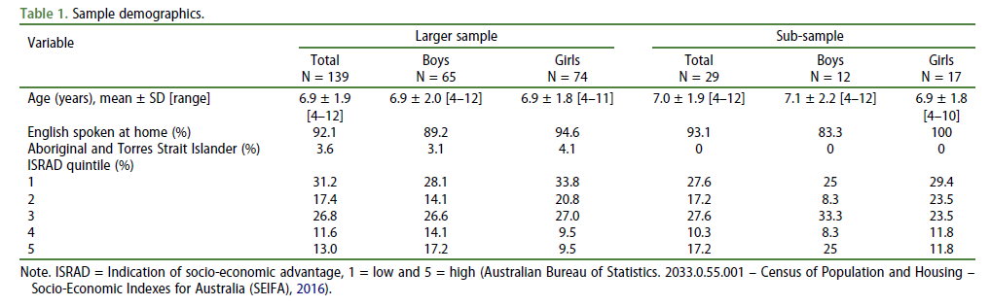
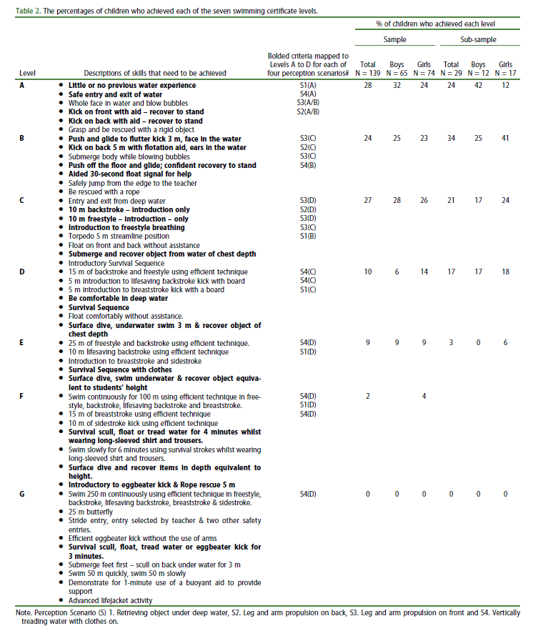

Analysis
Descriptive statistics were used to report on the swimming level reported, the swimming perceptions for all children and boys and girls for the four situations, and the summed score. Swimming perceptions for individual situations (4-point ordinal items) were analysed using non-parametric statistical tests, while the summed score (range 4–16) was treated as continuous and analysed using parametric tests. Differences in actual and/or perceived skills between girls and boys were assessed using t-tests (perceived skill summed score) or the Wilcoxon rank-sum test. Cronbach’s alpha was used to assess internal consistency of the four swimming competence perception items for all children in both samples (i.e., larger sample and sub-sample) and for boys and girls (larger sample only). Cronbach’s alpha was also conducted for 4–6-year olds and for 7–12-year olds (sample divided at median age to maximise numbers). Alpha values were considered acceptable if greater than 0.70 (Tavakol & Dennick, 2011). Spearman correlations for each of the four situations, and as a total score, were then conducted to examine whether child perceptions of their swimming competence were associated with their actual swimming competence. Correlations were also calculated for boys and girls separately (larger sample only).
A linear regression model was fitted to the larger sample to examine differences in perceived skill total score (dependent variable) between achieved skill levels [categorical variable, with groups A, B, C, & D or above (i.e., D/E/F)], adjusting for child age and gender. Next, a t-test was performed to assess difference in perceived competence between those who did other organised swim lessons throughout the year compared to those who did not. A further regression model was per- formed with perceived competence as the outcome, other organised lessons as the predictor, and adjusted for actual skill level, and sex. Finally, associations between perceived and actual skill level were assessed using Spearman’s correlations separately for those who did other organised swim lessons throughout the year and those who did not. All analyses were conducted using Stata/SE 16.1 (StataCorp, TX) and statistical significance was set at p < .05.

Results

Boys and girls swimming differences
In the larger sample, girls had statistically significantly higher perceptions of their ability for all four items as an overall sum score and for swimming on their front and on their back compared to boys (Table 3). Supplementary file 2 shows these perception scores descriptively for each level of perceived competence as percentages. Boys and girls rated their ability in treading water in clothes and retrieving a deep underwater object, similarly. For actual skill levels, there were no significant differences between boys and girls for either sample (n = 139, p = 0.41; n = 29, p = 0.37).

Internal consistency
The participants’ scores on the PSPWC–4 (to denote the brief version with four items and four responses per item) demonstrated acceptable internal consistency with a Cronbach’s alpha of 0.89 for the whole sample (n = 139), 0.89 for boys, and 0.90 for girls. There was also evidence of acceptable internal consistency in both older and younger children, with α = 0.87 for 4– 6-year olds and α = 0.84 for 7–12-year olds.

Associations with actual swim level achieved at program start and at the conclusion
For the larger sample (n = 139), statistically significant moderate positive correlations were found between the swimming certificate level that the child started the programme with, and:1. Retrieving object under deep water (rho = 0.57), 2. Leg and arm propulsion on back, (rho = 0.69), 3. Leg and arm propulsion on front (rho = 0.60), 4. Vertically treading water with clothes on (rho = 0.63) and the summed score of all four situations (rho = 0.71). Associations for girls were stronger than for boys (Table 4). For the sub-sample (n = 29), the correlation between their final achieved swimming level and the summed perceived score was rho = 0.64.
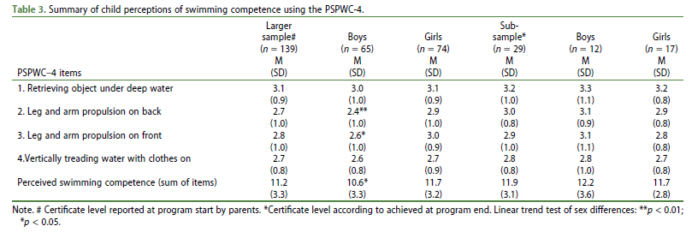
Regression analyses showed statistically significant (i.e., p < .01) differences in total perceived skill between all four skill level groups apart from Level D and greater vs. Level C, with all differences in the expected direction (i.e., higher perceived skill with increasing achieved skill levels). There were statistically significant (p < .05) age and sex effects in both unadjusted and adjusted models. Perceived competence was higher in females compared to males and with increasing age, independent of actual competence (Table 5).

Did children with other organised swim experience differ in their perceptions?
Perceived competence was higher in those who engaged in additional swimming programmes (M = 11.8 [SD = 2.9]) compared to those who did not (M = 10.7 [SD = 3.4]), though this difference was not statistically significant (p = 0.07). When adjusted for actual skill level, sex and age, there was no evidence of differences in perceived competence in those who did other lessons compared to those who did not (p = 0.32). Associations between perceived and actual level were similar for those who did other lessons (rho = 0.77) and those who did not (rho = 0.67).
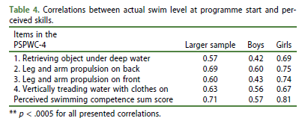
Discussion
This study aimed to provide validity evidence for a brief self- report pictorial instrument designed for children based on different swimming situations. As a ceiling effect was reported in previous studies using the PSPWC (D’Hondt et al., 2021; De Pasquale et al., 2021), an additional level of complexity was added to a selection of items to expand the response options allowing for greater diversity or skill representation. The four scenarios selected were considered reflective of critical swim and water safety skills based on feedback from swimming teachers and could be feasibly used in swim programmes. Results showed that the PSPWC-4 had excellent internal consistency and compared favourably with the score for all 17 items (α = .87) in a study in 6–9-year-old Belgian children (D’Hondt et al., 2021) and was higher than the score in 4– 8-year-old Australian children (α = .68; De Pasquale et al., 2021). Younger children tend to have less idea of their own competence (Harter, 1982), which might explain why the inter- nal consistency in the Australian study was lower than in Belgium study. Our sample covered a wide age range with good values of internal consistency when split at the median age, suggesting that this brief scale could be used as an alternative to the full-length PSPWC instrument; however, more research is needed to ascertain this – as the four selected situations are not assessing all water fundamentals.
This study also aimed to assess whether child perception of swimming competence was associated with actual achieved swim level. We found good concordance between children’s perceived and actual (teacher-assessed) swimming levels, thereby providing evidence that this scale can be used to gain an indication of a child’s swimming and water safety competence. Potentially this scale could be used by teachers and care staff as a brief screening tool before children are exposed to water and guide programmes delivered in aquatic settings. Even though past research has reported that parent perception of child swimming level is not accurate (D’Hondt et al., 2021), in this case, for our analysis involving certificate at the start of the programme, many parents had a previous certificate based on swim teacher assessment, or if new customers, they were likely to be entering their child at the beginner lower levels. Our results show that there was a moderate correlation (rho = 0.71) between these certificate levels at programme start and the child’s perception, which reinforces that our parent reporting (which in many cases was parent recall of teacher assessment) on this basis may have been accurate (or at least aligned with child perceptions). In addition, the correlation value for this analysis was slightly higher than that of the analysis which used actual achievement levels (rho = 0.64) which gives further confidence in this method.
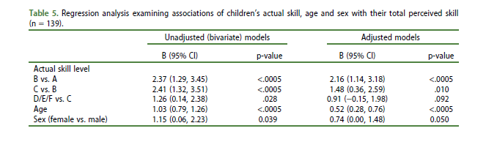
As per previous studies using the full instrument (D’Hondt et al., 2021; De Pasquale et al., 2021), all children were enrolled in a swimming programme and therefore it is plausible that is why they had a good understanding of their swimming ability. It is possible that children with little experience of organised swimming have less idea of their own level of competence in the water. However, it is important to note that in this study the swimming programme is a summer intensive with around 60% of children engaged in no other organised lessons during the year, as in this state of Australia, not all schools offer a swimming programme. This means that more than half the children had not necessarily had much swimming experience. Interestingly, we found no difference between those who had other organised swim lessons during the year and those who did not, which supports the idea that this scale could be used for all children regardless of swimming experience or exposure. Future research may wish to explore how perceptions of swimming competence influence risk – for instance, are those who think/are more competent more/less likely to swim in risky scenarios such as rivers and open water beach environments?
Girls reported higher perceived competence than boys but were not actually more swim competent. In contrast, in the previous studies in Australia (De Pasquale et al., 2021) and Belgium D’Hondt et al., 2021), boys and girls did not differ in their swim perception (De Pasquale et al., 2021). Prior research examining children’s land-based motor skill perceptions shows boys tend to report higher levels of perceived competence when it comes to ball skills (Barnett et al., 2015) but there are often no sex-based differences for locomotor-based skills (Slykerman et al., 2016; Barnett et al., 2018). This reflects actual motor skill data in that boys’ typically score higher than girls in assessments of object control skills (Barnett, Lai et al., 2016; Barnett et al., 2010). Since swimming is a locomotor activity our finding contradicts this land-based evidence. This provides a valuable insight as it suggests we can’t assume the same sex performance across different locomotor skills as these assumptions could be potentially dangerous for water-based skills.
The strength of the study is that the sample is larger compared to other studies in this area (D’Hondt et al., 2021; De Pasquale et al., 2021) (probably because it covers a state-based programme) and has socio-demographically diverse participants, although we cannot be confident that the identification of the four skills in the short scale is equally relevant to other samples of young swimmers (both in other parts of Australia and other countries). A strength to scale development is that the new additional level allowed a reduction of the ceiling effect seen in earlier versions of the instrument. When examining the child perceptions of swimming competence in the supplementary material, for items 2, 3, and 4, there does not appear to be ceiling effect as the responses are spread between the levels. For item 1 (retrieving object), over 70% report that they are in the upper two categories so there is potentially a ceiling effect for that one item. Another strength is that the use of a four-item pictorial scale was successful to reach significant correlation with actual competence.
In terms of study limitations, it is important to note that information is lost when not using the full scale, as the four items selected cannot represent the complete picture of a child’s perceived swimming competence that the full scale was designed to achieve. By comparing the full and short PSPWC, we can say that the short version fails to assess three aquatic fundamentals: water entry, water exit and water orientation with the ability to turn and/or to change of direction in the water, which is also an important skill for water safety. The briefness of the scale does mean, however, that it could have utility for large scale epidemiological surveys.
We were limited in the numbers who had the level achieved at the end of the programme recorded in the swimming provider database (n = 29) due to limited data available from the provider that could be matched across data sources, but it is arguable that our associations between actual and perceived level would have been even higher if we had this data, rather than the registration entry-level parent report data that we used. This is because children’s perception of themselves would likely be proximally affected by their recent experience in the intensive programme.
A limitation is that perceived and actual competence were not compared with the same tests. Whilst the perception items were present within the actual competencies children needed to achieve for the certificates, there was not a direct equivalency between each perception item and actual skill competency (Estevan & Barnett, 2018). A newly developed instrument to assess actual water competencies has been published since data collection for this study occurred, titled the Actual Aquatic Skills Test (AAST), and this instrument will be ideal in the future to examine the relationship between perceived and actual competence (Mertens et al., 2022). However, we capitalised in this study from using the certificate levels of the swimming provider which enabled us to make use of their existing data.
Another potential consideration is the timing of the perception data collection which was after children’s participation in the swimming programme. This was analysed in relation to certificate level at the start of the programme (reported by parents-larger sample) and certificate level at the end of the programme (reported by teachers-sub sample). It is feasible that children’s views of their competence may have improved after the swimming programme, thereby contributing to potentially increased correlations in the subsample. In fact, the correlation for all four items was slightly higher for the larger sample than the sub-sample (rho = 0.71 versus rho = 0.64). Another point to consider is that the online administration of the test in children’s homes without researcher supervision may be less standardised than in previous in person administered studies. Finally, the items for front crawl and backstroke were originally portrayed as a front glide and back glide in the original scale. We added an extra image onto these items with the aim to turn them into items assessing front crawl and backstroke. Future research may wish to explore face validity with children to ensure they are seeing the sequence of images in the way we intended. Moreover, the psychometrics of the scale need to be tested in alternative samples.
In conclusion, this research effort has provided evidence for the use of a four-item developmentally appropriate scale to assess child perceived swimming competence – at least for this Australian state-based sample. The items cover four important swimming and water safety skills (i.e., being able to propel on front and back, remain afloat in water and the ability to go under- water and surface) and allow for a diversity of competence in responses. It is important to note that these skills do not represent all fundamental water skills. Future research may wish to investigate how well the items can detect and distinguish those with low competency, compared to those with acceptable/high competency. Such a scale may have potential, with further validation of the psychometrics, to be used as a brief screening assessment from a safety perspective by teachers, or other relevant staff (such as staff who supervise holiday programmes) who have a need to understand children’s swim perceptions.

Acknowledgments
Development of these additional images is credited to the same artist as the original version of the Pictorial Scale of Perceived Water Competence (PSPWC), i.e., Corinne Tarcelin. In addition to the authors, the content idea for the revised instrument was developed by Kathy Parton (Aquatics and Recreation Victoria, Australia) and Maria Apostolopoulos and Sacha Bosman (Deakin University) and three Regional Swimming Coordinators employed by the Victorian Aquatics Peak Association: Katrina Van Eyk, Jillian Cooper and Sarah Hernan. The research was supported by the Victorian Government.

Disclosure statement
No potential conflict of interest was reported by the authors.

Funding
This work was supported by the State Government of Victoria.

ORCID
Lisa M. Barnett http://orcid.org/0000-0001-9911-3010

References
Australian Bureau of Statistics. 2033.0.55.001 - Census of Population and Housing - Socio-Economic Indexes for Australia (SEIFA). 2016. Available at: Accessed 2020 03 September https://www.abs.gov.au/AUSSTATS/ abs@.nsf/DetailsPage/2033.0.55.0012016?OpenDocument
Australian Water Safety Council. Australian Water Safety Strategy 2030. 2021. Available at Accessed 2022 31 May https://www.swimaustralia. org.au/docs/AWS_Strategy2030_Final.pdf
Bardid, F., De Meester, A., Tallir, I., Cardon, G., Lenoir, M., & Haerens, L. (2016). Configurations of actual and perceived motor competence among children: Associations with motivation for sports and global self-worth. Hum Movement Sci, 50, 1–9. https://doi.org/10.1016/j.humov.2016.09.001
Barnett, L. M., Lai, S. K., Veldman, S. L. C., Hardy, L. L., Cliff, D. P., Morgan, P. J., Zask, A., Lubans, D. R., Shultz, S. P., Ridgers, N. D., Rush, E., Brown, H. L., & Okely, A. D. (2016). Correlates of gross motor competence in children and adolescents: a systematic review and meta-analysis. Sports Medicine, 46(11), 1663–1688. https://doi.org/10.1007/s40279-016-0495-z
Barnett, L. M., Lubans, D. R., Timperio, A., Salmon, J., & Ridgers, N. D. (2018). What is the contribution of actual motor skill, fitness, and physical activity to children’s self-perception of motor competence? Journal of Motor Learning and Development, 6(s2), S461–S473. https://doi.org/10.1123/jmld.2016-0076
Barnett, L. M., Ridgers, N. D., & Salmon, J. (2015). Associations between young children’s perceived and actual ball skill competence and physical activity. Journal of Science and Medicine in Sport, 18(2), 167–171. https:// doi.org/10.1016/j.jsams.2014.03.001
Barnett, L. M., van Beurden, E., Morgan, P. J., Brooks, L. O., & Beard, J. R. (2010). Gender differences in motor skill proficiency from childhood to adolescence: A longitudinal study. Research Quarterly for Exercise and Sport, 81(2), 160–170. https://shapeamerica.tandfonline.com/action/ showCitFormats?doi=10.1080/02701367.2010.10599663
Barnett, L. M., Vazou, S., Abbott, G., Bowe, J. S., Robinson, L. E., Ridgers, N. D., & Salmon, J. (2016). Construct validity of the pictorial scale of perceived movement skill competence. Psychology of Sport and Exercise, 22, 294–302. https://doi.org/10.1016/j.psychsport.2015.09.002
Barnett, L. M., Webster, E. K., Hulteen, R. M., De Meester, A., Valentini, N. C., Lenoir, M., ... Rodrigues, L. P. (2021). Through the looking glass: A systematic review of longitudinal evidence, providing new insight for motor competence and health. Sports Med, 52(4), 875–920. https://doi.org/10.1007/s40279-021-01516-8
Costa, A. M., Frias, A., Ferreira, S. S., Costa, M. J., Silva, A. J., & Garrido, N. D. (2020). Perceived and real aquatic competence in children from 6 to 10 years old. International Journal of Environmental Research and Public Health, 17(17), 6101. https://doi.org/10.3390/ijerph17176101
De Meester, A., Barnett, L. M., Brian, A., Bowe, S. J., Jiménez-Díaz, J., Van Duyse, F., Irwin, J. M., Stodden, D. F., D’Hondt, E., Lenoir, M., & Haerens, L. (2020). The relationship between actual and perceived motor competence in children, adolescents and young adults: A systematic review and meta-analysis. Sports Medicine, 50(11), 2001–2049. https://doi.org/ 10.1007/s40279-020-01336-2
De Pasquale, C., De Sousa Morgado, L., Jidovtseff, B., De Martelaer, K., Barnett, L. M., & Smith, J. (2021). Utility of a scale to assess Australian children’s perceptions of their swimming competence and factors associated with child and parent perception. Health Promotion Journal of Australia, 32(S2), 106–115. https://doi.org/10.1002/hpja.404
D’Hondt, E., Buelens, L., Barnett, L. M., Howells, K., Sääkslahti, A., Costa, A. M., Jidovtseff, B., Mertens, L., & Martelaer, K. D. (2021). Differences between young children’s actual, self-perceived and parent-perceived aquatic skills. Perceptual and Motor Skills, 128(5), 1905–1931. https://doi.org/10. 1177/00315125211017864
Estevan, I., & Barnett, L. M. (2018). Considerations related to the definition, measurement and analysis of perceived motor competence. Sports Medicine, 48(12), 2685–2694. https://doi.org/10.1007/s40279-018-0940-2
Harter, S. (1982). The perceived competence scale for children. Child Development, 53(1), 87–97. https://doi.org/10.2307/1129640
Harter, S., & Pike, R. (1984). The pictorial scale of perceived competence and acceptance for young children. Child Development, 55. https://doi.org/ 10.2307/1129772
Howland, J., Hingson, R., Mangione, T. W., Bell, N., & Bak, S. (1996). Why are most drowning victims men? Sex differences in aquatic skills and behaviors. American Journal of Public Health, 86(1), 93–96. https://doi. org/10.2105/AJPH.86.1.93
Lin, C.-Y., Wang, Y.-F., T-H, L., & Kawach, I. (2015). Unintentional drowning mortality, by age and body of water: An analysis of 60 countries. Injury Prevention, 21(e1), e43–e50. https://doi.org/10.1136/injuryprev-2013-041110
Meddings, D. R., Scarr, J.-P., Larson, K., Vaughan, J., & Krug, E. G. (2021). Drowning prevention: Turning the tide on a leading killer. The Lancet Public Health, 6(9), e692–e695. https://doi.org/10.1016/S2468-2667(21)00165-1
Mertens, L., De Martelaer, K., Sääkslahti, A., & D’Hondt, E. (2022). The inter- rater and intra-rater reliability of the Actual Aquatic Skills Test (AAST) for assessing young children’s motor competence in the water. International Journal of Environmental Research and Public Health, 19(1), 446. https:// doi.org/10.3390/ijerph19010446
Morgado, L. D., De Martelaer, K., D'Hondt, E., Barnett, L. M., Costa, A. M., Howells, K., Sääkslahti, A., & Jidovtseff, B. (2020). Pictorial scale of perceived water competence (PSPWC) testing manual. University of Liege.
Murcia, J. A. M., & Pérez, L. M. R. (2008). Aquatic Perceived Competence in Children: Development and Preliminary Validation of a Pictorial Scale. Int Journal of Aquat Research, 2(4), 313–329. https://doi.org/10.25035/ijare.02.04.05
Peden, A. (2012). A 9 year analysis of drowning in children and adolescents aged 5–19 years in Australia, 2002–2011. Injury Prevention, 18(Suppl 1), A133–A133. https://doi.org/10.1136/injuryprev-2012-040590h.7
Royal Lifesaving Society- Australian Government. National Benchmarks for Swimming and Water Safety. N.d. Available at: Accessed 2022 31 May https://www.royallifesaving.com.au/ data/assets/pdf_file/0017/32192/ RLS_SwimWaterSafety_NatBenchmarks-Assessment.pdf
Sherker, S., Brighton, B., & Thompson, M. (2012). Coastal drowning deaths in Australia: Is a 50% reduction by 2020 within reach? Injury Prevention, 18(Suppl 1), A133–A134. https://doi.org/10.1136/injuryprev-2012-040590h.8
Slykerman, S., Ridgers, N. D., Stevenson, C., & Barnett, L. M. (2016). How important is young children’s actual and perceived movement skill competence to their physical activity? Journal of Science and Medicine in Sport, 19(6), 488–492. https://doi.org/10.1016/j.jsams.2015.07.002
Tavakol, M., & Dennick, R. (2011). Making sense of Cronbach’s alpha. International Journal of Medical Education, 2, 53. https://doi.org/10.5116/ijme.4dfb.8dfd
Visser, E. L., Mazzoli, E., Hinkley, T., Lander, N. J., Utesch, T., & Barnett, L. M. (2020). Are children with higher self-reported wellbeing and perceived motor competence more physically active? A longitudinal study. Journal of Science and Medicine in Sport, 23(3), 270–275. https://doi.org/10.1016/ j.jsams.2019.09.005

