Visual sensitivity to parallel configurations of contours compared with sensitivity to other configurations

Maria Dvoeglazova, Ekaterina Koshmanova¹ , Tadamasa Sawada *
School of Psychology, HSE University, Moscow, Russia

ABSTRACT
People can perceive 3D information from contour drawings and some types of configurations of contours in such drawings are important for 3D perception. We know that our visual system is sensitive to these configurations. Koshmanova & Sawada (2019, Vision Research, 154, 97–104) showed that the sensitivity is higher to a parallel configuration of contours than to a perpendicular configuration of contours. In this study, two psychophysical experiments were conducted that compared the sensitivity to a parallel configuration to two different configurations. In Experiment 1, orientation thresholds were measured with parallel and converging configurations composed of three contours. In Experiment 2, orientation thresholds of configurations composed of two contours were measured with parallel, collinear, and perpendicular configurations. The results of Experiment 1 showed that the visual system is more sensitive to parallel configurations than to converging configurations. The results of Experiment 2 showed that the sensitivity to the parallel configuration is analogous to the sensitivity to the collinear configuration, and it is higher than the sensitivity to the perpendicular configuration. The role that the parallel configuration plays in the 3D perception of contour-drawings is discussed.
KEYWORDS: Parallelism; Collinearity; Convergence; Linear perspectiv ; Perspective projection ; Orthographic projection

Corresponding author: tada.masa.sawada@gmail.com, tsawada@hse.ru (T. Sawada).

Introduction
People can recognize scenes and objects based on contour drawings of them (e.g. Attneave, 1954; Biederman, 1987; Pizlo, 2008; Pizlo, Li, Sawada, & Steinman, 2014; Wilder et al., 2019; Walther, Chai, Caddigan, Beck, & Fei-Fei, 2011; Sayim & Cavanagh, 2011; Farshchi, Kiba, Sawada, & Lappe, 2021). Contours in drawings can be characterized by local properties at every point along the contour and the visual system is sensitive to three local properties, namely, position, orientation, and curvature. The sensitivity to the property can be characterized by the thresholds associated with discriminating the difference between two values of the property. For example, an orientation threshold is the minimum difference between the orientation of a contour that can be discriminated reliably. In this study, for the sake of simplicity, we confined our interest to the consideration of straight contours (line-segments) and their orientations.
Our visual system is also sensitive to configurations that are composed of contours within contour drawings, for example, a set of parallel contours and a perpendicular junction (Biederman, 1987; Chen & Levi, 1996; Feldman, 2007; Koffka, 1935; Kubilius, Sleurs, & Wagemans, 2017; Leeuwenberg & van der Helm, 2013; Metzger, 2009/1936; Wagemans, 1992; Witkin & Tenenbaum, 1983; Xu, Chen, & Kuai, 2018). The sensitivity to a configuration, composed of multiple contours, can also be characterized by the orientation threshold of a single contour (Heeley & Buchanan-Smith, 1996; Koshmanova & Sawada, 2019). The visual system is sensitive to a perpendicular junction and it is even more sensitive to a pair of parallel contours (Koshmanova & Sawada, 2019). The orientation threshold measured with the parallel contour was lower than the threshold measured with the perpendicular junction and both thresholds were lower than the threshold measured with a single contour. The sensitivity to these configurations cannot be explained by the perception of the individual contours composing the configurations. The sensitivity to the configurations was, to some extent, robust against the eccentricity of the contours.
In this study, the sensitivity to parallel contours was compared with the sensitivity observed with two other types of configurations of contours. The first was a set of contours that converged at a common point. A set of parallel contours in a 3D scene are projected to a set of contours that converge at a common point in a 2D image under a perspective projection, and they projected to a set of parallel contours in a 2D image under an orthographic projection. Note that a projection from a 3D scene to a 2D retinal image is a perspective projection and that the 2D orthographic projection is often used as an approximation to a perspective projection. The orthographic projection is a good approximation of the perspective projection when the object is small relative to the viewing distance and when it is around the center of projection.

Figure 1. Three types of configurations of contours in Experiment 1: (A) parallel and converging with angles of 10.0◦ and of 20◦ between the peripheral contours. Black disks represent the circular aperture (29 cm in diameter) in front of the screen in the apparatus. The contours, which were 1.0 mm (2.15 arcmin) wide in the visual stimuli, were made wider in this figure to make them visible.
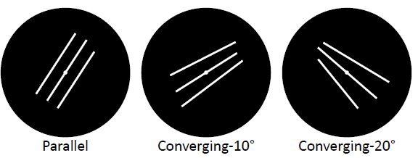

Figure 2. The three stages used to generate the visual stimuli in Experiment 1. (A) A vertical contour was drawn at the center of the screen and two other vertical contours were drawn to the left and to the right of the central contour. (B) The central contour was first rotated randomly between ± 10.0◦ from the vertical orientation. Once this was done, the left and right contours were rotated. For the parallel configuration, these peripheral contours were oriented to become parallel to the central contour. For a converging configuration, the peripheral contours were oriented toward a point on a line that was collinear to the central contour (dotted gray). The position of the dot was adjusted along the line to control the angle α between the two peripheral contours. (C) The whole configuration, containing 3 three contours, was rotated randomly between ± 180.0◦ around the center of the screen.
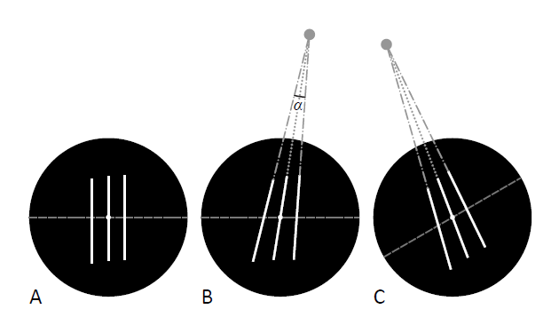
Note that the converging and parallel contours in a 2D image can be regarded as both the exact and approximate invariants of the parallel contours in a 3D scene. It is reasonable to assume that the visual system is sensitive to converging contours because they are the exact invariant of the correct perspective projection. But also note that it has been shown that an approximate invariant of this parallelism can play an important role when the visual system perceives the 3D shape of an object from its 2D image (Sawada & Pizlo, 2008; Sawada, 2010).
The second configuration discussed was the collinearity of the contours. The visual system is known to integrate two separated contours by interpolating between them if the contours are collinear with one another (Casco, Campana, Han, & Guzzon, 2009; Chen & Levi, 1996; Heeley & Buchanan-Smith, 1996; Kwon, Agrawal, Li, & Pizlo, 2016; Loffler, 2008; Westheimer & Ley, 1997). The sensitivity to a violation of collinearity is critical for the detection of the vertices of polygonal contours and for classifying types of junctions (e.g. T- and Y-junctions) and these are important features in contour drawings (e.g. Attneave, 1954; Walther & Shen, 2014; see also Kennedy & Domander, 1985). The sensitivity to the vertex of the polygonal contours has been studied by using a “chevron” task in which the observer discriminated between two directions of a L-junction (e.g. ‘<’ and ‘>’, Andrews, Butcher, & Buckley, 1973; Tyler, 1973; Uchikawa & Andrews, 1980; Watt, 1984). The sensitivity in the chevron task was very high and it was similar to the sensitivity observed in a “vernier” task in which the observer discriminated between left and right misalignments of two vertical line segments (Andrews et al., 1973; Watt, 1984). Note that the sensitivity observed in a vernier task is one of the hyperacuities in the visual system (Strasburger, Huber, & Rose, 2018; Westheimer, 1976).
In this study, we conducted two psychophysical experiments. Experiment 1 tested the sensitivity to parallel and converging configurations of contours, and Experiment 2 tested the sensitivity to parallel, perpendicular, and collinear configurations of contours. The sensitivity to these configurations was characterized by the orientation threshold of a single contour. This allowed us to compare the sensitivity to the configurations quantitatively, and to discuss why the visual system might be sensitive to the configurations of contours.

Experiment 1

A set of parallel contours in a 3D scene are projected to a set of parallel contours in a 2D image under an orthographic projection, but note that a projection from a 3D scene to a 2D retinal image is a perspective projection. The parallel contours in the scene are projected to contours that converge at a common point in the retinal image. This converging point is called the vanishing point of the parallel contours. In Experiment 1, we measured the orientation threshold for the configurations of parallel contours and converging contours.

  - Methods
The experiments reported in this study were conducted in accordance with the Code of Ethics of the World Medical Association (Declaration of Helsinki) and approved by the institutional review board (the HSE Committee on Interuniversity Surveys and Ethical Assess of Empirical Research).
    - Apparatus
The visual stimuli were displayed on a 120 Hz 24-inch LCD monitor (BenQ Zowie XL2411). The monitor’s screen size was 53.1 X 29.8 cm (1920 X 1080 pixels). A black panel (57 X 50 cm) with a circular aperture (29 cm diam.) was attached to the screen so that the center of the aperture coincides with the center of the screen. Observers viewed the screen binocularly from a distance of 160 cm in a dark room. Their eye-level was at the center of the screen, and their head was supported by a chinrest. A headrest was not used.
× ×
×
    - Stimuli
All stimuli consisted of three contours configured to be parallel to one another, or to converge at a point (Fig. 1). A central contour passed through the center of the screen. The two peripheral contours of the parallel configuration were parallel to the central contour. The relative orientation between the two peripheral contours of the converging configuration was 10.0◦ or 20.0◦ and the peripheral and central contours converged.
The stimuli were generated in three stages (Fig. 2). First, three vertical contours were drawn (Fig. 2A). One contour was drawn at the center of the screen and the other two contours were drawn to the left and to the right of the central contour with random eccentricities between 3.0 ± 0.3 cm. The distance of the endpoints of the contours from the eye-level (the dashed line in Fig. 2A) was chosen randomly between 8.0 ± 1.0 cm. This made the length of the contour 16.0 cm ± 2.0 cm.
Next, the orientation of the central contour was randomly changed within 10.0◦ from the vertical orientation (Fig. 2B). Once this was done, the orientations of the left and right contours were also changed. For the parallel configuration, the peripheral contours were oriented to become parallel to the central contour.

Figure 3. Results from Experiment 1. The ordinate shows the orientation threshold, and the abscissa shows the three types of configurations of contours. (A) Results of individual subjects. Error bars represent the standard errors calculated from two sessions for each condition. (B) Averaged results from all three subjects. Error bars represent the standard errors calculated from 6 observers.
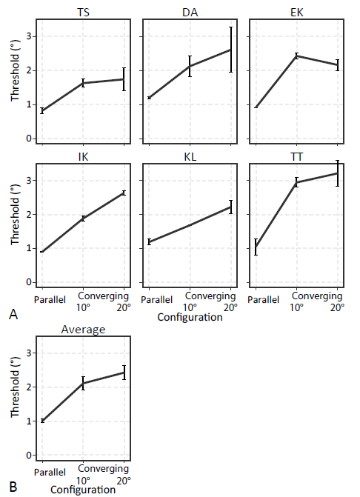

For a converging configuration, consider a line (the dotted gray line in Fig. 2B) that was collinear to the central contours and a point (the gray dot in Fig. 2B) on the dotted gray line. The peripheral contours were oriented toward this dot. The position of the dot was adjusted along the dotted gray line to control an angle (α in Fig. 2B) between the two peripheral contours. Two levels of α (10.0◦ and 20.0◦) were used for the converging configuration. In the last stage, the whole configuration with three contours was rotated randomly between ± 180.0◦ around the center of the screen (Fig. 2C).

    - Procedure
There were three conditions of the configurations: parallel, converging-10◦, and converging-20◦ (Fig. 1). Each block tested a single condition and the observer ran two blocks for each condition. The observer ran his/her first session with three blocks of all of the conditions in a random order. The observer then ran the other three blocks in the reverse order.
The Method of Constant Stimuli with the two-alternative-forced-choice design was used choice design was used in Experiment 1. Each trial began by fixating a point at the center of the screen for 250 ms that was followed by two intervals containing visual stimuli. The duration of each stimulus was 250 ms with a 250 ms inter-stimulus interval. Two configurations of contours were shown with random orientations in these stimulus in- tervals with one of the two configurations distorted. A response display screen was shown 250 ms after the offset of the second stimulus. The observer used a mouse to indicate which of the two configurations was not distorted. Audio feedback about the accuracy of the response was given after each response.
A configuration consisting of three contours was distorted by changing the orientation of the central contour. There were 8 levels of disorientation: 4.8◦, 4.2◦, 3.6◦, 3.0◦, 2.4◦, 1.8◦, 1.2◦, and 0.6◦. The observer ran 20 trials for each degree of distortion. The distorted configuration was shown in the first interval for 10 of the 20 trials. The remaining 10 trials were run in the second interval. Each block consisted of 160 trials with their order randomized.
The frequency of correct responses was plotted as functions of the levels of the disorientation of the configuration for each block. The two functions obtained were for two sets of trials in which the distorted configuration was shown in the first and in the second intervals, respectively. This pair of plots were analyzed by using a modified Method of Constant Stimuli (Appendix A) that was revised from the method used in Koshmanova and Sawada (2019). This revised method characterized the two plots with their orientation threshold as well as the response bias between the two intervals. The orientation threshold represented the uncertainty of the perceived orientation of the central contour. Note that the observer judged whether the central contour was disoriented or not based on the peripheral contours. The uncertainty represented by the orientation threshold was based the perception of both the central contour and the peripheral contours (see Appendix A for details).
The observers were two of the authors (EK and TS) and 4 volunteers. All had normal or corrected-to-normal vision. The volunteers were naïve about the purpose of the study. EK, TS, and one of the volunteers (KL) had previous experience participating in psychophysical experiments. The other 3 volunteers (DA, IK, and TT) had no prior experience in psychophysical experiments
  - Results
Fig. 3 shows the estimated orientation thresholds of individual observers in Experiment 1. It also shows their averaged results. The ordinate shows the estimated orientation threshold. The abscissa shows the three types of the configurations of contours. These results were analyzed by using a one-way ANOVA with repeated measures. The main effect of the type of the configuration was significant (F_{2,10} = 33, p = 3.8 X 10—5). An a posteriori test (Tukey) showed that the orientation threshold was lower with the parallel configuration than with the converging contours of 10◦ (p = 3.3 X 10—4) and of 20◦ (p = 4.1 X 10—5). The difference in the thresholds between the two angles of the converging configurations was not statistically significant (p 0.25).
Experiment 1 compared the sensitivity of the visual system to parallel and converging configurations of contours. The results showed that the visual system is less sensitive to converging contours than to parallel contours. Note that this difference in sensitivity could be explained by the geometrical properties of these configurations because the converging configuration is more complex geometrically than the parallel configuration. Consider the parallel configuration first. Its peripheral contours were parallel to one another and their common orientation is the proper orientation of the central contour that forms the parallel configuration. This proper orientation only depends on the orientation of the peripheral contours. Now, consider a converging configuration. Its peripheral contours converge at a point and this point specifies the proper orientation of the central contour that forms the converging configuration. The central contour with the proper orientation converges at this point. The position of the converging point depends on both the orientations and the positions of the peripheral contours. The converging configuration is more complex geometrically than the parallel configuration because the positions of the contours affect the converging configuration but they do not affect the parallel configuration. This difference in the geometrical properties of these configurations could explain the difference in sensitivity observed between the configurations. This hypothetical explanation was tested by using the computer simulation described in Appendix B where it was not sup- ported (see Appendix B for details).

Figure 4. The 3 types of contour configurations (parallel, perpendicular and collinear) with the 3 levels of eccentricities of the contours (1.0 cm, 2.0 cm, and 3.0 cm). The black circles represent the circular aperture (29 cm in diameter) attached to the computer screen. The contours, which were 1.0 mm (2.15 arcmin) wide in the visual stimuli, were made wider in this Figure to make them visible.
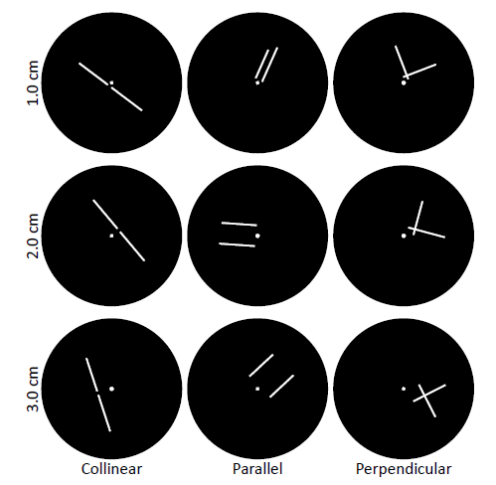

Figure 5. The position of each contour (solid white line segment) that composed the configurations. A dotted gray line is collinear with this contour. The eccentricity of the contour (gray arrow) was defined as the distance of this dotted gray line from the center of the screen (small white disk). The dashed gray line that passes the center of the screen is perpendicular to the dotted gray line. The distance of the two endpoints of the contour from the dashed gray line was chosen randomly between 0.5 ± 0.25 cm and between 8.0 ± 1.0 cm.
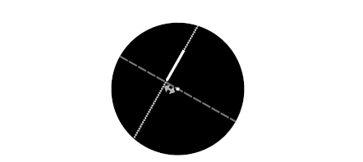

Figure 6. The results obtained in Experiment 2. The ordinate shows the orientation threshold, the abscissa shows the 3 levels of the eccentricity, and the symbols show the 3 types of the configurations. (A) Results of individual observers. (B) Averaged results from all six observers. Error bars show the standard errors calculated for 6 observers for the collinear and parallel conditions and for 5 observers for the perpendicular condition
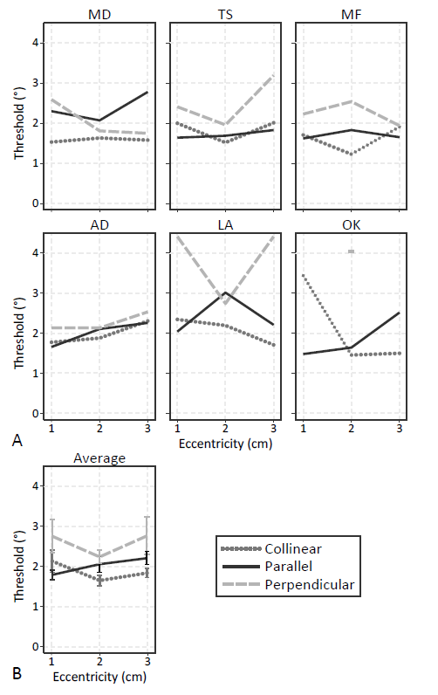

Figure 7. The results obtained in our control experiment with the collinear configuration. The ordinate shows the orientation threshold, the abscissa shows the 2 levels of the eccentricity. (A) Results of individual observers. (B) Averaged results from all three observers. Error bars show the standard errors calculated from 3 observers.
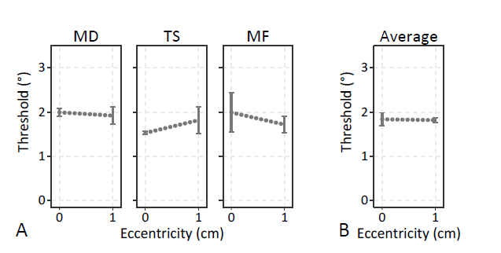

Experiment 2

Experiment 1 showed that the visual system is more sensitive to parallel contours than to converging contours. In Experiment 2, we measured the orientation threshold for the configurations of parallel contours with the sensitivity to the configurations of collinear and perpendicular contours. The collinear configuration was tested because the visual system was expected to be also sensitive to this configuration. The perpendicular configuration was also tested because it could serve as a reference for evaluating the difference in sensitivity between the parallel and collinear configurations. It was shown that the sensitivity to the perpendicular configuration was lower than the sensitivity to the parallel configuration but it was still higher than the sensitivity to the configurations of contours that formed the other angles (Chen & Levi, 1996; Heeley & Buchanan-Smith, 1996; Koshmanova & Sawada, 2019; Xu et al., 2018).
  - Methods
The same apparatus setting was used in both Experiments 1 and 2.

    - Stimuli
All stimuli consisted of two contours configured to be: 180◦ (collinear), 0◦ (parallel), or 90◦ (perpendicular) with respect to each other (see Fig. 4). The orientation of the whole configuration was random. Now, consider a line that was collinear to a contour within the configuration (the dotted gray line in Fig. 5). The eccentricity of this contour was defined as the distance this dotted gray line is from the center of the screen. Eccentricities of 1.0, 2.0, and 3.0 cm were used with a random perturbation between 0.30 cm. The eccentricity of the contour was the same as the eccentricity of the other contour within the configuration. Next, consider a line that is perpendicular to the dotted gray line and passes the center of the screen (the dashed gray line in Fig. 5). The distance of the two endpoints of the contour from this dashed gray line was chosen randomly between 0.5 ± 0.25 cm and between 8.0 ± 1.0 cm. This made the length of the contour 7.5 cm +- 1.25 cm. The width of the contour was 1 mm. The luminance of the contours was 297 cd/m2 and it was drawn on a dark background (0.48 cd/m2).
±
    - Procedure
There were nine (3 X 3) conditions of configurations: 3 types: collinear, parallel, or perpendicular, and 3 levels of eccentricity: 1.0, 2.0, or 3.0 cm. Each block tested a single condition and the observer ran one block for each condition. The order of blocks was randomized.
The Method of Constant Stimuli with the two-alternative-forced-choice design was used in Experiment 2. The same procedure was used in both Experiments 1 and 2. Two configurations of contours were shown with random orientations in two stimulus intervals with one of the two configurations distorted. The observer indicated which of the two configurations was not distorted.
A configuration consisting of two contours was distorted by changing the relative orientation between two of the contours. There were 9 levels of disorientation: 4.6◦, 3.7◦, 2.9◦, 2.2◦, 1.6◦, 1.1◦, 0.7◦, 0.4◦, and 0.2◦. The observer ran 20 trials for each degree of distortion. The distorted configuration was shown in the first interval for 10 of the 20 trials, and in the second interval for the other 10 trials. Each block consisted of 180 trials with their order randomized.
The frequency of correct responses was plotted as functions of the levels of the disorientation of the configuration for each block. The two functions obtained were for two sets of trials in which the distorted configuration was shown in the first and in the second intervals, respectively. This pair of plots were analyzed by using the modified Method of Constant Stimuli used in Koshmanova and Sawada (2019). Their method characterized the two plots with their orientation threshold as well as the response bias between the two intervals. The orientation threshold represented the uncertainty of the perceived orientation of a single contour based on the assumption that the contours forming each configuration were perceived individually, and that they were integrated linearly.
The observers were two of the authors of this study (MD and TS) and 4 volunteers: all had normal or corrected-to-normal vision. The authors and one of the volunteers (MF) had previous experience participating in psychophysical experiments. The other 3 volunteers (AD, LA, and OK) had no prior experience in psychophysical experiments.
  - Results

Fig. 6 shows the estimated orientation thresholds of individual observers in Experiment 2. It also shows their averaged results. The ordinate shows the estimated orientation threshold. The abscissa shows the eccentricity of the contours. The symbols show the types of the configurations. Note that the performance of OK was very low with the perpendicular configuration and that a threshold could not be estimated with the perpendicular configuration with an eccentricity of 1 cm. OK’s results with the perpendicular configuration were eliminated from all subsequent analyses.
These results were analyzed by using a two-way ANOVA with repeated measures on both factors (Neter, Kutner, Nachtsheim, & Wasserman, 1996), i.e., the three types of configurations (collinear, parallel, and perpendicular) and the three levels of eccentricity (1.0 cm, 2.0 cm, and 3.0 cm). The main effect of the type of configuration was significant (F_{2,37.9} = 8.2, p = 0.0011 X 3, where 3 is multiplied for a Bonferroni correction, see Cramer et al., 2016). The main effect of eccentricity (F_{2,37.2} = 1.4, p = 0.27 × 3) and the interaction between these two factors were not significant (F_{4,37.2} = 1.3, p = 0.28 X 3).
An a posteriori test (Tukey) was performed to test the main effect of the type of configuration. The threshold was higher with the perpendicular configuration than with the collinear configuration (p = 0.0012) and with the parallel configuration (p = 0.010). There was no significant difference of the threshold between the collinear and parallel configurations (p = 0.68).
Experiment 2 showed that the sensitivity to the parallel configuration of contours is similar to the sensitivity to the collinear configuration and that the sensitivity to these configurations is higher than the sensitivity to the perpendicular configuration. We did not observe any statistically reliable differences in sensitivity to the collinear and parallel configurations. The sensitivity to the configurations was robust against the eccentricity of the contours that composed the configurations within the range of 1.0 cm to 3.0 cm. The higher sensitivity to the parallel configuration than to the perpendicular configuration, and the robustness of the sensitivity to the parallel and perpendicular configurations against the eccentricity of the contours were also observed by Koshmanova and Sawada (2019).
  - Control experiment

The orientation threshold with the collinear configuration of contours was tested with the non-zero eccentricity of the contours in Experiment 2. Note that in prior studies that measured the sensitivity to the detection of the vertex of a polygonal contour, the vertex was placed at a fixation point and its eccentricity was set to zero. In a control experiment, the orientation threshold with the collinear configuration was measured for 2 levels of the eccentricity, namely, 0.0 cm and 1.0 cm of the eccentricity. In this control experiment, the eccentricity was not randomly perturbed. The two conditions were blocked and the observer ran two blocks for each condition. The authors and one of the volunteers (MF) participated the control experiment.
Fig. 7 shows the estimated orientation thresholds observed in the control experiment for individual observers and their averaged results. The ordinate shows the estimated orientation threshold. The abscissa shows the eccentricity of the contours. These results were analyzed by using a paired t-test. A significant difference of the thresholds was not observed (t₂ = 0.12, p = 0.92). Based on the results of Experiment 2 and the Control experiment, it was possible to suggest that the sensitivity to the parallel configuration of contours is similar to the sensitivity to the collinear configuration of contours even when the contours of the collinear configuration are at the fixation point.

Discussion
Experiment 1 compared the sensitivity of the visual system to parallel and converging configurations of contours. The results showed that the visual system is less sensitive to converging contours than to parallel contours. This difference of the sensitivity cannot be explained by the geometrical properties of these configurations (see Appendix B). Experiment 2 compared the sensitivity of the visual system to 3 types of configurations of contours: parallel, collinear, and perpendicular. The results showed that the system is more sensitive to the parallel and collinear configurations than to the perpendicular configuration. We did not observe any statistically reliable differences in sensitivity to the parallel and collinear configurations. The sensitivity to the configurations was robust against the eccentricity of the contours composing the configurations within the range of 1.0 cm and 3.0 cm. The sensitivity to the collinear configuration was also tested with zero eccentricity in a Control experiment, and we also did not observer any statistically reliable change in the sensitivity.
The sensitivity to the parallel configuration was higher than the sensitivity to the converging configuration. A set of parallel contours and a set of converging contours in a 2D retinal image can be regarded as both the approximate and exact invariants of a set of parallel contours in a 3D scene (see Appendix B). Note that the parallel contours in a 3D scene are projected to parallel contours under a 2D orthographic projection. An orthographic projection is often used as an approximation to a perspective projection, which is the most accurate projection of a 3D scene to its 2D retinal image.
Note That the parallel contours in the scene are projected to a set of converging contours under a perspective projection. The results of Experiment 1 suggest that the visual system is more sensitive to the approximate invariant than to the exact invariant of the correct perspective projection. Also, note that the sensitivity to the parallel configuration was similar to the sensitivity of the collinear configuration, and that the approximate invariant of the parallel con tours worked when the size of an object that has parallel contours in a 3D scene is sufficiently small relative to its viewing distance (10% of the viewing distance, see Appendix B). This suggests that the visual system uses the rules of the orthographic projection, at least partly, for processing the retinal image of a small object (see Hagen & Elliot, 1976; Sawada & Pizlo, 2008; Sawada, 2010). If the retinal image is larger, the visual system needs to rely on the exact invariant of the correct perspective projection that is provided by the converging configuration of contours.
The visual system is sensitive to a converging configuration of contours but this sensitivity to a converging configuration was not as high as it was to a parallel configuration. The converging configuration of contours in a 2D retinal image is also an important image feature for perceiving the 3D information contained in a scene. This is commonly referred to as linear perspective, which is one of the pictorial depth cues (Howard, 2012; Sedgwick, 1986). The set of parallel contours in a 3D scene are projected to a set of converging contours in its retinal image. It is possible to recover the 3D orientation of these contours in the scene from their vanishing point, that is, the point to which the contours in the image are converging. Note that a line that connects the vanishing point to the eye of an observer is parallel to the contours in the scene. Also note that uncertainty about the perceived orientation and position of the contours in the image leads to uncertainty about the perceived position of the vanishing point (see Appendix C). This uncertainty about the perceived position of the vanishing point also leads to uncertainty about the perceived 3D orientation of the contours in the scene if the perception of the 3D orientation is based on the vanishing point.
Why is the visual system more sensitive to the parallel configuration, which is only an approximate invariant under the correct perspective projection, than it is to the converging configuration, which is an exact invariant? The parallel configuration is computationally simpler than the converging configuration because it is characterized only by the orientations of contours composing the configuration. The converging configuration is characterized by both the orientations and the positions of the contours (see Appendix C). The parallel configuration can be composed of only 2 or more than 2 contours but the converging configuration requires 3 contours, at least. It is worth pointing out that a pair of contours in a natural 3D scene is never exactly parallel to one another. Such roughly-parallel contours in a 3D scene are projected to contours that are not exactly converging in the retinal image but they are roughly-parallel and roughly-converging in the image under a perspective projection. Roughly-parallel contours in a 3D scene can be detected by finding either the roughly-parallel or the roughly- converging configurations in the 2D image. The visual system can find the roughly-parallel configuration more easily than the roughly-converging configuration because finding the roughly-parallel configuration can be based only on the orientations of two contours in the image but finding the roughly-converging configuration requires using both the orientations and the positions of three contours (see Sawada & Pizlo, 2008; Sawada, 2010). Note that the 3D orientation of the contours in the 3D scene can only be recovered from the converging configuration as linear perspective but not from the parallel configuration. It is possible that the visual system makes use of both the parallel and converging configurations, individually, for detecting and for recovering a set of parallel contours in a 3D scene.
The collinear configuration is one of important cues that the visual system uses to organize contours in a 2D retinal image (Koffka, 1935; Leeuwenberg & van der Helm, 2013; Li, 1998; Loffler, 2008; Metzger, 2009/1936; Wagemans et al., 2012; Wagemans, 1992). The collinear configuration is an invariant in both an orthographic and a perspective projection and a pair of collinear contours in a 3D scene is always projected to a pair of collinear contours in a 2D retinal image. It is reasonable to assume that a collinear configuration in a retinal image is a projection of collinear contours in the scene except for an accidental case, and one can also assume that collinear contours in a scene belong to a single object except in an accidental case. Contours in an image can be organized into images of individual objects on the basis of the collinear and some other configurations (Biederman, 1987; Elder, 2015; Kwon et al., 2016; Witkin & Tenenbaum, 1983).
The sensitivity to the collinear configuration can also be important for the visual system to detect angular vertices of contours in an image. The angular vertex of a contour is the point at which two neighboring segments of the contour violate the collinearity configuration. The angular vertices in an image are important image features for recovering the 3D shapes of objects and for recognizing the objects (Attneave, 1954; Sawada & Pizlo, 2008; Koenderink, 1984; Koenderink & Van Doorn, 1982, see also Kennedy & Domander, 1985).
A perpendicular configuration is not an invariant under either an orthographic or a perspective projection. A pair of perpendicular contours in a scene can be projected to a pair of contours that form any angle in the retinal image but the angle in the image is perpendicular more frequently than any other angle (Xu et al., 2018). Note that the sensitivity to a perpendicular configuration was lower than the sensitivity to both the parallel and collinear configurations (Experiment 2), but it was still higher than the sensitivity to the configurations of the contours that formed all of the other angles (Chen & Levi, 1996; Heeley & Buchanan- Smith, 1996; Koshmanova & Sawada, 2019; Xu et al., 2018). This moderately high sensitivity can be attributed to a property of the perpendicular configuration, which is not the invariant, but is more frequently found in a retinal image.
The sensitivity to the parallel configuration was analogous to the sensitivity to the collinear configuration. Note, however, the mechanisms explaining the sensitivity to these configurations can be different from one another. Note also that the visual system is highly sensitive to a collinear configuration composed of 2D Gabor patterns (e.g. Field, Hayes, & Hess, 1993; Loffler, 2008; Polat & Sagi, 1994; Polat, 1999). Such high sensitivity is not observed with Gabor patterns when their orientations are parallel to one another but not located collinearly. The high sensitivity observed to collinear Gabor patterns is often associated with a facilitatory interaction of neurons in V1 (Loffler, 2008; Polat, 1999). Activity of some neurons in V1 are facilitated by other neurons whose receptive field patterns are collinear to the receptive field pat- terns of the facilitated neurons (Polat, Mizobe, Pettet, Kasamatsu, & Norcia, 1998). This facilitatory effect of V1 neurons can also explain the sensitivity to the collinear configuration of contours (Li, 1998; Kwon et al., 2016, see also Xu et al., 2018) but it cannot explain the sensitivity to the parallel configuration of contours. It is possible that the sensitivity to the parallel configuration can be attributed to activities in the higher- order visual areas (e.g. Costa, Orsten-Hooge, Gaudencio Rego, Wagemans, & Pomerantz, 2018; Seymour, Karnath, & Himmelbach, 2008).
We can perceive 3D information from a contour drawing. Note we know that the visual stimuli used to study 3D perception cannot be random or overly simple if they are going to allow 3D perception (Kwon et al., 2016; Minkov & Sawada, 2021; Pizlo & Salach-Golyska, 1994; Pizlo, 2008). The 2D image must contain configurations that are associated with the kind of a priori constraints that can be used by the visual system for the perception of 3D (Pizlo et al., 2014; Sawada, Li, & Pizlo, 2015). There are also configurations in a 3D scene that can affect the sensitivity to features in the scene (e.g. Glennerster & McKee, 1999; Norman & Todd, 1996; see also Minkov & Sawada, 2021; Sawada, 2021). These configurations should be studied, quantitatively, to further our understanding of the mechanisms that facilitate our visual system’s perception of 3D.

CRediT authorship contribution statement
Maria Dvoeglazova: Formal analysis, Investigation, Data curation, Writing - original draft, Visualization. Ekaterina Koshmanova: Formal analysis, Investigation, Data curation, Writing - original draft, Visualization. Tadamasa Sawada: Conceptualization, Methodology, Software, Validation, Resources, Writing - review & editing, Visualization, Supervision, Project administration, Funding acquisition.

Acknowledgement
This manuscript was prepared as a result of a project “Visual perception in our everyday life” within the framework of the Academic Fund Program at the National Research University Higher School of Economics (HSE University) in 2019 (grant N◦ 19-04-006) and by the Russian Academic Excellence Project «5-100».

Appendix A. The modified method of constant stimuli used for analyzing the results of Experiment 1
All of the stimuli used in Experiment 1 consisted of two peripheral contours and one central contour configured to be parallel to one another, or to converge to a point. The peripheral contours of the configuration specified the proper orientation of the central contour. The configuration was distorted when the actual orientation of the central contour was different from the proper orientation specified by the peripheral contours.
Assume that the visual system independently processes the specified orientation from the peripheral contours and the orientation of the central contour. The perception of the specified orientation can be represented as a normal distribution:
where φ is the perception of the specified orientation, φ is the true specified orientation, and σs represents the uncertainty of the perception. The perception of the orientation of the central contour can be also represented as a normal distribution:
where θ is the perceived orientation of the central contour, θ is the actual orientation of the central contour, and σc represents the uncertainty of the perception. When this is done, a probability distribution representing the perception of the relative orientation between any two contours can be derived by using the cross-correlation of two distributions of their perceived orientations:

where ⋆ is the cross-correlation operation. Eq. (A.3) is also a normal distribution whose mean is θ - ˙φ and whose standard deviation is 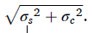
Note that θ - ˙φ is zero without any distortion of the configuration. In Experiment 1, the standard deviation of this distribution is referred to as the “orientation threshold”.
The perceived distortion of the configuration can be characterized as: |θ — φ|. The probability distribution of the distortion |θ — φ| is:
Note that in Experiment 1, the responses of the observers were collected with the Two-Alternative-Forced-Choice method. The observer was shown two configurations of contours in two stimulus intervals with one of the two configurations distorted. The observer indicated which of the two configurations was not distorted. This task can be modeled as follows. The observer compares the perceived distortions of the configurations, and chooses the configuration that was less distorted. This model is mathematically formulated in Koshmanova and Sawada (2019).
Let d₁ and d₂ be the perceived distortions of two configurations in two stimulus intervals. Their probability distributions P_{d1} and P_{d2} are individually represented by using Eq. (A.4). The probability distribution of the difference between d₁ and d₂ is:
where ˙ φ1 and ˙ φ2 are the proper orientations specified by the peripheral contours and ˙ θ1 and ˙θ2 were the actual orientations of the central contours in the first and second intervals. It is assumed that the standard deviation σs of the perception of the specified orientation and the standard deviation σc of the perception of the orientation of the central contour are constant across the intervals.
The observer decides that the configuration in the first interval is not distorted if d₂ - d₁ > β where β is a response bias. The probability that the observer decides that that the first interval is not distorted can be computed as:
In Experiment 1, the orientation threshold 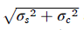and the response bias β were estimated from the data obtained in each block. Note that the distortions in the two intervals were controlled so that 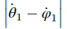 took on several different values while 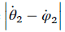was 0 in a half of the trials in the block.
In the other half of the trials,took several different values while was 0. The observer’s percent correct was measured and plotted as a function of for the trials with = 0 and as a function of for the trials with = 0. The orientation threshold and the response bias β were estimated from these two plots by using the maximum likelihood method.

Appendix B. Geometrical properties of parallel and converging configurations of contours

Experiment 1 tested the sensitivity of the visual system to parallel and converging configurations of three contours. The results showed that the visual system is less sensitive to converging contours than to parallel contours. This difference in sensitivity could be explained by the geometrical properties of these configurations because the converging configuration was more complex geometrically than the parallel configuration. In this Appendix, the sensitivity of these configurations was also compared with respect to the geometry of these configurations.
Each configuration was formed by three contours when the central contour of the configuration had the proper orientation that was specified by two peripheral contours in the configuration. The configuration was distorted when the actual orientation of the central contour was different from the proper orientation. The perception of the individual peripheral contours can be represented as two independent normal distributions:
where ψl and ψr represent the perception of the peripheral contours, ψl and ψr are their actual orientations, and σlr represents the uncertainty of the perception. The perception of the central contour can also be represented as a normal distribution whose standard deviation is σc (Eq. (A.2) in Appendix A).
The peripheral contours of the parallel configuration were parallel to one another (ψl = ˙ψr ) and their common orientation is the specified orientation of the central contour. With the uncertainty of the perceived orientations ψl and ψr of the peripheral contours, the specified orientation can be modeled as the average of ˙ ψl and ˙ψr :
Fig. B1. The results of the simulation experiment. The ordinate shows the estimated orientation threshold. The abscissa shows the types of configurations of contours. The average thresholds measured for the observers in Experiment 1 were superimposed to facilitate comparison (gray).
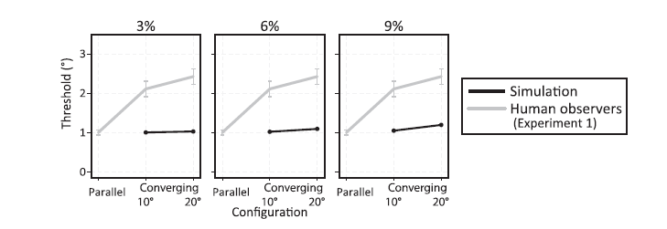
where ψ0 represents the perception of the average orientation and . The standard deviation of the normal distribution in Eq. (B.2) is σlr /and it is represented as σs in Eq. (A.1) in Appendix A. Note that in Experiment 1, the “orientation threshold” refers to 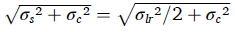(Appendix A). Experiment 1 showed that the measured threshold of the observers with the parallel configuration was about 1◦ (Fig. 3). Now let σlr and σc be in this Appendix so that when we assume (see Experiment 2 in Koshmanova & Sawada, 2019).
Now, consider the converging configuration. The peripheral contours of the converging configuration are not parallel to one another and they converge at a point. This converging point specifies the proper orientation of the central contour that forms the converging configuration. The central contour with the proper orientation converges at this point. Note that the position of the converging point depends on both the orientations and the positions of the peripheral contours. The uncertainty of the perceived orientations and positions of the peripheral contours introduces some uncertainty in the perceived proper orientation of the central contour.
The uncertainty of the perceived proper orientation of the central contour was estimated in a Monte-Carlo simulation experiment. In each trial of this simulation experiment, the converging configuration of three contours were first generated in the same way this was done in Experiment 1. Specifically, the central contour was drawn at the center of the screen and the two peripheral contours were drawn to the left and to the right of the central contour with their eccentricities varied randomly between 3.0 ± 0.3 cm. The orientation of the central contour was randomly set between ± 10.0◦ from the vertical. The peripheral contours were oriented so that all three of the contours converged at a point and the angle between the pe ripheral contours was 10.0◦ in the converging-10◦ condition and at 20.0◦ in converging-20◦ condition.
Next, consider the orientations and the positions of the peripheral contours that were randomly perturbed to represent their uncertainty. This perturbation of the orientations was the normal distribution shown in Eq. (B.1) with assuming that . The perturbation of the positions was a normal distribution along the horizontal orientation. The standard deviation of this normal distribution was 3%, 6%, and 9% of the eccentricities of the peripheral contours (see Chan, Stevenson, Li, & Pizlo, 2006; M. Levi & A. Klein, 1990).
Finally, the intersection of the perturbed peripheral contours and its orientation from the center of the screen were computed. This orientation was the perturbed “proper” orientation of the central contour that was specified by the perturbed peripheral contours. The difference between the perturbed and actual proper orientations of the central contours was measured.
The conditions used in the simulation experiment included two settings in which the converging angle between the peripheral contours were, 10.0◦ and 20.0◦ and three levels of the perturbation of the positions of the peripheral contours, 3%, 6%, and 9%. There were 106 trials in each condition and the standard deviation of the measured difference between the perturbed and actual proper orientations was estimated from these trials. This standard deviation represents the uncertainty of the perceived proper orientation of the central contour σs with the converging configuration. From the estimated σs, the “orientation threshold” 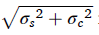in Experiment 1 can be computed where σc is the standard deviation of the orientation of the central contour. Note that both σc and the standard deviation σlr of the orientation of the individual peripheral contours were estimated to be 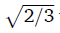with the parallel configuration, so the analytically-computed threshold becomes approximately equal to the thresholds of the observers measured in Experiment 1 (Eq. (B.2)). In this simulation experiment with converging configurations, σc and σlr were also assumed to be to allow a comparison of the converging configurations with the parallel configurations.
Fig. B.1 shows the “orientation thresholds” that were estimated from the simulation experiment. The average thresholds measured for the observers in Experiment 1 are superimposed for comparison. The ordinate shows the estimated orientation threshold. The abscissa shows the types of configurations of contours. The thresholds estimated for the converging configuration are slightly above 1.0, which is the analytically-computed threshold with the parallel configuration. The estimated threshold is only slightly affected by the difference in the geometrical properties of the converging and parallel configurations. The thresholds estimated in the simulation experiment are clearly lower than the thresholds measured in Experiment 1 with the converging configuration. These results suggest that the difference observed between the human sensitivity to the parallel and converging configurations could not be explained by the geometrical properties of these configurations. Furthermore, our visual system could have a mechanism that is tuned to the parallel configuration rather than tuned to a more general converging configuration that includes the parallel configuration.

Fig. C1. (A) Histograms of the relative orientation between c_{A} and c_{B} for each value of the size S. The ordinates show the frequency and the abscissas show the orientation. The tails of the histograms were cut off at 0.001◦ and at 100◦. (B) Histograms of the normalized orientation between c_{A} and c_{B} for each value of the size S. The ordinates show the frequency and the abscissas show the normalized orientation. The normalize orientation was computed by normalizing the relative orientation c_{A} and c_{B} with the orientation threshold of c_{B} (Eq. (A6)). The tails of the histograms were cut off at 0.0001 and at 10. The dashed vertical lines represent the threshold.
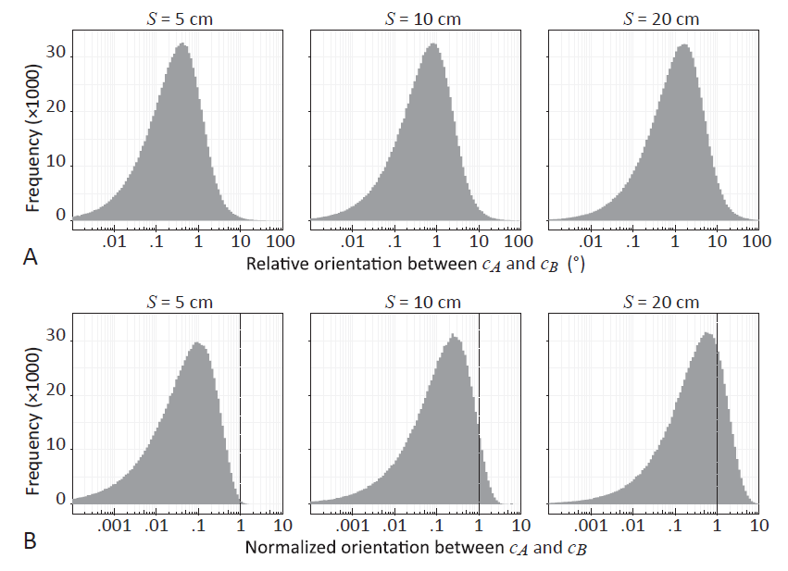

Fig. C2. The frequency of the normalized orientation above the threshold as a function of the size S. The ordinates show the frequency of the normalized orientation above the threshold and the abscissas show the size S.
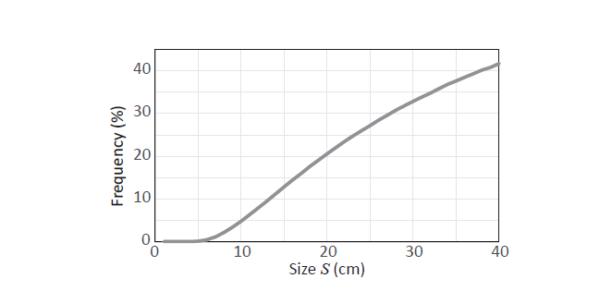

Appendix C. Parallelism of contours as an approximate invariant of a perspective projection
A projection from a 3D object to a 2D retinal image is a perspective projection but note that a 2D orthographic projection is often used as an approximation to a perspective projection. The orthographic projection is a good approximation of the perspective projection when the object is small relative to the viewing distance and when it is around the center of projection (Aloimonos, 1990; DeMenthon & Davis, 1992; Pizlo & Rosenfeld, 1992; Pizlo, 1991).
A set of parallel contours in a 3D scene are projected to a set of contours that converge at a common point in a 2D image under a perspective projection, and they project to a set of parallel contours in the image under an orthographic projection. The converging and parallel contours in the 2D retinal image can be regarded as both the exact and approximate invariants of parallel contours in a 3D scene. Experiment 1 showed that the visual system is more sensitive to the parallel contours than to the converging contours. In this appendix, we describe a simulation experiment designed to evaluate how well the parallelism of contours works as an approximate invariant of a perspective projection.
Now, consider a 2D perspective projection of a 3D scene. The XYZ Cartesian coordinate system of the scene and the xy Cartesian coordinate system of a 2D image of the projection are set as follows: (i) the Z-axis of the 3D coordinate system is perpendicular to the image plane ΠI and ΠI is Z = 0, (ii) the Z-axis passes through the origin of the 2D coordinate system, and (iii) the X- and Y-axes of the 3D coordinate system coincide with the x- and y-axes of the 2D coordinate system, respectively. The center of projection is set at [0 0 f]t where f is a positive constant that represents the focal distance. Under this condition, a point [X_{3D} Y_{3D} Z_{3D}]t in a 3D scene is projected to [x_{p2D} y_{p2D}]t = [fX_{3D}/(f - Z_{3D}) fY_{3D}/(f- Z_{3D})]t.
Now, consider a pair of parallel contours C_{A} and C_{B} that are a part of an object around the origin of the 3D scene. The endpoints of C_{A} are [0 0 L₀]t and [0 0 L₁]t where |L₁ — L₀| represents the length of the contours. The endpoints of C_{B} are [D 0 L₀]t and [D 0 L₁]t where D represents the distance between C_{A} and C_{B}. The contours C_{A} and C_{B} are rotated together in the scene around the origin. This rotation can be characterized by slant ωS , tilt ωT, and roll ωR: the contour pair is rotated first around the Z-axis for ωR — ωT, around the Y-axis for ωS, and finally around the Z-axis for ωT. The perspective projections of the rotated contours are contours c_{A} and c_{B} in the 2D image that converge at their vanishing point. The vanishing point is an intersection of the image plane ΠI with a line that passes the center of projection [0/0 f]t and that is parallel to the rotated contours. The contour c_{A} passes the origin of the 2D image that is the principal point of the perspective projection and the orientation of c_{A} is the same as the orientation of the contours that are 2D orthographic projections of C_{A} and C_{B}, so the relative orientation between c_{A} and c_{B} can be used as a measure how much the parallelism of the contours is violated.
First, we tested the frequencies of the relative orientation between c_{A} and c_{B} in a Monte-Carlo simulation experiment. In each trial of the simulation experiment, the contours C_{A} and C_{B} in the 3D scene were randomly generated and rotated. Second, we measured the relative orientation between c_{A} and c_{B}. We also measured the length of c_{B} and the eccentricity of its midpoint from the origin of the 2D image were.
The contours C_{A} and C_{B} were generated by randomly sampling L₀, L₁, and D as follows
where random(r₁, r₂) was a random number generator of a uniform distribution between r₁ and r₂ and S was a constant representing the size of the object of C_{A} and C_{B}. The random rotation of C_{A} and C_{B} was generated so that the 3D orientation of C_{A} and C_{B} became uniformly distributed across the trials. It could be done by randomly sampling the slant ωS, tilt ωT, and roll ωR as follows:
Note that, if ωS were uniformly distributed between 0◦ and 360◦ (ωS = random(0, 360)), the 3D orientation of C_{A} and C_{B} would become biased and would tend to be close to the orientation of the Z-axis. If D were uniformly distributed between 0 and S (D random(0, S)), the position of C_{B} would become biased and would tend to be close to the origin of the 2D image.
The focal distance f was set to 100 cm in the simulation experiment. The size S of the object was an independent variable (5, 10, and 20 cm) in this experiment. There were 106 trials for each value of S.
The results of this simulation experiment are shown in Fig. C.1A. Histograms of the measured orientation between the contours c_{A} and c_{B} in the 2D image are plotted for each value of the size S. The ordinates show the frequency and the abscissas show the orientation. The histograms show that the orientation is widely distributed for each S. The shapes of the histograms are analogous to one another but their positions shift from left to right as the size S increases. This change means that the contours c_{A} and c_{B} in the 2D image are closer to being parallel more frequently when the size S is smaller.
Next, consider how well the visual system can see the orientation of a single contour. This can be characterized by the orientation threshold σ of the contour that represents the uncertainty of the perceived orientation of a single contour. The orientation threshold σ depends on the length l and eccentricity ε of the contour. The threshold σ becomes smaller and it approaches the minimum threshold σ_{min} asymptotically as the contour becomes longer and as its eccentricity becomes smaller (Mäkelä, Whitaker, & Rovamo, 1993; Scobey, 1982; Vandenbussche, Vogels, & Orban, 1986). This relation can be formulated with the following equation (Mäkelä et al., 1993):
where p, l_{k}, and εk are constants. In Eq. (C.3), the contour length l is scaled as a function of the eccentricity ε:
Eq. (C.3) is approximately equal to σ_{min} when the length l of the contour is sufficiently large and is approximately equal to:
when the length l is sufficiently small. The constant l_{k} represents the scaled length l_{s} that makes Eq. (C.5) equal to σ_{min}. Mäkeläet al. (1993) estimated the constants concerned with the length and eccentricity of the contour on the basis of their psychophysical experiments that measured the orientation threshold: p = 0.5, l_{c} = 14.5/60 (◦), and εk = 1.95 (◦).
The minimum threshold σ_{min} was estimated by using data from the parallel condition of Experiment 2 in the present study (see Fig. 6). Note that this Appendix discusses how well the parallelism of contours works as an approximate invariant of a perspective projection. The contours c_{A} and c_{B} in the 2D image are perspective projections of the parallel contours C_{A} and C_{B} in the 3D scene. This approximate invariant works well if the orientation c_{A} and c_{B} is small relative to the orientation threshold. The results of Experiment 2 showed that the orientation threshold for detecting the parallelism of contours was about 2◦. The average length of the contours was 2.68◦ and the average eccentricities of their midpoints was 1.56◦, 1.68◦, and 1.86◦ in the three conditions of the eccentricity of the contours. Then, the minimum threshold σ_{min} was estimated to be 1.48◦, 1.47◦, and 1.45◦ in the conditions of the eccentricity by using Eq. (C.3). The minimum threshold σ_{min} was set to be 1.5◦ in order to analyze the results of the simulation experiment.
The relative orientation α_{AB} between the contours c_{A} and c_{B} in the 2D image was normalized by the orientation threshold of c_{B}:
where l_{B}, and ε _{B} are the length and eccentricity of c_{B}. Note that l_{B}, and ε _{B} were also measured as well as the relative orientation between c_{A} and c_{B} in each trial of the simulation experiment.
Measurements of the normalized orientation α_{AB} are plotted as histograms in Fig. C.1B. The ordinates show the frequency and the abscissas show the normalized orientation. The positions of the histograms shift from left to right and the frequency of the normalized orientation above the threshold 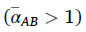becomes higher as the size S increases. The frequencies are 0.075%, 4.8%, and 20% for the 3 values of S (5 cm, 10 cm, and 20 cm).
The effect of the size S on the normalized orientation was further tested with finer samples of S (1 cm, 2 cm, … 40 cm). There were 106 trials for each value of S and the frequency of the normalized orientation above the threshold was measured.
The measured frequency was plotted as a function of the size S in Fig. C.2. The ordinates show the frequency of the normalized orientation above the threshold and the abscissas show the size S. The frequency becomes higher as the size S increases. This trend means that the contours c_{A} and c_{B} in the 2D image are approximately parallel more frequently when the size S is smaller. The frequency is around 0.5% and around 5% when S is 6 cm and 10 cm. These values are 6% and 10% of the viewing distance of the object (100 cm).
This Appendix discussed how well the parallelism of contours works as an approximate invariant of a perspective projection. Perspective projections of two parallel contours in a 3D scene were contours in the 2D image. The relative orientation between these two contours in the image was used as a measure of the violation of the invariant. The relative orientation was normalized by using the orientation threshold of the single contour that was used to detect the parallelism of the contour with respect to another contour. We found that this approximate invariant works if the size of the object is sufficiently small relative to its viewing distance, e.g., 10%, or 6% if you want a stricter criterion.

References
Aloimonos, J. Y. (1990). Perspective approximations. Image and Vision Computing, 8(3), 179–192.
Andrews, D. P., Butcher, A. K., & Buckley, B. R. (1973). Acuities for spatial arrangement in line figures: Human and ideal observers compared. Vision Research, 13(3), 599–620. https://doi.org/10.1016/0042-6989(73)90026-6.
Andrews, D. P. (1967). Perception of contour orientation in the central fovea, part I: Short lines. Vision Research, 7(11-12), 975–997. https://doi.org/10.1016/0042-6989 (67)90014-4.
Attneave, F. (1954). Some informational aspects of visual perception. Psychological review, 61(3), 183. https://doi.org/10.1037/h0054663.
Biederman, I. (1987). Recognition-by-components: A theory of human image understanding. Psychological Review, 94, 115–147. https://doi.org/10.1037/0033- 295X.94.2.115.
Casco, C., Campana, G., Han, S., & Guzzon, D. (2009). Psychophysical and electrophysiological evidence of independent facilitation by collinearity and similarity in texture grouping and segmentation. Vision Research, 49(6), 583–593.
Chan, M. W., Stevenson, A. K., Li, Y., & Pizlo, Z. (2006). Binocular shape constancy from novel views: The role of a priori constraints. Perception & Psychophysics, 68(7), 1124–1139.
Chen, S., & Levi, D. M. (1996). Angle judgment: Is the whole the sum of its parts? Vision research, 36(12), 1721–1735.
Costa, T. L., Orsten-Hooge, K., Gaudencio Rego, G., Wagemans, J., R Pomerantz, J., & S´ergio Boggio, P. (2018). Neural Signatures of the Configural Superiority Effect and Fundamental Emergent Features in Human Vision. Scientific Reports, 8(1), 13954. 10.1038/s41598-018-32289-2.
Cramer, A. O., van Ravenzwaaij, D., Matzke, D., Steingroever, H., Wetzels, R., Grasman, R. P. P. P., … Wagenmakers, E. J. (2016). Hiddenmultiplicity in exploratory multiway ANOVA: Prevalence and remedies. Psychonomic Bulletin & Review, 23(2), 640–647. https://doi.org/10.3758/s13423-015-0913-5.
DeMenthon, D., & Davis, L. S. (1992). Exact and approximate solutions of the perspective-three-point problem. IEEE Transactions on Pattern Analysis and Machine Intelligence, 14(11), 1100–1105.
Elder, J. H. (2015). Bridging the dimensional gap: Perceptual organization of contour into two-dimensional shape. The Oxford handbook of perceptual organization, 207–235.
Farshchi, Maddex, Kiba, Alexandra, Sawada, Tadamasa, & Lappe, Markus (2021). Seeing our 3D world while only viewing contour-drawings. PLoS ONE, 16(1), e0242581. https://doi.org/10.1371/journal.pone.0242581.
Feldman, J. (2007). Formation of visual “objects” in the early computation of spatial relations. Perception & Psychophysics, 69(5), 816–827. https://doi.org/10.3758/ BF03193781.
Field, David J., Hayes, Anthony, & Hess, Robert F. (1993). Contour integration by the human visual system: Evidence for a local “association field”. Vision Research, 33(2), 173–193.
Fisher, N. I. (1996). Statistical Analysis of Circular Data. Cambridge, MA: Cambridge University Press. 10.1002/bimj.4710380307.
Glennerster, A., & McKee, S. P. (1999). Bias and sensitivity of stereo judgements in the presence of a slanted reference plane. Vision Research, 39(18), 3057–3069. https:// doi.org/10.1016/s0042-6989(98)00324-1.
Hagen, M. A., & Elliot, H. B. (1976). An investigation of the relationship between viewing condition and preference for true and modified linear perspective with adults. Journal of Experimental Psychology: Human Perception and Performance, 2(4), 479–490.
Heeley, D. W., & Buchanan-Smith, H. M. (1996). Mechanisms specialized for the perception of image geometry. Vision Research, 36(22), 3607–3627. https://doi.org/ 10.1016/0042-6989(96)00077-6
Howard, I. P. (2012). Perceiving in Depth: Volume 3 Other Mechanisms of Depth Perception. Oxford, UK: Oxford University Press
Kennedy, J. M., & Domander, R. (1985). Shape and contour: The points of maximum change are least useful for recognition. Perception, 14(3), 367–370.
https://journals. sagepub.com/doi/pdf/10.1068/p140367.
Koenderink, Jan J (1984). What does the occluding contour tell us about solid shape. Perception, 13(3), 321–330. https://doi.org/10.1068/p130321.
Koenderink, J. J., & Van Doorn, A. J. (1982). The shape of smooth objects and the way contours end. Perception, 11, 129–137. 10.1068/p110129.
Koffka, K. (1935). Principles of gestalt psychology. New York, NY: Harcourt, Brace, & World.
Koshmanova, E., & Sawada, T. (2019). Perceiving perpendicular and parallel contours in the frontoparallel plane. Vision Research, 154, 97–104. https://doi.org/10.1016/j. visres.2018.11.003.
Kubilius, J., Sleurs, C., & Wagemans, J. (2017). Sensitivity to nonaccidental configurations of two-line stimuli. i-Perception, 8(2), 1–12. https://doi.org/10.1177/ 2041669517699628.
Kwon, TaeKyu, Agrawal, Kunal, Li, Yunfeng, & Pizlo, Zygmunt (2016). Spatially-global integration of closed, fragmented contours by finding the shortest-path in a log-polar representation. Vision Research, 126, 143–163.
Leeuwenberg, E., & van der Helm, P. A. (2013). Structural Information Theory: The Simplicity of Visual Form [Kindle version]. New York, NY: Cambridge University Press.
M. Levi, Dennis, & A. Klein, Stanley (1990). The role of separation and eccentricity in encoding position. Vision research, 30(4), 557–585.
Li, Zhaoping (1998). A neural model of contour integration in the primary visual cortex. Neural Computation, 10(4), 903–940.
Loffler, Gunter (2008). Perception of contours and shapes: Low and intermediate stage mechanisms. Vision Research, 48(20), 2106–2127. https://doi.org/10.1016/j. visres.2008.03.006.
Mäkalä P., Whitaker, D., & Rovamo, J. (1993). Modelling of orientation discrimination across the visual field. Vision Research, 33(5–6), 723–730. https://doi.org/10.1016/ 0042-6989(93)90192-Y.

Metzger, W. (2009). Laws of seeing translated by L Spillman & S Lehar. Cambridge, MA: MIT
Press. (Originally published as: Metzger, W. 1936. Gesetze des Sehens. Kramer, Frankfurt.) 10.1163/156916208X338828.

Minkov, V., & Sawada, T. (2021). Theoretical treatment of limitations inherent in simple 3D stimuli: Triangles and the P3P problem. Vision, 5(1), 10. https://doi.org/ 10.3390/vision5010010.

Neter, J., Kutner, M. H., Nachtsheim, C. J., & Wasserman, W. (1996). Applied linear statistical models. Boston, MA: McGraw-Hill.

Norman, J Farley, & Todd, James T (1996). The discriminability of local surface structure. Perception, 25(4), 381–398.

Pizlo, Z. (1991). Shape Constancy in Human Beings and Computers Based on a Perspective Invariant (Unpublished PhD thesis). College Park MD: University of Maryland

Pizlo, Z. (2008). 3D shape: Its unique place in visual perception. Cambridge, MA: MIT Press.

Pizlo, Z., Li, Y., Sawada, T., & Steinman, R. M. (2014). Making a machine that sees like us. New York, NY: Oxford University Press.

Pizlo, Zygmunt, & Rosenfeld, Azriel (1992). Recognition of planar shapes from perspective images using contour-based invariants. CVGIP: Image Understanding, 56 (3), 330–350.

Pizlo, Zygmunt, & Salach-Golyska, Monika (1994). Is vision metric? Comment on lappin and love (1992). Perception & Psychophysics, 55(2), 230–234.

Polat, Uri (1999). Functional architecture of long-range perceptual interactions. Spatial Vision, 12(2), 143–162.

Polat, U., Mizobe, K., Pettet, M. W., Kasamatsu, T., & Norcia, A. M. (1998). Collinear stimuli regulate visual responses depending on cell’s contrast threshold. Nature, 391 (6667), 580–584.

Polat, U., & Sagi, D. (1994). Spatial interactions in human vision: From near to far via experience-dependent cascades of connections. Proceedings of the National Academy of Sciences, 91(4), 1206–1209.

Regan, D., Gray, R., & Hamstra, S. J. (1996). Evidence for a neural mechanism that encodes angles. Vision Research, 36(2), 323–330. https://doi.org/10.1016/0042- 6989(95)00113-E.

Sawada, T. (2010). Visual detection of symmetry in 3D shapes. Journal of Vision, 10(6), 1–22. https://doi.org/10.1167/10.6.4.

Sawada, Tadamasa (2021). Recovering depth from stereo-input without using any oculomotor information: A computation model. Journal of Mathematical Psychology, 102, 102538. https://doi.org/10.1016/j.jmp.2021.102538.

Sawada, T., & Pizlo, Z. (2008). Detection of skewed symmetry. Journal of Vision, 8(5), 14.1–14.18. https://doi.org/10.1167/8.5.14.

Sawada, T., Li, Y., & Pizlo, Z. (2015). Shape Perception. In J. Busemeyer, J. Townsend, Z. J. Wang, & A. Eidels (Eds.), Oxford Handbook of Computational and Mathematical Psychology (pp. 255–276). New York, NY: Oxford University Press.

Sayim, B., & Cavanagh, P. (2011). What line drawings reveal about the visual brain. Frontiers in Human Neuroscience, 5, 118.

Scobey, R P (1982). Human visual orientation discrimination. Journal of Neurophysiology, 48(1), 18–26.

Sedgwick, H. A. (1986). Space perception. In K. R. Boff, L. I. Kaufman, & J. P. Thomas (Eds.), Handbook of Perception and Human Performance, Volume 1: Sensory Processes and Perception (pp. 1–57). New York, NY: Wiley.

Seymour, K., Karnath, H.-O., & Himmelbach, M. (2008). Perceptual grouping in the human brain: Common processing of different cues. NeuroReport, 19(18), 1769–1772. https://doi.org/10.1097/WNR.0b013e328318ed82.

Strasburger, H., Huber, J., & Rose, D. (2018). Ewald Hering’s (1899) On the limits of visual acuity: a translation and commentary: with a supplement on Alfred Volkmann’s (1863) physiological investigations in the field of optics. i-Perception, 9 (3), 1–14.

Tyler, C. W. (1973). Periodic vernier acuity. Journal of Physiology, 228, 637–647. https:// doi.org/10.1113/jphysiol.1973.sp010104.

Uchikawa, K., & Andrews, D. P. (1980). Temporal integration of characteristics for Chevron pattern perception. Japanese Journal of Optics (Kogaku), 9, 96–101.

Vandenbussche, E., Vogels, R., & Orban, G. A. (1986). Human orientation discrimination: Changes with eccentricity in normal and amblyopic vision. Investigative Ophthalmology & Visual Science, 27(2), 237–245

Wagemans, J. (1992). Perceptual Use of Nonaccidental Properties. Canadian Journal of Psychology, 46, 236–279. https://doi.org/10.1037/h0084323.

Wagemans, J., Elder, J. H., Kubovy, M., Palmer, S. E., Peterson, M. A., Singh, M., & von der Heydt, R. (2012). A century of Gestalt psychology in visual perception: I. Perceptual grouping and figure-ground organization. Psychological Bulletin, 138(6), 1172–1217. https://doi.org/10.1037/a0029333.

Walther, D. B., & Shen, D. (2014). Nonaccidental properties underlie human categorization of complex natural scenes. Psychological Science, 25(4), 851–860. https://doi.org/10.1177/0956797613512662.

Walther, D. B., Chai, B., Caddigan, E., Beck, D. M., & Fei-Fei, L. (2011). Simple line drawings suffice for functional MRI decoding of natural scene categories. Proceedings of the National Academy of Sciences, 108(23), 9661–9666. https://doi.org/10.1073/ pnas.1015666108.

Watt, R. J. (1984). Towards a general theory of the visual acuities for shape and spatial arrangement. Vision Research, 24(10), 1377–1386. https://doi.org/10.1016/0042-6989(84)90193-7.

Westheimer, Gerald (1976). Diffraction theory and visual hyperacuity. American Journal of Optometry and Physiological Optics, 53(7), 362–364.

Westheimer, G. (2001). Relative localization in the human fovea: Radial-tangential anisotropy. Proceedings of the Royal Society of London B, 268(1471), 995–999. https://doi.org/10.1098/rspb.2001.1614.

Westheimer, G., & Ley, E. J. (1997). Spatial and temporal integration of signals in foveal line orientation. Journal of Neurophysiology, 77(5), 2677–2684. https://doi.org/ 10.1152/jn.1997.77.5.2677.

Wilder, J., Rezanejad, M., Dickinson, S., Siddiqi, K., Jepson, A., & Walther, D. B. (2019). Local contour symmetry facilitates scene categorization. Cognition, 182, 307–317. https://doi.org/10.1016/j.cognition.2018.09.014.

Witkin, A. P., & Tenenbaum, J. M. (1983). On the role of structure in vision. In J. Beck, B. Hope, & A. Rosenfeld (Eds.), Human and Machine Vision (pp. 481–543). New York, NY: Academic Press.

Xu, Z.-X., Chen, Y., & Kuai, S.-G. (2018). The human visual system estimates angle features in an internal reference frame: A computational and psychophysical study. Journal of Vision, 18(13), 10.1–10.11. https://doi.org/10.1167/18.13.10.

These authors contributed equally to this work
It is referred to as a detection if the discrimination is made between 0 and non-zero values on a ratio scale.
Note that the contours were parallel on the screen but their projections converged slightly in the retinal image, but this converging angle was small enough to be ignored. This convergence occurred because the observers’ line- of-sight was not exactly normal to the screen when the observers’ eye was fixating at the center of the screen. The screen was viewed binocularly and the two eyes were spatially-separated by about 6.5 cm. Also, the observers’ head was not completely fixed so the position of the eye could change a little in the scene. Now, with these factors in mind, consider an extreme case in which the viewing distance from the screen became 155 cm and the distance of the eye from a line normal to the screen at the screen’s center was 10 cm. Note that the converging angle in the retinal image even under this extreme condition was less than 0.08◦, which was well below the orientation threshold (Koshmanova & Sawada, 2019).
This study did not consider any effect of the absolute orientation of a configuration of contours on the perception of the configuration. Heeley and Buchanan-Smith (1996, p. 3614) observed that the sensitivity to the relative orientation between a pair of contours was robust with respect to the absolute orientation of the configuration of the contours. But, Xu et al. (2018) observed that the sensitivity clearly depended on the absolute orientation of the configuration. Note that Heeley and Buchanan-Smith (1996) randomly jittered the absolute orientation of the configuration in their experiments, and in each trial of Xu et al.’s experiment (2018), the observer was shown two configurations of the contours that had the same absolute orientation in separate in tervals. With Xu et al. (2018) procedure the observer could judge the relative orientations of the configurations on the basis of the absolute orientations of the individual contours that composed the configurations (Chen & Levi, 1996; Regan, Gray, & Hamstra, 1996). This difference in their experimental procedures could explain the difference in their observations.
The normal distribution is used in Equations (A1) and (A2) as an approximation of the circular normal distribution (see Fisher, 1996). This approximation should be adequate because a cycle of the circular distribution is 180◦ for the orientation of a contour and both σs _{s} and σc are sufficiently small compared with the cycle (e.g. Westheimer, 2001; Mäkelä et al., 1993; Andrews, 1967; Koshmanova & Sawada, 2019).
We also measured the eccentricity of the intersection of the peripheral contours from the center of the screen. The eccentricity of the intersection was also perturbed by perturbing the orientations and positions of the peripheral contours. Note that no systematic biases in the perturbed eccentricities were observed.
If the threshold estimated in the simulation experiment were close to the observers’ thresholds measured with the converging configuration, one could suggest that the difference in the human’s sensitivity to the parallel and converging configurations could be explained well by the geometrical properties of these configurations. Also, if the estimated thresholds were higher than the measured thresholds, one could suggest that the visual system’s mechanism for detecting the converging configuration was more precise than a mechanism for detecting the parallel configuration.

