Unraveling the impact of the capsule material on the aroma of brewed coffee by headspace analysis using a HiSorb probe followed by reverse fill/flush flow modulation GC×GC‑MS
Damien Eggermont¹ · Natasha Damiana Spadafora² · Juan Aspromonte³ · Giorgia Purcaro¹
- Gembloux Agro‑Bio Tech, University of Liège, Bât. G1 Chimie des agro‑biosystèmes, Passage des Déportés 2,5030 Gembloux, Belgium
- Department of Chemical, Pharmaceutical and Agricultural Sciences, University of Ferrara, 44121 Ferrara, Italy
- Laboratorio de Investigación y Desarrollo de Métodos Analíticos, LIDMA, Facultad de Ciencias Exactas (Universidad Nacional de La Plata, CIC-PBA, CONICET), 1900 La Plata, Argentina
Keywords:
Headspace (HS) · HiSorb · Solid-phase microextraction (SPME) · Multidimensional comprehensive gas chromatography (GC×GC) · Coffee · Chemometrics
Abstract
The present paper discusses the use of a high-concentration-capacity tool, HiSorb, to investigate the impact of capsule material on the aroma profile of espresso-brewed coffee. The specific high-concentration-capacity probe used is characterized by a sorbent volume (63 μL) intermediate between the solid-phase microextraction (SPME) fiber (0.6 μL) and the stir-bar sorptive extraction rod (126 μL). The extraction performance of the HiSorb was compared, in terms of both absolute signal and compound coverage, with both an equivalent sorbent (polydimethylsiloxane) and a divinylbenzene/carboxen/polydimethylsiloxane SPME fiber using both targeted and untargeted approaches. The HiSorb showed superior extraction compared with the SPME fibers. The HiSorb was then optimized in terms of extraction time and temperature and used to investigate the volatile profile of 23 espresso-brewed coffees prepared with capsules made of different materials—aluminum, compostable, and aluminum multilayer pack—prepared using a refillable capsule. Comprehensive two-dimensional gas chromatography equipped with a reverse fill/flush flow modulator and coupled to mass spectrometry was used to obtain a chromatographic fingerprint of the volatile profile of the brewed coffee. The data were aligned and compared using a tile-based approach, and the results were obtained by performing raw data mining within the same software platform. The data mining enabled the extraction of informative features responsible for the differentiation between the different capsule materials, showing a significant depletion in aroma intensity in the compostable capsule.

Introduction
Solid-phase microextraction (SPME) is a well-established high-concentration-capacity (HCC) tool widely used in food analysis thanks to its ease of use, straightforward automatization [1] and suitability for the requirements of green analytical chemistry (GAC) [2] and white analytical chemistry (WAC) [3]. Despite the great advantages and excellent performance of SPME, some limitations linked to the robustness and sensitivity of the technique have been reported over the years, leading to the development of alternative techniques, such as stir-bar sorptive extraction (SBSE) [4]. Thanks to its larger sorbent volume, SBSE can achieve better recoveries, improve the extraction capacity for polar compounds, and obtain higher sensitivity than SPME [5]. Although SBSE has proven its potential in many fields of study [5], it cannot be easily automated, making it rather labor-intensive. Thus, in an attempt to overcome the limited sorbent volume of SPME while retaining its ease of automation, SPME Arrows were developed more recently [6–9]. The SPME Arrow incorporates a higher-sorbent-volume SPME fiber, 10.2 μL compared with 0.6 μL for a traditional 100 μm polydimethylsiloxane (PDMS) fiber. Nevertheless, the sorbent capacity of the SPME Arrow remains far lower than that of SBSE (~126 μL).
To tackle the issue of increasing the sorbent capacity while retaining the simplicity of SPME, an alternative HCC sorptive extraction device was introduced on the market in 2016. This probe-like tool consists of a stainless-steel rod larger than an SPME fiber, with approximately 63 μL of sorbent. Initially, it was employed offline by inserting the probe into an empty thermal desorption tube to thermally desorb the analytes after extraction [10–17], but it is now automated into a dedicated autosampler. This HCC tool has proved useful for the analysis of volatiles in the dairy industry [10–13], feed and meat industry [14], insect–plant relation [15, 16], nicotinoid degradation products in tobacco products [17], soil [18], and hard seltzer beverages [19]. The extraction yields of this tool were comparable and in some cases even superior to dynamic headspace [11].
The goal of this study was to optimize a headspace (HS) extraction using this probe tool by adopting an untargeted approach and investigating the performance with targeted compounds. The analysis of the volatile profile of brewed coffee was used as a case study. Coffee is one of the most widely consumed brewed beverages in the world thanks to its pleasant aroma and stimulant effect. A highly complex volatile profile (approximately 1000 volatiles) has been detected, and a small number (35–40) have been characterized as key aroma compounds [20–24]. The volatile profiles have been proven to be highly affected by the geographical origin and post-harvest processing, roasting, storage, and extraction conditions [25], leaving a traceable signature in the volatile fingerprint. The brewing method plays a fundamental role in determining the final flavor, this being the last step before consumption [25]. The brewing methods can be classified into decoction methods (e.g., Turkish coffee and boiled coffee), infusion methods (e.g., filter coffee), and pressure methods (e.g., espresso and moka). The latter has gained increased popularity since the introduction of coffee capsules, although with a significant impact on sustainability due to the generation of a high amount of non-recyclable waste [26]. The study of the volatile profile in relation to the brewing methodology and the packaging material is still relatively unexplored [27, 28].
The extraction potential of the probe tool, coated with PDMS, was initially compared with SPME using both PDMS and DVB/CAR/PDMS fiber coating. The extraction conditions were then optimized in terms of extraction time, temperature, and sample volume. A reverse fill/flush flow-modulated comprehensive two-dimensional gas chromatograph coupled to a mass spectrometer (GC×GC-MS) was used. Data were explored using untargeted workflows to evaluate the optimal extraction conditions. The optimized extraction conditions were applied to investigate the volatile profiles of 23 espresso-brewed samples obtained using coffee packed into capsules of different materials. A post-analysis data mining platform was used, incorporating tile-based data analysis to reduce the complexity of the data and find class differentiating chemical features.

Material and methods

Chemicals and reagents
Hexane (GC grade) and normal alkane mixture (C₇-C₃₀) for system quality control and linear retention index (LRI) calculation were obtained from MilliporeSigma (USA).
HiSorb coated with polydimethylsiloxane (PDMS) short version (H1-XXABC) was kindly provided by Markes International Ltd. (UK). The SPME fibers, with 100 μm PDMS and divinylbenzene/carboxen/polydimethylsiloxane (DVB/ CAR/PDMS) d_{f} 50/30 μm/cm length, were kindly provided by MilliporeSigma (USA).

Coffee samples and brewing procedure
A total of 23 coffee samples were kindly provided by the local coffee roasting company Charles Liégeois (Belgium). The samples, composed of different arabica and robusta mixtures in various proportions, included six aluminum capsule-packed coffee samples (Alu), six compostable capsule-packed samples (Bio), and 11 aluminum-pack coffee samples (Pack).
A coffee sample (100% arabica) purchased at a local supermarket was used for method optimization and was prepared according to the Turkish method proposed by Bicchi et al. (2002) [29]. Briefly, the ground coffee was added to agitated distilled boiling water in a ratio of 12 g per 60 mL in a 250 mL beaker. The coffee mixture was allowed to boil for 20 s under stirring before being left to rest for 9 min. The coffee was filtered under vacuum on a cellulose filter (MN 640 [Macherey-Nagel], average retention capacity of 4–12 μm).
Aliquots (1 or 4 mL) were directly transferred to an HS vial (20 mL) after filtration. If not analyzed the same day, samples were stored at 4 °C up to a maximum of 5 days (stability was verified by analyzing the same sample on the day of preparation and after 3 and 5 days).
All the other samples were prepared using a Nespresso Inissia coffee machine (De’Longhi Appliances S.r.l., Italy). A reusable aluminum capsule was used to prepare the espresso from the coffee held in the multilayer aluminum pack (hereafter simply “pack”). Five capsules were opened to weigh their amount of coffee (5.52 ± 0.07 g), and the same weight was used to fill the reusable capsule. The same 18 L bottle of water was used for all the experiments.

Headspace analysis extraction
Sample preparation was automated on the Centri sample extraction and enrichment platform (Markes International Ltd, UK). A quantity of 1 mL of brewed coffee was placed in a 20 mL sealed vial and extracted using either HiSorb or SPME, following the procedure reported below. Each optimization step was performed in triplicate.

Probe tool (HiSorb) extraction
HiSorb probes were preconditioned as recommended by the manufacturer: 10 min at 50 °C, then 90 min at 270 °C.
Before extraction, samples were equilibrated for 20 min under agitation at the extraction temperature to allow phase pre-equilibration. Agitation consisted of cycles of 10 s of agitation at 350 rpm separated by 2 s resting. The extraction was performed at 30, 40, 50, 60, or 75 °C for 10, 30, 40, or 60 min.
After extraction, the HiSorb probes were dried under airflow prior to injection to evacuate the potential condensation. Two steps of drying for 10 s under constant flow were applied before withdrawal at 2 mm/s under the same flow.
The HiSorb probes were fully desorbed at 270 °C for 10 min (with 2 min purge at 40 °C and 30 mL/min helium flow). The volatiles were refocused on an electrically cooled focusing trap (U-T12ME-2S, Markes International Ltd.) set at 0 °C. After 1 min of helium purge at 50 mL/min, the trap was heated to 300 °C and held for 3 min.

SPME extraction
SPME fibers were preconditioned as recommended by the manufacturer: 30 min at 250 °C for PDMS and 30 min at 270 °C for DVB/CAR/PDMS.
The sample preparation and extraction procedures were the same as for HiSorb, except for the drying step which was not applied for SPME. The SPME desorption was limited to 4 min, verifying the absence of carryover.

GC×GC‑qMS analysis
A Shimadzu GCMS-TQ8050 NX detector (Shimadzu, Germany), consisting of a GC-2030 and triple-quadrupole mass spectrometer detector (TQ-MS), coupled to the Centri platform (Markes International, UK) was used to perform the analyses. The system was equipped with an INSIGHT differential flow modulator (SepSolve Analytical Ltd, UK).
The primary column used (¹D) was a 20 m × 0.18 mm i.d. × 0.18 μm SLB-5MS silphenylene polymer capillary column [practically equivalent in polarity to poly(5% diphenyl/95% methylsiloxane)] that was kindly donated by MilliporeSigma (USA). The secondary column (²D) was a BPX-50 (Trajan Scientific, 5 m × 0.25 mm i.d. × 0.25 μm) equivalent to 50% phenylpolysilphenylene/50% siloxane. The secondary column outlet was connected through a Y-union (Restek) to a 1.1 m × 0.1 mm i.d. uncoated capillary connected to the MS and a 20 cm × 0.25 mm i.d. uncoated capillary connected to a VUV detector (VGA-101, VUV Analytics, USA) (data not used in this study). The calculated split flow ratio between the MS and the VUV was 41 % and 59 %, respectively. The temperature program of the GC oven was 40 °C, held for 5 min, and then increased to 280 °C at 6 °C/min. Helium was used as carrier gas in a programmed pressure mode at both the inlet and the auxiliary pressure-controlled module to regulate the ²D column flow. The pressure was regulated in order to obtain a flow corresponding to 0.6 mL/min in the ¹D column and 16 mL/min in the ²D column. Additionally, a 1 m × 0.1 mm i.d. bleed line was installed and connected to an auxiliary pressure control to easily regulate the bleed flow during method optimization. The bleed line flow was regulated at 0.6 mL/min. The total modulation time was set at 3.5 s, with 100 ms of reinjection time.
The MS was operated in single-quadrupole mode, using electron ionization (EI) at 70 eV. The ion source and transfer line temperatures were 200 °C and 280 °C, respectively. The scan range was set to 35–350 m/z, with an acquisition frequency of 50 Hz.
Data were acquired using GCMSsolution version 4.45 software from Shimadzu.

Data treatment and statistical analysis
Data were processed using ChromCompare+ version 2.1.4 software (SepSolve Analytical Ltd, UK).

Data alignment
The chromatograms obtained using the different tools and optimization conditions were firstly aligned to one userselected reference chromatogram in ChromCompare+ software based on the ¹D and ²D retention time and the available spectral information.

Untargeted tile‑based approach
An untargeted tile-based approach was then applied to enable the raw data to be imported into the chemometrics platform for direct comparison of chromatograms. In this approach, each chromatogram was divided into small sections, or “tiles.” A tile size of five modulations in ¹D and of 50 spectra in ²D with 25% overlap was applied. The signal for every individual m/z channel of each tile was integrated for comparison across every chromatogram in the dataset. This process generated a list of features labeled according to the tile retention times and m/z channel.
The data matrices were cleaned of possible artifacts and siloxane derived from the sorbent by a careful comparison with blank samples and then normalized using the grand total abundance. The data underwent a square root transformation to make the distribution of the variables closer to normal [30].
Data reduction was then performed using the proprietary feature selection algorithm in ChromCompare+ software. The algorithm uses a multivariate method to consider the covariance between features. For each comparison during the method optimization, the top 100 most significant features were retained for further elaboration.
For the cross-sample pattern recognition based on the packaging of the coffee, an additional feature selection was applied, namely the random forest (RF), in order to build classification models and select the most discriminatory core volatile analytes [31].

Chromatography integration and volatile organic compound (VOC) identification
Sample chromatograms were integrated via ChromSpace GC×GC data processing software, incorporated within the ChromCompare+ interface (SepSolve Analytical, Peterborough, UK) analytical software using the proprietary deconvolution algorithm, wherein co-eluting peaks can be resolved on the basis of mass spectra. Integrated peaks were putatively identified via comparison with the NIST20 library based on the combination of the mass spectra similarity match ≥80% and the experimental linear retention index (LRI) within a ±20 range compared with the LRI reported in the NIST20 library.

Further statistical analysis
Morpheus (https://s oftware.b roa dinstit ute .org/m orp heus /), Excel (Microsoft Office, version 2016), Minitab (Minitab LCC, version 19.2020.1) and RStudio (RStudio PBC, version 1.4.1717, R version 4.1.0) were used for other statistical and visualization treatments.
The hierarchical clustering was performed with the hclust function in package stat using MetaboAnalyst 5.0 [27]. The heatmap was column-normalized, and each feature underwent a square root transformation to make feature intensity more comparable.

Results and discussion

SPME and HiSorb comparison
As mentioned, HiSorb has previously been used for a diverse range of applications [10–18, 32], but none has reported a systematic optimization of the extraction step or a comparison of the performance with the more commonly used SPME fiber in food analysis, namely the DVB/ CAR/PDMS [33].
An initial comparison between HiSorb and SPME was performed using the HS extraction condition reported by Bicchi et al. [29]. The impact of phase volume on the extraction efficiency and selectivity was evaluated using 30 min extraction time at 60 °C. HiSorb has a sorbent volume of roughly two orders of magnitude greater than the classical SPME fiber (i.e., ~63 μL vs. 0.6 μL of a 1 cm 100 μm PDMS fiber). It is known that the sorbent volume positively enhances the extraction yield according to the equation R=Eβ, where R is the recovery, E the enrichment factor and β the phase ratio. In turn, β=V_{e}/ V_{s}, where V_{e} is the volume of the extractant or sorbent and V_{s} the volume of the sample [34]. Therefore, β is increased by increasing V _{e} and decreasing V _{s}. Nevertheless, a less discussed benefit is the change in extraction efficiency towards different analyte polarities, as shown by David et al. [5] when comparing the extraction efficiency of SPME (0.6 μL), SBSE (126 μL), and SPME Arrow (10.2 μL). In that study, an increase in sorbent volume increased the extraction yield of compounds with a lower octanol–water partition coefficient (K_{ow}).
Here, the extraction capability of HiSorb was compared not only with the equivalent phase SPME fiber (i.e., PDMS) but also with the DVB/CAR/PDMS SPME fiber, which is widely used because of its capacity to extract compounds characterized by a rather broad range of polarity. Figure 1 shows the comparison of the 2D plots obtained using the three extraction devices and a heatmap showing the untargeted comparison performed using the tile-based approach. As suggested by Pawliszyn’s group in a study of the extraction efficiency of apple metabolites [35], the formation of structured chromatograms using GC×GC based on the chemical characteristics of the compounds allows for a visual comparison of the selectivity of the different sorbent materials. Here, the features that played a more significant role in differentiating the extraction devices can be visualized in the heatmap. It is noteworthy that not only does HiSorb present a much more intense extraction yield compared to SPME, but the polarity of the compounds extracted is highly different from those obtained by SPME-PDMS, as shown by the wider distribution of the peaks in the 2D plot in Fig. 1.
Furthermore, a subgroup of 25 compounds (Supplementary Table S1) were selected based on the ²D distribution and carefully identified based on the MS similarity match and the correspondence of the LRI. The information on the K_{ow} for each of these compounds was obtained through KOWWIN v1.69 (EPI Suite, US Environmental Protection Agency) and the area intensity was plotted versus the K_{ow} values to estimate the extraction efficiency towards compounds of different polarity using the three devices (Fig. 2). SPME-PDMS (green triangles) showed the lowest and generally constant signals over the compound range observed, regardless of the logK_{ow} value (Fig. 2). The DVB/CAR/PDMS SPME (red squares) showed higher signals than the SPME-PDMS, as expected, but lower than the signals of HiSorb (blue circles). The latter is also true for the compounds with lower logK_{ow}, in particular for compounds with logK_{ow} ≤ 2, with up to a fourfold increase in the signals when using HiSorb. Although the increased selectivity of thicker PDMS phases towards compounds characterized by lower logK_{ow} was already reported by David et al. when studying SBSE performance [5], there was no comparison to a sorbent more prone to extracting polar compounds, such as the DVB/CAR/PDMS sorbent.
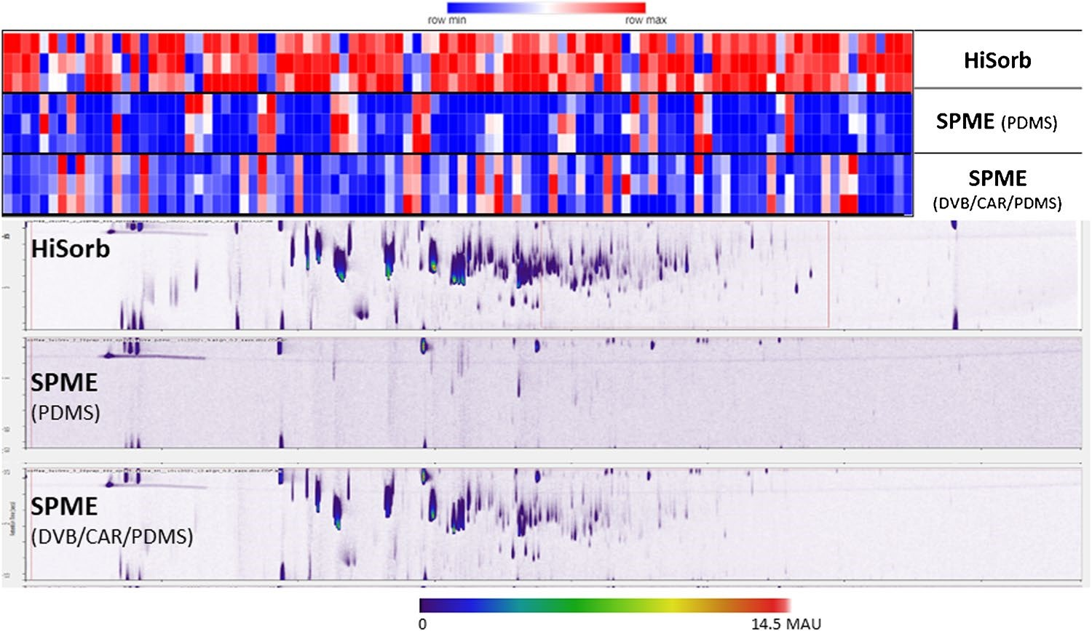
Figure 1

Fig. 1 Comparison of the intensities of the 100 most significant features able to discriminate among HiSorb, SPME-PDMS, and SPME-DVB/CAR/PDMS, along with the 2D plot obtained extracting the same brewed coffee at 60 °C for 30 min
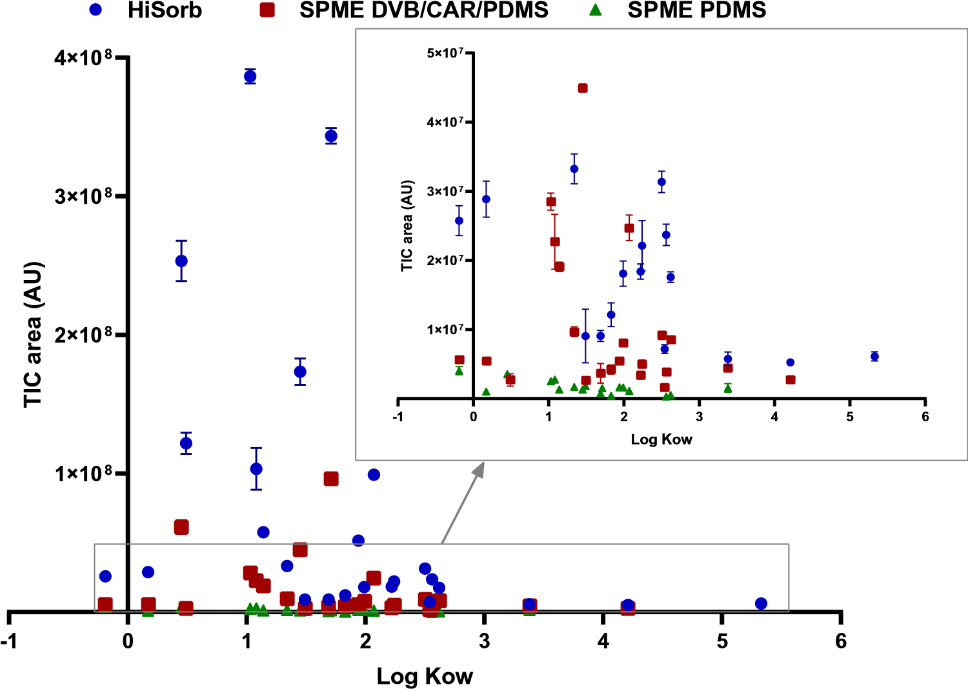
Figure 2

Fig. 2 Correlation between the signal intensity and the logKow for the 25 target compounds reported in Supplementary Table S1, obtained extracting the same brewed coffee at 60 °C for 30 min for HiSorb (blue circles), SPME-PDMS (green triangles), and SPME DVB/ CAR/PDMS (red square). Error bars represent standard error (n=3). For the color code, refer to the online version

HiSorb optimization
In the previous experiments, HiSorb was used based on previously optimized conditions for SPME for comparison purposes only. Therefore, once the superior extraction capacity and compound coverage of HiSorb was proven, the time and extraction temperature were optimized to further improve the extraction efficiency. In order to evaluate the possibility of using lower sample volumes to extend the applicability of the technique to experiments with limited sample amounts, a comparison between 1 mL and 4 mL of sample was performed to evaluate the effect of reducing β on the overall extraction capacity. These two volumes were tested at different sampling times to find the best possible condition.
The data were elaborated using the untargeted workflow explained in "Untargeted tile-based approach", and the top 100 most significant features in differentiating the condition tested were visualized using a heatmap as reported in Fig. 3. The time profile (Fig. 3) using the two different sample volumes was first explored at 50°C, showing a highly significant improvement (p-value<0.001 for the entire profile) when extracting for 30 min rather than 10 min, but without a significant improvement (p-value>0.05) when extending the extraction time to 40 and 60 min. This trend is confirmed using both 1 mL and 4 mL sample volumes. Indeed, comparing the median intensity of the overall profile normalized on the intensity at 10 min, a 1.64-fold improvement was observed between 10 and 30 min, while only a 1.71-fold improvement was found when extended from 10 to 60 min. Comparing the ratio of the same time points using 1 mL or 4 mL, an average improvement based on the median value of the 100 features at each extraction time of 1.09 ± 0.04 was obtained, with a slightly higher value (i.e., 1.14) at 60 min extraction, related to the absorptive nature of the extraction mechanism.
Nevertheless, the very low gain in extraction efficiency was deemed not worth the extra time used for extraction.
The best compromise between extraction yield and throughput was 30 min extraction time and 1 mL of sample. Therefore, these conditions were used for further experiments assessing the temperature profile starting from 30 °C up to 75 °C (30, 40, 50, 60, 75 °C) (Fig. 4).
As expected, the amount extracted increased with temperature, as explained by the exponential relationship between the vapor pressure and the temperature as described by Antoine’s law, and by the partition constants K_{e/}HS and K_{HS/}s , which are influenced directly and indirectly by increasing Henry’s constants [36, 37]. Nevertheless, considering that the consumption temperature of espresso coffee has been reported to be below 70 °C [38], 60 °C was chosen as the optimized temperature to evaluate the aroma of brewed coffee.
Despite the fact that the complexity of the odor perception process is related to the wide range of components that define the overall HS of a sample, generally, only some compounds (usually fewer than 40) can be defined as key contributors of the odor signature [39]. Blank et al. [23] determined the potent odorants of brewed coffee using aroma extract dilution analysis, and the defined compounds were further characterized by GC-MS using different column coatings after extraction with a mixture of dichloromethane/ Freon 11 (1:1 v/v) and distillation. The list of key odorants (32 compounds) is reported in Supplementary Table S2.
The presence of these key odorants was verified in the HS profiles obtained using either the HiSorb probe or SPME fiber with the DVB/CAR/PDMS coating, and compared with odor methods reported in the literature (Supplementary Table S2). The number of compounds extracted by sorptive techniques differs strongly from those obtained from solvent extraction and distillation. Generally, about half of the key odorants reported by Blank et al. [23] were detected using sorptive extraction.
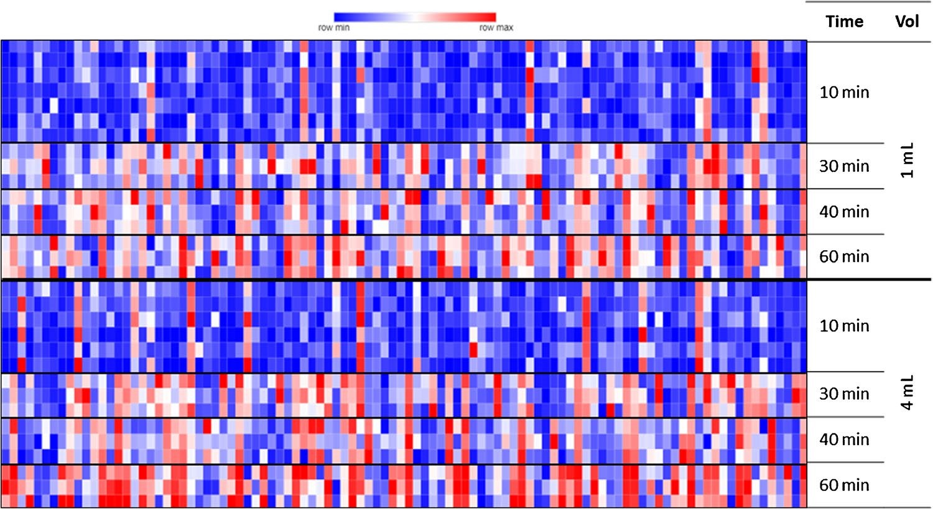
Figure 3

Fig. 3 Changes in extraction profile for different extraction times and at 1 mL and 4 mL sample volume. Extraction performed at 50 °C using HiSorb. Visualization of the intensities of the 100 most significant features, with the reddish color representing the most intense features and bluish the least intense
Figure 4
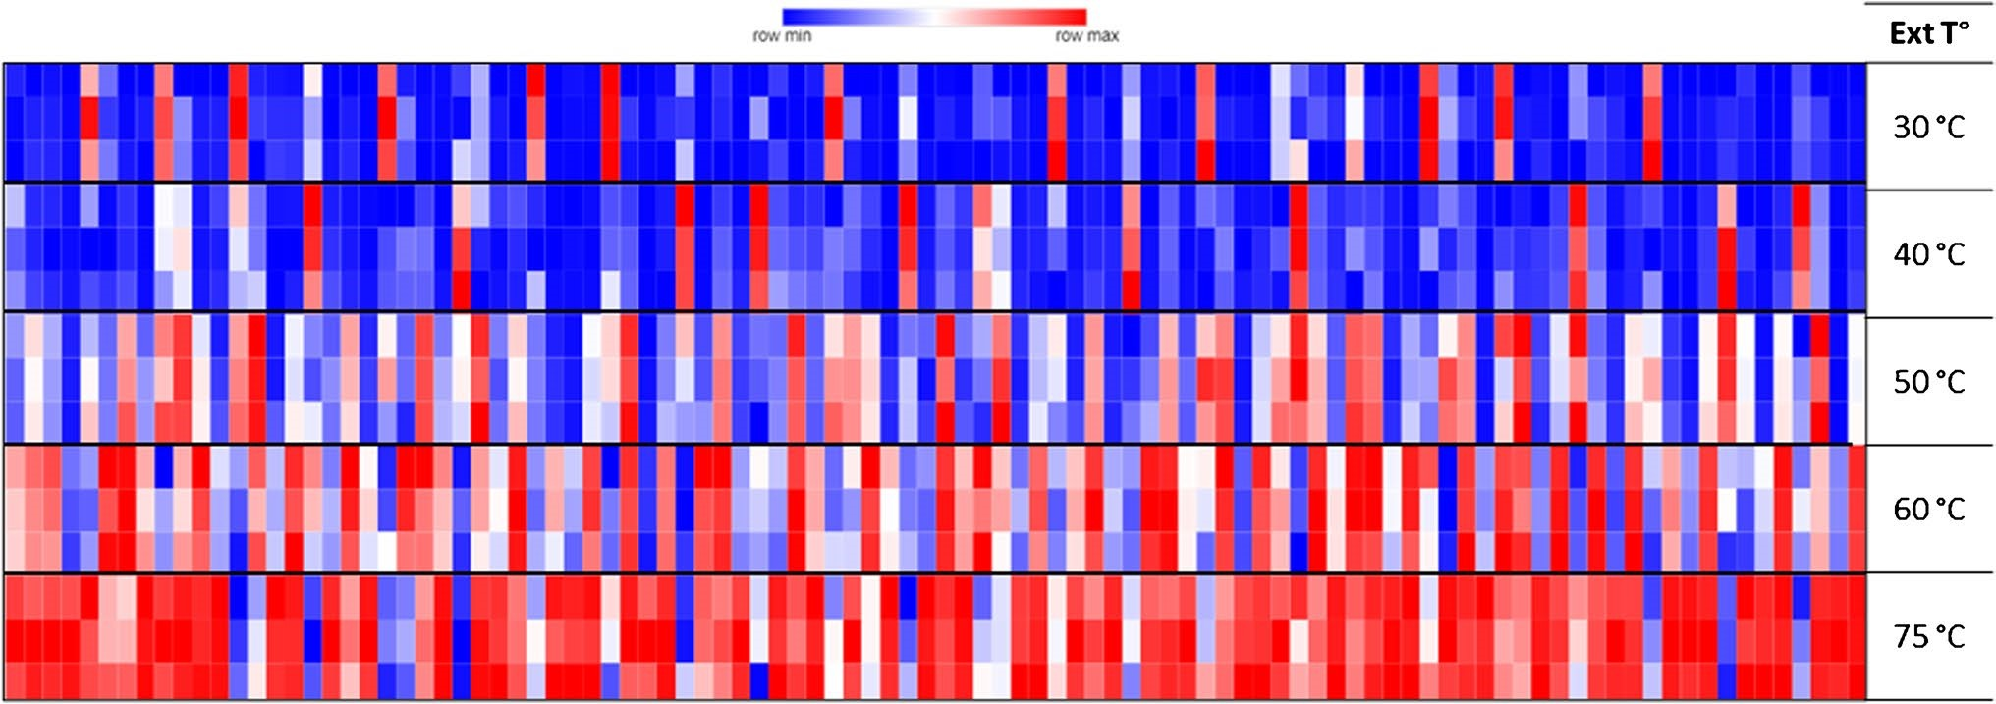
Fig. 4 Changes in extraction profile at different extraction temperatures. Extraction performed using HiSorb for 30 min and with 1 mL sample volume. Visualization of the intensities of the 100 most significant features, reddish the most intense and bluish the least intense
Overall, the HiSorb probe extracted the highest number of key odorants, i.e., 15 out of the 32, while using DVB/CAR/PDMS SPME fiber, 13 compounds were extracted, as by Pua et al. using CAR/PDMS HS-SPME. However, all sorptive extraction techniques failed to extract 12 compounds (i.e., 3-methyl-2-buten-1-thiol , 2-methyl-3-furanthiol, 2-furfurylthiol, methional, trimethylthiazole, 5-ethyl-2,4-dimethylthiazole, 2-hydroxy-3,4-dimethyl-2-cyclo-penten-1-one, (E)-2-nonenal, p-anisaldehyde, 5-ethyl-3-hydroxy-4-methyl2(5H)-furanone, bis(2-methyl-3-furyl)disulfide, vanillin). Hofmann et al. [40] discussed the low extraction of thiol compounds in the HS due to the strong interaction with some matrix compounds. In addition, the difficulty in detecting such compounds is also linked to the sensitivity of the detector. Pua et al. [40] improved the detectability of some trace odorants by using low-energy electron ionization (i.e., 15 eV). The limitation due to detector sensitivity was also highlighted by Akiyama et al. [41], where seven more compounds were detected by GC-olfactometry than by GC-MS.
The sample preparation method represents the key step in the analytical workflow to provide a consistent and representative image of the volatile that contribute to the overall sensory perception. An efficient extraction method should provide the same profile as perceived by the human nose to correlate the sensory perception with the chemical signature. Nevertheless, in 2017, Bressanello et al. highlighted that, despite the different selectivity obtained using HS-SPME and in-solution SBSE (Supplementary Table S2), the chemical information encrypted in the aroma profile allowed for discrimination equivalently between arabica and robusta brewed coffee. The reported result suggests that different techniques may capture a different nuance of the sensory experience without modifying the overall discrimination capability.

Application to real samples
The optimized HiSorb method (1 mL of sample and 30 min extraction at 60 °C) was used to analyze the aroma profile of espresso-brewed coffee and, in particular, to evaluate the impact of the type of packaging on the volatile compound profiles. Coffee packed in an aluminum capsule, compostable capsule, or a multilayer aluminum pack (refillable aluminum capsule, called “pack”) were prepared using the same coffee machine, and the volatile profiles were compared after HiSorb extraction and through a cross-sample analysis.
The data were elaborated using the tile-based workflow explained in "Untargeted tile-based approach". The tilebased approach was previously defined as a peak-region feature [42] and later further elaborated into the tile-based approach today incorporated in several commercial software programs [43]. A detailed discussion of this is outside the scope of the present article. For the purpose of this work, after feature generation and preliminary cleaning of the matrix and data reduction, the random forest (RF) algorithm was used to select the most discriminatory features among the three types of packaging (Table 1).
Hierarchical cluster analysis (HCA) was performed using Euclidian distance as the similarity measure and the Ward linkage clustering algorithm to minimize the sum of squares of any two clusters. The results were visualized as a heatmap with three distinct clusters representing the three types of packaging (Fig. 5). However, the coffees contained in the aluminum capsule (Alu) and those from the pack (Pack) showed a higher similarity in their aroma profiles than the compostable one (Bio). The discrimination observed between Alu and Pack was likely due to the brewing procedure, as also shown by Greco et al. [44]. In fact, the samples brewed from the refillable Pack group, although prepared using the same coffee machine and using the same amount of powder as the commercial capsules, may have had different extraction pressure and level of packaging. For example, it was noticed that when shaking the commercial capsules (Alu and Bio), free space was present inside. In the case of the refillable capsule, the cap was much thicker, resulting in less empty space. Thus, the coffee was more compressed, changing the brewing conditions.
Most of the features showed a lower abundance in the Bio samples than in the Alu and Pack ones. For instance, furan, 2-methyl- (F2), one of the most volatile compounds in coffee, showed low abundance in the Bio samples. Similar results have been reported in a previous study monitoring coffee freshness based on four types of packaging capsule systems, where it was shown that aluminum-based capsules better preserved the aroma of coffee than those that did not have an aluminum barrier [45]. Of the 16 discriminatory features, some have already been identified as responsible for the typical coffee aroma; for example, 2-furanmethanol acetate (F13) and butanal, 2-methyl- (F3) were found in high levels in espresso coffee [46–48], while pyrazine, methyl- has been suggested as a potential marker to monitor coffee bean roasting processes [49].
Overall, these results show that the capsule material could indeed impact the aroma of coffees, most probably due to different storage conditions; as Alu and Pack samples have an aluminum barrier that prevents diffusion of air, they are better at preserving the coffee from oxidation [45]. On the other hand, the compostable capsule (Bio) presented an overall much lower volatile profile than the other two groups of samples, proving a much less effective barrier effect for the preservation of the content.

Conclusion
The use of HiSorb extraction probes to provide a significantly higher amount of sorbent volume resulted in a significantly higher extraction yield than SPME when using the same phase (PDMS) as well as DVB/CAR/PDMS. The optimization of the extraction conditions, namely time and temperature, was conducted in an untargeted way to evaluate the overall profile rather than specific compounds that can bias the interpretation. In order to study the effect of packaging on the perceived aroma, the optimal conditions selected did not represent the highest extraction yield but rather a compromise that better represents the situation during consumption of the brewed coffee. Therefore, an extraction temperature of 60°C was selected because it is closer to the consumption temperature of espresso coffee.
It can be said that HiSorb particularly fits the coupling with flow-modulated GC×GC-MS, where part of the flow has to be diverted out of the MS, thus compensating for the loss of sensitivity. Nevertheless, the extraction methods presented in this study could potentially be applied to a cryogenic modulated system by adjusting the split ratio to avoid possible overloading. It is also important to highlight that the use of PDMS minimizes the displacement effect that occurs in adsorption coatings such as the DVB/ CAR/PDMS, enabling broader coverage. The use of the optimized HiSorb along with GC×GC-MS and tile-based chemometrics enabled the investigation of the aroma of the brewed coffee in relation to the nature of the capsule material, showing that the use of aluminum preserved the complexity of the aroma, while a compostable capsule depleted the aroma complexity. Although more sustainable from an environmental viewpoint, compostable capsules may impact the overall perceived aroma that is characteristic of espresso coffee and has made it one of the most widely consumed beverages in the world.
Future studies on the comparison of different HiSorb phases to extend the coverage of key odorants, as well as a more in-depth investigation of the impact of the use of refillable capsules, are planned.
Supplementary Information The online version contains supplementary material available at https://d oi.org/1 0 .1007 /s 00216-022-0 4457- x.
Acknowledgements The authors thank Shimadzu, Markes, SepSolve, and MilliporeSigma for their support. This article is based upon work from the Sample Preparation Study Group and Network, supported by the Division of Analytical Chemistry of the European Chemical Society.

Declarations
Conflict of interest The authors have no financial or proprietary interests in any material discussed in this article.

References
- Pawliszyn J. Handbook of Solid Phase Microextraction, First. London: Elsevier Inc.; 2012.
- Gałuszka A, Migaszewski Z, Namieśnik J. The 12 principles of green analytical chemistry and the SIGNIFICANCE mnemonic of green analytical practices. TrAC - Trends Anal Chem. 2013;50:78–84. https:// doi. org/ 10. 1016/j. trac. 2013. 04. 010.
- Nowak PM, Wietecha-Posłuszny R, Pawliszyn J. White Analytical Chemistry: An approach to reconcile the principles of Green Analytical Chemistry and functionality. TrAC - Trends Anal Chem. 2021;138:116223. https:// doi. org/ 10. 1016/j. trac. 2021. 116223.
- Baltussen E, Sandra P, David F, Cramers C. Stir bar sorptive extraction (SBSE), a novel extraction technique for aqueous samples: Theory and principles. J Microcolumn. 1999;11:737– 47. https:// doi. org/ 10. 1002/ (SICI) 1520- 667X(1999) 11: 10< 737:: AID- MCS7>3. 0. CO;2-4.
- David F, Ochiai N, Sandra P. Two decades of stir bar sorptive extraction: A retrospective and future outlook. TrAC - Trends Anal Chem. 2019;112:102–11. https:// doi. org/ 10. 1016/j. trac. 2018. 12. 006.
- Kremser A, Jochmann MA, Schmidt TC. PAL SPME Arrow - Evaluation of a novel solid-phase microextraction device for freely dissolved PAHs in water. Anal Bioanal Chem. 2016;408:943–52. https:// doi. org/ 10. 1007/ s00216- 015- 9187-z.
- Helin A, Rönkkö T, Parshintsev J, Hartonen K, Schilling B, Läubli T, Riekkola ML. Solid phase microextraction Arrow for the sampling of volatile amines in wastewater and atmosphere. J Chromatogr A. 2015;1426:56–63. https:// doi. org/ 10. 1016/j. chroma. 2015. 11. 061.
- Scheuler KH, Schilling C (2014) Extraction Device. US 20140220701 A1, n.d.
- Herrington JS, Gómez-Ríos GA, Myers C, Stidsen G, Bell DS. Hunting molecules in complex matrices with spme arrows: A review. Separations. 2020;7:12. https:// doi. org/ 10. 3390/ separ ation s7010 012.
- Elia S, Stylianou M, Agapiou A. Aroma characterization of raw and electrochemically treated goat whey wastewater. Sustain Chem Pharm. 2022;27:100640. https:// doi. org/ 10. 1016/j. scp. 2022. 100640.
- Cheng Z, Mannion DT, O’sullivan MG, Miao S, Kerry JP, Kilcawley KN. Comparison of automated extraction techniques for volatile analysis of whole milk powder. Foods. 2021;10:1–19. https:// doi. org/ 10. 3390/ foods 10092 061.
12 . Faulkner H, O’Callaghan TF, McAuliffe S, Hennessy D, Stanton C, O’Sullivan MG, Kerry JP, Kilcawley KN. Effect of different forage types on the volatile and sensory properties of bovine milk. J Dairy Sci. 2018;101:1034–47. https:// doi. org/ 10. 3168/ jds. 2017- 13141.
13. Clarke HJ, Fitzpatrick E, Hennessy D, O’Sullivan MG, Kerry JP, Kilcawley KN. The Influence of Pasture and Non-pasture-Based
Feeding Systems on the Aroma of Raw Bovine Milk. Front Nutr. 2022;9:841454. https:// doi. org/ 10. 3389/ fnut. 2022. 841454.
14 . Grabež V, Egelandsdal B, Cruz A, Hallenstvedt E, Mydland LT, Alvseike O, Kåsin K, Ruud L, Karlsen V, Øverland M. Understanding metabolic phenomena accompanying high levels of yeast in broiler chicken diets and resulting carcass weight and meat quality changes. Poult Sci. 2022;101:101749. https:// doi. org/ 10. 1016/j. psj. 2022. 101749.
- Lee Díaz AS, Rizaludin MS, Zweers H, Raaijmakers JM, Garbeva P. Exploring the Volatiles Released from Roots of Wild and Domesticated Tomato Plants under Insect Attack. Molecules. 2022;27:1612. https:// doi. org/ 10. 3390/ molec ules2 70516 12.
- Zanardi OZ, Volpe HXL, Luvizotto RAG, Magnani RF, Gonzalez F, Calvo C, Oehlschlager CA, Lehan BJ, Esperança V, Delfino JY, de Freitas R, de Carvalho RI, Mulinari TA, Miranda MP, Bento JMS, Leal WS. Laboratory and field evaluation of acetic acidbased lures for male Asian citrus psyllid, Diaphorina citri. Sci Rep. 2019;9:1–10. https:// doi. org/ 10. 1038/ s41598- 019- 49469-3.
- Alberti S, Sotiropoulou M, Fernández E, Solomou N, Ferretti M, Psillakis E. UV-254 degradation of nicotine in natural waters and leachates produced from cigarette butts and heat-not-burn tobacco products. Environ Res. 2021;194:110695. https://d oi.org/ 10. 1016/j. envres. 2020. 110695.
- Brown RW, Mayser JP, Widdowson C, Chadwick DR, Jones DL. Dependence of thermal desorption method for profiling volatile organic compound (VOC) emissions from soil. Soil Biol Biochem. 2021;160:108313. https://d oi.org/1 0 .1016 /j.s oilbio.2 021 .10831 3.
- Hearn L, Cole R, Spadafora ND, Szafnauer R. Volatile and semivolatile compounds in flavoured hard seltzer beverages: Comparison of high-capacity sorptive extraction (HiSorb) methods. Adv Sample Prep. 2022;3:100032. https:// doi. org/ 10. 1016/j. sampre. 2022. 100032.
- Wang X, Wang Y, Hu G, Hong D, Guo T, Li J, Li Z, Qiu M. Review on factors affecting coffee volatiles: from seed to cup. J Sci Food Agric. 2022;102:1341–52. https:// doi. org/ 10. 1002/ jsfa. 11647.
- Angeloni S, Mustafa AM, Abouelenein D, Alessandroni L, Acquaticci L, Nzekoue FK, Petrelli R, Sagratini G, Vittori S, Torregiani E, Caprioli G. Characterization of the aroma profile and main key odorants of espresso coffee. Molecules. 2021;26:1–29. https:// doi. org/ 10. 3390/ molec ules2 61338 56.
- Semmelroch P, Grosch W. Studies on character impact Odorants of coffee brews. J Agric Food Chem. 1996;44:537–43. https://d oi. org/ 10. 1021/ jf950 5988.
23 . Blank I, Sen A, Grosch W. Potent odorants of the roasted powder and brew of Arabica coffee. Z Leb Unters Forsch. 1992;195:239– 45. https:// doi. org/ 10. 1007/ BF012 02802.
- Bressanello D, Liberto E, Cordero C, Rubiolo P, Pellegrino G, Ruosi MR, Bicchi C. Coffee aroma: Chemometric comparison of
the chemical information provided by three different samplings combined with GC–MS to describe the sensory properties in cup. Food Chem. 2017;214:218–26. https:// doi. org/ 10. 1016/j. foodc hem. 2016. 07. 088.
- Cordoba N, Fernandez-Alduenda M, Moreno FL, Ruiz Y. Coffee extraction: A review of parameters and their influence on the physicochemical characteristics and flavour of coffee brews.
Trends Food Sci Technol. 2020;96:45–60. https:// doi. org/ 10. 1016/j. tifs. 2019. 12. 004.
- de Figueiredo Tavares MP, Mourad AL. Coffee beverage preparation by different methods from an environmental perspective. Int J Life Cycle Assess. 2020;25:1356–67. https:// doi. org/ 10. 1007/ s11367- 019- 01719-2.
- Greco G, Núñez-Carmona E, Abbatangelo M, Fava P, Sberveglieri V. How coffee capsules affect the volatilome in espresso coffee. Separations. 2021;8:248. https:// doi. org/ 10. 3390/ separ ation s8120 248.
- Lolli V, Acharjee A, Angelino D, Tassotti M, Del Rio D, Mena P, Caligiani A. Chemical Characterization of Capsule-Brewed Espresso Coffee Aroma from the Most Widespread Italian Brands by HS-SPME/GC-MS. Molecules. 2020;25:1166. https://d oi.org/ 10. 3390/ molec ules2 50511 66.
- Bicchi C, Iori C, Rubiolo P, Sandra P. Headspace sorptive extraction (HSSE), stir bar sorptive extraction (SBSE), and solid phase microextraction (SPME) applied to the analysis of roasted Arabica coffee and coffee brew. J Agric Food Chem. 2002;50:449–59. https:// doi. org/ 10. 1021/ jf010 877x.
- Massart D. Chemometrics : a textbook. New York: Elsevier Science Ltd.; 1988.
- Smolinska A, Hauschild A-C, Fijten RRR, Dallinga JW, Baumbach J, van Schooten FJ. Current breathomics—a review on data pre-processing techniques and machine learning in metabolomics breath analysis. J Breath Res. 2014;8:027105. https:// doi. org/ 10. 1088/ 1752- 7155/8/ 2/ 027105.
- Hearn L, Cole R, Spadafora ND, Szafnauer R. Volatile and semivolatile compounds in flavoured hard seltzer beverages: Comparison of high-capacity sorptive extraction (HiSorb) methods. Adv Sample Prep. 2022;3:100032. https://d oi.org/1 0 .1016 /j.s ampre.2022.1 0003 2.
- Mascrez S, Eggermont D, Purcaro G. SPME and chromatographic fingerprints in food analysis. In: Pawliszyn J (ed) Evolution ofSolid Phase Microextraction Technology. Royal Society of Chemistry, p in press; 2022.
- Reyes-Garcés N, Gionfriddo E, Gómez-Ríos GA, Alam MN, Boyacı E, Bojko B, Singh V, Grandy J, Pawliszyn J. Advances in Solid Phase Microextraction and Perspective on Future Directions. Anal Chem. 2018;90:302–60. https:// doi. org/ 10. 1021/ acs. analc hem. 7b045 02.
- Risticevic S, DeEll JR, Pawliszyn J. Solid phase microextraction coupled with comprehensive two-dimensional gas chromatography-time-of-flight mass spectrometry for high-resolution metabolite profiling in apples: Implementation of structured separations for optimization of sample preparation. J Chromatogr A. 2012;1251:208–18. https://d oi.org/1 0 .1016 /j.c hroma.2012.0 6 .05 2.
- Kolb B, Ettre LS. Static Headspace–Gas Chromatography: theory and Practice. 2nd ed. Hoboken: John Wiley & Son; 2006.
- Bicchi C, Cordero C, Liberto E, Rubiolo P, Sgorbini B, Sandra P. Impact of phase ratio, polydimethylsiloxane volume and size, and sampling temperature and time on headspace sorptive extraction recovery of some volatile compounds in the essential oil field. J Chromatogr A. 2005;1071:111–8. https:// doi. org/ 10. 1016/j. chroma. 2004. 09. 054.
38 . Abraham J, Diller K. A Review of Hot Beverage Temperatures—Satisfying Consumer Preference and Safety. J Food Sci. 2019;84:2011–4. https:// doi. org/ 10. 1111/ 1750- 3841. 14699.
- Chiralertpong A, Acree TE, Barnard J, Siebert KJ. Taste–Odor integration in espresso coffee. Chemosens Percept. 2008;1:147– 52. https:// doi. org/ 10. 1007/ s12078- 008- 9018-0.
- Pua A, Lau H, Liu SQ, Tan LP, Goh RMV, Lassabliere B, Leong KC, Sun J, Cornuz M, Yu B. Improved detection of key odourants in Arabica coffee using gas chromatography-olfactometry in combination with low energy electron ionisation gas chromatography-quadrupole time-of-flight mass spectrometry. Food Chem. 2020;302:125370. https:// doi. org/ 10. 1016/j. foodc hem. 2019. 125370.
- Akiyama M, Murakami K, Hirano Y, Ikeda M, Iwatsuki K, Wada A, Tokuno K, Onishi M, Iwabuchi H. Characterization of headspace aroma compounds of freshly brewed arabica coffees and studies on a characteristic aroma compound of Ethiopian coffee. J Food Sci. 2008;73:C335–46. https://d oi.org/1 0 .1111 /j.1 750-3841.2 008 .00752. x.
- Cordero C, Liberto E, Bicchi C, Rubiolo P, Reichenbach SE, Tian X, Tao Q. Targeted and non-targeted approaches for complex natural sample profiling by GC×GC-qMS. J Chromatogr Sci. 2010;48:251–61. https:// doi. org/ 10. 1093/ chrom sci/ 48.4. 251.
43 . Marney LC, Christopher Siegler W, Parsons BA, Hoggard JC, Wright BW, Synovec RE. Tile-based Fisher-ratio software for improved feature selection analysis of comprehensive two-dimensional gas chromatography-time-of-flight mass spectrometry data. Talanta. 2013;115:887–95. https:// doi. org/ 10. 1016/j. talan ta. 2013. 06. 038.
- Greco G, Núñez-Carmona E, Abbatangelo M, Fava P, Sberveglieri V. How coffee capsules affect the volatilome in espresso coffee. Separations. 2021;8. https://d oi.org/1 0 .3390 /s eparations 812 024 8.
- Glöss AN, Schönbächler B, Rast M, Deuber L, Yeretzian C. Freshness indices of roasted coffee: Monitoring the loss of freshness for single serve capsules and roasted whole beans in different packaging. Chimia (Aarau). 2014;68:179–82. https:// doi. org/ 10. 2533/ chimia. 2014. 179.
- Naudé Y, Rohwer ER. Investigating the coffee flavour in South African Pinotage wine using novel offline olfactometry and comprehensive gas chromatography with time of flight mass spectrometry. J Chromatogr A. 2013;1271:176–80. https://d oi.org/1 0 . 1016/j. chroma. 2012. 11. 019.
- Caporaso N, Genovese A, Canela MD, Civitella A, Sacchi R. Neapolitan coffee brew chemical analysis in comparison to espresso, moka and American brews. Food Res Int. 2014;61:152–60. https:// doi. org/ 10. 1016/j. foodr es. 2014. 01. 020.
48 . Sunarharum WB, Williams DJ, Smyth HE. Complexity of coffee flavor: A compositional and sensory perspective. Food Res Int. 2014;62:315–25. https:// doi. org/ 10. 1016/j. foodr es. 2014. 02. 030.
49. Hashim L, Chaveron H. Use of methylpyrazine ratios to monitor the coffee roasting. Food Res Int. 1996;28:619–23. https://d oi.org/ 10. 1016/ 0963- 9969(95) 00037-2.
Publisher’s note Springer Nature remains neutral with regard to jurisdictional claims in published maps and institutional affiliations.
Springer Nature or its licensor (e.g. a society or other partner) holds exclusive rights to this article under a publishing agreement with the author(s) or other rightsholder(s); author self-archiving of the accepted manuscript version of this article is solely governed by the terms of such publishing agreement and applicable law.

