Interaction between APOE4 and lifestyle on neuroimaging biomarkers and cognition in cognitively unimpaired older adults

Francesca Felisatti¹, Léa Chauveau¹, Robin de Flores¹, Natalie Marchant², Fabienne Collette³, Harriet Demnitz-King², Tim Whitfield², Florence Requier³, Cassandre Palix¹, Sacha Haudry¹, Marion Delarue¹, Vincent de la Sayette⁴, Denis Vivien1^{1,5}, Géraldine Poisnel¹, Gaël Chételat¹ & Julie Gonneaud¹ for the MEDIT-AGEING Research Group

¹ Normandy University, UNICAEN, INSERM, U1237, PhIND "Physiopathology and Imaging of Neurological Disorders", Institut Blood and Brain @ Caen-Normandie, Cyceron, 14000 Caen, France.
³ GIGA CRC In vivo Imaging - Sleep and chronobiology, University of Liege, Liege, Belgium.
² Division of Psychiatry, University College London, London, United Kingdom
⁴ Service de Neurologie, CHU de Caen, Caen, France.
⁵ Département de Recherche Clinique, CHU Caen-Normandie, Caen, France.

Background: APOE4 is the main genetic risk factor for Alzheimer’s disease (AD). Recent findings suggest that lifestyle factors could modulate the association between APOE4 and cognitive impairment and/or dementia risk. However, a comprehensive assessment of the interactions between lifestyle and APOE4 status on neuroimaging and cognitive markers of aging and AD is still missing. Our objective is to assess this question in cognitively normal elderly.
Method: Baseline data of 134 cognitively unimpaired older adults (mean age: 69) from the Age-Well cohort were analysed. They underwent lifestyle questionnaires (physical and cognitive activity, and diet), neuropsychological evaluation (memory, attention, executive function and global cognition) and multimodal neuroimaging (structural MRI, FDG- and Florbetapir-PET). Interactions between lifestyle and APOE4 status on neuroimaging and cognition were assessed for each lifestyle factor separately.
Result: There was an interaction between APOE4 status and cognitive activity on neuroimaging measures (ps<.04), such that higher cognitive engagement was associated with lower grey matter volume in the parahippocampus and lower brain perfusion in the entorhinal and perirhinal cortices in APOE4 carriers only (Figure 1A). However, greater cognitive engagement was associated with increased cognitive performance (global cognition, executive function and attention, all ps<.005), and this irrespectively of APOE4 status (i.e., no cognitive activity x APOE4 status interaction; Figure 1B). For diet, interactions were evidenced (ps <.04) such that higher adherence to the Mediterranean diet was associated with i) higher brain glucose metabolism in the medial temporal lobe (Figure 2A) and ii) higher performance on attention tests (Figure 2B) in APOE4 carriers only. No interactions were found for physical activity.
Conclusion: Our results indicate that APOE4 carriers with higher cognitive activity had lower brain outcomes but preserved cognition, suggesting that enriched cognitive engagement promote cognitive resilience in this population. On the other hand, APOE4 carriers with higher adherence to the Mediterranean diet had greater cerebral metabolism and greater attention capacities. Overall, this suggests that distinct lifestyle factors differentially help APOE4 carriers to resist or cope with brain alteration and postpone cognitive decline.

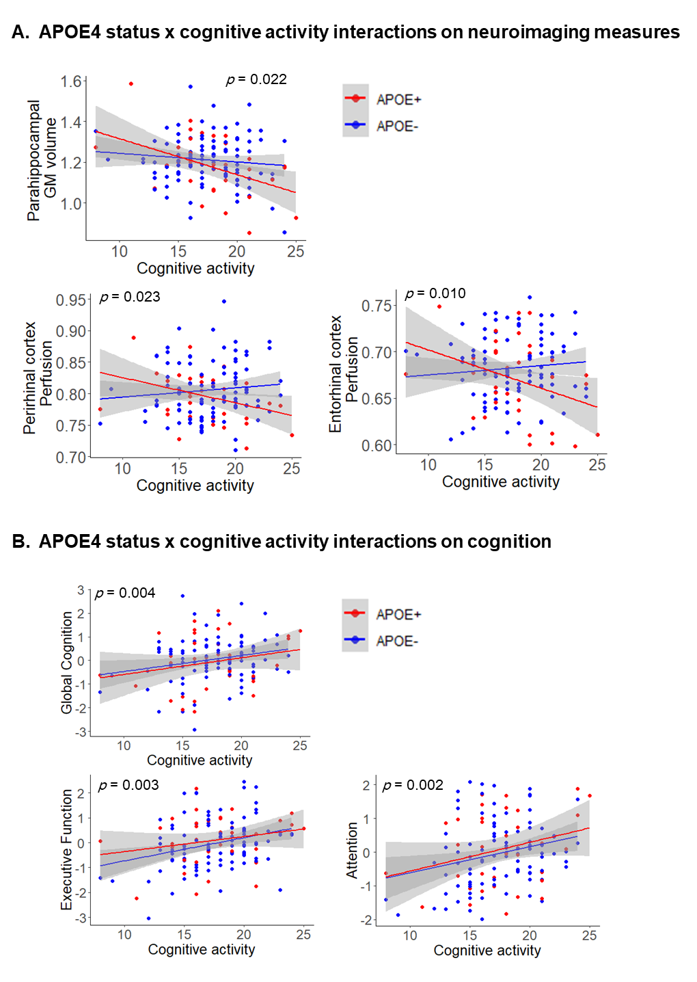
Figure 1 Interactive effects of cognitive activity and APOE4 status on neuroimaging measures (A) and cognition (B). Adjusted p-values are indicated for the significant interactive effects and were obtained using general linear models controlling, for age, sex, and education. Raw data (i.e., unadjusted) are plotted. Solid lines represent estimated regression lines and shaded areas represent 95% confidence intervals. Abbreviations: APOE+ = APOE4 carriers, APOE- = APOE4 non-carriers, GM = gray matter,

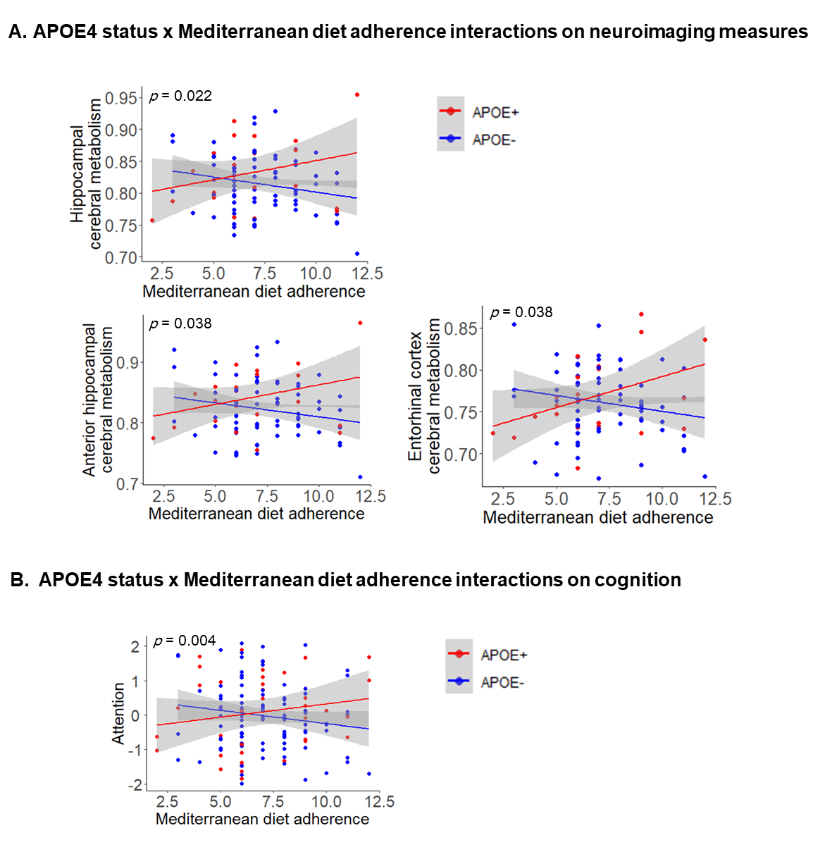

Figure 2 Interaction of APOE and adherence to the Mediterranean diet on neuroimaging measures (A) and cognition (B). Adjusted p-values are indicated for the significant interactive effects and were obtained using general linear models controlling for age, sex, and education. Raw data (i.e., unadjusted) are plotted. Solid lines represent estimated regression lines and shaded areas represent 95% confidence intervals. Abbreviations: APOE+ = APOE4 carriers, APOE- = APOE4 non-carriers, GM = gray matter.

