Analysis of mixed plastic pyrolysis oil by comprehensive two-dimensional gas chromatography coupled with low- and high-resolution time-of-flight mass spectrometry with the support of soft ionization

Marco Beccaria ^{a,b,*}, Marco Piparo ^{c,d}, Yun Zou ^{b,**}, Pierre-Hugues Stefanuto ^{b}, Giorgia Purcaro ^{e}, Anna Luiza Mendes Siqueira ^{f}, Adrien Maniquet ^{f}, Pierre Giusti ^{c,d}, Jean-François Focant ^{b}

ª University of Ferrara, Department of Chemical, Pharmaceutical, and Agricultural Sciences, via L. Borsari 46, Ferrara, Italy
^{b} Organic and Biological Analytical Chemistry Group, MolSys Research Unit, University of Liège, Liège, Belgium
^{c} TotalEnergies One Tech, R&D, Downstream Processes & Polymers, Total Research and Technologies, Gonfreville, France
^{d} International Joint Laboratory - iC2MC: Complex Matrices Molecular Characterization, TRTG, Harfleur, France
^{e} Analytical Chemistry Lab, Gembloux Agro-Bio Tech, University of Liège, Gembloux, 5030, Belgium
^{f} TotalEnergies One Tech, R&D, Fuels & Lubricants, Solaize Research Center, Solaize, France

Keywords: Plastic pyrolysis oil Central composite design (CCD) PTV optimization Comprehensive 2D-GC (GC×GC)-TOFMS Photoionization interface (PI) GC soft Ionization HRMS

Abstract
According to the annual production of plastics worldwide, in 2020 about 370 million tons of plastic were pro- duced in the world. Chemical recycling, particularly pyrolysis of plastic wastes, could be a valuable solution to resolve these problems and provide an alternative pathway to produce “recycled” chemical products for the petrochemical industry. Nevertheless, the pyrolysis oils need a detailed characterization before the upgrading test to re-use them to generate new recycled products. Multidimensional gas chromatography coupled with both low- and high-resolution time-of-flight mass spectrometers was employed for a detailed investigation among and within different chemical classes present in bio-plastic oil. The presence of several isomeric species as well as homologs series did not allow a reliable molecular identification, except for a few compounds that showed both MS similarity >800/1000 and retention index within ±20. Indeed, the identification of several isomeric species was assessed by high-resolution mass spectrometry equipped with photo-

* Corresponding author. University of Ferrara, Department of Chemical, Pharmaceutical, and Agricultural Sciences, via L. Borsari 46, Ferrara, Italy.
** Corresponding author.
E-mail addresses: marco.beccaria@unife.it (M. Beccaria), yun.zou.titech@gmail.com (Y. Zou).
ionization interface. This soft ionization mode was an additional filter in the identification step allowing unambiguous identification of analytes not identified by the standard electron ionization mode at 70 eV. The injection method was also optimized using a central composite design to successfully introduce a wide range of carbon number compounds without discrimination of low/high boiling points.

Introduction

The ubiquitous pollution of plastics is a threat to humans and the earth. The concentration of the global population and the increasing use of plastics aggravate the current environmental situation [1–3]. Thus, the end-of-life (EOL) management of plastic waste is essential. Singh and coworkers summarized four main approaches for recycling plastic solid waste (PSW) [4]: I) primary recycling (reuse/repair) of the single un- contaminated type of polymers; II) secondary recycling (mechanical recycling) that downgrades the materials; III) tertiary recycling (thermo-chemical recycling) by chemical means, and IV) quaternary recycling which incinerates waste for energy recovery [4,5]. In 2018 in the EU, 42.6% of plastic waste was used for energy recovery, 32.5% was recycled, and 2.9% was landfilled [3]. Worldwide up to 2015, 9% of the plastic waste was recycled, 12% was incinerated (energy recovery), and the majority 79% was accumulated in landfills [6]. Although incineration can recover energy, the extended emission of greenhouse gases such as NOx, SOx, and COx cannot be negligible [7]. Thermo-chemical recycling is a promising process for producing fuels and recovering monomers for plastic production. This concept of the waste refinery is based on the development of environmentally friendly pyrolysis technology [1]. Pyrolysis breaks down the material’s macromolecular structure into small molecules and produces various types of hydrocar- bons [7]. The pyrolysis oil is a mixture of paraffins, olefins, naphthenes, aromatics, and sulfur-, nitrogen-, oxygen-containing compounds. The composition differs depending on the type of plastic waste pyrolyzed [7, 8].
The most widely applied technique to determine the composition of plastic pyrolysis oil is the conventional one-dimensional gas chromatography (1D-GC) coupled to mass spectrometry (GC-MS) [9–11]. However, 1D-GC encounters many challenges while dealing with ultra-complex samples due to the limitation of the separation power [11]. Comprehensive two-dimensional GC (GC × GC) coupled to MS became the state-of-the-art technique to unravel the complex composition of challenging samples in both targeted and non-targeted analyses [12–16]. Indeed, recently, GC × GC-MS has been employed in plastic pyrolysis oil analysis. Many sulfur- (thiophenes, thiols, etc.), nitrogen- (nitriles, pyridines, etc.), and oxygen- (ketones, aldehydes, etc.) containing compounds, in addition to pure hydrocarbon groups, were identified thanks to the outstanding separation power of GC × GC [7,8,17,18]. The improved chromatographic resolution enables to obtain a more accurate MS similarity search, which, complemented with the linear retention indices (LRIs), provides an additional level of certainty to the identification of the compounds. LRIs are now easily included in most the commercial MS libraries, such as the National Institute of Standards and Technology (NIST).
In addition to the advantages of GC × GC, the coupling of high-resolution MS (HRMS) provides extra benefits to the identification of unknown compounds. The exact molecular mass enables the prediction of the elemental composition of unknown compounds and to assign of their class species according to the heteroatom numbers (CcHhNnOoSsPp) and double bond equivalent (DBE) [19,20]. This feature helps to identify the compounds which are not yet included in any MS libraries. The ability to identify or predict the structures of previously unknown compounds accelerates the understanding of plastic pyrolysis oil and the pyrolysis mechanisms. A detailed characterization is also essential for supporting the development of a dedicated pyrolysis process [21].
In this study, we aimed to better characterize the composition of plastic pyrolysis oil by using GC × GC coupled to both low-resolution time of flight mass spectrometry (LRTOFMS) and HRTOFMS with electron impact ionization (EI) and photoionization (PI). Chemical class identification was achieved using GC × GC-EI-LRTOFMS, while the identification of several isomers was conducted by the combined interpretation of mass spectra generated using EI and PI -HRTOFMS. The PTV GC injection method was also optimized using a central composite design (CCD) to minimize the discrimination of low/high boiling point compounds caused by the PTV injector.

Materials and methods

CHEMICALS AND SAMPLES

Cyclohexane was purchased from Sigma-Aldrich (St Louis, MO). Alkanes’ mixture (n-C6-n-C33 mix) was purchased from Merck (Bellefonte, PA, USA). The mixed plastic pyrolysis oil was supplied by TOTAL TRTF (Total Research and Technology, Feluy, Belgium). One hundred kilograms of this mix was pyrolyzed in a 20 L continuous pyrolysis unit at 410 ◦C under an inert atmosphere without additive additions, as recently reported by Mase and coworkers [22]. The pyrolysis oil sample was dissolved to a concentration of 5 mg mL^{—1} in cyclohexane prior to the GC analyses.

FM-GC x GC-EI-LRTOFMS INSTRUMENTATION

A Pegasus 4D (LECO Corp., St. Joseph, MI, U.S.A.) GC × GC-TOFMS instrument with electron ionization (EI) interface operating at 70 eV, equipped with a LECO Flux™ Flow Modulator (FM) and conventional (non-polar × polar) column set, composed of a non-polar Rxi-5MS (30 m × 0.25 mm i.d. × 0.25 μm df, Restek Corp.) in the first dimension (1D) and a mid-polar Rxi-17Sil MS (1.4 m × 0.1 mm i.d. × 0.1 μm df, Restek Corp.) in the second dimension (2D), was employed. The modulation period (PM) was set at 3.5 s. Data processing of GC × GC-EI-TOFMS was performed on ChromaTOF ver. 4.72 (LECO Corp.). The injection volume was 1 μL in split mode 1/5. The GC oven was set at 50 ◦C initially and hold for 0.2 min, then the temperature increased to 325 ◦C (hold for 5 min) at a rate of 2 ◦C min^{—1}. The transfer line was set at 330 ◦C. The carrier gas flow was constantly 0.8 mL min^{—1}. MS waiting acquisition time: 480 s, m/z range: 45–600, Acquisition frequency: 200 Hz. Putative identification was based on the combination of the MS similarity with the NIST17 library (800/1000) with the confirmation using the experimental linear retention index (LRI) within a ±20 window.

PTV-GC x GC-EI/PI-HRTOFMS INSTRUMENTATION

The molecular structure identification was conducted on a GC (7890B, Agilent Technologies, Wilmington, DE, U.S.A.) equipped with a Zoex II thermal modulator (Zoex Corp., Houston, U.S.A.) and an HRTOFMS with both EI and PI ion sources (JMS-T200GC “AccuTOF GCx-plus”, JEOL Ltd., Tokyo, Japan). The column set installed in this instrument was identical to the one used in the FM-GC × GC-LR-EI-TOFMS. This GC was equipped with a programmed temperature vaporizer (PTV) injector. The solvent vent mode of PTV injection was applied in this study. To optimize the PTV condition, an experimental design (DoE), specifically a three-variable (k = 3) inscribed rotatable central composite design (CCD), was employed to find the most suitable vent pressure, vent flow, and vent time. There were 24 individual injections of the CCD (Table S1), including 8 conditions from fractional factorial design points, 6 conditions of axial points (extreme points), and 10 replicates of the central point. Based on some preliminary examinations of how the PTV conditions affect the peak intensities in the chromatograms, certain ranges of the three factors were set up for the CCD experiments. Vent pressure was tested between 52.39 kPa and 92.39 kPa, vent flow between 5.00 mL min^{—1} and 45.00 mL min^{—1}, and vent time between 0.01 min and 0.99 min. The central point condition was with a vent pressure of 72.39 kPa, a vent flow of 25.00 mL min^{—1}, and a vent time of 0.50 min. The optimal PTV condition was evaluated using the response surface plot methodology on a mixture of alkanes from C9 to C39 and various chemical families in the C21 group. The temperature program of the PTV injector was initially set at 50 ◦C, and increased to 200 ◦C (hold for 1 min) with a rate of 100 ◦C.min^{—1}, then increased to 325 ◦C with a rate of 200 ◦C.min^{—1}. The injection volume was 1 μL. The GC oven was set at 50 ◦C initially and hold for 0.2 min, then the temperature increased to 325 ◦C (hold for 5 min) at a rate of 2 ◦C.min^{—1}. The carrier gas flow was constantly 0.8 mL min^{—1}. The EI ionizing voltage was 70 eV and the detector voltage was 2300 V. No ionizing voltage was applied in PI mode. The detector voltage of PI was 2700 V. The ion chamber and interface temperatures were 200 ◦C and
300 ◦C, respectively, in both EI and PI mode. The PM was set at 6 s with a hot jet period of 450 ms and a constant cold gas flow of 13 L min^{—1}. Detailed information on the optimized condition is shown in Table S2.

SOFTWARE

ChromaTOF software (LECO Corporation, version 5.51) was employed for the FM-GC × GC-LRTOFMS analyses and data elaboration and visualization. The CCD for PTV optimization parameters was performed using R v4.1.0 (R Foundation for Statistical Computing, Vienna, Austria) and RStudio (version 1.4), while GC-Image software (version 2.5 HRMS) was employed for GC × GC-HRTOFMS analyses and data elaboration and visualization.

Results and discussion

CLASS IDENTIFICATION BY FM-GC x GC-EI-LRTOFMS

A non-polar × medium-polar column set of high thermal stability was chosen considering the high boiling points of many constituents present in plastic pyrolysis oil [11]. Before the real-world sample GC analysis, an alkanes mix (C6–C33) was injected into the FM-GC × GC-LR-EI-TOFMS system to calculate the experimental LRI. Fig. 1A shows the GC × GC-TOFMS plot of the plastic pyrolysis oil sample, presenting a carbon atom range between C7 and C39. A 10 min delay in the TOFMS acquisition was applied to preserve the integrity of the MS filament from the solvent, thus low boiling compounds (<C7) were not considered. Fig. 1B and C are a zoom of the red-dotted line in Fig. 1A in the range of C14 -C28. Fig. 1B shows the distribution of linear not-branched hydrocarbons, namely n-alkanes (first trend-line from the bottom), alkenes (DBE = 1, second trend-line), and di-alkenes (DBE = 2, third trend-line). In Fig. 1C (same zoom as Fig. 1B), further below the n-Alkanes, three pairs of peak groups are observed which are the oligomers of polypropylene [23]. Polypropylene oligomers can have a highly branched structure due to the methyl moiety added with each propylene unit [24]. In general, with this type of column configuration (non-polar × medium-polar) the branched paraffins are eluted below the n-alkanes row. The first group is represented by the polyolefin saturated hydrocarbon (POSH, first trend-line from the bottom). The second group (second trend-line from the bottom) is represented by the PO mono-unsaturated hydrocarbons (POMH), while the third group by PO di-unsaturated hydrocarbon (PODH) (third trend-line from the bottom), as confirmed by their reduced masses. The branching of the hydrocarbons significantly reduces the retention in both columns and this effect is more evident in increasing the carbon number (CN). Indeed, branched-low boiling point compounds (about C7–C11) show almost the same retention as the linear ones, while at the increase of CN, the branched degree reduces the retention. In the first-dimension column (horizontal axis), several C24-25 POHs eluted between nC18-nC20. (see section 3.3). It is important to highlight that, with this column set, in the medium-polar D2 column, POSHs have separated from n-alkanes due at the increment of degree of branche(s), while the POMH and PODH can overlap with the linear not-branched hydrocarbons zone in the low-mid CN range (Fig. 1C) due to the effect of the unsaturation(s) with the mid-polar column. As expected, cyclic hydrocarbons, such as the naphthenes and aromatics, are positioned above the row of the n-alkanes. Fig. 1D shows C21–C23 group separation (zoom of the black-dotted line in Fig. 1A), where, above the linear hydrocarbon rows, n-alkyl-cyclo-pentanes/pentenes, and n-alkyl-cyclo-hexanes/hexenes are well separated. Above the naphthenes, there is the n-alkyl-benzenes raw. This scheme reported in Fig. 1D for the C21–C23 groups is also common for the other C groups.

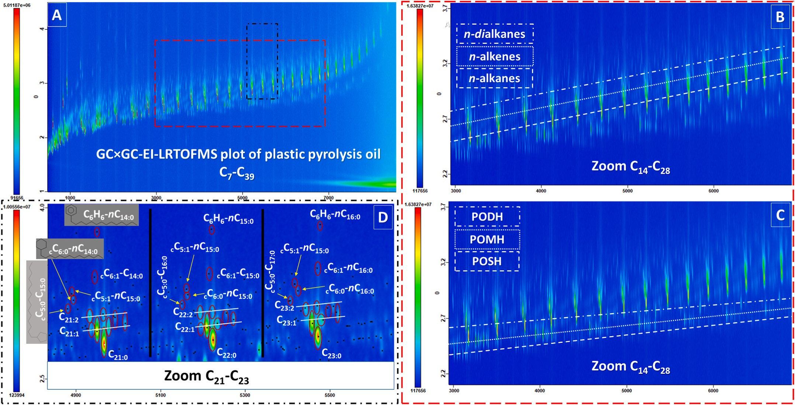
Fig. 1. A: FM-GC × GC-LR-EI-TOFMS chromatogram of plastic pyrolysis oil; B–C: expansion of the red-dotted line in Fig. 1A in the range of C₁₄ -C₂₈; B: GC × GC distribution of linear hydrocarbons (saturated, mono-, and di-unsaturated); C: GC × GC distribution of polyolefins hydrocarbons (POH): saturated (POSH), mono-(POMH) and di-unsaturated (PODH). D: expansion of the black-dotted line in Fig. 1A in the range of C₂₁ -C₂₃; chemical class separation according to the carbon group. (For interpretation of the references to color in this figure legend, the reader is referred to the Web version of this article.)
The identification of the observed chemical species is highly challenging. The hydrocarbons present very similar MS fragmentation patterns with EI, even if lower kinetic energies than 70 eV is applied, making their identification a difficult task [25–27]. Of course, the use of LRI as an additional identification filter can help to rule in/out com- pound identities during the identification process, but not always this information is available, nor when a most common non-polar column is used as a 1D column. The tentative identification by GC × GC-LR-EI-TOFMS was based on different criteria:

- mass spectral EI database matching at 70 eV (≥800/1000), and MS database and spectrum interpretation when MS% < 800/ 1000);
- LRI window in the ±20 range, based on the 1D LRI information reported in the NIST database;

Moreover, chemical class 2D-GC plane locations can also support the identification capability at the molecular lever, providing structural information regarding the different chemical classes based on their location in the 2D chromatographic space.

OPTIMISATION OF PTV CONDITIONS

The split injection condition of FM-GC × GC-LR-EI-TOFMS was applied on the PTV injector operating with the hot split mode. However, significant discrimination of high-boiling-point compounds was observed. The discrimination could not be significantly eliminated by injecting using pulsed split mode. Finally, the solvent vent mode was selected to mitigate the discrimination caused by the PTV injector, since it was reported to be capable to analyze a wide range of carbon numbers with high-boiling-point compounds [28]. Moreover, the solvent vent mode, which is a large volume injection, ensured a proper response while using the relatively lower sensitivity PI as the ion source. MS also has a discrimination effect on the responses of hydrocarbons. However, mitigating the discrimination caused by MS is not the purpose of this study.
In solvent vent mode, the inlet is in split mode with a low initial temperature and a low inlet pressure. When a sample is injected, the analytes are accumulated on the liner wall while the solvent is evaporated. Then the inlet switches to splitless mode and heats up to transfer the analytes to the column. GC oven is also under an appropriate initial temperature so that the solvent can refocus the analytes on the column. As reported by Piparo and coworkers, the initial temperature of the oven and the injector significantly affects the recovery of low-boiling-point compounds [28]. Setting both the oven and the injector at 30 ◦C produced the highest recovery of nonane [30]. Due to the lack of a cooling module on the employed PTV injector in this study, we selected 50 ◦C as a good compromise between low temperature and fast pre-run time. As the results presented by Piparo and coworkers, the best initial temperature of the oven was 50 ◦C while the injector temperature was 50 ◦C [28]. Therefore, the initial oven and injector temperature were set at 50 ◦C accordingly. The temperature program of the PTV injector applied in this study was also referred to as the method applied in the above research. Besides the temperatures, the vent pressure, vent flow, and vent time are three crucial parameters of the solvent vent mode. To be specific, the vent pressure is the initial inlet pressure when venting starts. The vent time is the time period that the inlet keeps in the split mode. The vent flow is also conducted when the inlet is in split mode. To optimize the above three factors, an experimental design was conducted. As it is a three-factor design, CCD is more efficient than a three-factor-three-level factorial design since fewer experimental points are required. Moreover, a rotatable CCD applied in this study provides constant prediction variance at the points that are at an equal distance from the central point [29].
The pyrolysis oil was used in the CCD experiments. The peak volumes of alkanes (C9-39) were used to calculate the response surfaces to evaluate the best condition for a full range of alkanes. Excluding some alkanes which are stationary points of the response surface falling out of the box or near the stationary ridge, the 3D response surface plots of 21 alkanes are presented in Fig. S1. The maximum point of the response surface indicated the best combination of representative parameters. As can be seen from the response surfaces of vent pressure versus vent time, the maximum points were around the central point for C9, C10, C11, C19, C20, C21, C23, C25, C26, C27, C28, C29, C30, C31, C32, C33, C34, C35, C36, and C37 alkanes. While C38 did not show regular dome shape response sur- faces. The vent pressure and the vent time had a significant impact on the response of alkanes, especially for C19-38. Under the same vent flow condition, if the vent time is too long, more analytes are vented out before being transferred to the column which leads to lower response. If the vent time is too short, there is discrimination of the high-boiling point analytes in the GC liner [30]. If the vent pressure is too high, more solvent is loaded on the column before analytes are transferred, which would also cause a low response. The vent flow did not have much impact on the response of the relatively higher-boiling-point alkanes, namely C19-38. However, for low-boiling-point alkanes (C9-11), higher vent flow resulted in a lower response (Figure S1). This is because the higher vent flow removed part of the low-boiling-point alkanes together with the solvent. Most of the alkanes showed the calculated stationary points close to the central point (Table 1). In summary, the average of the stationary points was a vent pressure of 72.38 kPa, a vent flow of
29.60 mL min^{—1}, and a vent time of 0.45 min, which was close to the central point in the CCD (72.39 kPa, 25.00 mL min—1, 0.50 min). The repeatability of the central points of CCD (n = 10) was below 17% (coefficient variation) except for C36-39 which was above 22%.

Table 1
The stationary points of the response surfaces of alkanes.

Alkane | Vent pressure (kPa) | Vent flow (mL min^{—1}) | Vent time (min)
C9 | 74.08 | 33.61 | 0.30
C10 | 73.94 | 32.65 | 0.49
C11 | 71.96 | 33.20 | 0.43
C19 | 70.79 | 32.04 | 0.42
C20 | 71.58 | 28.05 | 0.44
C21 | 72.19 | 28.58 | 0.46
C23 | 72.71 | 31.12 | 0.47
C25 | 72.74 | 29.23 | 0.48
C26 | 72.57 | 29.38 | 0.50
C27 | 72.67 | 31.43 | 0.48
C28 | 72.24 | 29.60 | 0.48
C29 | 72.60 | 29.75 | 0.47
C30 | 72.73 | 29.19 | 0.47
C31 | 72.82 | 28.72 | 0.47
C32 | 73.02 | 28.64 | 0.47
C33 | 72.98 | 28.89 | 0.46
C34 | 72.97 | 27.85 | 0.45
C35 | 72.96 | 27.71 | 0.45
C36 | 72.64 | 27.33 | 0.43
C37 | 71.61 | 27.40 | 0.41
C38 | 68.12 | 27.25 | 0.32
Average (SD) | 72.38 (±1.19) | 29.60 (±1.93) | 0.45 (±0.05)

Besides alkanes, various chemical families were present in the sample (Section 3.1). Taking the C21 group as the “middle point” in the C7–C39 2D-GC chromatogram (Fig. 1), the peak volumes of the representative chemical families present in this group were used to select the best condition for the PTV injection. Ten representative compounds included 3 mono-olefins, 3 di-olefins, and 4 cyclic and aromatic com- pounds (Fig. 2). All the response surfaces of vent pressure versus vent time showed the maximum point closed to the central point of CCD. However, vent flow did not show much impact on the response. The average of the stationary points of 10 representative compounds was with a vent pressure of 72.31 kPa, a vent flow of 30.71 mL min^{—1}, and a vent time of 0.45 min (Table 2). The repeatability of the central points of CCD (n = 10) was below 28% (coefficient variation) except for peak 9 of 43%. Finally, the central point condition was thereby selected as the best compromise for both alkanes and other chemical families. This condition was applied for the following analysis.

CHEMICAL STRUCTURE PREDICTION BY PTV-GC x GC-EI/PI-HRTOFMS

The 2D chromatographic space location generated by FW-GC × GC- EI-LRTOFMS was useful in the assignment of chemical classes to the analytes present in the sample. However, the identification and their MS interpretation of individual isomers which have the same molecular weight became difficult task using the above instrumentation. With the increasing number of carbons, the number of isomers grows exponentially. The EI mass spectrum, even coupled to the LRIs cannot provide enough information to identify the isomer with certainty. Therefore, an HRTOFMS coupled with EI/PI was applied to identify/predict the isomer structures. Applying PI, a soft ionization, a significant enhancement of the intensity of molecular ions compared to EI can be obtained. PI together with HRTOFMS can further provide accurate molecular mass, which was then used to predict the compound formula with an assessment of the mass accuracy (MA). Moreover, PI can also provide an informative fragmentation pattern in the mass spectra, which was used to predict the isomer structure, such as the double bond location and branching [14].
In this section, the C12 group was investigated in detail as an example. There were 13 peaks selected, which were aliphatic alkanes and olefins (Fig. 3). The molecular ions of all peaks were extracted from PI mass spectra to predict the chemical class (Table S3). 12 out of 13 compounds showed MA below 5 ppm. Comparing to the library LRIs, 5 out of 13 compounds were identified with a ΔLRI lower than 2.85. They were 1-dodecene, (Z)-3-dodecene, dodecane, (E)-2-dodecene, and (Z)-2- dodecene, respectively. The remaining 8 compounds were olefins. The LRIs were used to predict whether they were linear or branched olefins. As reported in a previous study, the branched dodecenes eluted before the linear dodecenes in a normal phase column set [14]. As said, the higher the branching, the earlier the isomers elute. The LRIs of linear dodecenes are 1186–1211. The LRIs between 1154 and 1186 are mono-branched dodecene isomers [14]. Therefore, peaks 2 and 5 with LRIs higher than 1154 and lower than 1186 were predicted as mono-branched dodecenes. The prediction of the structure of dodeca- diene isomers by LRIs is much more difficult because the LRIs of only 4 dodecadiene isomers is reported in the NIST Chemistry WebBook. The LRI of 1,11-dodecadiene is 1169, which is lower than dodecane (1200). The LRIs of E,E,2,10-dodecadiene and Z,Z,2,10-dodecadiene are 1203 and 1215, respectively, which are higher than dodecane. 3, 8-dimethyl-1,9-decadiene has a much lower LRI of 1093 compared to its linear isomers (Table S4). To understand better how the distance between two double bonds of linear di-olefins affects the LRIs, hexadiene was used as an example since the isomers are less complex and more LRI information can
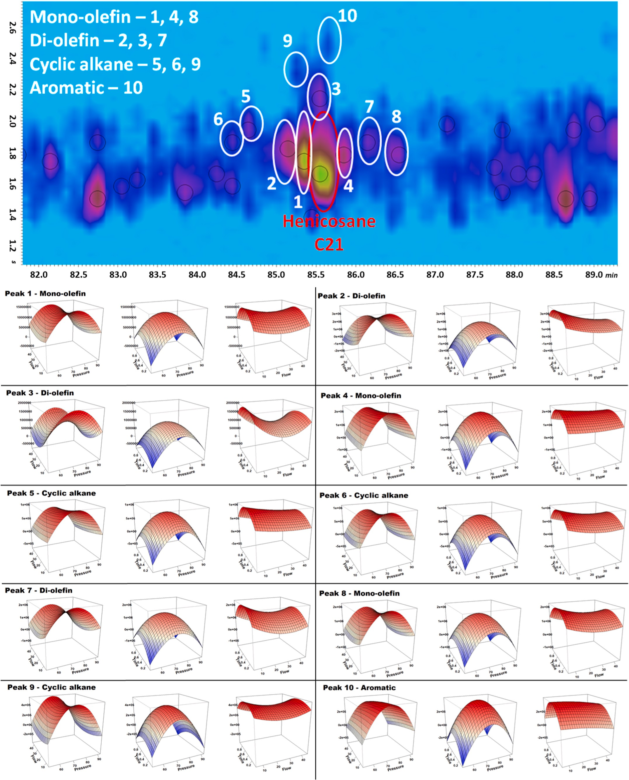
Fig. 2. On the top: GC × GC-PI-HRTOFMS chromatogram of the expansion of C21 group. Each number corresponds to a molecule belonging to a specific chemical class (on the top left of the 2D-GC plot zoom). On the bottom: Response surface of C21 analytes (n = 10) to vent pressure versus vent time (central), vent pressure versus vent flow (left), and vent time versus vent flow (right). Vent pressure versus vent time showed the maximum point closed to the central point of CCD, while vent flow did not show much impact on the response.
be obtained from the NIST Chemistry Web- Book (Table S4). The trends of hexadiene isomers are: (i) The further the distance is between two double bonds, the smaller the LRI is on the non-polar column (e.g. the LRI of 1,5-hexadiene is smaller than that of 2, 4-hexadiene); (ii) With the same distance between two double bonds, the further the double bond is from the terminal carbon, the higher the LRI is on non-polar column (e.g. the LRI of 2,4-hexadiene is higher than that of 1,3-hexadiene); (iii) The LRI of hexane (600) falls in the range of hexadiene isomers (568–672). Assuming the above trends can apply to dodecadienes, the peaks 10, 12, and 13 were predicted as linear dodecadienes. Peak 1 was a branched isomer, while peaks 3 and 4 might be either linear or branched isomers (Table S3).

Table 2
The stationary points of the response surfaces of representative chemical fam- ilies in C21 group.

Family | Peak No. | Vent pressure  (kPa) | Vent flow (mL.min-1) | Vent time (min)
Mono-olefin | 1 | 71.66 | 28.27 | 0.47
 | 4 | 72.23 | 37.94 | 0.47
 | 8 | 71.98 | 32.13 | 0.47
Di-olefin | 2 | 73.38 | 45.18 | 0.37
 | 3 | 72.86 | 28.01 | 0.42
 | 7 | 72.01 | 29.94 | 0.47
Cyclic | 5 | 71.77 | 44.73 | 0.47
alkane | 6 | 72.25 | 35.33 | 0.47
 | 9 | 71.81 | 25.73 | 0.43
Aromatic | 10 | 73.16 | —0.12 | 0.47
Average |  | 72.31 | 30.71 | 0.45

The PI mass spectra were used to understand the structure of individual dodecene and dodecadiene isomers. In the photoionization process of olefins, the cleavage at β C–C bond (regarding the location of the double bond) requires less energy than the cleavage at other bonds [30]. Therefore, the fragment ions in PI mass spectra with relatively higher intensity are a result of β-cleavage, which can be used to predict the double bond location. In this study, two dodecene isomers, peaks 2 and 5, were predicted as 7-methyl-5-undecene and 4-ethyl-4-decene, respectively. In peak 2, the fragment ions m/z 125.1310 and m/z 110.1070 were the products of β-cleavage. Moreover, the fragment ion m/z 96.0936 was produced from the secondary β-cleavage of the fragment m/z 110.1070. The fragment ion m/z 70.0795 was from the secondary β-cleavage of either m/z 110.1070 or m/z 125.1310 (Fig. 3). In the predicted structure of peak 5, there were 3 β-bonds. The β-cleavages produced fragment ions of m/z 153.1636, m/z 139.1480, and m/z 112.1231. The fragment m/z 70.0772 was the product when all the 3 β-bonds were cleaved (Fig. 3).
According to the fragmentation pattern, the linear dodecadienes, peaks 10, 12, and 13, were predicted as 1,9-dodecadiene, 3,9-dodecadiene, and 2,9-dodecadiene, respectively. In peak 12, the in- tensity of the fragment ion m/z 96.0936 was much higher than the rest of the fragments, which indicated that it was produced by β-cleavage. Moreover, two double bonds located at C3–C4 and C9–C10 can produce the same β-cleavage fragments, which was m/z 96.0936 (Fig. 3). It was reported
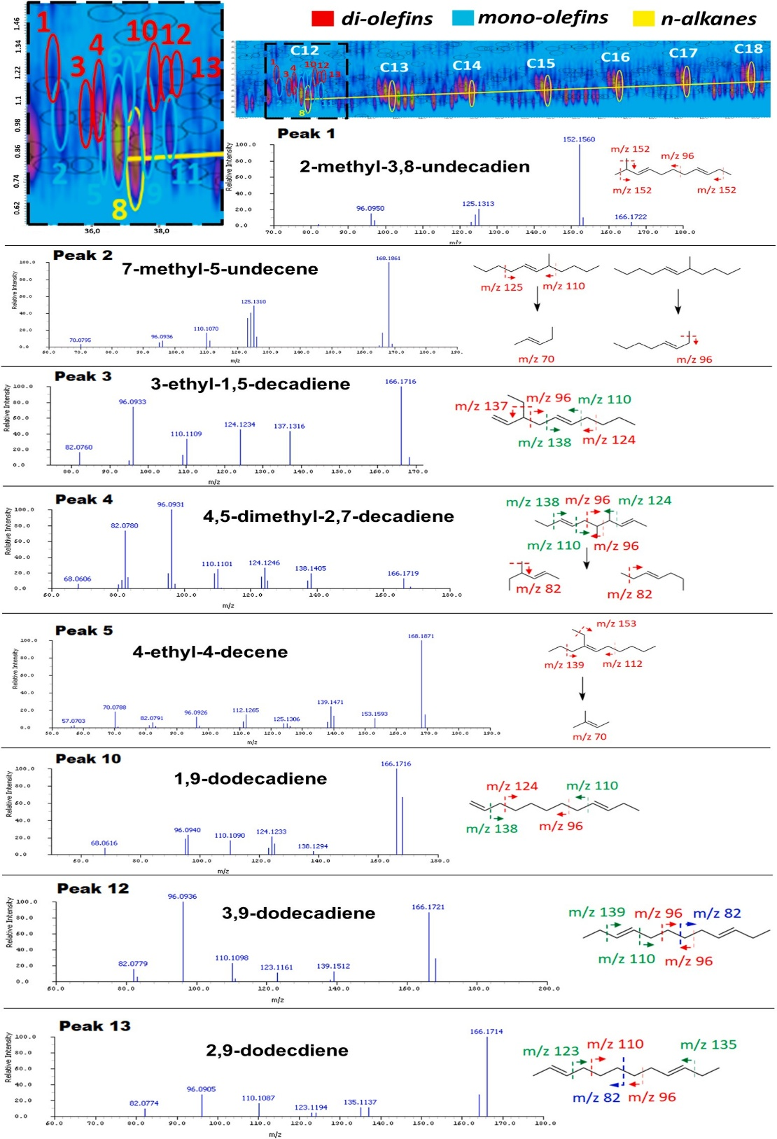
Fig. 3. GC × GC-PI-HRTOFMS investigation of C12 group. On the top left: zoom of the C12 group, where each color number corre- sponds to saturated (yellow), mono- unsaturated (blue), or diunsaturated (red) hydrocarbons. On the top central-right: same chemical classes for the C12 group in the carbon range of C12–C18. Peak 1–13 (black/bold): PI-MS spectra and pattern fragmentations of the analytes numbered in the C12 group (top-left). The accurate mo- lecular ions of all peaks as well as the pu- tative identification are reported in Table S3. (For interpretation of the refer- ences to color in this figure legend, the reader is referred to the Web version of this article.)
that besides β-cleavage, olefins can also undergo α-cleavage and γ-cleavage. However, the intensities of such fragments are much lower than β-cleavage [30]. The fragments m/z 139.1512 and m/z 110.1098 were contributed by α-cleavage. The fragment m/z 82.0779 was produced by γ-cleavage. The m/z 123.1161 could be from a combination of α-cleavage and β-cleavage. In peak 13, the fragments m/z 96.0905 and 110.1087 were more abundant than the rest. They were from the β-cleavage. α-cleavage caused the production of m/z 135.1137 and 123.1194. The m/z 82.0774 might be produced from γ-cleavage (Fig. 3). In peak 10, β-cleavage produced m/z 124.1233, m/z 96.0940, and m/z 68.0616. α-cleavage produced m/z 138.1294. The fragment m/z 110.1096 could be from either α-cleavage or γ-cleavage (Fig. 3).
The branched dodecadienes, peaks 1, 3, and 4, were predicted as 2- methyl-3,8-undecadien, 3-ethyl-1,5-decadiene, and 4,5-dimethyl-2,7- decadiene, respectively. The fragment ion m/z 152.1560 in peak 1 was the most abundant because there was β-cleavage at 3 bonds that can produce the same fragments. β-cleavage also produced m/z 96.0950 (Fig. 3). In peak 3, the top 3 abundant fragments, m/z 96.0933, 124.1234, and 137.1316, were β-cleavage products. While α-cleavage produced m/z 110.1109 and 82.0760 with relatively lower intensities (Fig. 3). In peak 4, m/z 96.0931 and 82.0780 were produced by the first β-cleavage and secondary β-cleavage. The rest of the fragments were α-cleavage products (Fig. 3). Even in the case where was not possible to tentatively predict the chemical structures of the analytes due to the complexity of the chemical structures, the use of the PI-HRMS allowed to assign at least the CN/DBN ratio of the analytes. As observed before, at the increase of the CN and the branching degree into the POHs, in particular in the unsaturated ones, there is a decrease in the retention. The example reported in Fig. 4 shows how C24–C25 POHs can elute be- tween the 1D retention time window of the C18–C20 linear hydrocarbon groups.

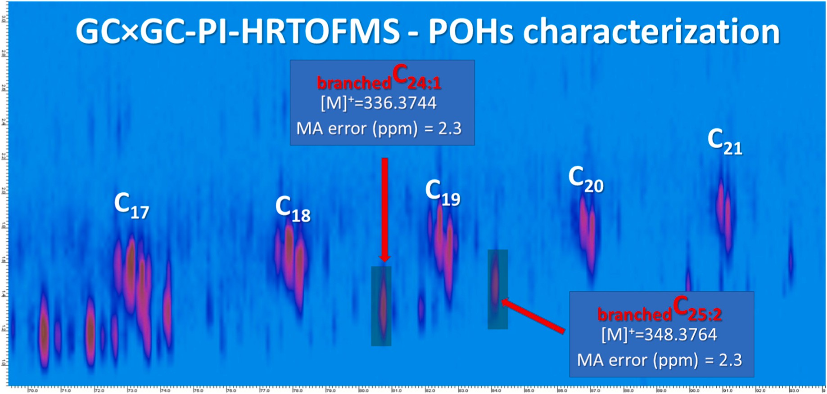
Fig. 4. GC × GC-PI-HRTOFMS of C24–C25 POHs eluted between the C18–C20 linear hydrocarbon groups.

It is worth mentioning at the end of this section that the olefin structures were predicted but not accurately identified. The prediction was based on the relative intensity of the fragment ions under the presented analytical condition, although the fragment ion intensities can be affected by the parameters and conditions of the instrument. However, investigating the repeatability of the fragment ion intensities under different analytical conditions is not the purpose of this study. This section means to show the potential of PI in understanding the isomer structures. Since there is a lack of information on the LRIs and reference mass spectrum, the only approach to make sure of the isomer structures is to synthesize mono-standards which is also challenging.

Conclusion

To limit plastic pollution promoting the circular economy, scientists have been spending significant effort looking at more effective plastic waste management techniques based on thermochemical routes like pyrolysis. Indeed, plastic pyrolysis oil represents a source to obtain monomers, fuel, and chemicals. Although the initial promise of plastic pyrolysis, several bottlenecks still limit its industrial applications [31]. Thus, to improve conversion and valorization processes, an advanced molecular description is essential.
In this context, GC × GC coupled with both LR and HRTOFMS was employed for a deeper investigation among and within different chemical classes present in bio-plastic oil. The identification of the main chemical classes was performed by GC × GC-EI-TOFMS, but the presence of several isomeric species as well as homologs series did not allow a reliable molecular identification, except for a few compounds that showed both MS% > 800 and LRI ±20. The identification of several isomers was conducted by the interpretation of PI mass spectra from GC × GC-HRTOFMS, leading to a putative identification of molecules not previously identified using the most common EI-MS approach. The GC injection method by PTV solvent vent mode was also optimized using CCD to successfully introduce a wide range of CN compounds without discrimination of low/high boiling points. In addition, in both multidimensional approaches, the characteristic 2D-GC plot location provided a sort of chemical fingerprint composed of different chemical classes from which different levels of information can be extrapolated.

CRediT authorship contribution statement

Marco Beccaria: Conceptualization, Methodology, Formal analysis, Investigation, Data Curation, Writing - Original Draft, Writing - Review & Editing, Visualization, Supervision, Marco Piparo: Resources, Supervision, Writing - Review & Editing, Yun Zou: Conceptualization, Methodology, Formal analysis, Investigation, Data Curation, Writing – Original Draft, Writing - Review & Editing, Pierre-Hugues Stefanuto: Resources, Writing - Review & Editing, Giorgia Purcaro: Resources, Data Curation, Writing - Review & Editing, Anna Luiza Mendes Siqueira: Resources, Supervision, Writing - Review & Editing, Adrien Maniquet: Resources, Supervision, Writing - Review & Editing, Pierre Giusti: Resources, Supervision, Writing - Review & Editing; Jean- François Focant: Resources, Supervision, Writing - Review & Editing, Project administration, Funding acquisition.

Declaration of Competing Interest

The authors declare that they have no known competing financial interests or personal relationships that could have appeared to influence the work reported in this paper.

Appendix A. Supplementary data

Supplementary data to this article can be found online at https://doi. org/10.1016/j.talanta.2022.123799.

References

- R. Palos, A. Gutie´rrez, F.J. Vela, M. Olazar, J.M. Arandes, J. Bilbao, Waste refinery: the valorization of waste plastics and end-of-life tires in refinery units, A Review, Energy and Fuels 35 (2021) 3529–3557, https://doi.org/10.1021/acs. energyfuels.0c03918.
- W.L. Filho, A.L. Salvia, A. Bonoli, U.A. Saari, V. Voronova, M. Klo˜ga, S.S. Kumbhar, K. Olszewski, D.M. de Quevedo, J. Barbir, An assessment of attitudes towards plastics and bioplastics in Europe, Sci. Total Environ. (2021) 755, https://doi.org/ 10.1016/j.scitotenv.2020.142732.
- PlascticsEurope, Plastics-the Facts 2020 An analysis of European plastics production, demand and waste data, n.d. https://doi.org/https://plasticseurope. org/wp content/uploads/2021/09/Plastics_the_facts-WEB-2020_versionJun21_ final.pdf.
- N. Singh, D. Hui, R. Singh, I.P.S. Ahuja, L. Feo, F. Fraternali, Recycling of plastic solid waste: a state of art review and future applications, Compos. B Eng. 115 (2017) 409–422, https://doi.org/10.1016/j.compositesb.2016.09.013.
- M. Solis, S. Silveira, Technologies for chemical recycling of household plastics – a technical review and TRL assessment, Waste Manag. 105 (2020) 128–138, https://doi.org/10.1016/j.wasman.2020.01.038.
- R. Geyer, J.R. Jambeck, K.L. Law, Production, Use, and Fate of All Plastics Ever Made, 2017.
- H.E. Toraman, T. Dijkmans, M.R. Djokic, K.M. Van Geem, G.B. Marin, Detailed compositional characterization of plastic waste pyrolysis oil by comprehensive two-dimensional gas-chromatography coupled to multiple detectors, J. Chromatogr. A 1359 (2014) 237–246, https://doi.org/10.1016/j. chroma.2014.07.017.
- H. Dao Thi, M.R. Djokic, K.M. van Geem, Detailed group-type characterization of plastic-waste pyrolysis oils: by comprehensive two-dimensional gas chromatography including linear, branched, and di-olefins, Separations 8 (2021), https://doi.org/10.3390/separations8070103.
- L. Quesada, M. Calero, M.A. Martín-Lara, A. P´erez, G. Blázquez, Characterization of fuel produced by pyrolysis of plastic film obtained of municipal solid waste, Energy 186 (2019), https://doi.org/10.1016/j.energy.2019.115874.
- W. Kaminsky, J.S. Kim, Pyrolysis of mixed plastics into aromatics, J. Anal. Appl. Pyrol. 51 (1999) 127–134, https://doi.org/10.1016/S0165-2370(99)00012-1.
- M. Beccaria, A.L.M. Siqueira, A. Maniquet, P. Giusti, M. Piparo, P.H. Stefanuto, J. F. Focant, Advanced mono- and multi-dimensional gas chromatography–mass spectrometry techniques for oxygen-containing compound characterization in biomass and biofuel samples, J. Separ. Sci. 44 (2021) 115–134, https://doi.org/ 10.1002/jssc.202000907.
- A. Giri, M. Coutriade, A. Racaud, K. Okuda, J. Dane, R.B. Cody, J.F. Focant, Molecular characterization of volatiles and petrochemical base oils by photo- ionization GC×GC-TOF-MS, Anal. Chem. 89 (2017) 5395–5403, https://doi.org/10.1021/acs.analchem.7b00124.

- A. Giri, M. Coutriade, A. Racaud, P.H. Stefanuto, K. Okuda, J. Dane, R.B. Cody, J. F. Focant, Compositional elucidation of heavy petroleum base oil by GC × GC-EI/ PI/CI/FI-TOFMS, J. Mass Spectrom. 54 (2019) 148–157, https://doi.org/10.1002/ jms.4319.
- Y. Zou, P. Stefanuto, M. Maimone, M. Janssen, J.-F. Focant, Unraveling the complex olefin isomer mixture using two-dimensional gas chromatography- photoionization-time of flight mass spectrometry, J. Chromatogr. A 1645 (2021), 462103, https://doi.org/10.1016/j.chroma.2021.462103.
- G. Purcaro, L. Barp, M. Beccaria, L.S. Conte, Fingerprinting of vegetable oil minor components by multidimensional comprehensive gas chromatography with dual detection, Anal. Bioanal. Chem. 407 (2015) 309–319, https://doi.org/10.1007/ s00216-014-8140-x.
- S. Salivo, M. Beccaria, G. Sullini, P.Q. Tranchida, P. Dugo, L. Mondello, Analysis of human plasma lipids by using comprehensive two-dimensional gas chromatography with dual detection and with the support of high-resolution time- of-flight mass spectrometry for structural elucidation, J. Separ. Sci. 38 (2) (2015) 267–275, https://doi.org/10.1002/jssc.201400844.
- M. Beccaria, Y. Zou, P.H. Stefanuto, A.L.M. Siqueira, A. Maniquet, M. Piparo, P. Giusti, G. Purcaro, J.F. Focant, Deeper investigation of oxygen-containing compounds in oleaginous feedstock (animal fat) by preparative column chromatography and comprehensive two-dimensional gas chromatography coupled with high-resolution time-of-flight mass spectrometry, Talanta 238 (2022), https://doi.org/10.1016/j.talanta.2021.123019.
- R.L. Ware, S.M. Rowland, R.P. Rodgers, A.G. Marshall, Advanced chemical characterization of pyrolysis oils from landfill waste, recycled plastics, and forestry residue, Energy Fuel. 31 (2017) 8210–8216, https://doi.org/10.1021/acs. energyfuels.7b00865.
- V.O. Nunes, R.V.S. Silva, G.A. Romeiro, D.A. Azevedo, The speciation of the organic compounds of slow pyrolysis bio-oils from Brazilian tropical seed cake fruits using high-resolution techniques: GC × GC-TOFMS and ESI(±)-Orbitrap HRMS, Microchem. J. 153 (2020), 104514, https://doi.org/10.1016/j.microc.2019.104514.
- N.S. Tessarolo, R.C. Silva, G. Vanini, A. Pinho, W. Romão, E.V.R. de Castro, D. A. Azevedo, Assessing the chemical composition of bio-oils using FT-ICR mass spectrometry and comprehensive two-dimensional gas chromatography with time- of-flight mass spectrometry, Microchem. J. 117 (2014) 68–76, https://doi.org/ 10.1016/j.microc.2014.06.006.
- M. Staš, M. Auersvald, P. Vozka, Two-dimensional gas chromatography characterization of pyrolysis bio-oils: a review, Energy Fuel. 35 (10,) (2021) 8541–8557, https://doi.org/10.1021/acs.energyfuels.1c00553.
- C. Mase, J.F. Maillard, B. Paupy, M. Farenc, C. Adam, M. Hubert-Roux, C. Afonso, P. Giusti, Molecular characterization of a mixed plastic pyrolysis oil from municipal wastes by direct infusion fourier transform ion cyclotron resonance mass spectrometry, Energy Fuel. 35 (2021) 14828–14837, https://doi.org/10.1021/acs. energyfuels.1c01678.
- M. Biedermann, K. Grob, Comprehensive two-dimensional gas chromatography for characterizing mineral oils in foods and distinguishing them from synthetic hydrocarbons, J. Chromatogr. A 1375 (2015) 146–153, https://doi.org/10.1016/j. chroma.2014.11.064.
- S. Biedermann-Brem, N. Kasprick, T. Simat, K. Grob, Migration of polyolefin oligomeric saturated hydrocarbons (POSH) into food, Food Additives and Contaminants - Part A Chemistry, Analysis, Control, Exposure and Risk Assessment 29 (2012) 449–460, https://doi.org/10.1080/19440049.2011.641164.

- P.Q. Tranchida, I. Aloisi, B. Giocastro, L. Mondello, Current state of comprehensive two-dimensional gas chromatography-mass spectrometry with focus on processes of ionization, TrAC, Trends Anal. Chem. 105 (2018) 360–366, https://doi.org/ 10.1016/j.trac.2018.05.016.
- M. Beccaria, F.A. Franchina, M. Nasir, T. Mellors, J.E. Hill, G. Purcaro, Investigation of mycobacteria fatty acid profile using different ionization energies in GC–MS, Anal. Bioanal. Chem. 410 (2018) 7987–7996, https://doi.org/10.1007/ s00216-018-1421-z.
- A. Glineur, M. Beccaria, G. Purcaro, Exploring 20 eV electron impact ionization in gas chromatography-tandem mass spectrometry for the determination of estrogenic compounds, J. Chromatogr. A 1652 (2021), 462359, https://doi.org/ 10.1016/j.chroma.2021.462359.
- M. Piparo, L. Flamant, G. Jousset, P. Cardinael, P. Giusti, Careful investigations of PTV injection parameters for the analysis of vacuum gas oil by high-temperature comprehensive GC × GC, Energy Fuel. 34 (2020), 12010, https://doi.org/10.1021/acs.energyfuels.0c01314, 12017.
- G. Purcaro, P.H. Stefanuto, F.A. Franchina, M. Beccaria, W.F. Wieland-Alter, P. F. Wright, J.E. Hill, SPME-GC×GC-TOF MS fingerprint of virally-infected cell culture: sample preparation optimization and data processing evaluation, Anal. Chim. Acta 1027 (2018) 158–167, https://doi.org/10.1016/j.aca.2018.03.037.
- S.E. Van Bramer, P.L. Ross, M. V Johnston, Unimolecular photochemistry of n- alkenes studied by photodissociation-photoionization mass spectrometry, J. Am. Soc. Mass Spectrom. 4 (1993) 65–72.
- S. Armenise, W. SyieLuing, J.M. Ramírez-Vela´squez, F. Launay, D. Wuebben, N. Ngadi, J. Rams, M. Munõz, Plastic waste recycling via pyrolysis: a bibliometric survey and literature review, J. Anal. Appl. Pyrol. 158 (2021), https://doi.org/ 10.1016/j.jaap.2021.105265.

