Supplementary material
Metabolome parameters in FUS-transgenic mice treated with thiamine compounds
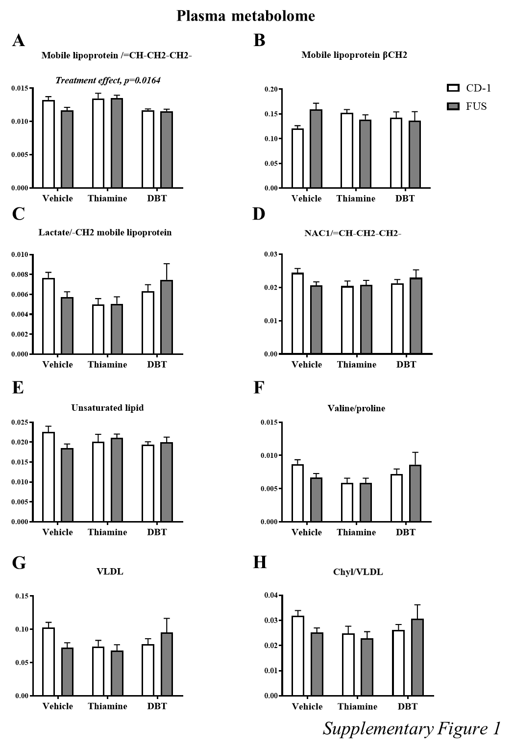
Supplementary Figure 1. Metabolome parameters in FUS-tg mice treated with thiamine compounds. (A) Significant treatment effect was shown for mobile lipoprotein /=CH-CH2-CH2; (B-H) No significant differences were found in mobile lipoprotein βCH2, lactate/-CH2 mobile lipoprotein, NAC1/=CH-CH2-CH2-, unsaturated lipid, valine/proline ratio VLDL and Chyl/VLDL ratio. p>0.05, two-way ANOVA and post hoc Tukey’s test. Bars are Mean ± SEM. DBT = dibenzoyl thiamine.

