Is Bitcoin dead?*

Jean-Marie Choffray**
Liège, November 5, 2022.

Abstract. With Bitcoin having lost more than sixty percent of its value over the last twelve months, the question arises: Is Bitcoin dead? The reasonable answer is that it follows the “natural evolution” of any innovative technology: slow and gradual adoption; acceleration of its diffusion; and, finally, complete substitution. So, there is nothing new under the sun! The most important fact, or truth, about the “Proof-Of-Work” protocol and, to a lesser extent, the “Proof-Of-Stake” process, is that both have withstood the storms they experienced. No fatal crash! No deadly hack! To the exclusion of a few casualties among the so-called “shitcoins”. It usually takes a generation (about thirty years) for a new technology to impose itself (cf. La révolution internet). There's no reason for it to be any different this time around.

* The information contained in this paper is for informational purposes only. It is not to be construed as an offer to buy or sell any financial assets or securities.

** Emeritus Professor of Management Science at the University of Liège, Belgium.
PhD-77, Massachusetts Institute of Technology.

As underlying adoption continues, Bitcoin and Ether remain positioned to reshape
the current monetary and internet ecosystems, which strongly suggests that
crypto has “staying power,” and that this is likely just
the beginning of the digital asset revolution.

Joe Orsini and Damon Polistina

Is Bitcoin dead?

Source: Buy Bitcoin Worldwide: Bitcoin Is Dead” – The #1 Database of Notable Bitcoin Skeptics, October 2022

Is Bitcoin dead? No…!

It is alive and well and living on the edge of the cloud…

The Bitcoin's story cannot be told without due respect to its strongest believers and disbelievers. Skepticism is always healthy. It speeds up the development and the adoption of the most valuable technologies.

With perfect regularity, experts and pundits of all kinds have called for the death of Bitcoin in each of its drawdowns over its thirteen-year history… With the same regularity, they have been wrong!

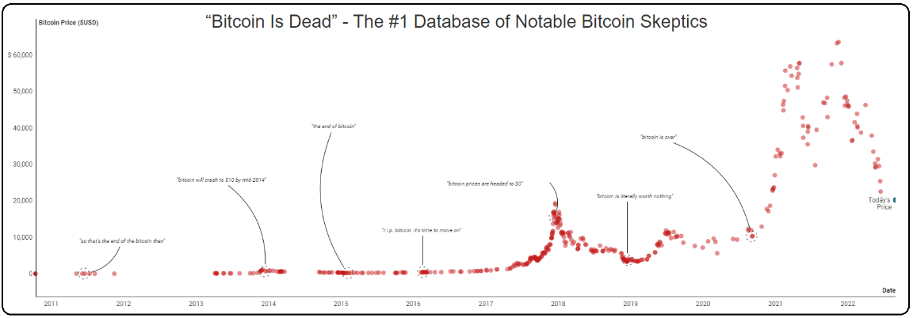
(Click on image to enlarge and animate)

* * *

Source: Eaglebrook Advisors: Market Commentary, October 25, 2022

Some optimism in a world full of negativity

Bitcoin and Ether just weathered one of the toughest market environments in quite some time. They showed resiliency and technical Robustness despite evident price weakness and Volatility.

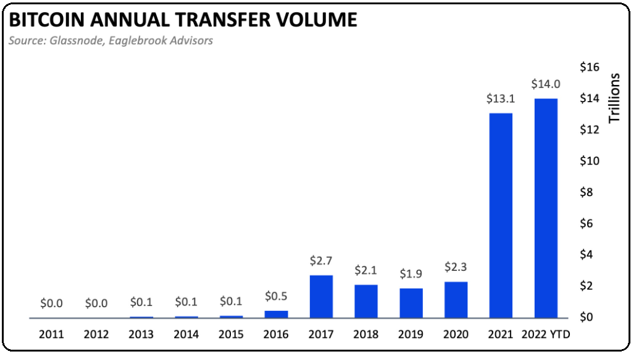

Interestingly, Ethereum’s new issuance has dropped markedly after its shift to “Proof-Of-Stake.” (The Merge)

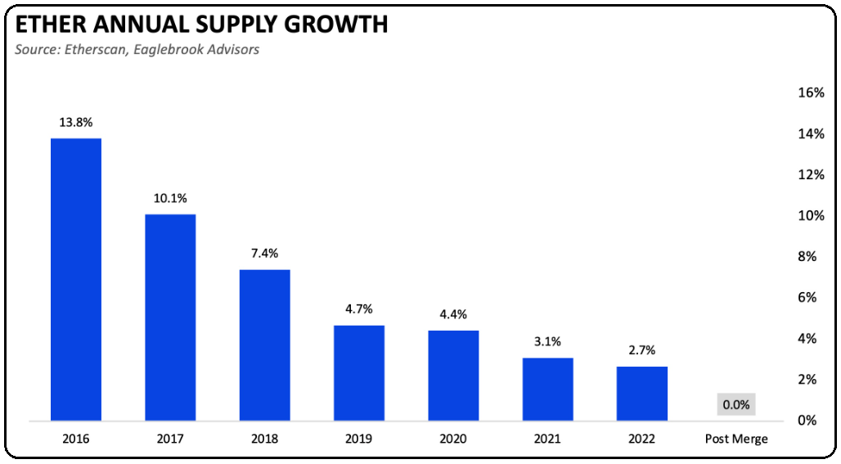

* * *

Source: Eaglebrook Advisors: Q3 2022 Digital Assets Staying Power, August 31, 2022

Comparing the price meltdowns

As often observed in history, large price drops do not necessarily result in the end of a new technology. Economic life (natural selection) gives rise to inevitable fluctuations. Frequency and Amplitude are key attributes of free markets behavior.

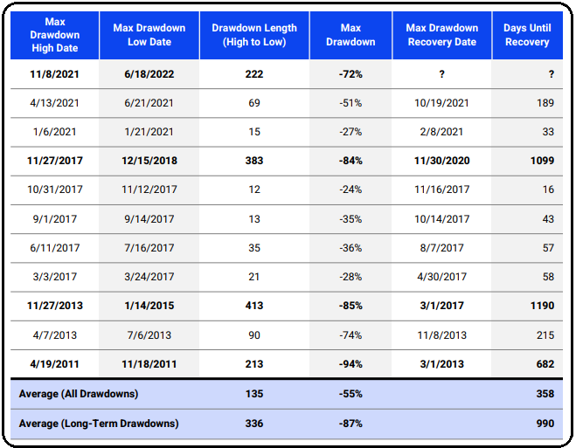

Only the best survives…

The dotcom bubble implosion in 2000 provides an interesting analogy. The Madness of crowds and investors’ dysphoria led to the collapse of most internet-based businesses. What happened afterwards is part of History!

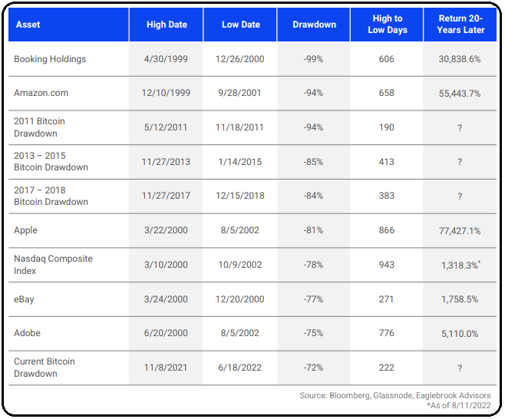

* * *

With Bitcoin having lost more than sixty percent of its value over the last twelve months, the question arises: Is Bitcoin dead? The reasonable answer is that it follows the “natural evolution” of any innovative technology: slow and gradual adoption; acceleration of its diffusion; and, finally, complete substitution. So, there is nothing new under the sun! The most important fact, or truth, about the “Proof-Of-Work” protocol and, to a lesser extent, the “Proof-Of-Stake” process, is that both have withstood the storms they experienced. No fatal crash! No deadly hack! To the exclusion of a few casualties among the so-called “shitcoins”. It usually takes a generation (about thirty years) for a new technology to impose itself (cf. La révolution internet). There's no reason for it to be any different this time around.

