A Levered Long Bitcoin Hybrid Strategy*

Jean-Marie Choffray**
Liège, November 2, 2022.

Abstract. MicroStrategy (Nasdaq: MSTR) is the only listed company I know of that has a Levered Long Bitcoin Hybrid Strategy. Its main goal is to grow its enterprise analytics business and acquire and hold Bitcoin as a treasury reserve for the long term. The company is also in the initial stage of exploring innovative Lightning applications for cybersecurity to help customers monetize websites and deploy wallets in mass using Bitcoin. Since MicroStrategy adopted its Bitcoin strategy, its stock has outperformed all of the major asset classes that it benchmarks against. It has outperformed most big tech stocks and enterprise software stocks too. Will its performance last? It’s anyone’s guess! But, some of the observations made by management during its recent Q3 2022 earnings call, are probably worth meditating on.

* The information contained in this paper is for informational purposes only. It is not to be construed as an offer to buy or sell any financial assets or securities.

** Emeritus Professor of Management Science at the University of Liège, Belgium.
PhD-77, Massachusetts Institute of Technology.

The way we're going to achieve performance better than Bitcoin is through intelligent leverage when we have the ability to either convert our cash flows into Bitcoin
and we do generate cash flow or if we can issue debt or equity under
terms that we believe are accretive to the shareholders.

Michael Saylor

A Levered Long Bitcoin Hybrid Strategy
Source: MicroStrategy (MSTR) Q3 2022 Earnings Call Transcript

“MicroStrategy (Nasdaq: MSTR) is an independent publicly-traded business intelligence company, with a leading enterprise analytics platform. Its vision is to enable Intelligence Everywhere. It provides modern analytics on an open, comprehensive enterprise platform, used by many of the Fortune Global 500. Optimized for cloud and on-premises deployments, the platform features HyperIntelligence, a technology that overlays actionable enterprise data on popular business applications to help users make smarter, faster decisions […] Its skilled and experienced consultants continue to support, innovate and modernize its platform across its customer base.”

“An interesting area where MicroStrategy differentiates its offerings is Bitcoin Lightning software development for the enterprise. It is in the initial stage of exploring innovative Lightning applications for cybersecurity to help enterprise customers monetize websites and deploy wallets in mass using Bitcoin.”

“MicroStrategy's core strategies are to operate and grow its enterprise analytics business and to acquire and hold Bitcoin as a treasury reserve for the long-term. This hybrid strategy represents a paradigm shift where we seek to maximize the performance of both segments of our business, while identifying and capitalizing on the synergies that come from combining a mature and profitable enterprise software business with a large-scale digital asset holding.”

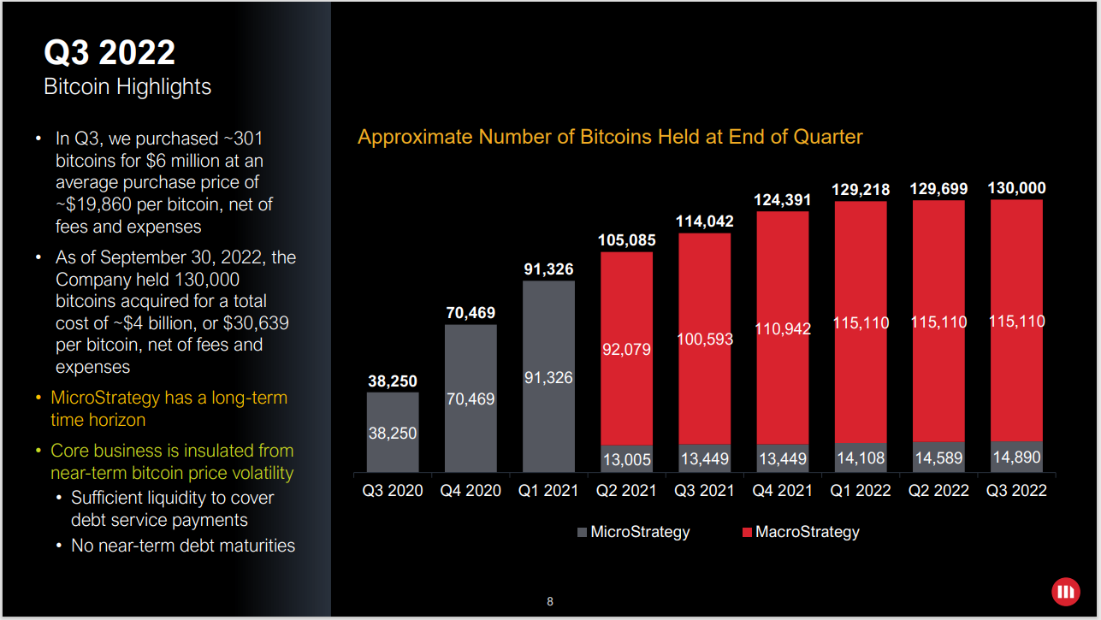
(Source: MSTR Q3 2022 Financial Results, November 1, 202)

* * *

Phong Le – President and Chief Executive Officer

“Despite a challenging macroeconomic environment in Q3 with continuing high inflation, weakening foreign currencies and the ongoing war in Ukraine […] We continued the commitment to our strategy and purchased 301 additional Bitcoins for approximately $6 million at an average purchase price of $19,000 – $19,860 per Bitcoin, net of fees and expenses. We have not sold any Bitcoin to date […] We seek to acquire and hold Bitcoin for the long-term. And we do not currently plan to engage in sales of Bitcoin. We have a long-term time horizon and the core business is not impacted by the near-term Bitcoin price fluctuations. As a final comment, I would say macro and market volatility are expected to be the new normal.”

* * *

Andrew Kang -- Senior Executive Vice President and Chief Financial Officer

“Stable Bitcoin prices this quarter led to a nominal $700,000 Bitcoin impairment charge in contrast to the $65 million charge in Q3 of 2021. The Bitcoin volatility as measured by the one-month realized volatility fell below that of the major equity indices such as the S&P 500 and Nasdaq this past quarter […] We view this recent market shift as a possible signal that Bitcoin's investor base and institutional adoption is continuing to mature, making it more suitable and accepted by traditional market participants. During the quarter, Bitcoin prices remained above our carrying value, low watermark of approximately $17,600 – and as a result, we saw a minimal digital asset impairment charge in Q3 […] the lowest digital asset impairment charge since we launched our Bitcoin strategy in Q3 of 2020.”

“As you know, GAAP accounting treats our Bitcoin holdings as an indefinite-lived intangible asset, which means that any decrease in the fair value below our carrying value any time after date of acquisition requires us to recognize an impairment. Conversely, when prices increase, the current accounting rules did not allow us to increase the carrying value. On October 12, the Financial Accounting Standards Board unanimously voted to recommend the adoption of fair value accounting for all public and private companies in measuring certain digital assets, including Bitcoin. Under current fair value accounting standards, both decreases and increases in the fair market value of an asset would be recognized in GAAP earnings […] We understand this is an initial step in the standard-setting process and many of the details and disclosures have yet to be determined, but we are extremely encouraged and supportive of the FASB's decision for the change and the improved investor transparency it should provide. We believe this is an extremely positive step for the future of digital asset accounting, and we remain committed as we have in the past to supporting these efforts.”

* * *

Michael Saylor -- Executive Chairman and Co-Founder

“I'm delighted to report to all the shareholders that since MicroStrategy adopted the Bitcoin strategy on August 11, 2020, our stock has outperformed all of the major asset classes that we benchmark ourselves against. It has outperformed all big tech stocks, and we have outperformed all enterprise software stocks that we benchmark ourselves against.”

“So even though I think there's a lot of publicity about the volatility of Bitcoin and some of the non-cash charges we've taken, the real interesting story here is that MicroStrategy's Bitcoin strategy is the winner against all of these other strategies over the last 2.25 years. We generally pick August 10, 2020, as that date to go back to because that was the date before we purchased $250 million worth of Bitcoin, and we announced a $250 million Dutch auction or share buyback.”

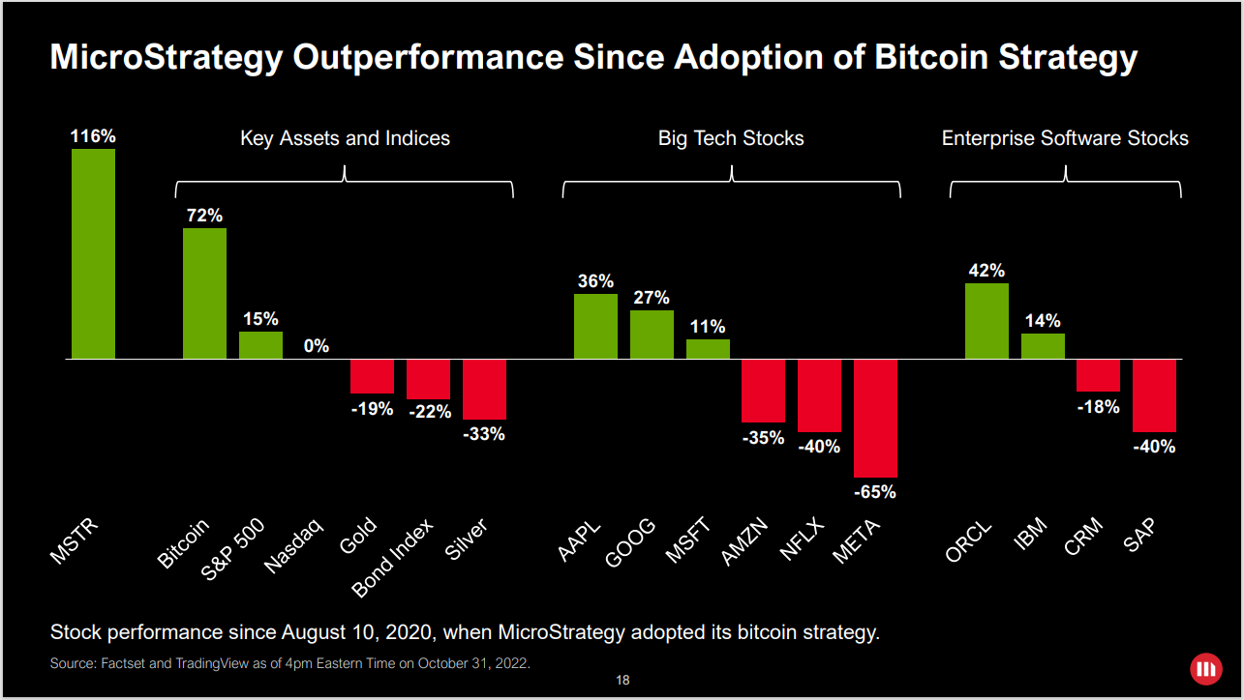
(Source: MSTR Q3 2022 Financial Results, November 1, 202)

“And so, that was a pretty critical point in the history of the company. Before that date, we are operating the software business without any treasury strategy and we had our $500 million in cash invested in short-term treasuries zero to 12-month treasury bills. And our primary strategy was either to buy the stock back or invest in treasuries. And after that date, we had a Bitcoin strategy that was implemented on $250 million […] And then, we had to wait until the end of the Dutch auction around September 10th of 2020 before we knew what was going to happen next. And then, we had $175 million, which we invested in Bitcoin, and we have continued with our consistent Bitcoin long strategy since.”

“The most important thing that's happened in the past 12 months is the risk-free interest rate in the world, and I don't just mean the Western world, the entire world has gone from 12 basis points to 465 basis points. That's the one-year treasury rate on US treasuries. And that's an extraordinary climb. In the middle of 2018, the one-year rate was about 280 basis points. […] The important point right now is that we're now at a seriously inverted Yield Curve […] The classic interpretation would be that the Yield Curve is pointing toward expectation of recession, and the reason the 30-year rate is higher (sic) than the three-month rate is an expectation that eventually the Fed will begin to loosen monetary policy and lower rates […] The pound and the euro are off about 15% against the dollar in the last 12 months. Japanese yen is down about 23% […] The Bitcoin fundamentals have improved. As Andrew pointed out, volatility of Bitcoin shifted for being more volatile than Nasdaq and highly correlated to being less volatile than Nasdaq and not so much correlated in the past three months. That's really bullish, I think, for the asset class and auspicious […] BNY Mellon officially announced its Bitcoin custody services. That's very auspicious because that's probably the first major bank that stepped up into that business. Block […Nasdaq: SQ] upgraded Cash App and Cash App is a 40 million user type mobile application, and they upgraded it in their support of Lightning […] We're already seeing this create a massive amount of enthusiasm in the Lightning development community.”

“And one of the more interesting stories right now is a supermarket chain call Pick-N-Pay, all around South Africa. Pick-N-Pay rolled out Lightning payments to 40 of their stores in production as the second stage of their Bitcoin adoption […] Traditionally, the view of Bitcoin is it's just a store of value because it runs on a level one transaction network with only seven transactions a second. But now that people are saying that it's infinitely scalable over the Lightning Network, it's not just a store value. It's a game-changing technology that you can build into a mobile App on billions and billions of mobile devices […] Another big development that happened this quarter is FASB made the fair value decision by a vote of seven to zero. It doesn't mean that we have enough guidance to change our accounting. But if we consider what happens next, we know we have unanimous support to adopt fair value accounting for Bitcoin.”

“There's been an increase in SEC crypto enforcement actions, and this is serving to educate an entire generation of crypto investors as to the difference between a commodity and a security. And I think that as people become educated as to the difference, they realize that there's a great benefit to holding a commodity and Bitcoin is the only crypto asset universally acknowledged to be a commodity. And so, I think that the world is getting educated there.”

“And then, last point I'll make is that the Bitcoin hash rate is hitting an all-time high right now, and there are people suggesting they see it touching 300 exahashes. So throughout the crypto winter and all the volatility, the Bitcoin hash rate has continued to expand. And people often ask, well, what is Bitcoin backed by. It's backed by the most powerful crypto computing network in the world, which is also the most powerful computing network on earth, like so powerful that it's orders of magnitude more powerful than the hash rate that could be generated by all of the Microsoft, Amazon, and Google cloud computing hardware, if it were all turned against the network. So the fact that Bitcoin has this wall of crypto energy, 300 exahashes of it, makes the entire asset censorship resistant, hack resistant. It gives it integrity. It gives a longevity. It makes it neutral. […] We've considered all of those [… alternative investments], and we concluded Bitcoin is the Apex property and there's nothing better. Everything else that we could invest in would be dilutive versus Bitcoin.”

“So our conclusion is that the best strategy for us is Long Bitcoin, only Bitcoin as a digital asset […] The way we're going to achieve performance better than Bitcoin is through intelligent leverage when we have the ability to either convert our cash flows into Bitcoin and we do generate cash flow or if we can issue debt or equity under terms that we believe are accretive to the shareholders. And they don't introduce any undue risk or fragility to the balance sheet. So I think you'll just see a very thoughtful execution of the Levered Long Bitcoin strategy. And we don't feel a need to reach for yield or try to juggle any other asset. We view that all these other strategies are dilutive to the Bitcoin strategy.”

* *
*

