Electronic supplementary material for:

Many-to-one function of cat-like mandibles provides new evidence of mosaic evolution in sabretooth jaw systems.
Narimane Chatar^{1,}*, Valentin Fischer¹, Z. Jack Tseng²
¹ Evolution & Diversity Dynamics lab, UR Geology, Université de Liège, Building B18, Quartier Agora, Allée du Six Août 14, 4000 Liège, Belgium

² Department of Integrative Biology and Museum of Paleontology, University of California,
Berkeley, CA 94720, United States

* Corresponding author: narimane.chatar@uliege.be

Supplementary material and methods

Material
Table S1: Cranium used in the analysis. Specimens for which cranium and mandible did not belong to the same individual or for which the original cranium had to be reconstructed are highlighted in bold. See later in ESM for the details of the reconstruction.
Genus | Species | Specimen n°  mandible | Cranium used to compute focal coordinates
Caracal | Caracal | A58401 | A58401
Lynx | rufus | FAVE09 | FAVE09
Panthera | pardus | AMNH 113745 | AMNH 113745
Panthera | onca | MNHN-ZM-MO-2006-641 | MNHN-ZM-MO-2006-641
Panthera | tigris | MNHN-ZO-AC-1931-60 | MNHN-ZO-AC-1931-60
Prionailurus | rubiginosus | MNHN-ZM-MO-2012-54 | MNHN-ZM-MO-2012-54
Amphimachairodus | palanderi | PMU 21831 | PMU 21831 + HD-9196
Dinofelis | barlowi | DNMNH-BF-55-23 | DNMNH-BF-55-22 + Dinofelis piveteaui DNMNH-KA-61-5534 & 5535
Homotherium | crenatidens | MNHN.F.PET2000 | MNHN.F.PET2000
Machairodus | aphanistus | NHMUK-PV-M37356 | Amphimachaioruds palanderi PMU 21831 + HD-9196
Metailurus | major | PMU-21771/2 | PMU-21771/1
Paramachairodus | orientalis | NHMUK-PV-M-89559 | Paramachairodus maximiliani PMU 21773
Smilodon | fatalis | AMNH-14349 | AMNH-14349
Yoshi | minor | PMU 21766/2 | PMU 21766/1
Hoplophoneus | primaevus | LACM-42890 | LACM-42890
Dinictis | felina | LACM-162986 | LACM-162986 + CIT-98
Barborofelis | fricki | UCMP-124942 | UF-VP-27447
Barborofelis | loveorum | UF-VP-36855 | UF-VP-27447

Reconstruction
Due to the incompleteness of some fossil specimens, part of those specimens had to be reconstructed or retrodeformed. The left side of the mandible of Amphimachairodus palanderi PMU 21831 misses the angular process and the mandibular condyle thus it was reconstructed based on the perfectly preserved right side. Also, the skull of Amphimachairodus palanderi PMU 21831 lacks both zygomatic arches, to compute the center of gravity of the origin of both m. masseter the surface scan of Amphimachairodus palanderi HD-9196 published by [1] was used after being scaled to corresponds to the size of PMU 21831.
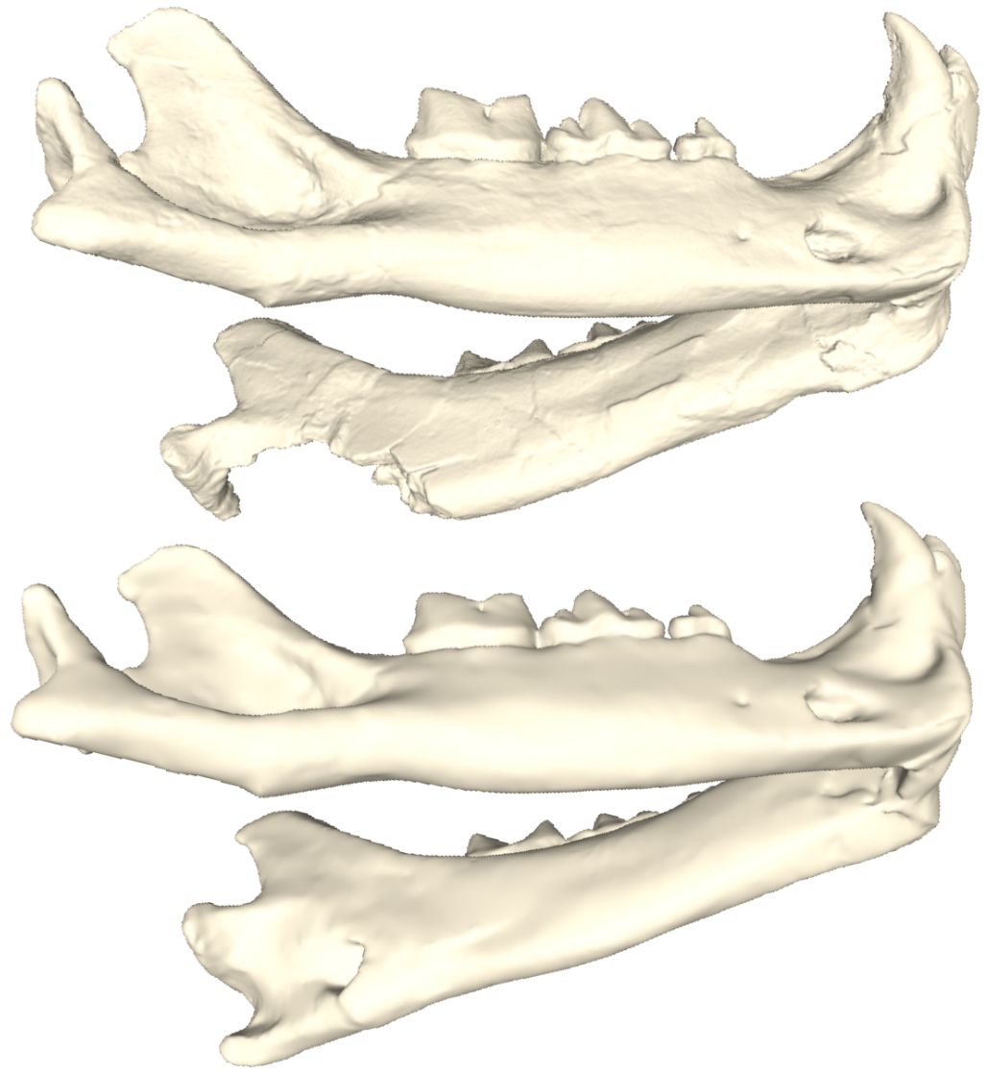
Figure S1: Amphimachairodus palanderi PMU 21831 before (above) and after(below) reconstruction
The tip of both coronoid processes of Yoshi minor PMU 21766/2 was missing. No other 3D model of Yoshi minor had a perfectly preserved coronoid process so different mandibles of felines and machairodontines were scaled to the size of Y. minor to assess which other taxa had a similar coronoid shape to PMU 21766/2. The cheetah, Acinonyx jubatus MNCN COMP-3438 and the snow leopard Panthera uncia MNHN-ZO-AC 1970-102 seemed to be the two best candidates but finally the cheetah was chosen to reconstruct the coronoid processes of Y. minor.
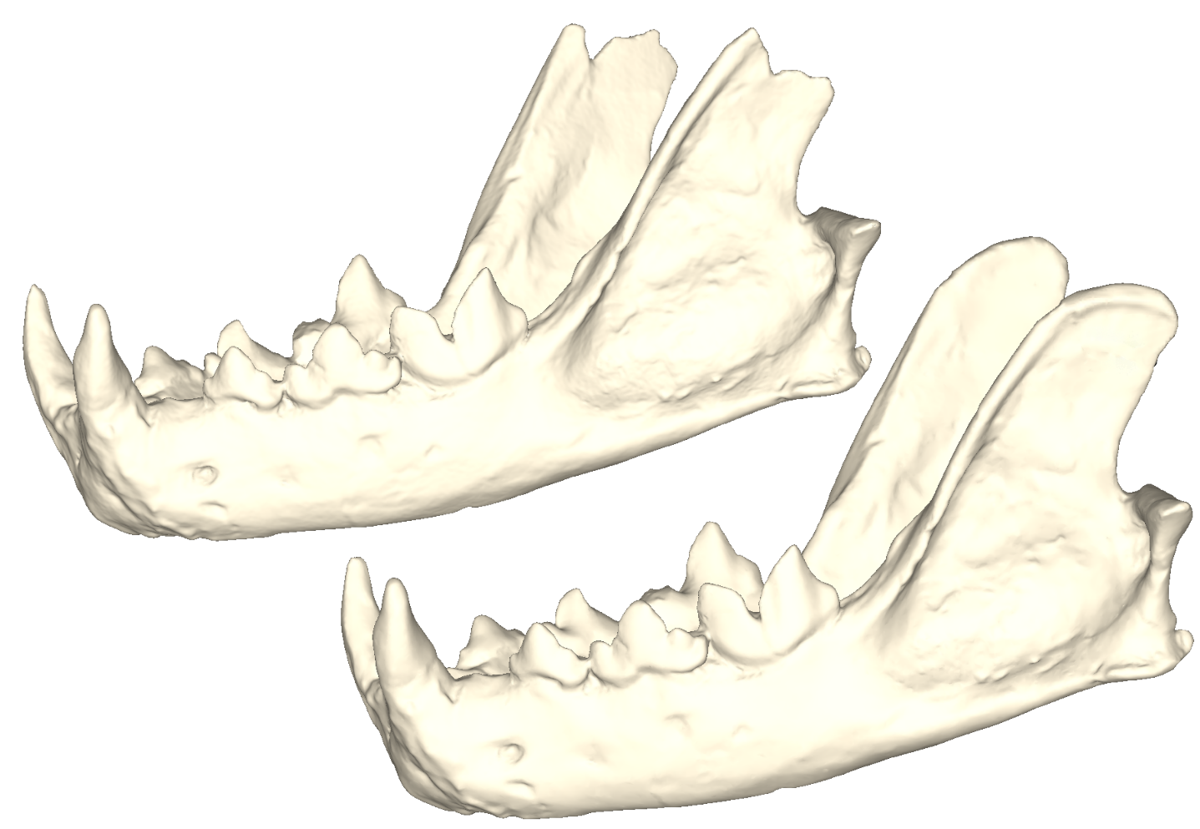
Figure S2: Yoshi minor PMU 21766/2 before (above) and after(below) reconstruction

The mandible NHMUK-PV-M37356 of Machairodus aphanistus from Pikermi was a cast of an isolated dentary missing p3 and the lower canine so it was reconstructed based on a specimen from Batallones and reflected to create a complete mandible. No Machairodus aphanistus cranium was available for the analysis so the skulls PMU 21831 and HD-9196 of Amphimachairodus palanderi were scaled to fit the size of the mandible NHMUK-PV-M37356 and muscles origins were drawn on those skulls to estimate the focal points.
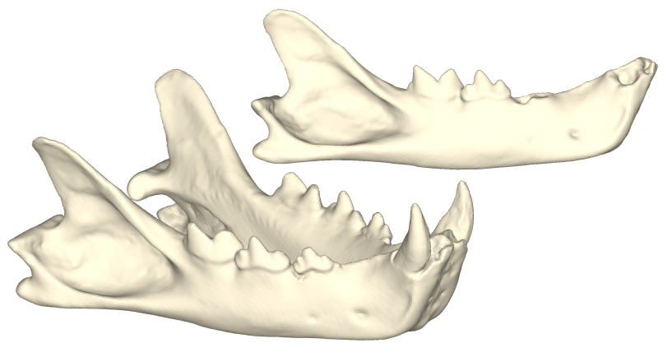
Figure S3: Machairodus aphanistus NHMUK-PV-M37356 before (above) and after (below) reconstruction

The Dinoeflis barlowi mandible DNMNH-BF-55-23 was sheared and had to be retrodeformed using the retrodeformation tool from the Landmark editor v.3 software. To do so, 16 landmarks were placed on both side of the mandible (8 on each side) and the Motani Method was used to compute the retrodeformation. Some holes on the left coronoid process were also opened and filled using Geomagic.
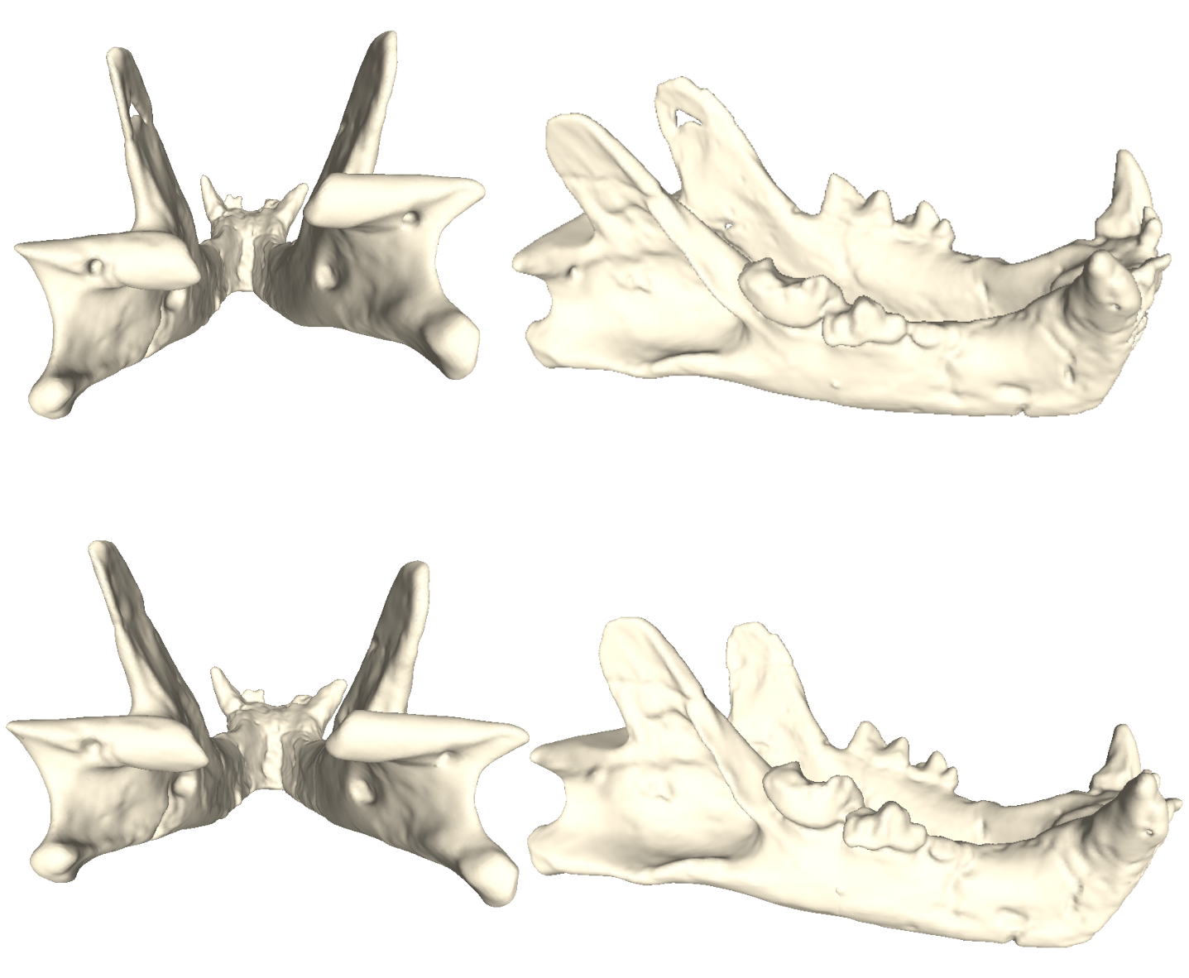
Figure S4: Dinofelis barlowi DNMNH-BF-55-23 before (above) and after(below) reconstruction

The Homotherium crenatidens mandible was lacking the left tip of the coronoid process so it was reconstructed based on the right coronoid process. Also, the cranium was missing the right zygomatic arch, the origin of the right masseter was thus obtained by performing a symmetry of the left origin relative to the sagittal plane.
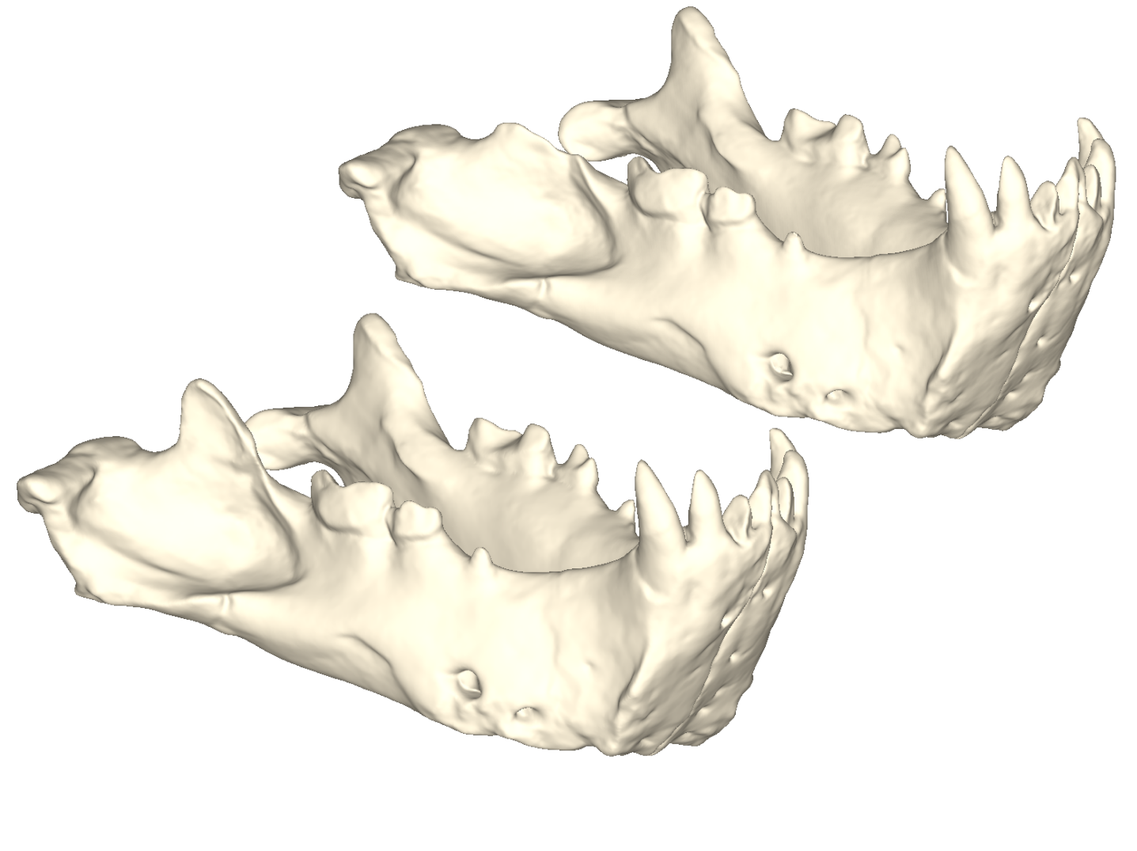
Figure S5: Homotherium crenatidens MNHN.F.PET2000 before (above) and after(below) reconstruction

No Paramachairodus orientalis cranium was available so to define the focal coordinates of the different muscle groups the cranium of Paramachairodus maximiliani PMU 21773 was articulated with the Pa. orientalis mandible after being scaled to the size of the mandible. The coronoid process of Pa. orientalis was reconstructed based on that of Promegantereon ogygia from Batallones.
Figure S6: Paramachairodus orientalis NHMUK-PV-M-89559 before (above) and after(below) reconstruction

The braincase of the cranium associated with the Dinictis felina LACM-162986 mandible was deformed so we used the Dinictis felina CIT-98 cranium to draw the origins of the temporalis and pterygoideus muscles. Still, the cranium CIT-98 missed both zygomatic arches and the LACM-162986 had quite well-preserved arches so we draw the masseter origins on the LACM-162986 cranium.
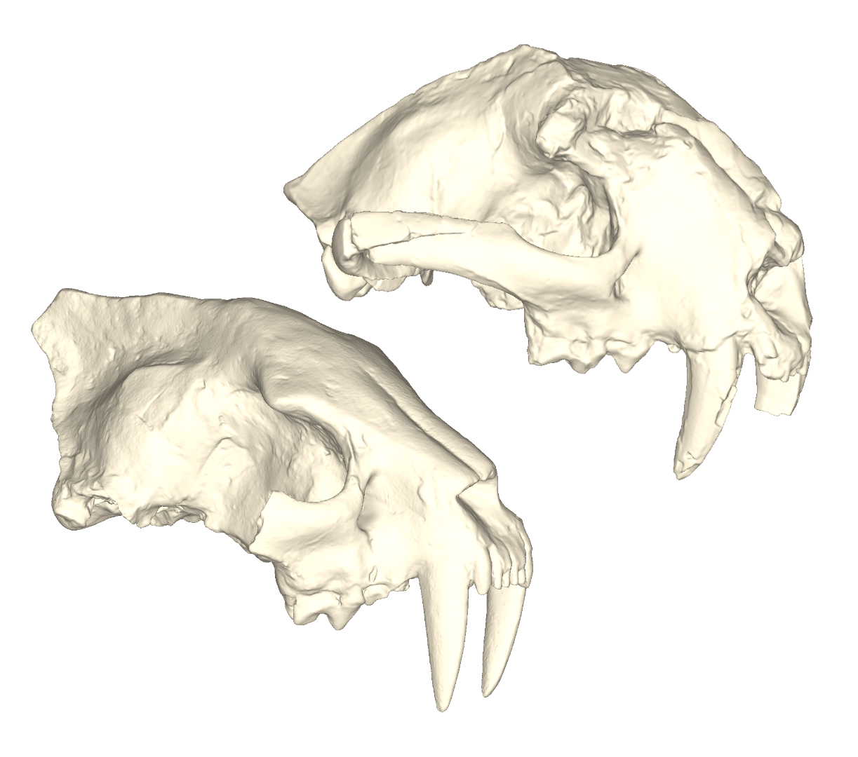
Figure S7: Dinictis felina cranium LACM-162986 (above) and CIT-98 (below) used to estimate the centroid of the different muscle origins.

The only available Barbourofelis fricki mandible UCMP-124942 was the cast of a right dentary UCMP-124942 casted on the holotype specimen UNSM-76000. We had to mirror the model and stitch both dentaries to create a ‘mandible’ for our analyses. Then, to compute the focal coordinates we articulate that “mandible” with the cranium of Barbourofelis loveorum UF-VP-36855 that we scaled to adjust it to the size of the Barbourofelis fricki mandible.
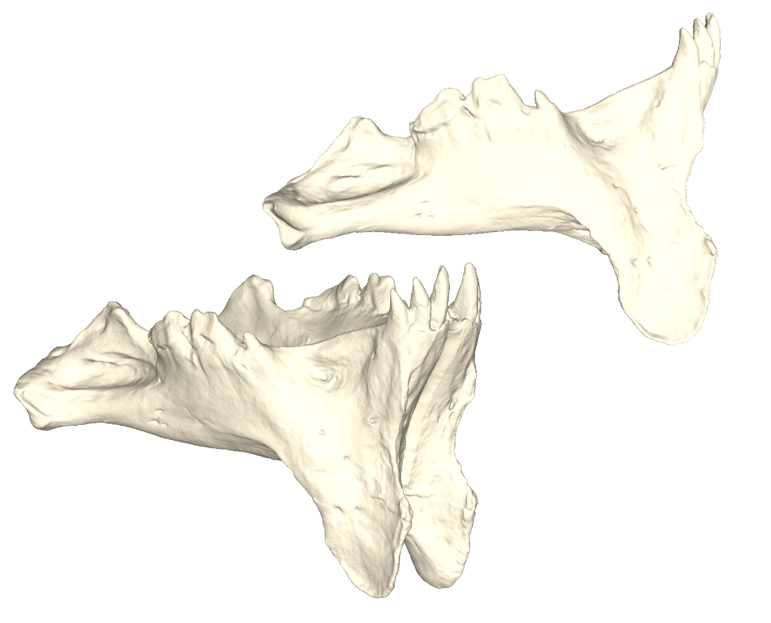
Figure S8: Barbourofelis fricki left dentary UCMP-124942 (above) and the resulting mandible created after reflection and fusion (below).

The only available Barbourofelis loveorum mandible was the holotype UF-VP-36855 which is a left dentary and had to be mirrored to obtain a ‘mandible’ for our analyses
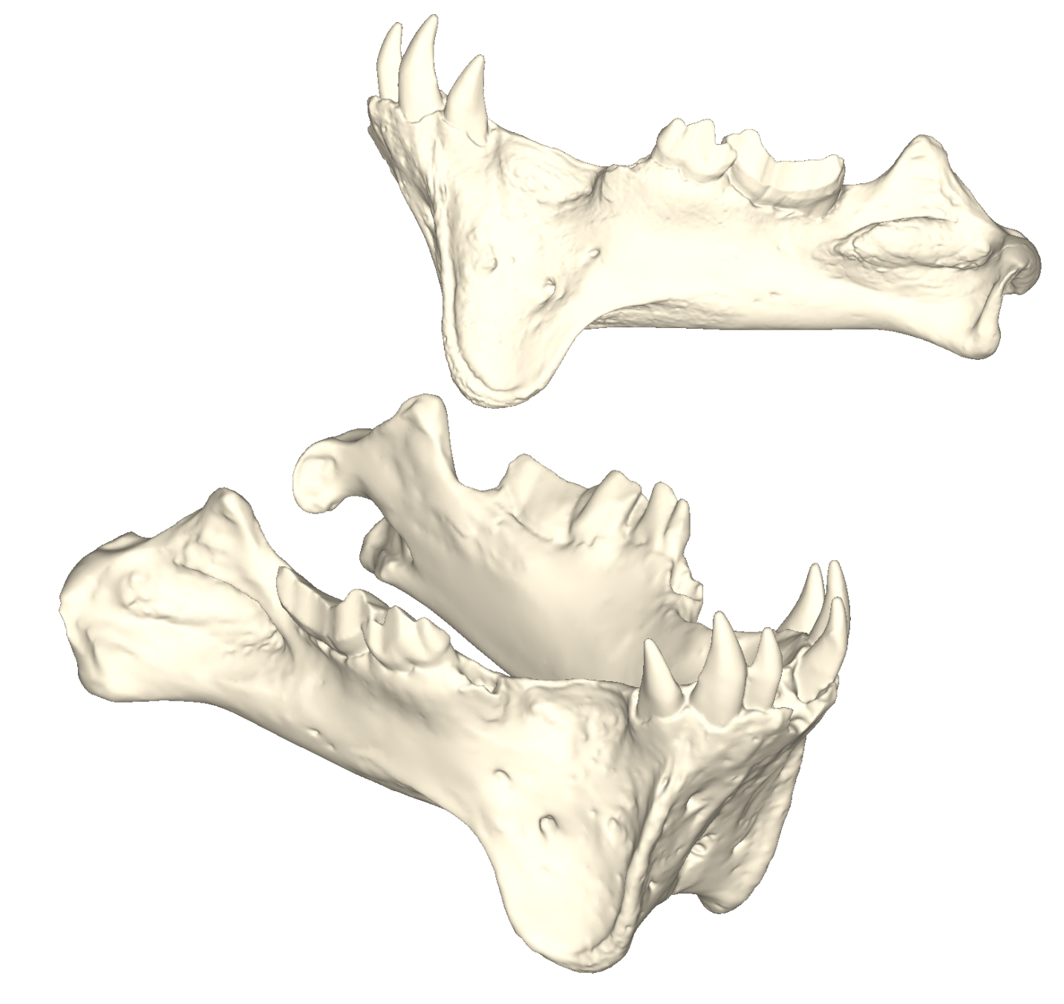
Figure S9: Barbourofelis loveorum left dentary UF-VP-36855 (above) and the resulting mandible created after reflection and fusion (below).

Comparison CT- and surface scan-based models
Seeing recent results published by Morales-García et al. (2019) comparing different approaches to build models for FEA we also decided to test the utility of surface-scan based models to predict the stress response of a carnivora mandible. To do so we performed the same analyses on two mandibles Lynx rufus and Panthera pardus using a CT scan-based model and the external shell of the CT scan-based model to simulate a surface scan-based model. The mechanical efficiency and adjusted strain energy are summarized in Table S2. von Mises stress contour plot are shown in Figure S10. In broad terms, both mechanical efficiency and adjusted strain energy in the models lacking the internal anatomy are extremely similar (more than 92.5% of similarities, see Table S2 and Figure S111) to the results obtained when including the internal anatomy. Overall, stress patterns in the mandible is also extremely consistent between those two kinds of models (Figure S10).
Table S2: Percentages of similarities between the results obtained with or without the internal anatomy for the two taxa compared.
 | Mechanical efficiency | Adjusted strain energy
Lynx rufus | 99.5% | 95.4%
Panthera pardus | 98.5% | 92.5%

Panthera pardus, the highest resolution CT, is somewhat more variable between the two types of models compared. After processing the CT images the mandibular canal of Lynx rufus FAVE09 was incomplete due to the poor resolution of the image stack while that of Panthera pardus was perfectly reconstructed which probably explains the higher variability in the leopard. However, due to taphonomic alteration the internal anatomy of fossil specimens is often not perfectly preserved, as we observed in the mandible of Smilodon fatalis AMNH-14349 while this specimen is in an excellent stage of preservation. Thus, the incomplete mandibular canal observed in Lynx rufus FAVE09 is probably the most similar to the condition of fossil specimens and hence this suggests that, at least for mammalian mandibles, surface scans lacking any internal anatomy can provide extremely reliable results for finite element analysis especially when dealing with fossils.
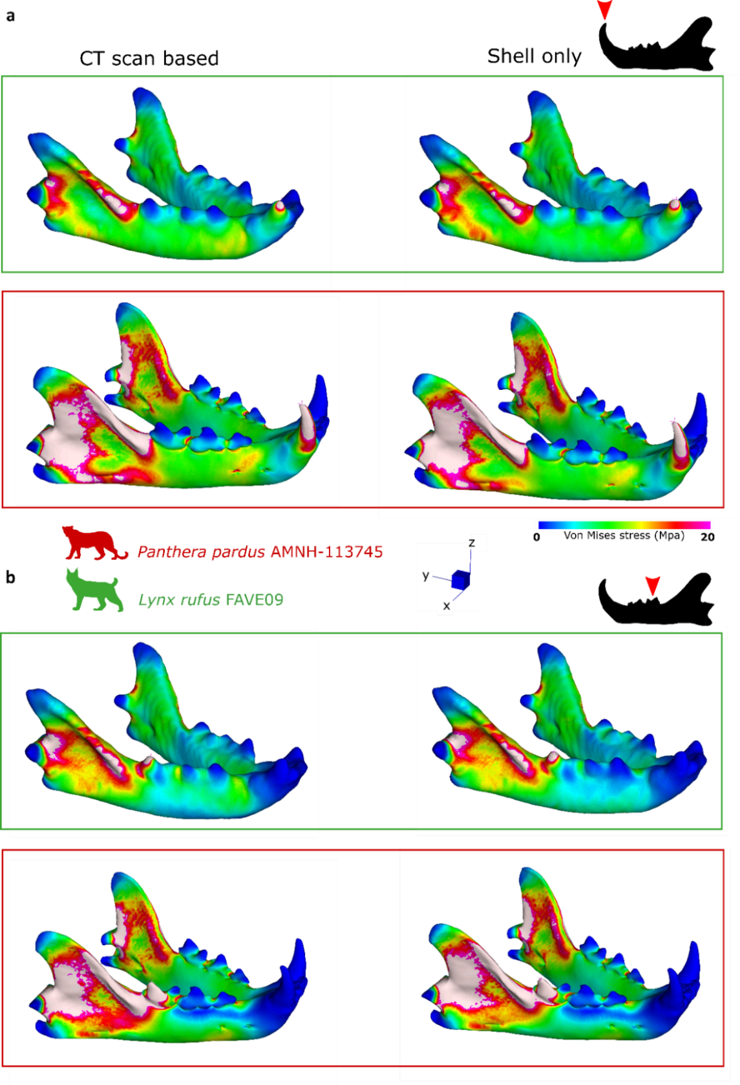
Figure S10: Comparison of von Mises stress contour plots obtained for a canine bite (a) and a first molar bite (b) on the two test specimens (Lynx rufus and Panthera pardus) for models including the mandibular canal (CT scan based, left) vs models that do not include the mandibular canal (shell only, right).
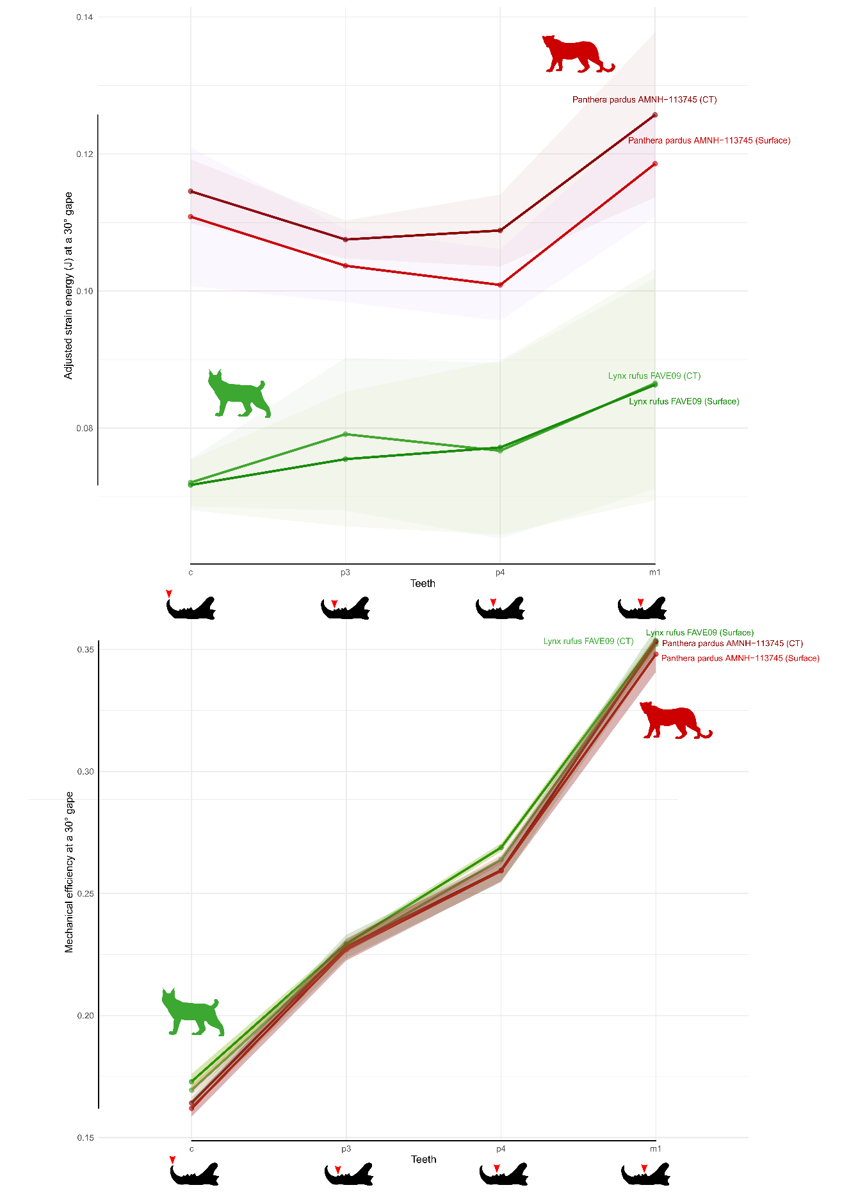
Figure S11: Comparison of the adjusted strain energy (a) and the mechanical efficiency (b) on the two test specimens (Lynx rufus and Panthera pardus) for models including the mandibular canal (CT scan based) vs models that do not include the mandibular canal (‘surface’).

Scanning parameters
Table S3: Scanning parameters of each CT-scanned specimen used in the Finite Element (FE) simulations. For institutional abbreviations see caption Table S1.
 | Tube voltage (kV) |  | Tube current (mA) | Voxel Size (um) | # Slices final Stack
Panthera pardus AMNH 113745 | 160 | 170 |  | 136x136x136 | 1,810
Lynx rufus FAVE09 | 140 | 99 |  | 976.6x976.6x625 | 141
Smilodon fatalis AMNH-14349 | 160 | 170 |  | 136x136x136 | 1,170

Table S4: Scanning parameters of each surface-scanned specimen used in the Finite Element (FE) simulations. For institutional abbreviations see caption Table S1.
Genus | Species | Specimen n° | Resolution (mm)
Panthera | tigris | MNHN-ZO-AC-1931-60 | 0.5
Amphimachairodus | palanderi | PMU 21831 | 0.2
Yoshi | minor | PMU 21766/2 | 0.2
Machairodus | aphanistus | NHMUK-PV-M37356 | 0.2
Panthera | onca | MNHN-ZM-MO-2006-641 | 0.2
Metailurus | major | PMU 21771/2 | 0.2
Caracal | caracal | A585401 | 0.2
Paramaichairodus | orientalis | NHMUK-PV-M-89559 | 0.2
Prionailurus | rubiginosus | MNHN-ZM-MO-2012-54 | 0.2
Hoplophoneus | primaevus | LACM-42890 | 0.2
Dinitctis | felina | LACM-162986 | 0.2
Barbourofelis | fricki | UCMP-124942 | 0.2

Measurements
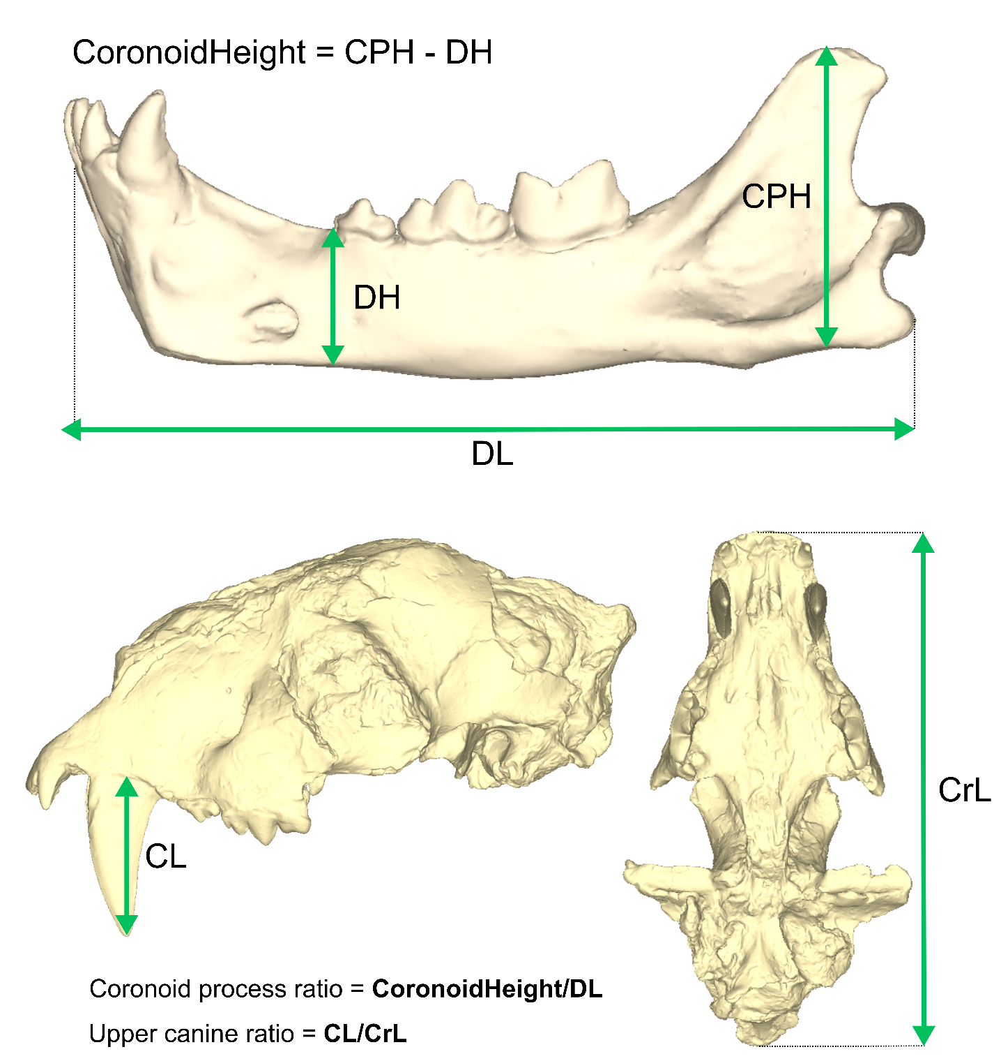
Figure S12: Measurements taken on the specimens to perform the analyses shown on the cranium of Amphimachairodus palanderi.

Models properties
Table S5: Properties of FE models analyzed in this study. Tet4, 4-noded tetrahedral elements; coarse, low resolution model; medium, medium resolution model; fine, high resolution model; N, Newtons.
 |  | Model volume (mm³) | Muscle area (mm²) | Total input force (N) | tet4 quantity | # of triangles after decimation
Lynx rufus FAVE09 (CT) | Coarse | 4,356.180 | 809.537 | 194.664 | 752,514 | 150,000
 | Medium | 4,356.180 | 809.537 | 194.664 | 881,058 | 150,000
 | Fine | 4,356.180 | 809.537 | 194.664 | 1,045,517 | 150,000
Lynx rufus FAVE09 (Surface) | Coarse | 4,381.560 | 809.537 | 194.664 | 716,965 | 144,968
 | Medium | 4,381.560 | 809.537 | 194.664 | 836,566 | 144,968
 | Fine | 4,381.560 | 809.537 | 194.664 | 1,000,432 | 144,968
Panthera pardus AMNH-113745 (CT) | Coarse | 38,996.100 | 4,323.250 | 1,031.344 | 1,004,460 | 199,804
 | Medium | 38,996.100 | 4,323.250 | 1,031.344 | 1,140,739 | 199,804
 | Fine | 38,996.100 | 4,323.250 | 1,031.344 | 1,333,939 | 199,804
Panthera pardus AMNH-113745 (Surface) | Coarse | 42,503.500 | 4,323.250 | 1,031.344 | 648,355 | 140,000
 | Medium | 42,503.500 | 4,323.250 | 1,031.344 | 737,174 | 140,000
 | Fine | 42,503.500 | 4,323.250 | 1,031.344 | 875,473 | 140,000
Amphimachairodus palanderi PMU-21831 | Coarse | 173,428.000 | 7,171.880 | 1,719.100 | 610,246 | 116,666
 | Medium | 173,428.000 | 7,171.880 | 1,719.100 | 678,419 | 116,666
 | Fine | 173,428.000 | 7,171.880 | 1,719.100 | 789,907 | 116,666
Yoshi minor PMU-217661-2 | Coarse | 30,457.600 | 4,063.370 | 982.332 | 759,540 | 167,242
 | Medium | 30,457.600 | 4,063.370 | 982.332 | 854,083 | 167,242
 | Fine | 30,457.600 | 4,063.370 | 982.332 | 992,389 | 167,242
Panthera tigris MNHN-ZO-AC 1931 60 | Coarse | 309,117.000 | 17,465.700 | 4,210.671 | 592,537 | 124,900
 | Medium | 309,117.000 | 17,465.700 | 4,210.671 | 658,029 | 124,900
 | Fine | 309,117.000 | 17,465.700 | 4,210.671 | 747,559 | 124,900
Smilodon fatalis AMNH-14349 | Coarse | 324,969.000 | 7,152.840 | 1,723.513 | 822,871 | 154,545
 | Medium | 324,969.000 | 7,152.840 | 1,723.513 | 925,418 | 154,545
 | Fine | 324,969.000 | 7,152.840 | 1,723.513 | 1,084,282 | 154,545
Machairodus aphanistus NHMUK-PV-M37356 | Coarse | 186.250,000 | 10.894,100 | 2.621,697 | 769.039 | 120.456
 | Medium | 186.250,000 | 10.894,100 | 2.621,697 | 794.166 | 120.456
 | Fine | 186.250,000 | 10.894,100 | 2.621,697 | 857.860 | 120.456
Dinofelis barlowi DNMNH-BF-55-23 | Coarse | 212,081.000 | 9,971.950 | 2,376.397 | 814,124 | 179,992
 | Medium | 212,081.000 | 9,971.950 | 2,376.397 | 866,245 | 179,992
 | Fine | 212,081.000 | 9,971.950 | 2,376.397 | 1,149,117 | 179,992
Panthera onca MNHN-ZM-MO-2006-641 | Coarse | 89,800.100 | 6,520.930 | 1,551.655 | 823,534 | 185,380
 | Medium | 89,800.100 | 6,520.930 | 1,551.655 | 1,062,092 | 185,380
 | Fine | 89,800.100 | 6,520.930 | 1,551.655 | 1,102,560 | 185,380
Metailurus major PMU-21771/2 | Coarse | 86,532.600 | 6,302.440 | 1,507.135 | 717,684 | 152,609
 | Medium | 86,532.600 | 6,302.440 | 1,507.135 | 791,794 | 152,609
 | Fine | 86,532.600 | 6,302.440 | 1,507.135 | 919,808 | 152,609
Caracal caracal A585401 | Coarse | 8,463.690 | 1,818.680 | 438.414 | 685,847 | 158,202
 | Medium | 8,463.690 | 1,818.680 | 438.414 | 799,915 | 158,202
 | Fine | 8,463.690 | 1,818.680 | 438.414 | 919,684 | 158,202
Homotherium crenatidens MNHN.F.PET2000 | Coarse | 390,251.000 | 7,258.00 | 1,761.325 | 881,540 | 171,104
 | Medium | 390,251.000 | 7,258.00 | 1,761.325 | 986,843 | 171,104
 | Fine | 390,251.000 | 7,258.00 | 1,761.325 | 1,124,568 | 171,104
Paramachairodus orientalis NHMUK-PV-M-89559 | Coarse | 73.105,900 | 4.530,18 | 1081,064 | 717.847 | 150.663
 | Medium | 73.105,900 | 4.530,18 | 1081,064 | 788.202 | 150.663
 | Fine | 73.105,900 | 4.530,18 | 1081,064 | 896.795 | 150.663
Prionailurus rubiginosus MNHN-ZM-MO-2012-54 | Coarse | 3,713.280 | 1,081.73 | 262.523 | 743,930 | 162,472
 | Medium | 3,713.280 | 1,081.73 | 262.523 | 808,295 | 162,472
 | Fine | 3,713.280 | 1,081.73 | 262.523 | 910,751 | 162,472
Hoplophoneus primaevus LACM-42890 | Coarse | 68,988.500 | 2,848.45 | 681.913 | 1,022,206 | 199,590
 | Medium | 68,988.500 | 2,848.45 | 681.913 | 1,138,922 | 199,590
 | Fine | 68,988.500 | 2,848.45 | 681.913 | 1,298,066 | 199,590
Dinictis felina LACM-162986 | Coarse | 57,829.800 | 4,221.73 | 1,022.146 | 797,689 | 166,222
 | Medium | 57,829.800 | 4,221.73 | 1,022.146 | 886,648 | 166,222
 | Fine | 57,829.800 | 4,221.73 | 1,022.146 | 1,016,260 | 166,222
Barbourofelis fricki UCMP-124942 | Coarse | 574,980.000 | 5,535.23 | 1,341.366 | 997,941 | 194,546
 | Medium | 574,980.000 | 5,535.23 | 1,341.366 | 1,114,473 | 194,546
 | Fine | 574,980.000 | 5,535.23 | 1,341.366 | 1,270,895 | 194,546
Barbourofelis loveorum UF-VP-36855 | Coarse | 223,943.000 | 3,034.47 | 705.891 | 999,295 | 193,094
 | Medium | 223,943.000 | 3,034.47 | 705.891 | 1,110,131 | 193,094
 | Fine | 223,943.000 | 3,034.47 | 705.891 | 1,304,358 | 193,094

Muscle insertions
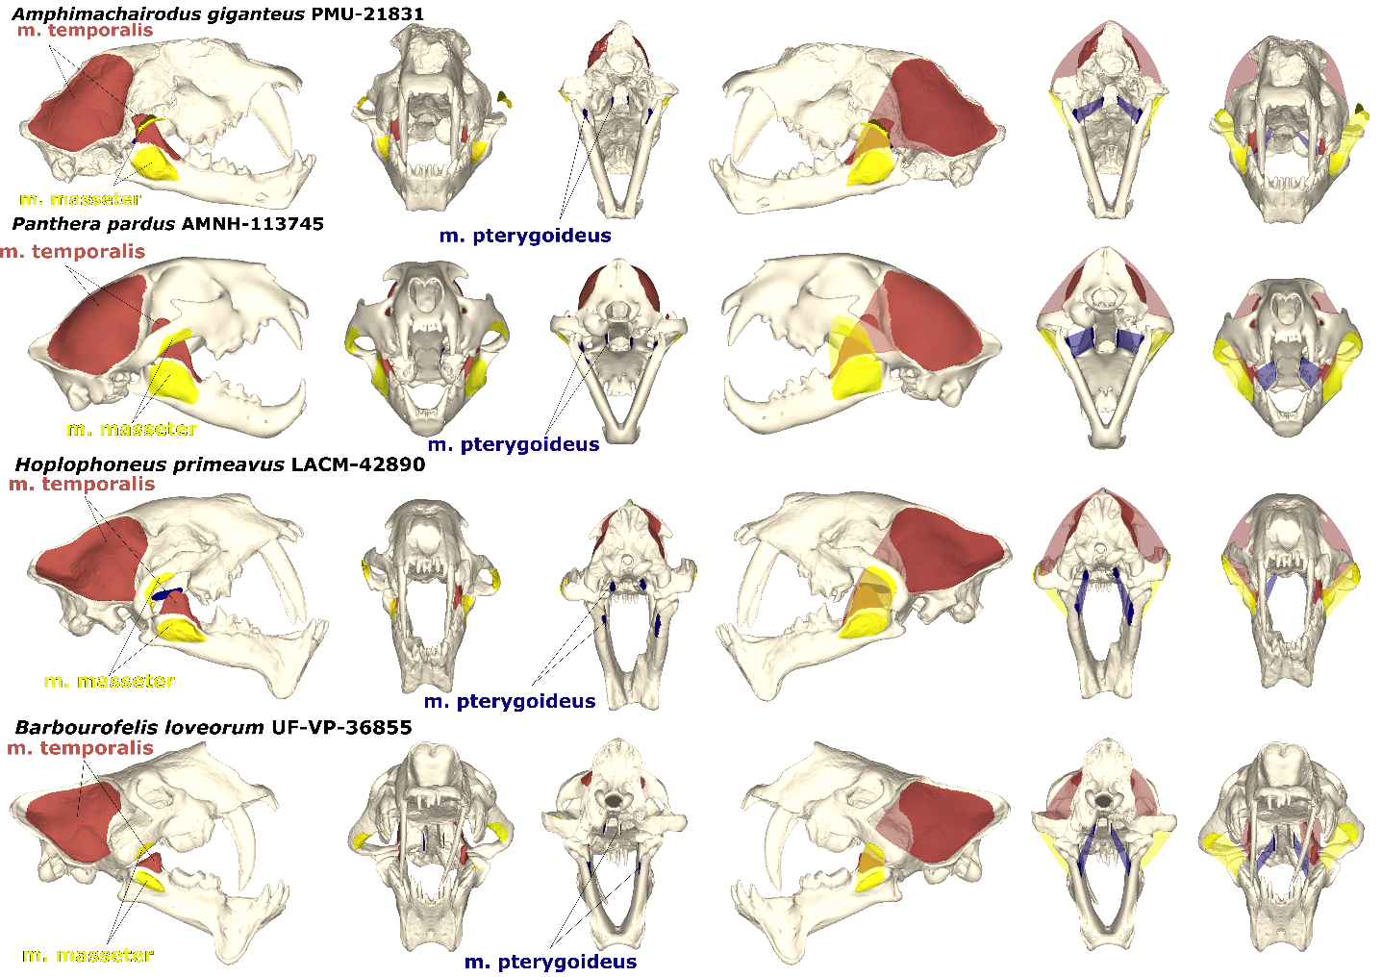
Figure S13: Three muscle groups (origins and insertions) drawn on each mandible and cranium.

Performance variables for model comparison

- Mechanical efficiency
Nodal reaction forces at each tooth constraint. Each reaction force was then scaled by dividing its value by the total input force (TIF) being the sum of both working and balancing side of the temporalis, masseter and pterygoid. This performance variable is named the mechanical efficiency (ME) and is a scale-independent estimation of the muscle force proportion that is translated into bite force [2].
$$ME= \frac{Reaction force}{Total input force}$$
- Adjusted strain energy
The strain energy (SE) which is a metric of energy efficiency that quantifies the energy expended by external forces to deform a structure and transmit forces through it [3] and has often has been used as a metric of the work-efficiency of the craniodental system under designated loads [4]. The raw strain energy was calculated from the FE simulation results and then scaled according to the formula proposed by [3] to be adjusted relative to the volume and total input force of the Panthera pardus AMNH 113745 model (chosen arbitrarily as the standard of scaled comparisons):
$$U_{B'}={\left(\frac{V_{B}}{V_{A}}\right)}^{1/3}{\left(\frac{F_{A}}{F_{B}}\right)}^{2}U_{B}$$
Where:
$U_{B'}$ = Adjusted strain energy
$U_{B}$ = “Raw” strain energy
$V_{A}$ = Volume of the reference model
$V_{B}$ = Volume of the model to adjust
$F_{A}$ = TIF of the reference model
$F_{B}$ = TIF of the model to adjust

- von Mises stress
von Mises stress which is a measure of the aptitude of a ductile material to resist failure by plastic deformation [2]. Different criteria (Rankine, Mohr-Coulomb, von Mises, etc.) have been proposed for bone tissue performing different experiments to try to validate them but the von Mises criterion is now considered to be the most accurate when studying bones [5,6]. As two models may have the same von Mises stress mean but completely different stress distribution, we choose to compute von Mises contour plots (heatmaps) to compare this performance variable in between our specimens. We also measured the stress across the mandible using the ‘Graph’ option in Strand7 by drawing a straight line from the base of the coronoid process to the symphysis region.

Statistical analyses

Data were imported and transformed using the reshape [7], zoo [8]and dplyr package. Plots describing the values of adjusted strain energy and mechanical efficiency and evolution of von Mises stress across the mandible were obtained using the ggplot2 package [9] ggpubr [10]. Linear regressions between the mean von Mises stress (independent variable) and typical sabretooth traits (upper canine length and coronoid process heights as the dependent variables) were performed using geom_smooth from the ggplot2 [9] package through the argument method = “lm”.

Phylogeny

A composite tree containing the living carnivorans, nimravids and machairodontinae was built in R by binding the tree published by [11–13] using the ‘bind.tree’ function of the ape package [14]. We dropped the tips absent from our dataset using the ‘drop.tip’ function. In the machairodontine tree we had to replace Yoshi parvulus by Yoshi minor as it was absent from the tree, we also removed Panthera leo and Lynx rufus as they were already present in the extant carnivoran tree. We time-scaled the resulting supertree using the ‘timePaleoPhy’ function from the Paleotree package [15] through the minimum branch length (mbl) method. We generated the time tree using the ‘geoscalePhylo’ function from the paleotree package [15] and visualize the variation of relative coronoid process height on our tree using ggtree [16]. Finally, we computed a phylogenetic heatmap using the ‘phylo.heatmap’ function from the phytools package [17] to visualize the variation of mechanical efficiency and adjusted strain energy at the different angle and combined all those data on Figure 3 and Figure S26.
To test for the presence of a phylogenetic signal in our performance variables we used the ‘phylosig’ function from the phytools package [17] and presented the results in Table 2.

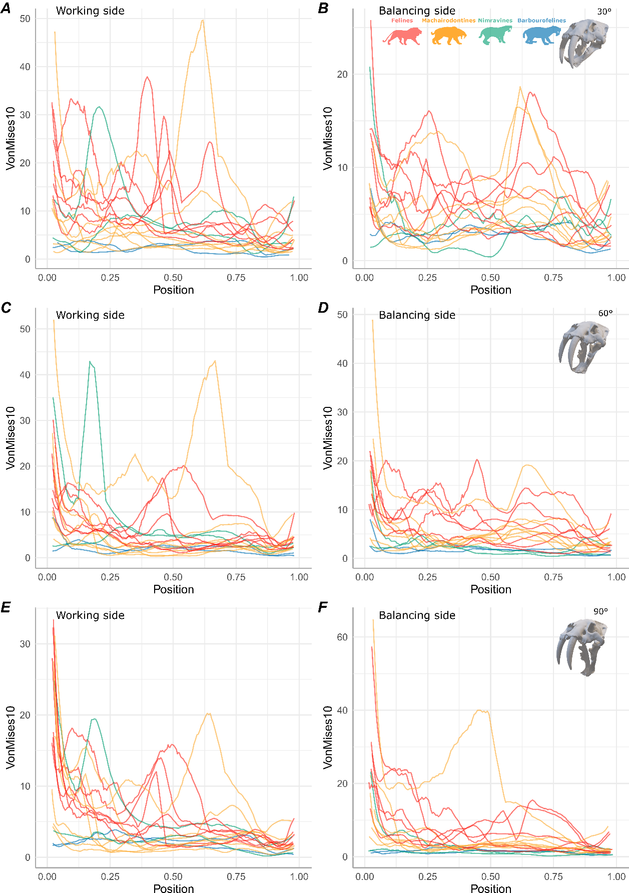
Supplementary results
Figure S14: Rolling mean (10) of the von Mises stress value measured across the mandible on the whole dataset for a canine bite at the different angles: 30° (A-B), 60° (C-D), 90° (E-F) for the working (A, C, E) and balancing (B, D, F) side. Position: 0 = base of the coronoid process, 1 = symphysis region
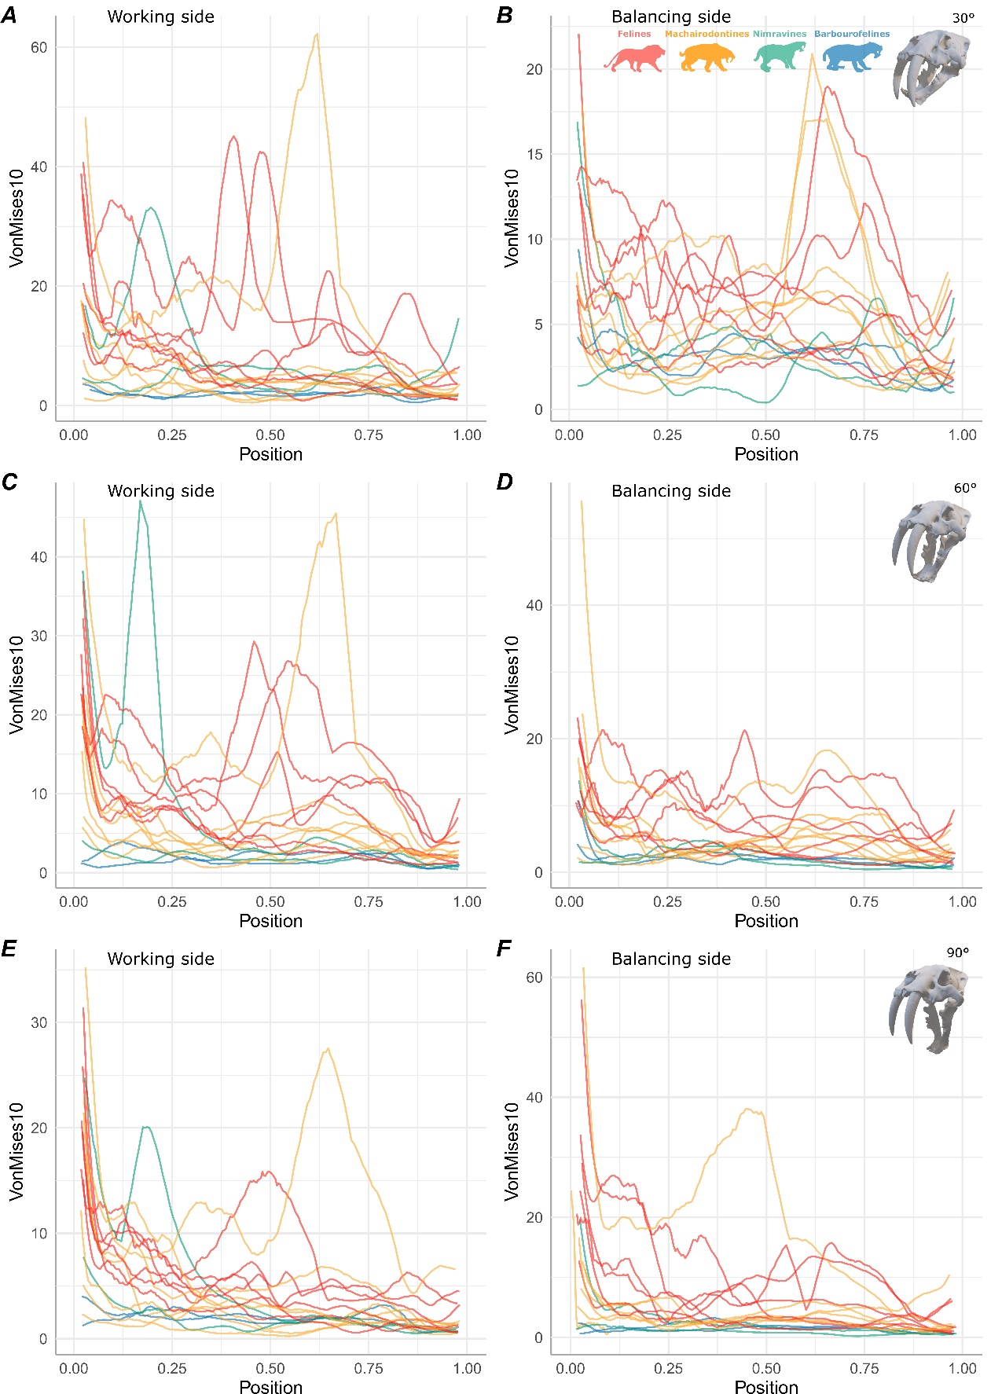
Figure S15: Rolling mean (10) of the von Mises stress value measured across the mandible on the whole dataset for a first molar bite at the different angles: 30° (A-B), 60° (C-D), 90° (E-F) for the working (A, C, E) and balancing (B, D, F) side. Position: 0 = base of the coronoid process, 1 = symphysis region
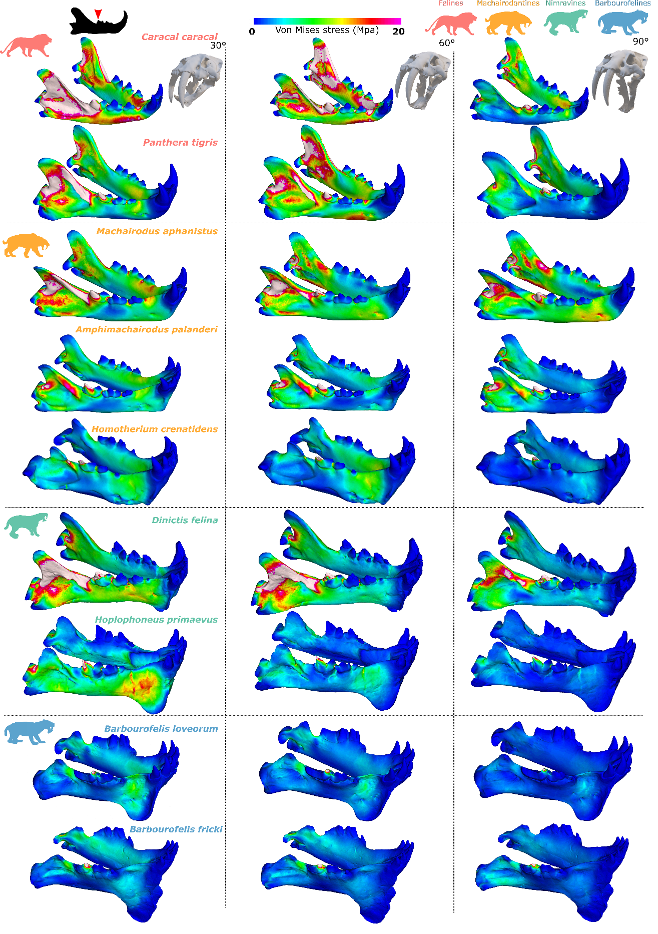
Figure S16: von Mises stress contour plots on nine different taxa at the three different angles for a molar bite.
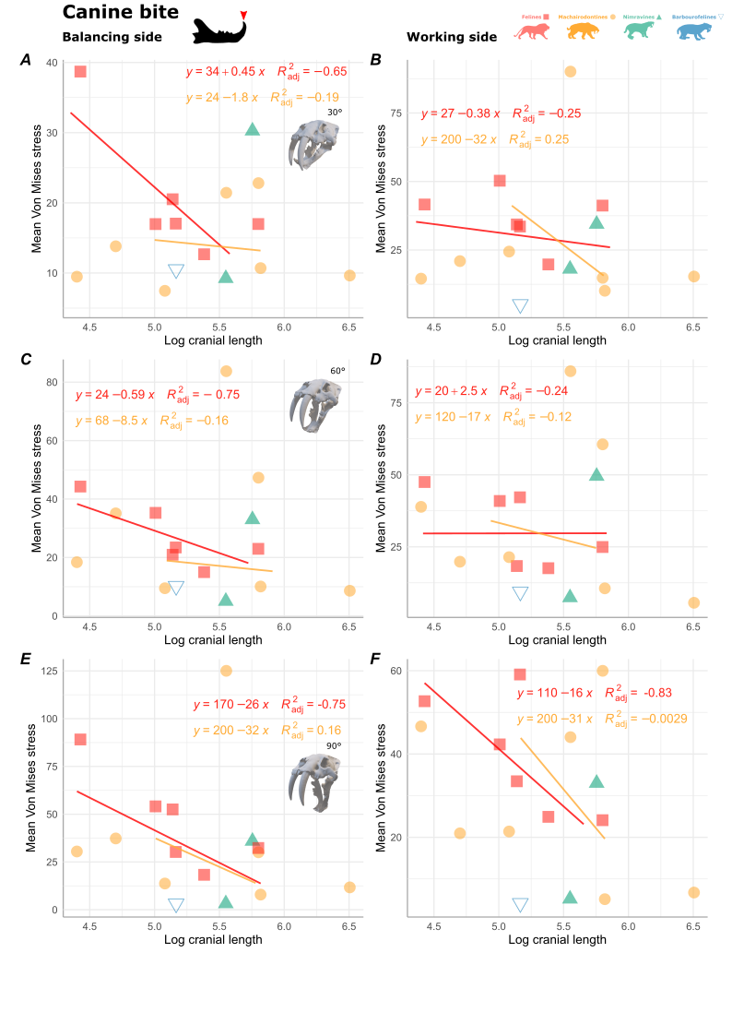
Figure S17: Regressions between the log cranial length and the max von Mises stress measured across the mandible at 30° (A-B), 60° (C-D) and 90° (E-F) for a canine bite in both the balancing (A, C and E) and the working side (B, D and F). Barbourofelis fricki was removed from the plots as the only pictures we could access did not show any scale.
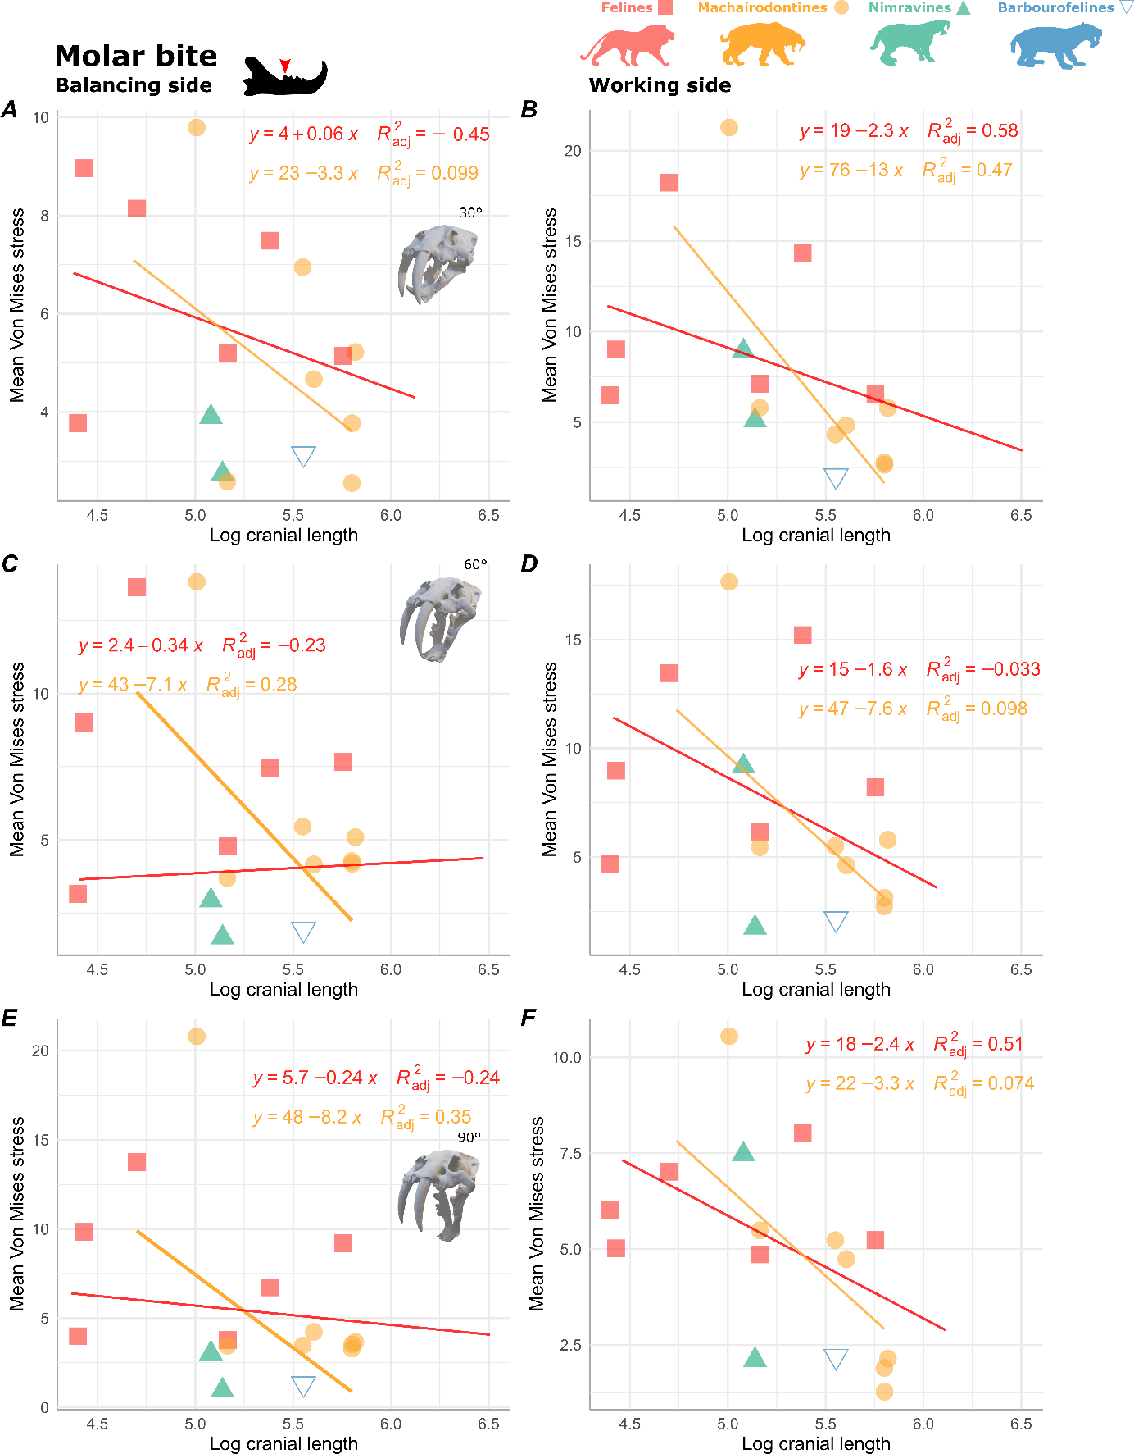
Figure S18: Regressions between the log cranial length and the max von Mises stress measured across the mandible at 30° (A-B), 60° (C-D) and 90° (E-F) for a molar bite in both the balancing (A, C and E) and the working side (B, D and F). Barbourofelis fricki was removed from the plots as the only pictures we could access did not show any scale.
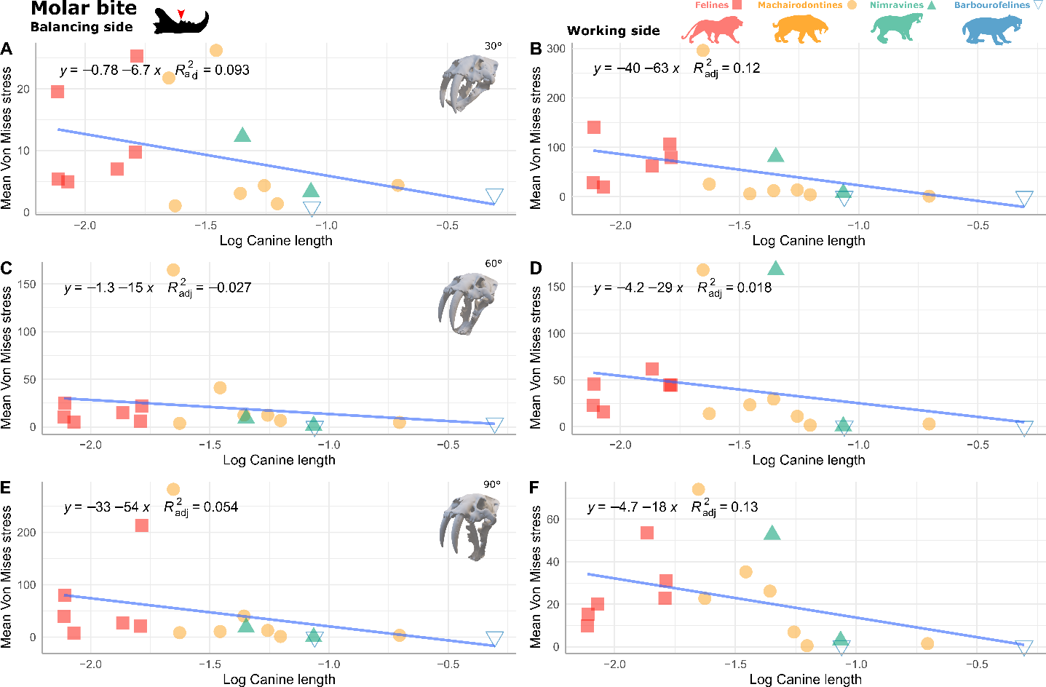
Figure S19: Regressions between the log canine length and the mean von Mises stress measured across the mandible at 30° (A-B), 60° (C-D) and 90° (E-F) for a molar bite in both the balancing (A, C and E) and the working side (B, D and F).
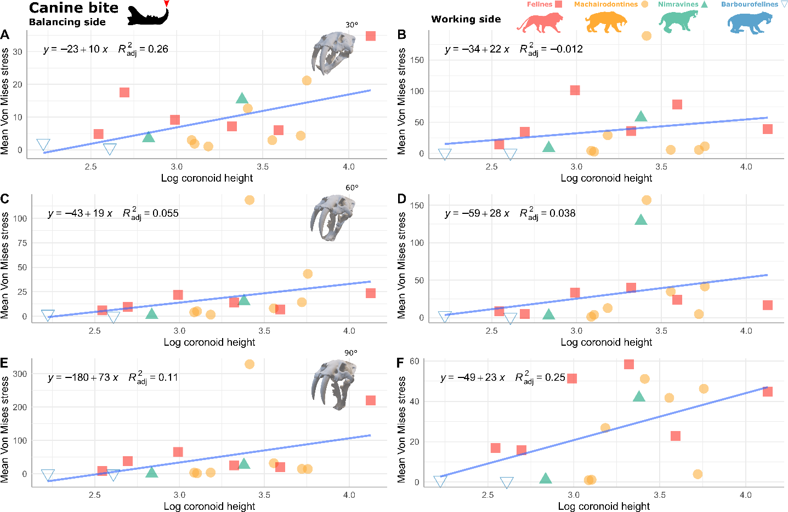
Figure S20: Regressions between the log coronoid process height and the mean von Mises stress measured across the mandible at 30° (A-B), 60° (C-D) and 90° (E-F) for a canine bite in both the balancing (A, C and E) and the working side (B, D and F).
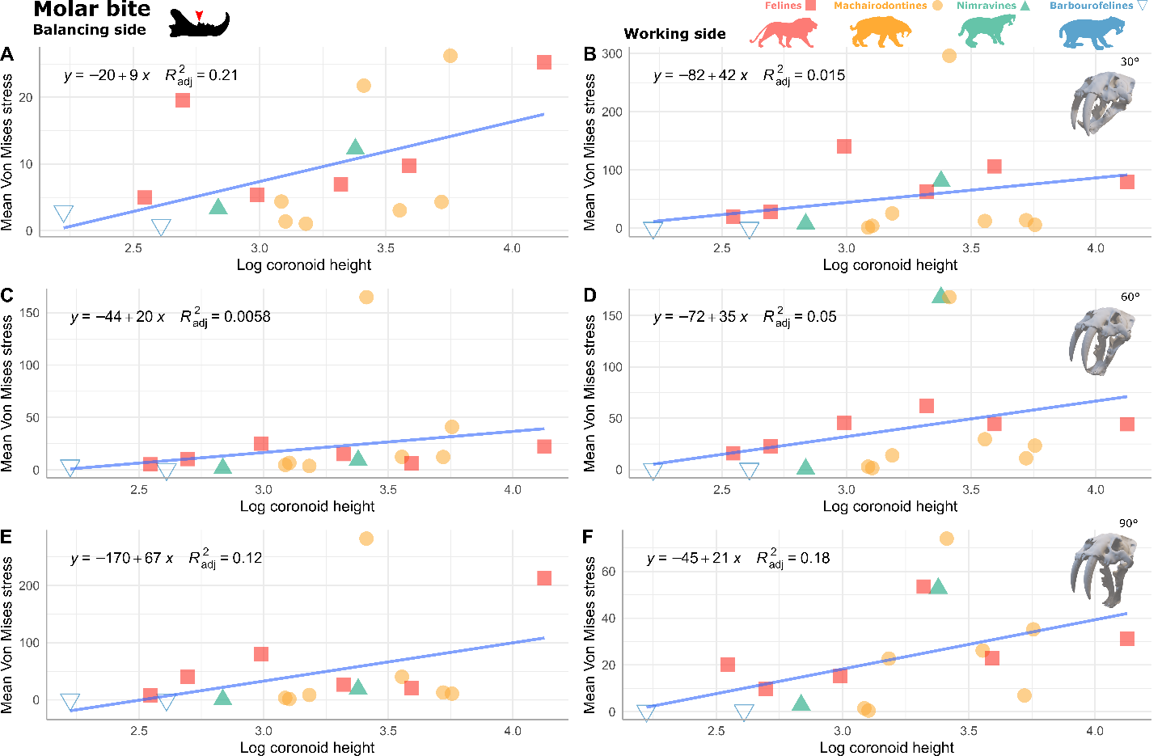
Figure S21: Regressions between the log coronoid process height and the mean von Mises stress measured across the mandible at 30° (A-B), 60° (C-D) and 90° (E-F) for a molar bite in both the balancing (A, C and E) and the working side (B, D and F).
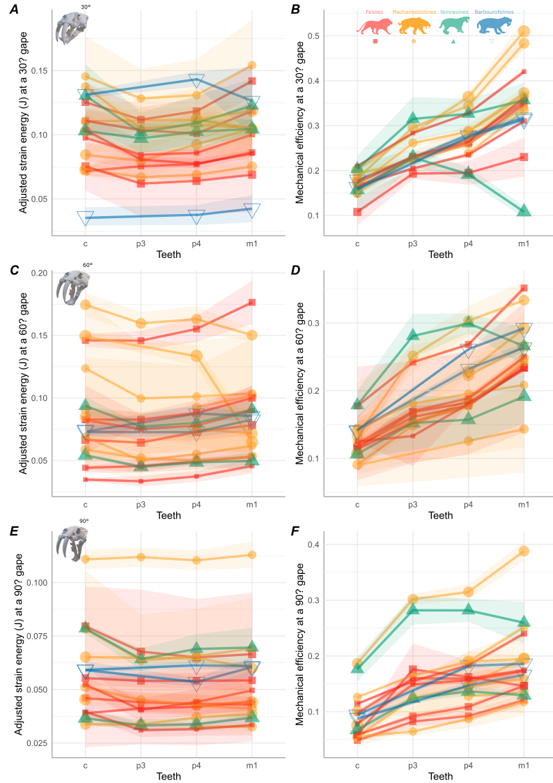
Figure S22: Adjusted strain energy (A, C and E) and mechanical efficiency (B, D and F) measured at the three gape angles tested; 30° (A-B), 60° (C-D) and 90° (E-F) on each tooth.
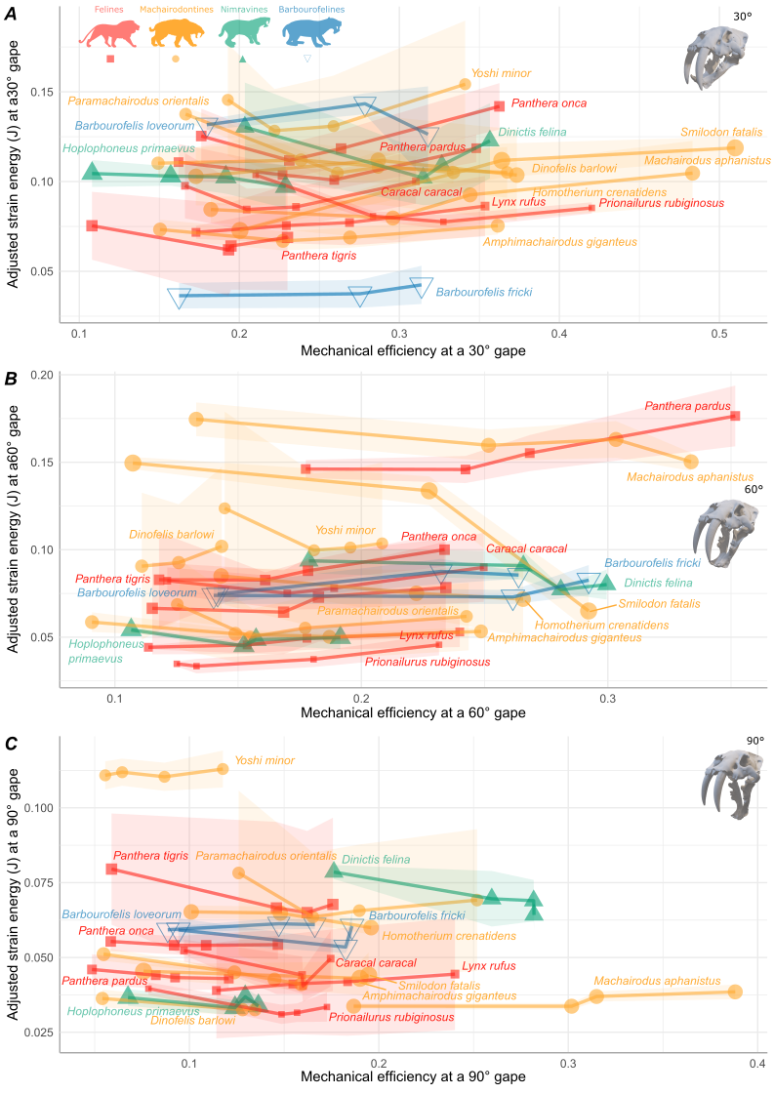
Figure S23: Adjusted strain energy versus mechanical efficiency measured at the three gape angles tested; 30° (A), 60° (B) and 90° (C).
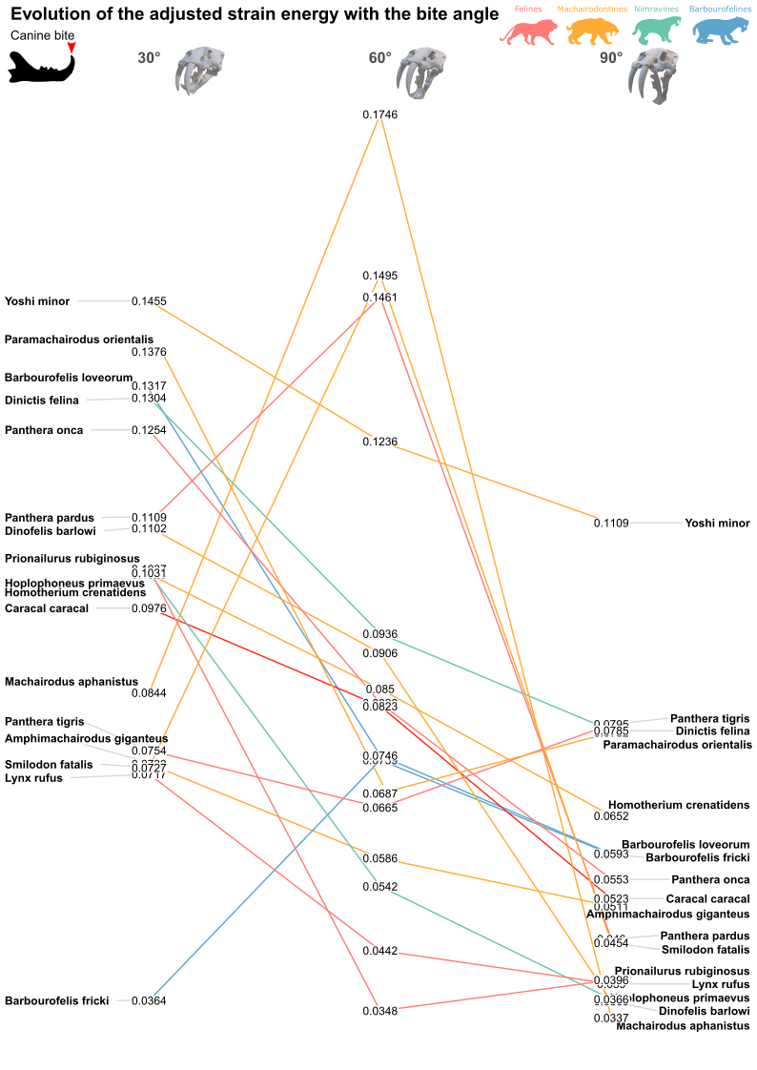
Figure S24: Evolution of the adjusted strain energy at the different biting angles (30, 60 and 90°) for a canine bite
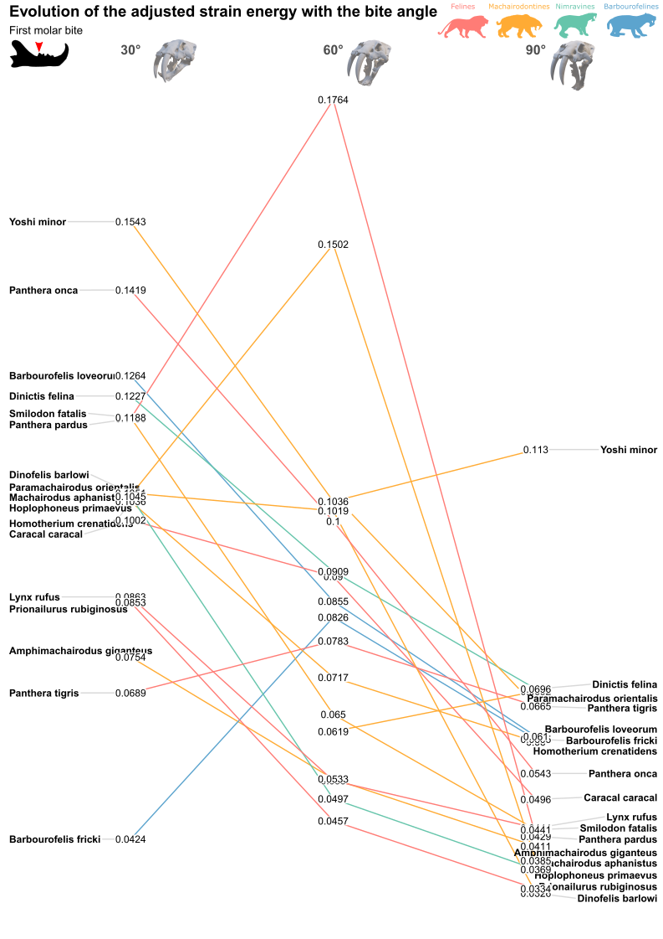
Figure S25: Evolution of the adjusted strain energy at the different biting angles (30, 60 and 90°) for a molar bite
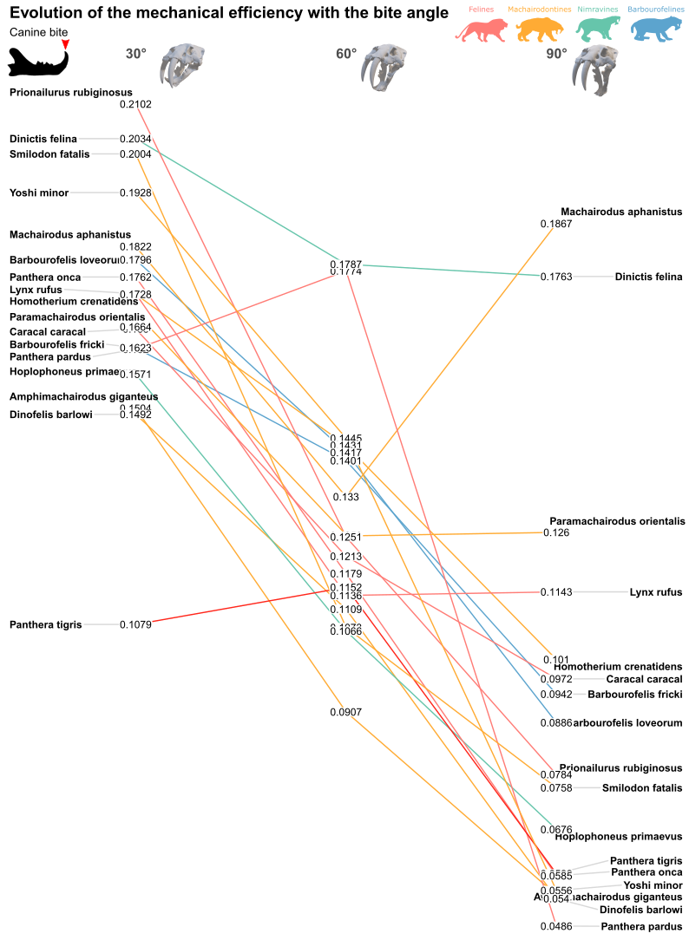
Figure 26: Evolution of the mechanical efficiency at the different biting angles (30, 60 and 90°) for a canine bite.
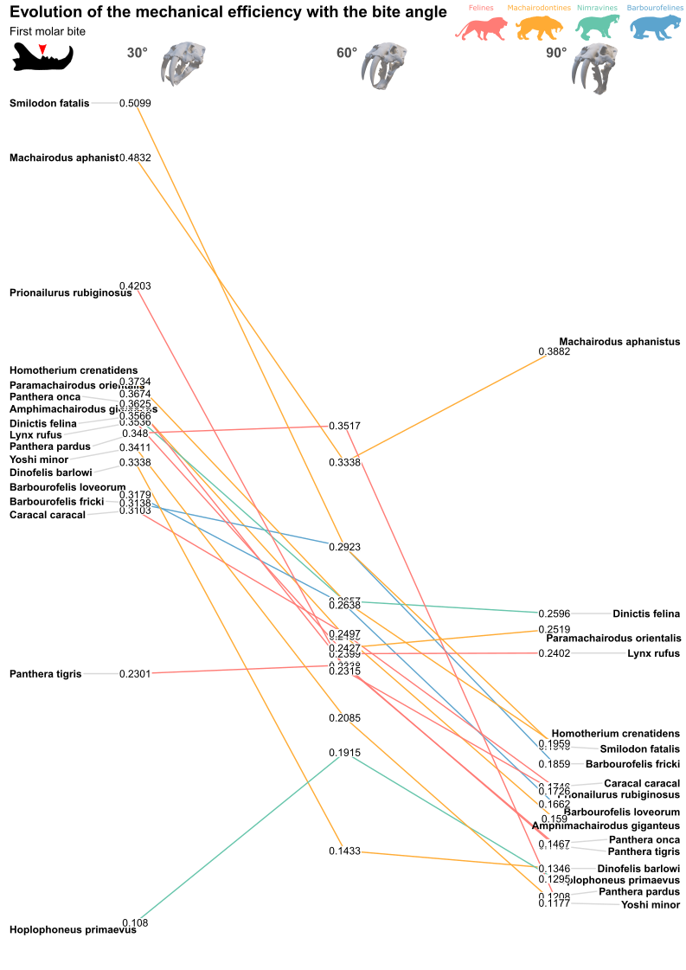
Figure S27: Evolution of the mechanical efficiency at the different biting angles (30, 60 and 90°) for a molar bite.

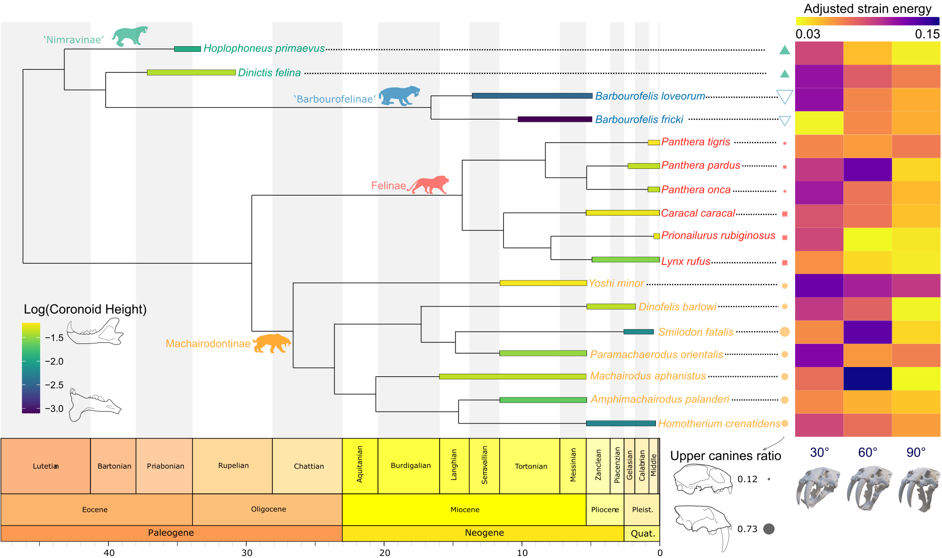
Figure S28: Phylogenetic relationships between the taxa studied with a continuous color scale on the branches indicating the relative coronoid process height on a logarithmic scale, point size indicating the relative upper canine size and a heatmap showing the evolution of adjusted strain energy at the three different angle.

1. Geraads D, Spassov N. 2020 A skull of Machairodus Kaup, 1833 (Felidae, Mammalia) from the late Miocene of Hadjidimovo (Bulgaria), and its place in the evolution of the genus. Geodiversitas 42, 123–137. (doi:10.5252/geodiversitas2020v42a9)
2. Dumont ER, Davis JL, Grosse IR, Burrows AM. 2011 Finite element analysis of performance in the skulls of marmosets and tamarins. J Anat 218, 151–162. (doi:10.1111/j.1469-7580.2010.01247.x)
3. Dumont ER, Grosse IR, Slater GJ. 2009 Requirements for comparing the performance of finite element models of biological structures. J Theor Biol 256, 96–103. (doi:10.1016/j.jtbi.2008.08.017)
4. Hylander WL. 1979 An experimental analysis of temporomandibular joint reaction force in macaques. Am J Phys Anthropol 51, 433–456. (doi:10.1002/ajpa.1330510317)
5. Doblaré M, García JM, Gómez MJ. 2004 Modelling bone tissue fracture and healing: A review. Eng Fract Mech. 71, 1809–1840. (doi:10.1016/j.engfracmech.2003.08.003)
6. Keyak JH, Rossi SA. 2000 Prediction of femoral fracture load using finite element models: An examination of stress- and strain-based failure theories. J Biomech 33, 209–214. (doi:10.1016/S0021-9290(99)00152-9)
7. Wickham H. 2007 Reshaping Data with the reshape Package. J Stat Softw 21.
8. Zeileis A, Grothendieck G, Ryan JA, Ulrich JM, Andrews F. 2022 Package ‘zoo’.
9. Wickham H. 2006 An introduction to ggplot: An implementation of the grammar of graphics in R. Statistics (Ber) , 1–8.
10. Kassambara A. 2020 ggpubr.
11. Barrett PZ. 2021 The largest hoplophonine and a complex new hypothesis of nimravid evolution. Sci Rep 11, 1–9. (doi:10.1038/s41598-021-00521-1)
12. Jiangzuo Q, Werdelin L, Sun Y. 2022 A dwarf sabertooth cat ( Felidae : Machairodontinae ) from Shanxi , China , and the phylogeny of the sabertooth tribe Machairodontini. Quat Sci Rev 284, 107517. (doi:10.1016/j.quascirev.2022.107517)
13. Slater GJ, Friscia AR. 2019 Hierarchy in adaptive radiation: A case study using the Carnivora (Mammalia). Evolution (N Y) 73, 524–539. (doi:10.1111/evo.13689)
14. Paradis E, Schliep K. 2019 Ape 5.0: An environment for modern phylogenetics and evolutionary analyses in R. Bioinformatics 35, 526–528. (doi:10.1093/bioinformatics/bty633)
15. Bapst DW. 2012 paleotree: an R package for paleontological and phylogenetic analyses of evolution. Methods Ecol Evol 3, 803–807. (doi:10.1111/j.2041-210X.2012.00223.x)
16. Yu G, Smith DK, Zhu H, Guan Y, Lam TTY. 2017 ggtree: an r package for visualization and annotation of phylogenetic trees with their covariates and other associated data. Methods Ecol Evol 8, 28–36. (doi:10.1111/2041-210X.12628)
17. Revell LJ. 2012 phytools: An R package for phylogenetic comparative biology (and other things). Methods Ecol Evol 3, 217–223. (doi:10.1111/j.2041-210X.2011.00169.x)

