SUPPLEMENTAL INFORMATION
Participants’ information (Table S1)
Participants were between ages 59-82, retired and lived independently at home. They were all French-speakers and had normal/corrected to normal vision and hearing. None of the participants indicated moderate or severe depression (Beck Depression Inventory [BDI-II] < 19)⁵⁹ or severe anxiety (Beck Anxiety Inventory [BAI] < 30).⁶⁰ Clinical symptoms of cognitive impairment were assessed by Mini Mental State Examination [MMSE score > 26]⁶¹ and Mattis Dementia Rating scale [MDR score > 130].⁶² Absence of major sleep disorders were screened during a night of polysomnography, mainly screening for sleep apnea disorder (mean apnea/hypopnea index = 5.34 ± 5.01). Other exclusion criteria were Body Mass Index ≤ 18 and ≥30 kg/m2, recent psychiatric history or severe brain trauma, chronic medication affecting the central nervous system, diabetes, smoking, caffeine (> 4 cups/day) or alcohol abuse (> 14 units/week) and drug consumption. Participants with stable treatment (for > 6 months) for hypertension and/or hypothyroidism were included in the study and they had not travelled more than one time zone in the 3 months prior to the study begin.
Participants’ recruitment was performed through access to a GDPR-compliant existing database in the laboratory and via study advertisement in newspapers. Participants were recruited according to their napping habits, which was subjectively assessed through a questionnaire. Prospective nap recruitment served as tool to enhance inter-individual variation in daytime rest. In the final sample of 57 participants, 81 % (n=46) subjectively reported to nap and 19 % (n=11) declared not to nap. Daytime rest (DTR), the main outcome of the current study, was objectively assessed by actigraphy recordings.
 | Mean | SDª | Min | Max
Age, years | 68.86 | 5.54 | 59 | 82
Gender, female, n(%) |  |  |  | 24 (42.1%)
Ethnic status, Caucasian, n(%) |  |  |  | 57 (100%)
Educational, years | 14.60 | 3.37 | 7 | 25
Body Mass Index, kg/m² | 25.16 | 2.64 | 19.53 | 29.9
Sleep apnea/hypopnea index, per hour | 5.29 | 4.98 | 0.2 | 17.9
Mini Mental State Examination Score (0 – 30) | 29.24 | 0.84 | 27 | 30
Mattis (0 – 144) | 141.70 | 2.61 | 135 | 144
Beck Depression Inventory (0 – 63) ^{b} | 3.79 | 3.45 | 0 | 15
Beck Anxiety Inventory (0 – 63) ^{b} | 3.39 | 4.00 | 0 | 19
Note: ªSD: Standard Deviation. ^{b}Missing value: 1.
Table S1. Descriptive statistics of demographic data (N = 57).
Circadian phase assessment
After one week of fixed sleep-wake schedule to ensure sufficient sleep and stable circadian entrainment before starting circadian phase, participants underwent a 40-h multiple nap protocol under controlled constant-routine conditions. The protocol encompassed 10 short sleep-wake cycles consisting of 80 minutes sleep opportunities alternating with 160 minutes of wakefulness, starting 130 minutes after wake-up, and was preceded and followed by an 8-h baseline and recovery night, respectively (Figure 1A). During scheduled wakefulness, participants had to complete subjective sleepiness scales and mood ratings every hour and they also performed vigilance and working memory tasks. Selected activities were allowed in-bed to maintain wakefulness, such as reading, listening to music, watching movies (with screen illuminance controlled in order to not exceed 5 lux) and talking to the experimenter. Furthermore, a continuous EEG and video camera monitoring allowed the experimenter to detect early signs of falling asleep (e.g. closed eyes) and to enter the participant’s room to prevent him falling asleep.
Light measurement (Table S2)
During the 40-h multiple nap protocol, participants were exposed to an environmental light comprised between 4.5 and 5 lux (15.78 mW/m² total irradiance). The light source was a squared homogeneous surface composed by phosphor blue converted LED-B3. Light level was adjusted the afternoon preceding the baseline night of the multiple nap protocol using a Macam Q203 quantum radiometer (Macam Photometrics) held at the eye’s level of the participant in semi-recumbent position in the bed (~ 1.40 m) and directed towards the horizontal light source. After the baseline night of the nap protocol, light level was verified once per day. Illuminance and α-opic (ir)radiances are presented in Table S2.
Condition | Dim light condition
Illuminance, lux | 5.0
S-cone-opic irradiance, mW/m² | 2.53
M-cone-opic irradiance, mW/m² | 6.44
L-cone-opic irradiance, mW/m² | 8.13
Rhodopic irradiance, mW/m² | 5.06
Melanopic irradiance, mW/m² | 4.19
Table S2. Specifications of dim light condition.
Melatonin measurement
No food intake was permitted 30 minutes prior to saliva samples and participants were not allowed any water intake and posture change for 15 minutes prior to collection. Salivary melatonin analysis were performed in the Department of Clinical Chemistry of the University of Liège. Saliva samples were stored at -80 degrees Celsius until assayed via a liquid chromatography coupled to a tandem mass spectrometer. 500 uL of saliva samples were extracted by a liquid/liquid extraction before separation by a Nexera X2 UPLC (Shimadzu, Kyoto, Japan). Separation was achieved on a C18 column. Extracts were then analysed and quantitated by a QTrap6500 mass spectrometer (Triple quadrupole and linear Trap analyser) (Sciex, CA, USA). Two MRM transitions were monitored for native and labelled melatonin. Each sample was processed in single. The range of the measure was 0.78 to 100 pg/mL. The limit of quantification was 0.8 pg/mL with an inter-run accuracy and precision of respectively 98,4% and 4,3%. Validation samples were produced in melatonin-depleted human saliva spiked to reach 0.8, 2.4, 40 and 80 pg/mL. Intra- and inter-run accuracies were between 96 and 112.5% while intra- and inter-run precisions were between 0,9% and 4,5%. The limit of quantification was used to compute melatonin profiles.
Actigraphy
Automatic rest detection: performance against visual scoring
Actigraphy data were downloaded from the devices using the MotionWatch software (v1.2.5) and then processed by the open-source software pyActigraphy (v1.0).²⁷ Periods of 30 seconds were automatically scored as rest or active using the Munich Actimetry Sleep Detection Algorithm (MASDA).²⁸ Epochs with activity counts below a threshold of 15% of the 24-h centered moving average during at least 15 minutes were classified as rest periods. In order to assess the performance of this algorithm, agreement between the MASDA algorithm and visual scoring was evaluated in a sub-sample of the Multi-Ethnic Study of Atherosclerosis (MESA) cohort.²⁹ In MESA cohort, visual scoring was performed by a trained technician in 30-s epoch according to MESA guidelines.⁶³ The MASDA algorithm was applied in a sub-sample of 336 older adults (age range = 59 – 82 y.o., 71.91 y.o.± 6.50, Caucasian, retired, 189 women). MESA participants worn the Actiwatch Spectrum devices (Philips Respironics, Murrysville, PA) at the non-dominant wrist during 7 days. Rest-activity classification of the MASDA algorithm for each 30-s epoch was compared to visual scoring. Agreement between the scoring methods was assessed by measures of sensitivity, specificity, accuracy and precision. Epochs determined as sleep by visual scoring and also detected as rest by the MASDA algorithm contributed to the true positives whereas visually-scored sleep epochs scored as active by the MASDA algorithm are considered as the false negatives. Sensitivity reached 80% (interquartile range (IQR): [61%-94%]) during the biological day (from DLMOff + 2h to DLMOn -2h) and 99% [97%-100%] during the night-time period (from actigraphy-derived activity offset time to actigraphy-derived activity onset time). Specificity attained 99% [97%-100%] and 81% [55%-100%], during the day and the night respectively. Accuracy rose to 98% [96%-99%] during the day and 96% [91%-99%] during the night. In addition, precision got to 75% [42% - 99%] during the day and 98% [94% - 100%] during the night. The MASDA algorithm adequately detected 80% of daytime rest periods (sensitivity) and 99% of daytime active periods (specificity). 98% of daytime rest periods of manual scoring was correctly classified by the MASDA.
Adjustments for activity onset- and offset times
Activity onset- and offset times were automatically detected in actigraphy recordings and then verified by indications provided in sleep diaries. If the self-reported activity onset and offset times deviated more than 30 minutes compared to the automatically detected ones, values were adjusted after visual inspection of the actigraphy profile (adjusted onset and offset times: n=8 and n=12, respectively).
Cognitive tests
Three cognitive domains, which are known to be sensitive to the healthy aging process (executive functions, attentional performance and episodic memory)⁶⁴ were investigated. Cognitive assessment was usually performed during the afternoon (between the hours of 13:30 and 17:00) to avoid confounding effects of time of day on cognitive performance.
The attentional composite score included the Trail Making Test part A⁶⁵ (completion time in seconds), Digit Symbol Substitution Test⁶⁶ (2-min score), D2 task⁶⁷ (Gz-F score), 10 minutes Psychomotor Vigilance Task⁶⁸ (mean reaction time in seconds) and a visual 1-back task⁶⁹ (mean hit reaction time in seconds to evaluate the processing speed for attentional performance).
The executive function composite score was composed of the Trail Making Test part B⁶⁵ (completion time in seconds), verbal fluency (category with animal and phonemic with letter “p”,⁷⁰ 2-min score), Digit Span backward⁷¹ (number of correct reproductions), Plus Minus task⁷² (shifting score), Stroop test⁷³ (inhibition score), and visual 2- and 3-back task⁶⁹ (d prime score).
The episodic memory composite score comprised the Free and Cued Selective Reminding test⁷⁴ (sum of all free recalls), the Mnemonic Similarity Task⁷⁵ (recognition memory score) and the Logical Memory Test⁷⁶ (delayed recall of items).
Trail Making Test part B and Plus Minus scores were respectively transformed according to logit and square root transformations. Box-cox transformations were applied for Mnemonic Similarity task, Digit Span backward and Stroop scores and were conducted in R 3.6.3³⁴ with the packages MASS⁷⁷ and forecast.⁷⁸
Due to missing data, the Psychomotor Vigilance Task score and visual 1-back score were not included in the attention score and the visual 2- and 3-back scores were not included in the executive score for one participant. The episodic memory score was calculated without the Mnemonic Similarity Task score for two participants. For the executive score, one participant did not complete the Plus Minus and Stroop tasks and one participant did not complete the Stroop task.
Automatic detection of rest bouts vs. subjective nap reports (Figure S1)
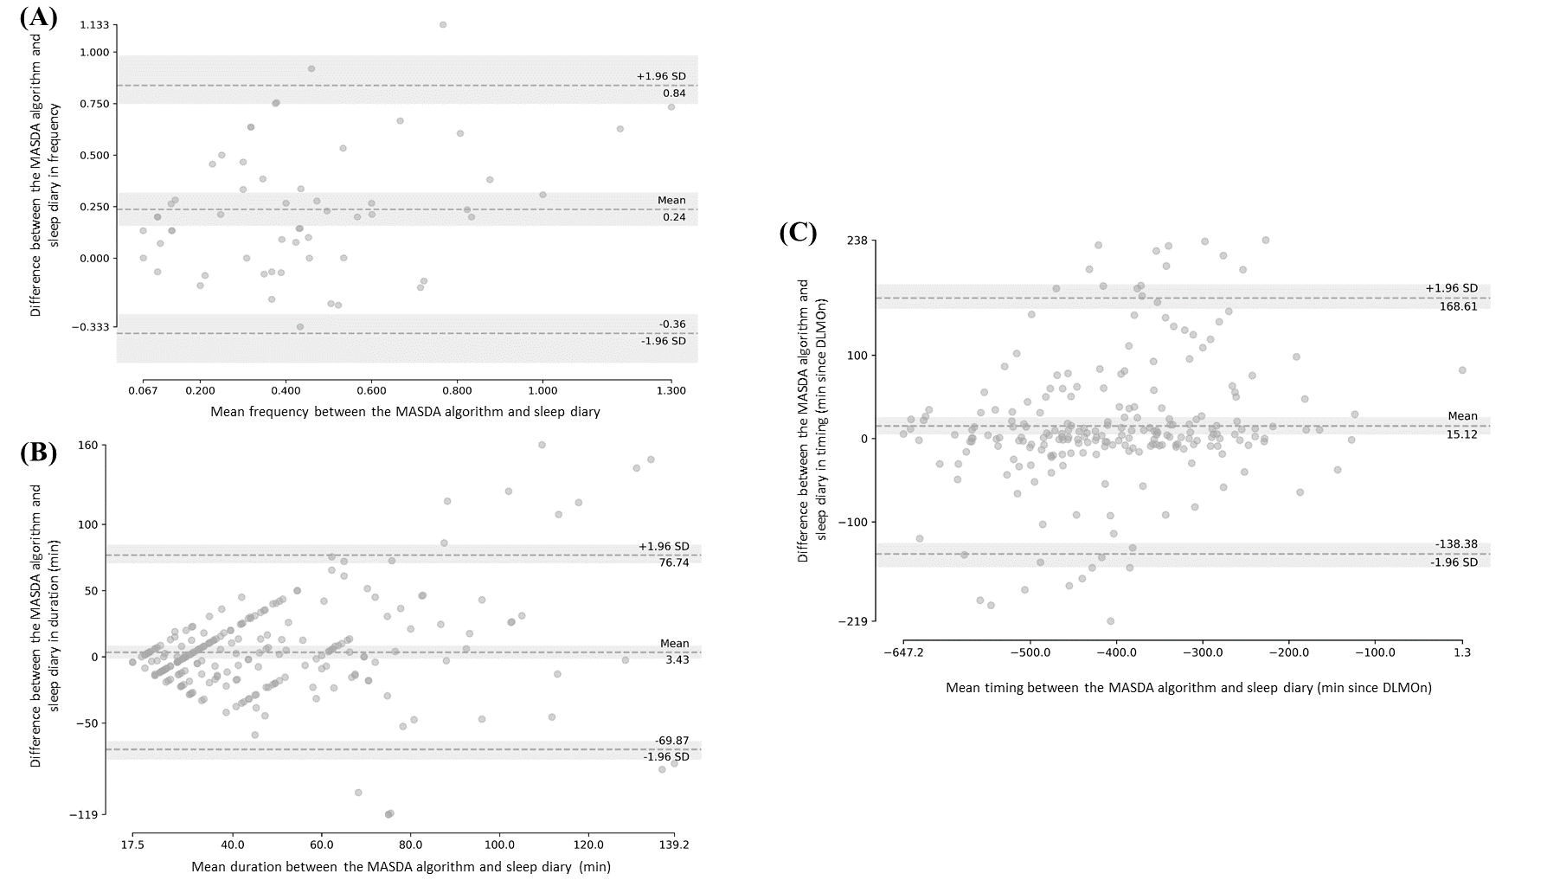
Figure S1. Bland-Altman plots of daytime rest characteristics detected by the Munich Automatic Sleep Detection Algorithm (MASDA) and reported naps in the sleep diary were established on the whole sample (N = 57) for frequency (A) and only for participants who reported naps in their sleep diary (N = 45) for duration (B) and timing (C). The mean between the MASDA algorithm and sleep diary is plotted on the x-axis. The y-axis corresponds to the difference in methods (MASDA algorithm - sleep diary). The middle dashed line represent the average difference between the two methods. Dotted upper and lower lines illustrate the 95% limits of agreement. Grey areas display the 95% confidence interval of the corresponding parameter.
Association between daytime rest frequency and night-time rest-to-activity transition probability (Figure S2)
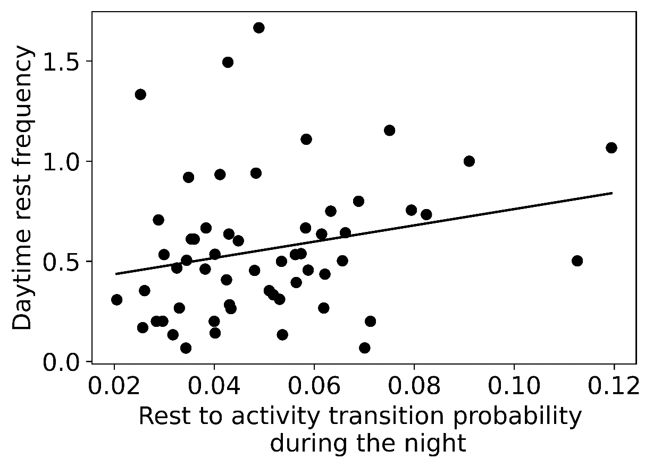
Figure S2. Scatter plot of the correlation between daytime rest frequency and rest-to-activity transition probability during the night (N = 57). Kendall’s rank correlation: τ=0.20, p< 0.05.
Association between daytime rest characteristics and circadian outcomes (Table S3, Figure S3)
 | DLMO onset (DLMOn) | Distance between DLMOn and activity offset times | DLMO offset (DLMOff) | Distance between DLMOff and activity onset times
Daytime rest duration | β = 0.004, t = 0.04  p = 0.97 | β = 0.04, t = 0.38  p = 0.71 | β = -0.06, t = -0.41  p = 0.68 | β = 0.03, t = 0.18  p = 0.86
Daytime rest frequency | β = 0.10, t = 0.89  p = 0.38 | β = -0.11, t = -0.98  p = 0.33 | β = -0.04, t = -0.25  p = 0.80 | β = 0.13, t = 0.88  p = 0.38
Daytime rest timing | β = -0.69, t = -6.67  p < 0.001*** | β = 0.63, t = 5.83  p < 0.001*** | β = -0.32, t =-2.40  p < 0.025* | β = 0.16, t = 1.13  p = 0.26
Daily activity level | β = 0.007, t = 0.06  p = 0.95 | β = -0.16, t = -1.45  p = 0.15 | β = -0.02, t = -0.17  p = 0.86 | β = -0.10, t = -0.67  p = 0.51
Night-time rest duration | β = 0.20, t = 1.80  p = 0.08 | β = -0.31, t = -2.72  p < 0.01** | β = 0.13, t = 0.90  p = 0.38 | β = 0.19, t = 1.25  p = 0.22
Mean light timing⁵⁰⁰ | β = 0.06, t = 0.51  p = 0.61 | β = -0.03, t = -0.23  p = 0.82 | β = 0.06, t = 0.38  p = 0.71 | β = -0.004, t = -0.02  p = 0.98
Time above threshold¹⁰⁰ | β = -0.03, t = -0.27  p = 0.79 | β = -0.03, t = -0.23  p = 0.82 | β = -0.04, t = -0.24  p = 0.81 | β = 0.02, t = 0.12  p = 0.90
Apnea/hypopnea index | β = -0.09, t = -0.85  p = 0.40 | β = 0.12, t = 1.12  p = 0.27 | β = 0.22, t = 1.60  p = 0.12 | β = -0.21, t = -1.53  p = 0.13
Note: * p < 0.025 (Bonferroni-corrected); ** p < 0.01; *** p < 0.001.
Table S3. Statistical outcomes of the univariate linear regression models investigating associations between daytime rest characteristics (predictor) and circadian variables (N = 57).
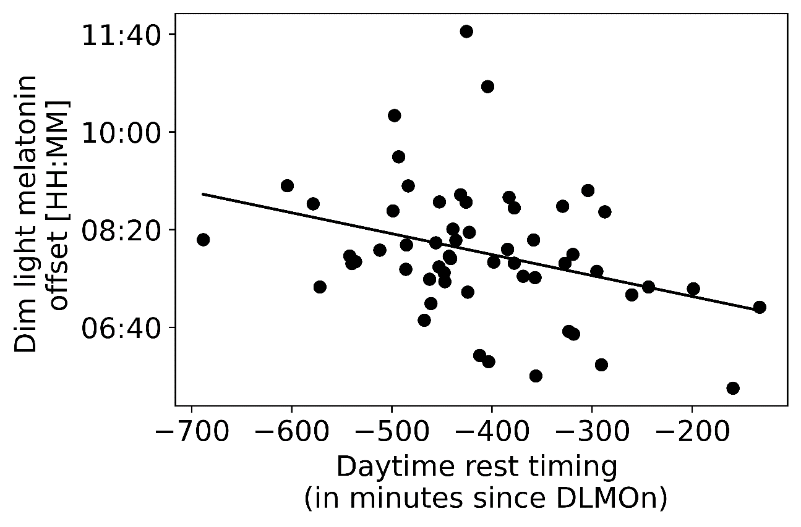
Figure S3. Scatter plots of the associations between daytime rest timing and dim light melatonin offset as circadian phase marker (N = 57). Regression was used for visual display only, and not as a substitute for the linear regression model (see Table S3).

Association between daytime rest characteristics and cognitive performance (Table S4)
 | Multivariate analysis | Attention performanceª | Executive functions^{b} | Episodic memory performance^{c}
Daytime rest duration | F_{3,42} = 0.86  p = 0.47 | β = 0.22, t = 1.60  p = 0.12 | β = 0.05, t = 0.35  p = 0.73 | β = -0.03, t = -0.18  p = 0.86
Daytime rest frequency | F_{3,42} = 2.72  p = 0.06 | β = 0.09, t = 0.66  p = 0.51 | β = -0.04, t = -0.24  p = 0.81 | β = -0.40, t = -2.64  p_{corr} < 0.016*^{B}
Daytime rest timing | F_{3,42} = 0.53  p = 0.66 | β = -0.14, t = -0.78  p = 0.44 | β = -0.23, t = -1.17  p = 0.25 | β = -0.07, t = -0.35  p = 0.73
Age | F_{3,42} = 3.28  p < 0.05* | β = -0.42, t = -2.95  p < 0.01** | β = -0.30, t = -1.95  p = 0.06 | β = -0.13, t = -0.86  p = 0.40
Gender | F_{3,42} = 0.54  p = 0.66 | t = -0.95  p = 0.35 | t = -0.62  p = 0.54 | t = 0.45  p = 0.66
Education | F_{3,42} = 0.07  p = 0.98 | β = 0.04, t = 0.29  p = 0.77 | β = 0.02, t = 0.15  p = 0.88 | β = 0.06, t = 0.36  p = 0.72
Body Mass Index | F_{3,42} = 0.36  p = 0.78 | β = -0.08, t = -0.48  p = 0.63 | β = -0.14, t = -0.84  p = 0.40 | β = 0.02, t = 0.14  p = 0.89
Daily activity level | F_{3,42} = 1.19  p = 0.33 | β = 0.21, t = 1.53  p = 0.13 | β = 0.19, t = 1.28  p = 0.21 | β = -0.01, t = -0.09  p = 0.93
Night-time rest duration | F_{3,42} = 0.16  p = 0.92 | β = -0.01, t = -0.07  p = 0.94 | β = -0.11, t = -0.65  p = 0.52 | β = -0.01, t = -0.09  p = 0.93
DLMO onset (DLMOn) | F_{3,42} = 0.42  p = 0.74 | β = -0.03, t = -0.12  p = 0.91 | β = -0.27, t = -1.04  p = 0.30 | β = -0.02, t = -0.08  p = 0.93
Distance between DLMOn and activity offset times | F_{3,42} = 0.65  p = 0.59 | β = 0.12, t = 0.53  p = 0.60 | β = -0.10, t = -0.42  p = 0.68 | β = 0.21, t = 0.86  p = 0.40
Apnea/hypopnea index | F_{3,42} = 0.06  p = 0.98 | β = -0.05, t = -0.29  p = 0.77 | β = 0.03, t = 0.21  p = 0.84 | β = 0.03, t = 0.18  p = 0.86
Note: * p < 0.05; *^{B}p_{corr} < 0.016 (Bonferroni-corrected); ** p < 0.01; ª Missing value: 1; ^{b} Missing value: 3; ^{c} Missing value: 2.
Table S4. Statistical outcomes of the multivariate linear regression model (Type III) and the corresponding post-hoc analysis investigating associations between daytime rest characteristics (predictor) and cognitive performance (N = 57).

Confirmatory analyses included participants with no daytime rest periods
Due to the impossibility to determine daytime rest (DTR) timing in 3 participants, because no daytime rest periods were detected in actigraphy recordings, we had to exclude them in our analyses. To confirm significant associations with DTR duration and timing, we assessed these associations with inclusion of these 3 participants and remove the DTR timing in statistical models. Higher DTR duration and frequency were associated with increased rest probabilities during daytime period (duration: 6.17-7.17 hours before DLMOn, p_{cluster}< 0.01; frequency: between 7.5-9.33 hours (p_{cluster}<0.01), 4.17-6.67 hours (p_{cluster}<0.001) and 2.00 and 3.00 hours (p_{cluster}<0.01)). Increasing DTR frequency was also associated with reduced rest probabilities during the second part of the night-time period (4.67-8.00 after DLMOn, p_{cluster}<0.001). In addition, DTR frequency was positively associated with rest-to-activity transition probabilities (kRA) during night-time (Kendall’s rank correlation: τ=0.21, p< 0.05). Regarding cognitive performance, DTR frequency was a significant predictor for cognitive performance (F_{3,46}=3.54, p< 0.05), more specifically it was negatively associated with episodic memory performance (β=-0.44, t =-3.10, p< 0.01).
REFERENCES
59. Beck AT, Ward CH, Mendelson M, Mock J, Erbaugh J. An Inventory for Measuring Depression. Arch Gen Psychiatry. 1961;4:561-571.
60. Beck AT, Epstein N, Brown G, Steer RA. An inventory for measuring clinical anxiety: psychometric properties. J Consult Clin Psychol. 1988;56(6):893-897.
61. Folstein MF, Folstein SE, McHugh PR. “Mini-mental state”: A practical method for grading the cognitive state of patients for the clinician. J Psychiatr Res. 1975;12(3):189-198.
62. Mattis S. Mental Status Examination of Organic Mental Syndrome in the Elderly Patient. In: Bellack L, Karusu TB, eds. Geriatric Psychiaty. New York: Grune and Stratton; 1976:77-121.
63. MESA: Multi-Ethnic Study of Atherosclerosis. MESA Actigraphy Scoring and Processing Guidelines. 2016. https://sleepdata.org/datasets/mesa/files/documentation/MESA_Sleep_Actigraphy_Scoring_Manual.pdf. Accessed January 27, 2022.
64. Harada CN, Natelson Love MC, Triebel KL. Normal Cognitive Aging. Clin Geriatr Med. 2013;29(4):737-752.
65. Reitan RM. Validity of the Trail Making Test as an Indicator of Organic Brain Damage. Percept Mot Ski. 1958;8(3):271-276.
66. Wechsler D. Wechsler Adult Intelligence Scale- Revised Manual. San Antonio: Psychological Corporation; 1981.
67. Brickenkamp R, Schmidt-Atzrt L, Liepmann D. Test D2-R - Revision. Aufmerksamkeits- Und Konzentrations Test. [Test D2-r-Revision: Attention and Concentration Test]. Göttingen: Hogrefe; 1962.
68. Dinges DF, Powell JW. Microcomputer analyses of performance on a portable, simple visual RT task during sustained operations. Behav Res Methods, Instruments, Comput. 1985;17(6):652-655.
69. Zimmermann P, Fimm B. Tests d’évaluation de l’attention (TEA). Würselen: Psychologische Testsysteme; 1994.
70. Borkowski JG, Benton AL, Spreen O. Word fluency and brain damage. Neuropsychologia. 1967;5(2):135-140.
71. Wechsler D. WAIS-IV, Echelle d’intelligence de Wechsler Pour Adultes - 4ème édition. Paris: Editions du Centre de Psychologie Appliquée; 2011.
72. Jersild AT, Arthur T. Mental set and shift. Arch Psychol. 1927;14(89):81.
73. Stroop JR. Studies of interference in serial verbal reactions. J Exp Psychol. 1935;18(6):643-662.
74. Grober E, Buschke H. Genuine memory deficits in dementia. Dev Neuropsychol. 1987;3(1):13-36.
75. Kirwan CB, Stark CEL. Overcoming interference: An fMRI investigation of pattern separation in the medial temporal lobe. Learn Mem. 2007;14(9):625-633.
76. Wechsler D. MEM-IV - Echelle Clinique de Mémoire de Wechsler- 4ème édition. Paris: Editions du Centre de Psychologie Appliquée; 2012.
77. Venables WN, Ripley BD. Modern Applied Statistics with S. Fourth Edi. Springer, New York; 2022.
78. Hyndman R, Athanasopoulos G, Bergmeir C, et al. forecast: Forecasting functions for time series and linear models. 2022. R package version 8.13. https://pkg.robjhyndman.com/forecast/

