Iterative Prior Resampling and rejection sampling to improve 1D geophysical imaging based on Bayesian Evidential Learning (BEL1D)
Hadrien MICHEL^{(1,2,3)}, Thomas HERMANS⁽²⁾ and Frédéric NGUYEN⁽¹⁾

¹University of Liège, Urban and Environmental Engineering Department, Faculty of Applied Sciences, Liège, Belgium
²Ghent University, Department of Geology, Ghent, Belgium
³F.R.S.-FNRS (Fonds de la Recherche Scientifique), Brussels, Belgium

Corresponding author: Hadrien MICHEL (hadrien.michel@uliege.be)

Short title: Improving BEL1D with IPR and rejection sampling

Abstract
The non-uniqueness of the solution of inverse geophysical problem has been recognized for a long-time. Although stochastic inversion methods have been developed, deterministic inversion using subsequent regularization are still more widely applied. This is likely due to their efficiency and robustness, compared to the computationally expensive and sometimes difficult to tune to convergence stochastic methods. Recently, Bayesian Evidential Learning 1D imaging has been presented to the community as a viable tool for the efficient stochastic 1D imaging of the subsurface based on geophysical data. The method has been proven to be as fast, or sometimes even faster, than deterministic solution. However, the method has a significant drawback when dealing with large prior uncertainty as often encountered in geophysical surveys: it tends to overestimate the uncertainty range. In this paper, we provide an efficient way to overcome this limitation through Iterative Prior Resampling (IPR) followed by rejection sampling. IPR adds the posterior distribution calculated at a former iteration to the prior distribution in a subsequent iteration. This allows to sharpen the learning phase of the algorithm and improve the estimation of the final posterior distribution while rejection sampling eliminates models not fitting the data. In this contribution, we demonstrate that this new approach allows BEL1D to converge towards the true posterior distribution. We also analyze the convergence behavior of the algorithm and derive guidelines for its application. We apply the approach for the interpretation of surface waves dispersion curves but the approach can be generalized to other geophysical methods.

Machine learning; Inverse theory; Probability distributions; Surface waves and free oscillations

1. Introduction
Solving geophysical inverse problems lies at the heart of many scientific observations and engineering studies (e.g. Tarantola, 2005; Aster et al., 2013). Deterministic approaches to the ill-posed inverse problem are often used due to the lower computational cost compared to stochastic approaches and the ease of visualizing one solution compared to analyzing an ensemble (Cockett et al., 2015; Loke et al., 2003; Rücker et al., 2017). Deterministic methods generally involve regularization techniques that may yield solutions which are geologically unrealistic and allow only limited uncertainty quantification typically related to data errors propagation based on Gaussianity (Clapp et al., 2004; Lai et al., 2005). To circumvent the former issue, multiple approaches have been proposed such as adapting regularization approach to the geological context (e.g.: Clapp et al., 2004). Bayesian inversion (Aster et al., 2018; Sambridge & Mosegaard, 2002) on the other hand aims at generating the full posterior distribution allowing to quantify uncertainty related to all parameters of the inverse problems. For stochastic methods, many types of approaches have been proposed in recent years, with Markov chain Monte Carlo (McMC) being at the core of most of those methods (Tarantola, 2005; Sambridge & Mosegaard, 2002; Irving & Singha, 2010; Linde et al., 2017). Most methods have in common to rely on many forward simulations to calculate the data misfit (or likelihood) in an iterative way. More recently, machine learning has gained popularity to process geophysical data (Kim & Nakata, 2018; Laloy et al., 2018; Russell, 2019). Below, we will review how stochastic methods and machine learning have been developed for surface wave dispersion and propose a novel framework to invert dispersion curves.
The dispersion of surface waves or interface waves is used at various scales ranging from crustal imaging (e.g.: Press, 1968; Meier et al., 2007) to engineering characterization (e.g.: Park et al., 1999; Xia et al., 1999; Moss, 2008). In contrast to many other geophysical methods, the inversion of dispersion curves using stochastic approaches is well established and routinely performed (Garofalo et al., 2016a). Local linearized least square optimization is still often used (e.g.: Cercato, 2008; Lai et al., 2005) but global search algorithms are also commonly applied, such as Genetic Algorithm (e.g.: Dal Moro et al., 2007) or Simulated Annealing (e.g.: Ryden and Park, 2006). The most commonly applied method, according to Garofalo et al. (2016a), is a global search algorithm: the neighborhood algorithm (Sambdrige, 1999a; Sambrdige, 1999b), for example implemented in Wathelet et al. (2005) and Wathelet (2008) for dispersion curves. This method samples models in the prior model space according to a density map and provides multiple models of high likelihood assessed by the data misfit (Sambridge, 1999a; Sambridge, 1999b). More classical Monte-Carlo approaches are also commonly used (Press, 1968; Socco and Boiero, 2008) and yield an estimation of the posterior uncertainty from the dataset.
Machine learning algorithms have been applied early in the 1990s to the interpretation of surface waves (Meier and Rix, 1993; Williams and Gucunski 1995; Gucunski and Krstic, 1995; Michaels and Smith, 1997). It was also among the first to see an application of a probabilistic neural network (Devilee et al., 1999). To achieve a probabilistic output of the neural network, Devilee et al. (1999) used two types of networks: the histogram and the median neural networks. They both provide estimations of the probabilities on a discretize space. Later, more advanced machine learning algorithms have been proposed to interpret surface waves into velocity profiles. Meier et al. (2007) proposed to interpret surface waves dispersion curves using a mixture density networks (MDNs; Bishop, 1994). The main strength of MDNs over Devilee et al. (1999) solution is that it provides a continuous estimate of the posterior probability density function. Zhang and Curtis (2021) applied an invertible neural network (INN; Ardizzone et al., 2019) to achieve the Bayesian inversion of those data. This approach supersedes MDNs as it is able to provide an accurate estimation of the posterior probability density function and to account for eventual correlations between parameters (Zhang and Curtis, 2021). The use of machine learning for the interpretation of surface waves is still a very active subject of research. Among recent publications, Mitu et al. (2021) compared the performances of different machine learning algorithms (Multilayer perceptron, random forest, support vector gradient) trained on real field data for the interpretation of dispersion curves into shear wave velocity (Vs) profiles. Yablokov et al. (2021) explored the optimal parameters to build an artificial neural network that provides Vs profiles from fundamental mode dispersion curves. They point towards the importance of a relevant training dataset for efficient estimation of accurate models. By re-running the training of the network with different training sets and propagating the datasets in the new network each time, they estimate uncertainty on their results. Aleardi and Sutcchi (2021) propose the use of a residual neural network to convert dispersion images into Vs profiles. Combined with a Monte-Carlo approach to propagate the noise and inaccuracy from the forward modelling, they achieved estimation of posterior probability density functions. Among the main challenges pointed out by the literature are computational optimization issues, network design for specific problems and uncertainty quantification through the machine learning algorithm.
In this contribution, we are proposing to extend the framework of Bayesian Evidential Learning (BEL) (Scheidt et al., 2018) to solve the surface wave inverse problem efficiently while computing the associated uncertainty. Compared to previous approaches, BEL provides both the computation efficiency of Machine Learning approaches and the uncertainty quantification of Bayesian inversion. The methodology requires a learning phase, allowing to approximate the Bayesian problem in a reduced dimension space by developing a statistically significant relationship between data and predictions. This linearized statistical relationship between data and predictions is based on a canonical correlation analysis in reduced dimensions. It has seen several applications in geosciences from oil field production prediction (Satija et al., 2017) to hydrogeological prediction of well-head protection area (Thibaut et al., 2021) and hydrogeophysical modeling of heat transport (Hermans et al., 2018; Hermans et al., 2019). BEL was originally designed as a prediction-focused approach applied to time dependent processes, circumventing the need to estimate the posterior distribution of model parameters by inversion. Recently, we introduced a new variation of BEL that enables instantaneous uncertainty quantification of static subsurface model parameters (1D imaging) together with a global sensitivity analysis and validated on surface Nuclear Magnetic Resonance (Michel, Nguyen, et al., 2020) and time domain Electromagnetic (TEM) (Ahmed et al., 2021). In addition to the low computational cost associated with predicting 1D models, associated uncertainty, and the global sensitivity that BEL1D provides, it also enables tracking posterior model and identify unexpected models in the posterior.
A current drawback of BEL1D lies in the overestimation of the uncertainty from the prior model space to the posterior model space for low sensitivity parameters of the models (Michel, Hermans, et al., 2020). This happens when the relationship obtained between the predictions and the data is not properly linearized for example when dealing with large prior uncertainty (Hermans et al., 2019; Michel at al., 2020; Ahmed et al., 2021). This uncertainty overestimation has been encountered previously in Bayesian frameworks (Jeong et al., 2017; Mariethoz et al., 2010; Dosne et al., 2016 or Park & Caers, 2020). To address it, Iterative Spatial Resampling (ISR) (Jeong et al., 2017; Mariethoz et al., 2010) can augment the prior with new information drawn from the posterior at the previous iteration. Sampling Importance Resampling (SIR) (Dosne et al., 2016) assign new loads to the prior (changes the statistical distribution that describes it) according to previously drawn models and their likelihood in McMC. These algorithms are often introduced to achieve better convergence of Bayesian approaches when dealing with large prior uncertainty, as is often the case in geophysics. More recently, Park & Caers (2020) proposed in the framework of Bayesian Evidential Learning to update the uncertainty of data and prediction variable, by using the obtained posterior models as prior models for the next iteration after running forward functions on the obtained posterior samples. The iterative procedure is stopped when the error in fit decreases below some specified threshold.
In this contribution, we propose to reduce the overestimation of the uncertainty based on a resampling algorithm (Park & Caers, 2020), here named Iterative Prior Resampling (IPR). IPR iteratively improves the posterior distribution by adding a sub-sample of posterior models from the previous iteration to obtain a “better informed” prior, improving the learning phase of the algorithm and leading to an improved quantification of the uncertainty. In this paper, we show that the combination of BEL1D with IPR significantly improves the precision and accuracy of BEL1D but is not sufficient to reach an uncertainty similar to McMC approaches. We therefore propose to apply a rejection sampling algorithm to the models obtained at the last iteration to reach a more precise estimation. We show empirically that this approach is converging towards the posterior model space (benchmarked with McMC, Vrught, 2016) while still having reasonable computational times. In this paper, we demonstrate the approach on the case of the dispersion curve from seismic surface waves, although BEL1D can be applied to any 1D geophysical inversion scheme.

2. Methods

2.1. BEL1D
A detailed description of the 1D imaging algorithm can be found in Michel, Nguyen, et al. (2020) and the Bayesian Evidential Learning framework in Scheidt et al. (2018). The main steps are summarized below:
- Generation of n models $m$ sampled from the prior distribution and their associated data $d$ by forward modeling of the geophysical process of interest
- Reduction of the dimensionality of the data and model using principal component analysis (PCA): ${PCA(d)\underset{→}{yields}d}^{f}$ and $P{CA(m)\underset{→}{yields}m}^{f}$
- Constitution of statistical relationships between the reduced model parameters and the reduced data, using canonical correlation analysis (CCA) : ${CCA(d^{f}, m^{f})\underset{→}{yields}(d}^{c},m^{c})$
- Generation of posterior distributions of $m^{c}$ by constraining the bivariate distributions $(d^{c},m^{c})$ to field data $d_{obs}^{c}$ using kernel density estimators
- Sampling of the computed posterior distributions $m^{c}$
- Back-transformation of the samples into the original space $m$, delivering a set of 1D models of the subsurface $m_{post}$ that are constrained to the geophysical data
The main advantage of this method over iterative stochastic approaches (e.g., McMC) is that the algorithm can be separated into 2 phases – learning and prediction –, with the numerically costly operations being only dependent on the prior distribution and limited to the learning phase. Therefore, they do not require the knowledge of the dataset to interpret; resulting in quasi-instantaneous stochastic prediction (equivalent to stochastic inversion) once the dataset is collected. Few parameters are required to tune the algorithm with the most significant parameter being the number of models sampled in the prior model space. Finally, a relationship between all sampled models and their origin in the prior can be made in the reduced dimension space, which enables a better understanding of the link between the prior and the dataset (identification of clusters of models that are outside the main distribution for example). In contrast to other methods, the algorithm is not limited to a specific shape of the prior or posterior model space. The learning phase of BEL1D is based on independent forward simulations of geophysical data from the sampled prior models, allowing for efficient parallelization (Michel, 2022).

2.2. Iterative Prior Resampling and rejection sampling
IPR within BEL1D consists in adding a given number of the models sampled from the estimated posterior to the prior and rerunning all the BEL1D operations from this new augmented prior (Figure 1). The number of models to be added is derived from a mixing ratio, which defines the proportion between the numbers of models added from the posterior compared to the number of models in the initial prior. Since BEL1D approximates the Bayesian problem in a reduced space where learning operations occur, IPR is designed to improve the quality of the uncertainty estimation by enabling a better correlation between the models parameters and their corresponding datasets. IPR increases the number of models compared to a uniform distribution in the region of the prior space where the posterior distribution shows a higher probability density.
This algorithm is inspired by proven methods like ISR (Jeong et al., 2017; Mariethoz et al., 2010) and SIR (Dosne et al., 2016) which indicates that improving the prior knowledge iteratively does reach convergence towards the actual posterior. As is the case with BEL1D (Michel et al., 2020), we cannot prove that IPR converges towards the actual posterior model space, even though previous studies showed empirically that the results are comparable to McMC (Michel et al., 2020) and rejection sampling (Satija and Caers, 2015). We will thus empirically demonstrate that the method converges towards a posterior distribution similar to classical Markov chain Monte-Carlos approaches (see section 3.1).
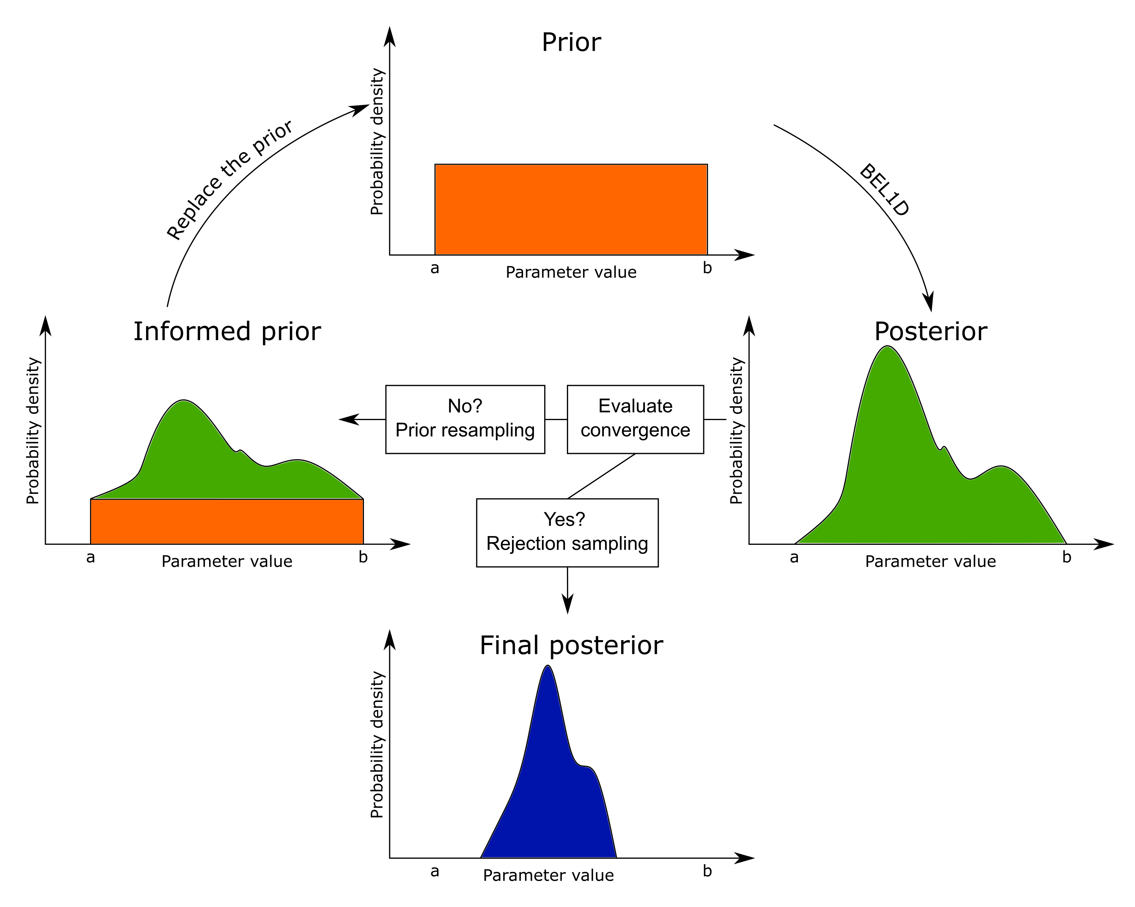
Figure 1. Illustration of the principle of Iterative prior resampling. The mixing ratio in this figure would be the ratio between the area in green and the area in orange in the “informed prior” graph. As a final step once the IPR algorithm has converged, we apply rejection sampling.
To stop the iterative process, the Kolmogorov-Smirnoff distance (KS) (Thas, 2010) between the univariate model parameter distributions at the current and previous iterations is used by defining a threshold on the similarity between the posterior distributions at two successive iterations. If this is not reached after 100 iterations, the algorithm stops.
The computations are conducted in a normalized space to avoid giving too much importance to some parameters due to their high relative magnitude. The threshold is defined through empirical testing on multiple distributions with a probability of falsely rejecting the null hypothesis (the two distributions are not equal) lower than 5%. The KS distance has the advantage to be computed on the cumulative distributions functions, hence is normalized (Thas, 2010). This ensures that the distance may be used even if the obtained distributions are not Gaussian. The threshold is thus only varying with the number of models in the compared distributions.
Once IPR has converged, as a final step, a rejection sampling algorithm, accounting for data misfit, further improves the estimated posterior. This algorithm consists of a Metropolis Sampler applied to the models from the last iteration of IPR. This algorithm differs from a McMC approach fundamentally, as it re-samples models out of a set of already sampled models (the posterior distribution after IPR) contrary to generating new models from perturbations of previously accepted models.
- For all models from the sampled posterior, compute the likelihood from the field data and the simulated data according to Equation 1 (Vrugt, 2016).
 | $$L\left(m | d_{obs}, σ^{2}\right)=\prod_{i=1}^{n}{\frac{1}{\sqrt{2πσ_{i}^{2}}}×\exp\left(-\frac{1}{2}{\left(\frac{d_{obs,i}-d_{i}\left(m\right)}{σ_{i}}\right)}^{2}\right)}$$ | (1)
In Equation 1, $m$ is the tested model, $d_{obs}$ is the observed field data of dimensionality $\left(1×n\right)$, $d\left(m\right)$ is the simulated data for the current model $m$ and $σ^{2}$ is the estimated Gaussian data variance (of dimensionality $\left(1×n\right)$) (Vrugt, 2016).
- Initialize a counter for the number of rejected models to 0.
- Select a random model ($m_{0}$) out of the samples with a likelihood $λ_{0}$. The first model is always accepted.
- Select another random model ($m_{1}$) with a likelihood $λ_{1}$ and compute the ratio between the two likelihoods: $r=λ_{1}/λ_{0}$.
  - If $r> U(0,1)$, accept the model $m_{1}$, replace $λ_{0}$ with $λ_{1}$ and reset the counter to 0.
  - Else, reject the model $m_{1}$ and increase the counter of rejected model by 1. If the counter of rejected models is higher than 20, accept the model $m_{1}$, replace $λ_{0}$ with $λ_{1}$, and reset the counter to 0.
- Select another random model $m_{1}$.
- Repeat the operations of the 4th and 5th points until all the models have been analyzed.
In practice, this step allows to remove the models of the posterior that are not fitting the data, i.e. which have a low likelihood. The order of the models are taken randomly not to introduce any bias in the computation. Assuming that the datasets corresponding to these models are already computed to calculate their Root Mean Square Error (RMSE), the computation of the Likelihood and rejection sampling is straightforward.

2.3. Surface Waves forward simulation
In this paper, we use a Python port of sdisp96 from surf96 (PySurf96) (Herrmann, 2013) to compute the dispersion curves (the data d) of 1D models and we demonstrate our approach on the fundamental mode. The models m are expressed in terms of layer thicknesses, P-wave velocity ($V_{P}$), S-wave velocity ($V_{S}$) and density ($ρ$). Since surface waves are mostly sensitive to S-wave velocity (Xia et al., 1999; Cox and Teague, 2016), a link between $V_{P}$ and $V_{S}$ can be considered through the Poisson’s ratio ($σ$) (Equation 2) (see e.g. Wathelet, 2008).
 | $$V_{S}=V_{P}×{\left(\frac{0.5-σ}{1-σ}\right)}^{\frac{1}{2}}$$ | (2)
In order for BEL1D to run accounting for potential uncertainties in the datasets, we use the frequency-dependent error model proposed by Boaga et al. (2011) :
 | $$ϵ\left(V,f\right)=A×V+B/f$$ | (3)
With V the velocity, f the frequency, A [km/s] and B [s] two parameters that can be tuned according to the noise level. In this paper, we use $A=0.075 km/s$ and $B=20 s$. Those values are empirically selected to accurately represent the uncertainty arising from the different experts interrogated during the InterPACIFIC project (Garofalo, et al., 2016a; Garofalo, et al., 2016b) in the Mirandola case (see section 4 for more details). We will use the same model for the synthetic benchmark and the field validation (the previously mentioned Mirandola test case).

3. Synthetic benchmark
We first apply iterative prior resampling with rejection sampling to a synthetic surface wave’s dataset generated from a model where only the shear-wave velocity profile is unknown. The other parameters (compression waves velocities and densities) are fixed mainly for visualization and comparison purposes. This simplifying assumption is later released. All the computations are performed on Windows 10 with an Intel Core i7-6800K running at stock with 64 GB of RAM at 2400MHz.
The benchmark model that we are selecting consists of two layers overlying a half-space (Table 1).

Table 1. Benchmark model description.
 | Thickness ($th$) [m] | S-wave velocity ($V_{s}$) [m/s] | P-wave velocity ($V_{p}$) [m/s] | Density ($ρ$) [kg/m³]
Layer 1 | 10 | 120 | 300 | 1500
Layer 2 | 50 | 280 | 750 | 1900
Half-space | / | 600 | 1500 | 2200

We are considering a noisy dataset with the noise distribution described in Equation 2. The frequency range that we use is between 1.25 Hz and 32Hz.
For the prior model space, only the thicknesses ($th_{i}$) and S-wave velocities ($V_{s,i}$) are varying. We use a uniformly distributed prior with ranges for the shear-wave velocities that are selected to obtain physically consistent Poisson’s coefficient for all layers when considering the benchmark values for the compression-wave velocities ($V_{p}$). Therefore, we do not need to enforce specific conditions to ensure a valid range of Poisson’s coefficient, which is useful for McMC, where imposing relationships between parameters is complex. We define the prior on the five parameters with BEL1D in Table 2. The ranges for the uniformly distributed parameters are selected voluntarily to reflect a large prior uncertainty.
Table 2. Description of the uniformly distributed prior model space for the benchmark.
 | Thickness ($th$) [m] |  | S-wave velocity ($V_{s}$) [m/s]
 | Minimum | Maximum | Minimum | Maximum
Layer 1 | 1 | 30 | 100 | 180
Layer 2 | 10 | 100 | 250 | 450
Half-space | / | / | 500 | 900

This prior is automatically falsified in the BEL1D algorithm. When projecting the data into the CCA reduced space ($d_{obs}^{C}$, represented by the red lines in Figure 2 C to F), the position is compared to the kernel density estimation of the distributions $f(d_{i}^{c},m_{i}^{C})$. If the position of $d_{obs}^{C}$ lies inside the probable parts of the distributions (between the 1% and 99% percentiles), the prior is accepted. Otherwise, the dataset is declared outside of the prior and the algorithm stops automatically. Here, BEL1D was initially run with 1000 models in the prior and progressively augmented with 1000 models at each IPR iterations (mixing ratio of 1).
In the following benchmark study, we first present the improvements brought by the iterative resampling scheme and analyze its iterative behavior in terms of uncertainty reduction and posterior estimation accuracy and compare it with the posterior estimated from McMC. We then show how the rejection sampler allows filtering the posterior by accounting for the data misfit. As an alternative, we show how the approach can also be used to define a pre-posterior before running McMC. Finally, we proceed with a parametric study of the algorithm.

3.1. Results and McMC comparison
In this section, we first show how the IPR approach allows reducing the uncertainty of the posterior distribution compared to the original BEL1D algorithm. The improvement in the statistical correlation and the disentanglement of the model parameters in the reduced dimension brought by IPR is shown in Figure 2. Figures 3A and 3B show the reduction of uncertainty in the posterior distribution over the prior space for the original BEL1D algorithm. We note that the estimated uncertainty remains large with a significant proportion of posterior models showing large RMSE. This modest uncertainty reduction is due to the poor relationship that we observe between the model parameters and the reduced data spaces (Figures 2 C and E) after one iteration. The higher dimensions, containing less sensitive parameters (Michel et al., 2020) display a large scattering, and hence a poor correlation. The first iteration therefore fails to resolve less sensitive parameters. In this case, as seen in Figure 2 (A), the different parameters are entangled in the different dimensions, indicating that all the parameters are similarly informed by the dataset given the obtained posterior.
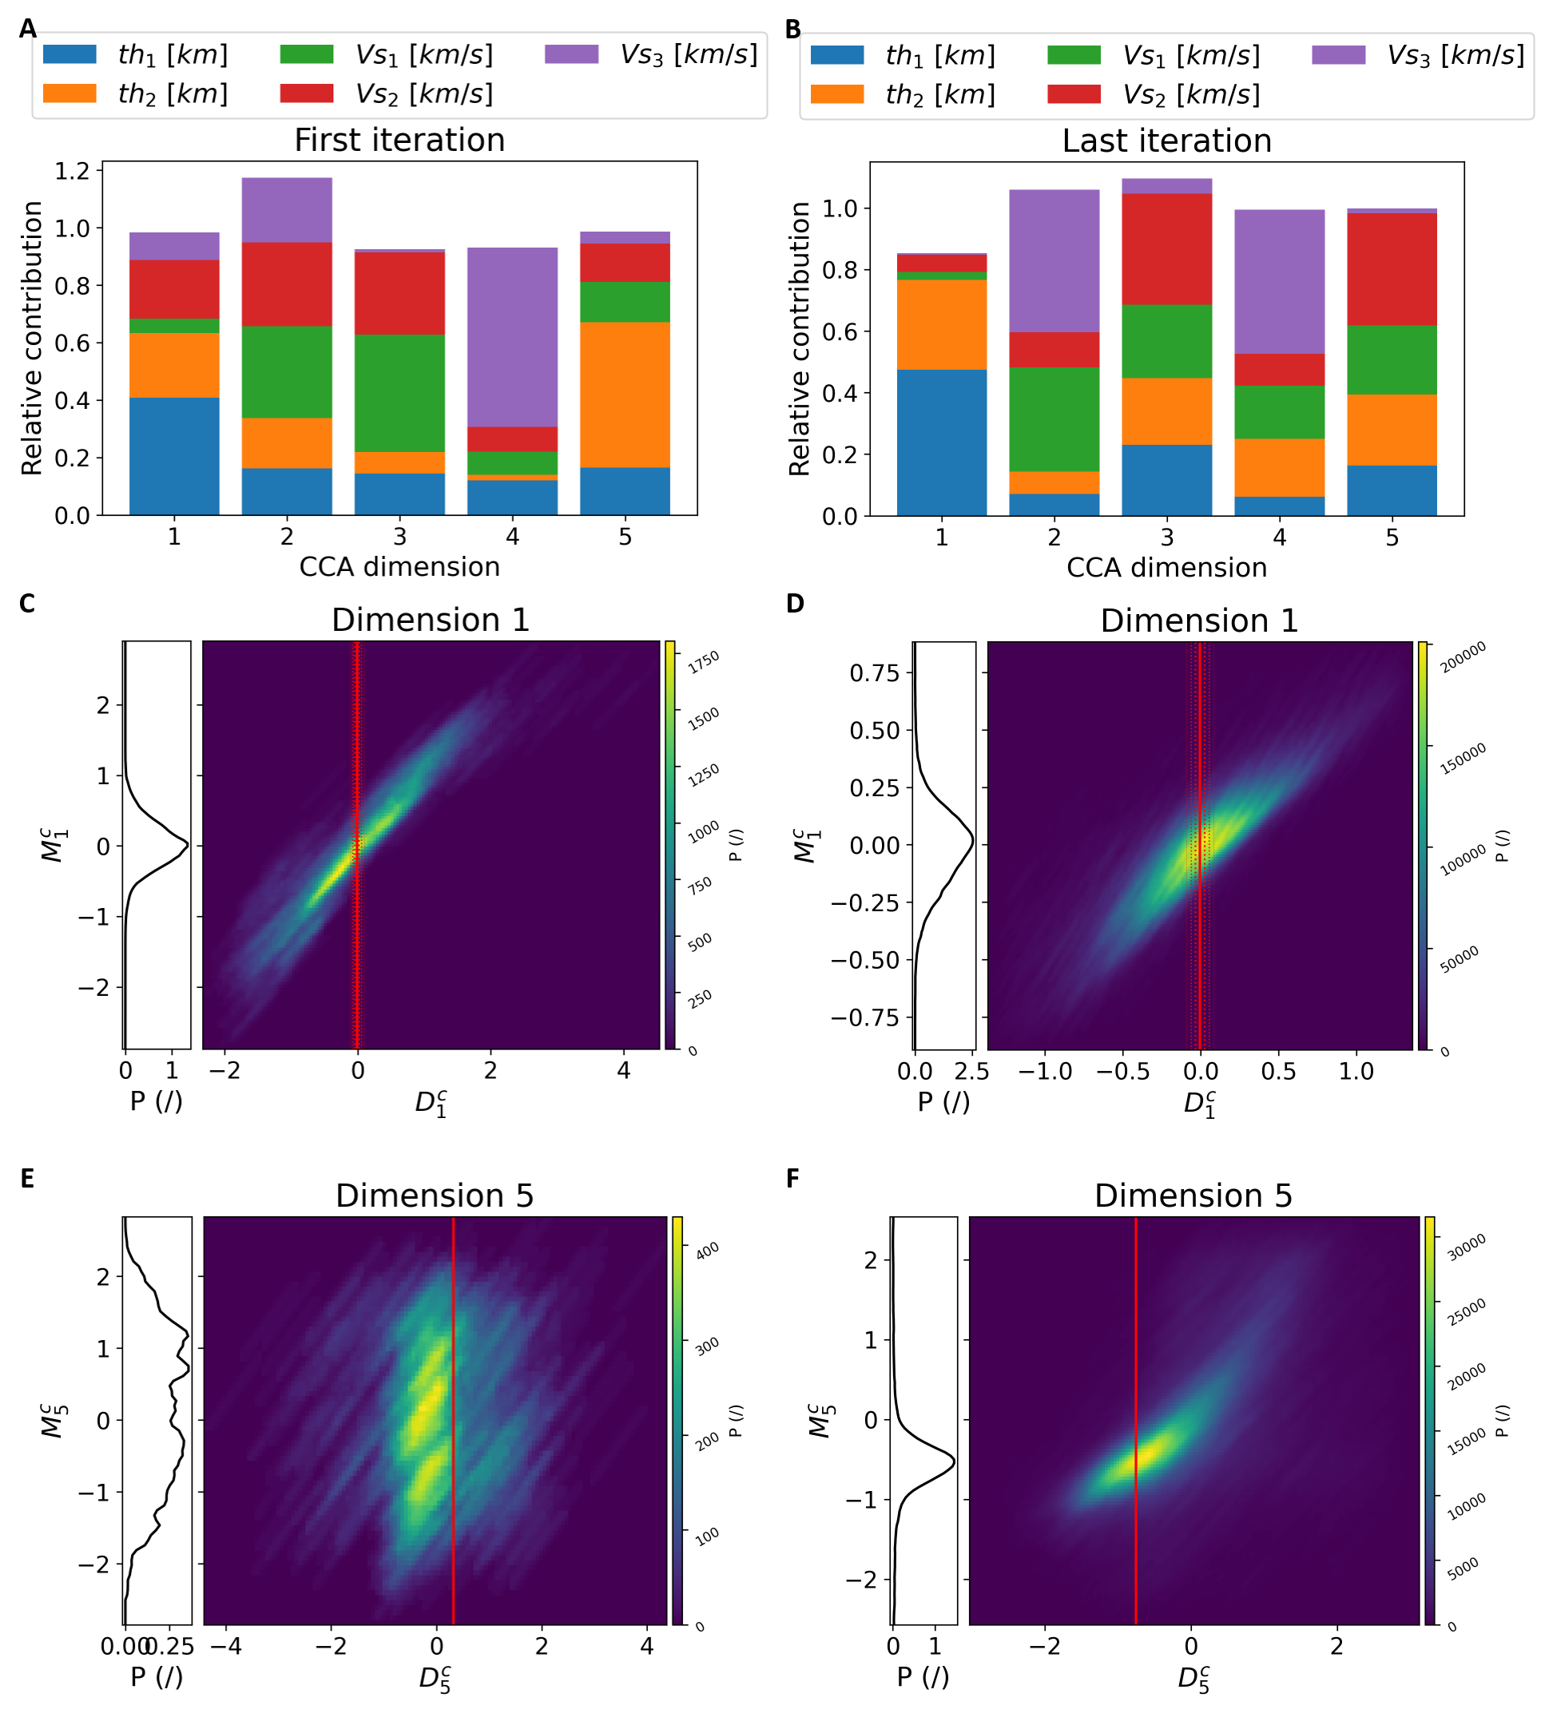
Figure 2. Visualization of the CCA space relationship between the models’ parameters and the reduced data. A and B represent the relative contributions of all the models’ parameters to the different CCA dimensions at (A) the first and (B) the last, 18th in this case, iterations. C and D represent the relationship for the first CCA dimension at (C) the first and (D) the last iterations. We present the same for the fifth dimensions in E and F for the first and last iterations respectively. In those figures, the vertical red bar represents the actual position of the data in the reduced data space (solid line) along with the noise propagated (dotted lines representing +/- 1, 2 and 3 standard deviations). The pdfs represented on the left are the kernel density estimated probability density functions of the reduced model’s parameters given the dataset. We use those to sample back models from the estimated posterior. The narrower those distributions, the narrower the obtained posterior in the original model space.
The implemented iterative procedure allows a substantial reduction of uncertainty from the prior (yellow in Figure 3 D) to the posterior at the last iteration (blue in Figure 3 D) and a disentanglement of the model parameters in the reduced dimension (Figure 2B). The improvement of the statistical relationship that is learnt through the procedure is evident from the comparison between Figures 2C and 2D (dimension 1, mostly sensitive to the thicknesses) and between Figures 2E and 2F (dimension 5 where all parameters are entangled but where the corresponding velocities dominate). Moreover, the posterior are more accurate with iterative resampling than without. The posterior models are shown as 1D profile in Figure 3 with their root mean squared error on the dataset as color scale. As can be seen, most models of the posterior are fitting the data within their noise level, but some models with a high RMSE remain.
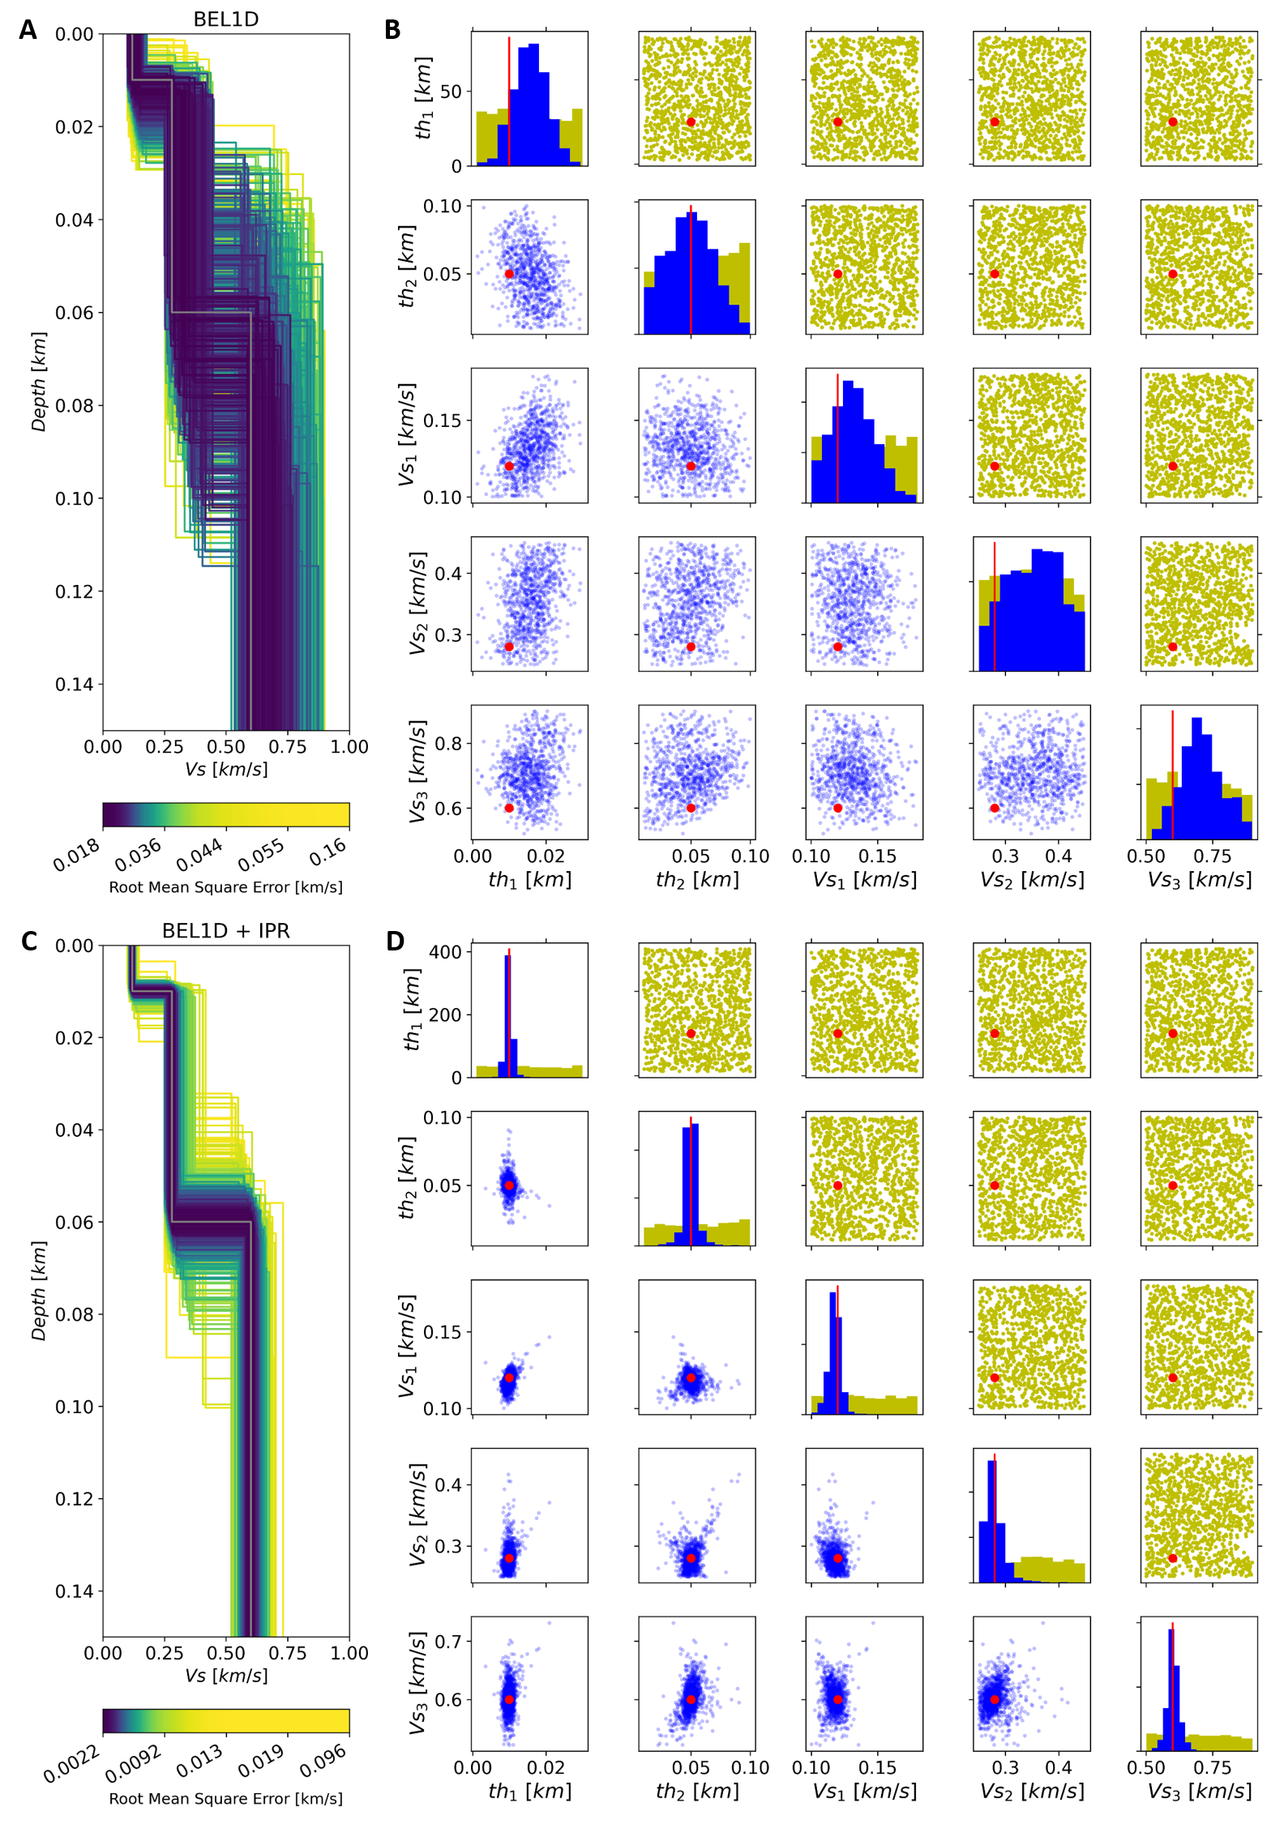
Figure 3. Results of BEL1D before (A and B) and after applying IPR (C and D) on the benchmark case. (A and C) Visualization of the obtained 1D profiles along with their associated RMSE and (B and D) comparison of the prior (yellow) and the posterior (blue) model space for the different variables of the models. The scale for the RMSE is linear but we built the color scale to represent percentiles, with each color representing as many models as the others. The RMSE corresponding to the noise level is 0.026 km/s. Eighteen iterations were required to achieve convergence based on the KS distance in this specific case. They took under 20 seconds to run on the test computer.

Figure 4 shows the evolution of the different parameters with the iterations. The mean value of the posterior for the first iterations are far away from the actual values and fall outside of the likely part of the distribution for some parameters, with a corresponding too large uncertainty. IPR proves efficient in improving the accuracy of the posterior and in reducing its uncertainty due to the improved correlations between the data and the parameters (Figure 2), especially for the higher dimensions.
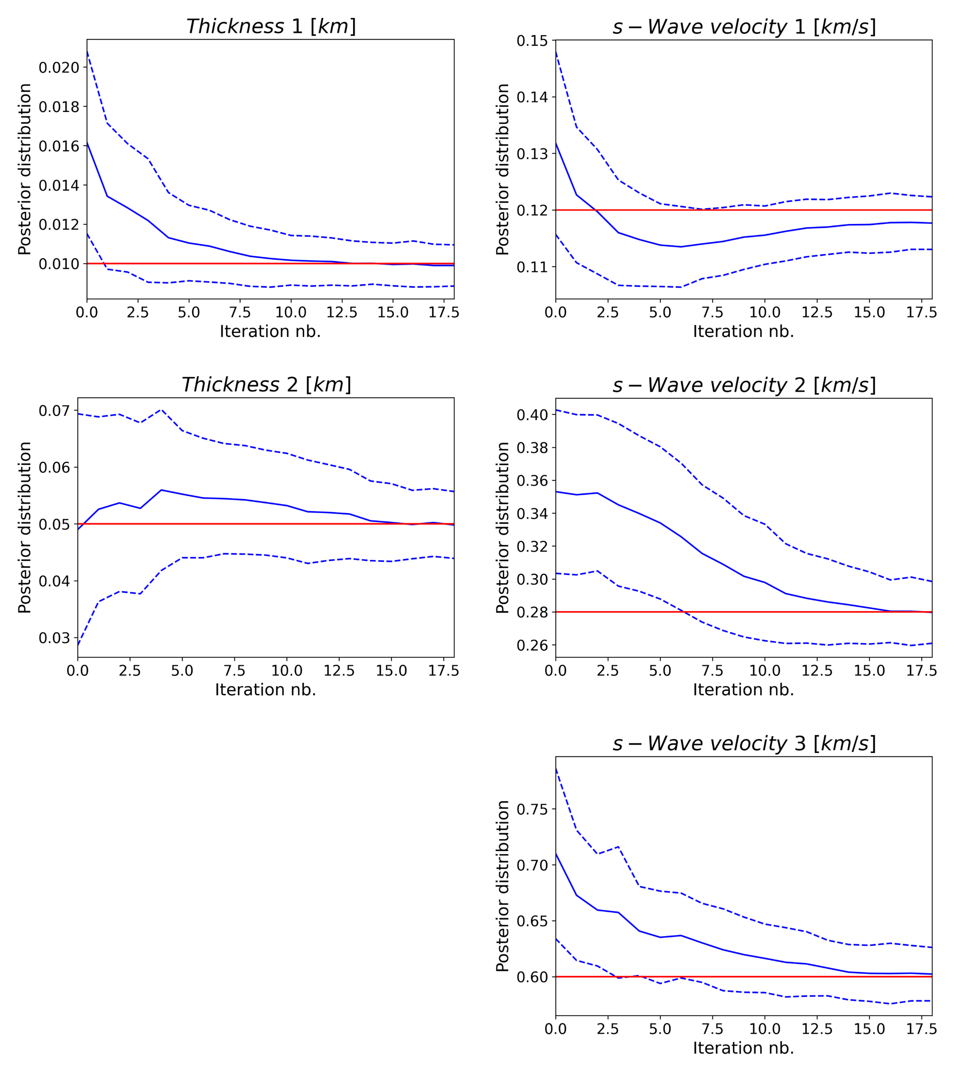
Figure 4. Analysis of the convergence of IPR. The solid blue lines represent the mean for the corresponding distributions, the dashed lines the mean +/- the standard deviation and the red lines represent the actual benchmark value that we are searching.
Since BEL1D (with or without IPR) does not theoretically ensures convergence towards the actual posterior, we benchmark our results with a McMC algorithm: a Metropolis sampler with on-the-fly adaptation of the scaling factor (Vrugt, 2016) (Figure 5). We can see that our implementation delivers an accurate estimation of the posterior mean but that the uncertainty is still overestimated. Note that BEL1D and IPR results were obtained in less than 5% of the time it took the McMC algorithm to converge and required only 3% of the number of models sampled by the McMC algorithm. In addition, McMC clearly identifies a strong correlation between parameters, $e_{2}/v_{S,2}$ being the most pronounced. The results obtained by using IPR on BEL1D show the same correlation, but it is partly hidden by outliers in the distribution. Since BEL1D does not require the data misfit or the likelihood of a model to determine if the sampled model from the posterior distribution is accepted or not as opposed to McMC, some models with high RMSE values are sampled. This can be observed in Figure 3B where the uncertainty range is impacted by sampled models having a high RMSE. It is thus inherent to BEL1D to find outliers that would be discarded in an approach that is based on the data misfit (or the likelihood) and is a result of the approximation of the inverse problem in the low dimensional space.
To account for this limitation, we propose to apply rejection sampling to the models that are present in the sampled posterior model space in Figure 5. Rejection sampling allows to get rid of highly unlikely models with high RMSE (or low likelihood) and to generate results much closer to the McMC benchmark with little computational efforts (1 sec in this case). After, rejection sampling the correlations that exist between the parameters are clearly identified.
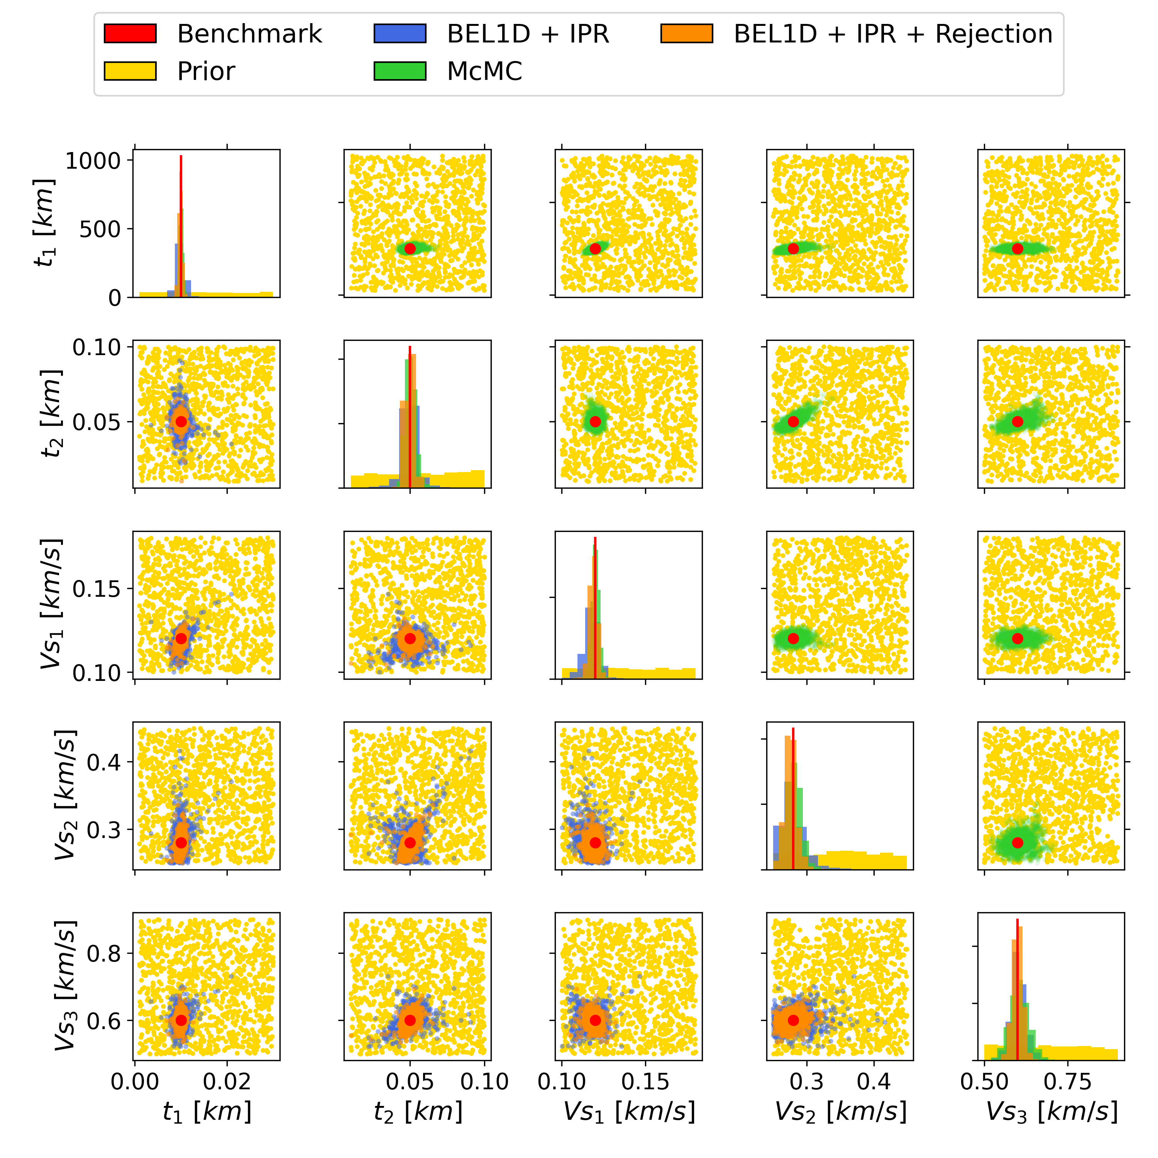
Figure 5. Improvements obtained by using rejection sampling after IPR. The results are compared to the results obtained by a McMC algorithm applied on the prior model space (green).
Even though rejection sampling is very compelling as a quick approach to refine the obtained distributions, it does not provide the exact posterior model space. We therefore propose another approach to obtain the exact posterior distribution: we use the posterior obtained from BEL1D and IPR as the prior for a classical McMC approach. The results of this approach are presented in Figure 6. Using this approach, the retrieved posterior distribution is similar to the one obtained by McMC with the original prior.
In terms of computation time, all proposed approaches significantly reduces computation time compared to McMC on the original prior (which takes 490 sec). BEL1D + IPR takes 20 sec (4 % of the McMC) while BEL1D + IPR + McMC takes 125 sec (25.5%). Nonetheless, applying rejection sampling provides the best compromise between accuracy and computation time as it only takes one second to compute after BEL1D and IPR for a total of 21 sec (less than 4.5% of the time for a standard McMC approach).
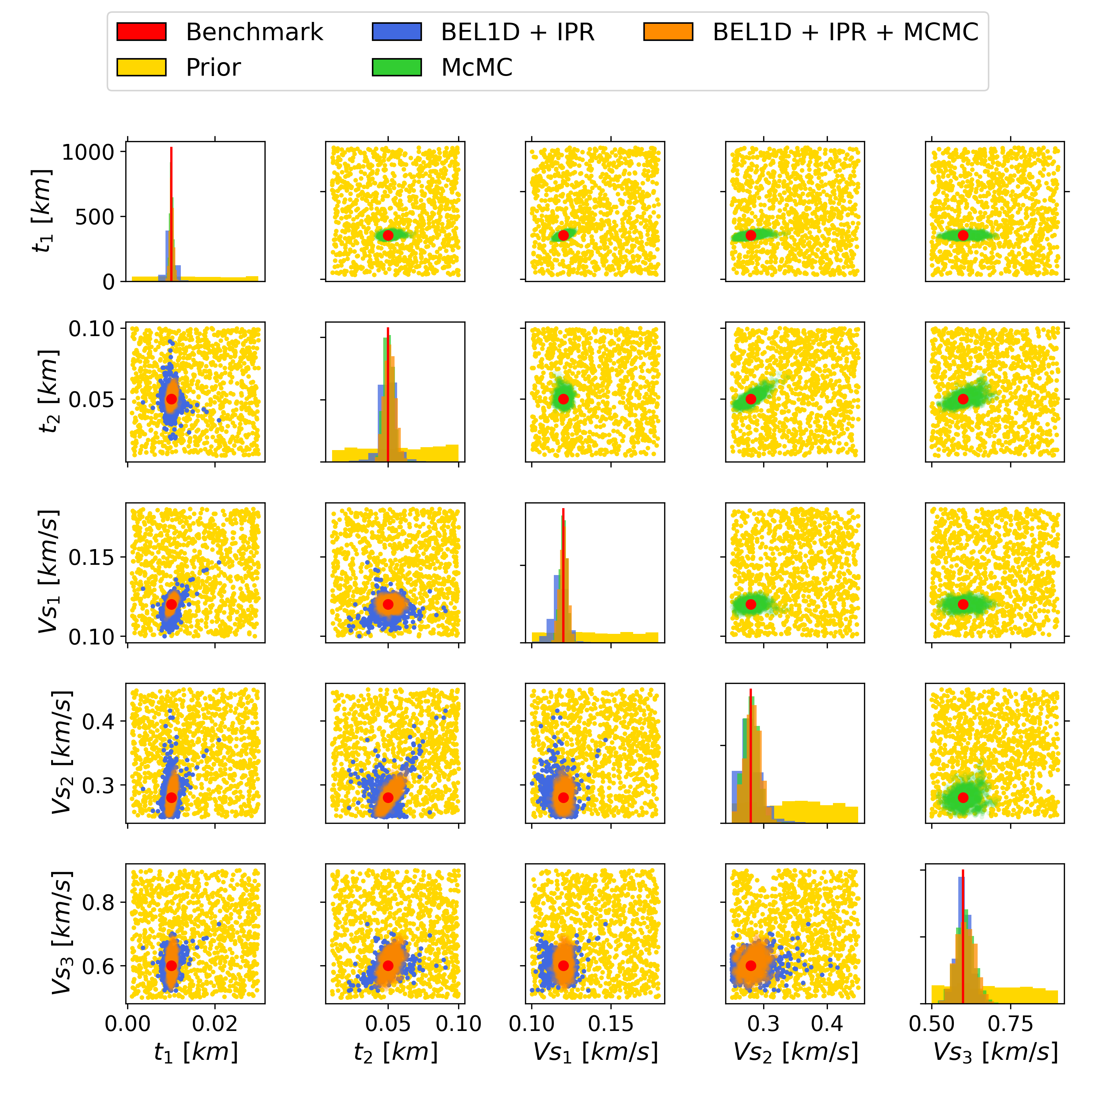
Figure 6. Improvements obtained by using McMC after IPR. The results are compared to the results obtained by a McMC algorithm applied on the prior model space (green).
In summary, BEL1D when combined with IPR already provides a rapid first estimation of the posterior model space but overestimates the uncertainty (Figure 3). When combined with rejection sampling (obtained at a negligible CPU cost) the obtained distribution mimics the behaviors of the results from a McMC approach, but small discrepancies remain (Figure 5). Therefore, if one wants to improve even further the estimation of the posterior model space, it is possible to use the posterior obtained through the BEL1D + IPR workflow as a pre-posterior for a McMC approach that will provide an accurate estimation of the posterior (Figure 6) while still being faster to converge than the application of the McMC approach to the original prior.

3.2. Parametric study of iterative prior resampling
Here, we sequentially study the influence of key parameters in the proposed methodology.
First, we discuss the impact of the number of models in the original prior and the mixing ratio $n_{posterior,add}/n_{prior,init}$ between the posterior to add to the prior and the initial prior. We will analyze their impact on key aspects of the posterior estimation and on the computation time, since it is crucial to remain under a reasonable threshold in order for the method to remain attractive. We are using different indicators to analyze the impact of the parameters. First, we use the normalized difference between the mean of the obtained posterior distribution and the actual benchmark value. Then, we use the reduction of the standard deviation from the prior model space to the posterior model space. Again, we normalize this reduction for visual purposes. Finally, we are recording the needed computational time. We repeated each test 10 times to account for natural variability of the Bayesian process (standard deviation of the indicators presented with error bars).
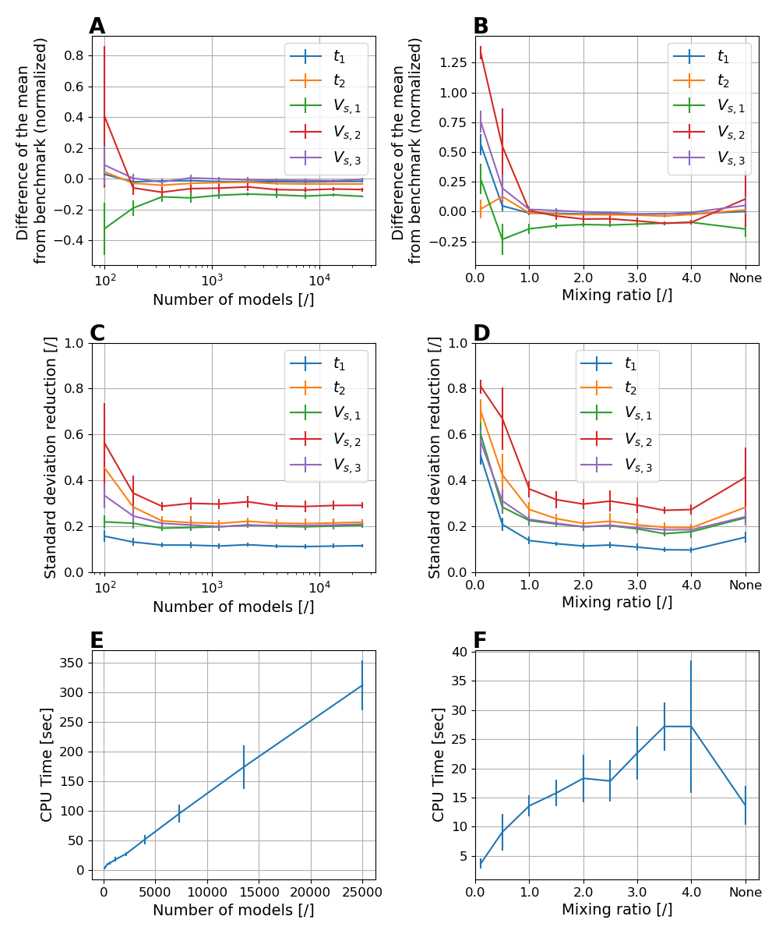
Figure 7. Impact of the number of models in the sampled prior (first column) and of the mixing ratio posterior/prior (second column). From top to bottom, (A and B) the accuracy of the obtained estimation (Euclidian distance between the mean of the obtained posterior distribution and the benchmark model, normalized by the initial prior standard deviation), (C and D) the precision of the obtained estimation (ratio of the obtained standard deviation for the posterior estimation and the initial prior standard deviation) and (E and F) the computation time. For each value presented on the graph, the computations where performed ten times to estimate the run-to-run standard deviations (error bars). None for the mixing ratio means adding everything that is sampled without taking care of the ratio.
By default, the number of models in the initial prior corresponds to the number of models to be sampled in the posterior which can be defined by the user, corresponding to a mixing ratio of 1. The number of sampled models can increase or decrease to reach the required mixing ratio that can also be defined by the user. However, the initial number of model sampled in the prior still largely governs the convergence of the algorithm, as it controls the accuracy of the algorithm in the early iterations (Michel et al., 2020).
The results of the analysis is presented in Figure 7 (first column). There is clearly an impact of the number of models in the prior on the convergence of the algorithm. For a low number of models sampled in the prior, we can see that the prediction is neither precise (Figure 7 – A), nor accurate (Figure 7 – C): the mean of the posterior is not properly estimated and the uncertainty is overestimated. Above 500 models sampled, we see that the behavior stabilizes itself towards a more precise and accurate prediction. This means that choosing any value above 500 for the number of models in the sampled prior model space is conservative. This behavior is related to the requirement to sample enough models to properly learn the relationship in the low dimensional space. Otherwise, the first iteration will not identify properly the region of the prior that should be resampled, adding inappropriate models to refine the posterior and resulting in a prior not consistent with the data.
When analyzing the impact on the computation time (Figure 7 – E), we note that the time is only increasing linearly, which indicates the order of complexity of the algorithm being approximately$O(n)$, n being the number of models sampled in the prior. Therefore, we should stick to the lower values for this parameter.
We introduced the mixing ratio in the model to avoid bias in the estimation of the posterior. This parameter ($m$) equilibrates the load between the prior and the posterior. The idea is that at a given moment, convergence will be achieved, not by reaching a stable posterior, but because perturbations in the prior from IPR become negligible. For low mixing ratios (Figure 7 – B and D), BEL1D converges towards a poorly resolved mean estimation of the posterior. The number of added samples is too small to really improve the learning process. From the benchmark, a mixing ratio around one seems appropriate, since adding more samples does not change significantly the mean estimation nor reduces the standard deviation, while remaining reasonably time consuming.
We also add the sampled models from the posterior at each iteration without taking care of the proportions between one-another (see ‘None’ in the figures). This leads to similar results globally, with the noticeable exception of the observed run-to-run standard deviation on the obtained distributions, which is larger.
In terms of computation time (Figure 7 – F), we observe that the time increases with the mixing ratio. This increase in time is due to the increased number of models that need to be computed in order to satisfy the mixing ratio. It is also observable that the CPU time required is similar with a mixing ratio of “1” and no mixing ratio (“None”). Therefore, we advise to use a mixing ratio of one for an optimal behavior control.

The parametrization of the prior model space has typically an important impact. We analyze the impact of having 3 (the above benchmark model), 4, 5, 6 and 7 layers defined in the prior. For each case, we use the same type of parametrization as in the benchmark. Hence, we only take into account the $n-1$ thicknesses and $n$ s-wave velocities, $n$ being the number of layers.
For the algorithm to work properly with additional layers (thus more parameters to explore), we increased the number of models sampled from the initial prior by multiplying it by 2 for each added layer, since the models are more complex to explore. This relationship was obtained through empirical testing.
The results are presented in Figure 8. We observe that adding layers in the model slightly increases the uncertainty, which is logical since the prior uncertainty is larger. Nonetheless, we are still able to retrieve the main aspects from the model, namely the number of identified layers still remaining 3 for all the cases, showing that the method does not need a prior constrained to 3 layers to predict them. Some variations are observed inside the layers but the estimation is always skewed at the boundaries between the layers and not in the middle, where the impact on the dataset is more important. This results in smoother transitions between layers and is inherent to the non-unicity of the solutions when the number of parameters increases.
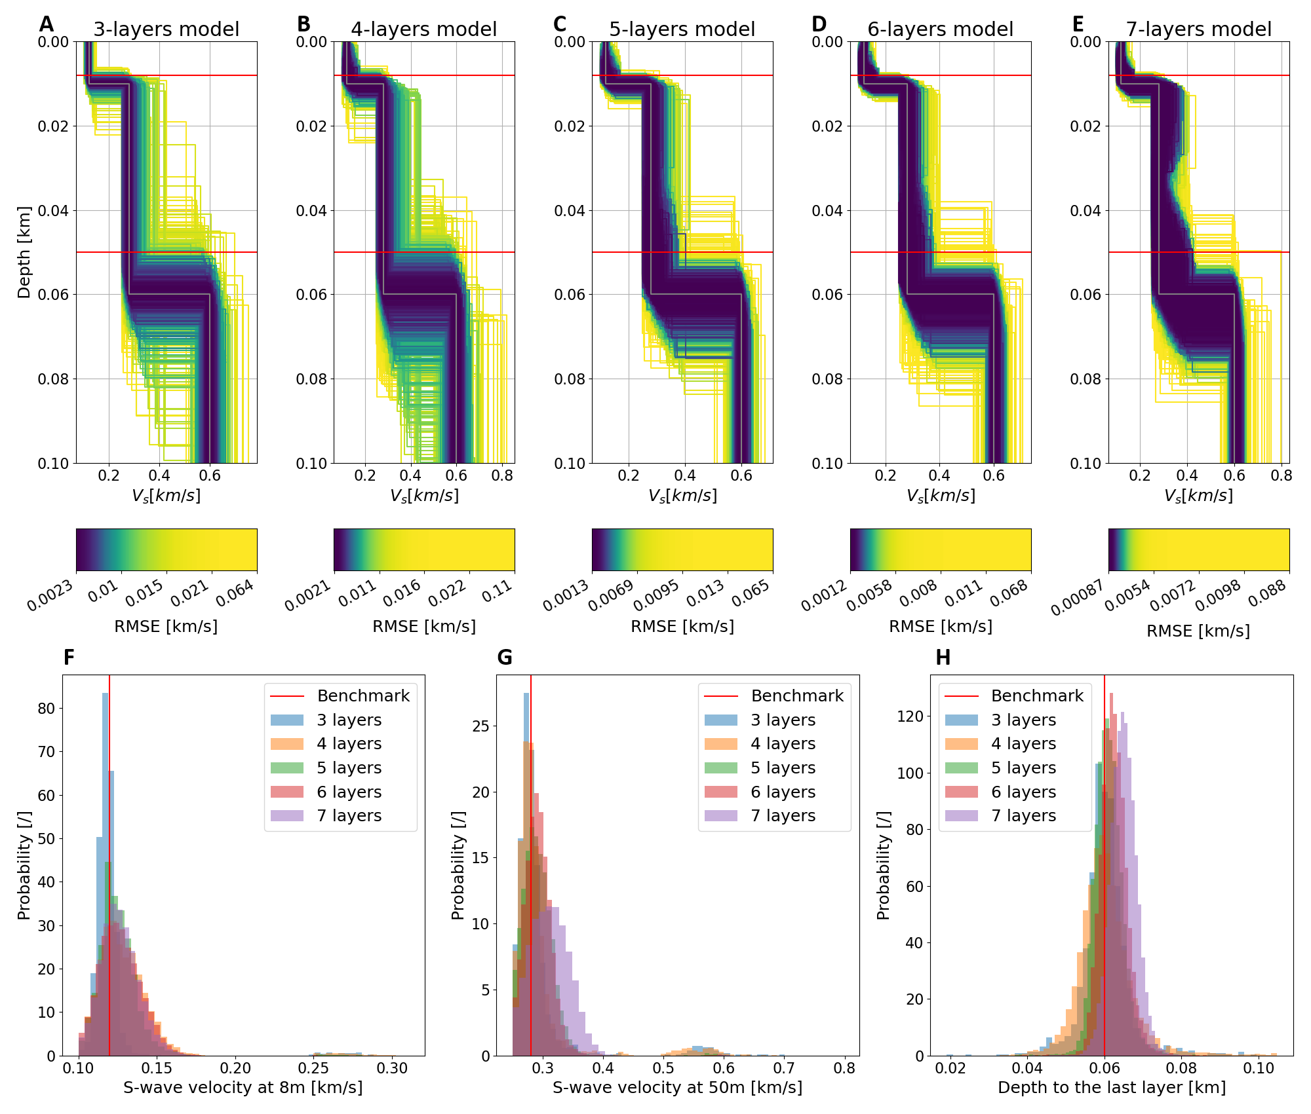
Figure 8. Impact of the number of layers on the obtained posterior model space. (Top) From A to E with respectively 3 to 7 layers with an increment of one. The color scale is unique to every subplots as it represents the obtained probability for the represented case with each color representing as many models in the subplot. The RMSE corresponding to the noise level is 0.026 km/s. (Bottom) Histograms of the obtained models at specific depths (8 and 50 meters for F and G respectively) and the estimated depth to the bedrock (H).
Exploring a larger model space requires more time since more models are required in the prior samples (multiplying by 2 for each added layer). In the test case presented above, the time was approximately doubled for each added layer. This is linked to the number of models required to cover the full model space and a similar increase applies to McMC approaches. Nonetheless, in case the number of layers in the model is uncertain, it can be beneficial to start with a large number of layers to identify how many layers are necessary to explain the data, and then to run BEL1D with a reduced number of layers.

4. Validation: application to Mirandola field dataset (InterPacific)
The InterPacific project (Intercomparison of methods for site parameter and velocity profile characterization) aimed at assessing the reliability of in-hole and surface wave methods for the estimation of shear wave velocity by comparing the interpretation obtained from different experts (Garofalo, et al., 2016a; Garofalo, et al., 2016b). In this section, we use the mean dispersion curve that arose from these experts’ analyses of the raw data to demonstrate BEL1D applicability to retrieve the shear wave velocity profile. We will focus on the case proposed by Garofalo, et al. (2016a) in the Mirandola test-site located in the Po plain. The site is characterized by soft sediments (sand, clays and gravels) overlaying a Pliocene bedrock (sand and marine pelite), found at a depth between 50 and 150 meters (Garofalo, et al., 2016a).
From this available information, we will assume that the terrain is composed of three layers: two soft layers, representing the alluvial plain and its heterogeneity and a third layer representing the bedrock. Above this, we will impose that the models must have Poisson’s coefficient within the range 0.2 to 0.45 for each layer through added conditions on the prior. Including the Poisson’s coefficient in the prior would be redundant with the inclusion of either $V_{s}$ or $V_{p}$ as knowing two of the three parameters enables the computation of the third. We made the choice to use $V_{s}$ and $V_{p}$ in the prior and to exclude models that do not correspond to the acceptable range of Poisson’s coefficient. Therefore, the prior is no longer uniformly distributed across the different dimensions, as some models are excluded through this added rule. The prior is composed of 11 parameters: 2 thicknesses ($th_{i}$), 3 S-waves velocities ($V_{s,i}$), 3 P-waves velocities ($V_{p,i}$) and 3 densities ($ρ_{i}$). Their uniformly distributed prior distributions are described below:
- ${th}_{1}∈U\left[5, 50\right] m$
- ${th}_{2}∈U\left[45, 145\right] m$
- $V_{s,1}∈U\left[100, 500\right] m/s$
- $V_{s,2}∈U\left[100, 800\right] m/s$
- $V_{s,3}∈U\left[300, 2500\right] m/s$
- $V_{p,i}∈U\left[200, 4000\right] m/s$ with $i=1, 2 or 3$
- $ρ_{i}∈U\left[1500, 3500\right] kg/m^{3}$ with $i=1, 2 or 3$
As is observed, the prior is very large given the context. This approach is used to show the capacity to reduce significantly the uncertainty when very few is known in advance from the site.
In this case, since they are more parameters in the model, we will use a larger set of models sampled from the prior. We settled on 10.000 as being a good trade-off between fast computations and reliable estimations.
To sample the models, we used uniformly distributed variables with rejection in order to satisfy the Poisson’s coefficient interval. From the original 60 dimensions of the data (the 60 couples frequency-phase velocity of the sampled dispersion curve), PCA reduced the dimensionality to 11, explaining more than 95% of the variability. In this case, the number of dimensions is constrained by the BEL1D algorithm and not the variability to explain as, to be able to perform further steps of BEL1D, the dimension of $d^{f}$ (the PCA reduced dataset) must be larger or equal to the one of $m^{f}(=m)$ (the, potentially PCA reduced, model space).
We propagate the error on the data itself using the propagation process described by Michel et al. (2020) with the noise model from equation 3. Once noise propagated, we can sample as many models from the posterior as wanted. Here, since we are iterating on the prior, we sample a number of models sufficient to satisfy the mixing ratio fixed to one, as for the previous benchmark case.
After 13 iterations (3min), we obtain the results presented in Figure 9 and Figure 10. They clearly show that we are encompassing the uncertainty observed by the different experts from the InterPacific project (Garofalo et al., 2016a). We can observe multiple interesting aspects. First, we see that we do not reduce the uncertainty for the densities. This is coherent with the well-known fact that surface waves have low sensitivities to this parameter (Xia et al., 1999). On the other hand, we observe that we have achieved significant reduction for the parameters of the $V_{s}$ profile and, to a lesser extent for the $V_{p}$ profile. This latter observation is mostly due to the intrinsic link that exists between $V_{s}$ and $V_{p}$ through the Poisson’s coefficient, as the measurement itself is not particularly sensitive to the compression waves velocities. This is especially visible in Figure 10 where we can see that the range of values for $V_{p}$ is limited by the sampled values of $V_{s}$ for a given layer. In Figure 9, we present the results of the algorithm at different steps. Figure 9A presents the results of BEL1D, where we easily see the large uncertainty in the estimated posterior. If we directly apply rejection sampling to the results of BEL1D (Figure 9B), we reach a better estimation, but we are still overestimating the uncertainty. Applying IPR (Figure 9C) results in a better overall estimation with some outliers still present. Finally, applying rejection sampling to BEL1D with IPR (Figure 9D) removes most of the high RMSE (low likelihood) models for a very reasonable cost (less than 1 second). The better estimation is also illustrated in the dataspace for the initial BEL1D run (Figure 9E) and the final BEL1D, IPR and rejection sampling results (Figure 9F).
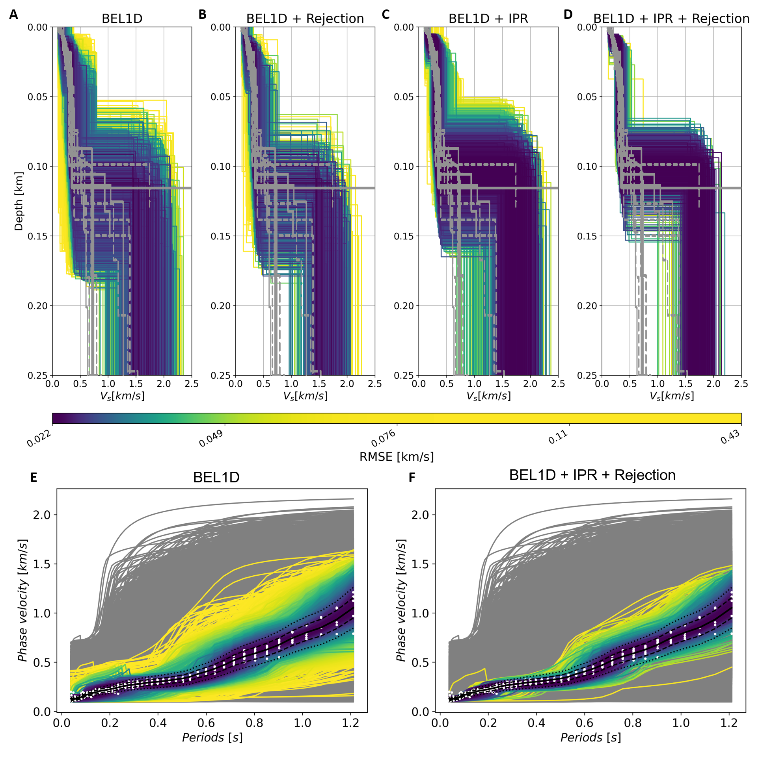
Figure 9. Results of BEL1D, IPR and rejection sampling applied to the Mirandola test case. (A to D) Models of the shear-wave velocity obtained from (A) BEL1D, (B) rejection sampling applied directly after BEL1D, (C) BEL1D and IPR and (D) rejection sampling applied after BEL1D and IPR with the color scale representing the RMSE. Those figures presents also the profiles obtained by the different experts (overlaid in gray) for the shear-wave velocities (Garofalo et al., 2016a). (E and F) Datasets associated to the different models (with their RMSE) after (E) BEL1D and (F) rejection sampling applied to the results of BEL1D and IPR. In white, we present the datasets as found by the different experts. The color scale is the same for all the different graphs. The RMSE corresponding to the noise level is 0.038 km/s.
We observe some discrepancies on the bedrock estimations compared to previous studies. We explain this behavior by the use of the average dispersion curve as data, whereas there is a large discrepancy at low frequencies (long periods) for the dispersion curves used by the different experts (Garofalo et al., 2016a and Figure 9).
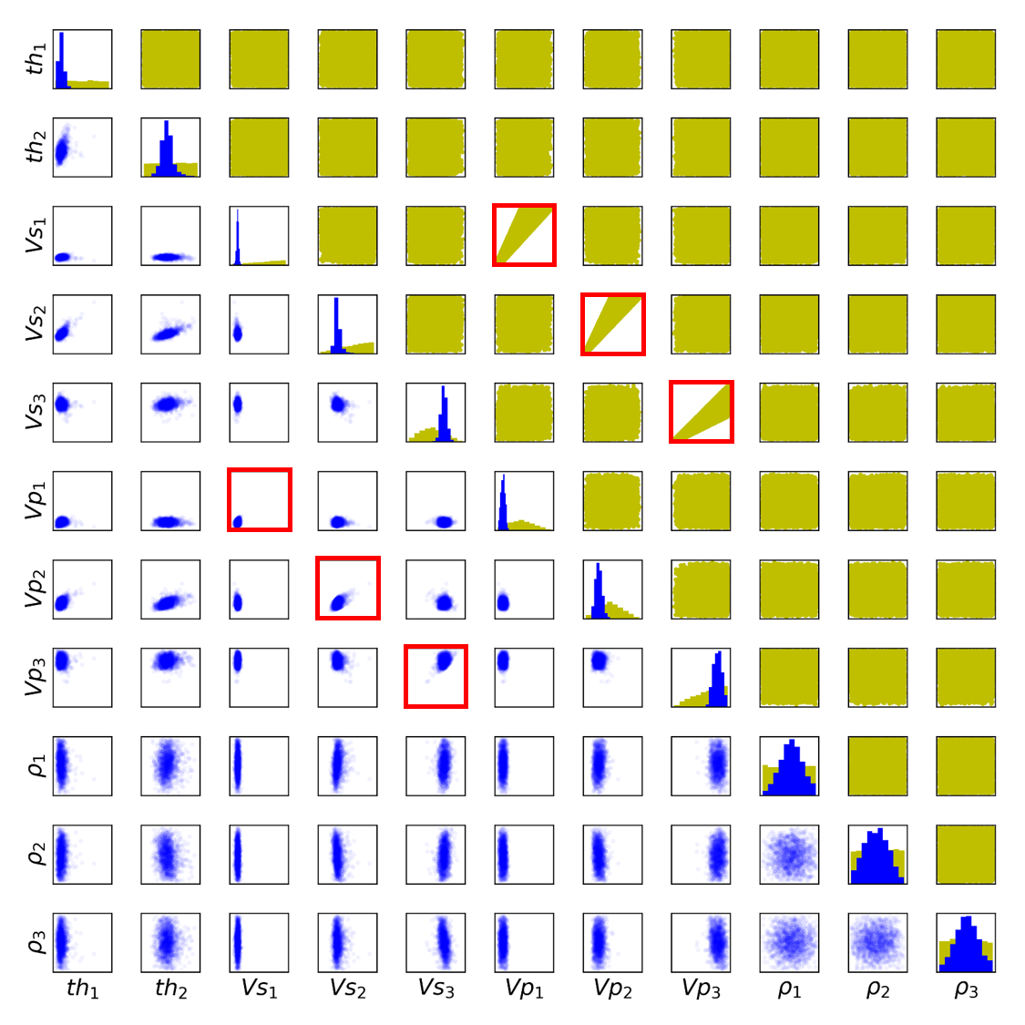
Figure 10. Results from BEL1D, IPR and rejection sampling applied to the Mirandola dataset. The prior models sampled from the prior model space are presented in yellow and the posterior models from the estimated posterior model space are shown in blue. The subplots presenting a light correlation between $V_{s}$ and $V_{p}$ are highlighted by red rectangles. This correlation is mainly due to the Poisson’s coefficient that limits the ranges of possible values in the prior.
We can further validate our approach by comparing the depth to the bedrock measured in drilling cores (Garofalo et al., 2016b) to the estimated depth from the proposed numerical process. This comparison is presented in Figure 11. There, we observe that our mean estimation is slightly underestimating the actual depth. Nonetheless, the measured depth is close to the mean and still in a high probability area of our estimated posterior. The relatively large uncertainty is related to the lack of constraints on the bedrock in the dispersion curve. In this figure, we illustrate once again the need for IPR to better constrain the posterior model space as only running BEL1D and rejection sampling results in a quasi-negligible uncertainty reduction.
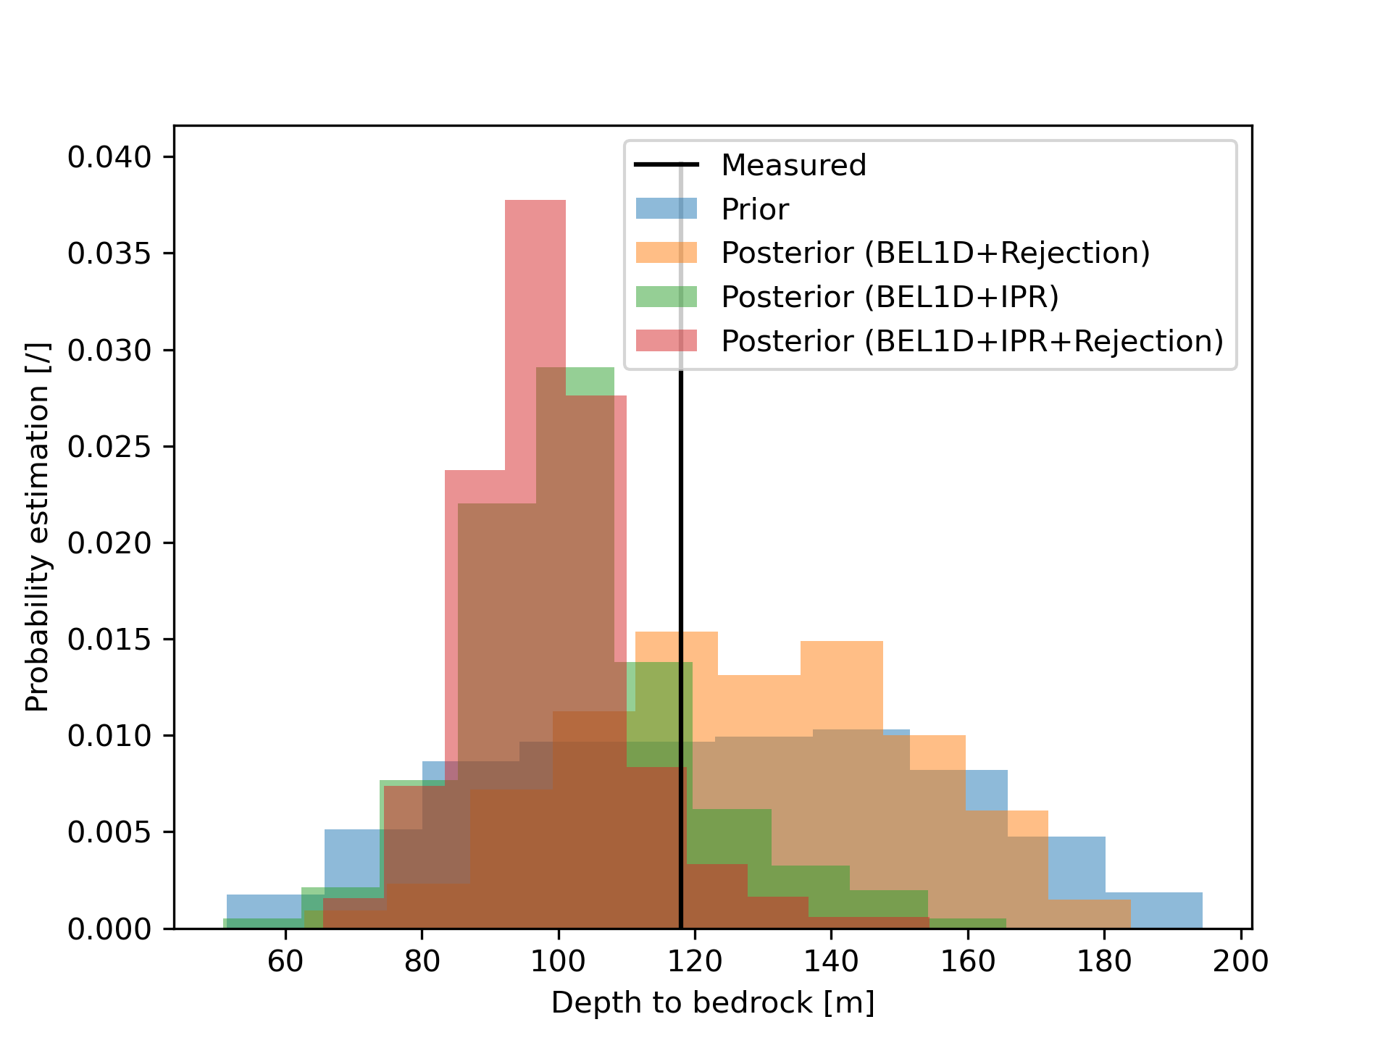
Figure 11. Estimation of the depth to the bedrock from BEL1D with IPR (and rejection). The actual measured depth is displayed in black above the histograms.

5. Conclusions
In this paper, we introduce an iterative process and rejection sampler to improve results from Bayesian Evidential Learning 1D imaging (BEL1D). This process is a combination of a first iterative step called Iterative Prior Resampling (IPR), aiming at establishing statistically representative relationships between model parameters and datasets, and a final rejection sampling test allowing to remove models not fitting the data from the posterior. Although using IPR deviates from the theoretical basis underlying Bayes rule, we show empirically that this addition to BEL1D leads to an improved quantification of the uncertainty. Our results indicate that we obtain posterior estimates from the modified IPR priors that are similar to ones obtained through McMC using the original prior.
We validate the method using dispersion curves obtained from surface waves analysis, both for a synthetic case and for an already documented field case (Mirandola, see Garofalo et al., 2016). Contrary to previous applications where the prior was relatively simple and informative (fewer parameters, low ranges of prior uncertainty and absence of insensitive parameters), here, the use of IPR was required to provide a satisfactory posterior estimation. This is most likely due to the low sensitivity to multiple parameters from the inverse problem (namely the compression wave velocities and the densities – Xia et al., 1999) that highly impair the ability to reduce the uncertainty through BEL1D.
The benchmark with synthetic models shows that the method evolves towards the posterior model space as estimated by a McMC algorithm. While still slightly overestimating the posterior uncertainty, the combination of BEL1D, IPR and rejection sampling approach seems the best compromise to reach the convergence at a limited computational cost.
The application to the field dataset validates the approach on a more complex case. In this example, we show that we are capable of retrieving a set of models that is coherent with results obtained by different experts and algorithms. We also show that our results are validated against in-situ field measurements for the depth to the bedrock and for prior distribution with related parameters. Note that in both cases, the resulting distributions are not multimodal. The behavior of BEL1D combined with IPR on multimodal distributions remains to be explored, although previous application of BEL to other data types has shown that multimodal distributions can be recovered (Hermans et al., 2019).
On the prior design for 1D imaging, we show that, even though using more layers is less time-efficient, priors with a large number of layers converge to a simpler posterior model. This shows that even though prior uncertainty might still be large, using a large number of layers remains a feasible approach. Another approach that could be applied but is not explored here is coupling BEL1D with a regularized smoothed inversion, or a blocky inversion, to have a first idea of the subsurface configuration and gather the supposed number of layers from these results. This approach is less automated and therefore requires a deeper knowledge of the inversion algorithm as regularization can lead to very smooth models where layers might be difficult to extract.
In the proposed approach, the rejection sampling step is computationally very efficient since the likelihood is readily available, and allows to retrieve posterior distributions similar to the one from a McMC algorithm, with a 95% gain in computational time. This gain is explained by the limited number of models required to learn a meaningful statistical relationship between the models and the data and the full parallelization of the forward. This contrasts with even the most advanced McMC algorithm that are still limited to parallelizing at most the number of chains, since the knowledge of the previous model is required to calculate the next models to test. As an alternative, using the posterior from BEL1D combined with IPR as the prior for a McMC approach results in faster convergence of the McMC algorithm for similar results. This later approach, even though more computationally intensive than the rejection sampling option, leads to the most precise and accurate approximation of the posterior with a significant computational gain (75%) compared to a standard McMC approach.
The algorithm released with this paper can be run for any data type as long as a forward model is provided and should lead towards real-time predictions of 1D models of the subsurface provided an adequate training phase of the algorithm.
Acknowledgments
The authors would like to thank Professor Sebastino Foti and Frederico Passeri for providing the dispersion curves from the INTERPacific project. Hadrien Michel is a fellow funded by the F.R.S.-FNRS.

Data availability
Version 1.1.0 of pyBEL1D used for all the BEL1D, IPR and rejection sampling computations as well as to produce the figures presented in this paper is preserved at https://doi.org/10.5281/zenodo.5717814, openly available under the BSD-2-clause license (Michel, 2022).
The datasets used in this paper are also available at the same location.

References
Ahmed, A., Michel, H., Deleersnyder, W., Dudal, D., & Hermans, T. (2021). Applying BEL1D for transient electromagnetic sounding inversion. EGU General Assembly. https://doi.org/10.5194/egusphere-egu21-1131
Aleardi, M., & Stucchi, E. (2021). A hybrid residual neural network-Monte Carlo approach to invert surface wave dispersion data. Near Surface Geophysics, 19, 397–414. https://doi.org/10.1002/nsg.12163
Ardizzone, L., Kruse, J., Wirkert, S., Rahner, D., Pellegrini, E. W., Klessen, R. S., Maier-Hein, L., Rother, C., & Köthe, U. (2019). Analyzing Inverse Problems with Invertible Neural Networks. ArXiv.
Aster, R. C., Borchers, B., & Thurber, C. H. (2013). Parameter estimation and inverse problems. Parameter Estimation and Inverse Problems, 1–404.
Bishop, C. M. (1994). Mixture Density Networks.
Boaga, J., Vignoli, G., & Cassiani, G. (2011). Shear wave profiles from surface wave inversion: the impact of uncertainty on seismic site response analysis. Journal of Geophysics and Engineering, 8(2), 162–174. https://doi.org/10.1088/1742-2132/8/2/004
Cercato, M. (2009). Addressing non-uniqueness in linearized multichannel surface wave inversion. Geophysical Prospecting, 57, 27–47. https://doi.org/10.1111/j.1365-2478.2007.00719.x
Clapp, R. G., Biondi, B., & Claerbout, J. F. (2004). Incorporating geologic information into reflection tomography. GEOPHYSICS, 69(2), 533–546. https://doi.org/10.1190/1.1707073
Cockett, R., Kang, S., Heagy, L. J., Pidlisecky, A., & Oldenburg, D. W. (2015). SimPEG: An open source framework for simulation and gradient based parameter estimation in geophysical applications. Computers & Geosciences, 85, 142–154. https://doi.org/10.1016/J.CAGEO.2015.09.015
Cox, B. R., & Teague, D. P. (2016). Layering ratios: a systematic approach to the inversion of surface wave data in the absence of a priori information. Geophysical Journal International, 207(1), 422–438. https://doi.org/10.1093/GJI/GGW282
Dal Moro, G., Pipan, M., & Gabrielli, P. (2007). Rayleigh wave dispersion curve inversion via genetic algorithms and Marginal Posterior Probability Density estimation. Journal of Applied Geophysics, 61(1), 39–55. https://doi.org/10.1016/J.JAPPGEO.2006.04.002
Devilee, R. J. R., Curtis, A., & Roy-Chowdhury, K. (1999). An efficient, probabilistic neural network approach to solving inverse problems’ Inverting surface wave velocities for Eurasian crustal thickness. JOURNAL OF GEOPHYSICAL RESEARCH, 104(BI2), 841–869. https://doi.org/10.1029/1999JB900273
Dosne, A.-G., Bergstrand, M., Harling, K., & Karlsson, M. O. (2016). Improving the estimation of parameter uncertainty distributions in nonlinear mixed effects models using sampling importance resampling. Journal of Pharmacokinetics and Pharmacodynamics 2016 43:6, 43(6), 583–596. https://doi.org/10.1007/S10928-016-9487-8
Garofalo, F., Foti, S., Hollender, F., Bard, P. Y., Cornou, C., Cox, B. R., Ohrnberger, M., Sicilia, D., Asten, M., di Giulio, G., Forbriger, T., Guillier, B., Hayashi, K., Martin, A., Matsushima, S., Mercerat, D., Poggi, V., & Yamanaka, H. (2016a). InterPACIFIC project: Comparison of invasive and non-invasive methods for seismic site characterization. Part I: Intra-comparison of surface wave methods. Soil Dynamics and Earthquake Engineering, 82, 222–240. https://doi.org/10.1016/J.SOILDYN.2015.12.010
Garofalo, F., Foti, S., Hollender, F., Bard, P. Y., Cornou, C., Cox, B. R., Dechamp, A., Ohrnberger, M., Perron, V., Sicilia, D., Teague, D., & Vergniault, C. (2016b). InterPACIFIC project: Comparison of invasive and non-invasive methods for seismic site characterization. Part II: Inter-comparison between surface-wave and borehole methods. Soil Dynamics and Earthquake Engineering, 82, 241–254. https://doi.org/10.1016/J.SOILDYN.2015.12.009
Gucunski, N., & Krstic, V. (1996). Backcalculation of Pavement Profiles from Spectral-Analysis-of-Surface-Waves Test by Neural Networks Using Individual Receiver Spacing Approach. Transportation Research Record, 1526, 6–13.
Hermans, T., Lesparre, N., Schepper, G. de, & Robert, T. (2019). Bayesian evidential learning: a field validation using push-pull tests. Hydrogeology Journal 2019 27:5, 27(5), 1661–1672. https://doi.org/10.1007/S10040-019-01962-9
Hermans, T., Nguyen, F., Klepikova, M., Dassargues, A., & Caers, J. (2018). Uncertainty Quantification of Medium-Term Heat Storage From Short-Term Geophysical Experiments Using Bayesian Evidential Learning. Water Resources Research, 54(4), 2931–2948. https://doi.org/10.1002/2017WR022135
Herrmann, R. B. (2013). Computer Programs in Seismology: An Evolving Tool for Instruction and Research. Seismological Research Letters, 84(6), 1081–1088. https://doi.org/10.1785/0220110096
Irving, J., & Singha, K. (2010). Stochastic inversion of tracer test and electrical geophysical data to estimate hydraulic conductivities. Water Resources Research, 46(11), 11514. https://doi.org/10.1029/2009WR008340
Jeong, C., Mukerji, T., & Mariethoz, G. (2017). A Fast Approximation for Seismic Inverse Modeling: Adaptive Spatial Resampling. Mathematical Geosciences 2017 49:7, 49(7), 845–869. https://doi.org/10.1007/S11004-017-9693-Y
Kim, Y., & Nakata, N. (2018). Geophysical inversion versus machine learning in inverse problems. The Leading Edge, 37(12), 894–901. https://doi.org/10.1190/TLE37120894.1
Lai, C. G., Foti, S., & Rix, G. J. (2005). Propagation of Data Uncertainty in Surface Wave Inversion. Journal of Environmental and Engineering Geophysics, 10(2), 219–228.
Laloy, E., Hérault, R., Jacques, D., & Linde, N. (2018). Training-Image Based Geostatistical Inversion Using a Spatial Generative Adversarial Neural Network. Water Resources Research, 54(1), 381–406. https://doi.org/10.1002/2017WR022148
Linde, N., Ginsbourger, D., Irving, J., Nobile, F., & Doucet, A. (2017). On uncertainty quantification in hydrogeology and hydrogeophysics. Advances in Water Resources, 110, 166–181. https://doi.org/10.1016/J.ADVWATRES.2017.10.014
Loke, M. H., Acworth, I., & Dahlin, T. (2003). A comparison of smooth and blocky inversion methods in 2D electrical imaging surveys. Exploration Geophysics, 34(3), 182–187. https://doi.org/10.1071/EG03182
Mariethoz, G., Renard, P., & Caers, J. (2010). Bayesian inverse problem and optimization with iterative spatial resampling. Water Resources Research, 46(11), 11530. https://doi.org/10.1029/2010WR009274
Meier, R., & Rix, G. (1993). An Initial Study of Surface Wave Inversion Using Artificial Neural Networks. Geotechnical Testing Journal, 16(4), 425–431. https://doi.org/10.1520/GTJ10282J
Meier, U., Curtis, A., & Trampert, J. (2007). Global crustal thickness from neural network inversion of surface wave data. Geophysical Journal International, 169(2), 706–722. https://doi.org/10.1111/J.1365-246X.2007.03373.X
Michaels, P., & Smith, R. B. (1997). Surface Wave Inversion by Neural Networks (Radial Basis Functions) for Engineering Applications. Journal of Environmental and Engineering Geophysics, 2(1), 65–76.
Michel, H. (2022). pyBEL1D - a Python implementation of BEL1D (Version 1.1.0) [Computer software]. https://doi.org/10.5281/zenodo.6833249
Michel, H., Hermans, T., Kremer, T., & Nguyen, F. (2020). Improving BEL1D accuracy for geophysical imaging of the subsurface. SEG Technical Program Expanded Abstracts, 3562–3566. https://doi.org/10.1190/SEGAM2020-3426204.1
Michel, H., Nguyen, F., Kremer, T., Elen, A., & Hermans, T. (2020). 1D geological imaging of the subsurface from geophysical data with Bayesian Evidential Learning. Computers and Geosciences, 138. https://doi.org/10.1016/j.cageo.2020.104456
Mitu, S. M., Rahman, N. Abd., Nayan, K. A. M., Zulkifley, M. A., & Rosyidi, S. A. P. (2021). Implementation of Machine Learning Algorithms in Spectral Analysis of Surface Waves (SASW) Inversion. Applied Sciences 2021, Vol. 11, Page 2557, 11(6), 2557. https://doi.org/10.3390/APP11062557
Moss, R. E. S. (2008). Quantifying Measurement Uncertainty of Thirty-Meter Shear-Wave Velocity Quantifying Measurement Uncertainty of Thirty-Meter Shear-Wave Velocity. Bulletin of the Seismological Society of America, 98(3), 1399–1411. https://doi.org/10.1785/0120070101
Park, C. B., Miller, R. D., & Xia, J. (1999). Multichannel analysis of surface waves. GEOPHYSICS, 64(3).
Park, J., & Caers, J. (2020). Direct forecasting of global and spatial model parameters from dynamic data. Computers and Geosciences, 143. https://doi.org/10.1016/J.CAGEO.2020.104567
Press, F. (1968). Earth models obtained by Monte Carlo Inversion. Journal of Geophysical Research, 73(16), 5223–5234. https://doi.org/10.1029/JB073I016P05223
Rücker, C., Günther, T., & Wagner, F. M. (2017). pyGIMLi: An open-source library for modelling and inversion in geophysics. Computers & Geosciences, 109, 106–123. https://doi.org/10.1016/J.CAGEO.2017.07.011
Russell, B. (2019). Machine learning and geophysical inversion — A numerical study. The Leading Edge, 38(7), 512–519. https://doi.org/10.1190/TLE38070512.1
Ryden, N., & Park, C. B. (2006). Fast simulated annealing inversion of surface waves on pavement using phase-velocity spectra. Geophysics, 71(4), R49–R58. https://doi.org/10.1190/1.2204964
Sambridge, M. (1999a). Geophysical inversion with a neighbourhood algorithm—I. Searching a parameter space. Geophysical Journal International, 138(2), 479–494. https://doi.org/10.1046/J.1365-246X.1999.00876.X
Sambridge, M. (1999b). Geophysical inversion with a neighbourhood algorithm—II. Appraising the ensemble. Geophysical Journal International, 138(3), 727–746. https://doi.org/10.1046/J.1365-246X.1999.00900.X
Sambridge, M., & Mosegaard, K. (2002). MONTE CARLO METHODS IN GEOPHYSICAL INVERSE PROBLEMS. Reviews of Geophysics, 40(3), 3–1. https://doi.org/10.1029/2000RG000089
Satija, A., & Caers, J. (2015). Direct forecasting of subsurface flow response from non-linear dynamic data by linear least-squares in canonical functional principal component space. Advances in Water Resources, 77, 69–81. https://doi.org/10.1016/j.advwatres.2015.01.002
Satija, A., Scheidt, C., Li, L., & Caers, J. (2017). Direct forecasting of reservoir performance using production data without history matching. Computational Geosciences 2017 21:2, 21(2), 315–333. https://doi.org/10.1007/S10596-017-9614-7
Scheidt, C., Li, L., & Caers, J. (2018). Quantifying Uncertainty in Subsurface Systems. 182, 215. https://doi.org/10.1002/9781119325888
Socco, L. V., & Boiero, D. (2008). Improved Monte Carlo inversion of surface wave data. Geophysical Prospecting, 56(3), 357–371. https://doi.org/10.1111/J.1365-2478.2007.00678.X
Socco, L. V., Foti, S., & Boiero, D. (2010). Surface-wave analysis for building near-surface velocity models-Established approaches and new perspectives. https://doi.org/10.1190/1.3479491
Tarantola, Albert. (2005). Inverse problem theory and methods for model parameter estimation. Society for Industrial and Applied Mathematics.
Thibaut, R., Laloy, E., & Hermans, T. (2021). A new framework for experimental design using Bayesian Evidential Learning: The case of wellhead protection area. Journal of Hydrology, 603, 126903. https://doi.org/10.1016/J.JHYDROL.2021.126903
Thas, O. (2010). Comparing Distributions. https://doi.org/10.1007/978-0-387-92710-7
Vrugt, J. A. (2016). Markov chain Monte Carlo simulation using the DREAM software package: Theory, concepts, and MATLAB implementation. Environmental Modelling & Software, 75, 273–316. https://doi.org/10.1016/J.ENVSOFT.2015.08.013
Wathelet, M., Jongmans, D., & Ohrnberger, M. (2005). Direct Inversion of Spatial Autocorrelation Curves with the Neighborhood Algorithm. Bulletin of the Seismological Society of America, 95(5), 1787–1800. https://doi.org/10.1785/0120040220
Wathelet, M. (2008). An improved neighborhood algorithm: Parameter conditions and dynamic scaling. Geophysical Research Letters, 35(9), 9301. https://doi.org/10.1029/2008GL033256
Williams, T., & Gucunski, N. (1995). Neural Networks For Backcalculation Of Moduli From SASW Test. Journal on Computing in Civil Engineering, 9(1), 1–8.
Xia, J., Miller, R. D., & Park, C. B. (1999). Estimation of near‐surface shear‐wave velocity by inversion of Rayleigh waves. Https://Doi.Org/10.1190/1.1444578, 64(3). https://doi.org/10.1190/1.1444578
Yablokov, A. v, Serdyukov, A. S., Loginov, G. N., & Baranov, V. D. (2021). An artificial neural network approach for the inversion of surface wave dispersion curves. Geophysical Prospecting, 69, 1405–1432. https://doi.org/10.1111/1365-2478.13107
Zhang, X., & Curtis, A. (2021). Bayesian geophysical inversion using invertible neural networks. Journal of Geophysical Research: Solid Earth. https://doi.org/10.1029/2021JB022320
Zou, C., Zhao, L., Xu, M., Chen, Y., & Geng, J. (2021). Porosity Prediction With Uncertainty Quantification From Multiple Seismic Attributes Using Random Forest. Journal of Geophysical Research: Solid Earth, 126(7). https://doi.org/10.1029/2021JB021826

