Supplementary material for “Jupiter’s low-altitude auroral zones: Fields, particles, plasma waves, and density depletions”
A. H. Sulaiman,¹ B. H. Mauk,² J. R. Szalay,³ F. Allegrini,^{4,5} G. Clark,² G. R. Gladstone,^{4,5} S. Kotsiaros,⁶ W. S. Kurth,¹ F. Bagenal,⁷ B. Bonfond,⁸ J. E. P. Connerney,^{9,10} R. W. Ebert,^{4,5} S. S. Elliott,¹¹ D. J. Gershman,¹⁰ G. B. Hospodarsky,¹ V. Hue,⁴ R. L. Lysak,¹¹ A. Masters,¹² O. Santolík,^{13,14} J. Saur,¹⁵ S. J. Bolton⁴
Corresponding author: A.H. Sulaiman, Department of Physics and Astronomy, University of Iowa, Iowa City, Iowa, USA. (ali-sulaiman@uiowa.edu)
¹Department of Physics and Astronomy, University of Iowa, Iowa City, IA, USA
²Johns Hopkins University, Applied Physics Laboratory, Laurel, MD, USA
³Department of Astrophysical Sciences, Princeton University, Princeton, NJ, USA
⁴Southwest Research Institute, San Antonio, TX, USA
⁵Department of Physics and Astronomy, University of Texas at San Antonio, San Antonio, TX, USA
⁶DTU-Space, Technical University of Denmark, Kongens Lyngby, Denmark
⁷Laboratory for Atmospheric and Space Physics, University of Colorado Boulder, Boulder, CO, USA
⁸Space Sciences, Technologies and Astrophysics Research Institute, LPAP, Université de Liège, Liège, Belgium
⁹Space Research Corporation, Annapolis, MD, USA
¹⁰NASA/Goddard Space Flight Center, Greenbelt, Maryland, USA
¹¹Minnetota Institute for Astrophysics, School of Physics and Astronomy, University of Minnesota, Minneapolis, MN, USA
¹²Blackett Laboratory, Imperial College London, London, UK
¹³Department of Space Physics, Institute of Atmospheric Physics of the Czech Academy of Sciences, Prague, Czechia
¹⁴Faculty of Mathematics and Physics, Charles University, Prague, Czechia
¹⁵Institute of Geophysics and Meteorology, University of Cologne, Cologne, Germany

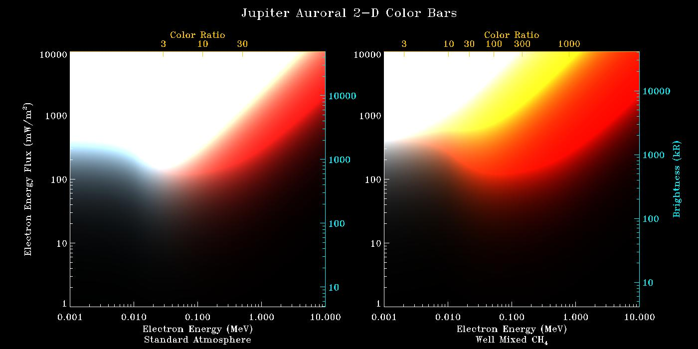
Figure S1 - The false-color UVS maps shown in this paper may interpreted (to first order) using these two-dimensional color bars, which show the expected false color as a function of mean precipitating electron energy (related to color ratio) and precipitating energy flux (related to brightness). The auroral brightness and color depend on the atmosphere structure and composition, which is effectively unknown for Jupiter’s auroral regions. The left color bar assumes the Model C upper atmosphere model of Moses et al. (2005), modified for polar region gravity, while the right color bar assumes the same atmosphere, except with methane well-mixed throughout (i.e., no methane homopause). The color bars assume a continuous slow-down approximation to estimate the volume emission rate due to precipitating mono-energetic electrons, similar to the description used by Gustin et al. (2016), distributed isotropically over the downward hemisphere. These color bars are not meant to be definitive, but merely to indicate rough values expected for the precipitating electron energy flux and mean energy associated with particular locations in the UVS false-color maps.

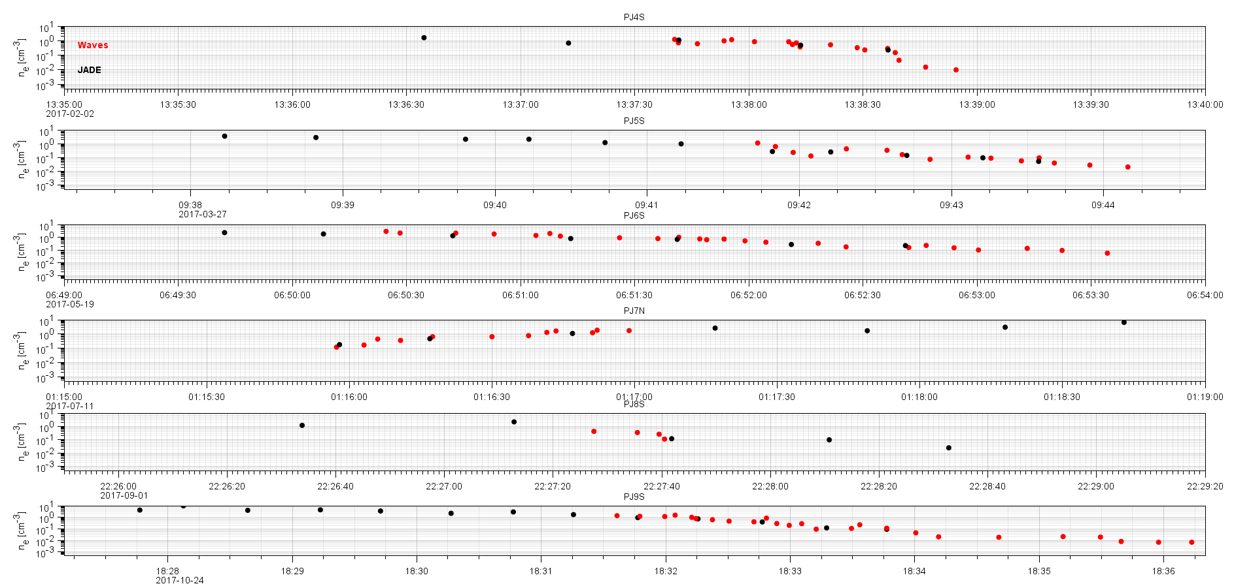
Figure S2 – Time-series of electron number densities: (red) inferred from the O-mode lower frequency cutoff by Waves and (black) measured electron partial densities by JADE. Five examples of auroral passes are presented where overlaps are present.

References:
Gustin, J., D. Grodent, L. C. Ray, B. Bonfond, E. J. Bunce, J. D. Nichols, and N. Ozak, Characteristics of north Jovian aurora from STIS FUV spectral images, Icarus, 268, 215-241, 2016.

Moses, J. I., T. Fouchet, B. Bézard, G. R. Gladstone, E. Lellouch, and H. Feuchtgruber, Photochemistry and Diffusion in Jupiter's Stratosphere: Constraints from ISO Observations and Comparisons with other Giant Planets, J. Geophys. Res., 110, E08001, 10.1029/2005JE002411, 2005.

