Numerical Simulation of Gas Migration in the Nuclear Waste Repository

Abhishek Rawat^{* 1}, arawat@uliege.be
Gilles Corman¹, Gilles.Corman@uliege.be
Adriana Quacquarelli¹, Adriana.Quacquarelli@uliege.be
Frédéric Collin, f.collin@uliege.be

1 : Department of Civil and Environmental Engineering, Université de Liège, Belgium

Abstract:

Within the framework of the European Joint Research Program on radioactive waste management, the conceptualization and evaluation of gas migration at the scale of a nuclear waste repository is presented. Considering the mechanism of gas generation over the lifespan of a waste repository, the simulation incorporates the time scale of 100,000 years over a space scale of several hundred meters. However, to ease the meshing and to reduce the calculation time, geometrical representations have been simplified into a 2D plane strain model compared to the original complexity in the field as shown in Figure 1. The model includes the different elements of reference disposal concepts adopted by ONDRAF (Zone B) from Belgium and ANDRA (Zone C) from France. Three different mechanical models (linear elastic model, elastoplastic model and a second gradient H²M model) were used along with the generalized Darcy’s law, Flick’s law and Henry’s law to simulate the advective visco-capillary two-phase flow and diffusive gas flow through porous media. Further, the Van-Genuchten retention curves formulations considering explicit gas entry pressure along with the relative permeability functions were used in the simulation of advective two-phase flow. The source terms for temperature and gas from the users (ONDRAF and ANDRA) were used to calculate the equivalent thermal/gas flow rates. The simulation results in terms of evolution of pore water pressure, gas pressure, water saturation, temperature, and the changes in the stress distribution at different locations are obtained for evaluating the impact of gas on the thermo-hydro-mechanical transient processes. In the thermal analysis, the evolution of temperature at different locations in Zone B are shown in Figure 2a. The temperature rises in canister overpack, concrete buffer, concrete backfill and concrete liner to 150 °C, 138 °C, 120 °C and 110 °C, respectively. However, the temperature in the inner EDZ rises to 80 °C. Figure 2b presents the modification of temperature gradients along the central line (T-4-B) at different timescales in Zone B. Whereas in Zone C, the temperature rises to 120 °C in waste package, air void, and in the steel liner (Fig. 3a). The heat from waste package modifies the temperature distribution along the depth. Figure 3b presents the modification of temperature gradients along the central line (T-4-B) at different timescales in Zone C. The temperature at the middle of host rock (label 4) reaches to 55 °C in 650 years.

Acknowledgment:

The authors are grateful for financial supports from EURAD, the European Joint Programme on Radioactive Waste Management (under grant agreement No 847593).

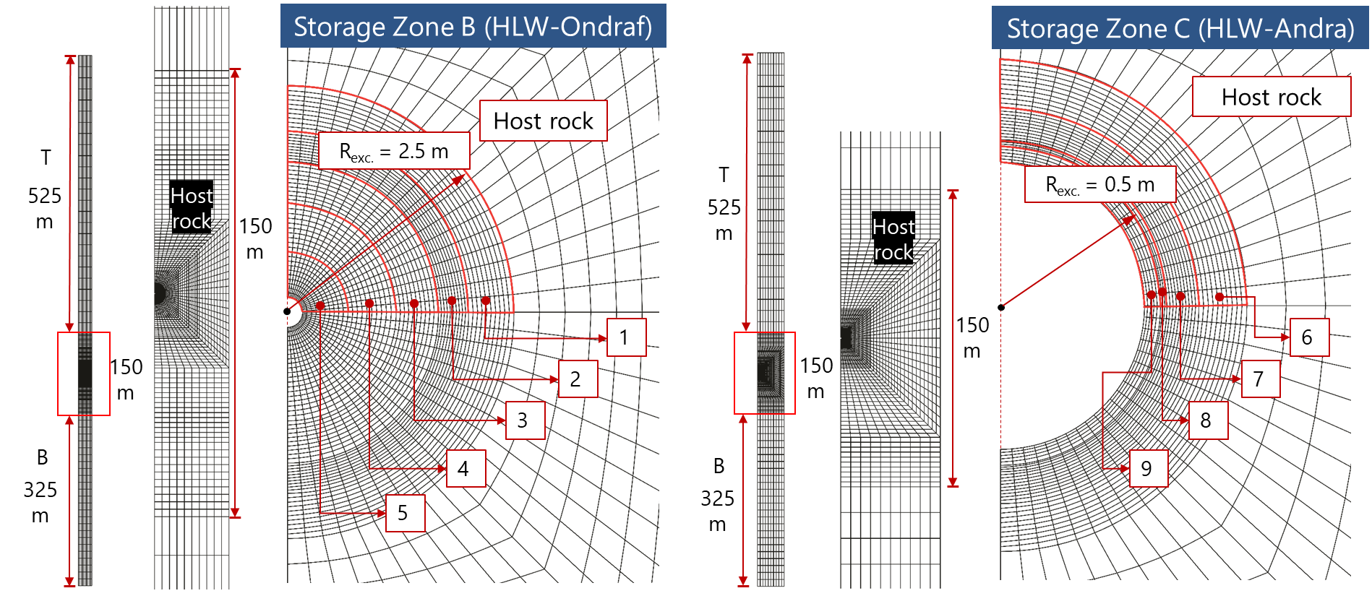

Figure 1: Finite Element Mesh and geometrical features (T = Top/Upper aquifer, B = Bottom aquifer; In storage Zone B: 1 = Outer EDZ, 2 = Inner EDZ, 3 = Concrete liner, 4 = Cementitious backfill, 5 = Concrete buffer; In storage Zone C: 6 = Outer EDZ, 7 = Inner EDZ, 8 = Steel liner, 9 = Void)
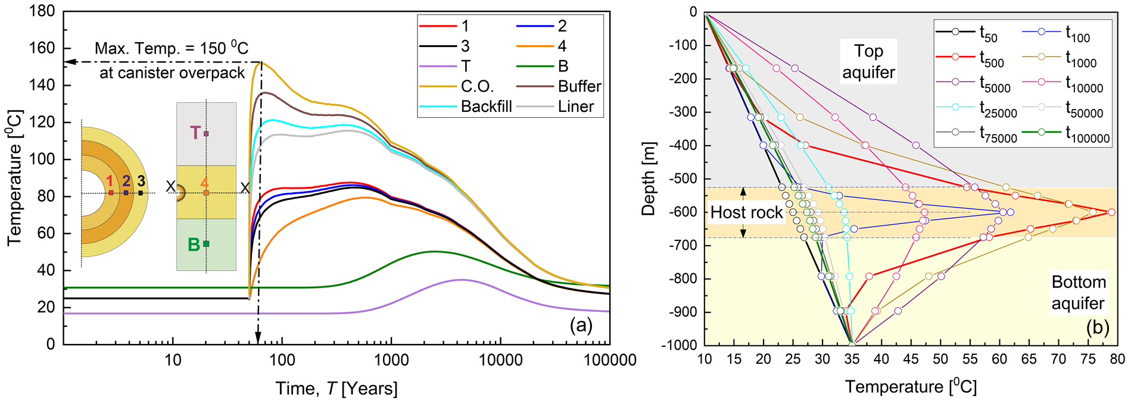
Figure 2: Evolution of temperature in the thermal analysis of Zone B, (a) at different locations, and (b) along the Y-axis
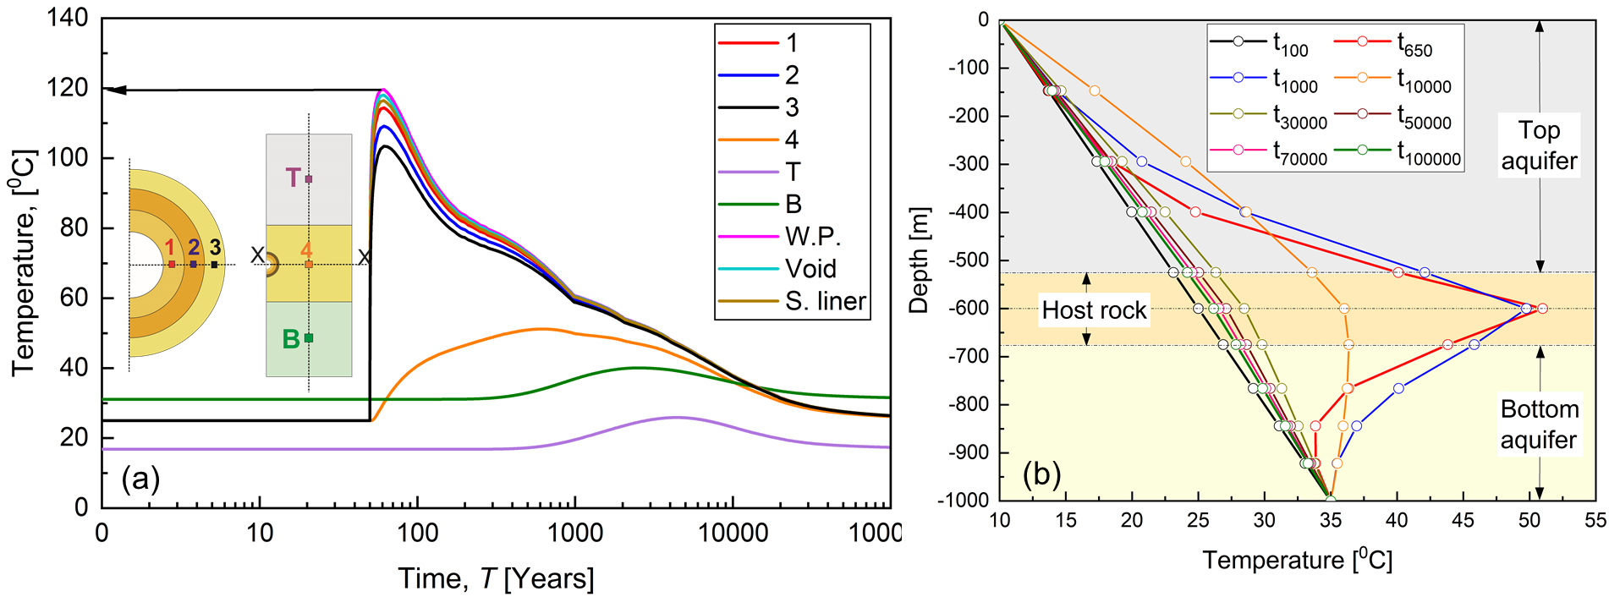
Figure 3: Evolution of temperature in the thermal analysis of Zone C, (a) at different locations, and (b) along the Y-axis

