ELECTRONIC SUPPLEMENTARY MATERIAL FOR:

Not a jaguar after all? Phylogenetic affinities and morphology of Panthera gombaszoegensis

Narimane Chatar^{1,*}, Margot Michaud², Valentin Fischer¹

¹ Evolution and Diversity Dynamics Lab, Université de Liège, Belgium
² Department of African Zoology, Royal Museum for Central Africa, Tervuren, Belgium
* Corresponding author: narimane.chatar@uliege.be

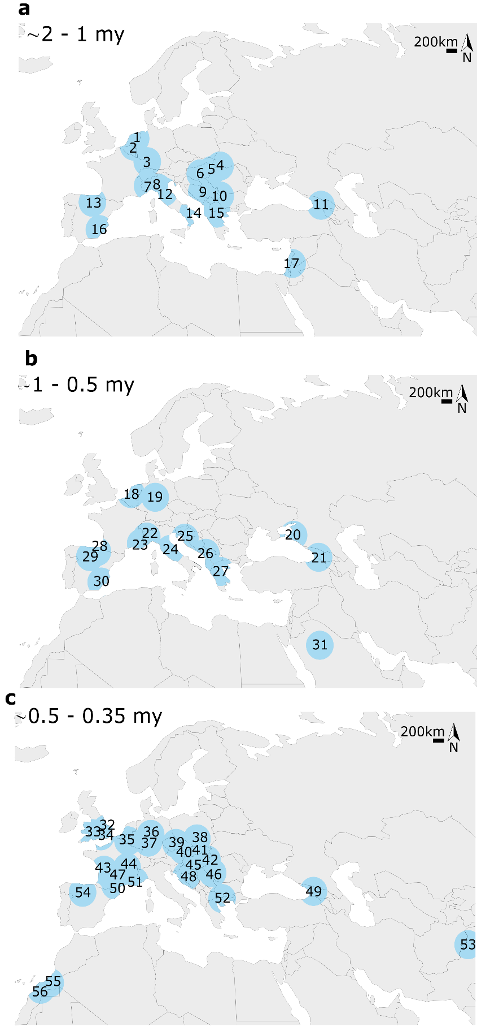
Figure S1: Evolution of the geographical distribution of Panthera gombaszoegensis through time (a, b and c). Blue regions represent a circle of 500km in diameter around each occurrence. For P. gombaszoegensis the list of sites with name, geological period and references associated is provided in Table S1.

Table S1: List of sites with name, geological period and references associated with Figure S1.
 | # |  | Site | age | References
1 |  | Tegelen |  | ∼2 - 1 my |  | O’Regan, H.J., Turner, A., 2004. Biostratigraphic and palaeoecological implications of new fossil felid material from the Plio-Pleistocene site of Tegelen, The Netherlands. Palaeontology 47, 1181–1193. https://doi.org/10.1111/j.0031-0239.2004.00400.x
2 |  | Langenboom |  | ∼2 - 1 my |  | Mol, D., Logchem, W. Van, Vos, J. De, 2011. New record of the European jaguar, Panthera onca gombaszoegensis (Kretzoi, 1938), from the Plio-Pleistocene of Langenboom (The Netherlands). Cainozoic Res. 8, 35–40.
3 |  | Erpfingen |  | ∼2 - 1 my |  | Lehmann, U., 1957. Weitere Fossilfunde aus dem ältesten Pleistozän der Erpfinger Höhle (Schwäbische Alb.). Mitt. Geol. Staatsinst. Hambg. 26, 60–99.
4 |  | Betfia VII-1, Betfia XIII, 13 |  | ∼2 - 1 my |  | Terzea, E., 1996. Biochronology of the Pleistocene deposits at Betfia (Bihor, Romania). Acta Zool. Cracoviensia 39, 531–540.
5 |  | Villany 3, Villany 5 |  | ∼2 - 1 my |  | Jánossy, D., 1986. Pleistocene vertebrate faunas of Hungary., Pleistocene vertebrate faunas of Hungary. Elsevier, Amsterdam.
6 |  | Kislang |  | ∼2 - 1 my |  | Jánossy, D., 1986. Pleistocene vertebrate faunas of Hungary., Pleistocene vertebrate faunas of Hungary. Elsevier, Amsterdam.
7 |  | Villa Spinola |  | ∼2 - 1 my |  | Argenti, P., Sardella, R., 2003. Early Pleistocene large mammals from Villa Spinola (Perugia, Central Italy). Bollettino-Societa Paleontol. Ital. 42, 315–322.
8 |  | Olivola, Valdarno |  | ∼2 - 1 my |  | Ficcarelli, G., & Torre, D. (1968). Upper Villafranchian panthers of Tuscany. Palaeontolographia Italica 64, 173-184.
9 |  | Strmica |  | ∼2 - 1 my |  | Malez, M., 1986. Die quartaÈren Vertebraten-faunen in der SFR Jugoslawien. Quartärpaläontologie 6, 101–117.
10 |  | Slivnitsa |  | ∼2 - 1 my |  | Spassov, N., 1998. Slivnitsa: a new bulgarian late villafranchian locality of vertebrate fauna and the mammalian dispersal events in Europe on the Pliocene/Pleistocene boundary. Biogeographia 19. https://doi.org/10.21426/b6110166
11 |  | Dmanisi |  | ∼2 - 1 my |  | Hemmer, H., Kahlke, R.-D., Vekua, A.K., 2010. Panthera onca georgica ssp. nov. from the Early Pleistocene of Dmanisi (Republic of Georgia) and the phylogeography of jaguars (Mammalia, Carnivora, Felidae). Neues Jahrb. fur Geol. und Palaontologie - Abhandlungen 257, 115–127. https://doi.org/10.1127/0077-7749/2010/0067
12 |  | Pantalla |  | ∼2 - 1 my |  | Gentili, S., Ambrosetti, P., Argenti, P., 1997. Large carnivores and other mammal fossils from the early alluvial plain of the Tiberino Basin (Pantalla, Central Italy). Preliminary reports. Boll. della Soc. Paleontol. Ital. 36, 233–240.
13 |  | Sima del Elefante |  | ∼2 - 1 my |  | Van Der Made, J., 2013. First description of the large mammals from the locality of Penal, and updated faunal lists for the Atapuerca ungulates e Equus altidens, Bison and human dispersal into Western Europe. Quat. Int. 295, 36–47. https://doi.org/10.1016/j.quaint.2012.03.001
14 |  | Pirro Nord |  | ∼2 - 1 my |  | de Beaumont, G., 1979. Note sur quelques carnivores (Mammifères) du Quaternaire ancien de la province de Foggia (Italie). Bull. la Société vaudoise des Sci. Nat. 74, 217–226.
15 |  | Gerakarou 1, Halykes |  | ∼2 - 1 my |  | Koufos, G., 1992. The Pleistocene carnivores of the Mygdonia Basin (Macedonia, Greece). Ann. Paleontol. 78, 205–257.
16 |  | Venta Micena |  | ∼2 - 1 my |  | Palmqvist, P., Martínez-Navarro, B., Arribas, A., 1996. Prey selection by terrestrial carnivores in a lower Pleistocene paleocommunity. Paleobiology 22, 514–534. https://doi.org/10.1017/S009483730001650X
17 |  | Ubeidyia |  | ∼2 - 1 my |  | Ballesio, R., 1986. Les carnivores du gisement pléistocène d’Oubeidiyeh (Israël), in: Tchernov, E., Guérin, C. (Eds.), Les Mammifères Du Pléistocène Inférieur de La Vallée Du Jourdain à Oubeidiyeh. CNRS, Paris, pp. 63–91.
18 |  | Maasvlakte 1 |  | ∼1 - 0.5 my |  | Hemmer, H., Kahlke, R., 2005. Nachweis des Jaguars (Panthera onca gombaszoegensis) aus dem späten Unter-oder frühen Mittelpleistozän der Niederlande. Deinsea 47–57.
19 |  | Untermassfeld |  | ∼1 - 0.5 my |  | Hemmer, H., Kahlke, R.-D., Vekua, A.K., 2001. The Jaguar - Panthera onca gombaszoegensis (Kretzoi, 1938) (Carnivora: Felidae) in the late lower pleistocene of Akhalkalaki (south Georgia; Transcaucasia) and its evolutionary and ecological significance. Geobios 34, 475–486. https://doi.org/10.1016/s0016-6995(01)80011-5
20 |  | Tsymbal |  | ∼1 - 0.5 my |  | Sotnikova, M., Titov, V., 2008. Carnivora of the Tamanian faunal unit (the Azov Sea area). Quat. Int. 201, 43–52. https://doi.org/10.1016/j.quaint.2008.05.019
21 |  | Akhakalaki 1 |  | ∼1 - 0.5 my |  | Hemmer, H., Kahlke, R.-D., Vekua, A.K., 2001. The Jaguar - Panthera onca gombaszoegensis (Kretzoi, 1938) (Carnivora: Felidae) in the late lower pleistocene of Akhalkalaki (south Georgia; Transcaucasia) and its evolutionary and ecological significance. Geobios 34, 475–486. https://doi.org/10.1016/s0016-6995(01)80011-5
22 |  | Slivia |  | ∼1 - 0.5 my |  | Ambrosetti, P., Bartolomei, G., De Giuli, C., Ficcarelli, G., Torre, D., 1979. La breccia ossifera di Slivia (Aurisinia-Sistiana) nel Carso di Trieste. Boll. della Soc. Paleontol. Ital. 18, 207–220.
23 |  | Vallonnet |  | ∼1 - 0.5 my |  | Moullé, P.E., Lacombat, F., Echassoux, A., 2006. Apport des grands mammifères de la grotte du Vallonnet (Roquebrune-Cap-Martin, Alpes-Maritimes, France) à la connaissance du cadre biochronologique de la seconde moitié du Pléistocène inférieur d’Europe. Anthropologie. 110, 837–849. https://doi.org/10.1016/J.ANTHRO.2006.10.006
24 |  | Monte Peglia |  | ∼1 - 0.5 my |  | Sardella, R., 2004. The Late Villafranchian Panthera ex gr. toscana-gombaszoegensis from Monte Argentario (Grosseto, South Tuscany, Central Italy), in: Proceedings of the 18th International Senckenberg Conference. Senckenbergische Naturforschende Gesellschaft.
25 |  | Somssichhegy II |  | ∼1 - 0.5 my |  | Pazonyi, P., Virág, A., Gere, K., Botfalvai, G., Sebe, K., Szentesi, Z., Mészáros, L., Botka, D., Gasparik, M., Korecz, L., 2018. Sedimentological, taphonomical and palaeoecological aspects of the late early Pleistocene vertebrate fauna from the Somssich Hill 2 site (South Hungary). Comptes Rendus Palevol 17, 296–309. https://doi.org/10.1016/J.CRPV.2017.06.007
26 |  | Trlica |  | ∼1 - 0.5 my |  | Vislobokova, I.A., Agadjanian, A.K., 2015. New data on large mammals of the Pleistocene Trlica fauna, Montenegro, the Central Balkans. Paleontol. J. 2015 496 49, 651–667. https://doi.org/10.1134/S0031030115060143
27 |  | Volos |  | ∼1 - 0.5 my |  | Koufos, G., 2001. The Villafranchian mammalian faunas and biochronology of Greece. Boll. della Soc. Paleontol. Ital. 40, 217–223.
28 |  | Punta Lucero Quarry |  | ∼1 - 0.5 my |  | Gómez-Olivencia, A., Sala, N., Arceredillo, D., García, N., Martínez-Pillado, V., Rios-Garaizar, J., Garate, D., Solar, G., Libano, I., 2015. The Punta Lucero Quarry site (Zierbena, Bizkaia): A window into the Middle Pleistocene in the Northern Iberian Peninsula. Quat. Sci. Rev. 121, 52–74. https://doi.org/10.1016/j.quascirev.2015.05.001
29 |  | Atapuerca |  | ∼1 - 0.5 my |  | García, N., Arsuaga, J.L., 1999. Carnivores from the Early Pleistocene hominid-bearing Trinchera Dolina 6 (Sierra de Atapuerca, Spain). J. Hum. Evol. 37, 415–430. https://doi.org/10.1006/JHEV.1999.0325
30 |  | Huescar |  | ∼1 - 0.5 my |  | Mazo, A.V., Sesé, C., Ruiz Bustos, A., Peña, J.A., 1985. Geología y paleontología de los yacimientos plio-pleistocenos de Huéscar (Depresión de Guadix-Baza. Granada). Estud. Geológicos 41, 467–493.
31 |  | An Nafud |  | ∼1 - 0.5 my |  | Thomas, H., Geraads, D., Vaslet, D., Memesh, A., Billiou, D., Bocherens, H., Dobigny, G., Eisenmann, V., Gayet, M., France de Lapparent de Broin, Petter, G., Halawani, M., 1998. First Pleistocene faunas from the Arabian Peninsula: An Nafud desert, Saudi Arabia. Comptes Rendus l’Académie des Sci. - Ser. IIA - Earth Planet. Sci. 326, 145–152. https://doi.org/10.1016/s1251-8050(97)87459-9
32 |  | Pakefield |  | ∼0.5 - 0.35 my |  | Lewis, M., Pacher, M., Turner, A., 2010. The larger Carnivora of the West Runton Freshwater Bed. Quat. Int. 228, 116–135. https://doi.org/10.1016/J.QUAINT.2010.06.022
33 |  | Westbury-sub-Mendip |  | ∼0.5 - 0.35 my |  | Bishop, M.J., 1974. A preliminary report on the middle Pleistocene mammal bearing deposits of westbury-sub-mendip, somerset. . Proc. Univ. Bristol Speleol. Soc. 13, 301–318.
34 |  | Swanscombe |  | ∼0.5 - 0.35 my |  | Stuart, A.J., 1982. Pleistocene vertebrates in the British Isles. Longman Financial Service, London/New York.
35 |  | La Belle-Roche |  | ∼0.5 - 0.35 my |  | Cordy, J.-M., Bastin, B., Demaret-Fairon, M., Ek, C., Geeraerts, R., Groessens-van Dyck, M.-C., Ozer, A., Peuchot, R., Quinif, Y., Thorez, J., Ulrix-Closset, M., 1993. La grotte de la Belle-Roche (Sprimont, Province de Liège) : un gisement paléontologique et archéologique d’exception au Benelux. Bull. l’Académie R. Belgique 4, 165–186.
36 |  | Mosbach |  | ∼0.5 - 0.35 my |  | Hemmer, H., 1971. zur Charakterisierung und stratigraphischen Bedeutung von Panthera gombaszoegensis (kretzoi, 1938). Neues Jahrb. für Geol. und Paläontologie Monatshefte 12, 701–711.
37 |  | Süssenborn |  | ∼0.5 - 0.35 my |  | Kahlke, H.D., 1975. The Macro- faunas of Continental Europe during the Middle Pleistocene: Stratigraphic sequence and problems of intercorrelation, in: Butzer, K.W., Isaac, G.L. (Eds.), After the Australopithecines: Stratigraphy, Ecology and Culture Change in the Middle Pleistocene. De Gruyter Mouton, The Hague, pp. 309–374. https://doi.org/10.1515/9783110878837.309/HTML
38 |  | Bisnik Cave |  | ∼0.5 - 0.35 my |  | Marciszak, A., 2014. Presence of Panthera gombaszoegensis (Kretzoi, 1938) in the late middle pleistocene of biśnik cave, Poland, with an overview of Eurasian jaguar size variability. Quat. Int. 326–327, 105–113. https://doi.org/10.1016/j.quaint.2013.12.029
39 |  | Stránská Skála |  | ∼0.5 - 0.35 my |  | Kahlke, H.D., 1975. The Macro- faunas of Continental Europe during the Middle Pleistocene: Stratigraphic sequence and problems of intercorrelation, in: Butzer, K.W., Isaac, G.L. (Eds.), After the Australopithecines: Stratigraphy, Ecology and Culture Change in the Middle Pleistocene. De Gruyter Mouton, The Hague, pp. 309–374. https://doi.org/10.1515/9783110878837.309/HTML
40 |  | Koneprusy C 718 |  | ∼0.5 - 0.35 my |  | Jánossy, D., 1986. Pleistocene vertebrate faunas of Hungary., Pleistocene vertebrate faunas of Hungary. Elsevier, Amsterdam.
41 |  | Hundsheim |  | ∼0.5 - 0.35 my |  | Wolsan, M., 1993. Evolution des carnivores quaternaires en Europe centrale dans leur contexte stratigraphique et paléoclimatique. Anthropologie. 97, 203–222.
42 |  | Uppony |  | ∼0.5 - 0.35 my |  | Jánossy, D., 1986. Pleistocene vertebrate faunas of Hungary., Pleistocene vertebrate faunas of Hungary. Elsevier, Amsterdam.
43 |  | Artenac |  | ∼0.5 - 0.35 my |  | Tournepiche, J., 1996. Les grands mammifères pléistocènes de Poitou-Charente. Paleo 8, 109–141.
44 |  | Chateau Breccia |  | ∼0.5 - 0.35 my |  | Argant, A., Argant, J., 2011. The Panthera gombaszogensis story: The contribution of the château breccia (Saône-Et-Loire, Burgundy, France). Quat. Suppl. 247–269.
45 |  | Gombasszög |  | ∼0.5 - 0.35 my |  | Kretzoi, M., 1938. Die Raubtiere von Gombasszög nebst einer Übersicht der Gesamtfauna. Geol. Paleontol. 31, 88–157.
46 |  | Betfia V |  | ∼0.5 - 0.35 my |  | Jánossy, D., 1986. Pleistocene vertebrate faunas of Hungary., Pleistocene vertebrate faunas of Hungary. Elsevier, Amsterdam.
47 |  | Grotte XIV |  | ∼0.5 - 0.35 my |  | Langlois, A., 2002. Présence de Panthera gombaszoegensis Kretzoï, 1938 à la grotte xiv (Cénac-et-Saint-Julien, Dordogne). Paléo 213–220. https://doi.org/10.4000/paleo.1449
48 |  | Vertesszöllös II |  | ∼0.5 - 0.35 my |  | Wolsan, M., 1993. Evolution des carnivores quaternaires en Europe centrale dans leur contexte stratigraphique et paléoclimatique. Anthropologie. 97, 203–222.
48 |  | Kudaro cave |  | ∼0.5 - 0.35 my |  | Baryshnikov, G.F., 2002. Local biochronology of middle and late Pleistocene mammals from the Caucasus. Russ. J. Theriol. 1, 61–67.
50 |  | La Nauterie I-14 |  | ∼0.5 - 0.35 my |  | Prat, F., Thibault, C., 1976. Le gisement de Nauterie à La Romieu (Gers). Fouilles de 1967 à 1973. Nauterie I. Mémoires du Museum Natl. d’histoire Nat. 35, 1–82.
51 |  | L’Escale |  | ∼0.5 - 0.35 my |  | Bonifay, M.F., 1971. Carnivores quaternaires du Sud-Est de la France. Mémoires du Muséum Natl. d’Histoire Nat. 21.
52 |  | Petralona |  | ∼0.5 - 0.35 my |  | KurtÉn, B., 1963. Notes on some Pleistocene mammal migrations from the Palaearctic to the Nearctic. Eiszeitalter und Gegenwart Quat. Sci. J. 14, 96–103. https://doi.org/10.3285/eg.14.1.08
53 |  | Haro River quarry |  | ∼0.5 - 0.35 my |  | Jiangzuo, Q., Liu, J., 2020. First record of the Eurasian jaguar in southern Asia and a review of dental differences between pantherine cats. J. Quat. Sci. 35, 817–830. https://doi.org/10.1002/jqs.3222
54 |  | Trinchera Dolina |  | ∼0.5 - 0.35 my |  | García, N., Arsuaga, J.L., 1999. Carnivores from the Early Pleistocene hominid-bearing Trinchera Dolina 6 (Sierra de Atapuerca, Spain). J. Hum. Evol. 37, 415–430. https://doi.org/10.1006/JHEV.1999.0325
55 |  | Thomas quarry-3 |  | ∼0.5 - 0.35 my |  | Geraads, D., 2008. Plio-Pleistocene Carnivora of northwestern Africa: A short review. Comptes Rendus Palevol 7, 591–599. https://doi.org/10.1016/J.CRPV.2008.09.008
56 |  | Thomas quarry-1 |  | ∼0.5 - 0.35 my |  | Geraads, D., 2008. Plio-Pleistocene Carnivora of northwestern Africa: A short review. Comptes Rendus Palevol 7, 591–599. https://doi.org/10.1016/J.CRPV.2008.09.008

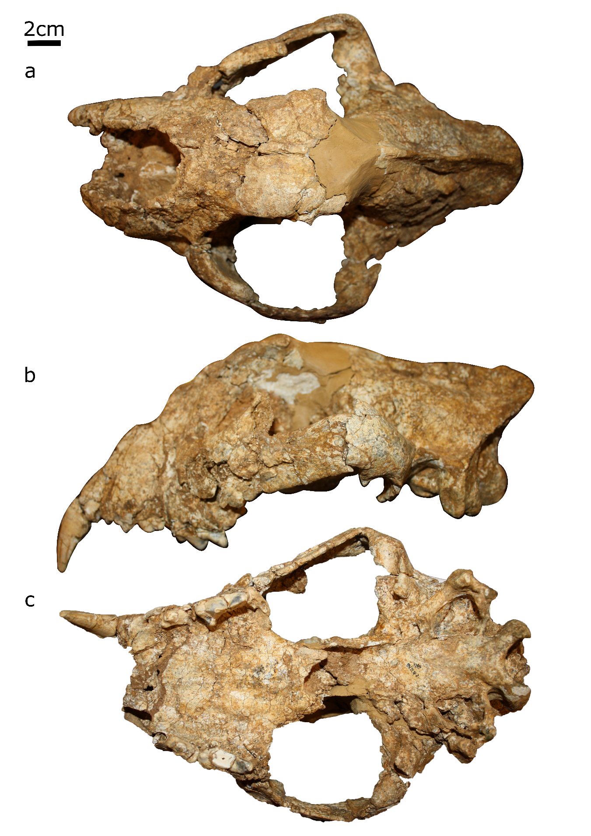
Figure S2: Cranium ULg-PA-BR-II-81-146 from la Belle Roche in (a) dorsal view, (b) lateral view and (c) ventral view.
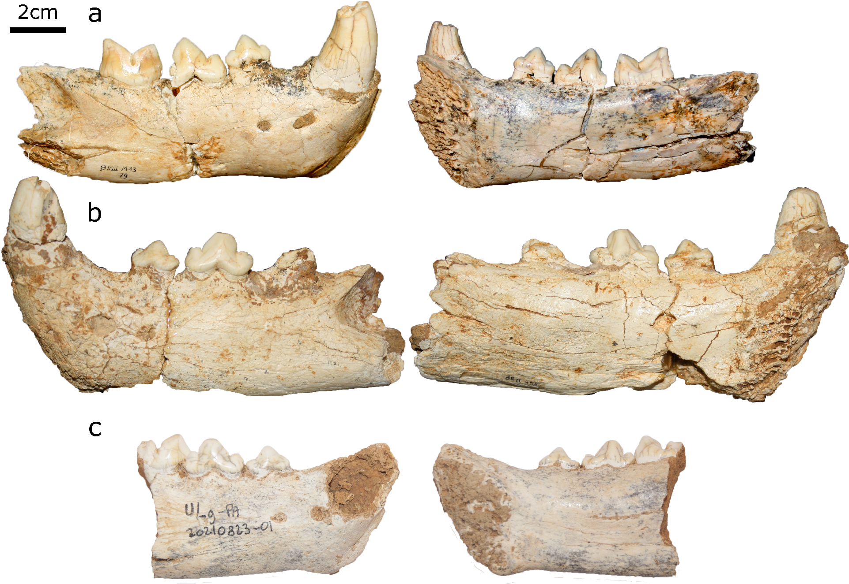
Figure S3: Mandibular fragments of (a) Ulg-PA-BR-III-M13-79, (b) Ulg-PA-BRII-455 and (c) Ulg-PA-20210823-01 in labial (left) and lingual (right)
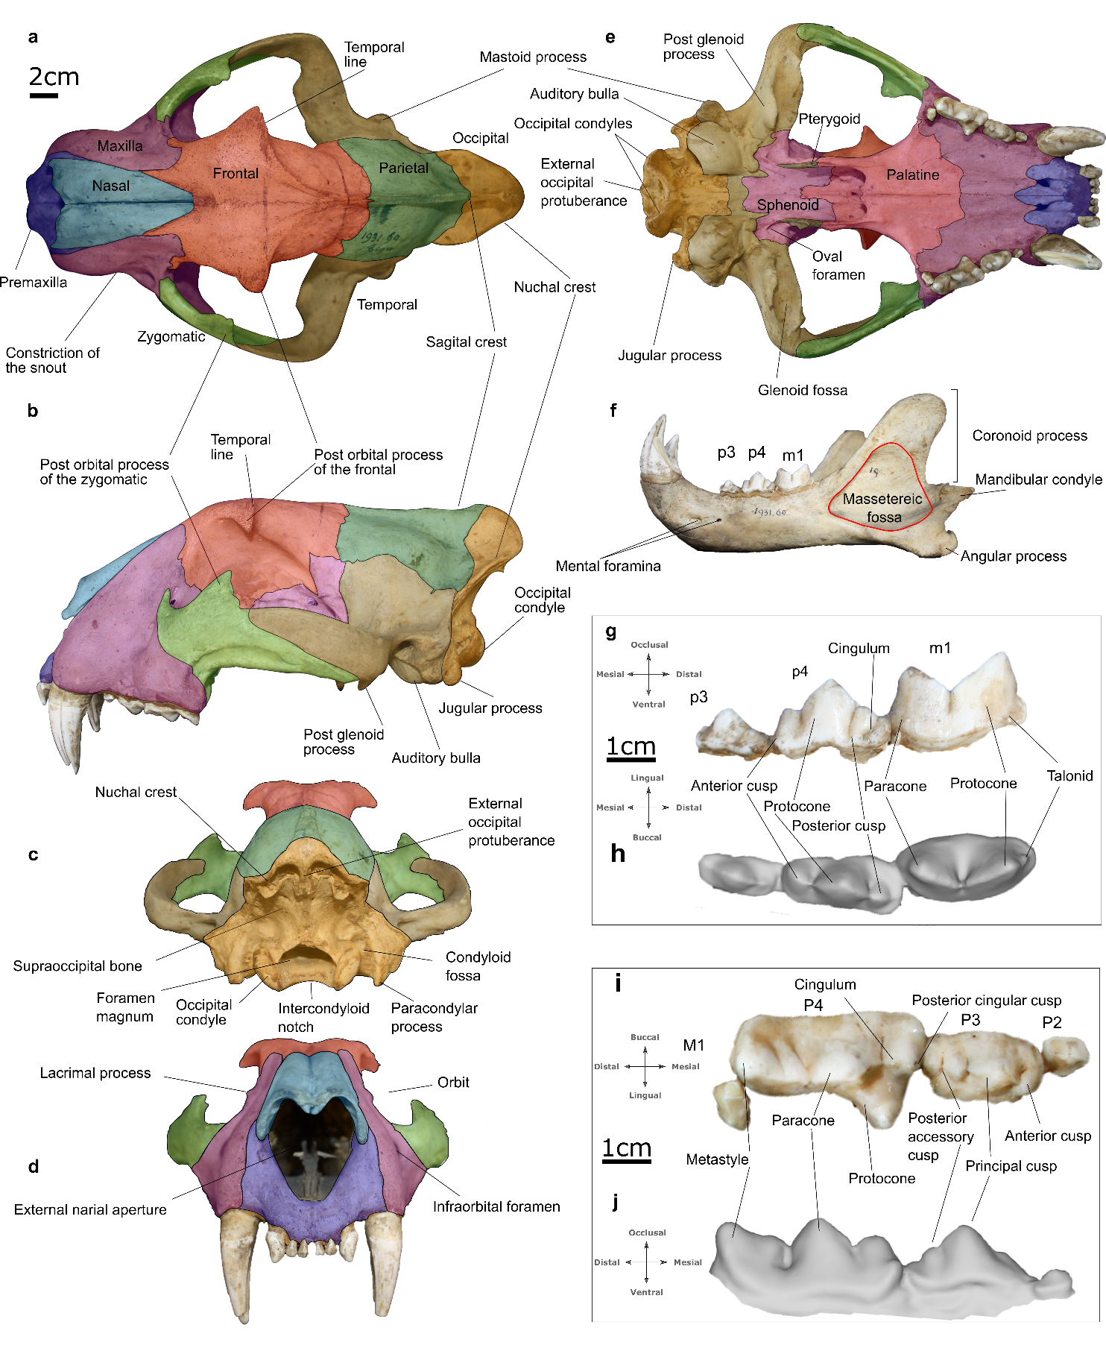
Figure S4: Cranium of Panthera tigris MNHN-ZM-AC-1931-60 in different view showing the different bones and anatomical terms used in this contribution. Cranium: a dorsal view, b lateral view, c posterior view, d anterior view, e ventral view. Mandible: f lateral view. Lower dentition: g buccal view, h occlusal view. Upper dentition: i occlusal view, j buccal view
Table S2 Specimens used for comparison and/or in the analysis.
Species | Specimen# | Holding institution | Part | Dataset
Panthera gombaszogensis | ULg-PA-BR-II-81-146 | ULg | Cranium | Cranium, upper dentition
 | Ulg-PA-20210823-01 | ULg | Dentary fragment | Lower dentition
 | Ulg-PA-BRII-455 | ULg | Dentary fragment | Lower dentition
 | Ulg-PA-BR-III-M13-79 | ULg | Dentary fragment | Lower dentition
 | Maas No number | NA | NA, published in (O’Regan, 2002) | Upper dentition
 | CD 1142 | NA | NA, published in (O’Regan, 2002) | Upper dentition
 | C-D 795 | NA | NA, published in (O’Regan, 2002) | Upper dentition
 | C-D 764 | NA | NA, published in (O’Regan, 2002) | Upper dentition
 | C-D 765 | NA | NA, published in (O’Regan, 2002) | Upper dentition
 | 1191 | NA | NA, published in (O’Regan, 2002) | Upper dentition
 | HU-1-86 D49 | NA | NA, published in (O’Regan, 2002) | Upper dentition
 | GER 165 | NA | NA, published in (O’Regan, 2002) | Upper dentition
 | IGF 4376 | NA | NA, published in (O’Regan, 2002) | Upper dentition
 | IGF 10032 | NA | NA, published in (O’Regan, 2002) | Upper dentition
 | IGF 12459 | NA | NA, published in (O’Regan, 2002) | Upper dentition
 | IGF 12459 | NA | NA, published in (O’Regan, 2002) | Upper dentition
 | IGF 4372 | NA | NA, published in (O’Regan, 2002) | Upper dentition
 | IGF 4373 | NA | NA, published in (O’Regan, 2002) | Upper dentition
 | F35 (M33681) | NA | NA, published in (O’Regan, 2002) | Upper dentition
 | M33683 | NA | NA, published in (O’Regan, 2002) | Upper dentition
 | F59 | NA | NA, published in (O’Regan, 2002) | Upper dentition
 | GIH no number | NA | NA, published in (O’Regan, 2002) | Upper dentition
 | B767 | NA | NA, published in (O’Regan, 2002) | Upper dentition
 | K150 | NA | NA, published in (O’Regan, 2002) | Upper dentition
 | IV69/647 |  |  | Upper dentition
Panthera onca | AMNH M147511 | AMNH | ? published in (Jiangzuo and Liu, 2020) | Upper dentition
 | AMNH M147513 | AMNH | ? published in (Jiangzuo and Liu, 2020) | Upper dentition
 | AMNH M147513 | AMNH | ? published in (Jiangzuo and Liu, 2020) | Upper dentition
 | AMNH M98683 | AMNH | ? published in (Jiangzuo and Liu, 2020) | Upper dentition
 | AMNH M98683 | AMNH | ? published in (Jiangzuo and Liu, 2020) | Upper dentition
 | AMNH M98841 | AMNH | ? published in (Jiangzuo and Liu, 2020) | Upper dentition
 | AMNH M98841 | AMNH | ? published in (Jiangzuo and Liu, 2020) | Upper dentition
 | AMNH M149328 | AMNH | ? published in (Jiangzuo and Liu, 2020) | Upper dentition
 | AMNH M149328 | AMNH | ? published in (Jiangzuo and Liu, 2020) | Upper dentition
 | AMNH M149326 | AMNH | ? published in (Jiangzuo and Liu, 2020) | Upper dentition
 | AMNH M149326 | AMNH | ? published in (Jiangzuo and Liu, 2020) | Upper dentition
 | MNHN-ZO-AC-2006-429 | MNHN | Cranium and mandible | Cranium, lower dentition
 | MNHN-ZM 2006-438 | MNHN | Cranium and mandible | Cranium, lower dentition
 | MNHN-ZM-AC 1914-259 | MNHN | Cranium | Cranium
 | MAV-2415 | MAV | Mandible | Lower dentition
Panthera tigris | AMNH M201798 | AMNH | ? published in (Jiangzuo and Liu, 2020) | Upper dentition
 | AMNH M201798 | AMNH | ? published in (Jiangzuo and Liu, 2020) | Upper dentition
 | AMNH M45520 | AMNH | ? published in (Jiangzuo and Liu, 2020) | Upper dentition
 | AMNH M45520 | AMNH | ? published in (Jiangzuo and Liu, 2020) | Upper dentition
 | AMNH M45519 | AMNH | ? published in (Jiangzuo and Liu, 2020) | Upper dentition
 | AMNH M45519 | AMNH | ? published in (Jiangzuo and Liu, 2020) | Upper dentition
 | AMNH M113743 | AMNH | ? published in (Jiangzuo and Liu, 2020) | Upper dentition
 | AMNH M113743 | AMNH | ? published in (Jiangzuo and Liu, 2020) | Upper dentition
 | AMNH M113744 | AMNH | ? published in (Jiangzuo and Liu, 2020) | Upper dentition
 | AMNH M113744 | AMNH | ? published in (Jiangzuo and Liu, 2020) | Upper dentition
 | AMNH M87349 | AMNH | ? published in (Jiangzuo and Liu, 2020) | Upper dentition
 | AMNH M87349 | AMNH | ? published in (Jiangzuo and Liu, 2020) | Upper dentition
 | MNHN-ZM-AC 1983-119 | MNHN | Cranium and mandible | Cranium, lower dentition
 | MNHN-ZM-AC-1931-60 | MNHN | Cranium and mandible | Cranium, lower dentition
 | MNCN-COMP-999 | MNCN | Mandible | Lower dentition
Panthera pardus | AMNH M52043 | AMNH | ? published in (Jiangzuo and Liu, 2020) | Upper dentition
 | AMNH M52043 | AMNH | ? published in (Jiangzuo and Liu, 2020) | Upper dentition
 | AMNH M165112 | AMNH | ? published in (Jiangzuo and Liu, 2020) | Upper dentition
 | AMNH M165112 | AMNH | ? published in (Jiangzuo and Liu, 2020) | Upper dentition
 | AMNH M54335 | AMNH | ? published in (Jiangzuo and Liu, 2020) | Upper dentition
 | AMNH M54335 | AMNH | ? published in (Jiangzuo and Liu, 2020) | Upper dentition
 | AMNH M81845 | AMNH | ? published in (Jiangzuo and Liu, 2020) | Upper dentition
 | AMNH M81845 | AMNH | ? published in (Jiangzuo and Liu, 2020) | Upper dentition
 | AMNH M52020 | AMNH | ? published in (Jiangzuo and Liu, 2020) | Upper dentition
 | AMNH M52020 | AMNH | ? published in (Jiangzuo and Liu, 2020) | Upper dentition
 | AMNH M52018 | AMNH | ? published in (Jiangzuo and Liu, 2020) | Upper dentition
 | AMNH M52018 | AMNH | ? published in (Jiangzuo and Liu, 2020) | Upper dentition
 | AMNH-113745 | AMNH | Cranium and mandible, 3D model | Cranium, lower dentition
 | MNHN-ZM-MO_1962-988 | MNHN | Cranium | Cranium
 | RMCA-2423 | RMCA | Mandible | Lower dentition
 | RMCA-2602 | RMCA | Mandible | Lower dentition
Panthera leo | AMNH M85149 | AMNH | ? published in (Jiangzuo and Liu, 2020) | Upper dentition
 | AMNH M85149 | AMNH | ? published in (Jiangzuo and Liu, 2020) | Upper dentition
 | AMNH M52073 | AMNH | ? published in (Jiangzuo and Liu, 2020) | Upper dentition
 | AMNH M52073 | AMNH | ? published in (Jiangzuo and Liu, 2020) | Upper dentition
 | AMNH M52078 | AMNH | ? published in (Jiangzuo and Liu, 2020) | Upper dentition
 | AMNH M52078 | AMNH | ? published in (Jiangzuo and Liu, 2020) | Upper dentition
 | AMNH M81838 | AMNH | ? published in (Jiangzuo and Liu, 2020) | Upper dentition
 | AMNH M81838 | AMNH | ? published in (Jiangzuo and Liu, 2020) | Upper dentition
 | AMNH M81839 | AMNH | ? published in (Jiangzuo and Liu, 2020) | Upper dentition
 | AMNH M81839 | AMNH | ? published in (Jiangzuo and Liu, 2020) | Upper dentition
 | AMNH M83618 | AMNH | ? published in (Jiangzuo and Liu, 2020) | Upper dentition
 | AMNH M83618 | AMNH | ? published in (Jiangzuo and Liu, 2020) | Upper dentition
 | AMNH M83620 | AMNH | ? published in (Jiangzuo and Liu, 2020) | Upper dentition
 | AMNH M83620 | AMNH | ? published in (Jiangzuo and Liu, 2020) | Upper dentition
 | AMNH M54996 | AMNH | ? published in (Jiangzuo and Liu, 2020) | Upper dentition
 | AMNH M54996 | AMNH | ? published in (Jiangzuo and Liu, 2020) | Upper dentition
 | MNHN-ZM-AC 1938-277 | MNHN | Cranium and lower dentition | Cranium, lower dentition
 | MNHN-ZM-AC 1938-632 | MNHN | Cranium and lower dentition | Cranium lower dentition
 | MNHN-ZM-AC 1995-164 | MNHN | Cranium | Cranium
 | MNCN-COMP-255 | MNCN | Mandible | Lower dentition
Panthera uncia | AMNH M119662 | AMNH | ? published in (Jiangzuo and Liu, 2020) | Upper dentition
 | AMNH M119662 | AMNH | ? published in (Jiangzuo and Liu, 2020) | Upper dentition
 | AMNH M166952 | AMNH | ? published in (Jiangzuo and Liu, 2020) | Upper dentition
 | AMNH M166952 | AMNH | ? published in (Jiangzuo and Liu, 2020) | Upper dentition
 | AMNH M35360 | AMNH | ? published in (Jiangzuo and Liu, 2020) | Upper dentition
 | AMNH M35360 | AMNH | ? published in (Jiangzuo and Liu, 2020) | Upper dentition
 | AMNH M24215 | AMNH | ? published in (Jiangzuo and Liu, 2020) | Upper dentition
 | AMNH M24215 | AMNH | ? published in (Jiangzuo and Liu, 2020) | Upper dentition
 | AMNH M35529 | AMNH | ? published in (Jiangzuo and Liu, 2020) | Upper dentition
 | AMNH M35529 | AMNH | ? published in (Jiangzuo and Liu, 2020) | Upper dentition
 | AMNH M35476 | AMNH | ? published in (Jiangzuo and Liu, 2020) | Upper dentition
 | MNHN-ZM-AC 1970-102 | MNHN | Cranium and mandible | Cranium, lower dentition
 | MNHN-ZM-AC 1979-52 | MNHN | Cranium and mandible | Cranium, lower dentition
 | MNHN-ZM-AC 2006-429 | MNHN | Cranium and mandible | Cranium, lower dentition
Panthera speleae | IMNH XXX | IMNH | Cranium, 3D model | Cranium, upper dentition
 | Ulg-PA-BRIII-L14-5 | ULg | Dentary fragment | Lower dentition
 | ULg-PA-SCHM-II-14-11 | ULg | Dentary | Lower dentition
Panthera palaeosinensis | PMU-M3656 | PMU | Cranium | Cranium, upper dentition
 | PMU-M3654 | PMU | Mandible | Lower dentition
Panthera blytheae | IVPP V18788.1 | IVPP | Cranium, 3D model | Cranium, upper dentition

Table S3: Measurements taken on the upper dentition. CH Upper canine height, CL Upper canine length, CW Upper canine width, P3L Upper third premolar length, P3W Upper third width, P4L Upper fourth premolar length, P4W Upper fourth premolar width, P4ML Upper fourth premolar metacone length, P4PL Upper fourth premolar paracone length, P4H Upper fourth premolar height
Locality | Specimen# | Species | CL | CW | CH | P3L | P3W | P4L | P4W | P4PL | P4ML | P4H
La Belle-Roche | ULg-PA-BR-II-81-146 | P. gombaszogensis | 17.78 | 13.25 | 37.01 | 20.47 | 9.87 | 31.45 | 17.86 | 12.80 | 12.40 | 13.83
Château Breccia1 |  | P. gombaszogensis | NA | NA | NA | 20.7 | 10.5 | 31.2 | 17.1 | NA | NA | NA
Château Breccia2 |  | P. gombaszogensis | NA | NA | NA | 20.5 | 9.8 | 31.6 | 15.9 | NA | NA | NA
Château Breccia3 |  | P. gombaszogensis | NA | NA | NA | 22.4 | 11.2 | 30.3 | 16.7 | NA | NA | NA
Château Breccia4 |  | P. gombaszogensis | NA | NA | NA | 22 | 11.2 | 30.4 | 16.6 | NA | NA | NA
Château Breccia5 |  | P. gombaszogensis | NA | NA | NA | 21.9 | 10.2 | 30.4 | 18.4 | NA | NA | NA
Château Breccia6 |  | P. gombaszogensis | NA | NA | NA | 22.00 | 10.9 | 32.4 | 15.6 | NA | NA | NA
Château Breccia7 |  | P. gombaszogensis | NA | NA | NA | 23.4 | 10.8 | 31.9 | 16 | NA | NA | NA
Unterma?eld |  | P. gombaszogensis | NA | NA | NA | 22 | 11 | 32 | 18.4 | NA | NA | NA
Unterma?eld |  | P. gombaszogensis | NA | NA | NA | 22.1 | 11.2 | 32.2 | 18 | NA | NA | NA
Tegelen | Maas No number | P. gombaszogensis | NA | NA | NA | NA | NA | 30 | NA | 11.30 | 11.40 | NA
L'Escale | CD 1142 | P. gombaszogensis | NA | NA | NA | NA | NA | 31.7 | 18.9 | 13.40 | 12.80 | NA
L'Escale | C-D 795 | P. gombaszogensis | 21.50 | 17.00 | 40.70 | 21.50 | 11.20 | 31.50 | 16.70 | 12.80 | 12.80 | NA
L'Escale | C-D 764 | P. gombaszogensis | NA | NA | NA | NA | NA | 32.40 | NA | 13.50 | 12.80 | NA
L'Escale | C-D 765 | P. gombaszogensis | NA | NA | NA | 23.00 | NA | NA | NA | NA | NA | NA
Rome | 1191 | P. gombaszogensis | 15.45 | 12.15 | 33.10 | 17.40 | 8.10 | 27.80 | 13.70 | 10.30 | 11.90 | NA
Huéscar | HU-1-86 D49 | P. gombaszogensis | NA | NA | NA | NA | NA | 29.10 | 14.20 | 12.20 | 11.80 | NA
Gerakarou 1 | GER 165 | P. gombaszogensis | NA | NA | NA | NA | NA | 29.90 | 15.80 | 12.00 | 12.20 | NA
Gerakarou 1 | GER 165 | P. gombaszogensis | NA | NA | NA | 20.00 | 10.40 | 29.40 | 16.20 | 12.20 | 12.00 | NA
Olivola | IGF 4376 | P. gombaszogensis | 17.70 | 15.10 | NA | 20.40 | 10.60 | 29.00 | 16.10 | 11.40 | 10.71 | NA
Olivola | IGF 10032 | P. gombaszogensis | 19.40 | 15.90 | NA | 22.00 | 10.20 | 31.70 | 16.00 | 12.40 | 12.80 | NA
Olivola (Cast) | IGF 12459 | P. gombaszogensis | NA | NA | NA | 20.60 | 10.50 | 31.00 | 15.00 | 11.70 | 13.00 | NA
Olivola (Cast) | IGF 12459 | P. gombaszogensis | NA | NA | NA | 20.70 | 10.80 | 31.70 | 15.30 | 13.00 | 12.91 | NA
Olivola | IGF 4372 | P. gombaszogensis | NA | NA | NA | 16.90 | 8.90 | 27.00 | 13.70 | 11.30 | 11.00 | NA
Olivola | IGF 4373 | P. gombaszogensis | NA | NA | NA | 20.70 | 9.60 | 32.00 | 15.80 | 11.70 | 13.60 | NA
Westbury-sub-Mendip | F35 (M33681) | P. gombaszogensis | NA | NA | NA | 21.70 | 10.70 | 1 33.1 | 18.00 | 12.90 | 12.80 | NA
Westbury-sub-Mendip | M33683 | P. gombaszogensis | NA | NA | NA | NA | NA | 31.30 | NA | 12.00 | 13.00 | NA
Westbury-sub-Mendip | F59 | P. gombaszogensis | NA | NA | NA | NA | NA | NA | NA | 12.50 | 11.00 | NA
Gombasek | GIH no number | P. gombaszogensis | 20.00 | 15.50 | NA | NA | NA | 29.80 | NA | 12.10 | 12.60 | NA
Gombasek | B767 | P. gombaszogensis | NA | NA | NA | NA | NA | 32.00 | 17.10 | 12.50 | 12.20 | NA
Gombasek | K150 | P. gombaszogensis | NA | NA | NA | NA | NA | NA | NA | NA | 12.60 | NA
Vértesszölös 11 | IV69/647 | P. gombaszogensis | NA | NA | NA | NA | 9.60 | 31.70 | NA | 12.30 | 12.50 | NA
 | AMNH M147511 | P. onca | 20.32 | 15.89 | NA | 19.54 | 10.38 | 30.06 | 14.67 | 7.08 | 11.5 | 16.29
 | AMNH M147511 | P. onca | 20.34 | 16.07 | NA | 19.56 | 10.38 | NA | NA | NA | NA | NA
 | AMNH M147513 | P. onca | 20.9 | 16.81 | NA | 20.05 | 11.09 | 29.93 | 16.14 | 8.75 | 10.86 | 15.14
 | AMNH M147513 | P. onca | 20.88 | 16.89 | NA | 20.29 | 10.81 | 29.87 | 16.52 | 8.26 | 10.51 | 15.68
 | AMNH M98683 | P. onca | 19.94 | 15.83 | 37.79 | 19.29 | 10.14 | 27.33 | 13.87 | 6.48 | 9.34 | 15.56
 | AMNH M98683 | P. onca | 19.78 | 15.5 | 37.73 | 19.45 | 10.38 | 27.4 | 14.1 | 6.44 | 9.18 | NA
 | AMNH M98841 | P. onca | 19.98 | 14.54 | 35.29 | 19.07 | 10.11 | 28.84 | 15.53 | 6.99 | 10.17 | 15.71
 | AMNH M98841 | P. onca | NA | NA | NA | 19.1 | 10.34 | 28.87 | 15.49 | 6.77 | 10.22 | 15.84
 | AMNH M149328 | P. onca | 17.98 | 14.67 | NA | 17.21 | 9.29 | 28.16 | 13.56 | 6.84 | 11.33 | 14.96
 | AMNH M149328 | P. onca | 17.98 | 14.55 | NA | 17.6 | 9.19 | 28.06 | 13.39 | 6.59 | 10.52 | 14.95
 | AMNH M149326 | P. onca | 20.29 | 14.82 | NA | 17.54 | 9.91 | 28.56 | 14.14 | 6.74 | 10.53 | 15.82
 | AMNH M149326 | P. onca | 20.62 | 14.96 | NA | 17.4 | 10.37 | 28.89 | 14.31 | 7.08 | 10.48 | 15.37
 | AMNH M201798 | P. tigris | 27.43 | 18.94 | 54.36 | 21.78 | 11.82 | NA | NA | NA | NA | NA
 | AMNH M201798 | P. tigris | 27.69 | 18.94 | NA | 22.7 | 12.19 | 37.48 | 17.85 | 8.77 | 13.12 | 19.54
 | AMNH M45520 | P. tigris | 21.75 | 16.2 | NA | 21.02 | 11.04 | 32.12 | 16.23 | 6.81 | 12.23 | NA
 | AMNH M45520 | P. tigris | NA | NA | NA | 20.96 | 10.95 | NA | NA | NA | NA | NA
 | AMNH M45519 | P. tigris | 26.34 | 18.86 | 53.22 | 22.5 | 12.2 | 34.82 | 17.71 | 7.68 | 13.82 | 17.95
 | AMNH M45519 | P. tigris | 26 | 19.3 | NA | 23.09 | 11.83 | 34.58 | 17.79 | 7.25 | 13.54 | NA
 | AMNH M113743 | P. tigris | 20.96 | 16.32 | NA | 20.18 | 10.14 | 32.64 | 15.33 | 8.06 | 12.66 | 16.91
 | AMNH M113743 | P. tigris | 20.66 | 16.52 | NA | 20.27 | 9.84 | 32.24 | 15.35 | 8.22 | 12.04 | NA
 | AMNH M113744 | P. tigris | 26.26 | 19.62 | NA | 23.45 | 11.65 | 35.21 | 17.31 | 8.65 | 13.98 | NA
 | AMNH M113744 | P. tigris | 26.62 | 19.5 | NA | 24.45 | 10.98 | 35.27 | 17.52 | 8.07 | 13.56 | NA
 | AMNH M87349 | P. tigris | 27.6 | 20.67 | NA | 24.78 | 12.62 | 36.7 | 18.47 | 7.94 | 14.64 | NA
 | AMNH M87349 | P. tigris | 27.67 | 21.34 | NA | 24.81 | 12.33 | 37.38 | 18.21 | 7.71 | 14.5 | NA
 | AMNH M52043 | P. pardus | 15.41 | 11.37 | 36.21 | 17.56 | 9.55 | 26.41 | 13.86 | 6.44 | 9.96 | 14.46
 | AMNH M52043 | P. pardus | 15.13 | 11.72 | NA | 17.69 | 9.34 | 26.28 | 13.93 | 7.13 | 9.48 | 14.73
 | AMNH M165112 | P. pardus | 13.88 | 10.15 | NA | 15.99 | 7.5 | 24.83 | 12.68 | 5.63 | 9.48 | 11.88
 | AMNH M165112 | P. pardus | 13.67 | 10 | 28.76 | 16.1 | 7.48 | 25.02 | 12.63 | 5.66 | 8.88 | 12.3
 | AMNH M54335 | P. pardus | 12.86 | 9.81 | NA | 14.94 | 7.69 | 23.18 | 11.85 | 5.8 | 8.09 | 11.41
 | AMNH M54335 | P. pardus | 12.27 | 9.94 | NA | 15.26 | 7.19 | 23.19 | 11.95 | 5.95 | 8.05 | 11.7
 | AMNH M81845 | P. pardus | 12.38 | 9.99 | NA | 15.95 | 8.28 | 25.46 | 11.96 | 5.8 | 10.01 | 14.07
 | AMNH M81845 | P. pardus | 12.39 | 9.97 | NA | 16.28 | 8.02 | 25.44 | 12.73 | 5.15 | 9.26 | NA
 | AMNH M52020 | P. pardus | 16.84 | 13.36 | 38.96 | 19.99 | 10.28 | 27.33 | 14.34 | 6.3 | 9.84 | 13.88
 | AMNH M52020 | P. pardus | 17.39 | 13.47 | 37.04 | 19.58 | 10.06 | 27.12 | 14.19 | 6.4 | 9.64 | 13.83
 | AMNH M52018 | P. pardus | 14.91 | 11.16 | 33 | 17.98 | 8.22 | 25.55 | 12.65 | 5.83 | 9.48 | 13.53
 | AMNH M52018 | P. pardus | 14.97 | 11.2 | 32.98 | 18.1 | 8.36 | 25.63 | 12.64 | 5.43 | 8.93 | 13.97
 | AMNH M85149 | P. leo | 26.38 | 18.78 | 48.19 | 25.65 | 13.21 | 38.33 | 17.95 | 9.47 | 14.54 | NA
 | AMNH M85149 | P. leo | 26.82 | 19.44 | NA | 25.49 | 13.16 | 37.61 | 18 | 8.59 | 13.56 | NA
 | AMNH M52073 | P. leo | 18.87 | 13.81 | NA | 21.6 | 10.96 | 34.1 | 16.26 | 9.19 | 11.96 | 17.17
 | AMNH M52073 | P. leo | 19.14 | 14.09 | NA | 21.57 | 10.94 | 34.04 | 16.72 | 9.23 | 11.91 | 18.04
 | AMNH M52078 | P. leo | 26.42 | 18.99 | NA | 26.55 | 12.92 | 35.99 | 18.57 | 7.98 | 12.93 | 19.98
 | AMNH M52078 | P. leo | 25.44 | 19.28 | NA | 26.21 | 12.99 | 36.1 | 18.32 | 8.67 | 12.97 | NA
 | AMNH M81838 | P. leo | 21.44 | 16.1 | NA | 22.9 | 12.07 | 34.56 | 16.1 | 8.59 | NA | 18.94
 | AMNH M81838 | P. leo | 21.07 | 16.24 | NA | 22.8 | 11.79 | 35.33 | 16.37 | 8.85 | 13.07 | NA
 | AMNH M81839 | P. leo | 20.69 | 15.52 | 41.65 | 26.05 | 12.38 | 37.37 | 17.9 | 10.14 | 13.31 | 19.91
 | AMNH M81839 | P. leo | NA | 16.08 | NA | 25.71 | 11.82 | 36.87 | 18.2 | 9.94 | 12.33 | 20.59
 | AMNH M83618 | P. leo | 20.64 | 13.97 | 39.57 | 22.54 | 10.78 | 35.32 | 15.97 | 8.87 | 13.08 | 18.52
 | AMNH M83618 | P. leo | 20.41 | 14.46 | NA | 22.87 | 10.35 | 35.12 | 16.1 | 8.39 | 12.38 | 19.87
 | AMNH M83620 | P. leo | 22.31 | 16.2 | NA | 25.22 | 12.14 | 36.16 | 17.73 | 9.04 | 13.5 | 18.63
 | AMNH M83620 | P. leo | 22.04 | 16.6 | NA | 25.64 | 12.32 | 36.16 | 17.34 | 9.12 | 13.44 | 19.2
 | AMNH M54996 | P. leo | 22.08 | 15.97 | NA | 23.23 | 11.19 | 34.41 | 16.3 | 8.53 | 12.99 | 18.72
 | AMNH M54996 | P. leo | 21.6 | 15.92 | 41.82 | 21.97 | 10.67 | 34.5 | 16.46 | 9.18 | 12.55 | NA
 | AMNH M119662 | P. uncia | NA | NA | NA | 15.08 | 7.77 | 23.18 | 12.06 | 5.5 | 7.91 | 11.68
 | AMNH M119662 | P. uncia | 11.32 | 9.52 | NA | 15.49 | 7.6 | 23.55 | 12.24 | 5.21 | 7.82 | 11.91
 | AMNH M166952 | P. uncia | 11.78 | 9.13 | NA | 14.94 | 7.29 | 23.3 | 11.92 | 5.03 | 8.67 | 11.91
 | AMNH M166952 | P. uncia | 11.72 | 9.35 | NA | 15.09 | 6.52 | 22.69 | 11.83 | 4.98 | 7.87 | 12.15
 | AMNH M35360 | P. uncia | 12.37 | 10.49 | NA | 16.56 | 7.85 | 24.5 | 12.63 | 5.93 | 8.08 | 12.42
 | AMNH M35360 | P. uncia | 12.3 | 10.99 | NA | 16.46 | 8.52 | 23.69 | 12.63 | 5.31 | 8.09 | 12.85
 | AMNH M24215 | P. uncia | NA | NA | NA | 16.72 | 8.62 | 25.36 | 13.69 | 5.61 | 8.82 | 12.75
 | AMNH M24215 | P. uncia | NA | NA | NA | 16.67 | 8.25 | 24.91 | 13.43 | 5.82 | 8.74 | 12.9
 | AMNH M35529 | P. uncia | 12 | 9.9 | NA | 14.94 | 8.03 | 23.42 | 12.36 | 4.56 | 7.92 | 12.34
 | AMNH M35529 | P. uncia | 11.8 | 9.84 | 29.6 | 14.33 | 8.06 | 23.3 | 12.15 | 4.66 | 7.79 | 12.88
 | AMNH M35476 | P. uncia | NA | 9.64 | NA | 15.05 | 7.21 | 24.01 | 12.14 | 5.48 | 8.23 | 12.69
 | AMNH M35476 | P. uncia | 11.79 | 9.71 | NA | NA | NA | 24.09 | 12.02 | 5.8 | 7.84 | 12.77
 | IMNH XXX | P. speleae | 39.025 | 28.0827 | 69.211 | 34.503 | 17.117 | 44.987 | 24.225 | 16.014 | 10.62 | 21.064

Table S4: Ratio used for the upper dentition dataset in the morphometric analyses.
Specimen# | Species | CW/CL | CH/CL | P3L/CL | P3W/CL | P4L/CL | P4W/CL | P4PL/CL | P4ML/CL | P4H/CL
ULg-PA-BR-II-81-146 | ULg-PA-BR-II-81-146 | 0.7452 | 2.0817 | 1.1510 | 0.5551 | 1.7691 | 1.0046 | 0.7201 | 0.6971 | 0.7780
C-D 795 | P. gombaszogensis | 0.7907 | 1.8930 | 1.0000 | 0.5209 | 1.4651 | 0.7767 | 0.5953 | 0.5953 | NA
1191 | P. gombaszogensis | 0.7864 | NA | 1.1262 | 0.5243 | 1.7994 | 0.8867 | 0.6667 | 0.7702 | NA
IGF 4376 | P. gombaszogensis | 0.8531 | NA | 1.1525 | 0.5989 | 1.6384 | 0.9096 | 0.6441 | 0.6051 | NA
IGF 10032 | P. gombaszogensis | 0.8196 | NA | 1.1340 | 0.5258 | 1.6340 | 0.8247 | 0.6392 | 0.6598 | NA
GIH no number | P. gombaszogensis | 0.7750 | NA | NA | NA | 1.4900 | NA | 0.6050 | 0.6300 | NA
AMNH M147511 | P. onca | 0.7820 | NA | 0.9616 | 0.5108 | 1.4793 | 0.7219 | 0.3484 | 0.5659 | 0.8017
AMNH M147511 | P. onca | 0.7901 | NA | 0.9617 | 0.5103 | NA | NA | NA | NA | NA
AMNH M147513 | P. onca | 0.8043 | NA | 0.9593 | 0.5306 | 1.4321 | 0.7722 | 0.4187 | 0.5196 | 0.7244
AMNH M147513 | P. onca | 0.8089 | NA | 0.9717 | 0.5177 | 1.4306 | 0.7912 | 0.3956 | 0.5034 | 0.7510
AMNH M98683 | P. onca | 0.7939 | 1.8952 | 0.9674 | 0.5085 | 1.3706 | 0.6956 | 0.3250 | 0.4684 | 0.7803
AMNH M98683 | P. onca | 0.7836 | 1.9075 | 0.9833 | 0.5248 | 1.3852 | 0.7128 | 0.3256 | 0.4641 | NA
AMNH M98841 | P. onca | 0.7277 | 1.7663 | 0.9545 | 0.5060 | 1.4434 | 0.7773 | 0.3498 | 0.5090 | 0.7863
AMNH M149328 | P. onca | 0.8159 | NA | 0.9572 | 0.5167 | 1.5662 | 0.7542 | 0.3804 | 0.6301 | 0.8320
AMNH M149328 | P. onca | 0.8092 | NA | 0.9789 | 0.5111 | 1.5606 | 0.7447 | 0.3665 | 0.5851 | 0.8315
AMNH M149326 | P. onca | 0.7304 | NA | 0.8645 | 0.4884 | 1.4076 | 0.6969 | 0.3322 | 0.5190 | 0.7797
AMNH M149326 | P. onca | 0.7255 | NA | 0.8438 | 0.5029 | 1.4011 | 0.6940 | 0.3434 | 0.5082 | 0.7454
AMNH M201798 | P. tigris | 0.6905 | 1.9818 | 0.7940 | 0.4309 | NA | NA | NA | NA | NA
AMNH M201798 | P. tigris | 0.6840 | NA | 0.8198 | 0.4402 | 1.3536 | 0.6446 | 0.3167 | 0.4738 | 0.7057
AMNH M45520 | P. tigris | 0.7448 | NA | 0.9664 | 0.5076 | 1.4768 | 0.7462 | 0.3131 | 0.5623 | NA
AMNH M45519 | P. tigris | 0.7160 | 2.0205 | 0.8542 | 0.4632 | 1.3219 | 0.6724 | 0.2916 | 0.5247 | 0.6815
AMNH M45519 | P. tigris | 0.7423 | NA | 0.8881 | 0.4550 | 1.3300 | 0.6842 | 0.2788 | 0.5208 | NA
AMNH M113743 | P. tigris | 0.7786 | NA | 0.9628 | 0.4838 | 1.5573 | 0.7314 | 0.3845 | 0.6040 | 0.8068
AMNH M113743 | P. tigris | 0.7996 | NA | 0.9811 | 0.4763 | 1.5605 | 0.7430 | 0.3979 | 0.5828 | NA
AMNH M113744 | P. tigris | 0.7471 | NA | 0.8930 | 0.4436 | 1.3408 | 0.6592 | 0.3294 | 0.5324 | NA
AMNH M113744 | P. tigris | 0.7325 | NA | 0.9185 | 0.4125 | 1.3249 | 0.6582 | 0.3032 | 0.5094 | NA
AMNH M87349 | P. tigris | 0.7489 | NA | 0.8978 | 0.4572 | 1.3297 | 0.6692 | 0.2877 | 0.5304 | NA
AMNH M87349 | P. tigris | 0.7712 | NA | 0.8966 | 0.4456 | 1.3509 | 0.6581 | 0.2786 | 0.5240 | NA
AMNH M52043 | P. pardus | 0.7378 | 2.3498 | 1.1395 | 0.6197 | 1.7138 | 0.8994 | 0.4179 | 0.6463 | 0.9384
AMNH M52043 | P. pardus | 0.7746 | NA | 1.1692 | 0.6173 | 1.7369 | 0.9207 | 0.4712 | 0.6266 | 0.9736
AMNH M165112 | P. pardus | 0.7313 | NA | 1.1520 | 0.5403 | 1.7889 | 0.9135 | 0.4056 | 0.6830 | 0.8559
AMNH M165112 | P. pardus | 0.7315 | 2.1039 | 1.1778 | 0.5472 | 1.8303 | 0.9239 | 0.4140 | 0.6496 | 0.8998
AMNH M54335 | P. pardus | 0.7628 | NA | 1.1617 | 0.5980 | 1.8025 | 0.9215 | 0.4510 | 0.6291 | 0.8872
AMNH M54335 | P. pardus | 0.8101 | NA | 1.2437 | 0.5860 | 1.8900 | 0.9739 | 0.4849 | 0.6561 | 0.9535
AMNH M81845 | P. pardus | 0.8069 | NA | 1.2884 | 0.6688 | 2.0565 | 0.9661 | 0.4685 | 0.8086 | 1.1365
AMNH M81845 | P. pardus | 0.8047 | NA | 1.3140 | 0.6473 | 2.0533 | 1.0274 | 0.4157 | 0.7474 | NA
AMNH M52020 | P. pardus | 0.7933 | 2.3135 | 1.1871 | 0.6105 | 1.6229 | 0.8515 | 0.3741 | 0.5843 | 0.8242
AMNH M52020 | P. pardus | 0.7746 | 2.1300 | 1.1259 | 0.5785 | 1.5595 | 0.8160 | 0.3680 | 0.5543 | 0.7953
AMNH M52018 | P. pardus | 0.7485 | 2.2133 | 1.2059 | 0.5513 | 1.7136 | 0.8484 | 0.3910 | 0.6358 | 0.9074
AMNH M52018 | P. pardus | 0.7482 | 2.2031 | 1.2091 | 0.5585 | 1.7121 | 0.8444 | 0.3627 | 0.5965 | 0.9332
AMNH M85149 | P. leo | 0.7119 | 1.8268 | 0.9723 | 0.5008 | 1.4530 | 0.6804 | 0.3590 | 0.5512 | NA
AMNH M85149 | P. leo | 0.7248 | NA | 0.9504 | 0.4907 | 1.4023 | 0.6711 | 0.3203 | 0.5056 | NA
AMNH M52073 | P. leo | 0.7318 | NA | 1.1447 | 0.5808 | 1.8071 | 0.8617 | 0.4870 | 0.6338 | 0.9099
AMNH M52073 | P. leo | 0.7362 | NA | 1.1270 | 0.5716 | 1.7785 | 0.8736 | 0.4822 | 0.6223 | 0.9425
AMNH M52078 | P. leo | 0.7188 | NA | 1.0049 | 0.4890 | 1.3622 | 0.7029 | 0.3020 | 0.4894 | 0.7562
AMNH M52078 | P. leo | 0.7579 | NA | 1.0303 | 0.5106 | 1.4190 | 0.7201 | 0.3408 | 0.5098 | NA
AMNH M81838 | P. leo | 0.7509 | NA | 1.0681 | 0.5630 | 1.6119 | 0.7509 | 0.4007 | NA | 0.8834
AMNH M81838 | P. leo | 0.7708 | NA | 1.0821 | 0.5596 | 1.6768 | 0.7769 | 0.4200 | 0.6203 | NA
AMNH M81839 | P. leo | 0.7501 | 2.0130 | 1.2591 | 0.5984 | 1.8062 | 0.8652 | 0.4901 | 0.6433 | 0.9623
AMNH M83618 | P. leo | 0.6768 | 1.9172 | 1.0921 | 0.5223 | 1.7112 | 0.7737 | 0.4297 | 0.6337 | 0.8973
AMNH M83618 | P. leo | 0.7085 | NA | 1.1205 | 0.5071 | 1.7207 | 0.7888 | 0.4111 | 0.6066 | 0.9735
AMNH M83620 | P. leo | 0.7261 | NA | 1.1304 | 0.5442 | 1.6208 | 0.7947 | 0.4052 | 0.6051 | 0.8351
AMNH M83620 | P. leo | 0.7532 | NA | 1.1633 | 0.5590 | 1.6407 | 0.7868 | 0.4138 | 0.6098 | 0.8711
AMNH M54996 | P. leo | 0.7233 | NA | 1.0521 | 0.5068 | 1.5584 | 0.7382 | 0.3863 | 0.5883 | 0.8478
AMNH M54996 | P. leo | 0.7370 | 1.9361 | 1.0171 | 0.4940 | 1.5972 | 0.7620 | 0.4250 | 0.5810 | NA
AMNH M119662 | P. uncia | 0.8410 | NA | 1.3684 | 0.6714 | 2.0804 | 1.0813 | 0.4602 | 0.6908 | 1.0521
AMNH M166952 | P. uncia | 0.7750 | NA | 1.2683 | 0.6188 | 1.9779 | 1.0119 | 0.4270 | 0.7360 | 1.0110
AMNH M166952 | P. uncia | 0.7978 | NA | 1.2875 | 0.5563 | 1.9360 | 1.0094 | 0.4249 | 0.6715 | 1.0367
AMNH M35360 | P. uncia | 0.8480 | NA | 1.3387 | 0.6346 | 1.9806 | 1.0210 | 0.4794 | 0.6532 | 1.0040
AMNH M35360 | P. uncia | 0.8935 | NA | 1.3382 | 0.6927 | 1.9260 | 1.0268 | 0.4317 | 0.6577 | 1.0447
AMNH M35529 | P. uncia | 0.8250 | NA | 1.2450 | 0.6692 | 1.9517 | 1.0300 | 0.3800 | 0.6600 | 1.0283
AMNH M35529 | P. uncia | 0.8339 | 2.5085 | 1.2144 | 0.6831 | 1.9746 | 1.0297 | 0.3949 | 0.6602 | 1.0915
AMNH M35476 | P. uncia | 0.8236 | NA | NA | NA | 2.0433 | 1.0195 | 0.4919 | 0.6650 | 1.0831
IMNH XXX | P. speleae | 0.7196 | 1.7735 | 0.8841 | 0.4386 | 1.1528 | 0.6208 | 0.4104 | 0.2721 | 0.5398

Table S5: Measurements taken on the lower dentition. cL lower canine length, cW lower canine width, diastema diastema length, CTL Cheek teeth length, p3L lower third premolar length, p3W lower third premolar width, p4L lower fourth premolar length, p4W lower fourth premolar width, m1W lower first molar width, m1L lower first molar length
Specimen# | Species | cL | p3L | p3W | p4L | p4W | m1L | m1W | CTL | Diasteama
Ulg-PA-20210823-01 | P. gombaszogensis | 25.02 | 15.08 | 7.2 | 21.41 | 9.7 | NA | 10.24 | NA | 12.43
Ulg-PA-BRII-455 | P. gombaszogensis | 21.088 | 17.344 | 9.281 | 24.191 | 12.49 | NA | NA | NA | 24.536
Ulg-PA-BR-III-M13-79 | P. gombaszogensis | 20.023 | 15.379 | 10.381 | 21.753 | 8.827 | 20.636 | 10.512 | 55.374 | 10.953
MNCN-COMP-255 | P. leo | 20.613 | 19.236 | 11.616 | 25.368 | 13.024 | 24.963 | 12.856 | 67.185 | 29.132
MNHN-ZM-AC-1938-277 | P. leo | 18.414 | 16.003 | 8.953 | 21.93 | 11.054 | 22.462 | 10.587 | 61.843 | 25.302
MNHN-ZM-AC-1938-632 | P. leo | 19.825 | 18.389 | 9.242 | 24.816 | 11.987 | 23.62 | 11.342 | 66.423 | 28.845
MNHN-ZO-AC-2006-429 | P. onca | 17.348 | 13.472 | 6.353 | 20.114 | 10.41 | 19.589 | 9.77 | 50.487 | 16.703
MAV-2415 | P. onca | 17.18 | 14.465 | 8.025 | 19.706 | 9.138 | 19.545 | 10.046 | 52.832 | 15.43
MNHN-ZM_2006-438 | P. onca | 15.214 | 11.987 | 7.12 | 19.987 | 9.135 | 19.564 | 9.879 | 49.245 | 15.987
PMU-M3654 | P. palaeosinensis | 18.916 | 14.916 | 10.892 | 21.629 | 11.482 | 20.653 | 11.816 | 55.769 | 18.001
AMNH-113745 | P. pardus | 12.082 | 11.05 | 5.79 | 16.566 | 7.91 | 17.116 | 7.833 | 42.461 | 15.447
RMCA-2423 | P. pardus | 13.068 | 10.001 | 4.012 | 15.204 | 6.254 | 15.667 | 6.362 | 38.633 | 15.238
RMCA-2602 | P. pardus | 10.985 | 9.68 | 4.273 | 14.005 | 6.874 | 16.614 | 6.749 | 39.979 | 15.139
MNCN-COMP-999 | P. tigris | 18.102 | 14.181 | 8.701 | 21.538 | 9.56 | 21.523 | 11.691 | 57.135 | 29.406
MNHN-ZO-AC-1931-60 | P. tigris | 21.868 | 14.909 | 8.346 | 23.985 | 10.769 | 26.958 | 13.633 | 63.904 | 30.303
MNHN-ZO-AC-1983-119 | P. tigris | 20.154 | 14.054 | 8.013 | 22.183 | 10.012 | 23.156 | 12.254 | 60.245 | 39.98
MNHN-ZO-AC-1970-102 | P. uncia | 12.369 | 12.637 | 8.07 | 17.373 | 9.893 | 20.624 | 9.407 | 48.417 | 10.947
MNHN-ZO-AC-2006-429 | P. uncia | 13.038 | 11.391 | 5.615 | 18.097 | 10.596 | 18.764 | 9.227 | 46.643 | 15.054
MNHN-ZO-AC-1979-52 | P. uncia | 16.111 | 14.925 | 8.416 | 20.452 | 9.986 | 20.404 | 12.494 | 52.53 | 17.305
ULg-PA-SCHM-II-14-11 | P. speleae | 31.325 | 21.832 | 10.606 | 29.353 | 13.125 | 31.603 | 14.677 | 80.779 | 37.614
Ulg-PA-BRIII-L14-5 | P. speleae | 30.6 | 17.32 | 9.73 | 27.25 | 13.47 | 28.13 | 16 | 72.4 | 28.29

Table S6: Ratio used for the lower dentition dataset in the morphometric analyses.
Specimen# | Species | p3L/cL | p3W/cL | p4L/cL | p4W/cL | m1L/cL | m1W/cL | CTL/cL | Diastema/cL
Unkown | P. gombaszogensis | 0.60271783 | 0.28776978 | 0.85571543 | 0.38768985 | NA | 0.40927258 | NA | 0.49680256
Ulg-PA-BRII-455 | P. gombaszogensis | 0.82245827 | 0.44010812 | 1.1471453 | 0.59227997 | NA | NA | NA | 1.16350531
Ulg-PA-BR-III-M13-79 | P. gombaszogensis | 0.76806672 | 0.51845378 | 1.08640064 | 0.44084303 | 1.03061479 | 0.52499625 | 2.76551965 | 0.54702093
MNCN-COMP-255 | P. leo | 0.9331975 | 0.56352787 | 1.23067967 | 0.63183428 | 1.21103187 | 0.62368408 | 3.2593509 | 1.41328288
MNHN-ZM-AC 1938-277 | P. leo | 0.86906701 | 0.48620615 | 1.19094167 | 0.60030412 | 1.21983274 | 0.57494298 | 3.35847725 | 1.37406321
MNHN-ZM-AC 1938-632 | P. leo | 0.9275662 | 0.46617907 | 1.25175284 | 0.60464061 | 1.19142497 | 0.57210593 | 3.35046658 | 1.45498108
MNHN-ZO-AC-2006-429 | P. onca | 0.77657367 | 0.36620936 | 1.15944201 | 0.60006917 | 1.12917916 | 0.56317731 | 2.91024902 | 0.96281992
MAV-2415 | P. onca | 0.8419674 | 0.46711292 | 1.14703143 | 0.53189756 | 1.13766007 | 0.58474971 | 3.07520373 | 0.89813737
MNHN-ZM_2006-438 | P. onca | 0.78789273 | 0.46799001 | 1.3137242 | 0.60043381 | 1.28592086 | 0.64933614 | 3.23682135 | 1.05080847
PMU-M3654 | P. palaeosinensis | 0.7885388 | 0.57580884 | 1.14342356 | 0.60699937 | 1.09182702 | 0.62465638 | 2.94824487 | 0.95162825
AMNH-113745 | P. pardus | 0.91458368 | 0.47922529 | 1.37113061 | 0.65469293 | 1.41665287 | 0.64831981 | 3.51440159 | 1.27851349
RMCA-2423 | P. pardus | 0.76530456 | 0.30700949 | 1.16345271 | 0.47857361 | 1.19888277 | 0.48683808 | 2.95630548 | 1.16605448
RMCA-2602 | P. pardus | 0.88120164 | 0.38898498 | 1.27492035 | 0.6257624 | 1.51242604 | 0.61438325 | 3.63941739 | 1.37815203
MNCN-COMP-999 | P. tigris | 0.7833941 | 0.48066512 | 1.18981328 | 0.52811844 | 1.18898464 | 0.64584024 | 3.15628107 | 1.62446139
MNHN-ZO-AC-1931-60 | P. tigris | 0.68177245 | 0.38165356 | 1.09680812 | 0.49245473 | 1.2327602 | 0.62342235 | 2.92226084 | 1.38572343
MNHN-ZO-AC-1983-119 | P. tigris | 0.69733055 | 0.39758857 | 1.1006748 | 0.49677483 | 1.14895306 | 0.60801826 | 2.98923291 | 1.98372532
MNHN-ZO-AC-1970-102 | P. uncia | 1.02166707 | 0.65243755 | 1.40455979 | 0.79982214 | 1.66739429 | 0.76053036 | 3.91438273 | 0.88503517
MNHN-ZO-AC-2006-429 | P. uncia | 0.87367694 | 0.43066421 | 1.38801963 | 0.81270133 | 1.43917779 | 0.70770057 | 3.57746587 | 1.15462494
MNHN-ZO-AC-1979-52 | P. uncia | 0.9263857 | 0.52237602 | 1.26944324 | 0.61982496 | 1.26646391 | 0.775495 | 3.26050524 | 1.07411086
ULg-PA-SCHM-II-14-11 | P. speleae | 0.69695132 | 0.33857941 | 0.93704709 | 0.41899441 | 1.0088747 | 0.46853951 | 2.57873903 | 1.20076616
Ulg-PA-BRIII-L14-5 | P. speleae | 0.56601307 | 0.31797386 | 0.89052288 | 0.44019608 | 0.91928105 | 0.52287582 | 2.36601307 | 0.9245098

Table S7: Measurements taken on the cranium. COL: Canine to occiput length, M1CL: length from M1 to C, POW: Post orbital process width, ZW: zygomatic width, CBW: Condylobasal maximum width, MaPW: Mastoid process maximum width, PaL, Palatal maximum length, BaL: Basioccipital + Basisphenoid length, OPL: Orbit to premaxilla length, NaW: Nasal width, TFL: Temporal fossa length, BrW: Maximum braincase width, CW: Canine width
Specimen# | Species | NaW | POW | BrW | ZW | CW | PaL | BaL | CBW | MaPW | OPL | M1CL | TFL | COL
ULg-PA-BR-II-81-146 | P. gombaszogensis | 42.949 | NA | 84.37 | NA | NA | 119.517 | 72.607 | 56.319 | 117.727 | 72.851 | 96.811 | 153.046 | 262.867
IVPP V18788.1 | P. blytheae | 19.874 | 76.496 | 69.09 | 117.294 | 42.296 | 63.604 | NA | NA | 61.104 | 33.749 | 54.18 | 72.156 | 155.65
MNHN-ZM-AC 1938-277 | P. leo | 58.991 | 117.18 | 118.022 | 228.707 | 98.424 | 170.044 | 59.708 | 67.131 | 147.105 | 111.26 | 113.643 | 168.814 | 360.476
MNHN-ZM-AC 1938-632 | P. leo | 59.238 | 112.429 | 92.896 | 219.902 | 90.242 | 167.495 | 74.222 | 65.581 | 136.172 | 126.359 | 114.287 | 172.318 | 362.064
MNHN-ZM-AC 1995-164 | P. leo | 55.581 | 117.739 | 80.585 | 211.954 | 90.513 | 147.859 | 59.398 | 57.002 | 130.507 | 117.981 | 102.295 | 174.058 | 329.74
MNHN-ZM-AC-2006-429 | P. onca | 32.724 | 74.203 | 74.741 | 133.673 | 55.349 | 91.827 | 46.507 | 44.604 | 89.166 | 58.606 | 68.862 | 123.98 | 218.643
MNHN-ZM 2006-438 | P. onca | 35.558 | 63.689 | 79.22 | 133.487 | 62.099 | 99.61 | 49.318 | 45.853 | 97.389 | 69.553 | 73.204 | 122.217 | 236.237
MNHN-ZM-AC 1914-259 | P. onca | 29.46 | 74.252 | 70.005 | 123.157 | 51.042 | 73.824 | 48.165 | 36.581 | 77.584 | 49.623 | 57.357 | 90.404 | 185.593
PMU-M3656 | P. palaeosinensis | 30.822 | 77.437 | 85.544 | 146.992 | 65.307 | 111.57 | 63.289 | 46.628 | 94.53 | 71.344 | 82.591 | 122.381 | 236.247
AMNH-113745 | P. pardus | 21.858 | 60.054 | 65.88 | 105.202 | 42.888 | 76.672 | 42.879 | 36.379 | 72.723 | 43.333 | 59.455 | 93.883 | 171.483
MNHN-ZM-MO_1962-988 | P. pardus | 23.761 | 48.664 | 69.144 | 104.2277 | 47.339 | 77.999 | 42.16 | 38.182 | 74.696 | 48.828 | 61.489 | 100.517 | 186.926
IMNH?? | P. spelaea | 68.518 | 127.932 | 125.712 | 259.855 | 117.4 | 174.193 | 87.475 | 82.641 | 174.671 | 130.326 | 133.458 | 198.069 | 405.967
MNHN-ZM-AC 1983-119 | P. tigris | 52.315 | 92.494 | 99.679 | 203.88 | 91.116 | 140.982 | 76.107 | 56.844 | 123.377 | 92.543 | 99.61 | 185.637 | 329.698
MNHN-ZM-AC-1931-60 | P. tigris | 49.052 | 97.903 | 96.256 | 208.108 | 88.768 | 143.056 | 69.738 | 57.573 | 120.616 | 94.137 | 99.508 | 176.4 | 318.64
MNHN-ZM-AC 1970-102 | P. uncia | 37.419 | 86.319 | 75.053 | 136.03 | 52.368 | 83.344 | 48.414 | 43.068 | 86.708 | 49.796 | 63.394 | 99.291 | 191.001
MNHN-ZM-AC 1979-52 | P. uncia | 38.24 | 92.737 | 84.004 | 171.626 | 70.91 | 105.899 | 60.025 | 48.461 | 1112.152 | 69.672 | 76.705 | 142.632 | 256.232
MNHN-ZM-AC 2006-429 | P. uncia | 31.47 | 74.564 | 70.88 | 115.776 | 48.071 | 76.082 | 51.725 | 40.022 | 81.115 | 93.405 | 57.375 | 44.075 | 176.9

Table S8: Ratio used for the cranial dataset in the morphometric analyses.
Species | NaW/CrL | POW/CrL | BrW/CrL | ZW/CrL | CW/CrL | PaL/CrL | BaL/CrL | CBW/CrL | MaPW/CrL | OPL/CrL | M1CL/CrL | TFL/CrL
P. gombaszogensis | 0.16339 | NA | 0.32096 | NA | NA | 0.45467 | 0.27621 | 0.21425 | 0.44786 | 0.27714 | 0.36829 | 0.58222
P. blytheae | 0.12768 | 0.49146 | 0.44388 | 0.75358 | 0.27174 | 0.40863 | NA | NA | 0.39257 | 0.21683 | 0.34809 | 0.46358
P. leo | 0.16365 | 0.32507 | 0.32741 | 0.63446 | 0.27304 | 0.47172 | 0.16564 | 0.18623 | 0.40809 | 0.30865 | 0.31526 | 0.46831
P. leo | 0.16361 | 0.31052 | 0.25657 | 0.60736 | 0.24924 | 0.46261 | 0.20500 | 0.18113 | 0.37610 | 0.34900 | 0.31565 | 0.47593
P. leo | 0.16856 | 0.35707 | 0.24439 | 0.64279 | 0.27450 | 0.44841 | 0.18014 | 0.17287 | 0.39579 | 0.35780 | 0.31023 | 0.52786
P. onca | 0.14967 | 0.33938 | 0.34184 | 0.61138 | 0.25315 | 0.41999 | 0.21271 | 0.20400 | 0.40782 | 0.26804 | 0.31495 | 0.56704
P. onca | 0.15052 | 0.26960 | 0.33534 | 0.56506 | 0.26287 | 0.42165 | 0.20876 | 0.19410 | 0.41225 | 0.29442 | 0.30988 | 0.51735
P. onca | 0.15873 | 0.40008 | 0.37720 | 0.66359 | 0.27502 | 0.39777 | 0.25952 | 0.19710 | 0.41803 | 0.26738 | 0.30905 | 0.48711
P. palaeosinensis | 0.13047 | 0.32778 | 0.36210 | 0.62220 | 0.27644 | 0.47226 | 0.26789 | 0.19737 | 0.40013 | 0.30199 | 0.34960 | 0.51802
P. pardus | 0.12746 | 0.35020 | 0.38418 | 0.61348 | 0.25010 | 0.44711 | 0.25005 | 0.21214 | 0.42408 | 0.25270 | 0.34671 | 0.54748
P. pardus | 0.12711 | 0.26034 | 0.36990 | 0.55759 | 0.25325 | 0.41727 | 0.22554 | 0.20426 | 0.39960 | 0.26122 | 0.32895 | 0.53774
P. spelaea | 0.16878 | 0.31513 | 0.30966 | 0.64009 | 0.28919 | 0.42908 | 0.21547 | 0.20357 | 0.43026 | 0.32103 | 0.32874 | 0.48789
P. tigris | 0.15868 | 0.28054 | 0.30233 | 0.61838 | 0.27636 | 0.42761 | 0.23084 | 0.17241 | 0.37421 | 0.28069 | 0.30212 | 0.56305
P. tigris | 0.15394 | 0.30725 | 0.30208 | 0.65311 | 0.27858 | 0.44896 | 0.21886 | 0.18068 | 0.37853 | 0.29543 | 0.31229 | 0.55360
P. uncia | 0.19591 | 0.45193 | 0.39295 | 0.71220 | 0.27418 | 0.43635 | 0.25348 | 0.22549 | 0.45397 | 0.26071 | 0.33190 | 0.51985
P. uncia | 0.14924 | 0.36193 | 0.32784 | 0.66981 | 0.27674 | 0.41329 | 0.23426 | 0.18913 | 4.34041 | 0.27191 | 0.29936 | 0.55665
P. uncia | 0.17790 | 0.42150 | 0.40068 | 0.65447 | 0.27174 | 0.43008 | 0.29240 | 0.22624 | 0.45854 | 0.52801 | 0.32434 | 0.24915

Appendix S1: TNT Script used to compute the analysis with k=9

macro= ;
mxram 1024 ;
piwe=12 ;
proc C:\Users\P_gombaszogensis_matrix.tnt;
force = (((9 11) 3) 5); constrain = ;
log P_gombaszogensis_IW12.out;
xpiwe=;
xmult: ratchet 200 drift 10 hits 5 replications 5 verbose;
bbreak: xbit safe tbr;
hold 1000000 ;
rseed 1234;
ttags= ;
xmult ;
bbreak ;
tsave C:\Users\P_gombaszogensis_IW9.ctf; save; tsave/;
export * + C:\Users\P_gombaszogensis_IW9.nex ;
Length;
resample [mu1=ho1;] sym rep 10000 prob 33 freq from 0;
Apo [0 ;
ttags;
log /;
quit;

Table S9: FAD and LAD used for each taxon with the associated references, the FAD for extant taxa was defined with the first site where the taxa were clearly identified (not “cf.”) and that could be dated. Some of the references are the articles that provided the datation of the site. The references were obtained using the PBDB.
Taxa | FAD | LAD | Reference
Leopardus pardalis | 0.781 | 0 | (Ubilla et al., 2005)
Puma concolor | 1.8 | 0 | (Repenning et al., 1995)
Neofelis nebulosa | 0.1 | 0 | (Liu et al., 2010)
Panthera palaeosinensis | 2.55 | 2.16 | (Qiu et al., 2004)
Panthera onca | 0.85 | 0 | (Eizirif et al., 2001; Repenning et al., 1995)
Panthera spelaea | 0.7 | 0.011 | (Barnett et al., 2009; Stuart and Lister, 2011)
Panthera pardus | 2.3 | 0 | (Adams et al., 2016; Herries et al., 2019)
Panthera leo | 2.3 | 0 | (Berger, 1993; Brain, 1994)
Panthera atrox | 0.24 | 0.011 | Approx. ”Rancholabrean” (King and Wallace, 2014; Stuart and Lister, 2011)
Panthera tigris | 0.85 | 0 | (Hemmer, 1971) approx.
Panthera gombaszoegensis | 2.1 | 0.35 | (O’Regan, 2002), compilation of different references
Panthera uncia | 1.3 | 0 | (Dennell et al., 2008)
Panthera blytheae | 6 | 4.1 | (Tseng et al., 2013)

Adams, J.W., Rovinsky, D.S., Herries, A.I.R., Menter, C.G., 2016. Macromammalian faunas, biochronology and palaeoecology of the early Pleistocene Main Quarry hominin-bearing deposits of the Drimolen Palaeocave System, South Africa. PeerJ 4, e1941. https://doi.org/10.7717/PEERJ.1941
Barnett, P., Shapiro, B., Barnes, I., Ho, S.Y.W., Joachim, B., Yamaguchi, N., Higham, T.F.G., Wheeler, T., Rosendahl, W., Sher, A. V, Sotnikova, M.S., Kuznetsova, T., Baryshnikov, G.F., Martin, L.D., Harington, C.R., Burns, J.A., Cooper, A., 2009. Phylogeography of lions ( Panthera leo ssp .) reveals three distinct taxa and a late Pleistocene reduction in genetic diversity. Mol. Ecol. 18, 1668–1677. https://doi.org/10.1111/j.1365-294X.2009.04134.x
Berger, L.R., 1993. A preliminary estimate of the age of the Gladysvale australopithecine site. Palaeontol. Africana 30, 51–55.
Brain, C.K., 1994. The Swartkrans Palaeontological Research Project in perspective: results and conclusions. Stud. HOMINID Evol. South African J. Sci. 90.
Dennell, R.W., Coard, R., Turner, A., 2008. Predators and scavengers in Early Pleistocene southern Asia. Quat. Int. 192, 78–88. https://doi.org/10.1016/J.QUAINT.2007.06.023
Eizirif, E., Kim, J.-H., Menotti-Raymond, M., Crawshaw JR., P.G., O’Brien, S.J., Johnson, W.E., 2001. Phylogeography, population history and conservation genetics of jaguars (Panthera onca, Mammalia, Felidae). Mol. Ecol. 10, 65–79.
Hemmer, H., 1971. zur Charakterisierung und stratigraphischen Bedeutung von Panthera gombaszoegensis (kretzoi, 1938). Neues Jahrb. für Geol. und Paläontologie Monatshefte 12, 701–711.
Herries, A.I.R., Adams, J.W., Joannes-Boyau, R., Armstrong, B., Baker, S., F. Blackwood, A., Boschian, G., V. Caruana, M., Penzo-Kajewski, P., Murszewski, A., S. Rovinsky, D., 2019. Integrating palaeocaves into palaeolandscapes: An analysis of cave levels and karstification history across the Gauteng Malmani dolomite, South Africa. Quat. Sci. Rev. 220, 310–334. https://doi.org/10.1016/J.QUASCIREV.2017.02.007
Jiangzuo, Q., Liu, J., 2020. First record of the Eurasian jaguar in southern Asia and a review of dental differences between pantherine cats. J. Quat. Sci. 35, 817–830. https://doi.org/10.1002/jqs.3222
King, L.M., Wallace, S.C., 2014. Phylogenetics of Panthera, including Panthera atrox, based on craniodental characters. Hist. Biol. 26, 827–833. https://doi.org/10.1080/08912963.2013.861462
Liu, W., Wu, Xianzhu, Pei, S., Wu, Xiujie, Norton, C.J., 2010. Huanglong Cave : A Late Pleistocene human fossil site in Hubei Province , China. Quat. Int. 211, 29–41. https://doi.org/10.1016/j.quaint.2009.06.017
O’Regan, H.J., 2002. A phylogenetic and palaeoecological review of the Pleistocene felid Panthera gombaszoegensis 349.
Qiu, Z., Deng, T., Banyue, W., 2004. Early Pleistocene mammalian fauna from Longdan, Dongxiang, Gansu, China. Palaeontol. Sin. 191, 1–217.
Repenning, C.A., Weasma, T.R., Scott, G.R., 1995. The Early Pleistocene ( Latest Blancan-Earliest Irvingtonian ) Froman Ferry Fauna and History of the Glenns Ferry Formation , Southwestern Idaho. U.S. Geol. Surv. Bull. 2105.
Stuart, A.J., Lister, A.M., 2011. Extinction chronology of the cave lion Panthera spelaea. Quat. Sci. Rev. 30, 2329–2340. https://doi.org/10.1016/j.quascirev.2010.04.023
Tseng, Z.J., Wang, X., Slater, G.J., Takeuchi, G.T., Li, Q., Liu, J., Xie, G., 2013. Himalayan fossils of the oldest known pantherine establish ancient origin of big cats. Proc. R. Soc. B Biol. Sci. 281, 1–7. https://doi.org/10.1098/rspb.2013.2686
Ubilla, M., Perea, D., Rinderknecht, A., Corona, A., 2005. Pleistocene Mammals From Uruguay: Biostratigraphic, Biogeographic and Environmental Connotations. SBP Monogr. 0–11.
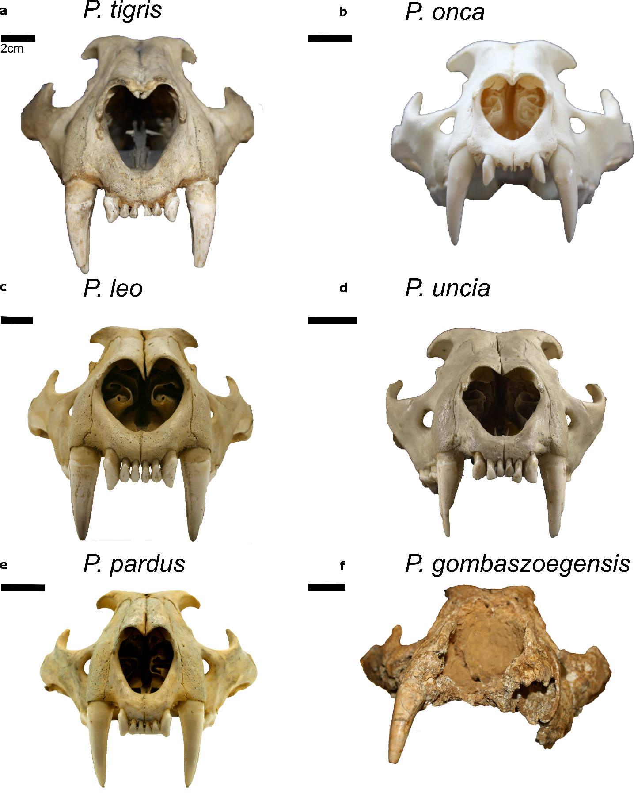
Figure S5: Crania of the different pantherines used for comparison in anterior view. a P. tigris MNHN-ZM-AC-1931-60, b P. onca MNHN-ZM 2006-641, c P. leo RMCA-34836, d P. uncia MNHN-ZO-AC 1917-18, e P. pardus RMCA-29292, f P. gombaszoegensis ULg PA BR-II-81-146
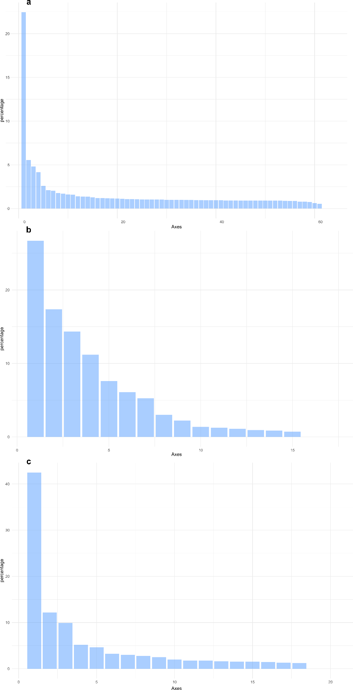
Figure S6: Percentage of variance explained by each axis in our three datasets: a upper dentition, b lower dentition and c cranium.
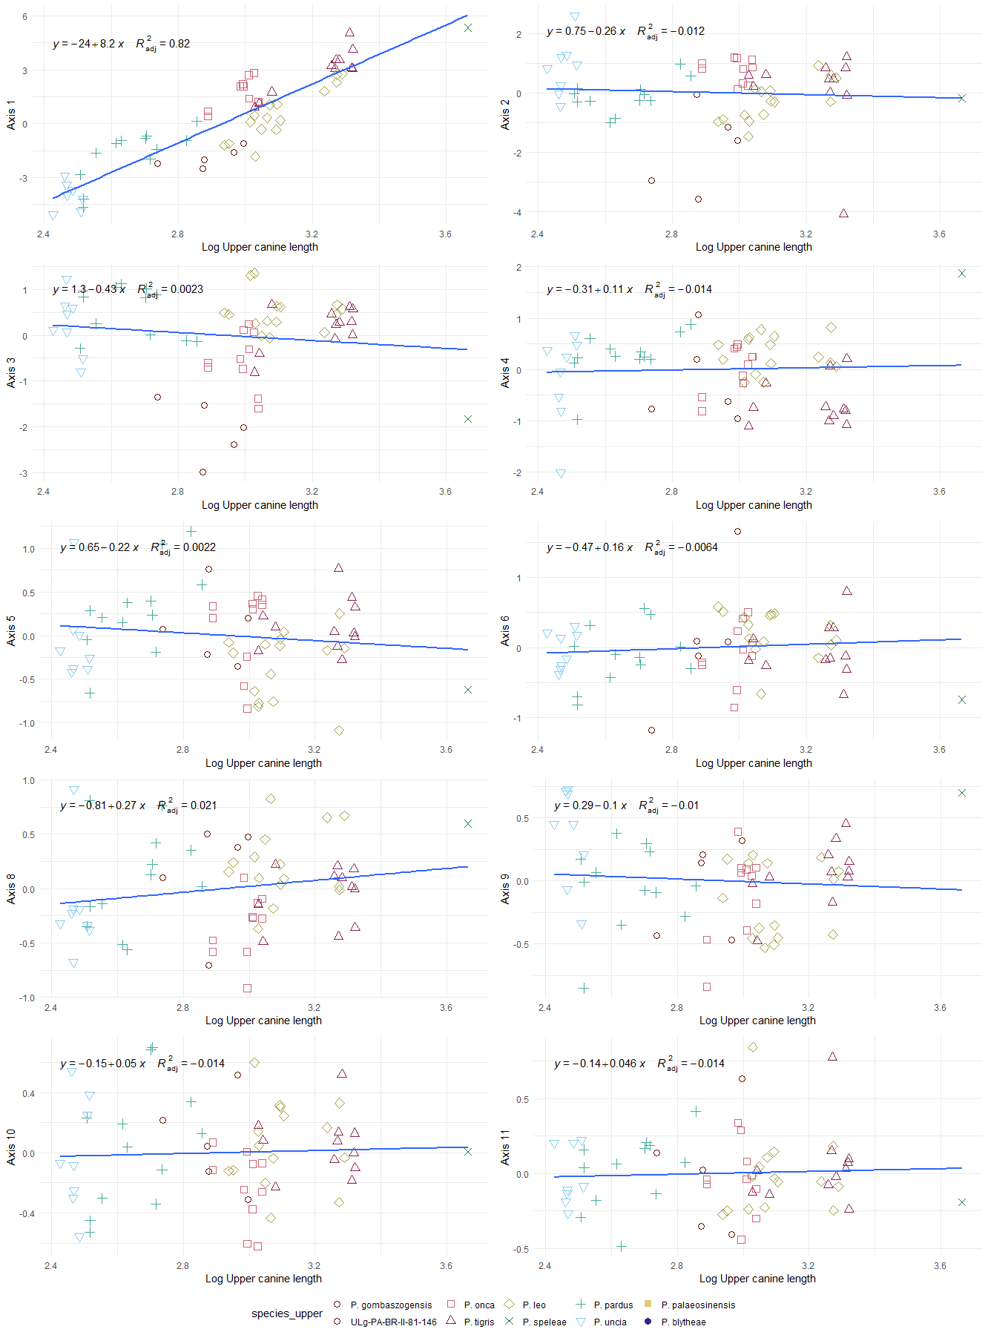
Figure S8: Regression between the upper canine length and the first 10 axes of our PCoA for the upper dentition dataset.
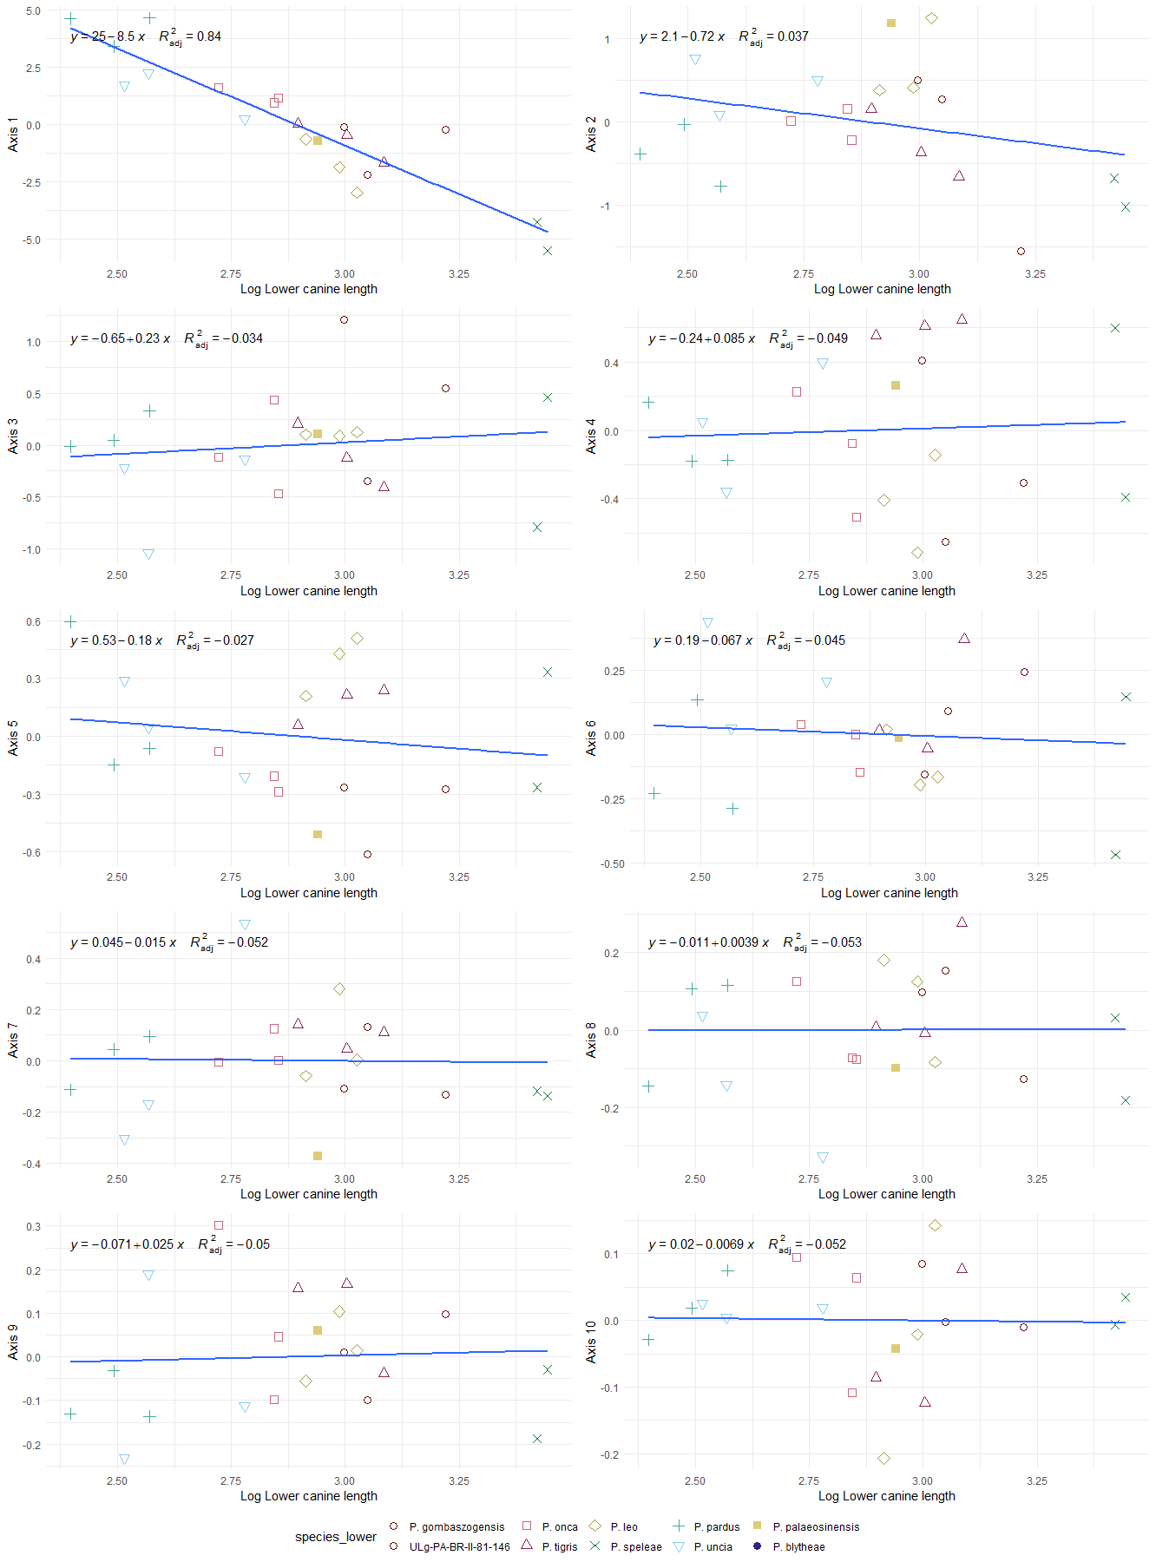
Figure S9: Regression between the lower canine length and the first 10 axes of our PCoA for the lower dentition dataset.
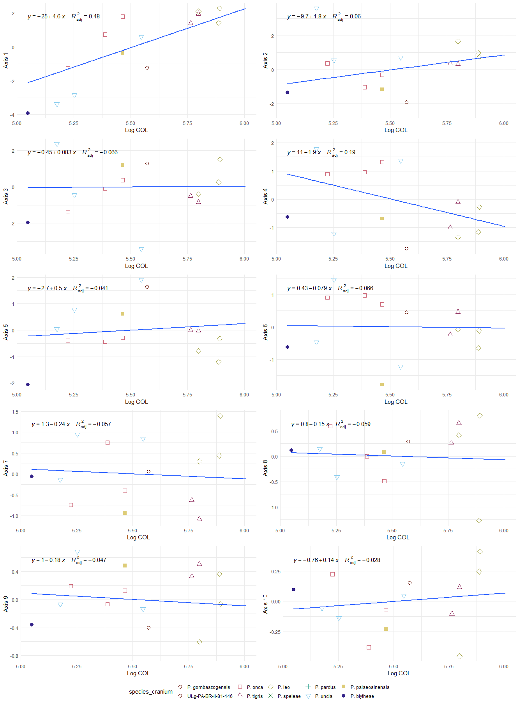
Figure S10: Regression between the canine to occiput length and the first 10 axes of our PCoA for the cranium dataset

