Thermal effects on THM coupling behaviour of COx claystone in Excavation Damage Zone

Hangbiao SONG^{* 1}, hangbiao.song@uliege.be
Frédéric COLLIN¹, f.collin@uliege.be
1: Université de Liège, UEE – Geomechanics and Engineering Geology, Liège, Belgium

Abstract:

Multi-barriers deep geological disposal is generally recognised as one of the most suitable solutions to manage high-level radioactive wastes [1]. The characterisation of in-situ THM behaviour of host rock is a crucial stage for the design of underground disposal facility and for its long-term safety. In this context, the rock response induced by temperature changes is of paramount importance. Indeed, the heat generated by the waste must not affect the favourable properties of the clay host rock for containment, especially its transport properties. In the vicinity of the drift, the excess pore pressure generated by the thermal expansion of pore water could induce fracture re-opening or propagation. In the far-field, the zone subjected to thermal loading from two neighbouring galleries could induce tensile or even shear failure and/or reactivate old fractures. The objective of current study is to investigate the multi-physical couplings associated with thermal effects and reproduce the development of strain localisation in the Excavation Damage Zone (EDZ).
A 2D plane strain generic model is proposed as a benchmark exercise within the European joint programme EURAD HITEC [2]. The geometry of this model is a cross-section of a heating drift (with support) in the host rock. Only a quarter of the full drift is modelled thanks to the symmetry of the problem and the boundary conditions. The full computation is described as three phases: excavation (0 ~ 24 h), waiting (24 h ~ 6 months) and heating (6 months ~ 10 years), conducted by adjusting boundary conditions of drift wall. The elasto-plastic mechanical law with hardening and softening is applied, and a local THM second gradient model incorporating microstructure effects allows a robust modelling of the post peak regime. The Callovo-Oxfordian claystone (COx) is selected as a candidate host formation due to its low permeability and good plasticity [3]. The numerical application is performed with the finite element code Lagamine developed at University of Liège.
The drift wall experiences a quick convergence during the excavation phase, and firstly gets partial contact with support at 45 degree direction. Strain localisation is not highly pronounced at the end of excavation, then it gradually weakens due to progressive drainage during waiting. Once the heating phase is activated, the plasticity develops rapidly, and the full contact between drift wall and support is realised subsequently. THM couplings at the drift wall are evidenced by excess pore pressure, that induces distinct growth of shear bands. Thermal effect plays a leading role in the development of strain localisation, and the shear bands occur preferably along with the minor principal stress direction.
The support plays a critical role in reproducing the in-situ coupling behaviour at EDZ, both the development of plasticity and strain localisation. On the one hand, taking a larger distance between the support and drift wall, the initiation of strain localisation is delayed, and the contact situation is also affected due to distinct convergence. The development of shear bands is influenced as well, since the cohesion is controlled by the loading conditions [4]. On the other hand, the model without support is also carried out, to investigate the influence of support on strain localisation. In that latter case, the plasticity develops quickly and the shear bands in minor principal stress direction is more pronounced.

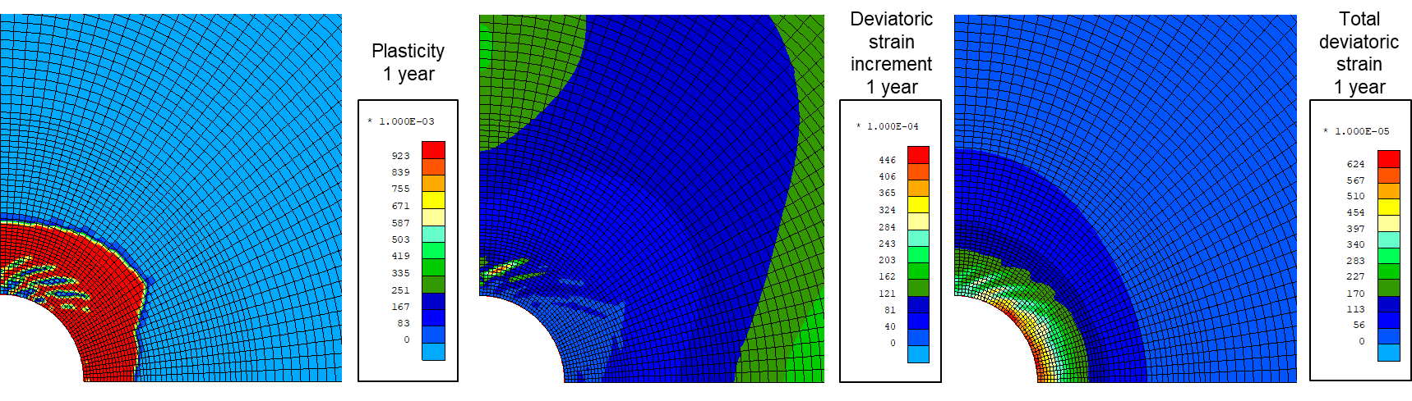
Figure 1: Evolution of strain localisation after 1 year (support distance=4.6mm)
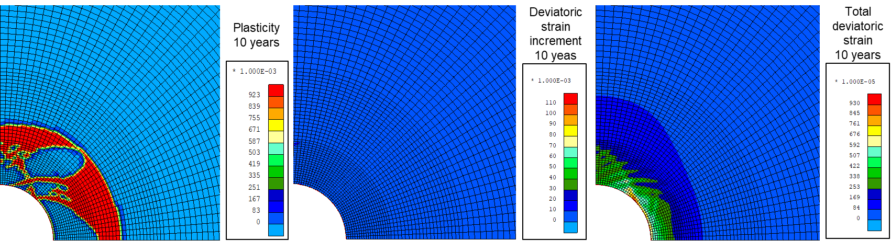
Figure 2: Evolution of strain localisation after 10 years (support distance=4.6mm)
Acknowledgments

This project has received funding from the European Union’s Horizon 2020 research and innovation programme under grant agreement No 847593.

The first author would like to thank the China Scholarship Council (No.201906710096), for their financial support.

References:

[1] NEA (2008). Moving Forward with Geological Disposal of Radioactive Waste, A Collective Statement by the NEA Radioactive Waste Management Commitee (RWMC). Technical report, OECD-Nuclear Energy Agency, Paris.

[2] EURAD WP HITEC - Milestone report 49 – Selection of benchmark exercises for task 2.3.

[3] Zhang, C.L. (2011). Experimental evidence for self-sealing of fractures in claystone. Physics and Chemistry of the Earth, 36: 1972-1980.

[4] Chen, L., Shao, J. F., and Huang, H. W. (2010). Coupled elastoplastic damage modeling of anisotropic rocks. Computers and Geotechnics, 37(1-2):187–194.

