Rapid and sensitive quantitation of DDMP (2,3-dihydro-3,5-dihydroxy-6-methyl-4H-pyran-4-one) in baked red jujubes by HS-SPME-GC-MS/MS

Yening Qiao ^{a,b}, Jinfeng Bi ^{a,**}, Qinqin Chen ^{a,*}, Xinye Wu ^{a,b}, Xinwen Jin ^{c}, Min Gou ^{a,b}, Xinrui Yang ª, Giorgia Purcaro ^{b}
- Institute of Food Science and Technology, Chinese Academy of Agricultural Sciences (CAAS)/ Key Laboratory of Agro-Products Processing, Ministry of Agriculture and Rural Affairs, 100193, Beijing, China
- Gembloux Agro-Bio Tech Department, University of Liège, 5030, Gembloux, Belgium
- Institute of Agro-products Processing Science and Technology, XinJiang Academy of Agricultural and Reclamation Science, 832000, Shihezi, China

Keywords: DDMP Baking Red jujube HS-SPME-GC-MS/MS Correlation analysis

Abstract
Baked red jujube is a common food ingredient used to enrich the nutritional value and enhance the aroma. DDMP (2,3-dihydro-3,5-dihydroxy-6-methyl-4H-pyran-4-one) with intense bitterness and potential toxicity may be present in several baked red jujube-based products but there are no well-defined methods to measure it quickly, sensitively, and accurately. Headspace solid-phase microextraction with gas chromatography-tandem mass spectrometry (HS-SPME-GC-MS/MS) was applied for the analysis of DDMP. The standard curve was linear be- tween the concentrations of 0.01 and 100 μg/mL, with a limit of detection at 0.1 ng/g that below the sensory threshold of DDMP (2.06 μg/g). Five cultivars of baked red jujubes from China were evaluated with the method for DDMP content (4.55–46.50 μg/g). The results indicated that jujube cultivars with a higher molar ratio of proline to glucose, lower moisture content, and stronger ability to resist water stress should be avoided from baking to modulate the formation of DDMP.

Abbreviations: HS-SPME-GC-MS/MS, Headspace solid phase microextraction with gas chromatography tandem mass spectrometry; DDMP, 2,3-dihydro-3,5- dihydroxy-6-methyl-4H-pyran-4-one; IS, internal standard; DVB/CAR/PDMS, divinylbenzene/carboxen/polydimethylsiloxane; PA, polyacrylate; HPAEC-PAD, high- performance anion-exchange chromatography equipped with pulsed amperometric detection; ANOVA, analysis of variance; LOD, limit of detection; LOQ, limit of quantitation; S/N, signal-to-noise; MRM, multiple reaction monitoring; RSD, relative standard deviation; MSDZ, Mingshanzazao; HZ, Huizao; JZ, Junzao; LWCZ, Lingwuchangzao; JSXZ, Jinsixiaozao.

* Corresponding author.
** Corresponding author.
E-mail addresses: bjfcaas@126.com (J. Bi), celerylc@163.com (Q. Chen).

Introduction

Red jujube (Ziziphus jujuba Mill.) represents a healthy food choice due to the high content of biologically active components such as phenolic compounds, triterpenic acids, polysaccharides, etc., which are correlated to both high nutritional values and biological activities, including antioxidant, anti-inflammatory, and antimicrobial activities (Gao et al., 2013; Kalogeropoulos et al., 2010; Feng et al., 2019; Gbaguidi et al., 2005). Red jujube is extensively cultivating in tropical and subtropical regions, such as East Asia (China), South Asia (India), North Africa, and Middle Eastern countries, and is now gradually being cultivated worldwide, including Russia, southern Asia, southern Europe, southwestern United States, and Australia (Rashwan et al., 2020). China is the native region of red jujube and over 400 cultivars are available (Li et al., 2007). Red jujube is also used as food ingredient (e.g., in breads, cakes) thus it can undergo thermal processing (involving the Maillard reaction), contributing to the formation of a particular strong aroma (Rashwan et al., 2020).
Among the formed compounds, DDMP (2,3-dihydro-3,5-dihydroxy- 6-methyl-4H-pyran-4-one), formed after 2,3-enolization and Amadori rearrangement products oxidation during baking of red jujube, is characterized by an intense bitter odor and potential toxicity (Li, Tang, et al., 2019). DDMP could also be found in various foods such as heated pear, whole wheat bread, and prunes (Bin & Peterson, 2016; Cechovska et al., 2011; Hwang et al., 2013; Lucie et al., 2011). The formation of DDMP was found to be related with sugars like glucose and fructose, amino acids including proline, tyrosine, histidine, and lysine (Zhou et al., 2014). Among which, the molar ratio of proline to glucose was important to the formation of DDMP (Nishibori & Kawakishi, 1994; Zhou et al., 2014). Furthermore, the factors of moisture content and reaction intensity were also involved in the contribution of formation of DDMP as reported by Li, Tang, et al. (2019).
Although the toxicological relevance of DDMP is not clear, it is thought to have negative consequences to human taste and animal health. DDMP was firstly identified as a novel nonenzymatic browning product, using IR spectroscopy and mass spectrometry (Mills & Hodge, 1970). It was identified in the model reaction of amino acids and sugars, using gas chromatography mass spectrometry (GC-MS) (Kim & Baltes, 1996). Recently, a method based on extraction in hexane for 30 min and 20% aqueous ethanol for 8h followed by GC-MS was applied for the determination of DDMP in wheat bread (Cechovska et al., 2011). The sample preparation was time consuming, reaching a limit of detection (LOD) of 1.00 μg/g, just slightly lower than the odor threshold of DDMP in water (2.06 μg/g) (Li et al., 2019b, 2021). Therefore, the development of a more sensitive, accurate, easy to operate, and solvent - free method for the detection of DDMP in food samples would be highly desirable.
GC coupled with tandem mass spectrometry (MS/MS)can provide the sensitivity and selectivity required with minimal sample preparation (Yost & Fetterolf, 1983). GC-MS/MS has been successfully applied in the fields of aroma and pesticide in food (Armorini et al., 2016; Hopfer et al., 2016; Kind et al., 2017; Zheng et al., 2021). For example, the detection of 2-acetyl-1-pyrroline in rice kernels, thymol and carvacrol in milk and tissues, 3-monochloro-1, 2-propanediol ester, 2-monochloro-1, 3-propanediol ester, glycidyl ester in fatty food, and pesticides in pigeonpea grains (Armorini et al., 2016; Harischandra et al., 2021; Hopfer et al., 2016; Zheng et al., 2021). However, there was no investigation carried out on the qualitative and quantitative characterization of DDMP in thermal processed red jujube.
This study aims to develop a sensitive, accurate, easy to operate, and solvent - free method using HS-SPME-GC-MS/MS for the detection of DDMP in thermal processed red jujube. The entire method was validated with regard to specificity, linearity, sensitivity, accuracy and precision using the matrix-matched method. This method was successfully applied to determine the quantity of DDMP in five cultivars of baked red jujubes.

Materials and methods

CHEMICALS

Certified chemical standards of DDMP (A Chemtek Inc, Massachusetts, USA), ethyl acetate (Macklin Biochemical Co., Ltd, Shanghai, China), 2-cyclohexen-1-one (Macklin Biochemical Co., Ltd), n-hexane (Aladdin Bio-Chem Technology Co., LTD, Shanghai, China), glucose (Sinopharm Chemical Reagent Co., Ltd, Beijing, China), and proline (Wako Pure Chemical Industries, Ltd, Chuoku, Japan) were prepared. SPME fiber coatings used in this project were 1 cm long divinylbenzene/ carboxen/polydimethylsiloxane (DVB/CAR/PDMS, 50/30 μm), PDMS/ DVB (65 μm), CAR/PDMS (85 μm), PDMS (100 μm), and polyacrylate (PA, 85 μm) (Supelco, St. Louis, MO, USA).

PREPARATION OF RAW AND BAKED RED JUJUBE SAMPLES

Red jujube samples were bought from three major red jujube trading markets (Beiyuanchun Jujube Market in Xinjiang province, Cuierzhaung Jujube Market in Hebei province, Mengzhuang Jujube Market in Henan province) in China. Five cultivars of red jujube (Junzao, Huizao, Jinsixiaozao, Lingwuchangzao, and Minghshandazao) were collected 50 kg separately and stored at 4 ◦C until tested (Table 1). Red jujube (100 g) of each cultivar without pests and diseases were cleaned, kernel removed, frozen by liquid nitrogen and ground into fine pulp with Joyoung grinder (JYL-C93T, Shandong, China). No DDMP was detected in the raw red jujube, thus it was used as a DDMP-free matrix. For the preparation of baked red jujube samples, red jujube (500 g) of each cultivar without pests and diseases were cleaned, kernel removed, sliced (4 mm) and put into an ovenware tray and baked at 180 ◦C for 4 min in an Isotemp forced-air oven (PT 2531, Media Co., Ltd., Anhui, China). The
baked slices were frozen by liquid nitrogen and ground into fine powder immediately. Accurate 1.00 ± 0.02 g of powder was put into a 20 mL vial (Welch Materials,Inc., Maryland, USA) sealed with a magnetic screwcap and septum (Welch) before testing.

PREPARATION OF STANDARD SOLUTIONS

A volume of 10 μL 2-cyclohexen-1-one diluted in n-hexane was prepared as internal standard (IS) (10 μg/mL). Standard solutions of DDMP at different concentrations (0.01, 0.1, 1, 10, and 100 μg/mL) were obtained by dilution with ethyl acetate and being added into the DDMP-free jujube matrix to create a standard curve for quantitation. The standard solutions were stored at 4 ◦C and protected from light before testing within 24h.

AUTOMATED HS-SPME CONDITIONS

An automated SPME utilizing a PAL RSI 120 autosampler (CTC Analytics AG, Zwingen, Switzerland) was used in the project. Five kinds of SPME fiber coatings including DVB/CAR/PDMS, PDMS/DVB, CAR/ PDMS, PDMS, and PA were tested for their abilities to extract DDMP
from baked Junzao. The fibers were preconditioned at 250 ◦C for 30 min firstly. The fibers were compared by using an extraction temperature of 50 ◦C for 30 min, after a 40 min equilibration period with an agitation speed of 450 rpm, together with a weight of 1.00 g baked Junzao using as the test material. DVB/CAR/PDMS was selected as it provided the largest peak area of DDMP.
The DVB/CAR/PDMS extraction was further optimized testing different extraction temperature (30, 50, and 70 ◦C) and time (5, 15, 25 and 50 min) using 40 min equilibration time. The final optimized extraction conditions were 70 ◦C for 25 min. The fiber was then desorbed for 8 min at 250 ◦C in the injection port of the GC equipped with a straight SPME inlet liner (0.75 mm ID, Agilent Technologies, Santa Clara, CA, USA).

GC-MS/MS SYSTEM AND OPERATING CONDITIONS

GC-MS/MS analysis was performed on a Xevo TQ-GC GC-MS/MS system from Waters (Milford, USA) coupled with automated SPME. The chromatographic column was a DB-WAX (30 m × 0.25 mm × 0.25 μm, Agilent Technologies). Helium (99.999%) was used as the carrier gas at a flow rate of 1.0 mL/min. The oven temperature was programmed with an initial temperature of 40 ◦C for 3 min, followed by a temperature ramp of 5 ◦C/min to 120 ◦C, 10 ◦C/min to 200 ◦C, with a final hold for 5 min. The samples were run in splitless mode with the split vent valve opened at 1.1 min with a flow of 30 mL/min and held until 2 min when it was reduced to 3 mL/min for the rest of the run. The MS transfer line and ion source were set at 250 ◦C and 200 ◦C, respectively. Instrument control, data acquisition, and processing were performed with MassLynx software (Waters).

OPTIMIZATION OF MULTIPLE REACTION MONITORING (MRM) CONDITIONS

A full mass scan mode was conducted with standard solutions of DDMP (100 μg/mL) and IS (10 μg/mL) to select target precursor ions. Mass spectra were acquired in an electron impact mode at an ionization energy of 70 eV. Then, a daughter ion scan mode was conducted to get target daughter ions with collision energy of 20eV. At last, the selected target ions were tested at various collision energy voltages (5, 10, 13, 15, 18, 20, 23, 25, 28, 30, 33, 35, 40, 45, 50 eV) to obtain the optimum MRM transitions. Argon gas (99.999% purity) was set at a flow rate of 1.5 mL/ min and used as collision gas for ion fragmentation. Dwell times were set to ensure 15–20 cycles over a peak. Optimized MRMs were selected based on highest mass counts closest to the precursor ions with minimal interferences. The following transitions were selected for DDMP: 144.10 → 54.60 (quantifier transition) and 144.10 → 100.90 (qualifier transition); for IS: 96.00 → 68.00 (quantifier transition) and 96.00 → 40.00 (qualifier transition).

VALIDATION OF HS-SPME-GC-MS/MS METHOD

The method was validated in terms of specificity, linearity, sensitivity, accuracy, and precision. To investigate the specificity of the method, the chromatogram of DDMP in baked Junzao was compared with the chromatogram of DDMP-free Junzao matrix (raw Junzao) to exclude the coelution of any endogenous interfering compounds at or close to the retention time of DDMP and IS. The evaluation of linearity, range, and linear regression function was performed by analyzing calibration curves of DDMP in concentrations of 0.01, 0.1, 1, 10 and 100 μg/mL (n = 3). The LOD (signal-to-noise (S/N) of 3:1) was used to determine the sensitivity. The limit of quantitation (LOQ) (S/N of 10:1) was determined experimentally to be the lowest spiked concentration that most consistently gave an accuracy of 100 (±15)%. Accuracy and precision were evaluated via the analysis of spiked samples using concentrations of 10, 20, 50 μg/mL (10 μL) for baked Junzao and baked Huizao. Repeatability was expressed as relative standard deviation (RSD) of the calculated concentrations of DDMP. The accuracy of the method was expressed as bias calculated from the tests.

DETERMINATION OF PROLINE

The determination of proline was mainly referred to Cho et al. (Cho et al., 2006). A Hitachi model L-8900 amino acid analyzer (Hitachi Co. Ltd., Tokyo, Japan) with a column packed with Hitachi custom ion-exchange resin 2622 (4.6 mm × 60 mm, particle size 5 μm) was applied for the analysis of amino acids. Accurate 2.0 g samples were macerated in 1% sulfo salicylic acid (50 mL) then ultrasonic treated for 20 min. A filtration (0.22 μm) volume of 20 μL was tested. Flow rates of lithium citrate buffer and ninhydrin was 0.35 mL/min and 0.30 mL/min, respectively. The column temperature ramped up from 30 ◦C to 70 ◦C and the reaction coil temperature was 135 ◦C.

DETERMINATION OF GLUCOSE

Quantitative analysis of glucose in red jujubes was performed by high-performance anion-exchange chromatography equipped with pulsed amperometric detection (HPAEC-PAD) according to Šimkovic et al. (2009). About 2.0 g homogenized red jujubes pulp was extracted with 50 mL water in ultrasonic bath (40 kHz) for 30 min. The extraction was carried out after centrifugation (20 min, 12,000 g). Then the filtered (0.45 μm) supernatant was analyzed in Dionex ICS-3000 system. An injection of 10 μL was tested in a Carbo Pac™PA20 column (3 × 150 mm) with A (water) and B (250 mmol/L NaOH) as the mobile phase. The flow rate was 0.4 mL/min and gradient elution condition was as follows: 0–20 min, 95% A and 5% B; 20–30 min, 80% A and 20% B; 30–40 min, 0% A and 100% B; 40–50 min, 95% A and 5% B. The standards of glucose were tested at the same condition for quantitative analysis.

DATA ANALYSIS

SPSS 21.0 Statistics (SPSS Inc.,Chicago, USA) was used for analysis of variance (ANOVA) and multiple comparisons. The differences at p < 0.05 were considered significant. ClustVis was applied for heatmap analysis. R language (version 2.13.0) was used for the correlation analysis.

Results and discussion

OPTIMIZATION OF MRM CONDITIONS

The precursor ion of DDMP and IS was m/z 144.10 and m/z 96.00, respectively (Fig. 1). As was shown in Fig. S1, quantifier transition and qualifier transition for DDMP were m/z 144.10 → 54.60 and m/z 144.10 → 100.90, respectively. Quantifier transition and qualifier transition for IS were m/z 96.00 → 68.00 and m/z 96.00 → 40.00, respectively. The collision energy and peak area for DDMP and IS were shown in Fig. S2. The optimized collision energies for quantifier transition and qualifier transition were listed in Table 2. The peak area of m/z 144.10 → 100.90 and m/z 144.10 → 54.60 were the first and second largest when the collision energy were 20 eV and 13 eV, respectively (Fig. S2). Besides, the collision energies of quantifier transition and qualifier transition for IS were both 20 eV (Fig. S2).

OPTIMIZATION OF HS-SPME CONDITIONS

DDMP extraction was optimized to ensure high-throughput analysis of DDMP at trace levels (far below the odor threshold of 2.06 μg/g) (Li et al., 2021). The HS-SPME condition of fiber coatings was optimized at extraction temperature of 50 ◦C for 30 min after a 40 min equilibration period with an agitation speed of 450 rpm. As was shown in Fig. 2, the peak area of DDMP reached the largest when DVB/CAR/PDMS was used. The peak area of 2-cyclohexen-1-one was the largest when CAR/PDMS was used, while the signal obtained with DVB/CAR/PDMS was roughly 38% lower, which was considered acceptable for the IS. On the whole, DVB/CAR/PDMS was selected as the fiber in this study. The result was in consistent with that of Pereira et al. (2020), who also used DVB/CAR/PDMS to extract DDMP from coffee (Pereira et al., 2020).
The adsorption time and temperature were optimized for assuring the required sensitivity and a fast overall analysis of DDMP in baked Junzao (Fig. 3). A volume of 10 μL IS (10 μg/mL) was added in the baked Junzao. Three extraction temperature (30 ◦C, 50 ◦C, and 70 ◦C) were tested, as well as four extraction time for each temperature (5, 15, 25, and 40 min). Clearly the extraction efficiency of DDMP increased raising the temperature to 70 ◦C. When the adsorption temperature was 30 ◦C and 50 ◦C, the area of IS did not change much. However, when the extraction temperature was raised to 70 ◦C, the area of IS increased a little. Thus the adsorption efficiency of both DDMP and IS was higher when the extraction temperature was 70 ◦C. Under the extraction temperature of 70 ◦C, it was observed that the area of DDMP increased gradually when the extraction time was extended from 5 min to 25 min. However, when it extended to 40 min, the extraction efficiency was not significantly improved. For IS, extraction time has no significant effect on extraction efficiency. Therefore, the optimal extraction condition could be determined as 70 ◦C for 25 min.

VALIDATION OF HS-SPME-GC-MS/MS METHOD

The target compound was identified according to European Com- mission (SANTE/11813/2017) rules. The information of retention time, mass-to-charge ratio, and monitor ion to peak area ratio should be examined. The retention time shift of the target compound in the sample and the standard should be within ±0.1 min. The mass-to-charge ratio of the target compound should be compared with that from reference. For the identification of the target compound, the peaks of the selected ions should overlap completely. Moreover, the peak area ratio is prescribed into four levels: >50%, 20–50%, 10–20% and >10%, in corresponding to the deviation of ±20%, ±25%, ±30% and ±50%, to demonstrate the reliability of the method (Chinese Pharmacopoeia (2015 Edition)). The method was validated with regard to precision, accuracy, specificity, linearity, LOD, and LOQ.

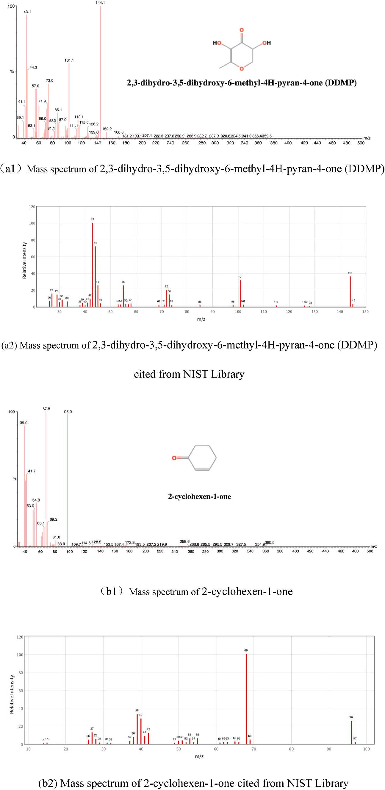
Fig. 1. (a1) Electron ionization mass spectra for 2,3-dihydro-3,5-dihydroxy-6-methyl-4H-pyran-4-one (DDMP); (a2) Mass spectrum of 2,3-dihydro-3,5-dihydroxy-6- methyl-4H-pyran-4-one (DDMP) cited from NIST Library (https://webbook.NIST.gov/chemistry/name-ser/); (b1) Electron ionization mass spectra for 2-cyclohexen- 1-one (IS: internal standard); (b2) Mass spectrum of 2-cyclohexen-1-one cited from NIST Library (https://webbook.NIST.gov/chemistry/name-ser/).
Table 1
Information of five cultivars of raw and baked red jujubes.

Code | Cultivar | Mean annual pluviometry (mm) | Mean annual temperature (C°) | Mean relative humidity (%) | Originate | Raw samples | Baked samples

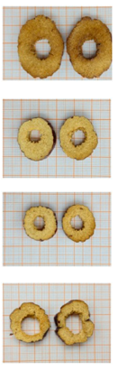
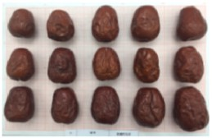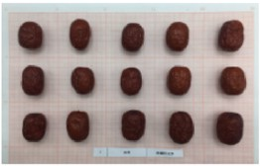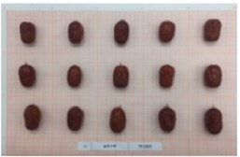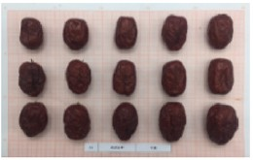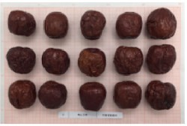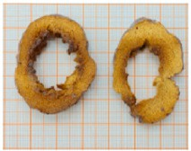
JZ
Junzao
70
5.7
56
Xinjiang Province, Akesu City
HZ Huizao Huizao jjjj
70
5.7
56
Xinjiang Province, Akesu City
JSXZ Jinsixiaozao Jinsixiaozao
600
13.3
58
Hebei Province, Cangzhou City
LWCZ Lingwuchangzao 445
8.4
60
Ningxia Province, Lingwu City
MSDZ Mingshandazao 88
9.5
57
Gansu Province,
Dunhuang City
The mean annual pluviometry was estimated over the previous 3 years.
The information of mean annual pluviometry, mean relative humidity and temperature was achieved from CHINA METEOROLOGICAL DATA SERVICE CENTRE National Meteorological Information Centre (http://data.cma.cn/en).

Table 2
The optimized condition of multiple reaction monitoring (MRM) mode for DDMP and IS.
compound | precursor ion | quantitative ion | collision energy (eV) | qualitative ion (eV) | collision energy | ratioª (%)
DDMP^{b} | 144.1 | 54.6 | 13 | 100.9 | 20 | 58.14 ± 0.23
IS^{c} | 96 | 68 | 20 | 40 | 20 | 38.43 ± 0.52
ª Represented the relative abundance ratio of qualitative ions to quantitative ions (n = 3).
^{b} DDMP:2,3-dihydro-3,5-dihydroxy-6-methyl-4H-pyran-4-one.
^{c} IS (Internal Standard):2-cyclohexen-1-one.

SPECIFICITY

As was shown in Fig. S3(a), there were no peaks in raw Junzao around retention time of 18.40 min when the transition were m/z 144.10 → 54.60 and m/z 144.10 → 100.90. In Fig. S3(b), the peaks were sharp and high in baked Junzao around retention time of 18.40 min when the transition were m/z 144.10 → 54.60 and m/z 144.10 → 100.90. Thus the specificity was proved that there were no peaks around the peak for DDMP in raw Junzao compared to baked Junzao. Besides, chromatograms showed the retention time of IS was 11.10 min. The retention time shifts for DDMP and IS were 0.02% and 0.03%, respectively (n = 3). The mass spectra of DDMP and IS were compared with those in the NIST library (Fig. 1). DDMP and IS were tentatively iden- tified. According to Table 3, the retention time of DDMP in baked red jujubes was within ±0.1 min compared to the standard. The peak area ratio of the DDMP standard was 58.14%. The deviation of the ratio in baked red jujube samples and the DDMP standard was in the 5.65–17.05% range, lower than the 20% maximum variation required by European Commission (SANTE/11813/2017) rules.

LINEARITY AND SENSITIVITY

The evaluation of linearity and range was performed by analyzing matrix-matched calibration curve in the ranges of 10–100000 ng/g for baked Junzao, using DDMP-free raw Junzao as calibration medium ( $\frac{[DDMP]}{[IS]}$ = 0.3899 × $\frac{area DDMP}{area IS}$ + 0.0266; R² = 0.992). The LOD was determined with the concentration of 0.1 ng/g (144.10 → 54.60, S/N = 10.26 > 3; 144.10 → 100.90, S/N = 5.96 > 3), which was lower than the threshold of DDMP (2.06 μg/g).14 Whereas, the LOQ was determined to be the concentration of 0.3 ng/g (144.10 → 54.60, S/N = 22.15 > 10; 144.10 → 100.90, S/N = 12.87 > 3).

ACCURACY AND PRECISION

Intraday and interday precision and accuracy of DDMP was shown in Table 4. Three different concentrations (10, 20, and 50 μg/mL) of DDMP (10 μL) was added in baked Junzao and baked Huizao to evaluate precision by RSD (%), and to evaluate the accuracy expressed as bias. RSD and recovery were demonstrated by the seven consecutive repeated analysis of standard solutions at 10, 20, and 50 μg/mL on the same day and by the repeated analysis of a sample for four consecutive days (three repeated analysis each day), respectively. The RSD of the intraday and interday repeated analysis were ≤7% and ≤11% in baked Junzao, and the bias of DDMP ranged from 1.2% to 12.1%. At the same time, the RSD of the intraday and interday repeated analysis were ≤10% and ≤14% in baked Huizao, and the bias of DDMP ranged from 3.8% to 14.6%. In general, the results indicate a reasonable precision and accuracy of the method for the determination of DDMP in baked red jujube.

EFFECT OF CULTIVARS ON DDMP CONTENTS IN BAKED RED JUJUBE

The optimized and validated method was used to evaluate the amount of DDMP in five cultivars of baked red jujube, as well as to evaluate the effect of geographical differences. The content of DDMP in baked red jujubes varied from 4.55 μg/g to 46.50 μg/g (Fig. 4). The content of DDMP was the highest in baked Mingshandazao (46.50 μg/g), followed by baked Junzao (34.15 μg/g), Lingwuchangzao (5.96 μg/g), Jinsixiaozao (5.61 μg/g), and Huizao (4.55 μg/g) in decreasing order. The content of DDMP in baked Mingshandazao and Junzao was about ten folds higher than that of baked Lingwuchangzao, Jinsixiaozao and Huizao.

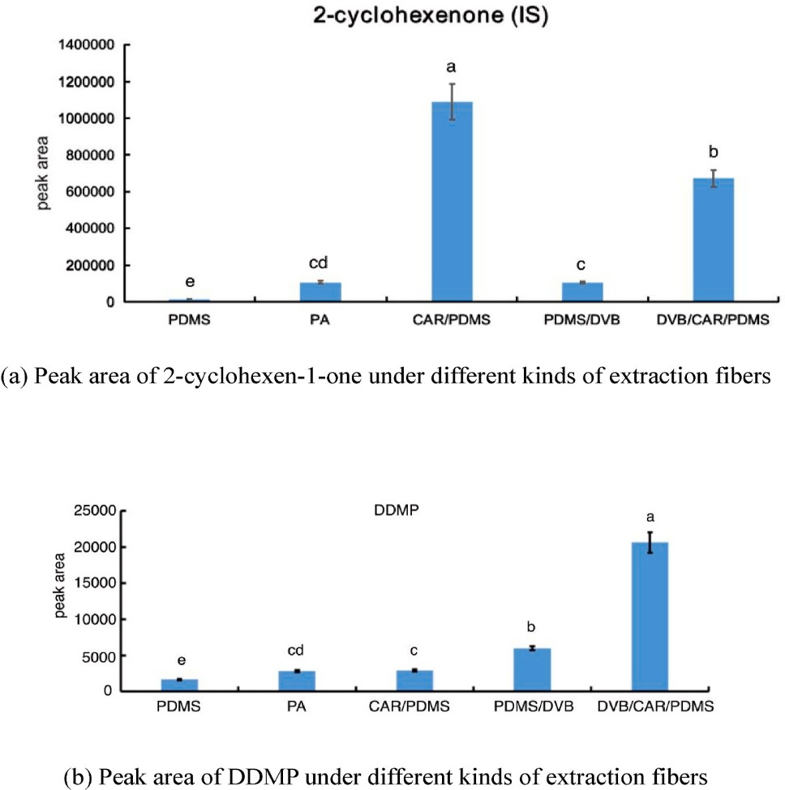

Fig. 2. Comparison of five kinds of SPME fiber coatings for the extraction of 2-cyclohexen-1-one (IS)(a) and DDMP (b) from baked Junzao. The experiments were conducted at an extraction temperature of 50 ◦C for 30 min after a 50 ◦C, 40 min equilibration period, using DB-WAX column. The sample was a weight of 1.00 ± 0.02 g baked Junzao with addition of 10 μg/mL 2-cyclohexeane (10 μL) as internal standard (IS). (DDMP, 2,3-dihydro-3,5-dihy- droxy-6-methyl-4H-pyran-4-one; CAR, carboxen; PDMS, polydimethylsiloxane; DVB, divinylbenzene; PA, polyacrylate).

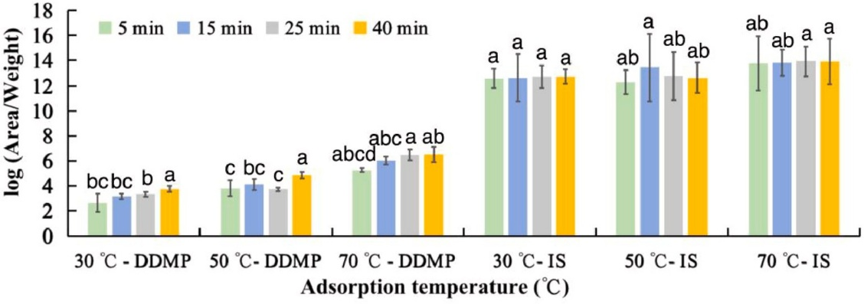
Fig. 3. Comparison of extraction time (5, 15, 25, 40 min) and temperature (30, 50, 70 ◦C) for DDMP and the IS. Error bars are standard deviations (n = 3). A weight of 1.00 ± 0.02 g baked Junzao with addition of 10 μL IS (10 μg/mL) was used as the tested sample. (DDMP:2,3-dihydro-3,5-dihydroxy-6-methyl-4H-pyran-4-one; IS (Internal Standard):2-cyclohexen-1-one). Different letters indicate significant differences at p < 0.05.
Table 3
The monitor ion to peak area ratio of DDMP in baked red jujube and the standard.
 | DDMP Standard (n= 3) | baked Huizao (n= 5) | baked Junzao (n= 5) | baked Jinsixiaozao  (n = 5) | Baked Lingwuchangzao (n= 5) | baked Mingshandazao (n= 5)
ratio ª (%) | 58.14 ± 0.23 | 48.46 ± 11.96 | 64.75 ± 7.70 | 52.49 ± 2.62 | 65.22 ± 10.46 | 41.09 ± 0.37
deviation ^{b}(%) | / | 9.68 | 6.61 | 5.64 | 7.08 | 17.05
Retention  time shift (min) | 0.01 | 0.04 | 0.01 | 0.04 | 0.01 | 0.03
DDMP: 2,3-dihydro-3,5-dihydroxy-6-methyl-4H-pyran-4-one.
ª Represented the monitor ion to peak area ratio of qualitative ions to quantitative ions.
^{b} Represented the deviation between the ratio* of DDMP in baked red jujube to that in the standard.

Table 4
Precision and accuracy of 2,3-dihydro-3,5-dihydroxy-6-methyl-4H-pyran-4-one (DDMP) obtained by HS/SPME GC-MS/MS.

Cultivar | Concentration (µg/mL) | Intraday (a) |  |  | Interday (b)
Cultivar | Concentration (µg/mL) | bias (%) | RSD (%) |  | bias (%) | RSD (%)
Baked | 10 | 5.4 | 6.9 |  | 8.5 | 10.3
Junzao | 20 | 3.2 | 4.3 |  | 12.1 | 9.2
 | 50 | 11.4 | 5.4 |  | 1.2 | 3.6
Baked | 10 | 4.3 | 3.8 |  | 4.3 | 4.2
Huizao | 20 | 7.5 | 2.5 |  | 3.8 | 5.9
 | 50 | 6.3 | 9.3 |  | 14.6 | 13.4
ª The intraday experiment was conducted with standard solutions and baked Junzao and Huizao
samples by seven times repeated analysis at the same day (n= 7).
^{b} The interday experiment was conducted with standard solutions and baked Junzao and Huizao
samples by three times repeated analysis in four different days (n = 12).

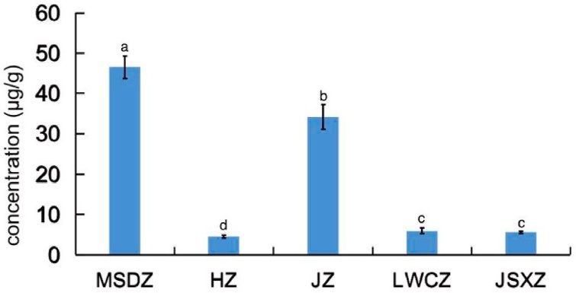
Fig. 4. The content of DDMP in different cultivars of baked red jujube (n = 5) (DDMP, 2,3-dihydro-3,5-dihydroxy-6-methyl-4H-pyran-4-one; MSDZ: Mingshanzazao; HZ: Huizao; JZ: Junzao; LWCZ: Lingwuchangzao; JSXZ: Jinsixiaozao).

ANALYSIS OF DIFFERENT DDMP CONTENT IN BAKED RED JUJUBES

The formation of DDMP is related to the Maillard reaction, which is mainly affected by temperature, water content, sugar, amino acid and other precursors (Li, Tang, et al., 2019). DDMP can be formed through two formation pathways, namely by 2,3-enolization pathway of the Maillard reaction, and on the other hand, it can also be formed during the heating of hexose (Nishibori et al., 1994; Shaw et al., 1971). The research about factors on the formation of DDMP in a solid-state Maillard reaction system demonstrated that proline and reactant molar ratio of proline to glucose have a key effect on the formation of DDMP. When the ratio of proline to glucose is greater than 1, especially when it to glucose in Mingshandazao and Junzao might be the reason for the higher DDMP content in the two cultivars of baked red jujubes.
As for the factors affecting Maillard reaction, reaction phase, amino acid properties and moisture content has been proved to affect the generation of DDMP (Li, Tang, et al., 2019). Moisture content can change the enolization site in glucose-proline system, which could affect the formation of DDMP. Research demonstrated that the lower moisture content facilitates the formation of DDMP in glucose-proline system (Li, Tang, et al., 2019). As was shown in Table 5, the moisture content in MSDZ (22.52%) and JZ (20.44%) was about 10% lower than that of HZ (31.56%), JSXZ (30.55%) and LWCZ (35.83%). Besides, the contents of DDMP in red jujube were negatively correlated with moisture content (Fig. 5). Thus, the lower moisture content in MSDZ and JZ could also promote the formation of DDMP that might lead to the higher content of DDMP.
Beside the correlation with the Maillard reaction above described and genetic influence on the DDMP content of baked red jujube, the environmental factors in the cultivation process also have an influence on the DDMP content. In fact, the cultivation conditions may affect the accumulation and composition of chemicals like sugars and amino acids, and thus affect the formation of DDMP.
The biosynthesis of proline in plants occurs mainly from glutamate via two NADPH-dependent enzyme, which was encoded by two genes (Furlan et al., 2020). Studies have shown that the stress tolerance of plants, which is decided by genes, cultivation practices or environmental factors, is closely related to the accumulation of endogenous proline (Evers et al., 2010; Hassine et al., 2008). For example, a higher accumulation of proline was observed in the drought stress tolerant cultivar of peanut (Ranganayakulu et al., 2015). Jujube, as an extremophile, has an excellent capability to survive under arid conditions with limited water availability, exhibiting high drought stress tolerant ability (Kumar et al., 2020). The plant tolerance to drought stress can also vary sub- stantially between cultivars (Furlan et al., 2020). Therefore, the gene-determined drought stress tolerant ability between cultivars will indirectly lead to the accumulation of proline content in red jujube. As was shown in Fig. 5, the relationship between DDMP and annual pluviometry, annual temperature, and relative humidity was negative. Thus, red jujube cultivars with a stronger ability to resist water stress would be more likely to produce DDMP during the baking process. Ac- cording to Tables 1 and 5, the lower mean annual pluviometry and moisture content of Junzao and Mingshandazao reflected the fact that they might suffer from a stronger water stress than others. Therefore, the two drought-adapted red jujube cultivars (Junzao and Mingshandazao) might also produce more proline in response to water stress than the other cultivars, which lead to a higher accumulation of DDMP.
Besides, taking into the factors (moisture content, glucose, proline and the molar ratio of proline to glucose) that affect the formation of DDMP in baked red jujube, the heatmap analysis showed that the cul- tivars of Huizao, Jinsixiaozao, and Mingshandazao clustered together except for Junzao and Mingshandazao (Fig. 6). Thus, the cluster analysis also proved the reliability of inference that DDMP was closely related to those chemical compositions in the correlation analysis.

Table 5
The contents of glucose, proline and moisture content in Huizao, Junzao, Jinsixiaozao, Lingwuchangzao and Mingshandazao.

indicators | Huizao | Junzao | Jinsixiaozao | Lingwuchangzao | Mingshandazao
glucose (mg/g) | 96.93 ± 7.83a | 55.25 ± 4.56c | 70.27 ± 0.06b | 62.44 ± 10.23b | 101.44 ± 10.23a
proline (mg/g) | 1.66 ± 0.12c | 2.17 ± 0.12b | 1.02 ± 0.05e | 1.21 ± 0.13d | 3.26 ± 0.20a
reactant molar ratio of proline to glucose | 0.03 ± 0.002c | 0.06 ± 0.003a | 0.02 ± 0.0012d | 0.03 ± 0.0023c | 0.05 ± 0.0021b
moisture content (g/100g) | 31.56 ± 2.21b | 20.44 ± 1.02d | 30.55 ± 4.23b | 35.83 ± 1.23a | 22.52 ± 1.40c
The results were expressed as mean ± SD (standard deviation) (n = 3). Different letters indicate significant differences at p < 0.05.

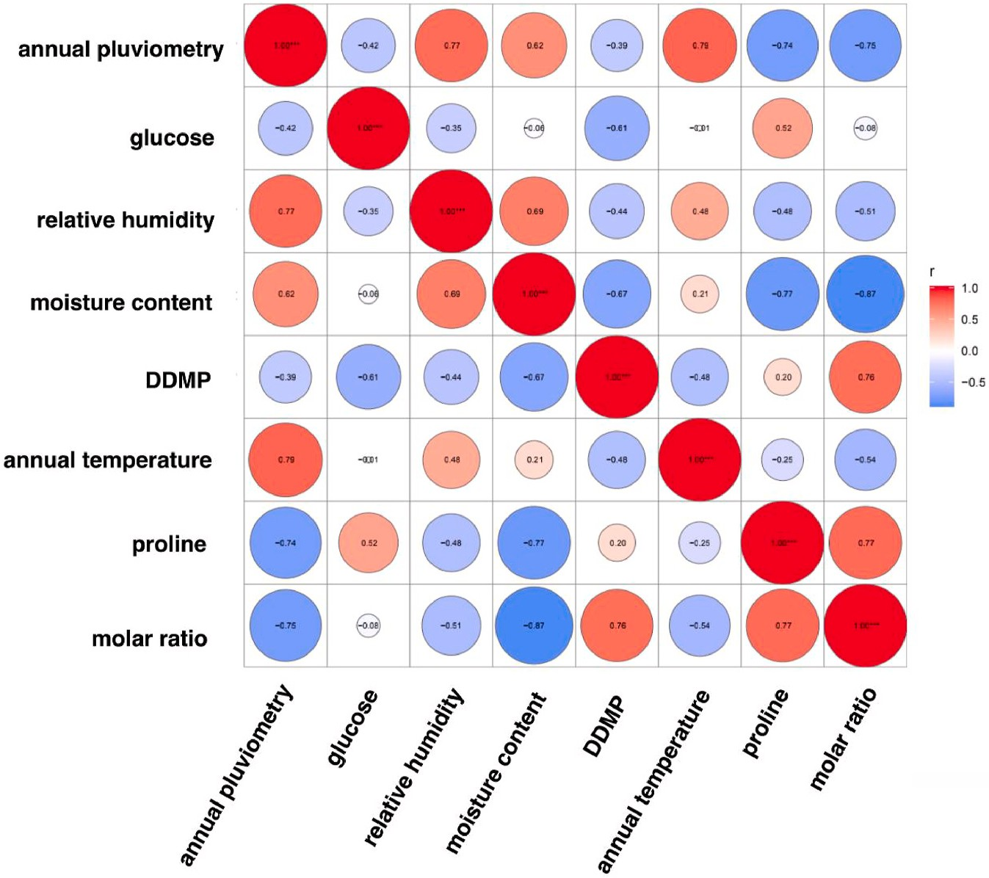
Fig. 5. Correlation analysis between the contents of 2,3-dihydro-3,5-dihydroxy-6-methyl-4H-pyran-4-one (DDMP) and glucose, proline, moisture content and resist water stress.

As one of the substances from Maillard reaction, DDMP could generate active oxygen species to cause DNA strand breaking and mutagenesis in Salmonella typhimurium TA100 without metabolic activation (Hiramoto et al., 1997). DDMP could also affect sympathetic nerve activity and metabolism in rats though the mechanism was not determined (Beppu et al., 2021). On the other hand, DDMP was proved to inhibit the activity of tyrosinase which could prevent mushroom from enzymatic browning (Xu et al., 2016). DDMP from onions could also inhibit colon cancer cell growth by inducing apoptotic cell death through the inhibition of NF-KB (Jung et al., 2007). Besides, the DDMP moiety can attach to the triterpene aglycone make it possible for scavenging toward active oxygen in soybean (Yoshiki & Okubo, 1995). The studies demonstrated that as one of the Maillard reaction products, DDMP contributed to the antioxidant activity and might present a synergistic effect with other Maillard reaction products (Yu et al., 2013). It was also speculated that the exhibited antioxidant capacities of DDMP were in relation with its stabilized endiol structure incorporated in the corresponding heterocycles both under laboratory conditions and in food (Kanzler et al., 2016).
As one of the heterocyclic compounds presented in thermal-treated foods and beverages, the qualitative and quantitative analysis set up in this project for the determination of DDMP is of high importance to evaluate food processing and storage protocols in practical applications.

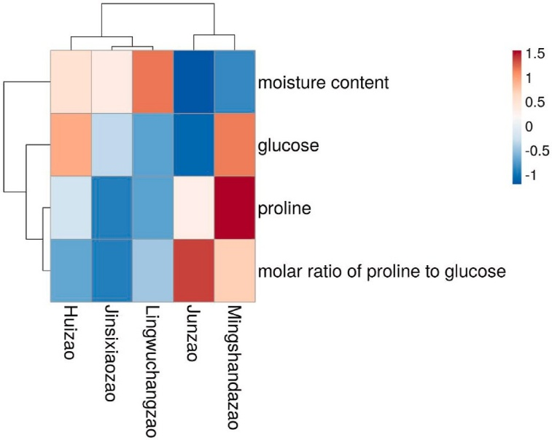
Fig. 6. Heatmap analysis of cultivars of Mingshandazao, Junzao, Lingwuchangzao, Jinsixiaozao, and Huizao based on chemical compositions.

Conclusion

In brief, a method for the quantitation of DDMP in baked red jujubes using HS-SPME GC-MS/MS has been developed. The method was vali- dated and was able to determine the DDMP content in cultivars of baked red jujube reliably and sensitively, in a range between 0.01 and 100 μg/g. Information on the occurrence of DDMP in red jujube was recorded and correlation with cultivars and geographical origin was examined. The contents of proline, glucose and moisture content in cultivars of red jujube, as well as the ability to resist water stress related to the formation of proline might correlated with the formation of DDMP.

Funding

This work was supported by the National Natural Science Foundation of China [31801564]; Financial Science and Technology Project of Xinjiang production and construction Corps [2020CB008]; Science and Technology Project in Key of Xinjiang production and construction Corps [2019AB024]; and Agricultural Science and Technology Innovation Project [CAAS-ASTIP-2020-IFST-04].

Ethical approval

This article does not contain any studies with human participants or animals performed by any of the authors.

CRediT authorship contribution statement

Yening Qiao: Conceptualization, Investigation, Formal analysis, Writing – original draft. Jinfeng Bi: Methodology, Validation, Resources, Writing – review & editing. Qinqin Chen: Methodology, Validation, Resources, Writing – review & editing. Xinye Wu: Resources, Writing – review & editing. Xinwen Jin: Resources, Writing – review & editing. Min Gou: Investigation, Writing – review & editing. Xinrui Yang: Investigation, Writing – review & editing. Giorgia Purcaro: Methodology, Validation, Resources, Writing – review & editing.

Declaration of Competing Interest

The authors declare that they have no known competing financial interests or personal relationships that could have appeared to influence the work reported in this paper.

Appendix Supplementary data

Supplementary data to this article can be found online at https://doi.org/10.1016/j.foodcont.2022.108820.

References

Armorini, S., Yeatts, J., Mullen, K., Mason, S., Mehmeti, E., Anderson, K., Washburn, S., & Baynes, R. (2016). Development of a HS-SPME-GC-MS/MS method for the quantitation of thymol and carvacrol in bovine matrices and to determine residue depletion in milk and tissues. Journal of Agricultural and Food Chemistry, 64(41), 7856–7865. https://doi.org/10.1021/acs.jafc.6b02899
Beppu, Y., Komura, H., Izumo, T., Horii, Y., Shen, J., Tanida, M., Nakashima, T., Tsuruoka, N., & Nagai, K. (2021). Identificaton of 2,3-dihydro-3,5-dihydroxy-6- methyl-4-H-pyran-4-one isolated from Lactobacillus pentosus strain S-PT84 culture supernatants as a compound that stimulates autonomic nerve activities in rats.
Journal of Agricultural and Food Chemistry, 60(44), 11044–11049. https://doi.org/ 10.1021/jf302355e
Bin, Q., & Peterson, D. G. (2016). Identification of bitter compounds in whole wheat bread crumb. Food Chemistry, 203, 8–15. https://doi.org/10.1016/j. foodchem.2016.01.116
Cechovska, L., Cejpek, K., Konecny, M., & Velisek, J. (2011). On the role of 2,3-dihydro- 3,5-dihydroxy-6-methyl-(4H)-pyran-4-one in antioxidant capacity of prunes.
European Food Research and Technology, 233(3), 367–376. https://doi.org/10.1007/ s00217-011-1527-4
Cho, I., Kim, S., Choi, H., & Kim, Y. (2006). Characterization of aroma-active compounds in raw and cooked pine-mushrooms (Tricholoma matsutake Sing.). Journal of Agricultural and Food Chemistry, 54, 6332–6335. https://doi.org/10.1021/jf060824l
European Commission Directorate-General for Health and Food Safety (SANTE). (2017). Guidance document on analytical quality control and method validation procedures for pesticides residues analysis in food and feed. Retrieved from https://www.
eurl-pesticides.eu. (Accessed 30 December 2021).
Evers, D., Lefevre, I., Legay, S., Lamoureux, D., Hausman, J. F., Gutierrez Rosales, R. O., Tincopa Marca, T. R., Hoffmann, L., Bonierbale, M., & Schafleitner, R. (2010).
Identification of drought-responsive compounds in potato through a combined transcriptomic and targeted metabolite approach. Journal of Experimental Botany, 61, 2327–2343. https://doi.org/10.1093/jxb/erq060
Feng, C., Wang, B., Zhao, A., Wei, L., Shao, Y., Wang, Y., & Zhang, F. (2019). Quality characteristics and antioxidant activities of goat milk yogurt with added jujube pulp. Food Chemistry, 277, 238–245. https://doi.org/10.1016/j.foodchem.2018.10.104
Furlan, A. L., Bianucci, E., Giordano, W., & Becker, D. F. (2020). Proline metabolic dynamics and implications in drought tolerance of peanut plants. Plant Physiology and Biochemistry, 151, 566–578. https://doi.org/10.1016/j.plaphy.2020.04.010
Gao, Q., Wu, C., & Wang, M. (2013). The jujube (Ziziphus jujuba Mill.) fruit: A review of current knowledge of fruit composition and health benefits. Journal of Agricultural and Food Chemistry, 61(14), 3351–3363. https://doi.org/10.1021/jf4007032
Gbaguidi, F., Accrombessi, G., Moudachirou, M., & Quetin-Leclercq, J. (2005). HPLC quantification of two isomeric triterpenic acids isolated from Mitracarpus scaber and antimicrobial activity on Dermatophilus Congolensis. Journal of Pharmaceutical and Biomedical Analysis, 39, 990–995. https://doi.org/10.1016/j.jpba.2005.05.030
Harischandra, N. R., Pallavi, M. S., Bheemanna, M., PavanKumar, K., Chandra Sekhara Reddy, V., Udaykumar, N. R., Paramasivam, M., & Yadav, S. (2021). Simultaneous determination of 79 pesticides in pigeonpea grains using GC-MS/MS and LC-MS/MS. Food Chemistry, 347. https://doi.org/10.1016/j.foodchem.2020.128986. Article 128986.
Hassine, A. B., Ghanem, M. E., Bouzid, S., & Lutts, S. (2008). An inland and a coastal population of the Mediterranean xero-halophyte species Atriplex halimus L. differ in their ability to accumulate proline and glycinebetaine in response to salinity and water stress. Journal of Experimental Botany, 59, 1315–1326. https://doi.org/ 10.1093/jxb/ern040
Hiramoto, K., Nasuhara, A., Michikoshi, K., Kato, T., & Kikugawa, K. (1997). DNA strand- breaking activity and mutagenicity of 2,3-dihydro-3,5-dihydroxy-6-methyl-4H- pyran-4-one (DDMP), a Maillard reaction product of glucose and glycine. Mutation Research: Reviews in Mutation Research, 395(1), 47–56. https://doi.org/10.1016/ S1383-5718(97)00141-1
Hopfer, H., Jodari, F., Negre-Zakharov, F., Wylie, P. L., & Ebeler, S. (2016). HS-SPME- GC-MS/MS method for the rapid and sensitive quantitation of 2-acetyl-1-pyrroline in single rice kernels. Journal of Agricultural and Food Chemistry, 64, 4114–4120. https://doi.org/10.1021/acs.jafc.6b00703
Hwang, I. G., Kim, H. Y., Woo, K. S., Lee, S. H., Lee, J., & Jeong, H. S. (2013). Isolation and identification of the antioxidant DDMP from heated pear (Pyrus pyrifolia Nakai). Preventive Nutrition and Food Science, 18(1), 76–79. https://doi.org/10.3746/ pnf.2013.18.1.076
Jung, O., In, G., Tae, M., Bang, Y., Ung, S., Heon, S., Young, W., Dae, J., & Jin, T. (2007). Anti-proliferate and pro-apoptotic effects of 2,3-dihydro-3,5-dihydroxy-6-methyl- 4H-pyranone through inactivation of NF-κB in human colon cancer cells. Archives of Pharmacal Research, 30(11), 1455–1463. https://doi.org/10.1007/BF02977371
Kalogeropoulos, N., Chiou, A., Ioannou, M., Karathanos, V. T., Hassapidou, M., & Andrikopoulos, N. K. (2010). Nutritional evaluation and bioactive microconstituents (phytosterols, tocopherols, polyphenols, triterpenic acids) in cooked dry legumes usually consumed in the Mediterranean countries. Food Chemistry, 121, 682–690. https://doi.org/10.1016/j.foodchem.2010.01.005
Kanzler, C., Haase, P., Schestkowa, H., & Kroh, L. (2016). Antioxidant properties of heterocyclic intermediates of the Maillard reaction and structural related compounds. Journal of Agricultural and Food Chemistry, 64(41), 7829–7837. https:// doi.org/10.1021/acs.jafc.6b03398
Kim, M., & Baltes, W. (1996). On the role of 2,3-Dihydro-3,5-dihydroxy-6-methyl-4H- pyran-4-one in the maillard reaction. Journal of Agricultural and Food Chemistry, 44 (1), 282–289. https://doi.org/10.1021/jf950208h
Kind, T., Tsugawa, H., Cajka, T., Ma, Y., Lai, Z., Mehta, S. S., Wohlgemuth, G., Barupal, D., Showalter, M. R., Arita, M., & Fiehn, O. (2017). Identification of small molecules using accurate mass MS/MS search. Mass Spectrometry Reviews, 37(4), 513–532. https://doi.org/10.1002/mas.21535
Kumar, N., Kumawat, S., Khatri, P., Singla, P., Tandon, G., Bhatt, V., Shinde, S., Patil, G., Sonah, H., & Deshmukh, R. (2020). Understanding aquaporin transport system in highly stress-tolerant and medicinal plant species jujube (Ziziphus jujuba Mill.).
Journal of Biotechnology, 324, 103–111. https://doi.org/10.1016/j. jbiotec.2020.09.026
Li, J., Fan, L., Ding, S., & Ding, X. (2007). Nutritional composition of five cultivars of Chinese jujube. Food Chemistry, 103, 454–460. https://doi.org/10.1016/j. foodchem.2006.08.016
Li, H., Tang, X. Y., Wu, C. J., & Yu, S. J. (2019). Formation of 2,3-dihydro-3,5-Dihydroxy- 6-Methyl-4(H)-Pyran-4-One (DDMP) in glucose-amino acids Maillard reaction by dry-heating in comparison to wet-heating. LWT-Food Science and Technology, 105, 156–163. https://doi.org/10.1016/j.lwt.2019.02.015
Li, H., Wu, C. J., Tang, X. Y., & Yu, S. J. (2019). Insights into the regulation effects of certain phenolic acids on the 2,3-dihydro-3,5-dihydroxy-6-methyl-4(H)-pyran-4-one (DDMP) formation in micro-aqueous glucose-proline system. Journal of Agricultural and Food Chemistry, 67(32), 9050–9059. https://doi.org/10.1021/acs.jafc.9b01182
Li, H., Zhang, W. C., Tang, X. Y., Wu, C. J., & Zhao, Z. Q. (2021). Identification of bitter- taste compounds in class-iii caramel colors. Flavour and Fragrance Journal, 36(3), 404–411. https://doi.org/10.1002/ffj.3652
Lucie, Č., Karel, C., Michae, K., & Jan, V. (2011). On the role of 2,3-dihydro-3,5-dihydroxy-6-methyl-(4H)-pyran-4-one in antioxidant capacity of prunes. European Food Research and Technology, 233(3), 367–376. https://doi.org/10.1007/s00217-011-1527-4
Mills, F. D., & Hodge, J. E. (1970). 2,3-dihydro-3,5-dihydroxy-6-methyl-4H-pyran-4-one, a novel nonenzymatic browning product. Tetrahedron Letters, 11(15), 1243–1246. https://doi.org/10.1016/S0040-4039(01)91599-0
Nishibori, S., & Kawakishi, S. (1994). Formation of 2,3-dihydro-3,5-dihydroxy-6-methyl- 4(H)-pyran-4-one from fructose and β-alanine under conditions used for baking.
Journal of Agricultural and Food Chemistry, 42, 1080–1084. https://doi.org/10.1021/ jf00041a006
Pereira, L. L., Guarçoni, R. C., Pinheiro, P. F., Osório, V. M., Pinheiro, C. A., Moreira, T. R., & Ten, C. (2020). New propositions about coffee wet processing: Chemical and sensory perspectives. Food Chemistry, 25(310). https://doi.org/ 10.1016/j.foodchem.2019.125943. Article 125943.
Ranganayakulu, G. S., Sudhakar, C., & Reddy, P. S. (2015). Effect of water stress on proline metabolism and leaf relative water content in two high yielding genotypes of groundnut (Arachis hypogaea L.) with contrasting drought tolerance. Journal of Experimental Biology and Agricultural Sciences, 3(1), 97–103. http://www.jebas.or g/00300120022015/Ranganayakulu%20et%20al%20JEBAS.pdf.
Rashwan, A. K., Karim, N., Shishir, M. R. I., Bao, T., Lu, Y., & Chen, W. (2020). Jujube fruit: A potential nutritious fruit for the development of functional food products. Journal of Functional Foods, 75. https://doi.org/10.1016/j.jff.2020.104205. Article 104205.
Shaw, P. E., Tatum, J. H., & Berry, R. E. (1971). 2,3-Dihydro-3,5-dihydroxy-6-methyl-4H- pyran-4-one, a degradation product of a hexose. Carbohydrate Research, 16, 207–211. https://doi.org/10.1016/S0008-6215(00)86115-7
Šimkovic, I., Nuñez, A., Strahan, G. D., Yadav, M. P., Mendichi, R., & Hicks, K. B. (2009).
Fractionation of sugar beet pulp by introducing ion-exchange groups. Carbohydrate Polymers, 78, 806–812. https://doi.org/10.1016/j.carbpol.2009.06.022
Xu, H., Zhang, X., & Karangwa, E. (2016). Inhibition effects of Maillard reaction products derived from l-cysteine and glucose on enzymatic browning catalyzed by mushroom tyrosinase and characterization of active compounds by partial least squares regression analysis. RSC Advances, 6(70), 65825–65836. https://doi.org/10.1039/ C6RA15769F
Yoshiki, Y., & Okubo, K. (1995). Active oxygen scavenging activity of DDMP (2,3- dihydro-2,5-dihydroxy-6-methyl-4H-pyran-4-one) saponin in soybean seed.
Bioscience Biotechnology and Biochemistry, 59, 1556–1557. https://doi.org/10.1271/ bbb.59.1556
Yost, R., & Fetterolf, D. (1983). Tandem mass spectrometry (MS/MS) instrumentation. Mass
Spectrometry Reviews, 2, 1–45. https://doi.org/10.1002/mas.1280020102
Yu, X., Zhao, M., Liu, F., Zeng, S., & Hu, J. (2013). Antioxidants in volatile Maillard reaction
products: Identification and interaction. Lebensmittel- Wissenschaft und-Technologie- Food
Science and Technology, 53(1), 22–28. https://doi.org/10.1016/j. lwt.2013.01.024
Zheng, X., Fu, W., Zheng, K., Gao, B., Lin, L., Liu, W., Lin, Z., & Fang, Q. (2021). A novel method for
the simultaneous determination of esterified 2-/3-MCPD and glycidol in foods by GC-
MS/MS. Food Control, 123. https://doi.org/10.1016/j. foodcont.2020.107766. Article
107776.
Zhou, Z., Xu, Z., Shu, J., She, S., Sun, W., Yin, C., Chen, M., Li, Y., & Zhong, F. (2014).
Influence of various factors on formation of 2,3-dihydro-3,5-dihydroxy-6-methyl-4 (H)-pyran-4-one (DDMP) in a solid-state model system of Maillard reaction. European Food Research and Technology, 239(1), 31–40. https://doi.org/10.1007/s00217-014- 2191-2

