Exploring multiple-cumulative trapping solid-phase microextraction coupled to gas chromatography–mass spectrometry for quality and authenticity assessment of olive oil

Natasha D. Spadafora ^{a,b,c}, Steven Mascrez ^{d}, Laura McGregor ^{e}, Giorgia Purcaro ^{d,*}

- DiBEST, University of Calabria, Via Ponte P. Bucci, Cubo 6b, Arcavacata Di Rende, 87036, Italy
- Markes International Ltd, 1000B Central Park, Western Avenue, Bridgend, CF31 3RT, UK
- Department of Chemical, Pharmaceutical and Agricultural Sciences, University of Ferrara, Via Luigi Borsari, n. 46, Ferrara 44121, UK
- Gembloux Agro-Bio Tech, University of Liège, Passage des Déportés 2, Gembloux 5030, Belgium
- SepSolve Analytical, 4 Swan Court, Peterborough PE7 8GX, UK

Keywords: Multiple-cumulative trapping headspace solid- phase microextraction MC-SPME Sensory evaluation Olive oil Quality Authenticity Random forest

Abstract
This study explores the potential of an innovative multi-cumulative trapping headspace solid-phase micro- extraction approach coupled with untargeted data analysis to enhance the information provided by aroma profiling of virgin olive oil. Sixty-nine samples of different olive oil commercial categories (extra-virgin, virgin and lampante oil) and different geographical origins were analysed using this novel workflow. The results from each sample were aligned and compared using for the first time a tile-based approach to enable the mining of all of the raw data within the chemometrics platform without any pre-processing methods. The data matrix obtained allowed the extraction of multiple-level information from the volatile profile of the samples. Not only was it possible to classify the samples within the commercial category that they belonged to, but the same data also provided interesting information regarding the geographical origin of the extra-virgin olive oil.

* Corresponding author at: Gembloux Agro-Bio Tech, University of Liège, Bât. G1 Chimie des agro-biosystèmes, Passage des Déportés 2, 5030 Gembloux, Belgium.
E-mail address: gpurcaro@uliege.be (G. Purcaro).

Introduction

Virgin olive oil is a high-value food commodity and an important ingredient of the Mediterranean diet with characteristic health benefits and sensory quality. According to European
Regulation No 2568/1991 and following modifications (European Commission Regulation No 2568/1991, 1991), physically extracted olive oil is classified into different commercial categories (i.e., extra virgin oil (EVO), virgin oil (VO), and lampante oil (LO)) based on physicochemical and sensory parameters. The sensory evaluation is based on highly standardised procedures following the European and the International Olive Council (IOC) methods (European Commission Regulation No 2568/1991, 1991; IOC, 2018a). Nevertheless, it still poses several trading problems due to the inherent difficulty of the sensory evaluation to guarantee robustness and reproducibility of the results. The evaluation procedure is tedious, time-consuming (4 samples can be assessed per session, with a maximum of 3 sessions per day), and costly, and considering the high number of samples that must be evaluated, may easily fail in consistency and robustness (Conte et al., 2020). The need to support the organoleptic analysis has been officially highlighted during the Horizon 2020 EU program (H2020-SFS-14a-2014) and it is one of the goals of the OLEUM European Project (Horizon 2020; Grant Agreement No. 635690).
Sensory perception is tightly correlated to the complex aroma profile of olive oil, which reflects several biological, geographical, and technological aspects (i.e., cultivar, geographical origin, fruit ripeness, processing practices, and storage). A strong effort has been dedicated to characterise and correlate the volatile profiles to the quality and authenticity attributes of the olive oil (Angerosa et al., 2004; Casadei et al., 2021; Cecchi, Migliorini, & Mulinacci, 2021; Kalua et al., 2007; Purcaro, Cordero, Liberto, Bicchi, & Conte, 2014; Quintanilla-Casas, Bustamante, et al., 2020; Quintanilla-Casas, Marin, et al., 2020; Stilo, Liberto, et al., 2019).
From the analytical viewpoint, different techniques have been used to profile the volatiles, but headspace (HS) solid-phase microextraction (SPME) coupled with gas chromatography (GC)–mass spectrometry (MS) is by far the most widely applied (Cecchi et al., 2021). HS-SPME is a solvent-free technique, easy to automate, which is based on the combination of two equilibria between three-phases (i.e. sample-HS and HS- fibre) (Pawliszyn, 2000; Zhang & Pawliszyn, 1993). The amount extracted by SPME (n) is theoretically proportional to the initial con- centration (C0) in the sample both under equilibrium and non- equilibrium conditions, but the direct proportionality between the chromatographic area and C0 is verified only when working in the HS linearity condition, which means avoiding saturation of the HS (Kolb & Ettre, 2006). Therefore, verification of HS linearity should not be neglected either when the area intensity of different samples is used as an indicator of absolute concentration, as usually done when untargeted studies of cross-sample comparisons are performed (Stilo, Cordero, Sgorbini, Bicchi, & Liberto, 2019). The HS linearity range depends on the distribution coefficient HS/sample (Khs) and the activity coefficients of the analytes, but it is generally in the 0.1–1% range of the sample concentration. Most of the applications for characterising the volatile profile of olive oil have used a sample quantity in the 1.0–6.0 g range for a 10- or 20-mL vial (Cecchi et al., 2021). However, it has been shown that these quantities largely saturate the HS, hindering the ability to perform effective cross-sample comparison by diminishing the differences and weakening the capability to discriminate among different olive oil quality categories (Mascrez & Purcaro, 2020b, 2020a; Stilo, Cordero, et al., 2019; Stilo, Liberto, et al., 2019). The use of a lower amount of sample is recommended to resolve this issue (i.e., 0.1 g in a 20-mL vial), while it does not significantly impair the sensitivity. The same authors propose the use of a multiple-cumulative trapping SPME (MC-SPME) approach, to improve the overall sensitivity (in particular for the semi-volatiles), while amplifying the difference among classes by using shorter multiple extraction time rather than a single longer extraction.
In this study, the MC-SPME–GC–MS technique using the reduced amount of sample discussed previously was validated using 69 samples (34 EVO, 22 VO, and 13 LO). Moreover, a novel post-analysis data mining platform was utilised, incorporating tile-based data analysis to reduce the complexity of the data and find class-differentiating chemical features. Tile-based Fisher ratio approaches have previously been applied to two-dimensional GC (Freye, Moore, & Synovec, 2018), but to the authors’ knowledge, this is the first reported application for one- dimensional GC–MS. The combination of the entire analytical flow- chart from MC-SPME to the data mining platform was explored for the first time in its capability to extract information at multi-levels, not only limited to the commercial class but extended to the geographical origin.

Materials and methods

CHEMICALS AND REAGENTS

A normal alkanes (C7–C30) mixture (MilliporeSigma®, USA) was used to calculate the linear retention index (LRI) and confirm peak identity. The divinylbenzene/Carboxen/polydimethylsiloxane (DVB/ CAR/PDMS) df 50/30 µm/ 1 cm length fibre was kindly provided by Millipore Sigma (USA).

OLIVE OIL SAMPLES

Samples of olive oil from different categories (i.e., EVO, VO, and LO) were kindly provided by Carapelli Firenze SpA - Italy (Deoleo group) along with the sensory evaluation, carried out by the internal recognized official panel following the IOC protocol (IOC, 2018b), and additional chemical analyses carried out according to the official method reported in Reg 2568/91 and following modifications (i.e., acidity, peroxide values, UV measurements, fatty acids profile, ethyl esters, and waxes). All the information is reported in Supplementary Table S1. A total of 69 samples of olive oil were analysed, belonging to different quality categories according to the requirements of the EU Reg 2568/91 (Commission Regulation (EEC) No. 2568/91, 1991), namely 34 EVO, 22 VO, and 13 LO. The EVO and VO samples were of verified geographical and botanical origin.

HS-SPME PROCEDURE

Quantities of 0.1 g of oil were weighed in 20-mL screw top vials, metallic caps with a central hole and polytetrafluoroethylene (PTFE)/ silicone septa (Restek, USA).
The DVB/CAR/PDMS SPME fibre was conditioned at the first use, as suggested by the manufacturer. A SPME fibre blank was performed at the start of the sampling batch and at set points during the sequence ensuring absence of carry-over. The Centri® sample extraction and enrichment platform (Markes International Ltd, Bridgend, UK) was used to perform all the MC-SPME extractions according to the conditions previously optimised (Mascrez & Purcaro, 2020a). Briefly, the sample was equilibrated for 5 min at 43 ◦C before 10 min extraction with stir- ring at 300 rpm. The fibre was then thermally desorbed at 250 ◦C for 2 min in split mode with a trap flow of 50 mL/min. The trap (U-T12ME-2S, Markes International; general-purpose in the C4–C32 volatile range) was cooled at 0 ◦C during desorption of the fibre in the injector. The HS- SPME extraction was performed three times, with a 5-min enrichment delay (at 43 ◦C), maintaining the trap at 0 ◦C during the three extractions. Then the trap was purged for 1 min at 50 mL/min and heated to 300 ◦C at the maximum ramp rate allowed by the system.
All the samples were injected once as the robustness of the method was supported by previous data on optimisation showing an average relative standard deviation (RSD) of 8.5% over a broad range of analytes (Mascrez & Purcaro, 2020a).

GC-MS ANALYSIS

A Shimadzu GC–MS (TQ8050 NX; Shimadzu, Kyoto, Japan), consisting of a GC2030 and triple-quadrupole mass spectrometer detector (TQ-MS), coupled to the Centri platform (Markes International, Bridgend, UK) was used to perform all analyses. The chromatographic column was a 30 m × 0.25 mm i.d. × 0.5 μm df SLB-5 MS capillary column [(silphenylene polymer, practically equivalent in polarity to poly(5%diphenyl/95% methylsiloxane)] obtained from MilliporeSigma (USA). GC oven temperature program: 30 ◦C for 3.5 min to 310 ◦C at 5 ◦C/min. Helium was used as carrier gas in constant linear velocity mode at 30 cm/s, corresponding to an initial inlet over-pressure of 21.6 kPa. The MS was operated in single-quadrupole mode, in EI mode at 70 eV. The ion source and transfer line temperatures were 200 ◦C and 280 ◦C, respectively. The scan range was set to m/z 50–450, with an acquisition frequency of 10 Hz. Data were acquired using Shimadzu GCMSolution Ver 4.45 (Shimadzu, Kyoto, Japan). NIST17 and FFNSC 3.0 MS commercial libraries were used for identification. Putative identification was based on the combination of the MS similarity with the NIST17 library and the FFNSC library (Shimadzu) (≥80%) with the confirmation using experimental linear retention indices (LRI) within a ± 15 range referring to the LRI reported in the databases using the same 5% stationary phase as reference.
The data acquired with GCMSolution were exported in .cdf and imported in ChromCompare+ (SepSolve Analytical, Peterborough, UK) for post-acquisition data elaboration.

DATA ELABORATION AND STATISTICAL ANALYSIS

DATA ALIGNMENT

The 69 chromatograms were firstly aligned to one user-selected reference chromatogram in ChromCompare+ software (SepSolve Analytical). The alignment algorithm was used to overcome retention time drift observed across the dataset (see Fig. S1 Supplementary In- formation). The algorithm used the available spectral information to automatically align each chromatogram in the dataset to a single ‘reference’ chromatogram. No further data pre-treatment was required.

UNTARGETED TILE-BASED APPROACH

A tile-based approach was applied to the aligned chromatograms to enable the raw data to be imported into the chemometrics platform directly, without the application of any pre-processing methods, such as integration and identification. Each chromatogram was divided into small sections or ‘tiles’ (in this case, 5-second windows with a 20% overlap), and the signal for every individual m/z channel was summed for each tile, for comparison across every chromatogram in the dataset. This resulted in thousands of analytical features, labelled according to the retention time of the tile they were located in and the specific m/z channel.
The data matrix resulting from the olive oil samples analysis was first normalised using the grand total abundance. The data underwent a square root transformation to stabilise the variance and make the distribution of the variables closer to normal (Massart, 1988).
Data reduction was then performed using the proprietary feature selection algorithm in ChromCompare+ software (SepSolve Analytical). The algorithm uses a multivariate method to consider the covariance between features. This enabled the top 100 most significant differentiators of the known sample classes (e.g., EVO versus non-EVO) to be found.
The tile-based software enables data reduction and preliminary statistical evaluation to be performed independently from the identification of each feature, significantly simplifying the overall flowchart of data elaboration. However, each feature is correlated with a specific tile; thus the retention time and m/z information are retained, allowing identification of the most significantly contributing peaks from the original chromatogram.
The number of features still outweighed the number of samples; therefore, a machine learning algorithm, namely random forest (RF) was applied to build models and select the most discriminatory core volatile analytes (Smolinska et al., 2014).

FURTHER STATISTICAL ANALYSIS

Hierarchical clustering was performed with the hclust function in package stat using MetaboAnalyst 5.0 (Pang et al., 2021). The heatmap was column normalised and each feature underwent a square root transformation to make features intensity more comparable.
Weighted correlation network analysis (WCNA) was used to correlate sensory descriptors with the top 20 discriminatory VOCs profile with a soft-power setting of 4 using ‘flashClust’ and ‘WGCNA’ in R software v.3.6.2 (Langfelder & Horvath, 2012; Muto et al., 2020).

Results and discussion

Most untargeted studies use the response of the instrument as a correlation of the concentration amount of the specific compound in the sample; therefore, despite the fact that no absolute quantification is generally performed, it is implicit and thus needs to be taken into account during method optimisation. This assumption works well unless saturation of the extraction media occurs. This is true also for HS-SPME analysis, where saturation may occur in the fibre or in the HS. The latter is often overlooked, while it is highly important to meet the HS linearity condition to validate the instrumental response/concentration correlation and to maximise the information extractable (Kolb & Ettre, 2006; Mascrez & Purcaro, 2020a; Stilo, Cordero, et al., 2019). Therefore, the sample volume to be used must be appropriately optimised. In this work, we used the conditions we previously proved optimal to maximise the level of cross-sample comparison information in terms of sample volume and number of multiple trappings (Mascrez & Purcaro, 2020a). It is worth stressing that it was observed that the use of lower sample volume affected the signal differently depending on the Khs of the analytes. Higher volatile compounds (low Khs) showed an increased signal with higher sample volume, while less volatile compounds (high Khs) were almost not affected. Moreover, it has been shown that longer extraction time increased the extraction yield of the most volatile compounds at the expense of the less volatile. This is likely due to a displacement effect which can occur when using porous fibres (Go´recki, Yu, & Pawliszyn, 1999; Trujillo-Rodríguez et al., 2017) such as the DVB/PDMS/CAR fibre used in this study. Performing MC-SPME for a shorter extraction time enhanced the sensitivity significantly for the less volatile compounds (up to ~4-folds), similar to the effect obtained applying vacuum-assisted extraction (Mascrez, Psillakis, & Purcaro, 2020), but with no addi- tional manipulation compared to traditional HS-SPME.

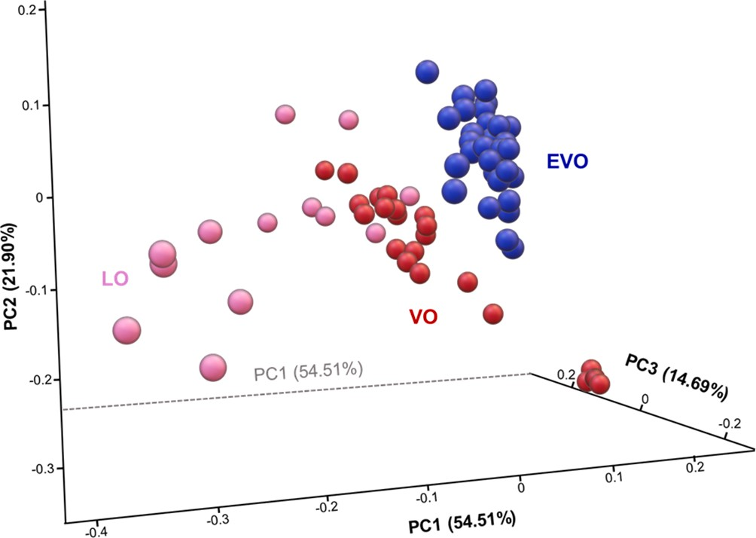
Fig. 1. Untargeted principal component analysis (PCA) of the entire set of samples analysed by MC-SPME–GC–MS.

In this work, the enhanced level of information obtainable with the MC-SPME approach was investigated in a larger number of samples (69 vs the 12 used as a proof of concept in (Mascrez & Purcaro, 2020a)) and multiple questions were investigated to extract not only the information regarding the quality category (i.e., EVO, VO, or LO) but also the geographical origin and the capability to distinguish blends of different origins.

PROFILING OF OLIVE OILS FOR QUALITY ASSESSMENT

The set of samples were examined within the post-processing platform using the entire raw data, investigating all the m/z as different channels, and finally visualising the data by means of a principal component analysis (PCA) (Fig. 1). A data reduction step was applied to minimise noise and reduce redundancy, before multivariate feature discovery to rank the features based on their significance, with the 50 most discriminatory features selected for further elaboration. The overall fingerprint of the volatile profile allowed separation of the EVO samples from the non-EVO ones, mainly towards PC1 with 54.5% of variance explained; while VO and LO were partially overlapped. For definition, the EVO samples present only positive sensory attributes since any negative attributes would declassify the sample to VO. On the other hand, VO and LO oils may present both positive and negative attributes at different intensities, thus are less well-defined. This is reflected by the partial overlap of the two clusters, as also reported previously (Quintanilla-Casas, Bustamante, et al., 2020)
The non-parametric random forest (RF) approach was applied as it has been proven to be robust to highly collinear data and resistant to different outliers (Breiman, 2001; Purcaro et al., 2018). Based on the preliminary data exploration, the samples were separated into two classes, namely EVO and non-EVO. Fig. 2 shows the PCA obtained using the top 20 most discriminatory features that were selected using random forest. The list of the selected features is reported in Table 1 along with the MS similarity match, the linear retention index (LRI) experimentally calculated and compared with the literature, and the indication of the group where each feature is more abundant. More detailed visualisation of the relative abundance of each feature between the two groups (i.e., EVO and non-EVO) is reported in Supplementary Fig. S2. Except for F18 and F20 for which no significant difference (p > 0.05) was highlighted between the EVO and non-EVO group, all the other features were significantly (p < 0.05) different. In Supplementary Fig. S1 the signifi- cance among the three groups (i.e., EVO, VO and LO) is reported.
Seventeen out of the 20 selected features were tentatively identified based on the MS similarity match over 80% and the LRI match with data reported in the commercial libraries used (i.e., NIST17 and FFNSC 3.0). All the compounds showed an LRI difference < ±15 compared to the LRI reported in the databases for the same column stationary phase, except for the earliest eluting component, for which the LRI was extrapolated as eluted before the first eluting alkane, showing a higher discrepancy (i.e., F17: –21).
The sub-group of non-EVO samples, namely VO and LO were then treated separately since the highly significant difference of this group of samples from the EVO masked the difference between VO and LO. A hierarchical cluster (HC) analysis was performed based on the top 20 features (VOCs), discriminating the different classes of oil samples and considering the similarity measure based on Pearson’s correlation and the average linkage where the clustering uses the centroids of the observations. The HM, along with the dendrogram reported in Fig. 3 provides visualisation of the data. Each coloured cell on the map corresponds to the relative abundance of each feature after square root transformation to make features intensity more comparable. The HM on the right side

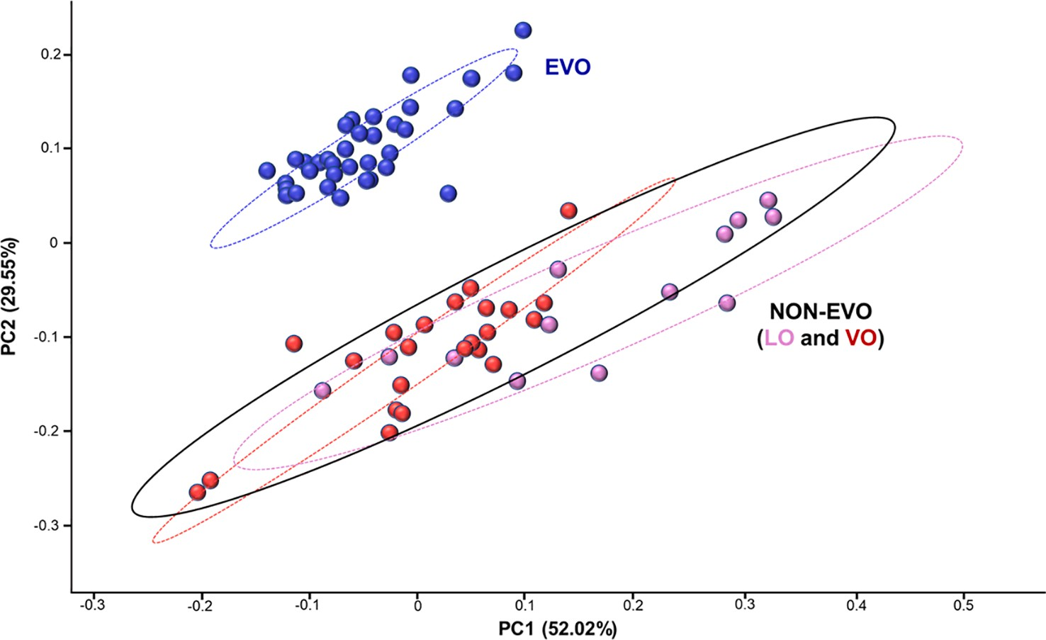
Fig. 2. Principal component analysis (PCA) obtained using the 20 top discriminatory features obtained with random forest (RF) of the entire set of samples analysed by MC-SPME–GC–MS. (For interpretation of the references to colour in this figure legend, the reader is referred to the web version of this article).
Table 1
List of the top discriminatory features extrapolated after two classes (EVO and non-EVO) random forest analysis, reported in order of elution, along with the PubChem CID, the CAS number, their octanol:air partition (Koa), mass similarity match (MS%), linear retention index (LRI) experimentally calculated and reported in the literature (LRIlib).
Feature | code | Compound | PubChem CID | CAS | Koa | MS % | LRI* | LRI_{lib} | Relative intensity#
1 | F9 | Unknown |  |  |  |  | 693 |  | ↑ EVO
2 | F17 | (E)-2-Penten-1-ol | 5364920 | 1576–96-1 | 4.44 | 85 | 748 | 769 | ↑ EVO
3 | F18 | Hexanal | 6184 | 66–25-1 | 3.84 | 97 | 818 | 806 | ↑ LO
4 | F19 | 2-Octene | 5364448 | 13389–42-9 | 3.026 | 84 | 831 | 824 | ↑ LO
5 | F20 | (E)-2-Hexenal | 5281168 | 6728–26-3 | 4.279 | 88 | 850 | 857 | ↑ VO
6 | F1 | 2-Heptanone | 8051 | 110–43-0 | 4.141 | 82 | 893 | 898 | ↑ LO
7 | F2 | (E)-2-Heptenal | 5283316 | 18829–55-5 | 4.341 | 95 | 957 | 956 | ↑ LO
8 | F3 | 1-Octen-3-ol | 18827 | 3391–86-4 | 5.625 | 86 | 981 | 978 | ↑ LO
9 | F4 | Octanal | 454 | 124–13-0 | 4.457 | 92 | 1003 | 1005 | ↑ LO
10 | F5 | (E)-2-Octenal | 5283324 | 2548–87-0 | 5.093 | 85 | 1059 | 1053 | ↑ LO
11 | F6 | (Z)-3-Nonen-1-ol | 5364631 | 10340–23-5 | 5.91 | 81 | 1072 | 1077 | ↑ LO
12 | F7 | Methyl nonyl ether | 522469 | 7289–51-2 |  | 83 | 1092 | 1091 | ↑ LO
13 | F8 | 4-Ethylphenol | 31242 | 123–07-9 | 7.08 | 91 | 1165 | 1166 | ↓EVO
14 | F10 | Pulegone | 442495 | 89–82-7 | 5.451 | 92 | 1240 | 1241 | ↓EVO
15 | F11 | Carvone | 7439 | 99–49-0 | 5.21 | 95 | 1244 | 1246 | ↓EVO
16 | F12 | α-Terpinyl acetate | 111037 | 80–26-2 | 5.336 | 84 | 1350 | 1349 | ↓EVO
17 | F13 | Unknown lactone | – | – | – | – | 1363 | – | ↑ LO
18 | F14 | Tetradecane | 12389 | 629–59-4 | 4.625 | 92 | 1398 | 1400 | ↓EVO
19 | F15 | Unknown alkane | – | – | – | – | 1406 | – | ↓EVO
20 | F16 | 1-Hexadecanol | 2682 | 36653–82-4 | 9.256 | 84 | 1882 | 1884 | ↓EVO
*Calculated using the normal alkanes (C₇–C₃₀) mixture from MilliporeSigma® on a 30 m × 0.25 mm i.d. × 0.5 μm d_{f} SLB-5-MS capillary column [(silphenylene polymer, practically equivalent in polarity to poly(5%diphenyl/95% methylsiloxane)].
# Boxplots of the relative abundance of each feature within the groups, (i.e., EVO, VO and LO) are reported in Supplementary Fig. S2.

shows results from WCNA analysis based on the Pearson’s correlation of each compound with the sensory descriptor. A negative correlation is shown in blue, while a positive correlation is shown in red. The sensory evaluation score is reported in Supplementary Table S1 and it was provided by an official/recognised panel following the exact procedure elucidated in the IOC guidelines (IOC, 2018b).
Three main hierarchical clusters among features are visible. The first one includes from F5 [(E)-2-octenal] to F19 (2-octene) where higher relative abundance (reddish colour on the cells) is shown in most of the LO samples. These compounds show a negative correlation with fruitiness, spiciness, and bitterness, and are positively correlated to the negative attributes. Indeed their odour quality is generally referred to as fat, grassy, nut, mouldy, earthy (Kalua et al., 2007; Üçüncüoğlu & Sivri-Ö zay, 2020). In particular, F2 [(E)-2-heptenal], F5 [(E)-2-octenal] and F18 (hexanal) have been reported in the literature as correlated to rancid attributes (Angerosa et al., 2004; Kalua et al., 2007).
The second cluster includes features from F13 (unknown lactone) to F15 (unknown alkane) in Fig. 3. These compounds are mostly low in LO samples, and generally show a higher abundance in VOs and specifically the highest relative abundance in four VOs (i.e., S3, S4, S5, S68), except for F13 (unknown lactone) that shows a fluctuating pattern. Most of the compounds of this cluster are also positively correlated to the positive sensory attributes. Among these, F20 [(E)-2-hexenal] has been largely reported as specific of EVO, thus related to positive attributes (Cecchi et al., 2021), F17 [(E)-2-penten-1-ol] has been reported by Cecchi and co-workers (Cecchi et al., 2020) as characteristic of EVO. This features cluster includes 1-hexadecanol, a long-chain alcohol reported as being characterised by bivalent descriptors, such as waxy, greasy, but also floral (Üçüncüoğlu & Sivri-Ö zay, 2020).
The third cluster from F4 (octanal) to F11 in Fig. 3 shows no sig- nificant trends across the samples. This lack of correlation is reflected in the sensory descriptors, which are only slightly more positively correlated to the positive attributes, except for octanal (F4), which shows a marked positive correlation to mouldy (musty-humid earthy) and fusty/ muddy as previously reported (Purcaro et al., 2014; Sales, Portol´es, Johnsen, Danielsen, & Beltran, 2019). The compounds of this cluster are also relatively more intense in the LOs, which present scores > 0 on the positive attributes (Supplementary Table S1). Moreover, in this group, carvone (F11) and pulegone (F10) are present, which so far have been reported only in aromatized olive oils (Assami, Chemat, Meklati, & Chemat, 2016; Kiralan, Karagoz, Ozkan, Kiralan, & Ketenoglu, 2021).

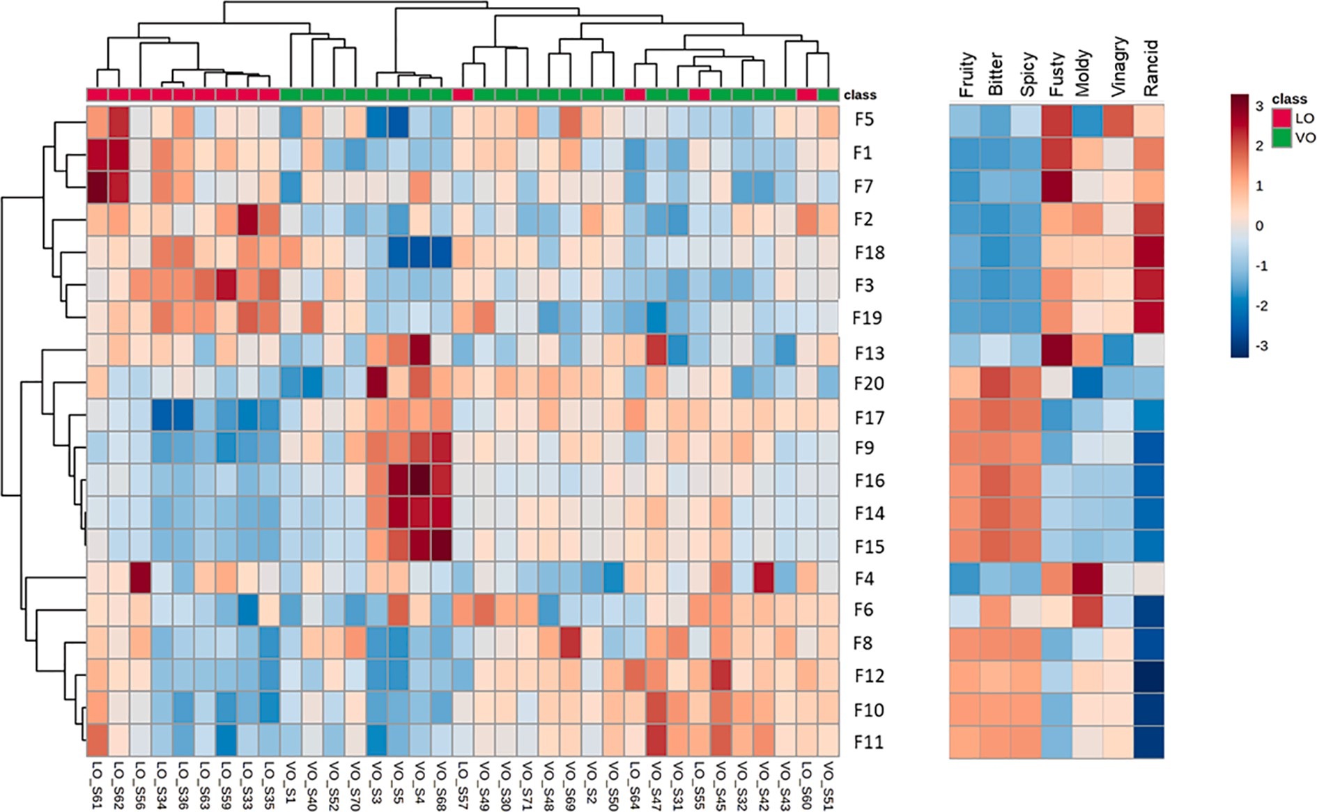
Fig. 3. Results of the hierarchical cluster analysis showed through a heatmap and a dendrogram. Weighted correlation network analysis (WCNA) was used to correlate sensory descriptors with the top 20 discriminatory VOCs profile with a soft-power setting of 4. Each coloured cell on the map corresponds to the relative abundance of each feature (column normalised) after square root transformation to make features intensity more comparable. Red colour showed higher intensity and positive correlation, while blue is lower intensity and negative correlation. (For interpretation of the references to colour in this figure legend, the reader is referred to the web version of this article).

GEOGRAPHICAL ORIGINS OF EXTRA VIRGIN OLIVE OIL

The second step of the research focused on the EVO samples and particularly on the samples with a specific geographical origin to evaluate the capability of the volatiles to discriminate and verify the authenticity information reported on the label. The geographical origin of the EVOs represents a significant added value on the final price, since consumers are willing to pay more for products from a specific known region compared to a blended EVO (European Union, 2006). Therefore, it is necessary to find a reliable and robust tool to verify the absence of commercial frauds, which are common and not yet easily detectable, despite several different instrumental approaches that have been pro- posed over the years (Cajka et al., 2010; Gumus, Celenk, Tekin, Yurdakul, & Ertas, 2017; Mohamed et al., 2018; Ruis´anchez, Jim´enez- Carvelo, & Callao, 2021). Among the different characteristics investigated, the volatile profile of olive oil has been proven highly correlated with the geographical origin (Cecchi et al., 2020; Luki´c, Carlin, Horvat, & Vrhovsek, 2019; Ouni et al., 2011). Nevertheless, the volatile fingerprinting is complicated by the many factors that affect the volatile profile besides the geographical origin, such as the pedoclimatic con- ditions during the tree’s growth, the varietal origin, the olive processing conditions, and storage (Angerosa et al., 2004). In this study, the use of a properly optimised sample volume (i.e., 0.1 g) coupled with the innovative MC-HS-SPME approach allowed maximisation of the extractable information thanks to the fact that the HS was not saturated, thus guaranteeing an unbiased volatile profile. Such an approach, proven successful for quality discrimination, has never been investigated for authentication purposes. Here the subset of EVO samples (n = 34) was separately analysed to explore such a capability. In the set of 34 samples, 12 samples were from Spain, 10 samples from Italy, 2 samples from Tunisia, the remaining 10 were blends of oil of different origins in known ratios created by the company for its commercial purposes (Supplementary Table S1). Among them only 9 were monovarietal and one was of an unknown cultivar.

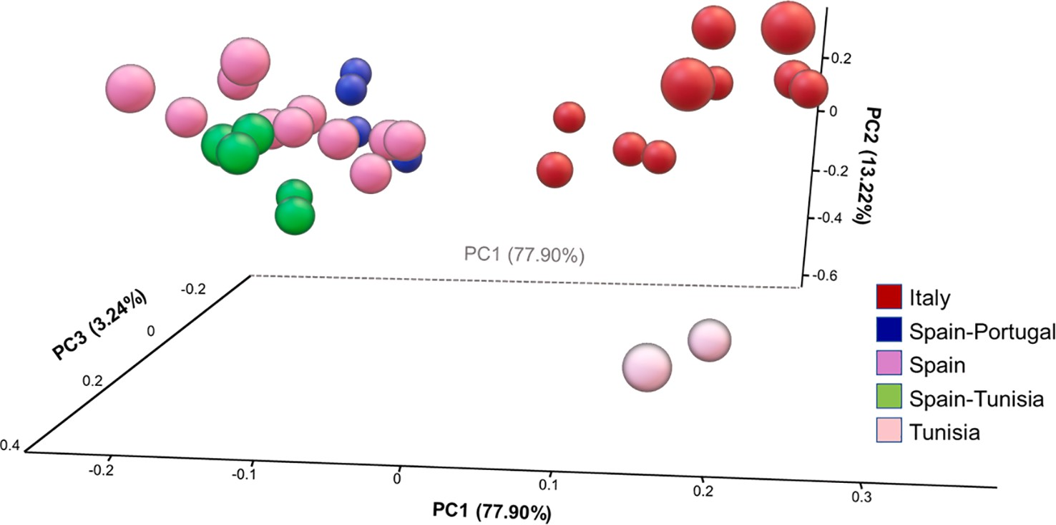
Fig. 4. Principal component analysis (PCA) obtained using the 12 top discriminatory features obtained with random forest (RF) using the 34 EVO samples analysed by MC-SPME–GC–MS. The RF algorithm was performed in a 3-class model, namely Italy, Spain and Tunisia, while the blends were later projected in the PCA. (For interpretation of the references to colour in this figure legend, the reader is referred to the web version of this article).
In this case, the dataset was split into classes based on the known origin of the sample (i.e., Spain, Italy, Tunisia, etc.) and subjected to grand total normalisation and square root transformation. A three-cluster model was created based on the three geographical origins available after multivariate feature discovery. The 25 most significant features based on random forest selection were visualised in a three-dimensional PCA (Fig. 4). In total, 12 compounds were identified as contributing to the top 25 differences – this is due to the nature of the tile-based approach, where overlapped sections are used (i.e., the same compound was found across multiple tiles). The list of the 12 identified compounds is reported in Table 2, along with the similarity match, LRI and the group where the feature is predominant among the three groups (boxplots of the relative abundance of each feature within the three geographical origins (i.e., Spain, Italy and Tunisia) are reported in Supplementary Fig. S3.
A total explained variance of ~98% was reported by the first three PCs (PC1: 83.15%, PC2: 12.89%, and PC3: 2.96%). The three geographical regions were very well discriminated from each other, without any misassigned sample. The blended samples were plotted in the PCA obtained using the selected feature from the 3-class model. All the blended samples were clustered with the Spanish samples, indeed the most abundant origin (over 75%) for all of them. It is important to highlight that the blends were mainly composed of Spain/Tunisia and Spain/Portugal. Samples originated only from

Table 2
List of the top discriminatory features extrapolated after random forest analysis to discriminate the three different geographical regions, namely Spain, Italy and Tunisia, reported in order of elution, along with the PubChem CID, the CAS number, their octanol air partition (Koa), mass similarity match (MS%), linear retention index (LRI) experimentally calculated and reported in the literature (LRIlib).
Compound | PubChem CID | CAS | Koa | MS% | LRI* | LRI _{lib} | Relative abundance#
F8 (E)-2-Penten-1-ol | 5364920 | 1576–96-1 | 4.44 | 83 | 751 | 769 | ↑ SP
F9 Unknown | – | – | – | – | 839 | – | ↑ Tun
F10 Methyl 3-methyl-2-  butenoate | 13546 | 924–50-5 | 4 | 82 | 855 | 842 | ↑ Tun
F11 (E)-2-Hexenal | 5281168 | 6728–26-3 | 4 | 97 | 862 | 850 | ↑ IT
F12 (Z)-3-Hexen-1-ol | 10993 | 928–96-1 | 5 | 92 | 865 | 868 | ↑ SP
F1 (E)-2-Heptenal | 5283316 | 18829–55-5 | 4 | 86 | 957 | 956 | ↑ Tun
F2 Unknown |  |  |  |  | 962 |  | ↑ SP
F3 1-Heptanol | 8129 | 111–70-6 | 6 | 85 | 972 | 970 | ↑ Tun
F4 1-Octen-3-ol | 18827 | 3391–86-4 | 6 | 84 | 981 | 978 | ↑ Tun
F5 2-Octanone | 8093 | 111–13-7 | 4 | 82 | 992 | 990 | ↑ Tun
F6 (Z)-3-Hexenyl acetate | 5363388 | 3681–71-8 | 4 | 97 | 1008 | 1008 | ↑ SP
F7 (Z)-3-Hexenyl propanoate | 91748607 | 33467–74-2 | 5 | 80 | 1100 | 1101 | ↑ SP
*Calculated using the normal alkanes (C₇–C₃₀) mixture from MilliporeSigma® on a 30 m × 0.25 mm i.d. × 0.5 μm d_{f} SLB-5-MS capillary column [(silphenylene polymer, practically equivalent in polarity to poly(5%diphenyl/95% methylsiloxane)].
# Boxplots of the relative abundance of each feature within the 3 groups, (i.e., Spain, Italy and Tunisia) are reported in Supplementary Fig. S3.

Spain were the most abundant (12 samples), while no sample originated from Portugal and only two samples from Tunisia were available. Therefore, the statistical power of the two underrepresented geographical regions was feeble (i. e., Tunisia) or null (i.e., Portugal). Nevertheless, it can be observed that all the blends clustered with the corresponding main geographical origin (i.e., Spain) but at the edge of the cluster. The two samples that slightly moved away from the Spain cluster towards Tunisia, were S22 and S10, composed of 15% and 10% of Tunisia-originated oil, respectively. Among the remaining three Spain/Tunisia blends, samples S12 and S23 were characterised by <3.5% of Tunisian oil, while S25 had 10% Tunisian oil but clustered close to the other two blend samples.
It can be hypothesised that with a proper sampling distribution of the different origin and a dedicated experimental design, it could be possible to create a kind of calibration to set a minimum blend addition to discriminate the presence of a different origin oil and possibly a calibration to estimate the different quantity used in the blend.

Conclusion

The present study confirmed the potential of volatiles fingerprints in supporting quality and authenticity assessment in the field of olive oil volatiles. The use of a reduced sample amount (i.e., 0.1 g) to avoid HS saturation and of the recently introduced MC-HS-SPME approach was proven successful in answering multiple questions in the field of olive oil quality and authenticity. The generation of a more representative volatile profile as not biased by saturation and displacement effects allowed the extraction of a high level of information already from the untargeted cross-sample comparison, i.e., EVO vs non-EVO. The use of an integrated data elaboration platform which used a tile-based Fisher ratio approach usually applied in 2D GC but here tested for the first time in 1D GC, allowed the differentiation of VO and LO oil with a satisfactory degree of certainty. Moreover, the volatile profile was clearly distinguished among different geographical regions, showing promising results on the possibility to create a “mixture scale” to highlight the presence of blended oil samples. Further devoted studies would be necessary in this direction with a much larger set of samples of each geographical area and their mixture to increase the statistical power and the accuracy of the model.

CRediT authorship contribution statement

Natasha D. Spadafora: Formal analysis, Visualization, Writing – review & editing. Steven Mascrez: Investigation, Methodology. Laura McGregor: Formal analysis, Visualization, Writing – review & editing. Giorgia Purcaro: Conceptualization, Methodology, Formal analysis, Visualization, Writing – original draft, Writing – review & editing, Re- sources, Supervision, Project administration, Funding acquisition.

Declaration of Competing Interest

The authors declare the following financial interests/personal re- lationships which may be considered as potential competing interests: Natasha Spadafora is employed by Markes International Ltd. Laura McGregor is employed by SepSolve Analytical.

Acknowledgments

The authors thank Supelco (MilliporeSigma) for providing the SPME fibres and Shimadzu for their support. N.D.S. contribution was sup- ported by Fondazione con il Sud, call Brain2South, as part of the FRUITY collaborative project (2015-0245). This article is based upon work from the Sample Preparation Study Group and Network, supported by the Division of Analytical Chemistry of the European Chemical Society.

Appendix A. Supplementary data

Supplementary data to this article can be found online at https://doi. org/10.1016/j.foodchem.2022.132438.

References

Angerosa, F., Servili, M., Selvaggini, R., Taticchi, A., Esposto, S., & Montedoro, G. (2004). Volatile compounds in virgin olive oil: Occurrence and their relationship with the quality. Journal of Chromatography A, 1054(1–2), 17–31. https://doi.org/10.1016/j. chroma.2004.07.093
Assami, K., Chemat, S., Meklati, B. Y., & Chemat, F. (2016). Ultrasound-assisted aromatisation with condiments as an enabling technique for olive oil flavouring and shelf life enhancement. Food Analytical Methods, 9(4), 982–990. https://doi.org/ 10.1007/s12161-015-0273-9
Breiman, L. (2001). Random forests. Machine Learning, 45(1), 5–32. https://doi.org/ 10.1023/A:1010933404324
Cajka, T., Riddellova, K., Klimankova, E., Cerna, M., Pudil, F., & Hajslova, J. (2010). Traceability of olive oil based on volatiles pattern and multivariate analysis. Food Chemistry, 121(1), 282–289. https://doi.org/10.1016/j.foodchem.2009.12.011
Casadei, E., Valli, E., Aparicio-Ruiz, R., Ortiz-Romero, C., García-González, D. L., Vichi, S., … Toschi, T. G. (2021). Peer inter-laboratory validation study of a harmonized SPME-GC-FID method for the analysis of selected volatile compounds in virgin olive oils. Food Control, 123, 107823. https://doi.org/10.1016/j. foodcont.2020.107823
Cecchi, L., Migliorini, M., Giambanelli, E., Rossetti, A., Cane, A., Mulinacci, N., & Melani, F. (2020). Authentication of the geographical origin of virgin olive oils from the main worldwide producing countries: A new combination of HS-SPME-GC-MS analysis of volatile compounds and chemometrics applied to 1217 samples. Food Control, 112(February), Article 107156. https://doi.org/10.1016/j. foodcont.2020.107156
Cecchi, L., Migliorini, M., & Mulinacci, N. (2021). Virgin olive oil volatile compounds: Composition, sensory characteristics, analytical approaches, quality control, and authentication. Journal of Agricultural and Food Chemistry, 69(7), 2013–2040. https://doi.org/10.1021/acs.jafc.0c0774410.1021/acs.jafc.0c07744.s001
Commission Regulation (EEC) No 2568/91. (1991). Official Journal of the European Communitiy. 2004R0726 – v.7 of 05.06.2013.
Conte, L., Bendini, A., Valli, E., Lucci, P., Moret, S., Maquet, A., … Gallina Toschi, T. (2020). Olive oil quality and authenticity: A review of current EU legislation, standards, relevant methods of analyses, their drawbacks and recommendations for the future. Trends in Food Science and Technology, 105(February 2019), 483–493.10.1016/j.tifs.2019.02.025.
European Commission Regulation No 2568/1991. (1991). Commission Regulation (EEC) No 2568/91 of 11 July 1991 on the characteristics of olive oil and olive-residue oil and on the relevant methods of analysis. Official Journal of the European Commission. Union, E. (2006). Council regulation (EC/510/2006) of 20 March 2006 on the protection of geographical indications and designations of origin for agricultural products and foodstuffs. Official Journal of the European Union, L93(510), 12–25.
Freye, C. E., Moore, N. R., & Synovec, R. E. (2018). Enhancing the chemical selectivity in discovery-based analysis with tandem ionization time-of-flight mass spectrometry detection for comprehensive two-dimensional gas chromatography. Journal of Chromatography A, 1537, 99–108. https://doi.org/10.1016/j.chroma.2018.01.008
Górecki, T., Yu, X., & Pawliszyn, J. (1999). Theory of analyte extraction by selected
porous polymer SPME fibres. Analyst, 124(5), 643–649. https://doi.org/10.1039/ a808487d
Gumus, Z. P., Celenk, V. U., Tekin, S., Yurdakul, O., & Ertas, H. (2017). Determination of trace elements and stable carbon isotope ratios in virgin olive oils from Western Turkey to authenticate geographical origin with a chemometric approach. European Food Research and Technology, 243(10), 1719–1727. https://doi.org/10.1007/ s00217-017-2876-4
IOC. (2018a). Sensory Analysis of Olive Oil – Method for the Organoleptic Assessment of Virgin Olive Oil. International Olive Council, (15).
IOC. (2018b). Sensory Analysis of Olive Oil – Method for the Organoleptic Assessment of Virgin Olive Oil. International Olive Council, (15). Retrieved from http://www. internationaloliveoil.org/estaticos/view/224-testing-methods.
Kalua, C. M., Allen, M. S., Bedgood, D. R., Bishop, A. G., Prenzler, P. D., & Robards, K. (2007). Olive oil volatile compounds, flavour development and quality: A critical review. Food Chemistry, 100(1), 273–286. https://doi.org/10.1016/j. foodchem.2005.09.059
Kiralan, S. S., Karagoz, S. G., Ozkan, G., Kiralan, M., & Ketenoglu, O. (2021). Changes in Volatile Compounds of Virgin Olive Oil Flavored with Essential Oils During Thermal and Photo-Oxidation. Food Analytical Methods, 14(5), 883–896. https://doi.org/ 10.1007/s12161-020-01926-w
Kolb, B., & Ettre, L. E. (2006). Static headspace-gas chromatography: theory and practice.
Choice Reviews Online. New York: Wiley-VHC. 10.5860/choice.44-1529.
Langfelder, P., & Horvath, S. (2012). Fast R functions for robust correlations and hierarchical clustering. Journal of Statistical Software, 46(11), 1–17. https://doi.org/ 10.18637/jss.v046.i11
Lukić, I., Carlin, S., Horvat, I., & Vrhovsek, U. (2019). Combined targeted and untargeted profiling of volatile aroma compounds with comprehensive two-dimensional gas chromatography for differentiation of virgin olive oils according to variety and geographical origin. Food Chemistry, 270(March 2018), 403–414. 10.1016/j. foodchem.2018.07.133.
Mascrez, S., Psillakis, E., & Purcaro, G. (2020). A multifaceted investigation on the effect of vacuum on the headspace solid-phase microextraction of extra-virgin olive oil. Analytica Chimica Acta, 1103. 10.1016/j.aca.2019.12.053.
Mascrez, S., & Purcaro, G. (2020a). Enhancement of volatile profiling using multiple- cumulative trapping solid-phase microextraction. Consideration on sample volume. Analytica Chimica Acta, 1122, 89–96. https://doi.org/10.1016/j.aca.2020.05.007
Mascrez, S., & Purcaro, G. (2020b). Exploring multiple-cumulative solid-phase microextraction for olive oil aroma profiling. Journal of Separation Science. in press.
Massart, D. (1988). Chemometrics: A textbook. New York: Elsevier Science Ltd.
Mohamed, M. Ben, Rocchetti, G., Montesano, D., Ali, S. Ben, Guasmi, F., Grati-Kamoun,
N., & Lucini, L. (2018). Discrimination of Tunisian and Italian extra-virgin olive oils according to their phenolic and sterolic fingerprints. Food Research International, 106 (December 2017), 920–927. doi: 10.1016/j.foodres.2018.02.010.
Muto, A., Müller, C. T., Bruno, L., McGregor, L., Ferrante, A., Chiappetta, A. A. C., …
Spadafora, N. D. (2020). Fruit volatilome profiling through GC × GC-ToF-MS and gene expression analyses reveal differences amongst peach cultivars in their response to cold storage. Scientific Reports, 10(1), 1–16. doi: 10.1038/s41598-020- 75322-z.
Youssef, O., Guido, F., Manel, I., Youssef, N. B., Luigi, C. P., Mohamed, H., … Mokhtar, Z. (2011). Volatile compounds and compositional quality of virgin olive oil from Oueslati variety: Influence of geographical origin. Food Chemistry, 124(4),
1770–1776. https://doi.org/10.1016/j.foodchem.2010.08.023
Pang, Z., Chong, J., Zhou, G., De Lima Morais, D. A., Chang, L., Barrette, M., … Xia, J. (2021). MetaboAnalyst 5.0: Narrowing the gap between raw spectra and functional insights. Nucleic Acids Research, 49(W1), W388–W396. https://doi.org/10.1093/ nar/gkab382
Pawliszyn, J. (2000). Theory of Solid-Phase Microextraction, 38(July), 270–278.
Purcaro, G., Cordero, C., Liberto, E., Bicchi, C., & Conte, L. S. (2014). Toward a definition of blueprint of virgin olive oil by comprehensive two-dimensional gas chromatography. Journal of Chromatography A, 1334, 101–111. https://doi.org/ 10.1016/j.chroma.2014.01.067
Purcaro, G., Stefanuto, P. H., Franchina, F. A., Beccaria, M., Wieland-Alter, W. F., Wright, P. F., & Hill, J. E. (2018). SPME-GC×GC-TOF MS fingerprint of virally- infected cell culture: Sample preparation optimization and data processing
evaluation. Analytica Chimica Acta, 1027, 158–167. https://doi.org/10.1016/j. aca.2018.03.037
Quintanilla-Casas, B., Bustamante, J., Guardiola, F., García-González, D. L., Barbieri, S., Bendini, A., … Tres, A. (2020). Virgin olive oil volatile fingerprint and chemometrics: Towards an instrumental screening tool to grade the sensory quality. Lwt, 121(November 2019), 108936. 10.1016/j.lwt.2019.108936.
Quintanilla-Casas, B., Marin, M., Guardiola, F., García-González, D. L., Barbieri, S., Bendini, A., … Tres, A. (2020). Supporting the sensory panel to grade virgin olive oils: an in-house-validated screening tool by volatile fingerprinting and chemometrics. Foods, 9(10), 1–14. https://doi.org/10.3390/foods9101509.
Ruisánchez, I., Jiménez-Carvelo, A. M., & Callao, M. P. (2021). ROC curves for the
optimization of one-class model parameters. A case study: Authenticating extra virgin olive oil from a Catalan protected designation of origin. Talanta, 222(June 2020). 10.1016/j.talanta.2020.121564.
Sales, C., Portolés, T., Johnsen, L. G., Danielsen, M., & Beltran, J. (2019). Olive oil
quality classification and measurement of its organoleptic attributes by untargeted GC–MS and multivariate statistical-based approach. Food Chemistry, 271(July 2018), 488–496. 10.1016/j.foodchem.2018.07.200.
Smolinska, A., Hauschild, A.-C., Fijten, R. R. R., Dallinga, J. W., Baumbach, J., & van Schooten, F. J. (2014). Current breathomics—a review on data pre-processing techniques and machine learning in metabolomics breath analysis. Journal of Breath Research, 8(2), Article 027105. https://doi.org/10.1088/1752-7155/8/2/027105
Stilo, F., Cordero, C., Sgorbini, B., Bicchi, C., & Liberto, E. (2019). Highly informative fingerprinting of extra-virgin olive oil volatiles: The role of high concentration- capacity sampling in combination with comprehensive two-dimensional gas chromatography. Separations, 6(3), 34. https://doi.org/10.3390/ separations6030034
Stilo, F., Liberto, E., Reichenbach, S. E., Tao, Q., Bicchi, C., & Cordero, C. (2019).
Untargeted and targeted fingerprinting of extra virgin olive oil volatiles by comprehensive two-dimensional gas chromatography with mass spectrometry: Challenges in long-term studies. Journal of Agricultural and Food Chemistry, 67(18), 5289–5302. https://doi.org/10.1021/acs.jafc.9b0166110.1021/acs.jafc.9b01661. s001
Trujillo-Rodríguez, M. J., Pino, V., Psillakis, E., Anderson, J. L., Ayala, J. H., Yiantzi, E., & Afonso, A. M. (2017). Vacuum-assisted headspace-solid phase microextraction for determining volatile free fatty acids and phenols. Investigations on the effect of pressure on competitive adsorption phenomena in a multicomponent system. Analytica Chimica Acta, 962, 41–51. https://doi.org/10.1016/j.aca.2017.01.056
Üçüncüoğlu, D., & Sivri-Özay, D. (2020). Geographical origin impact on volatile composition and some quality parameters of virgin olive oils extracted from the “Ayvalık” variety. Heliyon, 6(9), e04919. https://doi.org/10.1016/j.heliyon.2020. e04919
Zhang, Z., & Pawliszyn, J. (1993). Headspace solid-phase microextraction. Analytical Chemistry, 65(14), 1843–1852. https://doi.org/10.1021/ac00062a008

