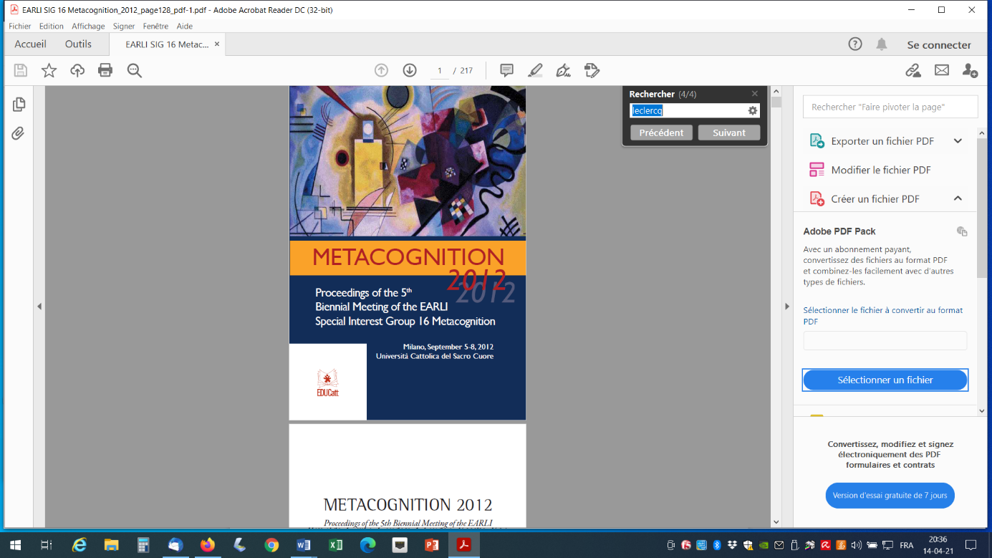

LECLERCQ, Dieudonné; LAGUESSE, Céline HENROTAY, Pierre (2012)

***Metacomprehension and cognitive vigilance. A multi-teachers experiment in last year of secondary school***

In Proceedings o the 5th Biennal Meeting of the EARLI Special Interest Group 16 Metacognition. Milano. UCSC (Universita Catolica del Sacro Cuore

Abstract p. 142

Teaching and testing for comprehension are challenges that can benefit from metacognition. Piaget has argued that in many occasions it is possible for a student to be successful without having understood the underlying concepts of the content.

Smedslund (1997)’s definition of comprehension: “A person S (as Student) understands a message M formulated by a person T (as teacher) if they agree on what, for T, is equivalent to M, is the contrary of M, is implied by M, has nothing to deal with M.” has many implications, namely that there should be a debate about COMMON understanding. Since understanding (comprehension) is linked to cognitive vigilance General Implicit Solutions (such as “Lack of data”, “Absurdity”, for Open Ended Questions and the same plus “None” and “All of them” for MCQs.

Metacognitive Spectral Tests (MST) have been adopted where:

(1) Students answer to about 20 questions, on a special sheet, adding to each response a confidence degree (0 20 40 60 80 100);

(2) Students answer a second time, with a red pencil, having been reminded one of the possible traps described here over. This second instruction enables to distinguish lack of comprehension from lack of vigilance.

(3) During the debriefing phase, for each question,

(a) the teacher communicates what is (are) the expected correct answer(s) for him/her;

(b) students are invited to debate about alternative correct answers they would propose

(c) the students position their answer on a (pre-printed) quality spectrum ranking from –100 (incorrect with 100% confidence) to 100 (correct with 100%);

(d) the students are invited to answer (if appropriate) to one of the two following metacognitive questions: “Why was I so sure whereas I was wrong?” or “Why was I so unsure whereas my answer was correct”; i.e., operate a self-diagnosis (or causal attribution), necessary for subsequent regulation.

(4) These MST are repeated during the school year and, at the end, students are invited to elaborate a “Metacognitive Retrospective and Prospective Report”. This kind of formative evaluation had been initiated at the university level ten years ago.

From September 2011, it has been implemented in a secondary school for about 40 students (in 2 classes) and 4 teachers in various areas, with the help of 2 university researchers in

(1) producing visualizations of individual progresses in terms of spectral quality in relation to self-diagnosis as well as item analysis based on classical indices such as the biserial correlations and on new indices based on Subjective mastery on realism in self-assessment,

(2) organizing reflexive workshops with teachers. Interesting results are already available in terms of insights in the students’ minds and in teachers’ ones as well as in terms of item analysis. The opinion of both, on this one year process, will be collected in April 2012, as well as an overall cost/benefit analysis.

