# A 2nd Gradient H2M Model to Investigate Gas Migrations in Clay Materials

***G. Corman1, F. Collin1, S. Levasseur2 and J. Talandier3***

*1University of Liège, Belgium*

*2ONDRAF/NIRAS, Belgium*

*3ANDRA, France*

[*gilles.corman@uliege.be*](mailto:gilles.corman@uliege.be)

***Abstract***

In the field of radioactive waste confinement, the question of gas transfers in clay formations, and more particularly in the so-called excavation damaged zone (EDZ) is a crucial issue. This zone created in the vicinity of the storage drifts by the underground drilling process exhibits modified hydro-mechanical (HM) properties [1]. For instance, the permeability is increased compared to the sound rock mass. Moreover, a certain amount of gases such as hydrogen may be generated during the exploitation of the system in the nearfield of the repository by the deterioration of the metal components, which could affect the clay barrier integrity.

In light of this, the present contribution aims at numerically investigating gas migrations in clay materials and the interactions with the damaged rock. To that end, a 2nd gradient H2M model is proposed (lagamine code, University of Liège), which includes the 2nd gradient theory as regularisation technique [2] to properly reproduce the fractures around the drifts with strain localisation in shear band mode. In addition, the model incorporates the features of a two-phase flow transfer approach [3] to deal with the multi-physics mechanisms inherent to gas migrations. On top of that, specific HM coupled effects [4] prone to occur in the EDZ are integrated to capture the impact of fracturing on the kinetics of gas transport.

This numerical tool is then applied at distinct scales and in different host rock formations to emphasise its versatility. In each case, 2D plane strain HM coupled simulations are carried out in 3 phases: excavation/ventilation in the short term, water pressure stabilisation in the medium term and gas release in the long term. The first application deals with two *in situ* gas injection tests conducted in different directions in Boom Clay [5], considering a quasi-isotropic configuration or anisotropy of stress state and permeability. This primary weakly coupled simulations provide information about the stress state evolution around the boreholes and the effect on the EDZ development, the permeability evolution and the subsequent gas migrations. The second application deals with a large-scale storage drift drilled in the Callovo-Oxfordian Claystone, and takes into account strong HM couplings materialised by the modification of the transfer properties with strains. A complete constitutive HM model encompassing viscoplastic effects is employed to reproduce the rock behaviour. This numerical modelling of the full life-span of the repository helps evidencing the impact of gas migration on the localization pattern (Figure 1), and more specifically the rock properties influencing the coupling between gas flows and mechanical behaviour (Figure 2).

#### **References**

[1] G. Armand, F. Leveau, C. Nussbaum, R. De La Vaissiere, A. Noiret, D. Jaeggi, P. Landrein, and C. Righini. Geometry and properties of the excavation-induced fractures at the Meuse/Haute-Marne URL drifts. Rock Mechanics and Rock Engineering, 47(1):21-41, 2014.

[2] F. Collin, R. Chambon, and R. Charlier. A finite element method for poro-mechanical modelling of geotechnical problems using local second gradient models. International Journal for Numerical Methods in Engineering, 65(11):1749-1772, 2006.

[3] P. Gerard, R. Charlier, K. Su, G. Duveau, R. Giot, C. Chavant, and F. Collin. Numerical modelling of coupled mechanics and gas transfer around radioactive waste in long-term storage. Journal of Theoretical and Applied Mechanics, 38:25-44, 2008.

[4] B. Pardoen, S. Levasseur, and F. Collin. Excavation damaged zone modelling including hydraulic permeability evolution in unsaturated argillaceous rock. Unsaturated Soils: Research and Applications – Proceedings of the 6th International Conference on Unsaturated Soils, UNSAT 2014, 2:1387-1393, 2014.

[5] G. Volckaert, L. Ortiz, P. De Canniere, M. Put, S. T. Horseman, J. F. Harrington, V. Fioravante, and M. Impey. MEGAS: modelling and experiments on GAS migration in repository host rocks, Technical Report, Eur. Comm., 1995.

#### **Figures**

*Figure 1: Development of shear bands during the excavation process in Cox.*

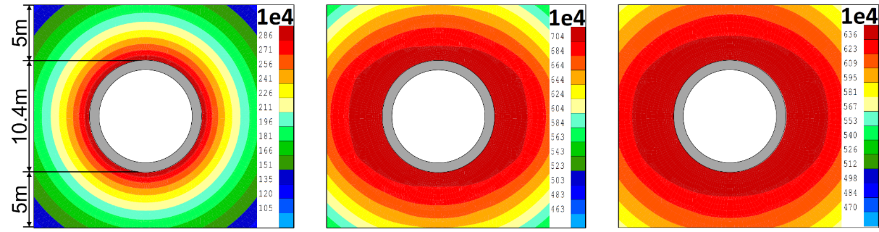

**10.000 years**

**50.000 years**

**100.000 years**

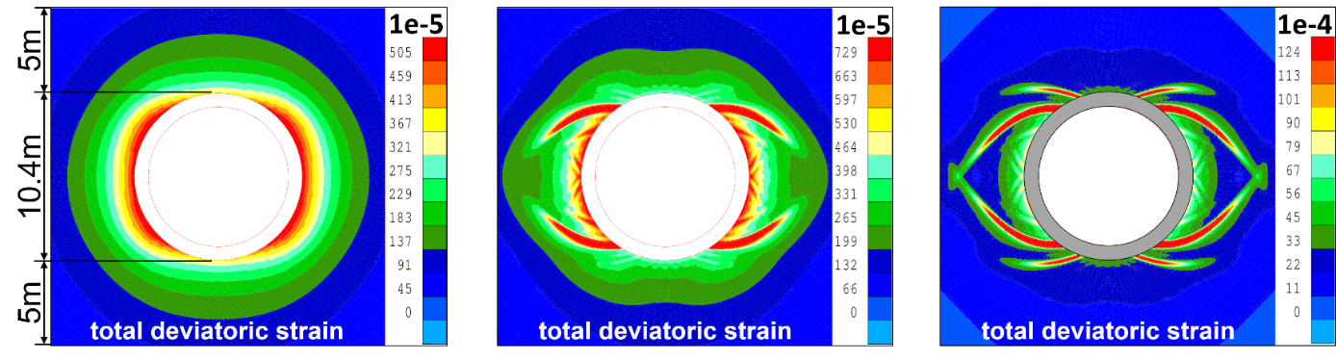

**100% deconfinement**

**90% deconfinement**

**80% deconfinement**

*Figure 2: Maps of gas pressure evolution considering advanced HM couplings in Cox (in Pa).*

***Keywords***: H2M Couplings, Gas Migrations, Strain Localisation, Numerical Modelling