
17th Conference on Wind Engineering – IN-VENTO 2022
Politecnico di Milano, IT 4 – 7 September 2022

A bivariate statistical model of large pressure peaks measured in wind tunnel tests

Vincent Denoël ¹, Thibaud Bastin ¹, Giulia Pomaranzi ², Alberto Zasso ³

1 Structural & Stochastic Dynamics, University of Liège, v.denoel@uliege.be
2 Politecnico di Milano, Dept of Mechanical Engineering, giulia.pomaranzi@polimi.it
3 Politecnico di Milano, Dept of Mechanical Engineering, alberto.zasso@polimi.it

SUMMARY:
A statistical approach for the treatment of large negative peak pressures is discussed. It is based on spatial correlation so that these large peak values, which are difficult to handle in a design, could be smoothed out by invoking the characteristic size associated with these events. The proposed method hinges on a mixture model of bicubic translation processes. Development of the method is summarized and applied to the computation of the area-average pressure on the building façade of a model tested in wind tunnel facilities at Politecnico di Milano.

Keywords: building facades, bicubic translation model, Bayesian regression, mixture model, size effect

INTRODUCTION

Several experimental evidences have shown that very high negative pressures could be measured on the facades of a building in the wind tunnel (Lamberti et al., 2020; Pomaranzi et al., 2022). They are being more frequently observed because of the widespread tendency to use higher frequency sampling and number of pressure taps in wind tunnel testing. The management of these major suction peaks remains an important issue today. Indeed, if these were to be treated in complete transparency, experimentalists would not be able to provide reasonable pressure peak values for the dimensioning of the structures. The main reason is that the time-space equivalence used today to smooth out the peak pressures does not hold at these small scales.

The same experimental evidences also show that the spatial extent of the peak pressure is relatively limited. This effectively justifies that building façades need to being dimensioned with these extreme values since, integration of pressure across a finite (non-zero) area would result in a smaller average pressure. A very high density of pressure taps is required to establish the size effect related to the spatial extent of this phenomenon. The data processing techniques traditionally used to limit the impact of these large negative pressure peaks consists of averaging in time rather than in space. The standard approach is to use the well-known TVL method (Lawson, 1976). This approach does not offer a uniformly valid solution in areas with large negative peaks, which is expected given that its origins are based on a stationary (in time) and homogeneous (in space) pressure field.
The origin of large negative peak pressures on the facades of the building corresponds to physical phenomena different from those generally observed in the shear layer. They presumably correspond to small hairpin vortices while a typical shear layer is composed of larger vortices (Simiu and Scanlan, 1996). Therefore, it is possible to model the measured pressure as a mixture of two components, one related to the small scale phenomenon, and one related to the large scale (Rigo et al., 2020)

The separation of the measured pressure into two components then becomes an important objective. While it is virtually impossible to attribute the pressure measured at a given time to any one of the two components, the de-mixing of the two processes can be achieved in a statistical sense. There exist several methods to de-mix mixtures of random variables (e.g. Moon 1996) and also random processes (Comon and Jutten, 2010), possibly by taking advantage of the different timescales in the two phenomena (Rigo et al., 2018). With these methods, it is possible to set up a methodology for decomposing a measured pressure signal into two components.

But the question of the spatial extent of these two components has not been addressed yet. This question is addressed in this paper by considering the mixture of different physics in joint distributions of pressure at several neighboring taps. Ultimately, this will answer the question of the spatial extent of each component and help derive appropriate techniques to determine peak value distribution from wind pressure data, after averaging on finite size (non-zero) areas.

The illustration is based on very high-fidelity experimental data, measuring pressure on the facades of a building with a very high density but the proposed methodology is applicable to scarcer tap density. The article is organized as follows: Section 2 presents the mathematical model which is fitted to the given data. Section 3 briefly describes the experimental setup. Section 4 presents the results of the study. Section five provides a discussion and conclusions of this preliminary research.

METHODS: THE STATISTICAL MODEL

The proposed statistical model hinges on the cubic translation (Grigoriu M., 1984; Winterstein S.R., 1987) which expresses the pressure at each pressure tap as a cubic transformation of a Gaussian variable :
(1)

and where the coefficients need to be adjusted to the data. It is possible to express the Probability Density Function (PDF) of the transformed variable as a function of these coefficients (Rigo et al. 2019). For brevity, its expression is omitted here. So, a suitable way to adjust them is to find the optimal values that minimize the (e.g. least-square) error between the PDF of the experimental data, obtained from a scaled histogram, and the PDF predicted by the model (Rigo et al. 2018).

As introduced earlier, the cubic translation model is not suitable to model the pressure at taps with large negative peaks, where several physics are captured. Instead, a mixture model is used. It is chosen to mix two such cubic translations, such that the PDF at critical pressure taps is modeled as:
(2)
where and represent two sets of 4 parameters, one for each component of the model, and where represents the mixing ratio. This formulation is sufficiently general and also covers the case where either component is Gaussian, since the cubic translation model is adjustable to Gaussian data, when the transformation is linear. In total, the unilateral PDF at each pressure tap is represented by a set of 9 parameters collected in , corresponding to twice four parameters plus the mixing ratio.

In this paper, we exploit an extension of the cubic translation model, that had been coined bicubic translation model in (Blaise et al., 2017) as it applies to a joint PDF between two different processes which are represented by cubic translation models each. Specifically, the considered joint PDF model of the pressures measured at taps i and j is expressed as a function of the 4 parameters of each pressure, plus their correlation coefficient. The nine parameters, again, in total are gathered in vector to simplify notations. For brevity, the complete expression of is also omitted.

Finally, the model is further extended in order to include two components, in the sense of a mixture model. As such, the joint PDF of the pressures recorded at two neighboring pressure taps is represented by:
(3)

where gathers a set of twice nine, plus one, i.e. the 19 parameters of the bicubic model. In summary, a bicubic translation model is composed of 19 parameters; it generalizes the concept of cubic translation model, while allowing to account for correlation of two non-Gaussian processes, at least to some extent. It falls in the family of parametric models to estimate the statistical properties of experimental data.

EXPERIMENTAL SETUP

Figure 1 depicts some details of the test setup that has been used to illustrate the findings of this research. It consists of a regular building with size 2000 x 1000 x 200 mm (H x W x b) at wind tunnel scale, equipped with a set of 254 pressure sensors which are distributed with variable density over the specimen. Specifically, the area located in an upper corner of the building (see Fig. 1-a, in blue) is equipped with a very high density of pressure taps. The smallest distance between two neighboring taps is as small as 3.4 mm. The closeup view in Figure 1-c allow appreciating the high density of the mesh.

The wind pressures have been measured on this building for various wind exposures at a wind tunnel sampling frequency of 500 Hz, and for a total duration of 5 minutes of measurement (N=150,000 sample points per channel). The reference pressure used to determine pressure coefficients is the dynamic pressure at the top of the building. In total, a large number of configurations have been tested, with various wind exposures, two different terrain categories, higher tap density on three different tiles (A, B, C), and with or without additional buildings in the near vicinity of the tested building. The full data set is available from an open repository (Pomaranzi, 2020). From this very large data set, only one configuration is considered in the following illustration. It concerns configuration A02B00, which stands for (i) tile A (higher density of pressure taps in the upper corner of the specimen, as shown in Fig. 1-a), (ii) terrain category II, (iii) test without secondary building (B00). Also, the considered exposure is equal to 10°, which.

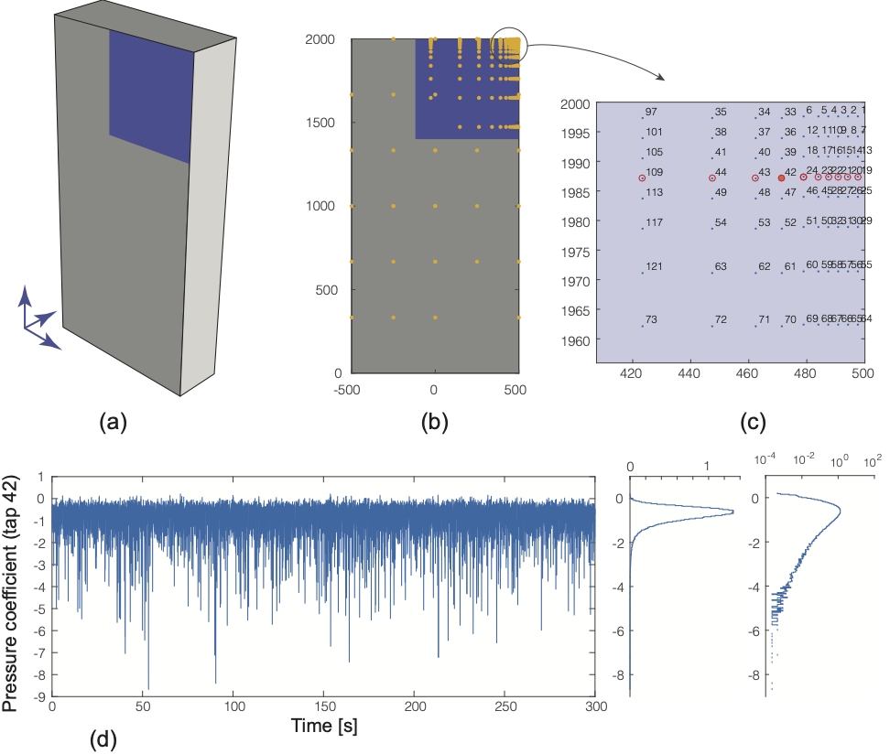

Figure 1. (a) Sketch of the experimental setup, (b) Positions of the pressure taps (units are in mm of the model),
(c) Numbering of pressure taps (d) example of pressure coefficient (measured at tap 42) and its histograms.

corresponds to a wind attacking the specimen from the back with an incidence of 10° with respect to the large face of the building

STATISTICAL ANALYSIS OF LARGE NEGATIVE PRESSURES

Figure 1-d shows the time series of the pressure coefficient measured at pressure tap 42. The corresponding PDF is also shown on the right in both linear and logarithmic scales. The average pressure coefficient is -0.79 and its standard deviation is 0.45. However, values as large as -8.68 have been registered by the scanner. These large negative values are not isolated events since the experimental PDF regularly drops at high negative pressure coefficients. The non-Gaussian nature of the pressure is visible in the log plot of the PDF, which does not decrease as a quadratic (as it would be the case if the process was Gaussian), but less fast, which is responsible for the small occurrences of the large negative pressures.

The pressure coefficient at pressure tap 42 can be modelled as a mixture of two cubic translation processes. Its experimental PDF (i.e. the scaled histogram) is adjusted to the parametric PDF of the mixture model. This operation is advantageously led by means of a Bayesian regression technique implementing the famous Monte Carlo Markov Chain algorithm known as the Metropolis-Hastings algorithm (Hastings, 1970). Alternative approaches, such as the Expectation Maximization algorithm (Moon, 1996) have also been used, but they have led to poorer estimates (Bastin, 2021). The results of the de-mixing are represented in Figure 2 for pressure tap 42. This figure shows the posterior distribution of the model parameters and as well as the PDF resulting from this 9-parameter univariate model. The agreement with the experimental data is almost perfect in both the linear and log scales.

The posterior distribution is obtained as the likelihood of Bayesian regression since uninformative prior was considered. A set of 7,500 jumps of the Metropolis-Hastings algorithm has been used with a burn-in size of 2,500 samples. The parameters of Component A (with the smallest average pressure in absolute value) are globally identified with a better confidence.

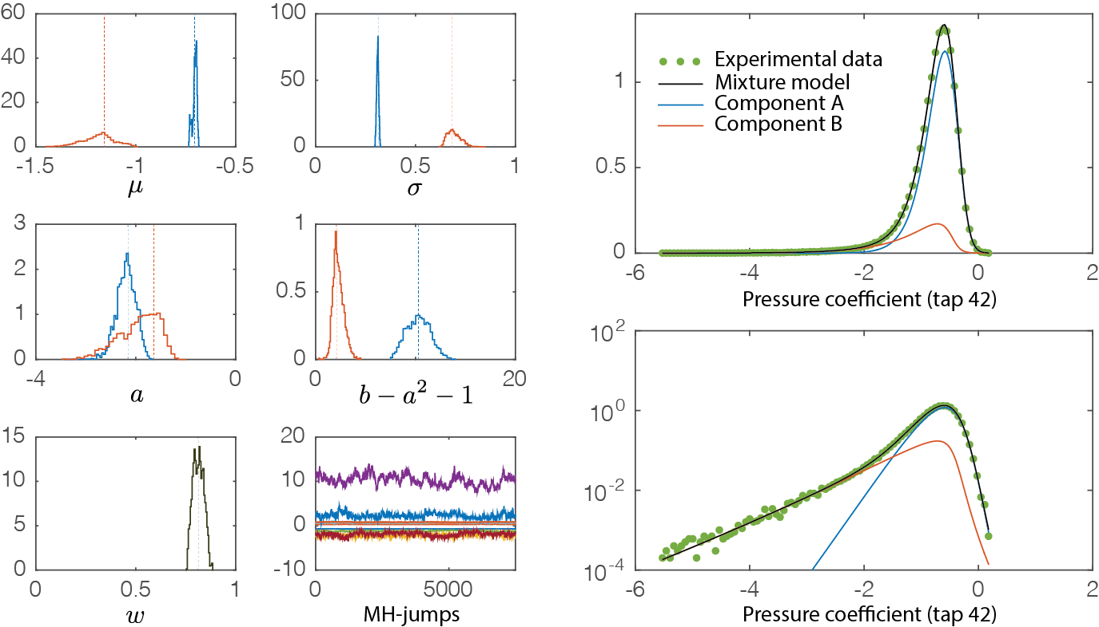
Figure 2. Result of the de-mixing of the pressure coefficient measured at pressure tap 42. (Left) Posterior distributions of the (4x2+1=) 9 model parameters and samples of the Metropolis-Hastings algorithm, (Right) Experimental and identified PDF of the pressure coefficient at tap 42.

Table 1. Median estimates of model parameters for the pressure coefficients measured at several taps.
Pressure tap
Tap 109 | -0.707 | 0.300 | -3.80 | 18.4 | -1.33 | 0.535 | -7.34 | 410. | 0.97
Tap 44 | -0.661 | 0.307 | -2.64 | 13.2 | -1.38 | 0.525 | -2.71 | 4.50 | 0.95
Tap 43 | -0.736 | 0.295 | -3.40 | 17.7 | -1.59 | 0.643 | -0.54 | 2.18 | 0.92
Tap 42 | -0.703 | 0.311 | -2.18 | 10.3 | -1.18 | 0.688 | -1.87 | 2.22 | 0.81
Tap 24 | -0.643 | 0.310 | -2.03 | 9.15 | -1.19 | 0.774 | -3.15 | 2.60 | 0.84
Tap 23 | -0.648 | 0.276 | -2.09 | 11.6 | -1.13 | 0.641 | -4.72 | 3.87 | 0.75
Tap 22 | -0.627 | 0.254 | -2.38 | 14.6 | -1.10 | 0.515 | -6.26 | 8.90 | 0.72
Tap 21 | -0.617 | 0.257 | -2.11 | 11.6 | -1.14 | 0.407 | -8.41 | 32.2 | 0.78
Tap 20 | -0.614 | 0.256 | -2.03 | 11.1 | -1.16 | 0.390 | -13.2 | 132. | 0.78
Tap 19 | -0.610 | 0.229 | -2.18 | 14.2 | -1.17 | 0.391 | -14.0 | 97.1 | 0.71

The numerical values (median) of the 9 identified model parameters are summarized in Table 1 for pressure tap 42 as well as for some other pressure taps located along the same horizontal line, see Figure 1 for tap numbering. These values show that the identified values of the mixture model are more or less smooth in space, although they have been independently identified. In particular, the average pressures and in both components and the mixing ratio all evolve very regularly along the considered line of pressure taps. The mixing ratio increases as one moves from right to left, i.e. going away from the edge of the building. This indicates that the isolated events corresponding to the tail of the distribution (the large negative peaks) vanish in a regular manner.

Figure 3 illustrates the joint PDF between the pressure coefficients at tap 42 and 24, which are two neighboring taps. From the univariate analysis it is known that each of them can be decomposed into two components, A and B. The same development is also possible with the joint PDF: the mixture model is a weighted sum of two bicubic translation processes, and the 19 parameters of this model are adjusted in order to match the PDF of experimental data. Distributions on the right of Figure 3 are related to these parameters.

Interestingly, the mixing ratio is again around 0.8, which corresponds to the value obtained with the unilateral analysis. Moreover, the correlation coefficients associated with the two components, A and B are respectively equal to 0.95 and 0.82, which indicates that the former phenomenon is more correlated over space that the latter, i.e. the typical turbulence of the shear layer is more correlated than the large negative peaks.

The same analysis is reported in Figure 4, for the correlation between tap 42 and tap 19, which are still on the same line but a little more away from each other. Both correlations drop and, in particular, the correlation associated with the large negative peaks is now around 0.4.

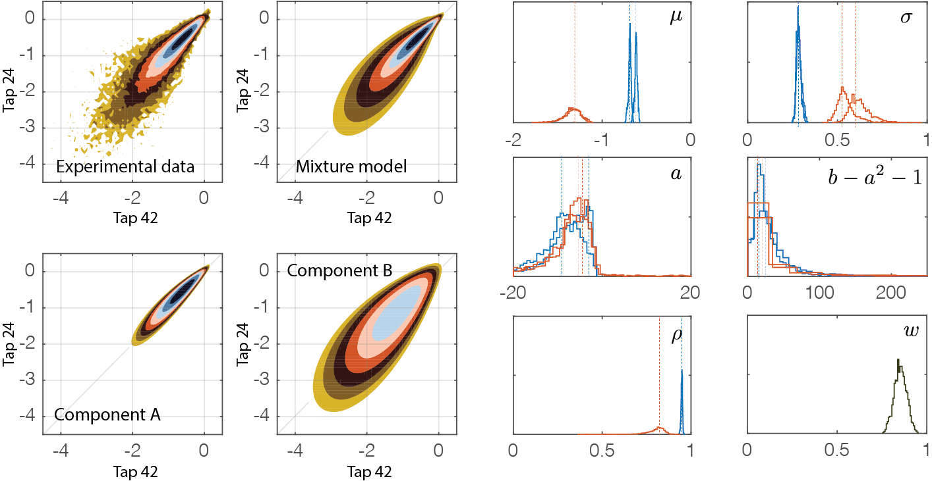
Figure 3. Results of the joint de-mixing of the pressure coefficients measured at pressure tap 42 and 24. (Right) Posterior distributions of the 19 model parameters (Left) Experimental and identified joint PDF.
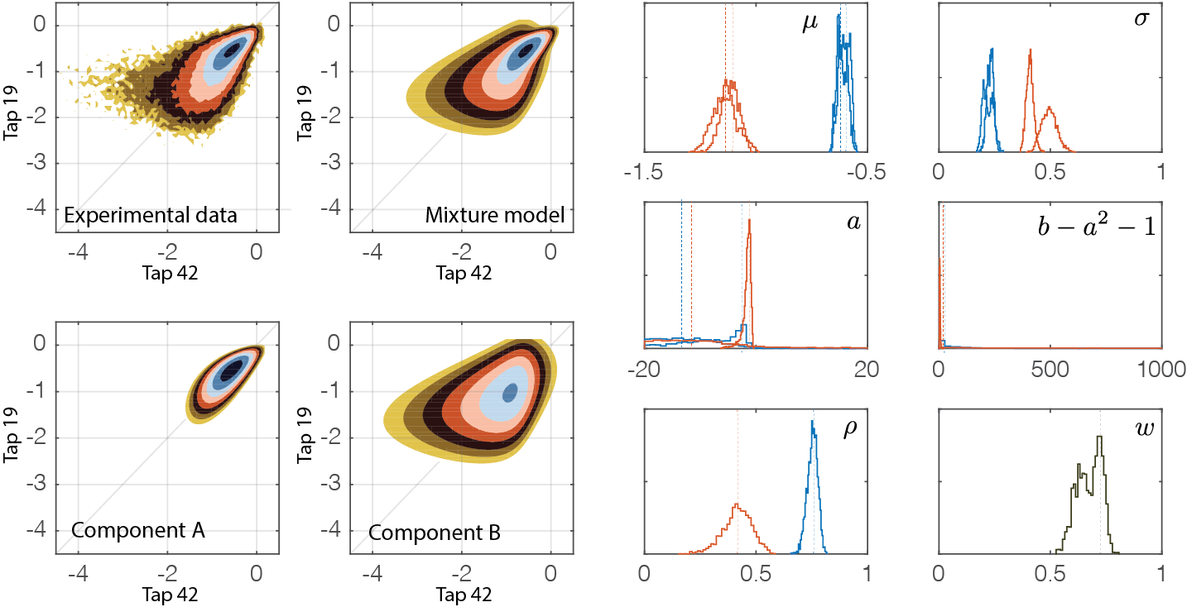
Figure 4. Results of the joint de-mixing of the pressure coefficients measured at pressure tap 42 and 19. (Right) Posterior distributions of the 19 model parameters (Left) Experimental and identified joint PDF.

Ultimately, the correlation coefficients between pressure tap 42 (used as a reference in this study), and the sequence of neighbors, i.e. taps 24 to 19 is recapitulated in Figure 5. On the left, this figure represents the distributions of the correlation coefficients between the pressure at tap 42 and various other taps (24 to 19). The thin lines refer to component A (bulk) while the thicker lines refer to component B (tail). The maximum likelihood estimation (mode of each these distributions) is represented on the right, for both components A and B, and as a function of the relative distance between sensor 42 and its neighbors.

The regular drop of the correlation is again visible especially the correlation coefficient associated with component B which corresponds to the large negative peaks. This indicates the small size of these phenomena in space. The intermediate dashed line represents the correlation coefficient of the full data set, considered as a whole, i.e. before de-mixing is performed.

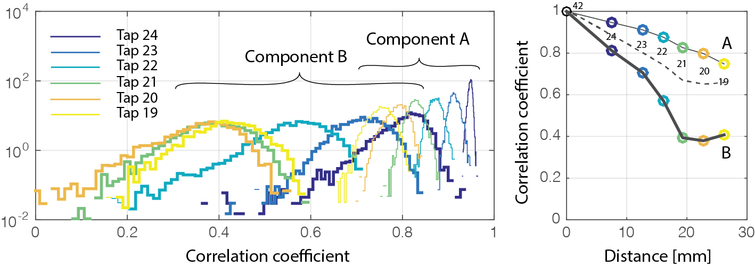
Figure 5. Correlation coefficients of components A and B between pressures at tap 42 and various other taps (24 to 19). The left plot shows the posterior distributions of the identified correlation coefficients; the right plot shows the maximum likelihood estimators as a function of the distance between the two sensors.

APPLICATION OF THE STATISTICAL MODEL TO AREA AVERAGING OF PRESSURES

The statistical framework presented in the previous section is a good tool to analyse, understand and predict the design pressure on façade elements. In particular, it is possible to provide a proxy of the area-averaged pressure on a surface with finite size. To illustrate this point, we have computed the extreme value of the average pressure along lines of continuously growing size. Specifically, the time series of the average pressure between taps 42 and 24, then 42, 24 and 23, …, until 42, 24, 23,…19 are established. The average of a type-I extreme value distribution of the minimum pressure coefficients on 10 windows of equal sizes is used as an experimental estimator of the extreme pressure along a finite length. This reference solution, available here because of the large tap density, is compared to a proxy which is based on the mixture model, see Figure 6.

More precisely, the extreme pressure averaged on the surface is obtained as the product of (i) the experimental estimator of the extreme pressure at a single tap (tap 42), (ii) a decreasing function of the total length of averaging, starting from 1 and monotonically decreasing. We notice that (i) is always available since it corresponds to usual statistical treatment of pressure taps, while (ii) is here constructed as the average of the squared correlation coefficient associated with component B, see Figure 5. This choice of function is justified by the fact that the correlation in space of component B (the one related to large negative peaks) drives the size effect related to area averaging.
It is also emphasized that the use of a smooth estimate of the correlation vs. distance relationship (like a decreasing exponential) instead of a high-density information would give a simple means to predict extreme values of area-averaged pressures. Additional work is required on this question, in order to assess the strictly required mesh density, in order to be able to properly capture the size effect. One possibility would be to use a scarcer tap mesh than in this study (hopefully similar to standard distances), and to adjust of model for the correlation coefficient of the tail component (B) with the possibly low values.

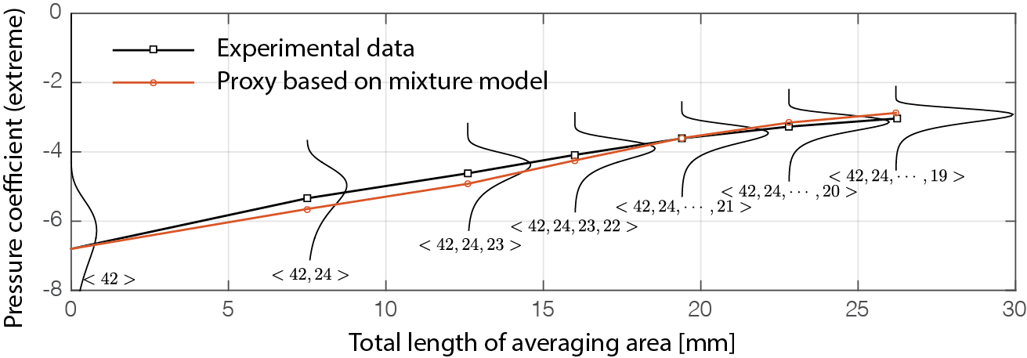
Figure 6. Extreme pressure coefficient: comparison of experimental data and prediction of the model, based on the correlation coefficient of component B.

DISCUSSION AND CONCLUSIONS

We have presented a statistical analysis of large negative peak pressures. For the first time, wind tunnel pressures are analyzed by means of joint bicubic distributions with the aims to focus on large extremes, decompose the measured processes in tail and bulk components and quantify the spatial correlation of each of them. While a mixture of the usual cubic translation process is used for the univariate case, the bicubic extension is used for the 2-by-2 joint statistics. There is a slight inconsistency in the model since the marginal distributions obtained from the joint PDFs do not exactly correspond to the univariate cases. The simplifying choice to allow this slight inconsistency was made to lighten the considered model and avoid mixing more than 2 components.

The 2-by-2 correlation is the necessary and sufficient information to quantify the statistics of the average of the pressure at 2 taps. As soon as more taps are averaged, higher correlation would, in principle, be necessary. However, it was found that the length scale extracted from the correlation in the tail distribution does a decent job in estimating the size effect. Therefore, it appears that the use of more complex models, e.g. non-Gaussian copulas and mixtures thereof, is not fully justified.

Despite providing decisive information about the characteristic scales in the problem, the model can be used to predict area-averaged pressure coefficients that do not require such a dense tap meshing. The current results are very encouraging, and the quality is explained by the fact that nowhere in the proposed formulation we need to formulate homogeneity in space, which is unfortunately required in classical methods to estimate the reduction of pressure on finite size non-zero areas.

Future works will aim at developing the same analysis to surface-average, possibly apply the same technique to structures with corner vortices (Blaise et al., 2017).

REFERENCES
Bastin T., Development and application of a separation algorithm for wind pressures on building façade panels, Master thesis, Univertisy of Liège, 2021.
Blaise N., Andrianne T., and Denoël V.. Assessment of extreme value overestimations with equivalent static wind loads. Journal of Wind Engineering and Industrial Aerodynamics, 168:123–133, 2017.
Comon P., Jutten C. (ed.). Handbook of Blind Source Separation: Independent component analysis and applications. Academic press, 2010.
Grigoriu,M.(1984).Crossingsofnon-Gaussiantranslationprocesses,J.Eng.Mech.,ASCE,110(4),610-620.
Hastings W. K., Monte Carlo Sampling Methods Using Markov Chains and Their Applications, Biometrika, vol. 57, no 1,‎ 1970, p. 97–109.
Lamberti G., Amerio L., Pomaranzi G., Zasso A., and Gorlé C.. Comparison of high resolution pressure measurements on a high-rise building in a closed and open-section wind tunnel. Journal of wind engineering and industrial aerodynamics, 204:104247, 2020.
Lawson, T. The design of cladding. Build. Environ. 11 (1), 37–38, 1976.
Moon, Todd K. The expectation-maximization algorithm. IEEE Signal processing magazine, 1996, vol. 13, no 6, p. 47-60.
Pomaranzi G., Amerio L., Zasso A., Politecnico di Milano - Wind tunnel test data on high-rise building, High-resolution pressure data recorded in wind tunnel tests performed at the Politecnico di Milano wind tunnel on a generic prismatic high-rise building, June 2020, https://zenodo.org/record/3948348#.YO0_nC0ivfY
Pomaranzi G., Amerio L., Schito P., Lamberti G., Gorlé C., Zasso A., Wind tunnel pressure data analysis for peak cladding load estimation on a high-rise building, Journal of Wind Engineering and Industrial Aerodynamics, Volume 220, 2022, 104855.
Rigo F., Andrianne T., and Denoël V.. On the use of the cubic translation to model bimodal wind pressures. Mathematical Modelling in Civil Engineering, Vol. 15‐No. 2: 20‐32‐2019 Doi: 10.2478/mmce‐2019‐0006
Rigo F., Andrianne T., and Denoël V.. Mixture model in high-order statistics for peak factor estimation on low-rise building. In Conference of the Italian Association for Wind Engineering, pages 613–629. Springer, 2018.
Rigo, F., Andrianne, T., & Denoël, V. A de-mixing approach for the management of large negative peaks in wind tunnel data. Journal of Wind Engineering and Industrial Aerodynamics, 206, 104279, 2020.
Simiu, E. and Scanlan, R.H., 1996. Wind effects on structures. John Wiley and Sons, New York, NY, USA.
Winterstein, S.R.(1987) Moment-based Hermite models of random vibration, Lyngby, Report No. 219.
Department of Structural Engineering, Technical University of Denmark, Lyngby, Denmark.

