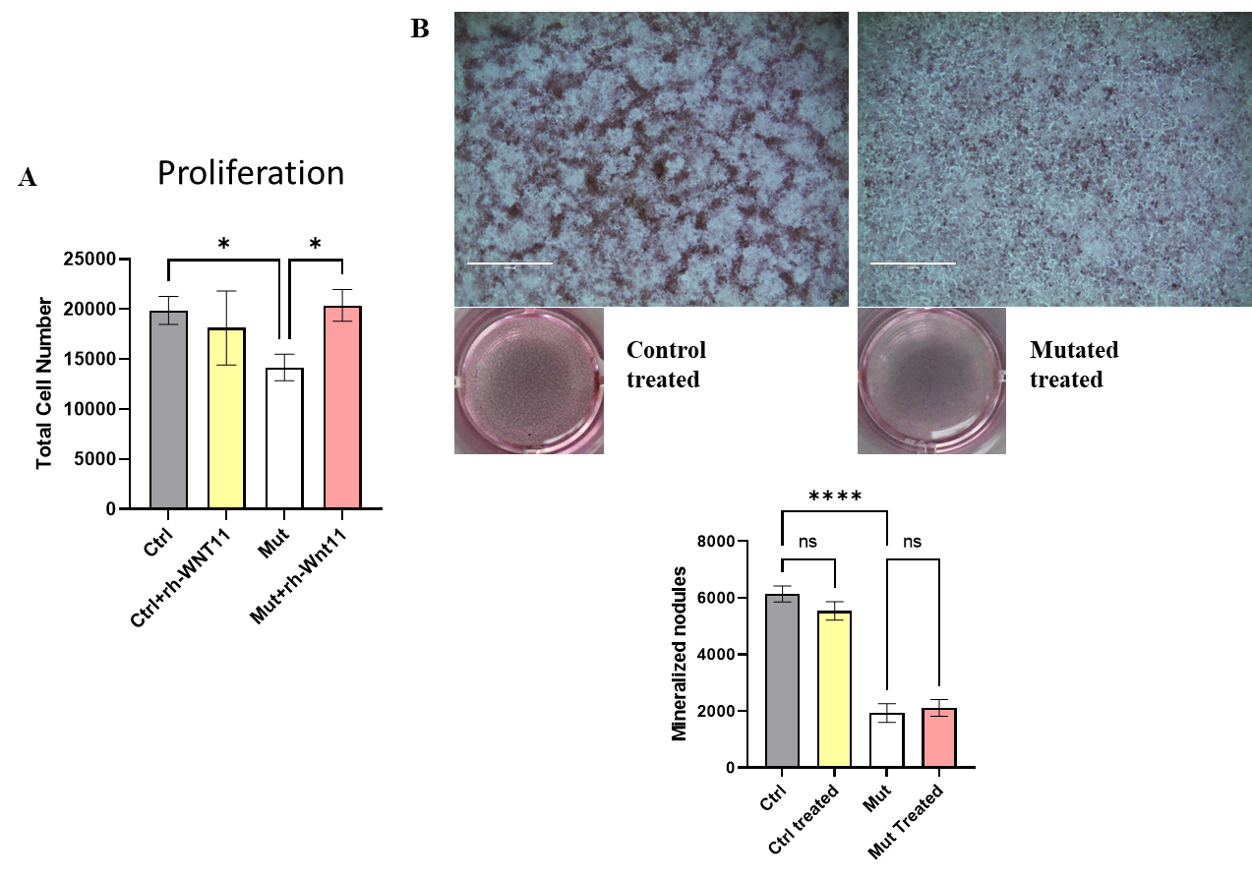**Supplementary material**

**Supplementary Figure 1: RhWnt11 treatment rescued the proliferation but not mineralization.** A)Proliferation of control, control treated with rhWnt11, *WNT11* mutant cells not treated and treated with rhWnt11 (N=42). Data are mean±SEM. B) Alizarin red staining showed formation of mineralized nodules after osteogenic differentiation treatment with osteogenic media in control, control treated with rhWnt11, *WNT11* mutant cells, and *WNT11* mutant cells treated with rhWnt11. (N=8). Data are mean±SEM. *: p<0.05, **** p<0.0001, ns: non-significant.



**Supplementary Figure 2: Control cells treated with rhWnt11.** RT-qPCR analysis of mRNA levels of genes of the Wnt canonical and non-canonical pathways in control cells with Wnt11 recombinant protein treatment. Ctrl: Control, Mut: *WNT11* mutant cells. Data are mean±SEM. ***p<0.001, ****<0.0001



**Supplementary Figure 3: RT-qPCR analysis of mRNA levels of *RSPO* receptors.**

Ctrl: Control, Mut: *WNT11* mutant cells. Data are mean±SEM. *p.<0.05

**Supplementary table 1. Primer sequences for gene expression RT-qPCR analysis**

|  |  |  |
| --- | --- | --- |
| Gene | Nucleotide sequences 5'-3' | Product (bp) |
| GAPDH | (F) CCCCGGTTTCTATAAATTGAGC  (R)CACCTTCCCCATGGTGTCT | 127 |
| JUN | (F) CCAAAGGATAGTGCGATGTTT  (R) CTGTCCCTCTCCACTGCAAC | 62 |
| ROCK1 | (F) GATCCCAAATCGGAAGTGAA  (R) CAAATCATATACCAAAGCATCCAA | 66 |
| MAPK9  (JNK2) | (F) GATATTCCAAGGCACTGACCA  (R) TTCCTCACAGTTGGCTGAAGT | 105 |
| OPG (TNFRSF11B) | (F) GAAGGGCGCTACCTTGAGAT  (R) GCAAACTGTATTTCGCTCTGG | 102 |
| ROR2 | (F) CCCCTCATTAACCAGCACAA  (R) TTCCCAAACCGGTCCTCT | 95 |
| RANKL (TNFSF11) | (F) TGATTCATGTAGGAGAATTAAACAGG  (R) GATGTGCTGTGATCCAACGA | 82 |
| B-CATENIN (CTNNB1) | (F) TGTTAAATTCTTGGCTATTACGACA  (R) CCACCACTAGCCAGTATGATGA | 90 |
| LRP5 | (F) GCCAAGACAGACAAGATCGAG  (R) CAGCGTGAACCCAAAAATG | 96 |
| RUNX2 | (F) GATGATGACACTGCCACCTCT  (R) GCCCAGTTCTGAAGCACCT | 84 |
| AXIN2 | (F) GCTGACGGATGATTCCATGT  (R) ACTGCCCACACGATAAGGAG | 70 |
| WNT11 | (F) TCCCACGGGACACAAGAC  (R) GGTGACGTAGCAGCACCA | 150 |
| RSPO3 | (F) GCGAAAAGTCCAAGATAAACAGA  (R) TTAAGGTGGGTCATGCGATT | 145 |
| RSPO1 | (F)ATCAAGGGGAAAAGGCAGA  (R) CAGAGCTCACAGCCTTTGG | 71 |
| LGR5 | (F) ACCAGACTATGCCTTTGGAAAC  (R) TCCCAGGGAGTGGATTCTATT | 76 |
| IBSP | (F) GAGCCTGCTTCCTCACTCC  (R) CCCAAAATGCTGAGCAAAAT | 82 |
| SP7 | (F) AGGAGAGACTCGGGACAGC  (R) GGGACTGGAGCCATAGTGAA | 133 |
| COL1A1 | (F) CTGGACCTAAAGGTGCTGCT  (R) GCTCCAGCCTCTCCATCTT | 106 |
| BGLAP  (OC) | (F) GGCGCTACCTGTATCAATGG  (R) TCAGCCAACTCGTCACAGTC | 106 |
| ALPL | (F) TCACTCTCCGAGATGGTGGT  (R) GTGCCCGTGGTCAATTCT | 99 |