Fluorescence Quenching by Molecular Pumping
Xuesong Li, ^{1, #} Arthur H. G. David,^{1, #} Long Zhang,¹ Bo Song,¹ Yang Jiao,¹ Damien Sluysmans,^{1,2} Yunyan Qiu,¹ Yong Wu,¹ Xingang Zhao,¹ Yuanning Feng,¹ Lorenzo Mosca,^{1, 3} J. Fraser Stoddart^{1, 4, 5, 6, *}

¹ Department of Chemistry, Northwestern University, 2145 Sheridan Road, Evanston, Illinois 60208, USA
² Research Unit MolSys, NanoChem, University of Liege, Sart-Tilman, B6a, Liege 4000, Belgium
³ Department of Chemistry, University of Rhode Island, 140 Flagg Rd., Kingston, Rhode Island 02881, USA
⁴ School of Chemistry, University of New South Wales, Sydney, NSW 2052, Australia
⁵ Stoddart Institute of Molecular Science, Department of Chemistry, Zhejiang University, Hangzhou 310027, China
⁶ ZJU-Hangzhou Global Scientific and Technological Innovation Center Hangzhou 311215, China
# Equal contribution

*E-mail: stoddart@northwestern.edu

MAIN TEXT
*Correspondence Address
Professor J Fraser Stoddart
Department of Chemistry
Northwestern University
2145 Sheridan Road
Evanston, IL 60208-3113 (USA)
Tel: (+1)-847-491-3793

E-Mail: stoddart@northwestern.edu

ABSTRACT:
Artificial molecular pumps (AMPs), inspired by the active cellular transport exhibited in biological systems, enable cargoes to undergo unidirectional motion, courtesy of molecular ratchet mechanisms in presence of energy sources. Significant progress has been achieved, using alternatively radical interactions and Coulombic repulsive forces, to create working AMPs. In an attempt to widen the range of these AMPs, we have explored the effect of molecular pumping on the photophysical properties of a collecting chain on a dumbbell incorporating a centrally located pyrene fluorophore and two terminal pumping cassettes. The AMP discussed here sequesters two tetracationic cyclophanes from solution, generating a [3]rotaxane in which the fluorescence of the dumbbell is quenched. The research reported in this communication demonstrates that the use of pumping cassettes allows us to generate the [3]rotaxane in which the photophysical properties of fluorophores can be modulated in a manner which cannot be achieved with a mixture of the dumbbell and ring components of the rotaxane on account of their weak binding in solution.
■ MAIN TEXT
Active cellular transport of substances, both ions and molecules across cell membranes, plays an essential role in biological systems in maintaining bio-functions.¹ This active transport relies on transmembrane carrier proteins^{1a-d} which are capable of transporting ions or molecules against their concentration gradients. In order to mimic the structures and/or functions of these carrier proteins, much effort has been devoted by chemists towards the synthesis of artificial counterparts.² These wholly synthetic analogues are dominated by artificial molecular machines³ since they possess multiple discrete components capable of moving ions and molecules away-from-equilibrium. In particular, artificial molecular pumps (AMPs), based on rotaxanes, are an important subset of molecular machines that display⁴ all the characteristics of doing work.
Recently, we have designed and synthesized AMPs fueled by redox processes^{4a, b, 5} to transport tetracationic cyclophanes ─ in particular, cyclobis(paraquat-p-phenylene) or CBPQT⁴⁺ in a nutshell. During the unidirectional transport of CBPQT⁴⁺ rings in AMPs, trisradical tricationic complexes are formed (Figure 1), upon the reduction of all the bipyridinium units⁵, first of all between a bisradical dication CBPQT^{2(+•)} and a radical cation BIPY^{+•} in each pumping cassette^{4b,6} composed of terminal PY⁺ units, BIPY²⁺ dications and 2-isopropylphenylene (IPP) groups. Subsequent oxidation restores the Coulombic repulsion between the CBPQT⁴⁺ rings and the BIPY²⁺ units in the pumping cassettes, pushing the rings over the steric barriers provided by IPP groups onto a central collecting chain, generating mechanical bonds and yielding a [3]rotaxane in the process. Multiple redox cycles, using dual pumping cassettes, allow for repeated pumping and transport of two CBPQT⁴⁺ rings at a time, producing high-energy oligorotaxanes in a precise manner.^{6b, 7} AMPs have also been employed to synthesize daisy-chain polymers,⁸ wherein the CBPQT⁴⁺ rings are functionalized with molecular pump heads comprising, in this instance, a 3,5-dimethylpyridinium moiety as well as a BIPY²⁺ dication. The exploration of AMPs, beyond what is present in abundance in nature, is of major importance in an effort to extend their applications in materials and medical sciences.
Modulation of the fluorescence in rotaxanes has received considerable attention⁹ throughout the years, since their architectures are well-known to afford robust and efficient switches. These switches have been used to design logic gates¹⁰ and circularly polarized luminescence switches¹¹, in addition to being incorporated into functional materials¹². The modification of the fluorescence properties of AMPs during or after pumping is, nevertheless, an underexplored event, despite the fact that Credi and co-workers¹³ have examined the threading of a light-driven molecular pump by observing the decrease in fluorescence of a luminescent macrocycle when it is bound to a dumbbell.
In an attempt to widen the horizon of applications for AMPs, we report herein the quenching of the fluorescence of a dumbbell-like molecule (Scheme 1) containing two pumping cassettes^{6a} at their termini to aid and abet the pumping of two CBPQT⁴⁺ rings. The dumbbell-like molecule also contains (Figure 1a) a fluorescent pyrene (PYR) unit in the middle of an oligoethylene glycol chain. Upon reduction (Figure 1b) of the BIPY²⁺ dications to BIPY^{+•} radical cations, pairing interactions between radicals drive the formation of trisradical tricationic complexes between CBPQT^{2(+•)} and BIPY^{+•}. Following the addition of Ag⁺ ions, BIPY^{+•} is oxidized back to BIPY²⁺, restoring the Coulombic repulsion in the pumping cassettes between the recognition sites and the rings, forcing them to move over the IPP steric barriers so as to interact with the PYR unit. In essence, as a result of the generation of mechanical bonds, the fluorescence of the PYR unit is quenched.
The synthesis of the [3]rotaxane 2·14PF₆ began with a Williamson reaction between 2,7-dihydroxypyrene¹⁴ (3) and the tetraethylene glycol derivative¹⁵ 4, affording 5 in moderate yield (20%). Subsequent treatment of 5 with ADMP in the presence of DBU¹⁶ gave the bisazide 6 in 63% yield. The synthesis of dumbbell 1·6PF₆ was completed by reacting 6 with 7·3PF₆ using a Cu-catalyzed-azide-alkyne cycloaddition (CuAAC) click reaction¹⁷ (69%). See Scheme 1 and Figure 2c. The resulting dumbbell 1·6PF₆ was then mixed with an excess¹⁸ of CBPQT·4PF₆ under an inert atmosphere prior to pumping. After reduction using CoCp₂, followed by oxidation with AgPF₆, two CBPQT⁴⁺ rings were pumped onto the dumbbell, affording the [3]rotaxane 2·14PF₆ in good yield (77%). It is worth emphasizing that without the use of pumping cassettes the formation of rotaxanes incorporating dumbbells with very weak PYR recognition sites and CBPQT⁴⁺ rings would be difficult employing traditional methods, i.e., threading-followed-by-capping,¹⁹ clipping,²⁰ or slipping²¹ strategies, since the association constant between PYR in 5 and CBPQT·4PF₆ is very low. ¹H NMR titration of 5 and CBPQT·4PF₆ revealed (Figures S51 and S52) that the binding constant is 22.4 M⁻¹ in CD₃CN at 298 K.
The [3]rotaxane 2·14PF₆ was fully characterized (Figure S13 – S21) by 1D and 2D NMR spectroscopy. Compared with the dumbbell 1⁶⁺, the formation of mechanical bonds in the [3]rotaxane 2¹⁴⁺ leads to significant upfield shifts of resonances for the PYR protons (ΔδH_{x} = − 1.95 ppm and ΔδH_{y} = − 0.89 ppm) and for protons on the tetraethylene glycol chains (ΔδH_{p} = − 0.25 ppm, ΔδH_{q} = − 0.34 ppm, ΔδH_{r} = − 0.84 ppm, ΔδH_{s} = − 0.89 ppm, ΔδH_{t} = − 0.61 ppm, ΔδH_{u} = − 0.30 ppm, ΔδH_{v} = − 0.28 ppm, and ΔδH_{w} = − 0.91 ppm). These changes result from the shielding effect of the CBPQT⁴⁺ rings on the dumbbell, indicating that the rings encircle the tetraethylene glycol chains and the periphery of the PYR unit. In concert with these changes, resonances for protons on the CBPQT⁴⁺ rings exhibit (Figure 2) upfield shifts (ΔδH_{β} = − 0.40 ppm) and downfield shifts (ΔδH_{Xyl} = 0.29 ppm) and H_{CH2} protons resonate as an AB system. Additionally, VT NMR spectra (Figure S21) reveal that the resonances for protons on the CBPQT⁴⁺ rings and PYR unit become broader as the temperature is decreased. Also, the resonances for protons on the tetraethylene glycol chains undergo significant shifts. Furthermore, DOSY NMR (Figure 3a) reveals a single diffusion coefficient estimated to be 4.4 × 10⁻⁶ cm² s⁻¹, i. e., relatively larger than that (4.1 × 10⁻⁶ cm² s⁻¹, Figure S12) for dumbbell 1⁶⁺ in keeping with the formation of the [3]rotaxane 2¹⁴⁺. Finally, high resolution mass spectrometry (HRMS) shows (Figure 3b) two characteristic peaks, i. e., m/z = 1409.3351 for [M − 3PF₆]³⁺ and m/z = 2186.4792 for [M − 2PF₆]²⁺, also confirming the formation of the [3]rotaxane 2¹⁴⁺.
Next, the photophysical characterizations of 5, CBPQT⁴⁺, the dumbbell 1⁶⁺ and the [3]rotaxane 2¹⁴⁺ were addressed. CBPQT⁴⁺ absorbs light in the 200 – 325 nm region, while the other three compounds display additional bands between 300 and 350 nm as a result of the presence of PYR unit in their constitutions. In the case of the rotaxane, the maximum absorption in this region (343 nm) was slightly red-shifted compared to that (337 nm) in the two other compounds (1⁶⁺ and 5) (Figure 4a), although their molar extinction coefficients (ε) were not significantly different in MeCN (ca. 2.5 × 10⁴ L mol^{–1} cm^{–1}). Moreover, the rotaxane possesses a broad band centered on 463 nm in MeCN (1.9 × 10³ L mol^{–1} cm^{–1}) on account of charge transfer between the CBPQT⁴⁺ rings and the PYR unit in the dumbbell. This phenomenon is not present in the spectrum of the dumbbell itself. This difference can be observed (Figure 4b) with the naked eye since, unlike the dumbbell, the solution of the [3]rotaxane is orange.
The PYR-containing compounds (1⁶⁺, 2¹⁴⁺ and 5) exhibit emission spectra (Figure 4c) with the same shape, i.e., a maximum centered on 400 nm and another one of lower intensity centered on 422 nm, while CBPQT⁴⁺ is not fluorescent (Figure S43) upon irradiation at 337 nm. The quantum yields exhibited by these molecules, however, differ drastically. The presence of the pyridinium salts on the dumbbell 1⁶⁺ causes a decrease in the intensity of emission compared with that for compound 5. Remarkably, the fluorescence intensity of the [3]rotaxane 2¹⁴⁺ is less (Figures 4d and S55) than that of the dumbbell 1⁶⁺ and is barely observable. Indeed, the quantum yield of 1⁶⁺ is 0.27%, while that of [3]rotaxane 2¹⁴⁺ decreases significantly to 0.046% in MeCN. The same behavior was also observed (Table S1 and Figure S48) in Me₂CO. This quenching of the fluorescence can be attributed²² to a photoinduced electron transfer between the PYR unit in the dumbbell and the CBPQT⁴⁺ rings on account of their closeness to each other.²³ In order to confirm that the pumping event results in the quenching of the fluorescence of the PYR unit, control experiments were performed. By mixing, separately, 1⁶⁺ and 5 with 30 equiv of CBPQT⁴⁺, no significant decrease of fluorescence was detected (Figures S49 and S50) compared with the spectrum recorded in the absence of CBPQT⁴⁺. Furthermore, upon irradiation with UV light (λ_{exc} = 364 nm), the difference between a solution containing 1⁶⁺ and CBPQT⁴⁺ (8 equiv) before and after the pumping event is clearly visible with the naked eye since initially the solution exhibits (Figure S53) blue emission and becomes dark on pumping, i.e., the pumping leads to a modulation of the fluorescence since the emission of the PYR unit on the dumbbell is almost completely quenched by the rings in the rotaxane. This quenching does not occur on mixing an excess of CBPQT⁴⁺ rings with molecules containing PYR units without the presence of mechanical bonds.
In summary, we have designed and synthesized a dumbbell containing a central fluorophore functionalized with two terminal pumping cassettes that are capable of transporting two rings onto an emissive dumbbell, leading to the quenching of its fluorescence. This modulation of luminescence using pumping cassettes provides us with the incentive to apply artificial molecular pumps in other fields, e.g., nanotechnology, materials and biomedical sciences.

■ ASSOCIATED CONTENT
Supporting Information
Detailed synthetic procedures and characterization data (NMR, HRMS, UV-Vis and fluorescence) for all the compounds. This information is available free of charge via the internet at http://pubs.acs.org.

■ AUTHOR INFORMATION
Corresponding Author
*stoddart@northwestern.edu
The authors declare no competing financial interests.
X.L. and A.H.G.D. contributed equally.

■ ACKNOWLEDGMENTS
The authors would like to thank Northwestern University for their continued support of this research. The authors acknowledge the Integrated Molecular Structure Education and Research Center (IMSERC) at NU for providing access to equipment for the experiments.
■ References
1. (a) Jørgensen, P. L., Mechanism of the Na⁺, K⁺ Pump Protein Structure and Conformations of the Pure (Na⁺ + K⁺)-ATPase. Biochim. Biophys. Acta 1982, 694, 27–68; (b) Boyer, P. D., Energy, Life, and ATP (Nobel Lecture). Angew. Chem. Int. Ed. 1998, 37, 2296–2307; (c) Skou, J. C., The Identification of the Sodium–Potassium Pump (Nobel Lecture). Angew. Chem. Int. Ed. 1998, 37, 2320–2328; (d) Walker, J. E., ATP Synthesis by Rotary Catalysis (Nobel lecture). Angew. Chem. Int. Ed. 1998, 37, 2308–2319; (e) Toyoshima, C.; Kanai, R.; Cornelius, F., First Crystal Structures of Na⁺,K⁺-ATPase: New Light on the Oldest Ion Pump. Structure 2011, 19, 1732–1738; (f) Walker, J. E., The ATP Synthase: the Understood, the Uncertain and the Unknown. Biochem. Soc. Trans. 2013, 41, 1–16.
2. (a) Cheng, C.; McGonigal, P. R.; Stoddart, J. F.; Astumian, R. D., Design and Synthesis of Nonequilibrium Systems. ACS Nano 2015, 9, 8672–8688; (b) Pezzato, C.; Cheng, C.; Stoddart, J. F.; Astumian, R. D., Mastering the Non-Equilibrium Assembly And Operation of Molecular Machines. Chem. Soc. Rev. 2017, 46, 5491–5507; (c) Astumian, R. D., Kinetic Asymmetry Allows Macromolecular Catalysts to Drive an Information Ratchet. Nat. Commun. 2019, 10, 3837; (d) Astumian, R. D.; Pezzato, C.; Feng, Y.; Qiu, Y.; McGonigal, P. R.; Cheng, C.; Stoddart, J. F., Non-Equilibrium Kinetics and Trajectory Thermodynamics of Synthetic Molecular Pumps. Mater. Chem. Front. 2020, 4, 1304–1314; (e) Qiu, Y.; Feng, Y.; Guo, Q.-H.; Astumian, R. D.; Stoddart, J. F., Pumps through the Ages. Chem 2020, 6, 1952–1977; (f) Feng, Y.; Ovalle, M.; Seale, J. S. W.; Lee, C. K.; Kim, D. J.; Astumian, R. D.; Stoddart, J. F., Molecular Pumps and Motors. J. Am. Chem. Soc. 2021, 143, 5569–5591.
3. (a) Lehn, J.-M., Supramolecular Chemistry: Receptors, Catalysts, and Carriers. Science 1985, 227, 849–856; (b) Balzani, V.; Credi, A.; Raymo, F. M.; Stoddart, J. F., Artificial Molecular Machines. Angew. Chem. Int. Ed. 2000, 39, 3348–3391; (c) Harada, A., Cyclodextrin-Based Molecular Machines. Acc. Chem. Res. 2001, 34, 456–464; (d) Stoddart, J. F., Molecular Machines. Acc. Chem. Res. 2001, 34, 410–411; (e) Coskun, A.; Banaszak, M.; Astumian, R. D.; Stoddart, J. F.; Grzybowski, B. A., Great Expectations: Can Artificial Molecular Machines Deliver on their Promise? Chem. Soc. Rev. 2012, 41, 19–30; (f) Erbas-Cakmak, S.; Leigh, D. A.; McTernan, C. T.; Nussbaumer, A. L., Artificial Molecular Machines. Chem. Rev. 2015, 115, 10081–10206; (g) Leigh, D. A., Genesis of the Nanomachines: The 2016 Nobel Prize in Chemistry. Angew. Chem. Int. Ed. 2016, 55, 14506–14508; (h) Sauvage, J.-P., From Chemical Topology to Molecular Machines (Nobel Lecture). Angew. Chem. Int. Ed. 2017, 56, 11080–11093; (i) Stoddart, J. F., Mechanically Interlocked Molecules (MIMs)—Molecular Shuttles, Switches, and Machines (Nobel Lecture). Angew. Chem. Int. Ed. 2017, 56, 11094–11125; (j) Kassem, S.; van Leeuwen, T.; Lubbe, A. S.; Wilson, M. R.; Feringa, B. L.; Leigh, D. A., Artificial Molecular Motors. Chem. Soc. Rev. 2017, 46, 2592–2621; (k) Lancia, F.; Ryabchun, A.; Katsonis, N., Life-like Motion Driven by Artificial Molecular Machines. Nat. Rev. Chem. 2019, 3, 536–551; (l) Mena-Hernando, S.; Pérez, E. M., Mechanically Interlocked Materials. Rotaxanes and Catenanes Beyond the Small Molecule. Chem. Soc. Rev. 2019, 48, 5016–5032; (m) Sluysmans, D.; Stoddart, J. F., The Burgeoning of Mechanically Interlocked Molecules in Chemistry. Trends Chem. 2019, 1, 185–197; (n) Aprahamian, I., The Future of Molecular Machines. ACS Cent. Sci. 2020, 6, 347–358; (o) Baroncini, M.; Silvi, S.; Credi, A., Photo- and Redox-Driven Artificial Molecular Motors. Chem. Rev. 2020, 120, 200–268; (p) Dattler, D.; Fuks, G.; Heiser, J.; Moulin, E.; Perrot, A.; Yao, X.; Giuseppone, N., Design of Collective Motions from Synthetic Molecular Switches, Rotors, and Motors. Chem. Rev. 2020, 120, 310–433; (q) Hoyas Pérez, N.; Lewis, J. E. M., Synthetic Strategies Towards Mechanically Interlocked Oligomers and Polymers. Org. Biomol. Chem. 2020, 18, 6757–6780; (r) Moulin, E.; Faour, L.; Carmona-Vargas, C. C.; Giuseppone, N., From Molecular Machines to Stimuli-Responsive Materials. Adv. Mater. 2020, 32, 1906036; (s) Heard, A. W.; Goldup, S. M., Simplicity in the Design, Operation, and Applications of Mechanically Interlocked Molecular Machines. ACS Cent. Sci. 2020, 6, 117–128; (t) Gisbert Y.; Abid S.; Kammerer C.; Rapenne G., Molecular Gears: From Solution to Surfaces. Chem. Eur. J. 2021, 27, 12019–12031; (u) Amano, S.; Borsley, S.; Leigh, D. A.; Sun, Z., Chemical Engines: Driving Systems Away from Equilibrium Through Catalyst Reaction Cycles. Nat. Nanotechnol. 2021, 16, 1057–1067.
4. (a) Li, H.; Cheng, C.; McGonigal, P. R.; Fahrenbach, A. C.; Frasconi, M.; Liu, W.-G.; Zhu, Z.; Zhao, Y.; Ke, C.; Lei, J.; Young, R. M.; Dyar, S. M.; Co, D. T.; Yang, Y.-W.; Botros, Y. Y.; Goddard, W. A.; Wasielewski, M. R.; Astumian, R. D.; Stoddart, J. F., Relative Unidirectional Translation in an Artificial Molecular Assembly Fueled by Light. J. Am. Chem. Soc. 2013, 135, 18609–18620; (b) Cheng, C.; McGonigal, P. R.; Schneebeli, S. T.; Li, H.; Vermeulen, N. A.; Ke, C.; Stoddart, J. F., An Artificial Molecular Pump. Nat. Nanotechnol. 2015, 10, 547–553; (c) Ragazzon, G.; Baroncini, M.; Silvi, S.; Venturi, M.; Credi, A., Light-Powered Autonomous and Directional Molecular Motion of a Dissipative Self-Assembling System. Nat. Nanotechnol. 2015, 10, 70–75; (d) Erbas-Cakmak, S.; Fielden, S. D. P.; Karaca, U.; Leigh, D. A.; McTernan, C. T.; Tetlow, D. J.; Wilson, M. R., Rotary and Linear Molecular Motors Driven by Pulses of a Chemical Fuel. Science 2017, 358, 340–343; (e) Amano, S.; Fielden, S. D. P.; Leigh, D. A., A Catalysis-Driven Artificial Molecular Pump. Nature 2021, 594, 529–534; (f) Corra, S.; Casimiro, L.; Baroncini, M.; Groppi, J.; La Rosa, M.; Tranfić Bakić, M.; Silvi, S.; Credi, A., Artificial Supramolecular Pumps Powered by Light. Chem. Eur. J. 2021, 27, 11076–11083.
5. A bolded descriptor denotes a compound, be it free or complexed, and an unbolded descriptor refers to either (i) a component within a compound or (ii) a component part of a mechanically interlocked molecule.
6. (a) Pezzato, C.; Nguyen, M. T.; Cheng, C.; Kim, D. J.; Otley, M. T.; Stoddart, J. F., An Efficient Artificial Molecular Pump. Tetrahedron 2017, 73, 4849–4857; (b) Pezzato, C.; Nguyen, M. T.; Kim, D. J.; Anamimoghadam, O.; Mosca, L.; Stoddart, J. F., Controlling Dual Molecular Pumps Electrochemically. Angew. Chem. Int. Ed. 2018, 57, 9325–9329; (c) Qiu, Y.; Zhang, L.; Pezzato, C.; Feng, Y.; Li, W.; Nguyen, M. T.; Cheng, C.; Shen, D.; Guo, Q.-H.; Shi, Y.; Cai, K.; Alsubaie, F. M.; Astumian, R. D.; Stoddart, J. F., A Molecular Dual Pump. J. Am. Chem. Soc. 2019, 141, 17472–17476; (d) Guo, Q.-H.; Qiu, Y.; Kuang, X.; Liang, J.; Feng, Y.; Zhang, L.; Jiao, Y.; Shen, D.; Astumian, R. D.; Stoddart, J. F., Artificial Molecular Pump Operating in Response to Electricity and Light. J. Am. Chem. Soc. 2020, 142, 14443–14449; (e) Feng, L.; Qiu, Y.; Guo, Q.-H.; Chen, Z.; Seale, J. S. W.; He, K.; Wu, H.; Feng, Y.; Farha, O. K.; Astumian R. D.; Stoddart, J. F., Active Mechanisorption Driven by Pumping Cassettes. Science 2021, DOI: 10.1126/science.abk1391.
7. Qiu, Y.; Song, B.; Pezzato, C.; Shen, D.; Liu, W.; Zhang, L.; Feng, Y.; Guo, Q.-H.; Cai, K.; Li, W.; Chen, H.; Nguyen, M. T.; Shi, Y.; Cheng, C.; Astumian, R. D.; Li, X.; Stoddart, J. F., A Precise Polyrotaxane Synthesizer. Science 2020, 368, 1247–1253.
8. Cai, K.; Shi, Y.; Zhuang, G.-W.; Zhang, L.; Qiu, Y.; Shen, D.; Chen, H.; Jiao, Y.; Wu, H.; Cheng, C.; Stoddart, J. F., Molecular-Pump-Enabled Synthesis of a Daisy Chain Polymer. J. Am. Chem. Soc. 2020, 142, 10308–10313.
9. (a) Pérez, E. M.; Dryden, D. T. F.; Leigh, D. A.; Teobaldi, G.; Zerbetto, F., A Generic Basis for Some Simple Light-Operated Mechanical Molecular Machines. J. Am. Chem. Soc. 2004, 126, 12210–12211; (b) Qu, D.-H.; Wang, Q.-C.; Ren, J.; Tian, H., A Light-Driven Rotaxane Molecular Shuttle with Dual Fluorescence Addresses. Org. Lett. 2004, 6, 2085–2088; (c) Wang, Q.-C.; Qu, D.-H.; Ren, J.; Chen, K.; Tian, H., A Lockable Light-Driven Molecular Shuttle with a Fluorescent Signal. Angew. Chem. Int. Ed. 2004, 43, 2661–2665; (d) Onagi, H.; Rebek Jr, J., Fluorescence Resonance Energy Transfer Across a Mechanical Bond of a Rotaxane. Chem. Commun. 2005, 4604–4606; (e) Zhang, H.; Hu, J.; Qu, D.-H., Dual-Mode Control of PET Process in a Ferrocene-Functionalized [2]Rotaxane with High-Contrast Fluorescence Output. Org. Lett. 2012, 14, 2334–2337; (f) Mateo-Alonso, A.; Ehli, C.; Guldi, D. M.; Prato, M., A Three-Level Luminescent Response in a Pyrene/Ferrocene Rotaxane. Org. Lett. 2013, 15, 84–87; (g) Kwan, C.-S.; Chan, A. S. C.; Leung, K. C.-F., A Fluorescent and Switchable Rotaxane Dual Organocatalyst. Org. Lett. 2016, 18, 976–979; (h) Ghosh, A.; Paul, I.; Adlung, M.; Wickleder, C.; Schmittel, M., Oscillating Emission of [2]Rotaxane Driven by Chemical Fuel. Org. Lett. 2018, 20, 1046–1049; (i) Wu, Y.; Frasconi, M.; Liu, W.-G.; Young, R. M.; Goddard, W. A.; Wasielewski, M. R.; Stoddart, J. F., Electrochemical Switching of a Fluorescent Molecular Rotor Embedded within a Bistable Rotaxane. J. Am. Chem. Soc. 2020, 142, 11835–11846.
10. (a) Leigh, D. A.; Morales, M. Á. F.; Pérez, E. M.; Wong, J. K. Y.; Saiz, C. G.; Slawin, A. M. Z.; Carmichael, A. J.; Haddleton, D. M.; Brouwer, A. M.; Buma, W. J.; Wurpel, G. W. H.; León, S.; Zerbetto, F., Patterning through Controlled Submolecular Motion: Rotaxane-Based Switches and Logic Gates that Function in Solution and Polymer Films. Angew. Chem. Int. Ed. 2005, 44, 3062–3067; (b) Qu, D.-H.; Wang, Q.-C.; Tian, H., A Half Adder Based on a Photochemically Driven [2]Rotaxane. Angew. Chem. Int. Ed. 2005, 44, 5296–5299.
11. (a) David, A. H. G.; Casares, R.; Cuerva, J. M.; Campaña, A. G.; Blanco, V., A [2]Rotaxane-Based Circularly Polarized Luminescence Switch. J. Am. Chem. Soc. 2019, 141, 18064–18074; (b) Li, W.-J.; Gu, Q.; Wang, X.-Q.; Zhang, D.-Y.; Wang, Y.-T.; He, X.; Wang, W.; Yang, H.-B., AIE-Active Chiral [3]Rotaxanes with Switchable Circularly Polarized Luminescence. Angew. Chem. Int. Ed. 2021, 60, 9507–9515.
12. (a) Cao, Z.-Q.; Miao, Q.; Zhang, Q.; Li, H.; Qu, D.-H.; Tian, H., A Fluorescent Bistable [2]Rotaxane Molecular Switch on SiO₂ Nanoparticles. Chem. Commun. 2015, 51, 4973–4976; (b) Cao, Z.-Q.; Luan, Z.-L.; Zhang, Q.; Gu, R.-R.; Ren, J.; Qu, D.-H., An Acid/Base Responsive Side-Chain Polyrotaxane System with a Fluorescent Signal. Polym. Chem. 2016, 7, 1866–1870; (c) Sagara, Y.; Karman, M.; Verde-Sesto, E.; Matsuo, K.; Kim, Y.; Tamaoki, N.; Weder, C., Rotaxanes as Mechanochromic Fluorescent Force Transducers in Polymers. J. Am. Chem. Soc. 2018, 140, 1584–1587; (d) Muramatsu, T.; Okado, Y.; Traeger, H.; Schrettl, S.; Tamaoki, N.; Weder, C.; Sagara, Y., Rotaxane-Based Dual Function Mechanophores Exhibiting Reversible and Irreversible Responses. J. Am. Chem. Soc. 2021, 143, 9884–9892.
13. Canton, M.; Groppi, J.; Casimiro, L.; Corra, S.; Baroncini, M.; Silvi, S.; Credi, A., Second-Generation Light-Fueled Supramolecular Pump. J. Am. Chem. Soc. 2021, 143, 10890–10894.
14. Crawford, A. G.; Liu, Z.; Mkhalid, I. A. I.; Thibault, M.-H.; Schwarz, N.; Alcaraz, G.; Steffen, A.; Collings, J. C.; Batsanov, A. S.; Howard, J. A. K.; Marder, T. B., Synthesis of 2- and 2,7-Functionalized Pyrene Derivatives: An Application of Selective C─H Borylation. Chem. Eur. J. 2012, 18, 5022–5035.
15. Heller, P.; Mohr, N.; Birke, A.; Weber, B.; Reske-Kunz, A.; Bros, M.; Barz, M., Directed Interactions of Block Copolypept(o)ides with Mannose-Binding Receptors: PeptoMicelles Targeted to Cells of the Innate Immune System. Macromol. Biosci. 2015, 15, 63–73.
16. Kitamura, M.; Koga, T.; Yano, M.; Okauchi, T., Direct Synthesis of Organic Azides from Alcohols Using 2-Azido-1,3-dimethylimidazolinium Hexafluorophosphate. Synlett 2012, 23, 1335–1338.
17. (a) Tornøe, C. W.; Christensen, C.; Meldal, M., Peptidotriazoles on Solid Phase: [1,2,3]-Triazoles by Regiospecific Copper(I)-Catalyzed 1,3-Dipolar Cycloadditions of Terminal Alkynes to Azides. J. Org. Chem. 2002, 67, 3057–3064; (b) Rostovtsev, V. V.; Green, L. G.; Fokin, V. V.; Sharpless, K. B., A Stepwise Huisgen Cycloaddition Process: Copper(I)-Catalyzed Regioselective “Ligation” of Azides and Terminal Alkynes. Angew. Chem. Int. Ed. 2002, 41, 2596–2599; (c) Meldal, M.; Tornøe, C. W., Cu-Catalyzed Azide−Alkyne Cycloaddition. Chem. Rev. 2008, 108, 2952–3015.
18. Barnes, J. C.; Juríček, M.; Vermeulen, N. A.; Dale, E. J.; Stoddart, J. F., Synthesis of Ex^{n}Box Cyclophanes. J. Org. Chem. 2013, 78, 11962–11969.
19. (a) Wu, C.; Lecavalier, P. R.; Shen, Y. X.; Gibson, H. W., Synthesis of a Rotaxane via the Template Method. Chem. Mater. 1991, 3, 569–572; (b) Gassensmith, J. J.; Barr, L.; Baumes, J. M.; Paek, A.; Nguyen, A.; Smith, B. D., Synthesis and Photophysical Investigation of Squaraine Rotaxanes by “Clicked Capping”. Org. Lett. 2008, 10, 3343–3346; (c) Joosten, A.; Trolez, Y.; Collin, J.-P.; Heitz, V.; Sauvage, J.-P., Copper(I)-Assembled [3]Rotaxane Whose Two Rings Act as Flapping Wings. J. Am. Chem. Soc. 2012, 134, 1802–1809; (d) David, A. H. G.; García-Cerezo, P.; Campaña, A. G.; Santoyo-González, F.; Blanco, V., [2]Rotaxane End-Capping Synthesis by Click Michael-Type Addition to the Vinyl Sulfonyl Group. Chem. Eur. J. 2019, 25, 6170–6179; (e) Biagini, C.; Fielden, S. D. P.; Leigh, D. A.; Schaufelberger, F.; Di Stefano, S.; Thomas, D., Dissipative Catalysis with a Molecular Machine. Angew. Chem. Int. Ed. 2019, 58, 9876–9880.
20. (a) Ashton, P. R.; Grognuz, M.; Slawin, A. M. Z.; Stoddart, J. F.; Williams, D. J., The Template-Directed Synthesis of a [2]Rotaxane. Tetrahedron Lett. 1991, 32, 6235–6238; (b) Bissell, R. A.; Cordova, E.; Kaifer, A. E.; Stoddart, J. F., A Chemically and Electrochemically Switchable Molecular Device. Nature 1994, 369, 133–137; (c) White, N. G.; Colaço, A. R.; Marques, I.; Félix, V.; Beer, P. D., Halide Selective Anion Recognition by an Amide-Triazolium Axle Containing [2]Rotaxane. Org. Biomol. Chem. 2014, 12, 4924–4931; (d) Leigh, D. A.; Marcos, V.; Nalbantoglu, T.; Vitorica-Yrezabal, I. J.; Yasar, F. T.; Zhu, X., Pyridyl-Acyl Hydrazone Rotaxanes and Molecular Shuttles. J. Am. Chem. Soc. 2017, 139, 7104–7109; (e) Saura-Sanmartin, A.; Martinez-Cuezva, A.; Bautista, D.; Marzari, M. R. B.; Martins, M. A. P.; Alajarin, M.; Berna, J., Copper-Linked Rotaxanes for the Building of Photoresponsive Metal Organic Frameworks with Controlled Cargo Delivery. J. Am. Chem. Soc. 2020, 142, 13442–13449.
21. (a) Ashton, P. R.; Belohradsky, M.; Philp, D.; Stoddart, J. F., Slippage – an Alternative Method for Assembling [2]Rotaxanes. J. Chem. Soc., Chem. Commun. 1993, 16, 1269–1274; (b) Ashton, P. R.; Belohradsdky, M.; Philp, D.; Spencer, N.; Stoddart, J. F., The Self-Assembly of [2]- and [3]Rotaxanes by Slippage. J. Chem. Soc., Chem. Commun. 1993, 16, 1274–1277; (c) Asakawa, M.; Ashton, P. R.; Ballardini, R.; Balzani, V.; Bělohradský, M.; Gandolfi, M. T.; Kocian, O.; Prodi, L.; Raymo, F. M.; Stoddart, J. F.; Venturi, M., The Slipping Approach to Self-Assembling [n]Rotaxanes. J. Am. Chem. Soc. 1997, 119, 302–310; (d) Yu, Y.; Li, Y.; Wang, X.; Nian, H.; Wang, L.; Li, J.; Zhao, Y.; Yang, X.; Liu, S.; Cao, L., Cucurbit[10]uril-Based [2]Rotaxane: Preparation and Supramolecular Assembly-Induced Fluorescence Enhancement. J. Org. Chem. 2017, 82, 5590–5596.
22. Photoinduced electron transfer occurring between pyrene and bipyridinium derivatives: (a) Ono, T.; Kawasaki, K.; Tanaka, K.; Nagamura, T., Ultrafast Photoresponsive Materials for All-Optical Light Modulation by Polymer Thin Films. Polymer 2017, 116, 523–533; (b) Jeevan, A. K.; Gopidas, K. R., Photoinduced Electron Transfer in a Self-Assembled Bis(β-cyclodextrin)-Linked Pyrene/Bis(adamantane)-Linked Methyl Viologen Donor–Acceptor System in Aqueous Solution. J. Phys. Chem. B 2021, 125, 4428–4437; (c) Jeevan, A. K.; Gopidas, K. R., Self-Assembly and Photochemistry of a Pyrene-Methyl Viologen Supramolecular Fiber System. J. Phys. Chem. B 2021, 125, 8539–8549.
23. CBPQT⁴⁺ is also known to quench the fluorescence properties of anthracene-based rotaxanes synthesized via a traditional clipping method: Ballardini, R.; Balzani, V.; Dehaen, W.; Dell'Erba, Adele E.; Raymo, Françisco M.; Stoddart, J. F.; Venturi, M., Anthracene-Containing [2]Rotaxanes: Synthesis, Spectroscopic, and Electrochemical Properties. Eur. J. Org. Chem. 2000, 591–602.
Captions for the Scheme and Figures
Scheme 1 | Synthesis of dumbbell 1⁶⁺ and the resulting [3]rotaxane 2¹⁴⁺ following a redox cycle carried out using CoCp₂ and AgPF₆, respectively. More details relating to the synthesis can be found in the Supporting Information. (ADMP: 2-azido-1,3-dimethylimidazolinium hexafluorophosphate, DBU: 1,8-diazabicyclo[5.4.0]undec-7-ene, TBTA: tris(benzyltriazolylmethyl) amine, CoCp₂: cobaltocene).

Figure 1 | Design and manipulation of fluorescence using the cyclophane CBPQT⁴⁺ and a luminescent dumbbell 1⁶⁺ as a result of molecular pumping. (a) Structural formulas and graphical representations of CBPQT⁴⁺ and dumbbell 1⁶⁺. The dumbbell 1⁶⁺ is composed of a dialkoxypyrene unit (PYR) positioned in the middle of an oligo-ethylene glycol chain linked by triazole rings to Mark II molecular pumps located at both termini. The pumping cassettes are composed of a 2,6-dimethylpyridinium (PY⁺) Coulombic barrier, a redox-active bipyridinium (BIPY²⁺) unit and an isopropylphenylene (IPP) steric barrier. The protons on dumbbell 1⁶⁺ (a - y) and CBPQT⁴⁺ (α, β, CH₂ and Xyl) are labeled in order to aid the interpretation of the ¹H NMR spectra recorded in Figure 2 and S5. (b) Graphical illustration of the molecular pumping of CBPQT⁴⁺ rings onto the dumbbell 1 with chemical fuels (left) and the related energy landscape for each step (right) of the redox cycle. In stage I, CBPQT⁴⁺ and dumbbell 1⁶⁺ are repulsive and separated from each other on account of the Coulombic repulsions between them. Following reduction with CoCp₂, BIPY²⁺ is reduced to BIPY^{+•} and CBPQT⁴⁺ to CBPQT^{2(+•)}, decreasing the energy barriers to threading and resulting in the formation of trisradical tricationic complexes between BIPY^{+ •} and CBPQT^{2(+•)}. Subsequently, the addition of AgPF₆ effects the oxidation of BIPY^{+ •} back to BIPY²⁺ and CBPQT^{2(+•)} back to CBPQT⁴⁺, along with the recovery of Coulombic repulsions, causing the motion of CBPQT⁴⁺ rings over the IPP steric barriers. The two CBPQT⁴⁺ interact with PYR, quenching its fluorescence. Note that in the energy landscapes the red arrows indicate that the motion of the CBPQT⁴⁺ ring is disfavored kinetically, while the green arrow indicates that the movements of the CBPQT⁴⁺ rings are favored kinetically.

Figure 2 | ¹H NMR spectra (500 MHz, CD₃CN, 298 K) of (a) CBPQT·4PF₆, (b) [3]rotaxane 2·14PF₆ and (c) dumbbell 1·6PF₆. The proton labels are defined in Figure 1. Comparing the chemical shifts of the protons on dumbbell 1⁶⁺ and those (x and y) on PYR, together with the protons (p, q, r, s, t, u, v and w) on the tetraethylene glycol units on the [3]rotaxane 2¹⁴⁺, significant upfield shifts are observed because of the shielding effect of CBPQT⁴⁺ following the formation of mechanical bonds between dumbbell 1⁶⁺ and CBPQT⁴⁺. Meanwhile, the protons (β, Xyl, CH₂) on CBPQT⁴⁺ in the [3]rotaxane shift as well on pumping compared with the chemical shifts of the protons on free CBPQT⁴⁺.

Figure 3 | (a) DOSY NMR spectrum (600 MHz, CD₃CN, 298 K) of [3]rotaxane 2¹⁴⁺, indicating that all the peaks diffuse as a whole. (b) HRMS (ESI⁺) spectrum of [3]rotaxane 2¹⁴⁺ highlighting the two ions: [M − 3PF₆]³⁺ and [M − 2PF₆]²⁺.

Figure 4 | Photophysical properties. (a) UV-Vis Absorption spectra of the [3]rotaxane 2·14PF₆ (blue), dumbbell 1·6PF₆ (red), compound 5 (green) and CBPQT·4PF₆ (purple) in MeCN at concentrations of ca. 2 × 10⁻⁵ M (for CBPQT·4PF₆, 5) and ca. 1 × 10⁻⁵ M (for the dumbbell 1·6PF₆ and the [3]rotaxane 2·14PF₆). (b) Zoom of the UV-Vis absorption spectra of [3]rotaxane 2·14PF₆ (blue) and dumbbell 1·6PF₆ (red) showing the charge transfer band for the rotaxane. The insert in (b) shows the MeCN solution (1.3 × 10⁻⁴ M) of the dumbbell 1·6PF₆ which is colorless, and the [3]rotaxane 2·14PF₆ which is orange, revealing the presence of a charge transfer band. (c) Normalized emission spectra (λ_{exc} = 337 nm) for the [3]rotaxane 2·14PF₆ (blue), dumbbell 1·6PF₆ (red) and compound 5 (green) in MeCN at ca. 2 × 10^{–6} M (for 5) and ca. 3 × 10^{–6} M (for the dumbbell 1·6PF₆ and the [3]rotaxane 2·14PF₆), indicating that they display exactly the same emission pattern resulting from the pyrene fragment. (d) Fluorescence emission spectra (λ_{exc} = 337 nm) of [3]rotaxane 2·14PF₆ (blue), dumbbell 1·6PF₆ (red) in MeCN at ca. 3 × 10^{–6} M. The insert in (d) displays the same solutions as those in (b) under a UV lamp irradiation (λ_{exc} = 364 nm). The apparent intensity difference between the dumbbell 1·6PF₆ and the [3]rotaxane 2·14PF₆ reveals that the formation of mechanical bonds after molecular pumping quenches dramatically the fluorescence of the pyrene units in the dumbbell 1·6PF₆, a situation which is impossible to realize using any other way.

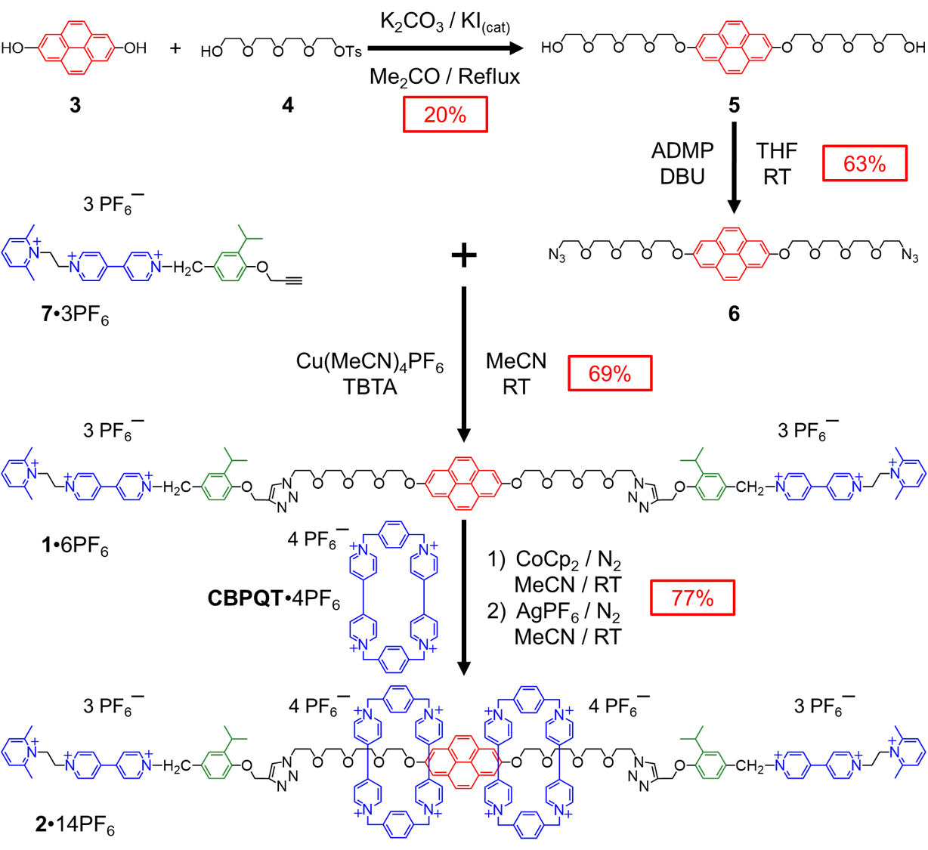

Scheme 1

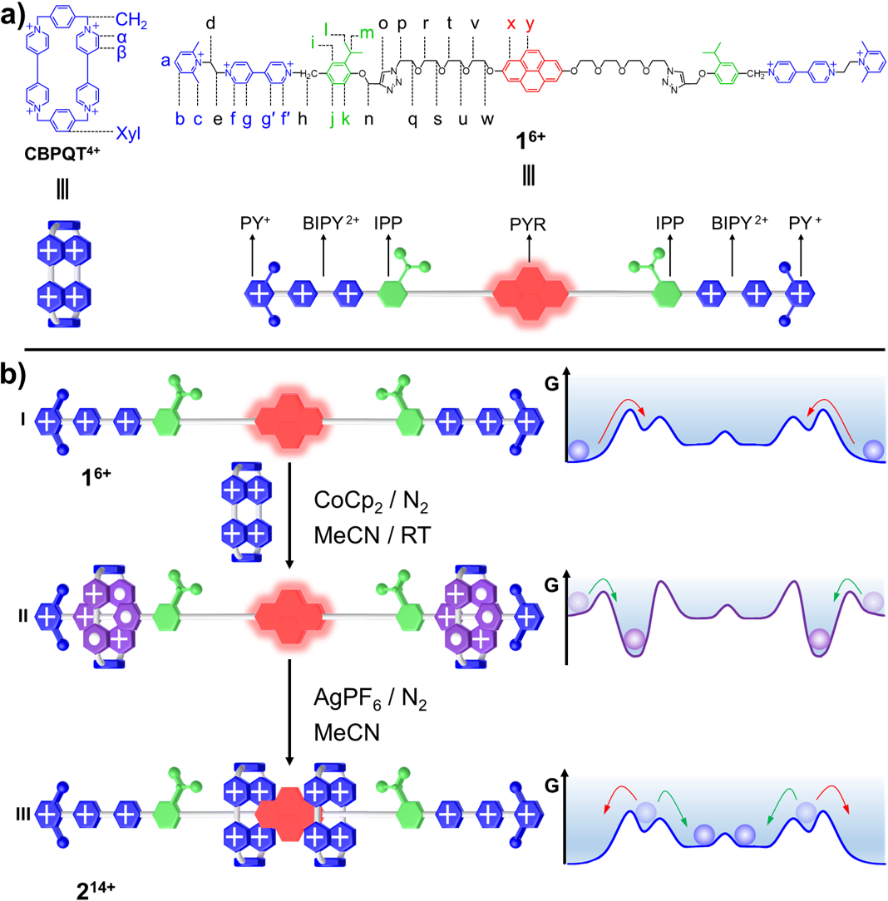
Figure 1

Figure 2
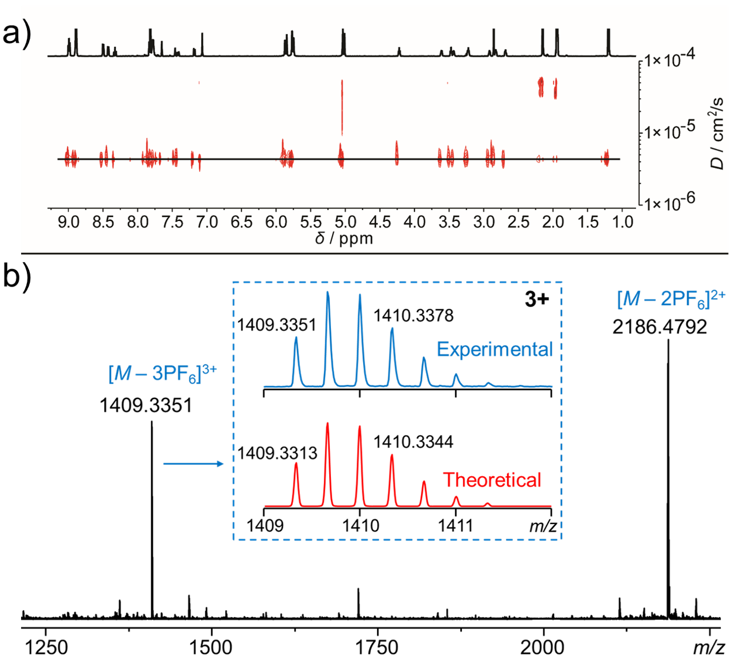

Figure 3

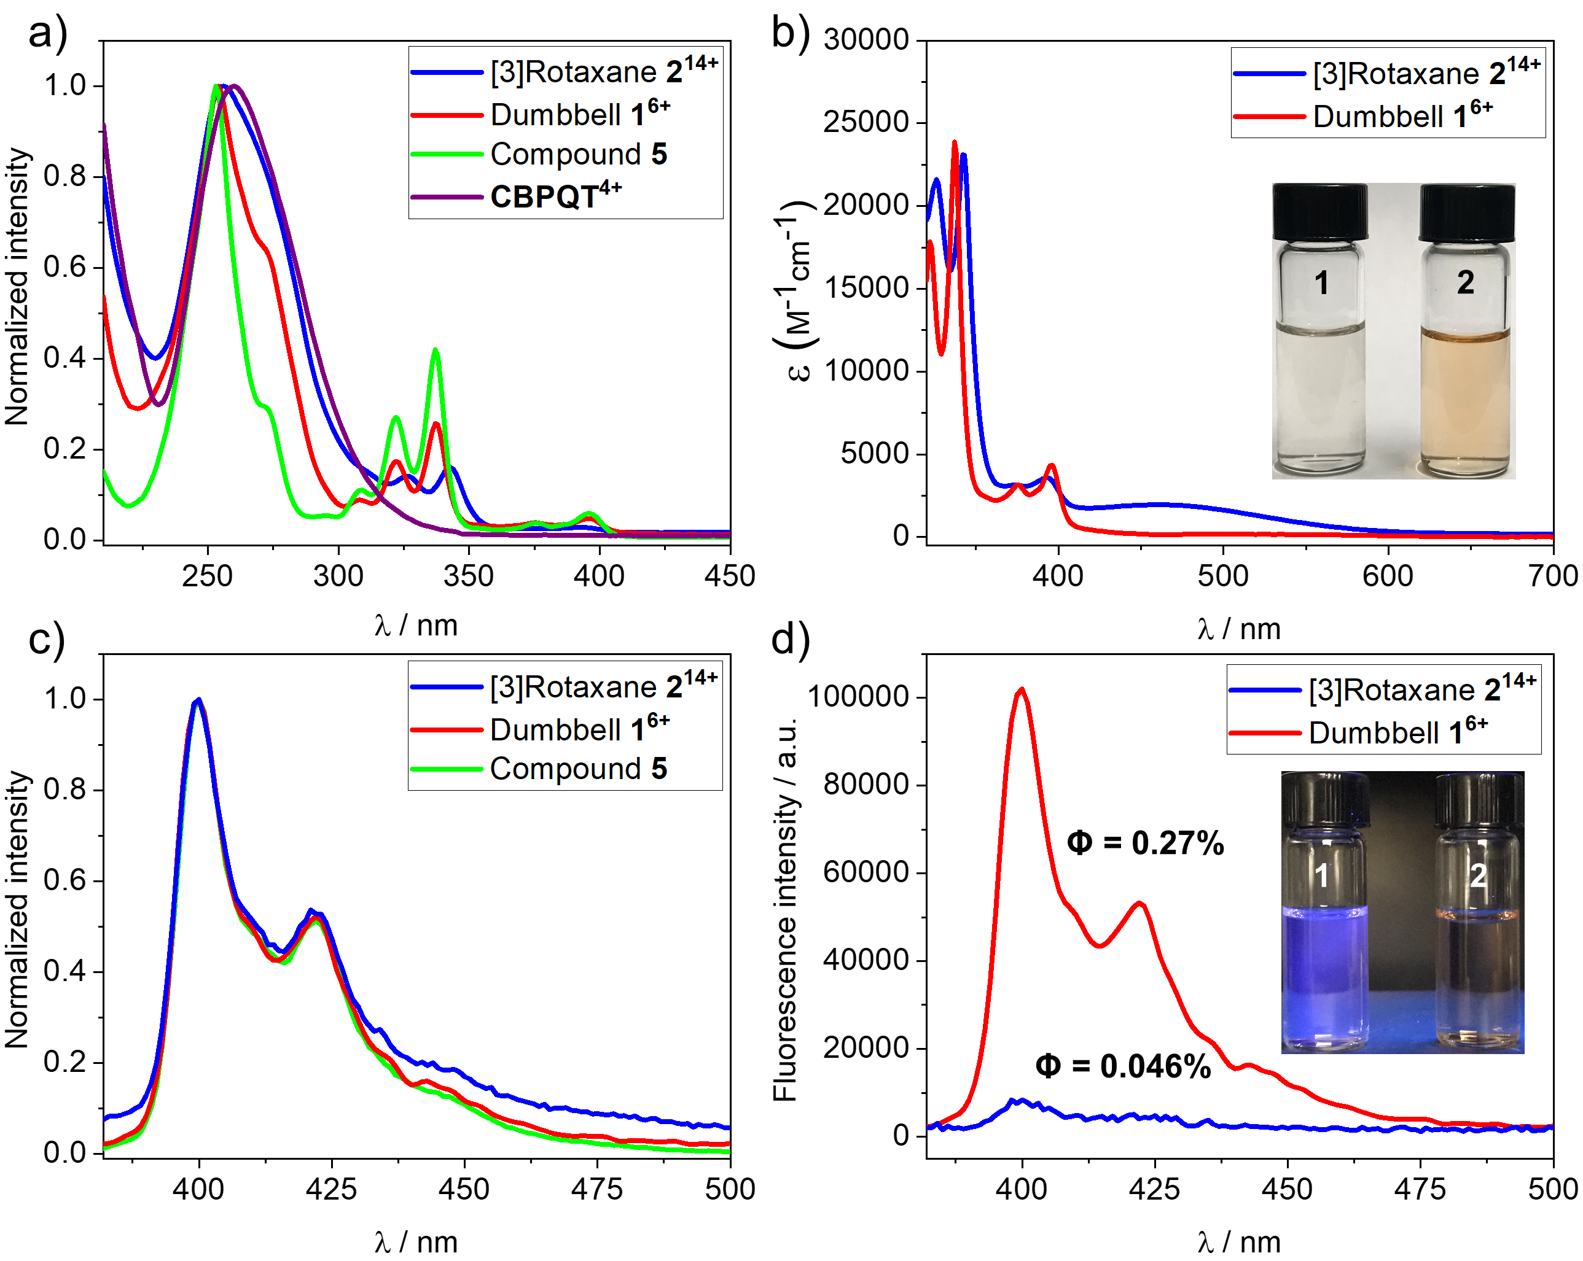

Figure 4
Table of Contents Graphic
