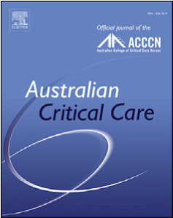
Brief research report
Contents lists available at
ScienceDirec
t
Australian Critical Care
journal homepage:
www.elsevier.com/locate/auc
c
Australian Critical Care xxx (xxxx) xx
x
Physical capacities assessment in critically ill patients: An exploratory study
Anne-Françoise Rousseau, MD PhD ^{a, *}, Isabelle Kellens, PT, PhD ª, Nadia Dardenne, MSc ^{b}, Benoit Misset, MD ª, Jean-Louis Croisier, PT, PhD ^{c}
ª Department of Intensive Care and Burn Center, University Hospital of Liege, Liege, Belgium; ^{b} Public Health Department, Biostatistics, University of Liege,
Sart-Tilman, Liege, Belgium; ^{c} Department of Sport Sciences and Rehabilitation, University of Liege, Sart-Tilman, Liege, Belgium

a r t i c l e i n f o r m a t i o n

Article history:
Received 19 June 2021
Received in revised form
30 October 2021
Accepted 10 November 2021

Keywords:
Critical care
Survivors
Muscle strength
Physical function
Quadriceps

a b s t r a c t

Background: The severity of muscle weakness after critical illness is very heterogeneous. To identify those patients who may maximally benefit from early exercises would be highly valuable. This implies an assessment of physical capacities, comprised at least of strength measurement and functional tests. Objectives: The objective of this study was to investigate the relationship between muscle strength and functional tests in an intensive care unit (ICU) setting.
Methods: Adults with ICU length of stay 2 days were included. Handgrip strength (HG) and maximal isometric quadriceps strength (QS) were assessed using standardised protocols as soon as patients were alert and able to obey commands. At the same time, their maximal level of mobilisation capabilities and their autonomy were assessed using ICU Mobility Scale (ICU-MS) and Barthel Index, respectively. Results: Ninety-three patients with a median age of 64 [57e71.5] years, body mass index of 26.4 [23.4 e29.6] kg/m², and Simplified Acute Physiology Score II of 33 [27.7e41] were included. Absolute and relative QS were, respectively, 146.7 [108.5e196.6] N and 1.87 [1.43e2.51] N/kg. HG was 22 [16e31] kg. The ICU-MS score was 4 [1e5]. A significant positive correlation was observed between HG and absolute QS (r_{s} ¼ 0.695, p < 0.001) and between HG and relative QS (r_{s} ¼ 0.428, p < 0.001). The ICU-MS score correlated with HG, with a weak positive relationship (r_{s} ¼ 0.215, p ¼ 0.039), but not with QS. The ICUMS score did not statistically differ between the weakest and strongest patients for absolute or relative QS, but was lower in patients with the lowest HG values (p ¼ 0.01). A weak positive correlation was observed between the Barthel Index and muscle strengths (maximum r_{s} ¼ 0.414, p < 0.001).
Conclusions: The present results suggest that, during ICU stay, there is no strong association between muscle strength and functional test such as the ICU-MS or Barthel Index. Muscle dynamometry and functional tests are probably complementary tools for physical capacities quantification.
© 2021 Australian College of Critical Care Nurses Ltd. Published by Elsevier Ltd. All rights reserved.

1. Introduction
Muscle weakness is recognised as a major complication of critical illness and stay in an intensive care unit (ICU). This acquired neuromuscular dysfunction is labelled “ICU-acquired weakness” (ICU-AW) and can lead to prolonged ICU and hospital length of stay (LOS).¹ It is also associated with long-term physical impairments, subsequently reducing the autonomy and the quality of life of ICU survivors.² Economic consequences can be significant for patients
* Corresponding author at: Department of Intensive Care and Burn Center, University Hospital of Liege, Sart-Tilman B35, B-4000, Li ege, Belgium. E-mail address: afrousseau@chuliege.be (A.-F. Rousseau).
https://doi.org/10.1016/j.aucc.2021.11.001
and their families, as well as implications for society in terms of increased healthcare utilisation.³ Yet, persistent ICU-AW is a key feature of the posteintensive care syndrome.⁴ The problem is frequent: ICU-AW is detected in 25e70% of patients, according to the timing of evaluation, the studied population, and the diagnostic tool used.^{2,5}
Clinical phenotype and severity of ICU-AW can be very heterogeneous. In a recent study, we confirmed the high variability of quadriceps strength between ICU patients.⁶ This reinforces the concept “one size does not fit all” and assumes a need for individualised and tailored strategies of rehabilitation. In this context, it would be highly valuable to identify those patients who may maximally benefit from early mobilisation and rehabilitation.⁷ This implies an assessment of physical capacity.

1036-7314/© 2021 Australian College of Critical Care Nurses Ltd. Published by Elsevier Ltd. All rights reserved. 2 A.-F. Rousseau et al. / Australian Critical Care xxx (xxxx) xxx

In daily clinical practice, physical capacity in the ICU can be assessed using two different approaches: an analytic approach assessing strength of key muscles groups and a global approach assessing physical function. Both approaches require the patient to be alert but help quantifying the patient's physical capacities in real time. Muscle strength measurement by dynamometry is an objective and quantitative alternative to the manual testing using the Medical Research Council (MRC) Scale, still considered as the gold standard for ICU-AW diagnosis.⁸ Handgrip strength has been thought to represent global muscle strength and to predict some outcomes of ICU patients.⁹ Cut-off scores for ICU-AW diagnosis have been described for men and women.^{5,10} From another point of view, quadriceps is essential for standing, sitting, and walking: considering quadriceps strength as a relevant parameter thus does make sense. Recently, we described the quadriceps strength of ICU patients using a novel and reliable method of quadriceps strength measurement.^{6,11} These both noninvasive measures can be performed at bedside with a high reliability.¹ In ICU context, feasibility of functional assessment is often limited owing to issues related to the patient (motivation, weakness, fatigability, pain, organ support) or organisation (human resources). A number of instruments are available, from scales to physical performance test.¹² The ICU Mobility Scale (ICU-MS) was developed for use in the ICU to standardise the recording of a patient's highest level of mobility.¹³ Lower values have been associated with lower MRC Scale scores and ICU-AW at discharge.¹⁴ The Barthel Index of activities of daily living (ADLs) is commonly used to measure functional status and dependency.¹⁵
To date, there are only a few reports addressing muscle strength in the critically ill patients with the purpose of guiding their physical activities.¹⁶ A positive relationship between muscle strength and physical capacities has been observed for years in elderly patients¹⁷ or in patients with Parkinson disease,¹⁸ for example. However, it is not clear if such conclusion can be drawn in ICU patients. Furthermore, it would be interesting to specify the interest of muscle strength and physical performance scales for physical capacities assessment during ICU stay. The present study aimed to investigate the relationship between handgrip strength, quadriceps strength, ICU-MS, and level of autonomy.

2. Methods
This observational study was conducted in 2018 and 2019 in a tertiary hospital after approval by the local ethics committee of our university hospital (Chairperson: Vincent Seutin, National Ref B707201732960, Local Ref 2017/178, 1st August 2017). Informed consent was obtained from the patients or their relatives before enrolment.

2.1. Participants
Patients who spent a minimum of 48 h in the ICU were enrolled. Exclusion criteria were as follows: a score >1 or < 1 on the Richmond AgitationeSedation Scale; coma; total hip or knee arthroplasty in the dominant limb; trauma in the dominant arm or leg; open wound located at the ankle's anterior face of the dominant leg; a documented history of neurological, neuromuscular, or muscular wasting diseases; spinal injury or hemiplegia; or refusal. One patient could not be included twice in the study, such as if readmitted later in the ICU.
During ICU stay, all patients with critical illness benefited from local standard care procedures. Nutrition was administered by oral, enteral, or parenteral routes according to the patient's status, aiming to obtain daily intakes of 20e25 kcal/kg and 1.2e1.3 g of proteins/kg. Continuous intravenous insulin was administered to maintain blood glucose level between 0.8 and 1.8 g/l. All patients had two physiotherapy sessions a day, during working days. They benefited from an early mobilisation strategy, including passive or active cycling, passive or active range of motion, sitting out of bed, transfers, ambulation, and other mobilisation techniques, as appropriate according to the level of consciousness.¹⁹

2.2. Procedure
Patients with critical illness still in the ICU on day 3 after admission were systematically and daily assessed for awakening based on their responses to orders (“Open or close your eyes”, “Look at me”, “Open your mouth and put out your tongue”). They were tested for muscle strength as soon as they were able to understand the instructions and obey. At the same time, the ICU-MS score and Barthel Index were noted.

2.3. Muscle strength testing
Peripheral muscle strength was determined by using handgrip and quadriceps dynamometry. Handgrip strength was assessed using a Jamar hydraulic hand dynamometer (Sammons Preston, IL, USA). Measurements were performed in a sitting position, with the elbow in 90 flexion. The protocol consisted of three consecutive maximal contractions for each muscle group, preceded by three warm-up trials. Observers provided standardised encouragement. The three measurements were performed with 30-s intervals between contractions. Patients were asked to gradually increase their muscle force to a maximum effort which had to be sustained for 6 s. The highest performance was considered for analysis. Grip strength varies with age and sex: strength 25 kg in men aged 60 years and 23 kg in men aged between 61 and 79 years or strength 14 kg in women aged 60 years and 13 kg in women aged between 61 and 79 years were considered normal.²⁰ Maximal isometric quadriceps strength was measured using a MicroFET2 handheld dynamometer (Hoggan Industries, Inc., West Jordan, UT, USA), with the patient lying on supine position. The highly standardised testing protocol is detailed in a previously published validation study.¹¹ Magnitude of the values that can be observed in healthy and critically ill patients is described elsewhere:⁶ median reported quadriceps strength was around 370 N and 210 N, respectively, and strength can range from 50 N in the weakest patients to more than 500 N in the strongest subjects. To reduce interindividual variability and minimise the effect of subject weight on muscle strength, absolute strength was normalised according to the actual body weight (relative strength expressed in N/kg).

2.4. Functional tests
The ICU-MS is a scale with scores ranging from 0 (lying in bed) to 10 (walking independently) measuring mobilisation capabilities.²¹ The Barthel Index measures the dependency for ADLs and consists of the following 10 subheadings: feeding, bathing, grooming, dressing, bladder control, bowel control, toilet use, chairebed transfer, mobility, and stair climbing.¹⁵ Scoring ranges from 0 to 100: a score of 100 was defined as being capable of ADL complete self-care.

2.5. Other descriptive data
Age (years), gender, weight (kg), height (cm), and body mass index (kg/m²) were recorded. Physical activity status before admission was also characterised according to the patient's selfreport: patients who reported recreational physical activity or sports activity for four or more hours per week were considered

Please cite this article as: Rousseau A-F et al., Physical capacities assessment in critically ill patients: An exploratory study, Australian Critical
Care, https://doi.org/10.1016/j.aucc.2021.11.001
A.-F. Rousseau et al. / Australian Critical Care xxx (xxxx) xxx 3

physically active, whereas patients who did not achieve this were considered physically inactive. Severity of clinical condition was scored using the Simplified Acute Physiology Score II (SAPS II).

2.6. Statistical analyses
Given the descriptive setting, no a priori sample size was calculated. Statistical analysis was performed using Graphpad Prism (version 9.0 for Mac OSX, Graphpad Inc., San Diego, CA, USA) and SAS (version 9.4 for Windows, SAS Institute, Cary, NC, USA). Normality was assessed using the ShapiroeWilk test. Characteristics of patients were described as median (interquartile range) or count (percent) for quantitative and qualitative variables, respectively. Correlation between parameters was assessed using nonparametric Spearman test. Ninety-five percent confident intervals (95% CIs) for the correlation coefficient were also mentioned. Each studied parameter of muscle strength (grip strength, absolute and relative quadriceps strength) was categorised into three categories according to the tertiles: the ICU-MS score in the 33% weakest patients was compared with the 33% strongest patients, using the KruskaleWallis test. Ninety-five percent CIs for the median differences between the two extreme categories were calculated using the HodgeseLehmann estimate of location shift for two-sample data. A p value < 0.05 was considered statistically significant.

3. Results
During a 35-weeks period in 2018 and 2019, 949 patients had an ICU LOS >48 h. A number of patients could not be assessed owing to exclusion criteria, patient or medical staff refusal, and organisational constraints. Finally, 93 patients met the inclusion criteria and were analysed. Descriptive characteristics of the included patients are detailed in Table 1. Their muscle strength and functional tests are described in Table 2.
A significant positive correlation was observed between grip strength and absolute quadriceps strength (r_{s} ¼ 0.695, 95% CI ¼ 0.57e0.79, p < 0.001). The positive correlation between grip strength and relative quadriceps strength was weaker but
Table 1 Demographics.
Data |  | n ¼ 93
Age, y |  | 64 [57e71,5]
Male, n (%) |  | 60 (64.5)
Weight, kg |  | 78.6 [65.1e90]
Height, cm |  | 170.5 [162.5e180]
BMI, kg/m² |  | 26.4 [23.4e29.6]
Comorbidity, n (%) | Cardiac | 69 (74.2)
 | Alcohol addiction | 26 (28)
 | Respiratory | 23 (24.7)
 | Diabetes | 20 (21.5)
 | Malignancy | 20 (21.5)
 | Chronic kidney disease | 17 (18.3)
 | Organ transplantation | 3 (3.2)
 | Liver cirrhosis | 2 (2.1)
Physically inactive before ICU, n (%) |  | 62 (66.7)
Barthel Index before ICU |  | 100 [95e100]
Admission type, n (%) Medical |  | 24 (25.8)
Surgical |  | 69 (74.2)
SAPS II |  | 33 [28e41]
Mechanical ventilation, n (%) |  | 25 (26.9)
Duration of mechanical ventilation, d |  | 5 [2.2e11.5]
Renal replacement therapy, n (%) |  | 5 (15.6)
ICU LOS, d |  | 6 [3e10.7]
BMI, body mass index; ICU, intensive care unit, LOS, length of stay; SAPS II, Simplified Acute Physiology Score II.
Table 2
Muscle strength and physical function.
Data | n ¼ 93
Handgrip (kg) | 22 [16e31]
Absolute QS (N) | 146.7 [108.5e196.6]
Relative QS (N/kg) | 1.87 [1.43e2.51]
ICU-MS | 4 [1e5]
Barthel Index | 30 [20e35]
ICU-MS, ICU Mobility Scale; QS, quadriceps strength.
significant (r_{s} ¼ 0.428, 95% CI ¼ 0.24e0.58, p < 0.001). There was a weak positive correlation between the Barthel Index and the three muscle strength parameters (maximum r_{s} ¼ 0.414, p < 0.001). On the contrary, the ICU-MS only correlated with grip strength, with a
very weak positive relationship (r_{s} ¼ 0.215, p ¼ 0.039). Neither absolute nor relative quadriceps strength was correlated with the ICU-MS: r_{s} ¼ 0.07 (95% CI ¼ -0.140 e 0.274, p ¼ 0.513) or r_{s} ¼ 0.092 (95% CI ¼ -0.120 e 0.295, p ¼ 0.395), respectively. The main correlations between strength and functional outcomes are illustrated in Fig. 1.
Patients with grip strength 18 kg (first tertile) had a significantly lower ICU-MS than the strongest patients with grip strength 29 kg (third tertile), (2 [1e5] versus 5 [2e8], respectively, 95% CI ¼ -2 [3 e 0], p ¼ 0.01). On the contrary, the ICU-MS did not statistically differ between the weakest and strongest patients for absolute or relative quadriceps strength: 95% CI ¼ 0 (3 e 0), p ¼ 0.38 and 95% CI ¼ 0 (2 e 1), p ¼ 0.99, respectively.

4. Discussion
In this exploratory study, we confirmed a correlation between handgrip strength and quadriceps strength. However, there was no strong association between the maximal level of mobility at the ICU-MS and grip strength or, even less, quadriceps strength. This observation is in contrast with some findings showing a moderate correlation between the ICU-MS and muscle strength assessed using the MRC Scale.¹³ In other ICU patients, quadriceps strength has been related to limb or physical function.^{22,23} However, in those studies, physical capacity was assessed using more complex tests than the ICU-MS, such as a walking test or the “Time Up and Go” test. In the present study, the median highest level of mobility was quite low: patients were able to do weight-bearing through the feet in the standing position, with or without assistance (corresponding to level four on the ICU-MS). It is thus possible that the ICU-MS focuses on physical performances that are not enough complex to require a full action of quadriceps muscle. Moreover, many barriers can delay out-of-bed mobilisations and walking activities (levels six or higher on the ICU-MS),²⁴ so that the best actual highest level of mobility may be drastically but artificially underevaluated during ICU stay. Finally, muscle strength measurement explores the maximal capacities of a patient at a specific time point, whereas the ICU-MS characterises the physical status of the patient without investigating his/her physical resources.
There was no strong association between the autonomy and muscle strength. Assessment of the dependency in the ICU setting is challenging. The Barthel Index is preferentially used after ICU discharge.⁸ However, self-care and exercises (such as transfers, ambulation outside the room, or even climbing training stairs) are increasingly promoted early during the ICU trajectory, and it is thus relevant to quantify the level of dependency during the ICU stay.
The link between quadriceps strength and function may not be so obvious in an ICU setting. First, physical function requires much more muscles than the quadriceps. Quadriceps strength alone may not be representative of global strength in the leg, even more if
4 A.-F. Rousseau et al. / Australian Critical Care xxx (xxxx) xxx
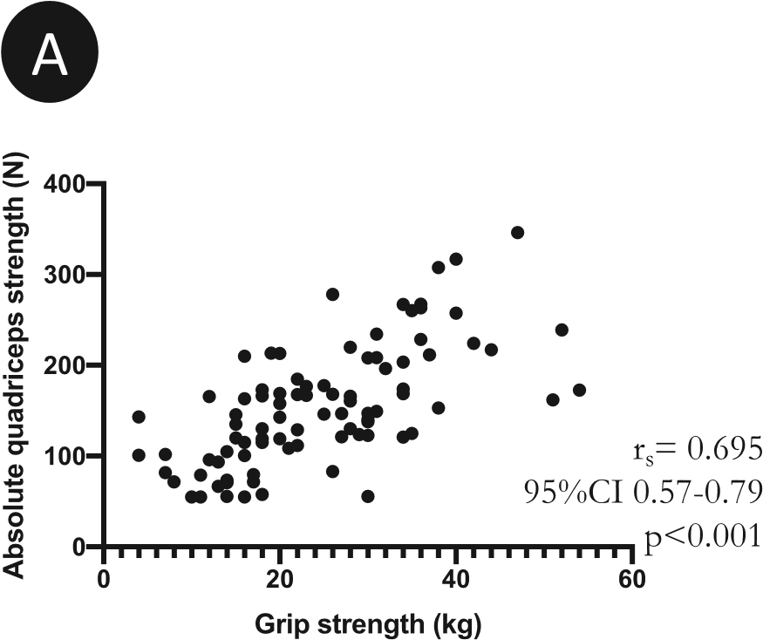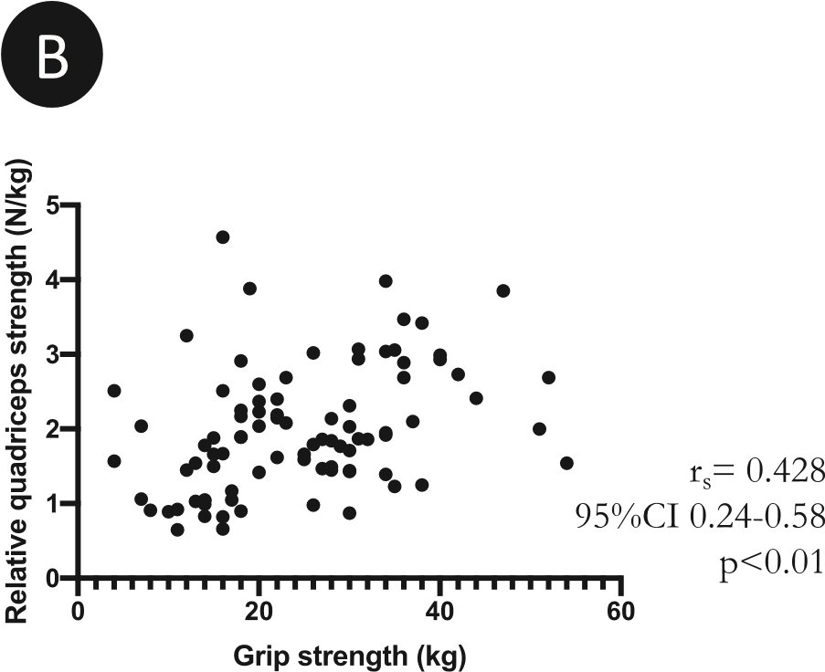
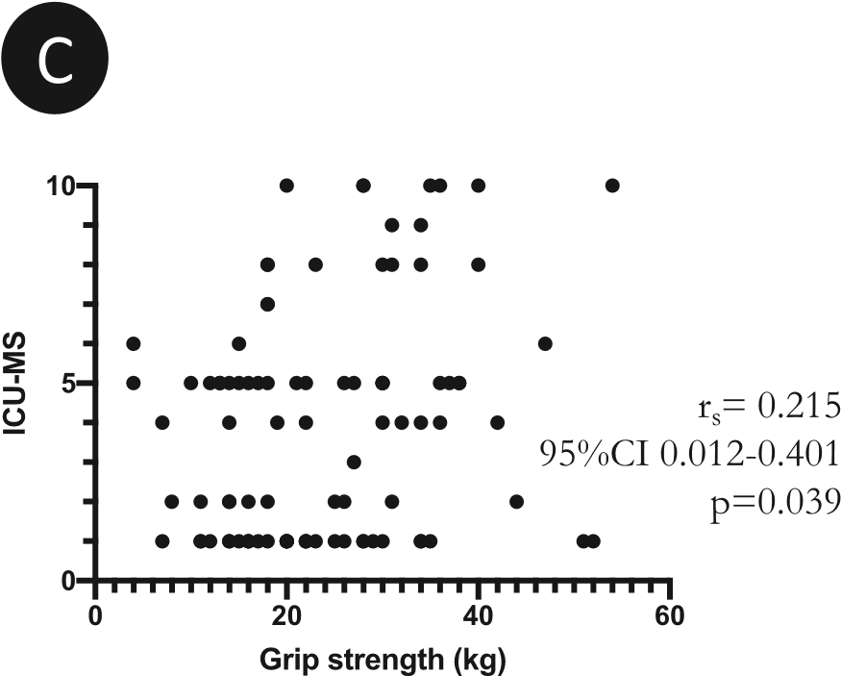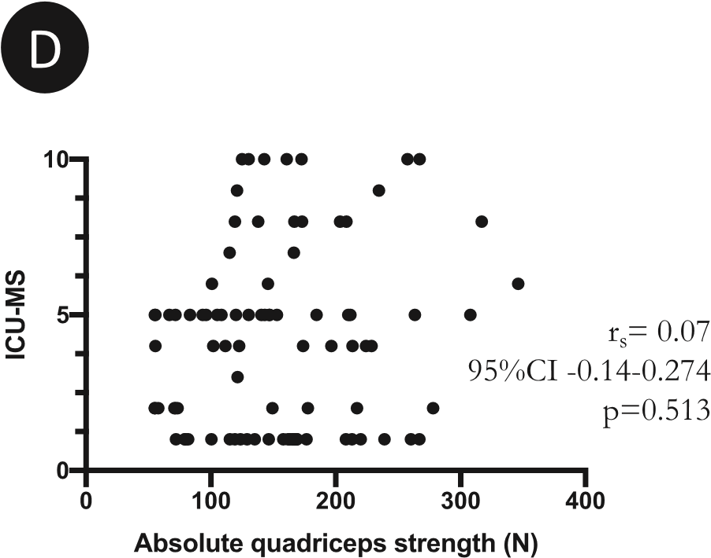
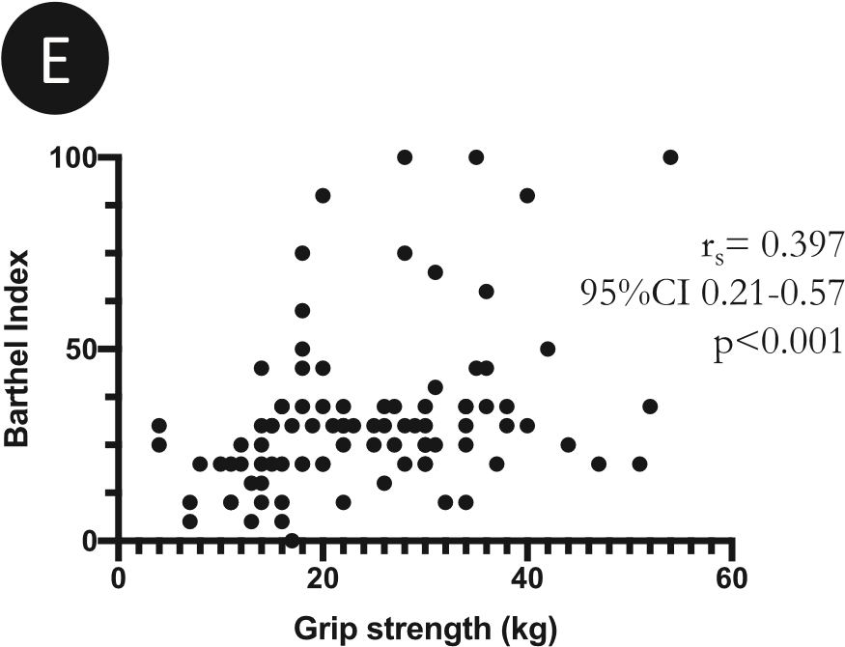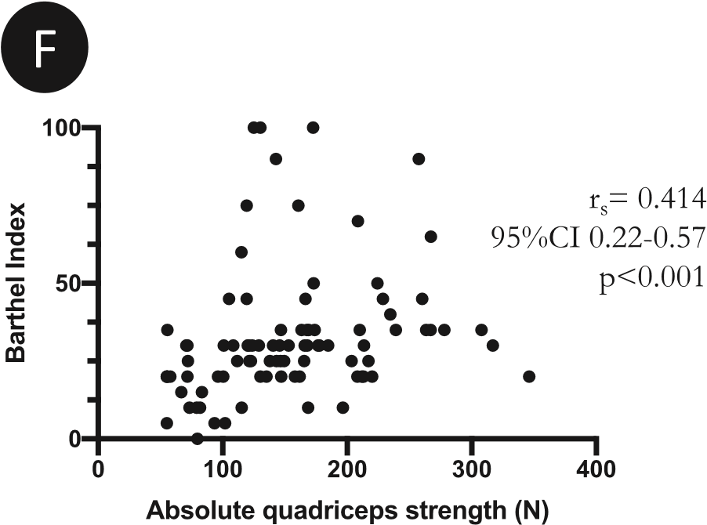
Fig. 1. Correlations between grip strength and absolute (A) or relative (B) quadriceps strength, between ICU-MS and grip strength (C) or absolute quadriceps strength (D), and between the Barthel Index and grip strength (E) or absolute quadriceps strength (F). CI, confidence interval; ICU-MS, ICU Mobility Scale.
strength is assessed using isometric contraction. Second, other parameters, such as pain, fatigue, or dizziness, may limit physical capacity, even without muscle weakness. This could reduce global physical performances, without affecting a one-time strength measurement.
Given the lack of a strong relationship between muscle strength and physical function, these both tests should probably be considered as complementary approaches of physical capacities at a given moment. The same muscle dynamometry can be used throughout the trajectory from the ICU to recovery: results can be

Please cite this article as: Rousseau A-F et al., Physical capacities assessment in critically ill patients: An exploratory study, Australian Critical Care, https://doi.org/10.1016/j.aucc.2021.11.001
A.-F. Rousseau et al. / Australian Critical Care xxx (xxxx) xxx 5

compared, and progress can be estimated. On the contrary, the way to assess physical capacity will change according to the timing of evaluation. In other words, it will not be possible to use the same test from ICU discharge to full recovery stage. Moreover, unlike dynamometry, many available function tests are characterised by a ceiling effect, limiting the possibilities to highlight improvements at the highest levels.¹²
To the best of our knowledge, this pilot study was the first to explore the relationship between dynamometry results and functional tests in critically ill patients. Standardised tests were used, strengthening the present results. The calculated 95% CI confirmed that the study was sufficiently powered to detect potential associations of interest. Some limitations need to be acknowledged: organisational constraints limited the number of included patients, and most of them were admitted to the ICU after cardiac surgery. However, they were considered as critically ill patients (and not as posteanaesthesia care unit patients), as proven by their ICU severity score. Future research should investigate if muscle strength (specially quadriceps dynamometry) measured at ICU discharge would be associated with the level of physical capacities at hospital discharge or at short term after discharge. This should help anticipating and individualising the needs in rehabilitation. This work is currently ongoing in our post-ICU follow-up clinic.

5. Conclusion
The present results suggest that, during ICU stay, there is no strong association between muscle strength and functional test such as the ICU-MS or Barthel index. Muscle dynamometry and functional tests are probably complementary tools for physical capacities quantification. Consent for publication Not applicable.
Funding
None.

CRediT authorship contribution statement
Anne-Françoise Rousseau: conceptualisation, methodology, investigation, validation, visualisation, writing e original draft
Isabelle Kellens: conceptualisation, methodology, investigation, validation, writing e review and editing
Nadia Dardenne: formal analysis, writing e review and editing Benoît Misset: writing e review and editing
Jean-Louis Croisier: supervision, writing e review and editing
We all confirm that the manuscript has been read and approved by all named authors and that there are no other persons who satisfied the criteria for authorship but are not listed. We further confirm that the order of authors listed in the manuscript has been approved by all of us. All authors declare that this manuscript is original, has not been published before and is not currently being considered for publication elsewhere. We understand that the Corresponding Author is the sole contact for the Editorial process. She is responsible for communicating with the other authors about progress, submissions of revisions and final approval of proofs.
Conflict of Interest
All authors declare that they have no competing interests.

Acknowledgements
We would like to thank our PT students for their precious help in data collection.

References
- Vanhorebeek I, Latronico N, Van den Berghe G. ICU-acquired weakness. Intensive Care Med 2020;46:637e53.
- Hermans G, Van den Berghe G. Clinical review: intensive care unit acquired weakness. Crit Care 2015;19:274.
- Hermans G, Van Mechelen H, Clerckx B, Vanhullebusch T, Mesotten D, Wilmer A, et al. Acute outcomes and 1-year mortality of intensive care unitacquired weakness. A cohort study and propensity-matched analysis. Am J Respir Crit Care Med 2014;190:410e20.
- Rousseau AF, Prescott HC, Brett SJ, Weiss B, Azoulay E, Creteur J, et al. Longterm outcomes after critical illness: recent insights. Crit Care 2021;25:108.
- Piva S, Fagoni N, Latronico N. Intensive care unit-acquired weakness: unanswered questions and targets for future research. F1000Research 2019;8.
- Blanjean A, Kellens I, Misset B, Joris J, Croisier JL, Rousseau AF. Quadriceps strength in intensive care unit survivors: variability and influence of preadmission physical activity. Aust Crit Care 2020 Jul;34(4):311e8.
- Parry SM, Nydahl P, Needham DM. Implementing early physical rehabilitation and mobilisation in the ICU: institutional, clinician, and patient considerations. Intensive Care Med 2018;44:470e3.
- Parry SM, Granger CL, Berney S, Jones J, Beach L, El-Ansary D, et al. Assessment of impairment and activity limitations in the critically ill: a systematic review of measurement instruments and their clinimetric properties. Intensive Care Med 2015;41:744e62.
- Braganca RD, Ravetti CG, Barreto L, Ataide T, Carneiro RM, Teixeira AL, et al. Use of handgrip dynamometry for diagnosis and prognosis assessment of intensive care unit acquired weakness: a prospective study. Heart Lung 2019;48:532e7.
- Ali NA, O'Brien Jr JM, Hoffmann SP, Phillips G, Garland A, Finley JC, et al. Acquired weakness, handgrip strength, and mortality in critically ill patients. Am J Respir Crit Care Med 2008;178:261e8.
- Rousseau AF, Kellens I, Freycenon G, Dardenne N, Bruyere O, Damas P, et al. Highly standardized quadriceps dynamometry of critically ill adults at bedside: a step towards individualized rehabilitation. Acta Anaesthesiol Belg 2018;69:159e64.
- Parry SM, Huang M, Needham DM. Evaluating physical functioning in critical care: considerations for clinical practice and research. Crit Care 2017;21:249.
- Tipping CJ, Bailey MJ, Bellomo R, Berney S, Buhr H, Denehy L, et al. The ICU mobility scale has construct and predictive validity and is responsive. A multicenter observational study. Ann Am Thorac Soc 2016;13:887e93.
- Tipping CJ, Hodgson CL. Clinimetrics: the intensive care unit mobility scale. J Physiother 2020;66:271.
- Mahoney FI, Barthel DW. Functional evaluation: the Barthel index. Md State Med J 1965;14:61e5.
- Roberson AR, Starkweather A, Grossman C, Acevedo E, Salyer J. Influence of muscle strength on early mobility in critically ill adult patients: systematic literature review. Heart Lung 2018;47:1e9.
- Manini TM, Visser M, Won-Park S, Patel KV, Strotmeyer ES, Chen H, et al. Knee extension strength cutpoints for maintaining mobility. J Am Geriatr Soc 2007;55:451e7.
- Mak MK, Pang MY, Mok V. Gait difficulty, postural instability, and muscle weakness are associated with fear of falling in people with Parkinson's disease. Parkinsons Dis 2012;2012:901721.
- Sommers J, Engelbert RH, Dettling-Ihnenfeldt D, Gosselink R, Spronk PE, Nollet F, et al. Physiotherapy in the intensive care unit: an evidence-based, expert driven, practical statement and rehabilitation recommendations. Clin Rehabil 2015;29:1051e63.
- Spies C, Krampe H, Paul N, Denke C, Kiselev J, Piper S, et al. Instruments to measure outcomes of post-intensive care syndrome in outpatient care settings e results of an expert consensus and feasibility field test. J Intensive Care Soc 2021 May;22(2):159e74.
- Hodgson C, Needham D, Haines K, Bailey M, Ward A, Harrold M, et al. Feasibility and inter-rater reliability of the ICU mobility scale. Heart Lung 2014;43:19e24.
- Schilling BK, Karlage RE, LeDoux MS, Pfeiffer RF, Weiss LW, Falvo MJ. Impaired leg extensor strength in individuals with Parkinson disease and relatedness to functional mobility. Park Relat Disord 2009;15:776e80.
- Iwakura M, Wakasa M, Okura K, Kawagoshi A, Sugawara K, Takahashi H, et al. Functionally relevant threshold of quadriceps muscle strength in patients with chronic obstructive pulmonary disease. Prog Rehabil Med 2021;6: 20210008.
- Dubb R, Nydahl P, Hermes C, Schwabbauer N, Toonstra A, Parker AM, et al. Barriers and strategies for early mobilization of patients in intensive care units. Ann Am Thorac Soc 2016;13:724e30.

