**Supplementary materials**

**Appendix A: General description of the 14 faba bean varieties tested in field trials (2019–2020) according to technical information provided by owners.**

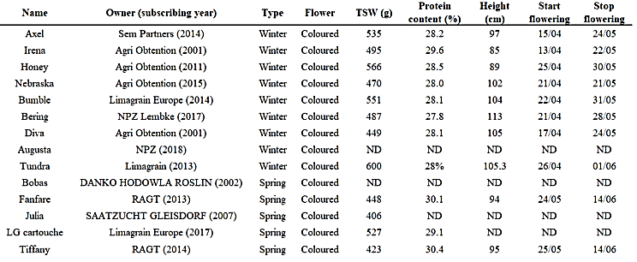

**Appendix B: Representative scheme of varietal field test dispositive.**

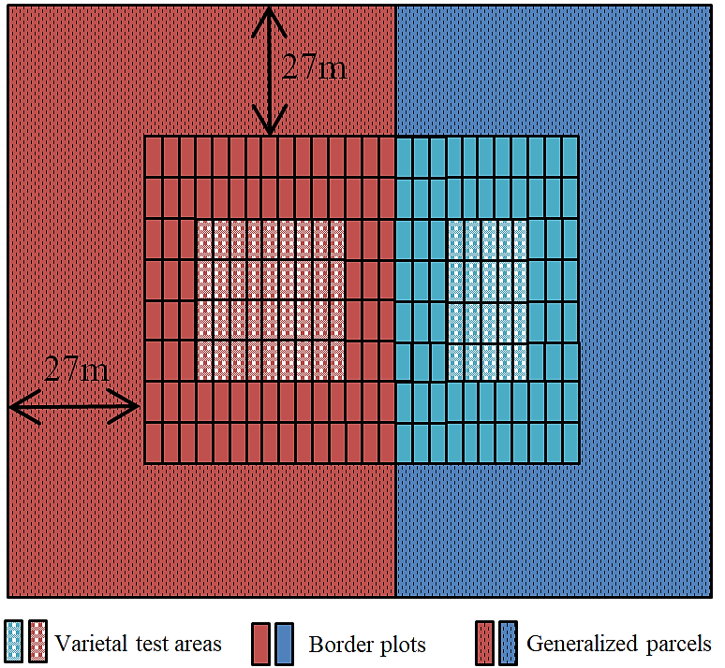

**Appendix C: Average and standard deviation of studied parameters per growing seasons (*i.e.*, Year*Type)**

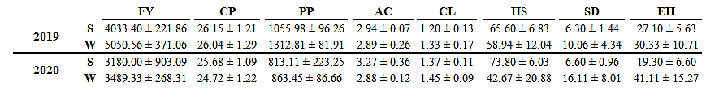

**Appendix D: Varietal phenology of each tested variety during the two growing seasons (2018–2019) and (2019–2020). DFF: day of first flowering; DLF: day of last flowering; DFP: day of first pods; DF: duration of flowering.**

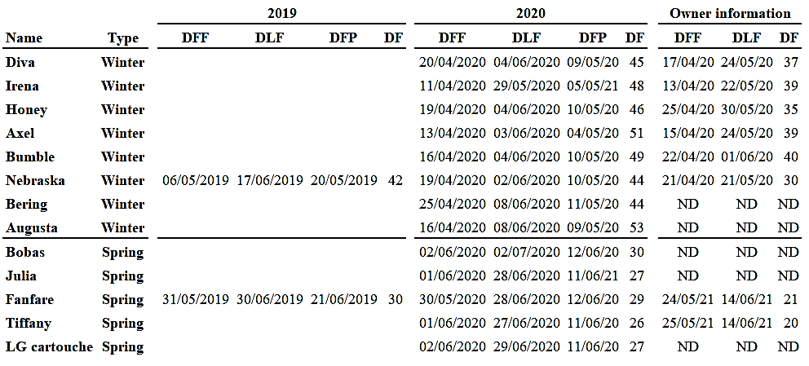

**Appendix E: PCA supplementary data.**

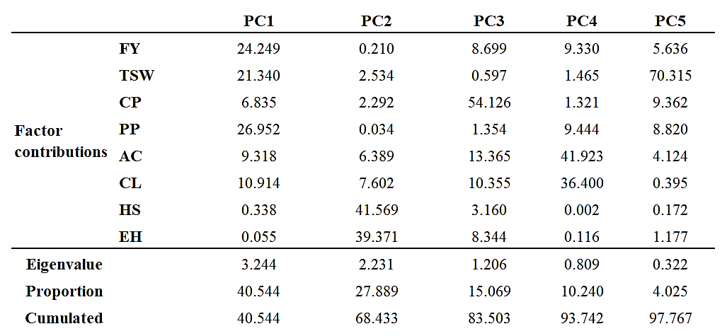

**Appendix F: Regression model equations.**

|  |  |  |
| --- | --- | --- |
| Type | Model | Equation |
| Winter | FY | FY = 3025904  - 1496.2 Year  - 185 Variety Augusta  + 412 Variety_Axel  - 198 Variety_Béring  - 442 Variety_Bumble  + 144 Variety_Diva  - 41 Variety_Honey  - 66 Variety_Irena  + 243 Variety_Nebraska  + 132 Variety_Tundra |
| CP | CP = 3335  - 1.637 Year  + 0.731 Variety_Augusta  - 0.078 Variety_Axel  + 0.493 Variety_Béring  - 0.813 Variety_Bumble  - 1.144 Variety_Diva  - 0.497 Variety_Honey  + 2.426 Variety_Irena  - 0.733 Variety_Nebraska  - 0.385 Variety_Tundra |
| PP | PP = 879013  - 434.7 Year  - 23.0 Variety_Augusta  + 98.8 Variety_Axel  - 25.7 Variety_Béring  - 136.0 Variety_Bumble  - 0.4 Variety_Diva  - 32.9 Variety_Honey  + 71.6 Variety_Irena  + 25.9 Variety_Nebraska  + 21.9 Variety_Tundra |
| HS | %HS = 32854  - 16.24 year  + 11.35 Variety_Augusta  - 18.68 Variety_Axel  - 2.32 Variety_Bering  - 8.23 Variety_Bumble  + 15.31 Variety_Diva  - 16.32 Variety_Honey  - 11.21 Variety_Irena  + 21.41 Variety_Nebraska  + 8.68 Variety_Tundra |
| EH | %EH = -20392  + 10.11 year  - 6.83 Variety_Augusta  + 17.23 Variety_Axel  + 1.75 Variety_Bering  - 0.79 Variety_Bumble  - 14.23 Variety_Diva  + 16.08 Variety_Honey  + 12.98 Variety_Irena  - 15.61 Variety_Nebraska  - 10.58 Variety_Tundra |
| Spring | FY | Field_yield = 1595902  - 788 Year |
| CP | CP = 1780  - 0.867 Year  - 0.655 Variety_Bobas  + 0.026 Variety_Fanfare  + 0.360 Variety_Julia  + 1.650 Variety_LG cartouche  - 1.382 Variety_Tiffany |
| PP | PP = 458167  - 226.4 Year |
| HS | %HS = -14798  + 7.36 year  + 2.69 Variety_Bobas  - 1.62 Variety_Fanfare  + 7.32 Variety_Julia  - 7.12 Variety_LG_cartouche  - 1.26 Variety_Tiffany |
| EH | %EH = 12974  - 6.41 year  - 0.96 Variety_Bobas  - 0.71 Variety_Fanfare  - 5.81 Variety_Julia  + 7.45 Variety_LG_cartouche  + 0.03 Variety_Tiffany |