Evaluation of hydroxyapatite texture using CTAB template and effects on protein adsorption
Ana P. F. Monteiro*^{a,b}, Gaelle Idczak ^{a,b}, Rémi G. Tilkin^{a,b}, Romain M. Vandebergª, Bénédicte Vertruyen^{c}, Stéphanie D. Lambert^{b}, Christian Grandfilsª
ª Interfaculty Research Center of Biomaterials (CEIB), University of Liège, Allée du Six Août 11, 4000 Liège, Belgium
^{b} Department of Chemical Engineering – Nanomaterials, Catalysis and Electrochemistry (NCE), University of Liège, Allée du Six Août 11, 4000 Liège, Belgium
^{c} Department of Chemistry – GREENMAT, CESAM Research Unit, University of Liège, Allée du Six Août 11, 4000 Liège, Belgium

*Corresponding author: a.monteiro@uliege.be, Tel: +32 (0)4 366 3609
Abstract
This work aims to optimize the texture properties of hydroxyapatite (HA) in view to adopt them as biopharmaceutical drug delivery carrier. For this purpose, cetrimonium bromide (CTAB) has been adopted as nanotemplate. The micellization behavior of this cationic surfactant has been studied within conditions simulating HA synthesis in order to better understand and control its aggregation behavior during HA synthesis. Micelle formation and their size have been monitored by dynamic light scattering (DLS) in the presence of phosphate ions, adopting different CTAB concentrations. Interestingly, distinct populations of CTAB aggregates have been distinguished in the autocorrelation curves derived from DLS analysis. The influence of CTAB aggregation during HA synthesis has been assessed comparing the purified inorganic powders by FTIR, XRD, TGA, BET and TEM analysis. The evolution of the size and shape of HA nanoparticles visualized under TEM has been closely correlated to the change in specific surface area, which has considerably increased (up to 150 m².g⁻¹) in a narrow range of CTAB concentration. Soybean trypsin inhibitor (STI) was adopted as a model of bone morphogenic protein. Its loading capacity, release rate in vitro and its stability were correlated to the HA nano-texture.
Keywords: hydroxyapatite, CTAB surfactant, protein adsorption, bone reconstruction, trypsin inhibitor, DLS technique

Introduction
Hydroxyapatite (HA), Ca₅(PO₄)₃(OH), is a natural ceramic, which represents 60-70% of human bones and is therefore extensively in clinical practices since 1970s for bone repair, but also to coat synthetic grafts [1]. However, despite its biocompatibility and good mechanical properties, its lack of osteointegration after implantation has often been reported in the literature [2]. Many strategies have been proposed to promote the integration of this material. One of them consists in the modification of bioceramic porosity to load and locally release active biomolecules [3–6] to enhance healing process [7,8].
For this purpose, several biomolecules have been already incorporated into HA. Among them, the bone morphogenetic protein-2 (BMP-2) is particularly attractive in order to promote osteoinduction and is accepted by the US Food and Drug Administration (FDA) for bone regeneration since 2002 [9–11]. Due to its high cost, other model proteins are typically used in the early stage of in vitro screening in order to simulate its behavior when loaded with new potential implants. With very closed macromolecular similarities to BMP-2, the soybean trypsin inhibitor (STI) appears to be a suitable candidate [12,13]. STI is a monomeric protein made from 181 amino acid residues and characterized by a molecular weight of 24 kDa with an isoelectric point at 4.5 [14,15]. Advantageously, the preservation of the conformation of this enzyme can be easily assessed using a simple colorimetric inhibitory assay to control its release rate and bioactivity after incorporation in a given matrix [16].
In order to adjust the loading of this growth factor and its kinetics of delivery, considerable efforts have been devoted to control the nano-texture of HA, in particular to increase their total specific surface area and finely tune their porosity at a nanoscale level [17–19]. Several approaches have been proposed in the literature, specially using surfactants as molecular aggregate template during material synthesis [20–23]. Cetrimonium bromide (CTAB – C₁₆H₃₃N(CH₃)₃Br), a quaternary ammonium cationic surfactant, has been widely used for this purpose [24–27]. For instance, adopting a hydrothermal method and CTAB, HA micro-needles were synthetized and their influence on osteoblast cell response in vitro was correlated to their texture properties [26]. Besides, Khalid et al. showed that the CTAB addition turned the morphology of HA particles from spherical to needle/rod-like and increased three times its specific surface area [25]. Nevertheless, the studies involving the adoption of this surfactant in HA synthesis are mostly empirical. Indeed, no systematic study has been published in order to correlate the surfactant behavior within experimental conditions of HA production and the resulting texture properties of this ceramic. Moreover, no detailed correlation has been drawn between HA characteristics and biomolecule loading and release rate.
In order to get more insights on the CTAB performances to act as a template for HA formation, its aggregation behavior has been first evaluated by DLS in real conditions of HA synthesis. The second part of this study was to verify if, by playing on the CTAB concentration and accordingly its aggregation regime, we could precisely control the porosity, specific surface area, and morphology of HA. HA samples has been analyzed by FTIR, XRD, TGA, BET and TEM techniques. The third part of this work correlated HA features with STI loading efficiency and release rate in vitro.

Experimental

2.1 Materials
Calcium nitrate tetrahydrate, Ca(NO₃)₂•4H₂O (>97 %), was purchased from Alfa Aesar (Kandel, Germany); Hexadecyl(trimethyl)ammonium bromide (CTAB, 98 %) and Serine Protease Trypsin Enzyme - porcine pancreas (STE ~10,000 BAEE U/mg) from Sigma-Aldrich, (St. Louis, USA), di-ammonium hydrogen phosphate (99 %), (NH₄)₂HPO₄, ammonia NH₃ 32 wt %, ethanol and dimethylsulfoxide (DMSO) from VWR (Leuven, Belgium). The protein Soybean Trypsin Inhibitor (STI ≥ 7000 BAEE U/mg) was provided by Carl ROTH (Karlsruhe, Germany), N-α-benzoyl-DL-arginine-p-nitroanilide hydrochloride (DL-BAPA, >97.5 %) by Acros Organic, and the Modified Lowry protein assay kit by Thermo Fisher Scientific (Paisley, UK). All reagents were used without further purification and the aqueous solutions were prepared using Milli-Q water (Millipore®, >18.2 MΩ•cm at 25 °C).

2.2 CTAB micelles behavior by DLS
To simulate HA reaction conditions, different concentrations of CTAB (0.42, 0.83, 2.5, 5.0, 8.3, 10, and 25 mmol.L⁻¹) were investigated in the presence of phosphate/hydroxyl ions ([(NH₄)₂HPO₄] 0.3 mol.L⁻¹ at pH = 10.5) using Dynamic Light Scattering (DLS). The aggregation behavior of CTAB with its concentration was also compared in Milli-Q water (blank samples) or ammonia solution (pH = 10.5) to evaluate the specific influence of phosphate anions. All CTAB solutions were equilibrated under stirring for 4 h at 25 ⁰C before proceeding to their particle size analysis. All solutions were previously filtered on 0.2 μm Milipore® polyethersulfone membrane into laminar flux to avoid dust interference.
DLS signals were acquired using a Malvern Nanosizer ZS-nano equipped with a He-Ne monochromatic laser beam (4 mW - 633 nm). Non-Invasive Backscatter (NIBS) optics was used to monitor at 173° in order to increase signal to noise ratio of the DLS signal. The average size of the surfactant micelles was assessed in a range of 0.3 nm to 10 μm and calculated from 3 runs of 10 scans, each one of a duration of 0.9 min. The analysis was performed on 1 mL of each sample placed in 12 mm square polystyrene cuvette thermostatized either at 25 ⁰C or 50 ⁰C. The deconvolution of the autocorrelation curves was performed using Zetasizer software provided by Malvern Instruments.

2.3 HA synthesis
HA synthesis was adapted from the protocol reported earlier by Tilkin et al [28]. The reaction was carried out by wet precipitation at 25 °C, according to the chemical equation 1:
$$10 Ca{(NO}_{3})_{2}+6 (NH_{4})_{2}HPO_{4}+8 NH_{4}OH→{Ca}_{10}(PO_{4})_{6}{\left(OH\right)}_{2}+20{ NH}_{4}{NO}_{3}+6 H_{2}O (1)$$
The compositions selected for HA synthesis are disclosed in Table 1. Four different concentrations of CTAB were chosen from DLS results where CTAB micelles showed more homogeneous size distribution (0.01, 0.025, 0.05 and 0.1 mol.L⁻¹). Briefly, a determined volume of CTAB 0.21 mol.L⁻¹ was diluted up to 84 mL with Milli-Q water in a Schott Duran GL45 flask of 250 mL. After 24 h under stirring, 18 mL of (NH₄)₂HPO₄ 2 mol.L⁻¹ were added into the flask. The solution was stirred during 1 h, before adding ammonia 32 wt% to achieve a pH = 10.5. Subsequently, 120 mL of Ca(NO₃)₂•4H₂O 0.51 mol.L⁻¹ were injected at a flow-rate of 5 mL.min⁻¹ controlled by a peristaltic pump. During Ca²⁺ addition, the pH was monitored and kept constant to 10.5 ± 0.2 by ammonia 32 wt % addition. The gel formed was aged for 24 h at 25 ⁰C before proceeding to supernatant elimination by centrifugation at 8000 rpm/8586 RCF (Van Der Heyden centrifuge, rotor 5615/1454, model 4125) during 5 min. Thereafter, the sample was dried at 100 °C for 24 h and washed with Milli-Q water and ethanol. The dry step should to be prioritized before washing to avoid the formation of other calcium phosphate phases in the gel due to change of pH during the wash step. The final product was filtered on qualitative paper filter (n°1), dried at room temperature, grinded with a pistil and stored at room temperature before physico-chemical characterization. A synthesis without CTAB addition was performed under the same conditions described above. Calcination step was not performed in neither sample in order to avoid the decrease in surface area of HA particles. However, a moiety of HA powder was calcinated at 350 ºC during 24 h just for comparison proposes.

2.4 STI loaded HA
STI loaded HA samples were performed via an impregnation method [16]. In brief, 10 mg of HACTAB samples into 2 mL Eppendorf tubes were incubated with 1 mL of STI 1 mg.mL⁻¹ in phosphate buffer (PBS 10 mmol.L⁻¹ pH = 7.4) under agitation with a rotator end-over-end at 650 rpm at 25 ± 2 °C for 24 h or 72 h. The supernatants were collected after centrifugation of the HA suspension at 10000 rpm/2683 RCF for 5 min (Eppendorf centrifuge, model mini Spin Plus). The STI impregnated on HA was quantified by determining the fraction of free STI remaining in the supernatants using the Modified Lowry protein assay [29]. A calibration curve at 750 nm was established with STI concentrations ranging from 5 to 250 µg.mL⁻¹ in PBS pH = 7.4 (Spectrophotometer PerkinElmer, Lambda 25). The amount of STI loaded was evaluated in triplicate.

2.5 Physico-Chemical Characterization
HA samples were evaluated by Fourier-Transform Infrared Spectroscopy (FTIR) using IRAffinity-1 device from Shimadzu. FTIR spectra were acquired in ATR mode (QATR™ 10 Single-Reflection ATR Accessory with a Diamond Crystal) at the wavelength range 400-4000 cm⁻¹ with a resolution of 2 cm⁻¹ and 30 scans. Data acquisition and FTIR spectra analyzes were realized with the LabSolutions IR software.
The powder crystalline structure was analysed by X-ray diffraction, using a powder diffractometer (D8 Twin-Twin, Bruker). This diffractometer was setup with CuK_{α} radiation (λ = 0.154 nm), a step duration of 0.15 s/detector strip and a step size of 0.02°. In order to extract information about crystallite size, ten peaks in the 20-38° 2theta range were fitted with the TOPAS software. The fundamental parameter approach [R.W. Cheary, A. Coelho, J. Appl. Crystallogr. 25 (1992) 109–121] and a Lorentzian function were used to model the instrumental and crystallite size contributions to the peak profiles, respectively. The values of average crystallite size CS (more exactly, the mean column length along the scattering direction) reported in section 3.2.2. were obtained through the expression CS=λ/(IB.cosθ), where λ is the X-ray wavelength, θ is the half of the scattering angle and IB is the integral breadth of the Lorentzian, i.e., the width of the rectangle with the same height and area as the Lorentzian.
Thermogravimetric analyses were performed in order to evaluate the thermostability and composition of the HA samples. These analyzes were performed with a Perkin Elmer Pyris 1 equipment under nitrogen atmosphere. A 10 mg sample weighted in aluminum pan was submitted to a heating cycle composed of a first heating phase from 30 °C to 90 °C at 20 °C/min, followed by a slower increase in temperature from 90 °C to 750 °C at 10 °C/min. The % of weight loss was calculated for each component between 100 °C and 750 °C. Means and standard deviations (STD) related to thermal degradation were calculated from duplicate analysis performed on each composite (i.e. n=2).
The textural properties were characterized by nitrogen adsorption-desorption isotherms, using an ASAP 2420 multi-sampler volumetric device from Micrometrics. Degazing process was performed at 100 °C for 300 min. The specific surface area, as well as the size of the pores, were estimated via Brunauer, Emmet and Teller theory (BET analysis) and Barrett, Joyner and Halenda (BJH analysis) [30].
Transmission electron microscopy was used to analyze the microstructure of HA powders. The samples were directly embedded in epoxy resin SPI-PON 812 (SPI-CHEM), hard mixture for diamond knife, and were left to polymerize in an oven at 60 °C for 3 days. Ultra-thin sections (80 nm) of the resin embedded samples were cut with a diamond knife (Diatome) on an ultamicrotome Reichert Ultracut-E. The sections were observed in a TEM/STEM-LaB6 Tecnai G2 twin (FEI, The Netherlands) under 200 kV of accelerating voltage.

In vitro STI release
HA loaded with STI was prepared by impregnation method as described in section 2.4. After STI impregnation in HA powder, the release kinetics of STI was carried out in maleate buffer 100 mmol.L⁻¹ (pH = 7.4) at 37 °C under lateral agitation equal to 50 rpm.
Brief, 1 mL of maleate buffer was added in each sample of HA loaded with STI (10 mg). At time equal to 0.25, 3, 6, 24, 48, 72 h and 7, 15, 28 days, the samples were centrifuged at 10000 rpm/1073 RCF (Eppendorf centrifuge, model mini Spin Plus) during 5 min in order to collect their supernatants. In each collect time, 1 mL of fresh buffer maleate buffer was replaced to continue the release kinetics. STI concentration in the released medium was determined by Modified Lowry protein assay [29]. A calibration curve was established adopting STI standards dissolved in maleate buffer and in a concentration ranging from 10 to 80 µg.mL⁻¹. Absorbance was measured at 750 nm with a spectrophotometer PerkinElmer, Lambda 25. STI release was evaluated in triplicate for each sample.

2.7 In vitro STI Activity
STI enzyme activity was evaluated using DL-BAPA as substrate and STE according to a method reported by Zhoul et. al. [31] and by Liu et. al. [32].
In brief, 160 µL of each STI sample (supernatants after HA loading or collected from the release kinetics) were incubated into 10 mL tube at 37 ⁰C for 5 min, before adding 400 µL of DL-BAPA 1.6 mg.mL⁻¹ (in Tris Buffer 50 mmol.L⁻¹, pH = 8.2, containing 20 mmol.L⁻¹ CaCl₂ and 4 % DMSO). The enzymatic assay was started by mixing 160 µL of prewarmed 37 ⁰C STE solution (80 µg.mL⁻¹ in HCl solution 1 mmol.L⁻¹, pH = 2.5, 5 mmol.L⁻¹ CaCl₂) into the tube. After exactly 10 min, 80 µL of 30 wt % acetic acid solution were added to stop the reaction. Do 410 nm was measured with a PerkinElmer, Lambda 25. A calibration curve was established using STI standards of concentration ranging from 10 to 80 µg.mL⁻¹ dissolved in maleate buffer (100 mmol.L⁻¹, pH = 7.4). STI activity was evaluated in triplicate for each sample and calculated using the equation 2:
$\% STI active=\frac{{[STI]}_{ BAPA} }{{\left[STI\right] }_{Lowry }} ×100 (2)$
where ${[STI]}_{ BAPA}$ is the mean STI concentration value obtained from DL-BAPA assay and ${\left[STI\right] }_{Lowry }$ is the mean STI concentration value obtained from Modified Lowry protein assay [16].

Results and Discussion

3.1 CTAB micelles behavior by Dynamic Light Scattering (DLS)
The adoption of CTAB surfactant as nanotemplate for HA synthesis has been already investigated in the literature, notably by Tari et al. [33], Gopi et al. [34] and Wang et al. [35]. However, no in-depth analysis have been reported in order to correlate the properties of CTAB micelles within HA synthesis conditions (typically in an alkaline pH = 10.5 and in the presence of phosphate ions). This study is extremely relevant, once the aggregation behavior of thisL cationic surfactant is affected by ionic strength, temperature and concentration [36–38]. Therefore, for the final goal to better adjust specific surface and texture of HA, our study has investigated CTAB micelle behavior in a simulated HA synthesis conditions. Table 2 shows the DLS results of CTAB micelles as a function of its concentration (0.42, 0.83, 2.5, 5.0, 8.3, 10, and 25 mmol.L⁻¹). The micelle behavior was studied in phosphate solution (pH = 10.5) to simulate the HA reaction medium before Ca²⁺ addition, as well as in Milli-Q water (blank) and ammonia (pH = 10.5) to compare the ion effect progressively.
Knowing that Critical Micelle Concentration (CMC) of CTAB has been previously reported around 0.9 mmol.L⁻¹ at 25 °C in water [39,40], we decided to analyze its behavior in Milli-Q water in two concentration ranges, i.e. either below or above CMC. As expected, just above CTAB CMC (i.e. > 0.9 mmol.L⁻¹) a DLS peak could be observed at 3.6 nm [39]. Interestingly, the hydrodynamic size of these micelles decreased from 3.6 nm to 1.0 nm when raising CTAB concentration from 2.5 mM to 25 mM. This behavior was followed by a second micelle peak at 10 mmol.L⁻¹. Although of lower intensity this peak (peak 2/peak 1 (P2/P1) = 0.1), the second population exhibited higher hydrodynamic size (13.5 nm at 10 mM and 15.7 nm at 25 mM). This bimodal size distribution could be explained by change of CTAB micelles morphology from spherical (lower size) to non-spherical (larger size) as observed by other authors [37,38,41]. For instance, Imae et al. have shown the formation of CTAB micelles with 44 nm in length [42]. Thereby, to assign the peaks (P1) and (P2) in Table 2 as spherical and non-spherical CTAB micelles, respectively, would be a valuable hypothesis.
In ammonia solution (pH = 10.5), CMC value appeared in lower concentration than in Mili Q water (at 0.83 mmol.L⁻¹). Further, the second micelle population was observed in lower concentration with higher P2/P1 ratio, suggesting that the formation of non-spherical micelles is more favorable in ammonia solution than water.
In phosphate solution, CTAB micellization differed significantly from the two former conditions. Interestingly, the CMC value shifted to below 0.42 mmol.L⁻¹ and a bimodal size distribution appeared only within the lowest CTAB concentration regime, i.e. from 0.42 mmol.L⁻¹ up to 0.83 mmol.L⁻¹. It seems that the micelle distribution in phosphate medium achieves an equilibrium size (7 ± 0.5 nm) above 2.5 mM of CTAB. All these observations evidence that CTAB solubility and aggregation is significantly affected by the presence of phosphate ions.
These findings indicate that CTAB concentration should be taken into account to benefit of the nanotemplate action expected from surfactant micelles to generate HA nanopowders. Accordingly, surfactant concentrations equal to 10, 25, 50 and 100 mmol.L⁻¹ were selected to HA synthesis, giving rise to more homogeneous CTAB micelle populations. Moreover, no significant difference in micellization behavior of CTAB was observed either at 25 or 50 °C (see Figure S1 in Supplementary Information for more details), then HA synthesis was performed at 25°C for convenience.

3.2 Physico-chemical Characterization of HA samples
After synthesis and purification HA powders have been analyzed by various analytical techniques in order to control their chemical identity, purity (FTIR and TGA), crystallinity (XRD), and textural properties (BET). Nano-morphology of HA powders has been also observed by TEM in order to consolidate XRD and BET observations.

3.2.1 Fourier-Transform Infrared Spectroscopy (FTIR)
As disclosed in Figure 1, the FTIR spectra of all samples exhibited the characteristic peaks of HA, in particular the bending of phosphate elements (PO4³⁻) at 559-561 cm⁻¹ and 598-600 cm⁻¹, the stretching of phosphate groups at 960-962 cm⁻¹ (i.e. symmetric O-P-O stretching), 1022-1024 cm⁻¹ and 1086-1090 cm⁻¹ (i.e. asymmetric O-P-O stretching). Structural OH⁻ peaks were also visible at 629-631 and 3578 cm⁻¹ [28,43,44].
Further, FTIR spectra showed the presence of carbonate groups at 874-876 cm⁻¹ (i.e. C-O bending) and at 1408-1418 cm⁻¹ and 1456 cm⁻¹ (i.e. C-O stretching) [45]. Taking into account that HA synthesis was not carried out under inert atmosphere, an ionic exchange may occur during the HA synthesis with substitution of hydroxyl (OH⁻) or phosphate (PO₄³⁻) by carbonate (CO₃²⁻) ions [25]. All the other peaks detectable were exclusively corresponding to hydroxyapatite.
Surfactant removal could be realized either under washing or heating above the melting point of CTAB (237-243 °C). Washing has been privileged to avoid a lost in the specific surface area. Indeed, heating HA powders at high temperatures is well known to drastically reduce the specific surface area of this inorganic compound while increasing its crystallite size [46].
Interestingly enough, if CTAB peaks should be well resolved from HA, especially the C-H stretching bands (2840-3000 cm⁻¹, aliphatic chain) [47], no specific signal could be detected from the HA samples whatever the CTAB content adopted in synthesis. This observation is worth to mention, because it highlights the efficiency of the washing protocol. Indeed, technical issues could be anticipated taking into account the relatively high surfactant content in this synthesis (3.6 wt % to HACTAB4 sample) but also the well-known difficulty to desorb surfactant from materials, especially nanoshaped ones, which are exhibiting high specific surface area.
This efficiency in CTAB removal from HA samples is of course critical to demonstrate in order to comply with safety and regulatory constraints imposed for medical applications [27].

3.2.2 X-ray powder diffraction (XRD)
Being requested for approval of hydroxyapatite in Medical Applications ISO 13779-3/2008, XRD analysis is suitable to control the crystallinity of HA and to detect the presence of other crystalline phases. The XRD pattern of HA blank has been compared to the standard diffraction pattern HA (JCPDS Card No. 09-0432), as shown in Figure 2. The peaks obtained at 2θ = 25.9º, 31.8º, 39.8º, 46.7º, 49.4º, and 53.2º related to the respective lattice planes at (002), (211), (310), (222), (213) and (004) were well consistent with those of standard crystalline HA.
XRD pattern of the HA samples synthetized with CTAB have been compared to the HA blank one (Figure 2a). All difractograms exhibited very similar diffraction pattern. No other phase, such as β-TCP, was detected. Moreover, the broad width of the characteristic peaks of all HA samples indicates the presence of crystallites in nano-range that was investigate by fitting 10 peaks in the 20-38° 2θ range (see details of the procedure in the experimental section). The 002 peak at 2θ ~ 25.9° was visibly less broad than the other nine peaks, therefore two crystallite sizes were refined, as reported in Table 3. The larger crystallite size associated to the 002 peak (about 25 nm against approx. 10 nm) indicates an anisotropic crystallite shape with a long axis along the c direction of the hydroxyapatite crystallographic structure. This is in agreement with the literature, where HA particles synthetized in the presence of CTAB are reported to exhibit different shapes, the most common one being the cylindrical/rod shape [49].

3.2.3 Thermal Analysis
Thermogravimetric analyses were performed from 30 to 750 °C to evaluate the thermostability and the chemical purity of the HA powders. Figure 2c shows the TGA and DTG curves of the HA powders, which achieved a maximal weight loss around 10 % upon heating to 750 °C. All TGA curves exhibited a first event occurring up to 100 °C, typically assigned to the evaporation of free water. Hence, the percentage of adsorbed water was equal to 2.5, 2.8, 3.7, 3.7 and 2.0% for HA blank, HACTAB1, HACTAB2, HACTAB3 and HACTAB4, respectively.
The second thermal event corresponds to a slow and progressive mass loss, which extends up to the maximal temperature (750 °C). This TGA profile is characteristic of the progressive elimination of water molecules physically entrapped within the hydroxyapatite crystallites. Interestingly, a slightly difference has been noticed in this second phase of weight loss observed between 100 to 750 °C. This second event show weight loss equal to 5.5, 4.8, 5.9, 6.9 and 5.5 % for HA blank, HACTAB1, HACTAB2, HACTAB3 and HACTAB4, respectively. These values could be directly correlated to the amount of water into HA structure.
Keeping in mind the limit of sensitivity of thermal analysis (i.e. 0.1 %, 0.1 mg in 10 mg HA) and considering the HA blank sample as reference, the TGA curves suggest that the washing procedure was efficient to eliminate CTAB residues, independently of its initial concentration used in the synthesis. Further, DSC analysis have not shown any peaks (Figure S2 in Supplementary Information), supporting which CTAB is not present in the HA samples after washing. However, it cannot be ruled out that CTAB residue (< 0.1 %) could still be present in the HA samples.

3.2.4 Textural Analysis
Nitrogen adsorption-desorption analysis was performed to all HA samples (HACTAB and HABlank) to evaluate their textural properties. To investigate the influence of calcination on the HA formation, the isotherm of HA blank calcined at 350 °C was also assessed (labelled HA350). Figure 3 (a-b) shows the isotherms obtained from all HA samples and Table 4 displays their respective specific surface area extracted from BET curves. According to the BDDT classification, HA Blank and HA350 are characterized by a mixture of Type II and IV isotherms [50] (Figure 3a). Indeed, the volume of adsorbed nitrogen increased rapidly at high pressure, reflecting a macroporous solid (Type II), while the two isotherms also disclosed a hysteresis, representative of mesoporous solid (Type IV). After calcination at 350 °C, the hysteresis of HA exhibited different porous distribution and lower specific surface area values. Indeed, the calcination process could strongly reduce the surface area of HA by sintering of pores [28,51]. Khalid et al. [25] showed HA powder with decrease up to 10 m².g⁻¹ when calcined at 900 °C. Hence, the heating process should be avoided in order to preserve a high specific surface area of HA.
Similarly, all HACTAB samples showed isotherm characteristic of a mixture of Type II and Type IV, as shown in Figure 3b. HACTAB1 and HACTAB4 samples exhibited their hysteresis at higher pressure compared to the HACTAB2 and HACTAB3, indicating the presence of larger mesopores. Furthermore, their specific surface area value was lower than the other HACTAB samples and close to HA synthetized without CTAB (80-90 m².g⁻¹). Thereby and as anticipated, at a too low concentration of CTAB (10 mmol.L⁻¹) (i.e. HACTAB1, 80 m².g⁻¹) the specific surface area of HA was below 100 m².g⁻¹. Interestingly enough, an optimal CTAB concentration, ranging from 25 mmol.L⁻¹ (HACTAB2) to 50 mmol.L⁻¹ (HACTAB3) during the HA synthesis, considerably increased the specific surface area of HA. Indeed, the value of specific surface area of HACTAB3 sample was equal to 150 m².g⁻¹, almost 70 % higher than HA blank. According to these data, 50 mmol.L⁻¹ seems to be the most appropriate surfactant concentration in this synthesis condition of HA, allowing higher interaction with macromolecules and improving drug load capacity. Above this concentration, i.e. 100 mmol.L⁻¹, the surfactant did not enhance anymore the development of inorganic surface (HACTAB4 disclosing a specific surface area of 90 m².g⁻¹).
The size distribution of the mesoporous of these samples was analyzed by BJH [52], as shown in Figure 3 (c-d). It was observed that HA calcination modified the porous size distribution and decreased the specific surface area by sintering of the particles. Among the other samples without calcination process, HACTAB2 and HACTAB3 obtained higher pore sizes besides the increase of specific surface area. These findings suggest that CTAB is an effective template to optimize the specific surface area as well as the size of pores of HA powder.

3.2.5 Transmission Electron Microscopy (TEM)
In order to understand the origin of the texture changes of HA and correlate them with morphological modification of HA crystals, all samples were observed by TEM. Figure 4 depicts the TEM micrographies of HA blank, HA 350, and HACTAB samples (HACTAB1 to HACTAB4). Figure 4a-b shows the size and morphology of the HA blank and HA 350 samples. Rod-like nanoparticles in the range of 30-50 nm with high aggregation were present for both samples. Additionally, the morphology of HA blank changed after calcination at 350 °C, exhibiting larger and denser particles in comparison to the untreated sample.
In contrast, HACTAB samples exhibited more elongated particles than the HA blank. This morphology noticed for HA prepared in the presence of CTAB is therefore supporting the concept that this surfactant is efficiently working as nano-template as expected to impose the morphology and size distribution of HA. Further, these results could be correlated with the observations pointed out in the DLS analysis of CTAB micelles, where non-spherical particles with larger size appeared to be formed in CTAB concentration above 2.5 mmol.L⁻¹ in phosphate medium. Accordingly, HACTAB1 and HACTAB2 samples showed similar elongated rod-like shape, although HACTAB2 also seems to contain some small particles (~50 nm). At higher CTAB concentrations, significant changes in morphology were observed with a shape transition from rods (HACTAB2) to less aggregate thin needles (HACTAB3) clearly noticed in those samples. For the HACTAB4 sample, TEM micrograph showed thicker needle-like particles compared to HACTAB3 one. This evolution in the morphological with CTAB concentration are well supporting the modification in specific surface area of HA mentioned before. The highest value of specific surface area for HACTAB3 sample (150 m² g⁻¹, Table 4) can be explained from the thin needle shape geometry, while more agglomerated HA particles were noticed using lower CTAB concentrations during the synthesis.
The influence of CTAB concentration on the growth of nanohydroxyapatite has been already investigated in previous studies. Nathanael et al. synthetized HA nanowires using a low CTAB concentration (≤ 1 mmol.L⁻¹) by a hydrothermal method [26]. Gopi et.al. reported the formation of HA with different shapes such as spheres, rods and fibers, depending on the CTAB concentration [34]. According to the authors, CTAB used with a concentration equal to 240 mmol.L⁻¹ is able to produce HA fibers using a microwave irradiation method. Nevertheless, besides using more complicated synthesis methods, the specific surface area of these powders as well as further physico-chemical properties were not explored in these works. Therefore, the present work showed a simple and efficient synthetic route able to produce mesoporous HA samples with high specific surface area.

STI loaded HA
The protein binding capacity within HA is expected to be affected by intrinsic properties of this inorganic substrate, in particular its specific surface area, porosity, surface charge. Further, the experimental conditions, such as the pH of the protein solution, the duration of impregnation, the temperature, the wetting conditions, should significantly affect the drug loading. Accordingly, STI loading capacity of HA has been assessed after 24 h and 72 h of impregnation (Table 4). Interestingly, STI adsorption in HA samples proceeded relatively quickly allowing to achieve protein loading equal to 39-80 mg of STI/g of HA after 1 day of impregnation. The adsorption equilibrium was not achieved after 24 h; a slight, but still significant increase (10 to 30 %) of STI loading was observed after 72 h of impregnation. A considerable decrease of STI loaded was noted for HA sintered at 350 ⁰C in comparison to HA without thermal treatment to both impregnation time (> 30 % at 72 h). All HA synthetized in the presence of CTAB gave rise to higher and faster STI loading in comparison to the other HA samples. Moreover, the amount of STI loading evolved in close correlation with the specific surface area. Accordingly, the highest protein loading was observed for HACTAB3 sample (~90 mg/g) which exhibited a specific surface area of 150 m²/g (see Table 4). However, the STI adsorption capacity do not appear dependent only to specific surface area of HA, once the HACTAB1 and HACTAB4 showed higher protein loading than HA blank and HA350 even though they have close surface area values. Thus, considering that HACTAB samples reveled distinct shape and size distribution from HA synthetized without CTAB template, it seems that HA morphology is an important factor in the HA/protein interaction.
Studies on the incorporation of protein on HA suggest that this process is mostly dominated by ionic interactions with a fast and reversible adsorption [53]. Thereby, the HA surface charge plays a pivotal role in adsorbing proteins. It is well known that HA possesses two different binding sites on the particle surface called C and P, where C sites are rich in calcium with positive charge and have more interactions with acid groups of proteins [17,54]. Further, some authors have claimed that (001) HA crystallography plane has exhibited higher adsorption strength for proteins [10,55]. Once the particle morphology may affect the exposal of crystallography plane distribution and C sites of HA, it can also strongly interfere on the protein adsorption at the HA surface.
This phenomena in protein adsorption behavior by different HA morphology has been investigated by Kandori et. al [19]. The authors disclosed that plate-like HA particles resulted in higher BSA protein adsorption than rod-like ones due to formation of a larger fraction of positively charged adsorbing sites on the C sites of HA. Taking into account these findings, further studies should be performed to investigate if the higher STI protein loading observed for HACTAB3 is associated with the prevalence of C sites of its needle shape.

3.4 In vitro STI release and activity
Pharmacological efficiency and safety of an implant doped with BMPs can only be satisfied if the growth factor is released locally under an active form and in a sustained release way [9]. Although physically adsorbed on the inorganic substrate, the keeping of its biological activity remains challenging due to its possible conformation change upon surface adsorption. If several publications have reported protein adsorption and release from inorganic matrix [18,56], very few studies have verified the activity of the protein released from these substrates.
Thus, in order to get more insights about the protein interaction and activity with the inorganic matrix, the release profiles of STI from the HA blank, HA350, and HACTAB3 samples were investigated. The HACTAB3 sample has been chosen for its highest protein loading.
The results have shown STI release from HA samples extended over 28 days (Figure 5a) with a kinetics profile not linear and composed by three different phases. At the first 15 minutes, a burst effect was noticed for the three HA samples and accounts to ~20 % of the total amount of loaded protein which was immediately released upon dispersion of the HA in PBS. During the second phase observed until 24 h, the release of the protein proceeded also quickly, before giving rise to a slow but sustained dissolution of STI up to 28 days (third phase). Similar release profiles were noticed for the three HA samples evaluated, with a slightly more rapid desorption rate from HA350 (10 % higher over 1 day compared to HA blank and HACTAB3). Although far to be linear, similar protein release profile has been reported by other authors [57]. Shen et al. obtained a sustained of BMP-2 from silk fibroin-nanohydroxyapatite scaffold up to 3 weeks with a burst release of 54 % at 24 h, when the protein was directly adsorbed onto scaffold [58].
The percentage of active form of STI released from HA was assessed at 3, 7, 15 and 28 days (Figure 5b). Although submitted to unexpected fluctuations, the percentage of active STI was higher for STI released from HA blank, especially just after onset of the dissolution. In contrast, the lowest residual activity of STI was noticed from the HACTAB3 sample and ranges between 20 to 40 % without correlation with the release duration. These remarks are likely due to differences in the textural properties of the HA samples, where the mesoporosity and morphology of the particles play an important role in the STI HA interactions and protein conformation.
It is worth to mention that significant loss of STI activity (~60 %) has been already reported after its incorporation by physisorption within silica gel [16]. The stability of this protein is well known to be strongly affected by the pH of the medium or even by local pH within HA, which could be at least two units different compared to the buffer pH. So, change in conformation resulting from STI adsorption to HA seems however plausible.
Conformational change of proteins induced by adsorption onto ceramics particles has been observed by Differential scanning calorimetry (DSC) and FTIR analysis [59]. The authors have claimed that the adsorption process results in destabilization and structural loss of three different proteins: bovine serum albumin, hen’s egg lysozyme and bovine serum fibrinogen. Further, other studies suggest that higher electrostatic interaction may cause conformational changes in proteins by exposing more polar charges [60]. However, none of these studies have mentioned that those conformational changes were reversible or not.
Accordingly, it could be anticipated that the difference in protein stability among the HA powders depends on the surface charges of those samples. Additionally, once the electrostatic interactions between protein and HA may be ruled by the distribution of C sites in the HA matrix, it is rational to note that the morphology (needles, spheres…) of HA particles plays also an important role in protein interaction and stability. Nevertheless, more studies should be performed to explore the effects of HA morphology on the protein activity.

Conclusions
In conclusion, CTAB micelles represent a very attractive nano-template for HA production according to a simple wet synthesis method, giving rise to a fine tuning of their texture with a high specific surface area, but also to high biopharmaceutical drug loading capacity with a sustained release. An optimal concentration in CTAB of 50 mmol.L⁻¹ gave rise to the highest specific surface area equal to 150 m².g⁻¹ of HA, which has been correlated to the spindle and fine shape of HA crystals. Moreover, and as expected, a close relationship has been observed between the specific surface area of HA and the STI loading. Indeed, the highest drug loading, close to 10 %, has been observed for the HACTAB3 sample. A sustained release of the protein was observed up to one month with 80 % STI delivered with enzymatic activity kept (minimum 25 %) for HACTAB 3 sample. These results show that CTAB can efficiently modify the HA shape and surface and and that interface exhibited by HA nanostructure plays an important role in protein loading and release. However, further studies should be conducted to investigate how HA surface modification could affect the protein stability in order to prevent irreversible conformational change.
Conflicts of interest
There are no conflicts of interest to declare.

Acknowledgments
The authors would like to thank Dr. Philippe Compère (CAREM, ULiege) for TEM analysis particularly appreciated and Jérôme Hurlet (CEIB, ULiege) for the assistance in the thermo analysis.

Funding
Ana P. F. Monteiro, Rémi G. Tilkin, and Stéphanie D. Lambert thank the Belgian National Funds for Scientific Research (F.R.S.-FNRS) for their Post-doctoral position, Fund for Research Training in Industry and Agriculture (FRIA) grant, and Senior Associate Researcher position, respectively. The authors acknowledge the Ministère de la Région Wallonne Direction Générale des Technologies, de la Recherche et de l’Energie and the Fonds de Bay.

References
[1] D. Arcos, M. Vallet-Regí, Substituted hydroxyapatite coatings of bone implants, J. Mater. Chem. B. 8 (2020) 1781–1800. https://doi.org/10.1039/c9tb02710f.
[2] W. Habraken, P. Habibovic, M. Epple, M. Bohner, Calcium phosphates in biomedical applications: Materials for the future?, Mater. Today. 19 (2016) 69–87. https://doi.org/10.1016/j.mattod.2015.10.008.
[3] K. Lin, L. Xia, J. Gan, Z. Zhang, H. Chen, X. Jiang, J. Chang, Tailoring the nanostructured surfaces of hydroxyapatite bioceramics to promote protein adsorption, osteoblast growth, and osteogenic differentiation, ACS Appl. Mater. Interfaces. 5 (2013) 8008–8017. https://doi.org/10.1021/am402089w.
[4] P.J.T. Reardon, J. Huang, J. Tang, Morphology Controlled Porous Calcium Phosphate Nanoplates and Nanorods with Enhanced Protein Loading and Release Functionality, Adv. Healthc. Mater. 2 (2013) 682–686. https://doi.org/10.1002/adhm.201200276.
[5] S. Zang, S. Chang, M.B. Shahzad, X. Sun, X. Jiang, H. Yang, Ceramics-based Drug Delivery System: A Review and Outlook, Rev. Adv. Mater. Sci. 58 (2019) 82–97. https://doi.org/10.1515/rams-2019-0010.
[6] G. Singh, R.P. Singh, S.S. Jolly, Customized hydroxyapatites for bone-tissue engineering and drug delivery applications: a review, J. Sol-Gel Sci. Technol. 94 (2020) 505–530. https://doi.org/10.1007/s10971-020-05222-1.
[7] T. Kimura, Y. Sugahara, K. Kuroda, Synthesis and characterization of lamellar and hexagonal mesostructured aluminophosphates using alkyltrimethylammonium cations as structure-directing agents, Chem. Mater. 11 (1999) 508–518. https://doi.org/10.1021/cm981036h.
[8] R. Dimitriou, E. Jones, D. McGonagle, P. V Giannoudis, Bone regeneration: current concepts and future directions, BMC Med. 9 (2011) 66. https://doi.org/10.1186/1741-7015-9-66.
[9] I. El Bialy, W. Jiskoot, M. Reza Nejadnik, Formulation, Delivery and Stability of Bone Morphogenetic Proteins for Effective Bone Regeneration, Pharm. Res. 34 (2017) 1152–1170. https://doi.org/10.1007/s11095-017-2147-x.
[10] Q. Wang, M. Wang, X. Lu, K. Wang, L. Fang, F. Ren, G. Lu, Effects of atomic-level nano-structured hydroxyapatite on adsorption of bone morphogenetic protein-7 and its derived peptide by computer simulation, Sci. Rep. 7 (2017) 1–14. https://doi.org/10.1038/s41598-017-15219-6.
[11] B. Huang, Y. Lou, T. Li, Z. Lin, S. Sun, Y. Yuan, C. Liu, Y. Gu, Molecular dynamics simulations of adsorption and desorption of bone morphogenetic protein-2 on textured hydroxyapatite surfaces, Acta Biomater. 80 (2018) 121–130. https://doi.org/10.1016/j.actbio.2018.09.019.
[12] C. Scheufler, W. Sebald, M. Hülsmeyer, Crystal structure of human bone morphogenetic protein-2 at 2.7 Å resolution, J. Mol. Biol. 287 (1999) 103–115. https://doi.org/10.1006/jmbi.1999.2590.
[13] T. Reiner, S. Kababya, I. Gotman, Protein incorporation within Ti scaffold for bone ingrowth using Sol-gel SiO2 as a slow release carrier, J. Mater. Sci. Mater. Med. 19 (2008) 583–589. https://doi.org/10.1007/s10856-007-3194-3.
[14] M. KUNITZ, Crystalline soybean trypsin inhibitor., J. Gen. Physiol. 29 (1946) 149–154. https://doi.org/10.1085/jgp.29.3.149.
[15] H.K. Song, S.W. Suh, Kunitz-type soybean trypsin inhibitor revisited: Refined structure of its complex with porcine trypsin reveals an insight into the interaction between a homologous inhibitor from Erythrina caffra and tissue-type plasminogen activator, J. Mol. Biol. 275 (1998) 347–363. https://doi.org/10.1006/jmbi.1997.1469.
[16] R.G. Tilkin, X. Colle, A. Argento Finol, N. Régibeau, J.G. Mahy, C. Grandfils, S.D. Lambert, Protein encapsulation in functionalized sol-gel silica: Effect of the encapsulation method on the release kinetics and the activity, Microporous Mesoporous Mater. 308 (2020). https://doi.org/10.1016/j.micromeso.2020.110502.
[17] K.K. Kandori, A. Fudo, T. Ishikawa, Study on the particle texture dependence of protein adsorption by using synthetic micrometer-sized calcium hydroxyapatite particles, Colloids Surfaces B Biointerfaces. 24 (2002) 145–153. https://doi.org/10.1016/S0927-7765(01)00227-2.
[18] T. Nagasaki, F. Nagata, M. Sakurai, K. Kato, Effects of pore distribution of hydroxyapatite particles on their protein adsorption behavior, J. Asian Ceram. Soc. 5 (2017) 88–93. https://doi.org/10.1016/j.jascer.2017.01.005.
[19] K. Kandori, R. Murata, Y. Yamaguchi, A. Yoshioka, Protein adsorption behaviors onto Mn(II)-doped calcium hydroxyapatite particles with different morphologies, Colloids Surfaces B Biointerfaces. 167 (2018) 36–43. https://doi.org/10.1016/j.colsurfb.2018.03.043.
[20] T. Ma, Z. Xia, L. Liao, Effect of reaction systems and surfactant additives on the morphology evolution of hydroxyapatite nanorods obtained via a hydrothermal route, Appl. Surf. Sci. 257 (2011) 4384–4388. https://doi.org/10.1016/j.apsusc.2010.12.067.
[21] N.K. Nga, L.T. Giang, T.Q. Huy, P.H. Viet, C. Migliaresi, Surfactant-assisted size control of hydroxyapatite nanorods for bone tissue engineering, Colloids Surfaces B Biointerfaces. 116 (2014) 666–673. https://doi.org/10.1016/j.colsurfb.2013.11.001.
[22] T.G.P. Galindo, I. Yamada, S. Yamada, M. Tagaya, Studies on preparation of surfactant-assisted elliptical hydroxyapatite nanoparticles and their protein-interactive ability, Mater. Chem. Phys. 221 (2019) 367–376. https://doi.org/10.1016/j.matchemphys.2018.09.058.
[23] S.M. Rajput, M. Kuddushi, A. Shah, D. Ray, V.K. Aswal, S.K. Kailasa, N.I. Malek, Functionalized surfactant based catanionic vesicles as the soft template for the synthesis of hollow silica nanospheres as new age drug carrier, Surfaces and Interfaces. 20 (2020) 100596. https://doi.org/10.1016/j.surfin.2020.100596.
[24] W.J. Shih, M.C. Wang, M.H. Hon, Morphology and crystallinity of the nanosized hydroxyapatite synthesized by hydrolysis using cetyltrimethylammonium bromide (CTAB) as a surfactant, J. Cryst. Growth. 275 (2005) 2339–2344. https://doi.org/10.1016/j.jcrysgro.2004.11.330.
[25] M. Khalid, M. Mujahid, S. Amin, R.S. Rawat, A. Nusair, G.R. Deen, Effect of surfactant and heat treatment on morphology, surface area and crystallinity in hydroxyapatite nanocrystals, Ceram. Int. 39 (2013) 39–50. https://doi.org/10.1016/j.ceramint.2012.05.090.
[26] A.J. Nathanael, S.I. Hong, T.H. Oh, Y.H. Seo, D. Singh, S.S. Han, Enhanced cell viability of hydroxyapatite nanowires by surfactant mediated synthesis and its growth mechanism, RSC Adv. 6 (2016) 25070–25081. https://doi.org/10.1039/c6ra01155a.
[27] H. Yang, Y. Wang, Morphology control of hydroxyapatite microcrystals: Synergistic effects of citrate and CTAB, Mater. Sci. Eng. C. 62 (2016) 160–165. https://doi.org/10.1016/j.msec.2016.01.052.
[28] R.G. Tilkin, J.G. Mahy, N. Régibeau, C. Grandfils, S.D. Lambert, Optimization of Synthesis Parameters for the Production of Biphasic Calcium Phosphate Ceramics via Wet Precipitation and Sol-Gel Process, ChemistrySelect. 4 (2019) 6634–6641. https://doi.org/10.1002/slct.201901175.
[29] G. Bennett, Lowry’s handbook of right-to-know emergency planning, J. Hazard. Mater. 30 (1992) 361–362. https://doi.org/10.1016/0304-3894(92)87011-4.
[30] S.L. Pirard, J.G. Mahy, J.P. Pirard, B. Heinrichs, L. Raskinet, S.D. Lambert, Development by the sol-gel process of highly dispersed Ni-Cu/SiO2 xerogel catalysts for selective 1,2-dichloroethane hydrodechlorination into ethylene, Microporous Mesoporous Mater. 209 (2015) 197–207. https://doi.org/10.1016/j.micromeso.2014.08.015.
[31] T. Zhou, S. Han, Z. Li, P. He, Purification and Quantification of Kunitz Trypsin Inhibitor in Soybean Using Two-Dimensional Liquid Chromatography, Food Anal. Methods. 10 (2017) 3350–3360. https://doi.org/10.1007/s12161-017-0902-6.
[32] K. Liu, Soybean Trypsin Inhibitor Assay: Further Improvement of the Standard Method Approved and Reapproved by American Oil Chemists’ Society and American Association of Cereal Chemists International, JAOCS, J. Am. Oil Chem. Soc. 96 (2019) 635–645. https://doi.org/10.1002/aocs.12205.
[33] N.E. Tari, M.M.K. Motlagh, B. Sohrabi, Synthesis of hydroxyapatite particles in catanionic mixed surfactants template, Mater. Chem. Phys. 131 (2011) 132–135. https://doi.org/10.1016/j.matchemphys.2011.07.078.
[34] D. Gopi, J. Indira, S. Nithiya, L. Kavitha, U.K. Mudali, K. Kanimozhi, Influence of surfactant concentration on nanohydroxyapatite growth, Bull. Mater. Sci. 36 (2013) 799–805. https://doi.org/10.1007/s12034-013-0540-6.
[35] J. Wang, S.P. Huang, K. Hu, K.C. Zhou, H. Sun, Effect of cetyltrimethylammonium bromide on morphology and porous structure of mesoporous hydroxyapatite, Trans. Nonferrous Met. Soc. China (English Ed. 25 (2015) 483–489. https://doi.org/10.1016/S1003-6326(15)63628-7.
[36] P.S. Goyal, B.A. Dasannacharya, V.K. Kelkar, C. Manohar, K. Srinivasa Rao, B.S. Valaulikar, Shapes and sizes of micelles in CTAB solutions, Phys. B Phys. Condens. Matter. 174 (1991) 196–199. https://doi.org/10.1016/0921-4526(91)90606-F.
[37] T.S. Davies, A.M. Ketner, S.R. Raghavan, Self-assembly of surfactant vesicles that transform into viscoelastic wormlike micelles upon heating, J. Am. Chem. Soc. 128 (2006) 6669–6675. https://doi.org/10.1021/ja060021e.
[38] V. Patel, N. Dharaiya, D. Ray, V.K. Aswal, P. Bahadur, PH controlled size/shape in CTAB micelles with solubilized polar additives: A viscometry, scattering and spectral evaluation, Colloids Surfaces A Physicochem. Eng. Asp. 455 (2014) 67–75. https://doi.org/10.1016/j.colsurfa.2014.04.025.
[39] T.G. Movchan, I. V. Soboleva, E. V. Plotnikova, A.K. Shchekin, A.I. Rusanov, Dynamic light scattering study of cetyltrimethylammonium bromide aqueous solutions, Colloid J. 74 (2012) 239–247. https://doi.org/10.1134/S1061933X1202007X.
[40] J.M. Goronja, A.M.J. Ležaić, B.M. Dimitrijević, A.M. Malenović, D.R. Stanisavljev, N.D. Pejić, Određivanje kritične micelarne koncentracije cetiltrimetilamonijum bromida: Različite procedure analize eksperimentalnih podataka, Hem. Ind. 70 (2016) 485–492. https://doi.org/10.2298/HEMIND150622055G.
[41] M.S. Santos, F.W. Tavares, E.C. Biscaia, Molecular thermodynamics of micellization: Micelle size distributions and geometry transitions, Brazilian J. Chem. Eng. 33 (2016) 515–523. https://doi.org/10.1590/0104-6632.20160333s20150129.
[42] T. Imae, R. Kamiya, S. Ikeda, Formation of spherical and rod-like micelles of cetyltrimethylammonium bromide in aqueous NaBr solutions, J. Colloid Interface Sci. 108 (1985) 215–225. https://doi.org/10.1016/0021-9797(85)90253-X.
[43] A. Ślósarczyk, C. Paluszkiewicz, M. Gawlicki, Z. Paszkiewicz, The FTIR spectroscopy and QXRD studies of calcium phosphate based materials produced from the powder precursors with different Ca/P ratios, Ceram. Int. 23 (1997) 297–304. https://doi.org/10.1016/s0272-8842(96)00016-8.
[44] D.K. Pattanayak, R. Dash, R.C. Prasad, B.T. Rao, T.R. Rama Mohan, Synthesis and sintered properties evaluation of calcium phosphate ceramics, Mater. Sci. Eng. C. 27 (2007) 684–690. https://doi.org/10.1016/j.msec.2006.06.021.
[45] R.N. Panda, M.F. Hsieh, R.J. Chung, T.S. Chin, FTIR, XRD, SEM and solid state NMR investigations of carbonate-containing hydroxyapatite nano-particles synthesized by hydroxide-gel technique, J. Phys. Chem. Solids. 64 (2003) 193–199. https://doi.org/10.1016/S0022-3697(02)00257-3.
[46] I. Mobasherpour, M.S. Heshajin, A. Kazemzadeh, M. Zakeri, Synthesis of nanocrystalline hydroxyapatite by using precipitation method, J. Alloys Compd. 430 (2007) 330–333. https://doi.org/10.1016/j.jallcom.2006.05.018.
[47] R.A. Campbell, S.R.W. Parker, J.P.R. Day, C.D. Bain, External Reflection FTIR Spectroscopy of the Cationic Surfactant Hexadecyltrimethylammonium Bromide (CTAB) on an Overflowing Cylinder, (2004). https://doi.org/10.1021/la048680x.
[48] J.I. Langford, A.J.C. Wilson, Scherrer after sixty years: A survey and some new results in the determination of crystallite size, J. Appl. Crystallogr. 11 (1978) 102–113. https://doi.org/https://doi.org/10.1107/S0021889878012844.
[49] M. Sadat-Shojai, M.T. Khorasani, E. Dinpanah-Khoshdargi, A. Jamshidi, Synthesis methods for nanosized hydroxyapatite with diverse structures, Acta Biomater. 9 (2013) 7591–7621. https://doi.org/10.1016/j.actbio.2013.04.012.
[50] M. Kruk, M. Jaroniec, Gas Adsorption Characterization of Ordered Organic-Inorganic Nanocomposite Materials, (2001). https://doi.org/10.1021/cm0101069.
[51] S. Hajimirzaee, S. Chansai, C. Hardacre, C.E. Banks, A.M. Doyle, Effects of surfactant on morphology, chemical properties and catalytic activity of hydroxyapatite, J. Solid State Chem. 276 (2019) 345–351. https://doi.org/10.1016/j.jssc.2019.05.031.
[52] V. Claude, J.G. Mahy, J. Geens, C. Courson, S.D. Lambert, Synthesis of Ni/Γ-Al2O3[sbnd]SiO2 catalysts with different silicon precursors for the steam toluene reforming, Microporous Mesoporous Mater. 284 (2019) 304–315. https://doi.org/10.1016/j.micromeso.2019.04.027.
[53] G. Yin, Z. Liu, J. Zhan, F. Ding, N. Yuan, Impacts of the surface charge property on protein adsorption on hydroxyapatite, Chem. Eng. J. 87 (2002) 181–186. https://doi.org/10.1016/S1385-8947(01)00248-0.
[54] K. Kandori, A. Masunari, T. Ishikawa, Study on adsorption mechanism of proteins onto synthetic calcium hydroxyapatites through ionic concentration measurements, Calcif. Tissue Int. 76 (2005) 194–206. https://doi.org/10.1007/s00223-004-0102-4.
[55] J.W. Shen, T. Wu, Q. Wang, H.H. Pan, Molecular simulation of protein adsorption and desorption on hydroxyapatite surfaces, Biomaterials. 29 (2008) 513–532. https://doi.org/10.1016/j.biomaterials.2007.10.016.
[56] S. Yamada, M. Tagaya, Analytical investigation of hydration and protein adsorption structures on hydroxyapatite-based mesoporous silica particles, Mater. Lett. 209 (2017) 441–445. https://doi.org/10.1016/j.matlet.2017.08.072.
[57] C. Ching Lau, P.J.T. Reardon, J. Campbell Knowles, J. Tang, Phase-Tunable Calcium Phosphate Biomaterials Synthesis and Application in Protein Delivery, ACS Biomater. Sci. Eng. 1 (2015) 947–954. https://doi.org/10.1021/acsbiomaterials.5b00179.
[58] X. Shen, Y. Zhang, Y. Gu, Y. Xu, Y. Liu, B. Li, L. Chen, Sequential and sustained release of SDF-1 and BMP-2 from silk fibroin-nanohydroxyapatite scaffold for the enhancement of bone regeneration, Biomaterials. 106 (2016) 205–216. https://doi.org/10.1016/j.biomaterials.2016.08.023.
[59] N. Brandes, P.B. Welzel, C. Werner, L.W. Kroh, Adsorption-induced conformational changes of proteins onto ceramic particles: Differential scanning calorimetry and FTIR analysis, J. Colloid Interface Sci. 299 (2006) 56–69. https://doi.org/10.1016/j.jcis.2006.01.065.
[60] C. Yongli, Z. Xiufang, G. Yandao, Z. Nanming, Z. Tingying, S. Xinqi, Conformational changes of fibrinogen adsorption onto hydroxyapatite and titanium oxide nanoparticles, J. Colloid Interface Sci. 214 (1999) 38–45. https://doi.org/10.1006/jcis.1999.6159.
TABLES:
Table 1- HA synthesis conditions
Sample | [CTAB]*  (mol.L⁻¹) | [(NH₄)₂HPO₄]* (mol.L⁻¹) | [Ca(NO₃)₂•4H₂O]  (mol.L⁻¹) | Ca/P molar ratio
HA blank | 0 | 0.3 | 0.51 | 1.67
HACTAB1 | 0.01 | 0.3 | 0.51 | 1.67
HACTAB2 | 0.025 | 0.3 | 0.51 | 1.67
HACTAB3 | 0.05 | 0.3 | 0.51 | 1.67
HACTAB4 | 0.1 | 0.3 | 0.51 | 1.67
*CTAB concentration when Ca²⁺ was added.
Table 2 – Comparison of the size of CTAB micelles prepared either in Milli-Q water (blank), ammonia solution (pH = 10.5), and phosphate ions solution at 25 °C.
CTAB (mmol.L⁻¹) | Milli-Q Water |  |  | Ammonia  (pH = 10.5) |  |  |  | Phosphate  (pH = 10.5)
CTAB (mmol.L⁻¹) |  |  |  | Hydrodynamic Size (nm)
CTAB (mmol.L⁻¹) | Peak 1 | Peak 2 | Intensity  Ratio*  P2/P1 | Peak  1 |  | Peak  2 | Intensity  Ratio*  P2/P1 | Peak  1 | Peak  2 | Intensity  Ratio*  P2/P1
0.42 | - | - | - | - | - |  | - | 0.6 | 4.8 | 1.0
0.83 | - | - | - | 6.5 | - |  | - | 0.7 | 5.6 | 1.2
2.5 | 3.6 | - | - | 3.6 | - |  | - | - | 7.5 | -
5.0 | 1.7 | - | - | 2.3 | - |  |  | - | 6.5 | -
8.3 | 1.7 | - | - | 1.5 | 8.7 |  | 0.1 | - | 6.5 | -
10 | 1.5 | 13.5 | 0.1 | 1.1 | 10.1 |  | 0.1 | - | 6.5 | -
25 | 1.0 | 15.7 | 0.1 | 1.1 | 15.7 |  | 0.8 | - | 7.5 | -
* Intensity peak ratio between the Peak 2 and Peak 1.

Table 3 - Crystallite size of HA samples
Sample | CS  (002 peak) | CS  (9 other peaks)
HA blank | 25(1) nm | 10.6(3) nm
HACTAB1 | 29(1) nm | 11.9(3) nm
HACTAB2 | 23(1) nm | 9.3(3) nm
HACTAB3 | 25(1) nm | 8.0(3) nm
HACTAB4 | 24(1) nm | 10.5(3) nm

Table 4 – Specific surface area of HA samples and amount of STI loaded by HA after 24 h and 72 h of impregnation
Samples |  | STI loaded
Samples | S_{BET} | 24h | 72h
Samples | (m².g⁻¹) | (mg/g) | (mg/g)
HA blank | 90 | 48.9 ± 3.0 | 63.5 ± 3.6
HA350 | 80 | 38.7 ± 2.0 | 43.1 ± 1.3
HACTAB1 | 80 | 71.7 ± 0.8 | 75.2 ± 0.4
HACTAB2 | 115 | 71.6 ± 1.3 | 77.6 ± 1.3
HACTAB3 | 150 | 79.7 ± 2.0 | 89.3 ± 0.2
HACTAB4 | 90 | 70.5 ± 1.8 | 76.2 ± 1.2
Note: HACTAB1, HACTAB2, HACTAB3, HACTAB4 represent samples synthetized with 10, 25, 50 and 100 mmol.L⁻¹ of CTAB, respectively.

Figure Captions:
Figure 1 - FTIR spectra of HACTAB1 ($█$), HACTAB2 ($●$), HACTAB3 ($▲$) and HACTAB4 ($◆$). (a) Range of 400-4000 cm⁻¹ and (b) 400-1300 cm⁻¹.
Figure 2 – (a) XRD patterns of HA samples, (b) XRD patterns of HA blank (upper) and standard HA (bottom) and (c) TGA curves of samples. HA blank ($⨯$) HACTAB1 ($█$), HACTAB2 ($●$), HACTAB3 ($▲$) and HACTAB4 ($◆$).
Figure 3 – (a-b) Nitrogen adsorption-desorption isotherms and (c-d) Porous size distribution determined by BJH of HA Blank ($●$), HA calcined at 350 °C ($█$), HACTAB1 ($█$), HACTAB2 ($●$), HACTAB3 ($▲$) and HACTAB4 ($◆$).
Figure 4 – TEM micrographs of HA powders (a) HA blank, (b) HA calcined at 350 °C, (c) HACTAB1, (d) HACTAB2, (e) HACTAB3 and (f) HACTAB4.
Figure 5 – (a) STI release profile from HA blank (HA), HA modified with CTAB (HACTAB) and HA sintered at 350 ⁰C (HA350) over 28 days and inset graph of STI release profile up to 24 hours. (b) Residual STI activity at 3, 7, 15, 28 days of release.
Figure 1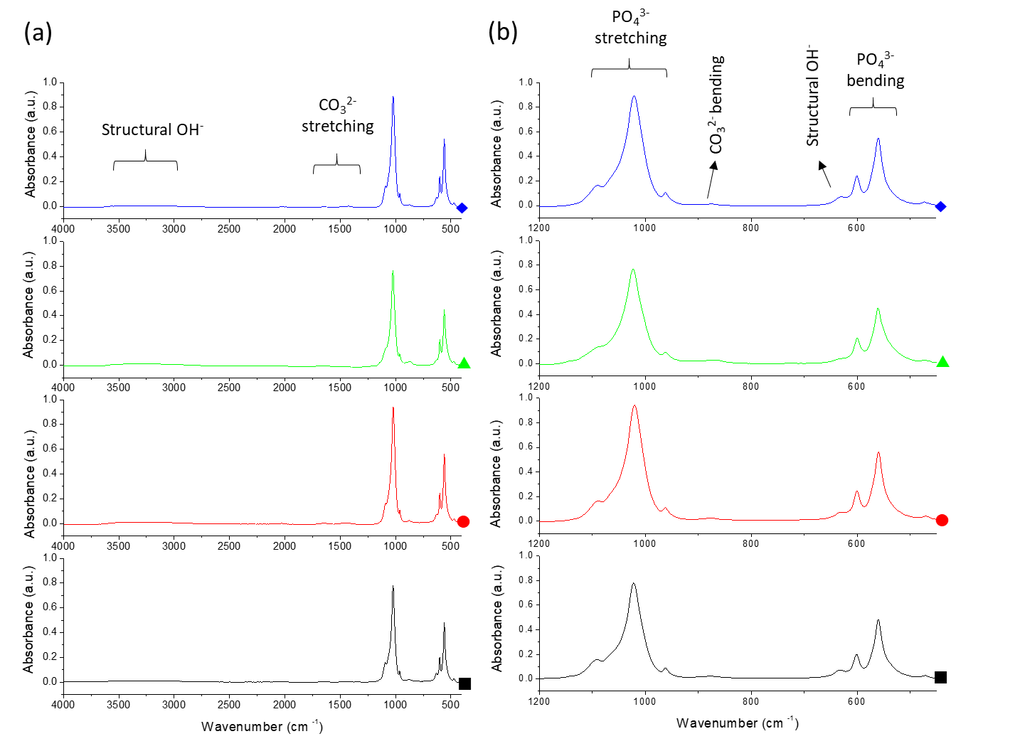
Figure 2
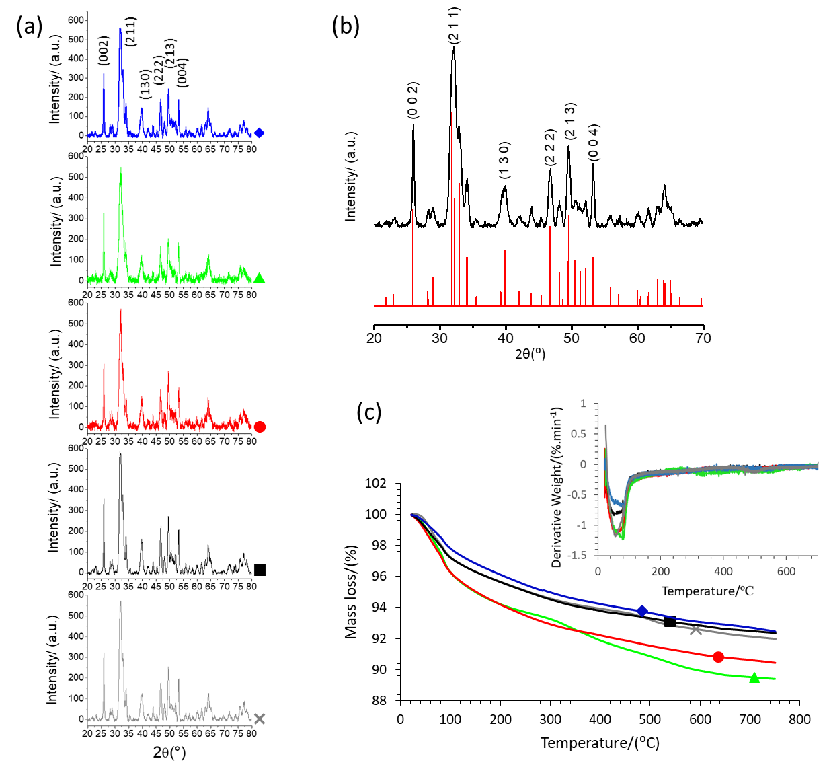
Figure 3
Figure 4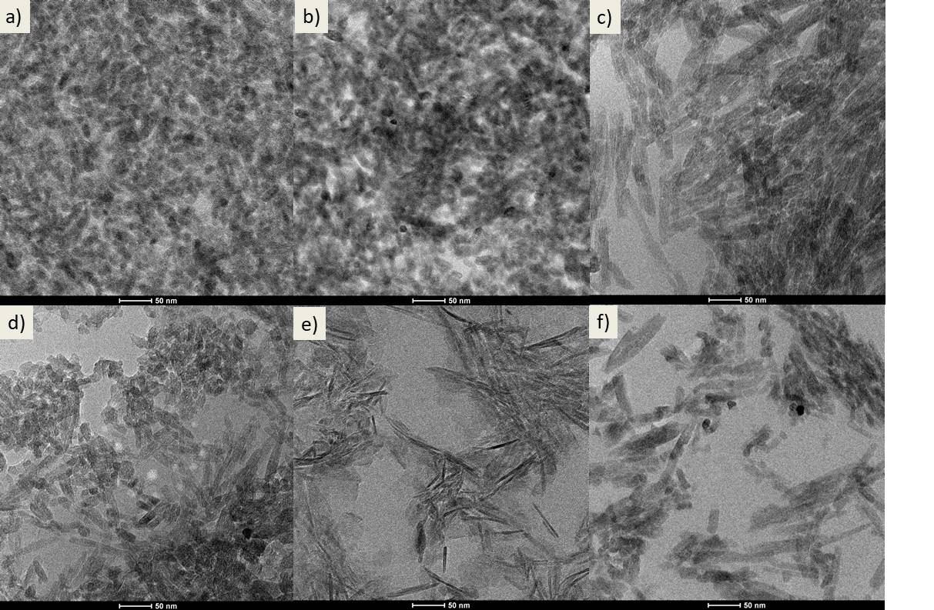
Figure 5
