CLINICAL CANCER RESEARCH | CLINICAL TRIALS: TARGETED THERAPY

Response to Rucaparib in BRCA-Mutant Metastatic Castration-Resistant Prostate Cancer Identified by

Genomic Testing in the TRITON2 Study

Andrea Loehr¹, Akash Patnaik², David Campbell³, Jeremy Shapiro⁴, Alan H. Bryce⁵, Ray McDermott⁶, Brieuc Sautois⁷, Nicholas J. Vogelzang⁸, Richard M. Bambury⁹, Eric Voog¹⁰, Jingsong Zhang¹¹, Josep M. Piulats¹², Arif Hussain¹³, Charles J. Ryan¹⁴, Axel S. Merseburge¹⁵, Gedske Daugaard¹⁶, Axel Heidenreich¹⁷, Karim Fizazi¹⁸, Celestia S. Higano¹⁹, Laurence E. Krieger²⁰, Cora N. Sternberg²¹, Simon P. Watkins²², Darrin Despain²³, Andrew D. Simmons¹, Melanie Dowson²⁴, Tony Golsorkhi²⁵, Simon Chowdhury²⁶, and Wassim Abida²⁷
¹Translational Medicine, Clovis Oncology, Inc., Boulder, Colorado.
²Section of Hematology/Oncology, Department of Medicine, The University of Chicago, Chicago, Illinois.
³Medical Oncology, Barwon Health, University Hospital Geelong, Geelong, Victoria, Australia.
⁴Medical Oncology, Cabrini Hospital, Malvern, Victoria, Australia.
⁵Hematology and Medical Oncology, Mayo Clinic, Phoenix, Arizona.
⁶Genitourinary Oncology, Adelaide and Meath Hospital (Incorporating the National Children’s Hospital), Dublin, Ireland.
⁷Department of Medical Oncology, University Hospital of Liège, CHU Sart Tilman, Liège, Belgium.
⁸Medical Oncology, Comprehensive Cancer Centers of Nevada, Las Vegas, Nevada.
⁹Medical Oncology, Cork University Hospital, Wilton, Cork, Ireland.
¹⁰Medical Oncology, Clinique Victor Hugo Centre Jean Bernard, Le Mans, France.
¹¹Genitourinary Oncology Program, H. Lee Moffitt Cancer Center, Tampa, Florida.
¹²Medical Oncology, Institut Catala d’Oncologia, Barcelona, Spain.
¹³Department of Medicine, Greenebaum Cancer Center, Baltimore, Maryland.
¹⁴Department of Medicine, University of Minnesota, Minneapolis, Minnesota.
¹⁵Department of Urology, Lübeck University Hospital, Lübeck, Germany.
¹⁶Department of Oncology, Copenhagen University Hospital, Rigshospitalet, Copenhagen, Denmark.
¹⁷Department of Urology, Universitätsklinikum Köln, Cologne, Germany.
¹⁸Department of Cancer Medicine, Institut Gustave Roussy, University of Paris Saclay, Villejuif Cedex, France.
¹⁹Department of Medicine, Division of Oncology, University of Washington and Fred Hutchinson Cancer Research Center, Seattle, WA.
²⁰Oncology, Genesis Care Integrative Cancer Centre, St Leonards, Sydney, New South Wales, Australia.
²¹Englander Institute for Precision Medicine, Weill Cornell Medicine, New York-Presbyterian, New York, New York.
²²Clinical Science, Clovis Oncology UK, Ltd., Cambridge, United Kingdom.
²³Biostatistics, Clovis Oncology, Inc., Boulder, Colorado.
²⁴Study Operations, Clovis Oncology UK, Ltd., Cambridge, United Kingdom.
²⁵Clinical Development, Clovis Oncology, Inc., Boulder, Colorado.
²⁶Medical Oncology, Guy's Hospital and Sarah Cannon Research Institute, London, United Kingdom. ²⁷Genitourinary Oncology Service, Memorial Sloan Kettering Cancer Center, New York, New York.

Abstract

Purpose: The PARP inhibitor rucaparib is approved in the United States for patients with metastatic castration-resistant prostate cancer (mCRPC) and a deleterious germline and/or somatic BRCA1 or BRCA2 (BRCA) alteration. While sequencing of tumor tissue is considered the standard for identifying patients with BRCA alterations (BRCA⁺), plasma profiling may provide a minimally invasive option to select patients for rucaparib treatment. Here, we report clinical efficacy in patients with BRCA⁺ mCRPC identified through central plasma, central tissue, or local genomic testing and enrolled in TRITON2.

Patients and Methods: Patients had progressed after next-generation androgen receptor-directed and taxane-based therapies for mCRPC and had BRCA alterations identified by central sequencing of plasma and/or tissue samples or local genomic testing. Concordance of plasma/tissue BRCA status and objective response rate and prostate-specific antigen (PSA) response rates were summarized.

Results: TRITON2 enrolled 115 patients with BRCA⁺ identified by central plasma (n = 34), central tissue (n = 37), or local (n = 44) testing. Plasma/tissue concordance was determined in 38 patients with paired samples and was 47% in 19 patients with a somatic BRCA alteration. No statistically significant differences were observed between objective and PSA response rates to rucaparib across the 3 assay groups. Patients unable to provide tissue samples and tested solely by plasma assay responded at rates no different from patients identified as BRCA⁺ by tissue testing.

Conclusions: Plasma, tissue, and local testing of mCRPC patients can be used to identify men with BRCA⁺ mCRPC who can benefit from treatment with the PARP inhibitor rucaparib.
INTRODUCTION
The PARP inhibitor rucaparib is approved in the United States for the treatment of patients with metastatic castration-resistant prostate cancer (mCRPC) and a deleterious BRCA1 or BRCA2 (BRCA) alteration, based on results from the phase II TRITON2 study (1).

Germline or somatic alterations in BRCA are observed in approximately 12% of men with advanced prostate cancer (2, 3). Protein truncating alterations, such as homozygous deletions, large rearrangements, as well as frameshift, nonsense, and pathogenic missense mutations, have been identified as drivers of the disease (3, 4), highlighting the need for robust approaches to select patients for treatment.

Sequencing of tumor tissue is the standard for genomic subtyping of solid cancers but has limitations in prostate cancer. While tissue samples from the prostate tumor are taken from almost all patients at diagnosis, the time to progression to mCRPC can span many years (5, 6), which can impact sample quality and subsequent success of molecular profiling (7). Furthermore, tumor genomics may evolve with disease progression or development of treatment resistance (7, 8), and diagnostic biopsy or radical prostatectomy samples may not reflect the genomics of advanced disease. Although DNA repair status can be accurately assessed from primary tumors in most cases (9, 10), more recent and metastatic biopsies are preferred for higher next-generation sequencing (NGS) success rate (3); however, mCRPC largely involves skeletal spread, and many patients lack accessible soft tissue lesions (11). Biopsies from bone metastases frequently have insufficient tissue content for NGS, and have high failure rates (3, 12-16).

Translational Relevance
Skepticism toward the efficacy of PARP inhibitor treatment in patients with mCRPC with a BRCA1/2 mutation identified by a cell-free DNA (cfDNA)-based plasma assay is fueled by concerns of false positives and false negatives. The comparative analyses of clinical efficacy in patients with rucaparib-treated mCRPC prospectively identified as having a BRCA1/2 mutation through liquid or solid biopsies shown here address these concerns. Objective and PSA responses to rucaparib were observed in patients with a BRCA1/2 alteration identified by plasma, tissue, or local testing, including within the subset of patients who were unable to provide a tissue sample and tested solely with the plasma assay. Plasma, tissue, and local testing of patients with mCRPC are suitable clinical tools to identify men with BRCA1/2-mutated mCRPC who can benefit from treatment with the PARP inhibitor rucaparib.

Blood-based assays have become a viable option for guiding treatment in tumors where tissue biopsies are difficult to obtain, such as non-small cell lung cancer (17-19). As cancer and normal cells undergo apoptosis or necrosis, they shed cell-free DNA (cfDNA) into the bloodstream which can be isolated from peripheral blood (20-22). Patients with mCRPC are frequently found to have sufficiently high fractions of tumor-derived cfDNA (23, 24), containing the DNA from primary and metastatic lesions (21) for tumor profiling through NGS. High fractions of circulating tumor DNA (catnap) have been reported to be associated with poor prognosis in mCRPC (25, 26). Sequencing of cfDNA has shown high concordance with tissue sequencing of metastatic biopsies in several tumor types, including mCRPC (27), and is suitable to help guide patient treatment. In contrast to tissue biopsies, the collection of plasma is minimally invasive for patients, ubiquitously accessible, and easily repeatable over the course of the disease.

Studies have demonstrated high concordance between BRCA alterations in the plasma and tissue of patients with mCRPC (3, 28), but no comparative analyses of clinical efficacy in patients who are BRCA⁺ prospectively identified through plasma or tissue testing have been reported, and skepticism towards the clinical applicability of targeted treatment in patients selected through plasma testing remains (2). Of concern are potential false positive results from the cfDNA assay due to technical (2) or biological factors, such as low variant allele frequency (AF) and clonal hematopoiesis of indeterminate potential (CHIP; ref. 29). Although very rarely seen in BRCA, recent analyses found CHIP mutations in non-BRCA DNA damage repair (DDR) genes frequently reported as tumor originating alterations during plasma testing of patients with advanced prostate cancer when sequencing of a matched normal sample is not performed (30). In patients with low tumor burden or less aggressive disease, somatic mutations may be missed due to insufficient amounts of ctDNA, calling into question the suitability of plasma assays to select patients for PARP inhibitor therapy (31, 32). Here, we compare clinical responses to rucaparib in patients with a deleterious BRCA alteration identified by plasma, tissue, or local testing and evaluate the concordance between the selection methodologies.

Patients and Methods

Study description
TRITON2 (NCT02952534) is an ongoing, international, open-label, phase II study evaluating rucaparib in patients with mCRPC associated with DDR deficiency. Men aged >18 years with histologically or cytologically confirmed mCRPC, Eastern Cooperative Oncology Group (ECOG) performance status of 0 or 1, and adequate organ function were enrolled. Eligible patients had a deleterious germline or somatic alteration in BRCA1, BRCA2, or one of 13 other DDR genes (ATM, BARD1, BRIP1, CDK12, CHEK2, FANCA, NBN, PALB2, RAD51, RAD51B, RAD51C, RAD51D, RAD54L) and disease progression following one to two lines of next-generation androgen receptor (AR)-directed therapy for prostate cancer and one prior taxane-based chemotherapy for castration-resistant disease. Patients treated with a PARP inhibitor, mitoxantrone, cyclophosphamide, or platinum-based chemotherapy, or with an active secondary malignancy were excluded. Patients were enrolled irrespective of measurable disease status.

Patients received a starting dose of 600 mg oral rucaparib twice daily. Dose reductions, in decrements of 100 mg, were permitted in case of grade ≥3 or persistent grade 2 treatment-emergent adverse events.

The study was approved by national or local institutional review boards and performed in accordance with the Declaration of Helsinki and Good Clinical Practice guidelines of the International Council for Harmonisation of Technical Requirements for Pharmaceuticals for Human Use. Patients provided written informed consent before participation.

The primary endpoint was objective response rate (ORR) by blinded independent radiology review (IRR) per modified Response Evaluation Criteria In Solid Tumors version 1.1 (RECIST) and Prostate Cancer Clinical Trials Working Group 3 (PCWG3) criteria in patients with measurable disease by IRR. Confirmed locally assessed prostate-specific antigen (PSA) response (≥50% decrease from baseline confirmed by a second measurement ≥ 3 weeks later) in all patients was a secondary endpoint. Duration of response (DOR) was defined as the time from the date of the first confirmed response to the date progression was first documented plus one day, and summarized using Kaplan-Meier methodology.

Efficacy analyses included patients who were BRCA⁺ enrolled by the cut-off date of May 8, 2019. The visit cut-off date was December 23, 2019; therefore, patients had a minimum of16 weeks of follow up, allowing for at least two radiographic tumor assessments and confirmation of response.

Patients were enrolled by 3 assay groups used to detect deleterious BRCA alterations: central tissue or central plasma testing or by documented evidence of a deleterious alteration from an existing test result performed locally. Patients were encouraged to submit both plasma and tissue samples for central testing. An additional blood sample for central germline testing was collected.

Central assays
The central tissue assay was the FoundationOne laboratory developed test (F1 LDT) for NGS of 395 cancer-related genes (including BRCA) from formalin-fixed paraffin-embedded tissue (33). The central plasma assay was the FoundationOneLiquid laboratory developed test (F1 L LDT) using circulating cfDNA isolated from plasma to sequence 70 cancer-related genes (including BRCA; ref. 20). Both central NGS assays detected germline and somatic alterations but did not distinguish between them. The Color Hereditary Cancer Test (34) was used to determine the germline status of BRCA alterations.
All assays were executed in Clinical Laboratory Improvement Amendments (CLIA)-certified and College of American Pathologists (CAP)-accredited laboratories.

Results

Overview of TRITON2 patients and genomic data
By the cut-off date, the TRITON2 study had enrolled 115 patients with a BRCA alteration. Clinical analyses of safety and efficacy in patients who were BRCA⁺ have been published (1). Patients who were BRCA⁺ were enrolled based on deleterious alterations in BRCA identified by central plasma (n = 34) or central tissue (n = 37) testing or by documented evidence of a deleterious alteration from local testing (n = 44; Fig. 1). Patients were encouraged to submit plasma and tissue (contemporaneous or archival) samples for central testing. Several patients were BRCA⁺ by both sample types. In those cases, the test result used for enrollment was the result that became available first. Due to this approach, most patients had 2 or more test results: 61 patients had a BRCA⁺ plasma result, 59 a BRCA⁺ tissue result, and 38 had both. Results from central germline testing were available for all patients. An overview of patients who were BRCA⁺ and test data is shown in Fig. 1.
Enrollment by assay group
BRCA alterations identified by central tissue or local test results included all alteration types (Fig. 2). The plasma assay was not validated to detect homozygous BRCA deletions, and no patients with this alteration type were identified by the plasma assay.

Figure 1.
Summary of genomic testing data for patients with BRCA alterations (BRCA⁺) by enrollment assay type. For every patient who was BRCA⁺ enrolled in TRITON2 (n = 115), 1 genomic test de novo identified an eligible deleterious BRCA1/2 alteration and was used to enroll the patient. Patients were enrolled based on central plasma testing (n = 34), central tissue testing (n = 34), or existing local test data (n = 44; A). Due to a comprehensive effort to obtain both plasma and tissue samples from patients for central testing, many patients had data from multiple test types available, resulting in greater numbers of patients testing BRCA⁺ by plasma and tissue test, compared with the number of patients who were enrolled by each assay (B). The Venn diagram depicts the number of patients with BRCA alteration results available from 1, 2, or all 3 assay groups (C). Pts., patients.

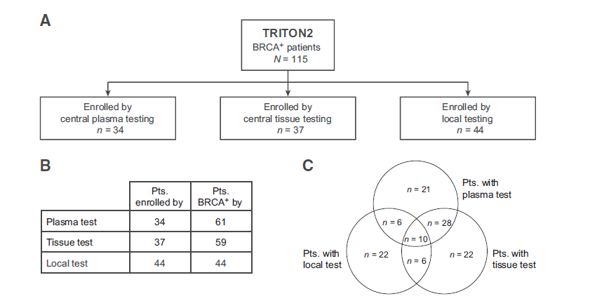

Central plasma testing was used to enroll 34 of 115 (30%) patients who were BRCA⁺, of whom 35% (12/34) had a germline and 65% (22/34) had a somatic alteration. The most common alteration types were frameshift (62%, 21/34) and nonsense (15%, 5/34) mutations. A subset of 21 patients enrolled by the plasma assay did not have a tissue sample available and was tested solely with the central plasma test.

Central tissue testing was used to enroll 37 of 115 (32%) patients who were BRCA⁺, among them 43% (16/37) with a germline and 57% (21/37) with a somatic alteration. Homozygous BRCA deletions were detected in 41% (15/37) of patients’ tissues and frameshift mutations in 30% (11/37).

A variety of local tests were used to enroll 44 (38%) patients who were BRCA⁺, most commonly by NGS-based gene panels (80%, 35/44 patients) or germline tests (20%, 9/44 patients). Of the local assays, 70% (31/44) were based on tissue profiling. Most prevalent were the FoundationOne (ref. 33; 18%, 8/44 patients) and MSK-IMPACT (ref. 35; 16%, 7/44 patients) tests. Plasma-based cfDNA assays were utilized for 9% (4/44) of patients enrolled by local testing; FoundationOne Liquid (20) was used most frequently (5%, 2/44 patients).

Figure 2.
Germline and somatic BRCA1/2 mutation rate and frequency of deleterious BRCA1/2 alteration types identified by central plasma testing (A), central tissue testing (B), or a variety of existing data from local genomic testing (C).
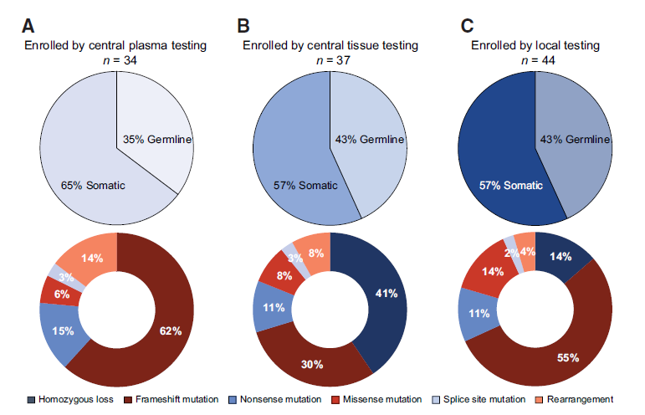
Blood-based germline tests were used for 20% (9/44) of the patients enrolled by local testing, with tests from Myriad Genetics (ref. 36; 5%, 2/44) and Ambry Genetics (ref. 37; 5%, 2/44) being the most common. Local testing identified a wide range of BRCA alterations: 43% (19/44) were germline and 57% (25/44) were somatic. Patients most commonly had frameshift alterations (55%, 24/44) or homozygous BRCA loss (14%, 6/44).

Overall, of 115 patients who were BRCA⁺ in TRITON2,13(11%) had a BRCA1 and 102 (89%) had a BRCA2 alteration. BRCA alterations were germline in 41% (47/115) of patients and somatic in 59% (68/115).

No confounding differences were observed in baseline demographics or prognostic factors in patients across the 3 enrollment assay groups.

Concordance of BRCA status by plasma or tissue testing

Both plasma and tissue data were available for 38 patients who were BRCA⁺ and used to evaluate concordance of BRCA status between the assays. Tissue samples were mostly archival prostate
tumor samples (84%; 32/38) with a median age of 3.5 years (range, 25 days–19.1 years). Six (16%) patients submitted metastatic samples, of which 5 were taken within 1 year of NGS testing (range, 2.2–
9.6 months). Plasma samples were collected prior to dosing on the first day of treatment.

In the analysis of concordance between the two assay types, the BRCA alterations used for enrollment were found in both tissue and plasma samples among 74% (28/38) of patients.

BRCA alterations in these patients were 50% (19/38) of germline and 50% (19/38) of somatic origin. All 19 germline alterations were detected in both tissue and plasma.

Concordant BRCA status was observed in 47% (9/19) of patients with somatic BRCA alterations. Only 1 patient in this subset had a homozygous deletion, suggesting that the discordance was predominantly
due to other biological and technical challenges. For example, in 4 patients a BRCA alteration was detected in the archival tissue but not the plasma. The maximum somatic AF observed in these plasma samples was below 3%. One plasma sample was void of any alterations entirely, indicating no or very
low levels of tumor DNA. One of the 4 patients in this group [25%; 95% confidence interval (CI), 0.6–80.6] had a PSA response. Another patient had measurable disease but neither a PSA nor a radiographic response.

In the reverse analysis, 6 patients were BRCA⁺ by plasma but BRCA⁻ by tissue testing. All 6 tissue samples were archival prostate samples with a median age of 2.6 years (range, 11 months–11.5 years),
and half (3/6) had low tumor purity (<25%). The majority (67%, 4/6) of BRCA alterations in the matched plasma samples were of very low (<1%) AF, suggesting subclonality. None of these 6 patients had a PSA response, and neither of the 2 patients with measurable disease had a radiographic response.

Efficacy in patients who were BRCA⁺ by enrollment assay group

Patient level genomics and responses from 113 PSA response-evaluable patients were grouped by enrollment assay and detailed in Fig. 3. Two patients did not meet the follow-up criteria required to be response evaluable and were excluded from the analyses.

Patients enrolled by the central tissue assay had a confirmed PSA response rate of 62.2% (95% CI, 44.8–77.5; 23/37; Fig. 4), where 15 patients with homozygous BRCA loss identified by tissue testing had higher PSA response rates (80.0%; 95% CI, 51.9–95.7; 12/15), compared with patients with other BRCA alteration types (50.0%; 95% CI, 28.2–71.8; 11/22). The median duration of PSA response was 9.0 months (range, 1.0–25.8⁺) in all patients enrolled by tissue, compared with 2.2 months (range, 1.0–9.0) in patients without homozygous BRCA loss and not yet reached (range, 2.7–25.8+ months) in those with homozygous BRCA loss.

Patients enrolled by the central plasma assay had a PSA response rate of 41.2% (95% CI, 24.6–59.3; 14/34), and a median duration of PSA response of 6.3 months (range, 3.7–11.7þ). The PSA response rate in patients enrolled by local assays was 59.1% (95% CI, 43.2–73.7; 26/44) with a median duration of PSA response of 4.6 months (range, 1.4–29.4þ). The 95% CIs overlapped in response rates across all
3 groups. PSA response rates in all patients with germline BRCA alterations were 61.7% (95% CI, 46.4-75.5; 29/47) and 50.0% in patients with somatic alterations (95% CI, 37.6-62.4; 34/68).

Figure 3.- Best percent change in PSA from baseline for patients who were BRCA⁺ in TRITON2, grouped by the assay type that was used for patient enrollment. Bars were capped at 100% for visual clarity. PSA increases for the 3 left-most patients enrolled by central plasma test were 689%, 231%, and 183%; PSA increase for the left-most patient enrolled by local test was 133%. Additional assay, outcome, and genomics data, including BRCA1 or BRCA2 (BRCA) status from additional test results, are indicated in the tile plot. PSA response status is shown for all patients, and RECIST response status is shown for those patients who had measurable disease at baseline. The genomic data for each patient are broken into BRCA gene, germline status, alteration type, and zygosity where available.
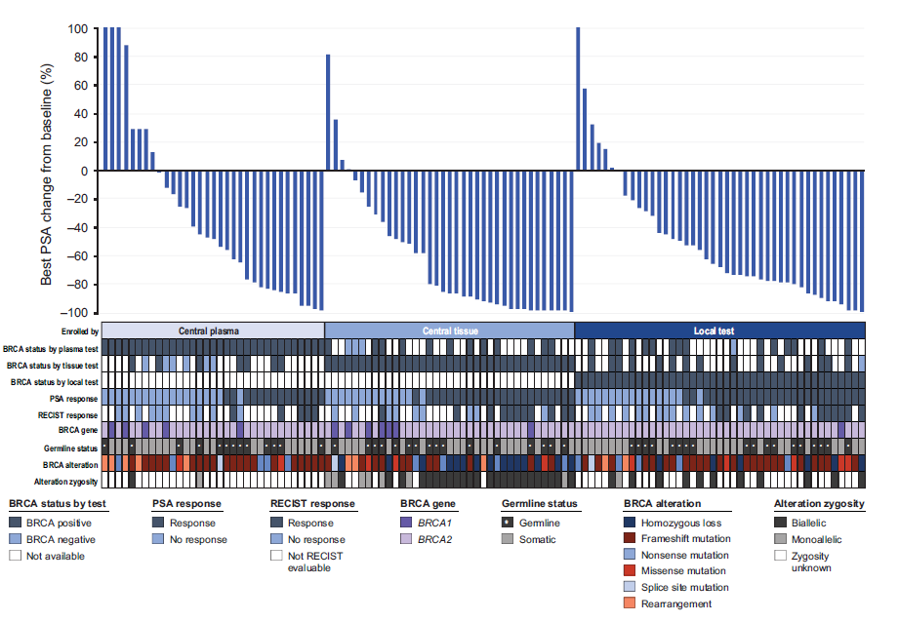

Confirmed ORR by enrollment assay was evaluated in 62 patients with measurable disease: patients enrolled by central tissue testing had an ORR of 55.0% (95% CI, 31.5-76.9; 11/20), compared with 31.3% (95% CI, 11.0-58.7; 5/16) in patients enrolled by central plasma test and 42.3% (95% CI, 23.4-63.1; 11/26) in patients enrolled by local test, while the 95% CIs overlapped across all 3 groups (Fig. 4). Patients enrolled by the tissue test and with homozygous BRCA loss had an ORR of 70.0% (95% CI, 34.8-93.3; 7/10), compared with 40.0% (95% CI, 12.2-73.8; 4/10) in those without homozygous loss. Duration of response was not yet reached (range, 2.3-23.0+ months) in patients enrolled by tissue testing, including patients with homozygous BRCA loss (median not yet reached; range, 4.0-23.0+ months) and without (6.8 months; range, 2.3-12.0+), compared with 6.6 months (range, 4.0-7.7+) in patients enrolled by plasma testing and not yet reached (range, 1.7-24.0+ months) in patients enrolled based on an existing local test result.

Reduction in sum of target lesions is shown in Supplementary Fig. S1. The ORR was 45.8% in patients with a germline BRCA alteration (95% CI, 25.6-67.2; 11/24) and 42.1% in patients with a somatic alteration (95% CI, 26.3-59.2; 16/38).

Efficacy in all patients BRCA⁺ by central plasma and/or tissue testing

Assessment of efficacy by plasma and tissue assays was per- formed in the subgroups of all patients BRCA⁺ by plasma (n = 61) and/or tissue test (n = 59), regardless of their enrollment assay. Consistent with the results above, PSA reductions in the 2 groups were not different (Fig. 5). Patients with homozygous BRCA deletions in tissue frequently showed significant PSA reductions and responses. PSA response rate in patients BRCA⁺ by the plasma assay was 47.5% (95% CI, 34.6-60.7; 29/61) compared with 57.6% in patients BRCA⁺ by tissue testing (95% CI, 44.1-70.4; 34/59; Fig. 4). Radiographic response rates were also not different in the subsets of patients with measurable disease and BRCA⁺ by plasma or tissue testing.

Patients BRCA⁺ solely by plasma testing

Twenty-one patients who were BRCA⁺ were unable to provide a tissue sample and enrolled by plasma testing (Fig. 1). These patients showed a PSA response rate of 52.4% (95% CI, 29.8–74.3; 11/21) and radiographic responses in 4 of 10 patients with measurable disease (40.0%; 95% CI, 12.2–73.8; Fig. 4), with rates not different to those in patients BRCA⁺ by tissue testing. Patients in this group most commonly had frameshift mutations (42%; 11/21), nonsense mutations (19%; 4/21), or rearrangements (19%; 4/21; Supplementary Fig S2). BRCA alterations were germline in 29% (6/21) and somatic in 71% (15/21) of patients.

Discussion

The PARP inhibitor rucaparib was approved for patients with BRCA⁺ mCRPC based on results from the TRITON2 study (1). Selection of patients who were BRCA⁺ occurred through central genomic testing of plasma or tissue and by local test result. Radiographic and PSA responses were observed independent of the assay type used to identify patients.

Figure 4. - Confirmed objective radiographic (by IRR; A) and PSA response rates (B) in patients with germline or somatic BRCA alterations and in subgroups of patients identified as having BRCA alterations (BRCA⁺) by the 3 different assay groups used during genomic screening.

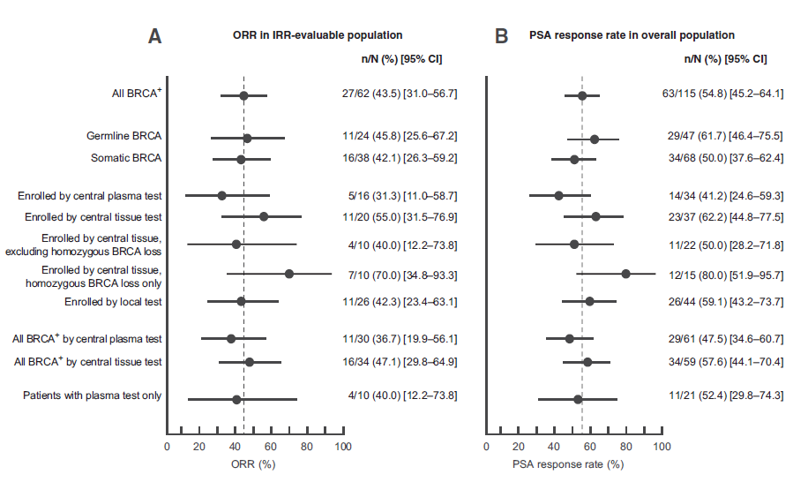

Both tissue and plasma assays face biological, technical, and practical challenges in the identification of patients who were BRCA⁺. Tumor tissue testing has long been a reliable method to assess genomics in patients with mCRPC, but lack of accessible lesions or archival tissue of adequate quality is often prohibitive to assessing tumor BRCA. In addition, a single-site tissue biopsy may not adequately reflect the landscape of somatic tumor heterogeneity that can develop. In contrast, patients’ plasma contains DNA from primary and metastatic lesions and can be readily collected from a minimally invasive blood draw. The data presented here provide evidence that plasma testing can detect germline and somatic driver mutations of mCRPC and identify alterations that arise through tumor heterogeneity, which in some cases may be subclonal. A technical challenge for plasma-based assays has been the detection of copy-number loss, and the plasma assay used for TRITON2 enrollment did not identify patients with homozygous BRCA deletions. Patients with this alteration type have been reported to respond particularly well to rucaparib (38), and their identification has been a priority in the technical advancement of plasma-based assays. Consequentially, the plasma assay used for TRITON2 enrollment has since been updated to the FDA-approved FoundationOneLiquid CDx (39), which detects and reports homozygous BRCA deletions.
Data from 115 patients who were BRCA⁺ enrolled in TRITON2 have shown that plasma and tissue samples from central or local testing can be used to identify patients with mCRPC as BRCA⁺. Across these assay groups, patients’ genomic characteristics with respect to germline status and alteration type were comparable with those reported in the literature (4, 7). The concordance between patients’ somatic BRCA status determined from plasma or tissue testing was 47% in 38 patients with paired samples.

In the 4 cases where the plasma test did not detect BRCA alterations found in tissue, there was evidence of minimal to no tumor DNA shedding in blood (estimated tumor fraction 0% to 3.7%) and lower disease burden (no visceral metastases, 2/4 with <10 bone metastases). Conversely, in 6 patients, the plasma assay detected a BRCA alteration which was not observed in the patient’s tissue. While there were no outstanding trends in patient characteristics or clinical factors in this discordant group, the BRCA⁻ tissue samples were mainly archival and frequently had low tumor purity. Simultaneously, the majority of BRCA alterations detected only in plasma were of low AF and likely subclonal. These results suggest that discordance may arise from tumor heterogeneity or lack of sample purity, and larger datasets will be required to assess the impact of these factors on response to therapy.

Radiographic and PSA responses were observed in patients with mCRPC with a BRCA alteration identified by central plasma, central tissue, or local testing. Although patients who were BRCA⁺ by plasma test were found to have numerically lower ORR and PSA response rates compared with patients who were BRCA⁺ by central tissue or local testing, these differences were not statistically significant, and the study was underpowered to draw definitive conclusions about differences in outcomes based on enrollment assay. A factor in this imbalance was the lack of well performing patients with homozygous BRCA deletions combined with an enrichment of patients with subclonal BRCA alterations within the plasma selected group. A subset of patients was unable to provide tissue samples and were assessed solely with the plasma assay. Some patients who were BRCA⁺ in this subgroup experienced objective and PSA responses, suggesting that plasma testing can be a valuable tool to may be identified by a variety of assays, determining the best option for any given patient may depend on many clinical and circumstantial factors and relies on clinicians’ discretion.

The potential for CHIP has raised concerns about the origin of somatic DDR gene alterations detected by plasma assays (31, 32), and the dataset presented here does not include sequencing of matched whole-blood controls. While we cannot ascertain the tumoral origin of the somatic BRCA alterations, we reason that they are unlikely to be CHIP mutations. In contrast to other DDR genes, BRCA is not frequently associated with CHIP: no case of CHIP in BRCA1 and only 1 case in BRCA2 has been reported in advanced prostate cancer (30). Nevertheless, in cases that were identified as BRCA⁺ in plasma at low AF but not in tissue, CHIP cannot be ruled out.

A strength of our analysis is the large amount of central genomic testing data in association with clinical outcome data. The analysis is limited because the collection of plasma and tissue samples was not concomitant, and metastatic tissue samples were rarely available. Given the expected intratumoral heterogeneity, we are unable to use the tissue NGS data as a ground truth reference for patients’ genomics to determine the positive predictive value of the plasma assay. Although TRITON2 did enroll patients with alterations in other DDR genes, the analyses presented here only include patients who were BRCA⁺ and do not allow for the calculation of the negative predictive value of the plasma assay.

Figure 5. - Efficacy in all patients with BRCA alterations (BRCA⁺) detected by central plasma or tissue testing, regardless of enrollment assay. Patient groups overlap but are not identical: 61 patients were identified as BRCA⁺ by central plasma test (A), and 59 patients were identified as BRCA⁺ by central tissue test (B). Bars were capped at 100% for visual clarity. PSA increases for the 3 left-most patients in A were 689%, 231%, and 183%.
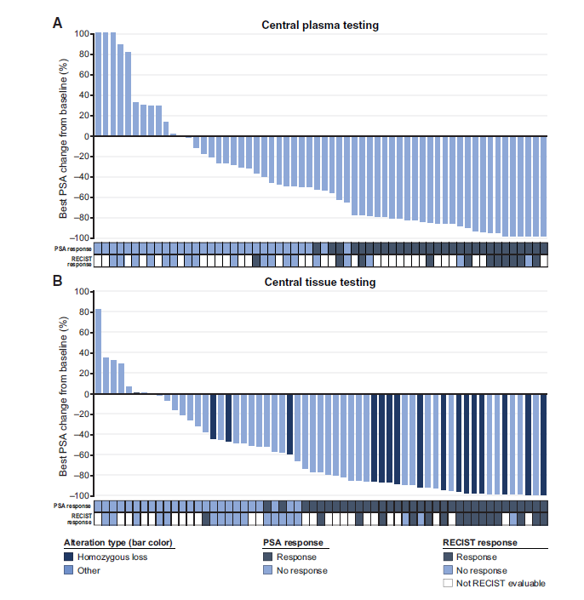

In summary, the analyses of concordance and efficacy among genomic testing data from the TRITON2 study demonstrated that plasma, tissue, or local testing of patients with mCRPC can be used to identify patients with BRCA⁺ mCRPC who can benefit from treatment with the PARP inhibitor rucaparib.

Authors’ Disclosures
A. Loehr reports other support from Clovis Oncology, Inc., during the conduct of the study. A. Patnaik reports other support from Clovis Oncology, Inc., during the conduct of the study as well as grants from Bristol-Myers Squibb and other support from Progenics, Laekna Inc, Exelixis, Prime, Jounce Therapeutics, Janssen, and Merck outside the submitted work. J. Shapiro has served in a consulting or advisory role for Amgen, Astellas, Ipsen, Merck, and Roche and received financial support for travel from Amgen and Merck. A.H. Bryce reports personal fees from Merck, Astellas, Bayer, and Pfizer outside the submitted work. R. McDermott reports personal fees from Clovis Oncology, Inc., during the conduct of the study as well as personal fees from Bayer, MSD, Sanofi, Janssen, Astellas, BMS, Pfizer, and Novartis outside the submitted work. B. Sautois reports other support from Clovis Oncology, Inc., during the conduct of the study as well as personal fees from Janssen, Astellas, and Sanofi outside the submitted work. N.J. Vogelzang reports personal fees from Clovis Oncology, Inc., AstraZeneca, and Pfizer during the conduct of the study. R.M. Bambury reports educational grant support and honoraria from Pfizer, Roche, Janssen, Astellas, and BMS; in addition, R.M. Bambury is the co-founder of Portable Medical Technology Ltd. J. Zhang reports personal fees from Clovis Oncology, Inc., during the conduct of the study as well as grants and personal fees from Astellas, Bayer, and AstraZeneca and personal fees fromMerck outside the submitted work. J.M. Piulats reports grants and personal fees from MSD, Pfizer, and Janssen; grants from BeiGene; and nonfinancial support from Clovis Oncology, Inc., during the conduct of the study as well as personal fees from Astellas, Bayer, and Roche and grants, personal fees, and nonfinancial support from BMSoutside the submitted work. A. Hussain reports other support from Clovis Oncology, Inc., during the conduct of the study as well as personal fees from Bayer, Merck, and Aveo Pharmaceuticals outside the submitted work; in addition, A. Hussain serves as institutional principal investigator (PI) on several sponsored clinical trials in prostate cancer, renal cancer, and bladder cancer where the respective sponsors provide funding directly to the institution (University of Maryland Greenebaum Comprehensive Cancer Center) to help defray costs of running the clinical trials. C.J. Ryan has received research support from Clovis Oncology, Inc., and has served as a consultant for AstraZeneca and Bayer. A.S. Merseburger reports personal fees, nonfinancial support, and other support from Clovis Oncology, Inc., during the conduct of the study as well as personal fees and nonfinancial support from AstraZeneca, Astellas, Janssen, Pfizer, and Ipsen outside the submitted work. G. Daugaard has served in a consulting or advisory role for Clovis Oncology, Inc., Astellas, AstraZeneca, Janssen, Merck, and Sanofi. A. Heidenreich reports personal fees from Clovis Oncology, Inc., during the conduct of the study as well as personal fees from Astellas, Bayer, Ipsen, Janssen, Pfizer, Takeda and MSDand grants and personal fees from Amgen and BMS outside the submitted work. K. Fizazi reports personal fees from Bayer, CureVac, andOrion and nonfinancial support from Astellas, Sanofi, Janssen,AstraZeneca, ClovisOncology, Inc., andNovartis outside the
submitted work. C.S. Higano reports grants and personal fees from Clovis Oncology, Inc., during the conduct of the study as well as personal fees and other support from Advanced Accelerator Applications, Blue Earth, Janssen, and Merck; grants from Aptevo, Emergent, Hoffman-LaRoche, and Medivation; grants, personal fees, and other support from Astellas, AstraZeneca, and Ferring; grants and personal fees from Bayer, Dendreon, Genetech, and Pfizer; and other support from Exelixis outside the submitted work. L.E. Krieger reports personal fees from Clovis Pharmaceuticals outside the submitted work. C.N. Sternberg reports personal fees from Clovis
Oncology, Inc., during the conduct of the study as well as personal fees from Pfizer, BMS, Sanofi-Genzyme, MSD, Merck, Roche-Genentech, Incyte, Foundation Medicine, Immunomedics, Medscape, UroToday, Janssen, CCO Clinical, and NCI outside the submitted work. S.P. Watkins reports other support from Clovis Oncology, Inc., during the conduct of the study as well as other support from Clovis Oncology, Inc., outside the submitted work. D. Despain reports other support from Clovis Oncology, Inc., outside the submitted work; in addition, D. Despain is an employee of Clovis Oncology, Inc., the sponsor of rucaparib and the TRITON2 study. A.D. Simmons reports other support from Clovis Oncology, Inc., during the conduct of the study. M. Dowson reports personal fees from Clovis Oncology, Inc., outside the submitted work. T. Golsorkhi reports other support from Clovis Oncology, Inc., during the conduct of the study. S. Chowdhury reports grants and personal fees from Clovis Oncology, Inc., and personal fees from AstraZeneca, Novartis, Janssen, Bayer, Telix, Astellas, Huma, and Remedy Bio during the conduct of the study. W. Abida reports personal fees from Clovis Oncology, Inc., Roche, Medscape, Onclive, Clinical Education Alliance, Aptitude Health, Janssen, ORIC Pharmaceuticals, and Daiichi and other support from Clovis Oncology, Inc., during the conduct of the study as well as other support from AstraZeneca, Zenith Epigenetics, ORIC Pharmaceuticals, and Epizyme outside the submitted work. No disclosures were reported by the other authors.

Authors’ Contributions
A. Loehr: Conception and design, data analysis and interpretation, manuscript writing, final approval of manuscript, accountability for all aspects of the work.
A. Patnaik: Provision of study materials or patients, collection and assembly of data, data analysis and interpretation, manuscript writing, final approval of manuscript, accountability for all aspects of the work.
D. Campbell: Provision of study materials or patients, collection and assembly of data, data analysis and interpretation, manuscript writing, final approval of manuscript, accountability for all aspects of the work.
J. Shapiro: Provision of study materials or patients, collection and assembly of data, data analysis and interpretation, manuscript writing, final approval of manuscript, accountability for all aspects of the work.
A.H. Bryce: Provision of study materials or patients, collection and assembly of data, data analysis and interpretation, manuscript writing, final approval of manuscript, accountability for all aspects of the work.
R. McDermott: Provision of study materials or patients, collection and assembly of data, data analysis and interpretation, manuscript writing, final approval of manuscript, accountability for all aspects of the work.
B. Sautois: Provision of study materials or patients, collection and assembly of data, data analysis and interpretation, manuscript writing, final approval of manuscript, accountability for all aspects of the work.
N.J. Vogelzang: Provision of study materials or patients, collection and assembly of data, data analysis and interpretation, manuscript writing, final approval of manuscript, accountability for all aspects of the work.
R.M. Bambury: Provision of study materials or patients, collection and assembly of data, data analysis and interpretation, manuscript writing, final approval of manuscript, accountability for all aspects of the work.
E. Voog: Provision of study materials or patients, collection and assembly of data, data analysis and interpretation, manuscript writing, final approval of manuscript, accountability for all aspects of the work.
J. Zhang: Provision of study materials or patients, collection and assembly of data, data analysis and interpretation, manuscript writing, final approval of manuscript, accountability for all aspects of the work.
J.M. Piulats: Provision of study materials or patients, collection and assembly of data, data analysis and interpretation, manuscript writing, final approval of manuscript, accountability for all aspects of the work.
A. Hussain: Provision of study materials or patients, collection and assembly of data, data analysis and interpretation, manuscript writing, final approval of manuscript, accountability for all aspects of the work.
C.J. Ryan: Provision of study materials or patients, collection and assembly of data, data analysis and interpretation, manuscript writing, final approval of manuscript, accountability for all aspects of the work.
A.S. Merseburger: Provision of study materials or patients, collection and assembly of data, data analysis and interpretation, manuscript writing, final approval of manuscript, accountability for all aspects of the work.
G. Daugaard: Provision of study materials or patients, collection and assembly of data, data analysis and interpretation, manuscript writing, final approval of manuscript, accountability for all aspects of the work.
A. Heidenreich: Provision of study materials or patients, collection and assembly of data, data analysis and interpretation, manuscript writing, final approval of manuscript, accountability for all aspects of the work.
K. Fizazi: Provision of study materials or patients, collection and assembly of data, data analysis and interpretation, manuscript writing, final approval of manuscript, accountability for all aspects of the work.
C.S. Higano: Provision of study materials or patients, collection and assembly of data, data analysis and interpretation, manuscript writing, final approval of manuscript, accountability for all aspects of the work.
L.E. Krieger: Provision of study materials or patients, collection and assembly of data, data analysis and interpretation, manuscript writing, final approval of manuscript, accountability for all aspects of the work.
C.N. Sternberg: Provision of study materials or patients, collection and assembly of data, data analysis and interpretation, manuscript writing, final approval of manuscript, accountability for all aspects of the work.
S.P. Watkins: Conception and design, data analysis and interpretation, manuscript writing, final approval of manuscript, account- ability for all aspects of the work.
D. Despain: Data analysis and interpretation, manuscript writing, final approval of manuscript, accountability for all aspects of the work.
A.D. Simmons: Conception and design, data analysis and interpretation, manuscript writing, final approval of manuscript, accountability for all aspects of the work.
M. Dowson: Data analysis and interpretation, manuscript writing, final approval of manuscript, accountability for all aspects of the work.
T. Golsorkhi: Conception and design, data analysis and interpretation, manuscript writing, final approval of manuscript, accountability for all aspects of the work.
S. Chowdhury: Conception and design, provision of study materials or patients, collection and assembly of data, data analysis and interpretation, manuscript writing, final approval of manuscript, accountability for all aspects of the work.
W. Abida: Conception and design, provision of study materials or patients, collection and assembly of data, data analysis and interpretation, manuscript writing, final approval of manuscript, accountability for all aspects of the work.

Acknowledgments
This work was funded by Clovis Oncology, Inc., and supported in part by the NCI Cancer Center Support Grant No. P30-CA008748, NCI Prostate Specialized Program of Research Excellence (SPORE) Grant No. P50-CA092629-16, Department of Defense Prostate Cancer Research Program Grant No. W81XWH-17-1-0124, and a Prostate Cancer Foundation Young Investigator Award (to W. Abida), and supported in part by a Prostate Cancer Foundation Challenge Award and NCI Prostate SPORE Grant No. P50-CA180995 (to A. Patnaik). Editorial support funded by Clovis Oncology, Inc., was provided by Shelly Lim and Stephen Bublitz of Ashfield MedComms, an Ashfield Health company.

Research support for the study: This study was funded by Clovis Oncology, Inc

The costs of publication of this article were defrayed in part by the payment of page charges. This article must therefore be hereby marked advertisement in accordance with 18 U.S.C. Section 1734 solely to indicate this fact.

References

- Abida W, Patnaik A, Campbell D, Shapiro J, Bryce AH, McDermott R, et al. Rucaparib in men with metastatic castration-resistant prostate cancer harboring a BRCA1 or BRCA2 gene alteration. J Clin Oncol 2020;38:3763-72.
- Stetson D, Ahmed A, Xu X, Nuttall BRB, Lubinski TJ, Johnson JH, et al. Orthogonal comparison of four plasma NGS tests with tumor suggests technical factors are a major source of assay discordance. JCO Precis Oncol 2019;3:1-9.
- Green F, Shapiro JD, McDermott R, Piulats JM, Reid A, Ostler P, et al. Comprehensive genomic profiling of >1000 plasma and tumor tissue samples from metastatic castration-resistant prostate cancer (mCRPC) patients gives insight into targeted treatment strategies. Cancer Res 2019;79:abstr 727.
- Chung JH, Dewal N, Sokol E, Mathew P, Whitehead R, Millis SZ, et al. Prospective comprehensive genomic profiling of primary and metastatic prostate tumors. JCO Precis Oncol 2019;3:PO.18.00283.
- Scher HI, Solo K, Valant J, Todd MB, Mehra M. Prevalence of prostate cancer clinical states and mortality in the United States: estimates using a dynamic progression model. PLoS One 2015;10:e0139440.
- Scher HI, Heller G. Clinical states in prostate cancer: toward a dynamic model of disease progression. Urology 2000;55:323-7.
- Abida W, Armenia J, Gopalan A, Brennan R, Walsh M, Barron D, et al. Prospective genomic profiling of prostate cancer across disease states reveals germline and somatic alterations that may affect clinical decision making. JCO Precis Oncol 2017;1:1-16.
- Steinkamp MP, O’Mahony OA, Brogley M, Rehman H, Lapensee EW, Dhanasekaran S, et al. Treatment-dependent androgen receptor mutations in prostate cancer exploit multiple mechanisms to evade therapy. Cancer Res 2009;69:4434-42.
- Mateo J, Seed G, Bertan C, Rescigno P, Dolling D, Figueiredo I, et al. Genomics of lethal prostate cancer at diagnosis and castration resistance. J Clin Invest 2020; 130:1743-51.
- Schweizer MT, Sivakumar S, Tukachinsky H, Coleman I, De Sarkar N, Yu EY, et al. Concordance of DNA repair gene mutations in paired primary prostate cancer samples and metastatic tissue or cell-free DNA. JAMA Oncol 2021;7:1-5.
- Wong SK, Mohamad NV, Giaze TR, Chin KY, Mohamed N, Ima-Nirwana S. Prostate cancer and bone metastases: the underlying mechanisms. Int J Mol Sci 2019;20:2587.
- Ross RW, Halabi S, Ou SS, Rajeshkumar BR, Woda BA, Vogelzang NJ, et al. Predictors of prostate cancer tissue acquisition by an undirected core bone marrow biopsy in metastatic castration-resistant prostate cancer-a Cancer and Leukemia Group B study. Clin Cancer Res 2005;11:8109-13.
- McKay RR, Zukotynski KA, Werner L, Voznesensky O, Wu JS, Smith SE, et al. Imaging, procedural and clinical variables associated with tumor yield on bone biopsy in metastatic castration-resistant prostate cancer. Prostate Cancer Pros- tatic Dis 2014;17:325-31.
- Gandaglia G, Abdollah F, Schiffmann J, Trudeau V, Shariat SF, Kim SP, et al. Distribution of metastatic sites in patients with prostate cancer: a population- based analysis. Prostate 2014;74:210-6.
- Sailer V, Schiffman MH, Kossai M, Cyrta J, Beg S, Sullivan B, et al. Bone biopsy protocol for advanced prostate cancer in the era of precision medicine. Cancer 2018;124:1008-15.
- Lorente D, Omlin A, Zafeiriou Z, Nava-Rodrigues D, Perez-Lopez R, Pezaro C, et al. Castration-resistant prostate cancer tissue acquisition from bone metastases for molecular analyses. Clin Genitourin Cancer 2016;14:485-93.
- Malapelle U, Sirera R, Jantus-Lewintre E, Reclusa P, Calabuig-Farinas S, Blasco A, et al. Profile of the Roche cobas(R) EGFR mutation test v2 for non- small cell lung cancer. Expert Rev Mol Diagn 2017;17:209-15.
- Hsiue EH, Lee JH, Lin CC, Yang JC. Profile of the therascreen(R) EGFR RGQ PCR kit as a companion diagnostic for gefitinib in non-small cell lung cancer. Expert Rev Mol Diagn 2016;16:1251-7.
- Satouchi M, Tanaka H, Yoshioka H, Shimokawaji T, Mizuno K, Takeda K, et al. Detection of epidermal growth factor receptor gene T790M mutation in cytology samples using the cobas((R)) EGFR mutation test. Lung Cancer 2017;111:190-4.
- Clark TA, Chung JH, Kennedy M, Hughes JD, Chennagiri N, Lieber DS, et al. Analytical validation of a hybrid capture-based next-generation sequencing clinical assay for genomic profiling of cell-free circulating tumor DNA. J Mol Diagn 2018;20:686-702.
- Oliveira KCS, Ramos IB, Silva JMC, Barra WF, Riggins GJ, Palande V, et al. Current perspectives on circulating tumor DNA, precision medicine, and personalized clinical management of cancer. Mol Cancer Res 2020;18:517-28.
- Husain H, Velculescu VE. Cancer DNA in the circulation: the liquid biopsy. JAMA 2017;318:1272-4.
- Wyatt AW, Azad AA, Volik SV, Annala M, Beja K, McConeghy B, et al. Genomic alterations in cell-free DNA and enzalutamide resistance in castration-resistant prostate cancer. JAMA Oncol 2016;2:1598-606.
- Volik S, Alcaide M, Morin RD, Collins C. Cell-free DNA (cfDNA): clinical significance and utility in cancer shaped by emerging technologies. Mol Cancer Res 2016;14:898-908.
- Annala M, Fu S, Bacon JVW, Sipola J, Iqbal N, Ferrario C, et al. Cabazitaxel versus abiraterone or enzalutamide in poor prognosis metastatic castration- resistant prostate cancer: a multicentre, randomised, open-label, phase II trial. Ann Oncol 2021;32:896-905.
- Maurice-Dror C, Fonseca N, Herberts C, Fan W, Wyatt AW, Chi KN. Circulating tumor DNA fraction (ctDNA%) to independently predict for clinical outcomes in patients (pts) with metastatic castration-resistant prostate cancer (mCRPC). J Clin Oncol 2021;39:5049.
- Adalsteinsson VA, Ha G, Freeman SS, Choudhury AD, Stover DG, Parsons HA, et al. Scalable whole-exome sequencing of cell-free DNA reveals high concordance with metastatic tumors. Nat Commun 2017;8:1324.
- Wyatt AW, Annala M, Aggarwal R, Beja K, Feng F, Youngren J, et al. Concordance of circulating tumor DNA and matched metastatic tissue biopsy in prostate cancer. J Natl Cancer Inst 2017;109:djx118.
- Bowman RL, Busque L, Levine RL. Clonal hematopoiesis and evolution to hematopoietic malignancies. Cell Stem Cell 2018;22:157-70.
- Jensen K, Konnick EQ, Schweizer MT, Sokolova AO, Grivas P, Cheng HH, et al. Association of clonal hematopoiesis in DNA repair genes with prostate cancer plasma cell-free DNA testing interference. JAMA Oncol 2021;7:107-10.
- Beware liquid biopsies to guide PARP blockade. Cancer Discov 2021;11:6.
- Reichert ZR, Jones MA, Alumkal JJ. A CHIP in the armor of cell-free DNA-based predictive biomarkers for prostate cancer. JAMA Oncol 2021;7:111-2.
- Frampton GM, Fichtenholtz A, Otto GA, Wang K, Downing SR, He J, et al. Development and validation of a clinical cancer genomic profiling test based on massively parallel DNA sequencing. Nat Biotechnol 2013;31:1023-31.
- Crawford B, Adams SB, Sittler T, van den Akker J, Chan S, Leitner O, et al. Multi-gene panel testing for hereditary cancer predisposition in unsolved high-risk breast and ovarian cancer patients. Breast Cancer Res Treat 2017; 163:383-90.
- Cheng DT, Mitchell TN, Zehir A, Shah RH, Benayed R, Syed A, et al. Memorial Sloan Kettering-Integrated Mutation Profiling of Actionable Cancer Targets (MSK-IMPACT): a hybridization capture-based next-generation sequencing clinical assay for solid tumor molecular oncology. J Mol Diagn 2015;17:251-64.
- Reid R, DiGiovanni M, Bernhisel R, Brown K, Saam J, Lancaster J. Inherited germline mutations in men with prostate cancer. J Clin Oncol 2018;36(suppl 6S): abstr 357.
- Pritzlaff M, Tian Y, Reineke P, Stuenkel AJ, Allen K, Gutierrez S, et al. Diagnosing hereditary cancer predisposition in men with prostate cancer. Genet Med 2020; 22:1517-23.
- Abida W, Campbell D, Patnaik A, Sautois B, Shapiro J, Vogelzang N, et al. Genomic characteristics associated with clinical activity of ruca- parib in patients (pts) with BRCA1 or BRCA2 (BRCA)-mutated meta- static castration-resistant prostate cancer (mCRPC). J Clin Oncol 2020; 38:abstr178.
- FoundationOne® Liquid CDx. Technical Specifications. Foundation Medicine, Inc; 2020. [cited 2020 Sept 22]. Available from: https://assets.ctfassets.net/w98cd481qyp0/wVEm7VtICYR0sT5C1VbU7/cc6ac2109785d70fe6d91903b241006f/FoundationOne_Liquid_CDx_Technical_Specifications. pdf

Note: Supplementary data for this article are available at Clinical Cancer Research Online (http://clincancerres.aacrjournals.org/).
Corresponding Author: Wassim Abida, Genitourinary Oncology Service, Memorial Sloan Kettering Cancer Center, 1275 York Avenue, New York, NY 10065. Phone: 646-422-4633; Fax: 646-227-2417; E-mail: abidam@mskcc.org

