Constraining water limitation of photosynthesis in a crop growth model with sun-induced chlorophyll fluorescence

S. De Canniereª,*, M. Herbst^{b}, H. Vereecken^{b}, P. Defourny^{b}, F. Jonard^{a,b,c}
ªEarth and Life Institute, Université catholique de Louvain, Croix du Sud 2 Box L7.05.02, 1348 Louvain-la-Neuve, Belgium
^{b}Agrosphere (IBG-3), Institute of Bio- and Geosciences, Forschungszentrum Jülich GmbH, 52425 Jülich, Germany
^{c}Geomatics Unit, Université de Liège (ULiège), Allée du Six Août 19, 4000 Liège, Belgium

Keywords: SIF; Root water uptake; Radiative transfer model; Drought stress; Transpiration; SCOPE; Vegetation model

ABSTRACT
Water fulfils key roles in maintaining a plant’s biological activity. Water shortage induces stomatal closure, causing a reduction in photosynthesis and transpiration rates. Sun-induced chlorophyll fluorescence (SIF) emission is sensitive to subtle, stress-induced variations in non-photochemical quenching and in photosynthetic electron transport, caused by e.g., a fluctuation in the water availability. Based on this sensitivity, a framework for calibrating a water stress function in a crop growth model using ground-based SIF observations is proposed. SIF time series are simulated by coupling the AgroC crop growth model to the Soil Canopy Observations Photosynthesis Energy (SCOPE) model. This allowed parametrizing the water stress function in the AgroC crop growth model, resulting in improved estimates of actual evapotranspiration and net ecosystem exchange over a sugar beet stand during stressed periods. The improvement in the estimation of the water and carbon fluxes by AgroC during the summer months highlights the ability of canopyscale SIF observations to serve as a remote sensing metric to indicate the intensity of a stress condition. We argue that our framework, linking SIF emission to stress functions, can be used to extract information concerning drought stress from the Fluorescence Explorer (FLEX) satellite, scheduled for launch in 2024.

- Introduction
Croplands play a vital role in the global food supply. Over the last five decades, two thirds of global cropland was affected from drought- induced crop yield losses (Heino et al., 2018). Crop models are suitable tools for assessing the impact of drought stress on the future crop yield (Kumar, 2016). Remote sensing datasets are valuable for informing crop growth models, as they allow the collection of data about the vegetation status over large spatial and temporal scales. Thermal, optical and microwave data have shown their value in the context of crop growth modeling (Ghazaryan et al., 2020).
The capacity of a plant to assimilate CO₂ through photosynthesis in light-abundant conditions is expressed by the maximum carboxylation capacity (VCMax). Stress reduces VCMax through a series of regulatory mechanisms (Zhou et al., 2014), causing the CO₂ assimilation in the dark reactions to slow down, forcing the light reactions to slow down with it, since an excess of light energy in the photosynthetic apparatus leads to oxidative stress. Through non-photochemical quenching (NPQ), a plant can dissipate the excess light energy that is absorbed by a chlorophyll molecule as heat. As a third process, in parallel with heat dissipation and photosynthesis, the absorbed photon can be re-emitted by a chlorophyll molecule (Ac et al., 2015). The latter process is referred to as chlorophyll fluorescence. Chlorophyll fluorescence has a specific emission spectrum between 650 nm and 800 nm, with emission peaks at 685 nm and 740 nm. Sun-induced chlorophyll fluorescence (SIF, i.e., the emission of chlorophyll fluorescence induced by sunlight) corresponds to 0.5-3% of the absorbed radiation (Porcar-Castell et al., 2014). SIF occurs under natural conditions and it is observable through proximal and spaceborne remote sensing. As it deals with only a limited amount of emitted energy, the retrieval of sun-induced chlorophyll fluorescence (SIF) is restricted to the solar and atmospheric absorption lines. Two main atmospheric absorption lines are linked to the absorption of atmospheric oxygen at 760 and 687 nm. These lines are referred to as the O₂-A and O₂-B band respectively. Named after their respective oxygen absorption band, SIF emission retrieved in these lines is referred to as SIFA and SIFB. ESA’s FLuorescence EXplorer (FLEX) satellite mission, scheduled for launch in 2024, will measure SIF in these bands (Drusch et al., 2017). Given the narrow bandwidth of these atmospheric absorption lines, a sub-nanometer spectral resolution is imperative to reliably measure SIF emission, both at the plot and at the satellite scale. The requirements to measure SIF emission in the O2-B band are even stricter compared to the O₂-A band, the former needing a spectral resolution below 0.5 nm (Julitta et al., 2016). Because of its less strict requirements concerning the spectral resolution, the behavior of field-observed SIFA in the context of stress is better described in the literature (Jonard et al., 2020).
Based on the mechanistic link between SIF emission and carbon assimilation, SIF is an interesting input to carbon uptake models, as it can serve as a constraint on photosynthetic activity, both at the local and at the global scale (Damm et al., 2010). SIF observations from already operational satellite missions have been used to constrain carbon uptake models at the global scale (Parazoo et al., 2014). Lee et al. (2015) expanded the community land model (CLM) with a SIF module based on van der Tol et al. (2014) and using the NPQ model from Lee et al. (2013). By implementing the photosynthesis and SIF modules from the Soil Canopy Observations Photosynthesis Energy (SCOPE) model into the Biosphere Energy Transfer HYdrology (BETHY) model, Norton et al. (2018) reduced the uncertainty in the model’s gross primary productivity (GPP) estimates. Qiu et al. (2018) constrained evapotranspiration (ET), SIF, and GPP simulations in the Simplified Simple Biosphere Model 2.0 (SSiB2) land surface model using soil moisture observations from the Soil Moisture Ocean Salinity (SMOS) satellite, to adapt the soil hydraulic parameters and the wilting point.
The link between photosynthetic activity, SIF emission and soil water content has also been investigated at the local scale. A crucial variable in linking SIF emission to photosynthesis is VCMax. Camino et al. (2019) retrieved VCMax based on airborne SIF measurements. They noted a correlation between soil moisture and VCMax in case of drought stress. Bayat et al. (2019) established a link between the soil water content and the GPP, by scaling the VCMax using a water stress factor, defined as a function of the soil water content. Wieneke et al. (2018) noted a reduction in SIFA emission in case of drought stress. Because of the link between stomatal closure and the reduction in the transpiration rate, Maes et al. (2020) observed a connection between SIF emission and transpiration.
When interpreting a spectrometer-observed value of SIF in a meaningful way, it is important to realize that the SIF signal is affected by many factors. The main driver of SIF is the absorbed photosynthetically active radiation (APAR) (Yang et al., 2018; Jonard et al., 2020). Along with the biochemical effects that affect the SIF emission, it is also affected by canopy radiative transfer including scattering and reabsorption processes that are determined by leaf properties and the 3D structure of the canopy (Yang and van der Tol, 2018; Pacheco-Labrador et al., 2019), which is, in turn, affected by the turgor pressure and thus by the plant water status (Parkash and Singh, 2020). As the SCOPE model considers both the leaf biochemical processes and the canopy structure, it is particularly well adapted to mechanistically link SIF emission to photosynthesis (Celesti et al., 2018).
At the local scale, the AgroC (Herbst et al., 2008) crop growth model describes the development of a certain crop type during an entire growing season. Previous studies have used the model to predict the field-scale (NEE) (Klosterhalfen et al., 2017), and simulate within-field variability of LAI (Brogi et al., 2020; Herbst et al., 2021). AgroC contains an aboveground module, describing the photosynthesis and the leaf and canopy development as well as a belowground module describing the root water uptake. In order to run properly, AgroC requires detailed information concerning the plant properties. Remote sensing is a suitable tool for providing such information to crop growth models, since it allows for the retrieval of plant properties over large areas. Recently, there has been a special interest is around the use of SIF to parametrize crop growth models, since SIF provides direct information from the photosynthetic apparatus, allowing to constrain the photosynthetic module in a crop growth model (Huang et al., 2019). Informing a crop growth model with SIF is therefore expected to lead to a better parametrization of VCMax.
Given the crucial role of VCMax in modeling photosynthesis and SIF emission, we aim at better estimating VCMax from SIF observations exploiting the sensitivity of VCMax to root zone water availability. Unlike to other studies, this paper does not seek to improve the parametrization of the maximum carboxylation capacity under reference conditions (VCMax,25). Instead, the sensitivity of VCMax to drought stress forms the backbone of this paper. Specifically, a better estimation of the drought stress conditions is supposed to improve the estimate of VCMax and therefore to lead to a better estimate of the photosynthetic activity. A water stress function quantifies the stress conditions at a given soil matric potential or soil water content. While water stress functions have proven their value in crop growth modeling, it is hard to characterize these functions for real field conditions. Since the parameterization of the water stress function quantifies the stress- induced reduction in VCMax, the sensitivity of the SIF emission to the parametrization of the water stress function is expected. AgroC uses the root water uptake model of Feddes et al. (1974) to define a water stress function. This function considers a region of soil water potential causing drought stress and a range of soil water potentials indicating waterlogging, with an optimal range of root water uptake in between. This study establishes a framework for parametrizing a water stress function in a crop growth model using SIF observations. An improvement in the estimated carbon and water fluxes is expected when calibrating the Feddes function using SIF observations.
- Materials and methods
  - Site description
This study was performed over a sugar beet stand in Merzenhausen (50°52‘14‘‘N, 6°26‘59‘‘E), Germany at 93 m above sea level. The region has a maritime influenced climate with annual precipitation of 698 mm and an annual mean temperature of 9.9°C in 2019 (Klosterhalfen et al., 2017). The soil is classified with a silt loam texture according to the USDA classification. The site is a part of the German Terrestrial Environmental Observatories (TERENO) initiative, an Earth observation network across Germany (Bogena et al., 2016). An eddy covariance (EC) at two meter high and a meteorological station provide data on atmospheric CO₂ and H₂O concentration (c_{a} and cH₂O, respectively), 3D wind components, air temperature (T_{air}), air humidity (RH) and the global radiation (Rad_{glob}) (Table 1). Based on this, the Net Ecosystem Exchange (NEE) and latent heat flux ( λE ) are calculated. Soil water content (SWC) and soil temperature T_{soi}l at different depths (5, 10, 20 and 50 cm) were also measured with in-situ sensors (Table 1). A detailed description of the site and the TERENO infrastructures is given in Bogena et al. (2016). The processing and quality assessment were done with the standardized TERENO strategy (Mauder et al., 2013) for EC data. The sugar beets were sown on April 24th (DOY 114) and they were harvested on November 14th (DOY 316).

Table 1 - Description of the TERENO infrastructure in Merzenhausen.
Variable | Symbol | Unit | Instrument
Atmospheric CO₂ concentration | c_{a} | mmol  CO₂ m⁻ ³ | LI7500, LI-COR Inc., Lincoln, USA
Atmospheric H₂O concentration | cH₂O | mmol  H₂O m⁻ ³ | LI7500, LI-COR Inc., Lincoln, USA
Wind speed | WS | ms⁻ ¹ | CSAT3, Campbell Scientific, Inc., Logan, USA
Wind direction | WD | deg | CSAT3, Campbell Scientific, Inc., Logan, USA
Soil water content | SWC | cm³ cm⁻ ³ | Hydraprobe, Steven Water  Monitoring Inc., Portland, USA
Soil temperature | T_{air} | ◦C | Hydraprobe, Steven Water  Monitoring Inc., Portland, USA
Global radiation | Rad_{glob} | Wm⁻ ² | CMP3, Kipp &Zonen, Delft, The Netherlands
Precipitation | Prec | mm | Thies Clima tipping bucket, Ecotech, Bonn, Germany
Air pressure | P_{air} | hPa | WXT521, Vaisala Inc., Helsinki, Finland
Relative air humidity | RH | % | HMP45C, Vaisala Inc., Helsinki, Finland

  - Canopy-scale observations of SIF
    - Measurement description
SIF was measured with the Fluorescence Box (FloX) field spectrometer (JB hyperspectral devices, Düsseldorf, Germany), commonly used in field-based SIF studies (Wohlfahrt et al., 2018; Yang et al., 2020). The FloX combines information from two spectrometers (QE Pro, Ocean Optics, USA), both designed to measure the upwelling as well as the downwelling radiation. The first spectrometer (spectrometer 1) focusses on the fluorescence spectrum (i.e., the red and near-infrared zone), while the second (spectrometer 2) focusses on the visible and near-infrared regions (Table 2). Considering the spectral range, the spectrometer 2 also provides measurements of the incoming Photosynthetically Active Radiation (PAR, 400-700 nm). The spectrometers were fixed at a height of 4 m, providing a footprint of 2.4 m² (Fig. 1). SIF was retrieved in the oxygen absorption lines at 760 nm (SIFA) with the improved Fraunhofer Line Depth (iFLD; Alonso et al., 2008) method. This method is based on the classical Fraunhofer Line Depth method, comparing the up-and downwelling radiances inside the oxygen absorption band (760 nm) and outside the absorption band (750 nm). In addition, a correction factor based on the reflectance is added to better separate the contributions of the reflected radiance and the fluorescence on the measured signal (Julitta et al., 2016; Mohammed et al., 2019). While the combination of SIFA and SIFB has been used to assess drought conditions (Wieneke et al., 2016) or GPP (Campbell et al., 2019). In contrast, more notable mismatches have been found when predicting SIFB based on photosynthetic activity (Wohlfahrt et al., 2018). Consequently, this study focuses on the SIFA.
    - Interpretation of canopy-scale SIFA
Unlike to the canopy-scale GPP, which is the sum of the carbon uptake of all the leaves, the canopy-scale SIFA is not merely the sum of the SIF emitted by the individual leaves. Rather, the observed SIF signal at each wavelength λ is the product of the PAR and three probabilities. First, there is the probability that a certain photon will be absorbed by a chlorophyll molecule (fPAR_{Chl}). Second, there is the probability that the photon will be re-emitted as fluorescence at wavelength λ _{(ψF}(λ)), which is mainly affected by the leaf biochemistry. Third, there is the probability of a photon escaping the canopy (σ (λ)), determined by the canopy structure (Eq. (1)).
SIF(λ )= PAR⋅fPAR_{Chl}⋅φF(λ)⋅σ(λ) (1)
The Fluorecence Correction Vegetation Index (FCVI; Eq. (2); Yang et al., 2020) serves as a reflectance-based surrogate for fPAR_{Chl} σ(λ), allowing to separate contribution of the leaf biochemistry φ(λ) and the canopy structure fPAR . σ(λ) to the SIF signal. FCVI is calculated as the difference in the reflectance in the near-infrared R_{NIR} and in the visible part R_{VIS}.
FCVI = fPAR_{Chl}⋅σ(760) = R_{NIR} ˗ R_{VIS} (2)

Table 2 - Characteristics of the spectrometers in the Fluorescence Box.
 | Spectrometer 1 | Spectrometer 2
Spectral range | 650-800 nm | 400-950 nm
Spectral sampling | 0.17 nm | 0.65 nm
Spectral resolution | 0.3 nm | 1.5 nm
Field of view downwelling radiation | 180° | 180°
Field of view upwelling radiation | 25° | 25°

Figure 1. Picture of the FloX, measuring SIF and hyperspectral reflectance over the test site.
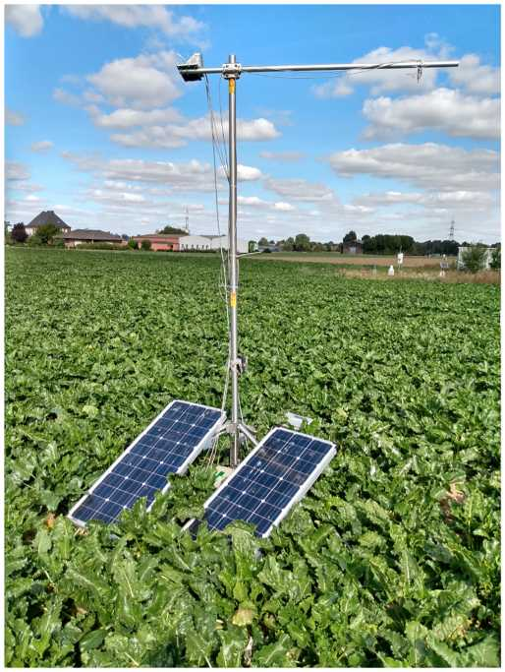
The SIFA normalized by the FCVI multiplied with the PAR is referred to as the fluorescence emission efficiency ( ε _{F}, Eq. (3)).
ε_{F} = π⋅SIFA ⋅ (3)
FCVI
This variable is less affected by irradiation or by canopy structure compared to SIFA. To minimize crop phenology effects on the SIF signal, we only took FloX measurements between August 1st (DOY 213) and August 23th, 2019 (DOY 235). During this period, the vegetation was fully developed. FloX measures the SIF emission with a temporal resolution of ~1 min. Outliers, defined as data that diverged more than 3 standard deviations from the seasonal mean, were removed. The data were averaged to hourly averages between 10AM and 2 PM UTC. This period was chosen to remove the points sampled at the moments with too high solar zenith angles, in which SIF is hard to retrieve. The FloX turned off when the solar panel powered battery could not keep up with the power demand by the device and its cooling system. This reduced the size of the SIF observations dataset to 10 days.
  - Description of the AgroC-SCOPE model
    - Modeling carbon fluxes in AgroC
AgroC (version 1.0; Herbst et al., 2008; Klosterhalfen et al., 2017) is a 1D crop growth model consisting of three modules: the crop growth module SUCROS (Spitters et al., 1988), the soil water, heat, and CO₂ flux module SOILCO2 (Simunek and Suarez, 1993) as well as the soil carbon turnover module RothC (Jenkinson and Coleman, 2008). AgroC requires: meteorological forcing variables as well as plant-related parameters and soil-related parameters. The soil- and plant-related parameters are field- and crop-specific, but time-invariant. These were taken from Klosterhalfen et al. (2017), which ran AgroC for sugar beets over the same test field. The meteorological input variables (air temperature, soil surface temperature, precipitation, solar radiation, and potential grass reference evapotranspiration) were aggregated to a temporal resolution of 1 h. Potential grass evapotranspiration was calculated using the FAO guidelines (Allen et al., 1998). As output, AgroC simulates both the aboveground and belowground plant growth and carbon fluxes, which are the sum of the GPP, the aboveground respiration (R_{ABG}) and the belowground respiration (R_{BG}). These fluxes are balanced to calculate the Net Ecosystem Exchange (NEE; Eq. (4)). The latter corresponds to the variable that is measured by EC towers. We, therefore, evaluated the capacity of AgroC to model carbon fluxes using the NEE.
NEE = GPP+R_{ABG} +R_{BG} (4)
Photosynthesis is described with the Farquhar et al. (1980) model, incorporated into the SUCROS part of the AgroC model. This mechanistic model considers three internally limiting factors on photosynthesis, being the light absorption, water availability and the rubisco concentration (see appendix for a detailed description of the Farquhar model). A key variable in this model is the maximum carboxylation rate (VCMax), which is affected by a water stress factor (ā), the maximum carboxylation capacity in reference conditions (VCMax,25) and an air temperature correction factor (f(T_{air})) (Eq. (5)).
VCMax = ā -VCMax, 25-f (T_{air}) (5)
    - Modeling water fluxes in AgroC
Belowground, AgroC models the terms of the soil water balance: soil water storage change, actual evapotranspiration, infiltration by solving the Richard’s equation (Herbst et al., 2008) with an hourly resolution. To do so, AgroC makes use of two input variables: the precipitation and grass reference evapotranspiration (ET0). Based on the precipitation, the amount of interception (Int) was calculated and the amount of infiltration was calculated, which then supplied the soil water content. Based on the crop coefficient K_{c}, which is a plant-specific literature value describing the plant transpiration in each stage of its growing season, and on the LAI, the ET0 was split into an potential evaporation (EP) and transpiration (TP) component (Eqs. (6) and (7)).
EP = ET0-K_{c}-e^{- 0.6-LAI} (6)
TP = ET0-K_{c} - EP - Int (7)

Potential transpiration is then scaled with the depth-specific stress factor α to reduce the depth-specific root water uptake once the potential evapotranspiration exceeds the water availability. To form the actual transpiration TA, TP is scaled with the average stress factor ā. The belowground water flow and the root water uptake in the soil are characterized in the SOILCO2 module through the site-specific soil hydraulic parameters (van Genuchten parameters), the bulk density and the porosity. These parameters are assigned to each vertical node in the soil profile, allowing the soil water content, water flow and root water uptake to be calculated for each node. For the experimental field in Merzenhausen, Klosterhalfen et al. (2017) calibrated the soil hydraulic parameters.
    - Use of SCOPE to model SIF emission
The Soil Canopy Observations Photosynthesis Energy (SCOPE; van der Tol et al., 2009) is an integrated model of soil-canopy spectral radiances, photosynthesis, fluorescence, temperature and energy balance. Both AgroC and SCOPE allow the use of the Farquhar et al. (1980) model to describe photosynthesis. In the latter model, stress conditions can be considered by lowering VCMax, which forms the connection between the AgroC and SCOPE models. The leaf reflectance and canopy scattering are affected by the plant properties, which are estimated based on reflectance time series. Given the mechanistic link between SIF emission, photosynthesis and stress conditions, this paper aims for estimating stress conditions based on SIF observations and use this information to inform the water stress model implemented in AgroC.
  - Quantifying drought stress in AgroC
The belowground and aboveground modules of AgroC are connected through root water uptake, which is linked to the soil water status. Actual root water uptake is calculated by scaling the potential root water uptake with the depth-specific water stress factor ā, calculated for each node in the soil profile. To do so, the module uses the Feddes function (Feddes et al., 1974), which requires information on the soil water status (expressed in pressure head h) and four threshold values h₁ to h₄, defining three zones, as visualized in Fig. 2. Each zone has its relationship between water availability and water stress (Eq. (8)).
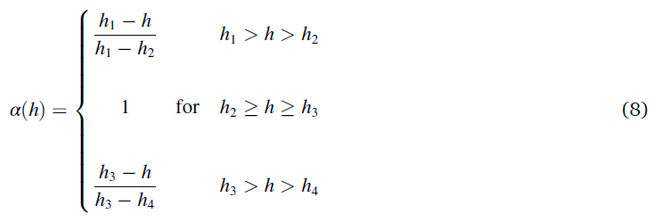
The position of h₄ and h₁ are universal at the wilting point (- 15 000 cm) and the water saturation (0 cm) point respectively. The values of h₂ (field capacity) and h₃ (drought onset) are a function of the plant and soil properties and have therefore to be calibrated for each site individually. Affecting both the duration and the intensity of the stress, knowing the exact position of h₃ is crucial for correctly linking drought stress to soil water availability. The four Feddes parameters are considered constant over the entire root profile and the entire growing season. Applying the Feddes function to each node in the soil profile results in a distribution of a along the root zone. The averaged value of the reduction factor along the depth profile becomes the water stress factor ā, serving as a correction factor for VCMax,25 to calculate VCMax (Eq. (5)). Based on the sugar beet measurements of (Vilfan et al., 2019), VCMax,25 was set to 100 µmol CO₂ m ⁻² s ⁻¹. We expect to see a connection between ɛ_{F} and h₃ as a affects the value of VCMax and the rate of non-photochemical quenching K_{n} (explained in paragraph 2.5; Fig. 3). This connection should enable ɛ_{F} data to serve as a metric of the drought stress conditions. This information allows calibrating the value of h₃, which affects both the onset of a drought as well as the intensity of ongoing drought conditions. As waterlogging conditions are not met during this study, h₂ is kept constant at - 50 cm. Fig. 3 visualizes the workflow of the calibration of h₃ based on the ɛ_{F} observations. Each paragraph in the Sections 2.5-2.8 explains one step of this workflow.
  - Connecting fluorescence emission with photosynthesis in AgroC
AgroC models the photosynthesis with the Farquhar et al. (1980) model, which calculates the photosynthesis along with the photosynthetic yield ( φ_{p} ), being the ratio of electrons participating in photosynthesis (J_{p}) with the absorbed photosynthetically active radiation (APAR) (Eq. (9)).
*p = Jp (9)
APAR
From the φ_{p}, the light saturation (x) is calculated, in which the maximum photosynthetic yield φ_{p0} is set to 0.8 by default:
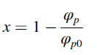 (10)
The light saturation is used to calculate the NPQ component. To establish the link between x and NPQ, we make use of a formalism called the rate constants (Butler, 1978), denoted here with K_{n}, K_{p}, K_{d} and K_{f} for the non-photochemical, photochemical, thermal decay and fluorescence components, respectively.

Figure 2. Stress factor α in function of water availability with the Feddes function.
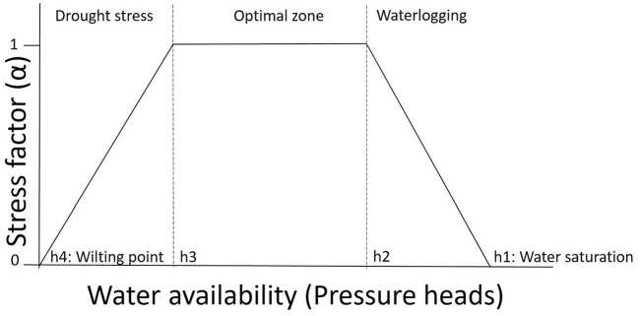

Figure 3. Visualization of the optimization approach.
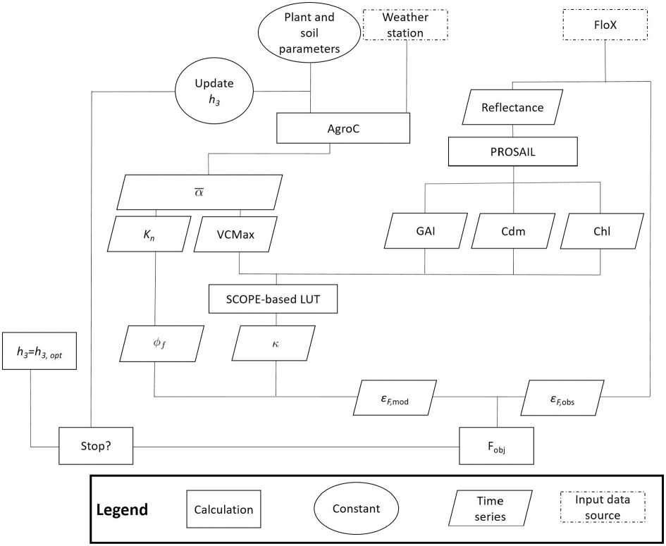
The fluorescence and thermal decay have default values being K_{f} = 0.05 and K_{d} = max(0.03 • T_{air} + 0.0773, 0.87) (Lee et al., 2015). As proposed by van der Tol et al. (2014), K_{n} is calculated based on x and on three fitting parameters γ, β and K_{n0} (Eq. (11)-(12)).
van der Tol et al. (2014) proposes two sets of fitting parameters to link K_{n} to x, depending on the plant water status, leading to calculation of K_{n,drought} and K_{n,standard} (Table 3). For high values of light saturation, the values of K_{n,drought} and K_{n,standard} can differ seriously, since drought stressed plants have the tendancy to increase the non-photochemical quenching as a photoprotective mechanism, leading to an incease in K_{n}. This behavior is more expressed for plants that experience a more intense form of drought stress.
Table 3 - Parametrization of the K_{n} model according to van der Tol et al. (2014) for standard and drought conditions.
 | Drought | Standard
γ | 1.93 | 2.83
β | 10 | 0.114
K_{n0} | 5.01 | 2.48

This is why this framework proposes a weighted average K_{n,avg} between the K_{n,drought} and K_{n,standard} based on the stress factor ā (Eq. (13)).
The fluorescence yield (φf) is calculated based on the rate constants (Eq. (14)). These rate constants allow us to interpret SIF emission in comparison to variables from pulse-amplitude modulated (PAM) fluorometry, in which fluorescence is induced with artificial light (Murchie and Lawson, 2013; Porcar-Castell et al., 2014). PAM experiments have established a link between φ_{p} and φ_{f}, based on the maximal fluorescence yield (φ_{F′m} ), corresponding to the fluorescence yield after a saturating light pulse. In this situation, none of the absorbed light goes to the photosynthesis, causing K_{p} = 0 (Eq. (15)).

The actual link between φ_{p} and φ_{f} is established through the Genty relationship (Genty et al. (1989); Eq. is established through the Genty relationship (Genty et al. (1989); Eq. (16)). This relationship shows that drought stress affects φ_{f} in two ways: on one hand, stress causes φ_{p} to decrease, increasing φ_{f}. On the other hand, stress induces an increase in K_{n},_{avg}, causing φ_{F′m} to decrease. The resulting behavior of these two effects characterizes the reaction of φ_{f} to drought stress.

  - Use of SCOPE to link AgroC Vf to spectrometer measurements
The AgroC-based φ_{ƒ} differs from ɛ_{F} in two ways. First, φ_{ƒ} considers the fraction of energy emitted as fluorescence over the entire fluorescent spectrum, not the emission at a specific wavelength. Second: φ_{ƒ} is a leafscale property, while ɛ_{F} is based on canopy measurements. Therefore, φ_{ƒ} cannot be directly compared to in situ measurements. To make φ_{ƒ} comparable to ɛ_{F}, measured at the canopy scale at 760 nm, a SCOPE-based correction is required. While running the entire SCOPE model in combination with AgroC would be too computationally heavy, a SCOPE-based conversion factor κ has been used. This factor serves two purposes: first, it links the leaf-level φ_{ƒ} to canopy-level ɛ_{F}, considering both leafscale and canopy-scale variables. Second, φ_{ƒ} considers the whole fluorescent spectrum, while ɛ_{F} is restricted to the fluorescence emission at 760 nm (Lee et al., 2015; Qiu et al., 2018). Consequently, κ considers both the photosynthetic variable VCMax as well as the leaf and canopy variables. After a sensitivity analysis using the ARTMO’s 3.2.6. global sensitivity analysis (GSA) tool, chlorophyll content (Chl), dry matter content (Cdm) and green area index (GAI) came out as the most sensitive variables. Given the little sensitivity of k to leaf inclination distribution function parameters (LIDFa and LIDFb), leaf equivalent water content (Cw) senescent material (Cs) and carotenoid content (Car), these variables were kept constant (sensitivity analysis not shown). To calculate κ, the SIF emission at 760 nm emitted by all leaves (F_{tot}) was simulated for each combination of VCMax, Chl, GAI and Cdm. F_{tot} was then divided by fPAR • PAR to calculate ɛ_{F},_{SCOPe} (Eq. (17); Yang et al., 2020).
Then, only the biochemical module of SCOPE was run with varying input for VCMax, to calculate the (φ_{ƒ},_{SCOPE}) for value of VCMax. φ_{ƒ},_{SCOPE} is not affected by Chl, GAI or Cdm. The ratio between SCOPE-based φ_{ƒ} and ɛ_{F,SCOPE} is defined as k (Eq. (18)).
For each combination of input variables, a value of k was calculated and written into a look-up table (LUT) (Table 4). The minimal and maximal values were chosen based on literature values sugar beet (Berger et al., 2018; Vilfan et al., 2019; Herbst et al., 2021). For Car, LIDFa and LIDFb, a seasonal mean was used based on the PROSAIL retrievals (Section 2.7). These values were Car = 12 µg cm ⁻², LIDFa = - 0.6, LIDFb =0.
Finally, based on the k value, which derived from the SCOPE model, it is possible to convert φ_{ƒ}, calculated by AgroC, to ɛ_{F} (Eq. (19)). In this context, the k accounts for the behavior of the fluorescent light as it propagates through the leaf and the canopy.
  - Inverting PROSAIL to retrieve plant properties
The SIF signal is determined by the plant properties and by the photosynthetic activity. The plant properties can be estimated using the PROSAIL radiative transfer model, which simulates the reflectance based on leaf and canopy properties (Verhoef et al., 2007; Féret et al., 2017). PROSAIL inversions were applied to the hourly time series of the hyperspectral reflectance, measured by the FloX spectrometer 2 (Fig. 3), to estimate the leaf and canopy traits that were considered to calculate k. Similar to van der Tol et al. (2016), a cost function was calculated using both the squared difference between modeled and observed reflectance values (R_{m} and R_{obs} respectively) and the squared difference between the posterior p and the α priori values p₀, normalized by the assumed standard deviation σ_{p} of each parameter and weighted by a coefficient w linking the two terms.
The value of w was set to 0.03 to compensate for the difference in the order of magnitude between the two terms. The α priori values and the assumed standard deviations were based on AgroC output for green area index (GAI) and Cdm, and Berger et al. (2018) for the other variables. GAI represents the amount of green area on a surface as seen by the spectrometer. This variable is better suited to calculate the radiative transfer compared to LAI, which is calculated by AgroC and is designed to upscale photosynthesis and transpiration to the plant level. The cost function f_{cost} was minimized using the global multilevel coordinate search optimization (GMCS) algorithm combined with the local Levenberg-Marquardt algorithm. As an additional constraint, | LIDFa| + |LIDFa| < 1 linked the two leaf inclination distribution parameters (Table 5).

Table 4 - Settings of the SCOPE based LUT for k. Note that the LAI parameter in SCOPE corresponds to the green area index (GAI).
Variable | Symbol | Minimal | Maximal | Step
Maximum carboxylation capacity (µ mol CO2 m⁻ ² s⁻ ¹) | VCMax | 5 | 200 | 5
Chlorophyll content (µg cm⁻²) | Chl | 35 | 45 | 5
Dry matter content (g cm⁻ ²) | Cdm | 0.003 | 0.007 | 0.001
Green area index (m² m⁻ ²) | GAI | 3 | 4 | 0.2

Table 5- Setting of the PROSAIL variables retrieved from the model. LB and UB refer to the lower and upper boundary of the optimization, respectively. p₀ refers to the a priori value and σ_{p} shows the expected variance.
Variable | Unit | LB | UB | P ₀ | σ_{p}
Chl | µg cm⁻ ² | 30 | 45 | 40 | 30
Car | µg cm⁻ ² | 6 | 15 | 10 | 7
Cdm | mg cm⁻ ² | 1 | 10 | 4 | 6
1-e- 0.2-GAI | (-) | 0 | 0.55 | 0.4 | 0.2
LIDFa | (-) | -1 | 1 | - 0.4 | 0.6
LIDFb | (-) | -1 | 1 | 0 | 0.6

  - Optimize h₃ with observed and modeled ɛ_{F}
As illustrated in Fig. 3, modeled ɛ_{F} time series draws input from different three sources. First, the plant and canopy parameters are retrieved based on the FloX-observed reflectance. VCMax was calculated in the AgroC model while taking temperature and drought stress into account. These variables are combined into k, which is then combined with the AgroC-based variable φ_{ƒ}, which also affected by the photosynthetic efficiency. The resulting ɛ_{F},_{mod} is then compared to the observed ɛ_{F},_{obs} by calculating the sum of squared errors (SSE; Eq. (21)), which serves as the objective function F_{obj}, which is minimized using the local Nelder-Mead simplex algorithm.
By minimizing the SSE, the h₃ is parameter optimized. An update in h₃ adapts the photosynthetic module, by changing φ_{ƒ} and VCMax, but it leaves the PROSAIL-based leaf and canopy variables untouched.
  - Evaluating the modeled carbon and water fluxes
AgroC was run between February 1st, 2019, and November 15th, 2019. To evaluate the effect of estimated h₃ values from SIF measurements, AgroC was run with both a default value used in Klosterhalfen et al. (2017) and the optimized value for h₃ to validate time series of estimates of NEE and ETA with EC measurements. The Nash-Sutcliffe Model Efficiency Coefficient (NSE, (Nash and Sutcliffe, 1970)), defined as one minus the ratio of the model error to the variance in the observations (Eq. (22)) served as the evaluation metric for the efficiency of the modeling of the carbon and water fluxes. A NSE close to 1 indicates that the simulations describe the observations well, while a NSE lower than 0 indicates that the mean of the observations is a better predictor than the simulations.
The growing season was split into a mid-season (DOY 176-255), containing most of the stressed days, an early (DOY 130-175) and a late (DOY 256-319) season. The mid-season contained 110 mm precipitation, while other years report a precipitation between 180 mm (in 2017) and 360 mm (in 2014) for that period. NSE was calculated for each sub-season as well as for the whole season. Covering the summer months, the mid-season is expected to be more affected by water stress compared to the early or late seasons. To validate the water fluxes, AgroC ETA was compared to ETA derived from in-situ EC latent heat flux (λE ). Assuming that all the energy in the latent heat flux goes to evapotranspiration, and having binned the EC and meteorological data to a temporal resolution of one hour, ETA has been calculated based on T_{air} and specific heat evaporation of water at 0^C (ΔQ_{v}) (Eq. (23); Wieneke et al., 2018).
The EC-observed carbon fluxes were split into its GPP and its respiration component using the flux partitioning algorithm using the nighttime-based carbon flux data (Reichstein et al., 2005), as implemented in the REddyProc tool (Wutzler et al., 2018), allowing to validate both the photosynthesis and respiration component in the carbon fluxes. AgroC splits the respiration component into an aboveground and a belowground component. This distinction cannot be made based on EC data.

  - Description of the growing season
Based on observations of the on-site weather station, the 2019 growing season had a mean temperature of 13.2°C at that site. The driest period was observed at the beginning of July, with low topsoil moisture and no precipitation (Fig. 4). Water stress was centred around the summer months (Fig. 5). The relatively good agreement between the modeled and measured topsoil moisture confirms the validity of the parametrization of Klosterhalfen et al. (2017) for the soil hydraulic parameters of the test site (Fig. 5a). The modeled soil moisture time series show a short period of drought stress around DOY 120, but most of the water stress occurred from DOY 220 onwards (Fig. 5). The modeled soil moisture exceeded the measured soil water content in during the FloX campaign, but the modeled soil water content was underestimated between DOY 100 and 150. This mismatch could cause the model to underestimate the stress conditions in that period. The SIF-based parametrization of h₃ resulted in more sensitivity to low water availability and it added a short drought period in May (Fig. 5b).
- Results
  - Forward modeling of ɛ_{F}
Fig. 6 shows the comparison between modeled and observed ɛ_{F} for the SIF-optimized h ₃. For the modeled ɛ_{F}, two AgroC-SCOPE simulations are considered: (i) one based on the SIF-optimized h3 and (ii) one considering no stress. i.e., with a constant ā = 1. The observed and modeled ɛ_{F} are in the same order of magnitude. Optimizing the h₃, the modeled ɛ_{F} leads to a better agreement between the model and the observations, lowering the SSE (Table 6).
  - Sub-daily performance of ɛ_{F}
To gain a better insight into the behavior of ɛ_{F} and its reaction to drought stress, the daily evolution of ɛ_{F} was plotted for DOY 215 and DOY 219, along with the NEE and the PAR of these days. Between DOY 215 and DOY 219, a series of precipitation events took place, which is expected to provide for some stress relief. Both days report a higher variability in the observed ɛ_{F} compared to the modeled ɛ_{F}. DOY 215, which occurred before the precipitation events, reported an ɛ_{F} around 2 - 10⁻ ⁵ nm⁻ ¹, while its modeled counterpart remained around 2.5 - 10 ⁵ nm 1. In the case of DOY 219, the observed e_{F}hovered around the modeled one (Fig. 7).
  - SIF-constrained h3 corrects NEE estimates in summer months
Fig. 8 compares the NEE estimates at noon with the two different AgroC parametrizations. It shows that estimating the h₃ parameter from SIF measurements resulted in a significant improvement in the midseason NEE estimates, as the default parametrization from (Klos- terhalfen et al., 2017) underestimates the water stress in the mid-season, explaining the difference in NSE between both model runs (Table 7). As the sugar beets experienced less water stress in the late season, calculating h₃ based on SIF observations did not improve the NEE estimates there.

Figure 4. Description of the meteorology on the site consisting of (a) the evolution of the average air temperature between 11.30 UTC and 12.30 UTC (solar noon is at 11.30 UTC) and (b) the daily precipitation.
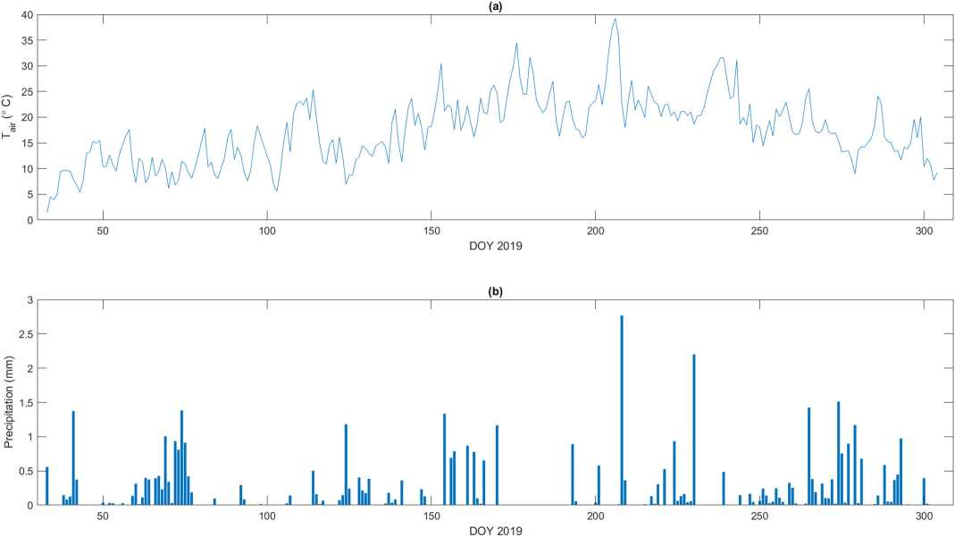
Figure 5. Description of the soil water status with different model parametrizations. (a): AgroC-SCOPE modeled top soil water content at 5 cm compared to in-situ measurements; (b): water stress factor according to the two parametrizations of AgroC-SCOPE. SIF measurements were taken during the period of the FloX campaign.
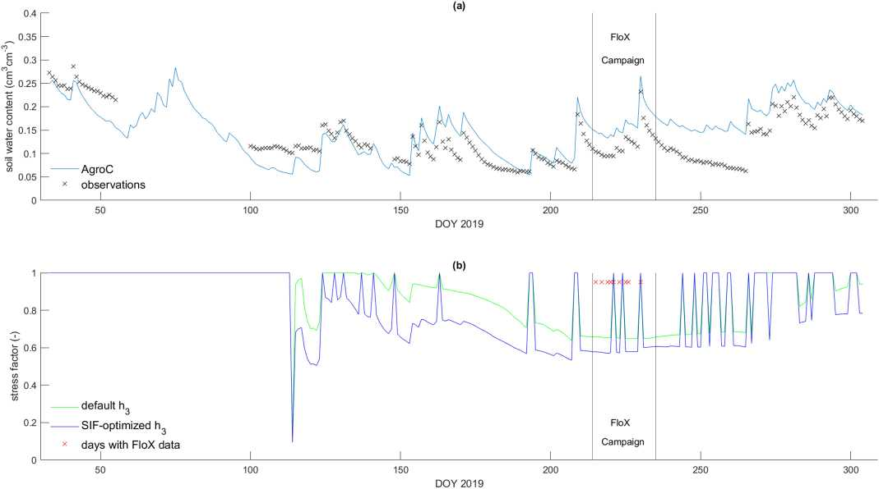

Figure 6. Daily averages of modeled ɛ_{F} time series using two model parametrizations (SIF-based h₃ and no stress) compared to daily averages of observed ɛ_{F} with their standard deviation. It should be noted that the FloX data were resampled to an hourly resolution before averaging. On DOY 225 and DOY 226, only data between 10 AM and 12 AM have been used.
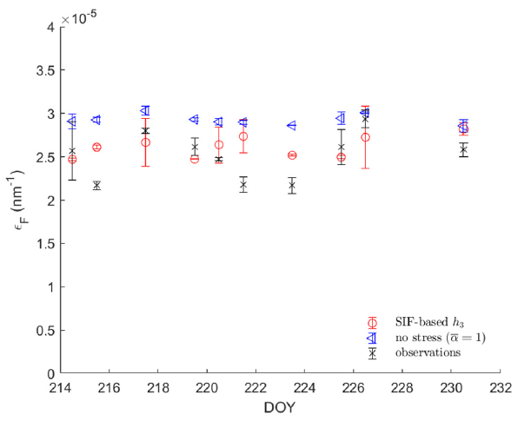

Table 6 - Sum of squared errors (SSE) between modeled and observed e_{F} and considering two model parametrizations (no stress and SIF-based h₃).
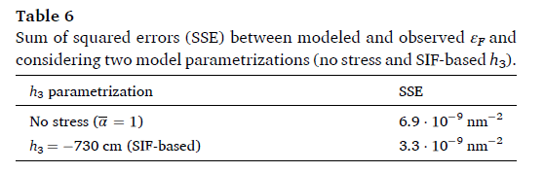

Considering the entire growing season, the model run with the SIF-optimized value for h₃ had the best NSE. Given the time-invariant nature of the Feddes curve, our approach leads to improvements in the NEE throughout the entire growing season, not only during the period in which the SIFA measurements were taken. Using only a few observations of ɛ_{F} during a drought-affected period was sufficient to correct the entire growing season.
Most of the correction in NEE comes from a correction in GPP, which is directly affected by the photosynthetic activity (Fig. 8). All three model runs overestimated the respiration during almost the entire growing season, but the model run with the SIF-based parametrization shows the least overestimation in the respiration component.

  - Ability of AgroC to predict plant water fluxes
Correcting h₃ affects the modeled ETA in two ways: first, the stress factor α serves as a scaling factor to convert the potential transpiration (TP) to actual transpiration (TA). Second, long-term drought stress exposure leads to reduced modeled plant growth, decreasing the modeled plant transpiration, which scales with the AgroC-modeled LAI. Calibrating the h₃ parameter with SIF observations also improved the mid-season ETA estimates, but the impact was less pronounced than for the NEE time series (Table 8). At the later stages of the growing season, most of the stress-induced decrease in transpiration was compensated by an increase in evaporation, minimizing the effect of the stress factor on ETA (Fig. 9).

- Discussion
  - Measurement differences between the FloX and the EC tower data
One of the challenges of integrating EC and tower-based spectrometer data in the AgroC-SCOPE model lies in the difference in footprint size between the FloX spectrometer (2.4 m², right below the sensor) and the EC station; 80-100% of the footprint is comes from less than 20 m to 100 m distance from the tower depending on the wind conditions. In all cases, the footprint of the EC tower is expected to remain within the field. AgroC is a one-dimensional model that produces estimates of NEE and ETA at the scale of the whole field, as was done by Klosterhalfen et al. (2017) for the same field. Herbst et al. (2021) expanded the AgroC model by incorporating a description of the soil properties at a sub-field scale. While they noted some significant within-field variability in the case of drought stress, it had only little effect on the overall NEE estimates. Linking the crop growth model to spatially distributed SIF measurements might improve its ability to assess the susceptibility of the field to water stress, but it is beyond the scope of this study.

Figure 7. Hourly AgroC-SCOPE modeled ɛ_{f} and modeled NEE according to the three model parametrizations compared to observed data for DOY 215 (a, c) and DOY 219 (b, d), as well as hourly observed PAR data for DOY 215 (e) and DOY 219 (f).
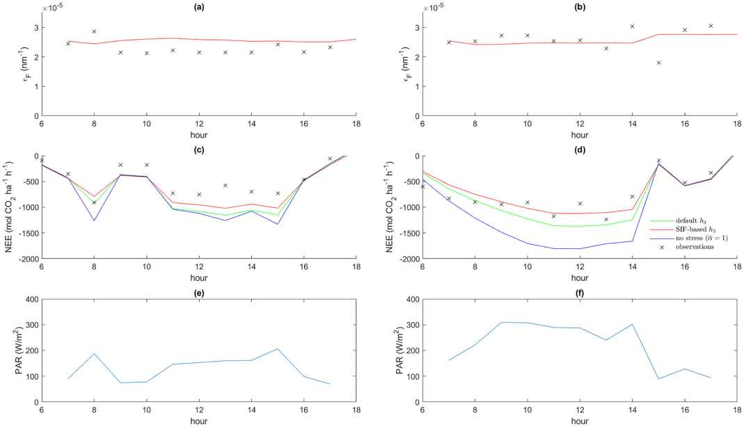

Figure 8. (a) NEE modeled by AgroC-SCOPE according to three different model parametrizations and EC derived NEE; (b) GPP modeled by AgroC-SCOPE according to three different model parametrizations and EC derived GPP; (c) respiration modeled by AgroC-SCOPE according to three different model parametrizations and EC derived respiration.

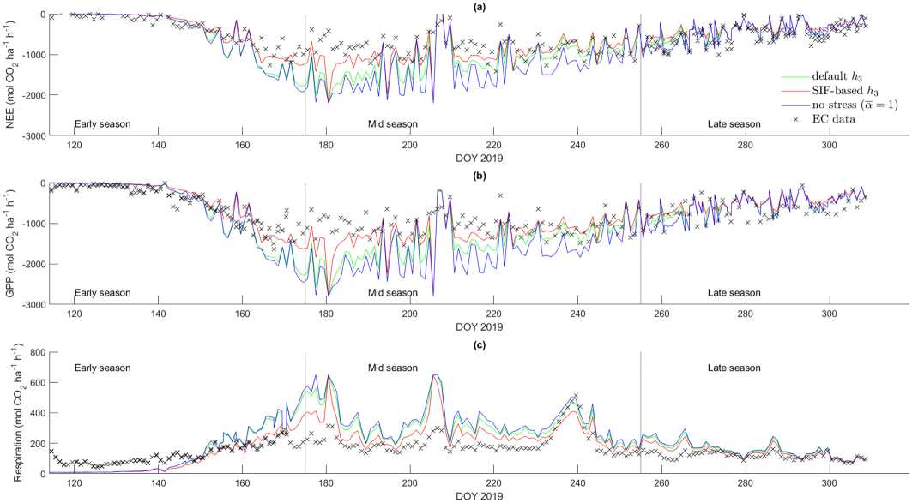

Table 7 - NSE for the NEE estimates in different parts of the growing season estimated with different parametrizations for the AgroC-SCOPE model.
Period | Default h₃ | SIF-based h₃ | No Stress ( ā = 1)
Early season | 0.59 | 0.81 | 0.53
Mid season | 0.60 | 0.78 | 0.35
Late season | 0.81 | 0.79 | 0.81
Whole season | 0.62 | 0.80 | 0.42

Table 8 - NSE for the ETA estimates in different parts of the growing season estimated with different parametrizations for the AgroC-SCOPE model.
Period | Default h₃ | SIF-based h₃ | No Stress ( a = 1)
Early season | 0.84 | 0.87 | 0.82
Mid season | 0.68 | 0.81 | 0.37
Late season | 0.81 | 0.78 | 0.79
Whole season | 0.66 | 0.70 | 0.55

  - Stress-induced changes in canopy structure
In the context of drought stress monitoring, it is necessary to provide information on the temporal variability of the dynamic canopy structure, since a drop in turgor pressure might change the leaf inclination (Jopia et al., 2020). This profoundly affects the SIF signal, as confirmed by observations (Dechant et al., 2020) and by SCOPE model (Verrelst et al., 2015). The uncertainties in the parametrization at both the leaf biochemical and canopy level makes the variability in SIFA hard to model (van der Tol et al., 2016; Wohlfahrt et al., 2018). Given the number of variables affecting the SIF signal, many studies dealing with SIFA simulations only used a limited number of input time series to produce SIFA while keeping the other inputs constant (Lee et al., 2015; Qiu et al., 2018). Consequently, these studies report a lower variability in the modeled SIFA time series compared to their observed counterparts. Model sensitivity to the uncertainties in the parametrization of the canopy structure can be reduced by normalizing the SIFA by FCVI, making the signal easier to interpret in biochemical terms. Consequently, ɛ_{F} appears to be a more suitable metric for detecting a stress-induced reduction in photosynthetic activity compared to SIFA itself. As an alternative, it would also be possible to retrieve canopy-scale ψ_{f} using the methods of (Celesti et al., 2018). It is however worth noting that the change in the structural component itself can also bear information about the plant water status, because of its link to the leaf turgor.

  - Applicability of this framework to other vegetation models
The main merit of this paper is the establishment of a quantitative link between water stress, water availability, photosynthesis and canopy-scale SIF emission, illustrated by coupling the AgroC and SCOPE models. In AgroC, water stress is described with the Feddes function and with water availabilities at different depths. While this exact structure is unique to the SoilCO2/RothC part of AgroC, the concept of a threshold value by which water stress starts to occur is found in various crop growth models (Tolomio and Casa, 2020). The same concept has also been used to constrain VCMax in SCOPE and thereby improve its GPP output (Bayat et al., 2019). If the input data can be aggregated correctly, AgroC, as well as many other crop growth models, can be run at the catchment scale or larger (Kuhnert et al., 2017). Problems might arise when models are run at a lower temporal resolution, since photosynthesis, non-photochemical quenching and therefore fluorescence shows a clear diurnal signal. To properly estimate the rate coefficients (i.e., K_{p}, Kn, Kd and Kf), an accurate description of the environmental conditions at the time by which the SIF measurements are taken is needed.

Figure 9. (a) AgroC-SCOPE modeled evapotranspiration using different parametrizations compared to EC-derived evapotranspiration; (b) modeled transpiration; (c) modeled evaporation.

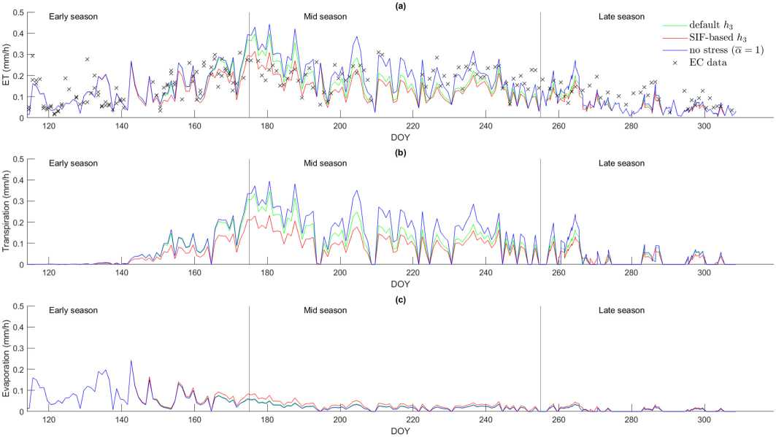

  - Perspectives on water stress function parametrization with spaceborne SIF data
This framework provides a method to define a stress level that considers both the SIF emission and the soil water availability. Since the soil water availability is modeled for the entire growing season, our approach improves the water stress estimation for the entire growing season, even on days without SIF observations. This is interesting in the light of the upcoming FLEX mission, which comes with a spatial resolution of 300 m and a temporal resolution of 27 days. This resolution allows for the collection of a few SIF observations at the field scale during each growing season, which is expected to be sufficient to constrain a water stress function in a crop growth model. Improving the parametrization of the drought stress function is expected to provide major improvements in the field of land surface modeling (Verhoef and Egea, 2014; Jonard et al., 2020).
  - In-situ validation of water stress function parametrization
Because of the importance of water stress in a plant’s water regime (Vereecken et al., 2008) and thereby its influence on photosynthesis and transpiration, considerable effort has been invested in the in-situ or lab-scale parametrization of these functions (Cai et al., 2018a,b). While these methods succeed in parametrizing a water stress function with great precision, their potential of characterizing a stress function at large scale is limited, possibly masking the spatial variability in the water stress conditions. Hupet et al. (2003) managed to inversely estimate the root water uptake parameters based on soil moisture data obtained with ground-penetrating radar. Only relying on soil moisture data, their approach does not account for the variation in a plant’s ability to extract water. The framework proposed here relies on few SIF observations, causing it to be suitable at a large spatial scale. Because of the direct link between VCMax, SIF emission and water stress, SIF provides more direct information about the plant water status. However, VCMax depends on the initial value of VCMax,25 as well as on ā, which depends on the Feddes function and soil water content, which in turn depends on the soil hydraulic properties. Neither the Feddes function nor VCMax nor the soil hydraulic properties is easy to obtain through in-situ measurements. Any error in the initial estimation of VCMax or in the soil hydraulic properties is therefore inevitably translated to a compensating error in ā through the estimation of h₃. It is therefore hard to interpret the value of ā outside of this model, and it might disagree with plant-based in-situ measurements of drought stress.

Summary and conclusion
This paper establishes a framework for parametrizing a drought stress function in a crop growth model using SIF observations, by coupling the AgroC crop growth model with the SCOPE model. Because of the many variables affecting the SIF signal, the AgroC-SCOPE model was not able to reproduce the variability in the observed SIF signal. Nevertheless, accounting for drought stress corrected a systematic overestimation of the ɛ_{F} by adjusting the parametrization of the Feddes function in AgroC. It should be noted that through the inversion procedure, the optimal value of h₃ is affected by many model parameters regarding photosynthesis and on the soil water availability. The new parametrization changed the stress factor and therefore the VCMax, in turn changing the estimates of photosynthetic activity. This leads to better estimates of NEE and ETA during the summer months. While the ɛ_{F} observations only covered a short subset of the growing season, a better estimate of h₃ improves the ETA and NEE estimates throughout the entire growing season. This is potentially interesting for using FLEX data to estimate drought stress. With FLEX being the first satellite designed to monitor SIF emission, it will be able to retrieve SIFA with a higher signal to noise ratio and a higher spatial resolution (300 m) compared to previous satellites. Since FLEX has a revisit time of 27 days, it will only provide a few data points during each growing season. Using the framework established here, we expect that the few SIFA observations provided by FLEX will provide significant improvement to crop growth model and land surface model estimates during drought conditions.

Declaration of Competing Interest
The authors declare that they have no known competing financial interests or personal relationships that could have appeared to influence the work reported in this paper.

Acknowledgments
This research has been funded by the Fonds pour la Formation à la Recherche dans l’Industrie et dans l’Agriculture (FRIA, Belgium) and the Deutsche Forschungsgemeinschaft (DFG, German Research Foundation) under Germany’s Excellence Strategy - EXC 2070 - 390732324.

Appendix A. Description of the Farquhar model in AgroC
As proposed by Farquhar et al. (1980), AgroC models photosynthesis using a big leaf approach. It considers three scenarios: light-limited photosynthesis, water limited photosynthesis and rubisco-limited photosynthesis. The photosynthesis depends on the meteorological conditions including: absorbed photosynthetically active radiation (APAR), atmospheric pressure (P_{atm}), air temperature (T_{air}), relative humidity (RH) and the ambient CO₂ and O₂ concentration (c_{s} and O_{i}). The plant physiological parameters are VCMax, the CO₂ partial pressure at compensation point (Γ*). The latter variable is calculated based on o_{i} and the temperature coefficients K_{c} and K_{o}:
in which the temperature coefficients are based on T_{air} and on constants: K_{c25} = 30Pa and K_{o25} = 30000 Pa at 25 ◦C as well as a_{Kc} = 2.1 and a_{Ko} = 1.2 (Eq. (A.2)-(A.3)).
The VCMax (Eq. (5)) is calculated based on the VCMax,25, ā and on the temperature sensitivity factor (f(T_{air}); Eq. (A.4)), which is calculated based on T_{air}, the freezing temperature of water (T_{freeze}) (both expressed in Kelvin) and on the universal gas constant (R_{gas}):
As implemented in SCOPE, the c_{i} was calculated in Eq. (A.5):
in which m is the Ball-Berry slope parameter. Photosynthesis (A) is finally calculated as the minimum of light limited (first part), water limited (second part) and rubisco limited photosynthesis (third part; Eq. (A.6)):
in which the quantum efficiency ζ was set to 0.06.

References
Ac, A., Malenovsky, Z., Olejmckova, J., Galle, A., Rascher, U., Mohammed, G., 2015. Meta-analysis assessing potential of steady-state chlorophyll fluorescence for remote sensing detection of plant water, temperature and nitrogen stress. Remote Sens. Environ. 168, 420-436.
Allen, R., Pereira, L., Raes, D., Smith, M., 1998. FAO: Irrigation and Drainage Paper No. 56. Food and Agriculture Organization of the United Nations (FAO), Rome.
Alonso, L., Gaomez-Chova, L., Vila-Francaes, J., Amoraos-Loapez, J., Guanter, L., Calpe, J., Moreno, J., 2008. Improved Fraunhofer line discrimination method for vegetation fluorescence quantification. IEEE Geosci. Remote Sens. Lett. 5, 620-624.
Bayat, B., van der Tol, C., Yang, P., Verhoef, W., 2019. Extending the SCOPE model to combine optical reflectance and soil moisture observations for remote sensing of ecosystem functioning under water stress conditions. Remote Sens. Environ. 221, 301-386.
Berger, K., Atzberger, C., Danner, M., D’Urso, G., Mauser, W., Vuolo, F., Hank, T., 2018. Evaluation of the PROSAIL model capabilities for future hyperspectral model environments: a review study. Remote Sens. 10.
Bogena, H.R., Borg, E., Brauer, A., Dietrich, P., Hajnsek, I., Merz, B., Pütz, T., Schmid, H. P., Wollschlager, U., Vereecken, H., Zacharias, S., 2016. TERENO: German network of terrestrial environmental observatories. J. Large Scale Res. Facilit. 2, 1-8.
Brogi, C., Huisman, J.A., Herbst, M., Weihermüller, L., Klosterhalfen, A., Montzka, C., Reichenau, T.G., Vereecken, H., 2020. Simulation of spatial variability in crop leaf area index and yield using agroecosystem modeling and geophysics-based quantitative soil information. Vadose Zone J. 19, 1-24.
Butler, W.L., 1978. Energy distribution in the photochemical apparatus of photosynthesis. Annu. Rev. Plant Physiol. 29, 345-378.
Cai, G., Vanderborght, J., Couvreur, V., Mboh, C.M., Vereecken, H., 2018a. Parameterization of root water uptake models considering dynamic root distributions and water uptake compensation. Vadose Zone J. 17, 160125.
Cai, G., Vanderborght, J., Langensiepen, M., Schnepf, A., Hüging, H., Vereecken, H., 2018b. Root growth, water uptake, and sap flow of winter wheat in response to different soil water conditions. Hydrol. Earth Syst. Sci. 22, 2449-2470.
Camino, C., Gonzalez-Dugo, V., Hernandez, P., Zarco-Tejada, P.J., 2019. Radiative transfer Vcmax estimation from hyperspectral imagery and SIF retrievals to assess photosynthetic performance in rainfed and irrigated plant phenotyping trials. Remote Sens. Environ. 213.
Campbell, P.K., Huemmrich, K.F., Middleton, E.M., Ward, L.A., Julitta, T., Daughtry, C. S., Burkart, A., Russ, A.L., Kustas, W.P., 2019. Diurnal and seasonal variations in chlorophyll fluorescence associated with photosynthesis at leaf and canopy scales. Remote Sens. 11.
Celesti, M., van der Tol, C., Cogliati, S., Panigada, C., Yang, P., Pinto, F., Rascher, U., Miglietta, F., Colombo, R., Rossini, M., 2018. Exploring the physiological information of Sun-induced chlorophyll fluorescence through radiative transfer model inversion. Remote Sens. Environ. 215, 97-108.
Damm, A., Elber, J., Erler, A., Gioli, B., Hamdi, K., Hutjes, R., Kosvancova, M., Meroni, M., Miglietta, F., Moersch, A., Moreno, J., Schickling, A., Sonnenschein, R., Udelhoven, T., van der Linden, S., Hostert, P., Rascher, U., 2010. Remote sensing of sun-induced fluorescence to improve modeling of diurnal courses of gross primary production (GPP). Global Change Biol. 16, 171-186.
Dechant, B., Ryu, Y., Badgley, G., Zeng, Y., Berry, J.A., Zhang, Y., Goulas, Y., Li, Z., Zhang, Q., Kang, M., Li, J., Moya, I., 2020. Canopy structure explains the relationship between photosynthesis and sun-induced chlorophyll fluorescence in crops. Remote Sens. Environ. 241.
Drusch, M., Moreno, J., Bello, U.D., Franco, R., Goulas, Y., Huth, A., Kraft, S., Middleton, E.M., Miglietta, F., Mohammed, G., Nedbal, L., Rascher, U., Schüttemeyer, D., Verhoef, W., 2017. Concept - ESA’s earth explorer 8. IEEE Trans. Geosci. Remote Sens. 55, 1273-1284.
Farquhar, G., von Caemmerer, S., Berry, J., 1980. A biochemical-model of photosynthetic CO₂ assimilation in leaves of C3 species. Planta 149, 78-90.
Feddes, R., Bresler, E., Neuman, S., 1974. Field test of a modified numerical model for water uptake by root systems. Water Resour. Res. 10, 1199-1206.
Féret, J.B., Gitelson, A., Noble, S., Jacquemoud, S., 2017. Prospect-d: towards modeling leaf optical properties through a complete lifecycle. Remote Sens. Environ. 193, 204-215.
Genty, B., Briantais, J.M., Baker, N.R., 1989. Electron transport and quenching of chlorophyll fluorescence. Biochim. Biophys. Acta 990, 87-92.
Ghazaryan, G., Konig, S., Rezaei, E.E., Siebert, S., Dubovyk, O., 2020. Analysis of drought impact on croplands from global to regional scale: a remote sensing approach. Remote Sens. 12, 1-17.
Heino, M., Puma, M.J., Ward, P.J., Gerten, D., Heck, V., Siebert, S., Kummu, M., 2018. Two-thirds of global cropland area impacted by climate oscillations. Nat. Commun. 9, 1-10.
Herbst, M., Hellebrand, H.J., Bauer, J., Huisman, J.A., Simunek, J., Weihermüller, L., Graf, A., Vanderborght, J., Vereecken, H., 2008. Multiyear heterotrophic soil respiration: evaluation of a coupled CO2 transport and carbon turnover model. Ecol. Model. 214, 271-283.
Herbst, M., Pohlig, P., Graf, A., Weihermüller, L., Schmidt, M., Vanderborght, J., Vereecken, H., 2021. Quantification of water stress induced within-field variability of carbon dioxide fluxes in a sugar beet stand. Agric. Forest Meteorol. 297, 108242.
Huang, J., Goémez-Dans, J.L., Huang, H., Ma, H., Wu, Q., Lewis, P.E., Liang, S., Chen, Z., Xue, J.H., Wu, Y., Zhao, F., Wang, J., Xie, X., 2019. Assimilation of remote sensing into crop growth models: current status and perspectives. Agric. Forest Meteorol. 276-277, 107609.
Hupet, F., Lambot, S., Feddes, R.A., Van Dam, J.C., Vanclooster, M., 2003. Estimation of root water uptake parameters by inverse modeling with soil water content data. Water Resour. Res. 39.
Jenkinson, D., Coleman, K., 2008. The turnover of organic carbon in subsoils: Part 2. Modelling carbon turnover. Eur. J. Soil Sci. 59, 400-413.
Jonard, F., De Cannière, S., Brüggemann, N., Gentine, P., Short Gianotti, D.J., Lobet, G., Miralles, D.G., Montzka, C., Pagaén, B.R., Rascher, U., Vereecken, H., 2020. Value of sun-induced chlorophyll fluorescence for quantifying hydrological states and fluxes: current status and challenges. Agric. Forest Meteorol. 291.
Jopia, A., Zambrano, F., Perez-Martmez, W., Vidal-Paez, P., Molina, J., Mardones, F.d.l. H., 2020. Time-series of vegetation indices (VNIR/SWIR) derived from sentinel-2 (A/ B) to assess turgor pressure in Kiwifruit. ISPRS Int. J. Geoinf. 9, 1-18.
Julitta, T., Corp, L.A., Rossini, M., Burkart, A., Cogliati, S., Davies, N., Hom, M., Mac Arthur, A., Middleton, E.M., Rascher, U., Schickling, A., Colombo, R., 2016. Comparison of sun-induced chlorophyll fluorescence estimates obtained from four portable field spectroradiometers. Remote Sens. 8.
Klosterhalfen, A., Herbst, M., Weihermüller, L., Graf, A., Schmidt, M., Stadler, A., Schneider, K., Subke, J.A., Huisman, J.A., Vereecken, H., 2017. Multi-site calibration and validation of a net ecosystem carbon exchange model for croplands. Ecol. Model. 363, 137-156.
Kuhnert, M., Yeluripati, J., Smith, P., Hoffmann, H., van Oijen, M., Constantin, J., Coucheney, E., Dechow, R., Eckersten, H., Gaiser, T., Grosz, B., Haas, E., Kersebaum, K.C., Kiese, R., Klatt, S., Lewan, E., Nendel, C., Raynal, H., Sosa, C., Specka, X., Teixeira, E., Wang, E., Weihermüller, L., Zhao, G., Zhao, Z., Ogle, S., Ewert, F., 2017. Impact analysis of climate data aggregation at different spatial scales on simulated net primary productivity for croplands. Eur. J. Agronomy 88, 41-52.
Kumar, M., 2016. Impact of climate change on crop yield and role of model for achieving food security. Environ. Monit. Assess. 188.
Lee, J.E., Berry, J.A., van der Tol, C., Yang, X., Guanter, L., Damm, A., Baker, I., Frankenberg, C., 2015. Simulations of chlorophyll fluorescence incorporated into the Community Land Model version 4. Global Change Biol. 21, 3469-3477.
Lee, J.E., Frankenberg, C., van der Tol, C., Berry, J.A., Guanter, L., Boyce, C.K., Fisher, J. B., Morrow, E., Worden, J.R., Asefi, S., Badgley, G., Saatchi, S., 2013. Forest productivity and water stress in Amazonia: observations from GOSAT chlorophyll fluorescence. Proc. R. Soc. B: Biol. Sci. 230.
Maes, W.H., Pagéan, B.R., Martens, B., Gentine, P., Guanter, L., Steppe, K., Verhoest, N.E., Dorigo, W., Li, X., Xiao, J., Miralles, D.G., 2020. Sun-induced fluorescence closely linked to ecosystem transpiration as evidenced by satellite data and radiative transfer models. Remote Sens. Environ. 249.
Mauder, M., Cuntz, M., Drüe, C., Graf, A., Rebmann, C., Schmid, H.P., Schmidt, M., Steinbrecher, R., 2013. A strategy for quality and uncertainty assessment of longterm eddy-covariance measurements. Agric. Forest Meteorol. 169, 122-135.
Mohammed, G., Colombo, R., Middleton, E., Rascher, U., van der Tol, C., Ladislav, N., Goulas, Y., Perez-Priego, O., Damm, A., Meroni, M., Joiner, J., Cogliati, S., Verhoef, W., Malenovsky, Z., Gastellu-Etchegorry, J.P., Miller, J.R., Guanter, L., Moreno, J., Moya, I., Berry, J., Frankenberg, C., Zarco-Tejeda, P., 2019. Remote sensing of solar-induced chlorophyll fluorescence (SIF) invegetation: 50 years of progress. Remote Sens. Environ. 231.
Murchie, E.H., Lawson, T., 2013. Chlorophyll fluorescence analysis: a guide to good practice and understanding some new applications. J. Exp. Bot. 64, 3983-3998.
Nash, J., Sutcliffe, J., 1970. River flow forecasting through conceptual models: Part I - A discussion of principles. J. Hydrol. 10, 282-290.
Norton, A.J., Rayner, P.J., Koffi, E.N., Scholze, M., 2018. Assimilating solar-induced chlorophyll fluorescence into the terrestrial biosphere model BETHY-SCOPE v1.0: model description and information content. Geosci. Model Dev. 11, 1517-1536.
Pacheco-Labrador, J., Perez-Priego, O., El-Madany, T.S., Julitta, T., Rossini, M., Guan, J., Moreno, G., Carvalhais, N., Martin, M.P., Gonzalez-Cascon, R., Kolle, O., Reischtein, M., van der Tol, C., Carrara, A., Martini, D., Hammer, T.W., Moossen, H., Migliavacca, M., 2019. Multiple-constraint inversion of SCOPE. Evaluating the potential of GPP and SIF for the retrieval of plant functional traits. Remote Sens. Environ. 234, 111362. https://doi.org/10.1016/j.rse.2019.111362.
Parazoo, N.C., Bowman, K., Fisher, J.B., Frankenberg, C., Jones, D.B., Cescatti, A., Péerez- Priego, O^{é} ., Wohlfahrt, G., Montagnani, L., 2014. Terrestrial gross primary production inferred from satellite fluorescence and vegetation models. Global Change Biol. 20, 3103-3121.
Parkash, V., Singh, S., 2020. A review on potential plant-basedwater stress indicators for vegetable crops. Sustainability (Switzerland) 12.
Porcar-Castell, A., Tyystjaorvi, E., Atherton, J., van der Tol, C., Flexas, J., Pfündel, E.E., Moreno, J., Frankenberg, C., Berry, J.A., 2014. Linking chlorophyll a fluorescence to photosynthesis for remote sensing applications: mechanisms and challenges. J. Exp. Bot. 65, 4065-4095.
Qiu, B., Xue, Y., Fisher, J.B., Guo, W., Berry, J.A., Zhang, Y., 2018. Satellite chlorophyll fluorescence and soil moisture observations lead to advances in the predictive understanding of global terrestrial coupled carbon-water cycles. Global Biogeochem. Cycles 32, 360-375.
Reichstein, M., Falge, E., Baldocchi, D., Papale, D., Aubinet, M., Berbigier, P., Bernhofer, C., Buchmann, N., Gilmanov, T., Granier, A., Grünwald, T., Havraénkovaé, K., Ilvesniemi, H., Janous, D., Knohl, A., Laurila, T., Lohila, A., Loustau, D., Matteucci, G., Meyers, T., Miglietta, F., Ourcival, J.M., Pumpanen, J., Rambal, S., Rotenberg, E., Sanz, M., Tenhunen, J., Seufert, G., Vaccari, F., Vesala, T., Yakir, D., Valentini, R., 2005. On the separation of net ecosystem exchange into assimilation and ecosystem respiration: review and improved algorithm. Global Change Biol. 11, 1424-1439.
Simunek, J., Suarez, D., 1993. Modeling of carbon dioxide transport and production in soil 1. Model development. Water Resour. Res. 29, 484-497.
Spitters, C., van Keulen, H., van Kraailingen, D., 1988. A Simple But Universal Crop Growth Simulation Model, SUCROS87. Simulation Monographs. PUDOC, Wageningen.
van der Tol, C., Rossini, M., Cogliati, S., Verhoef, W., Colombo, R., Rascher, U., Mohammed, G., 2016. A model and measurement comparison of diurnal cycles of sun-induced chlorophyll fluorescence of crops. Remote Sens. Environ. 186, 663-677.
Tolomio, M., Casa, R., 2020. Dynamic crop models and remote sensing irrigation decision support systems: a review of water stress concepts for improved estimation of water requirements. Remote Sens. 12, 1-34.
van der Tol, C., Berry, J.A., Campbell, P.K., Rascher, U., 2014. Models of fluorescence and photosynthesis for interpreting measurements of solar-induced chlorophyll fluorescence. J. Geophys. Res. Biogeosci. 119, 2312-2327.
van der Tol, C., Verhoef, W., Timmermans, J., Verhoef, A., Su, Z., 2009. An integrated model of soil-canopy spectral radiances, photosynthesis, fluorescence, temperature and energy balance. Biogeosciences 6, 3109-3129.
Vereecken, H., Huisman, J.A., Bogena, H., Vanderborght, J., Vrugt, J.A., Hopmans, J.W., 2008. On the value of soil moisture measurements in vadose zone hydrology: a review. Water Resour. Res. 46, 1-21.
Verhoef, A., Egea, G., 2014. Modeling plant transpiration under limited soil water: comparison of different plant and soil hydraulic parameterizations and preliminary implications for their use in land surface models. Agric. Forest Meteorol. 191, 22-32.
Verhoef, W., Jia, L., Xiao, Q., Su, Z., 2007. Unified optical-thermal four-stream radiative transfer theory for homogeneous vegetation canopies. IEEE Trans. Geosci. Remote Sens. 45, 1808-1822.
Verrelst, J., Pablo Rivera, J., van der Tol, C., Magnani, F., Mohammed, G., Moreno, J., 2015. Global sensitivity analysis of the SCOPE model: what drives simulated canopyleaving sun-induced fluorescence? Remote Sens. Environ. 8, 55-L.
Vilfan, N., van der Tol, C., Verhoef, W., 2019. Estimating photosynthetic capacity from leaf reflectance and Chl fluorescence by coupling radiative transfer to a model for photosynthesis. New Phytol. 223, 487-500.
Wieneke, S., Ahrends, H., Damm, A., Pinto, F., Stadler, A., Rossini, M., Rascher, U., 2016. Airborne based spectroscopy of red and far-red sun-induced chlorophyll fluorescence: implications for improved estimates of gross primary productivity. Remote Sens. Environ. 184, 654-667.
Wieneke, S., Burkart, A., Cendrero-mateo, M.P., Julitta, T., Rossini, M., Schickling, A., 2018. Linking photosynthesis and sun-induced fluorescence at sub-daily to seasonal scales. Remote Sens. Environ. 219, 247-258.
Wohlfahrt, G., Gerdel, K., Migliavacca, M., Rotenberg, E., Tatarinov, F., Müller, J., Hammerle, A., Julitta, T., Spielmann, F.M., Yakir, D., 2018. Sun-induced fluorescence and gross primary productivity during a heat wave. Sci. Rep. 8, 1-9.
Wutzler, T., Lucas-Moffat, A., Migliavacca, M., Knauer, J., Sickel, K., Sigut, L., Menzer, O., Reichstein, M., 2018. Basic and extensible post-processing of eddy covariance flux data with REddyProc. Biogeosciences 15, 5015-5030.
Yang, K., Ryu, Y., Dechant, B., Berry, J.A., Hwang, Y., Jiang, C., Kang, M., Kim, J., Kimm, H., Kornfeld, A., Yang, X., 2018. Sun-induced chlorophyll fluorescence is more strongly related to absorbed light than to photosynthesis at half-hourly resolution in a rice paddy. Remote Sens. Environ. 216, 658-673.
Yang, P., van der Tol, C., 2018. Linking canopy scattering of far-red sun-induced chlorophyll fluorescence with reflectance. Remote Sens. Environ. 209, 456-467.
Yang, P., van der Tol, C., Campbell, P.K., Middleton, E.M., 2020. Fluorescence Correction Vegetation Index (FCVI): a physically based reflectance index to separate physiological and non-physiological information in far-red sun-induced chlorophyll fluorescence. Remote Sens. Environ. 240.
Zhou, S., Medlyn, B., Sabaté, S., Sperlich, D., Colin Prentice, I., 2014. Short-term water stress impacts on stomatal, mesophyll and biochemical limitations to photosynthesis differ consistently among tree species from contrasting climates. Tree Physiol. 34, 1035-1046.

* Corresponding author.

