Journal of Geophysical Research
Supporting Information for

A preliminary study of Magnetosphere-Ionosphere-Thermosphere coupling

at Jupiter: Juno multi-instrument measurements and modelling tools
Yuxian Wang^{1,2,3}, Michel Blanc³, Corentin Louis³, Chi Wang^{1,2}, Nicolas André³, Alberto Adriani⁴, Frederic Allegrini^{5,14}, Pierre-Louis Blelly³, Scott Bolton⁵, Bertrand Bonfond⁶, George Clark⁷, Bianca Maria Dinelli⁸, Jean-Claude Gérard⁶, Randy Gladstone⁵, Denis Grodent⁶, Stavros Kotsiaros⁹, William Kurth¹⁰, Laurent Lamy^{11,12}, Philippe Louarn³, Aurélie Marchaudon³, Barry Mauk⁷, Alessandro Mura⁴, Chihiro Tao¹³
¹State Key Laboratory of Space Weather, National Space Science Center, Chinese Academy of Sciences, Beijing, China.
²College of Earth and Planetary Sciences, University of Chinese Academy of Sciences, Beijing, China.
³Institut de Recherche en Astrophysique et Planétologie, Toulouse, France.
⁴INAF-Istituto di Astrofisica e Planetologia Spaziali, Rome, Italy.
⁵Southwest Research Institute, San Antonio, Texas, USA.
⁶Laboratoire de Physique Atmosphérique et Planétaire, STAR Institute, Université de Liège, Liège, Belgium.
⁷The Johns Hopkins University Applied Physics Laboratory, Laurel, MD, USA.
⁸ISAC-CNR, Bologna, Italy.
⁹DTU Space, Technical University of Denmark, Kgs. Lyngby, Denmark.
¹⁰Department of Physics and Astronomy, University of Iowa, Iowa City, IA, USA.
¹¹Laboratoire d'études spatiales et d'instrumentation en astrophysique.
¹²Laboratoire d’Astrophysique de Marseille, Marseille, France.
¹³National Institute of Information and Communications Technology (NICT), Koganei, Japan
¹⁴Department of Physics and Astronomy, University of Texas at San Antonio, San Antonio, Texas, USA.

Appendices

A-1. Atmospheric model (JTAM)
The Jupiter Transplanet Atmosphere Model (JTAM) model employed here is a semi-empirical model using the assumptions of diffusive equilibrium well above the homopause and of mixed equilibrium well below the homopause. Its theoretical foundations are described in Banks and Kockarts (1973). The model was originally developed for Earth’s atmosphere and then adapted to Jupiter based on Galileo data (Seiff et al., 1998) by Blelly et al. (2019). In our current work, the model is further improved by an extension of the number of neutral species considered and by a versatile parameterization allowing to adjust it to a variety of observations. As a result, all physical quantities, including the temperatures and concentrations of the five neutral species considered (H, H₂, He, CH₄, and C₂H₂), are specified in terms of a limited set of “free parameters” chosen to represent the variability of the Jovian neutral atmosphere. In order to give a reference description of Jupiter’s auroral upper atmosphere, the initial values of these parameters are determined by fitting the atmosphere model of Grodent et al. (2001). As a consequence of this fitting procedure, the physical assumptions underlying our model, such as the use of an eddy diffusion coefficient to model the transition region around the homopause, are the same as those used by Grodent et al. (2001).
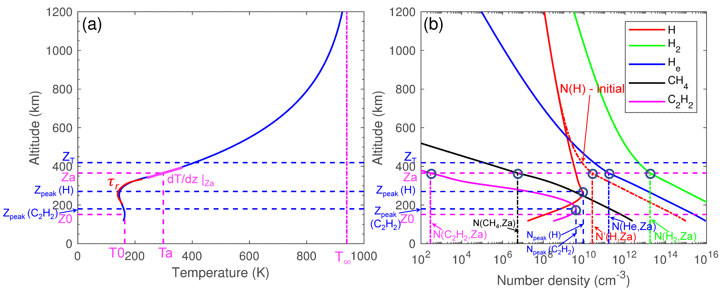
Figure A1-1. An illustration of the JTAM model. Panel (a) shows the neutral temperature profile, and panel (b) the density profiles for the 5 modelled species (H, H₂, H_{e}, CH₄, C₂H₂), both with an indication of the free model parameters. Among the two red curves shown for H, the solid one represents the modified fitting result while the dashed one corresponds to the initial version of the model.
The free parameters of JTAM can be categorized into 3 classes: altitude parameters, temperature parameters and density parameters. As shown in panel a, for the neutral temperature profile, the parameters include 5 critical altitudes and 5 temperature parameters (including the shape parameter $τ_{r}$), which also affect the density profiles. The density profiles shown in panel b use 7 parameters (shown as vertical dashed lines). In general, these density parameters specify densities at some reference altitude, like Z_{a} and Z_{peak} (H, C₂H₂). All these parameters are listed in Table A1-1.
Table A1-1. Free parameters of the JTAM atmosphere model.
 | Parameters | Physical meanings | Values
 | (1) Altitude Parameters
1 | Z0 (km) | Stratopause altitude of Jupiter’s atmosphere. | 151.0
2 | Za (km) | Junction point between the two analytical representations, also an inflexion point for the temperature profile (e.g. a local maximum for dT/dZ). | 325.0
3 | Z_{T} (km) | Altitude of the turbopause. | 419.0
4-5 | Z_{peak} (km) | Altitudes where the maximum density is found for the Gauss functions used for the H and C₂H₂ density profiles. | [300.0, 150.0]
A1 | Zd (km) | Transition altitudes between the initial JTAM result and the Gauss function used to smooth the density profiles of H and C₂H₂. | [270.0, 280.0]
A2 | Hd (km) | Scale heights used to smooth the density profiles of H and C₂H₂. | [38.6, 27.6]
A3 | FWHM  (km) | Full widths at half maximum for the Gauss function used to fit the density profiles of H and C₂H₂. | [250, 180]
 | (2) Temperature Parameters
6 | T0 (K) | Thermosphere temperature at stratopause. | 164.2
7 | Ta (K) | Temperature at the junction point Za. | 398.8
8 | $T_{∞}$ (K) | Exospheric temperature. | 1300.0
9 | dT/dZ|_{za} (K/km) | Slope of the temperature profile at Za. | 2.2
10 | $τ_{r}$ (1) | Shape parameter of the temperature profile (it mainly affects the shape of T at Z<Za). | -0.14
 | (3) Density Parameters
11-15 | N(*, Za) | Densities at Za for each species (H₂, H, He, CH₄, C₂H₂) (cm⁻³). | [1.0e13, 2.5e10, 1.6e11, 5.8e7, 3.4e3]
16-17 | N_{peak} (cm⁻³) | Peak density for the Gauss function used for H and C₂H₂ profiles. | [1.9e10, 8.0e9]

A-2. Ionosphere model and ionospheric conductances
The ionospheric model used in this study is based on the analytical expressions derived by Hiraki and Tao (2008), who parameterized the ionization rate of the neutral gas by electron impact in a similar way as Earth’s case. Their model provides a good approximation to the altitude distribution of the ionization rate for specified electron precipitation and neutral atmosphere (see also Gérard et al., 2020). For simplification, we only consider H₂ and CH₄ as the main neutral species for the atmosphere. This is reasonable since they are the dominant neutral components involved in the chemical reactions of the Jovian ionosphere (e.g., Gérard et al., 2020). Specifically, electron-H₂ collisions generate H₂⁺ ions, which are fast converted to H₃⁺ via a reaction with H₂. H₃⁺ is the dominant contribution to the ion composition and to conductances at altitudes above the homopause, while close to and below the homopause, a host of hydrocarbon ions produced by CH₄ become dominant (Perry et al.,1999; Gérard et al., 2020). In order to include the main effects of hydrocarbon species while keeping simplicity, we assume that CH₅⁺ ions are the final products of this set of hydrocarbon reactions at low altitudes. The chemical reactions included in our ionospheric model are listed in Table A2-1 below.
Table A2-1. Chemical reactions considered in the ionospheric model ($T_{e}$ is electron temperature).
Reactions | Rate Coefficient (cm³/s) | Reference
$$e^{-}+H_{2}→H_{2}^{+}+{2e}^{-}$$ | -ª | Hiraki and Tao (2008)
$$H_{2}^{+}+H_{2}→H_{3}^{+}+H$$ | -^{b} | Gérard et al. (2020)
$$H_{3}^{+}+e^{-}→products$$ | $$1.2×{10}^{-7}{(300/T_{e})}^{0.65}$$ | Sundstrom et al. (1994)  Gérard et al. (2020)
$$H_{3}^{+}+CH_{4}→CH_{5}^{+}+H_{2}$$ | $$2.4×{10}^{-9}$$ | Perry et al. (1999)
$${CH}_{5}^{+}+e^{-}→products$$ | 2.7$×{10}^{-7}{(300/T_{e})}^{0.52}$ | Perry et al. (1999)  Gérard et al. (2020)
ªThe production rates are calculated from the ionospheric model.
^{b}The H₂⁺ ions quickly transfer their charge to H₃⁺ with a reaction rate much higher than other listed reactions (e.g., Gérard et al., 2020).
To determine the electron precipitation input to the model, we use Juno particle measurements within the loss cone provided by JADE (electrons: 0.1 to 100 keV; ions: 5 to 50 keV) (McComas et al., 2017) and JEDI (electrons: 30 to 800 keV; ions: 10 keV to >1MeV) (Mauk et al., 2017) instruments.
The volume production rate of $H_{3}^{+}$ ions is derived by integration of ionization rates over the energy domain (Hiraki and Tao, 2008):
Q_{ion} (z) = $\int{q_{ion}\left(z,ε\right)F\left(ε\right)dε}$ (A1)
where $q_{ion}$ is the differential ionization rate per unit energy and altitude for an incident electron energy $ε$at an altitude $z$, and $F\left(ε\right)$ is the energy flux of precipitating electrons. This production rate is balanced by dissociative recombination of ions via the set of reactions listed in Table A2-1. As a result, we can derive the altitude-dependent density of $H_{3}^{+}$ and CH₅⁺ ions and calculate electron densities as their sum.
The altitude distributions of Pedersen $σ_{p}$and Hall conductances $σ_{H}$ are calculated by the standard formulas,
$$σ_{p}=\frac{n_{e}ⅇ}{B}\frac{\left|ω_{ce}\right|ν_{en}}{ν_{en}^{2}+ω_{ce}^{2}}+\sum_{i=1}^{n}{\frac{n_{i}ⅇ}{B}\frac{ω_{ci}ν_{in}}{ν_{in}^{2}+ω_{ci}^{2}}} (A2)$$
$$σ_{H}=\frac{n_{e}ⅇ}{B}\frac{ω_{ce}^{2}}{ν_{en}^{2}+ω_{ce}^{2}}-\sum_{i=1}^{n}{\frac{n_{i}ⅇ}{B}\frac{ω_{ci}^{2}}{ν_{in}^{2}+ω_{ci}^{2}}} (A3)$$
where $n_{e}$, $n_{i}$ are electron and ion number densities, respectively, $ω_{ce}$ and $ω_{ci}$ are the cyclotron frequencies of electrons and ions defined as $ω_{c}=\frac{Bq}{m}$, and q represents the electric charge. $B$ is the local magnetic field from Jupiter’s JRM09 internal magnetic field model combined with the magnetodisc current model (Connerney et al., 1981; Connerney et al., 2018). $ν_{en}$($ν_{in}$) are collision frequencies between electrons (ions) and neutrals (e.g., Banks and Kockarts, 1973; Gérard et al., 2020).
Introducing the collision ratios $r_{e}=\frac{ν_{en}}{ω_{ce}}$ and $r_{i}=\frac{ν_{in}}{ω_{ci}}$ further reduces these equations to the simpler expressions
$$σ_{p}=\frac{n_{e}ⅇ}{B}\frac{r_{e}}{1+r_{e}^{2}}+\sum_{i=1}^{n}{\frac{n_{i}ⅇ}{B}\frac{r_{i}}{1+r_{i}^{2}}} (A4)$$
$$σ_{H}=\frac{n_{e}ⅇ}{B}\frac{1}{1+r_{e}^{2}}-\sum_{i=1}^{n}{\frac{n_{i}ⅇ}{B}\frac{1}{1+r_{i}^{2}} (A5)}$$
As a simplified but useful reference, let us analyze the altitude variation of these conductivities when there is only one ion species: with $n_{e}=n_{i}$, the conductivity expressions are reduced to
$σ_{p}=\frac{n_{e}ⅇ}{B}\left(\frac{r_{e}}{1+r_{e}^{2}}+\frac{r_{i}}{1+r_{i}^{2}}\right)=\frac{n_{e}ⅇ}{B}M_{P} \left(r_{e}, r_{i}\right) (A6)$
$σ_{H}=\frac{n_{e}ⅇ}{B}\left(\frac{1}{1+r_{e}^{2}}-\frac{1}{1+r_{i}^{2}}\right)=\frac{n_{e}ⅇ}{B}M_{H } \left(r_{e}, r_{i}\right) (A7)$
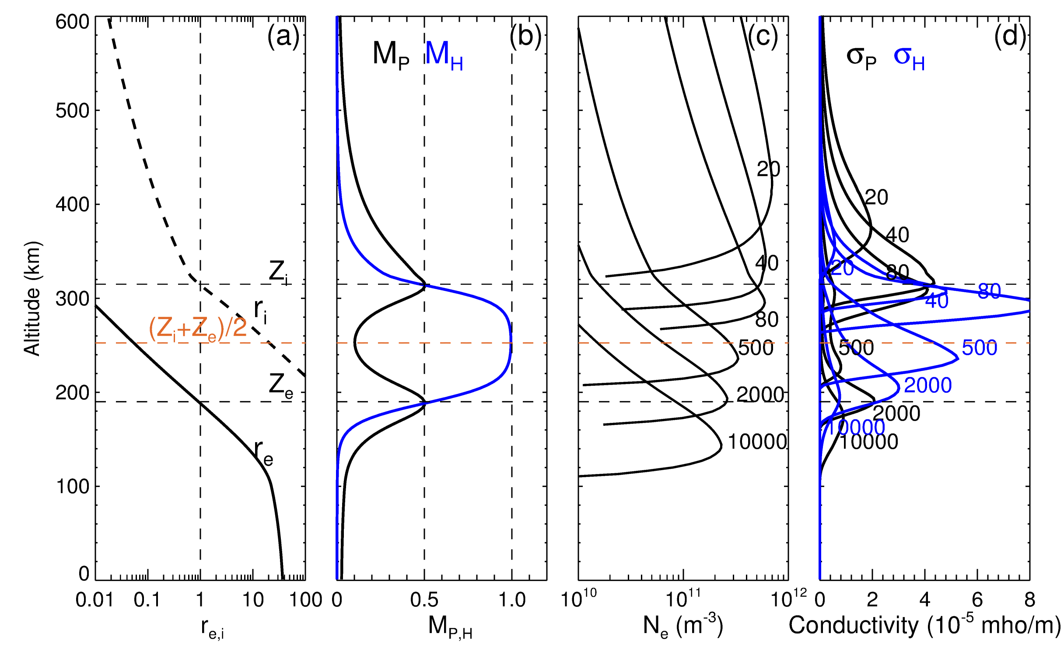
Figure A2-1. Altitude distributions of (a) collision ratios of ions and electrons,${ r}_{e,i}$, (b) $M_{P, H}$, (c) electron density profiles, N_{e} and (d) Pedersen (black) and Hall (blue) conductivity profiles produced by precipitation of a mono-energetic electron beam with initial energies of 20, 40, 80, 500, 2000, 10000 keV and a constant total energy flux of 100 mW/m². The vertical dashed line in panel (a) corresponds to ${ r}_{e,i}=1.0$, i.e., $ν_{en}=ω_{ce}$ or $ν_{in}=ω_{ci}$, while the horizontal black dashed lines represent the corresponding altitudes $Z_{e,i}$, and the orange dashed line represents the median of them. In panel (b), vertical lines correspond to 0.5 and 1.0, respectively, where the peaks of $M_{P, H}$occur.
The altitude distributions of ${ r}_{e,i}$, $M_{P, H}$, electron density and conductivities are plotted in Figure A2-1for a precipitation of 100 mW/m² by electrons with different energies. In panel (a), the ratios of collision frequencies to cyclotron frequencies for electrons and ions${ r}_{e,i}$ decrease with increasing altitude in proportion to molecular hydrogen (H₂) densities. The two horizontal dashed lines represent the altitudes where ${ r}_{e,i}=1$, respectively about 318 km and 190 km for ions ($Z_{i}$) and electrons ($Z_{e}$). At these two critical altitudes, $M_{P}$ reaches its maximum value of 0.5, we have ${ r}_{i}≫1$ ${ (r}_{e}≪1)$ and thus $M_{P}=M_{H}$, i.e., $σ_{p}=σ_{H}$. The Hall term $M_{H}$ has only one peak $M_{H}=1$, which corresponds to the local minimum of $M_{P}$ near ${(Z}_{e}+Z_{i})/2.$Panel (c) shows the altitude distributions of electron densities calculated for the cases of a precipitation of a 100 mW/m² mono-energetic electron beam with incident energies of 20, 40, 80, 500, 2000, 10000 keV. Pedersen (Hall) conductivities are shown in panel (d) with black (blue) curves for the different electron energies. For the cases where the stopping height of the electrons is higher than about ${(Z}_{e}+Z_{i})/2$ (20, 40, 80 keV), both Pedersen and Hall conductivities have only one peak. When it is lower than about ${(Z}_{e}+Z_{i})/2$, Pedersen conductivities have two peaks while Hall conductivities have only one. The peak Pedersen conductivity first increases with increasing initial electron energy, reaching a peak near the altitude of $Z_{i}$, then decreases, and then reaches a second maximum near the altitude of $Z_{e}$, forming a camel-like shape. Due to the single-peak distribution of $M_{H}$, the Hall conductivity has only one maximum as a function of the initial electron energy.
Figure A2-2 shows the total conductivity as well as the contributions from different ion species for a precipitation of 100 mW/m² by 100 keV mono-energetic electrons. Panel (a) shows that the main contribution to the Pedersen conductivity is provided by H₃⁺ ions for altitudes above about 400 km, and by CH₅⁺ ions for the middle altitudes between ~300 and ~400 km, while the electron contribution becomes dominant at lower altitudes. As the Hall conductivity is the difference between ion and electron contributions (equations A5 and A7), it is near zero for altitudes above 400 km, and then peaks at about 300 km, where the ion contributions are relatively low. Comparison of the dashed curves (without hydrocarbons) and solid curves (with hydrocarbons) in these two panels show that the inclusion of hydrocarbon ions in chemical reactions decreases the Pedersen conductivity and increases the Hall conductivity.
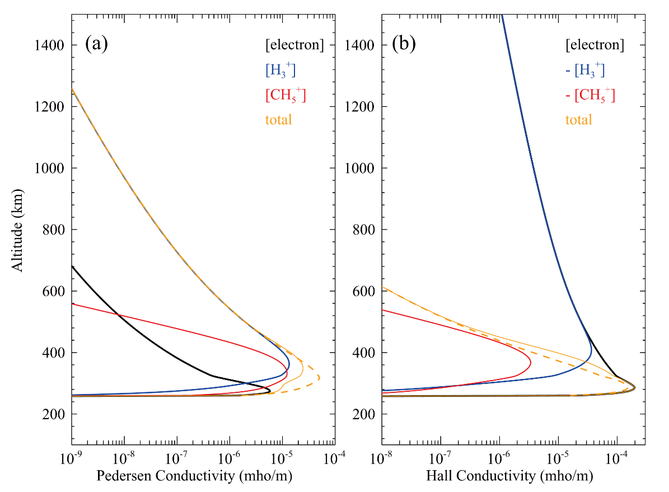
Figure A2-2. Altitude distribution of the Pedersen (a) and Hall (b) conductivities in the auroral regions for a precipitation of 100 mW/m² by 100 keV mono-energetic electrons. The curves with different colors show the contributions of each charged species: electrons (black), H₃⁺ (blue), CH₅⁺ (red) and total conductivity (orange). The solid/dashed orange curves represent the results of the ionospheric model with/without CH₄ and CH₅⁺. The total Pedersen conductance with (without) CH₅⁺ is 1.77 (2.55) mhos, while the Hall conductance is 6.60 (3.84) mhos.

A-3. Electrodynamics model
This appendix describes the method used to derive the MIT coupling parameters listed in Table 1, except for the calculation of conductances which is described in appendix A-2.
Reference frames for the electrodynamics model. The purpose of our calculations is to relate the parameters that are measured by Juno in the 3-D space corresponding to the “high latitude, auroral and polar magnetosphere” region of figure 2 (called Region II), to the key parameters of MIT coupling in the conducting layer of the ionosphere/thermosphere (called Region III). This conducting layer is modelled as a 2-D infinitely thin shell surrounding the planet. Indeed, as Figures A2-1 and A2-2 show, its vertical thickness (on the order of 200 km, and about 3×10⁻³ times the Jovian radius R_{J}) is very small compared to the planetary scale. The mean latitude of the main oval is shown as the lower red curve on this ionospheric thin shell. Mapping this main oval location to the altitude of Juno along magnetic field lines, one can construct the upper red curve.
To cover Region II, region III and their connections, we introduce two different reference frames which are adapted to each of them.
For the description of the 3-D space of Region II, we introduce a set of orthogonal curvilinear coordinates (x, y, z) such that x and y are constant along magnetic field lines, to facilitate the mapping of quantities between Juno’s location and its magnetic footprint in the ionosphere/thermosphere. Each point in (x, y, z) space is associated to a local orthogonal reference frame with vector units ($\hat{x},\hat{y},\hat{z}$). As shown in Figure A3-1, $\hat{z}$ is along the magnetic field direction, $\hat{y}$ is orthogonal to $\hat{z}$in the plane containing the local magnetic field vector and the local tangent to the oval, and $\hat{x}=\hat{y}×\hat{z}$. In this reference system, distances are given by the metric tensor ds² = h_{x}dx² + h_{y}dy² + h_{z}dz², in which h_{x}, h_{y} and h_{z} are the metric coefficients in the three directions.
To map quantities along field lines, we use the JRM09 magnetic field model (Connerney et al., 2018) complemented by the current sheet model of Connerney et al. (1981).
For the description of parameters related to the 2-D space of Region III, we use a reference set (x’, y’) which defines unit vectors $\hat{x'}$ and $\hat{y'}$. For convenience of the calculations, we choose this set such as $\hat{x'}$ points horizontally equatorward and orthogonal to the main oval, and $y'$ points eastward along the main oval. The parameters defined in this 2-D space of Region III are either scalars (Joule and particle heating), or 2-D vectors tangent to the ionospheric shell (i.e., height-integrated ionospheric currents, horizontal ionospheric electric fields), or 2-D tensors such as the horizontal height-integrated ionospheric conductances. In this reference system, distances are given by the metric tensor ds’²= h_{x’}dx’²+ h_{y’}dy’², in which h_{x’} and h_{y’} are the metric coefficients in the two horizontal directions. This 2-D set can be complemented by a $\hat{z'}$ vertical unit vector pointing upwards in the northern hemisphere and downward in the southern hemisphere.
Simplifying assumptions. To relate the MIT coupling parameters associated to Regions II and III, we assume that the variations of all quantities along the main auroral oval (i.e. along the red curves, both at the ionospheric altitude and at the altitude of Juno), are much smaller than the variations orthogonal to the oval and to the local direction of the magnetic field. This simplifying assumption is validated by inspection of UVS images showing that the main oval is reasonably homogeneous along its longitudinal extension and much thinner than its longitudinal extension in the vicinity of its crossing with the Juno ionospheric magnetic footprint. Figure 6 shows that this is the case for the two perijoves we have studied in detail, PJ-3S and PJ-6S. This assumption implies that $\frac{∂}{∂x}≫\frac{∂}{∂y}$ in Region II, and similarly $\frac{∂}{∂x'}≫\frac{∂}{∂y'}$ in Region III.
A second assumption we will use at times is to neglect parameter variations with spatial scales on the order of the planetary radius in comparison to variations at the scale of the latitudinal thickness of the main oval.
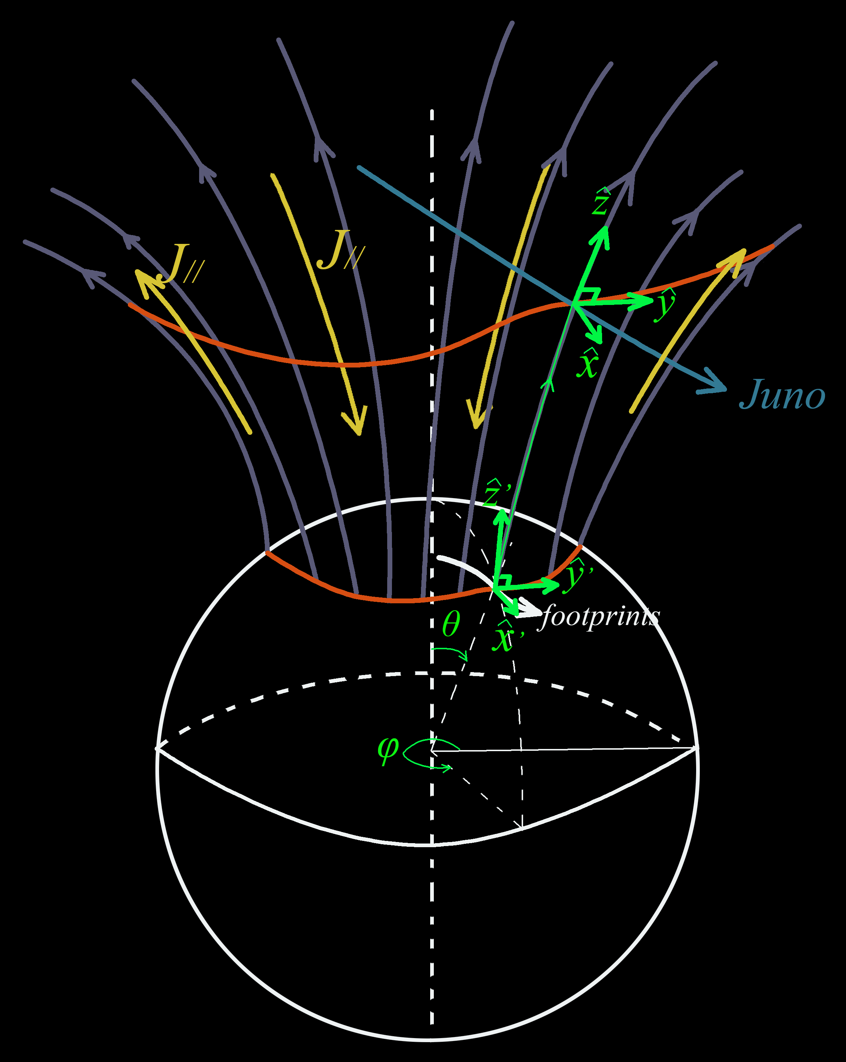
Figure A3-1. Illustration of the main oval crossing for one Juno Northern perijove. The magnetic field lines mapping to the mean latitude of the main oval (shown as the lower red curve on the ionospheric sphere) are shown in purple. They make it possible to map this main oval location to the altitude of Juno (upper red curve). Juno trajectories as well as their magnetic footprints are in sky-blue and white, respectively. Two local reference frames are used for our differential calculations. At the altitude of Juno and everywhere along magnetic field lines above the ionosphere, unit vector $\hat{z}$ points along the magnetic field, $\hat{y}$ is positive eastward along the tangent to the cone of field lines connected to the main oval, and $\hat{x}$ complements the frame, positive towards the equator in both hemispheres. At the ionospheric altitude, unit vectors $\hat{x'}$ and $\hat{y'}$ are horizontal and tangent to the conducting layer of the ionosphere which is assumed to be an infinitely thin surface surrounding the plane. $\hat{x'}$ is oriented towards the equator orthogonal to the auroral oval (red curve), $\hat{y'}$ is oriented eastward along the oval, and $\hat{z'}$ is vertical, positive upward in the northern hemisphere and downward in the southern hemisphere. $\hat{x'}$ and $\hat{y'}$ taken together provide a local 2-D reference frame for horizontal vectors and differential expressions defined in the plane tangent to the ionospheric conducting layer.
Relation of $J_{∥,iono}$ to the magnetic field perturbation at the altitude of Juno. Using Ampere’s law at Juno location under the approximation $\frac{∂}{∂x}≫\frac{∂}{∂y}$ provides the following relationship between the magnetic perturbation and $J_{∥,Juno}$:
$$J_{∥,Juno}=J_{z}=\frac{1}{μ_{0}h_{x}h_{y}}\frac{∂{(h_{y}δB}_{y})}{∂x} (A8)$$
Where $μ_{0}$ is the vacuum permittivity. The magnetic perturbation $δB_{y}$ is obtained from the Juno magnetometer measurement based on the method described in Kotsiaros et al. (2019). Since the metric coefficients vary slowly across the oval, contrary to the electrodynamic parameters, (A8) can be simplified to:
$$J_{∥,Juno}=J_{z}=\frac{1}{μ_{0}}\frac{∂{(δB}_{y})}{h_{x}∂x} (A9)$$
Using the conservation of magnetic flux along each field line,
$${(\frac{J_{∥}}{B})}_{iono}= {(\frac{J_{∥}}{B})}_{Juno} (A10)$$
One can write a direct relationship between the magnetic perturbation generated by field-aligned currents at the altitude of Juno and the intensity of these same currents at the top of the ionosphere,
$$J_{∥,iono}=\frac{B_{iono}}{μ_{0}∙B_{Juno}}\frac{∂{(δB}_{y})}{h_{x}∂x} (A11)$$
Relation of $J_{x}$ to $J_{∥}$ at the ionospheric altitude. Knowing $J_{∥,iono}$, a 2-D electric current continuity equation can be obtained for the 2-D horizontal height-integrated ionospheric current $\vec{J}$ = (J_{x’},J_{y’}), in units of A/m, flowing in the ionospheric conductor (Region III) by integrating the 3-D current continuity equation $∇⋅\vec{j}=0$ vertically across the ionospheric conductor. It reads:
$$\frac{∂(h_{y'}J_{x'})}{h_{y'}h_{x'}∂x'}=- J_{∥iono}\left|\sin{I}\right| (A12)$$
$J_{∥,iono}$ is positive for upward current, and $I$ is the inclination angle of the magnetic field with respect to the local vertical at Juno’s ionospheric footprints. Thus $J_{x'}$ can be derived by integration over $x'$ with the appropriate boundary condition that the current equatorward of the main oval goes to zero. Neglecting the slow (planetary-scale) variation of h_{y’} over the thickness of the main aurora, (A12) can be simplified as
$$\frac{∂J_{x'}}{h_{x'}∂x'}=- J_{∥,iono}\left|\sin{I}\right| (A13)$$
Elimination of $J_{∥,iono}$ between (A11) and (A13) provides an expression relating the ionospheric height-integrated electric current $J_{x'}$ to the magnetic perturbation ${δB}_{y}$ measured by Juno’s magnetic field measurements:
$$\frac{∂J_{x'}}{h_{x'}∂x'}=-\left|\sin{I}\right|∙ \frac{1}{μ_{0}}(\frac{B_{iono}}{B_{Juno}})\frac{∂{(δB}_{y})}{{{(h}_{x}∂x)}_{Juno}} (A14)$$
Since x and x’ both vary perpendicular to the main oval direction, one horizontal and one orthogonal to the local magnetic field direction, while y and y’ vary along the same direction corresponding to the local tangent to the oval, we can choose x’ = x and y’ = y in a vicinity of the Juno field line ionospheric footprint and reduce (A14) to an ordinary differential equation for the horizontal variable x’ which can also be written, using again conservation of magnetic flux along field lines, e.g., ${(B{∙h}_{x}∙h_{y})}_{Juno}={(B{∙h}_{x}∙h_{y})}_{iono}$ :
$$\frac{dJ_{x'}}{dx'}=-\left|\sin{I}\right|. \frac{1}{μ_{0}}\frac{{{(h}_{y})}_{Juno}}{{{(h}_{y})}_{iono}}\frac{h_{x'} d{(δB}_{y})}{h_{x,iono}dx'} (A15)$$
(A15) can be integrated with respect to x’ using a low-latitude boundary condition, namely that both $J_{x'} and {δB}_{y}$ vanish at some distance equatorward of the crossing of the main oval. For ${δB}_{y}$ this is seen directly in Juno observations (e.g., panels c in Figures 10 and 11), and for $J_{x'}$ this assumption implies that non-zero ionospheric currents are confined to the vicinity of and inside the main auroral ovals. Neglecting the variation of metric coefficients across Juno’s traversal of the main oval, one can then write a direct proportionality relation:
$$J_{x'}=-\left|\sin{I}\right|∙ \frac{1}{μ_{0}}\frac{{{(h}_{y})}_{Juno}}{{{(h}_{y})}_{iono}} \frac{h_{x'}}{h_{x,iono}}δB_{y} (A16)$$
Expressions (A15) or (A16) can be used in any magnetic field geometry to derive the horizontal ionospheric electric current orthogonal to the direction of the main oval from the magnetic field disturbance across the oval.
Let us finally consider for illustration the simple case of a dipole magnetic field symmetric about its polar axis and of a main oval locally following a circle of constant dipole latitude in the vicinity of the Juno crossing location (as for PJ-3S and PJ-6S, see Figure 6). We can choose (x’, y’) = ($θ, φ)$, introducing the colatitude and longitude of an ionospheric point with respect to the dipole axis, and extend this coordinate system along each field line to generate the ($\hat{x},\hat{y},\hat{z}$) coordinate system of region II. In this particular case, h_{y’} = h_{y} = r $∙\sin{θ}$ , where r is the radial distance to the planet’s center, (h_{x’}/h_{x}) = 1/$\left|\sin{I}\right|$ and (A16) reduces to:
$$J_{x}{≈J}_{θ}=-\frac{{\left(r\sin{θ}\right)}_{Juno }δB_{φ}}{{μ_{0}\left(r\sin{θ}\right)}_{iono}} (A17)$$
It is interesting to note that, in the approximation $\frac{∂}{∂x}≫\frac{∂}{∂y}$ we are using here, the ionospheric current orthogonal to the auroral oval ($J_{x}$) is directly determined from the magnetic field measured by Juno, and directly proportional to the field-aligned current density.
Derivation of the other MIT coupling parameters requires the use of the ionospheric ohm’s law $\vec{j}=\ddot{σ}⋅\left(\vec{E}+\vec{u}×\vec{B}\right)$ in its height-integrated form:
$$\int{\vec{j}dz}=\int{\ddot{σ}}⋅\vec{E}dz+ \int{\ddot{σ}}⋅\left(\vec{u}×\vec{B}\right)dz (A18)$$
where $\vec{j}$ is the current density in unit of A/m², $z$ is altitude, $\ddot{σ}$ is the horizontal ionospheric conductivity tensor defined as $\left(\begin{matrix}\frac{σ_{P}}{\sin^{2}{I}} & \frac{σ_{H}}{\sin{I}} \\ -\frac{σ_{H}}{\sin{I}} & σ_{P}\end{matrix}\right)$, $\vec{u}$ is the neutral wind velocity, and $\vec{E}$ and $\vec{B}$ are the static electric and magnetic fields in the ionosphere. Since $\vec{E}+\vec{u}×\vec{B}$ is an invariant for speeds small compared to the speed of light, this equation can be written in any reference frame, but we will follow the usual approach of expressing $\vec{E}$and $\vec{u}$ in a reference frame rotating rigidly with the planet. $\vec{E}$ is independent of altitude, because magnetic field lines can be assumed to be equipotential along their traversal of the ionospheric conductor. The neutral wind velocity u is altitude-dependent but can be regarded as quasi-horizontal. Thus, after writing the ionospheric Ohm’s law in the (r, $θ, φ)$ coordinate set and integrating in altitude across the ionospheric conducting layer, one finds:
$$\left(\begin{aligned}J_{θ} \\ J_{φ}\end{aligned}\right)=\left(\begin{matrix}\frac{Σ_{P}}{\sin^{2}{I}} & \frac{Σ_{H}}{\sin{I}} \\ -\frac{Σ_{H}}{\sin{I}} & Σ_{P}\end{matrix}\right)\left(\begin{aligned}E_{θ} \\ E_{φ}\end{aligned}\right)+\left(\begin{aligned}B_{r}\int{(\frac{σ_{P}}{\sin^{2}{I}}u_{φ}}-\frac{σ_{H}}{\sin{I}}u_{θ})dz \\ B_{r}\int{(-\frac{σ_{H}}{\sin{I}}u_{φ}}-σ_{P}u_{θ})dz\end{aligned}\right) (A19)$$
$Σ_{P}$($Σ_{H}$) is the height integrated Pedersen (Hall) conductance in units of mho. According to our assumption $\frac{∂}{∂x}≫\frac{∂}{∂y}$, we can also write $E_{φ}≈0$. The first line of this matrix equation relates $J_{θ}$, which is directly deduced from Juno measurements, to the ionospheric electric field, which we wish to calculate, and to the neutral wind, which is unknown by lack of supporting measurements:
$J_{θ}= \frac{Σ_{P}}{\sin^{2}{I}}. E_{θ}+ B_{r}\int{(\frac{σ_{P}}{\sin^{2}{I}}u_{φ}}-\frac{σ_{H}}{\sin{I}}u_{θ})dz$ $(A20)$
We introduce two weighted height-averages of the neutral wind components to further reduce the equation and evaluate the respective magnitudes of its electric field and neutral wind terms:
${<u}_{φ}>\left(Pedersen\right)=\int{{σ_{P}.u}_{φ}}. dz/\int{σ_{P }}dz$ (A21)
i.e., the height-averaged value of the zonal wind $u_{φ}$ using $σ_{P }$ as weighting function, and
$<u_{θ}>\left(Hall\right)=\int{σ_{H}.u_{θ}}. dz/\int{σ_{H }}dz$ (A22)
i.e., the height-averaged value of the meridional wind $u_{θ}$using $σ_{H }$ as weighting function. Then, using (A20), (A21) and (A22), we find an expression for the (meridional) electric field orthogonal to the local direction of the oval, $E_{x}$:
$$E_{x}≈E_{θ}=\frac{J_{θ}}{Σ_{P}}\sin^{2}I- {B_{r} (<u}_{φ}>\left(Pedersen\right)- \sin{I \frac{Σ_{H}}{Σ_{P}} }<u_{θ}> \left(Hall\right) ) \left(A23\right)$$
It can be reduced to the simpler expression:
$E_{x}≈E_{θ}={\frac{J_{x}}{Σ_{P}}sin}^{2}I$ (A24)
only if the second and third terms involving vertical weighted averages of the two components of the neutral wind can be neglected compared to the first one. Within the same “weak neutral wind approximation”, the zonal component of the ionospheric height-integrated electric field can be similarly deduced from the second line of the matrix Ohm’s law (A19) as:
$$J_{y}≈-\frac{Σ_{H}}{Σ_{P}}{\sin{I∙J}}_{x} (A25)⁡⁡$$
In the absence of direct neutral wind measurements, we can rely only on models to compare the three terms of equation (A23) and validate this approximation. The first term corresponds to the estimate of $E_{θ}$ derived from equation (A24) in our calculations. Figures 7 and 8 show that its amplitude is on the order of 300 mV/m for PJ-3S and of 1000 mV/m for PJ-6S. These values have to be compared to B_{r} times the average of the zonal neutral wind over the region of high Pedersen conductance, for the second term, and to B_{r} times the average of the meridional neutral wind over the region of high Hall conductance, for the third term. Figure A2-1 shows where the Pedersen and Hall conductivities are significant: around 300 km for Pedersen mobility, with a region of significant values between 200 and 400 km, and 50 km lower for the Hall mobility. This means that ${<u}_{φ}>$ and $<u_{θ}>$ are averages over altitudes below typically 400 km. Let us then have a look at the neutral wind predictions of two models of thermospheric response to auroral energy inputs. In the simulation of Tao et al. (2009), the zonal winds below 400 km in the region of maximum auroral energy deposition near 75° latitude are on the order of 50 m/s or less (see their figure 3, panels a and b), and the Pedersen conductivity-weighted velocity defined by equation (A19) is estimated to be ~100 m/s near 75° latitude in Tao et al. (2014) under rotationally variable solar EUV input. The meridional winds are at least a factor of five lower. Altogether, with B_{r} on the order of 1 mT, $B_{r}{<u}_{φ}>$ and $B_{r}$<$u_{θ}>$ in auroral regions are on the order of 50 or 100 mV/m at most, i.e., at least an order of magnitude lower than our observational estimates of $E_{θ}$. Similarly, inspection of the results of the different JTGCM simulations by Bougher et al. (2005) (Figures 5, 10, 14 panels b and c) provide estimates of the same orders of magnitudes of the zonal winds in the lower thermosphere below about 400 km height. Consequently, based on these models, the neutral wind terms in equation A21 are at least one order of magnitude smaller than the first term and can be neglected. Incidentally, this also means that the neutral atmosphere can be regarded as rigidly corotating with the planet in the regions where FACs close through the ionosphere.
To calculate momentum and energy transfer into/out of the ionosphere, let’s introduce ${\vec{E}}^{'}=\vec{E}+\vec{u}×\vec{B}$ , the ionospheric electric field in the rest frame of the neutral wind at a given altitude $z$. The total power transferred locally to the ionosphere conductor by the currents closing at this altitude is $Q=J∙E$, which can be re-written:
$Q=\vec{J}∙\vec{E^{'}}-\vec{J}∙\left(\vec{u}×\vec{B}\right)=\vec{J}∙\vec{E^{'}}+\vec{u}∙\left(\vec{J}×\vec{B}\right)$(A26)
The first term, $\vec{J}∙\vec{E^{'}}$, is Joule heating. The second one is the work exerted by the Lorentz force in a medium moving at the velocity $\vec{u}$. Again, in the absence of a direct measurement of neutral winds, it is simply impossible to calculate rigorously the partition of energy deposition between Joule heating and the work of the Lorentz force, which is the drag exerted on the neutral atmosphere by the ionospheric closure of FACs). But one can notice that the ratio of the second to the first term in equation (A24) is on the same order of magnitude as the ratios of the second and third terms to the first one in equation (A21), i.e., a factor of 10 lower. Under these conditions, the Joule heating $P_{J}$can be fairly well approximated by the first term in equation (A23), giving:
$Q$ = $P_{J}={J_{θ}^{2}/Σ}_{P}\sin^{2}I$ (A27)

