Supplementary Information

Cyanolichen microbiome contains novel viruses that encode genes to promote microbial metabolism

Alise J. Ponsero, Bonnie L. Hurwitz, Nicolas Magain, Jolanta Miadlikowska, François Lutzoni, and Jana M. U’Ren

This file includes:
Supplementary Materials, Methods, and Results
Supplementary Tables S1, S6, S7
Supplementary Figures S1-S6
Sampling, Metagenomic Sequencing, Quality Control and Assembly. To investigate the diversity, composition, and function of viral communities associated with cyanolichen thalli, we analyzed metagenomic data from eleven cyanolichens previously collected from montane and boreal forests in North America and Finland, as well as in Iceland and Panama (Table S1) [14]. Lichen mycobionts span the phylogenetic diversity of Peltigerales, including nine species of Peltigera and one species of the sister genus Solorina (Peltigeraceae, Lecanoromycetes) [14]. Phylogenetic relationships among lichen mycobionts (e.g., Fig. 1 and elsewhere) are based on a phylogeny of the genus Peltigera based on ref [21] that is available in T-BAS (https://tbas.hpc.ncsu.edu/tbas) [22, 23]. Information on lichen photobiont composition, including Nostoc rbclX phylogroup is provided in Table S1.
As described in [14], to extract genomic DNA lichen thalli were ground to fine powder by bead beating. Ground tissue was resuspended in 500 µL of sodium dodecyl sulphate (SDS) extraction buffer (0.15 M NaCl, 50mM Tris [pH 8.0], 10mM Na₂ EDTA, and 2% SDS). Five hundred µL of phenol:chloroform:isoamyl alcohol was added to each tube, mixed by inversion, and centrifuged for 5 minutes at room temperature. The aqueous layer was removed and cleaned with 250 µL of chloroform:isoamyl alcohol. DNA was precipitated with 0.5 volume of cold absolute isopropanol (-20°C; 0.6:1 isopropanol:aqueous volume), mixed by inversion, and pelleted by centrifugation (5 min at 10,000 G). The pellet was washed in cold 70% ethanol (-20°C), dried for 40 min in a rotary vacufuge, and eluted in 50 µL of sterile water. DNA library preparation (DNA-Seq, 300 bp insert) and metagenomic sequencing (Illumina HiSeq 4000 150-bp PE) was performed by the Sequencing and Genomic Technologies Shared Resource, Duke Center for Genomic and Computational Biology, Duke University (Durham, North Carolina, USA) [14].
We trimmed and filtered raw reads from each cyanolichen metagenome using TrimGalore! V0.4.5 [24]. Low-quality base calls (quality score below 20 Phred) were removed from the 3' end of the reads, as well as adapters and poly-G sequences. After trimming, we removed reads <20 bp in length. Quality-filtered reads were assembled using Megahit v1.2.9 using the default parameters [25, 26]. As lichens are complex microbial communities, the resulting reads for each metagenome represent eukaryotic and prokaryotic microbes, including fungi (mycobiont [1] and endolichenic fungi: [4, 5]), bacteria (cyanobacterial photobiont [27] and secondary epiphytic and endophytic bacteria [3]), as well as green algal photobionts (tri-membered only [1], i.e., one mycobiont species and two photobiont species; see Table S1).

Evaluation of ML tools for detecting viruses in eukaryotic dominated metagenomes. To date, machine learning (ML) tools for detecting viruses have been primarily evaluated on metagenomes dominated by prokaryotic microbes without eukaryotic sequences. However, previous analyses have demonstrated the high rate of viral false positives that can result from eukaryotic sequences for some computational approaches [15], thus we first evaluated the robustness of computational tools to detect viruses using a simulated mock community representing lichen metagenomes that contains fungal, algal, cyanobacterial (Nostoc sp.), and cyanophage genomes (see Table S2 for list of genomes).
Briefly, genome sequences were trimmed to 500, 1000, 3000 and 5000 bp fragments. For each fragment length, the sequences were then randomly selected to create 10 replicate evaluation sets, each composed of 1,000 sequences of fungal, algal, bacterial and viral sequences (4,000 total sequences per set). Each replicate mock community was analyzed with VirSorter, VirFinder, and Vibrant [11, 13, 28]. VirFinder v1.1 was run on the evaluation sets using the default model. A hit was considered as viral for a score equal or above 0.96. VirSorter v1.0.5 was run on the evaluation sets using the default database. All hit categories were taken into account. Vibrant v1.0.1 was run on the evaluation sets using the default database. All hit categories were taken into account.
Unlike VirSorter, VirFinder, and Vibrant that directly analyze contigs, MARVEL [12] requires a cluster step prior to analysis to bin contigs that are likely from the same organisms. Thus, to evaluate MARVEL, we generated artificial bins containing 10 sequences from the same genome. Each test, corresponding to a specific fragment length, was performed in ten randomly sampled replicates of 100 bins. Bins were submitted to MARVEL and predictions were evaluated for true positive rates, specificity, accuracy, and F1 score according to standard formulae. MARVEL v0.2 was run on the evaluation bins using the default settings. All bins retrieved by MARVEL were considered in the final comparison of tools. Overall, we found that VirFinder had the highest viral false positive rate when tested with eukaryotic sequences (Fig. S1), which we attribute to the absence of eukaryotic sequences in the training set for the VirFinder model (also see [15]). As such, we assessed whether including fungi and micro-eukaryotic sequences in the VirFinder training set would improve the tool’s performance by developing three new models trained using complete fungi and algal genomes (i.e., VirFinder A,B,C; see Data Availability and Code). The revised VirFinder models were trained using 15,000 sequences from RefSeq Viral genomes, 5,000 sequences from Ascomycota genomes, 5,000 sequences from Nostoc genomes, and 5,000 sequences from green algal genomes. The genomes were retrieved from the RefSeq [29] and PATRIC [30] databases and sequences were randomly fragmented into lengths of 5,000 bp. We created three random subsets of these sequences to train three independent models (VirFinder A,B,C) and evaluated their performance using the same mock community and methods as above. Although the new models showed a lower false positive rate for algal and fungal sequences (Fig. S1), the number of false positives was still higher than observed for VirSorter, MARVEL and Vibrant. As a result, we excluded VirFinder from the set of tools we used to identify viruses in cyanolichen metagenomes.

Identification of viral sequences in cyanolichen metagenomes. After evaluating computational tools for detecting viruses using mock community datasets and confirming low rates of viral false positives, we used VirSorter, Vibrant, and MARVEL [11–13] to identify viral sequences in cyanolichen metagenomes (Fig. S3). All programs were run using the default settings. MARVEL v0.2 was run on the assembled metagenomes after first binning using Metabat2 v2.12.1 [31]. For each putative viral contig identified, we implemented a validation pipeline to further confirm viral origins of putative contigs (Fig. S3, See Data Availability and Code).
Briefly, the validation pipeline confirmed putative viral contigs using the following methods. First, low coverage contigs were removed by mapping the raw reads (after QC) against the assembled contigs using Bowtie2 [32] and BBMap/samtools [33, 34]. Contigs with an average coverage depth less than 5x were removed. Second, we used Prodigal v2.6.3 [35] using default settings for gene calling on each putative viral contig. The predicted proteins were compared to pVOGs (downloaded on Jan. 30, 2020) [36] and PVF from the IMG/VR v2.0 database [37] (downloaded on Jan. 30, 2020) profiles using HMMer v3.3 [23]. Sequence
alignments were considered significant if the e-value was ≤0.01. Validated viral contigs contained at least three ORFs, with a minimum of 10% of all ORFs annotated as viral. Putative prophage sequences were considered viral if the contigs contained at least three ORFs annotated as viral. Finally, potential host and sequencing contamination was removed by comparing contigs to fungal genomes from the RefSeq database (downloaded on June 2019) and the PhiX genome using BLASTp [38]. We discarded viral contigs with a BLASTp e-value <0.01 and a hit length >500bp. The complete pipeline for validating that contigs are of viral origin is available as a snakemake workflow (see Data Availability and Code).
After the validation pipeline, several viral contigs appeared to represent circular viral genomes (Table S5a). We confirmed the circularity of non-prophage contigs by identifying matches between the start and end of the contig. Briefly, 100 bp at the start and end of each contig was aligned using BLASTn [38]. Potential circular contigs were defined by a hit longer than 45 bp between the 100 bp fragment at the beginning and end with a percent identity >85%. Overall, we predicted 1,301 high confidence viral contigs, with 27 contigs showing circularity consistent with complete viral genomes. Vibrant retrieved the largest number of putative viral contigs (n = 962), followed by VirSorter (n = 598), and then MARVEL (n = 136) (Fig. S2a). Comparison of the viral contigs predicted by each program indicated that each method predicted distinct viral sequences, illustrating that use of multiple ML approaches allows for broader retrieval of putative viral sequences (Fig. S2a). We attributed differences among ML methods to the different parameters used by each method. For example, Vibrant viral detection permits the inclusion of shorter viral sequences, whereas Virsorter tends to retrieve longer sequences (Fig. S2b). In total, only 59 viral contigs were identified by all three tools (Fig. S2a).
Overall, these viral detection methods retrieved very few contigs predicted to be prophages (9% of viral contigs). To assess whether this result was a biological phenomenon or methodological artifact (i.e., difficulty in retrieving prophages from assembled contigs or limitations in the length and quality of the assembly), we searched for prophage in publicly available lichen associated Nostoc genomes retrieved from NCBI (genome ID: SAMN03354403, SAMN07192327, SAMN03445855, SAMN07191894, SAMN07191895, SAMN07191897). We used VirSorter v1.0.5 (default database [11]) to predict prophages on scaffolds of six Nostoc genomes. We found 54 partial prophage sequences (VirSorter categories 2 and 3); however, no intact prophage sequence could be detected in these genomes (Table S3). Previous studies show a reduction in genome size and proliferation of pseudogenes in lichen-associated Nostoc compared to free-living species [39], which could also lead to a degradation of prophages integrated into Nostoc genomes and explain the absence of complete integrated prophages here.

Identification of cyanolichen viral taxonomy and putative bacterial hosts. As lichens represent complex communities with both primary cyanobacterial symbionts in the genus Nostoc, as well as secondary bacterial symbionts that occur on the surface and interiors of thalli, we classified the taxonomy of viral contigs with DemoVir [40] using the Trembl database with non-redundant sequences at 95% (https://doi.org/10.6084/m9.figshare.5822166.v1). Overall, 802 (61.6%) of the retrieved viral contigs were classified as bacteriophages (Table S3). The majority of phages were classified in the order Caudovirales (n = 796 contigs of Siphoviridae, Myoviridae, Podoviridae, and unclassified Caudovirales), although six contigs were classified as phages in the families Microviridae, Tectiviridae, and Inoviridae (Table S3). Only 2.2% of the retrieved contigs were classified as eukaryotic viruses (n = 28). Putative eukaryotic viruses had matches to nine viral families, including the viral families Caulimoviridae and Phycodnaviridae whose hosts include plants and green algae, respectively (Table S3). The remaining 36.2% (n = 471) of contigs could not be classified (Table S3).
Next, we used the PHIS detector to predict bacteriophage hosts in silico [41]. The resulting GenBank accession numbers for each putative host were compared to the NCBI taxonomy database to obtain consensus taxonomic classification (Fig. S4b) with a Least Common Ancestor (LCA) approach (sensu MEGAN) [42]. In cases where predicted taxonomic assignments were incongruent (e.g., predicted hosts represent two different bacterial phyla), hosts were categorized as ‘undecided’. In total, hosts were predicted for ∼25% (n = 324) of the bacteriophage contigs from cyanolichens (Table S3). The most common identifiable hosts across the cyanolichen viral contigs belonged to the bacterial classes Alphaproteobacteria (140 contigs), Nostocales (36 contigs), and Betaproteobacteria (13 contigs) (Fig. S4b). Among the 27 circular genomes retrieved, only five could be associated with a potential host (one host predicted as Gemmatimonadetes, one betaproteobacteria, and three phages of Nostoc).
We then compared the predicted bacterial host population to the observed bacterial communities in cyanolichen thalli (Fig. S4a). We classified all unassembled metagenomic reads using Centrifuge version 1.0.3 [43] (default settings) after QC filtering against the “p_compressed+h+v” compressed database (released April 15, 2018). Overall, predicted viral hosts are consistent with the observed taxonomy of the cyanolichen bacterial communities. For example, Proteobacteria and Cyanobacteria are the most abundant bacterial phyla present in the total metagenomes of bi-membered cyanolichen samples (Fig. S4a). Discrepancies between observed bacteria taxonomy and predicted bacteriophage hosts are likely due to the large fraction of bacteriophage with unknown host predictions (Fig. S4b).
Differences in the relative abundance of cyanobacteria among metagenomes (Fig. S4a) are likely the result of structural differences between bi- and tri-membered cyanolichens. For example, we observed fewer cyanobacterial reads in the tri-membered lichens P. venosa and P. leucophlebia, where the primary photobionts are green algae and cyanobacterial symbionts are restricted to cephalodia. In contrast, bi-membered cyanolichens that do not contain green algal photobionts generally contained a higher proportion of cyanobacterial reads (Fig. S4a). Differences in the relative abundance of Nostoc among samples is likely to impact the composition of viral sequences identified in each metagenome.

Comparisons of cyanolichen viral contigs to other terrestrial ecosystems. To assess the novelty of viruses found within cyanolichens, we compared predicted cyanolichen viral contigs to viral contigs from other terrestrial ecosystems. Briefly, we downloaded 466,091 non-singleton vOTU from "Soil", "Rhizoplane","Rhizosphere", "Phyllosphere" and "Plant litter" ecosystem type from the the IMG/VR database (version 4 - 2018-07-01_4) [37], as well as 2,191 reference phage genomes from NCBI Viral RefSeq version 88 [44]. RefSeq contains phage genomes from all environments, including marine, terrestrial, and human pathogens. All contigs were then annotated using Prodigal v2.6.3 and genus-level “viral clusters” (VCs) were computed with vConTACT 2.0 [45] (Fig. S5). The majority of cyanolichen viral contigs (n = 966) were classified as singletons or outlier VCs. The remaining 335 contigs represent 133 VCs across the 11 metagenomes (Fig. 1d), reflecting little overlap of VCs among different cyanolichen samples (Fig. S6). In total, only 28 VC had cyanolichen viral contigs and viral sequences from IMG and/or RefSeq (i.e., 15 VCs contained lichen, plant, and soil viral sequences; 3 VCs contained lichen, rhizoplane, and rhizosphere viral sequences; 4 VCs contained lichen and soil viral sequences; and 6 VCs contained lichen and RefSeq viral genomes). RefSeq phage genomes that clustered with lichen viral sequences were associated with diverse hosts: Acinetobacter, Bdellovibrio, Burkholderia, Stenotrophomonas, and Pseudomonas.

Clustering of cyanolichen viral proteins. We further confirmed the novelty of viruses among cyanolichen samples by investigating the shared protein clusters among our lichen samples. Putative proteins obtained by Prodigal were clustered using CD-HIT version 4.8.1 (built on Oct 26, 2019) [46], using a sequence identity threshold of 60% identity and 80% coverage [47]. Pfam annotations for the protein clusters (PCs) were obtained using the HMMERv3.3 and the Pfam HMM profiles v33.1 (May 2020) [48, 49]. The cutoff e-value was set to 0.01. Prodigal identified 21,855 open reading frames (ORFs) across all cyanolichen viral contigs. Clustering resulted in a total of 20,776 PCs, 33% of which were annotated with Pfam, which is higher than what was reported for soil viromes studies (10%) [50]. However, only 4% of PCs (n = 800) contained more than one sequence (i.e., non-singleton), consistent with high viral diversity across cyanolichen samples.

Detection of AMGs in cyanolichen viruses. Many phages have been shown to encode metabolic genes of host origin which may be retained in the viral genome, called Auxiliary Metabolic Genes (AMG). AMGs are thought to enhance viral replication by bolstering the metabolism of their hosts. We assessed the AMG content of viral contigs from cyanolichens by aligning predicted proteins against the KoFam HMM profiles using HMMERv3.3. Annotations were considered significant if the e-value was less than or equal to 1*10⁻⁵. The KoFam HMM profiles were downloaded (March 2019 release) at ftp://ftp.genome.jp/pub/db/kofam/archives/2019-03-20/ and selected for prokaryotic pathways [51]. Only genes involved in the category ‘Metabolism’ were included because ORFs encoding a function in DNA replication and repair are not generally considered as AMGs.
In total, 249 viral contigs (19.1% of all contigs) contained potential AMGs from various pathways (Fig. 2). The most abundant KEGG pathways were for the metabolism of carbohydrates, nucleotides, secondary metabolites, amino acids, and terpenoids/polyketides (Fig. 2; Table S4). The abundance of KEGG pathways for secondary metabolism (e.g., biosynthesis of vancomycin, enediyne antibiotics, ansamycins, streptomycin, acarbose, and validamycin) is consistent with previous metabolomic studies of Peltigera that found antibiotic compounds distributed throughout the thallus [52]. However, we did not observe complete biosynthetic gene clusters on viral contigs. The most abundant KEGG Orthology terms (KOs) for viral AMGs included KOs for methionine degradation, dTDP-L-rhamnose biosynthesis, pyrimidine deoxyribonuleotide biosynthesis, photosystem II, and fatty acid biosynthesis (Table S7). Consistent with previous studies of phages of marine cyanobacteria [53], we also identified AMGs associated with photosynthesis (e.g., psbA and psbD) on nine contigs, representing 15 ORFs and 4 ORFs, respectively. However, these viral contigs could not be assigned to hosts. Among the 50 contigs assigned to Nostoc as a host, 12 contigs carried at least one potential AMG (Table S6). Nine of the 27 circular viral genomes contained ORFs with potential AMGs (Table S5b).
One of the most abundant AMGs in lichen samples is for the rfb operon (rfbA, rfbB, rfbC, and rfbD). The rfb operon was found on 21 viral contigs (including 1 potential prophage) in eight cyanolichen samples. Consistent with the importance of rfb for gram-negative bacteria, the majority of viral contigs with the rfb operon were predicted to be phages of Proteobacteria. Most contigs carried at least two of rfb genes: six contigs contained rfbA and rfbB; eight contigs contained rfbA, rfbB and rfbC; and six contained the four genes together. One contig carried only rfbB.

References (not found in main text)
21. Chagnon P, Magain N, Miadlikowska J, Lutzoni F. Species diversification and phylogenetically constrained symbiont switching generated high modularity in the lichen genusPeltigera. J Ecol 2019; 107: 1645–1661.
22. Carbone I, et al. T-BAS Version 2.1: Tree-Based Alignment Selector Toolkit for evolutionary placement of DNA sequences and viewing alignments and specimen metadata on curated and custom trees. Microbiol Resour Announc 2019; 8.
23. Carbone I, et al. T-BAS: Tree-Based Alignment Selector toolkit for phylogenetic-based placement, alignment downloads and metadata visualization: an example with the Pezizomycotina tree of life. Bioinformatics 2017; 33: 1160–1168.
24. Krueger F. Trim Galore: a wrapper tool around Cutadapt and FastQC to consistently apply quality and adapter trimming to FastQ files, with some extra functionality for MspI-digested RRBS-type (Reduced Representation Bisufite-Seq) libraries. URL http://www bioinformatics babraham ac uk/projects/trim_galore/ (Date of access: 28/04/2016).
25. Li D, Liu C-M, Luo R, Sadakane K, Lam T-W. MEGAHIT: an ultra-fast single-node solution for large and complex metagenomics assembly via succinct de Bruijn graph. Bioinformatics 2015; 31: 1674–1676.
26. Li D, et al. MEGAHIT v1.0: A fast and scalable metagenome assembler driven by advanced methodologies and community practices. Methods 2016; 102: 3–11.
27. Rikkinen J. Cyanolichens: An Evolutionary Overview. In: Rai AN, Bergman B, Rasmussen U (eds). Cyanobacteria in Symbiosis. 2002. Springer Netherlands, Dordrecht, pp 31–72.
28. Ren J, Ahlgren NA, Lu YY, Fuhrman JA, Sun F. VirFinder: a novel k-mer based tool for identifying viral sequences from assembled metagenomic data. Microbiome 2017; 5: 69.
29. Pruitt KD, Tatusova T, Maglott DR. NCBI reference sequences (RefSeq): a curated non-redundant sequence database of genomes, transcripts and proteins. Nucleic Acids Res 2007; 35: D61–5.
30. Wattam AR, et al. PATRIC, the bacterial bioinformatics database and analysis resource. Nucleic Acids Res 2014; 42: D581–91.
31. Kang DD, et al. MetaBAT 2: an adaptive binning algorithm for robust and efficient genome reconstruction from metagenome assemblies. PeerJ 2019; 7: e7359.
32. Pongor LS, Vera R, Ligeti B. Fast and sensitive alignment of microbial whole genome sequencing reads to large sequence datasets on a desktop PC: application to metagenomic datasets and pathogen identification. PLoS One 2014; 9: e103441.
33. Bushnell B. BBMap: A fast, accurate, splice-aware aligner. 2014. Lawrence Berkeley National Lab. (LBNL), Berkeley, CA (United States).
34. Li H, et al. The Sequence Alignment/Map format and SAMtools. Bioinformatics 2009; 25: 2078–2079.
35. Hyatt D, et al. Prodigal: prokaryotic gene recognition and translation initiation site identification. BMC Bioinformatics 2010; 11: 119.
36. Grazziotin AL, Koonin EV, Kristensen DM. Prokaryotic Virus Orthologous Groups (pVOGs): a resource for comparative genomics and protein family annotation. Nucleic Acids Res 2017; 45: D491–D498.
37. Paez-Espino D, et al. IMG/VR v.2.0: an integrated data management and analysis system for cultivated and environmental viral genomes. Nucleic Acids Res 2019; 47: D678–D686.
38. Altschul SF, Gish W, Miller W, Myers EW, Lipman DJ. Basic local alignment search tool. J Mol Biol 1990; 215: 403–410.
39. Gagunashvili AN, Andrésson ÓS. Distinctive characters of Nostoc genomes in cyanolichens. BMC Genomics 2018; 19: 434.
40. Demovir. Github. https://github.com/feargalr/Demovir
41. Zhang F, et al. PHISDetector: a tool to detect diverse in silico phage-host interaction signals for virome studies. bioRxiv 2020; 661074.
42. Huson DH, Mitra S, Ruscheweyh H-J, Weber N, Schuster SC. Integrative analysis of environmental sequences using MEGAN4. Genome Res 2011; 21: 1552–1560.
43. Kim D, Song L, Breitwieser FP, Salzberg SL. Centrifuge: rapid and sensitive classification of metagenomic sequences. Genome Res 2016; 26: 1721–1729.
44. Brister JR, Ako-Adjei D, Bao Y, Blinkova O. NCBI viral genomes resource. Nucleic Acids Res 2015; 43: D571–7.
45. Jang HB, et al. Taxonomic assignment of uncultivated prokaryotic virus genomes is enabled by gene-sharing networks. Nat Biotechnol 2019; 37: 632–639.
46. Fu L, Niu B, Zhu Z, Wu S, Li W. CD-HIT: accelerated for clustering the next-generation sequencing data. Bioinformatics 2012; 28: 3150–3152.
47. Hurwitz BL, Sullivan MB. The Pacific Ocean virome (POV): a marine viral metagenomic dataset and associated protein clusters for quantitative viral ecology. PLoS One 2013; 8: e57355.
48. Eddy SR. A new generation of homology search tools based on probabilistic inference. Genome Inform 2009; 23: 205–211.
49. El-Gebali S, et al. The Pfam protein families database in 2019. Nucleic Acids Res 2019; 47: D427–D432.
50. Graham EB, et al. Untapped viral diversity in global soil metagenomes. bioRxiv 2019; 583997.
51. Aramaki T, et al. KofamKOALA: KEGG Ortholog assignment based on profile HMM and adaptive score threshold. Bioinformatics 2020; 36: 2251–2252.
52. Garg N, et al. Spatial molecular architecture of the microbial community of a Peltigera lichen. mSystems 2016; 1.
53. Lindell D, Jaffe JD, Johnson ZI, Church GM, Chisholm SW. Photosynthesis genes in marine viruses yield proteins during host infection. Nature 2005; 438: 86–89.
54. Magain N, Miadlikowska J, Goffinet B, Sérusiaux E, Lutzoni F. Macroevolution of specificity in cyanolichens of the genus Peltigera section Polydactylon (Lecanoromycetes, Ascomycota). Syst Biol 2017; 66: 74–99.
55. Magain N, et al. Species delimitation at a global scale reveals high species richness with complex biogeography and patterns of symbiont association in Peltigera section Peltigera (lichenized Ascomycota: Lecanoromycetes). Taxon 2018; 67: 836–870.
56. Chagnon PL, Magain N, Miadlikowska J, Lutzoni F. Species diversification and phylogenetically constrained symbiont switching generated high modularity in the lichen genus Peltigera. J Ecology 2019; 107: 1645-1661.
57. Otálora MAG, et al. Multiple origins of high reciprocal symbiotic specificity at an intercontinental spatial scale among gelatinous lichens (Collemataceae). Mol Phylogenet Evol 2010; 56: 1089–1095.
58. La Pardo-De Hoz CJ, et al. Contrasting symbiotic patterns in two closely related lineages of trimembered lichens of the genus Peltigera. Front Microbiol 2018; 9: 2770.
Supplementary Tables
Table S1. Mycobiont species, photobiont identity, site of collection and voucher information for 11 cyanolichen metagenomes.
Sample ID | SRA ID | Mycobiont | Photobiont* | Collection and Voucher information
NMS7 | SRX8034513 | Solorina crocea | Coccomyxa sp. and Nostoc sp. (subclade 2, phylogroup IV) | Finland, A. Simon 79, LG, P6110
JL23 | SRX8034517 | Peltigera aphthosa | Coccomyxa sp. and Nostoc sp. (subclade 3, phylogroup XXXIIIa) | Canada, Alberta, Miadlikowska & Lutzoni s.n., DUKE 0383963, P6003
NMS8 | SRX8034514 | Peltigera dolichorhiza | Nostoc sp. (subclade 3, haplotype cf. HT31) | Panama, N. Magain NM23, DUKE 357954, P6117
JL34 | SRX8034511 | Peltigera evansiana | Nostoc sp. (subclade 3, phylogroup V) | USA, Michigan, Miadlikowska & Lutzoni s.n., DUKE 0383961, P6005
JL31 | SRX8034518 | Peltigera extenuata | Nostoc sp. (subclade 3, phylogroup XXXIIIa) | Canada, Alberta, Miadlikowska & Lutzoni s.n., DUKE 0383965, P6001
NMS1 | SRX8034509 | Peltigera hydrothyria | Nostoc sp. (subclade 3, phylogroup H1) | Canada, Nova Scotia, F. Anderson 16529, NSPM, P6101
NMS5 | SRR14766325 | Peltigera leucophlebia | Coccomyxa sp. and Nostoc sp. (subclade 3, phylogroup VI) | Iceland, N. Magain, LG, P6106
JL33 | SRR11456913 | Peltigera malacea | Nostoc sp. (subclade 2, phylogroup III) | Canada, Alberta, Miadlikowska & Lutzoni s.n., DUKE 0383962, P6004
NMS9 | SRX8034515 | Peltigera phyllidiosa | Nostoc sp. (subclade 3, haplotype cf. HT62) | USA, North Carolina, N. Magain, DUKE 0383964, P3103
NMS3 | SRR14766324 | Peltigera venosa | Coccomyxa sp. and Nostoc sp. (subclade 3, phylogroup VI) | Canada, Québec, J. Gagnon 26.15, QFA, P6103
NMS4 | SRX8034512 | Peltigera venosa | Coccomyxa sp. and Nostoc sp. (subclade 3, haplotype cf. HT44) | Finland, A. Simon 80, LG, P6104
* Photobiont identity based on refs [54-56]. Previous rbcLX-based phylogenetic analyses demonstrated that Nostoc can be divided into clades I and II, as well as the three subclades (1–3) of clade II [57]. Well-supported clades of closely related Nostoc populations have been labelled as phylogroups, which was used as a proxy for species until more loci from genome-wide sequencing are available [54-57]. In the genus Peltigera, one-to-one specificity for both partners is very rare. Nostoc can display different degrees of biotic specialization (from strict specialists to generalists). Overall, studies suggest that the mycobiont (Peltigera) is more specialized to its Nostoc partners than vice versa [54-58].

Table S6: List of AMGs and metabolic pathways identified from 12 contigs assigned to Nostoc as a host (out of 50 total contigs assigned to Nostoc).
Sample | Contig ID | KEGG Orthology (KO) | Number of CDS | Gene | KEGG Module
JL31 | S10-k119_109292 | K00059 | 28 | fabG | Fatty acid biosynthesis
JL31 | S10-k119_1519 | K00059 | 6 | fabG | Fatty acid biosynthesis
JL31 | S1-k141_219310 | K00558 | 1 | DNMT1 | Cysteine and methionine metabolism
JL23 | S11-k119_124877 | K00558 | 2 | DNMT1 | Cysteine and methionine metabolism
JL34 | S13-k119_368571 | K00558 | 4 | DNMT1 | Cysteine and methionine metabolism
NMS7 | S7-k141_50137 | K00558 | 9 | DNMT1 | Cysteine and methionine metabolism
NMS5 | S5-k141_153852 | K02289 | 1 | cpcF | Photosynthesis - antenna proteins
NMS5 | S5-k141_196277 | K02639 | 2 | petF | Photosynthesis - ferredoxin
NMS5 | S5-k141_316970 | K02706 | 4 | psbD | Photosynthesis
JL34 | S13-k119_227010 | K03273 | 7 | gmhB | Lipopolysaccharide biosynthesis
NMS5 | S5-k141_155358 | K04091 | 5 | ssuD | Sulfur metabolism
JL23 | S11-k119_126207 | K13421 | 2 | UMPS | Pyrimidine metabolism
NMS5 | S5-k141_155358 | K15554 | 6 | ssuC | Sulfur metabolism
NMS5 | S5-k141_155358 | K15555 | 7 | ssuB | Sulfur metabolism

Table S7. Most common KEGG KO identified in cyanolichen viral contigs.
KEGG Orthology (KO) | Name(s) | Definition | KEGG Module | Total hits | Tri-member (% total) | Bi-member (% total)
K00558 | DNMT1, dcm | DNA (cytosine-5)-methyltransferase 1 [EC:2.1.1.37] | Methionine degradation | 47 | 17 (36%) | 30 (64%)
K01710 | rfbB, rmlB, rffG | dTDP-glucose 4,6-dehydratase [EC:4.2.1.46] | dTDP-L-rhamnose biosynthesis | 21 | 15 (71%) | 5 (24%)
K00973 | rfbA, rmlA, rffH | glucose-1-phosphate thymidylyltransferase [EC:2.7.7.24] | dTDP-L-rhamnose biosynthesis | 20 | 16 (80%) | 4 (20%)
K00525 | nrdA, nrdE | ribonucleoside-diphosphate reductase alpha chain [EC:1.17.4.1] | Pyrimidine deoxyribonucleotide biosynthesis | 18 | 12 (67%) | 6 (33%)
K02703 | psbA | photosystem II P680 reaction center D1 protein [EC:1.10.3.9] | Photosystem II | 15 | 12 (80%) | 3 (20%)
K00059 | fabG, OAR1 | 3-oxoacyl-[acyl-carrier protein] reductase [EC:1.1.1.100] | Fatty acid biosynthesis | 10 | 0 (0%) | 10 (100%)
K00067 | rfbD, rmlD | dTDP-4-dehydrorhamnose reductase [EC:1.1.1.133] | dTDP-L-rhamnose biosynthesis | 10 | 8 (80%) | 2 (20%)
K00390 | cysH | phosphoadenosine phosphosulfate reductase [EC:1.8.4.8 1.8.4.10] | Assimilatory sulfate reduction | 10 | 2 (20%) | 8 (80%)
K01711 | gmd, GMDS | GDPmannose 4,6-dehydratase [EC:4.2.1.47] | Carbohydrate metabolism | 10 | 8 (80%) | 2 (20%)
K01790 | rfbC, rmlC | dTDP-4-dehydrorhamnose 3,5-epimerase [EC:5.1.3.13] | dTDP-L-rhamnose biosynthesis | 10 | 9 (90%) | 1 (10%)
K03465 | thyX, thy1 | thymidylate synthase (FAD) [EC:2.1.1.148] | Pyrimidine deoxyribonucleotide biosynthesis | 10 | 3 (30%) | 7 (70%)

The file Ponsero_etal_SupplementalTables-final.xlsx contains the following additional tables.

Table S2. List of genomes used to construct the synthetic lichen mock community used to test ML viral detection accuracy.

Table S3. (a) Sample, contig, and taxonomic information for 1,301 cyanolichen viral contigs predicted with Marvel, Vibrant, and VirSorter. (b) Prophage sequences (n = 54) identified in Nostoc genomes with VirSorter.

Table S4. KEGG annotation for 550 AMGs (representing 904 KEGG annotations) identified on 249 cyanolichen viral contigs.

Table S5. (a) Sample and functional information for 27 circular viral contigs assembled from cyanolichen metagenomes; (b) Auxiliary Metabolic Genes (AMGs) identified on circular viral genomes.

Supplementary Figures and Legends

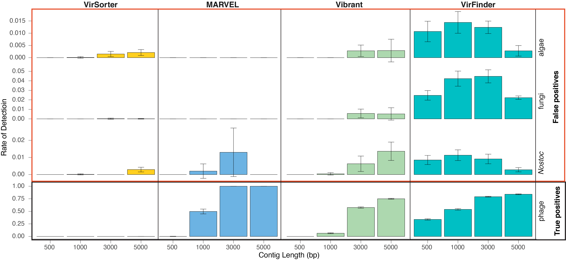

Figure S1: Performance comparison of MARVEL, Vibrant, VirFinder, and VirSorter on synthetic lichen mock communities. Error bars show the standard deviation of 10 independent replicates of the synthetic mock community. The top three rows represent the rate of false positives (i.e., algal, fungal, or Nostoc sequences that were falsely identified as being viral), whereas the bottom row demonstrates the rate of detection for true positives (i.e., phage sequences), as a function of contig length. Results of VirFinder were excluded due to the high false positive rate. Overall, false positive rates were less than 0.01 for the three ML tools used in this study.

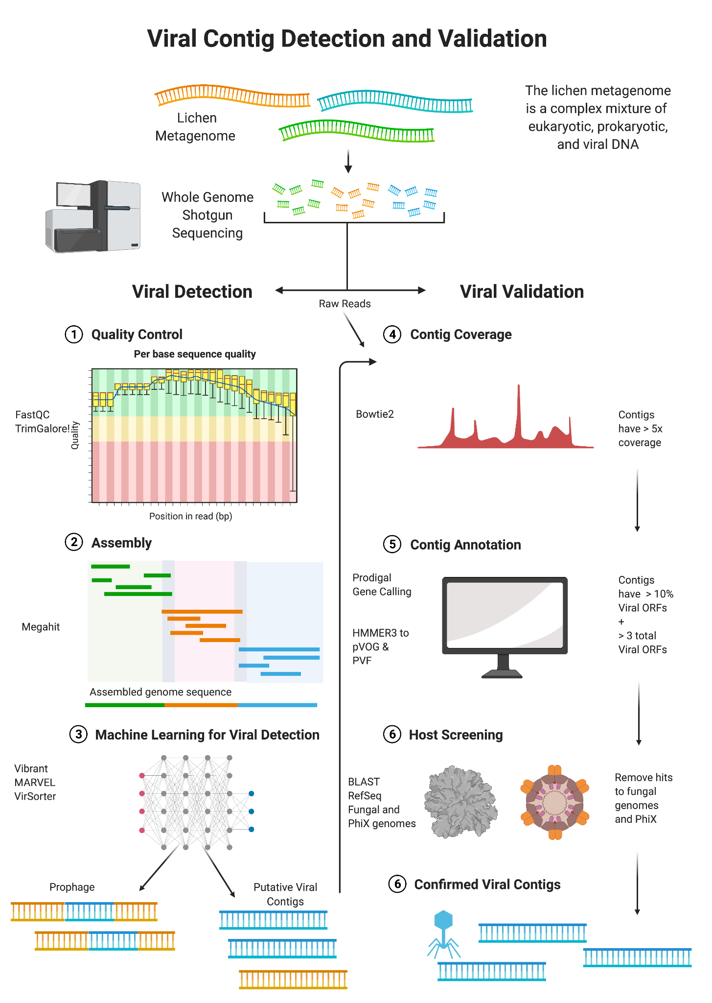
Figure S2: Analytical workflow for the retrieval of viral sequences from cyanolichen metagenomes.

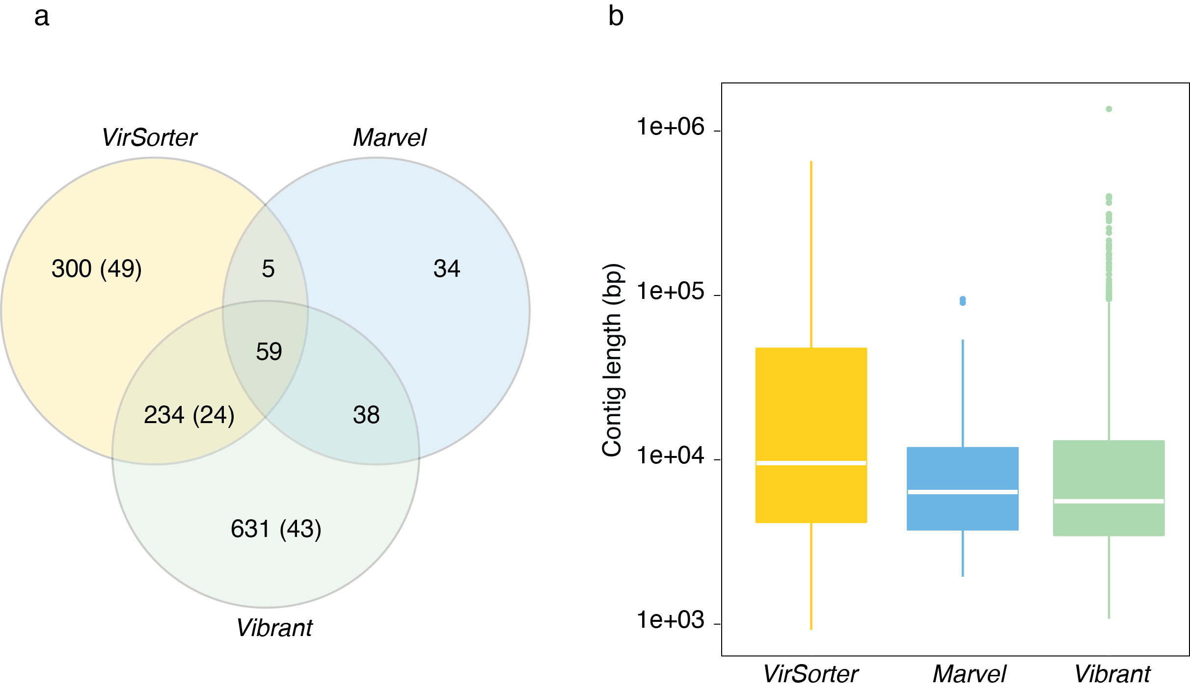Figure S3. Overlap and length distribution of 1,301 high-quality viral contigs identified with different ML viral detection methods. (a) Venn diagram of predicted viral contigs for three different machine-learning viral detection tools. Number of predicted prophages for VirSorter and Vibrant are shown in parentheses. (b) Box plot with median length and interquartile distribution of viral contigs by ML viral detection method.

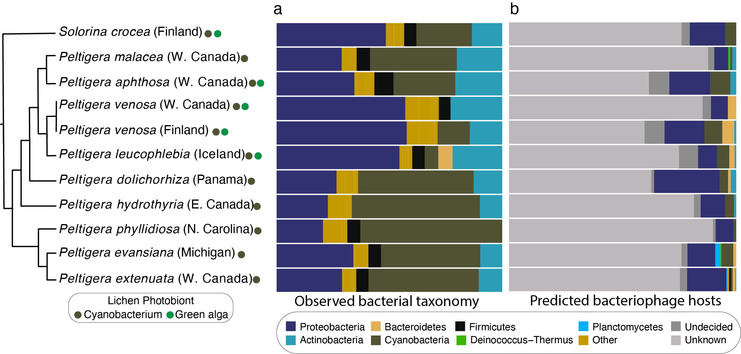
Figure S4. Congruence between bacterial taxonomy and predicted cyanolichen viral host range. (a) Phylum level taxonomy of bacterial sequences in cyanolichen metagenomes; and (b) viral host taxonomy as predicted with Demovir [40]. Phylogenetic tree follows Fig. 1.

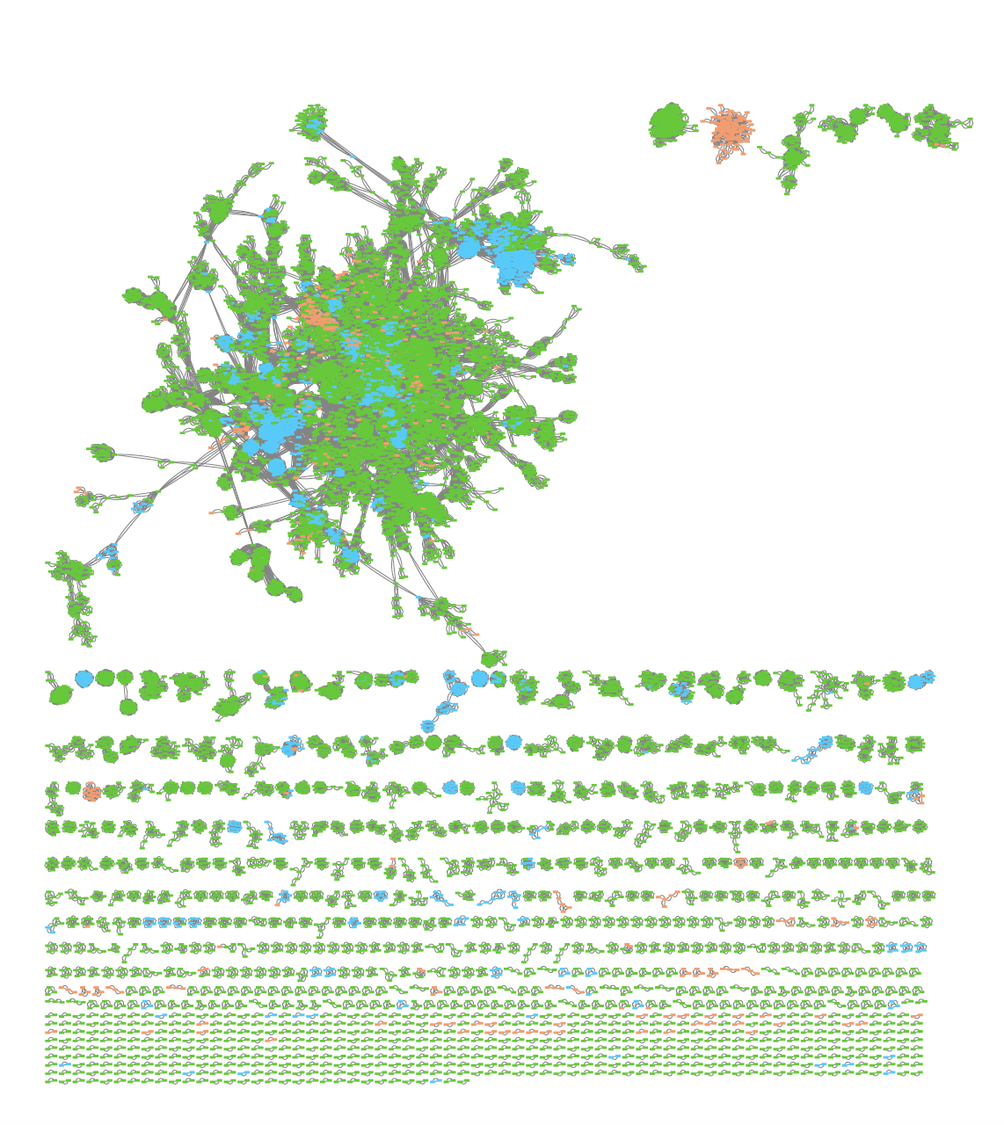
Figure S5: Network of viral contigs (VCs) illustrates uniqueness of cyanlichen VCs. To assess the novelty of cyanolichen viruses, we compared predicted cyanolichen viral contigs to >400,000 previously published viral contigs in IMG/VR from terrestrial ecosystems, as well as phage genomes in RefSeq. Colors indicate data source (orange: viral contigs from cyanolichen metagenomes; blue: RefSeq viral genomes; and green: viral contigs from IMG/VR representing other terrestrial habitats: soil, rhizoplane, rhizosphere, phyllosphere, and plant litter). The majority of cyanolichen viral contigs (n = 966 out of 1,301) did not form viral clusters (VCs) with non-lichen sequences and were classified as singletons or outlier VCs in network analysis. The remaining 335 cyanolichen viral contigs clustered into 133 VCs. Cyanolichen viral contigs had limited overlap to previously published sequences (i.e., only 28 VCs contained cyanolichen viral contigs and IMG/RefSeq sequences).

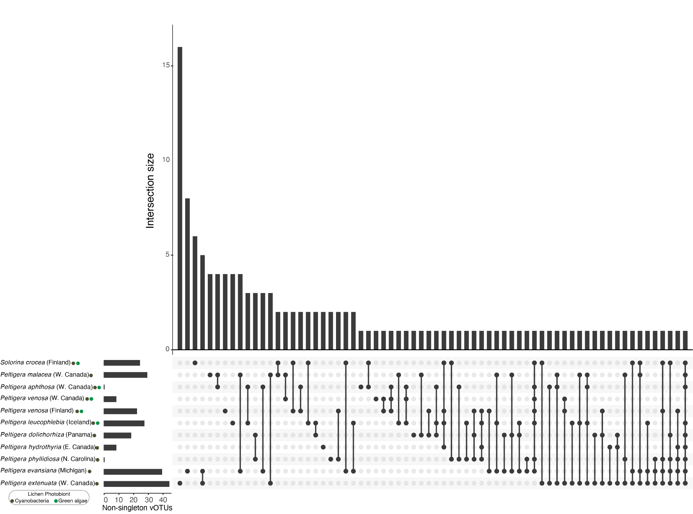
Figure S6: Cyanolichen metagenomes contain largely distinct viral clusters (VCs). UpSet Plot illustrates little overlap in 133 non-singleton VCs among 11 metagenome samples. Bi- and tri-membered lichen thalli shared 47 VCs (57 and 29 were unique to bi- or tri-membered thalli, respectively). No VCs were shared among all cyanolichen samples.

