Estimation of Vegetation Structure Parameters From SMAP Radar Intensity Observations

Thomas Jagdhuberª , Senior Member, IEEE, Carsten Montzka^{b}, Member, IEEE, Carlos Lopez-Martinez^{c}, Senior Member, IEEE, Martin J. Baur^{d}, Student Member, IEEE, Moritz Linkª, Marfa Piles^{e}, Senior Member, IEEE, Narendra Narayan Das^{f}, and Francois Jonard^{g}

ªMicrowaves and Radar Institute, German Aerospace Center, 82234 Wessling, Germany

^{b}Institute of Bio- and Geoscience, Research Center Julich, 52428 Julich, Germany

^{c}Universitat Polytecnica de Catalunya, Department of Signal Theory and Communications, 08034 Barcelona, Spain

^{d}Microwaves and Radar Institute, German Aerospace Center, 82234 Wessling, Germany, and also with the Center of Ecology and Environmental Research, University of Bayreuth, 95447 Bayreuth, Germany

^{e}Image Processing Lab, University of Valencia, 46980 Valencia, Spain

^{f}Jet Propulsion Laboratory, California Institute of Technology, Pasadena, CA 91109 91109 USA

^{g}Institute of Bio- and Geoscience, Research Center Julich, 52428 Julich, Germany, and also with Earth and Life Institute, Université catholique de Louvain, 1348 Louvain-la-Neuve, Belgium

KEYWORDS: Discrete scatterer, polarimetry, radar, scattering, Soil Moisture Active Passive (SMAP), vegetation model, vegetation structure

ABSTRACT
In this article, we present a multipolarimetric estimation approach for two model-based vegetation structure parameters (shape A _{P} and orientation distribution ψ of the main canopy elements). The approach is based on a reduced observation set of three incoherent (no phase information) polarimetric backscatter intensities (| S_{HH} |², | S_{HV} |², and | S_{VV} |²) combined with a two-parameter (A _{P} and ψ) discrete scatterer model of vegetation. The objective is to understand whether this confined set of observations contains enough information to estimate the two vegetation structure parameters from the L-band radar signals. In order to disentangle soil and vegetation scattering influences on these signals and ultimately perform a vegetation- only retrieval of vegetation shape A _{P} and orientation distribution ψ, we use the subpixel spatial heterogeneity expressed by the covariation of co- and cross-polarized backscatter Γ_{pp-Pq} of the neighboring cells and assume it is indicative for the amount of a vegetation-only co-to-cross-polarized backscatter ratio µ_{PP-PQ}. The ratio-based retrieval approach enables a relative (no absolute backscatter) estimation of the vegetation structure parameters which is more robust compared to retrievals with absolute terms. The application of the developed algorithm on global L-band Soil Moisture Active Passive (SMAP) radar data acquired from April to July 2015 indicates the potential and limitations of estimating these two parameters when no fully polarimetric data are available. A focus study on six different regions of interest, spanning land cover from barren land to tropical rainforest, shows a steady increase in orientation distribution toward randomly oriented volumes and a continuous decrease in shape arriving at dipoles for tropical vegetation. A comparison with independent data sets of vegetation height and above-ground biomass confirms this consistent and meaningful retrieval of A _{P} and ψ. The retrieved shapes and orientation distributions represent the main vegetation elements matching the literature results from model-based decompositions of fully polarimetric L-band data at the SMAP spatial resolution. Based on our findings, A _{P} and ψ can be directly applied for parameterizing the vegetation scattering component of model-based polarimetric decompositions. This should facilitate decomposition into ground and vegetation scattering components and improve the retrieval of soil parameters (moisture and roughness) under vegetation.

- Introduction
The advantage of radar signals at the L-band (typically at ~1.26 GHz) is that in most cases, major parts of the vegetation volume are penetrated and not just the top of the canopy as occurs at shorter wavelengths (e.g., C- and X-bands) [1]. The backscattering signal is a mixture of soil and vegetation contributions, which need to be disentangled according to the focus of the study. The vegetation component contains important information for the characterization of plant biophysical parameters, such as shape, size, orientation and distribution of plant elements, water content, plant height, leaf area index, above-ground biomass, or plant stress [2]-[5]. Both diurnal [6] and seasonal [7] timescales can be observed, making radar an important tool to assess the process feedbacks in the soil-vegetation-atmosphere system [8].
The main vegetation scattering methods consider vegetation as discrete dielectric scattering objects randomly located in space (see [9]). First, simple semiempirical models simulated vegetation as a water cloud whose droplets are held in place by the vegetative matter [10]. In these water cloud models, the backscattering coefficient was treated as a function of the target parameters soil moisture, vegetation water content (VWC), and plant height, where scattering and attenuation cross-section contributions of the signal path through the canopy were implemented. The canopy is regarded as a uniform layer of some specified height containing a random distribution of discrete scatterers, and only single scattering is accounted for [11]. Later, further parameters such as leaf size [12] and leaf area index [13] were introduced. Kweon and Oh [14] modified the water cloud model by implementing the average and standard deviation of leaf angle distribution for improved estimation of the backscattering coefficients with the angular effect of scattering particles in a vegetation canopy. However, the uniform random distribution of scatterers introduces inconsistencies during the vegetation parameter retrieval process mainly over forests. More advanced canopy scattering models such as the Michigan Microwave Canopy Scattering Model (MIMICS) were developed to better represent the transmission of energy through the multilayer scattering medium. MIMICS divides the canopy into three components, i.e., the crown, the trunk, and the underlying ground region [15]. Here, probability density functions (PDFs) of size, diameter, and orientation of these three canopy components are implemented. Typically, radar signals from vegetated surfaces comprise contributions of direct backscatter from the vegetation itself, backscatter from the soil that is attenuated by the canopy, and backscatter due to interactions between the vegetation and the underlying soil [16]. Therefore, polarimetric decomposition methods use, for instance, simple physics-based scattering models to separate total scattering from a target into its elementary scattering contributions [17]. Volume scattering from the canopy, surface scattering from a rough ground, and double-bounce scattering from the ground and stem are separated within the polarimetric covariance or coherency matrix. Cloude and Pottier [18] described target scattering by eigenvectors to trace the scattering mechanism and eigenvalues to characterize the intensity of each mechanism.
Scattering from vegetation canopies is a result of multiple scattering within the canopy and between the canopy and the ground [19]. Where early vegetation scattering studies focused on co-polarized backscatter (HH and VV; see [12]), the inclusion of cross-polarized backscatter (HV and VH), indicative of these multiple scattering events, provided improved retrieval of vegetation information such as leaf area index and biomass in many studies (see [20], [21]). Similar improvements were facilitated by implementing complex scattering mechanisms in the parameter retrieval. In addition to polarimetry, vegetation changes also impact the phase diversity [22], a research field currently not fully explored. Moreover, also synthetic aperture radar (SAR) tomography evolved during the last two decades toward three-dimensional (3-D) scattering response analysis for vegetation characterization or reconstruction by multibaseline interferometric SAR [23]-[26].
The problem of using advanced and more complex models to forward calculate radar backscatter is that a large number of parameters are needed. This data collection requirement may be attainable during intensive field campaigns, but it is too time consuming and expensive to be performed globally and regularly and for all types of vegetation covers [19].
Model inversion approaches to estimate those parameters typically make use of multiangular [27], multifrequency [28], multitemporal [29] observations, interferometry [30], [31], or a combination of multiple setups [32].
In this article, we develop a multipolarimetric estimation approach for vegetation structure parameters which is based on a reduced observation set of three incoherent (no phase information) polarimetric intensities, combined with a discrete scatterer model of vegetation. The research objective is to understand whether this confined set of information can be sufficient to estimate vegetation structure parameters (shape and orientation distribution of the main canopy elements). Hence, the requirement for this article is to develop a model-based approach to estimate two vegetation structure parameters with the limited observation set of three backscatter intensities (HH, VV, and HV). The developed approach is applied to NASA Soil Moisture Active Passive (SMAP) radar intensity observations, which were recorded in the period from April 13, 2015, to July 7, 2015.
First, we describe the characteristics of the SMAP data and its preprocessing (Section II). Second, the scattering mechanisms occurring in the vegetation canopy are explained (Section III-A) and a sensitivity experiment to identify the importance of the two main vegetation parameters (shape AP and orientation distribution y of the main canopy elements) for the prediction of volume scattering is introduced (Section III-B) and conducted (Section IV-A). An inverse retrieval approach for the mentioned vegetation parameters is developed in Sections III-C and III-D. An application of the proposed approach to SMAP active radar data is presented in Section IV-B and compared against independent data sets of vegetation height and biomass in Section IV-C. The results are discussed in Section V and conclusion is drawn in Section VI together with a short outlook to future research.
- Data
The SMAP mission of National Aeronautics and Space Agency (NASA) was launched in 2015 to acquire active and passive microwave measurements and produce global maps of soil moisture and freeze/thaw states in a 3-day cycle [41]. It was designed to record radiometer and SAR observations with a shared L-band (1.26 GHz for H and 1.29 GHz for V) horn antenna and a spinning mesh reflector [41], [47]. The data are acquired with a fixed incidence angle at 40° (off nadir) using a conical scan across a swath of 1000 km and at fixed local time (6 a.m.) [41]. The SAR instrument acquires backscatter (intensity and no phase) in HH and VV co-polarization and in one cross-polarization (HV or VH) with a relative radiometric accuracy of 0.5 dB and a noise equivalent sigma zero (NESZ) of -30 dB [42], [48], [49]. Due to the malfunction of the SAR instrument on July 7, 2015, only an 11-week period of global acquisitions—from April 13, 2015, to July 7, 2015—can be utilized for our analyses. Given this short acquisition period, we discard analyses of temporal dynamics due to limited statistical representativeness.
SMAP space-borne multipolarimetric SAR intensity observations (more specifically | S_{HH} |², | S_{VV} |², and | S_{HV} |², see Section III) are available on a global basis for the measurement period [41], [42]. The SAR data are processed on a nominal spatial resolution of 3 km (70% outer regions of swath) [47], [50] but resampled to 9-km posting [46]. A mask for deserts, water bodies, and urban areas was applied to filter out areas where the retrieval algorithm does not apply [43], [44]. Table i summarizes the SMAP radar data specifications. Further details are given in [42].
The 2005 MODiS MCD12Q1 international Geosphere-Biosphere Program (iGBP) collection 5 land cover product is used in Section IV to interpret the estimation results on model-based vegetation structure parameters (A_{P}, ψ) in terms of 17 land cover classes. it is a global product with 500-m spatial resolution and freely available from the U.S. Land Processed Distributed Active Archive Center (www.lpdaac.usgs.gov).
Independent data sets of vegetation height and above-ground biomass were selected for later comparison of the retrieved vegetation structure parameters (in Section IV-C). The vegetation height data are based on LiDAR measurements of the Geoscience Laser Altimeter System (GLAS) sensor on the iCESat platform combined with climatology and remote sensing of the optical bands [51]. The above-ground biomass estimates are derived from the ESA GlobBiomass project for the year 2010 by combining space-borne SAR, LiDAR, and optical observations together with auxiliary data sets from forest inventories, climatological variables, and ecosystems classifications [52]. Both data sets were regridded to match the SMAP radar data (9-km grid).

TABLE I - Specifications of Applied SMAP Radar Data for Input Into the Vegetation Parameter Estimation Algorithm [42], [47]-[49]
Specification | Global SMAP Level 2 radar data
Frequency | L-band
Polarizations | HH, W, HV (intensity, no phase)
Acquisition period | April 13,2015 to July 7, 2015
Temporal revisit | 2-3 days (depending on latitude)
Incidence angle | 40° (conical scan)
Spatial resolution | 9 km (re-gridded from 3 km)
Radiometric resolution | 0.5 dB
NESZ | -30 dB
Incidence angle | 40°

- Intensity-Based Vegetation Parameter Estimation Using a Discrete Scatterer Model
Predictions for vegetation volume backscattering are often conducted by discrete vegetation scattering models [5], [7]. Here, discrete scattering elements of the vegetation canopy, also called inclusions, are brought into a homogenous background medium, mostly air in case of naturally vegetated environments [33]-[35]. This allows backscatter simulations from a (homogenously) filled layer of discrete inclusions on the top of a single-scattering soil surface, like in [36].
The Sections III-A-III-D exemplify how radar intensity data (no phase information) can be used to retrieve vegetation properties by a model inversion approach. Section III-A serves as introduction into the discrete scattering model and the role of different vegetation parameters. Section III-B presents a sensitivity analysis of the simulated backscatter to the two main vegetation parameters this study is aiming to infer: shape and orientation of the vegetation inclusions. Section III-C details the retrieval methodology proposed to estimate both vegetation parameters from radar observations. Section III-D deals with the direct application of the approach to data from the SMAP mission.
  - Polarimetric Discrete Scatterer Model and the Role of the Vegetation Structure Parameters A _{P} and ψ
A coherent discrete scatterer model for a single-layer vegetation volume is presented in (1) using covariance matrix notation [C^{V}] [-]. it is derived and explained in detail in [37, Ch. 4.2.1.3] and is based on a vegetation model from Cloude [30]. This simplified discrete scatterer model, expressed with [C^{V}] in a single-channel form, simulates polarimetric vegetation scattering of a volume filled with evenly distributed and uniformly shaped spheroids within air as background medium. The model follows the single-scattering approximation and does not include multiple scattering effects. Among the wide suite of available vegetation models, it is selected due to its low parameterization (two variables) but sufficient flexibility to represent diverse vegetation scattering at longer wavelengths (L- and P-bands) neglecting multiple scattering terms occurring at shorter frequencies (C- and X-bands)
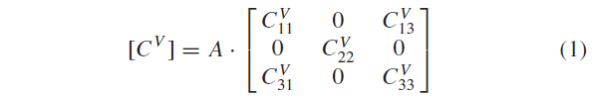
with
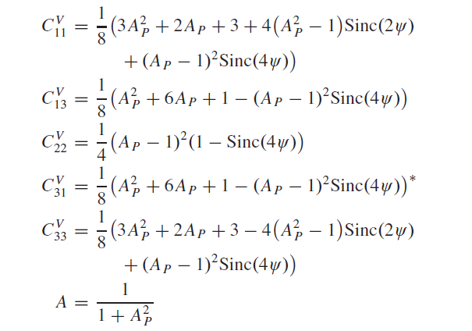
where Sinc (x) = Sin (x)/x and “*” symbolizes the conjugate operator. it considers different vegetation conditions expressed by the particle anisotropy A _{p} [-] for the predominant shape of the main plant elements and by the orientation distribution width ψ [rad] for different degrees of vegetation orientation from totally aligned to randomly oriented [38]. Fig. 1 provides a conceptual understanding of these two parameters for canonical vegetation structure cases [38]. A particle anisotropy of zero indicates vertically oriented dipoles, changing from vertical discs to spheres when increasing from 0 to 1. From one to infinity, the shape changes from spheres to horizontal disks, ultimately reaching the shape of horizontal dipoles. An orientation distribution width of zero indicates completely aligned and oriented vegetation, while an increase in ψ leads to randomization of the vegetation structure until a complete loss of orientation (complete randomization) for a distribution width of 90º.

Figure 1. Conceptual view on the vegetation structure parameters. (Top) Particle shape A _{p}. (Bottom) Orientation distribution width ψ [38].
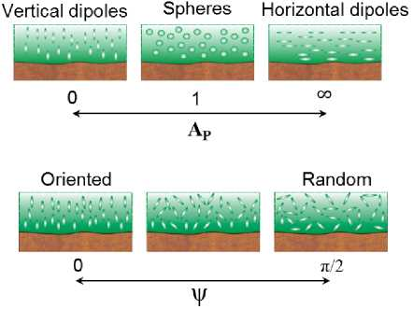
The distribution of different orientation angles is assumed to be uniform within ψ. Hence, the probability of occurrence for the individual orientation angles within y is equal.
In order to obtain a relative measure, which is easier to model and invert compared to absolute terms, the vegetation volume model in (1) can be normalized with the cross-polarized backscattering component | SPQ |² = (1/8)(A_{P} - 1)²(1 - Sinc(4ψ)) [half of C$\frac{V}{22}$ in (1)] leading to (2), as shown at the bottom of this page.
Hence, C$\frac{V11}{Norm}$and C$\frac{V33}{Norm}$ are the ratios of co-to-cross-polarization intensity and a function of the model-based vegetation structure parameters (A_{P}, ψ), as shown at the bottom of the next page in (3) and (4). Equations (3) and (4) can be applied as forward model formulas for co-to-crosspolarized backscatter ratios of vegetation or so-called µ$\frac{Model}{PP-PQ}$ parameters of the vegetation volume scattering model.
  - Design of Sensitivity Study for µ$\frac{Model}{PP-PQ}$-Parameters With Respect to A _{P} and ψ
To investigate the sensitivity of µ$\frac{Model}{PP-PQ}$ -parameters to the vegetation parameters (A _{p}, ψ), we design a forward modeling study. This leads to a deeper understanding of dependencies and to identify the best possible conditions for an observation based parameter inversion. We will show the behavior and trends of µ$\frac{Model}{PP-PQ}$ -with fixing either A _{p} or ψ and varying the respective other parameter. This is done for a splitted A _{p}-range of 0-1 and from 1 to 10⁸ due to different main orientations (either vertical or horizontal). The results of the sensitivity study are shown in Section IV-A.

  - Development of a Retrieval Methodology for Vegetation Parameters (A_{P}, ψ)
Simplified vegetation models, like the one in (1), are implemented as standard components in model-based polarimetric decompositions for longer wavelengths to account for the vegetation scattering contribution [17], [30], [39]. Equation (5) shows the covariance matrices for a standard model-based decomposition architecture for vegetated agricultural soils [17]. It includes a soil surface scattering term [C^{S}] [-], a vegetation volume scattering term [C^{V}] [-], and an interacting soil-vegetation double bounce scattering term [C^{D}] [-] [17], [39]
This means in particular for a single co-polarized [C]-matrix element | S_{PP} |² [-], the decomposition can be specified as follows [39]:
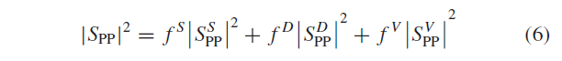
where the scattering matrix elements for the three polarimetric terms IS$\frac{S}{PP}$I², IS$\frac{D}{PP}$I², and IS$\frac{V}{PP}$I² are included with their respective lossy intensity components f^{S} [-], f^{D} [-], and f ^{V} [-].
In polarimetric decomposition theory for longer wavelengths such as L- and P-bands, it is assumed that vegetation volume scattering dominates the cross-polarized backscatter and the soil roughness contribution stays minor [17], [18], [30]. As IS_{PQ}I² [-] is indicative of volume scattering, co-polarized backscatter I S_{PP} I² [-] can be corrected for a vegetation contribution fV IS$\frac{V}{PP}$I² by using the cross-polarized component together with a co-to-cross polarized projection using the backscatter ratio µPP-PQ [-] [30], [37]
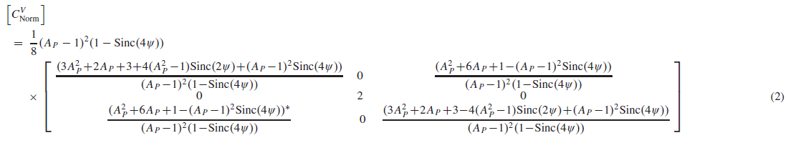

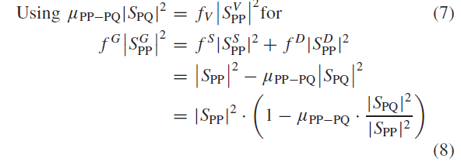
where f^{G} | S$\frac{G}{PP}$|² [-] is the vegetation-corrected ground scattering term. As proposed by Jagdhuber et al. [40], the co-to-cross-polarized backscatter ratio µ_{PP—Pq} will be linked to x_{PP—Pq} [dB/dB] from (9) to (11). X_{PP—Pq} is a ground backscatter-corrected (vegetation-only) co-to-cross-polarized backscatter ratio using the following assumption:
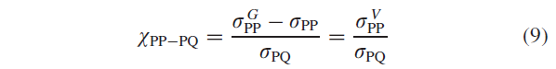
where the backscatter of the vegetation (no ground contribution) σ$\frac{V}{PP}$ [dB] is defined as σ$\frac{V}{PP}$= 10log₁₀ (1 — µ_{PP—Pq} • (|S_{PQ}|²)/(|S_{PP}|²)) and σ$\frac{G}{PP }$is (8) transformed in decibel notation. In addition, σ_{PQ} [dB] is the cross-polarized backscatter coefficients. After rearranging (9) and algebraic modification, X_{PP—P}q and µ _{PP—P}q are directly linked by
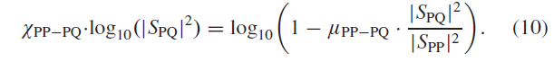
Solving for µ_{PP—Pq} leads to (11), which provides a direct retrieval of a vegetation-only co-to-cross-polarized backscatter ratio in linear units, if X_{PP—PQ} is known [40]:
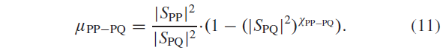
In an application case, (9)-(11) can be used to retrieve µ_{PP—Pq} from remote sensing data. Subsequently, the theoretical connection between µ_{PP—Pq} and the vegetation structure parameters A p and ψ can be used for direct inversion of these parameters. During the inversion process, the predicted µ$\frac{Model}{PP-PQ}$ and observed µ$\frac{Data}{PP-PQ}$ have to be compared and a minimization procedure must be established. However, µ$\frac{Model}{HH-HV}$and µ$\frac{Model}{VV-HV}$are unfortunately ambiguous with respect to particle anisotropy A _{P} (A _{p} =[0, 1] for vertical shapes and A _{p} = [1, ∞] for horizontal shapes), having a symmetry of both modeled µ$\frac{Model}{PP-PQ}$ -values around A _{P} = 1 (isotropic spherical shapes). This is shown in more detail by the results of the sensitivity analysis in Section IV-A.
With this ambiguity of µ$\frac{Model}{PP-PQ}$regarding symmetry of A _{P} , the most suitable parameter estimation procedure is a two- step approach. First, the vegetation orientation (ψ) retrieval is done for a fixed particle anisotropy of vertical (A_{P} = 0) and horizontal (A_{P} = 10 000) dipoles for both polarization combinations (HH–HV and VV–HV):
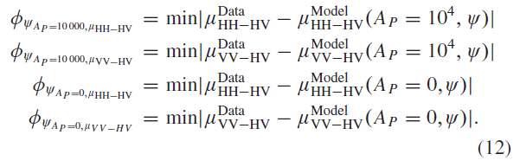
This ensures to include both major vegetation orientations (vertical and horizontal) in the retrieval.
In (12), the two solutions of ψ (ψ A _{P}, µ_{HH—HV}, ψ A _{P}, µ_{VV—HV}) for the respective particle anisotropy (vegetation shape) (A _{P} = 10 000 and A _{P} = 0) have a split validity range around the µ_{PP—PQ} -value of 3.0 due to the physics-given A _{P} -ambiguity of the retrieval (see Fig. 2(a) and [30]). Therefore, the following validity ranges are applied to generate the final two ψ -retrieval results (ψ A _{P}=0 and ψ A _{P}=10000) for vertical and horizontal dipoles.
In case of vertical dipoles (A _{P} = 0), this leads to the combined ψ A _{P} =0-product:
In case of horizontal dipoles (A _{P} = 10 000), this leads to the combined ψ A _{P} =10 000-product:
Consistently from both analysis, two results are produced: ψ A _{P}=10000 and ψ A _{P} =0.
The two data-derived co-to-cross polarized backscatter ratios (µ$\frac{Data}{HH-HV}$, µ$\frac{Data}{VV-HV}$) are used in the second retrieval step to estimate the two A _{P} -products ( A$\frac{HH-HV}{P}$and A$\frac{VV-HV}{P}$), applying the assumption of a fixed ψ of 90° (random volume) to ensure the same model sensitivities to both polarization combinations (see Section IV-A) and at the same time confining the retrievable information only to the shape of the particles. No assessment on orientation of their major axes (i.e., vertical or horizontal dipoles) is possible anymore when ψ is fixed to 90° [see Fig. 2(b)]:
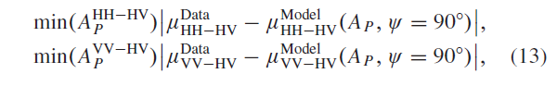
Two sets of ψ- (ψ A _{P}=10000, ψ A _{P}=0) and A _{P} -values (A$\frac{HH-HV}{P}$and A$\frac{VV-HV}{P}$) are obtained with the proposed retrieval. The two are thoroughly analyzed and compared with independent sources of vegetation height and biomass in Section IV-C.

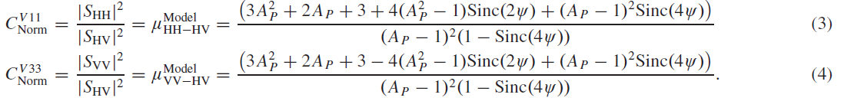

Figure 2. Modeled vegetation-only co-to-cross-polarized backscatter ratio µ$\frac{Model}{PP-PQ}$ [-] for different assumptions concerning vegetation shape (A p) or orientation distribution (ψ). (a) µ$\frac{Model}{PP-PQ}$ [-] for vertical (A p = 0) and horizontal (A p = 10 000) shapes along orientation distribution width ψ from absolutely oriented (ψ = 0°) to randomly oriented (ψ = 90°). (b) µ$\frac{Model}{PP-PQ}$[-] for strongly oriented (ψ = 10°), half-randomly (ψ = 45°) until totally randomly oriented ψ = 90°) vegetation along vegetation shape A p from vertical dipoles (A p = 0) until spheres (A p = 1). (c) µ$\frac{Model}{PP-PQ}$ [-] for strongly oriented (ψ = 10°), half-randomly (ψ = 45°) until totally randomly oriented (ψ = 90°) vegetation along vegetation shape A p from spheres (A p = 1) toward horizontal dipoles (A p = 5.0 x 10⁸).
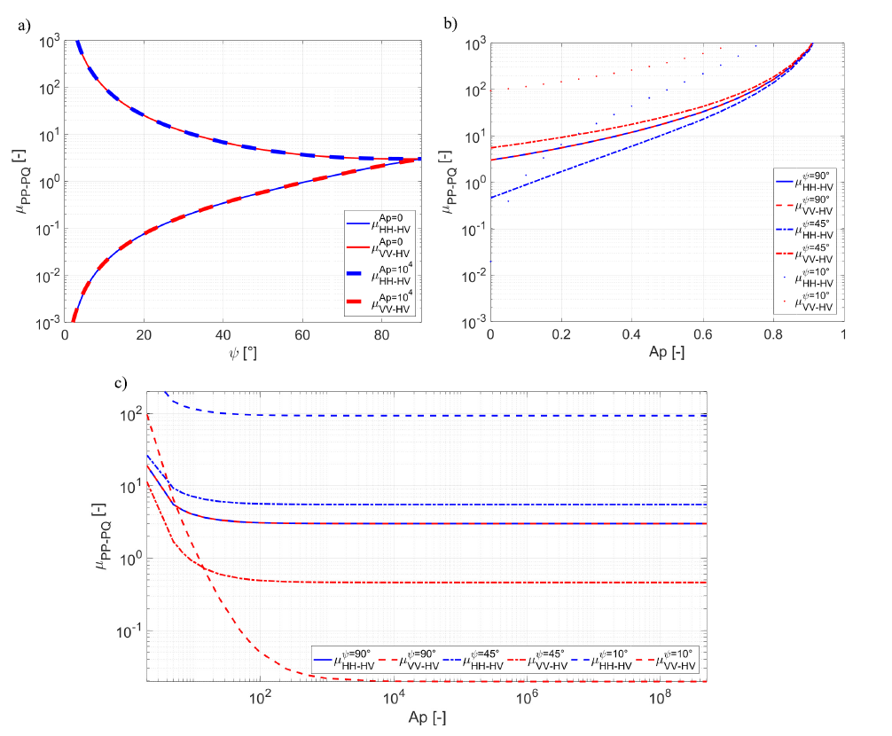
  - Adaption of Methodology for Application to Space-Borne SMAP Data
The methodology for vegetation parameter estimation developed in Section III is applied to global level-3 SMAP SAR data at the L-band with fixed 40° incidence angle. It is important to note that only radar intensity (| S_{HH} |², | S_{HV} |², and| S_{VV} |²) data and not fully polarimetric complex-valued measurements are provided from the active SMAP instrument. This is a challenging scenario, since phase information of the recorded microwaves would facilitate the retrieval.
The preprocessed and filtered SMAp data set is used to determine the data-based co-to-cross-polarized backscatter ratios (µ$\frac{Data}{HH-HV}$, µ$\frac{Data}{VV-HV}$)• It is important to mention that in the special case of SMAP, xp_{p-pq} in (11) is assumed equivalent to Γ_{pp-Pq} in the SMAP baseline algorithm developed by [45], [53]. Here, Γ_{pp-Pq} is calculated as the 9-km (medium scale) subpixel heterogeneity between co- and cross-polarization ∂ σ_{PP} and ∂ σ_{PQ} within one coarse-scale resolution cell (36 km) [46]. This leads to the following equation:
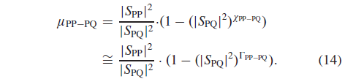
Hence, the subpixel spatial heterogeneity, expressed by the covariation of co- and cross-polarized backscatter Γ_{pp-Pq} in the coarse-scale cell, is taken to be indicative for the amount of vegetation-only co-to-cross-polarized backscatter ratio µ_{pp-Pq}. Behind is the assumption that local spatial heterogeneity, expressed by Γ_{pp-Pq}, for one time instant is dominated by vegetation [40], [45], [49], [53]-[55].
- Results of Vegetation Parameter Retrieval Using SMAP Data
The results of the sensitivity analysis, the application to SMAP data, and the comparison of the retrieved vegetation structure parameters with independent data sets of vegetation height and above-ground biomass are presented in the following.
  - Sensitivity Analysis of µ$\frac{Model}{PP-PQ}$ Parameters With Respect to Vegetation Structure Parameters A _{P} and ψ
It is important to understand from Fig. 2(a) that the dependencies of µ$\frac{Model}{HH-HV}$and µ$\frac{Model}{VV-HV}$on the orientation angle distribution width y are equivalent, when either vertical (A _{p} = 0) or horizontal (A p = 10 000) dipoles are assumed as particle shapes.
Note if particle shapes closer to spheres (A _{p} → 1) are assumed, the congruent course of the two µ$\frac{Model}{PP-PQ}$-curves in Fig. 2(a) would not be given and the dependencies would significantly differ (not shown). This is why assuming dipoles as particle shape of the vegetation volume is crucial: the identical µ$\frac{Model}{PP-PQ}$--trend for both dipole types enables a retrieval of the orientation distribution width ψ using only one µ_{PP-PQ}- value. The value of the respective µ$\frac{Model}{PP-PQ}$-informs on whether the main shape of the plant element has a horizontally (µ$\frac{Model}{PP-PQ}$- = [0, 3]) or vertically (µ$\frac{Model}{PP-PQ}$- = [3, ∞) oriented major axis [see Fig. 2(a)].
The dependence of µ$\frac{Model}{PP-PQ}$-on the shape of the main plant element A _{p} is depicted in Fig. 2(b) for three vegetation volume orientations (ψ = [10°, 45°, 90°]). If a randomly oriented volume (ψ = 90°) is assumed, then µ$\frac{Model}{HH-HV}$- and µ$\frac{Model}{VV-HV}$-_{v} have the same dependencies within an A _{p}-range from 0 (vertically oriented dipoles) to 1 (spheres) or from one to infinity (horizontally oriented dipoles). The more the vegetation volume is oriented (ψ = 10°), the more the curves of µ$\frac{Model}{HH-HV}$- and µ$\frac{Model}{VV-HV}$differ within the A _{p}-range of 0-1 due to different interaction of the polarized EM-waves with oriented (anisotropically scattering) vegetation. This is especially pronounced for low A p-values. For A _{p} around 1 (spheres), µ$\frac{Model}{PP-PQ}$-values rise toward infinity.
Hence, for the A _{p}-range from one (spheres) toward positive infinity (horizontal dipoles), the µ$\frac{Model}{PP-PQ}$-values monotonically decrease, as depicted in Fig. 2(c). The sensitivity of µ$\frac{Model}{PP-PQ}$for A _{p} is lost at A _{p} -values around 1000 and therefore, an A _{p}- value of 10 000 is already representative for horizontal dipole. However, this advocates A _{p}-retrievals to be conducted within the range of 0 (vertical dipoles) to 1 (spheres) due to the higher sensitivity of µ$\frac{Model}{PP-PQ}$.
  - Estimation of Vegetation Structure Parameters From Global SMAP Radar Data
In this section, the developed method is applied on SMAP radar data for global analysis and for detailed regional analysis of vegetation structure parameters. The initial (nonvegetation filtered) input radar backscatter intensities [dB] are shown in Fig. 3 averaged over the SMAP active-passive acquisition period (April to July 2015).

Figure 3. Global comparison of measured, time-averaged SMAP backscatter intensities [dB]. (a) |S_{HH} |² . (b)| S_{VV} |² .(c) | S_{HV} |² . Averaging was done over the SMAP active-passive acquisition period (April to July 2015); inset shows histogram of respective backscatter intensity.

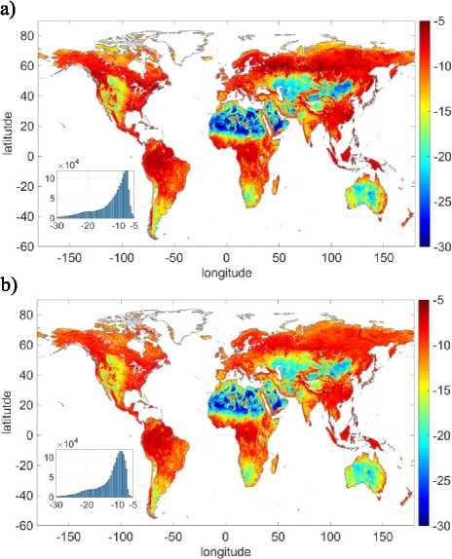

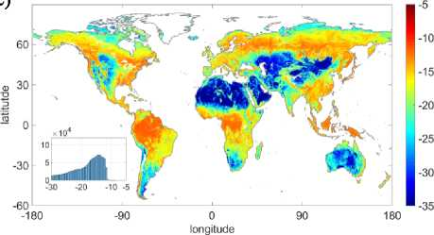
They serve as basis for the subsequent estimation of vegetation structure parameters. The backscatter variations follow mainly the global land cover patterns from the tropical to the boreal and Tundra zones with low backscatter especially in arid and hyper-arid (deserted) regions. The co-polarized backscatter intensities (HH, VV) indicate distribution maxima around -10 dB, while the crosspolarized intensity (HV) has typically a lower distribution maximum around -15 dB (see the inset histograms in Fig. 3).
Global Analysis of Retrieved Vegetation Structure Parameters: The developed vegetation parameter estimation method of Section III is applied to the space-borne SMAP data introduced in Section II. Both vegetation-only co-to-crosspolarized backscatter ratios µ$\frac{Data}{HH-HV}$ and µ$\frac{Data}{VV-HV}$ are displayed in Fig. 4(a) and (b), together with the illustration of their differences in Fig. 4(c) and (d). Fig. 4(d) reveals a difference for the two polarization combinations with µ$\frac{Data}{VV-HV}$having the lower maximum of both µ ^{Data}-parameters.
The most significant absolute difference | Δ µ |, shown in Fig. 4(c), occurs in semiarid areas (e.g., in the Sahel zone, Australia, and Tundra regions), where small-scale spatial heterogeneity is distinct. In contrast, the highest similarity of both µ ^{Data} -parameters is at the tropical and subtropical regions, where the structure is complex but spatially more homogeneous. Thus, both polarimetric retrievals lead to similar results.
Using the methodology presented in Section III leads to the model-based vegetation structure parameters: orientation distribution width (ψ) and particle anisotropy (A _{P}). Since the algorithm is executed as a two-step process, the orientation distribution width ψ with predefined A _{P}-values (vertical dipoles: A _{P} = 0 and horizontal dipoles: A _{P} = 10 000) are presented first and afterwards the particle anisotropy A _{P} with a fixed ψ-value of 90°. Fig. 5 shows the global comparison of the estimated vegetation orientation distribution width ψ averaged for the SMAP active-passive acquisition period (April to July 2015), while nonvegetated areas are masked out.
Fig. 5(a) and (b) shows the comparison of the global ψ- estimation for vertical and horizontal dipoles, both fixed inputs representing the shape of the main plant element. For randomly oriented volumes (tropical rainforest, temperate, and boreal forest zones), both ψ -products indicate high values above 80°. Lower ψ values (40° < ψ < 80°) are found within the global savanna and grassland zones. The lowest values (ψ < 40°) are present close to arid (Sahara) and barren (Himalayas) regions.
In addition, Fig. 5(c) reveals the absolute difference |Δ ψ| between the two ψ-estimates. Small differences between ψ A _{P}=0 and ψ A _{P} =10000 are found in highly vegetated areas of the tropical vegetation belt where the complexity of the canopy cover leads to a random orientation in the model-based ψ -estimation.

Figure 4. Global comparison of retrieved, time-averaged vegetation-only co-to-cross-polarized backscatter ratio µ_{PP-PQ} [-]. (a) µ$\frac{Data}{HH-HV}$. (b) µ$\frac{Data}{VV-HV}$. (c) Absolute difference of both: | Δµ | = |µ $\frac{Data}{VV-HV}$— µ$\frac{Data}{HH-HV}$I.
(d) Histogram of µ_{VV—HV} and µ_{HH—HV}. Averaging was done over the SMAP active-passive acquisition period (April to July 2015) and blank land masses are masked nonvegetated areas [see Fig. 4(a)-(c)] or invalid retrievals.

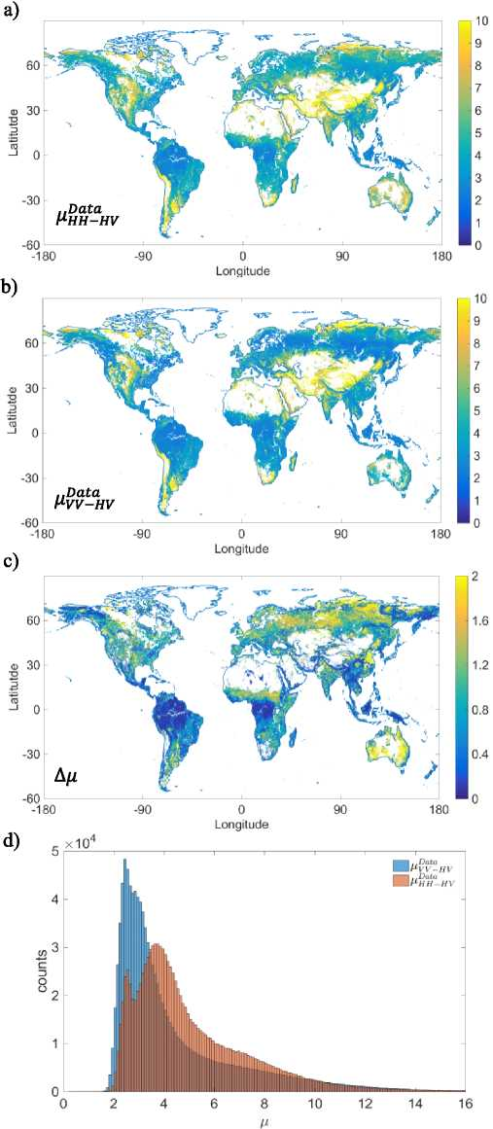
Thus, the shape of the constituting particles is not an influential factor any more. This is different for the boreal and agricultural zones. Here, the reduced complexity in vegetation structure (open forest) and the stronger orientation of crops (stalk- or leave-dominated plant structures) lead to significant differences between ψ A _{P} =0 and ψ A _{P} =10000. However, the majority of |Δψ|-values stays below 15° (1/6 of value range), which indicates a certain degree of similarity. The histograms for both ψ -products in Fig. 5(d) expose similar patterns for the two retrievals and bimodal distributions with local maxima between 35° and 65° as well as between 80° and 90°. There exist no values lower than 10° and only few below 20°. This means absolutely aligned vegetation structures, occurring most likely in agricultural areas, could not be detected, which might be due to the coarse grid of the SMAP radar sensor (9 km, aggregated from 3 km) with respect to the appearance and extent of strongly aligned vegetation within a kilometer-wide resolution cell.
Fig. 6 displays double (red: ψ A _{P}=0 and blue: ψ A _{P}=10000) box plots for the different IGBP-based land cover classes (excluding urban, snow-covered, and barren regions). Forests are located on a high level of ψ between 60° and 90°, while crop-, wet-, and grassland as well as open shrubs remain on a lower level predominantly between 30° and 60°. Closed shrubs, (woody) savanna, and other natural vegetation exhibit intermediate levels of y with 50° and 80°. Looking more closely to the difference between ψ A _{P}=0 and ψ A _{P}=10000 reveals that especially the evergreen and deciduous needleleaf forests as well as closed shrub land have distinctively different distribution width, when assuming different initial particle shapes. Hence, assumed vertical shapes (A _{P} = 0) lead to stronger estimated orientation, meaning smaller distribution width ψ.
Moreover, the box plots for ψ A _{P} =₁₀₀₀₀ (horizontal dipoles) unveil for woody savanna and closed shrub lands a wide range of p from 50º to 85º for the interquartile period. This might be due to the variety of vegetation structure cases allocated to these land cover classes.
The particle anisotropy A _{P} was retrieved globally assuming a fixed ψ-value of 90º and is shown in Fig. 7 for the two polarization combinations (HH - HV and VV - HV).The range of possible values stretches from 0, which indicates dipoles, via disks to spheres for an A p -value of 1. Fig. 7(a) and (b) reveals that most of the values are close to zero and none exceeds 0.6 (disks).
More in detail, dipole-representing values are dominant and can be found in the tropical, temperate, and boreal forest regions. In contrast, higher values (A _{p} > 0.3) can be found close to mountainous and tundra regions, whereby (semi-) arid regions do not necessarily exhibit the highest values (see Australia). The distribution of values for A$\frac{HH-HV}{P}$ and A$\frac{ VV-HV}{P}$in Fig. 7(d) support these observations and indicate the same range of values for both retrievals having just a different distribution from 0.01 until 0.35. The difference in both retrievals Δ A _{P} is visualized in Fig. 7(c), where the strongest deviations occur for savanna, crop- and shrublands as well as for evergreen and deciduous needle leaf forests mainly in higher Northern latitudes.

Figure 5. Global comparison of time-averaged vegetation orientation distribution width (ψ) [º]. (a) Taking vertical dipoles (A _{P} = 0)ψ A _{P} =0. (b) Taking horizontal dipoles (A _{P} = 10000)ψ A _{P} =₁₀000. (c) Difference of both: | Δψ| = |ψ A _{P} =o - ψ A _{P} =10000|. Histogram of ψ A _{P} =o and ψ A _{P} =10000. Averaging was done over the SMAP active-passive acquisition period (April to July 2015) and blank land masses are masked nonvegetated areas (see Fig. 4) or invalid retrievals.

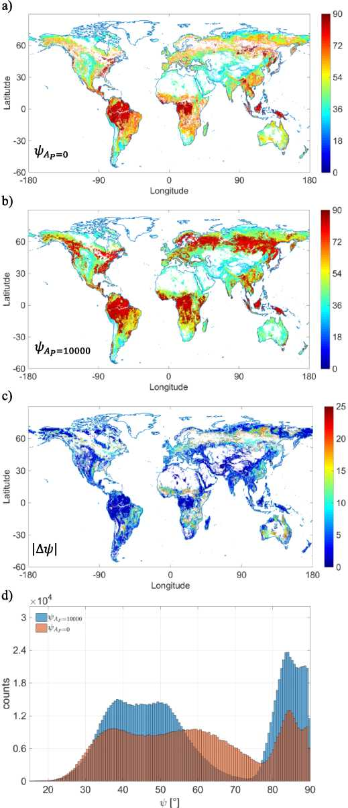
Figure 6. Box plots of retrieved time-averaged vegetation orientation distribution width (ψ) [º] where red color indicates the assumption of vertical dipoles ( A p = 0) and blue color the assumption of horizontal dipoles ( A p = 10 000); box plots are displayed for different IGBP-based land cover classes (excluding urban, cold, and barren regions). The red horizontal line within each box indicates the median value. The box represents the interquartile region (25%-75%) and the whiskers show the extent to the minimum and maximum value of ψ.
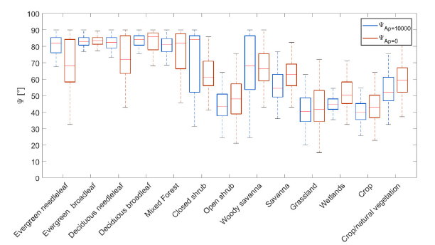
Fig. 8 presents double (red: A$\frac{VV-HV}{P}$ and blue: A$\frac{HH-HV}{P}$) box plots for different IGBP-based land cover classes (excluding urban, cold, and barren regions). For forested areas, closed shrub regions, and woody savannas with distinct vegetation cover (60% and higher), A p -values with a median below 0.1 (dipole type of shape) are predominantly encountered. In addition, open shrub, crops, grass-, and wetlands show the median values around 0.2 (more disk-like shape). A p -values above 0.3 occur only sparsely indicating the absence of sphere-like scattering. Moreover, the retrieval difference between A$\frac{VV-HV}{P}$ and A$\frac{HH-HV}{P}$is mostly above 0.05 except for evergreen as well as deciduous broadleaf forest and grassland, where directionalities within the vegetation structure do not lead to polarization-induced differences within the A _{P} -retrieval.
Figure 7. Global comparison of retrieved time-averaged vegetation shape (particle anisotropy) A_{P} [-] assuming a randomly oriented canopy (ψ = 90°). (a) A$\frac{HH-HV}{P}$from µ_{HH—HV}. (b) A$\frac{VV-HV }{P}$from µ_{VV—HV}. (c) Difference of both: Δ A_{P} = | A$\frac{VV-HV }{P}$- A$\frac{HH-HV}{P}$ |. (d) Histogram of A$\frac{VV-HV }{P}$and A$\frac{HH-HV}{P}$. Averaging was done over the SMAP active-passive acquisition period (April to July 2015) and blank land masses are masked nonvegetated areas (see Fig. 4) or invalid retrievals.

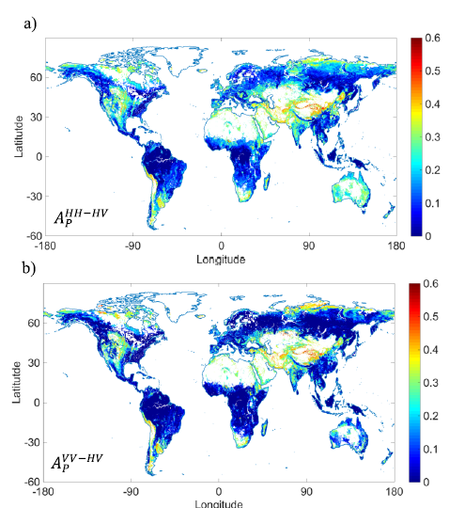
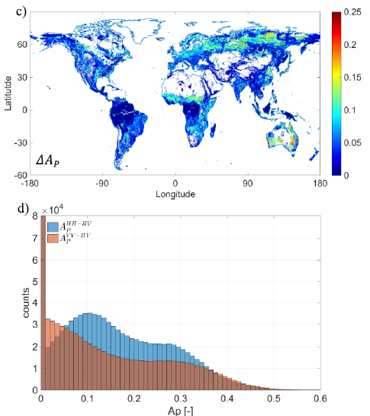

Figure 8. Box plots of retrieved time-averaged vegetation shape (particle anisotropy) (AP) [-] where red color indicates the derivation from p._{VV-HV} and blue color the derivation from p._{HH-HV}. Box plots are displayed for different IGBP-based land cover classes (excluding urban, cold, and barren regions). The red horizontal line within each box indicates the median value. The box represents the interquartile region (25%-75%) and the whiskers show the extent to the minimum and maximum value of A_{P}.
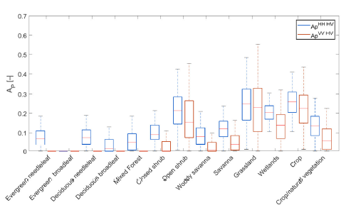

Analysis of Retrieved Vegetation Structure Parameters for Different Regions of Interest: In order to gain detailed insights on the dependencies between vegetation conditions and the retrieved model-based vegetation structure parameters A _{P} and ψ, six regions of interest with spatially homogenous land cover were selected [see Fig. 9(a)]. The exemplary regions feature different regimes for vegetation cover and plant moisture, as indicated by radar vegetation index (RVI) in Fig. 9(b) [56], [57] and VWC [kg/m²] in Fig. 9(c) which was provided from SMAP-mission auxiliary data of [42]. The conditions stretch from high cover (RVI ~ 1.0) and moisture (VWC > 9 kg/m²) within tropical rainforest of the Congo basin to no cover (RVI ~ 0.2) and no moisture (VWC < 0.1 kg/m²) within the Sahara and the Arabian Desert. In the analysis, savanna and grassland regions serve as reference with equivalent environmental conditions (RVI ~ 0.3 and VWC~0.2 kg/m²), where only little deviations between retrieved vegetation structure parameters are anticipated.
Fig. 10 displays the box plots of the retrieve results for the time-averaged shape A _{P} and vegetation orientation distribution width ψ of the vegetation from the six regions of interest. The most significant difference for both parameters occurs between the regions of forest-size vegetation cover (tropical rainforest and woody savanna) and the agriculture-size vegetated areas (agriculture, savanna, grassland, and barren). In Fig. 10(a), A _{P} stays below 0.2 for the forest-size vegetation and ranges mainly between 0.2 and 0.4 for agriculture-size plants. In addition, retrieved ψ-values in Fig. 10(b) vary between 50° and 90° for taller (forest) vegetation due to complex canopy structures and between 20° and 50° for agricultural types revealing more oriented and less random vegetation structures.
The difference between the two results of A _{P} and ψ, given for each respective class due to polarization for A _{P} and shape assumption for ψ, is only minor (equivalent median values in Fig. 10), except for the woody savanna region in Africa and the agricultural region in Europe. Moreover, the two control classes savanna and grassland state stable retrieval conditions by showing the same average estimation result (similar median for both retrievals), but grassland exhibits a wider variation for the interquartile area and for the outliers compared to the savanna class. Moreover, the barren class shows the highest A _{P} -value (around 0.4) and the lowest ψ-value (around 30°).

  - Comparison of Retrieved Vegetation Structure Parameters With Vegetation Height and Above-Ground Biomass Data Sets
A direct validation with in situ data for vegetation shape and main orientation (A _{P} and ψ) is intricate due to unavailability of appropriate measurements representing these model-based parameter estimates and due to the scale gap between in situ measurements (meter scale) of monitoring networks and remote sensing estimates (kilometer scale).
Hence, instead of validation with in situ measurements, which might be more or less of different type and, therefore, rather not comparable, an alternative strategy is suggested by globally comparing A _{P} and ψ-estimates with independent remote-sensing-based products of above-ground biomass and vegetation height. Both independently retrieved products are explained in detail in [51] and [52].

Figure 9. (a) Global overview of the IGBP-based regions of interest for analysis of the developed vegetation parameter retrieval. Blue: tropical rain forest (Africa), light green: woody savanna (Africa), red: agriculture (Europe), green: savanna (South America), orange: grassland (Asia), and dark red: barren land (Africa). (b) Vegetation cover indicated by the time-averaged RVI [-] calculated according to [56] and [57]. (c) Plant moisture described by time-averaged VWC [kg/m²] provided in [42]. The red horizontal line within each box indicates the median value. The box represents the interquartile region (25%-75%) and the whiskers show the extent to the minimum and maximum value of RVI [-] and VWC [kg/m²], respectively.
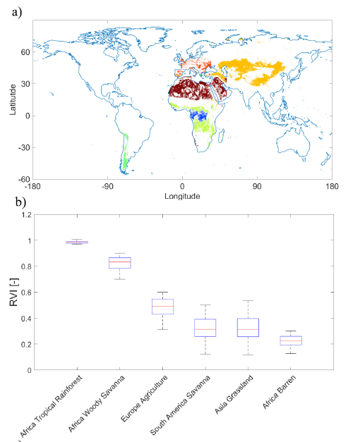
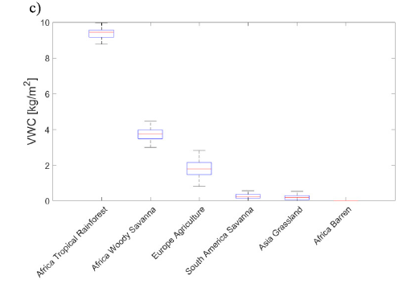

Figure 10. (a) Box plots of retrieved time-averaged vegetation shape (particle anisotropy) A _{P} [-] and (b) vegetation orientation distribution width ψ [° ] for selected target areas: tropical rain forest (Africa), light green: woody savanna (Africa), red: agriculture (Europe), green: savanna (South America), orange: grassland (Asia), and dark red: barren land (Africa). The red horizontal line within each box indicates the median value. The box represents the interquartile region (25%-75%) and the whiskers show the extent to the minimum and maximum value of A _{P} and ψ, respectively.
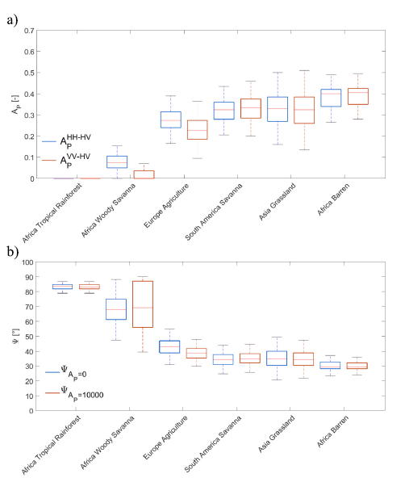
It is anticipated that with increasing biomass and height of vegetation, the orientation distribution proceeds toward 90° indicating a random distribution of the vegetation elements due to increase in complexity of vegetation structure. Fig. 11 confirms this anticipated trend for both vegetation parameters (biomass and height). Beyond 150 Mg/ha and 30-m height, the estimated vegetation orientation distribution ranges between 80° and 90° which indicates a large variety of plant element orientations in the vegetation canopy structure. Both ψ- estimates (A _{P} = 0 and A _{P} = 10 000) follow similar trends along vegetation biomass and height but with differing intraclass variance especially for medium-to- low vegetation cover. It is interesting that the lowest class (05 m) of vegetation height seems to be significantly biased by ground scattering influences (spatial heterogeneity and vertical heterogeneity of the canopy) and shows higher values of y than following (larger) vegetation height classes. This might be partly explained by the space-borne LiDAR-based derivation methodology of the vegetation height data set explained in [51].

Figure 11. Box plots of retrieved time-averaged vegetation orientation distribution width (ψ) [°] where red color indicates the assumption of vertical dipoles (A _{P} = 0) and blue color the assumption of horizontal dipoles (A _{P} = 10 000). (a) Box plots are displayed for different levels of above-ground biomass [Mg/ha] [52] and (b) vegetation height [m] [51]. The red horizontal line within each box indicates the median value. The box represents the interquartile region (25%-75%) and the whiskers show the extent to the minimum and maximum value of ψ.
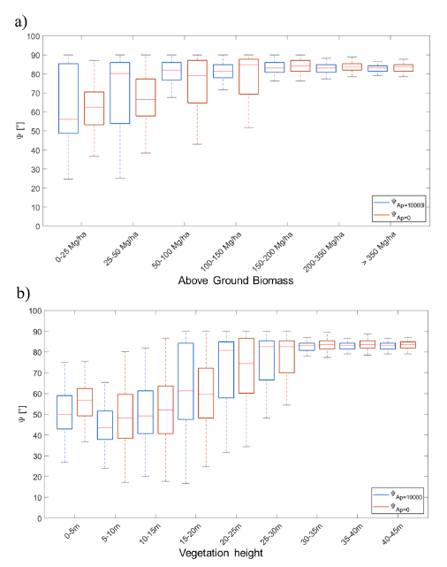

Figure 12. Box plots of retrieved time-averaged vegetation shape (particle anisotropy) (A _{P}) [-] where red color indicates the derivation from µ_{VV—HV} and blue color the derivation from µ_{HH—HV}. (a) Box plots are displayed for different levels of above-ground biomass [Mg/ha] (a) and (b) vegetation height [m]. The red horizontal line within each box indicates the median value. The box represents the interquartile region (25%-75%) and the whiskers show the extent to the minimum and maximum value of A _{P}.
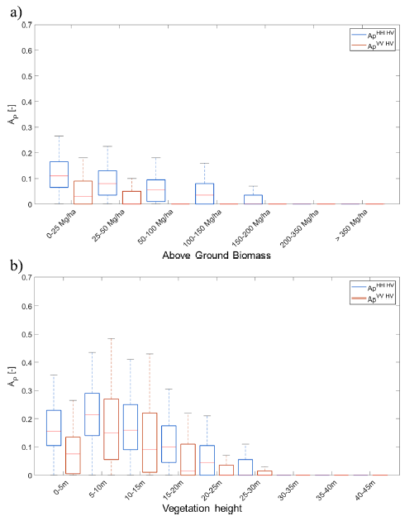

Fig. 12 presents the shape of the vegetation elements, estimated from the SMAP L-band radar data, versus biomass and height of vegetation from independent data sets. It is expected that with increasing vegetation cover (biomass and height), the estimated elements of the canopy tend to a dipole-like shape (A _{P} = 0). For biomass beyond 150-200 Mg/ha and heights above 30 m, this hypothesis is fulfilled. However, it has to be stated that even for medium-to-low vegetation biomass and height, the absolute values for A _{P} stay on a low level of 0.1-0.3, whereas the range of physically possible values extends until 1.0 (spheres). Moreover, A _{P} -estimates of both polarimetric combinations (HH-HV and VV-HV) show similar trends but different intraclass variance. This is more pronounced for low-to-medium vegetation cover (biomass < 50 Mg/ha and height < 20 m).
Figs. 11 and 12 confirm in comparison with the two independent vegetation data sets (above-ground biomass and height) that estimates of orientation distribution and shape of vegetation elements are consistent with measurable vegetation properties and have a physical interpretation.
This is in line with Figs. 6, 8, and 10 showing the distribution of vegetation structure parameters (A _{P} and ψ) along (selected) IGBP land cover classes. However, direct measurements of these model-based vegetation structure parameters are parsimonious to nonexistent rendering a direct in situ validation as very challenging.
- Discussion
The results in Section IV show the possibility to estimate model-based vegetation structure parameters (A _{P}, ψ) from three incoherent (no phase information), multipolarimetric (| S_{HH} |², | S_{HV} |², | S_{VV} |²) SMAP L-band radar observations. Numerous satellite missions can provide these measurements or have them archived (e.g., SMAP, ALOS-2, SAOCOM, and AQUARIUS). Hence, the applicability can be broadened beyond SMAP to these other space-borne radar sensors and their planned successors like NISAR [58], Rose-L [59], or Tandem-L [60].
However, the assumptions of having one layer of homogeneously filled spheroids as a vegetation model exhibiting only single scattering and no multiple scattering should be sufficient for the L-band (and lower frequencies) application but not for the C-band and higher frequencies [61]. This limits the application to low-microwave-frequency sensors.
Moreover, the penetration into the vegetation canopy decreases with increasing frequency [62]. In order to sense the entire above-ground vegetation canopy, longer wavelengths like the L-band are preferred. Nonetheless, the results indicate so far that local spatial heterogeneity can be used to separate the ground and vegetation scattering components within the mixed (soil-vegetation) signal for a vegetation-only retrieval of the structure parameters (A _{P}, ψ). This is subject to a potential limitation for sparse vegetation cover where the first results in [45], [54], and [63] indicate additional influences from the soil conditions on the radar signal. However, a dedicated study is needed to clarify these additional interfering influences in the future.
In addition, it has to be mentioned that the spatial resolution of the radar data and the extend of the neighboring area, which was used to estimate the local spatial heterogeneity, will reflect into the retrieval results for A _{P} and ψ. Hence, a scale transfer to higher or lower spatial resolution for structure representation might not be possible.
It is important to understand that strongly oriented vegetation estimates with ψ-values lower than 20° do not occur for any land cover on the globe (see Fig. 6). This does not mean that this aligned vegetation type, e.g., stalk-dominated crops like barley or wheat, does not exist. It is rather the case that the coarse spatial resolution of the SMAP radar sensor (9 km, aggregated from 3 km) contrary to the sparse appearance and small spatial extent of strongly aligned vegetation within a kilometer-wide resolution cell leads to an under-representation. Hence, it would be interesting to apply the approach to higher resolution SAR sensors, like ALOS-2, SAOCOM, or NISAR, in a future study to see the difference in retrieved structure parameters and to understand whether strongly aligned vegetation structures can be found at higher spatial resolution.
When focusing on the retrieved A _{P} -values, it is unexpected that A _{P} -values do not reach higher than 0.6, which is still significantly different from spherical shapes (A _{P} = 1). However, Fig. 2(b) indicates that the corresponding µ._{PP-PQ}-values fed into the A _{P} -retrieval need to have values of 20 and higher to obtain these kind of A _{P} -values. Fig. 4(a) and (b) indicates that such high µ._{PP-PQ}-values are not present in the global µ_{PP-PQ}-data from SMAP for vegetated soil regions.
In addition, the retrieved vegetation structure parameters (A _{P}, ψ) need to be understood in the light of a methodological limitation: The retrieval method is a two-step process, whereby the orientation distribution width ψ is estimated first with predefined A _{P} -values (vertical dipoles: A _{P} = 0 and horizontal dipoles: A _{P} = 10 000). This has the advantage that dependencies of µ$\frac{Model}{HH-HV}$and µ$\frac{Model}{VV-HV}$ on the orientation angle distribution width ψ are equivalent, when either vertical (A _{p} = 0) or horizontal (A _{p} = 10 000) dipoles are assumed for respective particle shape [see Fig. 2(a)]. Moreover, from Fig. 2(a), both dipole selections (A _{p} = 0a nd A _{p} = 10 000) are needed to obtain the full information on the orientation angle distribution width ψ for one polarization combination.
The particle anisotropy A _{P} is retrieved assuming a fixed ψ-value of 90°. With this assumption, µ$\frac{Model}{HH-HV}$and µ$\frac{Model}{VV-HV}$ have the same dependencies within an A p -range from 0 (fully oriented dipoles) to 1 (spheres) [see Fig. 2(b)]. It is recommended to extend the study at hand for the development of a single-step approach under the support of fully polarimetric observations. Here, Bayesian methods may help to investigate the full parameter space.
Moreover, it stays challenging to directly validate these model-based, space-borne radar resolution-scale vegetation structure parameters (A _{P} and ψ), as a fully equivalent in situ measurement is nonexistent, especially not at the size of satellite footprints. However, sophisticated vegetation characterization is urgently needed for remote sensing signal decomposition to assess the conditions on ground below vegetation cover.
Nevertheless, the retrieved vegetation structure parameters have practical implications on application of model-based polarimetric decompositions like in [17], [30], and [39]. Here, A _{P} and ψ can be used as adequate input parameters for the discrete scatterer model representing the vegetation. This should facilitate polarimetric decompositions of ground and vegetation scattering components and improve ground parameter retrieval, like for soil moisture and surface roughness [37], [38].
Szigarski et al. [56] analyzed the RvI using forward simulations with the discrete particle scattering model of (1). They also calculated the RvI from global SMAP L-band radar data. They show that the classical RvI of [56] needs to be corrected for soil scattering contributions at longer wavelength, e.g., L-band. They suggest a multisenor-based correction in [56]. The retrieved vegetation structure parameters in this article can be directly applied in the forward model formulas for RvI, presented in [56], to calculate an improved (vegetation-only) RvI for global vegetation cover analyses. This might be especially helpful for longer wavelength sensing (L- and P-bands) where soil scattering contributions are more likely included in the recorded signals.
The retrieved vegetation structure parameters might be also helpful to parameterize the vegetation attenuation in passive microwave (radiometer) radiative transfer approaches using the classical model of Mo et al. [64]. Here, A _{P} and ψ can contribute to the simulation of the vegetation optical depth (VOD) using models, e.g., from Jackson and Schmugge [65].
Moreover, environmental Earth System models might benefit from first-order estimations of shape and orientation distribution of the main vegetation elements from the presented retrieval [66]. This fulfills the purpose to inform globally and at large spatial scales rather than locally with (tree- or standbased) in situ observations.

- Conclusion and Outlook
In this article, we presented a radar-based estimation approach for two model-based vegetation structure parameters (shape A _{P} and orientation distribution ψ of the main canopy elements). The approach is based on a small observation set of three incoherent (no phase information) polarimetric intensities (| S_{HH} |², | S_{HV} |², and| S_{VV} |²) combined with a two- parameter (A _{P} and ψ) discrete scatterer model. The objective was to understand whether this confined set of information can be sufficient to estimate these vegetation structure parameters from the L-band signals.
Hence, the subpixel spatial heterogeneity, expressed by the covariation of co- and cross-polarized backscatter Γ_{PP-PQ} of the neighboring cells, is taken to be indicative for the amount of vegetation-only co-to-cross-polarized backscatter ratio µ_{PP-PQ}, moving out soil scattering influences and allowing a vegetation-only retrieval of vegetation shape A _{P} and orientation distribution ψ .
However, the retrievals of the two parameters are not possible simultaneously, but consecutively, while a preassumption on either A _{P} or ψ has to be made. Hence, the retrievals are not independent but show adequate estimates for the different land covers and global spatial distributions. For instance, tropical forests indicate randomly oriented dipoles as predominant vegetation structure type which is already indicated in [17] and [67]. The focus study on six different regions of interest, spanning from barren land to tropical rainforest, shows a steady increase in orientation distribution toward randomly oriented volumes and a continuous decrease in shape arriving at dipoles for tropical vegetation. For the barren regions, e.g. Sahara, the highest A _{P} -value (around 0.4) and the lowest ψ-value (around 30°) are obtained.
A comparison with independently derived data sets of vegetation height and above-ground biomass confirms the consistent and meaningful retrieval of A _{P} and ψ. However, it is a challenge to directly validate the model-based, space-borne radar resolution-scale vegetation structure estimates (A _{P} and ψ) as a fully equivalent in situ measurement is nonexistent, especially not at the size of satellite footprints.
Nonetheless, vegetation monitoring from space benefits from the proposed approach as also multipolarimetric data (no phase information) can add value to assess the vegetation structural parameters. In the light of upcoming space-borne active microwave missions (e.g., L- and S-band NISAR and P-band BIOMASS [68]), the technique could be applied right away to characterize vegetation canopies on global and regional scales at S-, L-, and P-band frequencies. This is especially relevant for NISAR, which has a significantly higher spatial resolution (in the order of meters) than the SMAP radar instrument (in the order of kilometers).
Moreover, the retrieved vegetation structure parameters could be directly applied for the vegetation scattering component of model-based polarimetric decompositions. This should facilitate decomposition into ground and vegetation scattering components and improve the retrieval of soil parameters (moisture and roughness) under vegetation.

-------
This work was supported in part by the MIT-Germany Seed Fund “Global Water Cycle and Environmental Monitoring Using Active and Passive Satellite-Based Microwave Instruments” and in part by the MIT-Belgium UCL Seed Fund “Early Detection of Plant Water Stress Using Remote Sensing.” The work of Carsten Montzka was supported by the ERA-PLANET/GEOEssential through the European Commission Horizon 2020 Program under Grant 689443 Project. The work of Maria Piles was supported by the Project RTI2018-096765-A-100 (MCIU/AEI/FEDER, UE). (Corresponding author: Thomas Jagdhuber)
Color versions of one or more of the figures in this article are available online at https://ieeexplore.ieee.org.

-------

References
- B. W. Barrett and G. P. Petropoulos, “Satellite remote sensing of surface soil moisture,” in Remote Sensing of Land Surface Turbulent Fluxes And Soil Moisture: State of the Art, G. P. Petropoulos, Ed. New York, NY, USA: Taylor & Francis, 2013, pp. 85-120.
- Y. Huang, J. P. Walker, Y. Gao, X. Wu, and A. Monerris, “Estimation of vegetation water content from the radar vegetation index at L-band,” IEEE Trans. Geosci. Remote Sens., vol. 54, no. 2, pp. 981-989, Feb. 2016.
- Y. Kim, T. Jackson, R. Bindlish, S. Hong, G. Jung, and K. Lee, “Retrieval of wheat growth parameters with radar vegetation indices,” IEEE Geosci. Remote Sens. Lett., vol. 11, no. 4, pp. 808-812, Apr. 2014.
- S. Sinha, C. Jeganathan, L. K. Sharma, and M. S. Nathawat, “A review of radar remote sensing for biomass estimation,” Int. J. Environ. Sci. Technol., vol. 12, pp. 1779-1792, Jan. 2015.
- H. Vereecken, L. Weihermuller, F. Jonard, and C. Montzka, “Characterization of crop canopies and water stress related phenomena using microwave remote sensing methods: A review,” Vadose Zone J., vol. 11, no. 2, May 2012, Art. no. vzj2011.0138ra.
- T. van Emmerik, S. C. Steele-Dunne, J. Judge, and N. van de Giesen, “Impact of diurnal variation in vegetation water content on radar backscatter from maize during water stress,” IEEE Trans. Geosci. Remote Sens., vol. 53, no. 7, pp. 3855-3869, Jul. 2015.
- H. McNairn and J. Shang, “A review of multitemporal synthetic aperture radar (SAR) for crop monitoring,” in Multitemporal Remote Sensing: Methods and Applications, Y. Ban, Ed. Cham, Switzerland: Springer, 2016, pp. 317-340.
- N. G. McDowell et al., “Global satellite monitoring of climate-induced vegetation disturbances,” Trends Plant Sci., vol. 20, no. 2, pp. 114-123, Feb. 2015.
- N. S. Chauhan, R. H. Lang, and K. J. Ranson, “Radar modeling of a boreal forest,” IEEE Trans. Geosci. Remote Sens., vol. 29, no. 4, pp. 627-638, Jul. 1991.
- E. P. W. Attema and F. T. Ulaby, “Vegetation modeled as a water cloud,” Radio Sci., vol. 13, no. 2, pp. 357-364, Mar. 1978.
- A. J. Graham and R. Harris, “Extracting biophysical parameters from remotely sensed radar data: A review of the water cloud model,” Prog. Phys. Geography, Earth Environ., vol. 27, no. 2, pp. 217-229, Jun. 2003.
- J. Paris, “The effect of leaf size on the microwave backscattering by corn,” Remote Sens. Environ., vol. 19, no. 1, pp. 81-95, Feb. 1986.
- H. J. C. Van Leeuwen and J. G. P. W. Clevers, “Synergy between optical and microwave remote sensing for crop growth monitoring,” in Proc. 6th Symp. Phys. Meas. Signatures Remote Sens., Val-d’Isere, France. Toulouse, France: Centre National d’Etudes Spatiales, Jan. 1994, pp. 1175-1182.
- S.-K. Kweon and Y. Oh, “A modified water-cloud model with leaf angle parameters for microwave backscattering from agricultural fields,” IEEE Trans. Geosci. Remote Sens., vol. 53, no. 5, pp. 2802-2809, May 2015.
- F. T. Ulaby, K. Sarabandi, K. Mcdonald, M. Whitt, and M. C. Dobson, “Michigan microwave canopy scattering model,” Int. J. Remote Sens., vol. 11, no. 7, pp. 1223-1253, Jul. 1990.
- F. T. Ulaby, R. K. Moore, and A. K. Fung, Microwave Remote Sensing: Active and Passive, From Theory to Applications, vol. 3. Dedham, MA, USA: Artech House, 1986.
- A. Freeman and S. L. Durden, “A three-component scattering model for polarimetric SAR data,” IEEE Trans. Geosci. Remote Sens., vol. 36, no. 3, pp. 963-973, May 1998.
- S. R. Cloude and E. Pottier, “An entropy based classification scheme for land applications of polarimetric SAR,” IEEE Trans. Geosci. Remote Sens., vol. 35, no. 1, pp. 68-78, 1st Quart., 1997.
- S. C. Steele-Dunne, H. McNairn, A. Monsivais-Huertero, J. Judge, P.-W. Liu, and K. Papathanassiou, “Radar remote sensing of agricultural canopies: A review,” IEEE J. Sel. Topics Appl. Earth Observ. Remote Sens., vol. 10, no. 5, pp. 2249-2273, May 2017.
- H. McNairn, J. Shang, X. Jiao, and B. Deschamps, “Establishing crop productivity using RADARSAT-2,” Int. Arch. Photogramm., Remote Sens. Spatial Inf. Sci., vol. 39-B8, pp. 283-287, Jul. 2012.
- G. Wiseman, H. McNairn, S. Homayouni, and J. Shang, “RADARSAT-2 polarimetric SAR response to crop biomass for agricultural production monitoring,” IEEE J. Sel. Topics Appl. Earth Observ. Remote Sens., vol. 7, no. 11, pp. 4461-4471, Nov. 2014.
- S. Zwieback and I. Hajnsek, “Influence of vegetation growth on the polarimetric zero-baseline DInSAR phase diversity-implications for deformation studies,” IEEE Trans. Geosci. Remote Sens., vol. 54, no. 5, pp. 3070-3082, May 2016.
- A. Reigber and A. Moreira, “First demonstration of airborne SAR tomography using multibaseline L-band data,” IEEE Trans. Geosci. Remote Sens., vol. 38, no. 5, pp. 2142-2152, 2000.
- F. Lombardini, “Differential tomography: A new framework for SAR interferometry,” IEEE Trans. Geosci. Remote Sens., vol. 43, no. 1, pp. 37-44, Jan. 2005.
- D. H. T. Minh et al., “SAR tomography for the retrieval of forest biomass and height: Cross-validation at two tropical forest sites in French Guiana,” Remote Sens. Environ., vol. 175, pp. 138-147, Mar. 2016.
- Y. Huang, J. Levy-Vehel, L. Ferro-Famil, and A. Reigber, “Threedimensional imaging of objects concealed below a forest canopy using SAR tomography at L-band and wavelet-based sparse estimation,” IEEE Geosci. Remote Sens. Lett., vol. 14, no. 9, pp. 1454-1458, Sep. 2017.
- M. Chakraborty, K. R. Manjunath, S. Panigrahy, N. Kundu, and J. S. Parihar, “Rice crop parameter retrieval using multi-temporal, multiincidence angle radarsat SAR data,” ISPRS J. Photogramm. Remote Sens., vol. 59, no. 5, pp. 310-322, Aug. 2005.
- E. Santi et al., “The potential of multifrequency SAR images for estimating forest biomass in Mediterranean areas,” Remote Sens. Environ., vol. 200, pp. 63-73, Oct. 2017.
- F. Canisius et al., “Tracking crop phenological development using multitemporal polarimetric Radarsat-2 data,” Remote Sens. Environ., vol. 210, pp. 508-518, Jun. 2018.
- S. R. Cloude, Polarisation: Applications in Remote Sensing. Oxford, U.K.: Oxford Univ. Press, 2010.
- M. Neumann, L. Ferro-Famil, and A. Reigber, “Estimation of forest structure, ground, and canopy layer characteristics from multibaseline polarimetric interferometric SAR data,” IEEE Trans. Geosci. Remote Sens., vol. 48, no. 3, pp. 1086-1104, Mar. 2010.
- F. Capodici, A. Maltese, G. Ciraolo, G. D’Urso, and G. La Loggia, “Power sensitivity analysis of multi-frequency, multi-polarized, multitemporal SAR data for soil-vegetation system variables characterization,” Remote Sens., vol. 9, no. 7, p. 677, 2017.
- L.-J. Du and W. H. Peake, “Rayleigh scattering from leaves,” Proc. IEEE, vol. 57, no. 6, pp. 1227-1229, Jun. 1969.
- M. A. Karam and A. K. Fung, “Scattering from randomly oriented circular discs with application to vegetation,” Radio Sci., vol. 18, no. 4, pp. 557-565, 1981.
- R. H. Lang, “Electromagnetic backscattering from a sparse distribution of lossy dielectric scatterers,” Radio Sci., vol. 16, no. 1, pp. 15-30, 1983.
- R. H. Lang and J. S. Sighu, “Electromagnetic backscattering from a layer of vegetation: A discrete approach,” IEEE Trans. Geosci. Remote Sens., vol. GE-21, no. 1, pp. 62-71, Jan. 1983.
- T. Jagdhuber, “Soil parameter retrieval under vegetation cover using SAR polarimetry,” Ph.D. dissertation, Dept. Sci., Univ. Potsdam, Potsdam, Germany, 2012. [Online]. Available: http://nbn- resolving.de/urn:nbn:de:kobv:517-opus-60519
- T. Jagdhuber, I. Hajnsek, and K. P. Papathanassiou, “An iterative generalized hybrid decomposition for soil moisture retrieval under vegetation cover using fully polarimetric SAR,” IEEE J. Sel. Topics Appl. Earth Observ. Remote Sens., vol. 8, no. 8, pp. 3911-3922, Aug. 2015.
- J. S. Lee and E. Pottier, Polarimetric Radar Imaging: From Basics to Applications. Boca Raton, FL, USA: CRC Press, 2009.
- T. Jagdhuber et al., “Physically-based retrieval of SMAP active-passive measurements covariation and vegetation structure parameters,” in Proc. IEEE Int. Geosci. Remote Sens. Symp. (IGARSS), Beijing, China, Jul. 2016, pp. 10-15.
- D. Entekhabi et al., “The soil moisture active passive (SMAP) mission,” Proc. IEEE, vol. 98, no. 5, pp. 704-716, May 2010.
- D. Entekhabi, N. Das, E. G. Njoku, J. T. Johnson, and J. Shi, SMAP L2 Radar/Radiometer Half-Orbit 9 km EASE-Grid Soil Moisture, Version 3. Boulder, CO, USA: NASA National Snow and Ice Data Center Distributed Active Archive Center, 2016, doi: 10.5067/8YTYSV6JGBK2.
- S. Chan, “Ancillary data report: Static water fraction,” Jet Propuls. Lab., California Inst. Technol., Pasadena, CA, USA, Tech. Rep. JPL D-53059, 2013.
- N. N. Das, “Ancillary data report: Urban areas,” Jet Propuls. Lab., California Inst. Technol., Pasadena, CA, USA, Tech. Rep. JPL D-53060, 2013.
- N. N. Das, D. Entekhabi, E. G. Njoku, J. J. C. Shi, J. T. Johnson, and A. Colliander, “Tests of the SMAP combined radar and radiometer algorithm using airborne field campaign observations and simulated data,” IEEE Trans. Geosci. Remote Sens., vol. 52, no. 4, pp. 2018-2028, Apr. 2014.
- D. Entekhabi, N. N. Das, E. G. Njoku, J. Johnson, and J. Shi, “Soil moisture active passive: Algorithm theoretical basis document L2 &L3 radar/radiometer soil moisture (active/passive) data products,” Jet- Propuls. Lab., Pasadena, CA, USA, JPL Rep., 2012. [Online]. Available: https://smap.jpl.nasa.gov/system/internal_resources/details/originaal/ 277_L2_3_SM_AP_RevA_web.pdf
- C. Derksen et al., “Retrieving landscape freeze/thaw state from soil moisture active passive (SMAP) radar and radiometer measurements,” Remote Sens. Environ., vol. 194, pp. 48-62, Jun. 2017.
- J. R. Piepmeier et al., “SMAP L-band microwave radiometer: Instrument design and first year on orbit,” IEEE Trans. Geosci. Remote Sens., vol. 55, no. 4, pp. 1954-1966, Apr. 2017.
- D. Entekhabi et al., “SMAP handbook,” Jet Propuls. Lab., California Inst. Technol., Pasadena, CA, USA, JPL Rep. 400-1567:1-192, 2014. [Online]. Available: http://smap.jpl.nasa.gov/mission/description/
- R. West, “SMAP L1C radar half-orbit 3 km EASE-grid backscatter, version 3,” Alaska Satell. Facility, Fairbanks, AK, USA, Tech. Rep. SMAP_L1C_S0_HiRes_V3, 2016, doi: 10.5067/ NVVUJ0MNG3PN.
- M. Simard, N. Pinto, J. B. Fisher, and A. Baccini, “Mapping forest canopy height globally with spaceborne lidar,” J. Geophys. Res., vol. 116, no. G4, pp. 1-12, 2011.
- M. Santoro et al. (2018). GlobBiomass Global Above-Ground Biomass and Growing Stock Volume Datasets. [Online]. Available: http://globbiomass.org/products/global-mapping
- D. J. Leroux et al., “Active-passive disaggregation of brightness temperatures during the SMAPVEX12 campaign,” IEEE Trans. Geosci. Remote Sens., vol. 54, no. 12, pp. 6859-6867, Dec. 2016.
- X. Wu, J. P. Walker, N. N. Das, R. Panciera, and C. Rudiger, “Evaluation of the SMAP brightness temperature downscaling algorithm using active-passive microwave observations,” Remote Sens. Environ., vol. 155, pp. 210-221, Dec. 2014.
- X. Wu, J. P. Walker, C. Rudiger, and R. Panciera, “Effect of landcover type on the SMAP active/passive soil moisture downscaling algorithm performance,” IEEE Geosci. Remote Sens. Lett., vol. 12, no. 4, pp. 846-850, Apr. 2015.
- C. Szigarski et al., “Analysis of the radar vegetation index and potential improvements,” Remote Sens., vol. 10, no. 11, p. 1776, 2018.
- Y. Kim and J. J. van Zyl, “On the relationship between polarimetric parameters,” in Proc. Int. Geosci. Remote Sens. Symp. Taking Pulse Planet, Role Remote Sens. Manag. Environ. (IGARSS), Honolulu, HI, USA, Jul. 2000, pp. 1298-1300.
- P. Rosen et al., “The NASA-ISRO SAR (NISAR) mission dualband radar instrument preliminary design,” in Proc. IEEE Int. Geosci. Remote Sens. Symp. (IGARSS), Fort Worth, TX, USA, USA, Jul. 2017, pp. 3832-3835.
- N. Pierdicca et al., “The copernicus L-band SAR mission ROSE-L (Radar Observing System for Europe) (conference presentation),” Proc. SPIE, vol. 11154, Oct. 2019, Art. no. 111540E.
- A. Moreira et al., “Tandem-L: A highly innovative bistatic SAR mission for global observation of dynamic processes on the Earth’s surface,” IEEE Geosci. Remote Sens. Mag., vol. 3, no. 2, pp. 8-23, Jun. 2015.
- G. Picard, T. Le Toan, and F. Mattia, “Understanding C-band radar backscatter from wheat canopy using a multiple-scattering coherent model,” IEEE Trans. Geosci. Remote Sens., vol. 41, no. 7, pp. 1583-1591, Jul. 2003.
- M. Baur, T. Jagdhuber, M. Link, M. Piles, R. Akbar, and D. Entekhabi, “Multifrequency estimation of canopy penetration depths from SMAP/AMSR2 radiometer and icesat lidar data,” in Proc. IEEE Int. Geosci. Remote Sens. Symp. (IGARSS), Valencia, Spain, Jul. 2018, pp. 22-27.
- C. Montzka et al., “Investigation of SMAP fusion algorithms with airborne active and passive L-band microwave remote sensing,” IEEE Trans. Geosci. Remote Sens., vol. 54, no. 7, pp. 3878-3889, Jul. 2016.
- T. Mo, B. J. Choudhury, T. J. Schmugge, J. R. Wang, and T. J. Jackson, “A model for microwave emission from vegetation-covered fields,” J. Geophys. Res., vol. 87, pp. 11229-11237, Dec. 1982.
- T. J. Jackson and T. J. Schmugge, “Vegetation effects on the microwave emission of soils,” Remote Sens. Environ., vol. 36, no. 3, pp. 203-212, Jun. 1991.
- V. Arora, “Modeling vegetation as a dynamic component in soil vegetation-atmosphere transfer schemes and hydrological models,” Rev. Geophys., vol. 40, no. 2, pp. 1-26, 2002.
- A. Freeman, “Fitting a two-component scattering model to polarimetric SAR data from forests,” IEEE Trans. Geosci. Remote Sens., vol. 45, no. 8, pp. 2583-2592, Aug. 2007.
- T. Le Toan et al., “The BIOMASS mission: Mapping global forest biomass to better understand the terrestrial carbon cycle,” Remote Sens. Environ., vol. 115, no. 11, pp. 2850-2860, Nov. 2011.

Thomas Jagdhuber (Senior Member, IEEE) received the Diploma degree (Hons.) in physical geography, physics, remote sensing, and geoinformatics from the Ludwig Maximilian University of Munich, Munich, Germany, in 2006 and the Ph.D. degree (Hons.) in hydrology from the Faculty of Science, University of Potsdam, Potsdam, Germany, in 2012.
From 2014 to 2019, he was a Yearly Visiting Scientist with the Massachusetts Institute of Technology (MIT), Cambridge, MA, USA, contributing to the preparation and continuation of the SMAP and SMAP/Sentinel-1 missions. Since 2007, he has been with the Microwaves and Radar Institute (HR), German Aerospace Center (DLR), Oberpfaffenhofen, Germany. His main research interests include physics-based multisensor data integration with focus on active and passive microwave interaction theory and on polarimetric techniques for hydrological, cryospheric, and agricultural parameter modeling and estimation.
Dr. Jagdhuber was a recipient of the DLR Science Award for his research on polarimetric SAR decomposition techniques in 2014. Together with Prof. Dr. Entekhabi (MIT), he was awarded with the MIT-MISTI Grant for global water cycle and environmental monitoring using active and passive satellite-based microwave instruments. He serves as a Lecturer for the University of Jena and the University of Augsburg as well as a Reviewer for several international journals and conference boards.

Carlos Lopez-Martinez (Senior Member, IEEE) received the M.Sc. degree in electrical engineering and the Ph.D. degree from the Universitat Politecnica de Catalunya, Barcelona, Spain, in 1999 and 2003, respectively.
He is an Associate Professor of remote sensing and microwave technology with the Universitat Politecnica de Catalunya, Barcelona, Spain. He has a large professional international experience with DLR (Germany), University of Rennes 1, Rennes, France, and as a Group Leader of Remote Sensing
and Natural Resources Modelling Team, Luxembourg Institute of Science and Technology, Esch-sur-Alzette, Luxembourg. He has authored over 200 articles in journals, books, and conference proceedings. His research interests include synthetic aperture radar (SAR) theory, statistics and applications, multidimensional SAR, radar polarimetry, physical parameter inversion, advanced digital signal processing, estimation theory, and harmonic analysis.
Dr. Lopez-Martmez received the EUSAR 2002 Conference Student Prize Paper Award and the IEEE-GRSS 2013 GOLD Early Career Award and has co-authored the paper awarded with the EUSAR 2012 Conference First Place Student Paper Award. He has broad academic teaching experience from bachelor, master, and Ph.D. levels to advanced technical tutorials presented at international conferences and space and research institutions worldwide. He is an Associate Editor of the IEEE Journal of S elected Topics in Applied Earth Observations and Remote Sensing and Remote Sensing (MDPI), acting also as an Invited Guest Editor for several special issues. He has collaborated in the Spanish PAZ and the ESA SAOCOM-CS missions in the proposal of the Parsifal mission and is a member of the ESA Sentinel ROSE-L Mission Advisory Group. He was appointed as a Vice President of the IEEE-GRSS Spanish chapter, and in 2016, he became its Secretary and Treasurer. Since 2011, he has been collaborating with the IEEE- GRSS Globalization initiative in Latin America, contributing to the creation of the IEEE-GRSS Chilean chapter and the organization of the 2020 LAGIRSS conference, being appointed as Latin America liaison in 2019. He is also a Co-Chair of the Tutorial Technical Committee of the Indian 2020 InGARSS Conference.

Martin J. Baur (Student Member, IEEE) received the B.S. degree in geography from Augsburg University, Augsburg, Germany, in 2016 and the M.S. degree in global change ecology from the University of Bayreuth, Bayreuth, Germany, in 2019.
He was with the Microwaves and Radar Institute, German Aerospace Center (DLR), Oberpfaffenhofen, Germany. He analyzed SMAP activepassive covariation and supported the development of the SMAP/Sentinel-1 radiometer/radar soil moisture product. From 2018 to 2019, he was a Visiting
Student with the Department of Civil and Environmental Engineering, MIT, Cambridge, MA, USA. He is conducting research on multifrequency retrievals of soil moisture and vegetation water content based on the SMAP and AMSR2 missions. His research interests include remote sensing of soil moisture and vegetation parameters as well as their application in ecohydrology.

Carsten Montzka (Member, IEEE) received the Ph.D. degree in geography from the University of Bonn, Bonn, Germany, in 2007, with a focus on the integration of multispectral remote sensing data into nitrogen cycle simulations.
In 2004, he joined the Institute of Bio- and Geosciences: Agrosphere (IBG-3), Forschungszentrum Julich, Julich, Germany. Since 2007, he has been focused on passive microwave retrieval for soil moisture and the SMOS and SMAP missions. This includes product validation, modeling, and upscaling of surface soil moisture, coupling hydrological models with microwave emission models, multiscale model calibration, and data assimilation, and comparison with and integration of airborne remote sensing data. He is an alumnus of the Arab-German Young Academy for Sciences and Humanities, Berlin, Germany, and a Co-Leader of the CEOS Land Parameter Validation Subgroup on soil moisture.
Moritz Link received the B.S. degree in physical geography and the M.S. degree in environmental systems and sustainability from the Ludwig-Maximilians-Universitat, Munich, Germany, in 2014 and 2017, respectively.
From 2016 to 2017, he was a Visiting Student at the Department of Civil and Environmental Engineering, Massachusetts Institute of Technology, Cambridge, MA, USA. Since 2014, he held different research positions at the Microwaves and Radar Institute, German Aerospace Center, Oberpfaffenhofen, Germany, and at the Earth and Mission Science Division, European Space Agency, Noordwijk, The Netherlands. His research interests include active and passive microwave remote sensing of soil moisture and other land surface variables.

Maria Piles (Senior Member, IEEE) received the M.Sc. degree in telecommunication engineering from the Universitat Politecnica de Valencia, Valencia, Spain, in 2005 and the Ph.D. degree in signal theory and communications from the Universitat Politecnica de Catalunya (UPC), Barcelona, Spain, in 2010, mastering in remote sensing.
Since 2017, she has been a Ramon y Cajal Senior Researcher with Image Processing Laboratory, Uni- versitat de Valencia. She has wide experience in the retrieval of the water content in soils and vegetation from low-frequency microwaves and has been actively involved within the scientific activities of ESA SMOS and NASA SMAP missions. She is a member of the Copernicus Imaging Microwave Radiometer (CIMR) Mission Advisory Group. Her research interests include microwave remote sensing, estimation of soil moisture and vegetation bio-geophysical parameters, and development of multisensor techniques for enhanced retrievals with focus on agriculture, forestry, wildfire prediction, extreme detection, and climate studies. Since 2015, she has been leading the IEEE Spain GRSS chapter.

Francois Jonard received the M.Sc. and Ph.D. degrees in bioscience engineering from the University of Louvain (UCLouvain), Louvain-la-Neuve, Belgium, in 2002 and 2012, respectively.
In 2011, he was a Visiting Scientist with the NASA Goddard Space Flight Center, Greenbelt, MD, USA, contributing to the preparation of the Soil Moisture Active and Passive (SMAP) mission. From 2018 to 2020, he was a Regular Visiting Scientist with the Massachusetts Institute of Technology (MIT), Cambridge, MA, USA. Since 2009, he has been with the Institute of Bio- and Geosciences (Agrosphere), Research Centre Julich, Julich, Germany. He is an Associate Professor with the Faculty of Bioscience Engineering and with the Earth and Life Institute, UCLouvain, and also a Lecturer with the Faculty of Sciences, University of Liege, Liege, Belgium. His research interests include terrestrial remote sensing (microwave and hyperspectral), ecohydrology, and hydrogeophysics.
Dr. Jonard was awarded the MIT-MISTI Grant for early detection of plant water stress using remote sensing.
Narendra Narayan Das was born in Bhilai, India. He received the B.E. degree from the National Institute of Technology Raipur, Raipur, India, and the master’s and the Ph.D. degrees from Texas A&M University, College Station, TX, USA, in 2005 and 2008, respectively.
In 2008, he joined Jet Propulsion Laboratory (JPL), Pasadena, CA, USA, and has been conducting research in hydrology and microwave remote sensing, especially for soil moisture retrievals using the combination of radiometer and radar, and applications of soil moisture for geophysical models relevant for weather, agriculture, and drought. He is a member of the RADAR Science Group, JPL. He is also a Core Member of the Science Algorithm Development Team for the Soil Moisture Active and Passive (SMAP) mission. He is the Deputy Application Leader for the SMAP mission based in JPL. He is an Applied Science Team Member of the NASA SERVIR Program to implement drought and crop forecast systems for the East Africa region and Lower Mekong Basin countries. He is also a Science Team member of the NASA ISRO
SAR (NISAR) mission with the responsibility to produce very high-resolution global soil moisture data product. He is a Research Scientist with the NASA JPL, California Institute of Technology.

