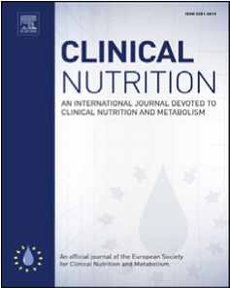
Original article
Contents lists available at
ScienceDirec
t
Clinical Nutrition
journal homepage:
http://www.elsevier.com/locate/cln
u
Clinical Nutrition xxx (xxxx) xx
x
Monitoring and parenteral administration of micronutrients, phosphate and magnesium in critically ill patients: The VITA-TRACE survey
Wouter Vankrunkelsven ^{a, 1}, Jan Gunst ^{a, 1}, Karin Amrein ^{b}, Danielle E. Bear ^{c},
Mette M. Berger ^{d}, Kenneth B. Christopher ^{e}, Valentin Fuhrmann ^{f}, Michael Hiesmayr ^{g}, Carole Ichai ^{h}, Stephan M. Jakob ^{i}, Sigismond Lasocki ^{j}, Juan C. Montejo ^{k},
Heleen M. Oudemans-van Straeten ^{l}, Jean-Charles Preiser ^{m}, Annika Reintam Blaser ^{n, o},
Anne-Françoise Rousseau ^{p}, Pierre Singer ^{q}, Joel Starkopf ^{r}, Arthur R. van Zanten ^{s},
Steffen Weber-Carstens ^{t}, Jan Wernerman ^{u}, Alexander Wilmer ^{v}, Michael P. Casaer ^{a, *}
a
KU Leuven, Department of Cellular and Molecular Medicine, Laboratory of Intensive Care Medicine, Leuven, Belgium
b Medical University of Graz, Division of Endocrinology and Diabetology, Department of Internal Medicine, Graz, Austria
c
Guys and St Thomas’ NHS Foundation Trust, Department of Critical Care and Department of Nutrition and Dietetics, London, United Kingdom ^{d} University of Lausanne Hospital - CHUV, Service of Intensive Care Medicine & Burns, Lausanne, Switzerland
e
Brigham and Womens Hospital, Division of Renal Medicine, Boston, United States
f
University Medical Center Hamburg-Eppendorf, Department for Intensive Care Medicine, Hamburg, Germany ^{g} Klinische Abteilung für Herz-Thorax-Gefaßchirurgische An€ asthesie€ & Intensivmedizin, Medizinische Universitat Wien, Vienna, Austria€ ^{h} University Cote d^ Azur, CHU de Nice, Hopital Pasteur 2, Department of Anesthesiology and Critical Care Medicine, Nice, France^
i
Inselspital, Bern University Hospital, University of Bern, Department of Intensive Care Medicine, Bern, Switzerland ^{j} Centre hospitalier universitaire dAngers, Departement Anesthesie-Reanimation, Angers, France k Hospital Universitario 12 de Octubre, Intensive Care Medicine Department, Madrid, Spain
l
Amsterdam Medical Centers location VUmc, Department Adult Intensive Care, Amsterdam, Netherlands ^{m} Erasme University Hospital - Universite Libre de Bruxelles, Department of Intensive Care, Brussels, Belgium n Lucerne Cantonal Hospital, Department of Intensive Care Medicine, Lucerne, Switzerland o University of Tartu, Department of Anaesthesiology and Intensive Care, Tartu, Estonia ^{p} University Hospital of Liege, Intensive Care Department and Burn Centre, Liege, Belgium q Rabin Medical Center, Tel Aviv University, General Intensive Care Department and Institute for Nutrition Research, Tel Aviv, Israel
r
University of Tartu - Tartu University Hospital, Department of Anaesthesiology and Intensive Care, Tartu, Estonia
s
Gelderse Vallei Hospital, Department of Intensive Care, RP Ede, Netherlands ^{t} Charite - Universitatsmedizin Berlin, Department of Anesthesiology and Operative Intensive Care Medicine, Berlin, Germany€ u Karolinska University Hospital Huddinge - Karolinska Institutet, Intensive Care Medicine, Stockholm, Sweden
v KU Leuven, Medical Intensive Care, Leuven, Belgium

a r t i c l e i n f o | s u m m a r y

Article history:  Received 29 April 2020  Accepted 7 June 2020  Keywords:  Micronutrients  Phosphate  Magnesium  Critical illness  Nutrition  Refeeding syndrome | Background & aims: Despite the presumed importance of preventing and treating micronutrient and mineral deficiencies, it is still not clear how to optimize measurement and administration in critically ill patients. In order to design future comparative trials aimed at optimizing micronutrient and mineral management, an important first step is to gain insight in the current practice of micronutrient, phosphate and magnesium monitoring and administration.  Methods: Within the metabolism-endocrinology-nutrition (MEN) section of the European Society of Intensive Care Medicine (ESICM), the micronutrient working group designed a survey addressing current practice in parenteral micronutrient and mineral administration and monitoring. Invitations were sent by the ESICM research department to all ESICM members and past members.  Results: Three hundred thirty-four respondents completed the survey, predominantly consisting of physicians (321 [96.1%]) and participants working in Europe (262 [78.4%]). Eighty-one (24.3%)

Abbreviations: EN, Enteral nutrition; ESICM, European Society of Intensive Care Medicine; ICU, Intensive care unit; MEN, Metabolism-Endocrinology-Nutrition; PN, Parenteral nutrition; RCT, Randomized controlled trial.
* Corresponding author. KU Leuven, Department of Cellular and Molecular Medicine, Laboratory of Intensive Care Medicine, Belgium. Herestraat 49, 3000, Leuven, Belgium. E-mail address: michael.casaer@uzleuven.be (M.P. Casaer).
1 Equally contributed.
https://doi.org/10.1016/j.clnu.2020.06.005
0261-5614/© 2020 The Authors. Published by Elsevier Ltd. This is an open access article under the CC BY-NC-ND license (http://creativecommons.org/licenses/by-nc-nd/4.0/).
respondents reported to monitor micronutrient deficiencies through clinical signs and/or laboratory abnormalities, and 148 (44.3%) reportedly measure blood micronutrient concentrations on a routine basis. Two hundred ninety-two (87.4%) participants provided specific data on parenteral micronutrient supplementation, of whom 150 (51.4%) reported early administration of combined multivitamin and trace element preparations at least in selected patients. Among specific parenteral micronutrient preparations, thiamine (146 [50.0%]) was reported to be the most frequently administered micronutrient, followed by vitamin B complex (104 [35.6%]) and folic acid (86 [29.5%]). One hundred twenty (35.9%) and 113 (33.8%) participants reported to perform daily measurements of phosphate and magnesium, respectively, whereas 173 (59.2%) and 185 (63.4%) reported to routinely supplement these minerals parenterally.
Conclusion: The survey revealed a wide variation in current practices of micronutrient, phosphate and magnesium measurement and parenteral administration, suggesting a risk of insufficient prevention, diagnosis and treatment of deficiencies. These results provide the context for future comparative studies, and identify areas for knowledge translation and recommendations.
© 2020 The Authors. Published by Elsevier Ltd. This is an open access article under the CC BY-NC-ND license (http://creativecommons.org/licenses/by-nc-nd/4.0/).

Introduction
Micronutrients, consisting of vitamins and trace elements, are essential substances needed in minuscule amounts to ensure proper functioning of crucial physiological and metabolic processes [1e3]. In addition, phosphate and magnesium although generally not labelled as micronutrient given their daily-required doses exceeding 100 mg are two essential minerals [2,3]. Given their important role in maintaining homeostasis, severe deficiencies of micronutrients, phosphate and magnesium are potentially lifethreatening [2,4,5]. Critically ill patients are at increased risk of developing such deficiencies due to illness-induced decreased intake, increased losses, drug interactions and potentially higher needs (Table 1) [1,2,4,6e8]. Moreover, the risk of developing a deficiency may be increased by the recent shift in feeding practices. Indeed, feeding guidelines based on recent large randomized controlled trials (RCTs) no longer support high-dose macronutrient feeding in the early phase of critical illness [9]. This delayed macronutrient administration may unintentionally reduce micronutrient, phosphate and magnesium provision in the early phase, potentially inducing or aggravating deficiencies. Since symptoms of micronutrient deficiencies, as well as of hypophosphatemia and hypomagnesemia are non-specific in the context of critical illness (Table 2), deficiencies can easily be overlooked [4,6]. Additionally, initiation of artificial feeding may render pre-existing deficiencies symptomatic. Indeed, refeeding acutely increases the need for certain minerals and micronutrients such as phosphate and thiamine, whereby rapid initiation of artificial feeding may lead to a potentially lethal refeeding syndrome [3]. Clinical signs of refeeding syndrome include cardiac arrhythmias, cardiogenic shock, muscle weakness and lactic acidosis. New-onset hypophosphatemia has been put forward as predominant biochemical feature of refeeding syndrome [10,11].
Despite the presumed importance of preventing and treating micronutrient and mineral deficiencies, it is still not clear how to optimize measurement and administration in critically ill patients, since large observational and interventional studies are lacking [1]. Blood micronutrient and mineral concentrations may be affected by exogenous infusion and redistribution, particularly related to inflammation [12], and thus not necessarily reflect tissue levels [8]. The need to separately administer micronutrients depends in part on the route of feeding [6]. Indeed, commercially available enteral nutrition formulations contain micronutrients, whereby their provision depends on the energy intake achieved [13]. In contrast, commercially available parenteral nutrition solutions not containing any micronutrients due to instabilities necessitate separate supplementation in patients receiving exclusive parenteral nutrition [9]. The optimal speed of parenteral micronutrient infusion is also a matter of debate. Direct sunlight and certain trace elements may degrade vitamins, particularly A, C and E [14,15]. A more rapid infusion of micronutrients could be an approach to overcome such degradation, but may transiently expose patients to supraphysiological concentrations and consequently enhance urinary loss of water-soluble micronutrients, which is concentrationdependent [16,17].
To gain more insight in the current practice regarding micronutrient, phosphate and magnesium monitoring and parenteral administration, the micronutrient working group within the Metabolism-Endocrinology-Nutrition (MEN) section of the European Society of Intensive Care Medicine (ESICM) designed a survey. The results will inform the design of comparative studies and may reveal discrepancies with existing guidelines.

Materials and methods
Nutritional experts with a special interest for micronutrients were invited to join the micronutrient working group. During an initial face-to-face meeting, the working group defined the scope of the survey and the target audience. Thereafter, the questionnaire was constructed, followed by adjustments through email communication until consensus was reached, optimizing content validity. Technical issues and timing were discussed during a final plenary meeting. The questionnaire was converted into an online survey with the web application Limesurvey (version 2.00, Hamburg, Germany) on a KU Leuven server. Only the principal investigators could make changes to the survey. To optimize face validity and unambiguous interpretation, the survey was tested by a focus group, consisting of intensive care specialists (n ¼ 10), after which final adjustments were made. Subsequently, the survey was sent to the expert group for final approval and discussion on which questions should be mandatory.
The full questionnaire is available as online supplement (see additional file 1). The survey consisted of two main sections. The first section addressed respondent's characteristics including their working environment and general nutritional and metabolic management. The second section comprised specific questions about routine monitoring and parenteral administration of micronutrients, phosphate and magnesium. All fields were mandatory, except for ancillary questions regarding specific details on individual micronutrients (see additional file 1). When inquiring timing
Table 1
Risk factors for developing a micronutrient, phosphate and/or magnesium deficiency.
Inadequate intake or uptake | Increased losses and consumption | Drug interaction (with single micronutrients)
- Prolonged starvation  - Unbalanced diet  - Bariatric surgery  - Malabsorption syndromes  (celiac disease, inflammatory bowel disease, chronic pancreatitis, cystic fibrosis, short bowel)  - Alcoholism  - Chronic liver disease  - Kidney dysfunction/failure  - Drugs (proton pump inhibitors, H2-receptor antagonists, cholestyramine, broad spectrum antibiotics, metformin, thyroxin, ….) | - Large burn wounds  - Meno(metro)rrhagia  - Prolonged inflammation and oxidative stress  - Increased urinary loss  (diuretics, hyperparathyroidism, tubular dysfunction)  - Continuous renal replacement therapy  - Gastrointestinal fistula, chylous leak | - Isoniazid  - Phenobarbital  - Phenytoin  - Penicillamine  - Theophylline  - Tricyclic antidepressants

Table 2
Clinical and laboratory signs of a micronutrient, phosphate and/or magnesium deficiency.

Anemia and other cytopenias
Hypokalemia
Hypocalcemia
Metabolic disturbances (lactic acidosis, hyperlipidemia, hyperglycemia)
Neurological and cognitive deficits
Cardiac dysfunction
Muscle weakness and myopathy
Osteoporosis/bone pain
Rickets and osteomalacia
Immune dysfunction
Skin lesions and delayed wound healing
Glossitis and (angular) cheilitis
Growth and developmental disorders

of particular events, day 1 was defined as the day of intensive care unit (ICU) admission.
The survey was active from October 1, 2018 until December 10, 2018. The invitation was sent by the ESICM research department to all ESICM members and past members on October 1, 2018. Respondents could only access the survey with the use of a unique token, preventing double participation. Non-respondents received a reminder on November 7 and November 26, 2018. The list of recipients and allocated tokens was not available to the researchers and was destroyed after completion of the survey. Participants had the possibility to save partially completed surveys and resume later. However, only fully completed surveys were available to the researchers and were included in the analyses. No personal data were
Table 3
Demographic characteristics of the respondents.
 | n (%)
Profession Physician | 321 (96.1%)
Nutritionist | 7 (2.1%)
Nurse | 5 (1.5%)
Clinical pharmacist | 1 (0.3%)
Type of hospital  Academic | 208 (62.3%)
Non-academic | 126 (37.7%)
Type of ICU  Surgical | 35 (10.5%)
Medical | 27 (8.1%)
Mixed | 267 (79.9%)
Burn/trauma | 5 (1.5%)
ICU population  Adults | 292 (87.4%)
Children | 16 (4.8%)
Mixed | 26 (7.8%)
saved and the answers could not be linked to the token used to access the survey, ensuring anonymity. The survey was endorsed by ESICM.
The Ethical Committee Research UZ/KU Leuven provided a favorable advice for the survey (S61822). The information provided in the survey was collected anonymously and did not contain personal data, hence falling outside the scope of the General Data Protection Regulation.
Data are presented as numbers and percentages, or as median (interquartile range). Percentages are expressed relative to the total number of respondents, unless indicated otherwise. Analyses were performed in JMP (version 14, SAS, Cary, North Carolina).

Results
3.1. General characteristics of the respondents
Three hundred thirty-four respondents completed the survey of whom 321 (96.1%) were physicians, 7 (2.1%) nutritionists, 5 (1.5%) nurses and 1 (0.3%) clinical pharmacist (Table 3). The reported working environment was predominantly European (262 [78.4%]), academic (208 [62.3%]), mixed surgical/medical ICU (267 [79.9%]), and only treating adult patients (292 [87.4%]) (Table 3 þ Fig. 1A). Within Europe, most countries were represented, with eleven countries having more than ten respondents
(Fig. 1B).
Two hundred twenty-seven (68.0%) participants reported to have access to sources documenting the presumed requirements of trace elements and vitamins in critically ill patients. The most commonly reported sources were guidelines (N ¼ 170/227 [74.9%]) and analysis of the literature (N ¼ 48/227 [21.1%]). One hundred sixty-eight (50.3%) respondents reported to have access to sources documenting the normal range of blood concentrations of trace elements and vitamins. The most commonly reported sources were guidelines (N ¼ 87/168 [51.8%]) and analysis of the literature (N ¼ 36/168 [21.4%]).
3.2. General nutritional and metabolic management
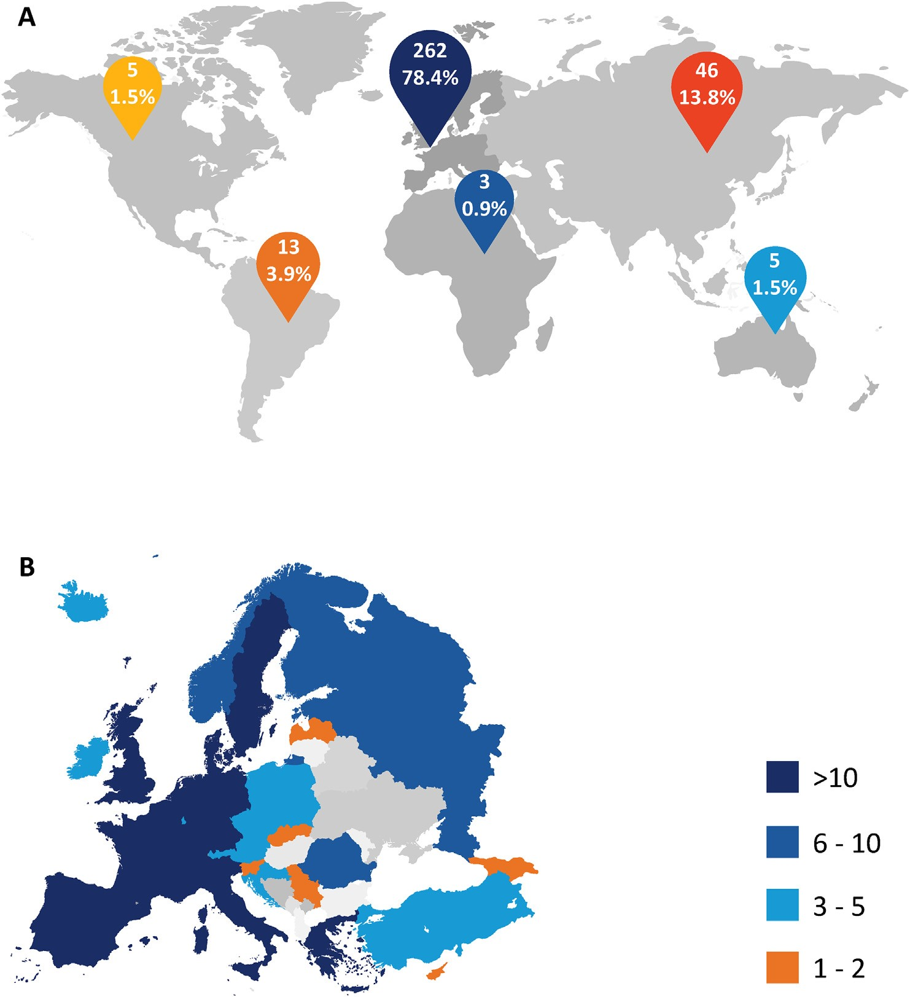
Fig. 1. Geographical location of the respondents. Continent (A) and European country (B) where respondents reported their intensive care unit is located.
Full enteral nutrition was reported to be reached in the average patient after a median of 3 (2e4) days, with a range from 1 to 10 days (Fig. 2). When less than 60% of caloric intake is provided by enteral nutrition, parenteral nutrition was reported to be initiated median at day 5 (3e7; total range 1e21). Three hundred nine (92.5%) participants reported to have a protocol for blood glucose control, with varying targets (Fig. 3). Parenteral micronutrient supplementation in patients receiving no or insufficient artificial nutrition is initiated median at day 3 (1e5; total range 1e999) for mixtures of water-soluble vitamins, day 3 (2e6; total range 1e999) for mixtures of lipidsoluble vitamins and day 3 (2e7; total range 1e999) for trace element preparations.
3.3. Micronutrient monitoring
Eighty-one (24.3%) respondents reported to monitor micronutrient deficiencies through clinical signs and/or laboratory abnormalities. The most frequently monitored laboratory abnormalities were anemia with or without other cytopenia (24 [7.2%]), followed by metabolic acidosis (13 [3.9%]). Among the clinical signs, skin lesions (46 [13.8%]), neurological signs (43 [12.9%]), decreased wellbeing and weakness (40 [12.0%]), and cardiac signs (32 [9.6%]) were most frequently monitored (Table 4). One hundred forty-eight (44.3%) respondents reported to routinely measure the blood concentrations of selected micronutrients to detect deficiencies. The 10 most frequently reported routine measurements and their respective measurement frequencies are depicted in Fig. 4. The three most frequently reported measurements were iron (97 [29.0%]), folate (65 [19.5%]) and vitamin B12 (58 [17.4%]).
3.4. Parenteral micronutrient administration
Two hundred ninety-two (87.4%) participants provided data on specific micronutrient supplementation, of whom 150 (51.4%) reportedly provided early parenteral combined multivitamin and trace element preparations at least in selected patients. Seventyeight (26.7%) respondents reported to parenterally supplement all patients and 63 (21.6%) reported to only supplement selected patients (Table 5). Within the specific parenteral micronutrient preparations, thiamine was reported as most frequently supplemented (146 [50.0%]), followed by vitamin B complex (104 [35.6%]), folic acid (86 [29.5%]), vitamin B12 (85 [29.1%]), vitamin C (83 [28.4%]) and iron (68 [23.3%]) (Fig. 5). Respondents supplementing specific parenteral micronutrient preparations most often did so in selected patients. The modality of parenteral administration of both combined and specific micronutrient preparations was highly variable (Table 6).
3.5. Phosphate and magnesium monitoring and administration
One hundred twenty (35.9%) and 113 (33.8%) respondents reported to daily measure phosphate and magnesium, respectively, whereas 75 (22.5%) and 85 (25.4%) reported not to routinely
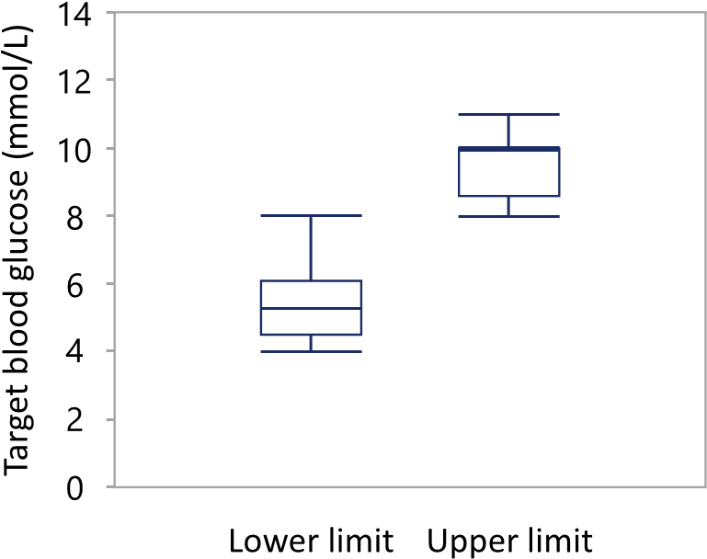
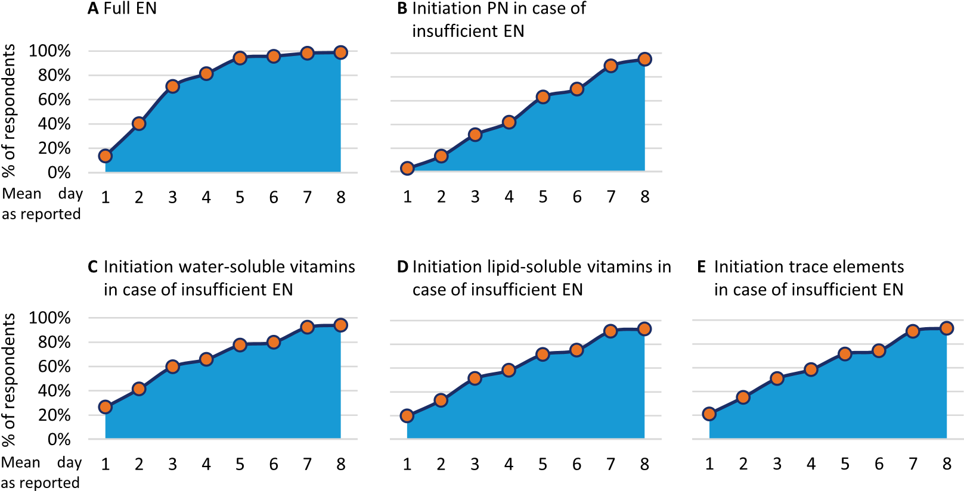
Fig. 2. Timing of enteral and parenteral nutrition, and parenteral micronutrient administration. (A) Average day in the intensive care unit (ICU) at which a respondent reported to reach full enteral nutrition (EN). (B) Average day at which a respondent reported to initiate parenteral nutrition (PN) if EN is insufficient (<60% of target caloric intake). (CeE) Average day at which a respondent reported to initiate parenteral water-soluble vitamins (C), lipid-soluble vitamins (D) or trace elements (E) in patients receiving insufficient enteral nutrition and no parenteral nutrition. Data presented as cumulative number of respondents. ICU day 1 represents the day of ICU admission.
Fig. 3. Blood glucose control. Upper and lower blood glucose target. Boxes indicate median and interquartile range, whiskers 10th and 90th percentile.
measure phosphate and magnesium, or to measure not more than once a week (Table 7). Of the 292 respondents providing data on parenteral micronutrient and mineral supplementation, 173 (59.2%) and 185 (63.4%) reported to regularly supplement phosphate and magnesium, respectively. The modality of parenteral phosphate and magnesium administration considerably differed among respondents (Table 7).
3.6. Practical aspects and protocols regarding micronutrient management
Most of the respondents (276 [82.6%]) reported that the attending intensivist is in charge for the prescription of parenteral micronutrients, followed by a dedicated internal nutritional team (n ¼ 27, [8.1%]) and a dedicated intensivist with extra expertise (n ¼ 17, [5.1%]) (Table 8). One hundred nineteen (35.6%) respondents reported to have a protocol for the administration of parenteral micronutrients. Of these protocols, 66 (55.5%) are designed to prevent inactivation of selected vitamins by daylight, and 58 (48.8%) take incompatibilities between some micronutrients into account. Seventy-six (22.8%) respondents reported to have a protocol to prevent omission of micronutrients in parenteral nutrition. One hundred seventy (50.9%) reported to prescribe enteral or parenteral micronutrients on top of full enteral nutrition in some occasions.

Discussion
The VITA-TRACE survey inquired current practices regarding monitoring and parenteral administration of micronutrients and minerals in the critically ill. The results suggest a wide variation in clinical practice. Indeed, while some respondents reported to not routinely measure blood micronutrient, phosphate and magnesium concentrations, others reported to perform selective measurements on a daily basis and to have structured protocols. Similarly, the timing and indication of parenteral micronutrient, phosphate and magnesium supplementation differed considerably, and the presence and content of protocols for micronutrient administration varied. Most respondents reported not aiming to reach the full caloric target in the first days of critical illness and avoiding early parenteral nutrition. The vast majority of participants were physicians with more than 10 years of expertise, mainly working in mixed ICUs and treating only adult critically ill patients. Most participants resided in Europe, and most European countries were sufficiently represented in the survey. Hence, the results appear generalizable and reflective for real-life practices in Europe.
The results provide the basis for future comparative studies, as planned by the micronutrient working group of ESICM. Indeed, since there are only limited data on the daily requirements of micronutrients, phosphate and magnesium in general ICU patients, future studies should investigate existing practices from a pharmacological perspective, and study effects on patient-centered and health-economic endpoints [1]. The variability in micronutrient measurements could be partially related to an uncertainty to what extent decreases in selected micronutrient concentrations are related to inflammation-induced redistribution, and whether this requires treatment or not. Apart from studying this topic, future studies should examine how individual micronutrient and mineral administration can be optimized, in order to prevent potential inactivation of certain micronutrients by slow administration and long storage, and potential rapid renal losses associated with bolus
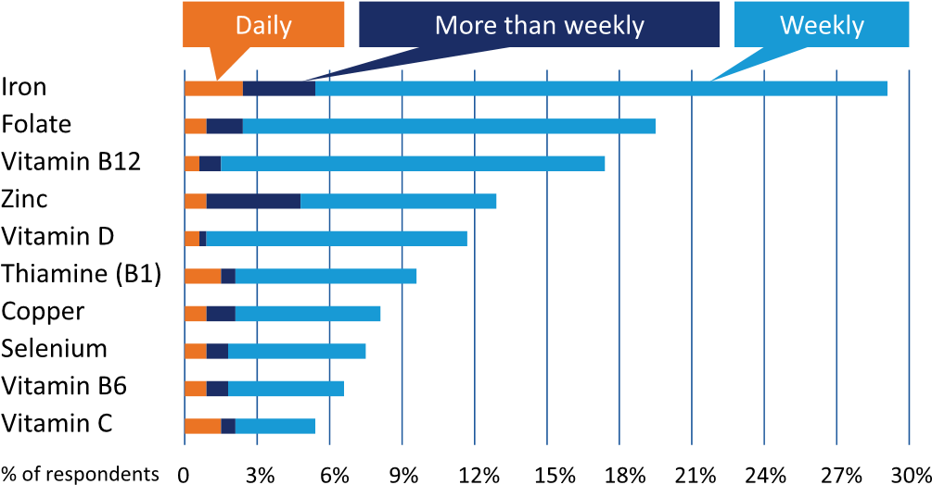
Table 4
Monitored clinical signs and laboratory abnormalities of micronutrient, phosphate and magnesium deficiencies.
Symptom | n (%)
Laboratory abnormalities | 49 (14.7%)
Anemia and/or other cytopenia | 24 (7.2%)
Metabolic acidosis | 13 (3.9%)
Other (altered liver enzymes or function, hypoalbuminemia, renal impairment, hypertriglyceridemia, increased INR, hyperammonemia, thyroid hormone, uremia) | 12 (3.6%)
Skin lesions (dermatitis, dry, fragile skin; delayed wound healing; decubitus) | 46 (13.8%)
Neurological signs | 43 (12.9%)
Peripheral symptoms (muscle cramps, abnormal reflexes, paresthesia, …) | 20 (6.0%)
Central nervous system (delirium, altered consciousness, convulsions, ataxia) | 14 (4.2%)
Undefined | 9 (2.7%)
Decreased general wellbeing and weakness | 40 (12.0%)
Cardiac signs (arrhythmias, cardiac failure, edema) | 32 (9.6%)
Mucosal lesions (mucositis, glossitis, angular cheilitis) | 18 (5.4%)
Hair and nail lesions | 17 (5.1%)
Bleeding diathesis | 12 (3.6%)
Gastrointestinal disorders (diarrhea, vomiting, ileus) | 9 (2.7%)
Ocular abnormalities (keratitis, Bitot's spots, night blindness, xerophthalmia) | 7 (2.1%)
Osteoporosis | 2 (0.6%)

Fig. 4. Top ten most frequent micronutrient measurements. Percentage of respondents and the frequency at which they reported to measure selected micronutrients. Only the 10 most frequent measurements are displayed. Percentages are expressed relative to the total number of respondents.
Table 5
Parenteral supplementation of mixed vitamins and trace elements.
infusions [14e17]. In addition, the optimal frequency of selected micronutrient measurements remains to be established, taking into consideration cost-effectiveness, and blood losses due to frequent blood sampling.
 |  | n (%)
Early mixed vitamin supplementationª |  | 209 (71.6%)
of which^{b} | in all patients | 118 (40.4%)
 | in selected patients | 85 (29.1%)
No early mixed vitamins supplementation |  | 83 (28.4%)
Early trace elements supplementation |  | 168 (57.5%)
of which^{c} | in all patients | 89 (30.5%)
 | in selected patients | 70 (24.0%)
No early trace element supplementation |  | 124 (42.5%)
Early mixed vitamins_{d} þ trace elements supplementation of which | in all patients | 150 (51.4%)  78 (26.7%)
 | in selected patients | 63 (21.6%)
No early mixed vitamins þ trace elements supplementation |  | 142 (48.6%)
Percentages were calculated relative to the number of participants providing data on supplementation (292/334, 87.4%).
a
Mixed vitamins ¼ mixed vitamins preparation, or combination of mixed water-soluble and lipid-soluble vitamin preparations, or vitamin A þ vitamin B mixture þ vitamin C þ vitamin D þ vitamin E.
b Data missing in 6 respondents.
c
Data missing in 9 respondents.
d Data missing in 9 respondent.
Iron, folate and vitamin B12 were the three micronutrients reported to be most frequently measured. Although speculative, this could be explained by the high frequency of anemia in critically ill patients [18]. Diagnosing iron deficiency is complex in critically ill patients, however, and we did not inquire whether additional measurements regarding iron status were performed concomitantly [19]. Not surprisingly, iron, folic acid and vitamin B12 were among the six most often parenterally supplemented micronutrients, mostly in selected patients. Vitamin B complex, thiamine and vitamin C completed the top six of most parenterally supplemented micronutrients. Thiamine administration is likely used in patients at risk to prevent Wernicke encephalopathy and cardiac failure [20]. Selective administration of vitamin C and thiamine
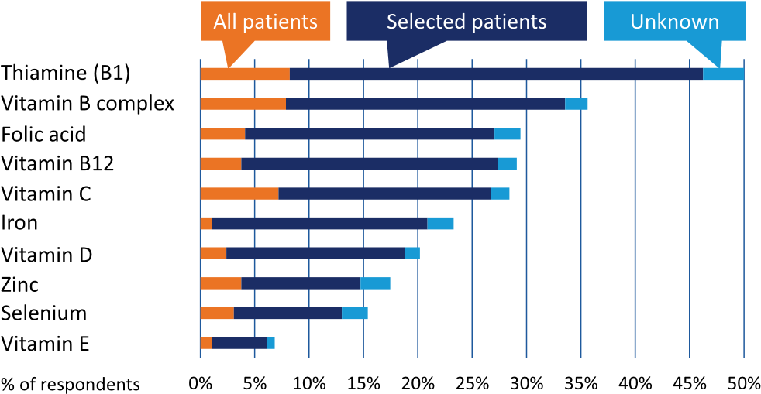
Fig. 5. Top ten most frequent specific parenteral micronutrient supplements. Percentage of respondents parenterally supplementing specific micronutrient formulations. Only the 10 most supplemented preparations are displayed. Percentages are expressed relative to the number of respondents providing data on parenteral micronutrient supplementation (N ¼ 292).
Table 6
Method of parenteral micronutrient supplementation.
 | Added to IV fluid bag, n (%)ª | Separate bolus, n (%)ª | Separate continuous infusion, n (%)ª | Unknown, n (%)ª
Combined water- and lipid-soluble vitamin preparations (N ¼ 144)  Combined water-soluble vitamin preparations (N ¼ 137)  Combined lipid-soluble vitamin preparations (N ¼ 107)  Combined trace element preparations (N ¼ 168)  Thiamine (B1) (N ¼ 146)  Vitamin B complex (N ¼ 104)  Folic acid (N ¼ 86)  Vitamin B12 (N ¼ 85)  Vitamin C (N ¼ 83)  Iron (N ¼ 68)  Vitamin D (N ¼ 59)  Zinc (N ¼ 51)  Selenium (N ¼ 45)  Vitamin E (N ¼ 20) | 69 (47.9%)  73 (53.3%)  60 (56.1%)  99 (58.9%)  23 (15.8%)  23 (22.1%)  5 (5.8%)  5 (5.9%)  16 (19.3%) 5 (7.4%)  2 (3.4%)  16 (31.4%)  12 (26.7%)  2 (10.0%) | 34 (23.6%)  26 (19.0%)  15 (14.0%)  26 (15.5%)  90 (61.6%)  51 (49.0%)  54 (62.8%)  58 (68.2%)  43 (51.8%)  37 (54.4%)  40 (67.8%)  12 (23.5%)  11 (24.4%)  9 (45.0%) | 17 (11.8%)  19 (13.9%)  17 (15.9%)  19 (11.3%)  9 (6.2%)  8 (7.7%)  5 (5.8%)  7 (8.2%)  10 (12.0%)  8 (11.8%) 3 (5.1%)  8 (15.7%)  6 (13.3%)  1 (5.0%) | 24 (16.7%)  19 (13.9%)  15 (14.0%)  24 (14.3%)  24 (16.4%)  22 (21.2%)  22 (25.6%)  15 (17.6%)  14 (16.9%)  18 (26.5%)  - (23.7%)  - (29.4%)  - (35.6%)  8 (40.0%)
IV: intravenous.
a
Percentage calculated relative to the number of respondents supplementing the respective micronutrient.
Table 7
Phosphate and magnesium.
 | n (%) | n (%)
 | Phosphate | Magnesium
Measurement blood concentration  Never | 22 (6.6%) | 32 (9.6%)
Once a week | 53 (15.9%) | 53 (15.9%)
2 or 3 times a week | 96 (28.7%) | 98 (29.3%)
More than 3 times a week | 43 (12.9%) | 38 (11.4%)
Once a day | 118 (35.3%) | 111 (33.2%)
More than once a day | 2 (0.6%) | 2 (0.6%)
Regular parenteral supplementation of phosphate and magnesiumª | 173 (59.2%) | 185 (63.4%)
All patients | 38 (13.0%) | 55 (18.8%)
Specific indications | 127 (43.5%) | 120 (41.1%)
Unknown | 8 (2.7%) | 10 (3.4%)
Method of parenteral administration^{b}  Separate continuous infusion | 61 (35.3%) | 45 (24.3%)
Separate bolus | 57 (32.9%) | 71 (38.4%)
Added to IV-fluid bag | 33 (19.1%) | 42 (22.7%)
Unknown | 22 (12.7%) | 27 (14.6%)
a
Percentage calculated relative to the number of respondents providing data on micronutrient supplementation.
b Percentage calculated relative to the number of respondents supplementing phosphate or magnesium respectively.
regularly monitor neither parenterally administer micronutrients, phosphate and magnesium. Furthermore, the reported global practice of tolerating a macronutrient deficit in the first days of critical illness, in line with recent feeding guidelines [9], may provoke or aggravate a deficit when micronutrients, phosphate and magnesium are not monitored or are equally restricted. This constellation is potentially dangerous, since symptoms of micronutrient deficiencies, hypophosphatemia, hypomagnesemia and refeeding syndrome are non-specific and potentially life-threatening when left untreated [4]. In this regard, in critically ill patients developing refeeding syndrome, as defined by new-onset hypophosphatemia after initiation of artificial nutrition, a large RCT has found that temporarily restricting macronutrient intake while correcting micronutrient deficiencies and hypophosphatemia improved survival as compared to continuing and increasing macronutrient intake [10]. When phosphate is not measured, however, it is unlikely

might also be performed as adjuvant therapy in septic shock, despite the lack of conclusive evidence [21e23].
The survey identified clear areas for knowledge translation. Indeed, a considerable fraction of respondents reported to not that this life-saving strategy would be implemented. Traditionally, several factors have been considered risk factors for developing refeeding syndrome, including pre-existing malnutrition and prolonged starvation [24]. However, a recent observational
Table 8
Practical aspects and protocols regarding micronutrient management.
 | n (%)
Responsible for prescribing parenteral micronutrients  Intensivist | 276 (82.6%)
Dedicated internal nutritional team | 27 (8.1%)
Dedicated intensivist with nutritional expertise | 17 (5.1%)
Dedicated external nutritional team | 8 (2.4%)
Pharmacist | 4 (1.2%)
Nurse | 2 (0.6%)
Protocol in place for parenteral micronutrient administration | 119 (35.6%)
Which prevents inactivation from daylightª | 66 (55.5%)
Which takes incompatibilities into accountª | 58 (48.8%)
Protocol to avoid omission of micronutrients in patients receiving parenteral nutrition | 76 (22.8%)
Prescribe enteral or parenteral micronutrients on top of full enteral nutrition in some occasions | 170 (50.9%)
a
Percentage calculated relative to the number of respondents with a protocol in place for parenteral micronutrient administration.
study has shown that refeeding syndrome could not be predicted by upon-admission risk factors [11]. This underscores the potential importance of measuring phosphate on a routine basis in critically ill patients.
Although speculative, potential differences in parenteral micronutrient administration could explain the divergent impact of artificial feeding on clinical outcome across recent nutritional RCTs in critically ill and hospitalized patients, apart from differences in patient population, energy and protein target, feeding route, and relative macronutrient content [25e35]. Indeed, in contrast to several RCTs in which micronutrient and mineral administration was protocolized in both study arms [25,28,30e33], other RCTs did not protocolize micronutrient management [26,34] or only advised physicians to prescribe micronutrients in the intervention arm [27,29,35]. Consequently, in RCTs without protocolized and comparable micronutrient management in both arms, it remains unclear whether the results are explained by differences in macronutrient intake, or by insufficient prevention and detection of micronutrient/mineral deficiencies and refeeding syndrome in one of the study arms [36].
The study was designed through collaboration between multiple experts in the field of nutritional management of critically ill patients. Yet, the study inherently has limitations. The number of respondents was relatively low. However, there was a good distribution across Europe and the unique token sent by ESICM prevented double participation. Moreover, most participants were experienced and worked in an academic center, and one could speculate that a considerable fraction may have a particular interest in the topic. Hence, we expect that this potential bias would more likely underestimate rather than overestimate potential inadequacies in current practice. A second limitation relates to the survey itself, whereby we could only inquire the intentions of the respondent. Indeed, previous research has shown that the administered macronutrient intake of critically ill patients often does not correspond to what is prescribed [37]. Hence, we do not know whether the reported micronutrient practice truly reflects the clinical practice of the respondent. However, also for this limitation, we are convinced this potential bias would underestimate rather than overestimate the need for knowledge translation. Third, not all participants provided data on specific micronutrient supplementation, whereby a blank answer may mean either no supplementation or missing data. However, by calculating the percentage of respondents relative to the number of participants who provided at least one answer (i.e. reported to provide at least one specific micronutrient), this potential bias would only underestimate the real percentage of participants not providing early parenteral micronutrients. Fourth, for the majority of questions, we focused on parenteral supplementation of micronutrients. Since micronutrients could also be administered enterally, this may have underestimated the use of routine supplementation. Also, we did not survey potassium monitoring and supplementation, which is equally important in preventing and treating refeeding syndrome. However, we expect that potassium measurements and subsequent supplementation are more routinely implemented, since most blood gas analyzers report potassium concentrations. Finally, despite carefully checking face validity by the focus group, we cannot exclude that some respondents unintentionally provided a wrong answer for some questions.

Conclusion
A substantial variation exists in monitoring and parenteral administration of vitamins, trace elements, phosphate and magnesium in critically ill patients. A considerable fraction of intensive care specialists reported to not regularly monitor and/or parenterally administer these micronutrients and minerals in the early phase of critical illness. The absence of routine monitoring and parenteral supplementation in the early phase may lead to undiagnosed deficiencies and unrecognized refeeding syndrome, two entities with non-specific symptoms that may potentially be lethal. Moreover, the shift towards hypocaloric nutrition in the first days of critical illness may increase the risk of developing deficiencies when also micronutrients and minerals would be restricted, although the optimal timing and dose of supplementation remains to be investigated. Hence, besides opening perspectives for comparative studies assessing the most optimal strategy regarding micronutrient monitoring and administration, the survey identified clear areas for knowledge translation.

Statement of autorship
All authors: conception and design of the questionnaire; WV, JG and MPC digitalized the questionnaire, analyzed and interpreted the data and drafted the first manuscript. All authors read and approved the final manuscript.

Funding sources
The study was supported by a research grant from KU Leuven (C24/17/070 to MPC and JG). JG holds a postdoctoral research fellowship supported by the Clinical Research and Education Council of the University Hospitals Leuven. MPC holds a postdoctoral research fellowship supported by the Research Foundation Flanders (1832817N).

Conflicts of interest
Dr. Amrein reports grants, personal fees and other from Fresenius Kabi (Austria), personal fees from Vifor Pharma (Austria), personal fees from Shire now part of Takeda (Austria), outside the submitted work. Dr. Bear reports personal fees from Nutricia (United Kingdom), personal fees from Baxter Healthcare (Global, based in USA), personal fees from Fresenius Kabi (Global, based in Germany), personal fees from Cardinal Health (USA), personal fees from AVANOS (USA), outside the submitted work. Dr. lasocki reports grants and personal fees from VIFOR PHARMA (France), personal fees from PFIZER (France), personal fees and non-financial support from MASIMO (France), non-financial support from PHARMACOSMOS (Denmark), outside the submitted work. Dr. Reintam Blaser reports grants from Fresenius Kabi (Germany), personal fees from Fresenius Kabi (Germany), personal fees from Nestle (Switzerland), outside the submitted work. Rousseau reports non-financial support from Fresenius (Belgium), personal fees and non-financial support from Baxter (Belgium), non-financial support from Nutricia (Belgium), non-financial support from Nestle (Belgium), outside the submitted work. Dr. van Zanten reports grants, personal fees and non-financial support from Nutricia Danone (Netherlands), grants from Mermaid (Denmark), personal fees and non-financial support from Fresenius Kabi (Belgium and Netherlands), grants and non-financial support from Cardinal Health (USA), personal fees from Nestle (USA), grants and personal fees from Amomed (Netherlands and Austria), grants and personal fees from Lyric (USA), personal fees from Baxter (Belgium), outside the submitted work. Dr. Casaer reports personal fees from Fresenius Kabi, (Belgium) outside the submitted work. MPC holds a postdoctoral research fellowship supported by the Research Foundation Flanders (1832817N). Gunst J holds a postdoctoral research fellowship supported by the Clinical Research and Education Council of the University Hospitals Leuven (Belgium). The other authors reported no competing interests.

Acknowledgements
We would like to thank Sherihane Bensemmane and Guy François from the ESICM Research Department for their practical help and sending out the survey. We would also like to thank all colleagues who participated to the survey.

Appendix A. Supplementary data
Supplementary data to this article can be found online at https://doi.org/10.1016/j.clnu.2020.06.005.

References
- Sriram K, Lonchyna VA. Micronutrient supplementation in adult nutrition therapy: practical considerations. J Parenter Enteral Nutr 2009;33(5):548e62.
- EFSA. Dietary reference values for nutrients: summary report, vol. 2017. EFSA supporting publication; 2017, e15121.
- Koekkoek WAC, Van Zanten ARH. Is refeeding syndrome relevant for critically ill patients? Curr Opin Clin Nutr Metab Care 2018;21(2):130e7.
- Casaer MP, Bellomo R. Micronutrient deficiency in critical illness: an invisible foe? Intensive Care Med 2019 Aug;45(8):1136e9.
- Ben-Hamouda N, Charriere M, Voirol P, Berger MM. Massive copper and selenium losses cause life-threatening deficiencies during prolonged continuous renal replacement. Nutrition 2017;34:71e5.
- Berger MM, Pantet O, Schneider A, Ben-Hamouda N. Micronutrient deficiencies in medical and surgical inpatients. J Clin Med 2019;8(7).
- Vanek VW, Borum P, Buchman A, Fessler TA, Howard L, Jeejeebhoy K, et al. A.S.P.E.N. position paper: recommendations for changes in commercially available parenteral multivitamin and multi-trace element products. Nutr Clin Pract 2012;27(4):440e91.
- Blaauw R, Osland E, Sriram K, Ali A, Allard JP, Ball P, et al. Parenteral provision of micronutrients to adult patients: an expert consensus paper. J Parenter Enter Nutr 2019;43(Suppl 1):S5e23.
- Singer P, Reintam Blaser A, Berger MM, Alhazzani W, Calder PC, Casaer MP, et al. ESPEN guideline on clinical nutrition in the intensive care unit. Clin Nutr 2019;38(1):48e79.
- Doig GS, Simpson F, Heighes PT, Bellomo R, Chesher D, Caterson ID, et al. Restricted versus continued standard caloric intake during the management of refeeding syndrome in critically ill adults: a randomised, parallel-group, multicentre, single-blind controlled trial. Lancet Respir Med 2015;3(12): 943e52.
- Olthof LE, Koekkoek W, van Setten C, Kars JCN, van Blokland D, van Zanten ARH. Impact of caloric intake in critically ill patients with, and without, refeeding syndrome: a retrospective study. Clin Nutr 2018;37(5): 1609e17.
- Duncan A, Talwar D, McMillan DC, Stefanowicz F, O'Reilly DS. Quantitative data on the magnitude of the systemic inflammatory response and its effect on micronutrient status based on plasma measurements. Am J Clin Nutr 2012;95(1):64e71.
- Iacone R, Scanzano C, Santarpia L, D'Isanto A, Contaldo F, Pasanisi F. Micronutrient content in enteral nutrition formulas: comparison with the dietary reference values for healthy populations. Nutr J 2016;15:30.
- Allwood MC. Factors influencing the stability of ascorbic acid in total parenteral nutrition infusions. J Clin Hosp Pharm 1984;9(2):75e85.
- Allwood MC, Martin HJ. The photodegradation of vitamins A and E in parenteral nutrition mixtures during infusion. Clin Nutr 2000;19(5): 339e42.
- Osland EJ, Ali A, Nguyen T, Davis M, Gillanders L. Australasian society for parenteral and enteral nutrition (AuSPEN) adult vitamin guidelines for parenteral nutrition. Asia Pac J Clin Nutr 2016;25(3):636e50.
- Ferrie S. Does infusion time affect the retention of parenteral trace elements? Br J Nutr 2019;122(1):56e62.
- Napolitano LM. Anemia and red blood cell transfusion: advances in critical care. Crit Care Clin 2017;33(2):345e64.
- Lasocki S, Longrois D, Montravers P, Beaumont C. Hepcidin and anemia of the critically ill patient: bench to bedside. Anesthesiology 2011;114(3):688e94.
- Collie JTB, Greaves RF, Jones OAH, Lam Q, Eastwood GM, Bellomo R. Vitamin B1 in critically ill patients: needs and challenges. Clin Chem Lab Med 2017;55(11):1652e68.
- Marik PE, Khangoora V, Rivera R, Hooper MH, Catravas J. Hydrocortisone, vitamin C, and thiamine for the treatment of severe sepsis and septic shock: a retrospective before-after study. Chest 2017;151(6):1229e38.
- Fowler 3rd AA, Truwit JD, Hite RD, Morris PE, DeWilde C, Priday A, et al. Effect of vitamin C infusion on organ failure and biomarkers of inflammation and vascular injury in patients with sepsis and severe acute respiratory failure: the CITRIS-ALI randomized clinical trial. J Am Med Assoc 2019;322(13):1261e70.
- Fujii T, Luethi N, Young PJ, Frei DR, Eastwood GM, French CJ, et al. Effect of vitamin C, hydrocortisone, and thiamine vs hydrocortisone alone on time alive and free of vasopressor support among patients with septic shock: the VITAMINS randomized clinical trial. J Am Med Assoc 2020.
- Nutrition support for adults: oral nutrition support, enteral tube feeding and parenteral nutrition. London: National Institute for Health and Care Excellence: Clinical Guidelines; 2006.
- Casaer MP, Mesotten D, Hermans G, Wouters PJ, Schetz M, Meyfroidt G, et al. Early versus late parenteral nutrition in critically ill adults. N Engl J Med 2011;365(6):506e17.
- National Heart L, Blood Institute Acute Respiratory Distress Syndrome Clinical Trials N, Rice TW, Wheeler AP, Thompson BT, Steingrub J, et al. Initial trophic vs full enteral feeding in patients with acute lung injury: the EDEN randomized trial. J Am Med Assoc 2012;307(8):795e803.
- Doig GS, Simpson F, Sweetman EA, Finfer SR, Cooper DJ, Heighes PT, et al. Early parenteral nutrition in critically ill patients with short-term relative contraindications to early enteral nutrition: a randomized controlled trial. J Am Med Assoc 2013;309(20):2130e8.
- Heidegger CP, Berger MM, Graf S, Zingg W, Darmon P, Costanza MC, et al. Optimisation of energy provision with supplemental parenteral nutrition in critically ill patients: a randomised controlled clinical trial. Lancet 2013;381(9864):385e93.
- Harvey SE, Parrott F, Harrison DA, Bear DE, Segaran E, Beale R, et al. Trial of the route of early nutritional support in critically ill adults. N Engl J Med 2014;371(18):1673e84.
- Arabi YM, Aldawood AS, Haddad SH, Al-Dorzi HM, Tamim HM, Jones G, et al. Permissive underfeeding or standard enteral feeding in critically ill adults. N Engl J Med 2015;372(25):2398e408.
- Fivez T, Kerklaan D, Mesotten D, Verbruggen S, Wouters PJ, Vanhorebeek I, et al. Early versus late parenteral nutrition in critically ill children. N Engl J Med 2016;374(12):1111e22.
- Allingstrup MJ, Kondrup J, Wiis J, Claudius C, Pedersen UG, Hein-Rasmussen R, et al. Early goal-directed nutrition versus standard of care in adult intensive care patients: the single-centre, randomised, outcome assessor-blinded EATICU trial. Intensive Care Med 2017;43(11):1637e47.
- Reignier J, Boisrame-Helms J, Brisard L, Lascarrou JB, Ait Hssain A, Anguel N, et al. Enteral versus parenteral early nutrition in ventilated adults with shock: a randomised, controlled, multicentre, open-label, parallel-group study (NUTRIREA-2). Lancet 2018;391(10116):133e43.
- Target Investigators ftACTG, Chapman M, Peake SL, Bellomo R, Davies A, Deane A, et al. Energy-dense versus routine enteral nutrition in the critically ill. N Engl J Med 2018;379(19):1823e34.
- Schuetz P, Fehr R, Baechli V, Geiser M, Deiss M, Gomes F, et al. Individualised nutritional support in medical inpatients at nutritional risk: a randomised clinical trial. Lancet 2019;393(10188):2312e21.
- Casaer MP, Van den Berghe G, Gunst J. Optimising early nutritional support for medical inpatients. Lancet 2019;394(10214):2069.
- Bendavid I, Singer P, Theilla M, Themessl-Huber M, Sulz I, Mouhieddine M, et al. NutritionDay ICU: a 7 year worldwide prevalence study of nutrition practice in intensive care. Clin Nutr 2017;36(4):1122e9.

