Mineral oil risk assessment: Knowledge gaps and roadmap. Outcome of a multi-stakeholders workshop

Andrea Hochegger ^{a,1}, Sabrina Moret ^{b,1}, Lucie Geurts ^{c}, Thomas Gude ^{d}, Erich Leitner ª, Birgit Mertens ^{e,f}, Susan O’Hagan ^{g}, Fátima Poças ^{h}, Thomas J. Simat ^{i}, Giorgia Purcaro ^{j,*}

ª Graz University of Technology, Institute of Analytical Chemistry and Food Chemistry, Stremayrgasse 9 / II, 8010, Graz, Austria
^{b} University of Udine, Department of Agri-Food, Environmental and Animal Sciences, Via Sondrio, 2A, 33100, Udine UD, Italy
^{c} ILSI Europe, Avenue E. Mounier, 83/B.6. B-1200 Brussels, Belgium
^{d} Swiss Quality Testing, CH-8953 Dietikon Grünaustrasse 23, Switzerland
^{e} Sciensano, SD Chemical and Physical Health Risks, Brussels, Belgium
^{f} University of Antwerp, Department of Biomedical Sciences, Wilrijk, Belgium
^{g} PepsiCo, Inc. Beaumont Park, 4 Leycroft Road Leicester, LE4 1ET, UK
^{h} Universidade Católica Portuguesa, CBQF - Centro de Biotecnologia e Química Fina – Laboratório Associado, Escola Superior de Biotecnologia, Rua Diogo Botelho 1327, 4169-005 Porto, Portugal
^{i} Technical University Dresden, Bergstr. 66 D-01062 Dresden, Germany
^{j} Gembloux Agro-Bio Tech, University of Liège Bât. G1 Chimie des Agro-biosystèmes, Passage des Déportés 2, 5030 Gembloux, Belgium

Keywords: Mineral oil hydrocarbon Risk assessment Exposure assessment Food contaminant MOSH MOAH

Abstract
Background: In recent years there have been significant advancements in the understanding of mineral oil hydrocarbons (MOH) in foods and their potential risk to health. However, important gaps in knowledge remain, such as the lack of validated and standardized analytical methods for relevant food matrices and gaps in assessing the risk for consumers’ health.
Scope & approach: A workshop was organized by the European Branch of the International Life Science Institute to identify knowledge gaps in analytical methods, assessment of exposure, hazard characterisation, and risk assessment of MOH. This work captures the outcome of the workshop and builds upon it by combining the perspectives of the participants with an updated review of the literature to provide a roadmap for future management of the topic.

* Corresponding author.
E-mail addresses: gpurcaro@uliege.be, publications@ilsieurope.be (G. Purcaro).
¹ Andrea Hochegger and Sabrina Moret share first authorship.
Key findings and conclusions: Most participants to the workshop agreed that the key issue underlying many of the knowledge gaps in the field of MOH risk analysis and management is the lack of standardized, validated analytical methods able to assure good inter-laboratory reproducibility and to enable understanding of MOH occurrence in foods. It has been demonstrated that method EN 16995 used for MOH determination in vegetable oils and fats is not reliable below 10 mg/kg of food. There is also a need for confirmatory methods that provide a detailed characterization of the unresolved complex mixture observed from one-dimensional chromatographic methods. This is required to enable adequate substance identification and quantification for input into risk assessment. A major gap in the exposure estimation is the limited number of surveys covering a wide range of foods and enough samples to detect major sources of contamination other than packaging in paperboard. Data on concentration of MOH fractions in human body needed to determine internal exposure estimates is scarce. Data relating concentration in tissues with personal data, lifestyle, food intake and the use of cosmetics are needed to clarify the complex system of distribution of MOSH in the body and to possibly establish relationship between external and internal exposure. Additional toxicological studies to better characterize the hazards of relevant MOH are required for a better human health risk assessment.

Introduction

The workshop participants were divided into three groups to discuss different topics: 1) analytical determination, 2) exposure assessment, Scope and background

List of technical abbreviations
ADI BMDL CYP DCPD DMSO FCMs FID GC HPLC LC LLE
LoD
LoQ MAE MAS mCPBA MDAF MO
Acceptable daily intake
Benchmark dose lower confidence limit Cytochrome P450
Dicyclopentadiene Dimethyl sulfoxide Food contact materials
Flame ionization detector Gas chromatography
High performance liquid chromatography Liquid chromatography
Liquid-liquid extraction Limit of detection Limit of quantification
Microwave-assisted extraction Microwave-assisted saponification Meta-chloroperoxybenzoic acid Mono-/diaromatic fraction Mineral oils
MOAH Mineral oil aromatic hydrocarbon MOE Margin of exposure
MOH Mineral oil hydrocarbons MORE Refine mineral oils
MOSH Mineral oil saturated hydrocarbon MS Mass spectroscopy
NOAEL No observed adverse effect level PAH Polycyclic aromatic hydrocarbons PAO Polyalphaolefins
PLE Pressurized liquid extraction
POH Polyolefin oligomeric hydrocarbons POMH Polyolefin mono-unsaturated oligomeric
POSH(cy) Polyolefin oligomeric saturated (mono-cyclic) hydrocarbons
MoA/HRF Mode of action/human relevance framework
PTV Programmed temperature vaporizing ROH Resin related oligomeric hydrocarbons SML Specific migration level
SPE Solid-phase extraction
ToFMS Time-of-Flight Mass Spectroscopy TPAF Three/poly aromatic fractions VUV Vacuum ultraviolet detection

In the early 1990’s, reports were published that mineral oil saturated hydrocarbons (MOSH) may migrate into foods from various food contact materials (FCM) such as hazelnuts and cocoa beans in jute bags, food wrapped in waxed paper or canned food (Grob, Biedermann, Artho, & Egli, 1991). However, the routine analysis of mineral oil hydrocarbon (MOH) components in food was limited to MOSH until 2009 when Biedermann et al. published an upgraded LC-GC-FID method that enabled the determination of MOSH and mineral oil aromatic hydro- carbons (MOAH) in food samples (Biedermann, Fiselier, & Grob, 2009). In December 2009, the Bundesinstitut für Risikobewertung (BfR) stated that the migration of MOH from recycled paperboard into dry foods should urgently be minimised (Bundesinstitut für Risikobewertung, 2009). In the same year the German Federal Ministry of Food and Agriculture (BMEL) initiated a project on the migration of contaminants from FCM made from recycled fiber that should serve as a database to be used as an input into the decision on whether to regulate MOH. The results of this project indicated that MOH from recycled paper and board packaging were the main contaminants occurring in the tested packed foods (Vollmer et al., 2011). The BMEL immediately drafted a regulation on MOSH and MOAH migration from recycled paperboard. In early 2012, the European Food Safety Authority (EFSA) published an opinion concluding that exposure to non-foodgrade MOH posed a potential health concern, but also acknowledged significant uncertainty due to knowledge gaps (EFSA, 2012b). The European Commission has requested both the collection of more occurrence and concentration data and the improvement of the analytical method to perform such identification and quantification, particularly of sub-classes of MOH (Euro- pean Commission, 2017). Further guidance on sampling, analysis and data reporting has more recently been issued (Bratinova & Hoekstra, 2019).
In February 2019, the European Branch of the International Life Science Institute (ILSI Europe) facilitated a two-days Workshop entitled “Mineral oil risk assessment: knowledge gaps and roadmap”. Experts from different sectors were invited. In total 61 participants attended the workshop. Details about workshop participants are available in Fig. 1A and Fig. 1B. and 3) hazard characterisation and risk assessment. The goal was to create an overview on the current scientific understanding of the topic across different sectors and identify critical knowledge gaps preventing a better understanding of the potential risks posed by MOH in food.
This paper presents the outcomes of the workshop including the viewpoints of the participating stakeholders and provides an updated review of the literature regarding analytical determination, exposure assessment, hazard characterization and risk assessment for MOH.

2. Mineral oils in different sectors and mineral oils in the context of food safety

During the workshop, representatives of different sectors – namely food and drink, FCM, cosmetics, petroleum and private analytical lab- oratories – shared their perspective which are summarized in Table 1.

2.1. Mineral oils in the context of food safety

Despite a common underlying background such as the definition of MO from the International Agency for research Cancer (IARC Working Group on the Evaluation of Carcinogenic
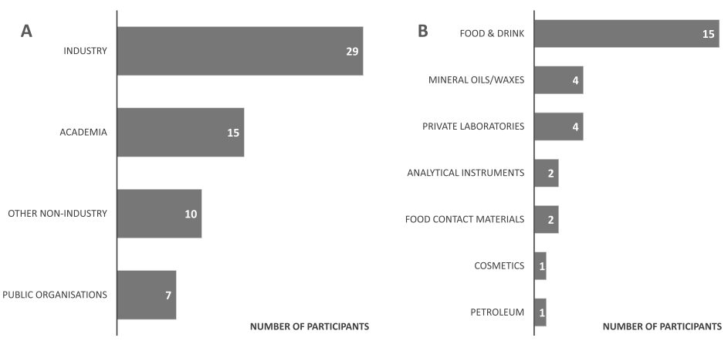
Fig. 1. A) Overview of the 61 participants to the workshop “Mineral Oils Risk Assessment” facilitated by ILSI Europe in February 2019 and B) sector distribution of the industry representatives.

Table 1
Summary of the perceptions of industry sectors regarding definition, challenges and actions concerning mineral oils. The opinion of a representative may not represent the opinion of the whole sector.
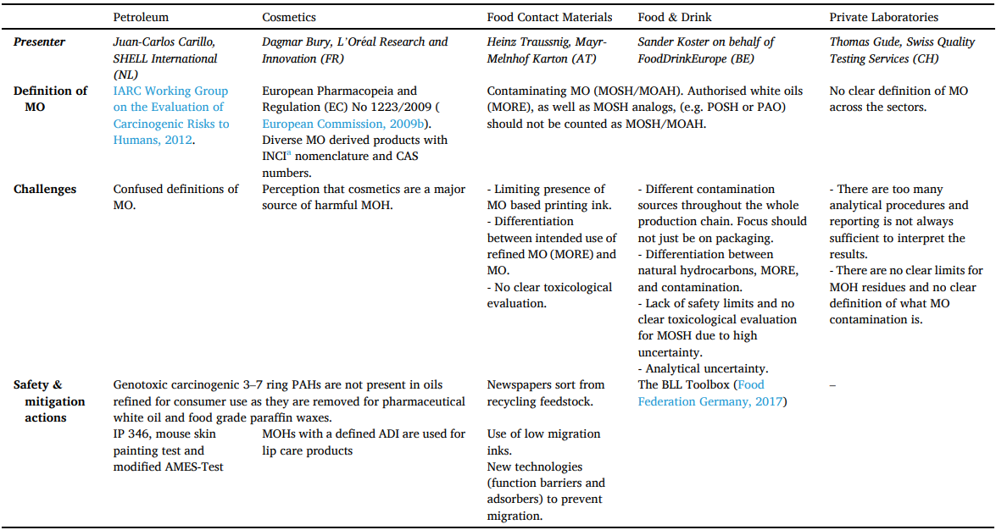
a INCI: International Nomenclature Cosmetic Ingredients

Risks to Humans, 2012), each sector is applying its own definition of MOSH and MOAH, which differ in fundamental elements. However, across the food sector there is a common understanding that the term MOH encompasses a diverse range of compounds which are often found as a mixture of isomers mainly related to two classes of compounds: MO saturated hydrocarbons (MOSH, composed by different sub-classes, i.e. linear, branched, and alkyl-substituted cyclo-alkanes (naphthenes)) and MO aromatic hydro- carbons (MOAH, which includes mainly alkyl-substituted (poly)aromatic hydrocarbons, partly hydrogenated) (Fig. 2). From an analytical viewpoint, structures that fall within the sub-groups MOSH and MOAH are defined in tight relation with the results of the specific analytical technique used for their analysis, namely LC-fractionation with subsequent GC-FID quantification with specific sample preparation and auxiliary techniques in order to enhance the specificity of the method to a reasonable extent. However, the determination of specific individual compounds (e.g. specific markers) that may or may not be acceptable from a safety or regulatory perspective is not achievable using LC-GC-FID nor is complete quantitative differentiation between MOH analogs.

Mineral oil hydrocarbon analogs

In addition to MOH, a range of other hydrocarbons may be found in food, such as those originating from polyolefins and diverse resins used in the manufacture of adhesives. These can migrate from FCM into food and elute in the so-called MOSH and MOAH fractions of the LC-GC-FID analytical method. The polyolefin oligomeric hydrocarbons (POH) include saturated (POSH), mono-unsaturated (POMH) as well as monocyclic (POSHcy) hydrocarbons (Fig. 3). Unsaturated non-aromatic hydrocarbons are not constitutents of MOH and can therefore be used to demonstrate the presence of POH in a mixture of MOH and POH sources (POH can consist of up to 30% of POMH, (Lommatzsch, Biedermann, Simat, & Grob, 2015).

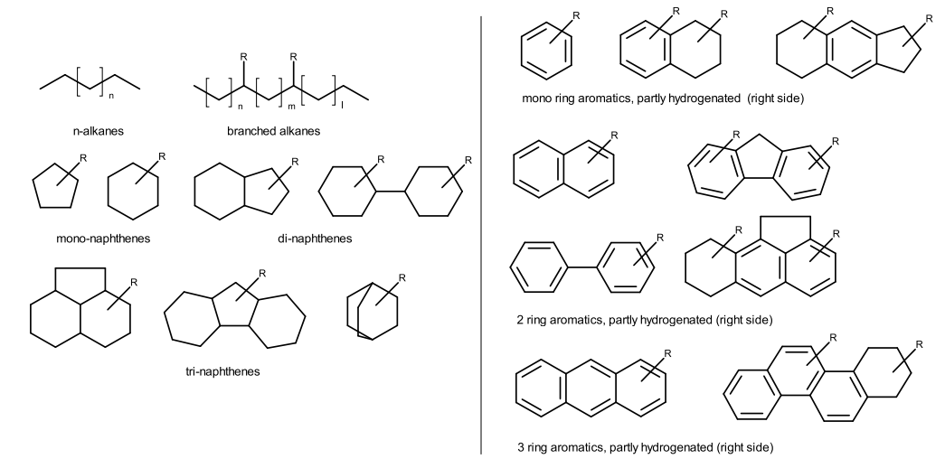
Fig. 2. Structures of MOSH (Left) and MOAH (Right), alkylations and hydrogenations exemplarily.

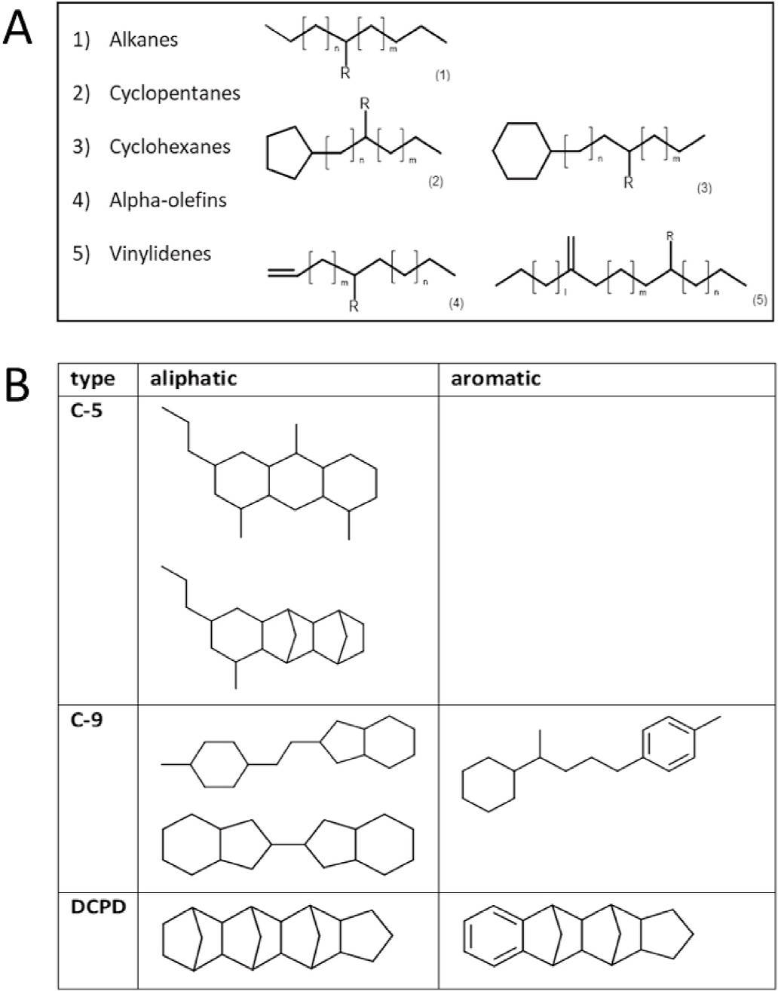
Fig. 3. A) Examples for polyolefin oligomeric hydrocarbons (POH), R = H: linear, R = alkyl: branched; B) examples for resin related oligomeric hydro- carbons (ROH) selection of C-5, C-9 and DCPD type oligomers, aliphatic and aromatic.

Adhesives such as so-called hotmelts or adhesives for re-sealable packaging also contain tackifier resins as well as polyolefines and paraffinic waxes. For the synthesis of these tackifier resins, feed stocks of unsaturated compounds from cracking petroleum streams are used, mainly C-5, C-9 and dicyclopentadiene (DCPD, C-10) feedstocks (FCM 97 in EC 10/2011). The oligomers of these resins can co-elute respectively in the MOSH fraction of the LC-GC methods or in the MOAH fraction (C-9 and DCPD type) (Lommatzsch, Biedermann, Grob, & Simat, 2016). The structures of these resin related oligomeric hydrocarbons (ROH) are different from those of the MOH related com- pounds (Fig. 3).
Other MOH analogs can be found in terpinoid tree resins also in use as adhesives ingredients and polyalphaolefins (PAO, C-8 – C-12) used as lubricants, respectively.

Regulations overview in Europe

MO have a number of approved uses based on regulations in Europe and other regions. Specified grades of MO and waxes can be used as food additives (European Commission, 2008) and processing aids in food – e.g. microcrystalline wax (E905) is an approved additive for use as a surface treatment agent on non-chocolate confectionary and certain fruits. Other MO are used as processing aids such as release agents from bakery molds and dedusting agents in cereal grain processing. Certain paraffinic MO are authorised as acaricides and insecticides for treating crops under Regulation (EC) No 1107/2009 and Commission Implementing Regulation (EU) No 540/2011 (European Commission, 2009a, 2011a).
MO are also authorised as additives for polymeric packaging under Commission Regulation (EU) No 10/2011 (European Commission, 2011b). A number of MO derived from petroleum-based or synthetic hydrocarbon feedstocks, are included in the Union list of additives approved for use in FCMs, such as white, paraffinic MO (FCM No 95), refined waxes of high viscosity (FCM No 94) and paraffinic refined waxes of low viscosity (FCM No 93). The latter has a specific migration level (SML) set at 0.05 mg/kg food. FCM 94 and 95 do not have SMLs but are subject to the overall migration limit of 60 mg/kg food.
Some European countries have national legislation on the use of MO in FCMs. The Swiss Printing Inks Regulation contained in the Ordinance on Materials and Articles (RS 817.023.21) lists a number of MO under the non-evaluated substances subject to a migration limit of <0.01 mg/kg (Département Fédéral de L’intérieur, 2016). These non-evaluate substances must not be classified as ‘mutagenic’, ‘carcinogenic’ or ‘toxic to reproduction’ (CMR substances). The BfR suggested a migration limit for paraffinic hydrocarbons C17–C20 of 4 mg/kg and for the fraction C12 – C16 a limit of 12 mg/kg, respectively (Bundesinstitut für Risikobewertung, 2011, Bundesinstitut für Risikobewertung, 2012).
In 2017 the BMEL issued an amendement to the 22nd Ordinance on FCM (i.e. the mineral oils ordinance), establishing a SML of 0.5 mg/kg food for MOAH. The use of recycled paperboard as packaging material is supported, provided that a functional barrier is introduced in order to reduce MOAH migration below the SML. This regulation in not intended to regulate the MOSH since there is no consumer health concern and there is no method able to distinguish them from the legally compliant MOSH analogs (Food Federation Germany, 2017).
MO used in cosmetics must comply with the requirements of Regulation (EC) No 1223/2009 which includes a list of prohibited materials including certain aromatic fractions of MO, and should where relevant align with EU Pharmacopeia specifications.
MO entering the food supply as contaminants are subject of ongoing regulatory discussion in Europe. In 2017, the European Commission published a monitoring recommendation for MO in food and FCMs (Commission Recommendation (EU) 2017/84). It recommends that Member States, together with other stakeholders, monitor the presence of MOH in a wide range of food products and FCMs used with those food products during 2017–2018. The data collected will be used in future safety assessments.
Gaps in the safety data on MOH have meant that health-based guidance values cannot be established for all MOH. There are also no codified regulatory limits for inadvertent contaminating MOH (in contrast to intentional uses such as specific SMLs or food additive uses). However, some expert bodies have recommended the establishment of threshold or benchmark levels. In Belgium, the Scientific Committee of the Federal Agency for the Safety of the Food Chain recommended action thresholds for MOSH in several food products (Federal Agency for the Safety of the Food Chain, 2017). Similarly, in Germany the Consumer Protection Consortium of the Federal States (LAV) and the German Federation for Food Law and Food Science (BLL) have issued benchmark levels for MO in various food products (Food Federation Germany, 2019).

Analytics

Current state of the art

MOH quantification is a very challenging task and it is at the center of a strong debate due to the relatively large uncertainty associated with this analysis, particularly at lower level. The debate can be well understood referring to some papers and relative commentary (Biedermann, McCombie, et al., 2017; Bratinova et al., 2020; Koster et al., 2020; Spack et al., 2017). The goal of this section is to provide a general overview of the analytical methods proposed and the outcomes of the workshop discussion on the topic. The current status of MOH testing is summarized in recent guidance from the JRC (Bratinova & Hoekstra, 2019). The key topics underlying the JRC guidance were discussed in the workshop. All laboratories are expected to follow the basic principles including performance criteria outlined in the guidance, especially for the reporting of defined fractions and expected limits of detection.

General method
As a general recommendation, analytical methods complying with the performance requirements as defined in the JRC guidance should be applied (Biedermann et al, 2009, 2017b; Biedermann & Grob, 2012a; Biedermann-Brem, Kasprick, Simat, & Grob, 2012). In short MOSH and MOAH are extracted from the sample matrix using an organic solvent after the addition of internal and verification standards. The extract is submitted to isolation and separation of the MOSH and MOAH fractions. MOSH and MOAH fractions are separated on a HPLC silica gel column using a n-hexane/dichloromethane gradient. In the off-line method the HPLC column is replaced by a glass column filled with silica/AgNO3, and toluene is added to the elution mixture to prevent wax esters from eluting with the MOAH fraction (Fiselier et al., 2013).
Each fraction is transferred either on-line or off-line to a GC (via the retention gap technique or PTV injector). Solvent vapours are usually discharged via a solvent vapour exit located between the uncoated pre- column and the GC separation column or by using a solvent vent in a GC programmed temperature vaporizer injector. Experienced operators are required for a correct interpretation of the GC chromatograms. If an interference is suspected even after purification, the characterisation of the MOSH or MOAH fraction has to be verified by using additional analytical methods, such as (LC-)GC-MS or GCxGC-FID/MS.

Quantification and performance criteria
Sub-fractions of MOSH and MOAH (so-called C-fractions) in chromatograms are defined by the retention times of n-alkanes. The JRC guidelines give the C-fractions that should be reported and performance requirements for different food types and cardboard. For each C-fraction, performance requirements include: maximum allowable limit of quantification (LoQ), target LoQ (0.1–0.5 mg/kg, depending on the food type), recovery ranges (70–120% or 80–110%, depending on the food fat content), and the intermediate precision (15–20%) for different types of samples (Bratinova & Hoekstra, 2019).

Official methods

In 2017, the LC-GC method developed by Biedermann et al., 2009 became, with little modification, the official method EN 16995:2017 for MOSH and MOAH determination in vegetable oils and foodstuff on basis of vegetable oils (EN European Standard, 2017). Based on the reproducibility data of a collaborative trial involving 9 laboratories, a “limit of applicability” of 10 mg/kg was established. Method improvement including sample enrichment to reach lower limit of applicability (1–2 mg/kg) is under discussion by a group of experts coordinated by the Institut des Corps Gras & produits apparentés (ITERG Canejan, FR) and the Max Rubner Institute (MRI, Detmold, DE). A pre-trial with the method has been conducted between November 2020 and January 2021. In October 2018, a new interlaboratory study (conducted within CEN/TC 327 work programme prEN 17517, under enquiry) for MOSH/MOAH determination in additives, pre-mixtures, feed materials, and vegetable oils, confirmed a limit of applicability of 10 mg/kg. Currently, with exception of the EN 16995 method, there is no official method available. This lack of official methods is leading to several variations to the originally published method summarized in the German BfR Compendium (Bun- desinstitut für Risikobewertung, 2012).

Sample preparation

Basic sample preparation for MOH determination in food generally comprises an extraction step, followed by MOSH and MOAH fractionation on a silica column (HPLC or cartridge), having also the function to retain triglycerides. Further sample preparation may be required to remove interferences (e.g. endogenous n-alkanes from MOSH, olefins from MOAH) and – if properly applied – to enhance accuracy and sensitivity. On the other hand, intensive sample preparation can lead to wrong results due to possible contamination during sample manipulation. For this reason, it is important to run blank analyses, check for solvent purity, use inert materials and cleaned glassware, and avoid the use of large volumes of solvent followed by extensive preconcentration and sample manipulation.

Extraction

Extraction represents a fundamental step of MOH analysis and can be more or less challenging depending on matrix composition (e.g. water and fat content), presence of interferences, origin of the contamination, and required sensitivity. Different extraction protocols have been developed and applied, depending on the different food type. A procedure suitable for a given food type may cause low recovery and poor accuracy when applied to another food type.
For MOH extraction from liquid samples, liquid-liquid extraction (LLE) with a non-polar solvent (i.e. n-hexane) and/or solid-phase extraction (SPE) are common methods of choice.
Complete extraction from wet food is complicated by the presence of water preventing the contact with the apolar extracting solvent. Pre- liminary drying may cause volatile losses and/or cross-contamination. Biedermann-Brem and Grob (2011), developed a method involving a two-steps extraction, first with ethanol and then with hexane overnight, followed by water addition to separate the hexane phase.
Complete extraction from difficult dry matrices (e.g. semolina pasta, milk powder) can be accomplished with the procedure described for wet foods, preceeded by soaking in hot water (EFSA, 2012b). Other traditional approaches include acid hydrolysis for milk samples (Concin et al., 2008) and saponification. The latter has the advantage to eliminate the fat, thus obtaining simultaneous extraction/enrichment.
As an alternative to traditional solvent extraction, innovative extraction methods, i.e. pressurized liquid extraction (PLE) (Moret et al., 2014), microwave-assisted extraction (MAE) (Gharbi et al., 2017), and microwave assisted saponification (MAS) (Moret, Scolaro, Barp, Purcaro, & Conte, 2016), exploiting the enhanced extraction power of a solvent taken at high temperatures under pressure, have been developed and recently applied. The latter can be applied (without any pre-treatment) to all food types (dry and wet, low or high fat content), avoiding the need to dry the sample before extraction. Main advantages of such techniques are high extraction yield, reduced extraction time, solvent consumption and sample manipulation, possibility of automation and simultaneous processing of a great number of samples.

Auxiliary techniques

Since the capacity of a typical silica HPLC column (e.g., 2 mm id × 250 mm) to retain fat is limited, auxiliary techniques to eliminate the fat prior to LC-GC-FID analysis have been developed to enhance sensitivity. Similarly, auxiliary techniques for sample purification have been pro- posed to eliminate interferences allowing for reliable quantification of the contamination. For the reason previously explained, such techniques should be used only when strictly necessary. For facilitating the choice of auxiliary methods a decision tree has been proposed (Bratinova & Hoekstra, 2019, Fig. 4).

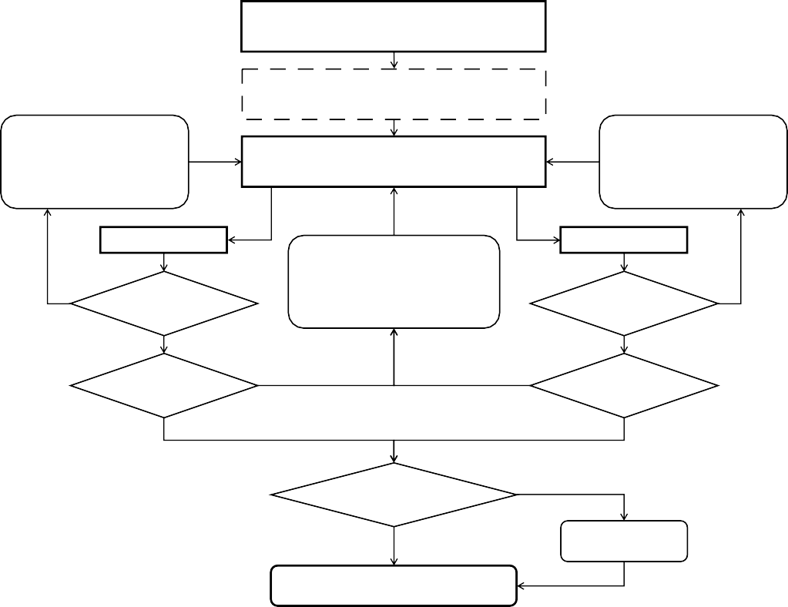
Extraction

Saponification for oil/fats and high fat content samples*
Matrix interference (e.g. odd-numbered
natural alkanes ≥ n-C21)
ALOX clean-up
On-line or manual MOSH/MOAH
separation and determination by GC-FID
Matrix interference (e.g. natural olefins, terpenes, squalene) Epoxidation
MOSH fraction
NO**
Free from interfering signals?
YES
Enrichment by concentration of extracts and/or saponification and/or off-line LC pre- separation
MOAH fraction
Free from interfering signals?
YES
NO**
Sufficient LoQs?
NO
NO
Sufficient LoQs?
YES YES
Plausibility check/verification
Not OK
OK
GC x GC-FID/MS
RESULT
** If ALOX cleanup or epoxidation already done: adjustLoQor use GC x GC-FID/MS
* The cleanup could start directly with saponification when known from experience that it couldn’t be avoided
Fig. 4. Decision tree to identify auxilary methods. Adapted from Bratinova & Hoekstra, 2019. ALOX: Al2O3.

Sample enrichment.

To enhance sensitivity, it is possible to concentrate the sample extract before injection. However, the amount of sample injected is limited to the fat content/capacity of the LC column, which means that further enrichment steps are needed to lower the LoQ.
Saponification with strong alkali followed by column chromatography or SPE was the first approach to remove triglycerides (Guinda, Lanzón, & Albi, 1996; Koprivnjak, Procida, & Favretto, 1997).
Sample enrichment can also be obtained by exploiting the adsorption properties of fat retainers such as activated silica gel and alumina. In particular, the former has a higher capacity, but the latter has the advantage of retaining long-chain endogenous n-alkanes, obtaining simultaneous enrichment/purification (Fiselier et al., 2009a, 2009b). Zurfluh, Biedermann, and Grob (2014) achieved a LoQ below 0.3 mg/kg for vegetable oils with an enrichment/purification on a glass column filled with a mixture of activated alumina and silica gel/0.3% silver nitrate on the bottom, and activated silica gel on top. Passage on a sulphuric acid impregnated silica gel (not tested on MOAH) represents another possible approach (Wrona, Pezo, & Nerin, 2013). All these methods enable processing high amounts of oil, but are solvent and time-consuming.

Removal of endogenous n-alkanes

Vegetable oils may contain high amounts of endogenous n-alkanes, generally in the range C21–C33, with a typical distribution in which odd carbon numbers predominate. However, some plant material such as vanilla pods may contain a range of hydrocarbons including both branched and n-alkanes (Ramaroson-Raonizafinimanana, Gaydou, & Bombarda, 1997). n-Alkanes usually form sharp peaks standing over the MOSH hump (if present), whose areas can be easily subtracted from the total area. Their removal becomes mandatory when they overload the GC column capacity. When using n-hexane as eluent, n-alkanes beyond C20 can be retained by activated alumina (350–400 ◦C), whereas iso-alkanes remain largely unretained (Fiselier et al., 2009a). Fiselier, Fiorini, and Grob (2009b) proposed a complex on-line LC-LC-GC method, involving a first silica column for MOSH/MOAH fractionation and a second LC column filled with alumina, for separating long-chain n-alkanes from iso-alkanes, which were then transferred to the GC-FID.

Removal of interfering olefins.

MOAH analysis in vegetable oils and food with a high fat content is complicated by the presence of olefins naturally present (carotenoids, squalene, sterenes) or formed during oil refining. They co-elute to some degree with the MOSH (particularly olefins with one double bound), and with the MOAH fraction (poly- unsaturated olefins).
By proper derivatization with meta-chloroperoxybenzoic acid (mCPBA), olefin polarity can be enhanced, shifting their elution from the LC column beyond the MOAH fraction (Biedermann et al., 2009). Epoxidation with mCPBA was found to be more selective compared to bromination (Wagner, Neukom, Grob, Moret, & Populin, 2001), but careful optimization of the reaction conditions is required to avoid un- acceptable MOAH losses, particularly of thiophenes, which are easily oxidized (Biedermann et al., 2009). Depending on the sample, epoxidation can give formation of artifacts or insufficient removal of interferences, with consequent raising of the LoQ and increase uncertainty.
Nestola and Schmidt (2017) proposed an automated epoxidation protocol, using ethanol instead of dichloromethane as reaction solvent and sodium thiosulfate instead of sodium carbonate as quenching re- agent. The modified protocol makes sub-ambient cooling unnecessary, and avoids addition of clean oil (when not present in the sample) as a buffering agent. A recent paper compared the two epoxidation protocols (Biedermann, Munoz, & Grob, 2020).
SPE on silica gel cartridge/columns treated with silver nitrate was demonstrated to be a valid alternative to epoxidation for some edible oils such as olive oil and grapeseed oil, but not for palm oil (unpublished results). Zoccali et al. (2016) developed an on-line LC-LC-GC method which uses a first LC column to retain fat and to pre-separate MOSH and MOAH, and a second column treated with silver ions to retain any interfering olefins.

Verification techniques (GC-MS, comprehensive two-dimensional GC-FID/MS)

MS detection (e.g. as on-line LC-GC-FID/MS) has been proposed to confirm or exclude the presence of MOH. The benefits of using MS detection are clear when specific markers are searched for the confirmation of source of MOH contamination, e.g. dibenzothiophene for little refined oils or diisopropyl naphthalene from recycled paperboard. However, work is still needed to robustly identify marker compounds for different contamination sources. On the other hand, the use of MS has been proposed for the evaluation of the undifferentiated analytical peaks or “hump” itself, but a debate is ongoing concerning this topic (Biedermann, McCombie, et al., 2017; Spack et al., 2017). The main issue is that the ions proposed for confirming the MOSH and MOAH hump are not selective, thus, false positive results are not ruling out.
Comprehensive two-dimensional gas chromatography (GC £ GC) coupled to FID for quantification and MS for confirmation (GC × GC-FID/MS) represents an interesting approach. While one dimensional GC only allows for class separation based on carbon chain length, GC × GC allows for a class separation in a two-dimensional (2D) space based on volatility, polarity, and molecular conformation, along with increased sensitivity due to the modulation process (Purcaro, Barp, & Moret, 2016). Despite the enormous gain in resolution, MOSH and MOAH must be analysed separately due to a partial overlap of the two fractions. In fact naphthenic hydrocarbons coelute with highly alkylated aromatic components. Particularly, four- and five-ring saturated hydrocarbons, such as steranes, hopanes, and bicyclic sesquiterpanes, coelute with the highly alkylated two- and three-ring aromatics (Biedermann & Grob, 2015; Purcaro, Moret, & Conte, 2013; Purcaro, Tranchida, et al., 2013). Moreover, if a MOAH fractions is present, it is on the range of traces (<<1% for white oil) up to ~30% compared to MOSH. Therefore, a different concentration factor is needed according to the fraction analysed.
The GC × GC columns combination is usually polar × apolar medium in order to maximize the resolution in the MOSH fraction. In particular, GC × GC produces 2D plots which allow to solve critical coelutions, such as the distinction between MOSH and POH or the presence of ROH (Lommatzsch et al., 2016). An expert analyst may be able to identify their presence in a monodimensional trace, but in a 2D plot POSH, POMH and ROH are eluted separately from each other and from MOSH avoiding any ambiguity. Indeed, the 2D pattern of both the MOSH and the MOAH fraction can support the identification of the source of contamination in food, not only because of the capability to separate the MOSH from the POH and ROH, but also because the distribution of the different sub-classes gives an indication of the kind of MO used and the type of refining it underwent (Biedermann & Grob, 2015). Quantification is possible with results comparable to the LC-GC determination (Purcaro, Tranchida, et al., 2013). Such a technique is still not widely available and it is still perceive as too sophisticated, slowing down its use at a routine level. Recently a comprehensive platform, namely LC-GC × GC-ToFMS/FID has been developed to face the analytical challenge of MOSH and MOAH
Table 2
- Current gaps and uncertainty in mineral oils analysis.
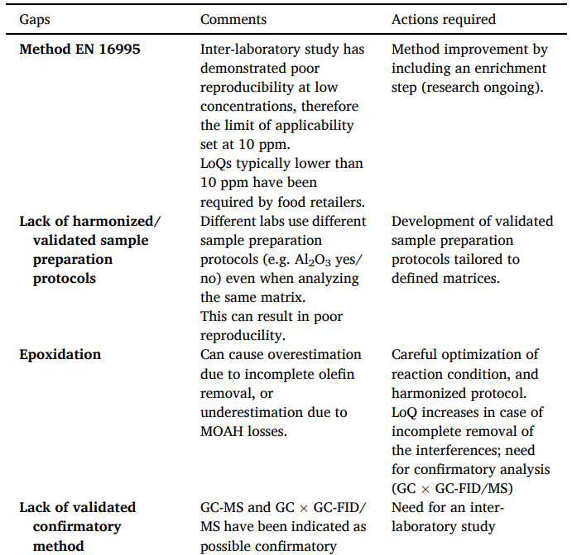
ª A first attempt to support the interpretation of chromatogram is in Biedermann and Grob (2012b) and in the JRC guidance (Bratinova & Hoekstra, 2019).

^{b} For each C-fraction not detected, a concentration equal to zero (lower bound), half the LoQ value (medium bound approach), equal to the LoQ value (upper bound approach) is assumed. In a 2019 Technical Report on “Rapid risk assessment on the possible risk for public health due to the contamination of infant formula and follow- on formula by mineral oil aromatic hydrocarbons (MOAH)”, EFSA applied the lower bound approach for MOAH quantification (Arcella, Baert, & Binaglia, 2019).

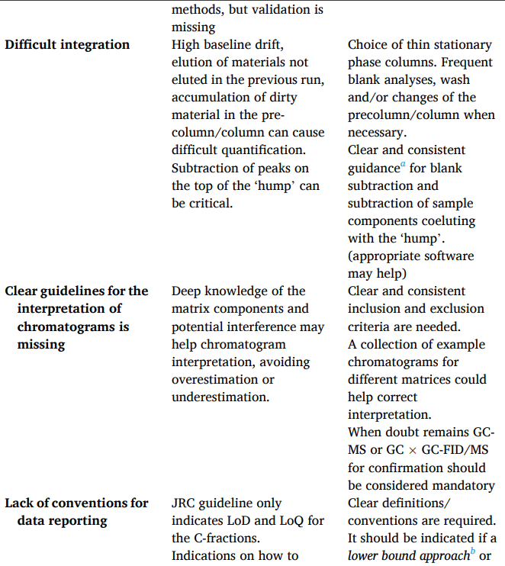

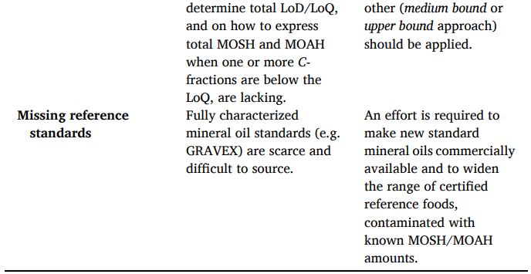

fractionation, characterization and quantification in a single analysis (Purcaro & Panto´, 2020 approach can also distinguish between the number of aromatic rings within the MOAH fraction without any further LC fractionation.

Current gaps and uncertainty in MOH analysis

Table 2 summarizes the current gaps in analytics, data interpretation and reporting with a commentary on possible actions to address the gaps. The need for standardized/validated methods has been addressed by most of the participants, especially by food companies that have to rely on analytical results provided by the control laboratories, which often are not aligned, mainly due to the different analytical protocol applied. In this context, method standardization could help in obtaining improved inter-laboratory reproducibility. On the other hand, according with some researchers there are too many variables (e.g. hydrocarbon mixtures, foods, interferences) to be optimally treated by one or a few standard methods. For instance, whether or not to apply enrichment, removal of n-alkanes, epoxidation or additional GCxGC analysis should remains expert judgement. Although standardization tends to lead to more reproducible results, it also presents the risk of hiding errors that are common to all the laboratories. Many labs underlined the need to develop matrix tailored sample preparation protocols, which could orient the choice of the sample preparation method. There was a general consensus on the fact that MOSH and MOAH analysis should be per- formed by well experienced analysts.

Future perspective

It appears evident that still a significant effort is necessary to fill the gap in the analytical determination of MOSH and MOAH. To avoid dispersion of energy it is highly necessary to focus on the relevant fractions of MOSH and MOAH. On the other side, toxicologists need a more detailed characterization of the different fractions for which an evaluation is necessary. Therefore, analysts and toxicologists should work in tight connection to advance in the field of MOSH and MOAH at the same pace optimizing the mutual efforts. At present, the main efforts is represented by a better characterization of the different MOSH and MOAH sub-classes and some approaches towards this direction have been just proposed.
Since MOAH with three or more non- or simple alkylated aromatic rings may be mutagenic and carcinogenic, it is important to distinguish them from MOAH with 1–2 aromatic rings. MOAH fractionation can be achieved by comprehensive GC × GC, although the partially hydrogenated polycyclics are located in the 2D plot across the clusters of MOAH of given rings disturbing the clear separation of the sub-classes. More- over, GC × GC increase the sensitivity of a factor of ~10 and allow the complete separation of the fraction of interest from the column bleeding. A pre-separation from the MOSH fraction is required for optimal sepa- ration. As already reported, on line LC-GC × GC-FID/MS represents a powerful approach for MOAH fractionation, characterization and quantification. MOAH fractionation can also be achieved via HPLC. An early reported method using on-line LC-LC-GC (Moret, Grob, & Conte, 1996) involved an LC pre-separation on a large silica column able to retain up to 150 mg of fat, on-line evaporation of the MOAH, MOAH fractioning (according to the ring number) on an amino column, and GC transfer through a vaporizer/overflow interface. This rather complicated method has never been used for routine analysis, but illustrated the potential of the amino phase for MOAH fractioning.
In 2019, Koch et al. published a method for separation into a mono-/ diaromatic fraction (MDAF) and three/poly aromatic fractions (TPAF). The method uses a silver nitrate loaded silica gel column for off-line separation into MOSH and MOAH. The MOAH fraction is subsequently separated into MDAF and TPAF by using a donor acceptor based HPLC column. Finally the extracts underwent on-line HPLC-GC-FID analysis as described for the “standard” procedure. Verification of the separation efficiency was achieved by GC × GC-MS.
García-Cicourel, van de Velde, Verduin, and Janssen (2019) used a silver nitrate LC column for off-line comprehensive LC × GC coupled to FID or vacuum ultraviolet detection (VUV) for detailed characterization of MOAH in the case of highly purified MO used in foods, cosmetics and pharmaceuticals.

Exposure assessment

Routes and sources of exposure

MOH are known to be unintentionally present in foods, pharmaceuticals, cosmetics and other consumer products. Therefore, exposure can occur through different routes, namely ingestion, skin contact and inhalation. The oral route is considered the most relevant and dietary intake is most likely the highest single source of exposure for many consumers. Dermal contact with materials and products such as cosmetics, toys and textiles have also been identified as an important exposure route (Concin et al., 2011; Gomez-Berrada, Ficheux, Dahmoul, Roudot, & Ferret, 2017). The BfR has recently addressed the topic of dermal exposure combined with oral intake due to hand-to-mouth contact and hand-to-food contact, of cosmetics including lip care products. It was concluded that the contribution of the dermal route to internal exposure (uptake) is limited due to low skin absorption of cosmetic formulations. Furthermore, the contribution of lip products to MO ingested orally was considered to be less than 10% of the Acceptable Daily Intake (ADI) value defined by Bundesinstitut für Risikobewertung (2015).
A number of intentional and unintentional sources of MOH in foods can be identified. Specifically regarding the contribution of FCMs, although MOH occurrence studies have primarily focused on foods that have been in contact with recycled paper and board, foods packaged in other materials may also contribute to exposure.

Occurrence data and exposure estimates

Dietary exposure

Overall, it is recognised that occurrence of accessible data of MOH in foods is scarce. Occurrence data used in an available EFSA opinion (EFSA, 2012b) concerned only a limited number of food groups and were obtained from a small number of countries. Furthermore, as MOSH and MOAH have different toxicological profiles, occurrence data on both fractions are required. However, in the opinion only total MOSH measurements were available and MOAH was estimated based on the typical composition of non-foodgrade MO products. Due to the lack of data, monitoring in Europe was launched by the European Commission in 2017 but results are not yet available. Some additional occurrence data have become available in the meantime, but most data collection efforts have targeted specific food groups selected based on the already identified sources of MOH, such as dry foods packed in paper and board FCMs (Food Watch, 2015; Vollmer et al., 2011). The lack of data originating from sampling plans covering a wider range of foods may hinder the identification of other potential sources of exposure and estimation of the relative contributions of different specific sources.
Recently, a survey of occurrence of MOH was performed for foods on the Belgian market (Van Heyst et al., 2018). Samples were selected taking into consideration consumption frequency, risk for MO contamination and market shares. A total of 198 samples were analysed, including grains and grain-based products, vegetables, sugar, confectionary, desserts, snacks, legumes, nuts and oil seeds, meat, fish and their products and animal and vegetable fats and oils. MOSH was detected in ca 70% of the samples at concentrations higher than the LoQ, with the highest mean and maximum values in confectionary including chocolate (28–85 mg/kg, respectively). The MOAH concentration was lower than the LoQ in 88% of the samples but it was detected in almost all vegetable oils and chocolate flakes at levels higher than the LoQ (max 2.24 mg/kg in coffee). Due to similar polarity, MOH are present in many fats and oils and consequently in the foods prepared thereof. The authors concluded that the measured concentrations were lower compared to previous market surveys.
A survey of MOSH and MOAH in cocoa butter, palm and sunflower oils, collected in Germany between 2013 and 2017, was recently re- ported (Stauff, Schnapka, Heckel, & Matissek, 2020). Values of MOSH (C10–C50) were in the range of <2.5 mg/kg (LoQ) up to 162 mg/kg in cocoa butter (n = 142), 124 mg/kg in palm oil (n = 21) and 17 mg/kg in sunflower oil (n = 12), respectively. For MOAH, values from <2.5 mg/kg (LoQ) up to 55 and 39 mg/kg, were found in cocoa butter and palm oil, respectively, while in all sunflower oil samples MOAH were < LoQ. Deodorization was shown to reduce MOSH/MOAH ≤ C24 significantly (Stauff et al., 2020).
Estimates of exposure to MOH have been made considering the total MOSH and total MOAH fraction (EFSA, 2012c). After the estimates were available, only a few additional exposure estimates have been produced in Europe. In the Netherlands, an estimation of the exposure to MOH was performed via the total diet and more specifically via foods packed in paperboard (van de Ven, Fragki, te Biesebeek, Rietveld, & Boon, 2017). No new occurrence data was generated as data from third-parties (EFSA, 2012c; Food Watch, 2015) were combined with Dutch consumption data from two surveys, namely one on children up to 6 years and another on population from 7 to 69 years old. Not surprisingly the results were in good agreement with the estimates from EFSA (EFSA, 2012a). For children, the estimated values for 95th percentiles of exposure to MOSH and MOAH were respectively 0.200 and 0.026 mg/kg bw per day via the total diet. The dietary exposure to MOSH and MOAH via the consumption of paperboard packed foods was only about 2% of the total exposure at the median level (50th percentile), in all populations. At the high level of exposure (95th percentile), this percentage increased to about 15% for children and 18% for persons aged 7 to 69 (van de Ven et al., 2017). The contribution of MOSH migrating from the recycled paperboard into dry foods to the MOSH total dietary exposure of the Dutch population, was found to be less important than previously reported by EFSA.
Dietary exposure to MOH has also been estimated based on the Belgian occurrence data (Van Heyst et al., 2018). For 3–9 years old consumers, exposure values of MOSH ranged from 0.006 (50th percentile) to 0.013 mg/kg by weight (bw) per day (95th percentile). For MOAH, exposure values were estimated to be between 0.00015 mg/kg bw per day (50th percentile) and 0.00038 mg/kg bw per day (95th percentile). For the older population (10–64 years old), MOSH exposure estimates were lower, for both median and high level of intake, while for MOAH similar, or even higher, estimates were obtained for both consumption scenarios.
Cereal products were the highest contributor to MOSH exposure: 53% for children and 37% for adults. The second most important food contributors differed with population age and were cakes and sweet biscuits (ca. 13%) for children and adolescents, and non-alcoholic beverages (i.e. tea and coffee) with ca. 32% for adults. Although cereal products and non-alcoholic beverages were the main contributors for the exposure to MOAH, the exposure was also driven by the consumption of fats and oils. These exposure estimates are considerably lower than those presented by EFSA (2012b) and RIVM (van de Ven et al., 2017) due to the wider range of foods sampled instead of targeting specifically dry foods grain-based or chocolate products (Van Heyst et al., 2018). Within the study, non-alcoholic drinks, such as coffee were identified as an additional relevant contributor to MOH exposure. However, it should be noted that the concentration of MOH in coffee was most probably overestimated since the concentration was determined in dry coffee and a 100% transfer into the drink was assumed.
Data specific on occurrence of MOAH in infant and follow-on formula was provided recently to EFSA. Information on the absence of 3–7 polycyclic aromatic compounds in the samples analysed was not made available (Arcella et al., 2019). Specialised Nutrition Europe provided results for different MOAH fractions related to 696 samples of infant and follow-on formula, in powder and liquid, collected between 2016 and 2019. In infant-formula powder, MOAH was detected in 4% of the samples with 1.6 mg/kg as the highest result found for MOAH C25–C35. In liquid formulas (13 samples of infant and 6 samples of follow-on formula) MOAH fractions were not detected. These data were combined with results provided by Austria and Germany, and with results made available by Foodwatch on 16 samples collected in France, Germany and the Netherlands. The minimum and maximum quantified concentrations of MOAH used for exposure estimates were 0.2 mg/kg and 3 mg/kg respectively. Based on the maximum concentration, the mean exposure to MOAH in consumers of infant formula and follow-on formula was estimated to be: for infants - from 12.3 to 44.6 μg/kg bw per day; for toddlers - from 6.4 to 13.4 μg/kg bw per day and for infants below 12 weeks - 64 μg/kg bw per day.
Regarding exposure from lip care products, occurrence of MOSH (and POSH) was determined in 175 cosmetic lip products taken from the Swiss market in order to estimate their contribution to human oral exposure due to ingestion. It was concluded that levels of MOSH and POSH should be reduced in the majority of cosmetic lip products to less than 5% to avoid an increase in the total exposure to these hydrocarbons by regular users (Niederer, Stebler, & Grob, 2016).

Data related to internal exposure

The dietary intake of MOSH and MOAH discussed above relates to external exposure. In contrast, levels of MOSH and MOAH found in animal and humans tissues may provide insights on the internal expo- sure as different exposure routes are taken into account. The fate and effects of MOSH in female Fischer rats (F-344) were investigated in a recent study (Cravedi, Grob, Nygaard, & Alexander, 2017). The results indicated that accumulation of MOSH depended on the mixture tested, but always occurred predominantly in the liver and to a lesser extent in adipose tissue and spleen. Strong differences were observed between liver and adipose tissue in terms of accumulated hydrocarbons: whereas in adipose tissue the accumulated fraction corresponded to the most volatile part of the administered mixture, in the liver, the most volatile as well as the highest boiling part of the mixture are almost absent. Also the types of hydrocarbons differ. When exposure ceased, a significant decrease of MOSH concentration was observed in the liver, but not in adipose tissue. However, extrapolation from these animal data to human tissues is highly uncertain and may under- or overestimate human in- ternal exposure (Barp et al., 2017b).
MOSH accumulation has also been studied in human tissue and was shown to vary between individuals and to depend on the size and structure of the substance and on the dose and duration of exposure. Within the same subject, accumulation also depends on the tissue. Several observations of MO in human tissue samples are also available, mostly lipogranulomas (Boitnott & Margolis, 1970; Cruickshank & Thomas, 1984; Dincsoy, Weesner, & MacGee, 1982; Lagana, Moreira, & Lefkowitch, 2010; Wanless & Geddie, 1985; Zhu, Bodenheimer, Clain, Min, & Theise, 2010). Furthermore, concentrations of MOH have also been determined in human milk (Noti, Grob, Biedermann, Deiss, & Brüschweiler, 2003) and in abdominal fat (Concin et al., 2008, 2011).
MOSH were measured recently in different human tissues (liver, lymph nodes, lung, fat tissues, brain, kidney and heart), in a sample of 37 individuals (11 females and 26 males) aged from 25 to 91 years (Barp et al., 2014). Results indicate a high level of accumulation for some tissues. Mean and median concentrations were clearly highest for the lymph nodes (223 and 166 mg/kg, respectively). Liver was next in average concentration (131 mg/kg). Fat tissue was the second highest in terms of median concentration (87 mg/kg). In the case of the spleen, for which data on possible MOH-associated granulomas was reported in the past, contained 2.4 times less MOSH in terms of mean values and 5.9 times less in terms of the median compared to lymph nodes. Brain, heart and kidney contained far less MOSH than other tissues analysed. Over- all, the maximum amount of MOSH (13.3 g) was estimated from concentrations measured in various tissues, for one individual. For 27% of the subjects a content of at least 5 g MOSH was estimated. Those amounts are indicative of a long-term accumulation. The MOSH composition in the fat tissue and in the lymph nodes was similar and varied little between the subjects while in spleen and liver MOSH with the same composition for a given subject was found but varied somewhat between subjects.
The proportions of the different fractions found in human tissues were highest for naphthenes (67%) > n-alkanes together with small branched paraffins (ca 24%) > multibranched paraffins (ca 9%). These proportions are considered to be similar to those present in contaminating MO mixtures, indicating that apart from the n-alkanes there is little apparent metabolic elimination. For naphthenes there was no significant trend towards compounds of lower or higher ring number.
MOAH was not detected in any of the tissues analysed at LODs ranging from 0.5 mg/kg in lungs to 5 mg/kg in spleen and lymph nodes. Since many of the mineral oils humans are exposed to contain MOAH at 10–30%, this means that MOAH are not accumulated (Barp, 2019; EFSA, 2012b).

Current gaps in MOH exposure assessment

Exposure estimates to MOH still suffer from significant data gaps. Only a limited number of surveys have covered a wide range of foods and a sufficient number of samples to detect major sources of contamination in order to determine their contributions to the dietary intake. Many surveys have focused on foods packed in paperboard. The contamination of food via environment, primarily with MOSH ubiquitous at low concentrations, may be a relevant contribution for specific foods with high level of consumption (Fiorini et al., 2008; Fiselier & Grob, 2009; Neukom, Grob, Biedermann, & Noti, 2002). Additionally, the analytical limitations on the detection, quantification and characterisation of different fractions of MO in different matrices have a direct impact on the exposure estimates. Internal exposure estimates from data on concentrations of MOH in the human body are fundamental to avoid under or over-estimation, but data on concentration of different MOH fractions in human body is even scarcer and there are attendant analytical challenges. Using levels of MOH in the human body to identify relevant sources of MOSH is of great interest. Data relating concentration in tissues with personal data, lifestyle, food intake and the use of cosmetics are needed to clarify the complex system of distribution of MOSH in the body and to possibly establish relationship between external and internal exposure.

Hazard characterization

The hazards of MOSH and MOAH have been extensively described by the EFSA in 2012 (EFSA, 2012b). Therefore, only the most important toxicological information is summarized below together with relevant data published after 2012. More details on the toxicological profile of MOSH and MOAH can be found in the recent review of Pirow et al. (2019). The following sections address mainly the chronic effects as acute toxicity of both MOSH and MOAH is considered to be low to moderate for both individual substances and mixtures. As the oral route is the most relevant for exposure to MOH, this section focuses on hazards of MOSH and MOAH present in food. Studies on the toxicological relevance of synthetic hydrocarbons are missing. According to Barp et al. (2014), due to their similarity to MOSH, POH presence should be evaluated considering their bioaccumulation potential in human tissues.

MOSH-related hazards

Toxicokinetic aspects

After ingestion, MOSH follow the absorption pathway of dietary lipids (Pirow et al., 2019). In rats, absorption of MOSH after oral exposure depends on the number of carbon atoms and the strains involved (Barp et al., 2017a; Boogaard et al., 2012; EFSA, 2012b). Human data on the uptake of MOSH from the gastrointestinal tract are scarce (Bevan, Harrison, Jeffery, & Mitchell, 2020). In a study with human female volunteers receiving a single oral dose of paraffinic hydrotreated white oil (P15H; 1 mg/kg bw), no MOSH were detected in blood (LoD = 16 μg/L) at any of the selected time points, suggesting that under the investigated conditions, absorption of MOSH is negligible. Nevertheless, the occurrence of MOSH in different human tissues suggests that absorption of MOSH does occur. After absorption, MOSH compounds are mainly distributed via the lymphatic system and normally metabolised to fatty alcohols and fatty acids by Cytochrome P450 (CYP). Metabolism is considered the most important process to eliminate absorbed MOSH (Pirow et al., 2019). Importantly, certain MOSH with a carbon number ranging from 16 to 40 accumulate in different tissues including the liver, mesenteric lymph nodes and fat, both in humans and animals (EFSA, 2012b). Although molecules in the range of C22–C34 are preferentially retained in tissues of rats and humans, there are important inter- and intraspecies differences in the degree and site of accumulation (Adenuga, Goyak, & Lewis, 2017). For example, both in F-344 Fisher and CRL-CD Sprague-Dawley rats, MOSH are preferentially retained in mesenteric lymph nodes and liver after subchronic oral administration of P15H. However, MOSH levels were much higher in the liver of F-344 rats compared to Sprague-Dawley rats (Firriolo et al., 1995). The same effect was reported for liver concentrations in a single dose study with P15H (Boogaard et al., 2012). Furthermore, MOSH appears to be preferentially retained in human adipose tissue whereas in F-344 rats, most of the MOSH was deposited in the liver (Bevan et al., 2020). Importantly, concentrations of MOSH found in certain human tissues were very high, far above the estimates from animal experiments, and sometimes even higher than those in animal experiments at the highest does (Barp et al., 2014). Both in humans and in animals, most of the ingested MOSH are not absorbed and are excreted in the faeces (EFSA, 2012b).

Toxicodynamic aspects

In studies using F-344 rats, accumulation of MOSH is associated with the presence of microgranulomas in liver and mesenteric lymph nodes, as well as increased organ weights, specifically in liver and spleen (Bevan et al., 2020; EFSA, 2012b). Microgranulomas in the mesenteric lymph nodes are regarded as non-specific, adaptive changes and consequently, not toxicologically significant (EFSA, 2012b). In contrast, the epithelioid granulomas found in the liver of the F-344 rats are associated with inflammation, and although not linked with other notable pathological changes (Trimmer, Freeman, Priston, & Urbanus, 2004), they were considered as the critical adverse effect of MOSH by EFSA in 2012. Over the last years, it has become clear that the mechanism underlying the formation of these granulomas in F-344 rats is not biologically relevant for humans as they are induced by components of waxes which do not accumulate in human tissues (Adenuga et al., 2017; Pirow et al., 2019). In humans, MOSH exposure has also been linked with granuloma formation in different organs including the liver (Boitnott & Margolis, 1970; Cruickshank & Thomas, 1984; Dincsoy et al., 1982). However, these granulomas are not epithelioid granulomas but lipogranulomas, small vacuolated macrophages with little or no lymphocytic inflammation which apparently do not progress over years and are morphologically different from the epitheloid granulomas found in F-344 rats. Furthermore, there was no evidence that the lesions were of clinical significance (Fleming & Carrillo, 2018). In 2017, the mode of action/human relevance framework (MoA/HRF) analysis was applied to epithelioid granuloma induced by MOSH in the F-344 rat model (Adenuga et al., 2017; Boobis et al., 2008). Within this assessment, increased intestinal absorption of MOSH, preferential tissue retention and an exaggerated inflammatory reaction were identified as key events leading to the development of epithelioid granulomas specifically in F-344 rats. The causality between the different key events was demonstrated based on the Bradford Hill criteria. However, the MoA present in the F-344 rat was not considered relevant to humans due to important strain/species differences for each of these key events (Adenuga et al., 2017). Compared to humans, F-344 rats have been suggested (i) to show a higher absorption rate for MOSH; (ii) to metabolize MOSH less efficiently, and (iii) to be more sensitive to the inflammatory response induced by MOSH. Furthermore, few reports on toxicity of retained fractions of MO in humans are available. Most of these effects were associated with high MOSH exposure and clearly different from those observed in F-344 rats (Adenuga et al., 2017). During the ILSI Europe workshop, based on several interpretations (Barp et al, 2014, 2017a, 2017b; Cravedi et al., 2017; Nygaard et al., 2019) the hypothesis was presented that the inflammation-associated granulomas found in F-344 rats are induced by paraffin waxes (solid) and not by MO (liquid). Paraffin waxes are mainly composed of linear alkanes (n-alkanes) which, regardless their origin (e.g. natural or mineral), are clearly retained in the liver in F-344 rats but not in other rat strains or humans due to kinetic differences. Accumulation of these n-alkanes may result in the formation of the inflammation-associated liver granulomas and consequently, liver effects in F-344 rats. Since waxes consist of almost only n-alkanes, these were considered by EFSA as the most potent MOSH, even if also n-alkanes from biogenic origin accumulate. Although paraffin waxes are not MO, data obtained with these complex substances were included in the evaluation of the MOSH-related hazards as the MOSH terminology does not discriminate between them. Interestingly, in the study of Cravedi et al. (2017), which was performed in response to the EFSA opinion of 2012, the highest incidence in epithelioid liver granulomas in F-344 rats was observed with the mixture containing the highest levels of n-alkanes. Furthermore, the hydrocar- bons found to accumulate in human liver are not n-alkanes, but instead medium and high viscosity cycloalkanes (Barp et al, 2014, 2017a; van de Ven et al., 2017). Based on these data, it was concluded that n-alkanes (mainly originating from waxes) are not very well absorbed and/or are efficiently metabolised and eliminated in humans, at the dietary intake levels (van de Ven et al., 2017). Accumulation in humans has been suggested to rather be the result of exposure to high molecular weight MOH (e.g. naphthenic hydrocarbons not present in waxes) originating from mineral oils. When the latter are present above a critical threshold (200 mg/kg tissue), oil droplets known as lipogranuloma are formed, which generally have no systemic or pathological consequence. This might be a further explanation why no MOSH-associated epithelioid granulomas (like those of the F-344 rat) have been observed in human liver (Boitnott & Margolis, 1970). Nevertheless, as indicated above, levels of accumulated MOSH in some human tissues are really high, and more insights are needed on whether they are of concern to human health or not.
MOSH are neither mutagenic nor carcinogenic. Some long-chain MOSH may present a tumour promoting effect (non-genotoxic effect) after dermal application at high doses in mouse skin-painting models of carcinogenesis, but little information is available on dose-response (EFSA, 2012b). In the opinion of 2012, EFSA recommended to further investigate the possible immune effects of MOSH after oral exposure, based on autoimmune responses observed in arthritis-prone rodent models after intradermal and intraperitoneal injections of high doses of certain MOSH (i.e. pristane and other adjuvants based on MO). Short term percutaneous exposure of abraded skin to MOSH resulted in a similar but milder and transient immune effect (Sverdrup, Klareskog, & Kleinau, 1998). Furthermore, an association between exposure to high doses of MOH and an increased risk for the development of automimmune diseases had been suggested in some epidemiological studies (Dahlgren et al., 2007; Sverdrup et al., 2005). Within this context, Andreassen et al. (2017) investigated the impact of dietary exposure to MOSH (i.e. pristane and MOSH mixtures) on the immune system in arthritis-susceptible Dark Agouti rats and compared it with the effect of a single intradermal injection of pristane. Whereas the latter resulted in arthritis symptoms and higher level of certain serum markers associated with arthritis development, no immune effects were observed after dietary exposure to pristane or MOSH mixtures. These results suggest that the immunotoxic effect of MOSH is route-specific and not relevant for long-term dietary intake of MOSH.

MOAH-related hazards

Toxicokinetic aspects

Based on the limited data available, MOAH appears to be absorbed following ingestion (Barrowman, Rahman, Lindstrom, & Borgstrom, 1989; Bevan et al., 2020). After absorption, MOAHs are oxidatively metabolised by CYP which partly explains why they do not accumulate in the body. Indeed, in humans, no MOAH has been detected in any tissues investigated (Barp et al., 2014). However, during metabolisation of certain MOAH, potentially genotoxic compounds (i.e. epoxide intermediates) may be formed. Like MOSH, MOAH are mainly excreted via the faeces (Iwahara, 1974).

Toxicodynamic aspects

MOAH may be mutagenic, specifically the 3–7 ring polycyclic aromatic compounds with no or a limited degree of alkylation, as these are bio-activated into DNA-reactive metabolites (Carrillo, van der Wiel, Danneels, Kral, & Boogaard, 2019; EFSA, 2012b; Mackerer, Griffis, Grabowski, & Reitman, 2003; Roy, Johnson, Blackburn, & Mackerer, 1988). Furthermore, MOAH can also interfere with other steps associated with the cancer process. Some strongly alkylated MOAH are known to act as tumor promoters (Carrillo et al., 2019; EFSA, 2012b; Rundhaug & Fischer, 2010), whereas certain simple MOAH (e.g. naphthalene) are carcinogenic through non-genotoxic mechanisms (IARC Working Group on the Evaluation of Carcinogenic Risks to Humans, 2002).
In order to remove substances with known carcinogenic activity, specific steps are undertaken in the refining of MO. The absence of carcinogenic compounds in refined hydrocarbon products has been evaluated with the mouse skin painting carcinogenicity assay. However, the assay provides a yes/no answer and no dose-response relationship because the protocol requires only one single standardized dose (undiluted oil sample). Oral carcinogenicity studies with MO complying with guidelines from the Organisation for Economic Co-operation and Development are not available. Furthermore, the mouse skin painting bioassay may be considered as a worst-case scenario.
Since the early 90’s, a DMSO-extraction based method (also known as IP346) (Roy et al., 1988) has been adopted in the EU as an alternative screening approach to the mouse skin bioassay. MOAH that may be still present in refined MO that passed the IP346 method are considered to be predominantly highly alkylated aromatic compounds, apparently largely monoalkylated (1–2 ring) aromatic compounds with long alkyl groups. It has been hypothesized that due to steric hindrance, these compounds are not bioactivated via oxidative metabolism by CYPs into DNA-reactive metabolites and thus these products of refining are considered not to contain genotoxic carcinogenic PAHs (Carrillo et al., 2019; Rundhaug & Fischer, 2010). However, so far, the exact impact of different types and degrees of alkylation on the genotoxicity of the parent compound remains unclear.
In contrast to refined MO products, the presence of mutagenic and carcinogenic 3–7 ring polycyclic aromatic compounds in MOAH detected in food (or other matrices) cannot be excluded as this will depend on the contamination sources. At present, there are no marker molecules to adequately characterize a MOAH mixture (EFSA, 2012b). Furthermore, as indicated above, hazard identification studies without dose-response information have been used to classify MOs containing 3–7 ring poly- cyclic aromatic compounds as possible human carcinogens. Such studies cannot be used to identify an oral reference point for hazard characterization of MOAH.
Some recent data suggest that MOAH may also have endocrine activity. A study with MO of varying aromatic hydrocarbon contents showed that MOAH present in these oils may act as xenoestrogens in vitro (Tarnow et al., 2016). Furthermore, the presence of 3–7 ring polycyclic aromatic hydrocarbons in DMSO extracts collected from petroleum substances could be correlated with the in vitro endocrine and dioxin-like activity detected in a panel of CALUX reporter gene assays with these extracts (Koch, Becker, Päch, Kühn, & Kirchhoff, 2019). In a follow-up study, the same authors were able to link the aryl hydrocarbon receptor (AhR)-mediated activities of the 3–7 ring polycyclic aromatic hydrocarbons with the prenatal developmental toxicity that has been observed for some petroleum substances (Koch, Becker, Päch, Kühn, & Kirchhoff, 2019). Consequently, also with respect to the endocrine potential of MOAH, it is of interest to know whether the 3–7 ring polycyclic aromatic hydrocarbons are actually present in MOAH detected in food (or other matrices). Also for MOAH, more information on the endocrine disrupting potential is needed.

Risk assessment

As illustrated above, MOSH and MOAH have a completely different toxicological profile, and therefore the associated risks are assessed individually. Furthermore, due to the unclear definition of MOSH and MOAH, the toxicology of single components within each group might be significantly different.

MOSH risk assessment

To date, risk assessment of MOSH has, regardless its composition, mainly been based on the no observed adverse effect (NOAEL) value of 19 mg/kg bw/day derived from the 90-day oral study in F-344 rats (Smith et al., 1996). In previous assessment of authorized mineral oil products, both waxes and mineral oils have been considered to act throught the same mode of action and consequently, they have both been based on the NOAEL value of 19 mg/kg bw/day. However, as highlighted above, this NOAEL value has been derived from a study performed with waxes, consisting mainly of n-alkanes, which do not accumulate in human tissues and consequently, this endpoint is not relevant for the human risk assessment of MOSH. Furthermore, the approach does not cover the risks induced by MOSH originating from (liquid) mineral oils which have been demonstrated to strongly accumulate in humans. Risks associated with MOSH originating from waxes and minderal oils should thus be assessed separately, and more adequate Point of Departure (PoD) values are needed for both. Within this context, changes in organ weights (mesenteric lymph node, spleen and liver) have been proposed (Grob, 2018) as a doubling in spleen weight was for example observed at concentrations lower than those observed in some human organs after treatment with an oil practically free of n-alkanes (Nygaard et al., 2019). Overall, to identify adequate PoDs, existing in- formation should be carefully reviewed and, if needed, complemented with new data.
Although risk assessment of MOSH detected in food should distinguish between MOSH originating from waxes and those derived from (liquid) mineral oils, in the assessments of the risks associated with dietary exposure to mineral oil performed so far (EFSA, 2012b; van de Ven et al., 2017), MOSH were analytically not differentiated into further subgroups. As a result, the lowest available NOAEL of 19 mg/kg bw/day was used as reference point for the risk assessments of the total MOSH (EFSA, 2012b; van de Ven et al., 2017). In these assessments, no health based guidance value (e.g. ADI or TDI) was derived but instead the Margin of Exposure (MOE) approach was applied comparing the estimated exposure to MOSH to the NOAEL (van de Ven et al., 2017):

MOE = ( NOAEL (19 mg kg—1 bw day—1) ) / Estimated exposure

Witin the assessment performed by EFSA (2012b), the minimal MOE value to consider MOSH exposure as ‘no concern’ was not mentioned. However, in the more recent risk assessment of the Netherlands, a MOE above 100 was considered to be associated with a low concern for human health. The selection of this value is due to the traditional use of standard Uncertainty Factors (UF) of 10 each for extrapolation of data from experimental animals to humans (interspecies variation) and for interindividual human (intraspecies) variation. Taking into account a MOE of 100, MOSH exposure was considered not of concern for human health in the Dutch population (van de Ven et al., 2018). Also in a recent study on the risks associated with dietary MOSH exposure for the Belgian population which used a similar risk assessment approach, the MOE for MOSH was well above 100 for all the investigated scenarios.
However, MOE of 100 may not be applicable for strongly accumulating substances, which might be the case for certain MOSH. Overall, there is a need to revise the risk assessment of MOSH, thereby taking into account new scientific insights, especially those related to the (lack of) human relevance of the liver epitheloid granulomas in F-344 rats.

MOAH risk assessment

When information on the origin of MOAH detected in food is not available, the complete MOAH fraction is in general considered to be genotoxic and carcinogenic. This worst-case approach has an important impact on the risk assessment process for MOAH because for genotoxic carcinogens it is established practice to consider that no toxicological threshold values exist. In this case, an MOE between a benchmark dose lower confidence limit (BMDL) and the assessed exposure, that is above 10,000 is considered to be of low priority with respect to human health concern (EFSA, 2012c).

MOE = BMDL / Estimated exposure

However, since no appropriate dose-response data for the carcinogenicity of MOAH are available to establish a BMDL, the MOE approach cannot be applied. Other possible approaches to assess the MOAH- related risks (i.e. Threshold of Toxicological Concern approach and MOE approach based on the BMDL value of PAH8; EFSA, 2008) were shortly discussed for the Belgian MO study during the workshop. However, as both are worst-case scenarios, they result in an over-estimation of the risks associated with MOAH exposure. Both the Dutch and the Belgian studies therefore concluded that no clear conclusion could be drawn on the risks related to MOAH exposure. It should be noted that in a recent assessment of the risks associated with MOAH contamination of infant formula and follow-on formula, EFSA stated that the detection of MOAH should be considered as potential concern for human health (Arcella et al., 2019).

Current gaps in MOH Risk Assessment

For MOSH, risk assessments have so far been based on the NOAEL value of 19 mg/kg bw/day derived from the 90-day oral study in F-344 rats with waxes. However, the epitheloid granulomas observed in the liver of these F-344 rats were shown not be relevant for humans. To improve risk assessment of MOSH detected in food, risks associated with MOSH constituents originating from waxes and those derived from (liquid) mineral oils should be evaluated separately. This requires both analytical differentiation between the two groups within the MOSH fraction and the use of more adequate PoD values. Such values can be obtained by carfully reviewing existing data and performing additional studies to fill existing data gaps, if needed, for example to further clarify whether the high levels of MOSH found in certain human tissues should be considered adverse or not. Furthermore, the evaluation of the authorized mineral oil products needs to be reconsidered as they are based on animal experiments with waxes and not with mineral oils.
For MOAH, neither dose-response data nor a toxicological reference point are available and consequently, no consolidated hazard characterization can be performed. Therefore, if no additional data on the presence of 3–7 ring polycyclic aromatic compounds in the MOAH fraction are available, the detection of MOAH in food (or other matrices) should be considered of possible concern for human health (EFSA, 2012b). Considering the important impact of 3–7 ring polycyclic aromatic compounds on the risk assessment, there is an urgent need to determine their presence in MOAH. However, in 2019, EFSA indicated that even if the presence of 3–7 ring polycyclic aromatic compounds in food can be excluded, characterization of non-neoplastic hazards would also not be feasible due to the lack of oral toxicity studies and completely toxicologically characterized MOAH-containing substances (Arcella et al., 2019), including the monoalkylated (1–2 ring) aromatic com- pounds with long alkyl groups. Studies generating information to identify and characterize the hazards, both carcinogenic and non-carcinogenic, of representative compounds found in MOAH are thus urgently needed.

Conclusions and recommendations

MOH may unintentionally contaminate food through different routes across food chains and the lifecycle of food contact materials. Analysis of MOH present in food reveals diverse humps of unknown origin. There is an urgent need for fully validated analytical methods, in particular in terms of specificity and reproducibility, for different food matrices to generate reliable MOH occurrence data. Indeed, the actual nature of what is identify as MOAH is still under debate due to the clear presence of large amount of interferences in the MOAH fractions which are not always handled properly and the high uncertainty of the results when dealing with low concentration and complex matrices. Identification of substances present in the humps are required to assist in the determination of sources of contamination and enable safety evaluation to be performed. In fact, the LC-GC-FID method alone fails to provide the additional information required verification techniques have been proposed but are still not widely applied and they are not validated yet. In addition, toxicological studies on the relevant MOH mixtures and possibly their components are required to enable human health risk assessment to be performed.

Funding

This manuscript is a proceeding of a workshop organized by ILSI Europe. The topic and potential contributing experts were identified by the Process-Related Compounds & Natural Toxins Task Force and the Packaging Materials Task Force. Members of those Task Forces are listed on the ILSI Europe website at https://ilsi.eu/. According to ILSI Europe policies, the expert group is composed of at least 50% of external non- industry members. The composition of the expert group and of the Task Force can be found at https://ilsi.eu/task-forces/food-safety/ process-related-compounds-and-natural-toxins/. The research project was handed over to the experts to independently refine the research question. Consequently the expert group carried out the work, i.e. collecting/analysing data/information and writing the scientific paper independently of other activities of the Task Forces. The research reported is the result of a scientific evaluation in line with ILSI Europe’s framework to provide a precompetitive setting for public-private partnership. For further information about ILSI Europe, please contact info@ilsieurope.be. The opinions expressed herein and the conclusions of this publication are those of the authors and do not necessarily represent neither the views of ILSI Europe, nor of its member companies, nor of any regulatory authority. Experts are not paid for the time spent on this work. However, non-industry members within the expert group were offered support for travel and accommodation costs to attend meetings to discuss the manuscript and a small compensatory sum (honorarium) with the option to decline.

Acknowledgments

The authors would like to thank Dr Maurizio Bonuomo, Dr Neil Buck, Mr Timothy Chandler, Dr Matthias Heume, Dr Francesca Lambertini, Ms Monika Mainka and Prof. An Vermeulen for their help. Within ILSI Europe, Dr Siméon Bourdoux, Dr Tobias Recker, Dr Elias Rito, and Mrs Belinda Antonio facilitated scientific meetings and coordinated the overall project management relating to the completion of this work.

References

Adenuga, D., Goyak, K., & Lewis, R. J. (2017). Evaluating the MoA/human relevance framework for F-344 rat liver epithelioid granulomas with mineral oil hydrocarbons. Critical Reviews in Toxicology, 47(9), 750–766. https://doi.org/10.1080/ 10408444.2017.1319336
Andreassen, M., Hjertholm, H., Cravedi, J. P., Grob, K., Alexander, J., & Nygaard, U. C. (2017). Effect of dietary pristane and other saturated mineral oils (MOSH) on autoimmune arthritis in rats. Toxicology Reports, 4, 104–112. https://doi.org/ 10.1016/j.toxrep.2017.02.002
Arcella, D., Baert, K., & Binaglia, M. (2019). Rapid risk assessment on the possible risk for public health due to the contamination of infant formula and follow-on formula by mineral oil aromatic hydrocarbons (MOAH). EFSA Supporting Publications, 16(11). https://doi.org/10.2903/sp.efsa.2019.EN-1741
Barp, L. (2019). What does human tissue data tell us about sources of exposure to MOH in man?.
Barp, L., Biedermann, M., Grob, K., Blas-Y-Estrada, F., Nygaard, U. C., Alexander, J., et al. (2017a). Accumulation of mineral oil saturated hydrocarbons (MOSH) in female fischer 344 rats: Comparison with human data and consequences for risk assessment. The Science of the Total Environment, 575, 1263–1278.
Barp, L., Biedermann, M., Grob, K., Blas-Y-Estrada, F., Nygaard, U. C., Alexander, J., et al. (2017b). Mineral oil saturated hydrocarbons (MOSH) in female Fischer 344
rats; accumulation of wax components; implications for risk assessment. The Science of the Total Environment, 583, 319–333. https://doi.org/10.1016/j. scitotenv.2017.01.071
Barp, L., Kornauth, C., Wuerger, T., Rudas, M., Biedermann, M., Reiner, A., et al. (2014).
Mineral oil in human tissues, Part I: Concentrations and molecular mass distributions. Food and Chemical Toxicology, 72, 312–321. https://doi.org/10.1016/j. fct.2014.04.029
Barrowman, J. A., Rahman, A., Lindstrom, M. B., & Borgstrom, B. (1989). Intestinal absorption and metabolism of hydrocarbons. Progress in Lipid Research, 28(3), 189–203. https://doi.org/10.1016/0163-7827(89)90012-X
Bevan, R., Harrison, P. T. C., Jeffery, B., & Mitchell, D. (2020). Evaluating the risk to humans from mineral oils in foods: Current state of the evidence. Food and Chemical Toxicology, 136, 110966. https://doi.org/10.1016/j.fct.2019.110966
Bundesinstitut für Risikobewertung. (2009). Übergänge von Mineralöl aus
Verpackungsmaterialien auf Lebensmittel. Stellungnahme Nr. 008/2010 Des BfR Vom 09. BfR. http://www.bfr.bund.de/cm/216/uebergaenge_von_mineraloel_aus_verpackun gsmaterialien_auf_lebensmittel.pdf.
Bundesinstitut für Risikobewertung. (2011). Sitzung der BfR-Kommission für Bedarfsgegenstände (BeKo) – protokoll der Sitzung vom 14 April 2011. BfR. http://www
.bfr.bund.de/cm/343/7_sitzung_der_bfr_kommission_fuer_bedarfsgegenstaende.pdf.
Bundesinstitut für Risikobewertung. (2012). Messung von Mineralöl - kohlenwasserstoffen in Lebensmitteln und Verpackungsmaterialien. BfR. https://www.bfr.bund.de/cm
/343/messung-von-mineraloel-kohlenwasserstoffen-in-lebensmitteln-und-verpa ckungsmaterialien.pdf.
Bundesinstitut für Risikobewertung. (2015). Highly refined mineral oils in cosmetics: Health risks are not to be expected according to current knowledge (Vol. 14, pp. 1–27). BfR, 008.
Biedermann-Brem, S., & Grob, K. (2011). Removal of mineral oil migrated from paperboard packing during cooking of foods in boiling water. European Food Research and Technology, 232(6), 1035–1041. https://doi.org/10.1007/s00217-011-
1478-9
Biedermann-Brem, S., Kasprick, N., Simat, T., & Grob, K. (2012). Migration of polyolefin oligomeric saturated hydrocarbons (POSH) into food. Food Additives & Contaminants Part A Chemistry, Analysis, Control, Exposure and Risk Assessment, 29(3), 449–460. https://doi.org/10.1080/19440049.2011.641164
Biedermann, M., Fiselier, K., & Grob, K. (2009). Aromatic hydrocarbons of mineral oil origin in foods: Method for determining the total concentration and first results. Journal of Agricultural and Food Chemistry, 57(19), 8711–8721.
Biedermann, M., & Grob, K. (2012a). On-line coupled high performance liquid chromatography-gas chromatography for the analysis of contamination by mineral oil. Part 1: Method of analysis. Journal of Chromatography A, 1255, 56–75. https:// doi.org/10.1016/j.chroma.2012.05.095
Biedermann, M., & Grob, K. (2012b). On-line coupled high performance liquid chromatography–gas chromatography for the analysis of contamination by mineral oil. Part 2: Migration from paperboard into dry foods: Interpretation of chromatograms. Journal of Chromatography A, 1255, 76–99. https://doi.org/ 10.1016/j.chroma.2012.05.096
Biedermann, M., & Grob, K. (2015). Comprehensive two-dimensional gas chromatography for characterizing mineral oils in foods and distinguishing them from synthetic hydrocarbons. Journal of Chromatography A, 1375, 146–153. https:// doi.org/10.1016/j.chroma.2014.11.064
Biedermann, M., McCombie, G., Grob, K., Kappenstein, O., Hutzler, C., Pfaff, K., et al. (2017). FID or MS for mineral oil analysis? Journal Fur Verbraucherschutz Und Lebensmittelsicherheit, 12(4), 363–365. https://doi.org/10.1007/s00003-017-1127-8
Biedermann, M., Munoz, C., & Grob, K. (2017). Update of on-line coupled liquid chromatography – gas chromatography for the analysis of mineral oil hydrocarbons in foods and cosmetics. Journal of Chromatography A, 1521, 140–149. https://doi. org/10.1016/j.chroma.2017.09.028
Biedermann, M., Munoz, C., & Grob, K. (2020). Epoxidation for the analysis of the mineral oil aromatic hydrocarbons in food. An update. Journal of Chromatography A, 1624(2), 461236. https://doi.org/10.1016/j.chroma.2020.461236
Food Federation Germany. (2017). BLL Toolbox for preventing the transfer of undesired mineral oil hydrocarbons into food. German Federation of Food Law and Food Science. https://www.lebensmittelverband.de/de/lebensmittel/verpackung/mineraloeluebergaenge/toolbox-vermeidung-mosh-moah.
Boitnott, J. K., & Margolis, S. (1970). Saturated hydrocarbons in human tissues. 3. Oil droplets in the liver and spleen. Johns Hopkins Medical Journal, 127(2), 65–78.
Boobis, A. R., Doe, J. E., Heinrich-Hirsch, B., Meek, M. E., Munn, S., Ruchirawat, M., et al. (2008). IPCS framework for analyzing the relevance of a noncancer mode of action for humans. Critical Reviews in Toxicology, 38(2), 87–96. https://doi.org/ 10.1080/10408440701749421

Boogaard, P. J., Goyak, K. O., Biles, R. W., van Stee, L. L. P., Miller, M. S., & Miller, M. J. (2012). Comparative toxicokinetics of low-viscosity mineral oil in Fischer 344 rats, Sprague-Dawley rats, and humans - implications for an Acceptable Daily Intake (ADI). Regulatory Toxicology and Pharmacology, 63(1), 69–77. https://doi.org/ 10.1016/j.yrtph.2012.02.014
Bratinova, S., & Hoekstra, E. (2019). Guidance on sampling, analysis and data reporting for the monitoring of minera oil hydrocarbons in food and food contact materials.
Luxembourg: Publications Office of the European Union, ISBN 978-92-76-00172-0. https://doi.org/10.2760/208879,JRC115694
Bratinova, S., Hoekstra, E., Emons, H., Hutzler, C., Kappenstein, O., Biedermann, M., et al. (2020). The reliability of MOSH/MOAH data: A comment on a recently published article. Journal Fur Verbraucherschutz Und Lebensmittelsicherheit, 15(3), 285–287. https://doi.org/10.1007/s00003-020-01287-w
Carrillo, J. C., van der Wiel, A., Danneels, D., Kral, O., & Boogaard, P. J. (2019). The selective determination of potentially carcinogenic polycyclic aromatic compounds in lubricant base oils by the DMSO extraction method IP346 and its correlation to mouse skin painting carcinogenicity assays. Regulatory Toxicology and Pharmacology, 106, 316–333. https://doi.org/10.1016/j.yrtph.2019.05.012
Concin, N., Hofstetter, G., Plattner, B., Tomovski, C., Fiselier, K., Gerritzen, K., et al. (2008). Mineral oil paraffins in human body fat and milk. Food and Chemical Toxicology, 46(2), 544–552. https://doi.org/10.1016/j.fct.2007.08.036
Concin, N., Hofstetter, G., Plattner, B., Tomovski, C., Fiselier, K., Gerritzen, K., et al. (2011). Evidence for cosmetics as a source of mineral oil contamination in Women. Journal of Women’s Health, 20(11), 1713–1719. https://doi.org/10.1089/ jwh.2011.2829
Cravedi, J., Grob, K., Nygaard, U. C., & Alexander, J. (2017). Bioaccumulation and toxicity of mineral oil hydrocarbons in rats - specificity of different subclasses of a broad mixture relevant for human dietary exposures. EFSA Supporting Publications, 14(2), 1090E. https://doi.org/10.2903/sp.efsa.2017.en-1090
Cruickshank, B., & Thomas, Jane (1984). Mineral oil (follicular) lipidosis. II. Histologic studies of spleen, liver, lymph nodes and bone marrow. Human Pathology, 15(8), 731–737. https://doi.org/10.1016/S0046-8177(84)80163-X
Dahlgren, J., Takhar, H., Anderson-Mahoney, P., Kotlerman, J., Tarr, J., & Warshaw, R. (2007). Cluster of systemic lupus erythematosus (SLE) associated with an oil field waste site: A cross sectional study. Environmental Health: A Global Access Science Source, 6(1), 8. https://doi.org/10.1186/1476-069X-6-15
Département Fédéral de L’intérieur. (2016). Ordonnance 817.023.21 du DFI du 16 de´cembre 2016 sur les matériaux et objets destinés à entrer en contact avec les denrées alimentaires (Ordonnance sur les matériaux et objets). Ordonnances du D´epartement F´ed´eral de L’int´erieur, Suisse, 1–60.
Dincsoy, H. P., Weesner, R. E., & MacGee, J. (1982). Lipogranulomas in non-fatty human livers. A mineral oil induced environmental disease. American Journal of Clinical Pathology, 78(1), 35–41. https://doi.org/10.1093/ajcp/78.1.35
EFSA. (2008). Polycyclic aromatic hydrocarbons in food - scientific opinion of the panel on contaminants in the food chain. EFSA Journal, 6(8). https://doi.org/10.2903/j. efsa.2008.724
EFSA. (2012a). Guidance on selected default values to be used by the EFSA Scientific Committee, Scientific Panels and Units in the absence of actual measured data. EFSA Journal, 10(3). https://doi.org/10.2903/j.efsa.2012.2579
EFSA. (2012b). Scientific opinion on mineral oil hydrocarbons in food. EFSA Journal, 10
(6). https://doi.org/10.2903/j.efsa.2012.2704
EFSA. (2012c). Statement on the applicability of the Margin of Exposure approach for the safety assessment of impurities which are both genotoxic and carcinogenic in substances added to food/feed. EFSA Journal, 10(3). https://doi.org/10.2903/j. efsa.2012.2578
EN European Standard. (2017). EN European Standard 16995:2017: Foodstuffs -Vegetable oils and foodstuff on basis of vegetable oils -Determination of mineral oil saturated hydrocarbons (MOSH) and mineral oil aromatic hydrocarbons (MOAH) with on-line HPLC-GC-FID analysis. EN European Standard.
European Commission. (2008). Regulation (EC) No 1333/2008 of the European parliament and of the council of 16 december 2008 on food additives. Off. J. Eur. Union, 351, 16–33.
European Commission. (2009a). Regulation (EC) No 1107/2009 of the European Parliament and of the Council of 21 October 2009 concerning the placing of plant protection products on the market and repealing Council Directives 79/117/EEC and 91/414/EEC. Off. J. Eur. Union, 309, 1–50.
European Commission. (2009b). Regulation (EC) No 1223/2009 of the European parliament and of the council of 30 november 2009 on cosmetic products (text with EEA relevance). Off. J. Eur. Union, 342, 59–209.
European Commission. (2011a). Commission implementing regulation (EU) No 540/ 2011 of 25 may 2011 implementing regulation (EC) No 1107/2009 of the European parliament and of the council as regards the list of approved active substances. Off. J. Eur. Union, 153, 1–186.
European Commission. (2011b). Commission Regulation (EU) No 10/2011 of 14 January 2011 on plastic materials and articles intended to come into contact with food. Off. J. Eur. Union, 10, 1–89.
European Commission. (2017). Commission Recommendation (EU) 2017/84 of 16 January 2017 on the monitoring of mineral oil hydrocarbons in food and in materials and articles intended to come into contact with food (Text with EEA relevance. ). Off. J. Eur. Union, 12, 95–96.
Federal Agency for the Safety of the Food Chain, Scientific Committee. (2017). Advice 19-2017 of the Scientific Committee of the FASFC on action thresholds for mineral oil hydrocarbons in food.
Fiorini, D., Fiselier, K., Biedermann, M., Ballini, R., Coni, E., & Grob, K. (2008).
Contamination of grape seed oil with mineral oil paraffins. Journal of Agricultural and Food Chemistry, 56(23), 11245–11250. https://doi.org/10.1021/jf802244r
Firriolo, J. M., Trimmer, G. W., Twitty, L. D., Smith, J. H., Freeman, J. J., & Morris, C. F. (1995). Comparative 90-day feeding study with low-viscosity white mineral oil in fischer-344 and sprague-dawley-derived CRL:CD rats. Toxicologic Pathology, 23(1), 26–33. https://doi.org/10.1177/019262339502300104
Fiselier, K., Fiorini, D., & Grob, K. (2009a). Activated aluminum oxide selectively retaining long chain n-alkanes: Part II. Integration into an on-line high performance liquid chromatography-liquid chromatography-gas chromatography-flame ionization detection method to remove plant paraffins for the d. Analytica Chimica Acta, 634(1), 102–109. https://doi.org/10.1016/j.aca.2008.12.011
Fiselier, K., Fiorini, D., & Grob, K. (2009b). Activated aluminum oxide selectively retaining long chain n-alkanes. Part I, description of the retention properties. Analytica Chimica Acta, 634(1), 96–101. https://doi.org/10.1016/j.aca.2008.12.007
Fiselier, K., & Grob, K. (2009). Determination of mineral oil paraffins in foods by on-line HPLC–GC–FID: Lowered detection limit; contamination of sunflower seeds and oils. European Food Research and Technology, 229(4), 679–688. https://doi.org/10.1007/ s00217-009-1099-8
Fiselier, K., Grundböck, F., Schön, K., Kappenstein, O., Pfaff, K., Hutzler, C., et al. (2013). Development of a manual method for the determination of mineral oil in foods and paperboard. Journal of Chromatography A, 1271(1), 192–200. https://doi.org/ 10.1016/j.chroma.2012.11.034
Fleming, K., & Carrillo, J. C. (2018). MOH accumulation in F344 rats. The Science of the Total Environment, 615, 1095–1098. https://doi.org/10.1016/j. scitotenv.2017.07.275
Food Federation Germany, Consumer Protection Consortium of the Federal States. (2019). Benchmark levels for mineral oil hydrocarbons (MOH) in foods. https:// www.lebensmittelverband.de/de/aktuell/20190502-veroeffentlichung-moh-orientierungswerte.
Food Watch. (2015). Mineral oil in food – results of the foodwatch test. https://www.foo dwatch.org/en/reports/2015/mineral-oil-in-food/.
García-Cicourel, A. R., van de Velde, B., Verduin, J., & Janssen, H. G. (2019).
Comprehensive off-line silver phase liquid chromatography × gas chromatography with flame ionization and vacuum ultraviolet detection for the detailed characterization of mineral oil aromatic hydrocarbons. Journal of Chromatography A, 1607. https://doi.org/10.1016/j.chroma.2019.460391
Gharbi, I., Moret, S., Chaari, O., Issaoui, M., Conte, L. S., Lucci, P., et al. (2017).
Evaluation of hydrocarbon contaminants in olives and virgin olive oils from Tunisia.
Food Control, 75, 160–166. https://doi.org/10.1016/j.foodcont.2016.12.003 Gomez-Berrada, M. P., Ficheux, A. S., Dahmoul, Z., Roudot, A. C., & Ferret, P. J. (2017).
Exposure assessment of family cosmetic products dedicated to babies, children and adults. Food and Chemical Toxicology, 103, 56–65.
Grob, K. (2018). Toxicological assessment of mineral hydrocarbons in foods: State of present discussions. Journal of Agricultural and Food Chemistry, 66(27), 6968–6974. https://doi.org/10.1021/acs.jafc.8b02225
Grob, K., Biedermann, M., Artho, A., & Egli, J. (1991). Food contamination by hydrocarbons from packaging materials determined by coupled LC-GC. Zeitschrift Fur Lebensmittel-Untersuchung Und Forschung, 193(3), 213–219.
Guinda, A., Lanzón, A., & Albi, T. (1996). Differences in hydrocarbons of virgin olive oils obtained from several olive varieties. Journal of Agricultural and Food Chemistry, 44 (7), 1723–1726. https://doi.org/10.1021/jf950571o
IARC Working Group on the Evaluation of Carcinogenic Risks to HumansIARC Working Group on the Evaluation of Carcinogenic Risks to Humans. (2012). Mineral oils, untreated or midly treated, 100F. Chemical agents and related occupations. Lyon: IARC Monographs.
IARC Working Group on the Evaluation of Carcinogenic Risks to Humans. (2002). Some Traditional Herbal Medicines, Some Mycotoxins, Naphthalene and Styrene, 82. IARC monographs on the evaluation of carcinogenic risks to humans. Lyon: IARCPress.
Iwahara, S. (1974). Studies on metabolism of diisopropylnaphthalene. National Defense Medical Journal, 21, 273–290.
Koch, M., Becker, E., Päch, M., Kühn, S., & Kirchhoff, E. (2019). Separation of the mineral oil aromatic hydrocarbons of three and more aromatic rings from those of one or two aromatic rings. Journal of Separation Science. https://doi.org/10.1002/ jssc.201900833
Koprivnjak, O., Procida, G., & Favretto, L. (1997). Determination of endogenous aliphatic hydrocarbons of virgin olive oils of four autochthonous cultivars from Krk Island (Croatia). Food Technology and Biotechnology, 35(2), 125–131.
Koster, S., Varela, J., Stadler, R. H., Moulin, J., Cruz-Hernandez, C., Hielscher, J., et al. (2020). Mineral oil hydrocarbons in foods: Is the data reliable? Food Additives & Contaminants Part A Chemistry, Analysis, Control, Exposure and Risk Assessment, 37(1), 69–83. https://doi.org/10.1080/19440049.2019.1678770
Lagana, S. M., Moreira, R. K., & Lefkowitch, J. H. (2010). Hepatic granulomas: Pathogenesis and differential diagnosis. Clinics in Liver Disease, 14(4), 605–617.
Lommatzsch, M., Biedermann, M., Grob, K., & Simat, T. J. (2016). Analysis of saturated and aromatic hydrocarbons migrating from a polyolefin-based hot-melt adhesive into food. Food Additives & Contaminants Part A Chemistry, Analysis, Control, Exposure and Risk Assessment, 33(3), 473–488. https://doi.org/10.1080/
19440049.2015.1130863
Lommatzsch, M., Biedermann, M., Simat, T. J., & Grob, K. (2015). Argentation high performance liquid chromatography on-line coupled to gas chromatography for the analysis of monounsaturated polyolefin oligomers in packaging materials and foods. Journal of Chromatography A, 1402, 94–101.
Mackerer, C. R., Griffis, L. C., Grabowski, J. S., & Reitman, F. A. (2003). Petroleum mineral oil refining and evaluation of cancer hazard. Applied Occupational and Environmental Hygiene, 18(11), 890–901. https://doi.org/10.1080/
10473220390237467
Moret, S., Grob, K., & Conte, L. S. (1996). On-line solvent evaporator for coupled LC systems: Further developments. HRC Journal of High Resolution Chromatography, 19 (8), 434–438. https://doi.org/10.1002/jhrc.1240190803
Moret, S., Scolaro, M., Barp, L., Purcaro, G., & Conte, L. S. (2016). Microwave assisted saponification (MAS) followed by on-line liquid chromatography (LC)–gas chromatography (GC) for high-throughput and high-sensitivity determination of mineral oil in different cereal-based foodstuffs. Food Chemistry, 196, 50–57. https:// doi.org/10.1016/j.foodchem.2015.09.032
Moret, S., Scolaro, M., Barp, L., Purcaro, G., Sander, M., & Conte, L. S. (2014).
Optimisation of pressurised liquid extraction (PLE) for rapid and efficient extraction of superficial and total mineral oil contamination from dry foods. Food Chemistry, 157, 470–475. https://doi.org/10.1016/j.foodchem.2014.02.071
Nestola, M., & Schmidt, T. C. (2017). Determination of mineral oil aromatic hydrocarbons in edible oils and fats by online liquid chromatography–gas chromatography–flame ionization detection – evaluation of automated removal strategies for biogenic olefins. Journal of Chromatography A, 1505, 69–76. https:// doi.org/10.1016/j.chroma.2017.05.035
Neukom, H.-P., Grob, K., Biedermann, M., & Noti, A. (2002). Food contamination by C20–C50 mineral paraffins from the atmosphere. Atmospheric Environment, 36(30), 4839–4847. https://doi.org/10.1016/S1352-2310(02)00358-8
Niederer, Markus, Stebler, Thomas, & Grob, Koni (2016). Mineral oil and synthetic hydrocarbons in cosmetic lip products. Internaitonal Journal of Cosmetic Science, 38, 194–200. https://doi.org/10.1111/ics.12276
Noti, A., Grob, K., Biedermann, M., Deiss, U., & Brüschweiler, B. J. (2003). Exposure of babies to C15-C45 mineral paraffins from human milk and breast salves. Regulatory Toxicology and Pharmacology, 38(3), 317–325. https://doi.org/10.1016/S0273-2300
(03)00098-9
Nygaard, U. C., Vege, Å., Rognum, T., Grob, K., Cartier, C., Cravedi, J. P., et al. (2019).
Toxic effects of mineral oil saturated hydrocarbons (MOSH) and relation to accumulation in rat liver. Food and Chemical Toxicology, 123, 431–442. https://doi. org/10.1016/j.fct.2018.11.022
Pirow, R., Blume, A., Hellwig, N., Herzler, M., Huhse, B., Hutzler, C., et al. (2019).
Mineral oil in food, cosmetic products, and in products regulated by other legislations. Critical Reviews in Toxicology, 49(9), 742–789. https://doi.org/10.1080/ 10408444.2019.1694862
Purcaro, G., Barp, L., & Moret, S. (2016). Determination of hydrocarbon contamination in foods. A review. Analytical Methods, 8(29), 5755–5772. https://doi.org/10.1039/ c6ay00655h
Purcaro, G., Moret, S., & Conte, L. (2013). Sample pre-fractionation of environmental and food samples using LC-GC multidimensional techniques. TRAC Trends in Analytical Chemistry, 43, 146–160.
Purcaro, G., & Panto´, S. (2020). Towards a fully integrated LC-GC×GC-ToFMS/FID platform to unravel the MOSH&MOAH hump in food, AOCS Annual Meeting & Expo. June 29- July 3. online presentation.
Purcaro, G., Tranchida, P. Q., Barp, L., Moret, S., Conte, L. S., & Mondello, L. (2013). Detailed elucidation of hydrocarbon contamination in food products by using solid- phase extraction and comprehensive gas chromatography with dual detection.
Analytica Chimica Acta, 773, 97–104. https://doi.org/10.1016/j.aca.2013.03.002 Ramaroson-Raonizafinimanana, B., Gaydou, É. M., & Bombarda, I. (1997). Hydrocarbons
from three vanilla bean species: V. Fragrans , V. Madagascariensis , and V. Tahitensis. Journal of Agricultural and Food Chemistry, 45(7), 2542–2545. https://doi. org/10.1021/jf960927b
Roy, T. A., Johnson, S. W., Blackburn, G. R., & Mackerer, C. R. (1988). Correlation of mutagenic and dermal carcinogenic activities of mineral oils with polycyclic aromatic compound content. Toxicological Sciences, 10(3), 466–476. https://doi.org/ 10.1093/toxsci/10.3.466
Rundhaug, J. E., & Fischer, S. M. (2010). Molecular mechanisms of mouse skin tumor promotion. Cancers, 2(2), 436–482. https://doi.org/10.3390/cancers2020436
Smith, J. H., Mallett, A. K., Priston, R. A.j., Brantom, P. G., Worrell, N. R., Sexsmith, C., et al. (1996). Ninety-day feeding study in fischer-344 rats of highly refined petroleum-derived food-grade white oils and waxes. Toxicologic Pathology, 24(2), 214–230. https://doi.org/10.1177/019262339602400210
Spack, L. W., Leszczyk, G., Varela, J., Simian, H., Gude, T., & Stadler, R. H. (2017).
Understanding the contamination of food with mineral oil: The need for a confirmatory analytical and procedural approach. Food Additives & Contaminants Part A Chemistry, Analysis, Control, Exposure and Risk Assessment, 34(6), 1052–1071. https://doi.org/10.1080/19440049.2017.1306655
Stauff, A., Schnapka, J., Heckel, F., & Matissek, R. (2020). Mineral oil hydrocarbons (MOSH/MOAH) in edible oils and possible minimization by deodorization through the example of cocoa butter. European Journal of Lipid Science and Technology, 122 (7), 1900383. https://doi.org/10.1002/ejlt.201900383
Sverdrup, B., Källberg, H., Bengtsson, C., Lundberg, I., Padyukov, L., Alfredsson, L., et al. (2005). Association between occupational exposure to mineral oil and rheumatoid arthritis: Results from the Swedish EIRA case-control study. Arthritis Research and Therapy, 7(6), R1296. https://doi.org/10.1186/ar1824
Sverdrup, B., Klareskog, L., & Kleinau, S. (1998). Common commercial cosmetic products induce arthritis in the DA rat. Environmental Health Perspectives, 106(1), 27–32. https://doi.org/10.1289/ehp.9810627
Tarnow, P., Hutzler, C., Grabiger, S., Schön, K., Tralau, T., & Luch, A. (2016). Estrogenic activity of mineral oil aromatic hydrocarbons used in printing inks. PloS One, 11(1), S64–S65. https://doi.org/10.1371/journal.pone.0147239
Trimmer, G. W., Freeman, J. J., Priston, R. A. J., & Urbanus, J. (2004). Results of chronic dietary toxicity studies of high viscosity (P70H and P100H) white mineral oils in Fischer 344 rats. Toxicologic Pathology, 32(4), 439–447. https://doi.org/10.1080/
01926230490465865
Van Heyst, A., Vanlancker, M., Vercammen, J., den Houwe, K., Mertens, B., Elskens, M., et al. (2018). Analysis of mineral oil in food: Results of a Belgian market survey. Food Additives & Contaminants: Part A, 35(10), 2062–2075.
van de Ven, B. M., Fragki, S., te Biesebeek, J. D., Rietveld, A. G., & Boon, P. E. (2017).
Mineral oils in food; a review of toxicological data and an assessment of the dietary exposure in The Netherlands. https://doi.org/10.21945/RIVM-2017-0182. In RIVM Letter Report 2017-0182.
Vollmer, A., Biedermann, M., Grundbock, F., Ingenhoff, J.-E., Biedermann-Brem, S., Altkofer, W., et al. (2011). Migration of mineral oil from printed paperboard into dry foods: Survey of the German market. European Food Research and Technology, 232(1), 175–182.
Wagner, C., Neukom, H.-P., Grob, K., Moret, S., & Populin, T. (2001). Mineral paraffins in vegetable oils and refinery by-products for animal feeds. Mitteilungen aus Lebensmitteluntersuchung und Hygiene, 92(5), 499–514.
Wanless, I. R., & Geddie, W. R. (1985). Mineral oil lipogranulomata in liver and spleen. A study of 465 autopsies. Archives of Pathology & Laboratory Medicine, 109(3),
283–286.
Wrona, M., Pezo, D., & Nerin, C. (2013). Rapid analytical procedure for determination of mineral oils in edible oil by GC-FID. Food Chemistry, 141(4), 3993–3999. https://doi. org/10.1016/j.foodchem.2013.06.091
Zhu, H., Bodenheimer, H. C., Jr., Clain, D. J., Min, A. D., & Theise, N. D. (2010). Hepatic lipogranulomas in patients with chronic liver disease: Association with hepatitis C and fatty liver disease. World Journal of Gastroenterology: WJG, 16(40), 5065.
Zoccali, M., Barp, L., Beccaria, M., Sciarrone, D., Purcaro, G., & Mondello, L. (2016). Improvement of mineral oil saturated and aromatic hydrocarbons determination in edible oil by liquid-liquid-gas chromatography with dual detection. Journal of Separation Science, 39(3), 623–631. https://doi.org/10.1002/jssc.201501247
Zurfluh, M., Biedermann, M., & Grob, K. (2014). Enrichment for reducing the detection limits for the analysis of mineral oil in fatty foods. Journal Fur Verbraucherschutz Und Lebensmittelsicherheit, 9(1), 61–69. https://doi.org/10.1007/s00003-013-0848-6

