Mineral oil saturated and aromatic hydrocarbons quantification: Mono- and two-dimensional approaches

Grégory Bauwensª, Sebastiano Pantó^{b}, Giorgia Purcaro^{a,∗}

ª Analytical Chemistry Lab, Gembloux Agro-Bio Tech, University of Liège, Gembloux, 5030, Belgium
^{b} LECO European Application and Technology Center (EATC), Berlin, Germany

Keywords: Mineral oil saturated hydrocarbons Mineral oil aromatic hydrocarbons Comprehensive two-dimensional gas chromatography LC-GC × GC Quantification

Abstract
The determination of the level of mineral oil contamination in foods is a well-known problem. This class of contaminants is generally divided into mineral oil saturated and aromatic hydrocarbons with different toxicological relevance and analytical challenges. Among the many challenges, data interpretation and integration represent an important source of uncertainty in the results provided by different laboratories leading to a variation evaluated on the order of 20%. The use of multidimensional comprehensive gas chromatography (GC × GC) has been proposed to support the data interpretation but the integration and the reliability of the results using this methodology has never been systematically evaluated. The aim of this work was to assess the integration and quantification performance of a two-dimensional (2D) software. The data were generated using a novel, completely automated platform, namely LC-GC × GC coupled to dual detectors, i.e., time-of-flight mass spectrometer (MS) and flame ionization detector (FID). From a systematic study of the failures of the two-dimensional quantification approach a novel solution was proposed for simplifying and automating the entire process. The novel algorithm was tested on ad hoc created samples (i.e. a paraﬃn mixture added of n-alkanes) and real-world samples proving the agreement of the results obtained by LC-GC × GC and the traditional mono-dimensional approach. Moreover, the benefits of using an entirely integrated platform were emphasized, particularly regarding the identity confirmation capability of the MS data, which can be easily translated into the 2D FID quantification feature.

∗ Corresponding author at: Gembloux Agro-Bio Tech, University of Liège, Bât. G1 Chimie des agro-
biosystèmes, Passage des Déportés 2, 5030 Gembloux, Belgium.
E-mail address: gpurcaro@uliege.be (G. Purcaro).

Introduction

Mineral oil hydrocarbons (MOH) originate from petroleum and its derived products and are classified into two main fractions composed of a large number of isomers, MO saturated hydro- carbons (MOSH, including linear, branched, and alkyl-substituted cycloalkanes) and MO aromatic hydrocarbons [MOAH, including mainly alkyl-substituted (poly)aromatic hydrocarbons with a different number of fused rings] [1].
The occurrence of MOH in food is known since 1991 [2], but the problem became of public concern in 2008/2009 after the finding of a highly contaminated edible oil (>1000 mg/kg) and the discovery of migration of MOH from recycled paperboard [3,4]. In 2012 the European Food Safety Authority (EFSA) published an Opinion on MOH in food, stressing the urgency of the matter and lack of conclusive data for risk assessment [5]. In 2017, the European Union (EU) required the collection of additional and more detailed occurrence data (Commission Recommendation 2017/84 [6]) and in 2019 stressed the importance of the 3–7 ring MOAH fraction for toxicological evaluation [7].
The LC-GC-FID method proposed by Biedermann et al. [8] in 2009 and later slightly modified [9,10] is considered as the reference procedure. However, the overall procedure is highly sample- dependent. A complete overview and discussion of the analytical techniques proposed so far can be found in some recently published reviews [11–14].
Despite significant efforts, the determination of MOSH and MOAH in food remains very challenging and an intense debate is ongoing with respect to the reliability of the data generated [15– 17]. Among the most relevant gaps that still need to be fulfilled, there are the lack of harmonized and validated protocols, lack of confirmatory methods, and the interpretation and integration (including the baseline drift and the riding peaks subtraction) of the final analytical data [18]. As reported by Biedermann et al. [19,20], a major source of uncertainty in MOSH and MOAH determination derives from the interpretation and integration of the final chromatogram. In fact, the instrumental uncertainty of the reference instrument (namely LC-GC-FID) was evaluated as only ~1%, while the interpretation/integration uncertainty was estimated at ~20%. This high uncertainty is related mainly to the baseline drift, the definition of the edge of a broad hump, and the removal of the riding peaks on top of the humps. Moreover, when the contamination extends over high boiling point compounds (current guidance requires quantification up to C50), the hump may coelute with column bleed, adding an extra source of inaccuracy. Thus, the column bleed should be carefully subtracted from the total area. In 2019, the Joint Research Center (JRC) published a Guidance with the attempt to standardize the overall analytical procedure [21]. The Guidance established how to quantify the MOSH and MOAH (in sub-fraction based on the carbon number, called C- fraction) and some performance parameters to be met by the chosen method, such as a response factor between 0.8–1.2 for C50 over C20 (when a solution at the same concentration for each hydro- carbon is injected), target and maximum accepted limit of quantification (LOQ) according to the fat content of food (ranging be- tween 0.1 an 10 mg/kg), recovery (in the 70–120% range), and intermediate-precision (in the 10–20% range) [21]. Moreover, the JRC Guidance reported a decision-tree to assist analysts in deciding the most suitable auxiliary procedure to adopt.
More recently, intense research has been devoted to proposing confirmatory methods for the MOSH and MOAH determination [15,16,22]. In fact, in contrast to other contaminants, where mass spectrometry (MS) confidently confirms the nature of the contamination [23], in the field of MOH determination, the interpretation of the MS information remains ambiguous. Spack et al. pro- pose GC–MS as a confirmatory method for identifying the MOSH and MOAH hump [15]. However, non-specific fragments were chosen (e.g., m/z 43, 57, 71, and 85 for MOSH and m/z 91, 105, 119, and 133 for MOAH), which may derive from many possible interfering components as well [16]. The exploitation of a more powerful chromatographic separation has been suggested to enhance the identification capability, thus pointing towards comprehensive two-dimensional GC (GC × GC) [16,17]. The use of GC × GC for a better characterization of MOSH and MOAH was proposed for the first time by Biedermann in 2009 [8,24]. Despite the increased separation, a pre-separation of MOSH and MOAH is necessary to avoid coelution of the four- and five-member ring saturated hydrocar- bons (i.e., steranes, hopanes, and bicyclic sesquiterpenes) with the highly alkylated two- and three-ring aromatics [4,20,24]. GC × GC has been coupled both to FID and MS, but data on quantification performed in GC × GC has been rarely reported [25–28]. In fact, until now, GC × GC has been mainly used as a confirmatory method [8,24,27,29], injecting a few μL mostly in a split/splitless injector without assuring the non-discrimination requirement pin- pointed by the JRC Guidance (response factor in the 0.8–1.2 range for C50 vs. C20 ).
The aims of this work are multiple: I) investigate in detail the quantification process of 2D plots in relation to the integration of the broad “cloud” generated by MOSH and MOAH; II) explore the potential of a novel, completely automated LC-GC × GC-FID/MS platform for the analysis and confirmation of the MOSH and MOAH contamination.

Materials and methods

REAGENTS, STANDARDS AND SAMPLES

All the solvents were purchased from MilliporeSigma (Over- ijse, Belgium). The MOSH and MOAH internal standards, containing 5-α-cholestane (Cho, 0.6 mg/mL), n-C11 (0.3 mg/mL), n-C13 (0.15 mg/mL), cyclohexyl cyclohexane (CyCy, 0.3 mg/mL), n- pentyl benzene (5B, 0.30 mg/mL), 1-methyl naphthalene (1-MN, 0.30 mg/mL), 2-methylnaphthalene (2-MN, 0.30 mg/mL), tri-tert– butyl benzene (TBB, 0.3 mg/mL) and perylene (Per, 0.6 mg/mL) in toluene, were kindly provided by Restek (Neukirchen-Vlun, Ger- many). As well as the MOSH/MOAH retention time standard, con- taining a standard mixture of n-alkane (C10 , C11 , C13 , C16 , C20 , C24 , C25 , C35 , C40 , and C50 ) 50 mg/L each (Restek, Neukirchen-Vlun, Ger- many). The paraﬃn oil (#18512) was from MilliporeSigma.
All the glassware was carefully washed and rinsed with distilled solvents (acetone and n-hexane) before use.
Four samples of fish feed were provided directly from producers as part of another project. The samples were prepared according to the procedure reported in [30].
Three samples of fats, namely two palm oils and one coconut oil, were provided by a collaborator ready to inject. Briefly, the samples were saponified at 60 °C for 30 min and then epoxidized [31] prior to LC-GC(× GC)-ToFMS/FID injection.

LC-GC x GC-FID/ToFMS ANALYSIS

All the LC-GC and LC-GC × GC analysis were carried out in a fully integrated platform consisting of:

- An Agilent 1260 Infinity II LC equipped with an isocratic pump G7110B and a Variable Wavelength Detector acquiring at 230 nm (Agilent Technologies, Waldbronn, Germany). The pump was modified by Axel-Semrau to assure the minimization of the dead volumes. LC conditions: A 250 mm × 2.1 mm i.d. × 5 μm dp Allure silica column (Restek) was used. Solvent A was hexane and sol- vent B was dichloromethane. The gradient program was as follows: 0 min 100% A; 1.5–6 min 65% A at 0.3 mL/min. At 6.10 min the column was backflushed with 100% B for 9 min at 0.5 mL/min. The flow was then switched in forwarding mode to re-equilibrate the column with 100% hexane 10 min at 0.5 mL/min and 5 min at 0.3 mL/min until the following analysis.

- The LC and GC are connected through three rotatory switching valves (VICI AG International, Schenkon, Switzerland), to guide the LC eluent from the LC into the GC. The valves, the carrier gas, and the solvent vapor exit were controlled by CHRONECT LC-GC from Axel Semrau (Sprockhövel, Germany). The LC eluent was transferred into the GC through the on-column inter- face, using a 10 m× 0.53 mm retention gap connected to an early solvent vapor exit (SVE) before the analytical column. The system was equipped with two lines to transfer the MOSH and MOAH fraction simultaneously, one to the FID and the other to the MS.

Transfer conditions: the MOSH fraction was transferred from the LC column between 2 and 3.5 min and the MOAH between 4.4 and 5.9 min (corresponding to 450 μL each). During the transfer, the inlet pressure was reduced to 90 kPa for MOSH and 110 kPa for MOAH. The SVE was opened 0.5 min prior to transfer and closed 0.3 min after the transfer of the fraction.

- the GC and GC × GC system consisted of a Pegasus BT 4D GC × GC ToFMS (LECO, St. Joseph, MI, USA). The system is constituted by an Agilent 7890A gas chromatograph, equipped with a secondary oven and a quad-jet dual-stage thermal modulator, a time-of-flight (ToF) MS and an FID detector. Both lines (to the FID and the MS) were equipped with a Rxi-17Sil MS 15 m × 0.25 mm i.d. × 0.25 μm df connected to a Rxi-1 MS 2 m × 0.15 mm i.d. × 0.15 μm df (both from Restek).

1D GC oven temperature program: 60 °C (hold 8 min) to 350 °C (hold 5 min) at 8 °C/min. 2D Oven temperature program: 100 °C (hold 11.67 min) to 135 °C at 7 °C/min and to 350 °C (hold 5.62 min) at 8 °C/min. A 5 °C positive offsetwas applied between the modulator and the secondary oven. The carrier gas, helium, was supplied in constant flow mode: 3.1 mL/min to the FID and 2.5 mL/min to the MS to compensate between the vacuum and the ambient pressure outlet. Modulation was performed every 10 s, applying variable hot and cold pulse durations based on the wide range of volatilities in the sample. The FID was operated as fol- lows: H2 flow: 30 mL/min; airflow: 300.0 mL/min; make up (He): 25.0 mL/min; Temperature: 360 °C. MS parameters: 50–700 m/z; spectra generation frequency (ToFMS and FID): 200 Hz in 2D and 20 Hz in 1D; MS interface and ion source temperatures were 340 °C and 250 °C, respectively. MS ionization mode: electron ionization (EI) at 70 eV .
Data was acquired using the commercially available ChromaToF software (v5.50). elaboration was performed using ChromaToF soft- ware (v5.50) and a prototype ChromaToF software, which will be explained in more detail in Section 3.3 and Supplementary Mate- rial.

Results and discussion

OPTIMIZATION OF THE LC-GC(xGC) PLATFORM

The performance of the novel LC-GC(× GC) platform was systematically controlled by injecting the MOSH/MOAH retention time standard and assuring that the response factor of each component (i.e., C10 to C50 ) against the C20 was within the 0.8–1.2 range as re- quired by the JRC Guidance [21]. No discrimination or modulation problems were observed over the entire carbon range. The ratio of the ISs added to each sample was carefully assessed before quantification. When a discrepancy exists between an expected value and that obtained in the sample, the use of another IS for quantification was evaluated or the analysis repeated. All the analyses were performed both in 1D and 2D. The 2D results were compared with the results obtained in 1D following the integration procedure (mainly referring to the drawing of the baseline) and interpretation (regarding peak subtraction) reported in [20].
The MOSH and MOAH fraction originated from a sample were simultaneously transferred, one toward the FID and one toward the ToFMS detector. Thus, two injections per sample were done to have the MS and FID signal for both fractions. The trigger signal for the GC program was provided by the end of the transfer of the fraction directed towards the MS to minimize the quantity of sol- vent reaching the MS detector. The simultaneous transfer required a compromise in terms of optimization. Indeed, it was necessary to hold the initial oven temperature isothermal for a longer time to guarantee the complete transfer of the MOAH fraction from the LC into the GC. This period of isotherm ruined the 2D structure of the earlier eluted peaks, thus requiring to adjust the secondary GC oven to try to compensate (see Section 2.2). The effect of both the shift caused by the different triggers of the GC and the initial isotherm is more evident on the earlier eluted compounds of the MOSH fraction, causing a slight shift that compromised the perfect overlap of the FID and MS traces. Luckily, such a problem was not observed in the MOAH fraction (the most critical one), allowing the perfect translation of the template generated in the MS trace into the FID, as discussed in [32]. Moreover, the information ac- quired in the MS trace can be used to support the decision process of which peaks need to be removed from the total quantification of the MOSH and MOAH humps. Indeed, using the MS filter feature based on custom-build spectral rules [32], the identification of the peaks that belong to the contamination and the ones that needs to be removed is rapid and straightforward. Fig. 1 shows an expansion of the MOAH region in the MS 2D plot. The colored markers indicate the peaks belonging to the specific chemical class defined within the “Classification” template (e.g. pink markers within the monoaromatic classification indicates the compounds that meet the MS filter rules for monoaromatics). Therefore, intense peaks within the classified region but not marked or eluted outside the area of interest, can be confidentially disregarded in the integration in the 2D (explained in more details in Section 3.3). In the example reported in Fig. 1 the intense peak coeluted in the monoaromatic region, identified as butylated hydroxytoluene (BHT), was subtracted in the 2D quantification since clearly present as a riding peak. If doubts arise on which peaks to remove or not the MS 2D plot can be used for confirmation. Such a decision-making process is manually made at present, but it can possibly be automated in the future.

1D VERSUS 2D QUANTIFICATION

The hump originated by the MOSH and MOAH contamination has to be integrated over a rather broad carbon range, namely the C10 –C50 range. According to the oven temperature ramp used and the stability of the column (as well as the age of the column), this range can easily overlay with typical column bleed, especially considering that fast oven ramps are usually preferred to increase the sensitivity. This means that, in the 1D integration, particular care must be paid to avoid the incorporation of the column bleed intensity into the resulting quantification. In this work, the signal of the baseline acquired running a system blank was subtracted point-to- point from each sample to remove the contribution of the blank and thus simplifing the identification of the endpoint of the hump when extended over the column bleeding. In the 5.50 software version, the blank subtraction was carried out by exporting the FID trace as CSV, subtracting the baseline generated by a blank run and importing the signal back into the software. When working in 2D GC the bleeding is chromatographically separated from the MOSH and MOAH fraction in the 2D space with the set of columns here used, thus eliminating the related problem of overestimation.
To evaluate the possibility to reliably quantify using the 2D signal, the first step was to compare the results obtained by building a calibration curve in 2D and 1D. A five-point calibration curve in triplicate (1–50 μg/mL range) was constructed by using a standard solution of paraﬃn oil and printing ink. The relative content of MOSH and MOAH of the printing ink was verified at each con- centration (n = 15), obtaining 80 ± 2% of MOSH and 20 ± 2% of MOAH. As the quantification process is the same for the MOSH and the MOAH fraction, here, only the MOSH fraction was considered for the comparison.
The data obtained in 1D were compared with the calibration built using the same mixture of standards in 2D. However, in contrast to 1D data, where the operator integrates a hump of mostly unresolved peaks, the 2D strategy for the integration of such samples is different and specific tools are needed to group-up the peaks and calculate a total area value for a still partially unresoved “cloud” of peaks. In this respect, a software feature called “Classifications” has been used. “Classifications” provides an easy way to group compounds into classes and regions based on specific user- defined requisites. The operator can deliberately draw regions directly into the 2D contour plot and assigns multiple peaks falling within a specific region to a “Class” (e.g. MOSH or MOAH). Finally, the summed area for the peaks within a certain Class is calculated through a simple software iteration.
Furthermore, two different quantification modes can be used for quantification, namely peak-based and signal-based integration mode.
In the 2D peak-based integration mode, the software detects a peak based on the peak finding algorithm and then integrates the area inscribed the detected peak. The user can define the signal-to- noise ratio (S/N) for determining which peak to retain. Moreover, the Classification features of the software can be used to directly obtain the summed area of the peaks within a user-defined Class.
In the 2D signal-based integration mode, the software sums up all the intensity over zero in the same user-defined Class in the 2D plot. The software does not discriminate between noise, signal, and bleeding, making the blank subtraction mandatory.
For the quantification of both the 1D and 2D samples, C11 was used since CyCy eluted over the hump generated by the printing ink, and its quantification was affected by the increased concentration of the printing ink, which presented many sharp peak riding on top of the hump.
The slopes of the six curves (i.e., printing ink and paraﬃn analyzed in 1D and 2D and in the
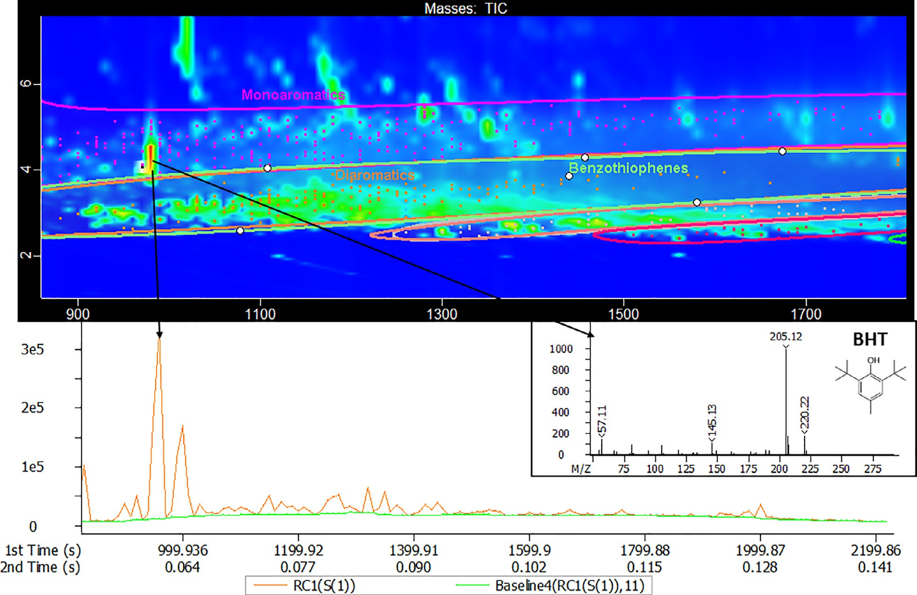
Fig. 1. On top, expansion of the MOAH fraction of sample fish feed 2, with the classification areas manually drawn (ellipsis for monoaromatics, diaromatics, benzothiophenes, etc) and the classes to which every single component belongs is depicted by markers with the corresponding color. On the bottom, the reconstructed 1D chromatogram from the 2D separation, highighting (in the sub-nominal MS spectrum) the identity of the riding peak (i.e., BHT).

latter case integrated using peak- based and signal–based integration modes) were all comparable, except for a slight overestimation using the 2D peak-based integration mode for paraﬃn.
As explained in [20], the well-shaped peaks riding on top of the hump should be subtracted from the quantification. This subtraction can be done in the 1D chromatogram by manually integrating all the peaks and removing them from the overall sum of the signal in the retention time window of interest. In the 2D chromatogram, this is more complicated. To evaluate the performance of the 2D algorithms, a solution with a known amount of paraffin oil, generating a hump, spiked with n-alkanes, to simulate the interfering peaks riding on top, was analysed. An alkanes mixture with an equal-concentration of alkanes all over the C10 –C40 range was prefered over the MOSH/MOAH retention time mixture, de- spite the latter covering up to C50, to have a complete series of n-alkanes to emphasize the trend observed. Nevertheless, as afore-mentioned, no discrimination problem was observed up to C50. To evaluate the performance of the integration algorithm, the area of the alkanes was evaluated. As all at the same concentration, similar areas should be obtained for all the alkanes. While this was the case in the 1D integration, the 2D integration algorithms (both signal-based and peak-based) included the area of the underlying hump in the area of each alkane, thus leading to overestimation of the alkane areas and underestimation of the MOSH hump. As pin- pointed in Fig. 2, where the area of each alkane is reported normalized to the C20, a clear trend was

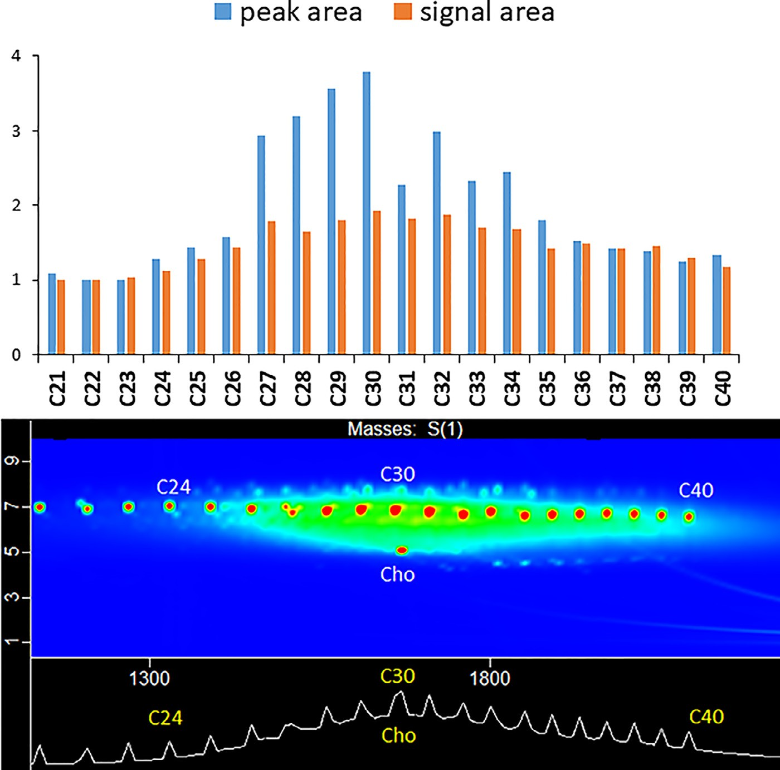
Fig. 2. On top, relative response factor (calculated versus C20 ) for the alkanes added (1 mg/kg each) on a solution of 77 mg/kg paraﬃn of alkanes spiked. On the bottom, the corresponding 2D plot showing the correspondence of the hump with the overestimated alkanes.

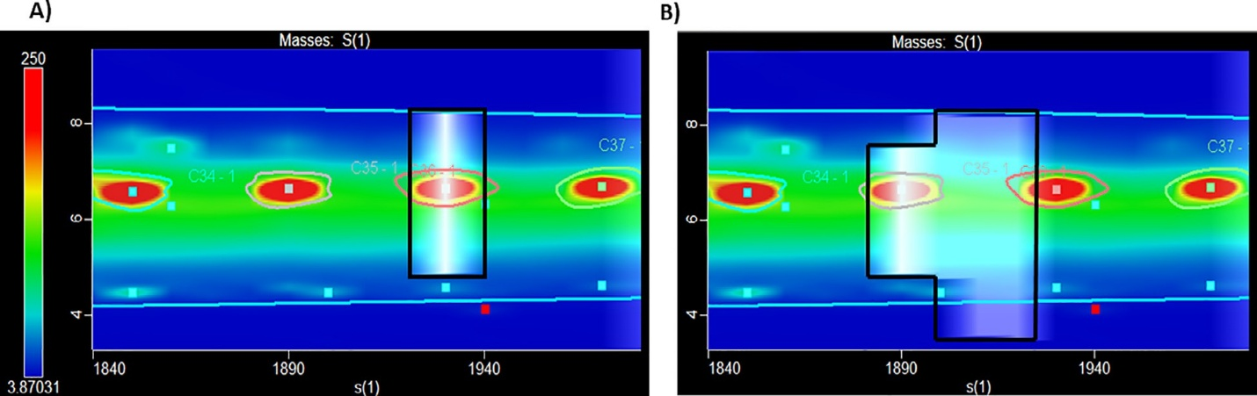
Fig. 3. Example of the integration problem encountered with peak-based integration mode. A) extension of the peak width to the baseline; B) inclusion of modulated peaks coming from the portion of the hump between two consecutive n-alkanes. The area used for the quantification of the selected n-alkane is highlighted in white. The red stencil around the alkane peak indicates the classification defined for the specific n-alkane. (For interpretation of the references to colour in this figure legend, the reader is referred to the web version of this article.)
observed reflecting the hump distribution. In fact, the alkanes lying in the middle of the hump had a greater area than those at the extremities, thus resulting in normalized values (versus C20 ) far above 1.
A worse overestimation of each alkane riding on top of the hump was obtained using the peak-based integration mode com- pared to the signal-based one. Indeed, the problem was exacerbated by the mechanism of peak identification. The algorithm considered the peak either until the baseline was reached or another peak was detected. Moreover, sometimes, due to the presence of many unresolved isomers in the MOSH fraction, the soft- ware summed too many sub-peaks for a single alkane, thus including a part of the hump located between two consecutive n-alkanes. Different S/N values were tried to tune the area integrated for the alkanes, but no improvement was observed. These two problems are illustrated in Fig. 3.
Using the signal-based integration mode, the chromatographic area to be considered as an alkane is manually defined by the operator using the above mentioned “Classifications” feature: a single-peak region is drawn in the 2D plot, which includes only the corresponding alkane. This procedure is highly time-consuming and operator-dependent, but significantly reduced the overestimation caused by the two phenomena mentioned above, although, the part of the hump underlying the peak remains included in the alkane area.
The problem of underestimation of the contamination due to the removal of part of the hump with the interference quantification was briefly mentioned also by Biedermann during a seminar held recently online [33]. Moreover, looking back to a previous quantification attempts in GC × GC, such as Purcaro et al. [27], a slight underestimation of the GC × GC results can be observed, most probably due to the same problem, although not discussed in that paper.

A NOVEL APPROACH: “TRIMMING THE RIDING PEAKS”

A novel algorithm was developed to face the particular problem of MOSH and MOAH integration and eﬃciently remove the peaks riding on top of the hump. A new integration feature was designed for both 1D and 2D data integration and interpretation. The blank subtraction in FID is

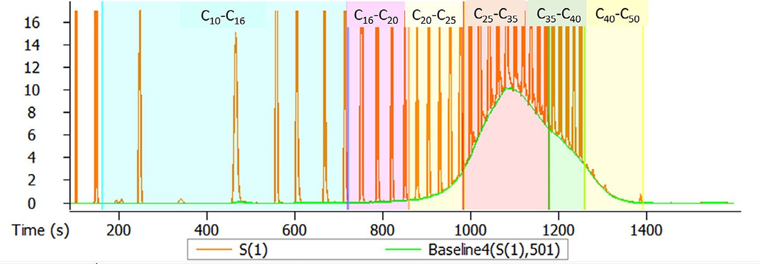

Fig. 4. Overlay of the original 1D LC-GC(× GC) chromatogram (orange trace) and the trimmed one (green trace) for a paraﬃn solution spiked with a C8 –C40 alkanes mixture. (For interpretation of the references to colour in this figure legend, the reader is referred to the web version of this article).

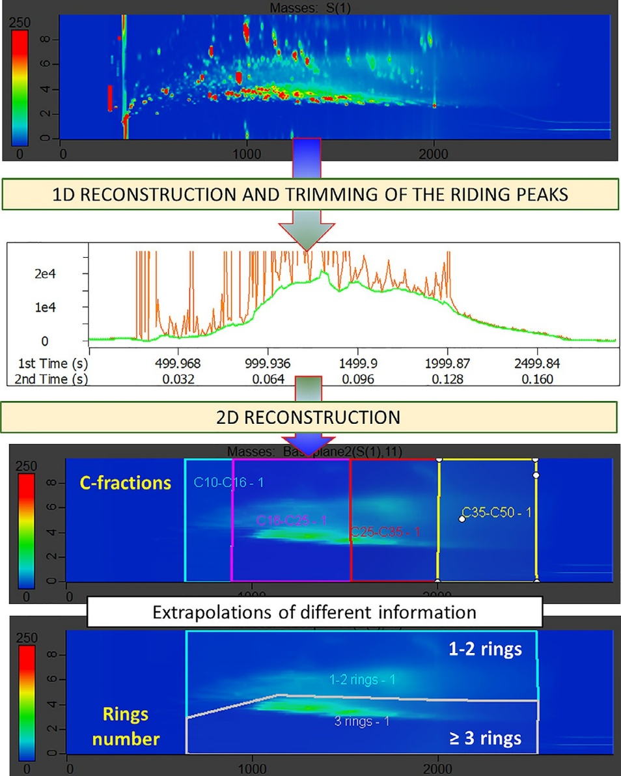
Fig. 5. Scheme of the process from the original 2D data, through the 1D reconstruction and the trimming of the riding peaks on top of the 2D hump and back reconstruction of the 2D plot without the interfering peaks for further data elaboration. MOAH fraction from fish feed 2.

now automatically performed in both 1D and 2D by simply indicating the blank sample to use, thus avoiding the tedious manual step of exporting in CSV and reimporting the data after blank subtraction. Moreover, the peaks riding on top of the hump are automatically trimmed. In 1D, the software removes all the narrow peaks while the wide hump is retained. A more detailed explanation of how this process is performed is reported in more detail in Supplementary Information. The outcome of this process allows to draw a new line located at the base of the well-shaped peak riding on top of the hump, thus generating a smooth hump that can be easily quantified. The main parameter to be optimized is the “baseline width”, which is proportional to the width of the peaks to be removed. This parameter can be set differently for each classification zone established before starting (usually corresponding at the C-fractions as required by the JRC Guidance). Variation in the “baseline width” changes the smoothing of the hump, and the operator can visualize the reconstructed one for evaluating the goodness of subtraction (Fig. 4).
For the 2D integration, a rationale similar to the 1D integration was applied. The newly developed software reconstructs the 1D chromatogram at each 2D point (similarly to a projection on the 1D axis) and it eliminates the narrow peaks according to the “baseline width” set by the operator (as for the 1D integration explained above). This means that the signal emerging as peaks riding on the top of the hump is removed automatically while the broad hump is retained. More details are reported in Supplementary Information. The reconstructed signal can be visualized either as a 1D or 2D chromatogram. In 1D, it provides a familiar visualization for scientists in the field and it can easily provide an evaluation of the smoothing procedure with the same logic routinely applied today for 1D chromatogram. The 2D visualization of the reconstructed signal does not lose any relevant information regarding the first and second dimension separation or the profile of the hump/humps, thus allowing for for further elaboration, as, for instance, the C-fraction integration or the classification of mono- and di-aromatics separated from the tri- and more rings MOAH (as shown in Fig. 1 for the untreated plot). The entire trimming of the riding peak and integration process is schematized in Fig. 5. It is important to stress that the original data are retained for any further characterization, such as specific markers identification or characterization of the interferences for better tuning the sample preparation step.

Table 1
Results (mg/kg) obtained from the 1D and 2D analysis of fish feed and fat samples performed by LC-GC × GC-FID. Data integrated as described in ref [20] for the 1D chromatogram and the signal-based mode for the 2D plot using the software version available with the instrument (“v5.50”). Data integrated using the protorype version, as explained in the main text, for the 1D chromatogram and the 2D plot (“Proto” in italic). Data reported for the C-fraction and the total C10–C50 range as requested by the JRC Guidance [32]. Values reported as ≤LOQ were calculated as equal to the LOQ for the sum; values reported as <LOD were considered as 0 in the sum.
 |  |  | MOSH |  |  |  |  |  |  |  | MOAH
 |  | Integration software | C10-C16 | C16-C20 | C20-C25 | C25-C35 | C35-C40 | C40-C50 | Total |  | C10-C16 | C16-C25 | C25-C35 | C35-C50 | Total
Fish feed 1 | 1D | v5.50 | 0.8 | 3.0 | 3.9 | 6.7 | 2.8 | 2.6 | 19.8 |  | <LOD | 1.0 | 0.9 | 0.8 | 2.7
 |  | Proto | 1.1 | 3.1 | 3.4 | 6.9 | 2.6 | 2.4 | 19.5 |  | ≤LOQ | 1.1 | 0.9 | 0.9 | 2.9
 | 2D | v5.50 | 0.6 | 2.6 | 4.4 | 4.1 | 2.4 | 0.9 | 15.0 |  | 0.2 | 1.1 | <LOD | 0.9 | 2.2
 |  | Proto | 0.5 | 4.8 | 5.3 | 6.2 | 2.2 | 0.8 | 19.8 |  | ≤LOQ | 0.9 | 0.8 | 0.8 | 2.6
Fish feed 2 | 1D | v5.50 | 0.7 | 2.4 | 3.7 | 7.8 | 1.9 | 1.7 | 18.2 |  | <LOD | 2.1 | 1.7 | 0.9 | 4.7
 |  | Proto | 0.6 | 2.3 | 3.5 | 7.9 | 1.7 | 1.6 | 17.6 |  | ≤LOQ | 2.3 | 1.7 | 0.9 | 5.0
 | 2D | v5.50 | 0.3 | 2.0 | 2.1 | 4.5 | 1.9 | 0.6 | 11.4 |  | 0.2 | 1.0 | 1.3 | 0.7 | 3.2
 |  | Proto | 0.5 | 1.9 | 3.3 | 7.2 | 1.5 | 0.8 | 15.2 |  | 0.2 | 2.3 | 1.7 | 0.7 | 4.9
Fish feed 3 | 1D | v5.50 | 0.7 | 2.4 | 2.2 | 3.7 | 1.2 | 1.1 | 11.3 |  | <LOD | 0.7 | 0.6 | 0.6 | 1.9
 |  | Proto | 0.7 | 2.1 | 2.1 | 3.8 | 1.2 | 1.0 | 10.9 |  | <LOD | 0.7 | 0.7 | 0.6 | 2.0
 | 2D | v5.50 | 0.3 | 0.3 | 1.8 | 0.8 | 1.0 | 0.5 | 4.7 |  | ≤LOQ | 0.8 | 0.7 | 0.6 | 2.2
 |  | Proto | 0.6 | 2.2 | 2.1 | 4.5 | 1.3 | 0.7 | 11.4 |  | <LOD | 0.6 | 0.6 | 0.5 | 1.7
Fish feed 4 | 1D | v5.50 | 0.5 | 1.6 | 2.8 | 4.8 | 1.0 | 1.3 | 12.0 |  | <LOD | 0.3 | 0.4 | 0.2 | 0.9
 |  | Proto | 0.4 | 1.6 | 2.9 | 4.6 | 1.2 | 1.3 | 12.0 |  | <LOD | 0.3 | 0.4 | 0.2 | 0.9
 | 2D | v5.50 | 0.2 | 0.7 | 3.8 | 3.2 | 1.0 | 0.5 | 9.4 |  | ≤LOQ | 0.4 | 0.4 | 0.3 | 1.2
 |  | Proto | 0.5 | 2.0 | 2.9 | 4.4 | 1.0 | 0.7 | 11.5 |  | <LOD | 0.4 | 0.4 | 0.3 | 1.1
Palm Oil 1 | 1D | v5.50 | 0.2 | 0.3 | 0.2 | 10.4 | 8.4 | 9.1 | 28.6 |  | ≤LOQ | 0.1 | 1.1 | 2.8 | 4.1
 |  | Proto | 0.5 | 0.8 | 0.7 | 9.7 | 8.5 | 8.5 | 28.7 |  | ≤LOQ | 0.3 | 1.0 | 2.8 | 4.2
 | 2D | v5.50 | 0.4 | 0.7 | 0.6 | 8.7 | 7.9 | 10.1 | 28.4 |  | ≤LOQ | 0.9 | 1.2 | 3.4 | 5.6
 |  | Proto | 0.3 | 0.5 | 0.6 | 9.5 | 9.0 | 8.5 | 28.4 |  | ≤LOQ | 0.4 | 1.4 | 3.0 | 4.9
Palm oil 2 | 1D | v5.50 | 0.4 | 0.4 | 0.5 | 7.9 | 5.4 | 6.1 | 20.7 |  | 0.2 | 0.4 | 0.9 | 1.7 | 3.2
 |  | Proto | 0.5 | 0.8 | 0.9 | 7.1 | 5.1 | 5.8 | 20.2 |  | ≤LOQ | 0.7 | 1.1 | 1.8 | 3.7
 | 2D | v5.50 | 0.7 | 0.8 | 0.9 | 6.9 | 4.8 | 7.2 | 21.3 |  | 0.2 | 0.9 | 1.0 | 2.0 | 4.1
 |  | Proto | 0.3 | 0.7 | 0.9 | 7.3 | 5.4 | 6.0 | 20.6 |  | ≤LOQ | 0.7 | 1.1 | 1.8 | 3.7
Coconut oil | 1D | v5.50 | 1.5 | 7.3 | 2.2 | 12.9 | 8.2 | 9.4 | 41.5 |  | 0.4 | 0.7 | 2.2 | 6.1 | 9.4
 |  | Proto | 2.4 | 6.7 | 1.6 | 12.0 | 8.0 | 8.9 | 39.6 |  | ≤LOQ | 1.1 | 1.8 | 6.3 | 9.3
 | 2D | v5.50 | 1.7 | 5.7 | 1.9 | 9.8 | 6.3 | 9.9 | 35.3 |  | 0.4 | 1.5 | 2.1 | 6.7 | 10.7
 |  | Proto | 1.6 | 6.4 | 1.9 | 12.0 | 8.8 | 8.7 | 39.4 |  | 0.2 | 0.9 | 1.9 | 6.5 | 9.5

To prove the reliability of the approach, a spiked sample was created ad hoc to test the accuracy of the process in trimming the riding peaks on top of the hump. A solution containing a known amount of paraﬃn oil and an alkane mixture (C8–C40) was analyzed three times. The data were integrated using the new software, both in 1D and 2D. Trueness (reported as the average of the absolute measured bias%) of 3.7% and 2.2% was observed for the Total C10–C50 range in 1D and 2D, respectively. Repeatability (measured as the coeﬃcient of variation, CV%) lower than 3% was obtained both in 1D and 2D (calculated on the value of the total hump, C10–C50).
Due to a lack of certified reference material for MOSH and MOAH method validation, the proposed quantification procedure was further evaluated by comparing the results obtained from different samples (i.e., fats and fish feeds). The 1D quantification, obtained after blank subtraction and the “manual integration” for re- moving each of the riding peaks [20], was considered as the reference value. It is important to highlight that this is an assumption and it is the authors’ opinion that the novel approach, that leaves less space to operator’s interpretation, tends to be more ro- bust. The 2D data was compared with the 1D and with the 2D obtained using the 2D algorithm (available at present) in signal- based mode. Both MOSH and MOAH were quantified. The limit of quantification (LOQ) for the fish samples was as reported in [30], namely 0.1 mg/kg. The LOQ for the fat samples was considered the same as also derived conservatively from the instrumental sensitivity. The authors acknowledge that this is not a validated method and that the LOQ for critical matrices as palm oil and coconut oil is far above this optimistic value. However, since the goal was to compare the integration procedure on the same sample, this LOQ was considered feasible. The results are reported in Table 1.
The data obtained in 2D using the v5.50 in signal-based mode resulted generally underestimated for the MOSH for the reasons discussed above, while for the MOAH the biases were more random, depending on the particular profile of the hump and the interferences.
The quantification data obtained using the two software versions, namely the prototype and the v5.50, both 1D and 2D were compared. 1D and 2D results obtained with the prototype version of the software were in good agreement, and both of them with what was considered the reference value, i.e., the manual 1D integration (reported in Table 1 as v5.50). The bias was generally below 10% for the MOSH fraction, except for the fish feed 2 sample for which the 2D results were slightly lower. The % bias for MOAH was higher due to the lower absolute value. The data showed a maximum absolute difference between the two integrations, namely 1D and 2D, both performed with the prototype soft- ware of 0.7 mg/kg in the total MOAH C10 -C50 range.
The novel approach used by the new algorithm in 2D proved to be reliable for the quantification. This quantification approach can be used in the GC × GC-FID platform, but the exploitation of the entire automated LC-GC × GC-ToFMS/FID platform allowed to easily reach the sensitivity required avoiding additional manipulation (i.e., collection and evaporation) that can lead to losses or cross- contamination. It was previously demonstrated that the 2D information obtained from the GC × GC-ToFMS can be easily transferred to the GC × GC-FID traces supporting, on one side, the identity confirmation of the detected hump, and on the other, the detailed characterization of the remaining interferences to support a better optimization of the sample preparation step.
The proven reliability of the 2D quantification will allow ex- tending the benefits of the GC × GC-FID trace to the 3–7 rings MOAH quantification without additional manipulation, as the one described by Koch et al. [34]. In fact, the “cloud” of MOAH obtained after the 2D reconstruction of the processed signal can be easily subdivided and quantified according to the number of rings, as shown in Fig. 5.

Conclusion

In the present work, a novel approach for 2D plot quantification devoted to the specific application of MOSH and MOAH was pro- posed and evaluated. For the sake of completeness and purpose of standardizing as much as possible the critical steps of data interpretation and integration, the manually applied procedure of integration used for the 1D trace was automated as well. Due to the lack of standard reference material for MOSH and MOAH validation, the results obtained from a series of real-world samples were compared with the MOSH and MOAH quantification obtained ap- plying the standard integration method. The results were in very good agreement and even more when comparing the results obtained with the new software in 1D and 2D. At present, the opera- tor needs to evaluate the baseline to properly accounting for it and then manually subtract the riding peaks. The new software sub- tracts the blank baseline automatically and then, after optimization of the “baseline width”, trims the riding peaks. Once a wider variety of samples will be evaluated and the software thoroughly tested and trained, a fully automated procedure can be foreseen for the trimming step, reducing at minimum the operator’s variability at this point in the analytical process. Indeed standardization of the procedure in the case of MOSH and MOAH is of paramount importance to reduce the variability due to sample integration and interpretation. Therefore, the approach here presented represents an important step in this direction.
Another important achievement is the agreement between the 1D and 2D results. The importance of the GC × GC-ToFMS/FID results is indisputable [14,32,35]. Nevertheless, the GC × GC analysis was always proposed as an additional confirmatory method with the only purpose to confirm the positive results. The possibility of performing reliable quantification from the GC × GC data opens new perspectives in the field. What we are herein proposing is to simplify the entire flowchart using a fully integrated system, namely LC-GC × GC-ToFMS/FID, to provide simultaneously quantitative and confirmatory results. In this way, the sample throughput will be maximized, avoiding performing the GC × GC analysis as an additional step after the routine LC-GC-FID. Moreover, the characterization of the 3–7 rings MOAH required by the EU can be easily provided without any additional sample preparation.
Finally, it is the authors‘opinion that this fully integrate plat- form along with the possibility to perform quantification in the 2D plot for the UCM obtained, will open new perpective to better tune the previous sample preparation steps, but also the second GC separation can serve as an additional purification step. Indeed, the 2D separation can be exploited to avoid some of the coelution that in 1D analysis would required extra sample preparation steps (e.g. POSH [36]) and at the same time would help to focus on the relevant coeluting interferences within the MOSH and MOAH fractions.
The authors will continue to validate the entire LC-GC × GC-ToFMS/FID and the software prototype proposed in further studies and possibly in comparative with other users.

Declaration of Competing Interest

The authors declare the following financial interests/personal relationships which may be considered as potential competing interests:

CRediT authorship contribution statement

Grégory Bauwens: Software, Validation, Formal analysis, Investigation, Data curtion, Visualization, Writing – review & editing. Sebastiano Pantó: Methodology, Software, Validation, Visualization, Writing – review & editing. Giorgia Purcaro: Conceptualization, Methodology, Visualization, Supervision, Software, Validation, Writing – original draft, Writing – review & editing, Project administration, Funding acquisition.

Acknowledgments

This work is supported by Fonds de la Recherche Scientifique Belgique (FNRS) (CDR projects-MOHPlatform, J.0170.20). The authors thank Restek for its support.

Supplementary materials

Supplementary material associated with this article can be found, in the online version, at doi:10.1016/j.chroma.2021.462044.

References

- International Agency for Research on Cancer (IARC), Mineral oils, untreated or mildly treated, IARC Monogr. Eval. Carcinog. Risks to Humans. 100 F (2012).
- K. Grob, A. Artho, M. Biedermann, J. Egli, Food Contamination by hydrocar- bons from lubricating oils and release agents: determination by coupled LC-GC, Food Addit. Contam. 8 (1991) 437–446.
- K. Grob, Could the Ukrainian sunflower oil contaminated with mineral oil wake up sleeping dogs? Eur. J. Lipid Sci. Technol. 110 (2008) 979–981, doi:10. 1002/ejlt.200800234.
- M. Biedermann, K. Grob, Is recycled newspaper suitable for food contact materials? Technical grade mineral oils from printing inks, Eur. Food Res. Technol. 230 (2010) 785–796, doi:10.1007/s00217-010-1223- 9.
- European Food Safety Authorithy (EFSA), Scientific Opinion on Mineral Oil Hydrocarbons in Food, 2012. doi:10.2903/j.efsa.2012.2704.
- European Commission, Commission Recommendation (EU) 2017/84 of 16 January 2017 on the monitoring of mineral oil hydrocarbons in food and in materials and articles intended to come into contact with food, Off. J. Eur. Union. L12 (2017) 95–96.
- D. Arcella, K. Baert, M. Binaglia, Rapid Risk Assessment On the Possible Risk For Public Health Due to the Contamination of Infant Formula and Follow- On Formula By Mineral Oil Aromatic Hydrocarbons (MOAH), 16, EFSA Support. Publ., 2019, doi:10.2903/sp.efsa.2019.en-1741.
- M. Biedermann, K. Fiselier, K. Grob, Aromatic hydrocarbons of mineral oil origin in foods: method for determining the total concentration and first result, J. Agric. Food Chem. 57 (2009) 8711–8721, doi:10.1021/jf901375e.
- M. Biedermann, C. Munoz, K. Grob, Update of on-line coupled liquid chromatography – gas chromatography for the analysis of mineral oil hydrocarbons in foods and cosmetics, J. Chromatogr. A. 1521 (2017) 140–149, doi:10.1016/j. chroma.2017.09.028.
- L. Barp, G. Purcaro, S. Moret, L.S. Conte, A high-sample-throughput LC-GC method for mineral oil determination, J. Sep. Sci. 36 (2013) 3135–3139, doi:10. 1002/jssc.201300114.
- K. Grob, Mineral oil hydrocarbons in food: a review, Food Addit. Contam. - Part A Chem. Anal. Control. Expo. Risk Assess. 35 (2018) 1845–1860, doi:10. 1080/19440049.2018.1488185.
- S. Weber, K. Schrag, G. Mildau, T. Kuballa, S.G. Walch, D.W. Lachenmeier, An- alytical Methods for the Determination of Mineral Oil Saturated Hydrocar- bons (MOSH) and Mineral Oil Aromatic Hydrocarbons (MOAH)—A Short Re- view, Anal. Chem. Insights. 13 (2018), doi:10.1177/1177390118777757.
- S. Moret, C. Conchione, A. Srbinovska, P. Lucci, Microwave-based technique for fast and reliable extraction of organic contaminants from food, with a special focus on hydrocarbon contaminants, Foods 8 (2019) 503, doi:10.3390/ foods8100503.
- N. Sdrigotti, M. Collard, G. Purcaro, Evolution of hyphenated techniques for mineral oil analysis, J. Sep. Sci. 44 (2021) 464–482, doi:10.1002/jssc. 202000901.
- L.W. Spack, G. Leszczyk, J. Varela, H. Simian, T. Gude, R.H. Stadler, Understanding the contamination of food with mineral oil: the need for a confirmatory analytical and procedural approach, Food Addit. Contam. - Part A Chem. Anal. Control. Expo. Risk Assess. 34 (2017) 1052–1071, doi:10.1080/19440049.2017.
1306655.
- M. Biedermann, G. McCombie, K. Grob, O. Kappenstein, C. Hutzler, K. Pfaff, A. Luch, FID or MS for mineral oil analysis? J. Fur Verbraucherschutz Und Leb. 12 (2017) 363–365, doi:10.1007/s00003- 017-1127- 8.
- S. Bratinova, E. Hoekstra, H. Emons, C. Hutzler, O. Kappenstein, M. Biedermann, G. McCombie, The reliability of MOSH/MOAH data: a comment on a recently published article, J. Fur Verbraucherschutz Und Leb. (2020) 2–4, doi:10.1007/ s00003-020-01287w.
- A. Hochegger, S. Moret, L. Geurt, T. Gude, E. Meitner, B. Mertens, S. ÓHagan,
F. Poças, T. Simat, G. Purcaro, Mineral Oil Risk Assessment : knowledge Gaps and Roadmap . Outcome of a multi-stakeholders workshop, Food Chem. Toxi- col. (2021) submitted.
- M. Biedermann, K. Grob, On-line coupled high performance liquid chromatography-gas chromatography for the analysis of contamination by mineral oil. Part 1: method of analysis, J. Chromatogr. A. 1255 (2012) 56–75, doi:10.1016/j.chroma.2012.05.095.
- M. Biedermann, K. Grob, On-line coupled high performance liquid chromatography-gas chromatography for the analysis of contamination by mineral oil. Part 2: migration from paperboard into dry foods: interpretation of chromatograms, J. Chromatogr. A. 1255 (2012) 76–99, doi:10.1016/j.chroma.2012.05.096.
- S. Bratinova, E. Hoekstra, Joint Research Center (JRC). Guidance on sampling, analysis and data reporting for the monitoring of mineral oil hydrocarbons in food and food contact materials. In the frame of Commission Recommendation (EU) 2017/84, 2019. 10.2760/208879.
- S. Koster, J. Varela, R.H. Stadler, J. Moulin, C. Cruz-Hernandez, J. Hielscher,
C. Lesueur, J. Roïz, H. Simian, Mineral oil hydrocarbons in foods: is the data reliable? Food Addit. Contam. - Part A Chem. Anal. Control. Expo. Risk Assess. 37 (2020) 69–83, doi:10.1080/19440049.2019.1678770.

- European Parliament and the Council of the European Union, Commission Decision of 12 August 2002 implementing Council Directive 96/23/EC concerning the performance of analytical methods and the interpretation of results (notified under document number C(2002) 3044)(Text withEEA relevance) (2002/657/EC), Off. J. Eur. Communities. (2002) 8–36, doi:10.1017/ CBO9781107415324.004.
- M. Biedermann, K. Grob, Comprehensive two-dimensional GC after HPLC pre- separation for the characterization of aromatic hydrocarbons of mineral oil ori- gin in contaminated sunflower oil, J. Sep. Sci. 32 (2009) 3726–3737, doi:10. 1002/jssc.200900366.
- M. Biedermann, L. Barp, C. Kornauth, T. Würger, M. Rudas, A. Reiner, N. Concin, K. Grob, Mineral oil in human tissues, Part II: characterization of the accumulated hydrocarbons by comprehensive two-dimensional gas chromatography, Sci. Total Environ. 506–507 (2015) 644–655, doi:10.1016/j.scitotenv.2014.07.038.
- G. McCombie, K. Hötzer, J. Daniel, M. Biedermann, A. Eicher, K. Grob, Compliance work for polyolefins in food contact: results of an oﬃcial control campaign, Food Control 59 (2016) 793–800, doi:10.1016/j.foodcont.2015.06.058.
- G. Purcaro, P.Q. Tranchida, L. Barp, S. Moret, L.S. Conte, L. Mondello, Detailed elucidation of hydrocarbon contamination in food products by using solid- phase extraction and comprehensive gas chromatography with dual detection, Anal. Chim. Acta. 773 (2013) 97–104, doi:10.1016/j.aca.2013.03.002.
- M. Zoccali, P.Q. Tranchida, L. Mondello, On-line liquid chromatography- comprehensive two dimensional gas chromatography with dual detection for the analysis of mineral oil and synthetic hydrocarbons in cosmetic lip care products, Anal. Chim. Acta. 1048 (2019) 221–226, doi:10.1016/j.aca.2018.10.069.
- L. Mondello, M. Zoccali, G. Purcaro, F.A. Franchina, D. Sciarrone, S. Moret,
L. Conte, P.Q. Tranchida, Determination of saturated-hydrocarbon contamination in baby foods by using on-line liquid-gas chromatography and off-line liquid chromatography-comprehensive gas chromatography combined with mass spectrometry, J. Chromatogr. A. 1259 (2012) 221–226, doi:10.1016/j.chroma.2012.03.096.
- A. Srbinovska, C. Conchione, P. Lucci, S. Moret, On-line HP(LC)-GC-FID determination of hydrocarbon contaminants in fresh and packaged fish and fish products Manuscript, J. AOAC Int. (2021) in press.
- M. Biedermann, C. Munoz, K. Grob, Epoxidation for the analysis of the mineral oil aromatic hydrocarbons in food. An update, J. Chromatogr. A. 1624 (2020) 461236, doi:10.1016/j.chroma.2020.461236.
- S. Panto, M. Collard, G. Purcaro, Comprehensive Gas Chromatography Coupled to Simultaneous Dual Detection (TOF-MS/FID) as a Confirmatory Method for MOSH and MOAH Determination in Food, Curr. Trend Mass Spectrom. (2020) 1–6.
- M. Biedermann, Comprehensive two-dimensional GC×GC-FID/MS for the char-acterization of the MOSH and MOAH fraction and the quantification of 3-7 ring MOAH, Int. Semin. Anal. Miner. Oils Foods (2020) 15–16.
- M. Koch, E. Becker, M. Päch, S. Kühn, E. Kirchhoff, Separation of the mineral oil aromatic hydrocarbons of three and more aromatic rings from those of one or two aromatic rings, J. Sep. Sci. 43 (2020) 1089–1099, doi:10.1002/jssc. 201900833.

- M. Biedermann, K. Grob, Advantages of comprehensive two-dimensional gas chromatography for comprehensive analysis of potential migrants from food contact materials, Anal. Chim. Acta. 1057 (2019) 11–17, doi:10.1016/j.aca.2018.10.046.
- M. Lommatzsch, M. Biedermann, T.J. Simat, K. Grob, Argentation high performance liquid chromatography on-line coupled to gas chromatography for the analysis of monounsaturated polyolefin oligomers in packaging materials and foods, J. Chromatogr. A. 1402 (2015) 94–101, doi:10.1016/j.chroma.2015.05.019.

